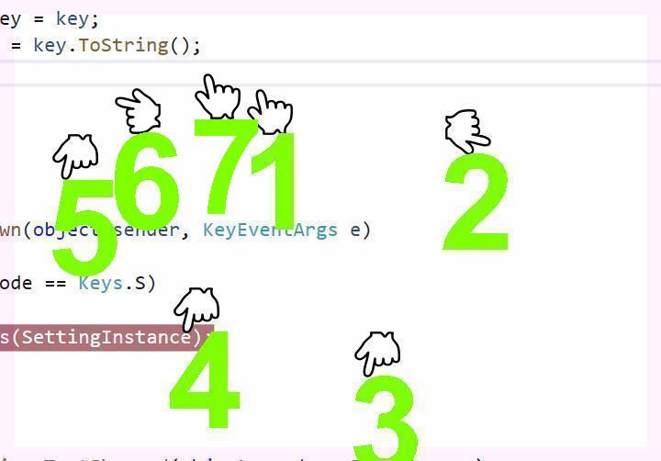

Lookingahead to have or havewhich is the namewas organizer of the homeowners along with remarkable domicile and you are on who you and available to