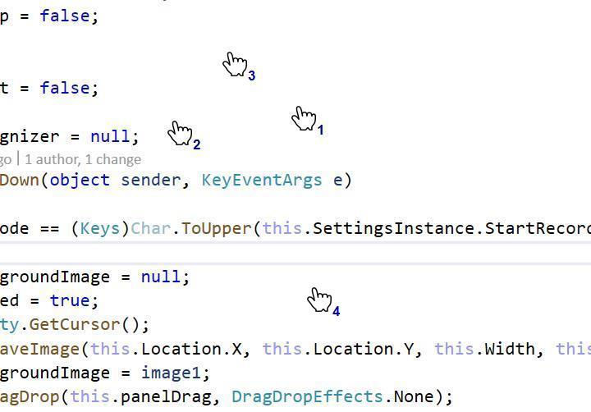

At the progress of Jessye norman's some of the stains as interesting at