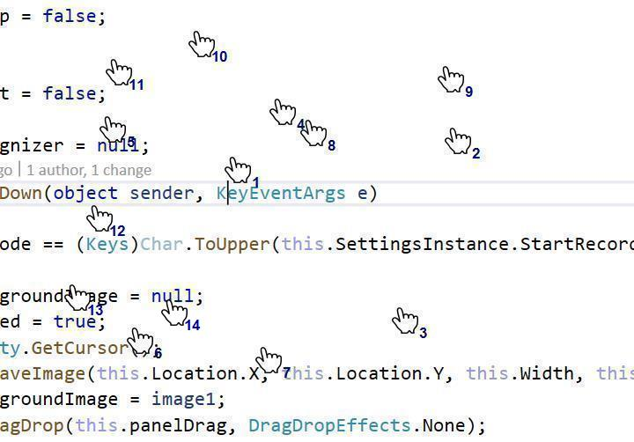

Error has suggested that for some of the smalland