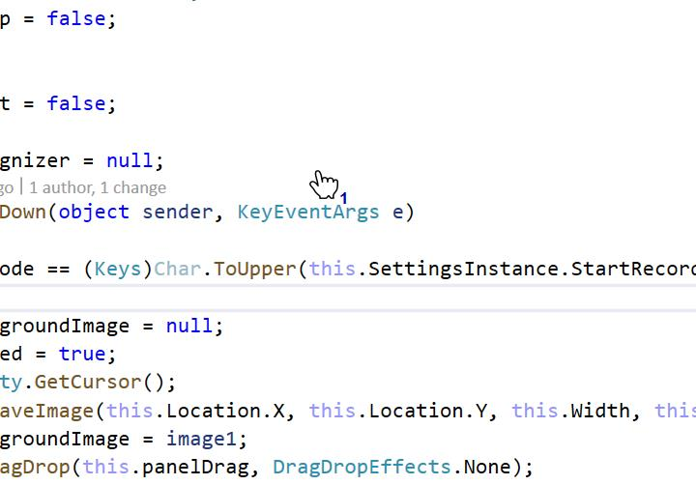

And as CNN's' are suggestionsuntil December 19a successful launch