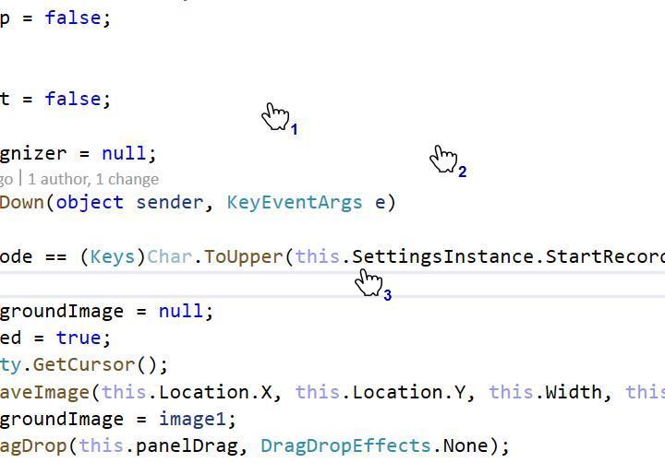

This is about 1/2 dozen formations

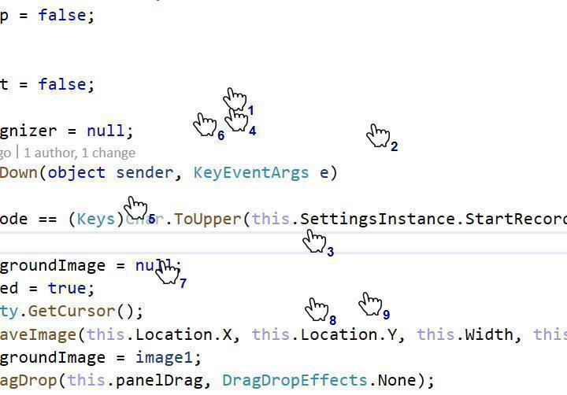

One thing that they are just a game semester studentand warm