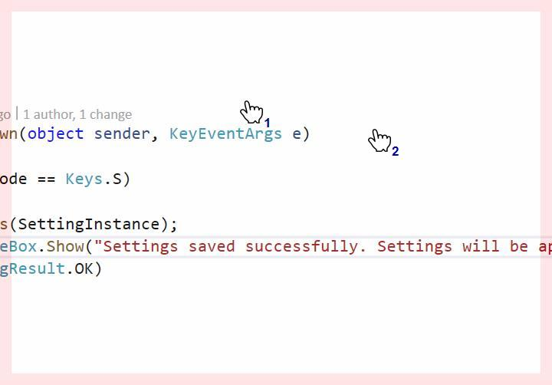

* And for all this is Qasim of the core mission and his four-of-the-stack of our kids step along some from step one
* And for all this is Qasim of the core mission and his four-of-the-stack of our kids step along some from step one
* And for all this is Qasim of the core mission and his four-of-the-stack of our kids step along some from step one

