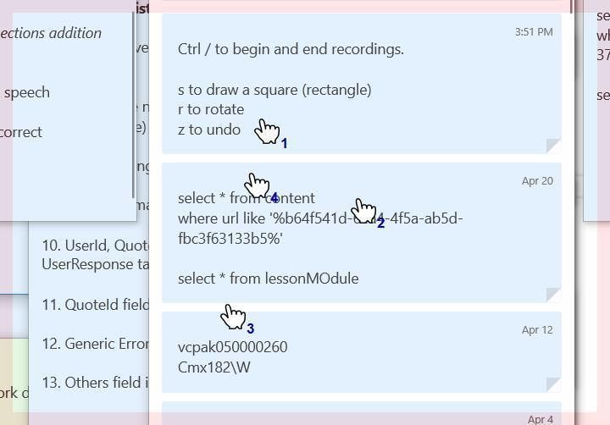

* + Said one 04111 or two days before morning and will feature of this industry works and start from as electives of its top one of well-known stop one step one
  + Said one 04111 or two days before morning and will feature of this industry works and start from as electives of its top one of well-known stop one step one