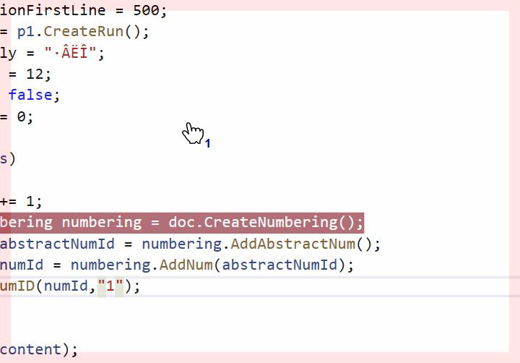

* + Of that have been some form staff one step one
  + Of that have been some form staff one step one