Business Requirements Document (BRD)
Project: Employee Salary Analysis Automation
1. Document Information
- Project Name : Employee Salary Analysis Automation
- Version : v1
- Prepared By : Madhu
- Date : 20th June 2026
- Approvals : Business Owner

2. Executive Summary
Example:
Employee Salary Analysis Automation is designed to automate the identification of employees whose salary exceeds predefined business thresholds. The solution will eliminate manual Excel filtering activities currently performed by HR analysts, improve reporting accuracy, and reduce processing effort.

3. Business Background
Explain:
- Why HR performs this analysis
- Current challenges
- Need for automation
- Expected business benefits
Example:
HR receives monthly employee master data extracts containing thousands of employee records. Analysts manually review salary information to identify employees meeting management-defined salary criteria. The process is repetitive, time-consuming, and prone to human error.

4. Business Objectives
ID | Objective
GO-01 | Reduce manual effort
GO-02 | Improve reporting accuracy
GO-03 | Standardize salary analysis
GO-04 | Reduce processing time
GO-05 | Maintain auditability

5. Current State Process
Detailed narrative:
- HR receives Employees.xlsx
- Analyst opens Excel
- Reviews data
- Applies Salary > 50,000 filter
- Reviews results
- Creates report
- Shares findings
Current State Process Flow Diagram
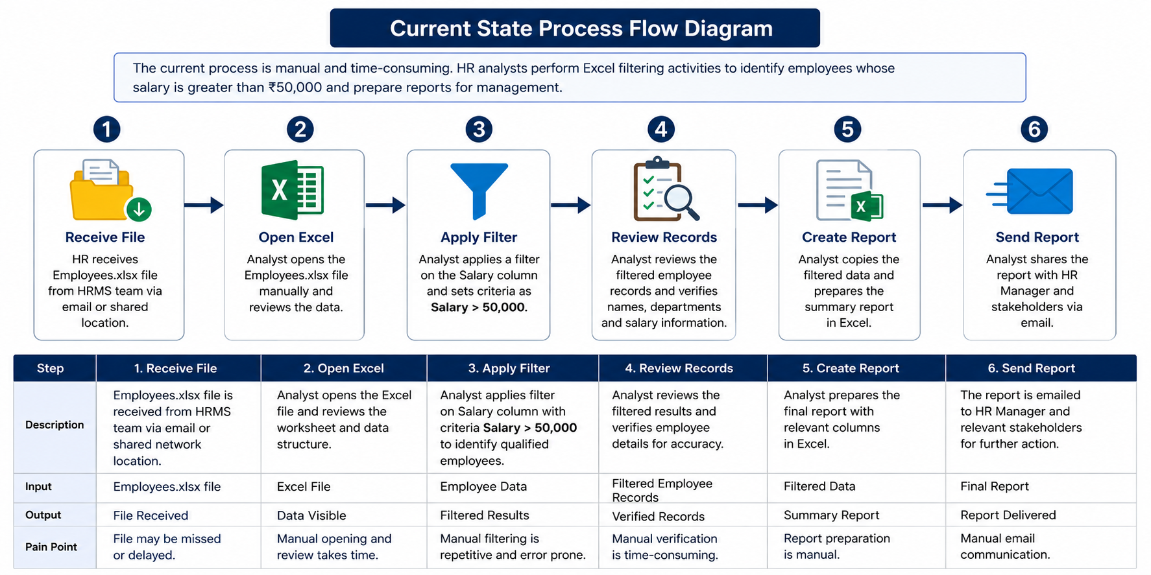
6. Future State Process
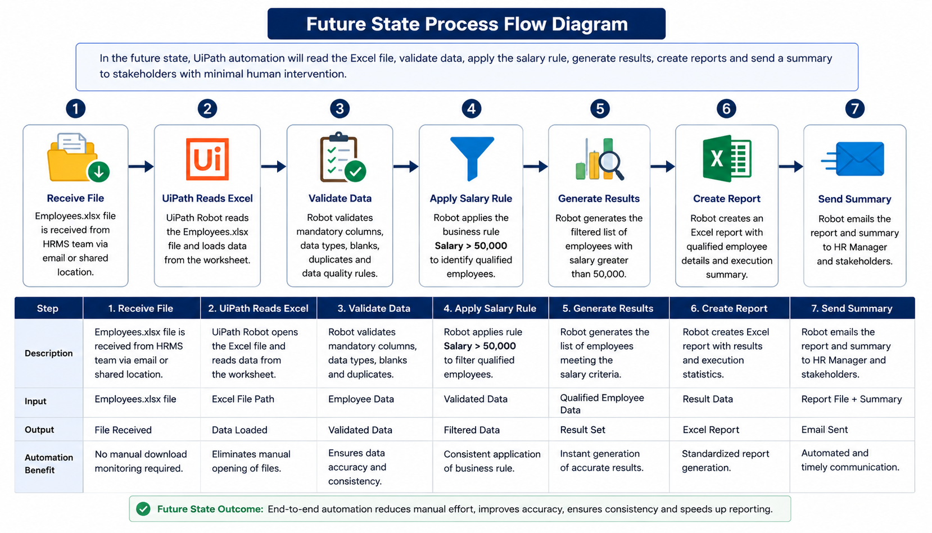

7. Stakeholders
Role | Responsibility
HR Analyst | Process owner
HR Manager | Report consumer
RPA Team | Development
Support Team | Maintenance

8. Applications & Systems
Application | Purpose
Microsoft Excel | Source Data
UiPath Studio | Development
UiPath Robot | Execution
Orchestrator | Scheduling

9. Functional Requirements
FR-001 – Excel File Ingestion
The system shall read Employee data from the provided Employees.xlsx file.
FR-002 – File Validation
The system shall validate that the input file exists and is accessible.
FR-003 – File Format Validation
The system shall validate that the uploaded file is in .xlsx format.
FR-004 – Worksheet Validation
The system shall validate that the expected worksheet is available in the workbook.
FR-005 – Mandatory Column Validation
The system shall verify the presence of mandatory columns:
- EmployeeID
- Name
- Department
- Salary
- HireDate
FR-006 – Data Extraction
The system shall extract all employee records from the Excel file.
FR-007 – Employee ID Validation
The system shall validate that EmployeeID is populated for every record.
FR-008 – Employee Name Validation
The system shall validate that Employee Name is populated for every record.
FR-009 – Department Validation
The system shall validate that Department is populated for every record.
FR-010 – Salary Validation
The system shall validate that Salary contains numeric values.
FR-011 – Hire Date Validation
The system shall validate that Hire Date contains a valid date value.
FR-012 – Duplicate Employee Detection
The system shall identify duplicate Employee IDs and log them as exceptions.
FR-013 – Salary Threshold Evaluation
The system shall evaluate whether employee Salary exceeds the configured threshold value.
FR-014 – Employee Filtering
The system shall filter all employee records whose Salary is greater than ₹50,000.
FR-015 – Qualified Employee Identification
The system shall identify and mark all employees meeting the salary criteria.
FR-016 – Result Logging
The system shall log Employee Name and Department for all qualified employees.
FR-017 – Summary Generation
The system shall generate an execution summary containing:
- Total Records Processed
- Qualified Employees
- Rejected Records
- Exception Count
FR-018 – Exception Handling
The system shall capture and log processing exceptions without terminating unexpectedly.
FR-019 – Audit Logging
The system shall maintain execution logs for audit and troubleshooting purposes.
FR-020 – Process Completion Notification
The system shall generate a final completion status indicating Success, Partial Success, or Failure.

10. Business Rules
Rule ID | Description
BR-01 | Salary must be numeric
BR-02 | Salary > 50,000 qualifies
BR-03 | Employee Name mandatory
BR-04 | Department mandatory
BR-05 | EmployeeID mandatory

11. Exception Scenarios
Exception | Action
File Missing | Stop Process
Invalid Format | Log Error
Missing Columns | Stop Process
Blank Salary | Skip Record

12. Assumptions
- Excel file follows standard format.
- Salary column contains numeric values.
- Required columns exist.

13. Constraints
- Only .xlsx supported.
- Single worksheet supported.
- Threshold initially fixed at ₹50,000.

14. Non Functional Requirements
- Performance
- Security
- Auditability
- Logging
- Maintainability

15. Reporting Requirements
Output should contain:
- Employee ID
- Employee Name
- Department
- Salary
- Execution Time
- Total Records
- Qualified Records

16. Success Criteria
- 100% accurate filtering
- Zero manual intervention
- Complete audit logs
- Processing time < 2 minutes

17. Appendix
- Sample Employees.xlsx structure
- Screenshot placeholders
- Process flow diagrams
- Glossary

