Kazan Viewer Problems, Questions and Suggestions

# Updated August 2023

## Main Window

1. Modify algorithm for number of digits on display.
2. Modify ‘unit’ parameter for 2D experiments
3. X-units often not recognized when loading files, even standard Bruker files
4. For Integral, how is the baseline determined?
5. Save dsc from KV dat file: wrong units and order of magnitude
6. Saving 2D asci: in addition to previous issue, second axis missing (field axis for transient)
7. Normalize option: divide by shots per loop and number of scans and video gain (mostly Bruker and Specman) Loader file available. Add normalization to parameter reader.
8. List of parameters do be displayed in Main Window and how to get them from which type of files.

## Plugins in general

1. List color code, e.g. for Simplugin red simulation, green difference, pink sum of simulation
2. Make plugins a bit larger and scalable
3. For multiple plugins, some options don’t work if setting is “1D” and not “Stack”

## Sim Plugin

1. Under optimization: what are meaning of the iterations, tolerances?
2. Shift.dx field: when saving a simulation, it does not save the dx shift for the individual simulation, but for sum does it. Did not test difference.
3. Shift.s: does shift the individual simulations, but not difference or sum. Does not take the shift.s when saving the simulation
4. Option to export parameters to workspace
5. Rename tool as icon
6. What are the reference regions and what is the function used for baseline_
7. What is “Optimize” vs Do not optimize? Is this a fitting function?
8. Frequency load more significant digits
9. Load Range should be one array, not start and end separately (e.g. for field sweep)
10. Are data from Easyspin scaled internally be Kazan or only by the one factor shown in Simplugin
11. Visualization of axes
12. Add Simplugin parameters with newer Easyspin nomenclature
13. Use of Saffron with Kazan viewer
14. Indication of simulation still running like Windows style waiting icon in Simplugin (helpful if simulations take a longer time)

## Minusbox Plugin

1. Shifts X, Y onlz
2. Escape for Zoom and Cursor
3. When saving option to save title of spectrum or reference spectrum (reverse the action)

## Fittingbox Plugin

1. Often does not work, unclear why. Sometimes just closing and re-opening seems to do it

## Compbox Plugin

## Transient Plugin: Transient data processing & visualization

1. Additional option: Linear baseline subtraction along magnetic field axis for all time points to compensate for broad light-induced background signal.
2. Additional option: 2D-presentation like in the examples below with surf/mesh after 2D data have been processed by laser background subtraction and dark signal subtraction. Could be different plugin if that is simpler.
3. In time view, second axis can not be scolled. Without that, not possible to see the fields where signal is. Select point in field action need to be reversed to seeing full spectrum numbers. (???) Fix display of field.
4. Smooth is the same level of smoothing in both dimensions?
5. Show smooth: display also non-smooth (add show no smooth)
6. Current 2D plot options?
7. 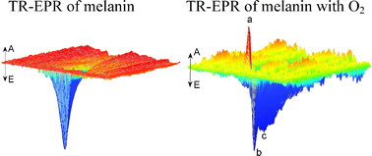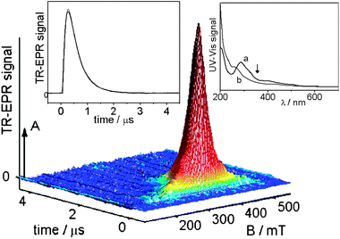

## ANL PLG Plugin: Transient data processing & visualization

1. No color is visible when transferring Output back to Source
2. For this plugins fit don’t work if setting is “1D” and not “Stack”
3. What is the offset time, the first point?
4. Some formulas are wrong or maybe unusual parameterized. Parameters should be able to set and fix if needed.
5. Kinetic with 1. Exponent: A*e((x-x0)/t1)+const
6. Kinetic with 2. Exponents: A*e((x-x0)/t1)+ B*e((x-x0)/t2)+const
7. Kinetic with 3. Exponents: A*e((x-x0)/t1)+ B*e((x-x0)/t2)+ C*e((x-x0)/t3+)const
8. Inv. Rec. with 1. Exponent: A*e((x-x0)/t1)+const
9. Inv. Rec. with 2. Exponents: A*e((x-x0)/t1)+ B*e((x-x0)/t2)+const

## Other

1. Saving or converting 2D file (transient) to asci looses information on second axis (magnetic field). Only time axis is preserved.