01/05/14

Error while attempting to fit an image using external mask (from MRI)

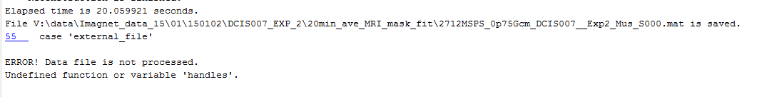

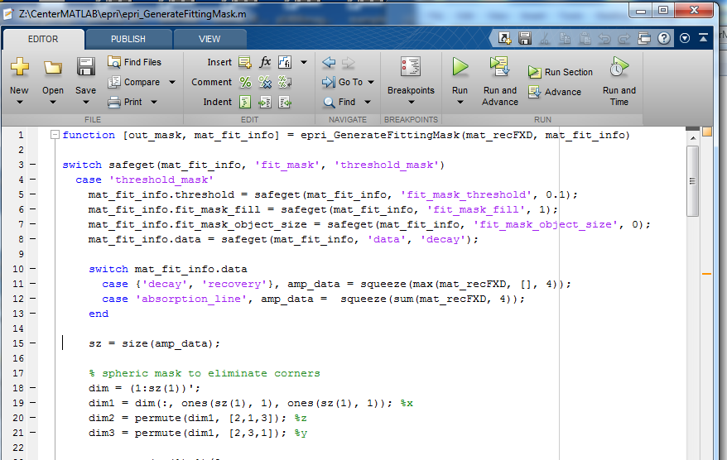

Fitting succeeds with threshold mask. BE fixes in software.

1/6/14

Reconstruction of a T1/T2 image fails. Seemed to have the right number of voxels. And the text for Reconstruction showed up.

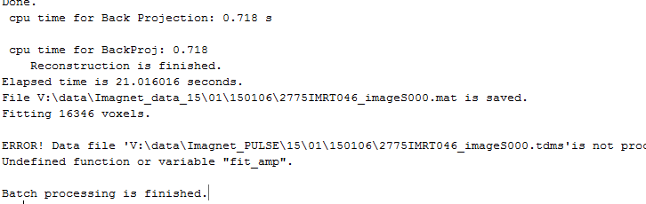

Figure 2

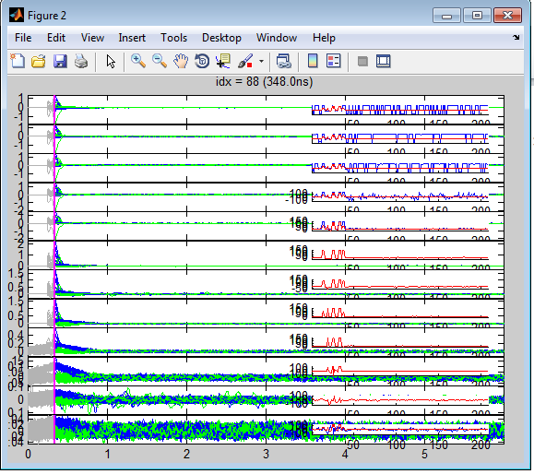

1/21/2015

After launching pvGUI and attempting to hit “viewer” to bring up an image.

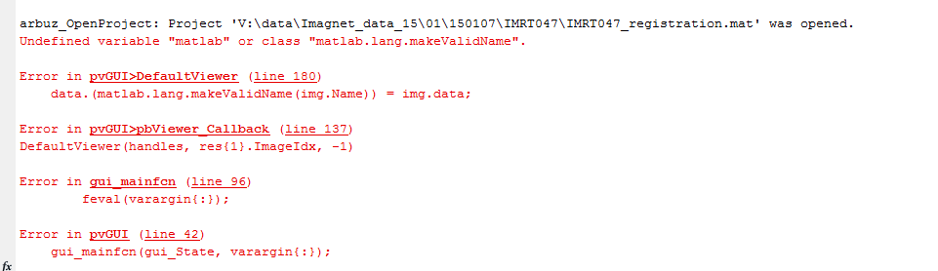

Error message. Matlab side problem. Upgraded to 2014. Fixed.

2/3/15

While attempting to do the casey stuff. HistoSetScalePLG does not load the 2D images.

The load Image (2D) button returns the following.

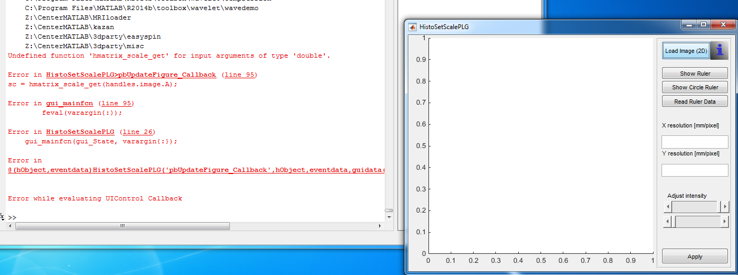

From previous errors this looks like a 2012-2014 migration issue. MM. BE fixes.

2/5/2015.

When trying to use HistoAlign to space out the 2D slices according to our caliper measurements.

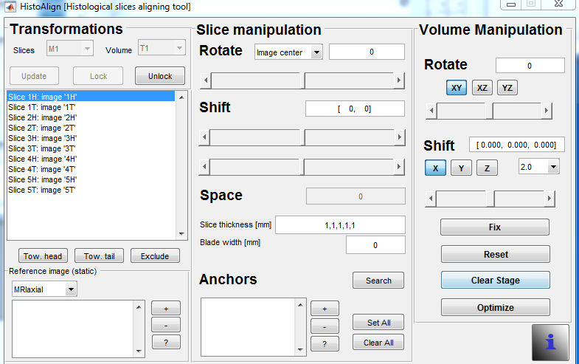

The Following error is obsereved.

