Evaluating an AI agent in a "telescope-time" environment
PLAsTiCC course · agentic evaluation practical · student guide
This guide explains the small evaluation system you will use this week: what the environment is, how Claude is connected to it, what happens during one run, and how the runs are graded. It assumes you know the PLAsTiCC dataset (objects, passbands, light curves, host redshifts, classes).

1. Three words: agent, environment, evaluation
- Agent. A language model that can act by calling tools, read the results, and decide what to do next, in a loop, until it stops. Here the agent is Claude (Haiku, Sonnet or Opus).
- Environment. The world the agent acts in. It defines which actions exist, what they cost, what the agent observes after each action, and when the interaction ends. Here it is a simulated telescope that sells observations of one PLAsTiCC object.
- Evaluation. Running the agent on many tasks, several times each, and measuring:
- the output: was the final answer right?
- the process: how did it get there? What did it buy, in what order, how much did it waste, and did it describe its evidence truthfully?
The key design choice is that the agent can only affect the world through the environment's tools. It has no shell, no files and no internet. So every action it takes passes through code we wrote, and every action is logged. That is what makes the process measurable.

2. The "Gym" pattern, in five lines
Reinforcement-learning research uses a standard interface for environments, known as the Gym interface:
observation = env.reset(task) # start an episode
while not done:
action = agent.choose(observation) # the agent decides
observation, reward, done = env.step(action) # the environment responds

- An episode is one attempt at one task, from reset to done.
- The environment holds the state: what has been bought and how much budget is left.
- The agent only sees observations: the text each tool returns.
Our environment follows this pattern, with names adapted to tool calling:
Gym | Here | What it does
reset(task) | env.reset(task) | Loads the target and returns the briefing (question, budget, prices)
step(action) | env.call(tool, **args) | Runs one tool, charges its cost, logs it, returns text
done | submit(...), or the call limit | Ends the episode
reward | env.finalize() | Grades the finished episode (section 6)

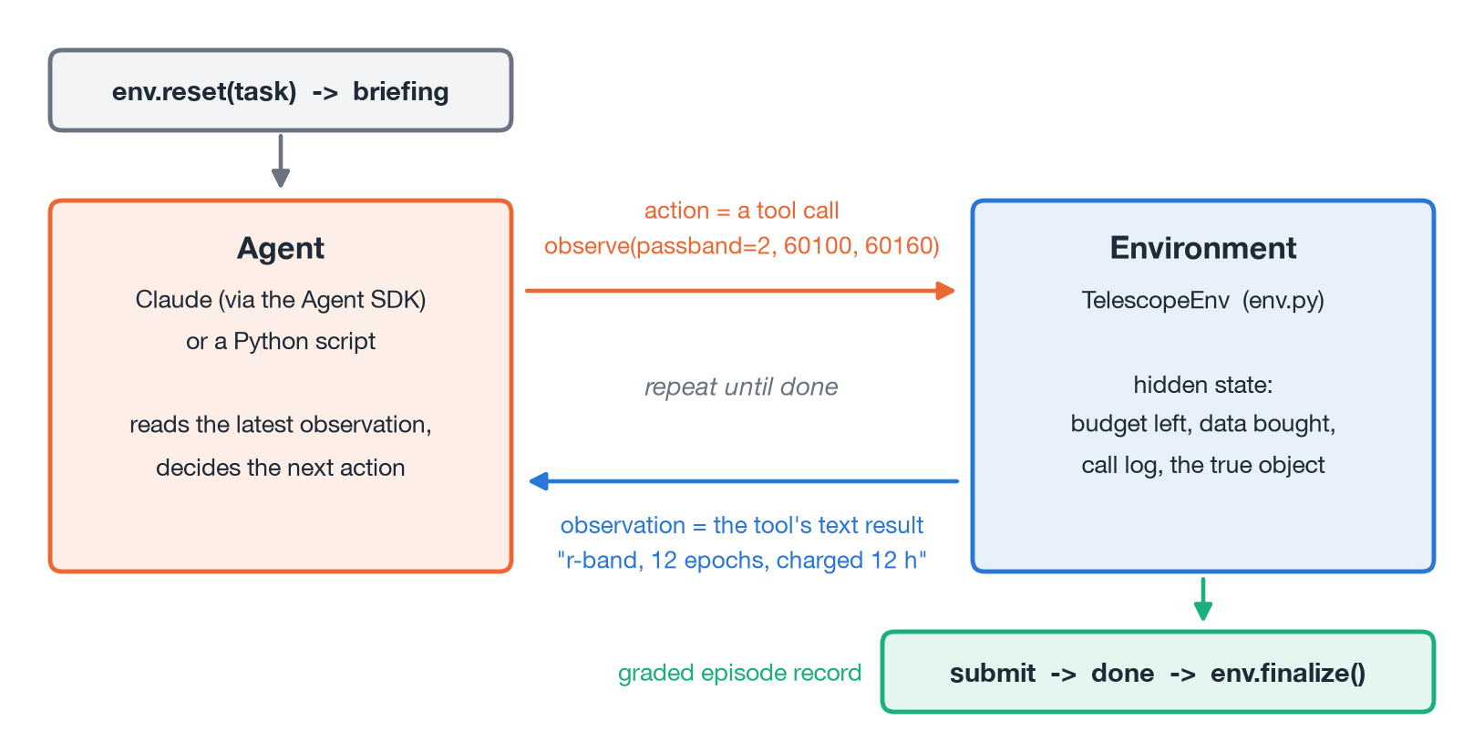
Figure 1. The Gym loop. Agent and environment exchange actions and observations until the agent submits; then the finished episode is graded.
The same environment can be driven by Claude or by a plain Python script. We use scripts as baselines (section 7).

3. The environment's rules
Setting. You are an observer with a limited allocation of telescope time. Each episode asks one question about one PLAsTiCC object. The object is hidden behind an alias such as T-3f9a, so the agent cannot look it up or recognise its object_id.
Budget.
- 30 telescope hours and at most 30 tool calls per episode.
- A typical object has about 176 epochs, so the budget buys roughly one sixth of its light curve.
Tools (the only possible actions):
Tool | Price | Returns
budget | free | hours and calls left
sky_position | free | ra, dec, Galactic l and b, Milky Way extinction E(B−V), deep-field flag
observing_log | free | observing seasons and epochs per band in each season (no fluxes)
alert_history | 2 h | when the object was significantly detected, grouped into clusters (no fluxes)
observe(passband, mjd_start, mjd_end) | 1 h per epoch (min 1 h) | mjd, flux, flux_err, detected for that band and window
host_photoz | 3 h | host photometric redshift; 0 means no extragalactic host, i.e. a Galactic object
host_specz | 10 h | host spectroscopic redshift
submit(answer, confidence, rationale) | free | the final answer, a probability of being right, and 1–3 sentences on the evidence

Rules the environment enforces:
- Too expensive: a call that costs more than the remaining budget is refused and nothing is charged.
- Window too large: an observe window with more than 30 epochs is refused, again free of charge. The agent must narrow the window.
- Paying twice: buying the same epochs twice costs twice. The waste is logged.
- Invalid answers: an answer that is not one of the options, or a confidence outside [0, 1], is rejected, and the agent may submit again.
- End of episode: after a valid submit, or after 30 calls, the episode is over and further calls are refused.
Three task families:
Family | Question | Counted correct if
is_snia | Is the target a SN Ia? | exact match. Most "no" cases are other supernovae, so this is hard
coarse_class | galactic_variable / supernova / agn / rare_transient | exact match
peak_time | MJD of peak brightness in r | within ±10 days of the brightest detected r-band epoch

Task sets are generated with a fixed random seed:
- tasks/dev.jsonl: 12 tasks, for trying things out.
- tasks/eval.jsonl: 30 tasks, for final numbers.
The answers are kept in separate *_answers.jsonl files, which only the grader reads.

4. How Claude is connected: the Agent SDK
We use the Claude Agent SDK (pip install claude-agent-sdk). It is Claude Code packaged as a Python library, and it authenticates with your Claude subscription login.
When our code calls query(...), the SDK starts Claude Code as a subprocess. That subprocess runs the agent loop for us:
1. It sends the conversation to the model.
2. When the model asks for a tool, it runs the tool.
3. It sends the result back to the model, and repeats.
We never write this loop ourselves. Our job is to supply the tools and the rules.
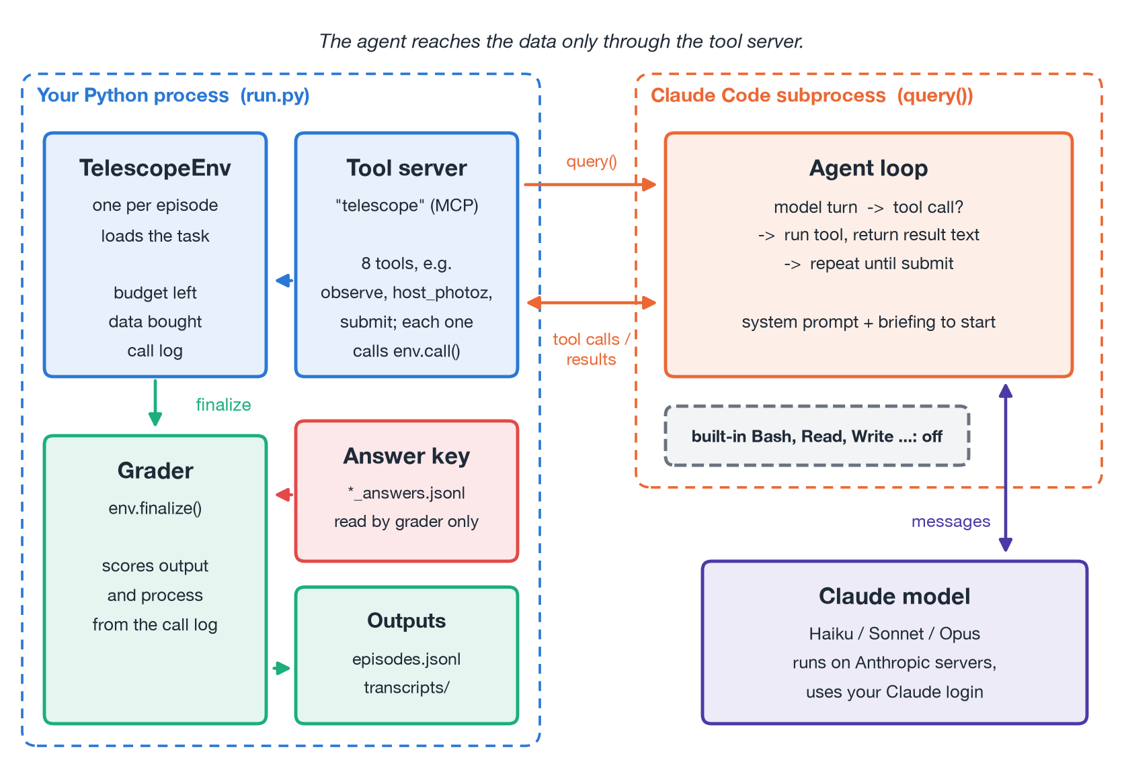
Figure 2. What runs where. Our Python process owns the environment, the tools and the grader. The Claude Code subprocess runs the agent loop and talks to the model. The agent's only way into the data is the tool server.
Step 1: turn each environment tool into an SDK tool. This is from telescope_env/claude_agent.py:
from claude_agent_sdk import tool, create_sdk_mcp_server
def make_tools(env):
tools = []
for spec in env.tool_specs(): # name, description, JSON schema
async def handler(args, _name=spec.name):
res = env.call(_name, **args) # <- the only door into the environment
return {"content": [{"type": "text", "text": res.text}], "is_error": res.error}
tools.append(tool(spec.name, spec.description, spec.schema)(handler))
return tools
server = create_sdk_mcp_server("telescope", tools=make_tools(env))

- Each handler is a closure bound to one env object. Several episodes can therefore run in parallel, each with its own environment and budget.
- The tools are served as an in-process MCP server. MCP (Model Context Protocol) is the standard way to plug tools into Claude.
- Claude sees each tool under a name like mcp__telescope__observe, together with its description and input schema. The description is all the model knows about a tool, so wording it well matters.
Step 2: start the agent in a locked room.
from claude_agent_sdk import ClaudeAgentOptions, query
briefing = env.reset(task)
opts = ClaudeAgentOptions(
system_prompt=open("prompts/default.md").read(), # the agent's standing instructions
mcp_servers={"telescope": server}, strict_mcp_config=True, # only our tool server
tools=[], # disable ALL built-in tools (Bash, Read, ...)
allowed_tools=["mcp__telescope__observe", ...], # pre-approve our tools
setting_sources=[], cwd=empty_temp_dir, # ignore local settings; nothing on disk
model="haiku", max_turns=40,
)
async for message in query(prompt=briefing, options=opts):
transcript.append(message) # everything the model says and does
record = env.finalize() # grade the episode

Each isolation option closes a loophole:
- tools=[]: without it, the agent could run shell commands and read the answer file.
- strict_mcp_config: keeps out any other tool servers configured on your machine.
- setting_sources=[]: ignores local settings and CLAUDE.md files.
- empty cwd: there is nothing on disk to discover.

5. One episode, step by step
Here is what actually happens, using real episode dev-006 from the Haiku pilot. The target is really a microlensing event, which is Galactic.
our code env.reset(task) -> briefing: "Target T-073f. Is the target a SN Ia? Budget 30 h ..."
SDK -> model system prompt + briefing + tool list
model "Let me start with the free tools." -> tool_use sky_position()
SDK -> handler env.call("sky_position") -> text back to the model (0 h)
model -> observing_log(), budget() (0 h)
model -> alert_history() "4 detection clusters ..." (-2 h, 28 left)
model -> observe(u, g, r, i over one season) four light-curve tables (-24 h, 4 left)
model -> host_photoz() "photo-z = 0: no host found" (-3 h, 1 left)
model "puzzling ... the host may be too faint"
model -> observe(r, next season) REFUSED: over budget (0 h)
model -> submit("yes", 0.68, "... photo-z failure likely reflects the bright transient ...")
env episode over -> finalize(): correct = False

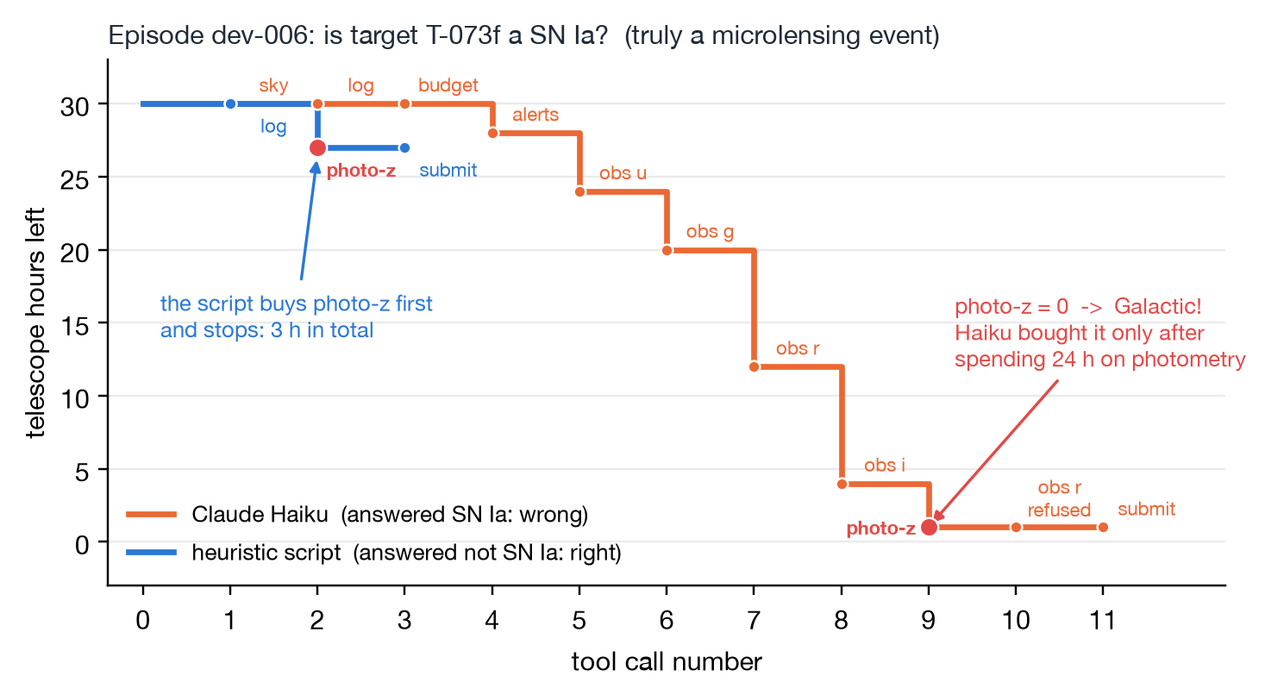
Figure 3. Episode dev-006: telescope hours left after each tool call, for Claude Haiku (orange) and the heuristic script (blue). The red points mark the photo-z purchase, the decisive clue.
Things to notice:
- Everything the model knows came back as tool text. It never saw the data file.
- The loop is the model's own sequence of decisions. Our code only answers each call.
- The costly mistake is in the process, not just the output. The decisive clue (photo-z = 0, so the object is Galactic) cost only 3 h. The agent bought it after spending 24 h on photometry, and then argued it away. A 40-line Python heuristic that buys photo-z first gets this task right for 3 h.
Three records are kept for every episode:
Record | Written by | Contains | Trust it for
Call log (episodes.jsonl → calls) | the environment | every call: tool, arguments, cost, error code, budget left | what the agent did
Transcript (transcripts/*.json) | the SDK | the model's text, its tool calls, the tool results | what the agent said and saw
Result message | the SDK | number of turns, tokens, wall time, errors | cost of running the agent

Process metrics are computed from the call log, never from the agent's own account.

6. Grading an episode
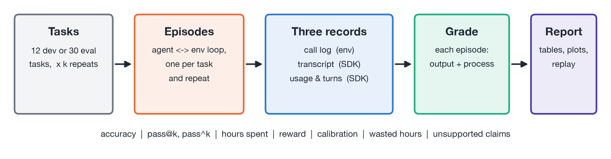
Figure 4. From tasks to report: every episode leaves three records, and each is graded on output and process.
env.finalize() turns an episode into one graded record.
Output metrics:
- correct: see the task table in section 3.
- conf_brier = (confidence − correct)²: is the stated confidence honest?
- reward = correct − 0.25 × (fraction of budget spent): a single number that trades accuracy against cost.
Process metrics, computed from the call log:
- spent, n_calls, n_budget_refusals (tried to overspend), n_invalid_calls.
- redundant_hours: epochs bought more than once.
- free_calls_before_first_paid: did it plan before spending?
- bands_observed, and observed_near_peak: for transients, did it buy a detected point within 15 days of the true peak?
- unsupported_claims: does the rationale cite evidence (a band, a redshift, alerts) that the log shows was never acquired? This is a crude text match: it can raise false alarms, and it misses wrong reasoning.
Across repeats. The model is not deterministic, so each task is run k times:
- pass@k: the fraction of tasks solved in at least one of k tries.
- pass^k: the fraction of tasks solved in all k tries.
A large gap between the two means the agent is unreliable.

7. Baselines: why we also run dumb scripts
A score only means something next to a reference. Three scripted policies use exactly the same tools as Claude (telescope_env/policies.py):
Policy | What it does | Why it is there
random | buys random windows, then guesses | the floor
heuristic | ~40 lines of astronomer rules: photo-z first, then alerts, then one r-band window | the bar an agent should clear
answer_key | reads the grader's answer file and submits | a cheater: perfect output score, zero evidence in the log

Pilot results on the dev set (12 tasks, one run each):
 | accuracy | hours spent | reward | mean confidence
random | 0.42 | 11.6 | 0.32 | 0.28
heuristic | 0.75 | 6.4 | 0.70 | 0.59
Claude Haiku | 0.75 | 25.0 | 0.54 | 0.86

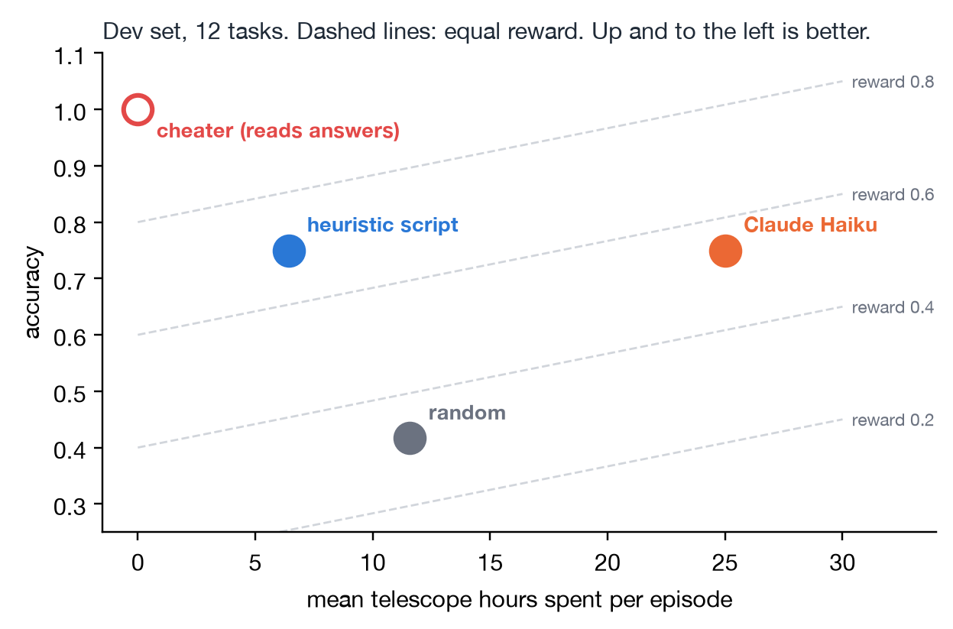
Figure 5. Pilot results on the dev set. The cheater is perfect on output alone; Claude Haiku matches the heuristic's accuracy but spends four times the telescope time.
The cheater shows why output metrics alone are not enough. Only the process log (0 hours, one call) reveals that it never looked at the data.

8. How it was built (and why in this order)
1. Environment first, as plain Python (env.py): tools, prices, rules and a call log, with no model involved. Every tool returns text, because text is what a language model reads.
2. Tasks with hidden answers (tasks.py, catalog.py): seeded sampling, balanced classes, aliases instead of object ids, and answer keys in separate files.
3. Grader (scoring.py): output metrics plus process metrics from the log.
4. Scripted policies (policies.py) and tests (tests/). These check that the rules and graders work before spending any model time. For example: the cheater must score 100%, and a call over budget must be refused and not charged.
5. The Claude adapter (claude_agent.py): only now is a model plugged in, through the same env.call door as the scripts.
6. Runner, report and replay (run.py, report.py, replay.py): run many episodes, then aggregate and inspect them.
This mirrors how real agent benchmarks are built. If the environment is not trustworthy without the model, the model's scores mean nothing.

9. Commands
Run from the practicals/observer_env/ folder, in a normal terminal, with the course environment active (or put uv run in front of each command). Runs launched from inside a Claude Code session fail to authenticate.
Keep your own files (prompts, metrics, runs, reports) in submissions/<your-slug>/observer_env/. Below, $MY stands for ../../submissions/<your-slug>/observer_env.
python -m pytest -q tests # the environment works
python -m telescope_env.run --policy heuristic --tasks tasks/dev.jsonl --runs-dir $MY/runs
python -m telescope_env.run --policy claude --model haiku --tasks tasks/dev.jsonl --k 3 \
--prompt $MY/my_prompt.md --runs-dir $MY/runs # about 12 min
python -m telescope_env.replay $MY/runs/<run-name> dev-006 # read one episode
python -m telescope_env.report $MY/runs/* --metrics $MY/my_metrics.py --out $MY/report.html

Useful switches for run:
- --budget 15: change the budget.
- --family is_snia: one task family only.
- --model sonnet: a different model.
- --limit 3: only the first 3 tasks.
- --prompt my_prompt.md: your own system prompt (start from a copy of prompts/default.md).
Every Claude episode uses your subscription quota (about 50 s and 12 model turns each), so develop with --limit and --k 1.

