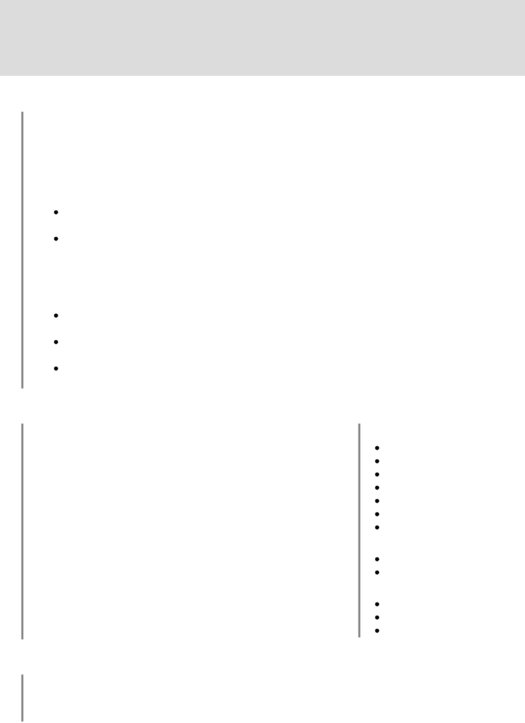

**Konstantin Meshavkin**

**Experience**

**Kaspersky Lab**

**Software Developer** Mar. 2018 – Now

Started as an internship and turned into a full time position.

Participated in two projects:

**React-based content editor – current project**

[meshavkin1996@gmail.com](mailto:meshavkin1996@gmail.com) [linkedin.com/in/kmeshavkin](https://www.linkedin.com/in/kmeshavkin/) [github.com/kmeshavkin](https://github.com/kmeshavkin) [kmeshavkin.github.io](https://kmeshavkin.github.io/)

This content editor is used for content creation which is deployed on kaspersky.com website

Supported legacy Javascript code (documentation, refactoring, testing), completed tasks on components creation, UI improvements, data handling, etc. before complete project rewrite

Participated in rewrite of content editor from ground-up on Typescript. Created various critical components like inbound and outbound data validation using JSON Schema and data migration tool

**Partner Portal**

Development and support of partners.kaspersky.com website

Supported legacy code for old Partner Portal before migration and developed e2e regression testing system for Portal using Jest and Puppeteer with email notifications

Participated in old portal migration on a new platform under time pressure – complete website for one region was built under 3 months, automated different tasks of the workflow

Created various components for portal with advanced business logic using HTML, JavaScript and CSS which are used on day-to-day basis by customers

**Projects**

**shortify**

Fullstack (Express/React) link shortener app deployed on Google Cloud. Server-side session management, MongoDB as database, Email/password or Google OAuth 2.0 authentication. Visit [Website](https://shortify-5kyuow2vuq-ew.a.run.app/) or [Github](https://github.com/kmeshavkin/shortify) for more info.

**rxmask.js**

Advanced input mask package published on npmjs. HTML embeddable. Allows to specify format for every character. Visit [Playground](https://kmeshavkin.github.io/rxmask-playground/), [Github](https://github.com/kmeshavkin/rxmask) or [npmjs](https://www.npmjs.com/package/rxmask) for more info.

**Weather Mood Radio**

Radio that picks Lo-Fi tracks from [SoundCloud](https://soundcloud.com/) according to current weather, day time and season at your geolocation. Visit [Playground](https://kmeshavkin.github.io/weather-mood-radio/) or [Github](https://github.com/kmeshavkin/weather-mood-radio) for more info.

**Skills**

**Main stack**

Typescript

Javascript (ES6+)

React, Redux

Node.js

Express

HTML5, CSS3, SASS

JSON Schema

**Testing**

Jest

Cypress, Puppeteer

**Other**

Version Control (Git) Agile/Scrum Confluence, TFS, Jira

**Education**

|  |  |
| --- | --- |
| **Master's degree in** | **Bachelor's degree in** |
| **Information Systems Security** | **Information Systems Security** |
| **MAI**, Sep. 2014 – Jun. 2018 | **MAI**, Sep. 2018 – Jun. 2020 |