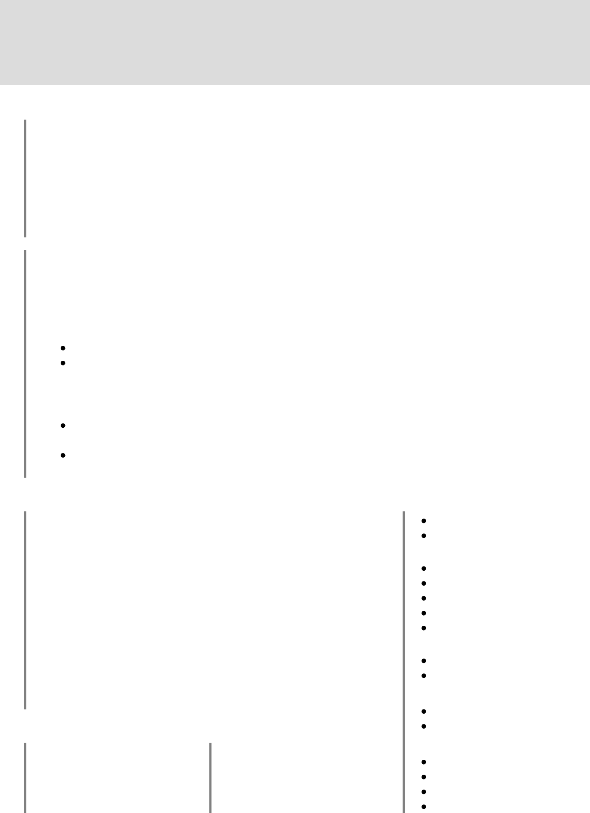

**Konstantin Meshavkin**

[meshavkin1996@gmail.com](mailto:meshavkin1996@gmail.com) [linkedin.com/in/kmeshavkin](https://www.linkedin.com/in/kmeshavkin/) [github.com/kmeshavkin](https://github.com/kmeshavkin) [portfolio.kmesh.dev](https://portfolio.kmesh.dev/)

**Experience**

**Tinkoff Bank**

**Software Developer**

Mar. 2021 – Now

Working in team creating small 2-4 months long promo projects ([project.tinkoff.ru](https://project.tinkoff.ru/)). Responsible for frontend, backend and/or deployment of several projects, as well as documentation and development of internal packages and templates.

Some of the projects include [kruzhok.project.tinkoff.ru](https://kruzhok.project.tinkoff.ru/) (backend), [loud-fans.project.tinkoff.ru](https://loud-fans.project.tinkoff.ru/) (backend), [hungrymiles.project.tinkoff.ru](https://hungrymiles.project.tinkoff.ru/) (backend, deployment), [grants.project.tinkoff.ru](https://grants.project.tinkoff.ru/) (frontend).

**Kaspersky Lab**

**Software Developer** Mar. 2018 – Mar. 2021

Started as an internship and turned into a full time position. Participated in two projects:

**React-based content editor**

This content editor is used for content creation which is deployed on [kaspersky.com](https://kaspersky.com/) website.

Documentation, refactoring, testing components creation, UI, data handling of legacy code. Participated in rewrite of project - created various critical components like inbound and outbound data validation using JSON Schema and data migration tool.

**Partner Portal**

Development and support of [partners.kaspersky.com](https://partners.kaspersky.com/) website.

Supported legacy code and took part in migration to a new platform - MVP was built under 3 months.

Created various components for portal with advanced business logic using HTML, JavaScript and CSS which are used on day-to-day basis by customers.

**Projects**

**shortify** ([Website](https://sh.kmesh.dev/), [Github](https://github.com/kmeshavkin/shortify))

Fullstack (Express/React) link shortener app deployed on Google Cloud. Server-side session management, MongoDB as database, Email/password or Google OAuth 2.0 authentication.

**rxmask.js** ([Playground](https://rxmask.kmesh.dev/), [Github](https://github.com/kmeshavkin/rxmask), [npmjs](https://www.npmjs.com/package/rxmask))

Advanced input mask package published on npmjs. HTML embeddable. Allows to specify format for every character.

**Weather Mood Radio** ([Playground](https://weather-mood-radio.kmesh.dev/), [Github](https://github.com/kmeshavkin/weather-mood-radio))

Radio that picks Lo-Fi tracks from [SoundCloud](https://soundcloud.com/) according to current weather, day time and season at your geolocation.

**Skills**

Typescript

Javascript (ES6+)

**Backend**

Node.js

NestJS, Express

PostgreSQL

Typeorm

Passport

**Frontend**

React, Redux

HTML5, CSS3, SASS

**Testing**

Jest

**Education**

**Master's degree in Information Systems Security**

**MAI**, Sep. 2014 – Jun. 2018

**Bachelor's degree in**

**Information Systems**

**Security**

**MAI**, Sep. 2018 – Jun. 2020

Cypress, Puppeteer

**Other**

Docker

Version Control (Git)

Agile (Scrum, Kanban)

Confluence, TFS, Jira