Integrating the Google API with GATE

- Introduction
The Google API is not integrated with GATE and can be used as a processing resource based plugin. This plugin allows the user to query Google and build the document corpus that contains the search results returned by Google for the query. There is a limit of 1000 queries per day as set by Google. For more information about the Google API please refer http://www.google.com/apis/ In order to use the Google Processing Resource you need to register with Google to obtain a license key.

This document provides an overview for the Google Processing Resource plugin used by GATE.

Such a processing resource could be used for a number of different application scenarios. For example, one use case is where a user wants to find out what are the different named entities that can be associated with a particular individual. In this example the user could build the collection of documents by querying Google and the running ANNIE in default mode. This would annotate the results and show what are the different Organizational, Location and other entities that can be associated with the query.

- Using the Google PR

In order to use the processing resource you first need to load the plugin using the plugin manager.

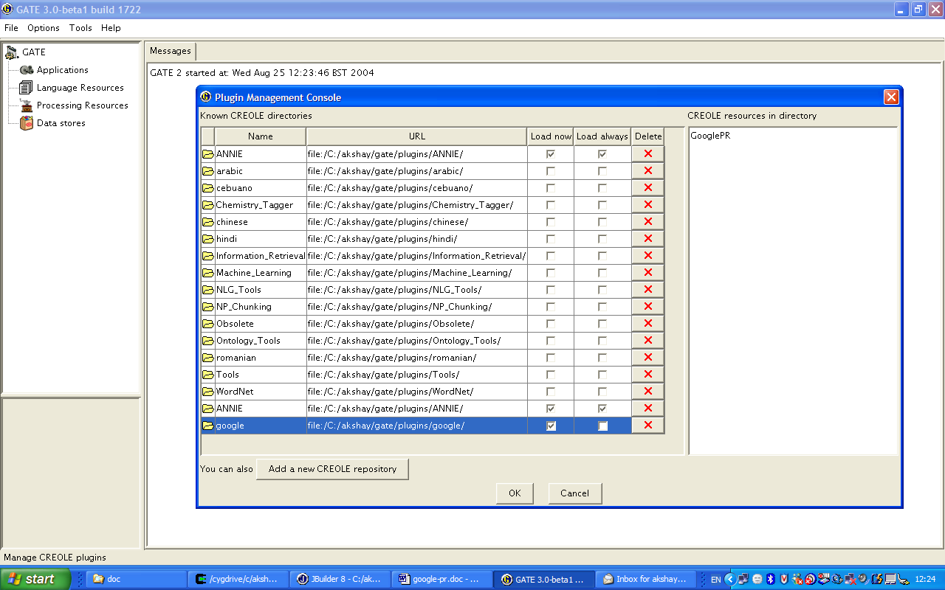
Figure 1: Load the Google PR from the plugin manager.

Once the PR is loaded, it can be initialized by creating an instance of a new PR. Here you need to specify the Google API License key. Please use the license key assigned to you by registering with Google.
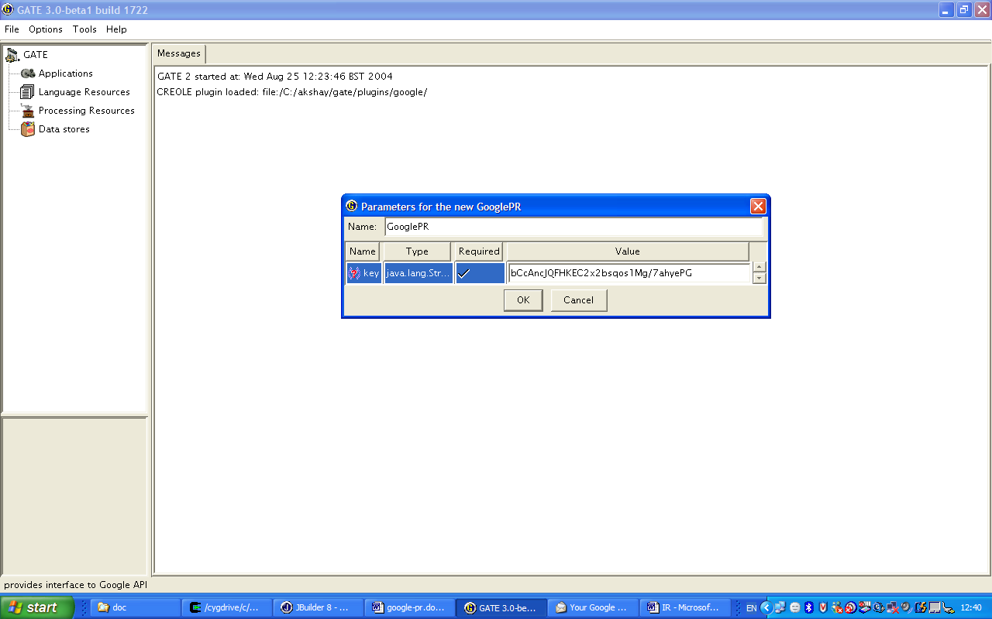
Figure 2: Create a Google PR and provide the runtime parameter, License key.

Once the Google PR is initialized, it will create a corpus that would be used for storing the query results obtained from Google. Now to use the PR, a new pipeline is to be created. This pipeline would contain the instance of Google PR just initialized as above. The following figure shows an example pipeline. The query and the limit for the number of results to be downloaded is set in this pipeline.

Once the required parameters are set we can run the pipeline. This would then download all the URLs in the results and create a document for each. These documents would be added to the corpus named google as shown in Figure 4.

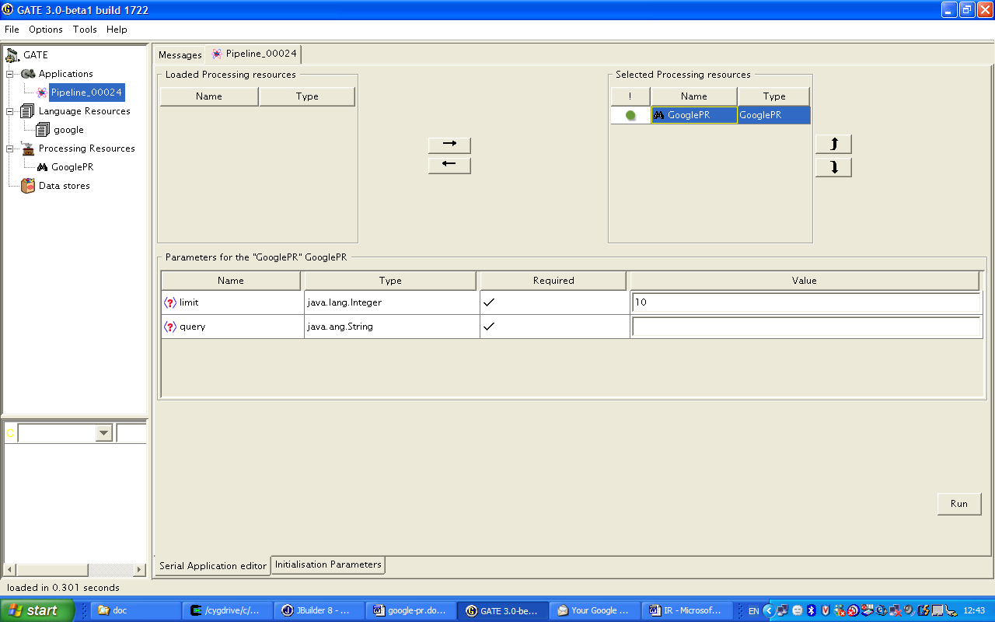
Figure 3: The pipeline created with Google PR. Set limit and the query as parameters.

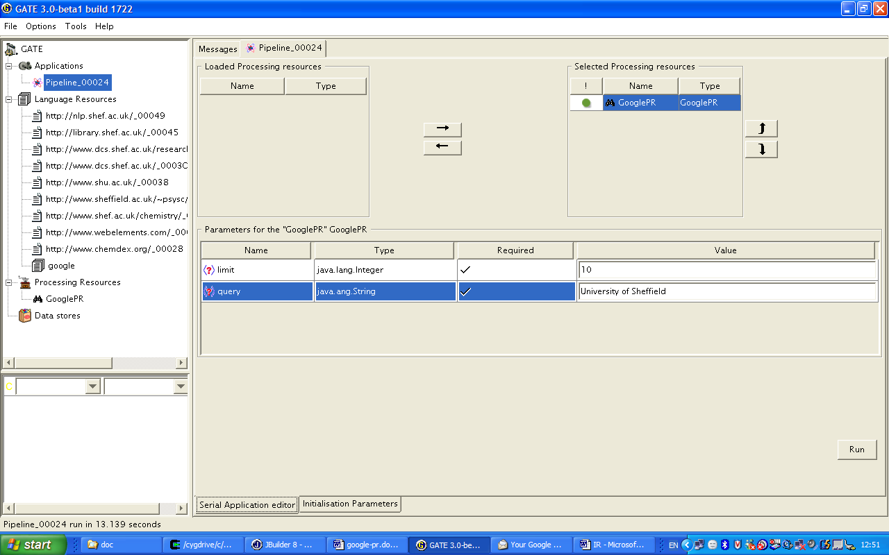
Figure 4: The URLs from the result set are downloaded and added to the corpus.

