History of the Market Regime Model - Part 5 (2020-2022)

2020-2022: Stimulus, Speculation, and the Inflation Shock
Jan 13, 2026
This article is part of a multi-part series where I walk through how the Market Regime model would have navigated different historical market environments. To keep things simple and transparent, I’m using TQQQ during Bullish regimes and GLD during Bearish regimes as proxies for how the system behaved in real time. Of course, past performance never guarantees future results—but understanding how a model responds across different conditions is exactly why I trade it live today. Seeing how it handled both calm and chaotic markets helps illustrate the consistency and robustness that make this approach so powerful.
In case you missed it, here’s links to the entire series:
Part 1
Part 2
Part 3
Part 4
Part 5
Part 6

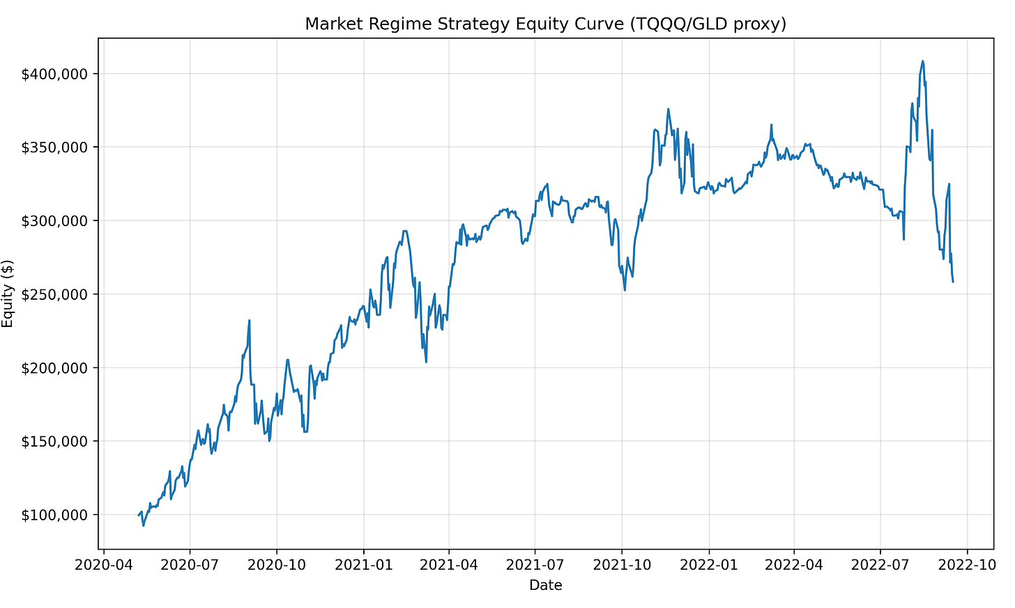

Part 5 covers one of the most extreme boom-and-bust cycles in modern market history.
Following the COVID crash, markets entered a historic, stimulus-fueled rally driven by zero interest rates, massive fiscal spending, and unprecedented liquidity. Risk was rewarded aggressively — until inflation surged, policy shifted, and conditions deteriorated rapidly.
From May 8, 2020 through September 16, 2022, the Market Regime model completed 9 trades, turning $100,000 into $259,871, a +159.87% total return, equivalent to a ~50% compounded annual growth rate.
This period highlights both the strength and the limitations of a systematic approach: explosive gains during sustained trends, followed by whipsaws and drawdowns as regimes transitioned.

PHASE 1 — 2020 to Early 2021: The Stimulus-Fueled Recovery

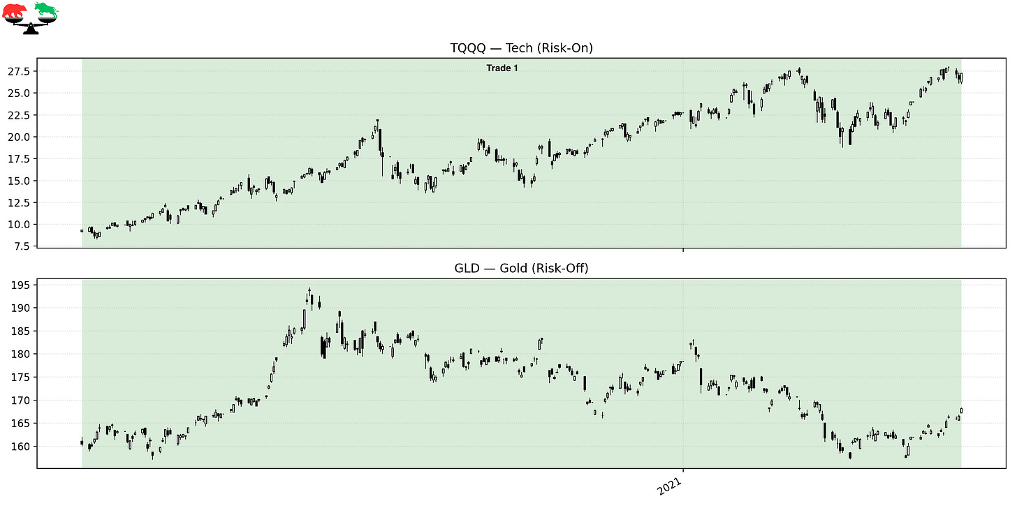

Trade 1 – Riding the Post-COVID Melt-Up
Instrument: TQQQ
Start: 2020-05-08
End: 2021-04-21
Length: 348 days
Return: +191.67%
The regime flipped bullish after the COVID crash once leadership and liquidity decisively improved. Massive fiscal stimulus, zero-rate policy, and emergency lending programs fueled one of the strongest rallies ever. The model stayed fully invested throughout this phase, capturing nearly a 3x move as markets recovered and surged into early 2021.

PHASE 2 — 2021: Early Cracks Beneath the Surface

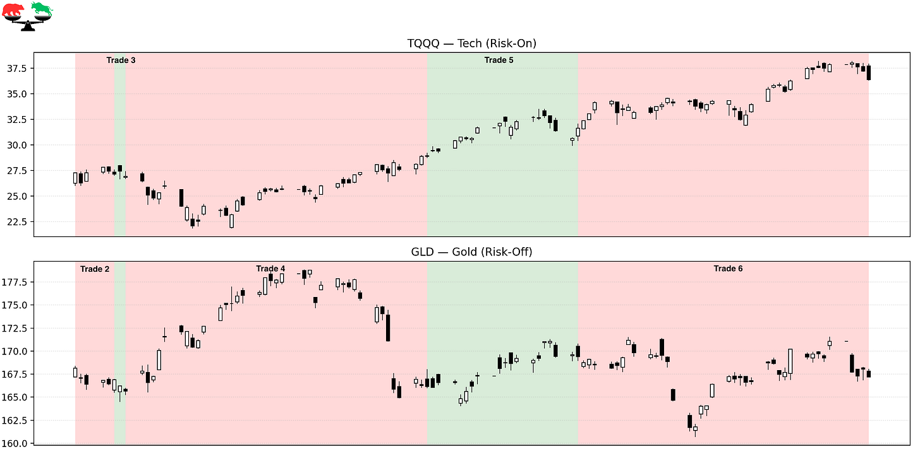

Trade 2 – Defensive Pause During Early 2021 Volatility
Instrument: GLD
Start: 2021-04-21
End: 2021-04-28
Length: 7 days
Return: -0.73%
As markets digested rapid gains and began reacting to inflation chatter, leadership weakened briefly. The model rotated defensively, reflecting early uncertainty. While the move was small, it highlighted growing fragility beneath the surface.

Trade 3 – A Brief Bullish Whipsaw
Instrument: TQQQ
Start: 2021-04-28
End: 2021-04-30
Length: 2 days
Return: -0.89%
A short-lived bullish signal emerged but quickly failed. These types of small losses are common during transitional phases, where markets struggle to establish sustained direction.

Trade 4 – Defensive Consolidation
Instrument: GLD
Start: 2021-04-30
End: 2021-06-23
Length: 54 days
Return: +0.29%
Markets moved sideways as inflation concerns continued to build. The regime remained defensive during this choppy consolidation, prioritizing capital preservation over forced exposure.

Trade 5 – Another Bullish Push
Instrument: TQQQ
Start: 2021-06-23
End: 2021-07-20
Length: 27 days
Return: +9.34%
Risk appetite briefly returned as markets pushed to new highs. The model participated in this rally, capturing a solid upside move before conditions weakened again.

Trade 6 – Defensive Rotation as Inflation Persists
Instrument: GLD
Start: 2021-07-20
End: 2021-09-10
Length: 52 days
Return: -1.30%
Inflation data remained elevated, and market leadership became increasingly uneven. The model rotated defensively as volatility rose and confidence wavered.

PHASE 3 — Late 2021 to 2022: Inflation and Policy Shock

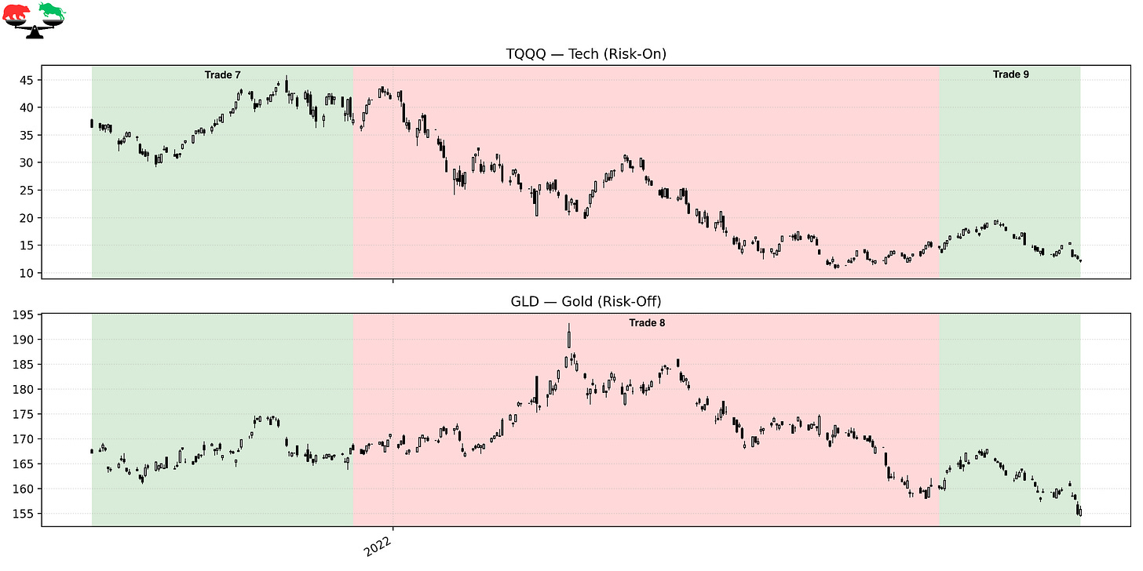

Trade 7 – Final Bullish Stretch Before the Breakdown
Instrument: TQQQ
Start: 2021-09-10
End: 2021-12-17
Length: 98 days
Return: +3.61%
Markets attempted to push higher late in 2021 despite growing inflation pressures. While gains were modest, leadership remained intact enough to justify bullish exposure — though the environment was becoming increasingly fragile.

Trade 8 – Defensive Through the Inflation Shock
Instrument: GLD
Start: 2021-12-17
End: 2022-07-25
Length: 220 days
Return: -4.51%
As inflation surged and the Federal Reserve shifted aggressively toward tightening, risk assets sold off sharply. Growth stocks collapsed, correlations spiked, and volatility rose. The model stayed defensive during much of the damage, though this period underscores that defensive assets are not immune during structural regime shifts.

Trade 9 – Failed Bullish Re-Engagement
Instrument: TQQQ
Start: 2022-07-25
End: 2022-09-16
Length: 53 days
Return: -15.43%
Markets attempted a mid-2022 rally as investors speculated about a policy pivot. That optimism proved premature. Leadership quickly deteriorated again, and the regime flipped bearish on September 16, 2022.

FINAL THOUGHTS
Here’s a recap of the trades taken during this period:

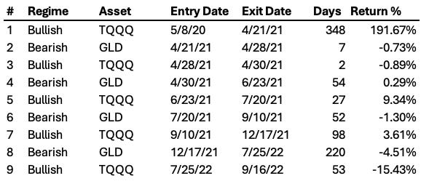

The 2020–2022 period perfectly illustrates the lifecycle of a market regime.
Early aggression was massively rewarded. Later complacency was punished. The Market Regime model experienced whipsaws and drawdowns as inflation reshaped the macro environment — and that had a real affect.
Across this stretch, the model delivered a +159.87% total return, and a ~50% compounded annual growth rate. While the latter half of the period was challenging, the framework succeeded by capturing the historic upside early and adapting as conditions deteriorated — without predictions or emotional decision-making.
This is what systematic discipline looks like through excess and reversal.

Coming Next: 2022-Present — Disinflation, AI, and a New Market Regime
Part 6 begins after the inflation bear market, as leadership quietly shifts again. We’ll examine the late-2022 transition, disinflation dynamics, the AI-driven rally, and how the Market Regime model has behaved in the most recent environment — including what it’s doing right now.

These historical reports show how the model handled the past.
Paid subscribers get to see how it handles the present.
If you want the same clarity in your trading today that this model brought to 2020-2022, join the paid community and follow along in real time.

