This Is What a Real Drawdown Looks Like
Mar 20, 2026

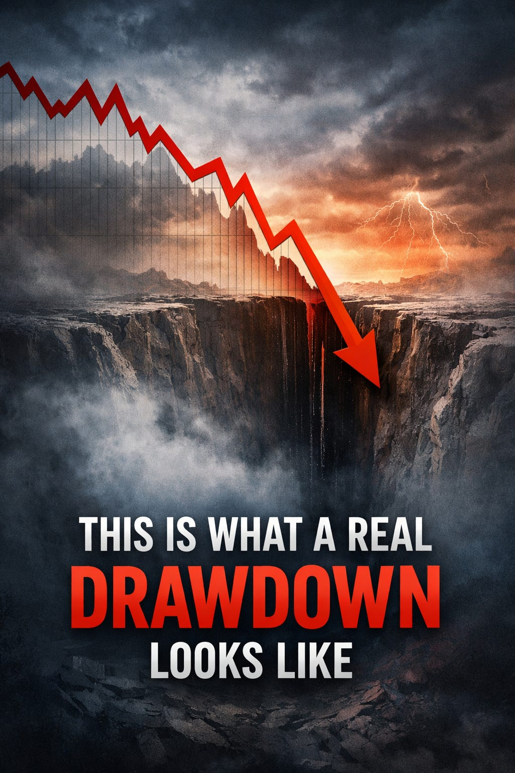

Gold is in a drawdown.
Not a small one. Not a routine one.
A real one.
If you’re following the model right now, this is the part that tests you. Not the signals. Not the logic. The experience of sitting in it.
So instead of avoiding that reality, let’s put it into context.

What We’re Actually Experiencing
The current regime is Bearish, which means the system is positioned in GLD.
As of today:
- The trade is down ~3% from entry
- But more importantly, it is down ~14% from its intra-trade peak
That second number is the one that matters.
Because that’s what you feel.
The frustration doesn’t come from being down a few percent.
It comes from watching a trade work… and then give a large portion of it back.
That’s what this is.

Entry vs. Drawdown (Why This Feels Worse Than It Looks)
There are two ways to look at any trade:
- Return from entry
- Drawdown from the best point reached
Most people focus on the first.
But psychologically, the second is what matters.
You don’t experience your P&L from the entry price.
You experience it from the high watermark.
And right now, that high watermark is well above where we are.
That’s why this feels like a large loss — even though the trade itself is only modestly negative.

How This Compares to History
Since TQQQ began trading in 2010, there have been dozens of bearish regime trades where the system held gold.
When you isolate just those trades:
- The typical drawdown is around 4–5%
- Even the worse-than-average ones tend to stay under 8%
This one is sitting at roughly 14%.
That puts it in a very different category.
In fact:
This is the second worst bearish-trade drawdown in the full history of the model.
That matters.
Because it tells us something important:
This is not a normal pullback.
It is a tail event within the system.

The Only Worse Example
There is only one bearish trade that experienced a deeper drawdown.
- March 2011
- Max drawdown: ~15%
- Final result: +17%
That trade looked worse than this one at its low.
It felt worse.
And it still finished as a strong winner.

What That Means (And What It Doesn’t)
This is where it’s easy to jump to the wrong conclusion.
You could say:
- “This is one of the worst drawdowns ever”
- “Something must be broken”
But history doesn’t support that.
Instead, it shows something more uncomfortable:
Deep drawdowns can occur inside trades that ultimately work.
Not always.
But often enough that you can’t treat drawdown alone as a failure signal.

The Pattern Beneath the Surface
When you look at the worst bearish trades:
- Several experienced double-digit drawdowns
- Many of them still recovered and finished positive
- The path was messy, even when the outcome wasn’t
That’s the key distinction.
Outcome and path are not the same thing.
A trade can be “right” in the long run and still look very wrong in the middle.

What This Actually Tests
This isn’t a test of prediction.
It’s a test of process.
Because in moments like this, you don’t have new information.
You have the same system, the same rules, and worse-looking numbers.
And the temptation is always the same:
- override the system
- reduce exposure
- second guess the signal
Not because the rules changed.
Because the experience did.

System Stress vs. System Failure
Every systematic approach goes through periods like this.
The important distinction is:
- System stress → uncomfortable, statistically expected, historically observed
- System failure → structural breakdown, edge disappears, behavior changes permanently
Right now, this fits firmly in the first category.
It is extreme.
But it is not unprecedented.
And more importantly, it has precedent that resolved positively.

The Point of the System
The goal of a regime system is not to eliminate drawdowns.
It’s to make sure:
- you know when to be in
- you know what to hold
- and you don’t have to make decisions in the middle of uncertainty
Because the hardest trades are not the ones that go straight against you.
They’re the ones that work… then don’t… then maybe will again.

Final Thought
This is what a real drawdown looks like.
Not theoretical. Not backtested. Real.
It’s uncomfortable. It’s statistically rare. It tests conviction.
But it’s also part of the distribution.
And if you’re going to follow a system, you don’t get to choose only the easy parts of that distribution.
You get all of it.

