I had some issues with the "sound" command when fs < 1kHz so I scaled fh so I could use fs=1000.

When fs >= 2\*fh, there are no issues with aliasing and the apparent frequency equals the actual frequency. This is shown in the first image where you can see the frequency of the sine wave increasing linearly with time. When fs < 2\*fh, aliasing occurs which causes the apparent frequency to "fold over". When aliasing occurs, frequencies above fs/2 "fold over" and the apparent frequency starts decreasing as the actual frequency increases. This can be seen in the second image where the frequency of the sine wave increases linearly until the actual frequency reaches fs/2, then the frequency of the sine wave starts to decrease until the actual frequency reaches fs. This sawtooth pattern will continually repeat as the actual frequency continues to increase.

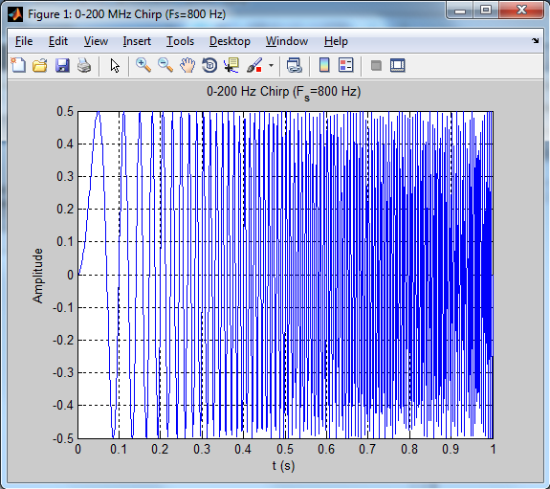

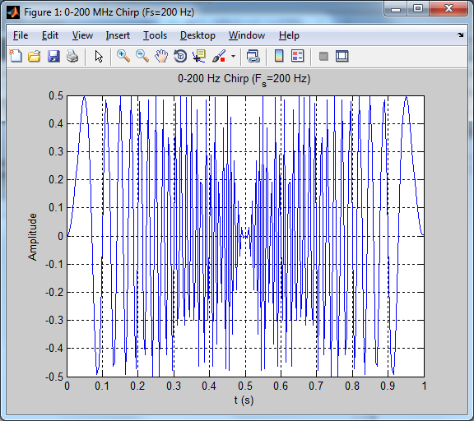

147 words