ONLINE BANKING SYSTEM

Technical Design Document

PRESENTED BY: TEAM 2

**PROJECT PURPOSE:**

The purpose of this project is to improve the interaction between bank and customer by providing an online banking application. This application allows the customer and the banker to perform their respective operations with ease. This project provides an advanced, user friendly interface for both bank users and bank customers to perform their operations efficiently.

**OBJECTIVES:**

* To create an advanced, user friendly online banking system which enables the bank users to register, modify, delete, add and close bank customer accounts on request
* It also allows the bank customer to transfer funds and to generate bank statements with respect to date or the last 10 transaction statements or account balance.

**TECHNOLOGIES USED:**

1. HTML, CSS, JavaScript, Bootstrap, JQuery, Ajax
2. Java Servlets, JSP, JavaBeans, JDBC
3. Oracle database

**OVERVIEW:**

Online banking system has two functionalities:

* **Banker Functionalities:**
* This module includes creation of customer profile for eligible customers, modification of an existing customers profile, deletion of customer profile, adding or closing of multiple accounts of an existing customer.
* After every operation, the database will be updated with the respective customer profile information.
* **Customer Functionalities:**
* Customer is assigned a login and a password to access his online banking portal, where the customer is provided with the option to either transfer funds to one of his own accounts or to any other customer within the same bank.
* The customer is also given an option to view his transaction statements in different formats like account balance, detailed transaction review within the date range / last 10 transactions for all his accounts.

**WORK FLOW:**

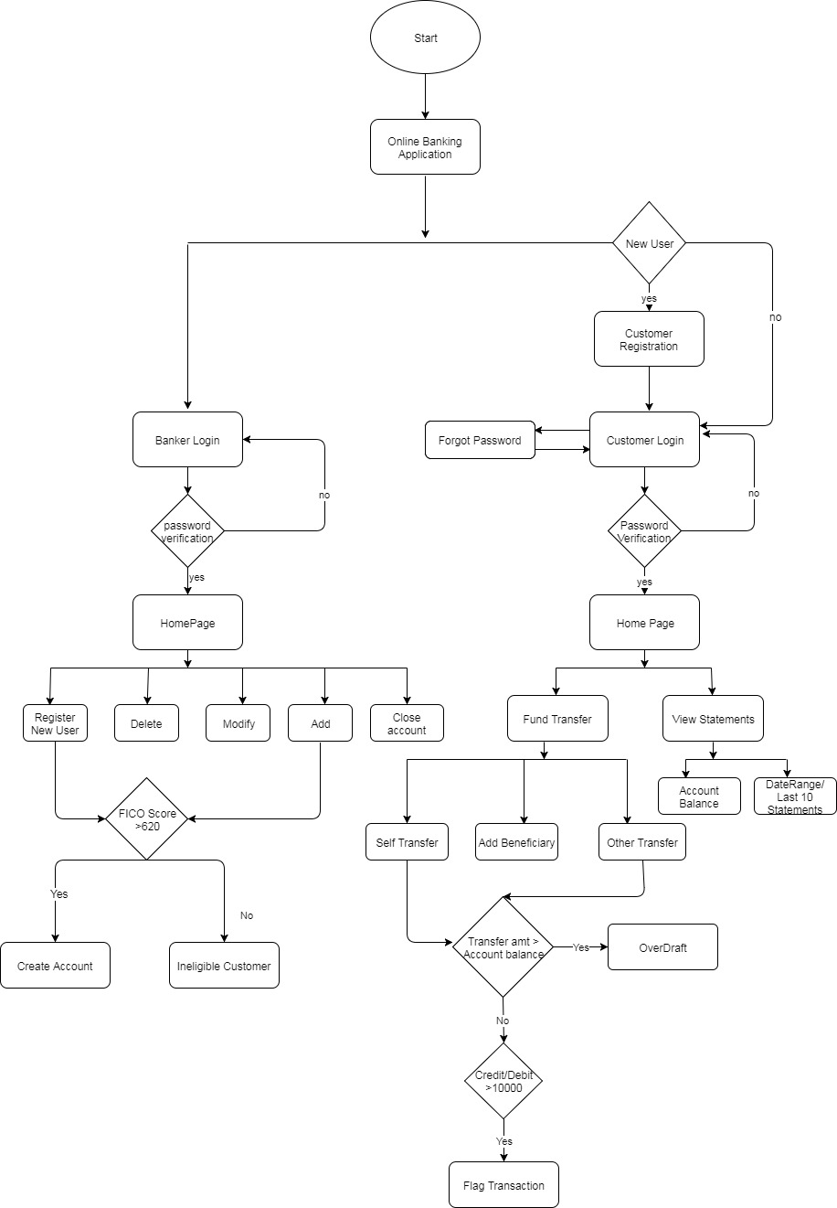

**DESCRIPTION:**

**Customer first time Registration:**

The Customer registers himself by providing required information, which includes the process of resetting the user profile password and setting the Transaction password.

**Banker Login:**

The banker enters his/her user ID and password which is verified to confirm the authenticity of the banker.

**Customer Login:**

Customer enters his/her user ID and password which is verified to confirm the authenticity of the user. If a customer forgets his password then a forget password option is available, which on selection will send a link to the registered email id to reset the password.

**Banker Home Page:**

This page displays the following options to the banker:

1. Register a new user
2. Delete
3. Modify
4. Add
5. Close

The registration page accepts customer details and inserts these details in the Database after verifying if the customer is an eligible customer.

**Identification of an eligible customer:**

* In order to determine if a customer is an eligible customer the FICO score of the customer is retrieved from the FICO database and is checked against the minimum FICO score i.e., 620.
* If the FICO score of the customer is greater than the minimum value (620) then the account is created, else the account is not created.
* For the customers who are creating an account for the first time the FICO score is set to 850 and account is created.

The deletion page displays the profile of the requested user and asks for conformation if the profile is to be deleted. After confirmation the profile is marked inactive in the database.

**Note:**

* The deletion process is possible only if all accounts under a customer are closed.

The modify option gives the banker access to modify some fields in the customer profile (ex: Customer contact no. , customer address…)

The Add option allows the banker to add a new account for an existing customer, provided his FICO score is greater than the minimum value.

**Note:**

* Each customer is allowed to have not more than 5 savings and 5 checkings accounts.

The close account option marks the specified account as inactive in the database only when the account balance is zero.

**Customer home page:**

This page gives options to do the following:

1. **Fund Transfer:** This page provides options to transfer funds to self or another customer of the same bank. To send funds to another Customer of the same bank the beneficiary is to be added initially to complete the transfer.

**Note:**

* The minimum balance in a customer’s account must be greater than $5000, else an alert is displayed.
* In case of any transactions above $10000 a flag is raised and these transactions are stored in a table to report when required.
* **Overdraft:** If the amount to be transferred exceeds the account balance then an overdraft charge of $35 is levied and transaction is completed.
* Overdraft facility is provided only when the account balance is greater than zero.

1. **View Statements:** Here the Customer can view the various transactions performed with respect to date or the last 10 transactions or can also view account balance of all his accounts.

**GUIDELINES:**

1. Phone number should have 10 digits only.
2. Email should be in the format xyz@pqr.com.
3. Password should be alphanumeric and should also contain a special character.
4. Password should contain at least 8 characters.
5. Date of Birth should be in MM/DD/CCYY.
6. SSN should be valid.
7. Account number can have 13 digits.
8. Customer ID should have 8 digits.
9. For a customer to be eligible to create an account FICO score of the customer must be >620.
10. For the customers who are creating an account for the first time the FICO score is set to 850.

**Tables in the Database:**

1. Customer
2. Customer Info
3. Account
4. Transactions
5. Banker
6. Beneficiary
7. FICO
8. Flag
9. Security

**Table attributes:**

1. **Customer**

* Customer Id – number(8) (Primary)
* Password – varchar(30)
* Transaction Password – varchar(15)

1. **Customer Info**

* SSN – number(10) (Primary)
* Customer Id- number(8) (Foreign)
* First Name – varchar(15)
* Middle Name – varchar(15)
* Last Name – varchar(15)
* Gender – varchar(7)
* Email – varchar(30)
* Phone Number – number(12)
* Address – varchar(60)
* DOB - Date
* Identification type – varchar(20)
* Identification ID – number(15)
* Issued Date – Date
* Expiry Date – Date
* Profile Status – number(1)
* Country – varchar(20)

1. **Account**

* Account Number – number(13) (Primary)
* Customer ID – number(8) (Foreign)
* Account Type – varchar(15)
* Opening Date - Date
* Account Status – number(1)
* Amount – number(15)

1. **Transactions**

* ID – number(15) (Primary)
* From – number (13) (Foreign)
* To Account – number(13) (Foreign)
* Type – varchar(10)
* Flag – number(1)
* Transaction Date - Date
* Amount – number(10)
* FromCustomer ID – number(8) (Foreign)
* ToCustomer ID – number(8) (Foreign)

1. **Banker**

* ID – number(15) (Primary)
* Name – varchar(20)
* Username – number(8)
* Password – varchar(30)

1. **Beneficiary**

* ID – number(5) (Primary)
* Benificiary Name – varchar(15)
* From Account – number(13) (Foreign)
* To Account – number(13) (Foreign)

1. **FICO**

* SSN – number(10) (Primary)
* Score – number(4)

1. **FLAG**

* ID – number(5)
* From Account – number (13)
* To Account – number(13)
* Type – varchar(10)
* Transaction Date - Date
* Amount – number(10)
* FromCustomer ID – number(8)
* ToCustomer ID – number(8)

1. **SECURITY**

* Customer ID – number(8) (Primary)
* First Phone no – number(10)
* Best Birthday Gift – varchar(30)
* User Custom Question – varchar(30)
* User Custom Answer – varchar(30)

**DATABASE SCHEMA:**

