Kevin Gong

kg2445

HW06

Stat W4240

Section 2

**Homework 6**

**Problem #1**

Part a)

The log-transformed salaries with NAs removed is below:

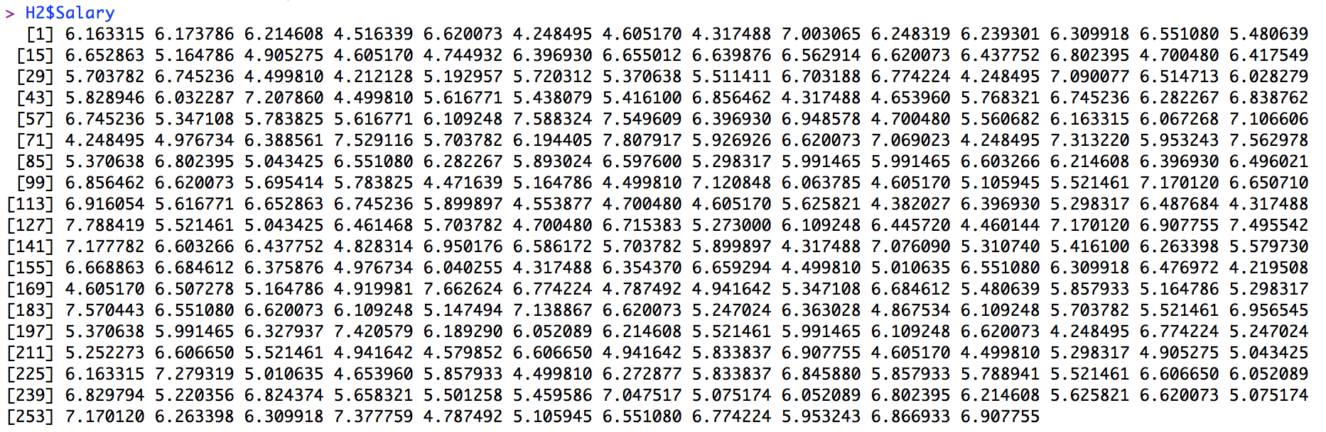

Part b)

We create a training set with 200 observations and a testing set with 63 observations.

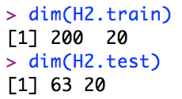

Part c)

Our plot with different shrinkage values and training MSE is below.

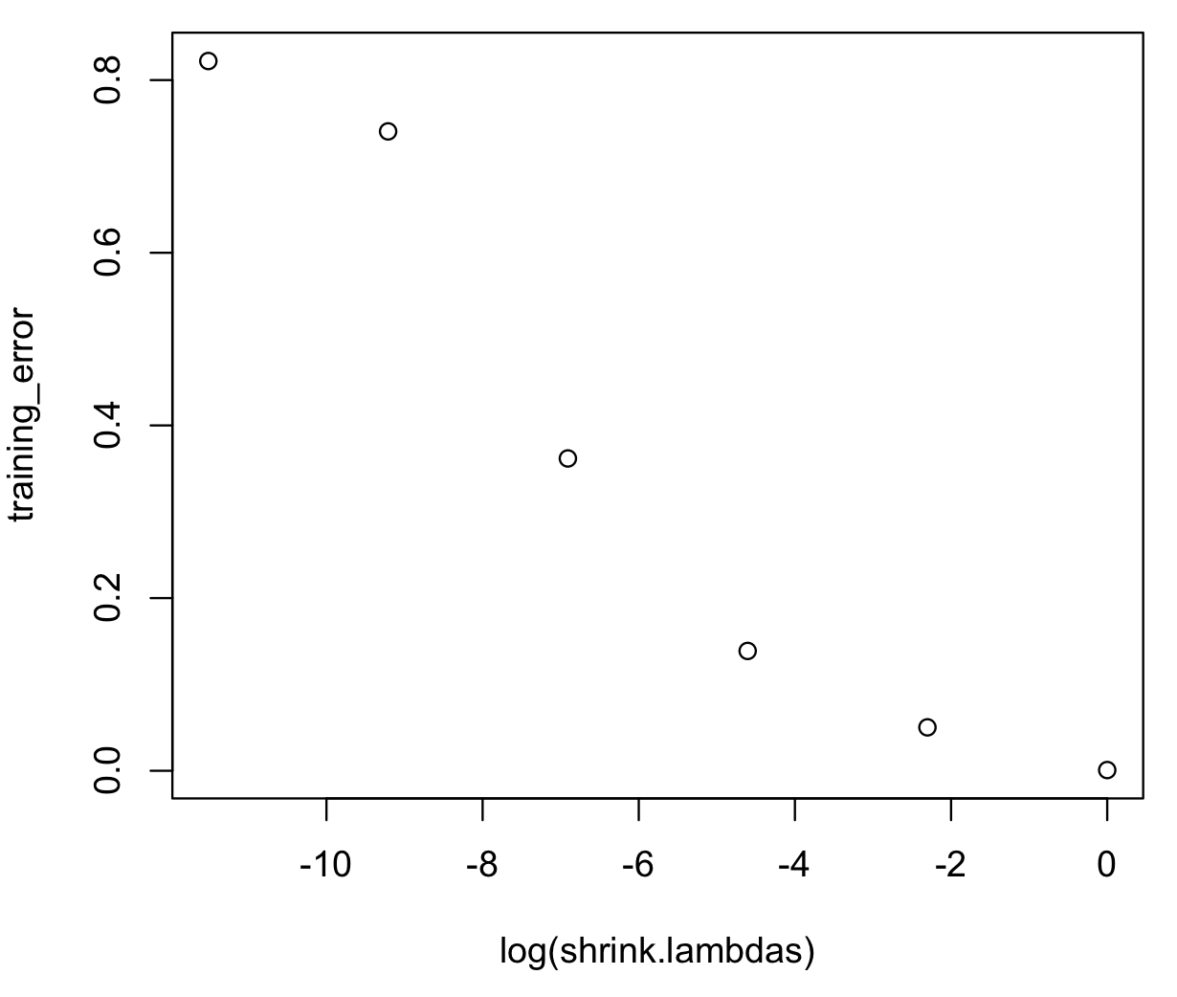

We can see that setting lambda equal to 1 (or log(lambda equal to zero) results in the lowest training MSE of approximately 0.

Part d)

Our plot with different shrinkage values and testing MSE is below.

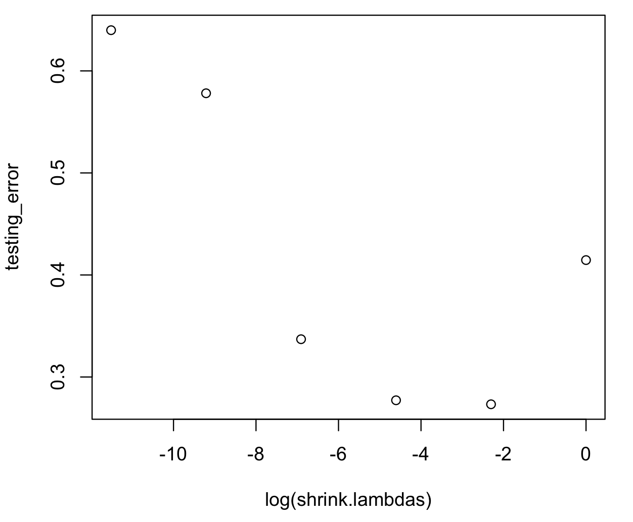

We can see that setting lambda equal to 0.1 results in the lowest testing MSE, while a lambda of 0.01 is not far behind.

Part e)

When comparing the test MSE results of the three techniques, we see that boosting is easily superior to lasso and best subset lm since it has a far lower test MSE than the other two techniques.

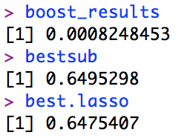

Part f)

The variables that appear to be the most important predictors in the boosted model are CHits and PutOuts, followed by Walks and HmRun.

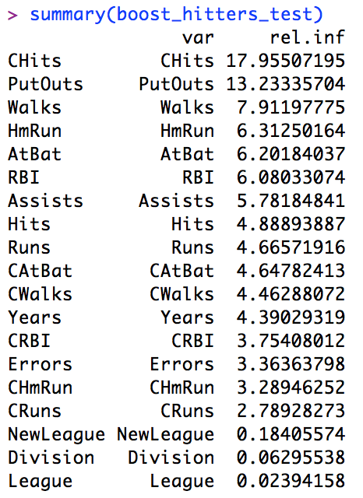

Part g)

The test MSE from the bagging approach is about 0.23. This is far higher than the lowest test MSE for boosting that we found in part e.

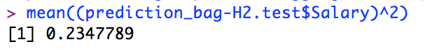

**Problem #2**

Part a)

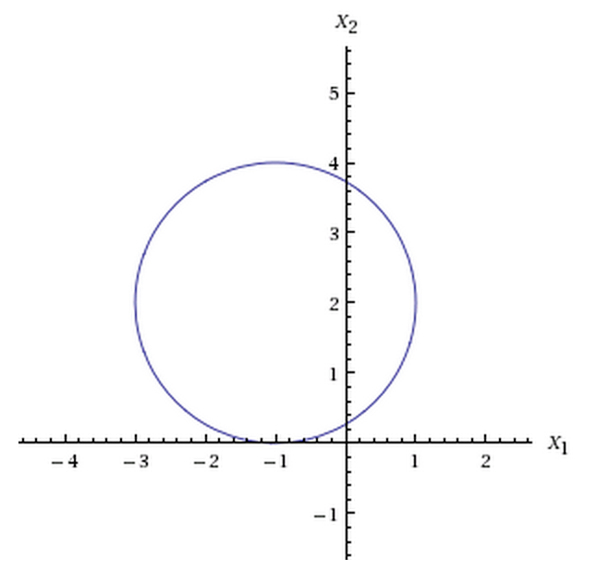

Part b)

(1 + X_1)^2 + (2 − X_2)^2 > 4 looks like this:

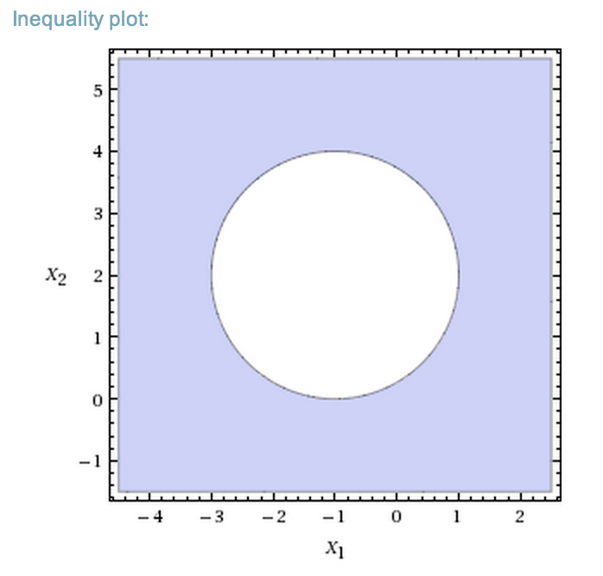

Meanwhile, (1 + X_1)^2 + (2 − X_2)^2 <= 4 looks like this:

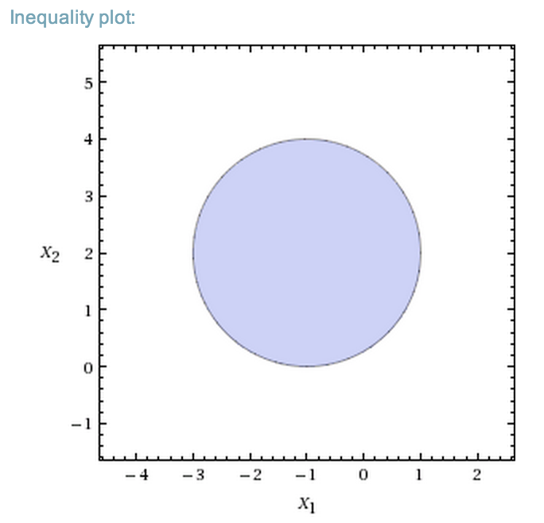

Part c)

From simply inserting the (X1,X2) coordinates into the inequality, we find that (0,0) is classified as blue, (-1,1) is classified as red, (2,2) is classified as blue, and (3,8) is classified as blue. This can also be seen in the graph where the points are either inside (red) or outside (blue) the circle.

Part d)

The decision boundary in part c is linear in terms of X1, X1^2, X2, and X2^2 since the inequality which defines the boundary forms a circle. Thus, the decision boundary must be linear in terms of these variables since they form the continuous edge of the circle.

**Problem #3**

Part a)

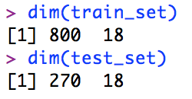

We create a training set of 800 observations and a testing set of 270 observations.

Part b)

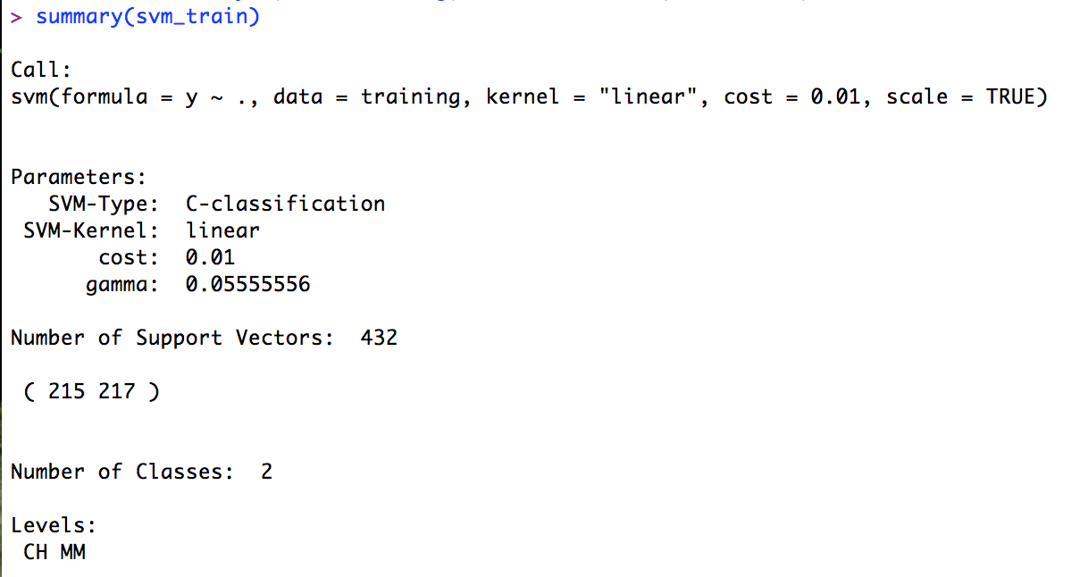

The support vector machine generated 432 support vectors and 2 classes: CH and MM.

Part c)

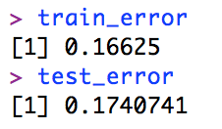

The training error is about 0.166, while the testing error is about 0.174.

Part d)

Part e)

Part f)

Using a support vector machine with a radial kernel, we find that the support vector machine generated 617 support vectors. Meanwhile, the training error for this svm was about 0.38, while the testing error was about 0.41.

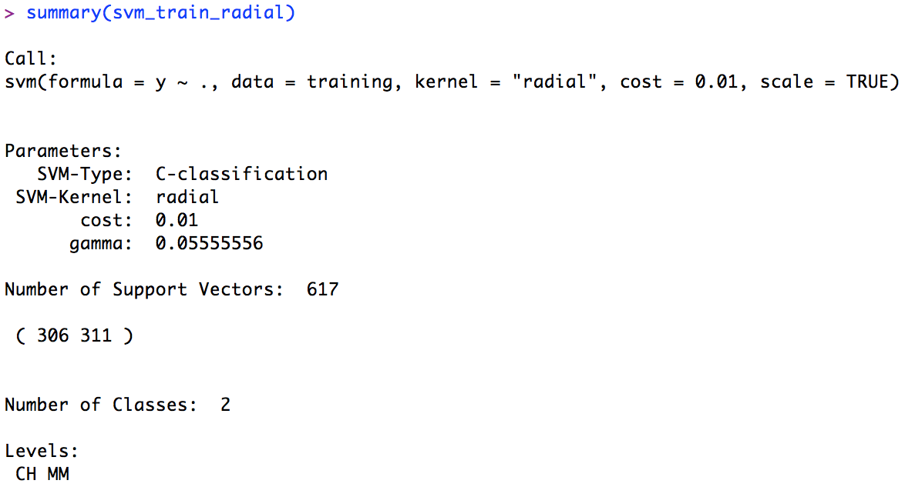

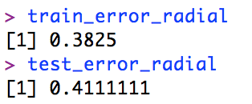

Part g)

Using a support vector machine with a polynomial kernel and degree of 2, we find that the support vector machine generated 620 support vectors. Meanwhile, the training error for this svm was about 0.38, while the testing error was about 0.41.

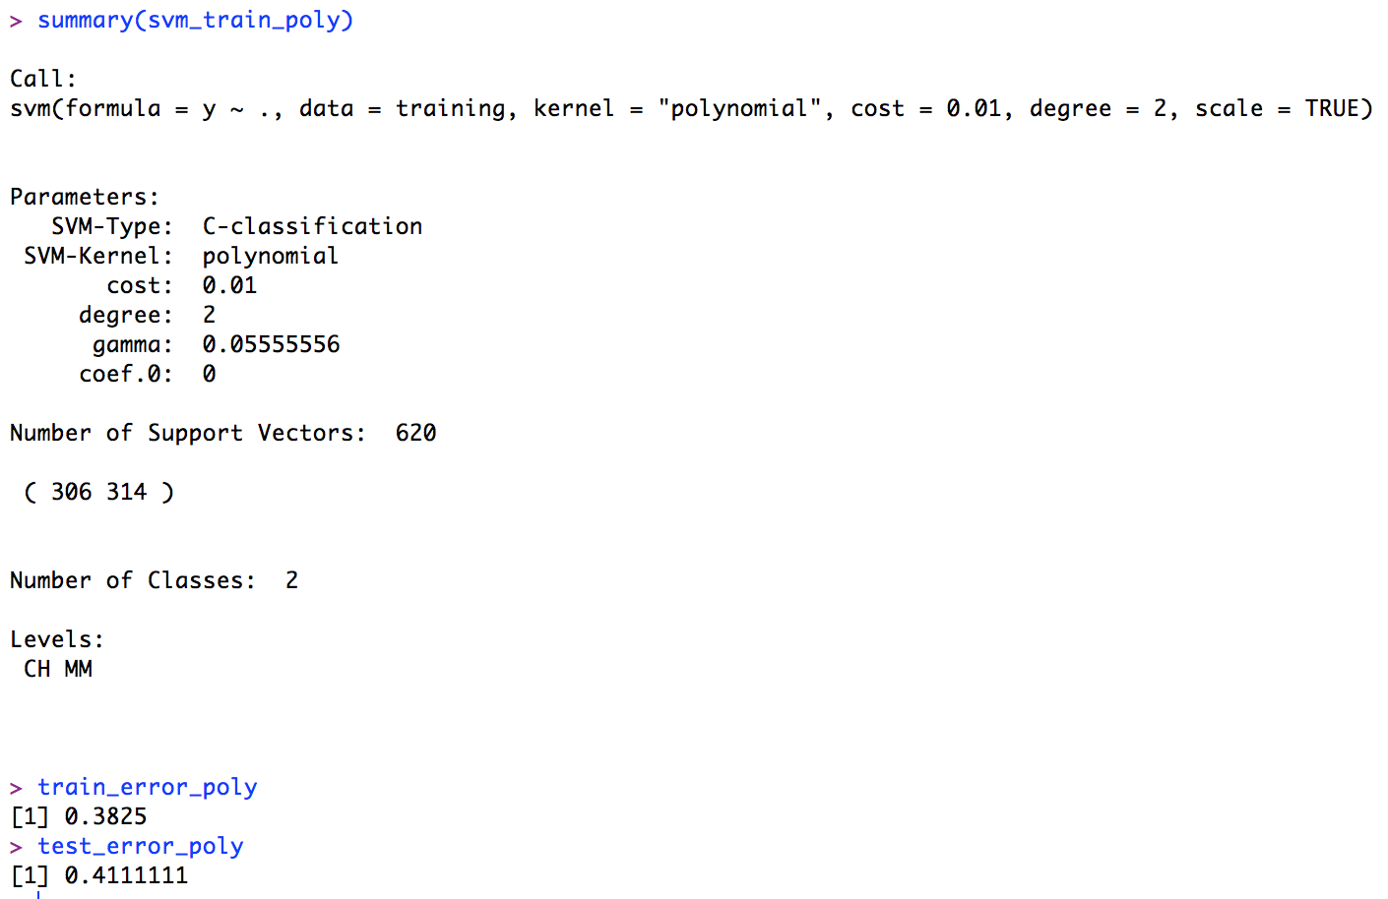

Part h)

Overall, the best approach, or the one with the lowest testing error, seems to be the original svm with a linear kernel.

**Problem #4**

Part a)

Overall, 21 of 27 documents were classified correctly, or about 78%. This result is very good compared to what we obtained from previous problem sets with naïve bayes, but it still lacks the accuracy of some of the lasso techniques we used (which generated around a 91% correct classification rate).

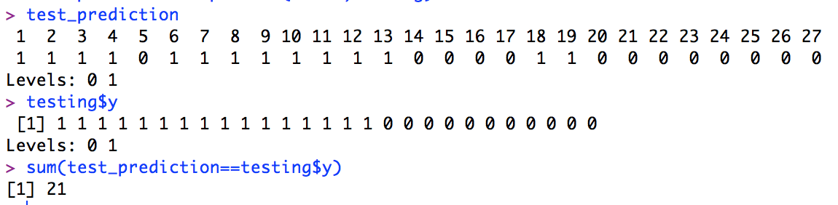

Part b)

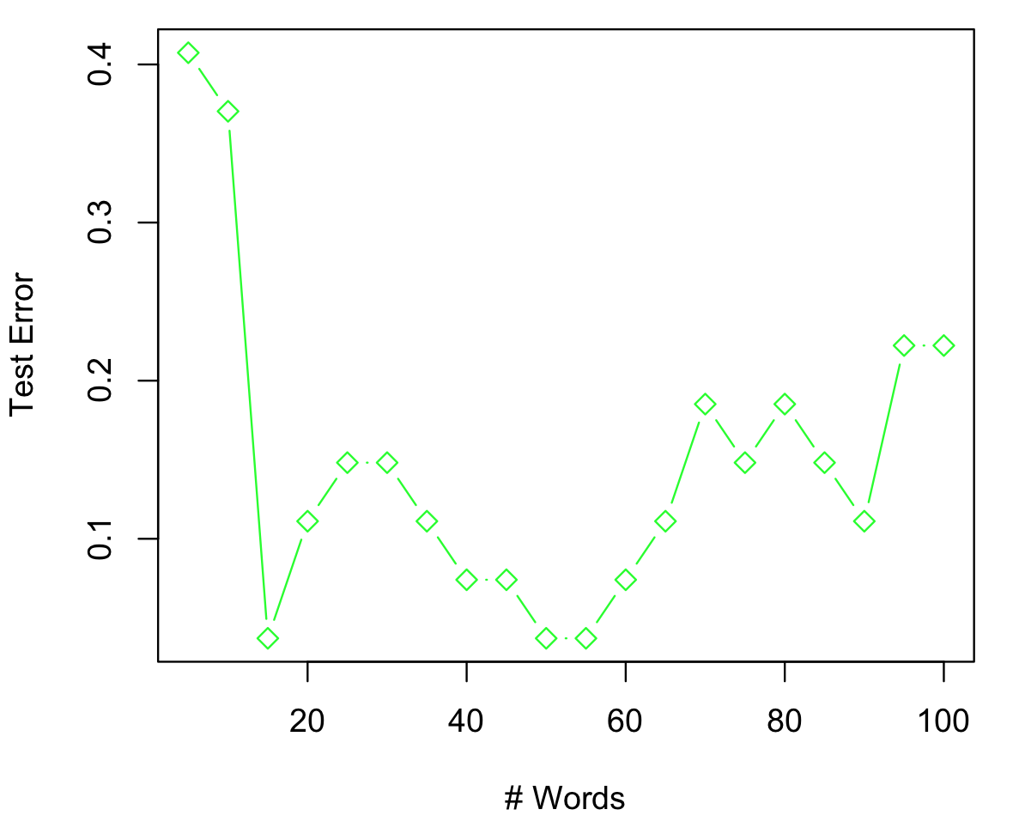

We see that test error is lowest when we use a linear SVM with the first 15, 50, or 55 words. While there seem to be multiple trends happening in the graph, it looks like there’s a general trend of increasing test error as one moves away from the median number of words.

Part c)

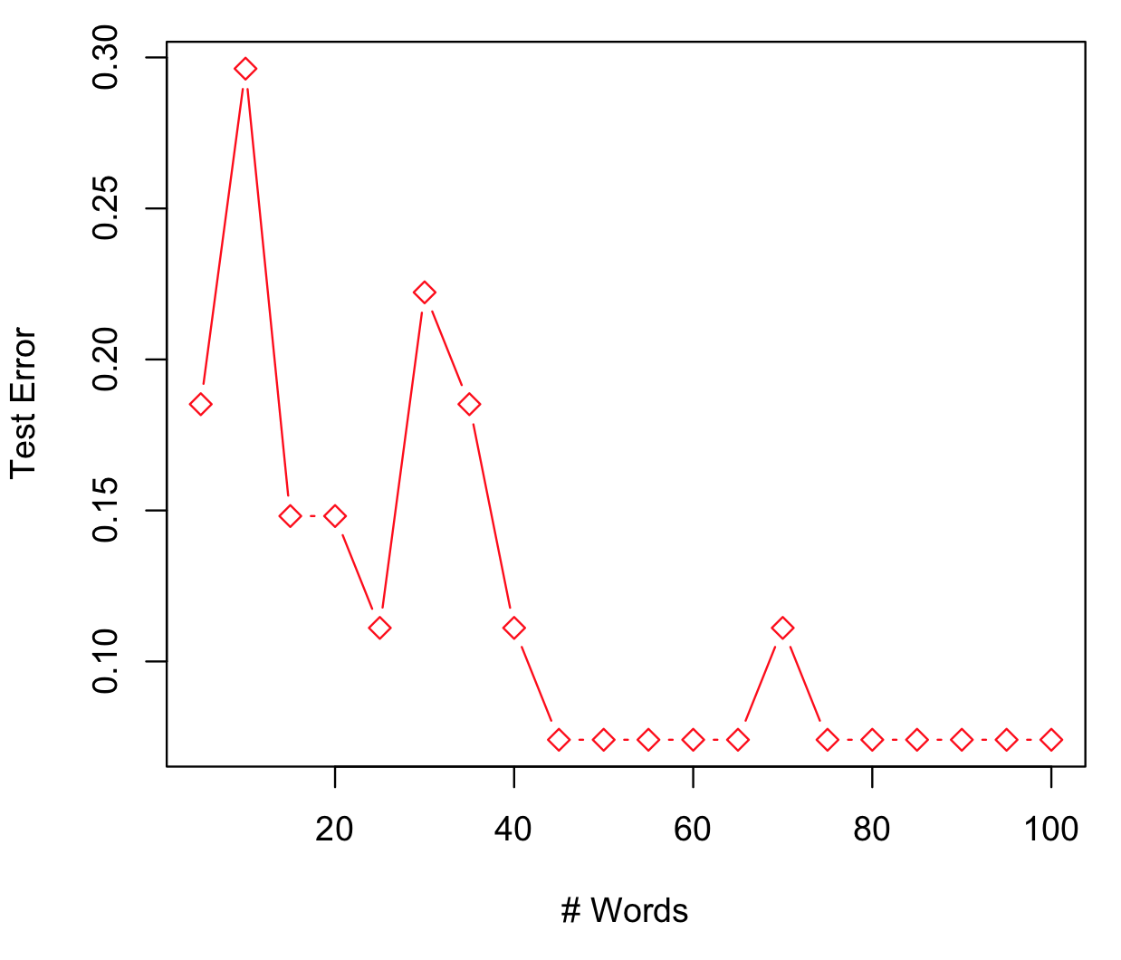

We see that test error is lowest when we use a linear SVM with the first 45 to 100 words, with the exception of 70 words. There seems to be a general trend of decreasing test error as the number of words used increases.

Part d)

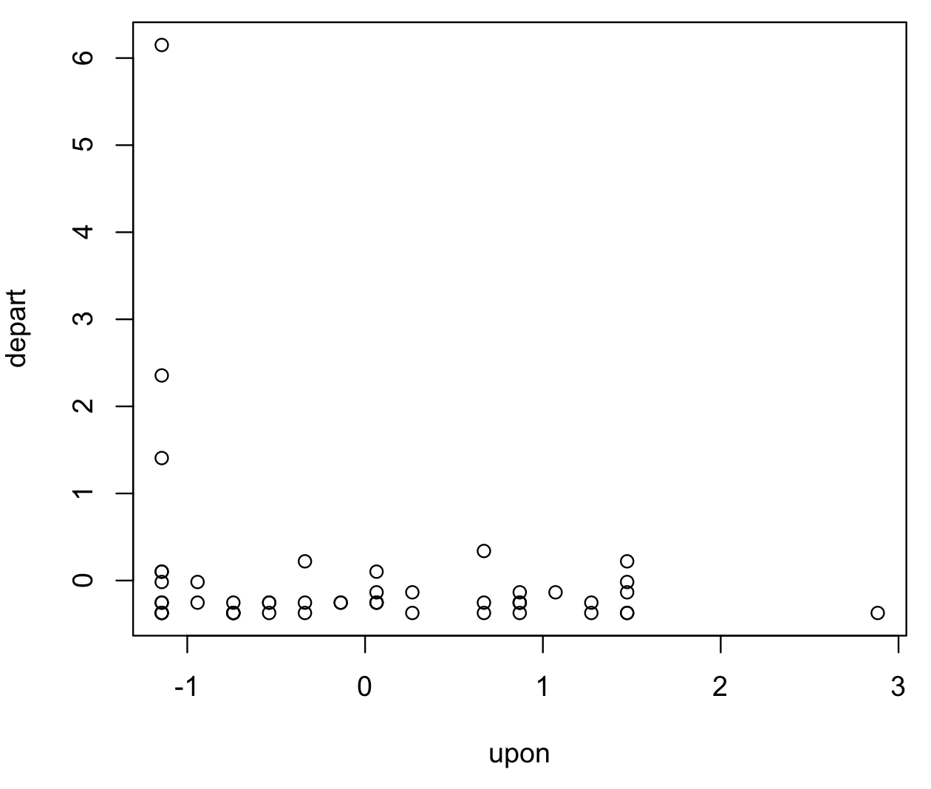

It appears that the authorship of a paper is more likely to be classified as Madison when the word “depart” is used, while authorship can be either classified as Madison or Hamilton when the word “upon” is used.

**Problem #5**

Part a)

Part b)

Each iteration of the K-means clustering algorithm decreases the objective function (in this case the squared error function) since each additional k increases clusters and moves the mean closer to the center of the data cluster, thus minimizing the average squared Euclidean distance of observations.

**Code**

#############################

# Kevin Gong

# STAT W4240

# Homework 06, Problem 1

# May 05, 2014

#

#############################

#################

# Setup

#################

# make sure R is in the proper working directory

# note that this will be a different path for every machine

setwd("~/Dropbox/SIPA/Data Mining/hw06")

# first include the relevant libraries

# note that a loading error might mean that you have to

# install the package into your R distribution.

# Use the package installer and be sure to install all dependencies

library(ISLR)

library(gbm)

library(glmnet)

library(randomForest)

#################

# Problem 1a

#################

data("Hitters")

Hitters

H2 <- Hitters[!is.na(Hitters$Salary),,drop=F]

H2$Salary <- log(H2$Salary)

H2$Salary

Salary

#################

# Problem 1b

#################

H2.train <- H2[1:200,]

H2.test <- H2[201:nrow(H2),]

dim(H2.train)

dim(H2.test)

#################

# Problem 1c

#################

library(gbm)

set.seed(5)

shrink.lambdas=c(0.00001,0.0001,0.001,0.01,0.1,1)

training_error=rep(NA,length(shrink.lambdas))

testing_error=rep(NA,length(shrink.lambdas))

#shrink.lambdas = sl

#interaction.depth=1, n.cores=10

for (i in 1:length(shrink.lambdas)){

#sl = shrink.lambdas[i]

boost_hitters = gbm(Salary~., data=H2.train, distribution="gaussian", n.trees=1000, shrinkage = shrink.lambdas[i])

predictions_train = predict(boost_hitters,H2.train, n.trees=1000)

predictions_test = predict(boost_hitters,H2.test, n.trees=1000)

training_error[i]=mean((predictions_train - H2.train$Salary)^2)

testing_error[i]=mean((predictions_test - H2.test$Salary)^2)

}

plot(log(shrink.lambdas),training_error)

#################

# Problem 1d

#################

plot(log(shrink.lambdas),testing_error)

#################

# Problem 1e

#################

#boosting

boost_results = training_error[which.min(training_error)]

#best subset lm

library(leaps)

placeholder = regsubsets(Salary~., data=H2.train, nvmax=19)

placeholder_s = summary(placeholder)

a = placeholder_s$which[which.min(placeholder_s$cp),][2:20]

names = c(names,"Division","Salary")

placeholder.lm = lm(Salary~.,data=H2.train[,colnames(H2.train)%in%names])

subsetlm_prediction = predict(placeholder.lm,H2.test[,colnames(H2.train)%in%names])

bestsub = mean((subsetlm_prediction-H2.test$Salary)^2)

#best lasso

library(glmnet)

eliminate=c("League","Division","NewLeague")

reformat=model.matrix(~.,H2)[,-1]

reformat.train=reformat[1:200,]

reformat.test=reformat[201:nrow(reformat),]

fit_lasso=cv.glmnet(reformat.train[,colnames(reformat)!="Salary"],reformat.train[,"Salary"])

fit_lasso=glmnet(reformat.train[,colnames(reformat)!="Salary"],reformat.train[,"Salary"],lambda=fit$lambda.1se)

pred=predict(fit_lasso,reformat.test[,colnames(reformat)!="Salary"])

best.lasso=mean((pred[,1]-H2.test$Salary)^2)

#compare the test MSEs

boost_results

bestsub

best.lasso

#the lasso is the best by a really little bit on the test data, but boosting came in close.

#################

# Problem 1f

#################

boost_hitters_test = gbm(Salary~., data=H2.train, distribution="gaussian", n.trees=1000, shrinkage = shrink.lambdas[which.min(training_error)], interaction.depth=1, n.cores=10)

summary(boost_hitters_test)

#################

# Problem 1g

#################

library(randomForest)

set.seed(1)

bagging_hitters = randomForest(Salary~.,data=H2.train, mtry=ncol(H2.train)-1, importance=TRUE)

#ntree=500

#mtry=19

prediction_bag = predict(bagging_hitters,newdata=H2.test)

mean((prediction_bag-H2.test$Salary)^2)

#############################

# Kevin Gong

# STAT W4240

# Homework 06, Problem 3

# May 05, 2014

#

#############################

#################

# Setup

#################

# make sure R is in the proper working directory

# note that this will be a different path for every machine

setwd("~/Dropbox/SIPA/Data Mining/hw06")

# first include the relevant libraries

# note that a loading error might mean that you have to

# install the package into your R distribution.

# Use the package installer and be sure to install all dependencies

library(ISLR)

library(e1071)

#################

# Problem 3a

#################

data("OJ")

OJ

set.seed(1)

rownumbers = sample(nrow(OJ))

train_set = OJ[rownumbers[1:800],]

test_set = OJ[-rownumbers[1:800],]

dim(train_set)

dim(test_set)

#################

# Problem 3b

#################

Purchase = train_set[,1]

training = data.frame(x=train_set[,-1], y=Purchase)

svm_train = svm(y~.,data=training, kernel="linear", cost=0.01, scale=TRUE)

summary(svm_train)

??svm

#################

# Problem 3c

#################

test = data.frame(x=test_set[,-1],y=test_set[,1])

svm_test = svm(y~.,data=test, kernel="linear", cost=0.01, scale=TRUE)

train_predict = predict(svm_train,training)

test_predict = predict(svm_test,test)

train_error = sum(train_predict!=train_set[,1])/length(train_predict)

test_error = sum(test_predict!=test_set[,1])/length(test_predict)

train_error

test_error

#################

# Problem 3d

#################

#################

# Problem 3e

#################

#################

# Problem 3f

#################

svm_train_radial = svm(y~.,data=training, kernel="radial", cost=0.01, scale=TRUE)

svm_test_radial = svm(y~.,data=test, kernel="radial", cost=0.01, scale=TRUE)

train_predict_radial = predict(svm_train_radial,training)

test_predict_radial = predict(svm_test_radial,test)

train_error_radial = sum(train_predict_radial!=train_set[,1])/length(train_predict_radial)

test_error_radial = sum(test_predict_radial!=test_set[,1])/length(test_predict_radial)

summary(svm_train_radial)

train_error_radial

test_error_radial

#################

# Problem 3g

#################

svm_train_poly = svm(y~.,data=training, kernel="polynomial", cost=0.01, scale=TRUE, degree=2)

svm_test_poly = svm(y~.,data=test, kernel="polynomial", cost=0.01, scale=TRUE, degree=2)

train_predict_poly = predict(svm_train_poly,training)

test_predict_poly = predict(svm_test_poly,test)

train_error_poly = sum(train_predict_poly!=train_set[,1])/length(train_predict_poly)

test_error_poly = sum(test_predict_poly!=test_set[,1])/length(test_predict_poly)

summary(svm_train_poly)

train_error_poly

test_error_poly

#############################

# Kevin Gong

# STAT W4240

# Homework 06, Problem 4

# May 05, 2014

#

# The following code analyzes the federalist papers

#############################

#################

# Setup

#################

# make sure R is in the proper working directory

# note that this will be a different path for every machine

setwd("~/Dropbox/SIPA/Data Mining/hw06")

# first include the relevant libraries

# note that a loading error might mean that you have to

# install the package into your R distribution.

# Use the package installer and be sure to install all dependencies

library(tm)

library(SnowballC)

library(rpart)

library(glmnet)

# to get the svm function...

library(e1071)

# to load previous dtm code, etc.

source("../hw04/hw04.R")

setwd("~/Documents/academic/teaching/STAT_W4240_2014_SPRG/dropbox/Homework/hw04")

#################

# Problem 4

#################

##########################################

# Preprocess the data

# You should have made directiories in

# hw04 for cleaned data; make sure these

# are in your path

##########################################

##########################################

# To read in data from the directories:

# Partially based on code from C. Shalizi

read.directory <- function(dirname) {

# Store the infiles in a list

infiles = list();

# Get a list of filenames in the directory

filenames = dir(dirname,full.names=TRUE);

for (i in 1:length(filenames)){

infiles[[i]] = scan(filenames[i],what="",quiet=TRUE);

}

return(infiles)

}

hamilton.train <- read.directory('fp_hamilton_train_clean')

hamilton.test <- read.directory('fp_hamilton_test_clean')

madison.train <- read.directory('fp_madison_train_clean')

madison.test <- read.directory('fp_madison_test_clean')

##########################################

##########################################

# Make dictionary sorted by number of times a word appears in corpus

# (useful for using commonly appearing words as factors)

# NOTE: Use the *entire* corpus: training, testing, spam and ham

make.sorted.dictionary.df <- function(infiles){

# This returns a dataframe that is sorted by the number of times

# a word appears

# List of vectors to one big vetor

dictionary.full <- unlist(infiles)

# Tabulates the full dictionary

tabulate.dic <- tabulate(factor(dictionary.full))

# Find unique values

dictionary <- unique(dictionary.full)

# Sort them alphabetically

dictionary <- sort(dictionary)

dictionary.df <- data.frame(word = dictionary, count = tabulate.dic)

sort.dictionary.df <- dictionary.df[order(dictionary.df$count,decreasing=TRUE),];

return(sort.dictionary.df)

}

dictionary <- make.sorted.dictionary.df(c(hamilton.train,hamilton.test,madison.train,madison.test))

##########################################

##########################################

# Make a document-term matrix, which counts the number of times each

# dictionary element is used in a document

make.document.term.matrix <- function(infiles,dictionary){

# This takes the text and dictionary objects from above and outputs a

# document term matrix

num.infiles <- length(infiles);

num.words <- nrow(dictionary);

# Instantiate a matrix where rows are documents and columns are words

dtm <- mat.or.vec(num.infiles,num.words); # A matrix filled with zeros

for (i in 1:num.infiles){

num.words.infile <- length(infiles[[i]]);

infile.temp <- infiles[[i]];

for (j in 1:num.words.infile){

ind <- which(dictionary == infile.temp[j])[[1]];

# print(sprintf('%s,%s', i , ind))

dtm[i,ind] <- dtm[i,ind] + 1;

#print(c(i,j))

}

}

return(dtm);

}

dtm.hamilton.train <- make.document.term.matrix(hamilton.train,dictionary)

dtm.hamilton.test <- make.document.term.matrix(hamilton.test,dictionary)

dtm.madison.train <- make.document.term.matrix(madison.train,dictionary)

dtm.madison.test <- make.document.term.matrix(madison.test,dictionary)

# check if the 4 dtm datasets are correct

dim(dtm.hamilton.train) # 35 4875

dim(dtm.hamilton.test) # 16 4875

dim(dtm.madison.train) # 15 4875

dim(dtm.madison.test) # 11 4875

##########################################

##########################################

# make training and test sets w/

# y=0 if Madison; =1 if Hamilton

# & var names being dictionary words

dat.train <- as.data.frame(rbind(dtm.hamilton.train, dtm.madison.train))

dat.test <- as.data.frame(rbind(dtm.hamilton.test, dtm.madison.test))

names(dat.train) <- names(dat.test) <- as.vector(dictionary$word)

dat.train$y <- as.factor(c(rep(1, nrow(dtm.hamilton.train)), rep(0, nrow(dtm.madison.train))))

dat.test$y <- as.factor(c(rep(1, nrow(dtm.hamilton.test)), rep(0, nrow(dtm.madison.test))))

# note: as.factor() makes the y label as factor, which is helpful for svm later (so it will do classification)

dim(dat.train) # 50 4876

dim(dat.test) # 27 4876

##################################

# center and scale the data as in HW05

mean.train <- apply(dat.train[,-4876], 2, mean) # col means of training x

sd.train <- apply(dat.train[,-4876], 2, sd) # col sd of training x

x.train <- scale(dat.train[,-4876]) # standardize training x

x.train[,sd.train==0] <- 0 # let the var be 0 if its sd=0

x.test <- scale(dat.test[,-4876], center = mean.train, scale=sd.train) # use training x mean & sd to standardize test x

x.test[,sd.train==0] <- 0 # let the var be 0 if its sd=0

y.train <-dat.train$y

y.test <- dat.test$y

############################

# Problem 4

############################

###########

# Part a

###########

training = data.frame(x=x.train[,1:100],y=y.train)

testing = data.frame(x=x.test[,1:100],y=y.test)

svm_1 = svm(y~.,data=training, kernel="linear", cost=10, scale=FALSE)

test_prediction = predict(svm_1,testing)

test_prediction

testing$y

sum(test_prediction==testing$y)

###########

# Part b

###########

a = seq(from=5, to=100, by=5)

train_errors = rep(NA,20)

test_errors = rep(NA,20)

for(i in 1:20) {

training_data = data.frame(x=x.train[,1:a[i]],y=y.train)

testing_data = data.frame(x=x.test[,1:a[i]], y=y.test)

train_prediction = predict(svm_1,training_data)

test_prediction = predict(svm_1,testing_data)

train_errors[i] = sum(train_prediction!=y.test)/length(train_prediction)

test_errors[i] = sum(test_prediction!=y.test)/length(test_prediction)

}

plot(a, test_errors, col="green", pch=5, type="b", xlab="# Words", ylab="Test Error")

###########

# Part c

###########

svm_2 = svm(y~.,data=training, kernel="radial", cost=10, scale=FALSE)

a = seq(from=5, to=100, by=5)

train_errors = rep(NA,20)

test_errors = rep(NA,20)

for(i in 1:20) {

training_data = data.frame(x.train[,1:a[i]],y=y.train)

testing_data = data.frame(x=x.test[,1:a[i]], y=y.test)

train_prediction.2 = predict(svm_2,training_data)

test_prediction.2 = predict(svm_2,testing_data)

train_errors[i] = sum(train_prediction.2!=y.test)/length(train_prediction.2)

test_errors[i] = sum(test_prediction.2!=y.test)/length(test_prediction.2)

}

plot(a, test_errors, col="red", pch=5, type="b", xlab="# Words", ylab="Test Error")

###########

# Part d

###########

features = c("upon", "depart")

features_training = data.frame(x=x.train[,features],y=y.train)

svm_features = svm(y~., data=features_training, kernel="radial", cost=10, scale=FALSE)

plot(svm_features, x.train[,features])

with(svm_features,plot(x.train[,features]))