RGB- & XY-sgraph Guide
Author: Kim Miikki
Date: 11.7.2021

Introduction
RGB- and XY-sgraph are data smoothing and plotting applications. The first program requires a CSV file which contains the RGB data. The second program is meant for general XY data smoothing from a CSV file.

System Requirements
Operating System: Raspberry Pi OS or Linux
Python 3 with Matplotlib, Numpy and SciPy.

Data Smoothing Methods
Two different smoothing methods are used in these programs. The first is moving average (MA) and the second Savitzky-Golay (SG) filtering by quadratic polynomial fit. The amount of smoothing can be controlled with the window size which is a integer for MA (minimum value 2) and an odd integer for SG (minimum value 3).

Program Usage
Both programs has a CSV file as a a mandatory argument, and plots can be optionally shown on screen. This feature is useful when using an IDE.
$ rgb-sgraph -h
positional arguments:
file RGB data file (*.csv)
optional arguments:
-h, --help show this help message and exit
-p plot calibration graphs on screen
The CSV file for rgb-sgraph.py must have 6 columns which header line is ordered this way:
picture_name, time [min], bw, red, green, blue
Next lines contains the data.
$ xy-sgraph.py
positional arguments:
file XY data file (*.csv)
optional arguments:
-h, --help show this help message and exit
-p plot graphs on screen
The CSV file for xy-sgraph.py consist of to columns: x and y. The x and y axis headers are defined in the first line.
Here is a list of the analysis files prefixes and suffixes, and their meanings:
Prefix | Program | Abbreviation or Usage
sdma-*.csv | both | Smooth data, moving average
sdsg-*.csv | both | Smooth data, Savitzky-Golay filter
sgRGB-*.png | rgb-sgraph.py | Smooth graph, RGB channels
sgoRGB-*.png | rgb-sgraph.py | Smooth graph, original data plot, RGB channels
sgBW-*.png | rgb-sgraph.py | Smooth graph, grayscale mean value
sgoBW-*.png | rgb-sgraph.py | Smooth graph, original data plot, grayscale mean value
sgXY-*.png | xy-sgraph.py | Smooth graph, XY data
sgoXY-*.png | xy-sgraph.py | Smooth graph, original data plot, XY data
Table 1. Data files prefixes and suffixes.

Use Cases
The usage of this programs are demonstrated in the following two subsections.

Smoothing Confirmed Cases Data of COVID-19 in Finland
Setup
- Data source: https://covid.ourworldindata.org/data/owid-covid-data.csv
- Download date: 11.7.2021
- Moving average with window width 7
The data file was downloaded, all other countries where discarded than Finland, confirmed cases data was copied to a new sheet as y values in second column and finally the first column where filled with consequent numbering (starting from 1). The first line in the sheet contained x and y axis labels. Finally this sheet was saved as a CSV file and xy-sgraph was executed:
$ xy-sgraph.py covid-19-fin-20210711.csv
XY smooth graph, (C) Kim Miikki 2021
Data smoothing method:
1 = Moving average
2 = Savitsky-Golay
Select smoothing method (1, 2; Default=2): 1
Add titles to graphs (Y/N, Default y: <Enter>):
Default selected: title mode enabled
Select window: (2...529, Default=2: <Enter>): 7
Select Line width (0.1...2.0, Default=1.0: <Enter>):
Default value selected: 1.0
Y axis auto scale (Y/N, Default y: <Enter>):
Default selected: Auto scale enabled
Enable grid (Y/N, Default y: <Enter>):
Default selected: Grid enabled

Three data files were created:
sdma-covid-19-fin-20210711.csv
sgoXY-covid-19-fin-20210711.png
sgXY-covid-19-fin-20210711.png
The first consist of smoothed CSV data, and the begginig of file look like this:
Day,Confirmed cases (COVID-19)
7.0,0.14
8.0,0.0
9.0,0.0
Smoothed graphs are shown in Figure 1.
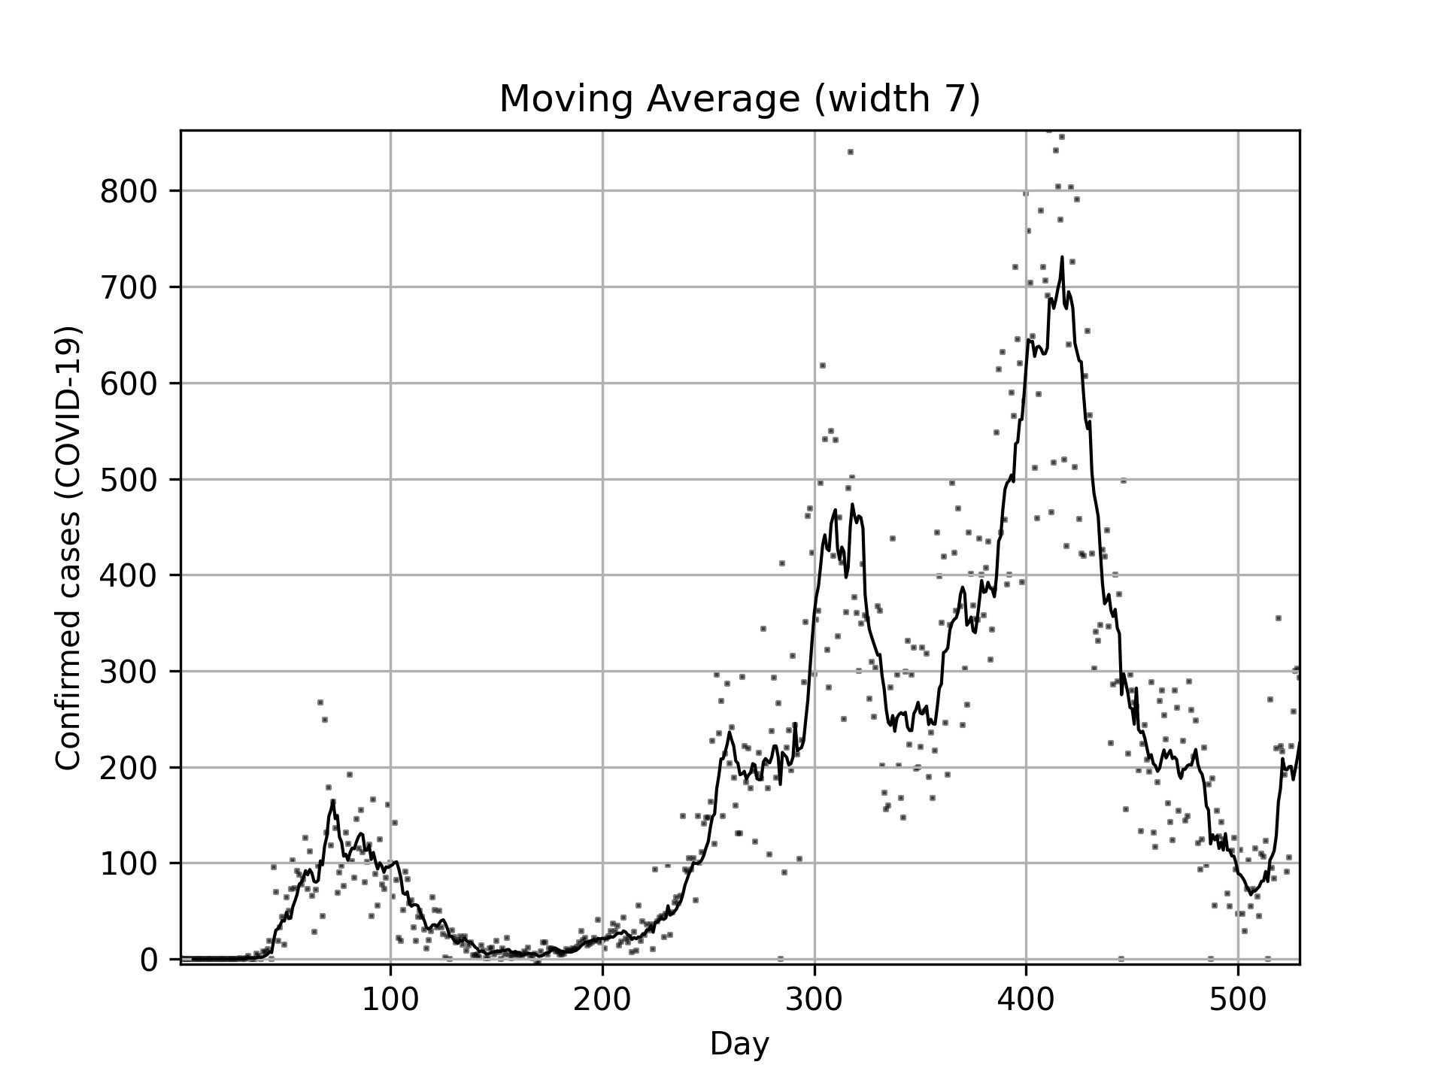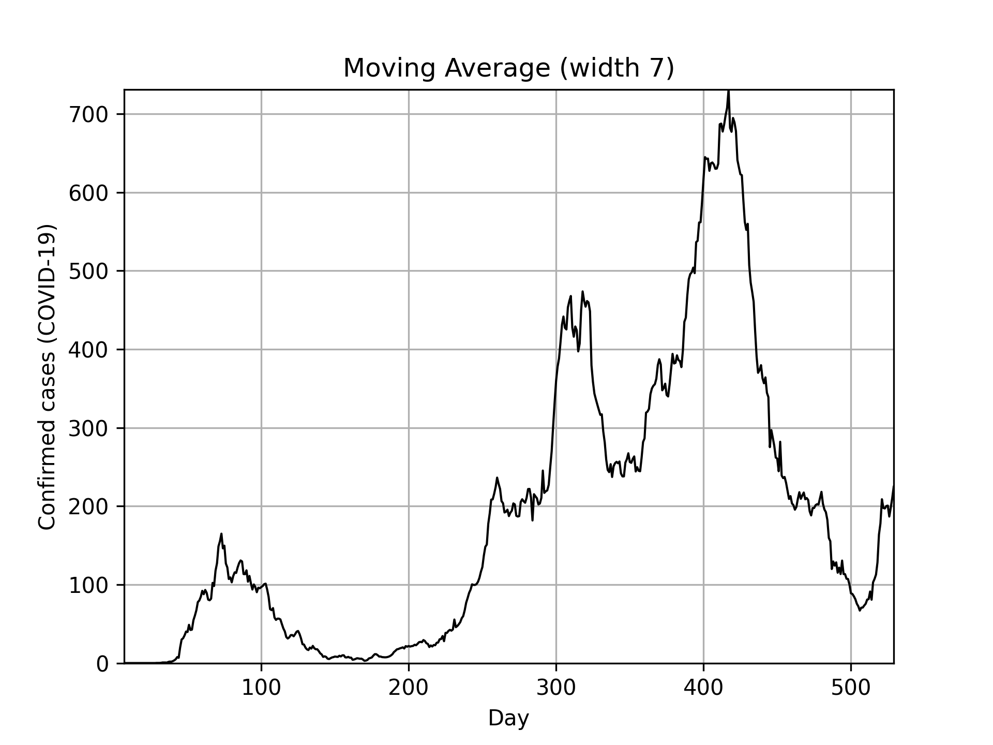
Figure 1. Confirmed COVID-19 cases in Finland, smoothed with moving average method with a window width of 7 days. The original data is represented as dots in the first plot.

Color analysis of Piece of Paper in a Black Box
Setup
- Black box
- Manfrotto Lumimuse 8 LED light
  - Dim level: 1/4
- Experiment time: 30 min
- Time-lapse interval 5 s
- Savitzky-Golay smoothing with window width 11
This experiment gives information of the light source stability as a function of time. External light was excluded from the time-lapse capturing by putting the light source, sample and the camera inside a black box. A ROI was selected after the time-lapse shooting, thereafter ROI batch cropping was performed and finally the color analysis were done with rgbmean.py. It creates a rgb.csv file which is required in this example:
$ rgb-sgraph.py rgb.csv
RGB smooth graph, (C) Kim Miikki 2021
Data smoothing method:
1 = Moving average
2 = Savitsky-Golay
Select smoothing method (1, 2; Default=2):
Default value selected: 2
Add titles to graphs (Y/N, Default y: <Enter>):
Default selected: title mode enabled
Custom X axis label (Y/N, Default n: <Enter>):
Default selected: custom label disabled
Select window size (odd number 3-89; Default=3): 11
Select Line width (0.1...2.0, Default=1.0: <Enter>):
Default value selected: 1.0
Y axis auto scale (Y/N, Default y: <Enter>):
Default selected: Auto scale enabled
Plot all channels (Y/N, Default y: <Enter>):
Default selected: Grayscale and RGB plots enabled
Enable grid (Y/N, Default y: <Enter>):
Default selected: Grid enabled
Five data files were created:
sdsg-rgb.csv
sgBW-rgb.png
sgoBW-rgb.png
sgRGB-rgb.png
sgoRGB-rgb.png

The CSV file consist of Savitky-Galoy smoothed RGB data. The beginning of this file look like this:
Picture_name,Time (min),Gray scale,Red,Green,Blue
0.417,195.12,195.45,190.31,199.59
0.5,195.24,195.69,190.44,199.6
0.583,195.19,195.67,190.46,199.43
The BW graphs are grayscale mean graphs of the RGB channels, which are shown in Figure 2. All or selected RGB channels are plotted as separate channel graphs. Examples of RGB graphs are shown in Figure 3.
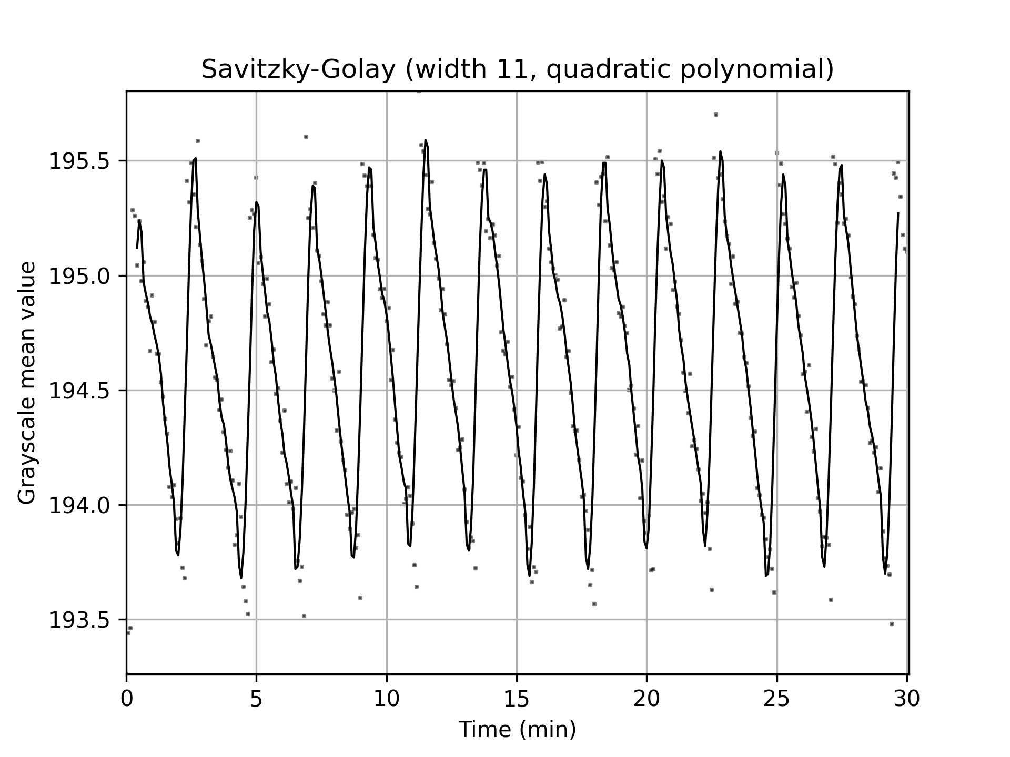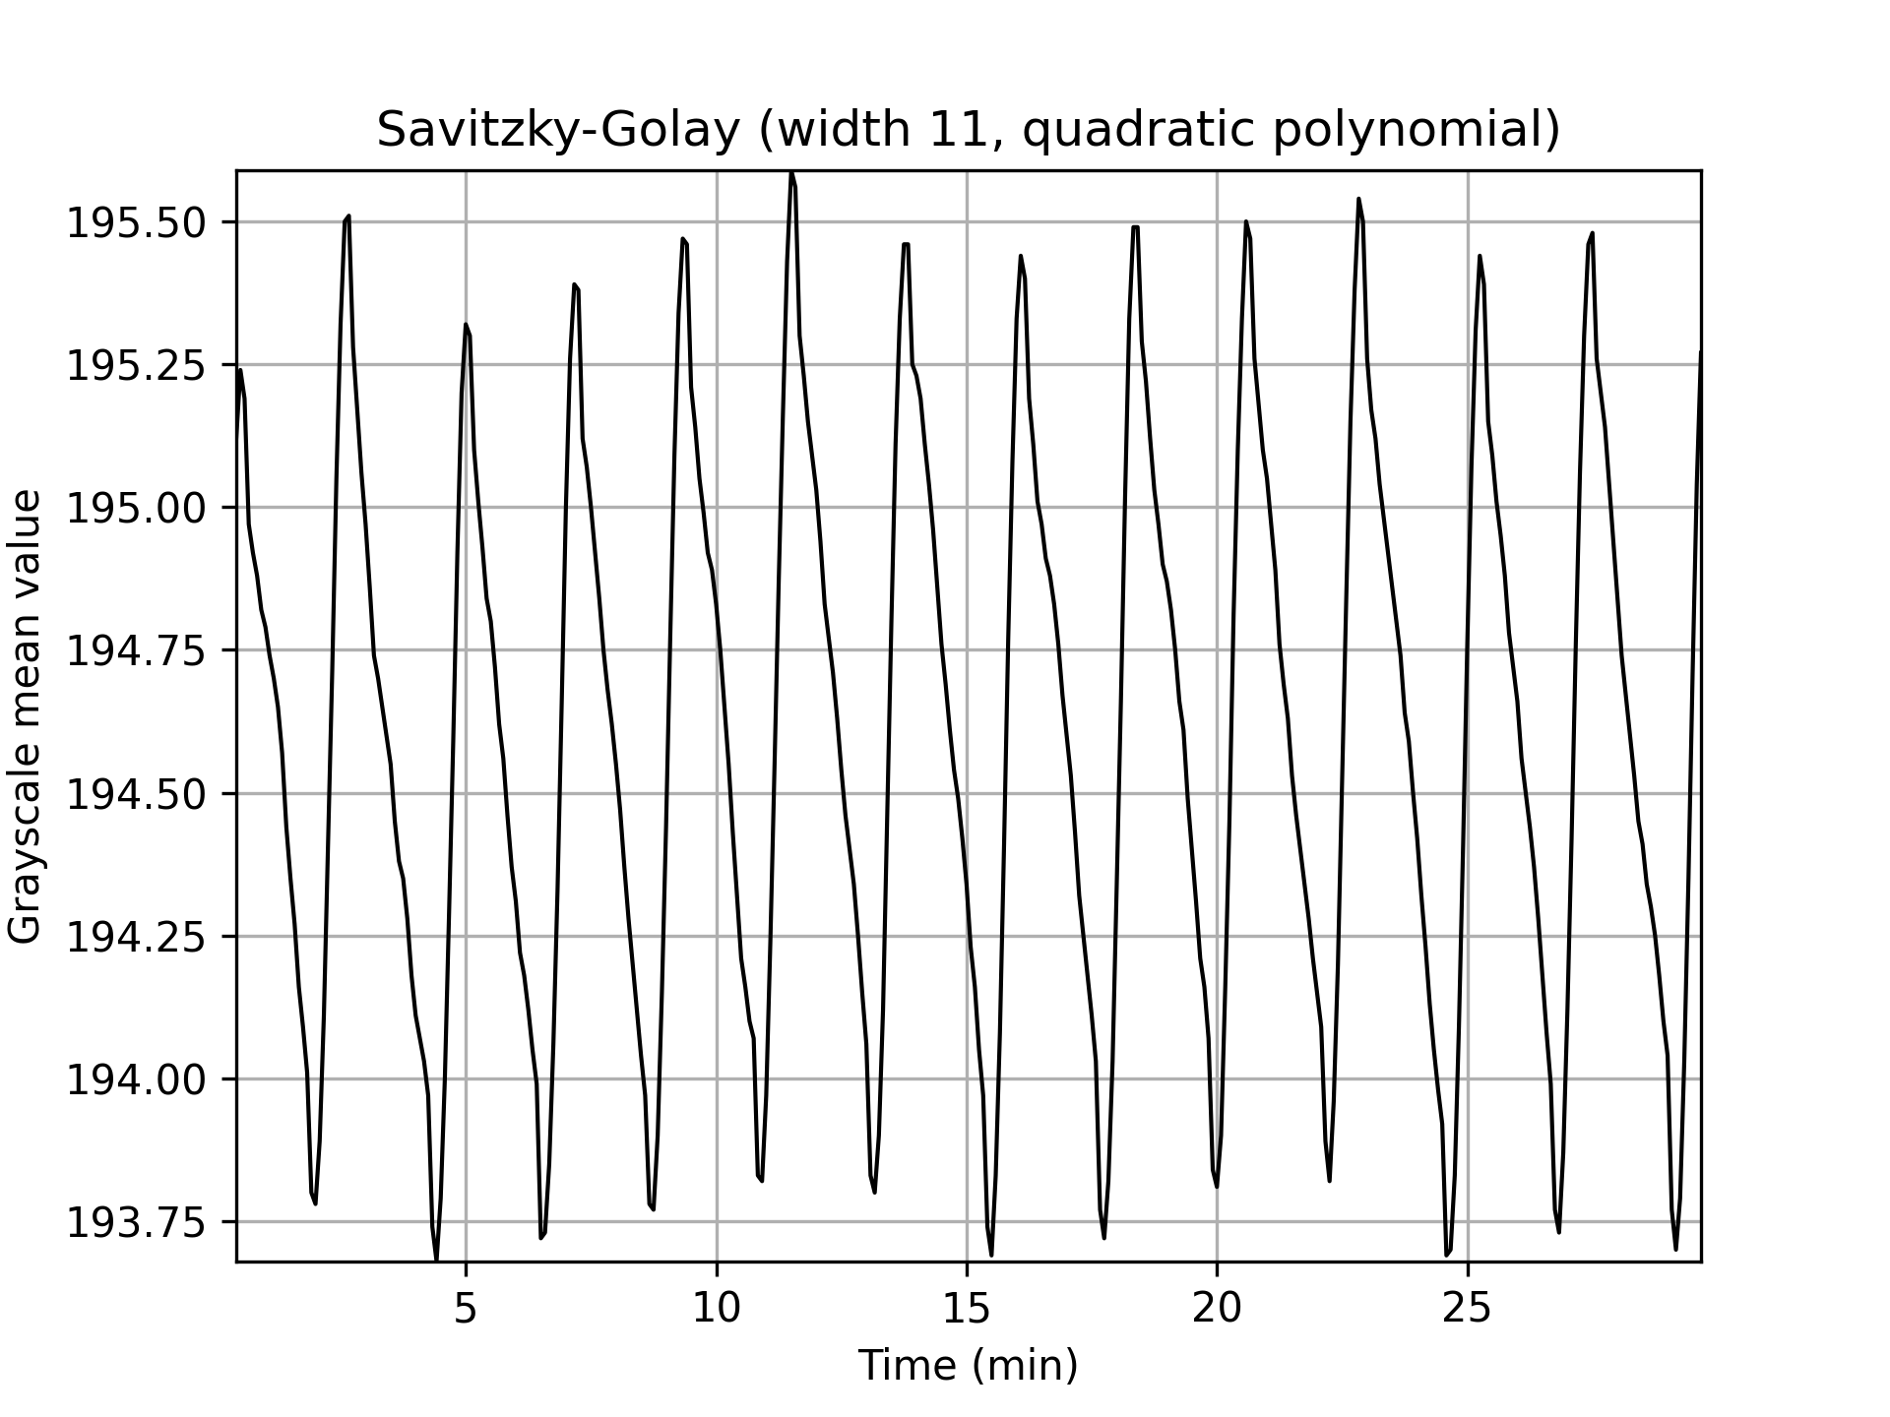
Figure 2. LED light stability and light intensity consistency testing with a piece of paper in a black box. The original data is represented as dots in the first plot. Data is smoothed with Savitzky-Golay filter with window size 11. Periodic variations are detected from these figures. However, the overall intensity is stable using dim level 1/4 within this time frame.
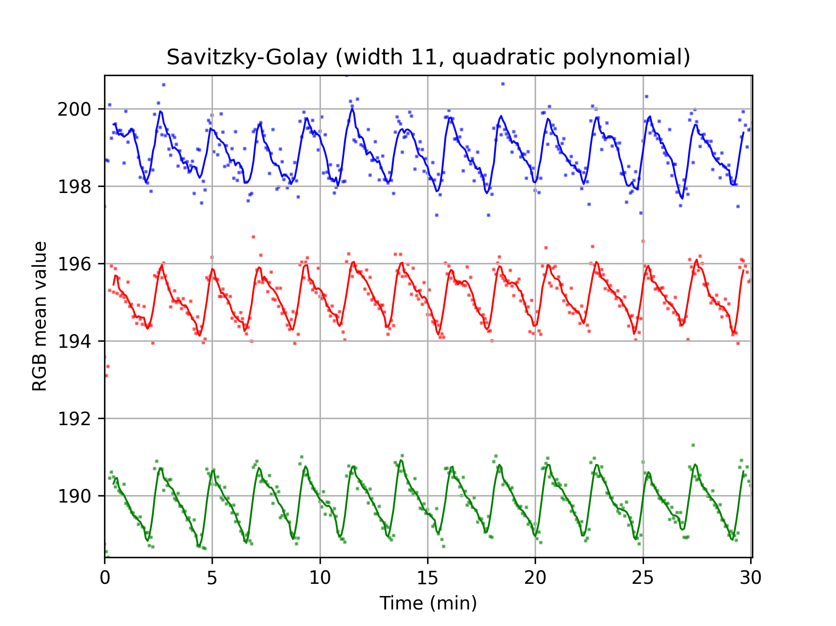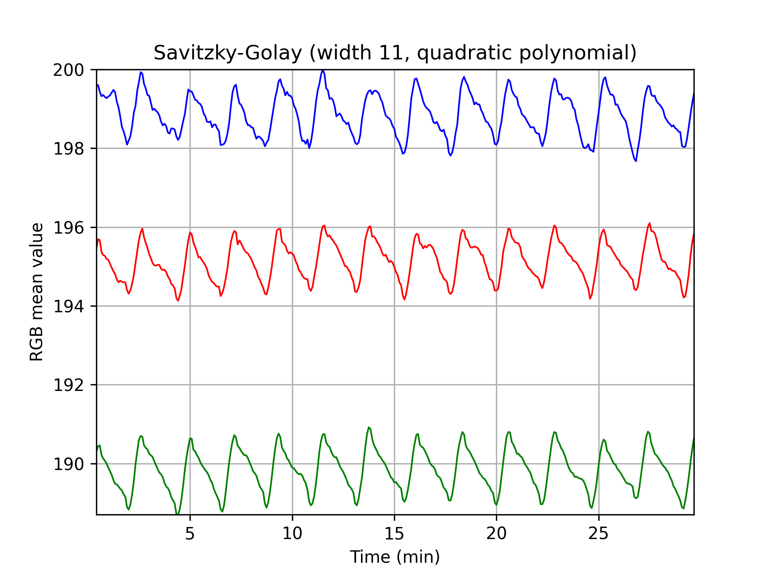
Figure 3. Separate RGB channels smoothed with Savitzky-Golay filter.

