Two Close-up Lens Sets (+1, +2 and +4) for Raspberry Pi HQ Camera 16 mm Telephoto Lens
Author: Kim Miikki
Date: 6.7.2020
Higher magnification of subjects can be achieved by adding close-up lenses to a Raspberry Pi 16 mm telephoto lens. Magnification is due to a shorter focal length which allows to capture pictures closer to the subject.
Two sets of a 37 mm +1, +2 and +4 diopters stackable close-up lenses where used in July 2020 to determine the minimum focusing distance of the subject (a ruler) and to calculate the magnification as a function of diopters. The camera was moved to the shortest distance of the subject which the lens or lens and close-up lens(es) could be focused. Focusing distances were measured in these experiments from the camera sensor to the subject.
Figure 1 shows the minimum focusing distance:

Figure 1. Minimum focusing distance between camera sensor and the subject.
Image magnification is defined as β = y'/y, where y' is sensor size and y is subject size. A HQ camera sensor area is 6.287 mm x 4.712 mm, from where 6.287 mm were used for the calculation of β. The results are shown in Table 1 and Figure 2.
Close-up [diopter] | Configuration | y [mm] | β | d [mm]
0 | tele | 93.0 | 0.068 | 290
+8 | tele+4+4 | 35.0 | 0.180 | 155
+9 | tele+4+4+1 | 33.0 | 0.191 | 150
+10 | tele+4+4+2 | 31.0 | 0.203 | 145
+11 | tele+4+4+2+1 | 29.0 | 0.217 | 145
+12 | tele+4+4+2+2 | 27.5 | 0.229 | 140
+13 | tele+4+4+2+2+1 | 26.2 | 0.240 | 140
+14 | tele+4+4+2+2+1+1 | 25.5 | 0.247 | 135
Table 1. Subject size (y), configuration of lenses, image magnification (β) and minimum focusing distances (d) with different close-up lens combinations.

Figure 2. Magnification of different close-up lens combinations.
The magnification capability of a telephoto lens combined with +14 diopter close-up lenses are demonstrated in the following figures:

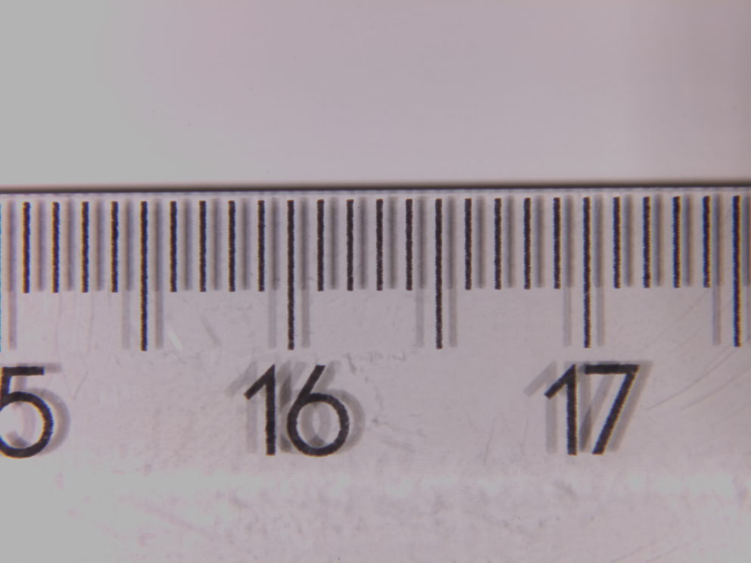
Figure 3. Part of a ruler: full field of view.

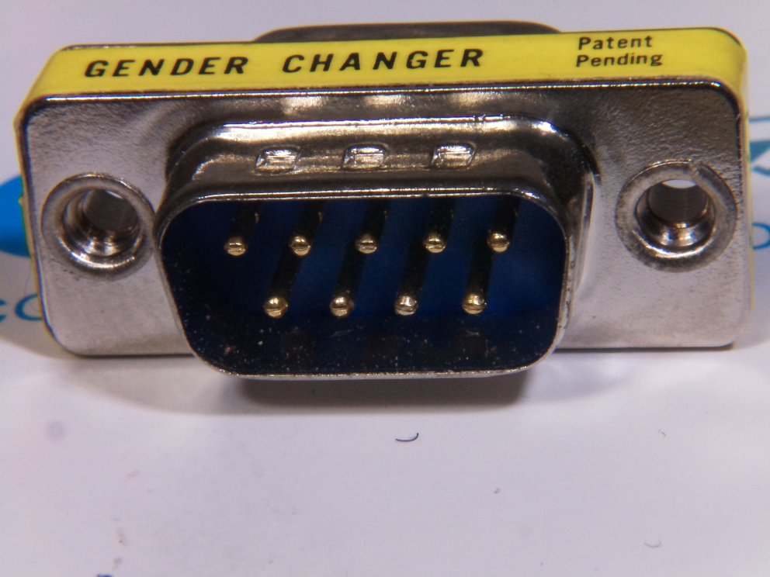
Figure 4. RS-232 gender changer: full field of view.

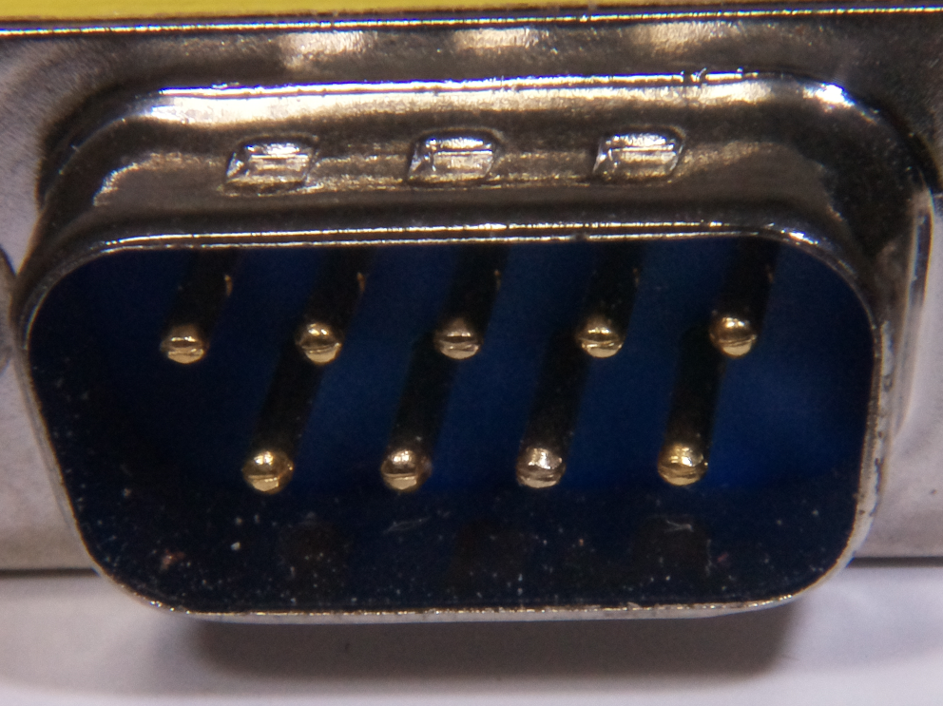
Figure 5. RS-232 gender changer: cropped view.

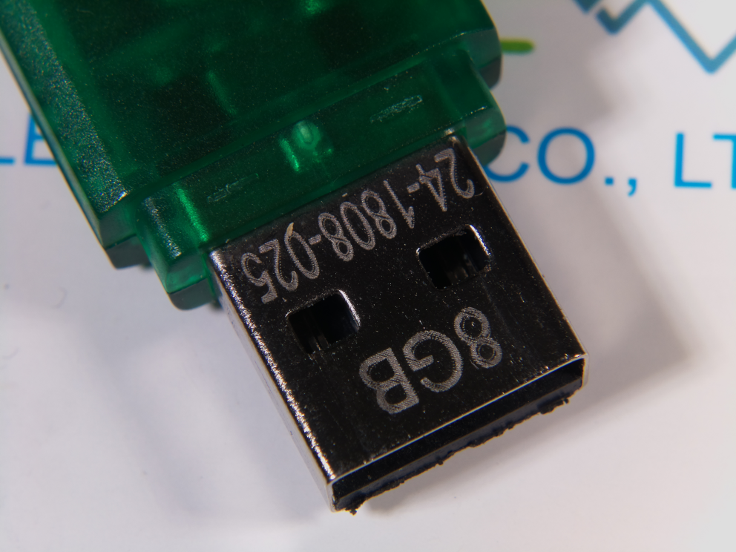
Figure 6. USB flash drive: full field of view.

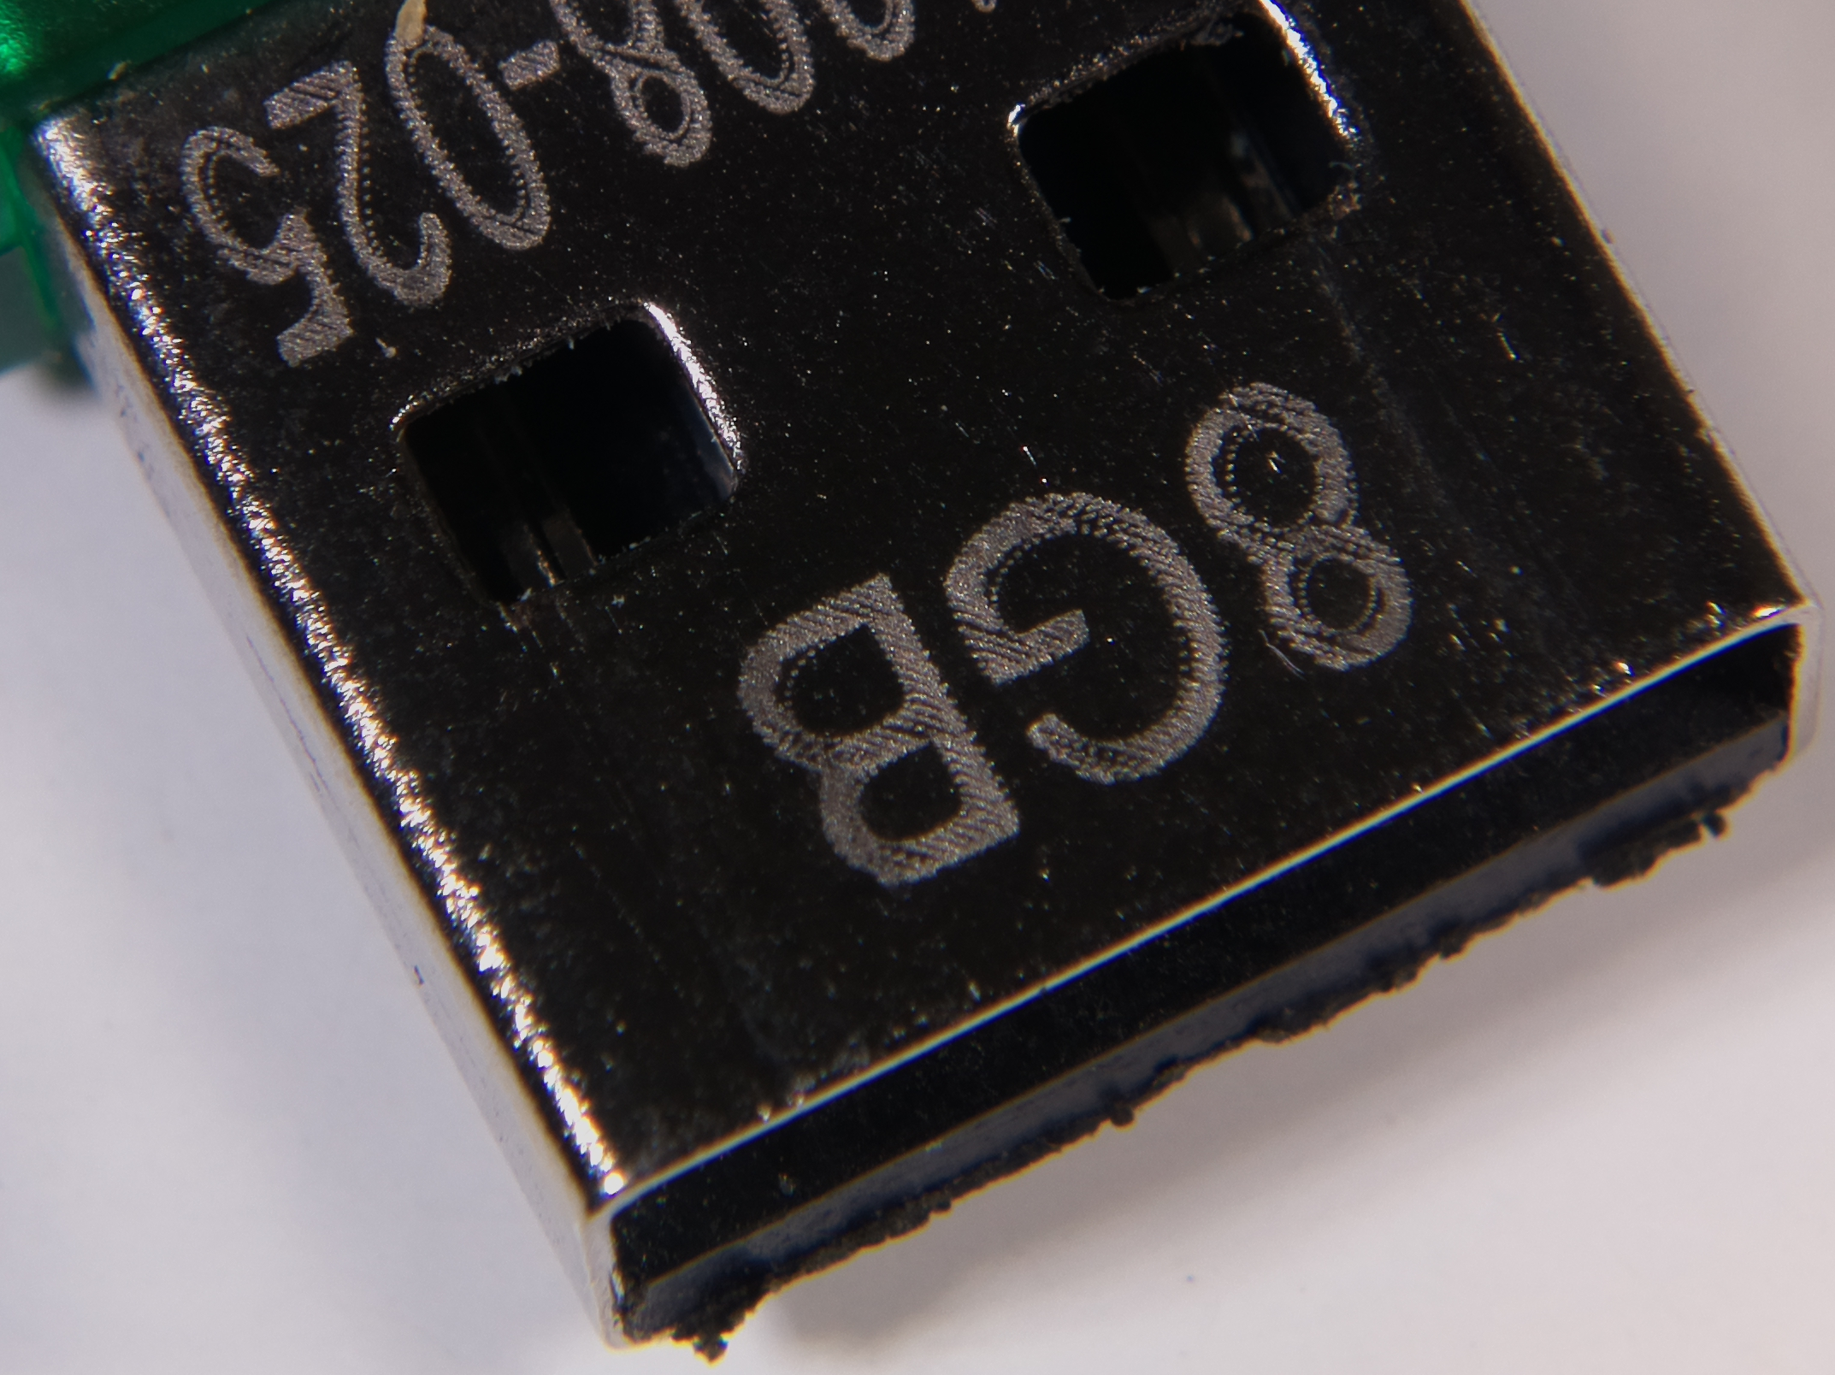
Figure 7. USB flash drive: cropped view.

