Calscale Guide
Author: Kim Miikki
Date: 18.5.2021

Introduction
Calscale is a calibration utility which is used to calculate a pixel scale from a graduated scale. It is designed to give a pixels/mm value from a mm scale (calibration image), but also other units can be used, if a straight scale is marked with even interval markers. A graduated pipette is a typical example of this.

System Requirements
Operating System: Raspberry Pi OS or Linux
Python 3 with Matplotlib, Numpy, SciPy and OpenCV.

Calibration Method
In order to calibrate a graduated scale a picture has to be captured. This can be done easyly with following command:
$ raspistill -o scale_name.jpg
Unnecessary elements should then be removed, usually by cropping the image. It should be copied to a working directory (or subdirectory) where the calibration script is executed the results will be presented. Next command starts the calibration by asking necessary questions:
$ calscale.py scale_name.jpg
When executing the script, image name as a mandatory script must be given. There are also two optional parameters: -d and -p. First optional argument disables creation of calibration files and second generates graphs on screen.
Unit, scale orientation and color scale mode will be asked. Valid orientations are horizontal or vertical. Normal scale colors are light background with dark markers. Opposite colors are here considered as an inverse color mode.
This program uses scipy.signals.find_peaks function for finding peaks (or inverse valleys). Minimal peak distance and minimal prominence are used to filter unwanted peaks from the calibration. Interval length threshold acts as the final validation of the calibration. Default tolerance for interval length is 20 % (0.2), but the value can be overridden.
When all parameters have been given, a color analysis is performed in horizontal or vertical direction. Then peaks are found with given parameters. A peak graph and a bar plot of the interval distribution is created with following names:
calbp-scale_name.jpg # calbp = calibration bar plot
calca-scale_name.jpg # calbp = calibration color analysis with peaks found
If interval threshold is exceeded, failures will be printed on screen. Data consist of interval lengths and their relative distance from the mean of intervals. Hence, the calibration has failed, and adjustments of parameters are required.
If the calibration is successful, a calibration log will be created, and the calibration value will also be printed on screen.
Interval statistics are printed on screen even if calibration fails. Distribution plot with numerical statistics will help especially when selecting minimal peak distance.

Use Cases
The usage of this program is demonstrated in following chapters. The first use case is a ruler calibration. All of images were captured with raspistill from a HQ camera and 16 mm tele lens.

Ruler Calibration
Setup
- mm scaled ruler
- image cropped with roi-picture.py
- horizontal mode
- normal color mode
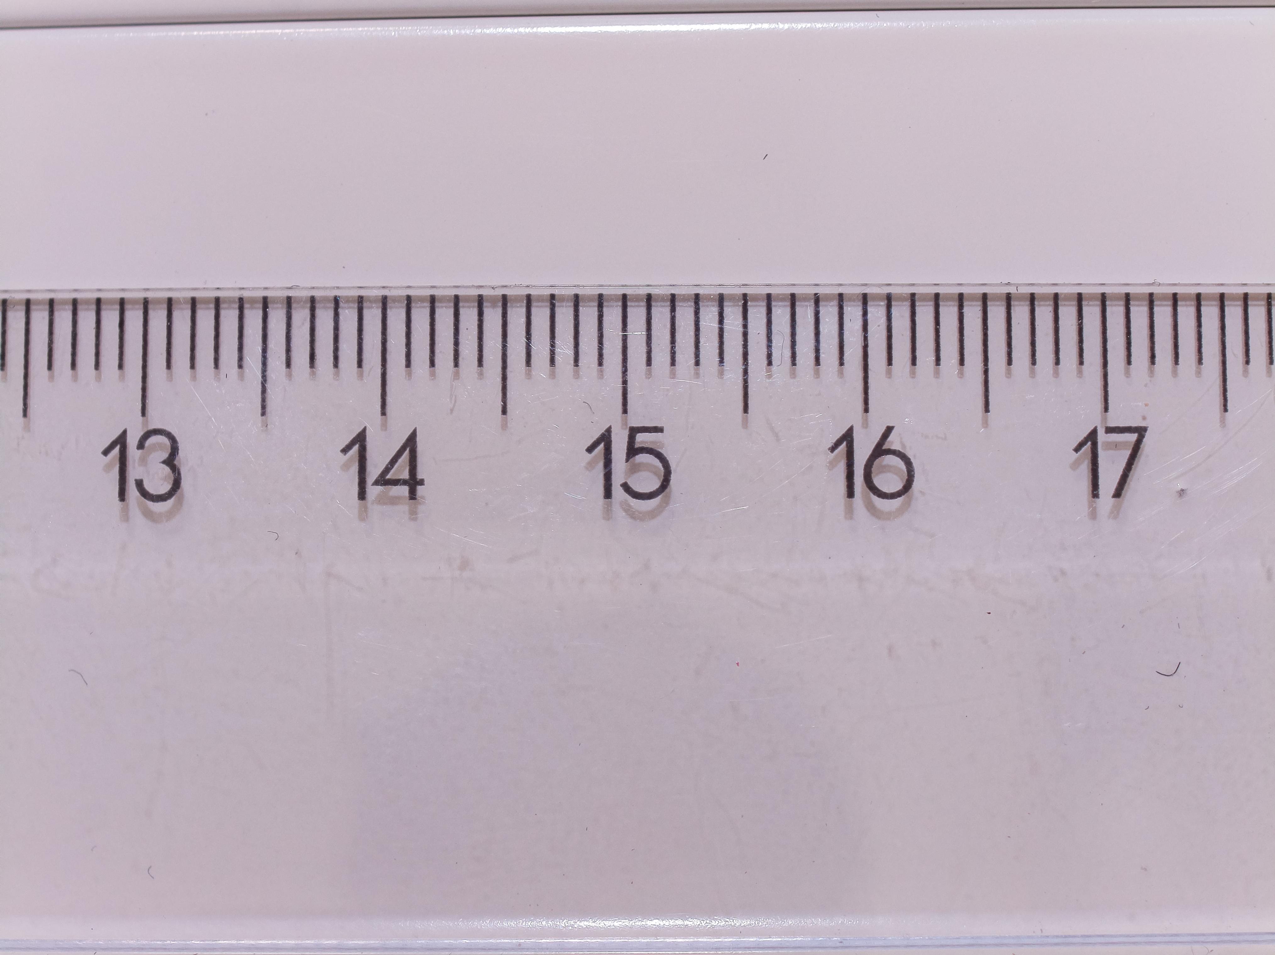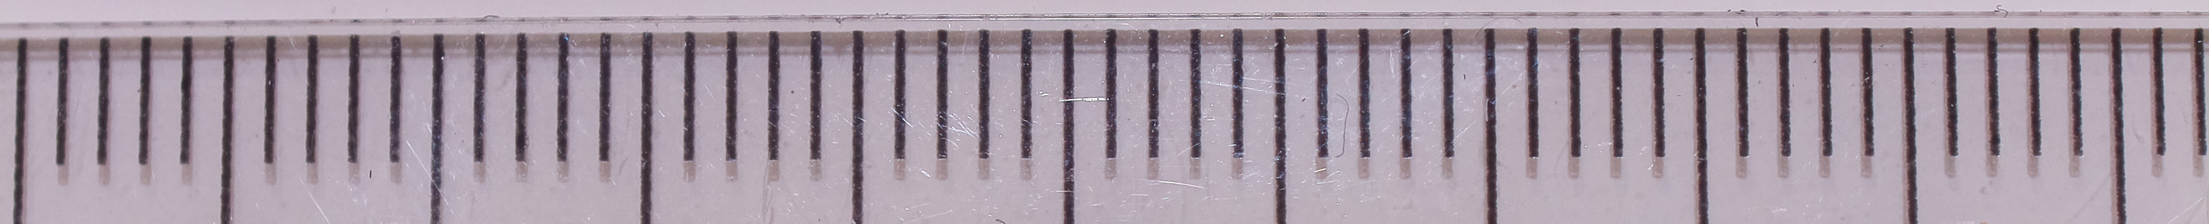
Figure 1. Original and cropped images of a ruler.
The original image (Fig. 1) was used in the first two attempts to calibrate a ruler. The third calibration attempt was performed with the cropped image. The crop operation was done with roi-picture.py which automatically generated a roi.ini file containing the crop selection:
scale;coordinate name;value
original;img_x0;0
original;img_x1;4056
original;img_y0;0
original;img_y1;3040
original;crop_x0;48
original;crop_x1;4056
original;crop_y0;880
original;crop_y1;1287
normalized;roi_x0;0.0118
normalized;roi_y0;0.2895
normalized;roi_w;0.9882
normalized;roi_h;0.1339
First calibration attempt:
$ calscale.py doc/images/ruler.jpg
Calscale 1.0, (c) Kim Miikki 2021
Current directory:
/home/pi/python/20210518-calscale
Enter unit (Default=mm: <Enter>):
Default unit selected: mm
Horizontal calibration (Y/N, Default y: <Enter>):
Default selected: horizontal mode enabled
Inverse color scale (Y/N, Default n: <Enter>):
Default selected: inverse mode disabled
Select minimal peak distance: (1...2028, Default=10: <Enter>):
Default value selected: 10
Select minimal prominence of peaks: (0...255, Default=5: <Enter>):
Default value selected: 5
Select interval length threshold: (0.01...1.0, Default=0.25: <Enter>):
Default value selected: 0.25
qt5ct: using qt5ct plugin
Distance statistics (pixel values):
Peaks : 56
Intervals : 55
Mean : 73.27272727272727
Median : 76.0
Min : 29
Max : 82
Sdev : 10.121901627756689
Distance threshold: 0.25
------------------------
Exceeded at interval 29: -0.6042183622828784
Exceeded at interval 33: -0.5496277915632753
Exceeded at interval 44: -0.3995037220843672
Exceeded at interval 50: -0.3176178660049627
Adjust peak fit parameters to filter non-marker peaks or increase threshold.
This calibration attempt failed due to exceeding the interval threshold. Found peaks and their distribution bar plot is shown in Figure 2.

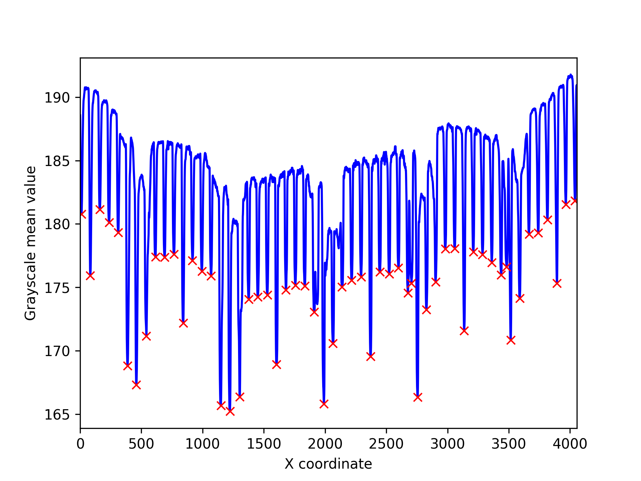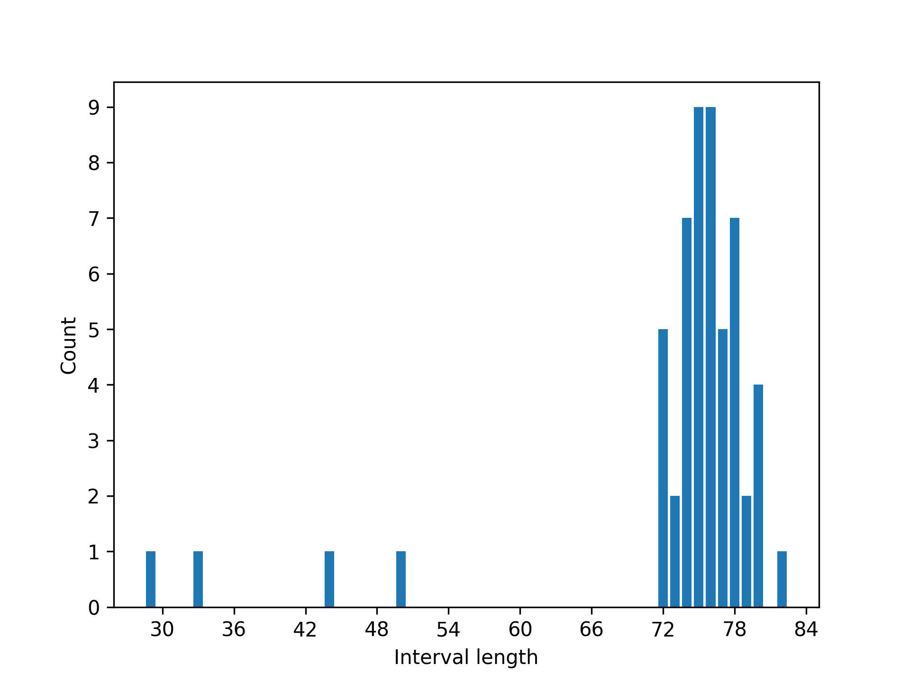
Figure 2. Grayscale and peak analysis of the cropped ruler image with default calibration values.
In order to eliminate unwanted peaks, the minimal peak distance should be increased to 60. Next calibration attempt demonstrates this:
$ calscale.py doc/images/ruler.jpg
Calscale 1.0, (c) Kim Miikki 2021
Current directory:
/home/pi/python/20210518-calscale
Enter unit (Default=mm: <Enter>):
Default unit selected: mm
Horizontal calibration (Y/N, Default y: <Enter>):
Default selected: horizontal mode enabled
Inverse color scale (Y/N, Default n: <Enter>):
Default selected: inverse mode disabled
Select minimal peak distance: (1...2028, Default=10: <Enter>): 60
Select minimal prominence of peaks: (0...255, Default=5: <Enter>):
Default value selected: 5
Select interval length threshold: (0.01...1.0, Default=0.25: <Enter>):
Default value selected: 0.25
qt5ct: using qt5ct plugin
Distance statistics (pixel values):
Peaks : 54
Intervals : 53
Mean : 76.0377358490566
Median : 76.0
Min : 72
Max : 82
Sdev : 2.362939200672192
Calibration value: 76.038 pixels/mm

The second calibration attempt succeeded, and a rounded calibration value is displayed on screen. A log file is also created in addition of distribution plots shown in Figure 3.
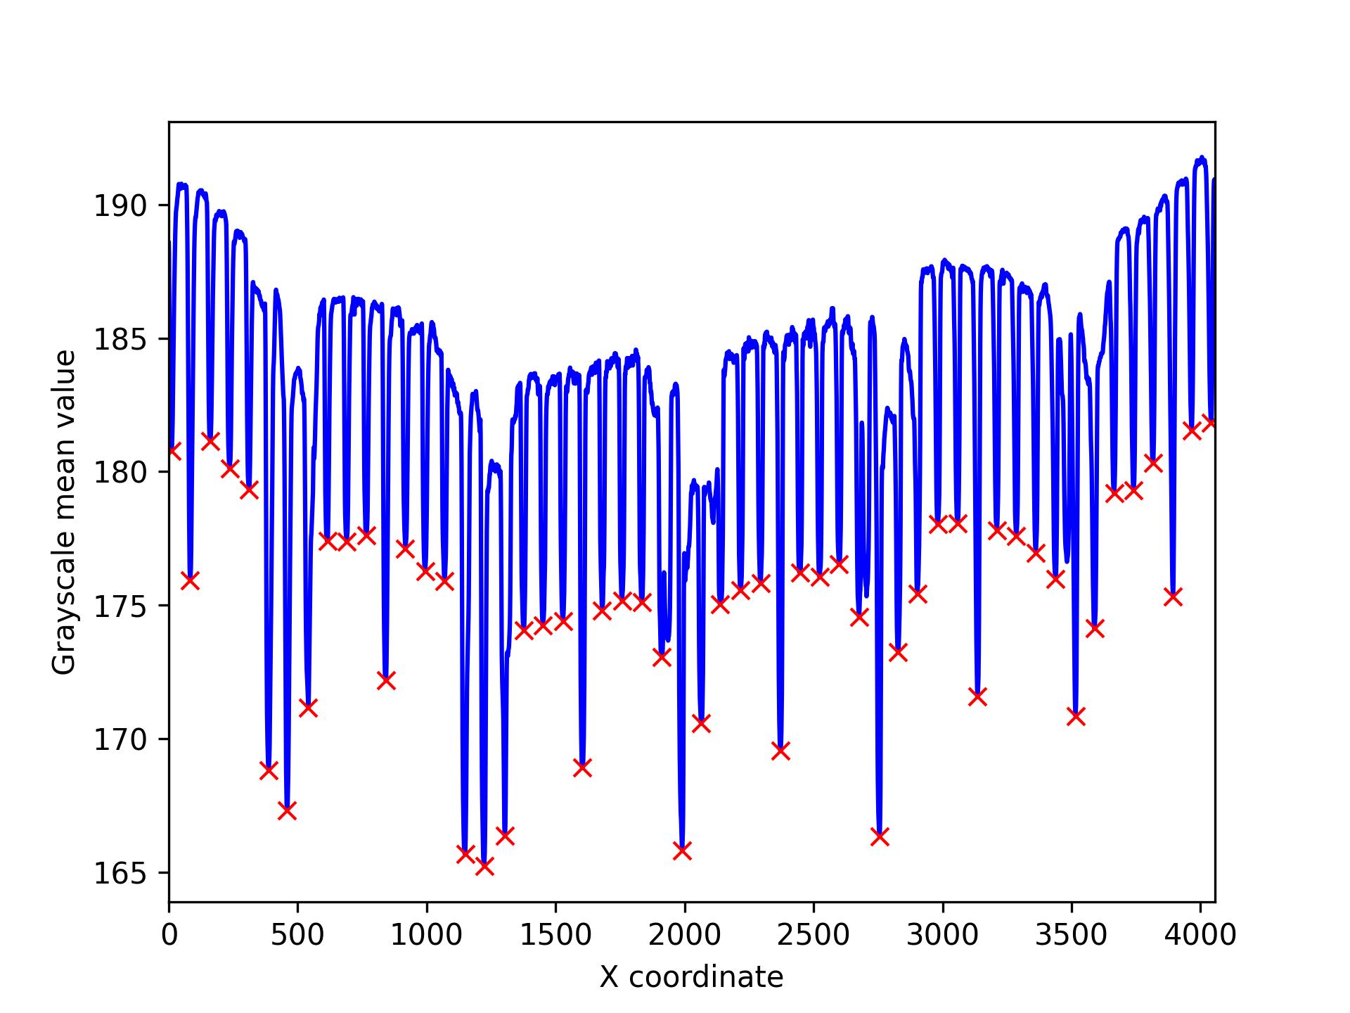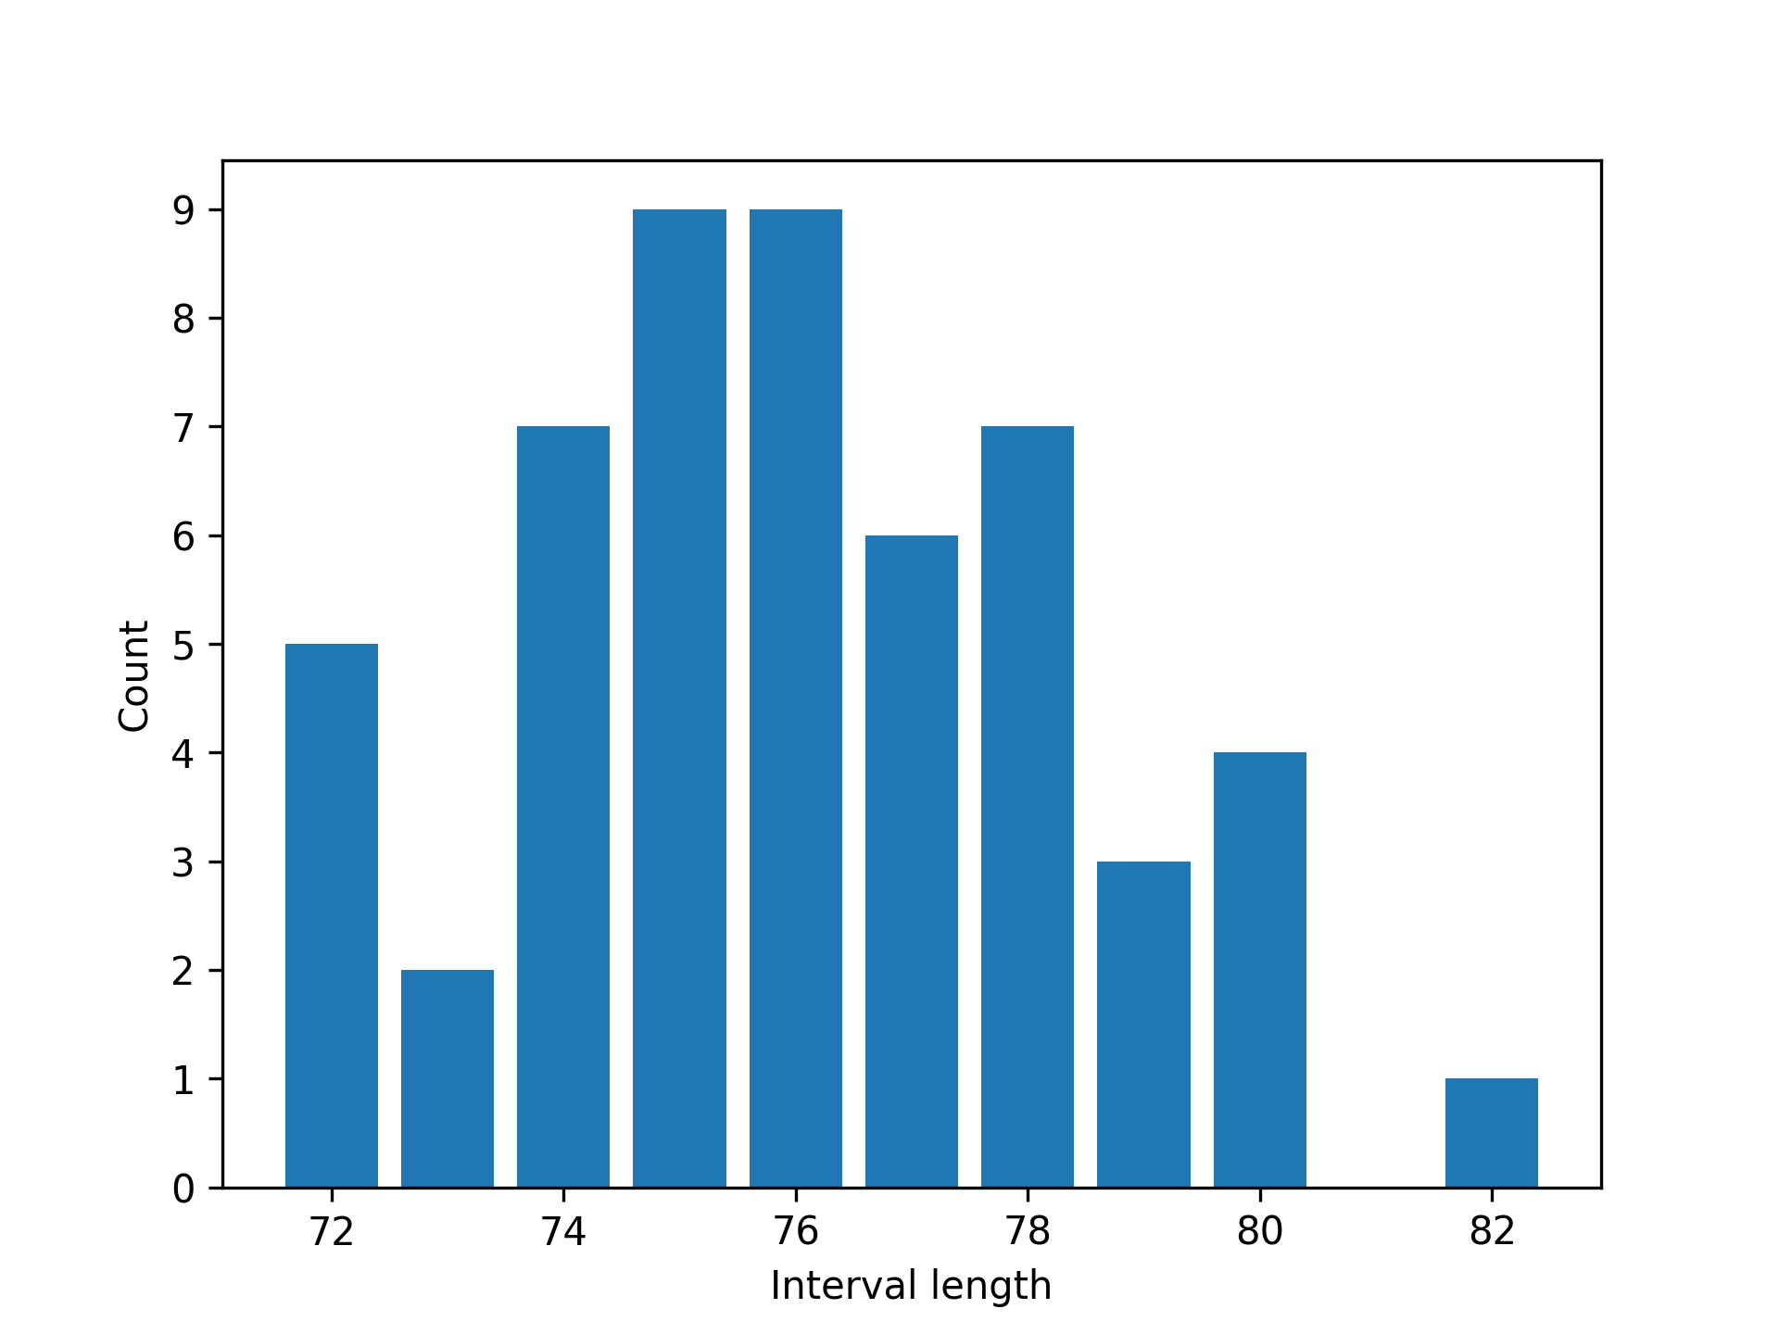
Figure 3. Peak analysis and a distribution plot of a successful calibration.
Calibration statistics and value are shown in a log file (cal-ruler.log):
calscale.py log file
Log created on 2021.05.18-08:58:04
Analysis directory: /home/pi/python/20210518-calscale
Calibration parameters:
Image name : ruler.jpg
Image width : 4056
Image height : 3040
Color channels: 3
Orientation : horizontal
Inverse mode : no
Minimal peak distance : 60
Minimal peak prominence : 5
Interval length threshold: 0.25
Distance statistics (pixel values):
Peaks : 54
Intervals : 53
Mean : 76.0377358490566
Median : 76.0
Min : 72
Max : 82
Sdev : 2.362939200672192
Calibration value: 76.038 pixels/mm

Normally a ROI (region of interest) should be selected, by cropping the image before calibration. This is done in this third calibration attempt:

$ calscale.py doc/images/roi-ruler.png
Calscale 1.0, (c) Kim Miikki 2021
Current directory:
/home/pi/python/20210518-calscale
Enter unit (Default=mm: <Enter>):
Default unit selected: mm
Horizontal calibration (Y/N, Default y: <Enter>):
Default selected: horizontal mode enabled
Inverse color scale (Y/N, Default n: <Enter>):
Default selected: inverse mode disabled
Select minimal peak distance: (1...2004, Default=10: <Enter>):
Default value selected: 10
Select minimal prominence of peaks: (0...255, Default=5: <Enter>):
Default value selected: 5
Select interval length threshold: (0.01...1.0, Default=0.25: <Enter>):
Default value selected: 0.25
qt5ct: using qt5ct plugin
Distance statistics (pixel values):
Peaks : 53
Intervals : 52
Mean : 76.09615384615384
Median : 76.0
Min : 72
Max : 79
Sdev : 1.6555224063327634
Calibration value: 76.096 pixels/mm

This attempt succeeded without any modification of default parameters. Both calibration values are very close to each other (difference < 0.1 %) which indicates that the calibration method is quite robust. It is an indication that some unwanted patterns do not significantly affect the calibration value. Distribution statistics is shown in Figure 4.

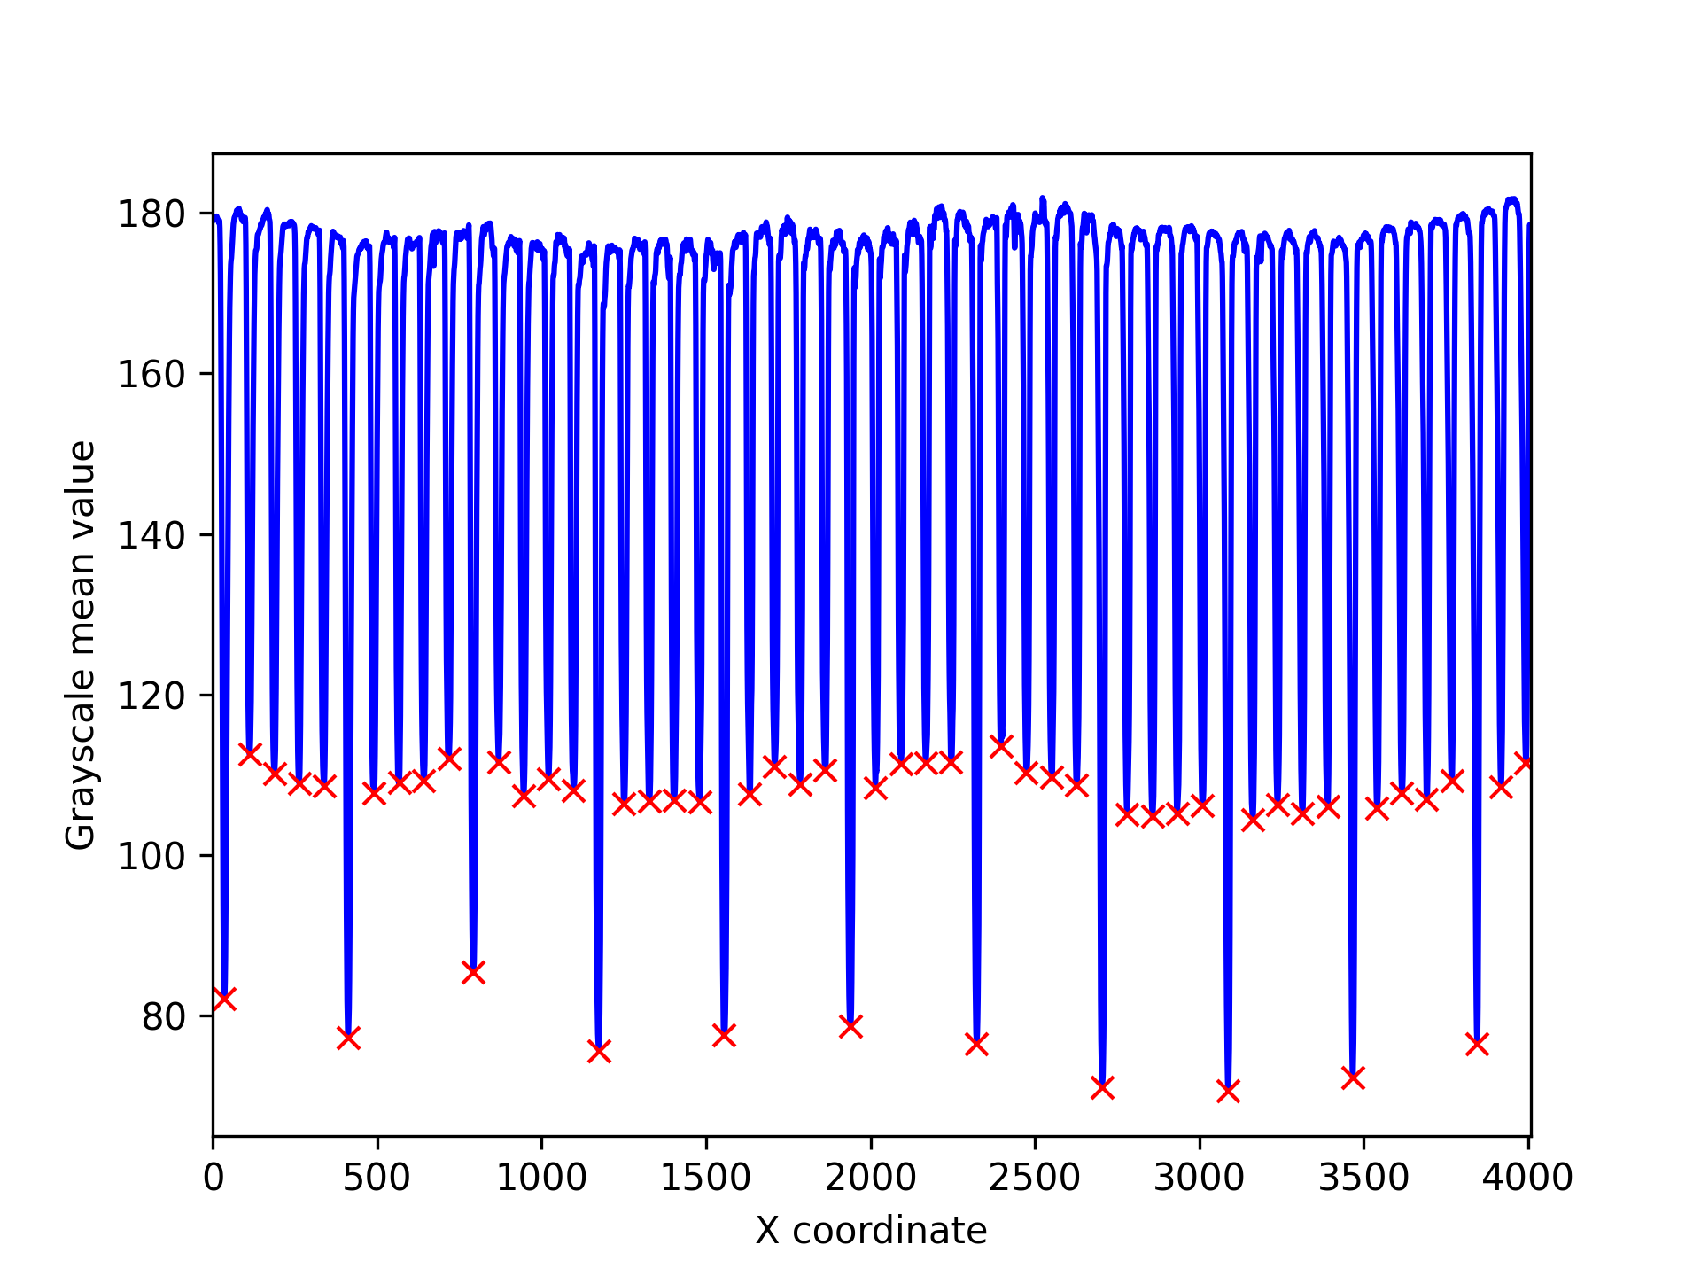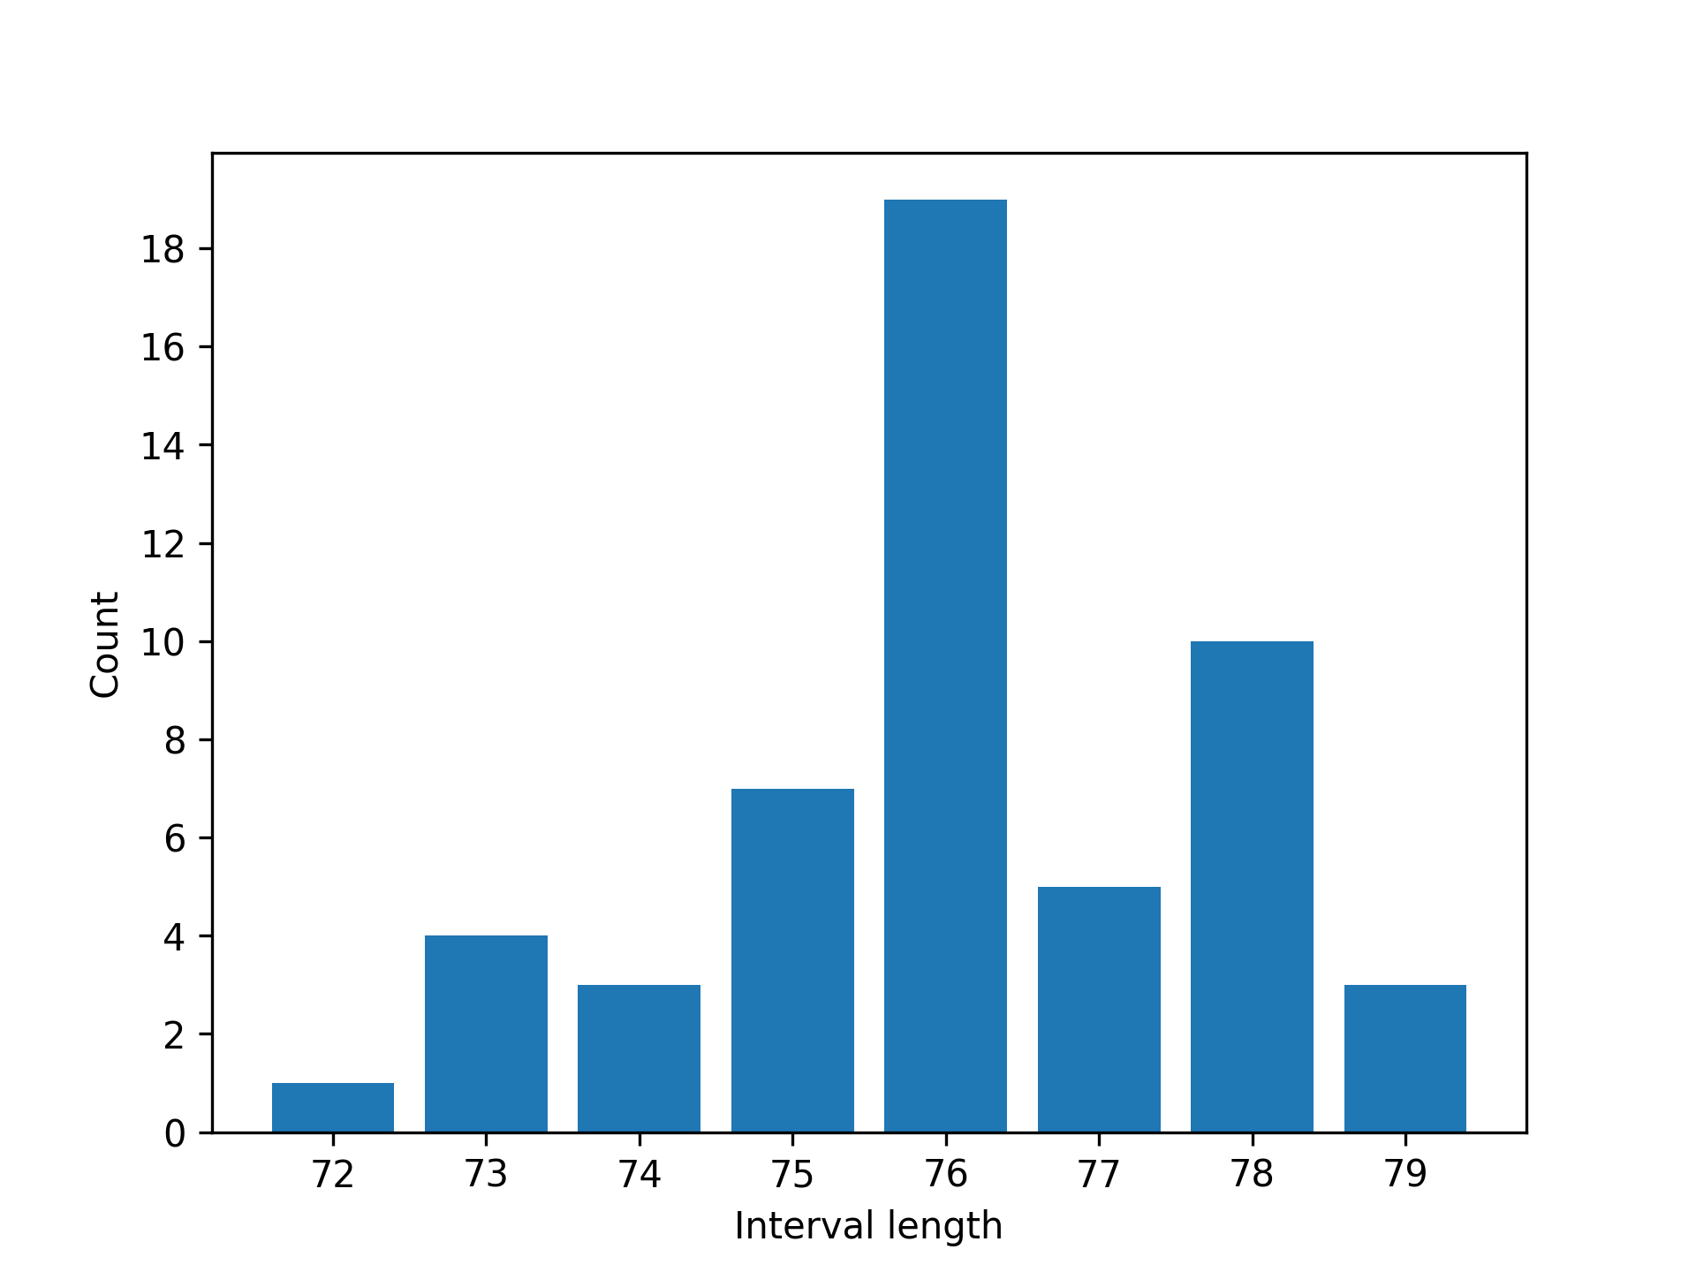

Figure 4. Grayscale analysis and an interval distribution plot of a cropped ruler image.

Calibration of a Graduated Pipette
Setup
- ml graduated pipette
- vertical mode
- normal color mode
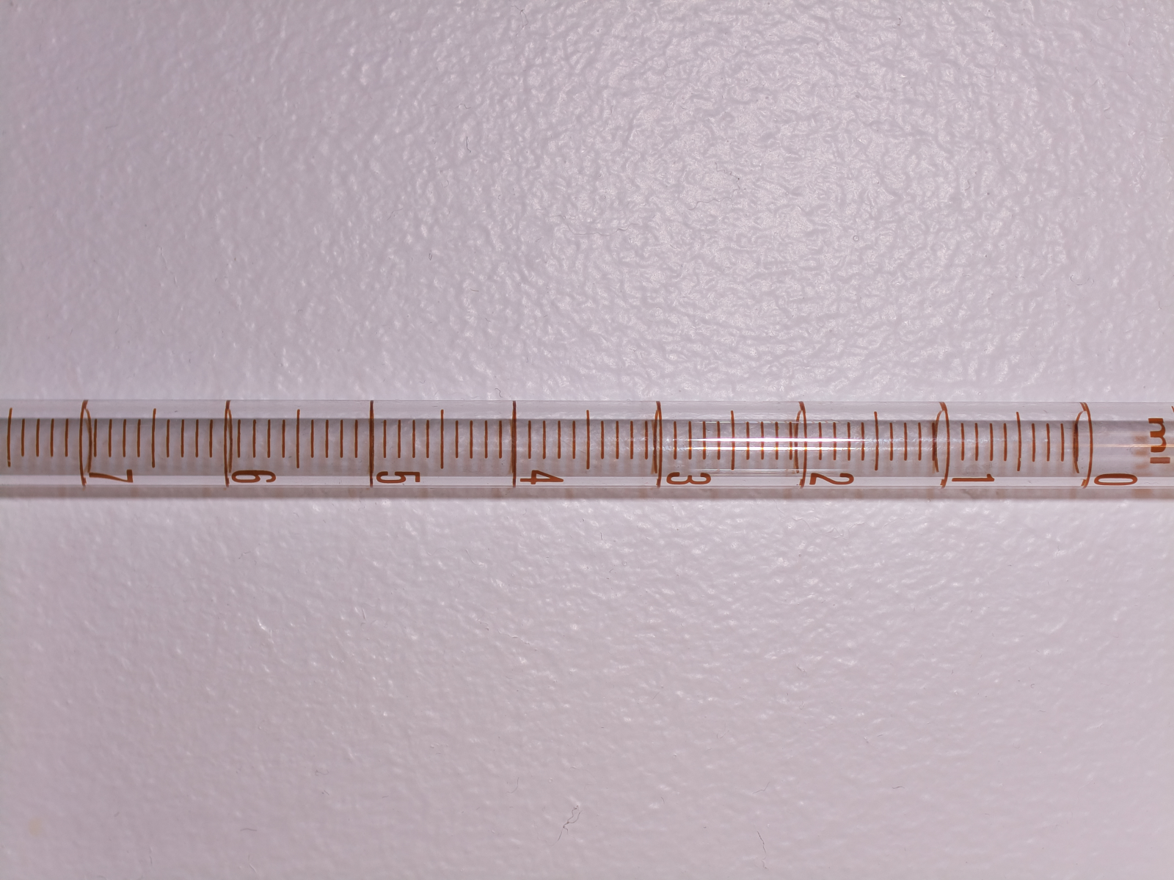
Figure 5. Original, cropped and 90° CCW rotated images of a graduated pipette.
The scale of a graduated pipette was captured, cropped, and rotated 90° counterclockwise. Unit and minimal distance were overridden with ml (unit) and 40 (minimal peak distance). Default orientation is determined from the image aspect ratio (if height>width: vertical, otherwise horizontal).

$ calscale.py doc/images/graduated_pipette_crop_rot.png
Calscale 1.0, (c) Kim Miikki 2021
Current directory:
/home/pi/python/20210518-calscale
Enter unit (Default=mm: <Enter>): ml
Horizontal calibration (Y/N, Default n: <Enter>):
Default selected: horizontal mode disabled
Inverse color scale (Y/N, Default n: <Enter>):
Default selected: inverse mode disabled
Select minimal peak distance: (1...1592, Default=10: <Enter>): 40
Select minimal prominence of peaks: (0...255, Default=5: <Enter>):
Default value selected: 5
Select interval length threshold: (0.01...1.0, Default=0.25: <Enter>):
Default value selected: 0.25
qt5ct: using qt5ct plugin
Distance statistics (pixel values):
Peaks : 64
Intervals : 63
Mean : 49.82539682539682
Median : 50.0
Min : 45
Max : 56
Sdev : 2.3807407313336726
Calibration value: 49.825 pixels/ml

Peak distribution results are shown in Figure 6.

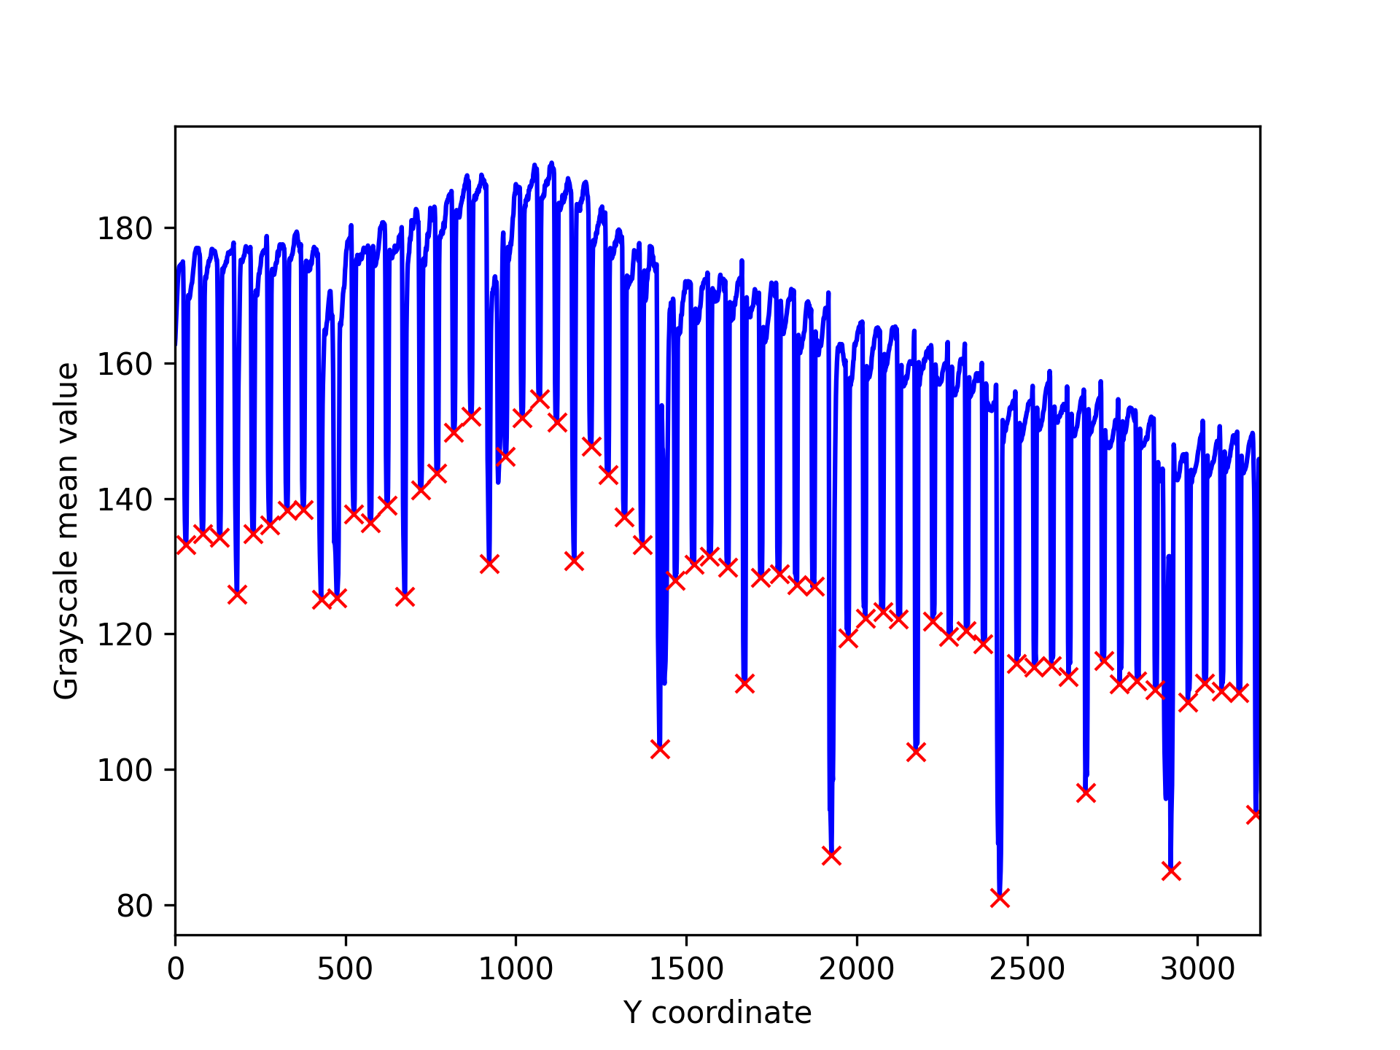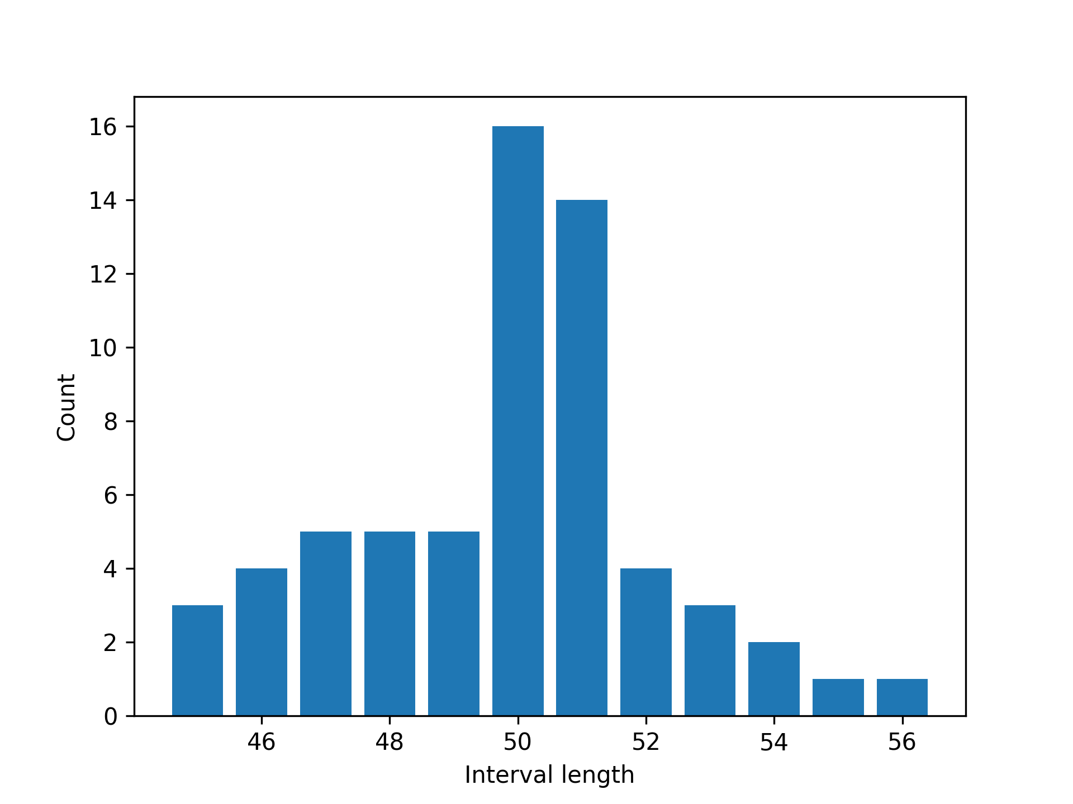

Figure 6. Peak analysis and a distribution plot.

How to Calibrate a Grid in Inverse Color Mode
Setup
- rectangular grid with pattern of 1 cm² squares
- horizontal mode
- inverse color mode
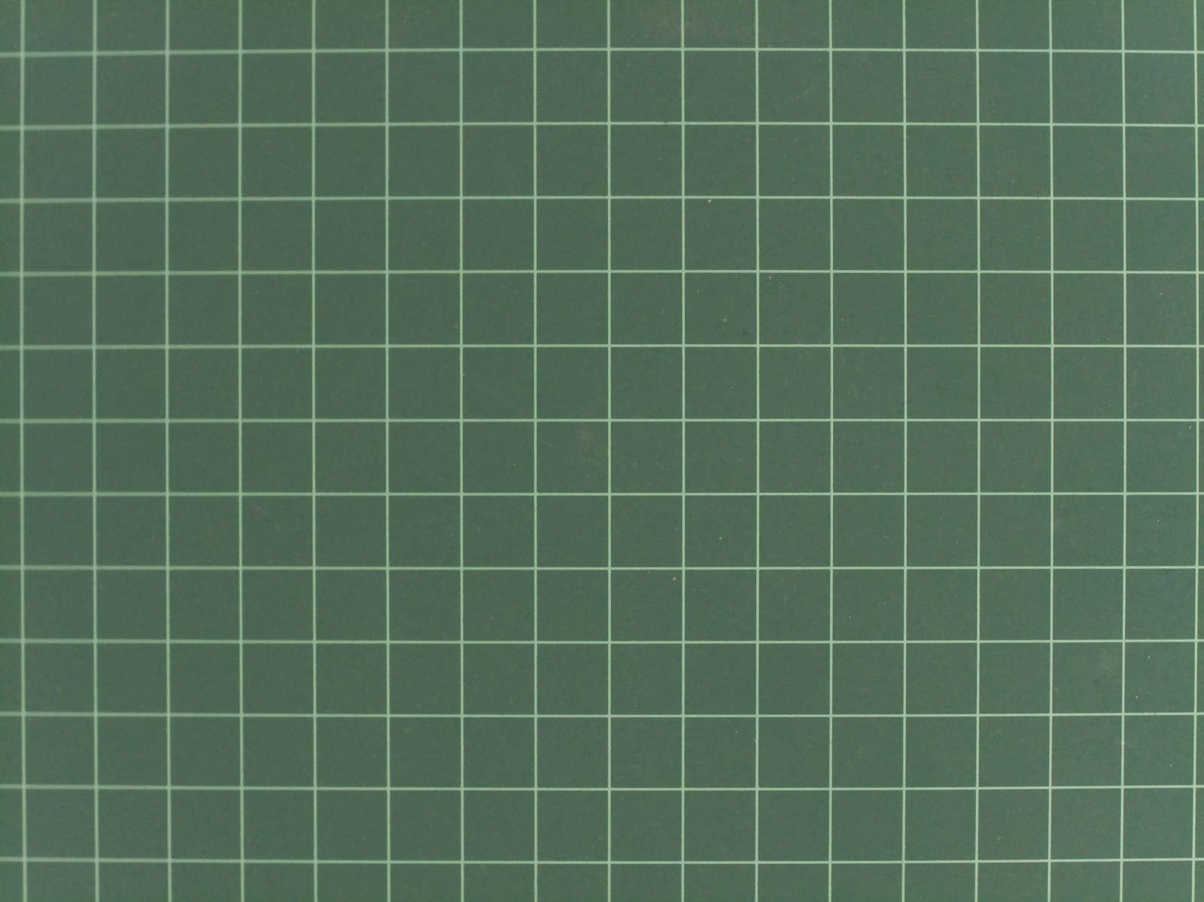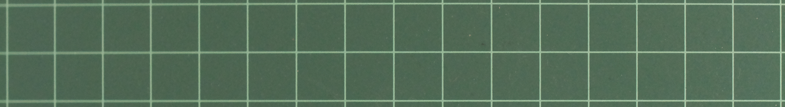
Figure 7. A grid in inverse color mode for calibration.
This example shows how to calibrate a scale when markers are lighter than background. Grayscale analysis detects markers as peaks when they are lighter than background. Therefore no inversion is required for peak detection. However, this kind of color scheme is considered as inverse color mode in calscale.py and inverse mode has to be selected.
$ calscale.py doc/images/grid_2_rows.png
Calscale 1.0, (c) Kim Miikki 2021
Current directory:
/home/pi/python/20210518-calscale
Enter unit (Default=mm: <Enter>): cm
Horizontal calibration (Y/N, Default y: <Enter>):
Default selected: horizontal mode enabled
Inverse color scale (Y/N, Default n: <Enter>): y
inverse mode enabled
Select minimal peak distance: (1...2010, Default=10: <Enter>):
Default value selected: 10
Select minimal prominence of peaks: (0...255, Default=5: <Enter>):
Default value selected: 5
Select interval length threshold: (0.01...1.0, Default=0.25: <Enter>):
Default value selected: 0.25
qt5ct: using qt5ct plugin
Distance statistics (pixel values):
Peaks : 17
Intervals : 16
Mean : 247.625
Median : 248.0
Min : 244
Max : 251
Sdev : 2.117634293262177
Calibration value: 247.62 pixels/cm

The colors are uniform in this example and there are no other disturbing patterns. Hence, the default parameters were not needed to be modified. The results are shown in Figure 8.

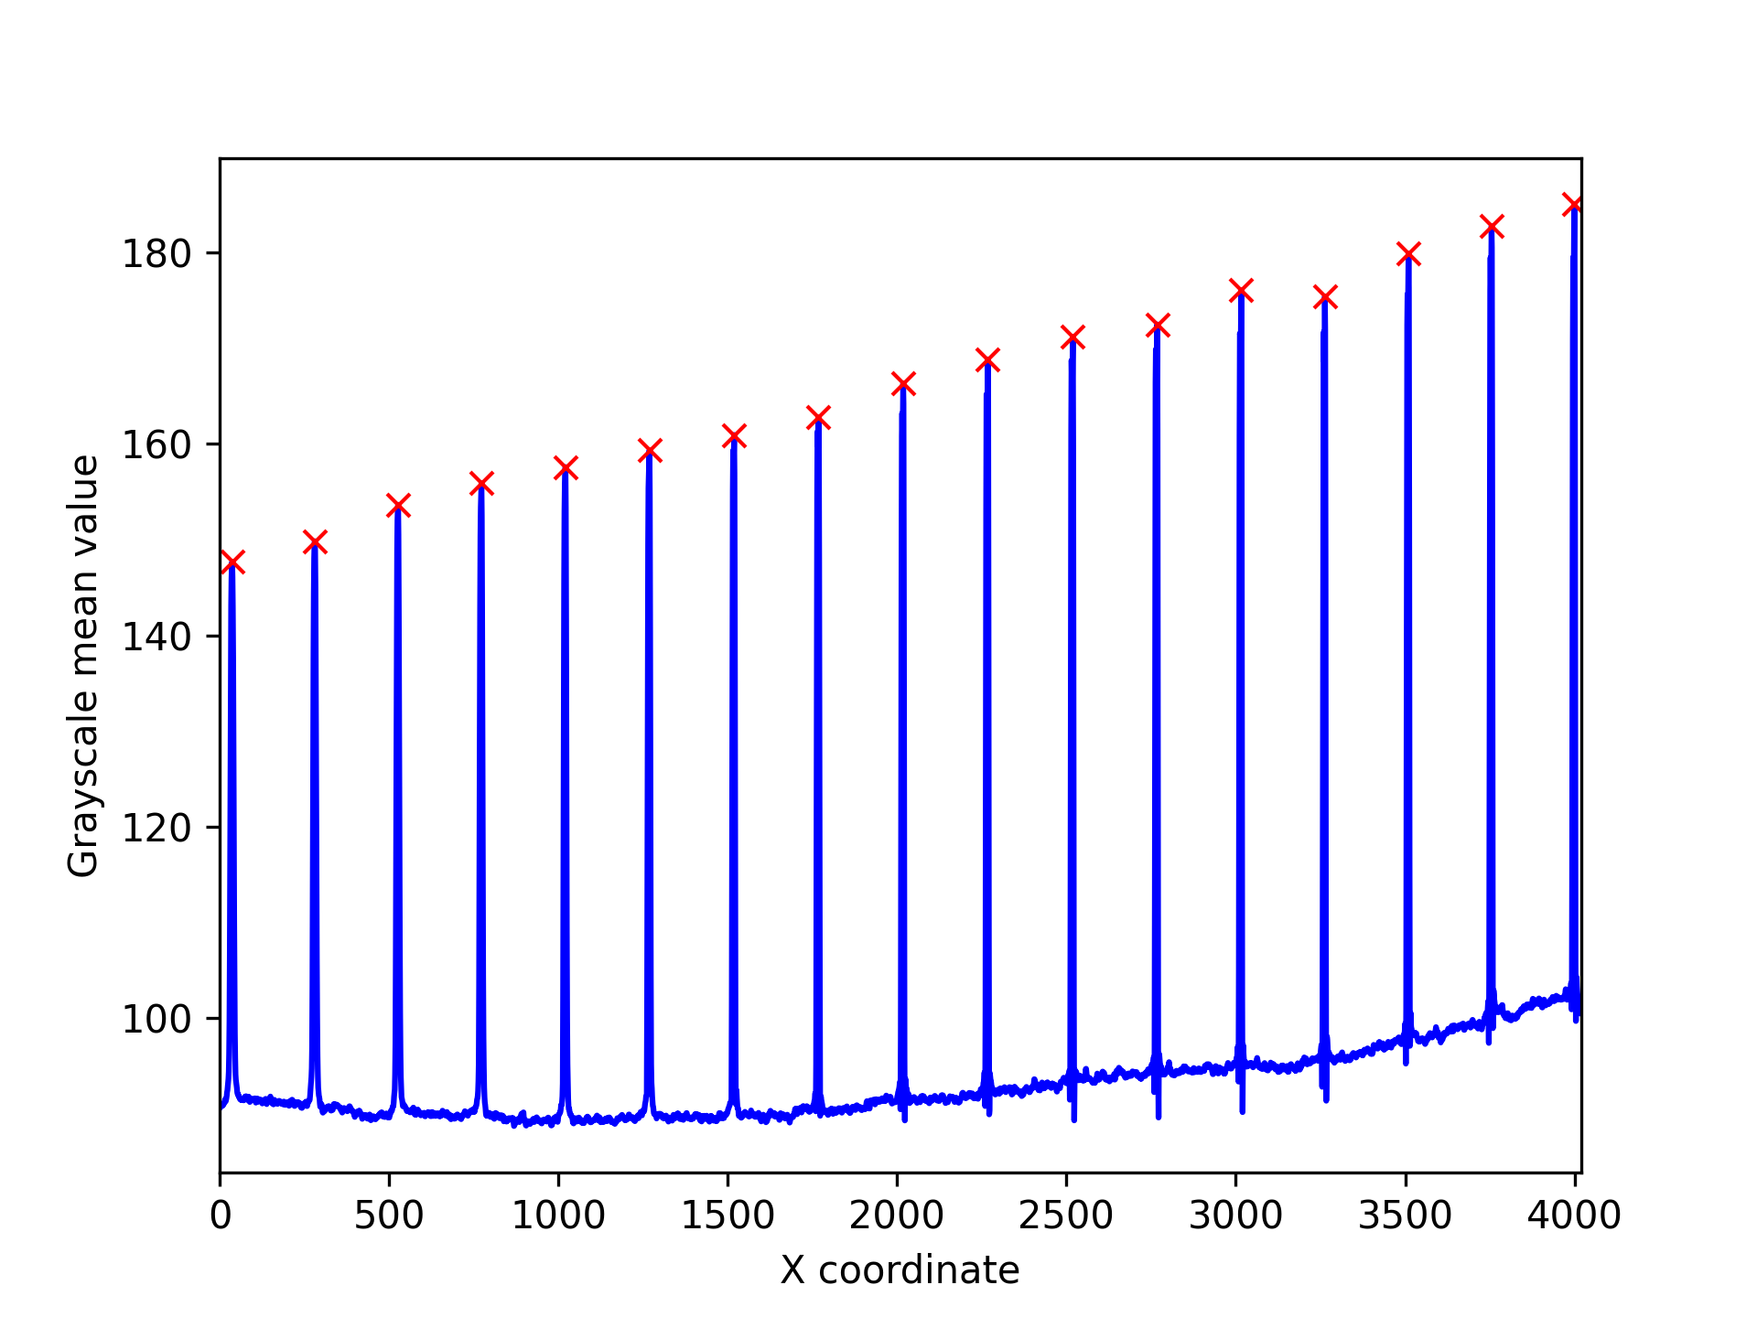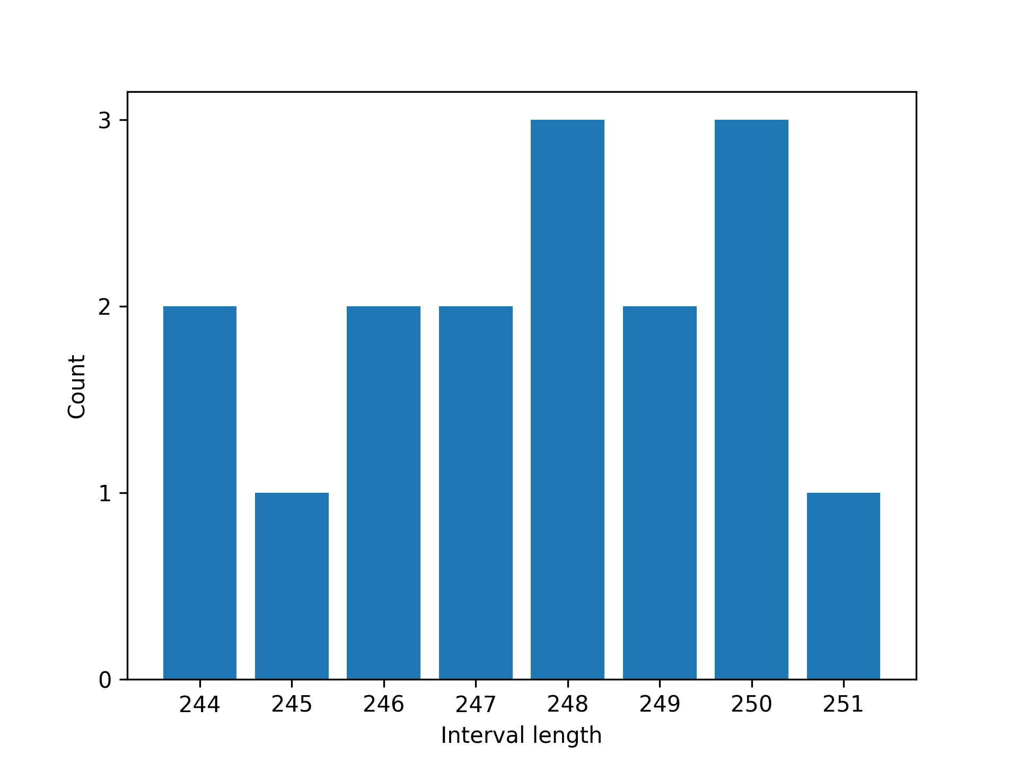

Figure 8. Grayscale analysis of the grid and an interval distribution bar plot.

