rgbxy Guide
Author: Kim Miikki
Date: 23.1.2022

Introduction
Directional RGB analysis can be performed easily row or column wise. The method gives reduced structural information of the image. It is typically used to find edges in the picture, either horizontally or vertically. Selecting a ROI of the subject, will usually increase the sensitivity of this method.

System Requirements
Operating System: Raspberry Pi OS or Linux
Python 3 with Matplotlib and Numpy

Directional Color Analysis
This program (rgbxy.py) performs directional color analysis on all images found in the current directory. Red, green and blue channels mean values are calculated line or row wise, the results are plotted and saved in one or separate subdirectories. BW or gray means are calculated from the three color channel mean values.

Program Usage
The program should be executed in the directory where the images are located. All optional arguments can be listed with argument -h:
$ rgb-sgraph -h
optional arguments:
-h, --help show this help message and exit
-s X and Y figures in separate directories
-i save images with coordinates
-rgb analyze RGB channel means
-bw analyze BW means
-x analyze RGB means in x direction
-y analyze RGB means in y direction
-n no CSV files
All analysis results are saved under a subdirectory named ‘rgb’, unless the -s option has been selected. In this case the analysis directories are: rgb, rgbx and rgby.

Here is a list of the analysis files prefixes and suffixes, and their meanings:
Prefix | Abbreviation or Usage
analysis.log | Analysis log file
img-*.png | Image map (X and Y coordinates added to the image)
x-*.csv | Color profile mean values in X direction
xBW-*.png | X direction color analysis gray scale graph of the image
xRGB-*.png | X direction RGB color analysis graph of the image
y-*.csv | Color profile mean values in Y direction
yBW-*.png | X direction color analysis gray scale graph of the image
yRGB-*.png | X direction RGB color analysis graph of the image
Table 1. Image analysis data files prefixes and suffixes.

Use Case – Detection of a Weak Line
In January 2022, two individuals performed some in vitro test for the SARS-CoV-2 antigen. The images were captured with a 35 mm telephoto lens (F/8, 0.020 s) attached with 3 extension tubes to a Raspberry Pi HQ camera with following commands:
raspistill -ss 20000 -awbg 2.1744,2.5017 -awb off -ISO 100 -t 5000 -o person1_test1_pos.png
raspistill -ss 20000 -awbg 2.1744,2.5017 -awb off -ISO 100 -t 5000 -o person2_test1_weak.png
raspistill -ss 20000 -awbg 2.1744,2.5017 -awb off -ISO 100 -t 5000 -o person2_test2_weak.png
raspistill -ss 20000 -awbg 2.1744,2.5017 -awb off -ISO 100 -t 5000 -o person2_test3_neg.png
A LED with 2800 K color temperature was used as the main light source, as well as the ambient room lightning (2 x LED 2800 K). The red and blue gains were calibrated with the main light source.
The cropped images are shown in the following figure:
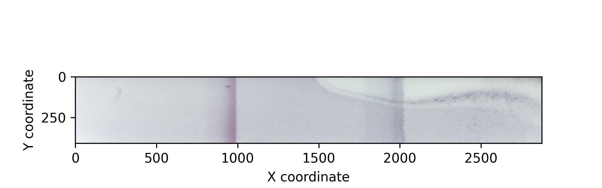 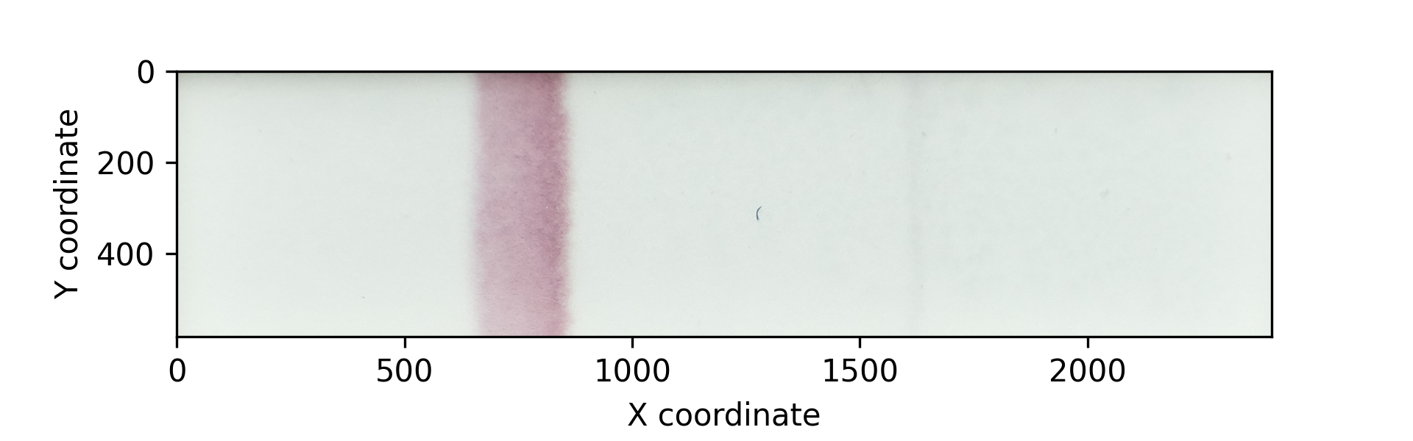
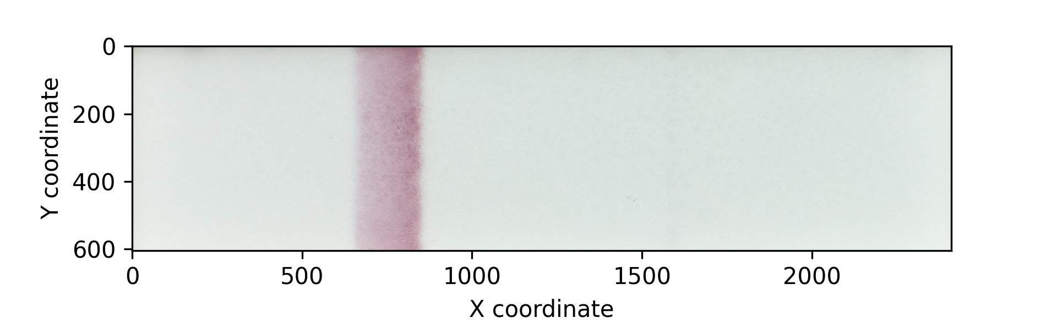 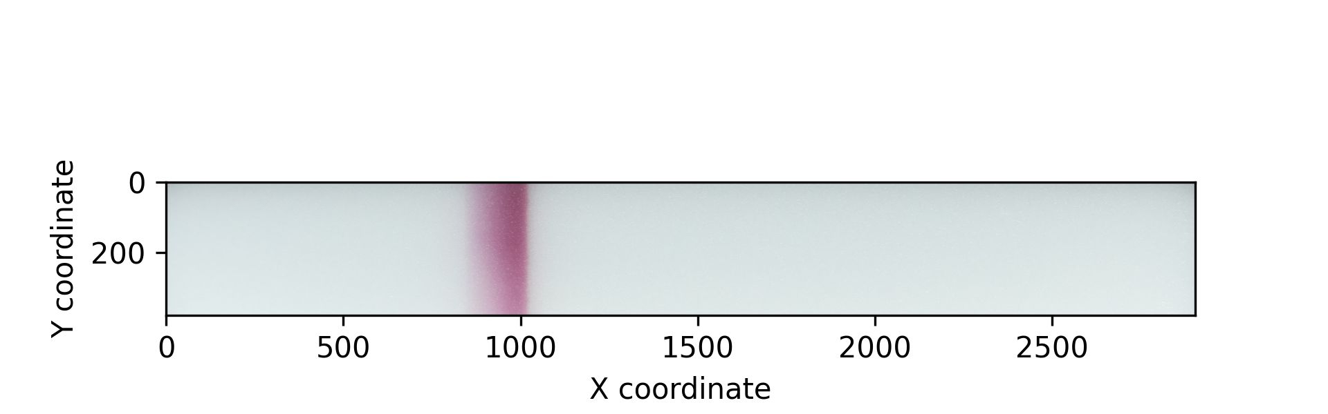
Figure 1. Top left: person 1, test 1, positive; Top right: person 2, test 1, weak positive; Bottom left: person 2, weak positive; Bottom right: person 2, negative

The rgbxy.py was executed with following options (analysis.log):
RGBXY version 2.0
Analysis directory: /media/pi/data/measurements/20220123-covid19-tests/roi
Options
-------
Create separate X and Y directories: Yes
Save images with coordinates: Yes
Analyze RGB channel means: Yes
Analyze BW means: Yes
Analyze RGB means in x direction: Yes
Analyze RGB means in y direction: Yes
Write CSV files: Yes
Command:
rgbxy.py -s -i -rgb -bw -x -y
Analyze:
1_person1_test1_pos.png: 2875x410
2_person2_test1_weak.png: 2405x583
3_person2_test2_weak.png: 2411x604
4_person2_test3_neg.png: 2904x377
Pictures analyzed: 4
Time elapsed: 0:00:22.094556
The directional analysis in horizontal (X) direction graphs are shown in figures 2 and 3.
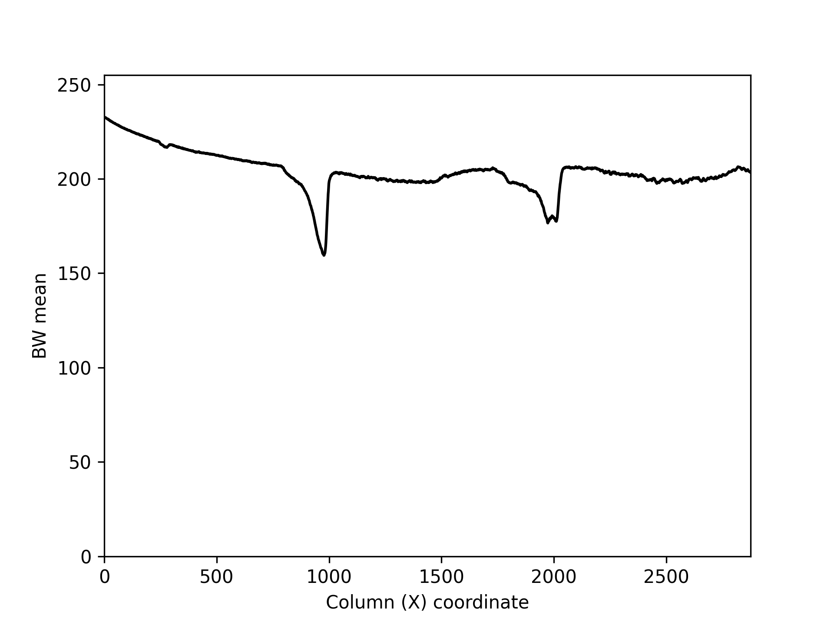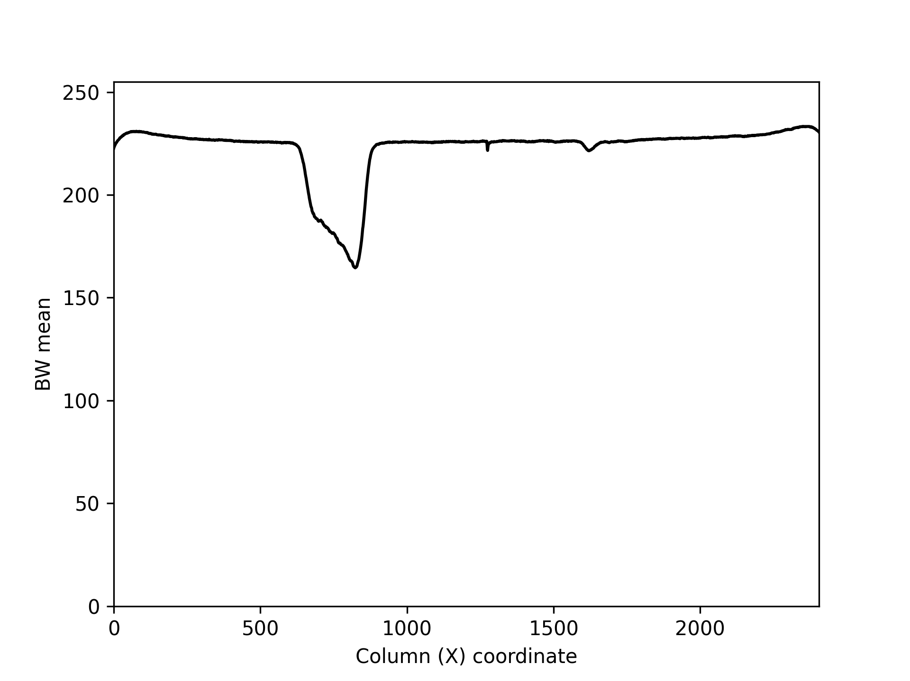
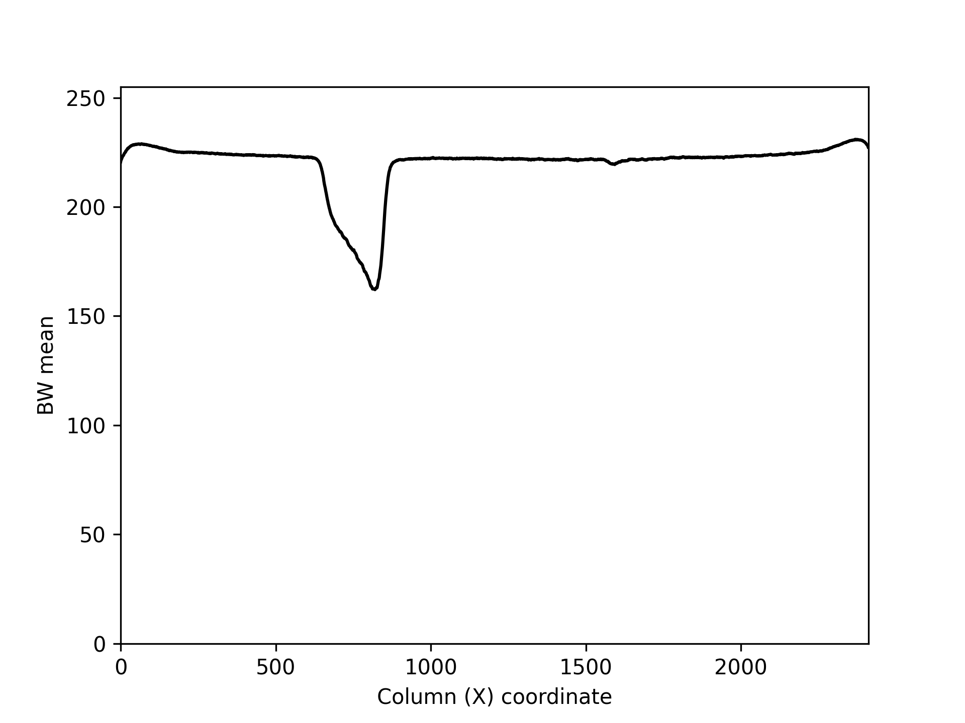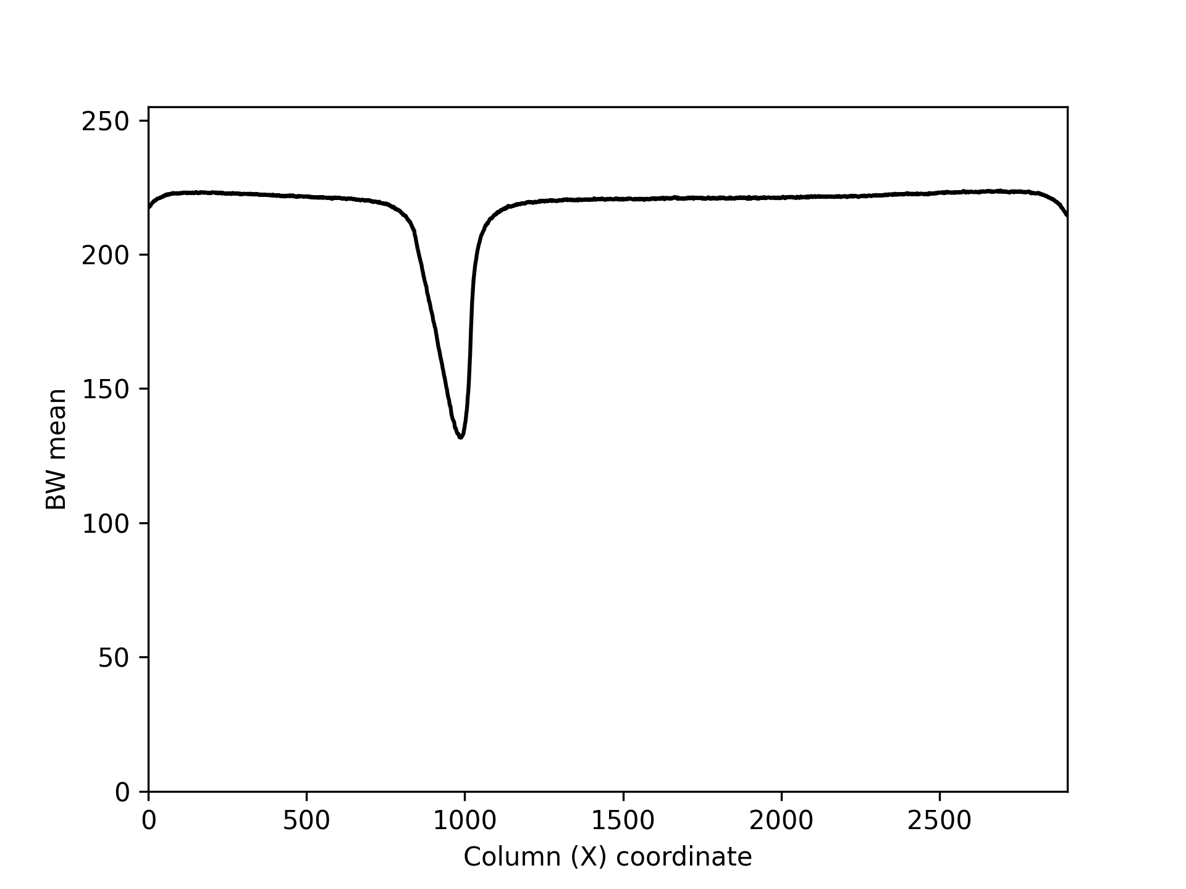
Figure 2. Directional horizontal color analysis: gray scale mean values. First valley indicates the control line (C) and the second valley between 1500 and 2000 indicates the test line (T). The first test is positive, next two weakly positives and the last negative.
The weak test line is more visible in directional RGB graphs (Fig. 3).
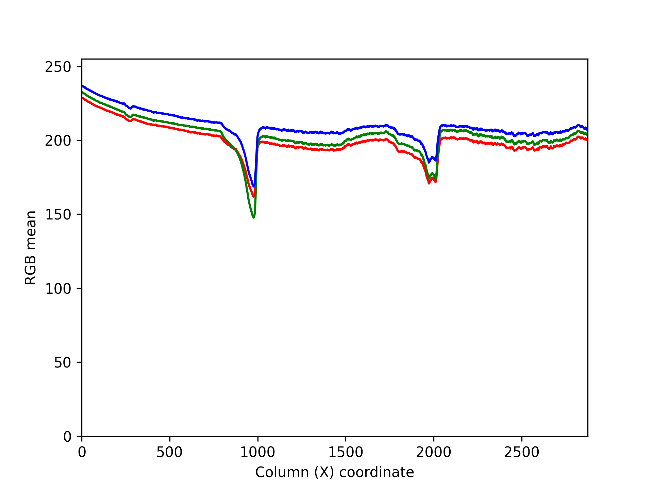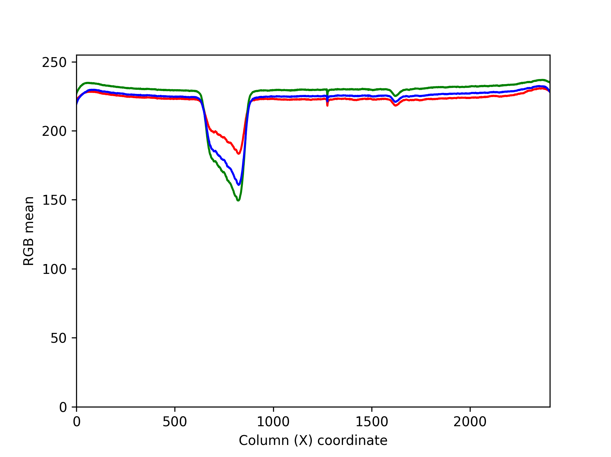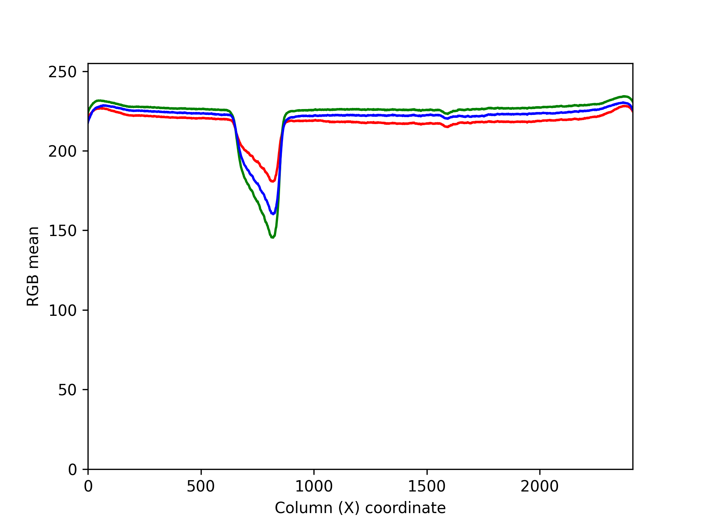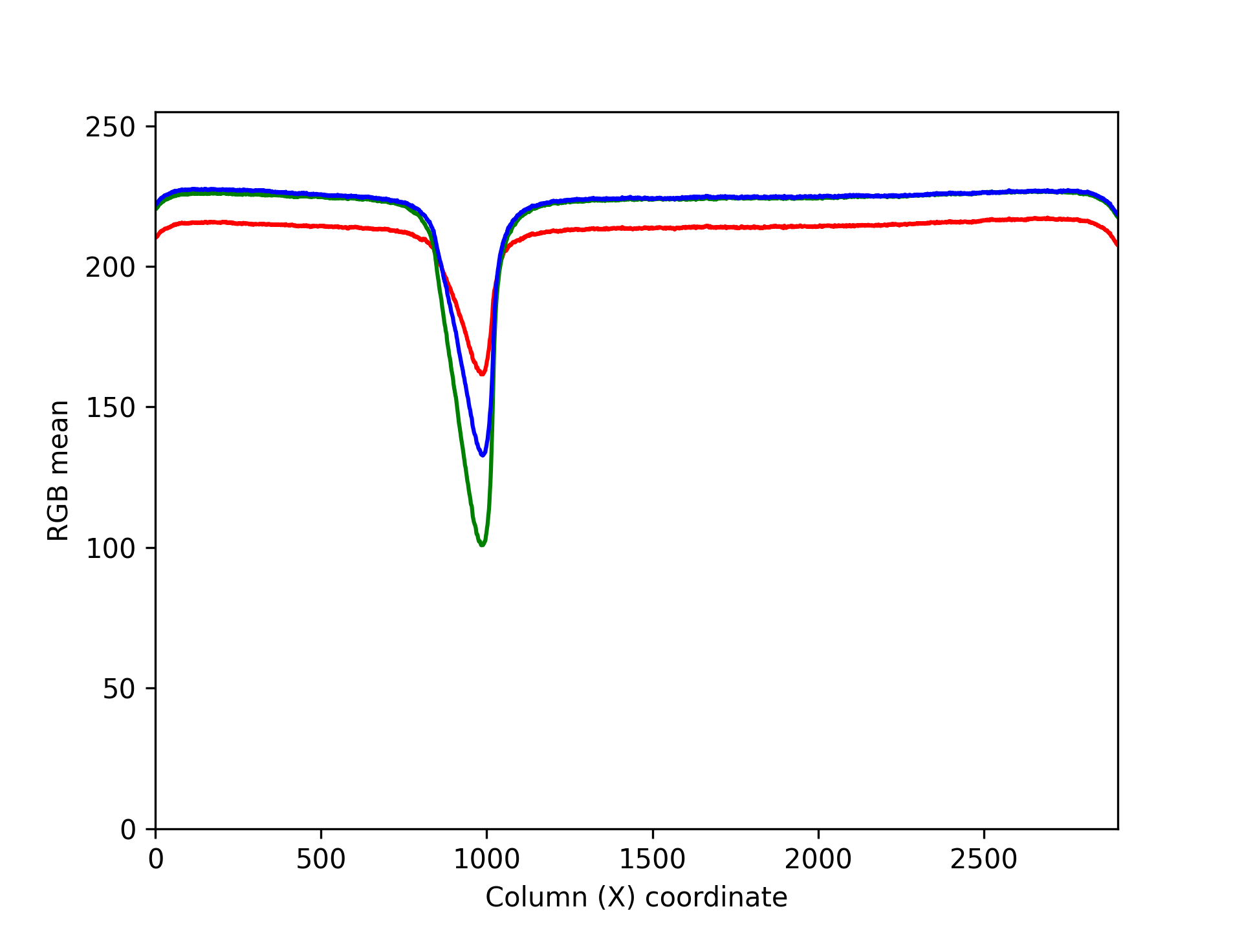
Figure 3. Directional RGB color analysis of SARS-CoV-2 antigen test cards.

