Ocean-analyze Guide
Author: Kim Miikki
Date: 2.11.2021

Introduction
The spectral data parsed with ocean2csv.py can be analyzed with the ocean-analyze.py. This program will create ordinary or transmission spectra as plots and text data.

System Requirements
Operating System: ALL
Python 3 with NumPy, Matplotlib, Pandas and scikit-learn.

Spectral Methods
This program supports two different spectral methods: normal and transmission. The first method creates mean spectra plots, where y axis is Intensity in counts. The second method creates spectral mean transmission plots. The mean spectrum is calculated form accepted scans in its scan range (= scans/sample). The acceptance is controlled with an area under curve threshold. The threshold is at default (2/3 of highest area or 2/3 of highest area mean of 1...N-1 areas). When the area falls under the mean area, the spectral data is discarded within other smaller-area data in the same scan series. An area plot is created when more than one spectrum is analyzed.

Program Usage
The program arguments are listed in Table 1.
Argument | Description
-h, --help | show this help message and exit
-s S | scans/spectrum
-t T | threshold value: 0.01-0.99
-d | display images on screen
-i | ignore threshold
-g | enable grid
-y | auto y axis
-ts | transmission spectra
Table 1. Program arguments.
At least scans/spectrum is asked if running the program without any arguments. The first spectrum is analyzed, and if trying to analyze transmission spectra as ordinary spectra, a data type question is asked if the transmission degree is at least 5 %. The grid can be enabled with the argument -g and auto y axis with the argument -y. When analyzing transmission spectra, the argument -ts should be used.

Use Cases
The usage of this program is demonstrated in the following subsections.

Analyzing Normal Spectra Files
Spectra parsed with ocean2csv.py were analyzed with ocean-analyze.py:
$ ocean-analyze.py
Ocean spectrometer CSV spectra analyzer
File format: CSV with a header line
Current directory:
/home/pi/python/20211102-ocean/data
Select scans/spectrum: (1...35, Default=1: <Enter>): 5
Processing:
00-20211021_FLMT044961__0__16.csv
01-20211021_FLMT044961__1__17.csv
02-20211021_FLMT044961__2__18.csv
03-20211021_FLMT044961__3__19.csv
04-20211021_FLMT044961__4__20.csv
00-spectrum-mean_(5#5).csv
...
30-20211021_FLMT044961__30__46.csv
31-20211021_FLMT044961__31__47.csv
32-20211021_FLMT044961__32__48.csv
33-20211021_FLMT044961__33__49.csv
34-20211021_FLMT044961__34__50.csv
30-spectrum-mean_(5#5).csv
Saving area files
The scans value was 5, therefore a set of five spectra is analyzed and compared with the area under curve. An analysis subdirectory is created for analysis files. In this case following files were created:
$ ls
'00-spectrum-mean_(5#5).csv' '20-spectrum-mean_(5#5).csv'
'00-spectrum-mean_(5#5).png' '20-spectrum-mean_(5#5).png'
'05-spectrum-mean_(5#5).csv' '25-spectrum-mean_(4#5).csv'
'05-spectrum-mean_(5#5).png' '25-spectrum-mean_(4#5).png'
'10-spectrum-mean_(5#5).csv' '30-spectrum-mean_(5#5).csv'
'10-spectrum-mean_(5#5).png' '30-spectrum-mean_(5#5).png'
'15-spectrum-mean_(5#5).csv' spectra-areas.csv
'15-spectrum-mean_(5#5).png' spectra-areas.png
The mean spectrum per scan series is stepped by 5. The first number correspond to the scan set. The PNG files contains the plots and CSV the data. The first spectrum is shown in Fig. 1.
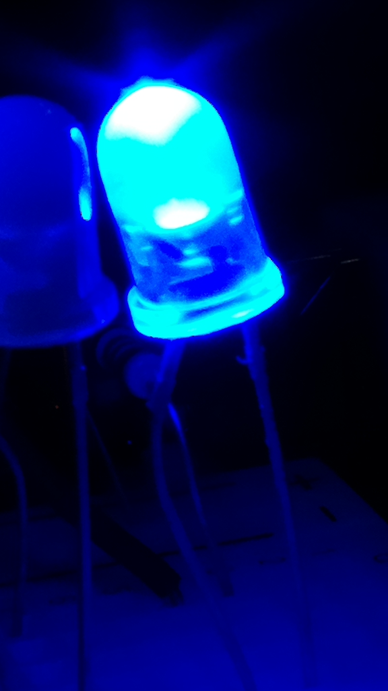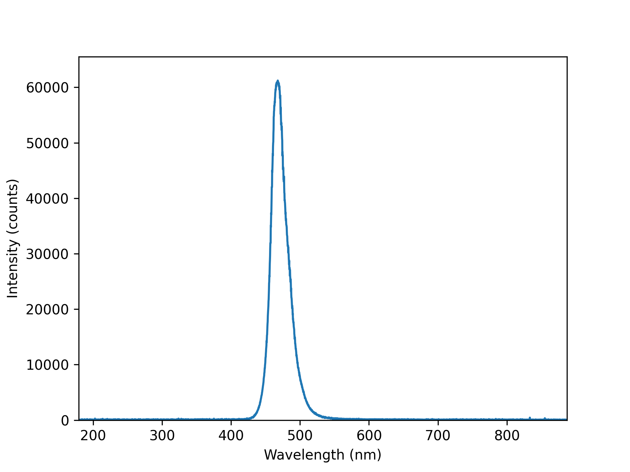
Figure 1. Blue LED on the left and its spectrum on the right.
The spectrum data is saved in a csv file:
$ head 00-spectrum-mean_\(5#5\).csv
Wavelength (nm),Intensity (counts)
179.018,-271.09
179.241,-271.09
179.464,-271.09
179.687,-249.606
179.91,-12.238
180.133,-28.44
180.356,18.048
180.578,-28.438
180.801,27.912
The 5#5 indicate that 5 spectra of 5 are accepted to the mean spectrum. The area curve for all scans are shown in Figure 2.
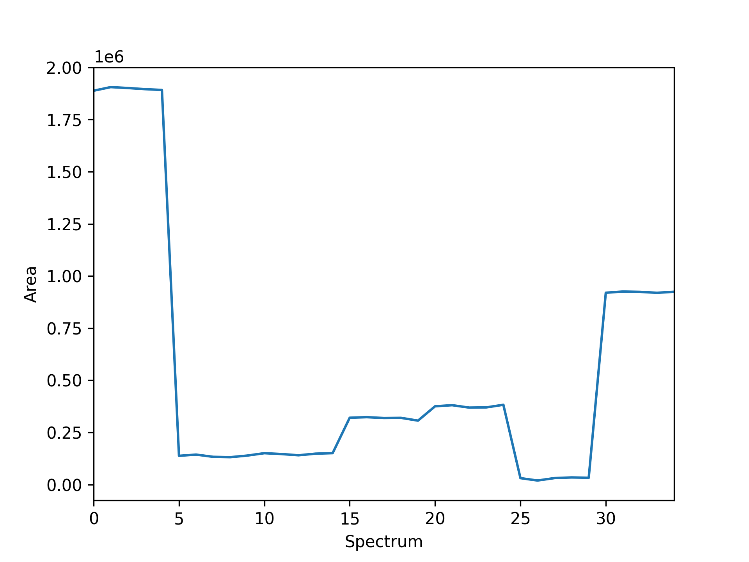
Figure 2. Spectra areas when the number of scans/series is 5.

Analyzing an IR-pass Filter in Transmission Mode
The transmittance of an infrared pass filter was measured with an Ocean spectrometer, the data was parsed with ocean2csv.py and finally the data was analyzed and plotted with ocean-analyze.py:
$ ocean-analyze.py -g -ts -s 5
Ocean spectrometer CSV spectra analyzer
File format: CSV with a header line
Current directory:
/home/pi/python/20211102-ocean/bw/data
Processing:
0-20211021_Transmission__35__35.csv
1-20211021_Transmission__36__36.csv
2-20211021_Transmission__37__37.csv
3-20211021_Transmission__38__38.csv
4-20211021_Transmission__39__39.csv
0-transmission-spectrum-mean_(5#5).csv
qt5ct: using qt5ct plugin
Saving area files
The mean transmission spectrum is shown in Figure 3.
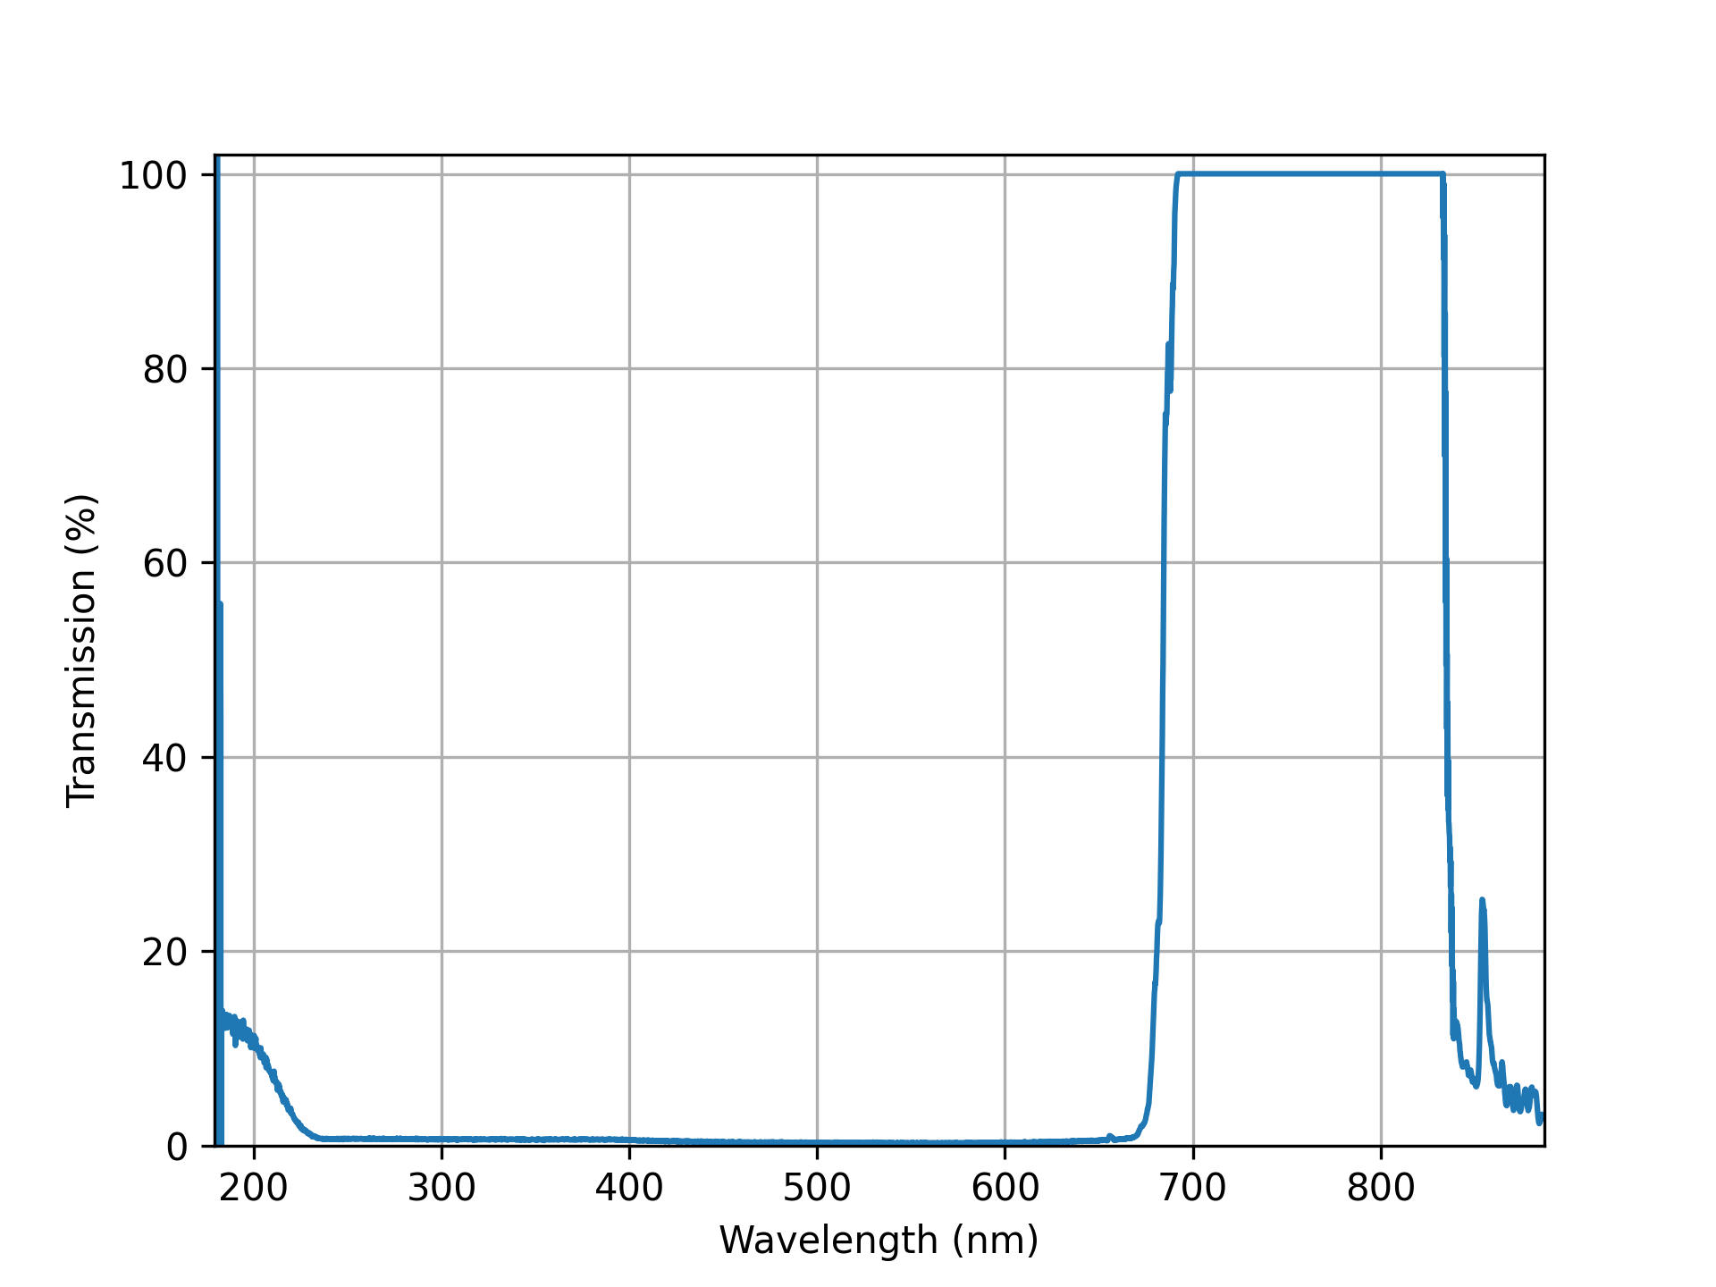
Figure 3. B+W 092 (DARK RED 20-40X) ø 55 mm filter transmission spectrum.

