autocrop Guide
Author: Kim Miikki
Date: 18.2.2022

Introduction
Unwanted image marginals should often be removed. This task can be automated by using autocrop.py. RGB mean values for each side of the image are calculated, then the selection rectangle is minimized column and row, wise until the new mean value differs from the last mean value. The required difference can be controlled with a threshold value. Also new marginals can be set from the the found crop rectangle.

System Requirements
Operating System: Raspberry Pi OS or Linux
Python 3 with OpenCV

Program Usage
The program should be executed in the directory where the images are located. All optional arguments can be listed with argument -h:
$ rgb-sgraph -h
usage: autocrop.py [-h] [-i I] [-o] [-x X] [-y Y] [-t T] [-f]
optional arguments:
-h, --help show this help message and exit
-i I input file name
-o preserve original file format
-x X maximum horizontal marginal as integer
-y Y maximum vertical marginal as integer
-t T threshold value as float, 1e-09 < t <= 255
-f fix odd dimensions by adjusting crop marginals
Cropped images are saved under a subdirectory named ‘crop’. Here is a list of currently supported file formats: .png, .jpg, .bmp, .tif, .tiff, .dib, .jpeg, .jpe, -pbm, .pgm, .ppm, .sr and .ras.
In single file mode (-i) a roi.in file is created. Unless the -i option is used, the program is executed in a batch mode, and it tries to autocrop all images in current directory. Original file format is preserved with argument -o. Fixed maximum marginals can be set with arguments -x and -y. Possible odd dimensions can be fixed with the then -f argument to even. It is done by extending or reducing the left and the bottom marginals by one pixel.
Without a threshold value (argument -t), even a smallest difference between the current and the last RGB mean values will stop the search of the marginal. Large threshold values often causes excess cropping. The rgbxy.py tool can be used for determining a optimal threshold value.

Use Cases
The usage of this program is demonstrated in this guide with two uses cases: cropping Finlands state flag and cropping text areas with marginals.

Cropping the coat of arms from the state flag of Finland
The state flag of Finald is shown in figure 1.

Figure 1. Flag of Finland (state).
The coat of arms is cropped easy with the following command:
$ autocrop.py -t 40
Autocrop 1.0, (c) Kim Miikki 2022
Current directory:
/media/pi/data
Processing:
Flag_of_Finland_(state)_2560px.png, size 2560x1564
Files processed: 1
Time elapsed: 0:00:01.134477
The cropped image is shown in figure 2.

Figure 2. Coat of arms of Finland.

Cropping Text with Marginals and even dimensions
Two ‘Lorem Ipsum’ images were cropped with autocrop with 16 pixels x and y marginals, and adjusted to even dimensions with this command:
$ autocrop.py -x 16 -y 16 -f
Autocrop 1.0, (c) Kim Miikki 2022
Current directory:
/media/pi/data/transfer/20220218-autocrop-doc
Processing:
1280px-Lorem_ipsum_design_part.png, size 388x550
lorem_ipsum_dark.png, size 640x281
Files processed: 2
Time elapsed: 0:00:00.091481
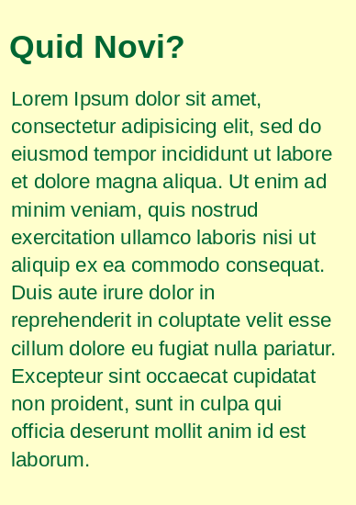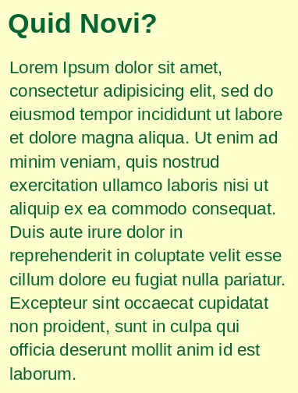
Figure 3. Dark text on light background - original and cropped images.

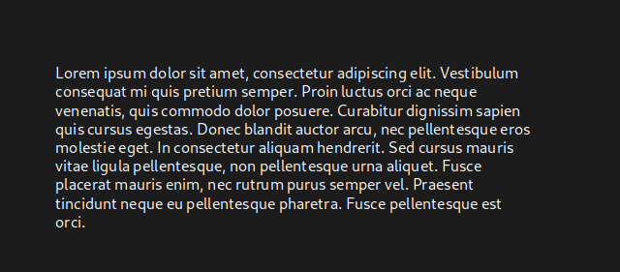
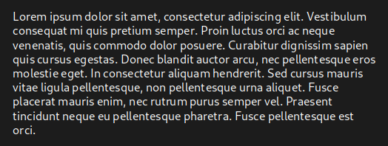
Figure 4. Automatically cropped image of light text on dark bakground.

