roi-aselect Guide
Author: Kim Miikki
Date: 22.12.2021

Introduction
While the selection of a ROI area is normally an easy task with roi-select.py or roi-picture.py, this utility provides even more automation. The selection can now be made with a single mouse click using directional color analysis and thresholds.

System Requirements
Operating system: Linux
Python 3 with OpenCV and NumPy.

ROI Selection Method
This program is used as an automatic rectangular ROI selection tool. The threshold is defined as a specific color distance from a mean color value of a square selection in a ROI area which size is s × s pixels. The seed ROI area will be expanded in four directions (up, right, down and left) until the threshold is reached in each direction or the edge of the image is reached. In vertical expansion the RGB mean value is calculated line-wise (size: s × 1) when moving away from the seed ROI. In horizontal expansion the mean is calculated column-wise (size: 1 × s) until the threshold or the edge is reached. At least one threshold of lower and upper thresholds has to be used. A schematic diagram of lower and upper thresholds is shown in Figure 1.

0 Low RGB_{mean} High 255

Low color filter 2 × threshold High color filter
Figure 1. Diagram of the use of lower and upper thresholds in directional color analysis.

Program Usage
The image file name must be specified with the -f argument. The other arguments are optional, and they are listed here:
optional arguments:
-h, --help show this help message and exit
-t T threshold (default: 5.0) as float
-s S selection size s x s (default: 20) as integer
-u enable under threshold
-o enable over threshold
Small thresholds results in small areas unless the color is very uniform, or by disabling the upper or lower threshold. ROI is selected more widely when using large thresholds, hence the risk of including unwanted areas increases. As default both under and over thresholds are enabled. By specifying -u or -o the other is disabled, unless it is also specified as an argument. Lower threshold is defined as RGB_{mean}-threshold and upper threshold as RGB_{mean}+threshold.
The selection size is as default 5, but it can be changed if a different sized area (usually larger) has to be chosen for the RGB_{mean} calculation. If the argument -s is specified, then the RGB_{mean} is calculated from a square which size is s × s. Increasing s also increases the threshold test line length to s.
ROI area is selected by pressing mouse left button. Pressing it again, will select a new ROI area. The selection can be deselected by clicking the mouse right button, and finally the selection is accepted by pressing any key on the keyboard.
After the selection is done, three images are created in current directory:
- roi-selection.jpg
- roi-patch.jpg
- roi.jpg
The first image is the original image patched with ROI area and a selection cross, the second is a ROI patched image and the third a ROI image.
The roi.ini file is created in addition to the image files created in the current directory.

Use Case
A spectrophotometer video was captured with a Raspberry Pi HQ camera without the internal infrared filter. The video frames were extracted with vid2pic.py and one image was selected for this use case. Here is the terminal output:
$ roi-aselect.py -f frame5515.jpg -u
Auto ROI selection
(C) Kim Miikki 2021
Image file: frame5515.jpg
Current directory:
/home/pi/Desktop/roi-aselect_documentation/hq_noir_slow_579_nm
1. Select ROI by pressing the mouse left button
2. Remove ROI by pressing the mouse right button
3. Press any key to accept the selection
(1203,561)
Saving roi.ini
Saving ROI image files
The following images (Figures 2-4) are saved after accepting the selection.

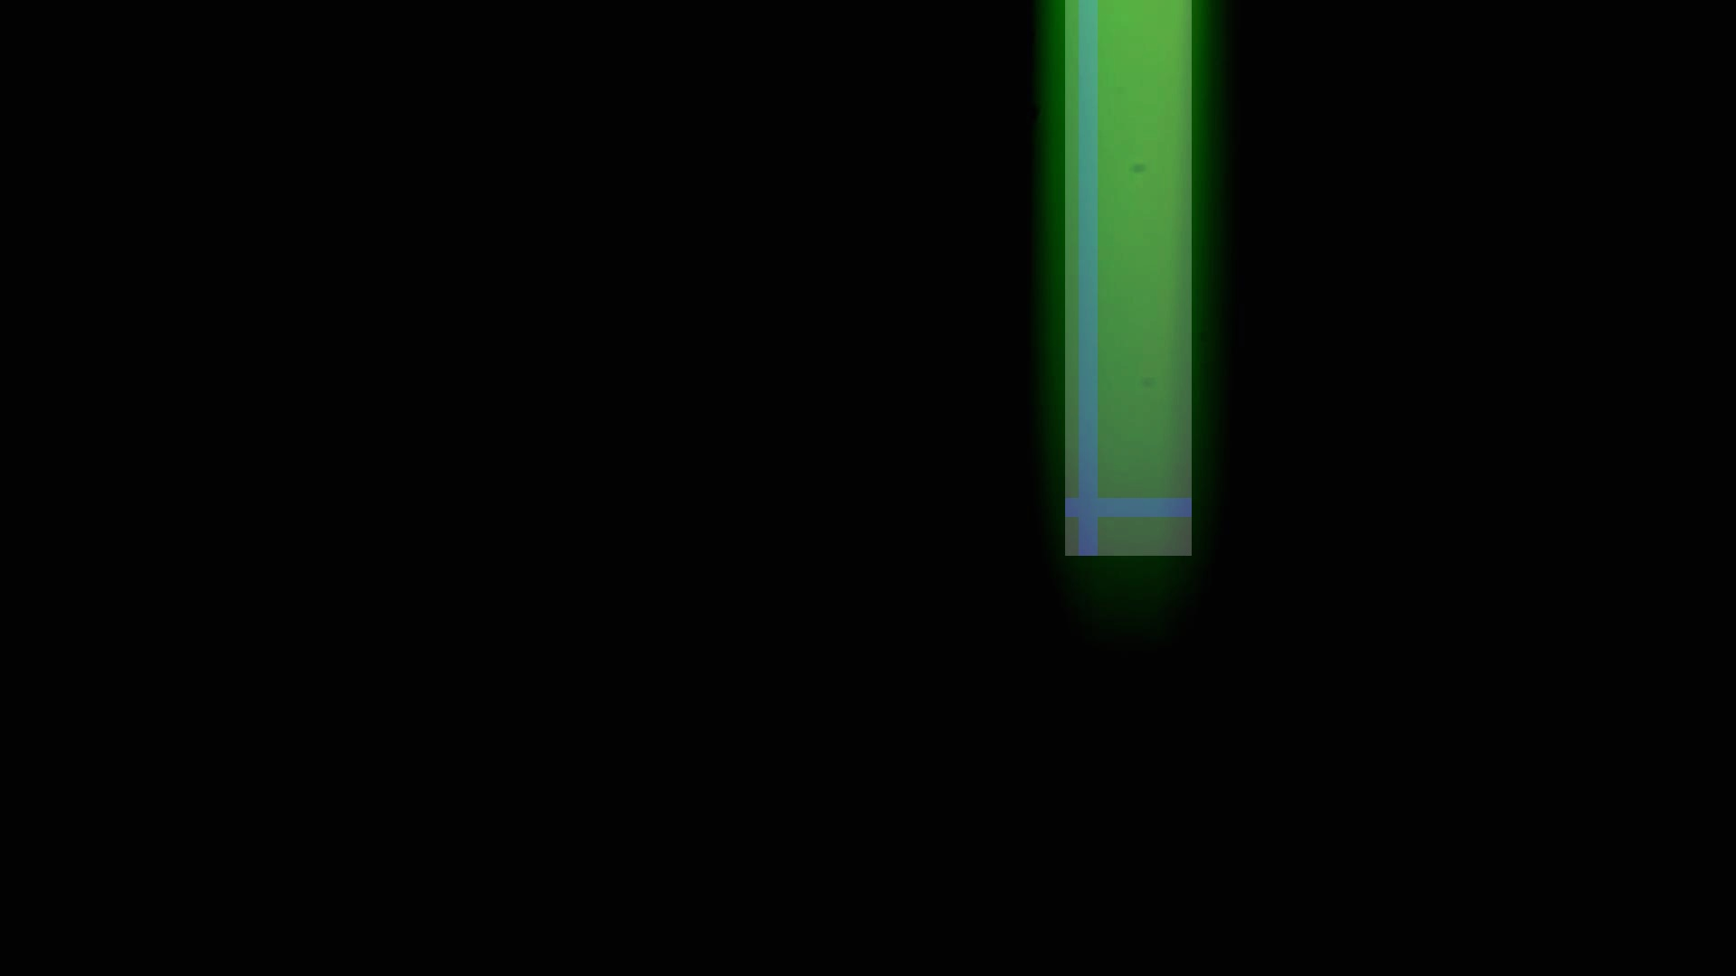
Figure 2. Image of a monochromatic beam at 579 nm wavelength with a patched ROI area and selection cross.

Figure 3. Image with a patched ROI area.


Figure 4. Image cropped by ROI area.
The roi.ini file content:
scale;coordinate name;value
original;img_x0;0
original;img_x1;1920
original;img_y0;0
original;img_y1;1080
original;crop_x0;1178
original;crop_x1;1317
original;crop_y0;0
original;crop_y1;614
normalized;roi_x0;0.6135
normalized;roi_y0;0.0
normalized;roi_w;0.0729
normalized;roi_h;0.5694

