Mapgains Guide
Author: Kim Miikki
Date: 7.11.2021

Introduction
The white balance of the Raspberry Pi camera can be controlled with red and blue channel gains. Increasing the red or blue gain reduces the sensitivity of all other channels. This program is used to measure the effects of red and blue channel gains on RGB channels. The mapgain.py is a calibration program.

System Requirements
Operating System: Raspberry Pi OS or Linux (only analyze mode)
Hardware: Raspberry Pi camera module v.2 or HQ for data acquisition
Python 3 with Matplotlib, Numpy and OpenCV.

Calibration and Analysis Method
The RGB mapping plan consists of following parameters: exposure time, red gain range and blue gain range. Fow calibration purpose a gray or white card is also needed. The resolutions of the ranges can be controlled by step parameters, and the range are defined in following way:
Red gain: [start, start+step, …, end], length=(end-start)/step+1
Blue gain: [start, start+step, …, end], length=(end-start)/step+1
All combinations of red and blue gains can be represented with a 2D matrix, where red gains are rows and blue gains columns. Programmatically the red values correspond to the outer loop and the blue values to the inner loop.
Each combination of the red and blue gains are measured by capturing a small picture from the center or ROI area, thereafter mean RGB values are calculated and stored to the measurement matrix.
The first step, data acquisition, requires a Raspberry Pi with a camera. The second step is analysis, and does not require a Raspberry Pi if the program is started in file mode.
R, G and B values are flattened to 1D arrays, their absolute RG, RB and DG distances are calculated, and finally the mean distance of these three distances. The minimum value of the mean distance value in the array is the calibration position. The index of red gain array is calculated with integer division: position // length of blue array, and the index of blue array with modulus: position % length of blue array. A sample image with minimum mean distance is captured if the program is executed in capture mode.
RGB and gray maps are saved in pickle format for analysis use. The mandatory ranges R and B are saved as CSV files.
If all files creation is enabled, the data will also be saved in clear text and all channels as 2D raster images. Finally, the distance distribution graph and the calibration results are saved.

Program Usage
The program will be executed in capture and analysis mode if no arguments are given. Here is a list of the optional arguments:
optional arguments:
-h, --help show this help message and exit
-f F file mode: read rgbmap-YYYYMMDD-hhmm.pkl
-a auto, non-interactive mode
-c auto calibration
-q quick calibration
-p precision scan
-pw precision scan wide
-d disable image preview
-n do not create all analysis files
-s use short date-time string
-i x axis label: Iteration
When file mode is selected, image capture is disabled. The red and blue gains ranges CSV files are mandatory, and must be present in the file mode.
The auto mode will capture everything based on source code default values.
Auto calibration (-c) asks only for exposure time. Then it will iterate gain values until the ranges steps are both 0.0001. Quick calibration (-q) halves the scan ranges, resulting in a shorter calibration time. However, the gain value may be outside the halved range, and an optimal gain value may not be found.
Indirect or inverse color analysis can be done with precision scans (-p and -pw). The idea is to do an initial calibration, use its calibration values when a slight color change has occurred (lightning or the sample), execute a precision scan and finally to run this program in file mode to get information how the gains changes in each calibration series.
If selecting -d, no preview window is displayed during capturing the images.
Argument -n will save only mandatory analysis files, calibration file and distance distribution plot. In capture mode, also a sample image will be captured.
Short file format (-s) is available for legacy reasons. Normally it is not recommended to use this argument. If the ‘Iteration label’ is required instead of ‘Calibration’ in file mode, it can be accomplished with the argument -i.
The program working directory is same as current directory. This information is given when the program is started, and that is also the path where all the results are stored.
The prefixes and extensions for files generated, are listed in the following table. DT is an abbreviation for the date-time string in the format YYYYMMDD-hhmm and represents the analysis time.
Prefix-DT.extension | Mode | Optional | Usage
rgbmap-DT.pkl | both, mandatory | - | RGB data in binary pickle format
rgbmap-b-gains-DT.csv | both, mandatory | - | Blue gains range values as an array
rgbmap-r-gains-DT.csv | both, mandatory | - | Red gains range values as an array
rgbmap-cal-DT.txt | both | - | Calibration log and results
rgbmap-cal-image-DT.png | capture | - | Calibrated sample image
rgbmap-r-DT.csv | both | Yes | Red channel data
rgbmap-r-im-DT.png | both | Yes | Red channel raster image
rgbmap-g-DT.csv | both | Yes | Green channel data
rgbmap-g-im-DT.png | both | Yes | Green channel raster image
rgbmap-b-DT.csv | both | Yes | Blue channel data
rgbmap-b-im-DT.png | both | Yes | Blue channel raster image
rgbmap-bw-DT.csv | both | Yes | Gray mean data
rgbmap-bw-im-DT.png | both | Yes | Gray mean data raster image
rgbmap-mdist-DT.csv | both | Yes | RGB mean distance array
rgbmap-mdist-DT.png | both | - | RGB mean distance plot
Table 1. Analysis files.
When more than one scan is performed, following files in Table 2 are created:
Prefix-DT.extension | Mode | Usage
rgbcals-gains-DT.png | > 1 calibration | rgain and bgain plot
rgbcals-rgain-DT.png | > 1 calibration | Red gain values plot
rgbcals-bgains-DT.png | > 1 calibration | Blue gain values plot
rgbcals-rgb-DT.txt | > 1 calibration | RGB mean values plot
rgbcals-rgbdist-DT.txt | > 1 calibration | RGB mean absolute distances plot
Rgbcals-graydist-DT.txt | > 1 calibration | Gray mean absolute distance plot
Table 2. Iteration or calibration series plots.

Use Cases
Some use cases are presented in this section. The first is a fast calibration and the second a multi-stage calibration. In both cases a white calibration card was used with a flicker-free LED lamp as the main light source.

Auto Calibration
Auto calibration is the preferred calibration method when the calibration values are unknown. It will iterate from very rough values until the ranges steps are decreased from 0.5 to 0.0001. The gains are then given with 4 decimals. This is achieved with 5 iterations.
A Manfrotto 8 LED light source were calibrated with the argument -c. In Figure 1 is show mean R, G and B values by iterations. It can be seen in the figure that already three iteration brings all channel values very close to each other.
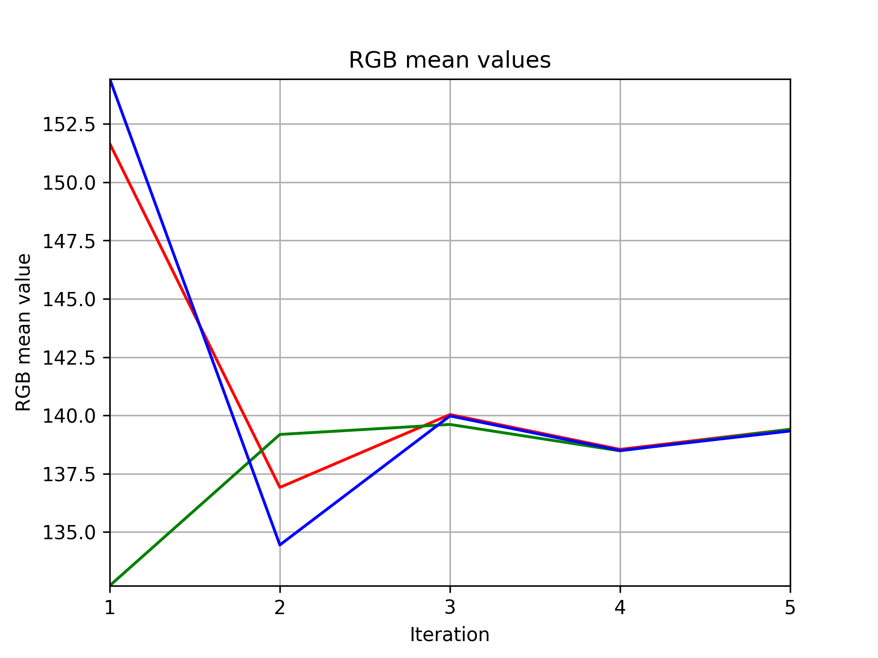
Figure 1. Development of red, green, and blue mean values by calibration iterations.

Fast Calibration
This two step calibration is based on the RPI camera auto white balance reading and one calibration stage. In Fig. 2 is shown then calibration card and a ROI of it which was selected with roi-select.py.
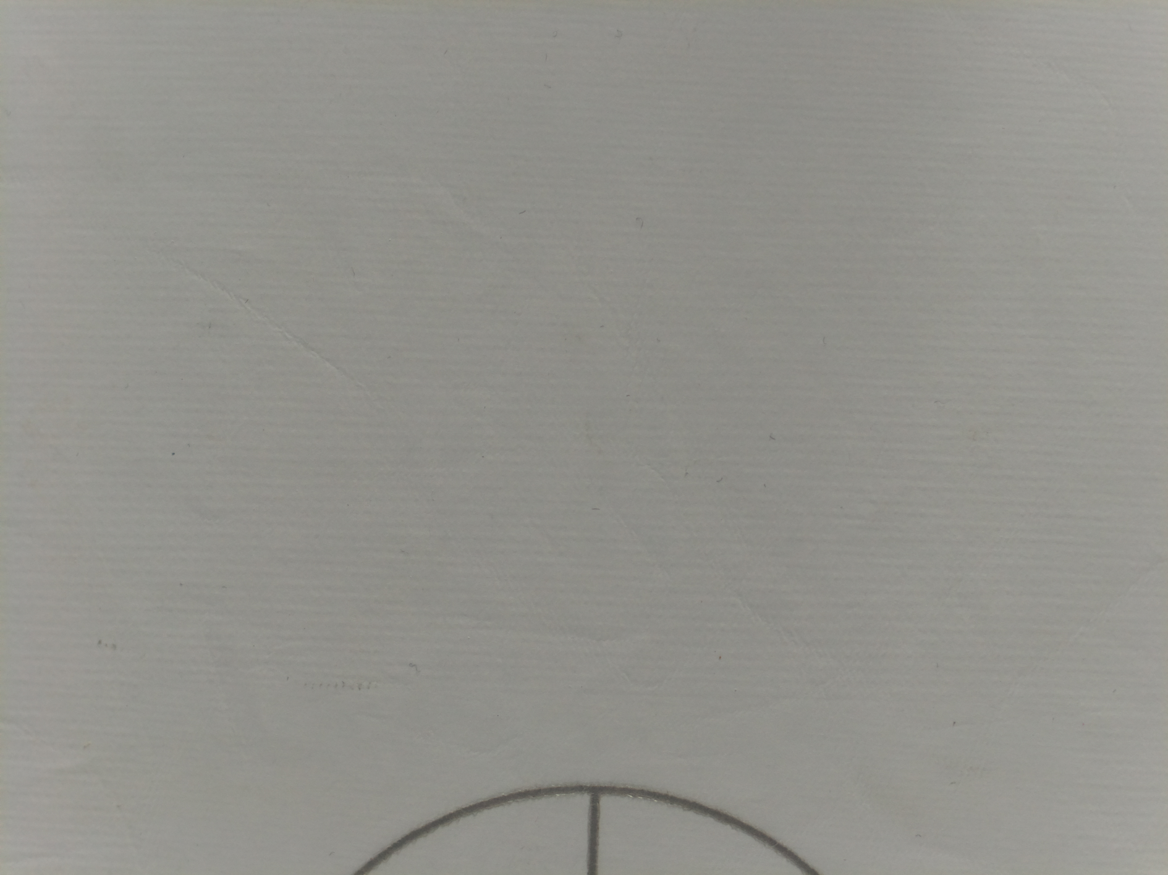 
Figure 2. White calibration card: FOV and ROI.
Rough gain values can be acquired by reading the auto white balance gain values with awb_gains.py:
$ awb_gains.py
Auto white balance gains for Raspberry Pi camera module imx477
Red gain: 3.35 857/256
Blue gain: 1.45 371/256
Theese gains are seeds for the red and blue gain ranges. In this case following ranges were selected:
R: 3.2-3.5, step 0.01
B: 1.3-1.5, step 0.01
These values was entered to mapgains.py:
$ mapgains.py
Mapgains - Map Raspberry Pi gamera gains and calibration
(C) Kim Miikki 2021

ROI file found in current directory: 0.39,0.3036,0.1916,0.2115

Current directory:
/home/pi/python/20211019-mapgains

Select exposure time (250...200000000 µs, Default=20000: <Enter>): 5000

Select red gain min (0.0001...8, Default=1: <Enter>): 3.2
Select red gain max (3.2...8, Default=8: <Enter>): 3.5
Select red gain step (0.0001...0.2, Default=0.2: <Enter>): 0.01

Select blue gain min (0.0001...8, Default=1: <Enter>): 1.3
Select blue gain max (1.3...8, Default=8: <Enter>): 1.5
Select blue gain step (0.0001...0.2, Default=0.2: <Enter>): 0.01

Capture mode

rgain,bgain: red,green,blue
3.2,1.3: 192.193,198.156,183.968
3.2,1.31: 191.687,197.621,184.676
...
3.5,1.5: 201.658,188.399,198.176

Analyzing data
qt5ct: using qt5ct plugin

Mode: capture and analyze
Time: 2021-10-19 16:13:44.869486

Capture time: 0:03:15.175772
Analyze time: 0:00:07.794050

Calibration
-----------
Red gain : 3.26
Blue gain: 1.42
Minimal distance: 0.077

Red and blue gains
-------------------
R gain min : 3.2
R gain max : 3.5
R gain step: 0.01

B gain min : 1.3
B gain max : 1.5
B gain step: 0.01

Matrix : 31x21
Position : [6,12]
Index : 138

Distance distribution
---------------------
N : 651
Min : 0.077
Max : 14.509
Mean : 6.269
Median: 6.165
Var : 9.244

After some minutes RGB values of all gain combinations were measured and analyzed. The calibration values in this setup were rgain=3.26 and bgain=1.46 with a mean absolute distance of 0.077 of the theoretical calibration distance 0.
Mean distance plot in Figure 3 shows the minimum position of the calibration values, and a verification of a succeeded calibration can be seen in the sample picture (Fig. 4) which were automatically captured with the calibration gains.

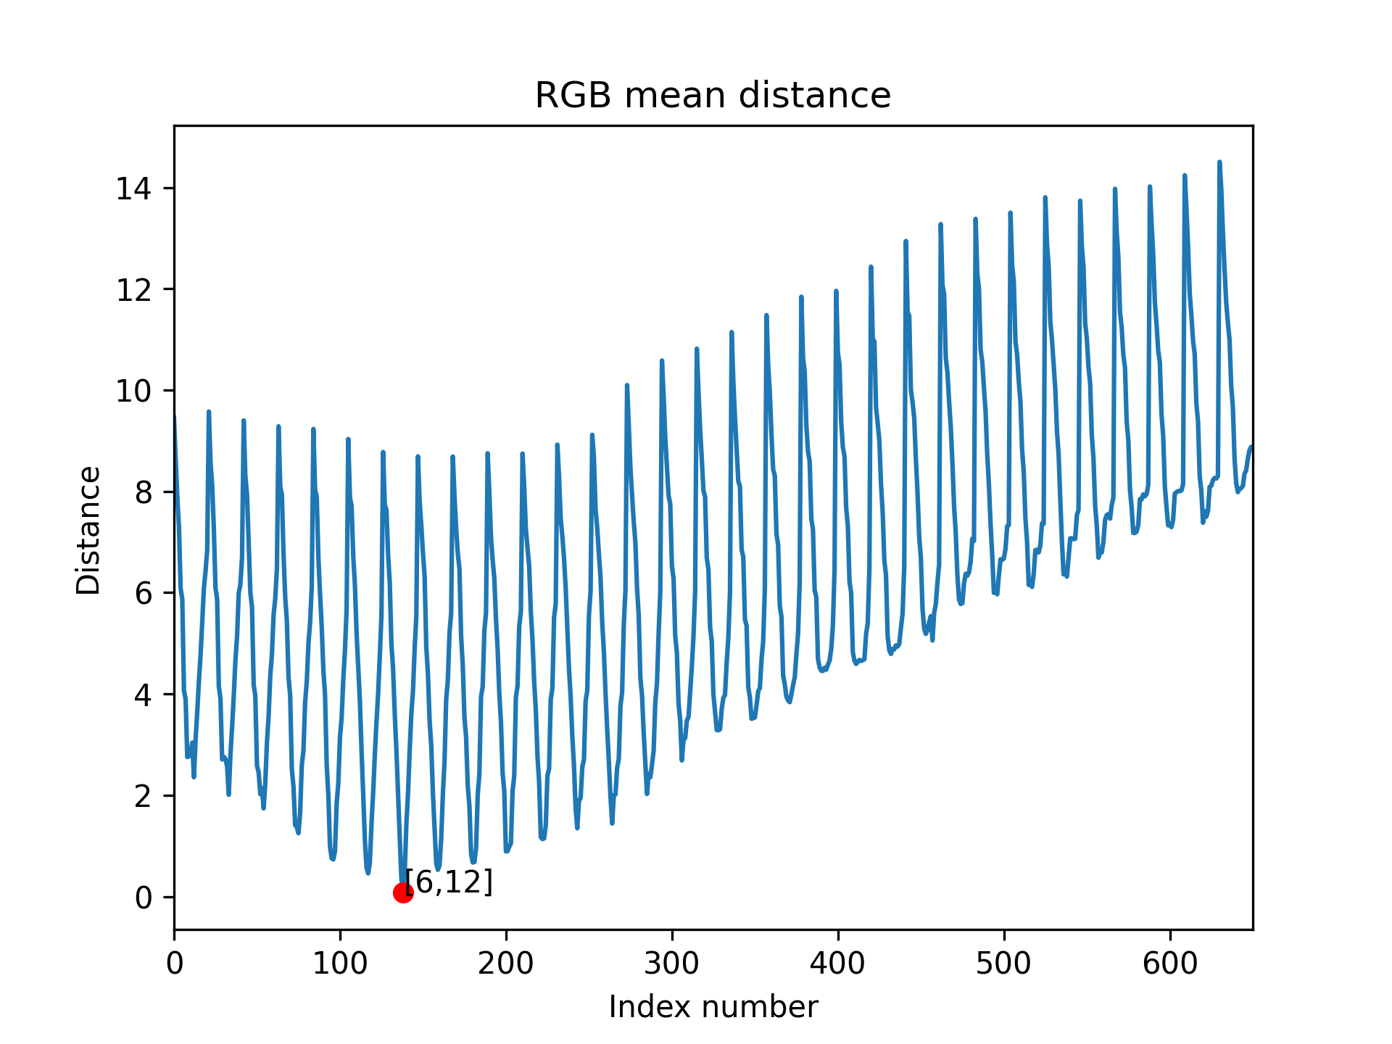
Figure 3. RGB mean distance of the calibration in this section.

Figure 4. Calibration sample image captured when rgain=3.26 and bgain=1.46.

Multi-Stage Calibration
This method is preferred when very accurate gain values are required. After each stage, the steps are divided by 10. First stage is very rough when the ranges are 1-8 for both gains with step of 1.
A calibration ODF a white card gave rgain=3 and bgain=2 with distance of 35.187. The new ranges for stage 2 were set to:
R: 2-4, 0.1
B: 1-3, 0.1
=> rgain=3.2, bgain=1.5, dist=2.224
In stage 3 the ranges were narrowed to these ranges:
R: 3.1-3.3, 0.01
B: 1.4-1.6, 0.01
=> rgain=3.18, bgain=1.47, dist=0.302
Two additional steps were performed. The step was 0.0001 in the last step. The final valibration valus were measured to rgain=3.1733, bgain=1.4670 and dist=0.014.
The gains are shown as a function of performed calibration in Figure 5.
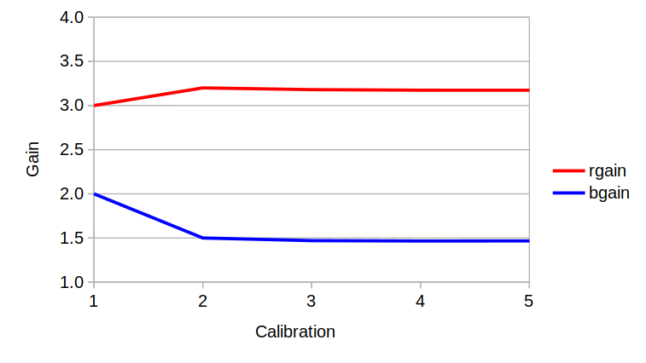
Figure 5. Red and blue gains as a function of calibration.
Better resolution can be obtained by performig a color analysis of the captured calibration images (Fig. 6). This is illustrated in Figure 6.

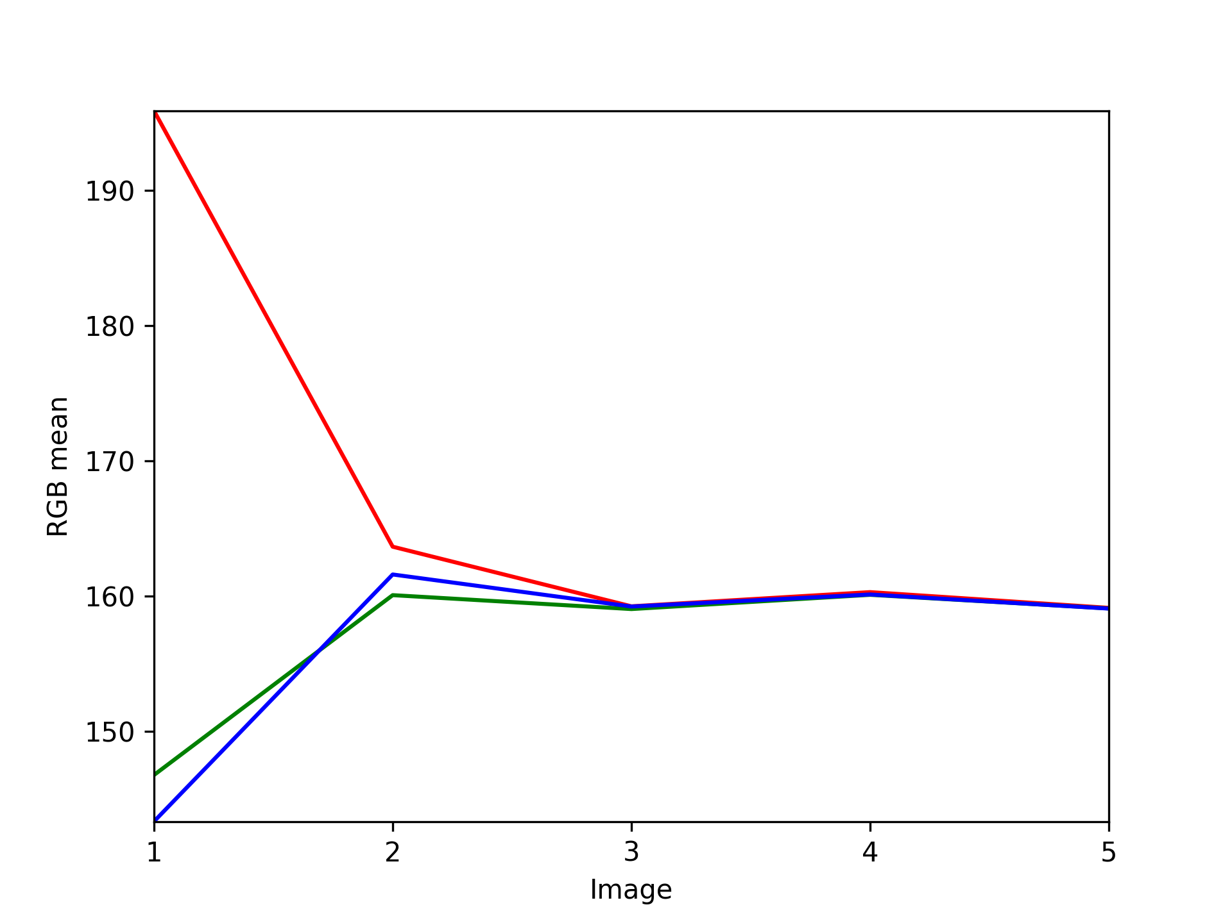
Figure 6. RGB mean values as a function of calibration.
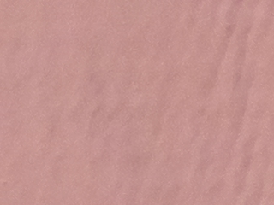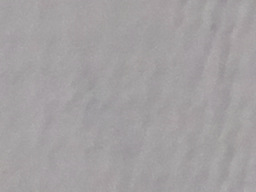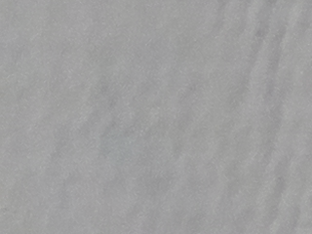
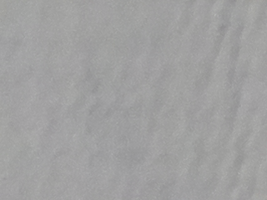 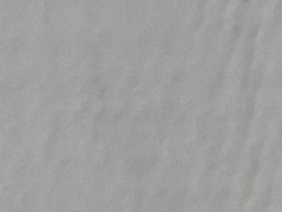
Figure 7. Sample images as a function of calibration.
RGB channel mean values of stage 2 are illustrated as raster images in Figure 8 and stage 5 in Figure 9.

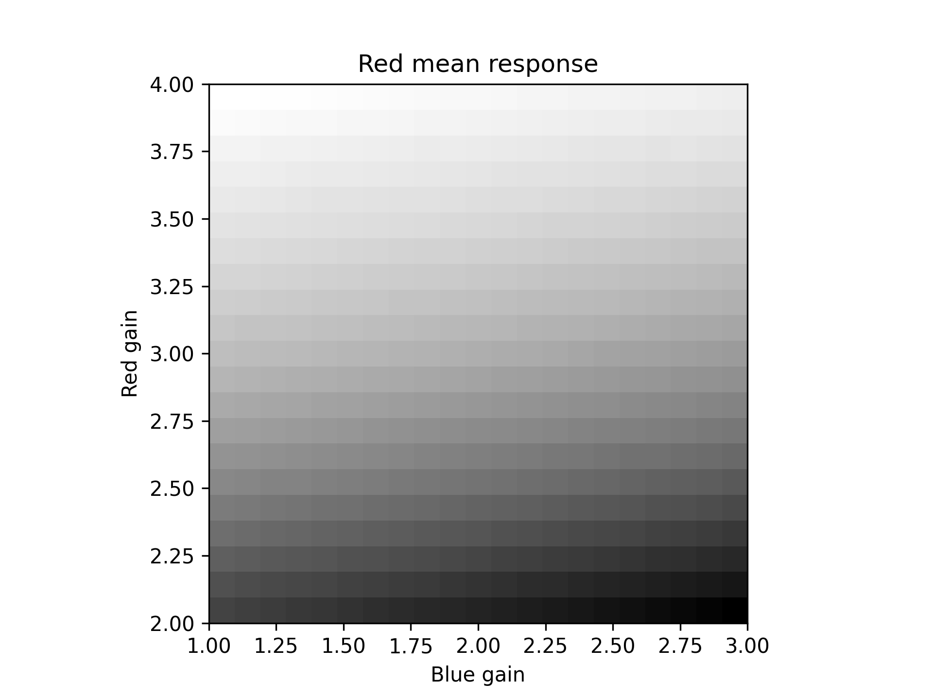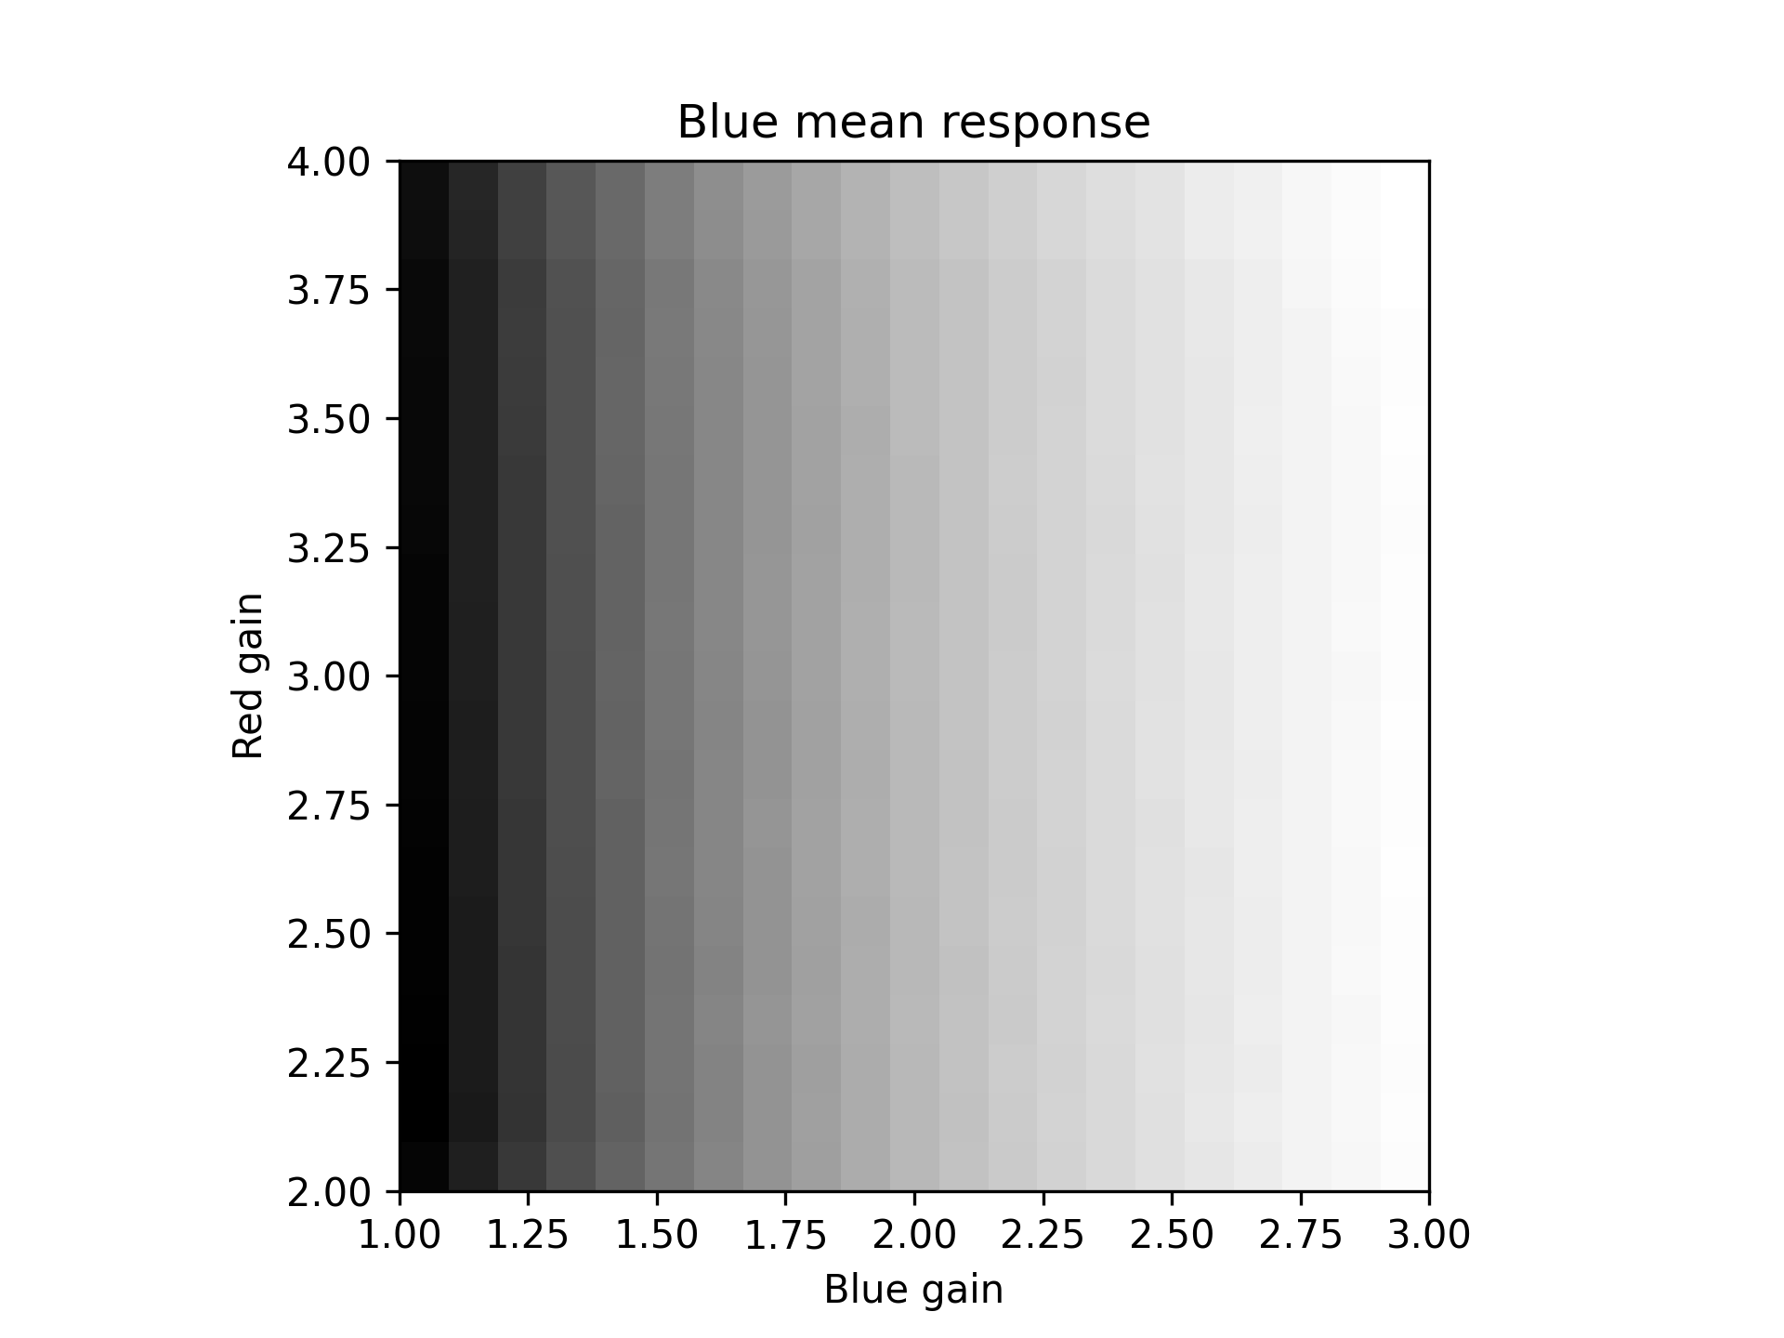
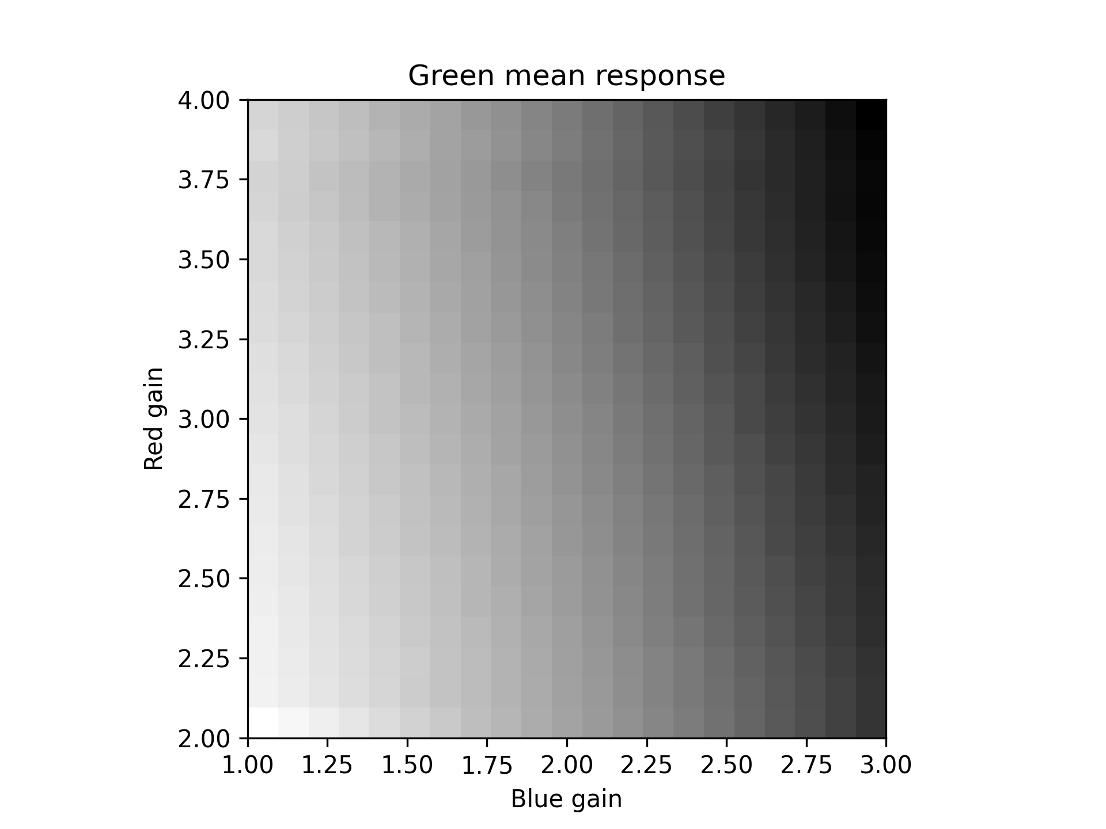 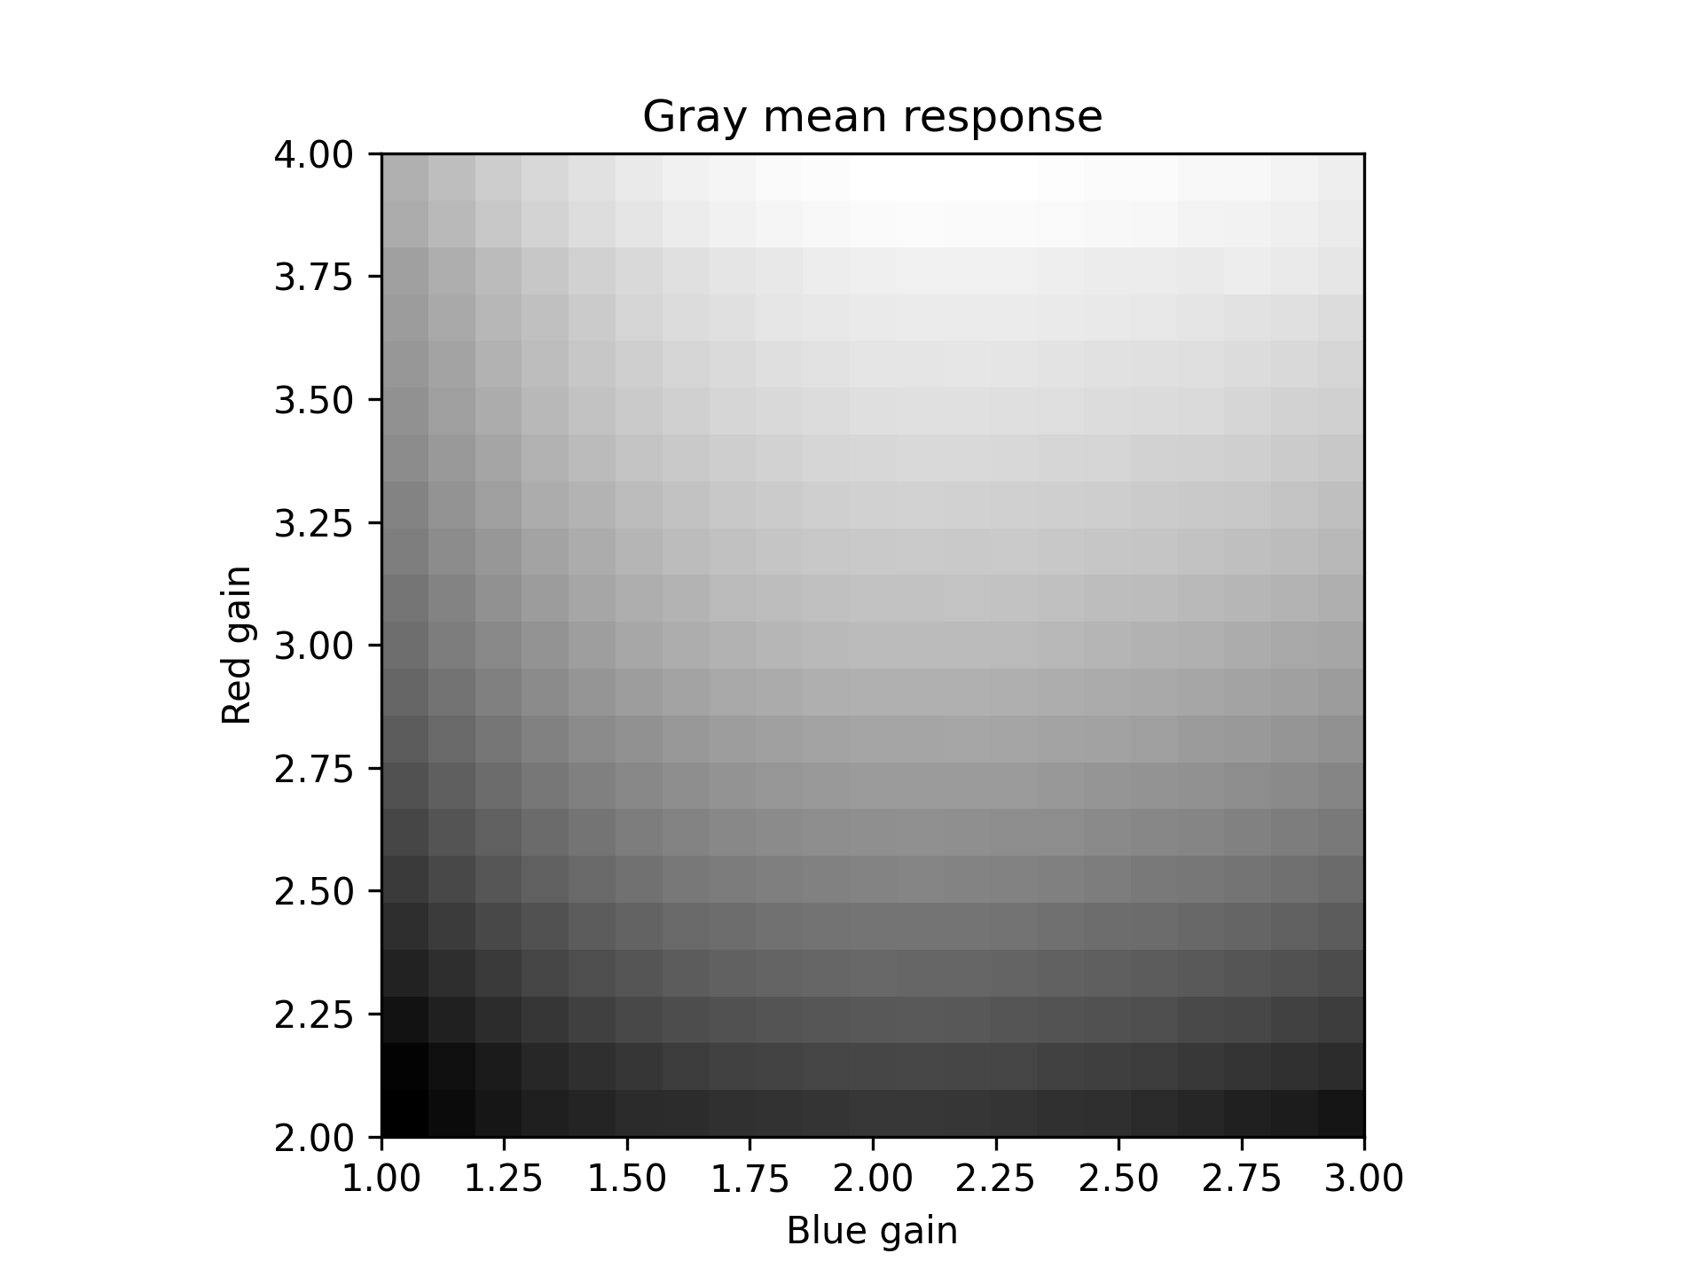
Figure 8. Stage 5 calibration - RGB mean channels.

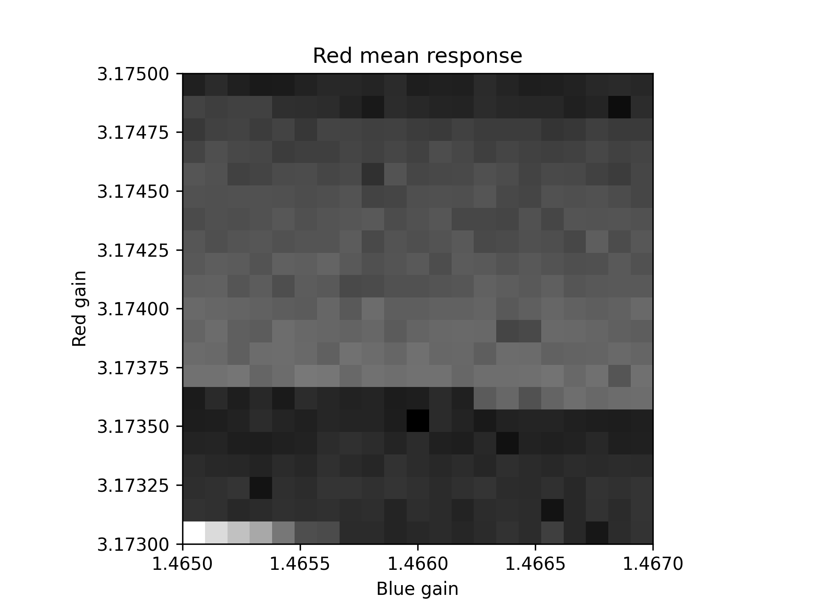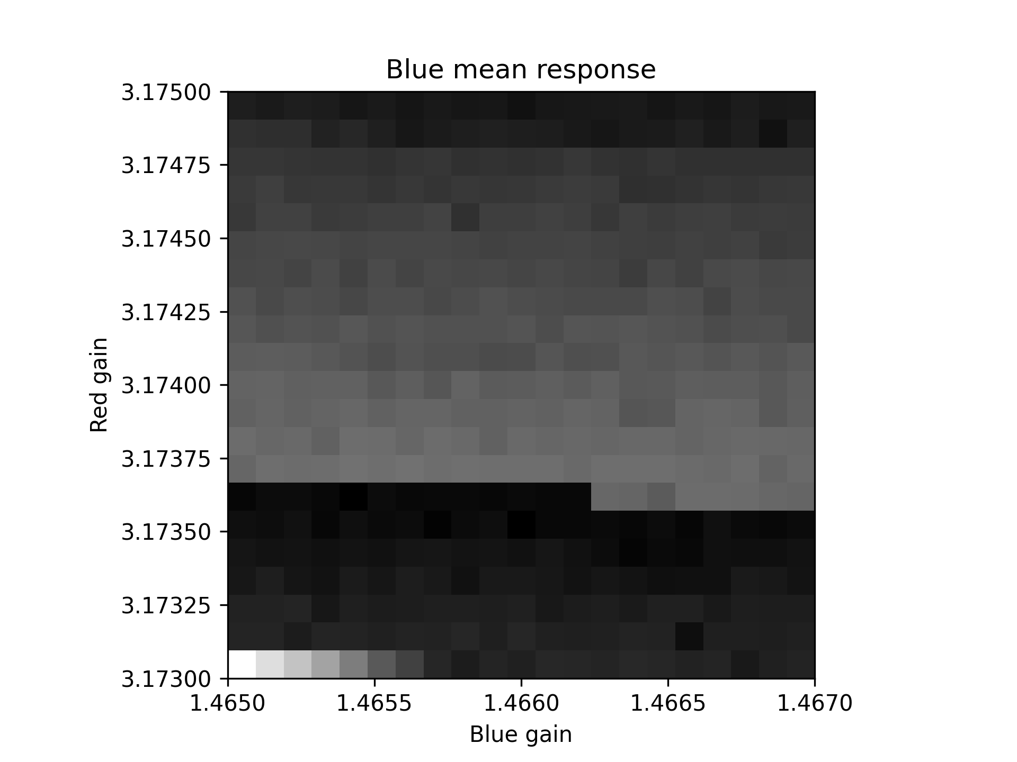
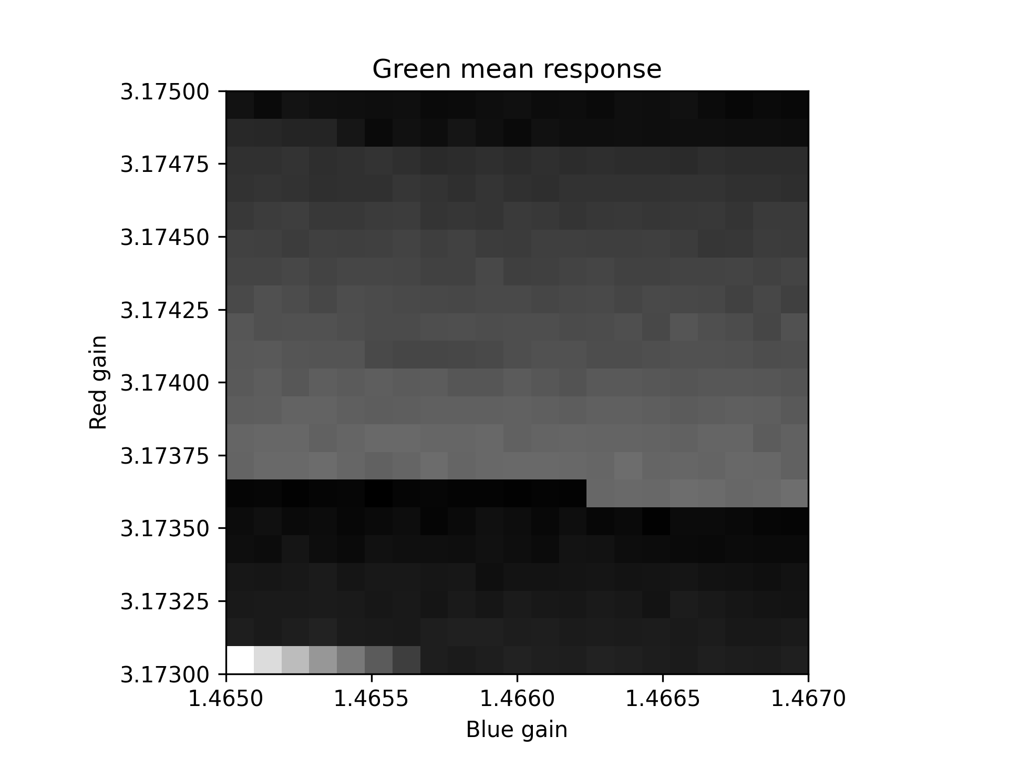 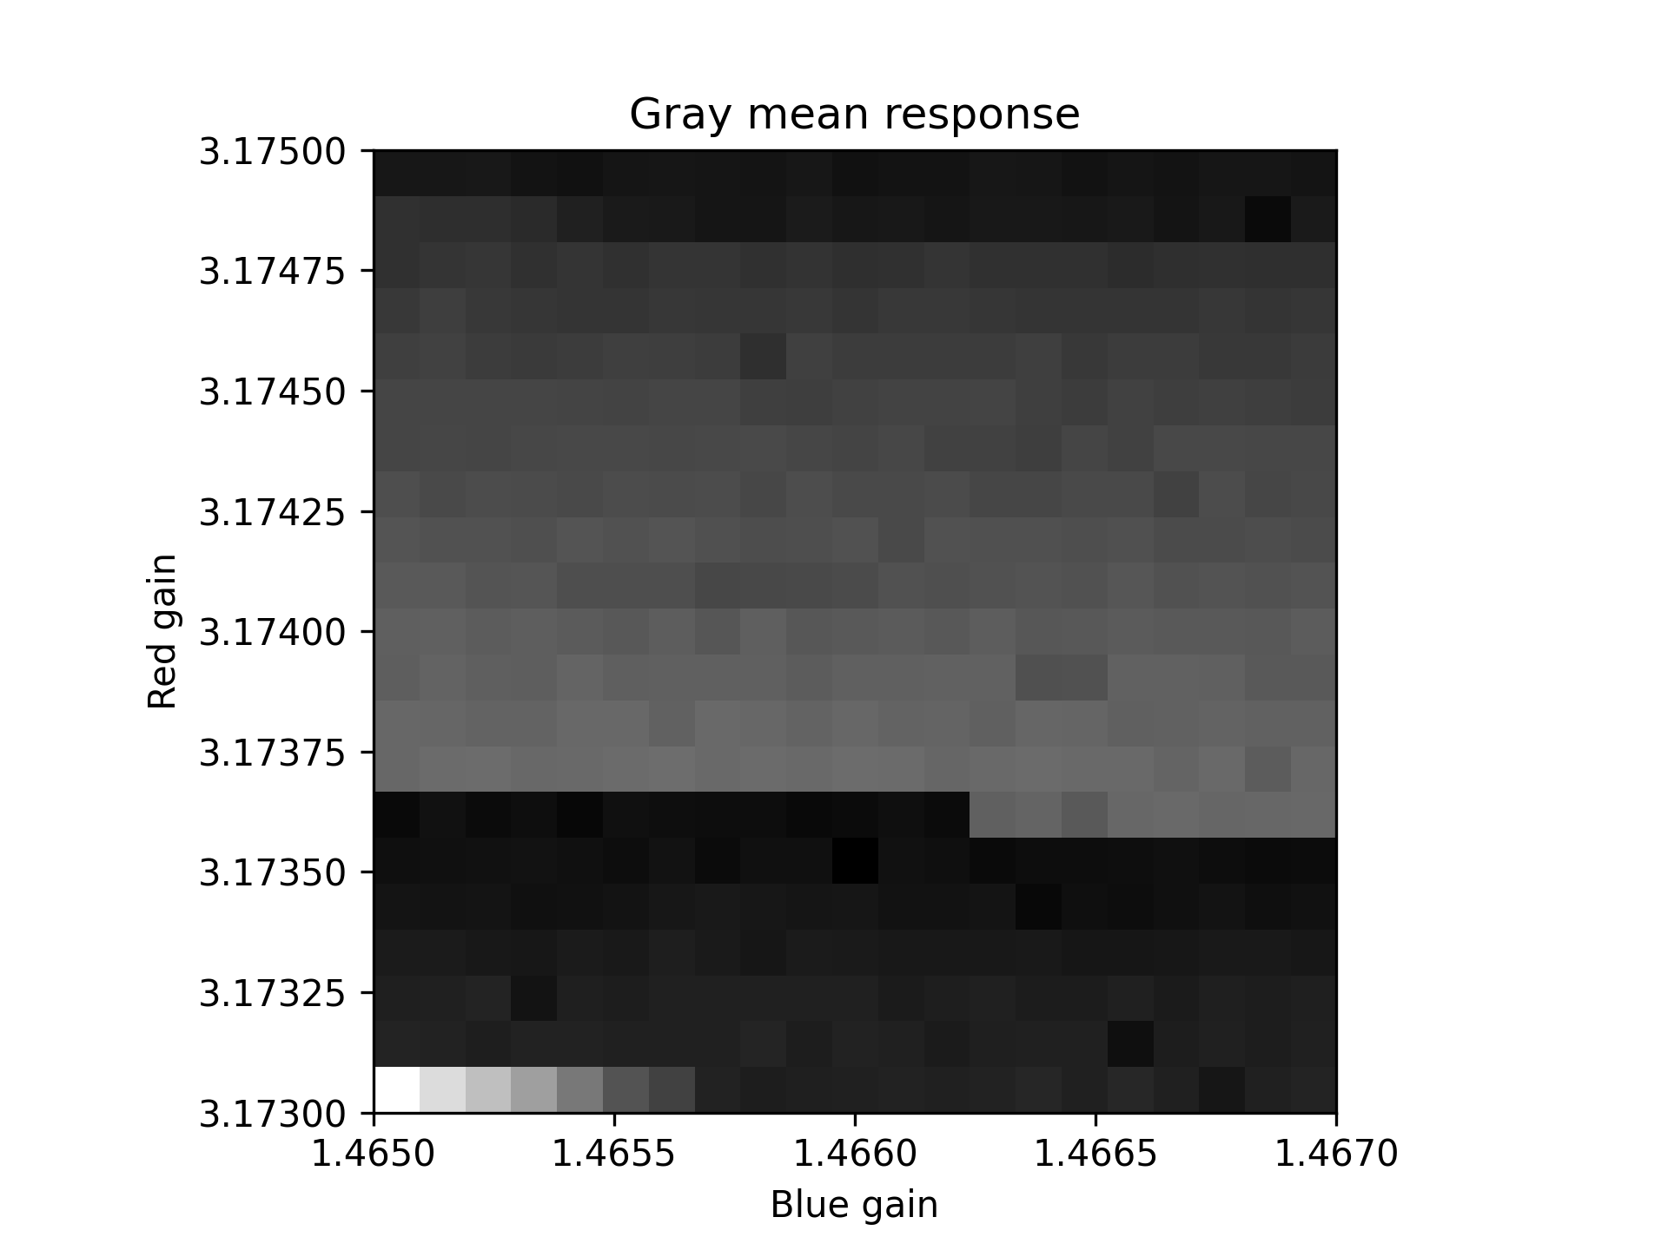
Figure 9. Stage 5 calibration - RGB mean channels.

Indirect Color Analysis
The red and blue gain can be adjusted on a Raspberry Pi camera module. Increasing one gain reduces the other two channel responses, and vice verse. Small changes in a color environment can be detected by the calibration values.
An experiment was conducted, where an 8 LED dimmable light source calibrated on each level of dimming. The results are shown in Figure 10, where the calibration corresponds to the dimming level.
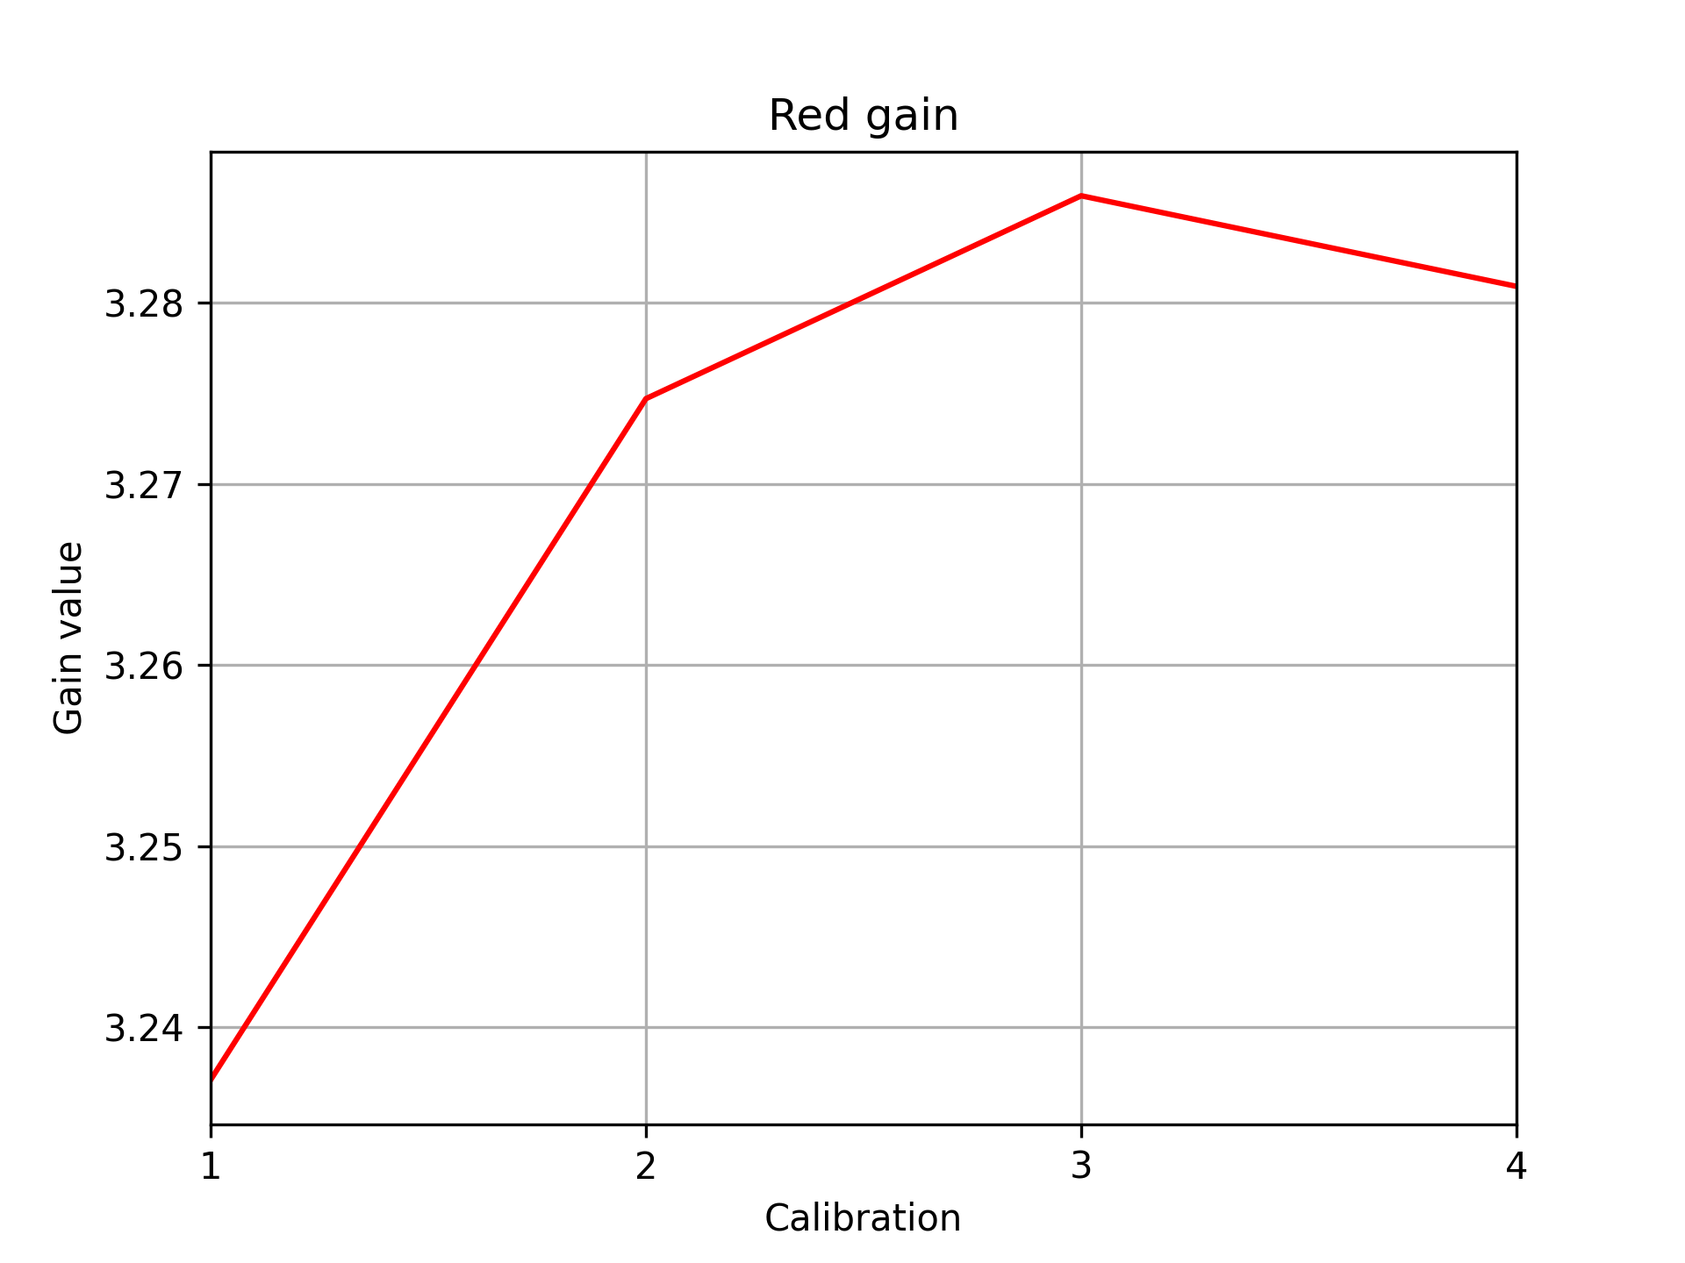 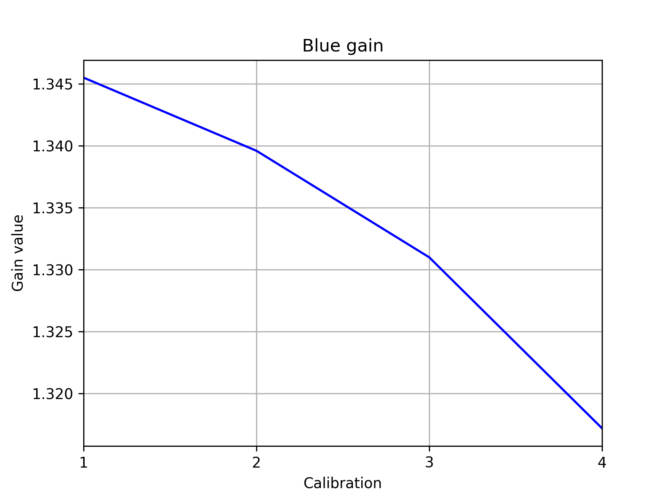
Figure 10. Red gain on the left and blue on the right as function of dimming level.
Figure 10 shows that the red gain increases and the blue decreases, indicating a decrease in red color and an increase in blue.

