Calen Guide
Author: Kim Miikki
Date: 31.5.2021

Introduction
Calen is a calibration and measurement application. An image of a square or circle is required for the length calibration. The measurement mode analyses the object height and width by using the acquired calibration value (pixels/length unit).

System Requirements
Operating System: Raspberry Pi OS or Linux
Python 3 with Matplotlib, Numpy, SciPy and OpenCV.

Calibration and Measurement Method
A calibration value can be obtained by capturing an image os a calibration square or circle. This program assume that the square has a solid monochrome color, preferable dark on white or white on dark. All shapes should be the same height and length, within a 5 % tolerance of deviation. When this condition is met, the calibration value is calculated as the mean of the height and width calibration values.
The calibration and length measurement method is based on directional color analysis in X and Y directions. The data is smoothed with a quadratic Savitzky-Golay filter, the second or first derivative is calculated in order to get edge locations as peaks. They are then detected with the scipy.signals.find_peaks function.
In measurement mode, the equality of width and height is not calculated, otherwise lengths are obtained in the same way as in calibration mode.

Program Usage
Some options has to be selected as arguments when executing the calen.py script:
positional arguments:
file calibration or analysis image
optional arguments:
-h, --help show this help message and exit
-d D Savitzky-Golay derivative: 1 or 2
-a auto peak selection
-c calibration mode
-o save all files
-n saving of graphs disabled
-p plot calibration graphs on screen
-s save data files
-t save patch image
The first argument, file name is mandatory. If the image is a calibration picture, the -c argument has to be selected. Otherwise the program operates in measurement mode. The -p option is useful when running the program under Spyder or an other IDE. Argument -o overrides argument -n, and all data files are saved.
Savitzky-Golay filter derivative order can be selected with the argument -d D, where D is 1 or 2. However, the first question when running the program is the same. If 2nd derivative is disabled, the 1st derivative is used instead.
The data window size is selected in the program. The value must be an add number and the minimum is 3. Default value is 11 which can be overridden.
The last question before color analysis is the minimum relative size of a peak. Selection range is 0.01 to 1.0. The latter is normalized from the highest (or lowest) peak value. This value is used for unwanted peak filtering. Default value is 0.15, and when trying to reduce peaks from a noisy data, one could typically try to filter more with a value of 0.5.
In the next stage color analysis are performed in X and Y directions. Thereafter Savitzky-Golay filter is used in order to smooth tha data and get 1st or 2nd derivative, and finally peaks ore found. If only two peaks are found in both directions, the program will continue to the last step before results. Otherwise start and end peak numbers is asked in X and Y directions. Their correct positions can be checked from the generated figures, if using -o or similar option.
The last stage depends on which mode has been selected. The first mode is calibration, where a length unit has to be selected (default is mm). Then shape width and height has to be given. Now the calibration values can be calculated in both directions. Some tolerance tests are performed to determine if the shape is a solid square or not. Depending on results from these tests, the final question asks if the calibration shape is a square. Otherwise a circle patch is provided as default. Before the program execution is ended, the a patched calibration image will be created and stored, depending on selected arguments.
The program working directory is same as current directory. This information is given when the program is started, and thet is also ta path where all the results are stored.
Here is a list of the analysis files prefixes and suffixes, and their meanings:
Prefix | Mode | Abbreviation or Usage
xcader1- | both | X direction, Color Analysis, Derivative 1
ycader2- | both | Y direction, Color Analysis, Derivative 2
xcasg- | both | X direction, Color Analysis, Savgol (smoothed graph)
ycap- | both | Y direction, Color Analysis, Peaks
xdata-… .csv | both | X direction, Color Analysis, Savgol in a CSV file
… .log | both | Log file, containing calibration or measurement results
patchcal- | calibration | Square, circle or rectangle patch on the original image
patch- | measurement | Square, circle or rectangle patch on the original image
Table 1. Data files prefixes and suffixes.

Use Cases
The following subsections show how calibrations and measurements are performed wit calen.py. All pictures were captured with a Raspberry Pi HQ camera, 16 mm tele lens and two extension rings.

Circle Calibration
Setup
- + 4 dpt close-up lens
- ø = 1.5 mm calibration circle
- Savgol 1st derivative
- minimum peak relative height = 0.5
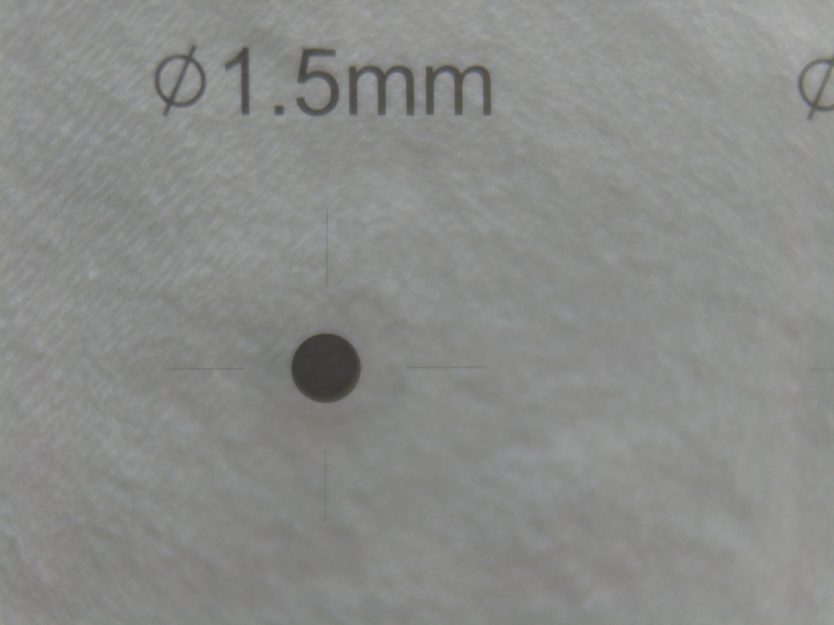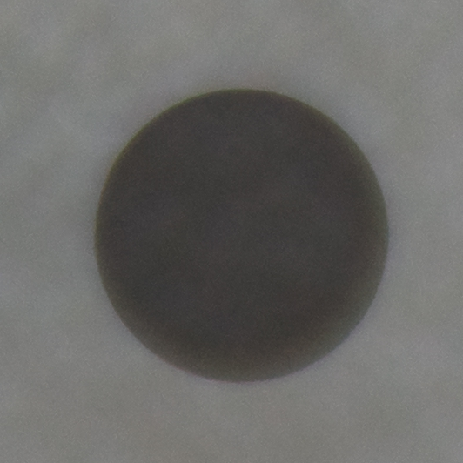
Figure 1. Original calibration sheet and a cropped circle.
$ calen.py mag/Magnification_2extensions_4dp_0001_crop.png -o -c
Calibration and length measurement utility, (C) Kim Miikki 2021
Current directory:
/home/pi/python/20210531-calen
Use Savitzky-Golay 2nd derivative (Y/N, Default y: <Enter>): n
2nd derivative mode disabled
Select window size (odd number 3-101; Default=11):
default selected
Select minimum peak relative height: (0.01...1.0, Default=0.15: <Enter>): 0.5
qt5ct: using qt5ct plugin

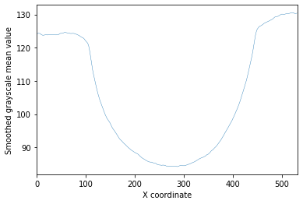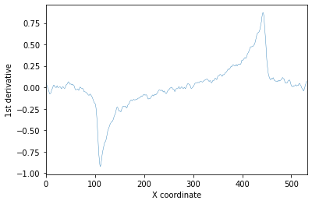
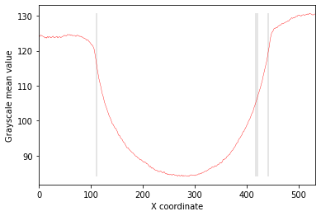
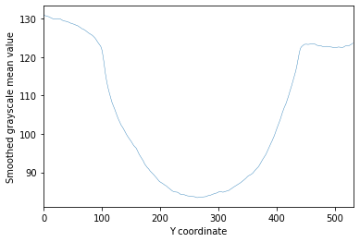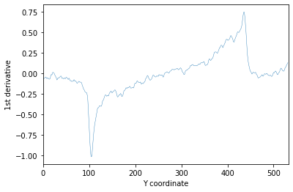
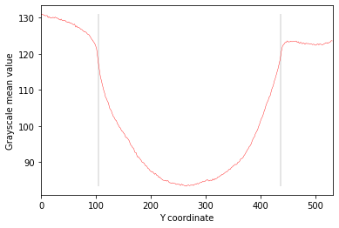
Figure 2. X and Y directional color analysis, savgol 1st derivative an peak positions on original image.
X direction, L peaks (left):
pos der1 value default
111: -0.9244 116.0 x
417: 0.4733 104.9
Select left peak position (111, 417; Default=111):
Default value selected: 111
X direction, R peaks (right):
pos der1 value default
442: 0.8711 120.2 x
420: 0.477 106.3
Select right peak position (442, 420; Default=442):
Default value selected: 442
- Length calibration mode -
Calibration length unit (Default=mm):
Horizontal length (mm): 1.5
Vertical length (mm; Default=1.5):
default selected
Horizontal calibration value: 220.67 pixels/mm
Vertical calibration value : 220.67 pixels/mm
Equal calibration values within 0.05 tolerance: 0
Mean calibration value: 220.67 pixels/mm
Color analysis distance tolerance subceeded: 0 < 0.05
X direction solid square tolerance exceeded: 0.101 > 0.02
Y direction solid square tolerance exceeded: 0.114 > 0.02
Use circle patch (Y/N, Default y: <Enter>):
Default selected: circle patch enabled
Saving: patchcal-Magnification_2extensions_4dp_0001_crop.png
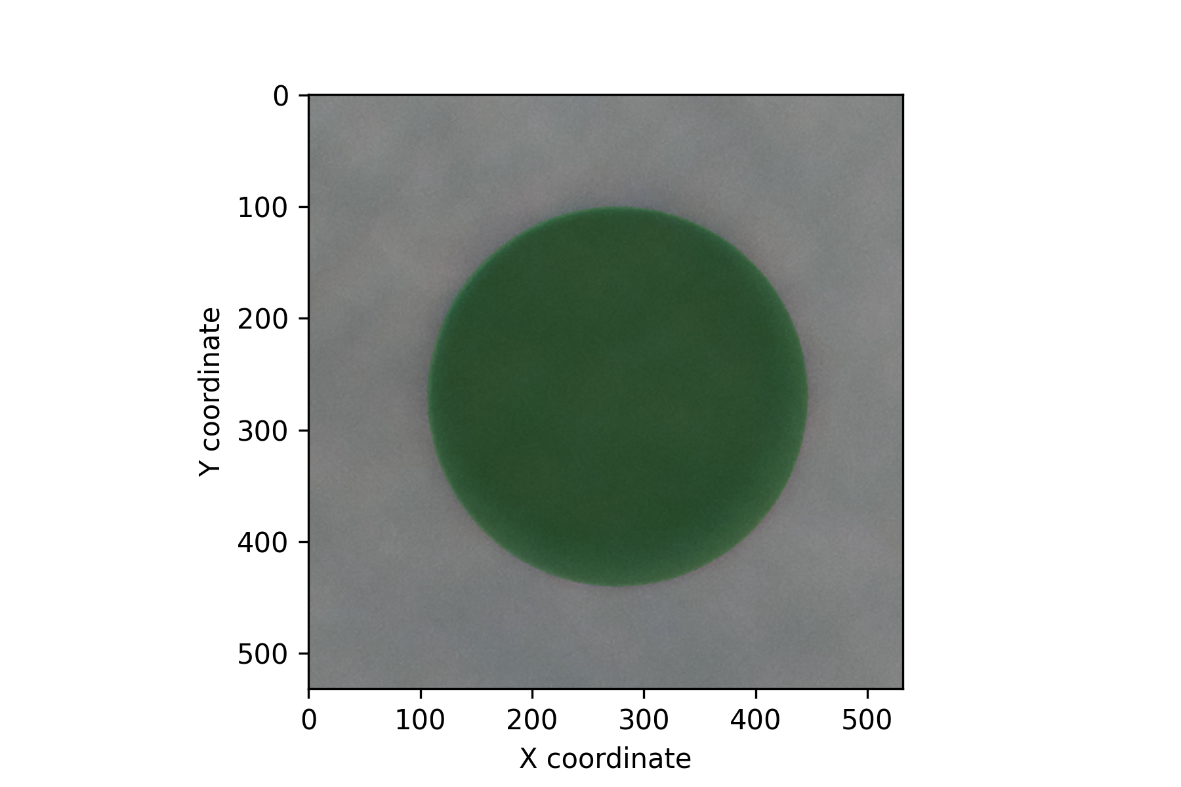
Figure 2. Circle patched calibration image.

Square Calibration
Setup
- calibration target
  - w = 10 mm
  - h = 10 mm
- Savgol 2nd derivative
- minimum peak relative height = 0.15
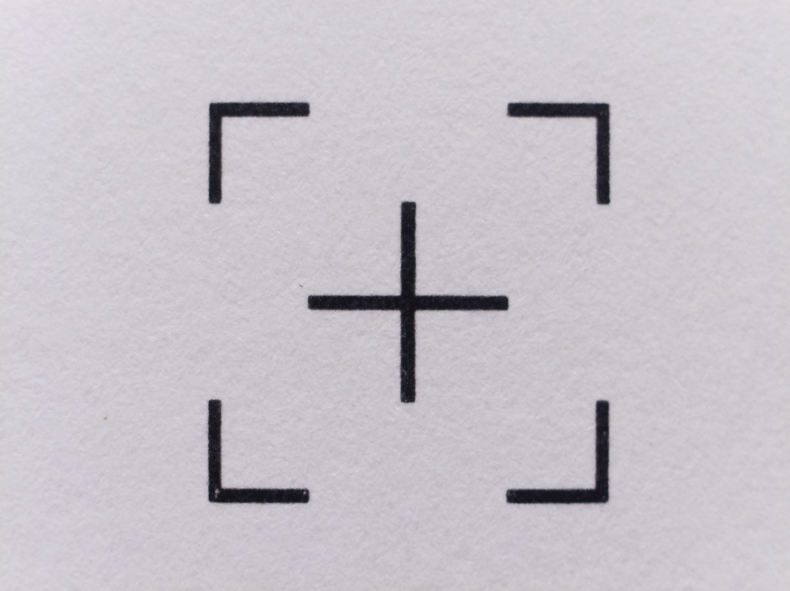
Figure 3. Calibration target.
This example can be executed with default parameters, only the last step is overridden (circle → square):
$ calen.py 10x10/10x10.png -o -c
Calibration and length measurement utility, (C) Kim Miikki 2021
Current directory:
/home/pi/python/20210531-calen
Use Savitzky-Golay 2nd derivative (Y/N, Default y: <Enter>):
Default selected: 2nd derivative mode enabled
Select window size (odd number 3-101; Default=11):
default selected
Select minimum peak relative height: (0.01...1.0, Default=0.15: <Enter>):
Default value selected: 0.15
qt5ct: using qt5ct plugin

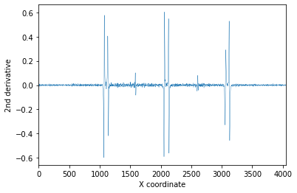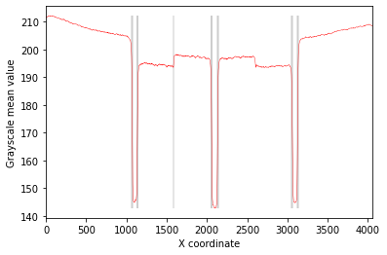
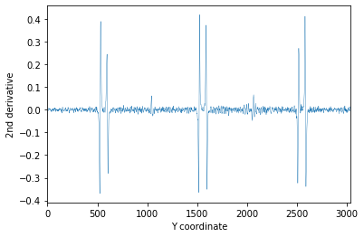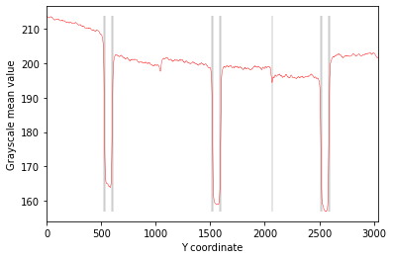
Figure 4. X and Y directions: Savgol 2nd derivative and color analysis with peaks.
X direction, L peaks (left):
pos der2 value default
1067: -0.5987 192.3 x
1076: 0.5769 154.2
1131: 0.4053 153.8
1141: -0.4187 186.2
Select left peak position (1067, 1076, 1131, 1141; Default=1067):
Default value selected: 1067
X direction, R peaks (right):
pos der2 value default
3131: -0.4577 188.7 x
3122: 0.5286 153.4
3066: 0.2916 155.0
3056: -0.3292 184.1
Select right peak position (3131, 3122, 3066, 3056; Default=3131):
Default value selected: 3131
Y direction, L peaks (top):
pos der2 value default
524: -0.3693 199.3 x
533: 0.3895 172.9
597: 0.2449 172.7
606: -0.2809 194.3
Select top peak position (524, 533, 597, 606; Default=524):
Default value selected: 524
Y direction, R peaks (bottom):
pos der2 value default
2592: -0.3387 190.9 x
2583: 0.4119 164.1
2519: 0.2711 166.0
2510: -0.3234 188.5
Select bottom peak position (2592, 2583, 2519, 2510; Default=2592):
Default value selected: 2592
- Length calibration mode -
Calibration length unit (Default=mm):
Horizontal length (mm): 10
Vertical length (mm; Default=10.0):
default selected
Horizontal calibration value: 206.4 pixels/mm
Vertical calibration value : 206.8 pixels/mm
Equal calibration values within 0.05 tolerance: 0.000968
Mean calibration value: 206.6 pixels/mm
Color analysis distance tolerance subceeded: 0.000968 < 0.05
X direction solid square tolerance exceeded: 0.0384 > 0.02
Y direction solid square tolerance exceeded: 0.242 > 0.02
Use circle patch (Y/N, Default y: <Enter>): n
circle patch disabled
Saving: patchcal-10x10.png
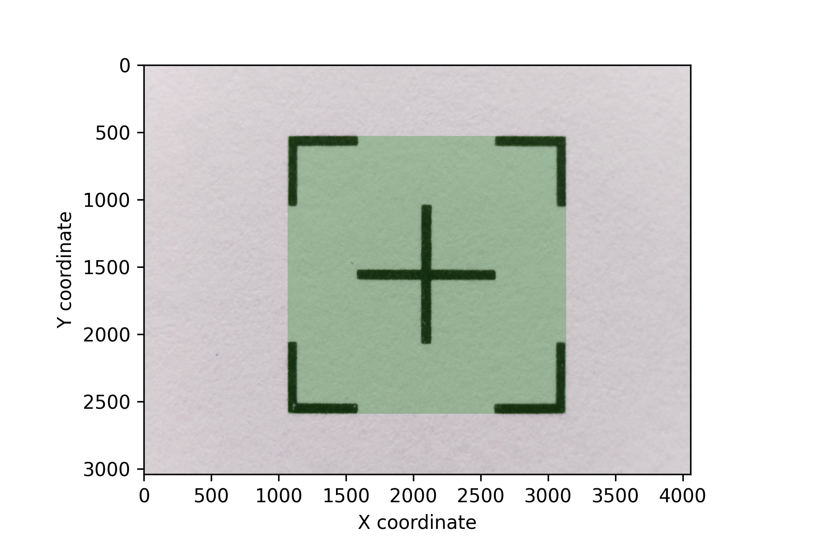
Figure 5. Patched calibration target.
Calibration inormation can be found in the log file:
calen.py log file
Log created on 2021.05.31-13:52:19
Program arguments: 10x10/10x10.png -c -o -p
Analysis directory: /home/pi/python/20210531-calen
Image parameters
Image name : 10x10.png
Image width : 4056
Image height : 3040
Color channels: 3
Savitzky-Golay filter parameters
Polynomial order: 2
Derivative : 2
Window length : 11
Peak find parameters
Minimum relative height: 0.15
Peak X directional analysis
---------------------------
peaks count : 13
height mean : 0.46261
height minimum : 0.10155
height maximum : 0.60406
start peak : 1067
start value : 192.33
center peak : 2099
center value : 142.83
end peak : 3131
end value : 188.7
width : 2064
min value : 142.76
max value : 198.28
base mean value: 190.52
extremum type : maximum
Peak Y directional analysis
---------------------------
peaks count : 13
height mean : 0.32338
height minimum : 0.066152
height maximum : 0.41922
start peak : 524
start value : 190.91
center peak : 1558
center value : 158.87
end peak : 2592
end value : 190.91
height : 2068
min value : 156.91
max value : 202.5
base mean value: 195.11
extremum type : minimum
Calibration mode
----------------
Unit : mm
Horizontal length: 10
Vertical length : 10
Horizontal calibration value: 206.4 pixels/mm
Vertical calibration value : 206.8 pixels/mm
Equal calibration values within 0.05 tolerance: 0.000968
Mean calibration value: 206.6 pixels/mm
Color analysis distance tolerance subceeded: 0.000968 < 0.05
X direction solid square tolerance exceeded: 0.0384 > 0.02
Y direction solid square tolerance exceeded: 0.242 > 0.02

Measuring the Dimensions of a Match Head
Setup
- calibration value (from chapter 5.2)
  - 206.6 pixels/mm
- Savgol 2nd derivative
- window length = 21
- minimum peak relative height = 0.6
$ calen.py match/match.jpg -o
Calibration and length measurement utility, (C) Kim Miikki 2021
Current directory:
/home/pi/python/20210531-calen
Use Savitzky-Golay 2nd derivative (Y/N, Default y: <Enter>): n
2nd derivative mode disabled
Select window size (odd number 3-101; Default=11): 21
Select minimum peak relative height: (0.01...1.0, Default=0.15: <Enter>): 0.6
qt5ct: using qt5ct plugin
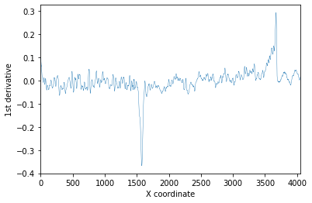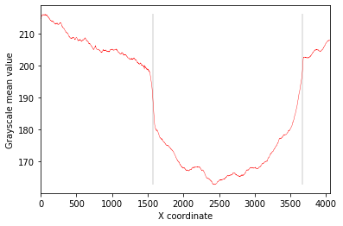
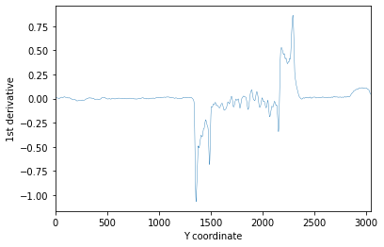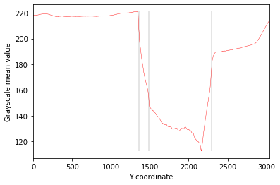
Figure 6. X and Y directions: Savgol 1stderivative and color analysis with peaks.
Y direction, L peaks (top):
pos der1 value default
1358: -1.0696 208.4 x
1487: -0.6842 152.9
Select top peak position (1358, 1487; Default=1358):
Default value selected: 1358
- Length measurement mode -
Calibration length unit (Default=mm):
Calibration value (pixels/mm): 206.6
Width : 10.14 mm
Height: 4.5208 mm
Saving: patch-match.png
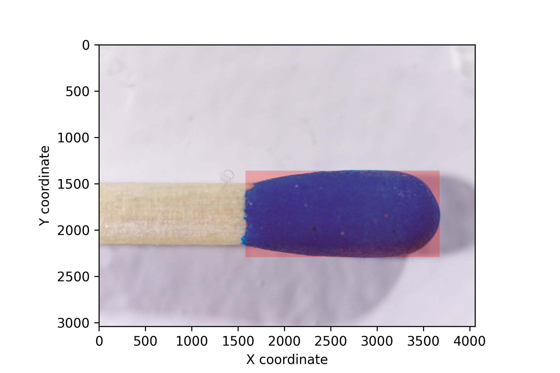
Figure 7. Measured and patched a match head.
Here is the contents of the log file for this measurement:
calen.py log file
Log created on 2021.05.31-22:10:59
Program arguments: match/match.jpg -o
Analysis directory: /home/pi/python/20210531-calen
Image parameters
Image name : match.jpg
Image width : 4056
Image height : 3040
Color channels: 3
Savitzky-Golay filter parameters
Polynomial order: 2
Derivative : 1
Window length : 21
Peak find parameters
Minimum relative height: 0.6
Peak X directional analysis
---------------------------
peaks count : 2
height mean : 0.33044
height minimum : 0.29322
height maximum : 0.36767
start peak : 1578
start value : 187.36
center peak : 2626
center value : 165.5
end peak : 3673
end value : 199.61
width : 2095
min value : 162.76
max value : 199.34
base mean value: 193.48
extremum type : minimum
Peak Y directional analysis
---------------------------
peaks count : 3
height mean : 0.87264
height minimum : 0.68418
height maximum : 1.0696
start peak : 1358
start value : 174.07
center peak : 1825
center value : 130.17
end peak : 2292
end value : 174.07
height : 934
min value : 112.49
max value : 208.39
base mean value: 191.23
extremum type : minimum
Analysis mode
-------------
Calibration value: 206.6 pixels/mm
Width : 10.14 mm
Height: 4.5208 mm

