VID2MP4 Guide
Author: Kim Miikki
Date: 15.9.2021

Introduction
This program converts a video file (e.g., h264 format video file) to mp4 format. Vid2mp4 is a front-end application for MP4Box. When the record speed in FPS is known and there is a PTS (Presentation Time Stamp) file present, the correct FPS value for the mp4 can be calculated. This is done in vid2mp4.py for accurate playback speed.

System Requirements
Operating System: ALL
Program: MP4Box (RPI/Ubuntu installation: sudo apt install -y gpac)
Python 3

Program Usage
Vid2mp4 has some arguments which are used for FPS adjustments and disabling generation of analysis plot files:
$ vid2mp4.py -h
usage: vid2mp4.py [-h] [-rec REC] [-fps FPS] [-n] file
positional arguments:
file video file name
optional arguments:
-h, --help show this help message and exit
-rec REC recorded FPS as float
-fps FPS playback FPS as float
-n do not create graphs
Only file is a mandatory argument for this program. Playback FPS is as default 25, but it can be overridden with a -fps argument. Correct video speed (slowdown, normal or speedup) can be controlled with the -rec argument and a PTS file. Generation of PTS graphs can be disabled with -n switch.

Use Case
A short video was recorded with fpsvideo.py to demonstrate how to use this program. The video recorder created these files:
v-1440x768_100.0fps_10000ss_120s.pts
v-1440x768_100.0fps_10000ss_120s.h264
v-1440x768_100.0fps_10000ss_120s.rec
v-1440x768_100.0fps_10000ss_120s.mkv
v-1440x768_100.0fps_10000ss_120s.log
Originally the vide was captured in the h264 file, alongside with a pts file. These two files were required when converting to video to mp4 format with following command:
$ vid2mp4.py v-1440x768_100.0fps_10000ss_120s.h264 -rec 100
The stem for the pts file must be same as the stem for the video file. Otherwise the pts file is not read. Following files are created:
v-1440x768_100.0fps_10000ss_120s-histogram.png
v-1440x768_100.0fps_10000ss_120s-distribution.png
v-1440x768_100.0fps_10000ss_120s-intervals.txt
v-1440x768_100.0fps_10000ss_120s.mp4
v-1440x768_100.0fps_10000ss_120s-mp4.log
Interval distribution plots are generated and saved to two png files. The results are shown in Figure 1.
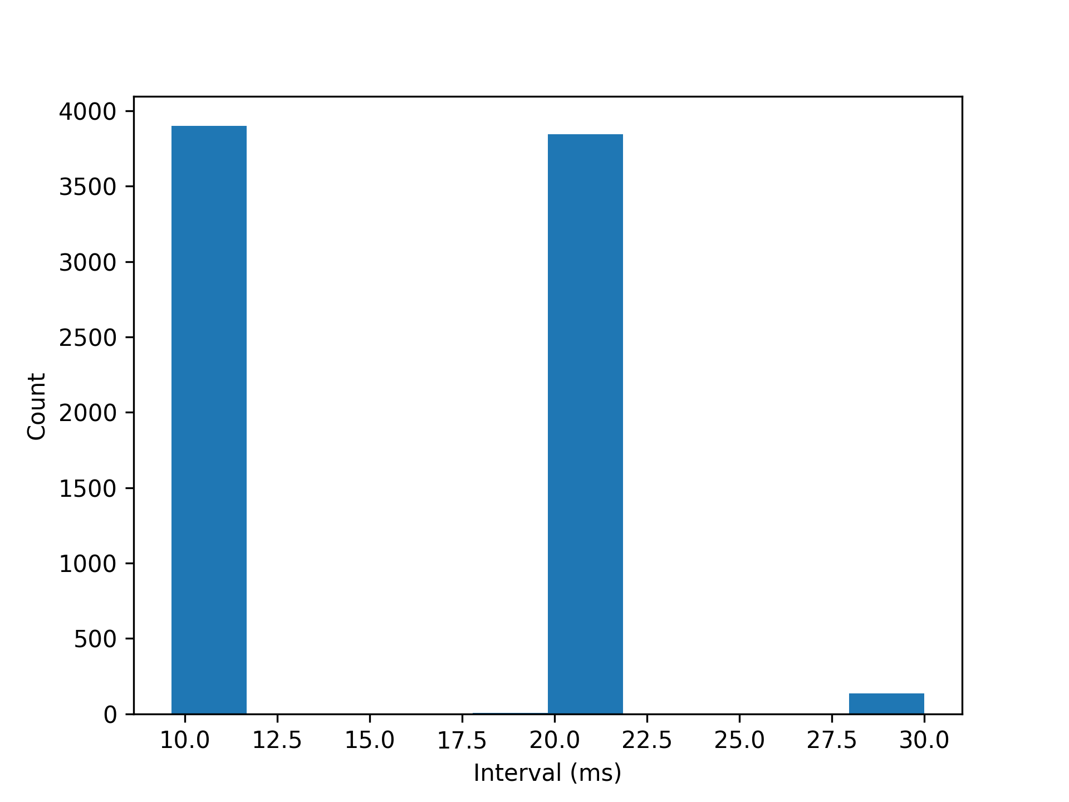 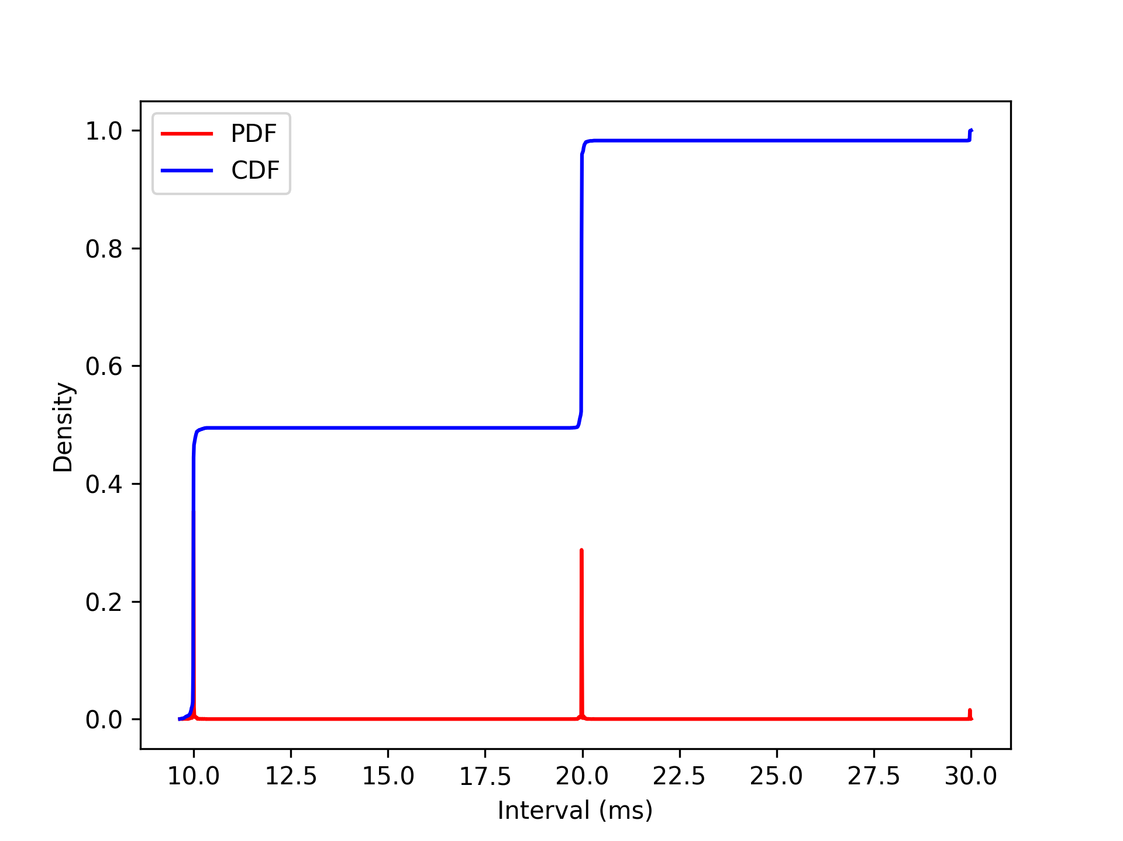
Figure 1. PTS file analyzed with graphs: interval distribution on left side, and probability and cumulative distribution function of the intervals on the right side.
The interval list is stored in a text file, where the stem is ended with “-intervals” string. A summary of selections and a statistical analysis can ar stored in the log file:
$ cat v-1440x768_100.0fps_10000ss_120s-mp4.log
vid2mp4.py log file
Log created on 2021.09.15-14:08:20
Program arguments:
FPS recorded: 100
FPS playback: 25
FPS: 16.434
Slowdown: 4.0x
Statistics:
Intervals: 7887
Frames : 7888
Mean : 15.21
Median : 19.91
Variance : 28.37
MP4 command:
MP4Box -add v-1440x768_100.0fps_10000ss_120s.h264 -new v-1440x768_100.0fps_10000ss_120s.mp4 -fps 16.434
A MP4Box command is generated and executed in order to convert the original video file to a mp4 format file. This command is also stored in the log file, as shown above.
Individual frames can be extracted with vid2pic.py, as shown in Figure 2.

Figure 2. Frame 7830 extracted with vid2pic.py.

The converted video file properties can be extracted and listed with mediainfo:
$ mediainfo v-1440x768_100.0fps_10000ss_120s.mp4
General
Complete name : v-1440x768_100.0fps_10000ss_120s.mp4
Format : MPEG-4
Format profile : Base Media
Codec ID : isom (isom/avc1)
File size : 153 MiB
Duration : 7 min 59 s
Overall bit rate : 2 672 kb/s
Encoded date : UTC 2021-09-15 11:08:11
Tagged date : UTC 2021-09-15 11:08:11
Video
ID : 1
Format : AVC
Format/Info : Advanced Video Codec
Format profile : High@L4.2
Format settings : CABAC / 1 Ref Frames
Format settings, CABAC : Yes
Format settings, ReFrames : 1 frame
Format settings, GOP : M=1, N=60
Codec ID : avc1
Codec ID/Info : Advanced Video Coding
Duration : 7 min 59 s
Bit rate : 2 672 kb/s
Maximum bit rate : 6 245 kb/s
Width : 1 440 pixels
Height : 768 pixels
Display aspect ratio : 1.85:1
Frame rate mode : Constant
Frame rate : 16.434 FPS
Color space : YUV
Chroma subsampling : 4:2:0
Bit depth : 8 bits
Scan type : Progressive
Bits/(Pixel*Frame) : 0.147
Stream size : 153 MiB (100%)
Title : 0fps_10000ss_120s.h264@GPAC0.5.2-DEV-revVersion: 0.5.2-426-gc5ad4e4+dfsg5-5
Encoded date : UTC 2021-09-15 11:08:11
Tagged date : UTC 2021-09-15 11:08:17
Codec configuration box : avcC

