Raspberry Pi High Speed Camera Software

Kim Miikki and Alp Karakoç
Table of Contents
1 List of Abbreviations and Symbols 3
2 Introduction 5
3 Prerequisites 5
3.1 Hardware 5
3.2 Operating System and Programs 6
3.3 Python and Required Libraries 8
3.4 Updating the software suite 10
3.5 RPI High Speed Camera Software 11
4 Launcher for RPI Camera Applications 14
5 Raspberry Pi Camera Module Information 15
6 Camera Preview for Composition 16
7 Video Preview with ROI for Composition 18
8 Region of Interest 20
8.1 Preview and Selection of a ROI 20
8.2 ROI Preview and Graphical Selection 21
8.3 Graphical ROI selection from a Single Picture 24
8.4 Camera Live Preview of a ROI area 25
8.5 Manual Selection of ROI 25
8.6 Crop Images in Batch by ROI 27
8.7 Sharpness Level Monitor and Camera 28
8.8 ROI Sharpness Level Monitor 30
8.9 Sharpness Live Graph Monitor 31
9 Auto Exposure Shutter Speed 32
10 Exposure Bracketing 32
11 Detect Minimum Exposure Time 36
12 Auto White Balance Gains 39
13 White Balance Calibration 39
13.1 Calibration procedure 41
13.2 Calibration with ROI 46
13.3 Analyze only mode 47
14 Get Optimum Gains from a Calibration File 47
15 Capturing Pictures in Manual Mode 48
15.1 Capturing Pictures with Preview Enabled 48
15.2 Camera with Preview 50
15.3 Capturing Pictures without Preview 53
16 Time-Lapse Photography 55
17 Video Recording 58
18 Creating Videos from Pictures 63
19 RGB Color Analysis 71
20 Splitting RGB Channels into Separate Images 74
20.1 Splitting RGB Channels into separate RGB Images 74
20.2 Splitting RGB Channels into Separate Gray Scale Images 76
21 Combining RGB split Images into Color Images 77
21.1 Combining 3 Channel RGB split Images into Color Images 77
21.2 Combining 1 Channel RGB split Images into Color Images 78
22 Batch Resize Images 78
23 Convert Images to PNG Format 81
24 Pictures to Time-lapse Files 81
25 Additional Info 82

List of Abbreviations and Symbols
$ Ordinary User in BASH Shell
µs microsecond = 10⁻⁶ s
ms millisecond = 10⁻³ s
2K 2560x1400 resolution
720p 1280x720 resolution
A/R Aspect Ratio
BW Black and White (eg. Gray Scale)
CRF Constant Rate Factor
CR2 Raw Image Format used by Canon Digital Cameras
CTRL Control Key
FFmpeg A complete, cross-platform solution to record, convert and stream audio and video
FHD 1980x1080, Full HD
FOV Field Of View
FPS Frames per Second
gparted GNOME Partition Editor
H.264 Advanced Video Coding
HQ High Quality (refers to the Raspberry Pi HQ camera module)
IR Infrared
JPG Lossy Compressed Image Format
Md Raspberry Pi video mode
mkvmerge Merge multimedia streams into a Matroska(tm) file
MKV Matroska Multimedia Container (free and open-standard format)
MP Mega Pixels
NoIR No Infrared Filter
PIL Python Imaging Library
PNG Lossless Compressed Image Format
raspistill Program for capturing still photographs with the camera module
raspivid Program for capturing video with the camera module
RGB Red, Green and Blue Color Channels
ROI Region of Interest
RPI Raspberry Pi
VGA 640x480 resolution
VIS Visible light

Introduction
Raspberry Pi combined with a camera module is a portable and cheap imaging system which. The camera (version 2.x) has an 8 MP sensor with a 1 µs minimum exposure time. There are currently two different camera modules which the first is equipped with an IR filter and the second (NoIR) without it. Both modules provides 200 FPS high speed video recording at VGA resolution and 90 FPS at 720p resolution. A new HQ camera module has also been released on April of 2020. All of the camera applications has been updated to support the new camera module.
A camera module connected to a RPI can be used in many different ways. This is due to the programmability of the system. There are four applications (raspistill, raspivid, raspiyuv and raspividyuv) which can be used without programming new applications. Unfortunately they have a lot of options and therefore with script generation software it is possible to make their use much easier. Some of the Python application described in this manual work in this way. An other way is to use RPI camera libraries and create applications with their functions.
All of these programs (Python scripts) are licensed under MIT license.

Prerequisites

Hardware
All programs have been tested to work with the following hardware:
Raspberry Pi 4 Model B 4 GB
Raspberry Pi CMOS CAMERA MODULE NoIR V2 8MPx or Raspberry Pi CMOS CAMERA MODULE V2 8MPx
Raspberry Pi HQ Camera 12.3 MP camera module
16 GB Raspberry Pi NOOBS (New Out of Box Software)
USB 3 SSD drive for storage of images or videos
Flicker free light source(s) if exposure time is under 10-20 ms
Some of the programs have been developed with a Raspberry Pi 3 Model B, but the newest versions of the applications have not been tested to work in that environment.

Operating System and Programs
The system is developed and tested to work with Raspbian GNU/Linux 10 (buster). Following steps (software installation etc.) have to be done in order to run applications which are described in this manual:
Configure a SSD Drive
$ lsblk → /sda
Start gparted
Remove all partitions from the SSD drive
Device → create partition table
msdos <Apply>
Partition > New
File system: ext4
Label: ssd
$ sudo tune2fs -m 0 /dev/sda1
Create /opt/tools directory and add it into the PATH variable
$ sudo mkdir /opt/tools
Copy RPI camera applications to /opt/tools directory
$ sudo chmod ugo+rx *.py

$ sudo nano /etc/profile.d/tools.sh
export PATH="$PATH:/opt/tools"

$ reboot

Create desktop shortcuts
campreview.py
vidpreview.py
Documents -> /opt/tools/documentation

Raspberry Pi Configuration (Preferences > RPC)
System > Auto login: [v] Login as user ’Pi’
Interfaces
Camera (*) Enable
SSH (*) Enable
SPI (*) Enable
I2C (*) Enable
Performance
GPU Memory: 76 → 512

$ reboot

Run the next command in order to test that camera module is working normally:
$ raspistill -t 0
This will show camera live preview forever (exit by CTRL+C).
More comprehensive test can be done with the following command:
$ raspistill -v -o test.png
Update RPI Firmware
$ sudo apt rpi-update
$ reboot

Additional programs
$ sudo apt install mkvtoolnix* exif exifprobe exiftags xscreensaver gparted gnome-disk-utility libraw-dev xclip xsel mediainfo ipython3 filezilla gnome-screenshot dos2unix

Prerequisites for gtlvideo.py
$ sudo apt install libraw-dev
$ sudo apt install ffmpeg

Gimp
$ sudo apt install gimp gimp-plugin* gimp-data-extras gimp-lensfun gimp-g* gimp-help-common gimp-help-en gimp-resynthesizer gimp-texturize

Development libraries for opencv-python
sudo apt install libgtk2.0-dev pkg-config

Python and Required Libraries
In order to run RPI camera applications Python version must be at least 3.5. The version is checked at least by gtlvideo.py.
These steps are required to be done before running the RPI camera applications:
sudo pip3 install --upgrade pip
sudo pip3 install path.py
sudo pip3 install rawpy
sudo pip3 install Pillow
sudo pip3 install imageio
sudo pip3 install exifread
sudo pip3 install numpy pandas
sudo pip3 install pyperclip
sudo pip3 install dlib face_recognition imutils
sudo pip3 install pysimplegui
sudo pip3 install Cython
sudo pip3 install scikit-build
In addition, the following applications must be installed:
sudo apt install opencv*
sudo apt install libatlas-base-dev
sudo apt install libjasper-dev
sudo apt install libqtgui4
sudo apt install python3-pyqt5
sudo apt install libqt4-test
sudo apt install python3-opencv
sudo apt install build-essential cmake pkg-config
sudo apt install libatlas3-base libgfortran5
$ sudo pip3 install numpy==1.19.1 --extra-index-url https://www.piwheels.org/simple

$ sudo pip3 install matplotlib==3.3.1 --extra-index-url https://www.piwheels.org/simple

$ sudo pip3 install --no-binary :all: opencv-python
Looking in indexes: https://pypi.org/simple, https://www.piwheels.org/simple
Collecting opencv-python
Using cached opencv-python-4.4.0.42.tar.gz (88.9 MB)
Installing build dependencies ... done
Getting requirements to build wheel ... done
Preparing wheel metadata ... done
Requirement already satisfied: numpy>=1.14.5 in /usr/local/lib/python3.7/dist-packages (from opencv-python) (1.19.1)
Building wheels for collected packages: opencv-python
Building wheel for opencv-python (PEP 517) ... done
Created wheel for opencv-python: filename=opencv_python-4.4.0.42-cp37-cp37m-linux_armv7l.whl size=10294672 sha256=1af48e51176c1ae154d2939686ec27f04e14f7fe53381541c46f82d576fd5eff
Stored in directory: /root/.cache/pip/wheels/87/89/42/0452b33622ef8f0fd9b90a8f199a7ab909e914e1432ea17b06
Successfully built opencv-python
Installing collected packages: opencv-python
Successfully installed opencv-python-4.4.0.42
Build time ~2 h

sudo pip3 install scipy
Looking in indexes: https://pypi.org/simple, https://www.piwheels.org/simple
Collecting scipy
Using cached scipy-1.5.2.tar.gz (25.4 MB)
Installing build dependencies ... done
Getting requirements to build wheel ... done
Preparing wheel metadata ... done
Building wheels for collected packages: scipy
Building wheel for scipy (PEP 517) ... done
Created wheel for scipy: filename=scipy-1.5.2-cp37-cp37m-linux_armv7l.whl size=50722066 sha256=58285d415bd0469e304a76154822db4eae20a0a58463a1241bda8c5204a6b68c
Stored in directory: /root/.cache/pip/wheels/3c/79/d0/bc51e2a8870685fb1ae515c967d15b7a89dfd530a99717f1fc
Successfully built scipy
Installing collected packages: scipy
Successfully installed scipy-1.5.2
Build time <1 h

Pyhton IDE
$ sudo apt install spyder3

Changing pyhton on pip versions by using alias
$ nano .bash_aliases
alias python=python3
alias pip=pip3

$ reboot

Updating the software suite
Latest version of the RPI software soite can be found here:
https://github.com/kmiikki/rpi-camera
The software and documentation can be downloaded as a ZIP package by pressing <Code> button and Selecting ‘Download ZIP’. It should be unpacked to a desired directory. To install or update the software on a RPI following command should be executed:
$ bash deploy-tools.sh
The script will create necessary sub-directories under /opt:
/opt/tools programs
/opt/tools/rpi common functions for RPI software suite programs
/opt/tools/documentation documentation
Program directory should be included in PATH environment variable. Current path can be printed from terminal:
$ printenv PATH
Persistent path can be done by creating a script under /etc/profile.d/:
$ sudo nano /etc/profile.d/tools.sh
export PATH="$PATH:/opt/tools"

RPI High Speed Camera Software
The RPI High Speed Camera Software will be available from GitHUB in the summer of 2020. Meanwhile they are only available from the author in Aalto University. Until they are released, the applications may only be used at Aalto University.
Some of these applications can be executed on any operating system if Python 3.5 is installed. Also some open source programs must be present, especially if Python application generates scripts for these programs.
List of RPI camera module applications
awb_gains.py
- Get auto white balance gains for red and blue channels
bracket-exposure.py
- Determine an optimal exposure time by capturing images with different exposures
bw-rgbsplit
- Split RGB channels of pictures into separate images (1 channel gray scale)
bw-rgbcombine
- Combine one channel R, G, B pictures into RGB pictures
calibratecam.py
- Calibrate camera module white balance red and blue gains
camapps.py
- High speed camera software suite application launcher
camera.py
- Camera which captures JPG images
camera_model.py
- Get camera information
campreview.py
- Camera preview for composition
capturepics.py
- Capture pictures manually without preview
capturepics-preview.py
- Capture lossless pictures manually with preview
capture-sharpness.py
- Sharpness level monitor and camera
dminexp.py
- Detect minimum exposure time
expss.py
- Get auto exposure shutter speed
fpsvideo.py
- Record videos in slow, normal or high speed
gen_tlfiles.py
- Copy and rename pictures to time-lapse files
gtlvideo.py
- Generate videos from pictures
optimum_gains.py
- Get optimal red and blue gains from a Calibration File
pics2png.py
- Convert image formats which PIL supports to png format
resize-batch.py
- Batch resize images
rgbinfo.py
- Calculate RGB and BW means of pictures
rgbsplit.py
- Split RGB channels of pictures into separate images (3 color channels)
rgbcombine.py
- Combine R, G, B channel pictures into RGB pictures

roiapps.py
- High speed camera ROI software suite application launcher
roi-batch.py
- ROI batch crop images
roi-manual.py
- Selection of ROI by values
roi-picture.py
- ROI graphical selection from a single picture
roi-preview.py
- Camera live ROI preview
roi-select.py
- ROI preview and graphical selection
roi-sharpness.py
- ROI focusing tool with sharpness monitor
sharpmon.py
- Sharpness live graph client for capture-sharpness.py
timelapse.py
- Capture time-lapse pictures
vidpreview.py
- Video preview with ROI for composition

Launcher for RPI Camera Applications
camapps.py
- High speed camera software suite application launcher
- RPI is not required
Most of applications which are described in this manual, can be launched from this program. Different tasks are organized under following categories: Composition, Exposure, White Balance Calibration, Images and Videos, Image Analysis and Operations. Their tasks are listed in the following example:
$ camapps.py
RPI High Speed Camera Software Suite (C) Kim Miikki 2020
Composition
1 Camera info
2 Camera preview
3 Video preview
Exposure
4 Auto exposure shutter speed
5 Exposure bracketing
6 Detect minimum exposure time
White Balance Calibration
7 Auto white balance (AWB) gains
8 Optimal gains from a calibration file
9 Calibration
Images and Videos
10 Camera
11 Camera without preview
12 Time-lapse
13 Video recorder
Image Analysis and Operations
14 Create videos from images
15 Color analysis
16 Split images to RGB channels
17 Combine RGB channels to color images
18 Split RGB channels to gray scale
19 Combine RGB gray scale channels to color images
20 Convert images to PNG format
21 Images to time-lapse files
0 Exit
Select task (0...21, Default=0: <Enter>):

Raspberry Pi Camera Module Information
camera_model.py
- Get Raspberry Pi camera module information
- RPI camera module is required
This application gives information about attached camera module: sensor model, megapixels and camera resolution. Here is an example of the HQ camera module:
$ camera_model.py
Raspberry Pi camera module
revision: imx477
model: RP_imx477
make: RaspberryPi
megapixels: 12.3
max x: 4056
max y: 3040

Camera Preview for Composition
camerapreview.py
- Camera Preview for Composition
- Requires a RPI and a camera module
- Uses PiCamera library
The first step in order to capture pictures or videos is to preview the composition. An application designed for this task is named campreview.py. Although same task can be done with the following command: raspistill -t 0, campreview.py does little more. From the current screen resolution it determines if there are two preview choices. Those are demonstrated by the following two pictures:
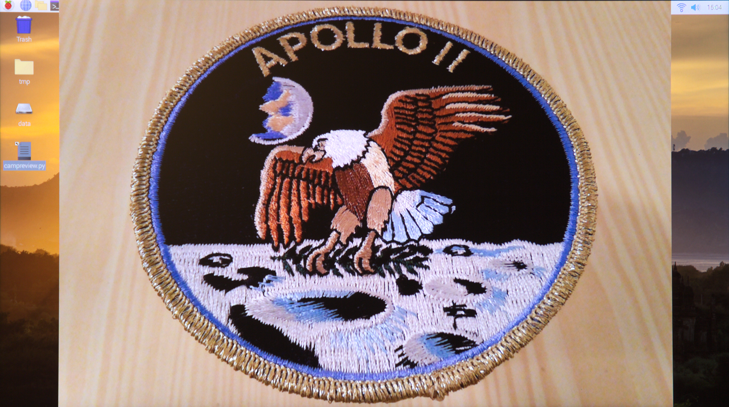Full preview composition with margins.
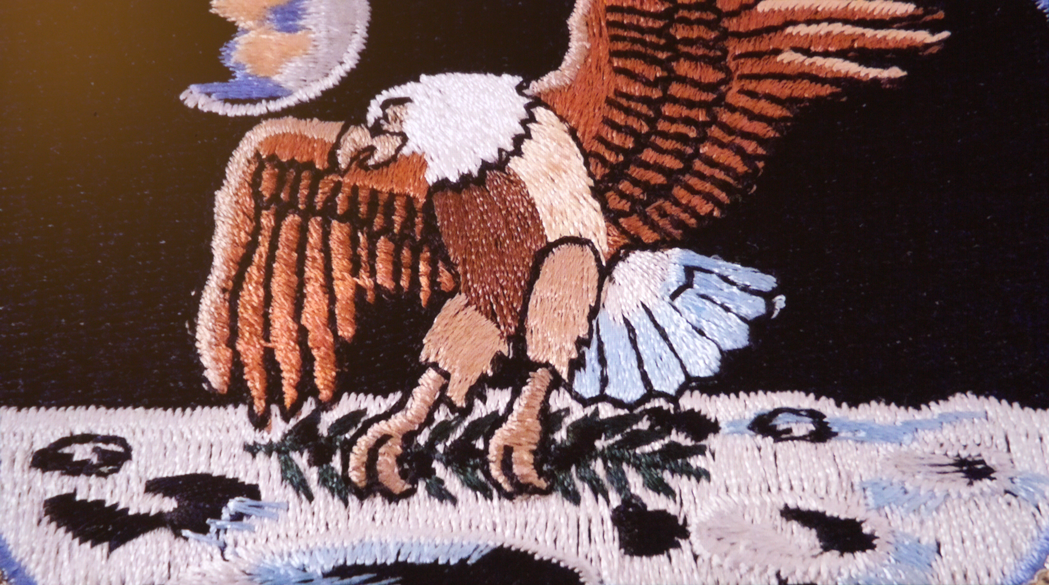Full screen and cropped preview composition without margins.
One can find in the source code following variables: maxx_tested and maxy_tested. They describe maximum preview window resolution which gives in full screen preview mode full composition. Beyond these values full screen preview will give a cropped composition. Unfortunately the values are not the same for every resolution. In the code the maximum tested preview size 1615x1200. So full composition in full screen will be always available for the resolution of 1280x1024 (which is available on RPI 4 Model B). FHD resolution will give margins if full composition is desired.
Caution! The application must be executed in terminal. Otherwise it is very difficult to exit the program.
Here is an example how to run the application in FHD mode:
Raspberry Pi camera module live preview
Full screen and cropped preview (Y/N, default: N <ENTER>)
Default selected
Preview: ENTER
Exit program: ESC
Preview will start by pressing Enter and end by pressing ESC.

Video Preview with ROI for Composition
vidpreview.py
- Video Preview for Composition
- Requires a RPI and a camera module
- Calculates ROIs for all supported video modes
- Uses PiCamera library
RPI camera module (ver. 2.x) have a set of video modes that can be used when recording videos. The following table summarizes which modes are available, their resolutions, regions of interests etc:

RPI camera module 2.x video modes
The table of video modes shows that the only mode, which gives full field of view (= maximum sensor area), is mode number 4. Modes 2-5 gives full FOV, but in modes 2, 3 and 6 not whole sensor area is used for capturing videos. This is due to different A/R from the sensor to video resolution. Mode 1 captures videos in FHD mode and modes 6 and 7 are high speed recording modes (up to 90 or 200 FPS). Binned 2x2 modes have better sensitivity than non binned mode, because the sensor data per pixel is collected from a 2x2 square of sensor pixels.
This application only asks for a desired video mode (1-8). Normalized ROI values (0...1) are calculated and a live preview of the selected video mode is enabled, until ESC is pressed.
The HQ camera has fever video modes which are shown in the following table. All of the documented resolutions [1] did not work on 3.6.2020. Hence a manual testing was required in order to get working video resolutions.

RPI HQ camera module manually tested video modes
Here is an example how to run this application:
$ vidpreview.py
Raspberry Pi camera v. 2.x video preview
Video modes
Md Video A/R W H ROI W ROI H
1 1920x1080 16:9 1920 1080 1920 1080
2 1920x1080 16:9 1920 1080 3280 1845
3 1920x1080 16:9 1920 1080 3280 1845
4 1640x1232 4:3 1640 1232 3280 2464
5 1640x922 16:9 1640 922 3280 1845
6 1280x720 16:9 1280 720 2560 1440
7 640x480 4:3 640 480 1280 960
Preview: Md
Exit program: ESC
Key 6 pressed
Md: 6
ROI: 0.109756,0.207792,0.780488,0.584416
ESC key terminates the video preview and the program
Cited references:
[1] https://www.raspberrypi.org/documentation/raspbian/applications/camera.md, 3.6.2020

Region of Interest
Often only a part of an image is desired. This area is called ROI (Region of Interest). Raspistill and raspivid accepts a -roi parameter, followed by a starting point of ROI, its width and height. This values are normalized from 0 to 1. For an example, the ROI parameter for FOV is -roi 0,0,1,1.
Most of the the RPI software suite ROI applications are collected under a software launcher: roiapps.py. Selection of ROI generates a roi.ini file which is used in several applications. The ini file contains information about image size, crop coordinates and normalized crop values. It should be placed in the working directory before launching a ROI application.

Preview and Selection of a ROI
roiapps.py
- High speed camera ROI software suite application launcher
- RPI is not required
This software launcher has two categories: ROI and focusing tools. In the first category ROI can be selected from a live preview picture, saved picture or by entering values. Thereafter ROI can be used in camera live preview, batch cropping and with ROI sharpness level monitor. Selection of a task is done from following menu:
$ roiapps.py
RPI High Speed Camera ROI Software Suite (C) Kim Miikki and Alp Karakoc 2020
Region of Interest
1 Preview and selection
2 ROI from a single picture
3 ROI camera preview
4 ROI manual selection
5 Batch crop
Focusing Tools
6 ROI sharpness level monitor
7 Sharpness level monitor and camera (server)
8 Sharpness live graph monitor (client)
0 Exit
Select task (0...8, Default=0: <Enter>):

ROI Preview and Graphical Selection
roi-select.py
- ROI preview and graphical selection
- Requires opencv Python library
- RPI and a camera module are required
This application has a straightforward workflow: compose the image, capture and save the image, open it automatically, select ROI graphically and generate roi.ini into current working directory. In addition of this, a ROI cropped image will be saved. This workflow is demonstrated here:
$ roi-select.py
Raspberry Pi Camera ROI Preview and Selection
Capture image mode (Y/N, Default y: <Enter>):
Default selected: Capture initial picture from camera enabled
Current directory:
/media/pi/data/20201019-LaserLiner_to_manual
Capture initial frame: SPACE
Exit program: ESC
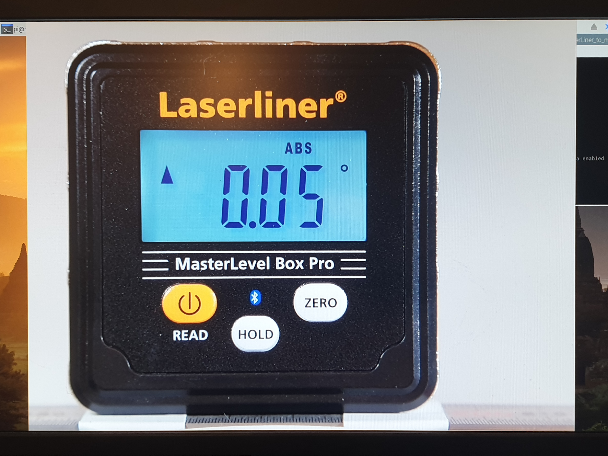
Composition of the image. Initial frame is captured by pressing SPACE.
Capturing initial frame…
Select a ROI and then press SPACE or ENTER button!
Cancel the selection process by pressing c button!
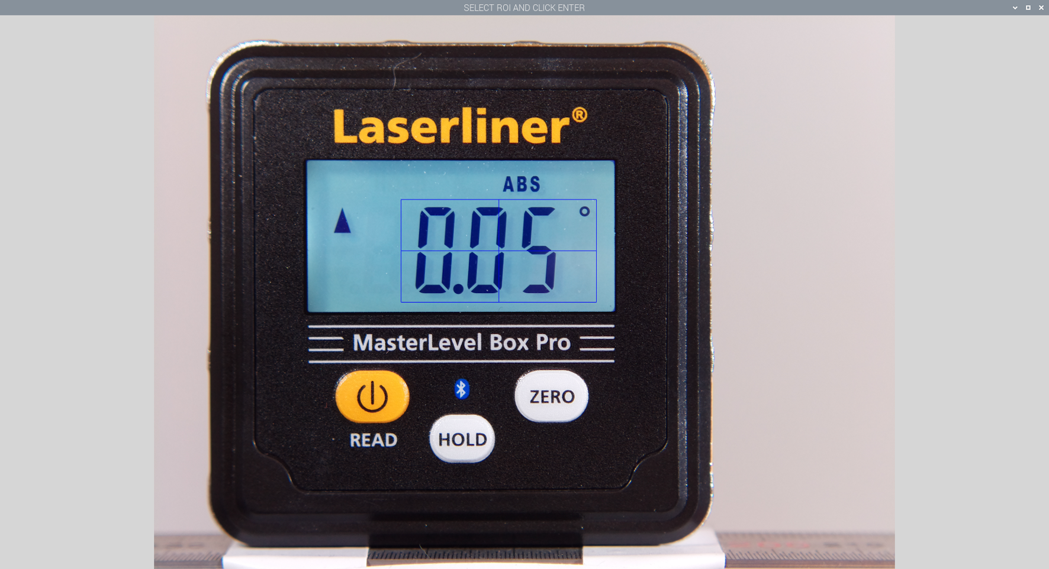
Initial frame opened with OpenCV. The ROI is selected graphically and the selection is approved by pressing ENTER or SPACE.
Roi option: -roi 0.3333,0.3326,0.2638,0.1859
The program generate following files to current directory:
roi-fov.png
roi-image.png
roi.ini
The first file is the initial frame, second is ROI cropped image if the initial frame and third file contains image and ROI information.
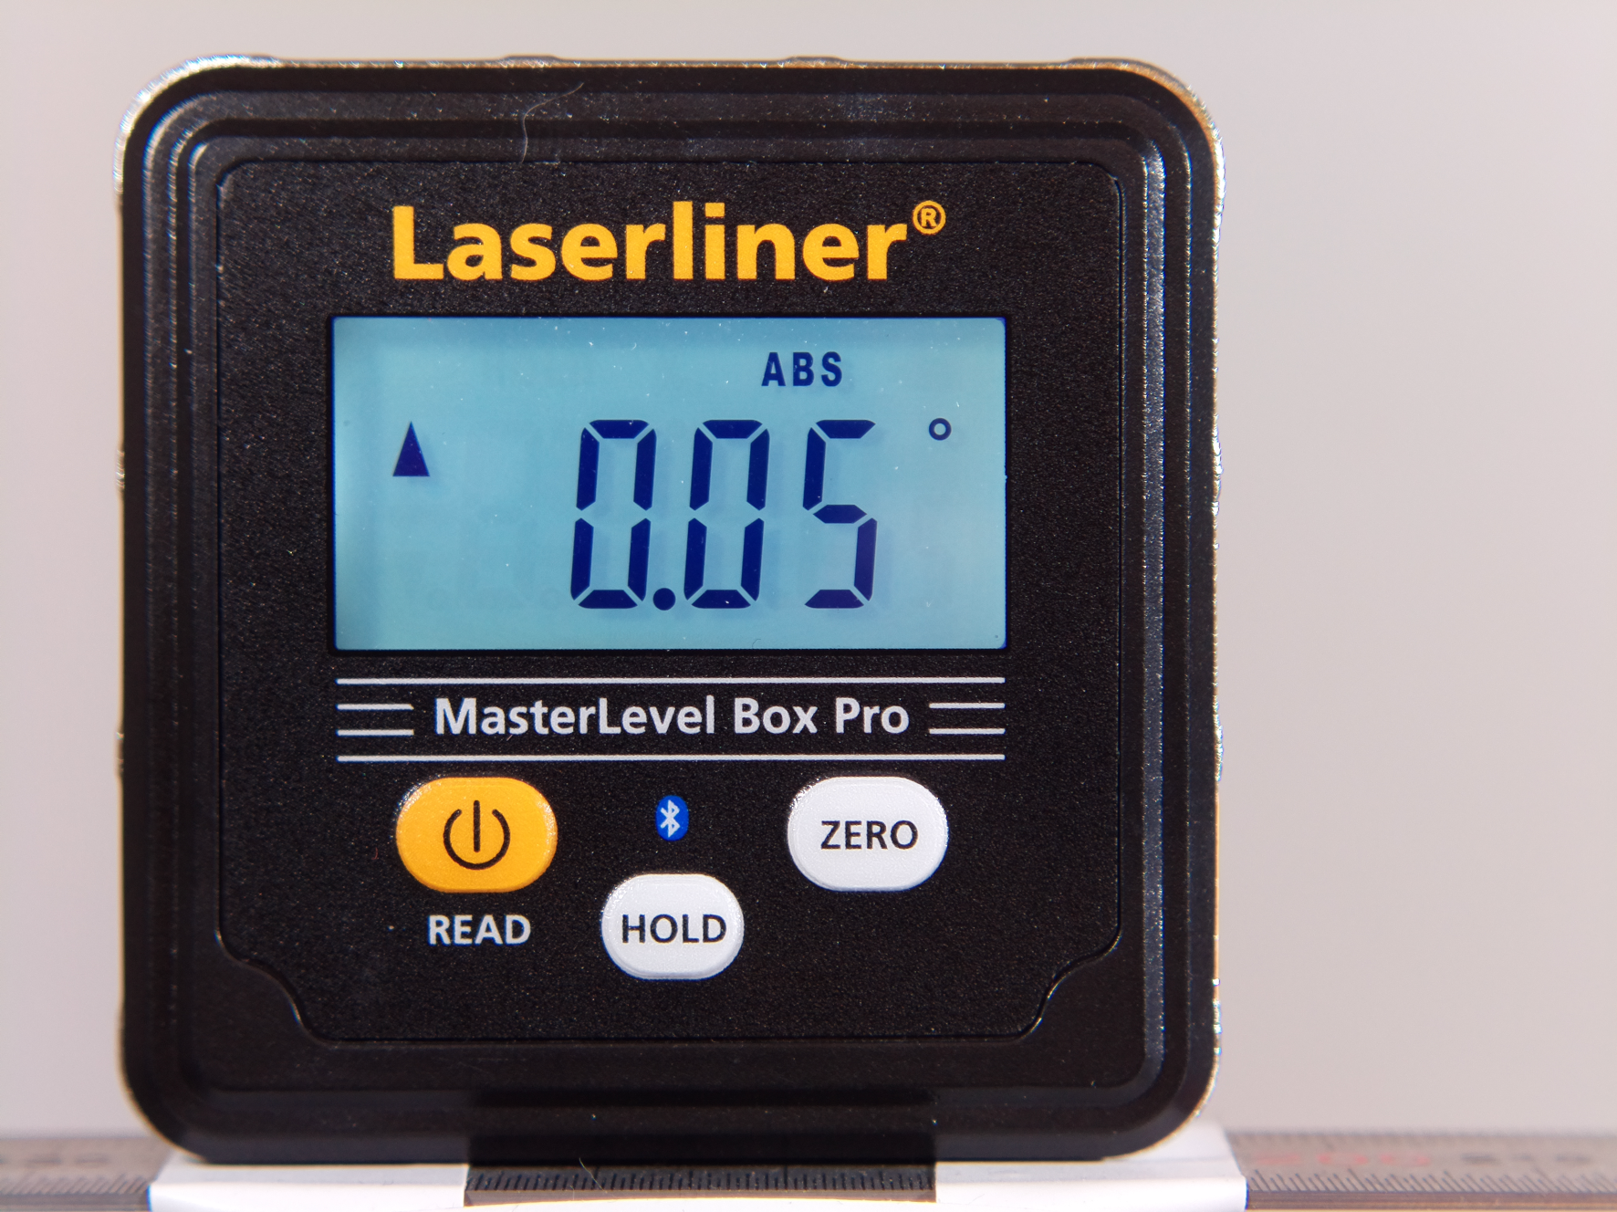
Initial frame with full field of view: roi-fov.png
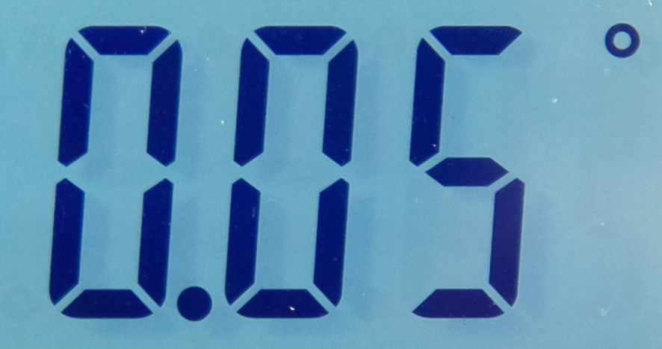
Cropped image by region of interest: roi-image.png

Contents of roi.ini:
scale;coordinate name;value
original;img_x0;0
original;img_x1;4056
original;img_y0;0
original;img_y1;3040
original;crop_x0;1352
original;crop_x1;2422
original;crop_y0;1011
original;crop_y1;1576
normalized;roi_x0;0.3333
normalized;roi_y0;0.3326
normalized;roi_w;0.2638
normalized;roi_h;0.1859
These pictures were captured with a HQ camera, 16 mm tele lens and 2 stacked +4 dpt close-up lenses.

Graphical ROI selection from a Single Picture
roi-picture.py
- ROI selection from a single picture
- Requires opencv and PySimpleGui Python libraries
This application is quite similar to roi-select.py but instead of capturing images a existing image is opened. Name or path of the image is asked with the following dialog:
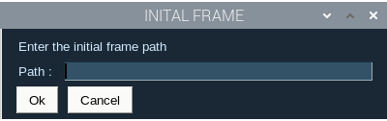
Thereafter the workflow is similar to roi-select.py

Camera Live Preview of a ROI area
roi-preview.py
- Camera live ROI preview
- RPI, camera module and roi.ini are required
Selected ROI area can be previewed live with roi-preview.py. Pressing space toggles between ROI and FOV of the composition:
$ roi-preview.py
Raspberry Pi Camera ROI Preview
Toggle between FOV and ROI: SPACE
Exit program: ESC
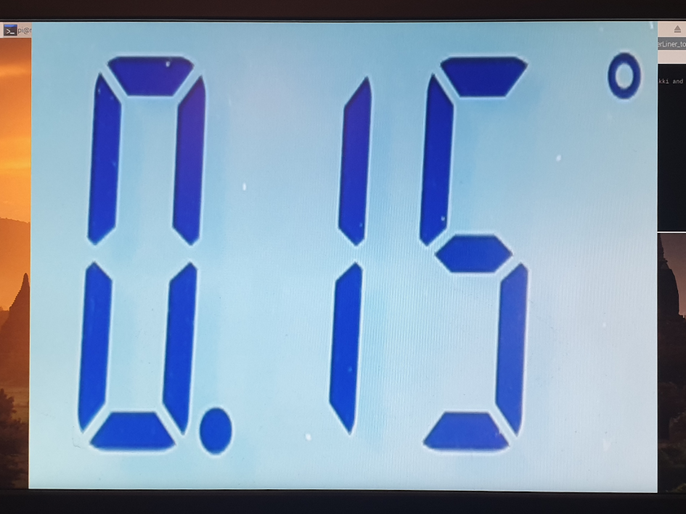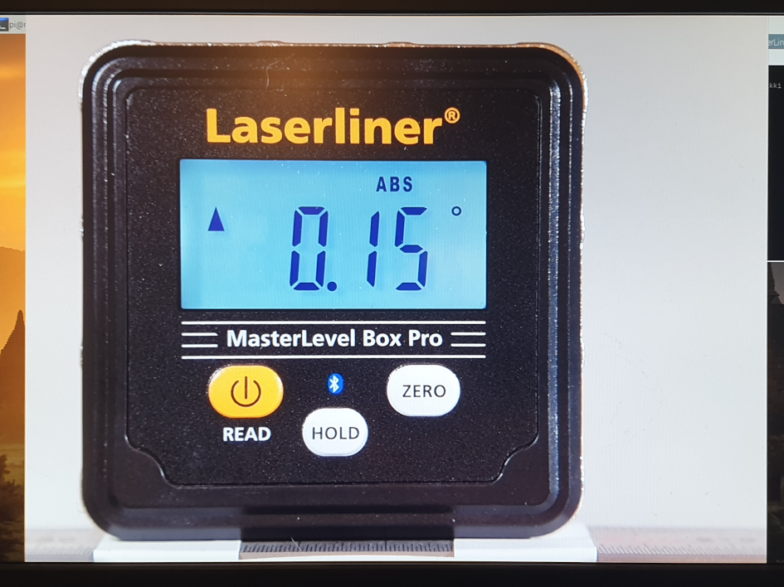
Toggle between ROI and FOV preview.

Manual Selection of ROI
roi-manual.py
- Selection of ROI by values
- Requires opencv Python library
In order to create roi.ini with specific coordinates or with predefined width and height, roi-manual.py could be used. Picture size is read from an image file, if it is given as an argument to the python script. Absolute mode for coordinates can be selected by changing the value of absolut_mode to True instead of False. This has to be done by editing the source file. Following example shows how to use this tool:
$ roi-manual.py ptfe-h2o-frame00000001.jpg
ROI manual selection
Current directory:
/media/pi/data/PTFE
Region of Interest
------------------
Select X0 (0...4055, Default=0: <Enter>): 1468
Select Y0 (0...3039, Default=0: <Enter>): 1632
Select Width (1...2588, Default=2588: <Enter>): 1280
Select Height (1...1408, Default=1408: <Enter>): 1024
Roi option: -roi 0.3619,0.5368,0.3156,0.3368
pi@rpicam:/media/pi/data/PTFE $ ls
ptfe-h2o-frame00000001.jpg ptfe-h2o-frame00000300.jpg roi.ini
ptfe-h2o-frame00000100.jpg ptfe-h2o-frame00000400.jpg
ptfe-h2o-frame00000200.jpg ptfe-h2o-frame00000500.jpg
pi@rpicam:/media/pi/data/PTFE $ cat roi.ini
scale;coordinate name;value
original;img_x0;0
original;img_x1;4056
original;img_y0;0
original;img_y1;3040
original;crop_x0;1468
original;crop_x1;2748
original;crop_y0;1632
original;crop_y1;2656
normalized;roi_x0;0.3619
normalized;roi_y0;0.5368
normalized;roi_w;0.3156
normalized;roi_h;0.3368
The difference of FOV and ROI images can bee seen in these pictures:
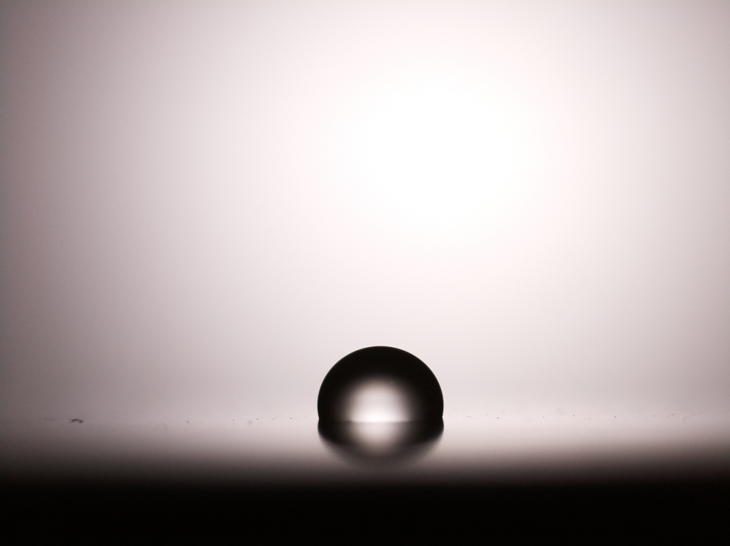 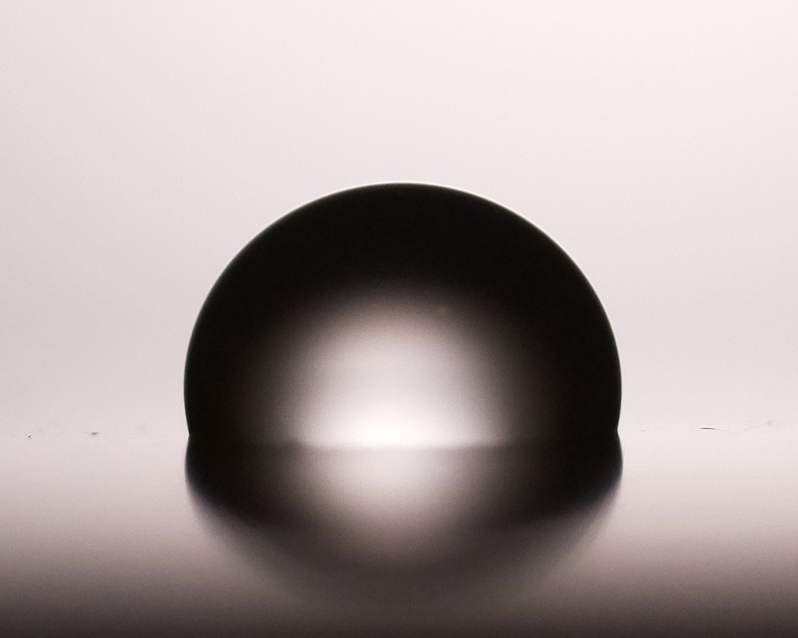
FOV: 4056x3040 ROI: 1280x1024

Crop Images in Batch by ROI
roi-batch.py
- ROI batch crop images
- Requires opencv Python library
A very convenient method to crop images in batch is to use roi-batch.py. This program should be executed in the working directory where images to be cropped are located. Their dimensions must be same as the dimensions defined in roi.ini. Here is an illustrative example how to use this tool:
$ roi-batch.py
ROI batch crop tool
ptfe-h2o-frame00000001.jpg (4056x3040): -> ptfe-h2o-frame00000001.jpg
ptfe-h2o-frame00000100.jpg (4056x3040): -> ptfe-h2o-frame00000100.jpg
ptfe-h2o-frame00000200.jpg (4056x3040): -> ptfe-h2o-frame00000200.jpg
ptfe-h2o-frame00000300.jpg (4056x3040): -> ptfe-h2o-frame00000300.jpg
ptfe-h2o-frame00000400.jpg (4056x3040): -> ptfe-h2o-frame00000400.jpg
ptfe-h2o-frame00000500.jpg (4056x3040): -> ptfe-h2o-frame00000500.jpg
Pictures converted: 6
Time elapsed: 0:00:04.937757
pi@rpicam:/media/pi/data/PTFE $ tree
.
├── ptfe-h2o-frame00000001.jpg
├── ptfe-h2o-frame00000100.jpg
├── ptfe-h2o-frame00000200.jpg
├── ptfe-h2o-frame00000300.jpg
├── ptfe-h2o-frame00000400.jpg
├── ptfe-h2o-frame00000500.jpg
├── roi
│ ├── ptfe-h2o-frame00000001.jpg
│ ├── ptfe-h2o-frame00000100.jpg
│ ├── ptfe-h2o-frame00000200.jpg
│ ├── ptfe-h2o-frame00000300.jpg
│ ├── ptfe-h2o-frame00000400.jpg
│ └── ptfe-h2o-frame00000500.jpg
└── roi.ini
1 directory, 13 files
pi@rpicam:/media/pi/data/PTFE/roi $ mediainfo roi/ptfe-h2o-frame00000001.jpg
General
Complete name : ptfe-h2o-frame00000001.jpg
Format : JPEG
File size : 222 KiB
Image
Format : JPEG
Width : 1 280 pixels
Height : 1 024 pixels
Color space : YUV
Chroma subsampling : 4:2:0
Bit depth : 8 bits
Compression mode : Lossy
Stream size : 222 KiB (100%)

Sharpness Level Monitor and Camera
capture-sharpness.py
- Sharpness level monitor
- Requires opencv and matplotlib Python libraries
- Server application for sharpmon.py
Focusing an object requires adjustment of the optical system. Capturing objects in a macro mode can be challenging regarding a decent focusing. One method to estimate the sharpness level of an image is to calculate its variance of Laplacian. Higher values of variance indicates that there are more sharp edges in the image. A blurry image yield lower variance. Large and smooth color areas decrease the variance although the object may be in focus. This issue can be handled by using ROI, i.e. roi-sharpness.py instead of capture-sharpness.py.
Default OpenCV capture mode (RPI: 640x480) can be overridden with an argument: -hd. In this mode resolution is 1280x720 but the variance is not calculated from FOV, but from a cropped image.
This program is as default in server mode if started from roiapps.py. It provides sharpness data to a client software: sharpmon.py. The server can be started in stand-alone mode with argument -s. Current directory is used as data source directory for monitoring of variance.
By pressing C the program captures pictures with consequent numbering under sharpness sub-directory. It is created under current directory. Pictures are saved in same resolutions as the live preview window but in gray scale. The resolutions are 640x480 and 1280x720. A variance of Laplacian graph is shown and saved (in current directory) aftor completing capturing and exiting program by pressing ESC. Capture data is also saved as a text file. The names of these files are varfig.png and var.txt.
The program can be launched from roiapps.py or by itself:
$ capture-sharpness.py
Monitor sharpness
Default capture mode enabled.
HD mode : -HD
Server mode: -S
Capture image: C
Toggle server: S
Text color : TAB
Exit program : ESC
qt5ct: using qt5ct plugin
Server mode: Enabled
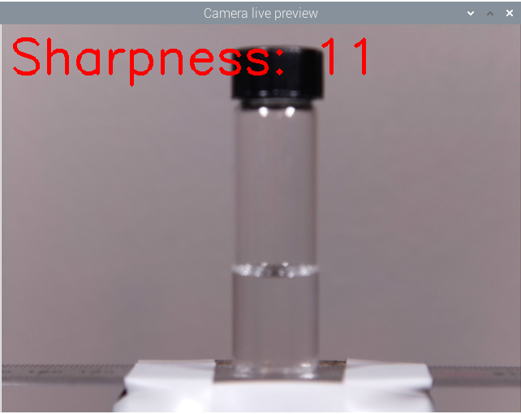 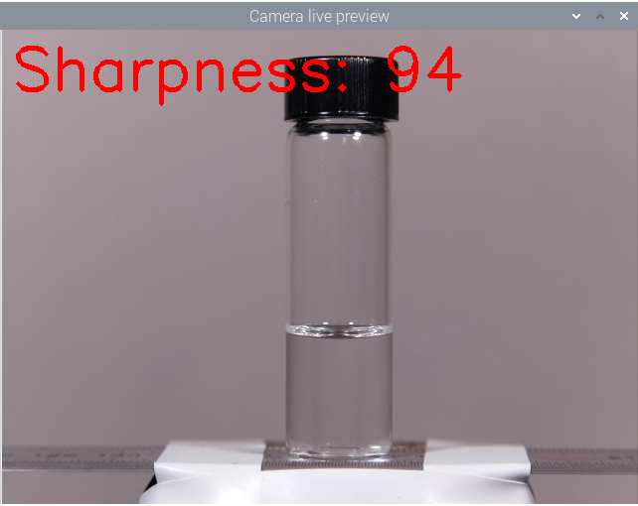
A higher value of the variance of Laplacian is an indication of a sharper image.

ROI Sharpness Level Monitor
roi-sharpness.py
- ROI focusing tool with sharpness monitor
- Requires opencv Python library
This program is very similar to capture-sharpness.py, but ROI is now used to calculate variance of Laplacian. The preview window is small for small ROI areas. A larger extrapolated preview can be used with the toggle button: SPACE.
This program has some run-time options which are listed in the following example:
$ roi-sharpness.py
Live ROI sharpness level monitor
Control keys
------------
Toggle ROI/stretch mode: SPACE
Toggle overlay on/off : Alt_L
Toggle console output : Ctrl_L
Text color: TAB
Exit program: ESC
Sharpness:
123
123
123
123
124
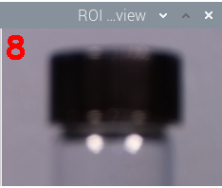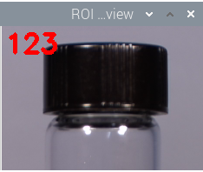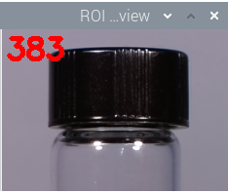
Live ROI sharpness level monitoring with roi-sharpness.py.

Sharpness Live Graph Monitor
sharpmon.py
- Focusing tool: live sharpness graph
- Requires matplotlib Python library
Sharpness if live preview can be monitored with sharpmon.py. As a client software it requires a data server which is capture-sharpness.py. Both programs must be run in same directory which is used as data source directory. If the program is started before server or server mode is enabled in capture-sharpness.py, client waits until data is provided. Thereafter monitoring will start.
The live graph monitor in conjunction with a live preview server enables an easier way to achieve a proper focusing. This is especially emphasized when capturing images when the field of depth is very narrow, e.g. macro photography.
Monitoring can be started by launching the program from roiapps.py launcher or as a standalone program. In both cases it has to be started in the data source directory, where the server application is being executed. This can be accomplished by opening to separate terminals in same directory, where server and client is ran in their respective terminals.
Here is an example how to run the client software:
$ sharpmon.py
Sharpness live graph monitor
Data source directory: /home/pi/python/20201021-monitor-sharpness.py/new
qt5ct: using qt5ct plugin
Waiting for server…
Server found and monitoring started.
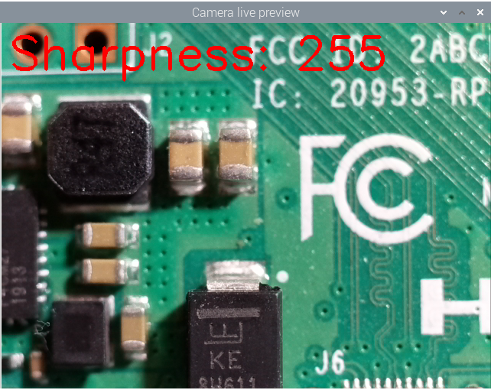 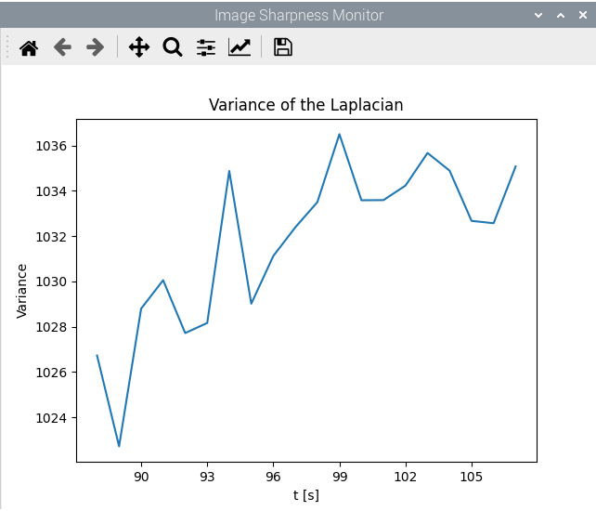 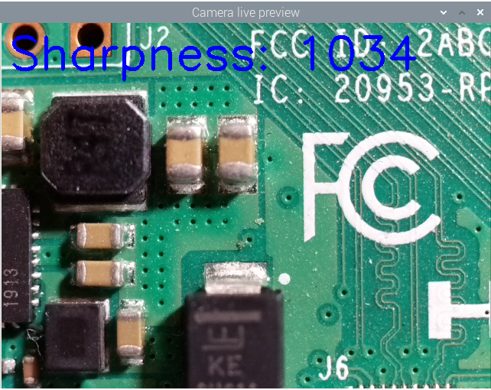
Initial focus improved with sharpmon.py live graph client and capture-sharpness.py server. Larger variance indicates a sharper image.

Auto Exposure Shutter Speed
expss.py
- Get auto exposure shutter speed
- Optionally get red and blue gains
- Requires a RPI and a camera module
The second step before starting to capture images or recording videos is to determine what is the optimum exposure time. This script returns the actual shutter speed in auto exposure mode. Also it is possible to get the red and blue gains by enabling gains in the code (enable_gains=True).
Shutter speed is returned in ms and µs units, as shown here:
$ expss.py
Auto exposure shutter speed for Raspberry Pi camera 2.x
Shutter speed: 8 ms
Shutter speed: 7533 µs

Exposure Bracketing
bracket-exposure.py
- Determine an optimal exposure time by capturing images with different exposures
- 26 JPG files will be created from exposures between 1 µs to 0.33 s
- Requires a RPI and a camera module
- Requires raspistill
- Generates and executes scripts (capture commands) which can be executed without Python
A better way to determine optimum exposure time is to do exposure bracketing. The bracket-exposure.py captures a series of pictures with different exposure times, starting from 1 µs and ending to 0.33 s. From these pictures, it is possible quickly to determine what is the optimum exposure for a imaging project.

Here is an example how bracketing exposures works:
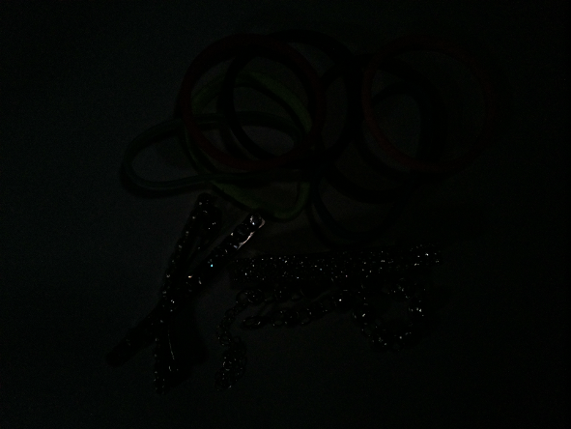 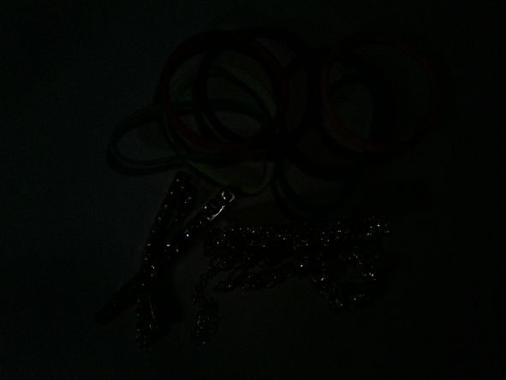 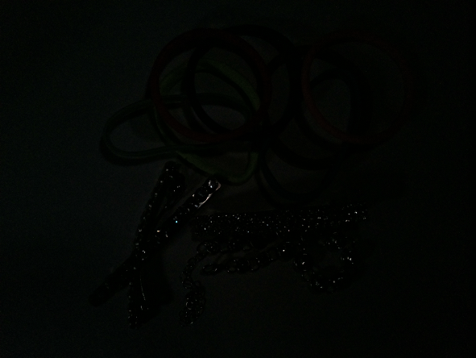
1 µs 5 µs 10 µs
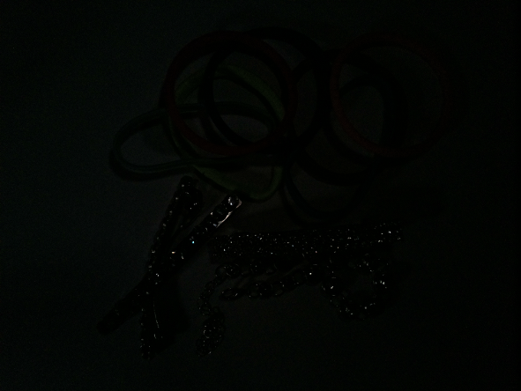 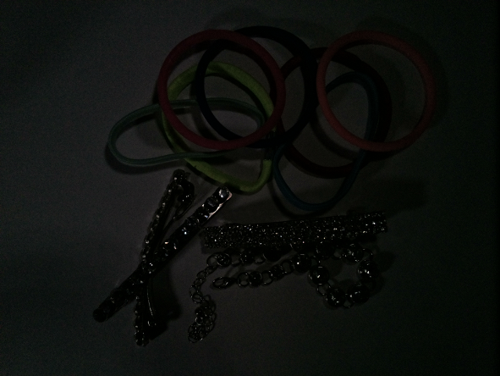 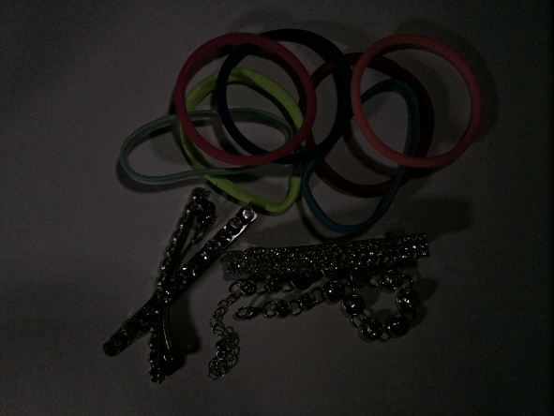
25 µs 50 µs 100 µs
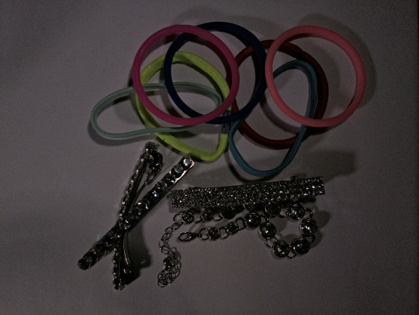 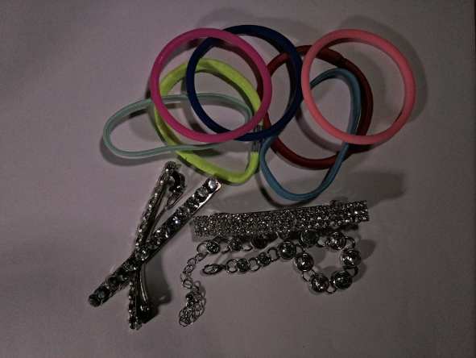 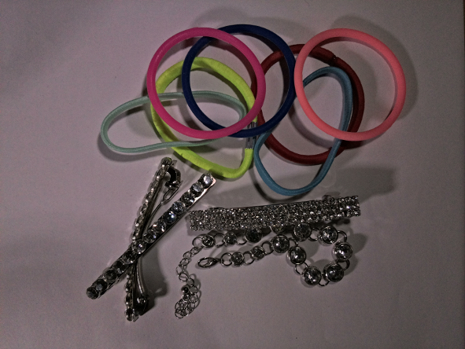
200 µs 350 µs 500 µs
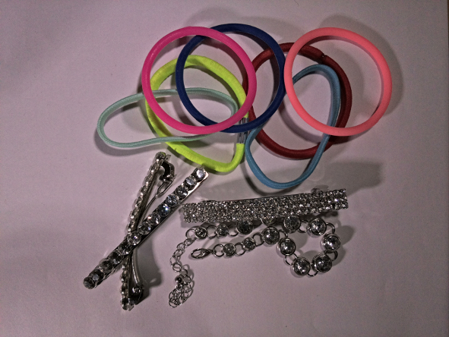 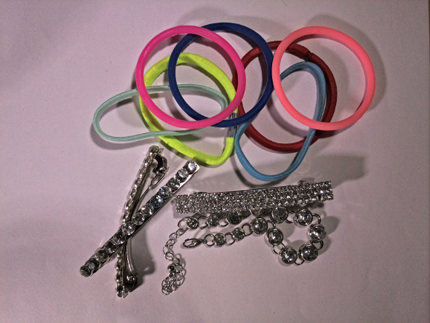 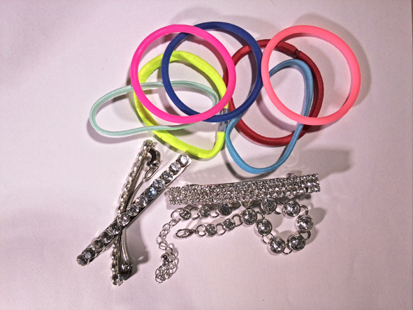
750 µs 1 ms 2 ms
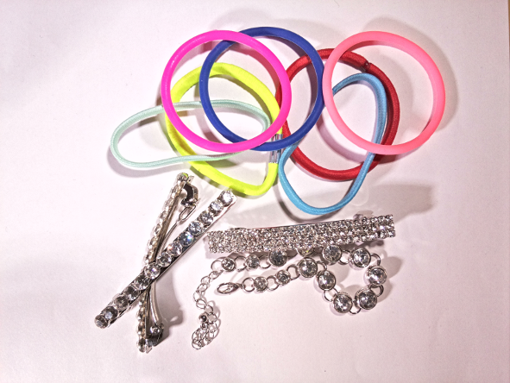 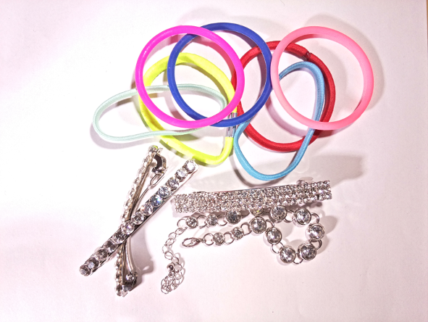 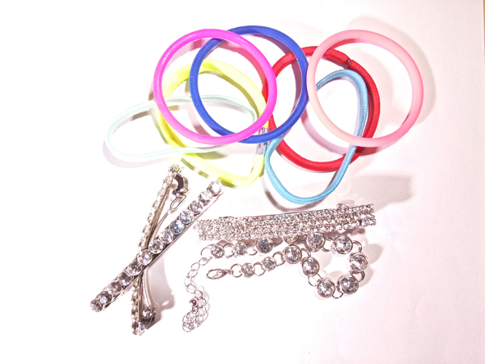
3.5 ms 5 ms 7.5 ms
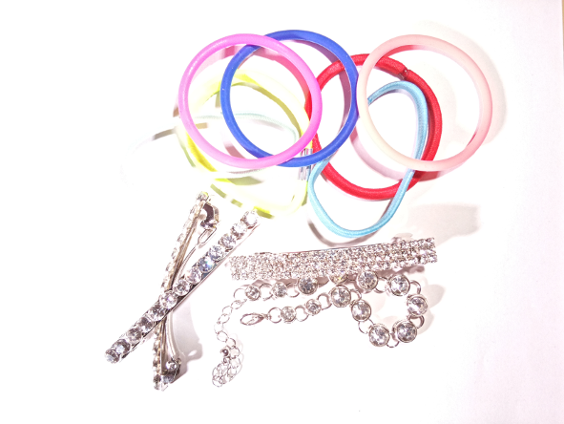 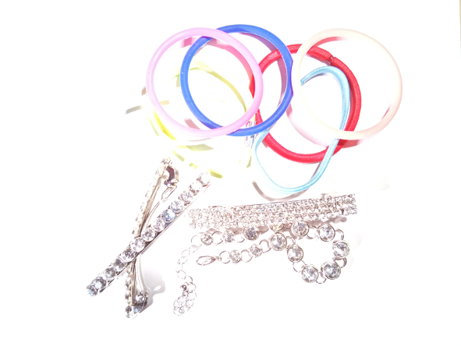 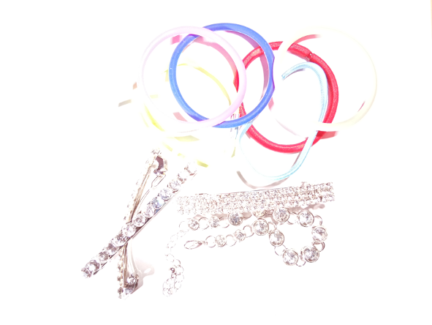
10 ms 15 ms 20 ms
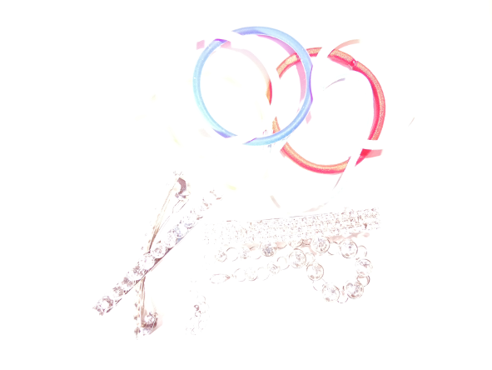 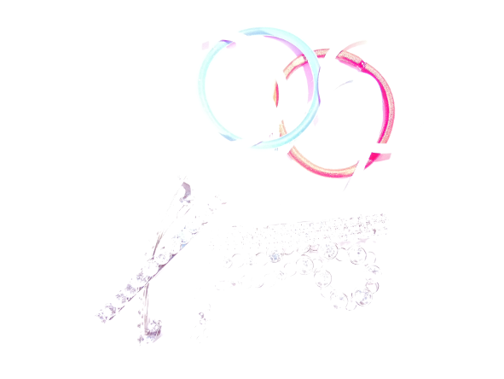 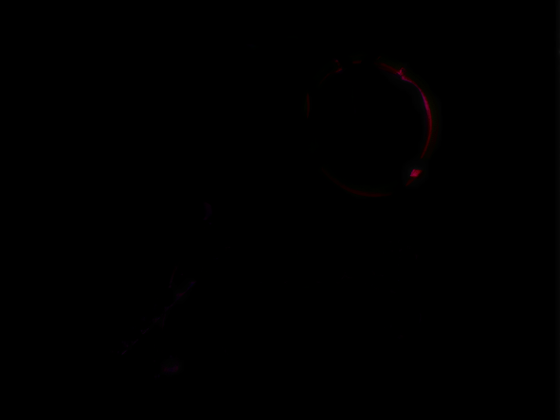
35 ms 50 ms 100 ms (too much light for sensor)
The rest exposure times were 150 ms, 200 ms, 250 ms, 300 ms and 330 ms. The camera sensor can not handle so much light. Therefore, these images are almost black (not shown here).
In this example, the composition was illuminated by two non flickering high power LED lamps (550 lx and 440 lx) and with ambient light sources (also non flickering).
The usage of this application is very simple which is shown here:
$ bracket-exposure.py
Exposure bracketing program for Raspberry Pi camera v. 2.x (c) Kim Miikki 2019
Select image quality (1...100; default: 90):
Default value selected: 90
List disk and partitions:
NAME MAJ:MIN RM SIZE RO TYPE MOUNTPOINT
sda 8:0 0 223.6G 0 disk
└─sda1 8:1 0 223.6G 0 part /media/pi/data
mmcblk0 179:0 0 14.8G 0 disk
├─mmcblk0p1 179:1 0 2.2G 0 part
├─mmcblk0p2 179:2 0 1K 0 part
├─mmcblk0p5 179:5 0 32M 0 part
├─mmcblk0p6 179:6 0 256M 0 part /boot
└─mmcblk0p7 179:7 0 12.3G 0 part /
Path to images (current directory: <Enter>):
Exposure bracketing name: test
Select ISO (100, 200, ... 800): 100
...

Detect Minimum Exposure Time
dminexp.py
- Detect the minimum exposure time for a RPI camera module
- Requires a RPI and a camera module
- Uses PiCamera library
This application captures initially 2000 pictures from 1 µs to 2000 µs by increasing exposure time with 1 µ s for each picture. Consistent results can be obtained by using red and blue gains instead of auto white balance. The images are not saved as default.
As a result a RGB analysis file is created and optionally each images are saved in 320x240 resolution. For an immediate analysis a 300 dpi matplotlib figure is also created, where each color channels (RGB) are represented as functions of exposure time in µs scale.
Some experiments were conducted on 24.6.2020 in order to determine the minimum exposure time for two different camera modules: version 2 (8 MP) and HQ (12.3 MP). Here are the results of these experiments:
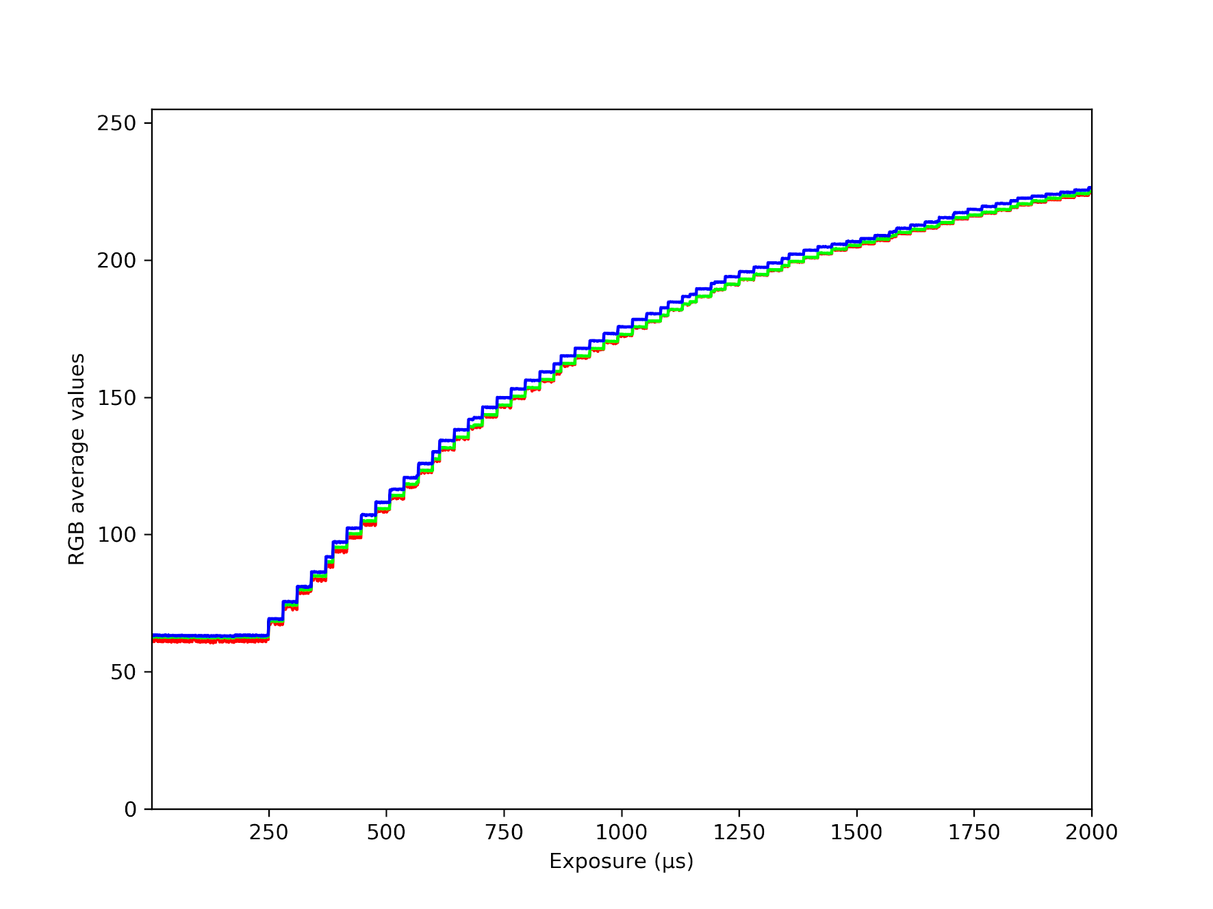
HQ camera module RGB response when red gain=3.16 and blue gain=1.24

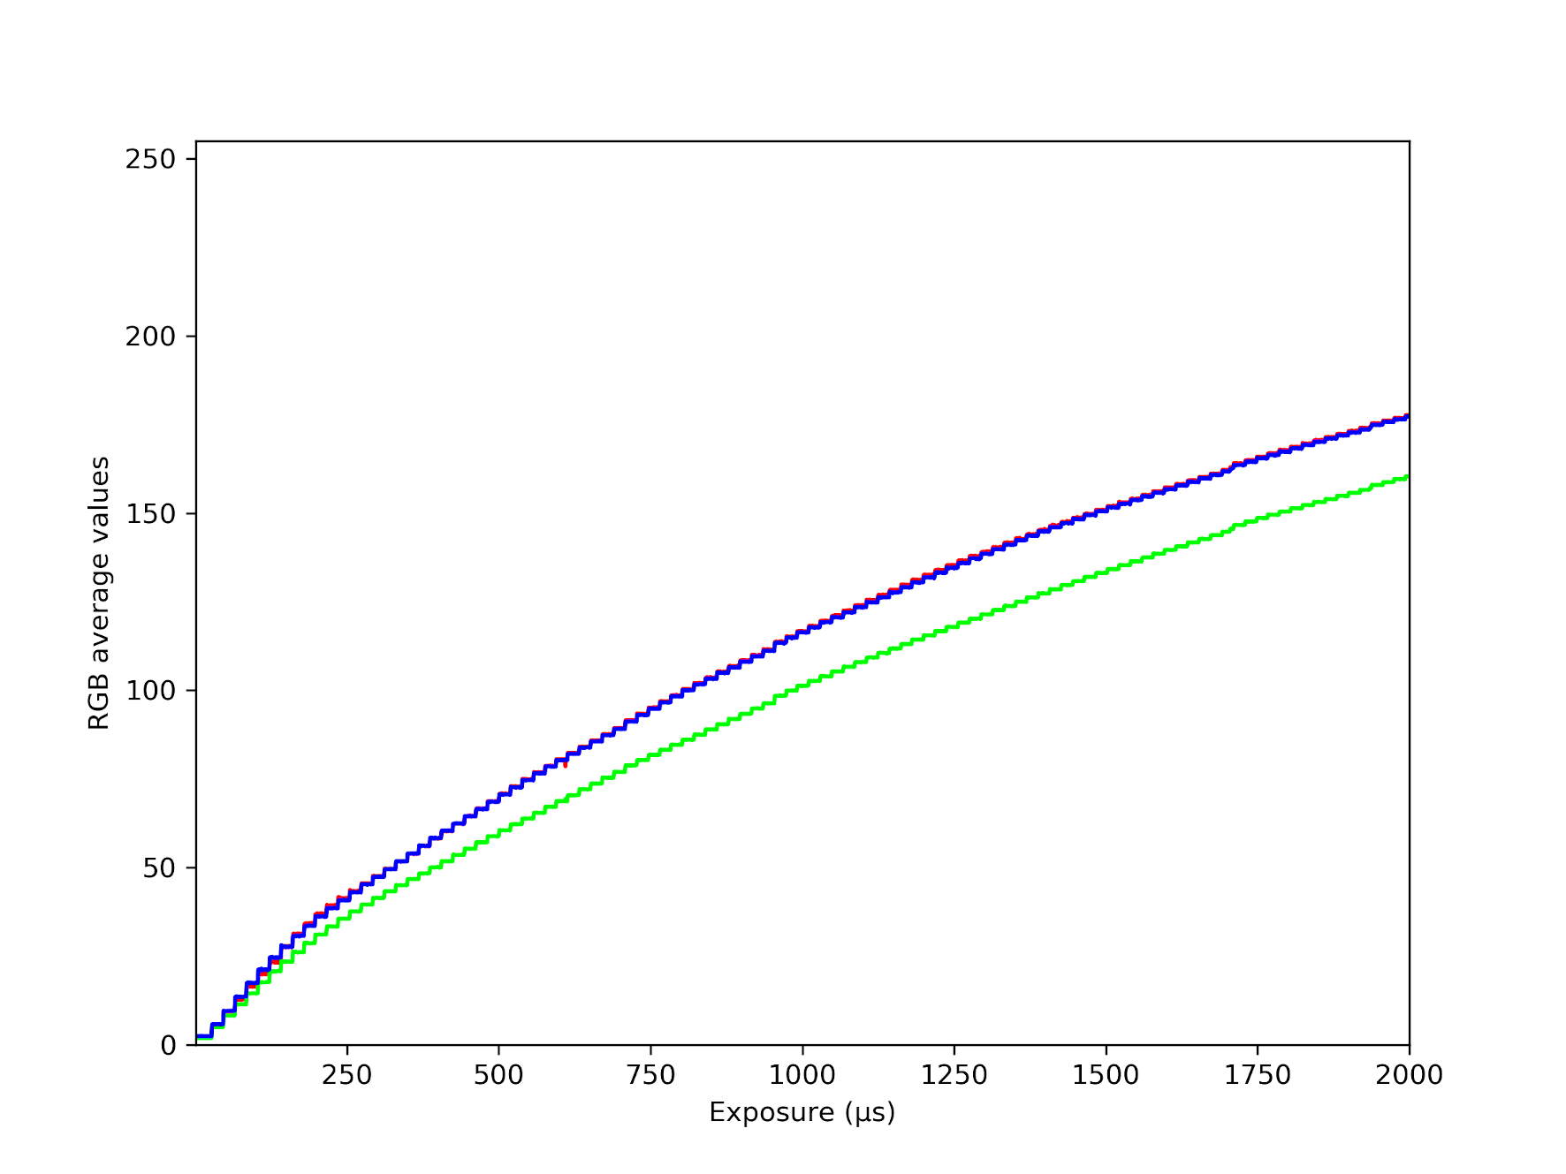
Camera module (version 2) RGB response in AWB mode
Fromn these pictures can be detected that HQ camera sensor starts to give respons at 250 µs and camera module version 2 almost immediately after 1 µs.

Here an output of a test run of this application:
$ dminexp.py
Raspberry Pi Detect Minimum Exposure Time
List disk and partitions:
NAME MAJ:MIN RM SIZE RO TYPE MOUNTPOINT
sda 8:0 0 223.6G 0 disk
└─sda1 8:1 0 223.6G 0 part /media/pi/data
sdb 8:16 1 7.5G 0 disk
└─sdb1 8:17 1 7.5G 0 part /media/pi/INTENSO
mmcblk0 179:0 0 28.8G 0 disk
├─mmcblk0p1 179:1 0 2.4G 0 part
├─mmcblk0p2 179:2 0 1K 0 part
├─mmcblk0p5 179:5 0 32M 0 part
├─mmcblk0p6 179:6 0 256M 0 part /boot
└─mmcblk0p7 179:7 0 26.2G 0 part /
Current directory:
/media/pi/INTENSO/20200624-rpi-ouput
Path to images (current directory: <Enter>):
Project name (default=exp: <Enter>):
Select ISO (100, 200, 320, 400, 500, 640, 800; Default=100):
Default value selected: 100
AWB mode on (Y/N, Default y: <Enter>):
Default selected: AWB enabled
Save captured images (Y/N, Default n: <Enter>):
Default selected: Save images disabled
Capturing images:
1 [3.01457031 2.02445312 3.06352865]
2 [2.98997396 2.02684896 3.04075521]
3 [2.60704427 1.75122396 2.54891927]
4 [2.57395833 1.77282552 2.52416667]
5 [2.5983724 1.75949219 2.53858073]
6 [2.99708333 2.02283854 3.06354167]
7 [2.99395833 2.01251302 3.08651042]
8 [3.00848958 2.00389323 3.07411458]
9 [2.99511719 2.01322917 3.06808594]
10 [2.62606771 1.70393229 2.62039063]
...

Auto White Balance Gains
awb_gains:
- Get red and blue gains
- Requires a RPI and a camera module
Consistent images can be captured when exposure times, white balance and gains are fixed. For frame rates over 120 fps (8.3 ms shutter speed), automatic exposure and gain control must be turned of [1]. However, the auto white balance can be used even with faster shutter speeds in order to determine red and blue gains. This method is used by awb_gains.py. As default the script uses auto exposure mode, but it can be turned off in the code (exp_mode_manual=”on”). Here is an example how to get the gains:
$ awb_gains.py
Auto white balance gains for Raspberry Pi camera 2.x
Red gain: 1.89 121/64
Blue gain: 1.55 397/256
A more accurate method to determine red and blue gains is described in next chapter.
Cited references:
[1] https://www.raspberrypi.org/documentation/raspbian/applications/camera.md, 1.4.2020

White Balance Calibration
calibratecam.py
- Calibrate camera module white balance red and blue gains
- Requires a RPI and a camera module
- Requires raspistill
In order to capture consistent pictures or videos AWB has be turned off. In manual white balance mode red and blue gains must be provided. A fast way to do this is described in previous chapter, but calibratecam.py will loop trough all combinations red and blue gains within their ranges, create calibration figures and calculate the optimum gains.
As the first automation step of the white balance calibration, the color data is obtained from three separate (R,G,B) channels in a range of [0, 255] for the investigated gain combinations and thereafter the average values of the data are calculated. Following this step, the absolute differences of all possible 2-tuples (RB, RG, GB) of the averaged data are summed up for different gain combinations. Eventually, the gain combination resulting in the minimum absolute difference is taken as the optimum gain.
This application has predefined ranges for red and blue gains 1.0 - 2.0 by step 0.1. The ranges can be overridden with custom steps. As default 11 x 11 directories will be created which results in 121 combination of red and blue gains. A series of pictures are then captured with different exposure times (user selected exposure range) in each directory. RGB color analysis is performed when all series are captured. Color analysis results are stored as calibration figures and in a text file. The later one is used for calculating optimum red and blue gains.

Calibration procedure
This section describes how to do the calibration for red and blue gains. The calibration method is based on white or gray reference color (white or gray card). The goal is to get red, green and blue average sensor response curves as close as possible each other. Only red and blue gains is adjustable. By increasing red or blue gains will decrease the response of the other channels. Hence the calibration becomes an optimizing task. The second requirement for fast shutter speeds (<10-20 ms) is to use flicker free light source(s).
The rough optimum shutter speed has to be determined when the composition with the illumination is ready. This is important when selecting a predefined ranges of exposure times. To get auto exposure shutter speed, expss.py can be executed.
In order to select proper ranges for calibration, awb_gains reads and returns AWB gain values. These are only rough values for read and blue gains. The calibration will give more accurate, if the optimization task is done in proper ranges and with small steps.
These two steps are recommended to execute before calibration:
$ expss.py
Auto exposure shutter speed for Raspberry Pi camera 2.x
Shutter speed: 2 ms
Shutter speed: 2410 µs
$ awb_gains.py
Auto white balance gains for Raspberry Pi camera 2.x
Red gain: 1.85 237/128
Blue gain: 1.51 387/256
Next step is to execute the calibration application:
$ calibratecam.py
Calibrate Raspberry Pi camera v. 2.x fast (c) Kim Miikki and Alp Karakoc 2020
Calibration from existing files (Y/N, Default N: <Enter>):
Default selected: Analyze only mode disabled
Select quality (1...100, Default=90: <Enter>):
Default value selected: 90
List disk and partitions:
...
Current directory:
/media/pi/data/20200403-calibration_for_manual
Path to images (current directory: <Enter>):
Calibration name: manfrotto-white-2xled8-step0.2
Select ISO (100, 200, 320, 400, 500, 640, 800; Default=100): Default value selected: 100
Calculating auto exposure range for calibration:
Auto shutter speed: 3 ms
Auto shutter speed: 2524 µs
Auto shutter speed range for calibration (µs):
[616, 1233, 1850, 2467, 3083, 3700, 4317]
Calibration modes
Md Pictures EXP min EXP max
1 6 50 1000 µs
2 6 1000 15000 µs
3 6 10000 60000 µs
4 6 20000 300000 µs
5 12 50 200000 µs
6 26 1 330000 µs
7 7 616 4317 µs
Select exposure range mode (1...7): 7
Calibration modes 1-4 captures only 6 pictures per series. With default gain ranges and steps the calibration is ready under 10 min by using a Raspberry Pi 4 Model B 4 GB with a USB3 SSD-drive. Mode 6 will last for about 1 h. The red, green and blue average of a picture are in a range of 0 to 255. The calibration application considers a picture as underexposed or overexposed if R,G,B<0.5 or R,G,B>254.5. This protects the calibration against not valid images which would distort the gain values. Additionally it enables the use of a full exposure range, when this kind of images are disposed. The following figures demonstrates, that all images under 100 µs are disposed as underexposed:
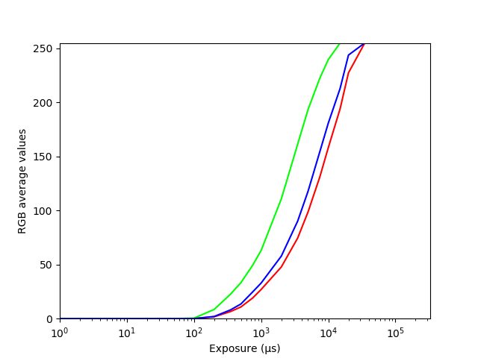 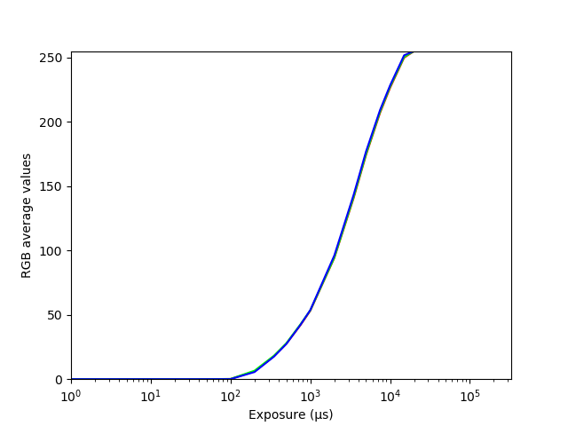
Uncalibrated and calibrated sensor RGB channel curves in logarithmic scale.

Calibration mode 7 reads the auto exposure value and generates the following exposure array:
[ 0.25*ss, 0.50*ss, 0.75*ss, ss, 1.25*ss, 1.50*ss, 1,75*ss ]
where ss is the shutter speed.
The mode 7 normally captures pictures which are properly exposed, and are valid for calibration. If consisted calibration with the same exposure time is required, a predefined array (i.e. exp_fast or exp_medium1) could be used in the code by replacing the original exposure times with exposure times calculated from the auto exposure value.
In the forth stage default ranges for red and blue gains are accepted or modified:
Default calibration ranges:
Red gain range: 1.0-2.0
Red gain step: 0.1
Blue gain range: 1.0-2.0
Blue gain step: 0.1
Accept default ranges (Y/N, Default Y: <Enter>): n
Current ranges disabled
Select red gain min (1.0...2.0, Default=1.0: <Enter>): 1.6
Select red gain max (1.6...2.0, Default=2.0: <Enter>): 1.8
Select red gain step (0.001...0.2, Default=0.1: <Enter>): 0.02
Select blue gain min (1.0...2.0, Default=1.0: <Enter>): 1.3
Select blue gain max (1.3...2.0, Default=2.0: <Enter>): 1.5
Select blue gain step (0.001...0.2, Default=0.1: <Enter>): 0.02
Select scale type (linear, log; Default=linear):
Default value selected: linear
Pictures are captured in stage 5 with the raspistill program. Normally the duration of this stage is from few minutes up to 1 hour. In stage 6 color analysis is done for each series of pictures and calibration figures are saved into a figures directory. In the last stage optimum red and blue gains are calculated. Here is a part of a calibration log file, where the results are presented:
…
Calibration images: 847
Optimal r_gain: 1.66
Optimal b_gain: 1.44
Total distance: 11.140924479166713
Time elapsed: 0:11:12.595477
The following pictures demonstrates the difference of uncalibrated and calibrated gains:
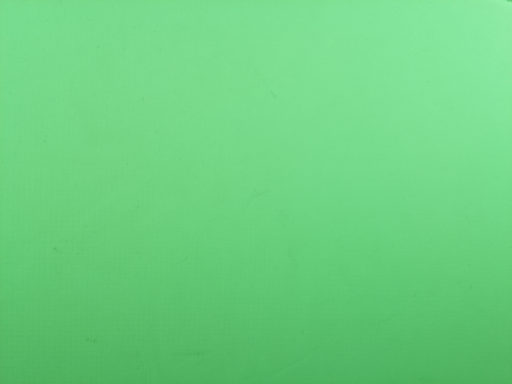 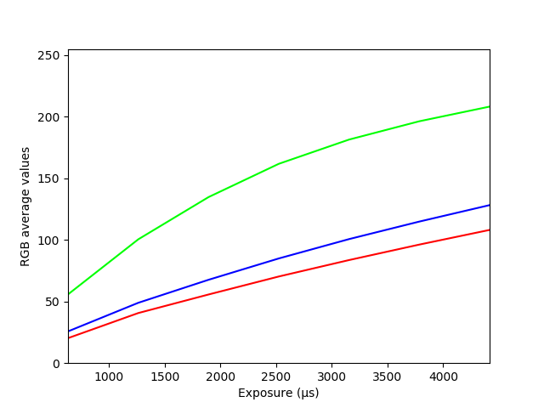
Uncalibrated white card picture and sensor RGB curves (gains: red 1.0 and blue 1.0).
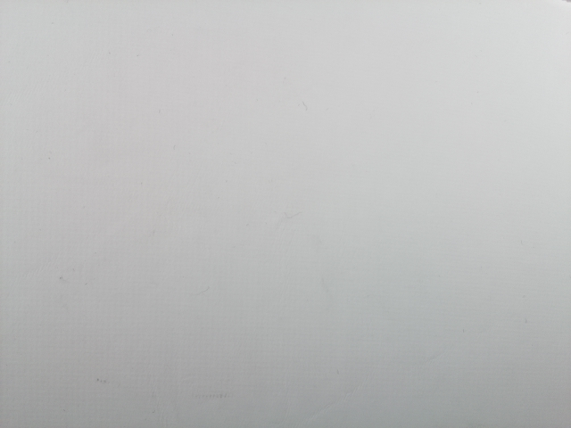 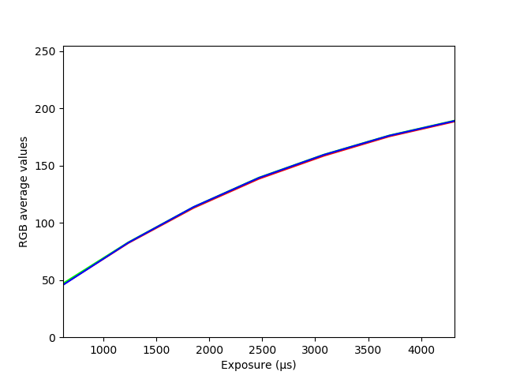
Calibrated white card picture and sensor RGB curves (gains: red 1.66 and blue 1.44).

Calibration with ROI
If the the white card or calibration area is too small, the camera module has to be closer the object or ROI must be applied. The field of view can be narrowed easily with the ROIs variable in the code:
roi_x0=0.0
roi_y0=0.0
roi_w=1.0
roi_h=1.0
The default values gives full field of view. All values are normalized from 0.0 to 1.0. Two first variables defines the coordinates where ROI starts from the upper left corner. The latter varibles defines width and height for ROI.Raspstill can be used in order to get desired ROI like the following example:
raspistill -t 0 -roi 0.25,0.25,0.5,0.5 (middle area of FOV with 25 % margins)

Analyze only mode
It is possible to do post-calibration from existing calibration pictures. Optimum gains can be calculated very fast if the calibration file exist (rgb-calibration_name*.txt). In such case, the gains can be calculated very fast with optimum_gains.py. However, if the calibration file is missing, change of scale type is desired (log→linear or linear → log) or calibration figures has to be re-created, then campreview.py can be executed in analyze only mode.
The Analyze only mode asks path to images (calibration base directory), calibration name and the scale type. Thereafter color analysis is performed for all valid calibration directories, which mean that the calibration name must be same as the calibration directories base name followed by _rgain,bgain, where rgain and bgain are positive numbers. All invalid directory names are disposed. The calibration program will create automatically these calibration directory names correctly when analyze only mode is disabled.
At the final stage optimum red and blue gains are calculated.

Get Optimum Gains from a Calibration File
optimum_gains.py
- Get optimal red and blue gains from a calibration file
This utility reads a calibration file (rgb-project_name.txt), which can be produced by calibratecam.py application. Optimal red and blue gains are calculated when the calibration data is read. Here is an example how to execute optimal_gains.py:
$ optimal_gains.py rgb-manfrotto-white-2xled8-step0.02_iso100.txt
Calibration images: 847
Optimal r_gain = 1.66
Optimal b_gain = 1.44
Total distance = 11.140924479166713

Capturing Pictures in Manual Mode
These applications are designed to capture pictures manually by pressing the space bar. The reason for two programs is that there is a different delay before a new picture can be captured. A live preview will lead to longer time before a new picture can be captured. That is to reason for the camera application without a preview.

Capturing Pictures with Preview Enabled
capturepics-preview.py
- Camera preview is enabled
- Captures lossless PNG pictures by pressing space bar
- Auto numbering of captures
- Delay before capturing next picture is several seconds
- Requires a RPI and a camera module
- Uses PiCamera library
This application would be very convenient if the time between captures would be smaller. The application can be used when the composition must be accurate and the amount of captures is small.
Here is an example how to run this application:
$ capturepics-preview.py
Raspberry Pi capture pictures
Select image quality (1...100; default: 90):
Default value selected: 90
List disk and partitions:
NAME MAJ:MIN RM SIZE RO TYPE MOUNTPOINT
sdb 8:16 0 223.6G 0 disk
└─sdb1 8:17 0 223.6G 0 part /media/pi/data
mmcblk0 179:0 0 14.8G 0 disk
├─mmcblk0p1 179:1 0 2.2G 0 part
├─mmcblk0p2 179:2 0 1K 0 part
├─mmcblk0p5 179:5 0 32M 0 part
├─mmcblk0p6 179:6 0 256M 0 part /boot
└─mmcblk0p7 179:7 0 12.3G 0 part /
Path to images (current directory: <Enter>):
Project name (default=pic: <Enter>):
Select ISO (100, 200, ... 800): 100
Select exposure time (1...330000) µs: 35000
Select first frame number (default=1: <Enter>):
Default value selected: 1
Select digits (min=1, default=4: <Enter>):
Default value selected: 4
No artist.txt file
Full screen and cropped preview (Y/N, default: N <ENTER>)
Default selected
Start capturing images: ENTER
Capture image: SPACE
Exit program: ESC
Capture mode enabled.
pic_0001
pic_0002
ESC key pressed → termination of the application

Camera with Preview
camera.py
- Camera preview is enabled
- Captures pictures by pressing ENTER
- Auto numbering of captures
- Time between captures is about 1 second
- Requires a RPI and a camera module
- Requires raspistill
- Generates and executes scripts (capture commands) which can be executed without Python
This application captures pictures much faster than capturepics-preview.py. However, the captured pictures are compressed in a lossy JPG format. The program generates a raspistill command which can be ran without Python. Following example shows how to run this program:
$ camera.py
Raspberry Pi camera
Select image quality (1...100, Default=90: <Enter>):
Default value selected: 90
List disk and partitions:
NAME MAJ:MIN RM SIZE RO TYPE MOUNTPOINT
mmcblk0 179:0 0 29.7G 0 disk
├─mmcblk0p1 179:1 0 256M 0 part /boot
└─mmcblk0p2 179:2 0 29.5G 0 part /
Current directory:
/home/pi/pics
Path to images (current directory: <Enter>):
Project name (default=pic: <Enter>):
Select ISO (100, 200, 320, 400, 500, 640, 800; Default=100):
Default value selected: 100
Auto exposure on (Y/N, Default y: <Enter>):
Default selected: EXP auto enabled
AWB mode on (Y/N, Default y: <Enter>):
Default selected: AWB enabled
Select analog gain (0.0...12.0, Default=1.0: <Enter>):
Default value selected: 1.0
Select digits (1...8, Default=4: <Enter>):
Default value selected: 4
Select first frame (1...9999, Default=1: <Enter>):
Default value selected: 1
"raspistill" Camera App (commit f73fca015d42 Tainted)
Camera Name imx477
Width 4056, Height 3040, filename pic_%04d.jpg
Using camera 0, sensor mode 0
GPS output Disabled
Quality 90, Raw no
Thumbnail enabled Yes, width 64, height 48, quality 35
Time delay 0, Timelapse 0
Link to latest frame enabled no
Full resolution preview No
Capture method : Capture on keypress
Preview Yes, Full screen Yes
Preview window 0,0,1024,768
Opacity 255
Sharpness 0, Contrast 0, Brightness 50
Saturation 0, ISO 100, Video Stabilisation No, Exposure compensation 0
Exposure Mode 'auto', AWB Mode 'auto', Image Effect 'none'
Flicker Avoid Mode 'off'
Metering Mode 'average', Colour Effect Enabled No with U = 128, V = 128
Rotation 0, hflip No, vflip No
ROI x 0.000000, y 0.000000, w 1.000000 h 1.000000
Camera component done
Encoder component done
Starting component connection stage
Connecting camera preview port to video render.
Connecting camera stills port to encoder input port
Press Enter to capture, X then ENTER to exit
Opening output file pic_0001.jpg
Enabling encoder output port
Starting capture 1
Finished capture 1
Press Enter to capture, X then ENTER to exit

Opening output file pic_0002.jpg
Enabling encoder output port
Starting capture 2
Finished capture 2
Press Enter to capture, X then ENTER to exit
x
Opening output file pic_0003.jpg
Enabling encoder output port
Starting capture 3
Finished capture 3
Closing down
Close down completed, all components disconnected, disabled and destroyed
Capturing pictures is exited by pressing X followed with ENTER.
A log file is created of the selections. This example generated the following file:
pic.log
Log created on 2020.10.26-22:00:12
File path: Not defined
Capture pictures parameters:
Resolution: 4056x3040
Sensor: imx477
Quality: 90
Compression: lossy
ISO value: 100
Exposure: auto
AWB mode: Enabled
Analog gain: 1.0
Start frame: 1
Digits: 4
First file name: pic_0001.jpg
Capture command:
raspistill -v -t 0 -q 90 -ISO 100 -ag 1.0 -k -fs 1 -o pic_%04d.jpg

Capturing Pictures without Preview
capturepics.py
- Camera preview is disabled
- Captures pictures by pressing space bar
- Auto numbering of captures
- Time between captures is about 1 second
- Requires a RPI and a camera module
- Requires raspistill
- Generates and executes scripts (capture commands) which can be executed without Python
The capturepics.py generates commands, which will capture pictures by using raspistill program. The delay before capturing a new picture is much smaller than with the capturepics-preview.py. The drawback is that there is no preview. Therefore, the composition must be done before using this application.
This example shows how to use capturepics.py:
$ capturepics.py
Raspberry Pi capture pictures
Select image quality (1...100; default: 90):
Default value selected: 90
List disk and partitions:
NAME MAJ:MIN RM SIZE RO TYPE MOUNTPOINT
sdb 8:16 0 223.6G 0 disk
└─sdb1 8:17 0 223.6G 0 part /media/pi/data
mmcblk0 179:0 0 14.8G 0 disk
├─mmcblk0p1 179:1 0 2.2G 0 part
├─mmcblk0p2 179:2 0 1K 0 part
├─mmcblk0p5 179:5 0 32M 0 part
├─mmcblk0p6 179:6 0 256M 0 part /boot
└─mmcblk0p7 179:7 0 12.3G 0 part /
Path to images (current directory: <Enter>):
Project name (default=pic: <Enter>):
Select ISO (100, 200, ... 800): 100
Select exposure time (1...330000) µs: 35000
Select first frame number (default=1: <Enter>):
Default value selected: 1
Select digits (min=1, default=4: <Enter>):
Default value selected: 4
No artist.txt file
Start capturing images: ENTER
Capture image: SPACE
Exit program: ESC
Capture mode enabled.
pic_0001
pic_0002
pic_0003
pic_0004
pic_0005
ESC key pressed → termination of the application
The log file which contains data about to project, looks like this:
Log created on 2019.12.29-18:14:07
File path: Not defined
Artist:
Capture pictures parameters:
Quality: 90
ISO value: 100
Exposure: 35000 µs
Start frame: 1
Digits: 4
First file name: pic_0001.png
raspistill -n -t 1 -ISO 100 -q 90 -ss 35000 -bm -drc high -o pic_0001.png
raspistill -n -t 1 -ISO 100 -q 90 -ss 35000 -bm -drc high -o pic_0002.png
raspistill -n -t 1 -ISO 100 -q 90 -ss 35000 -bm -drc high -o pic_0003.png
raspistill -n -t 1 -ISO 100 -q 90 -ss 35000 -bm -drc high -o pic_0004.png
raspistill -n -t 1 -ISO 100 -q 90 -ss 35000 -bm -drc high -o pic_0005.png

Time-Lapse Photography
timelapse.py
- Capture pictures in time-lapse mode
- Minimum interval between captures is 1 s
- Pictures are stored in JPG format
- Requires a RPI and a camera module
- Requires raspistill
- Generates and executes a script (capture command) which can be executed without Python
The idea of time-lapse photography can be easily demonstrated by melting an ice cube:
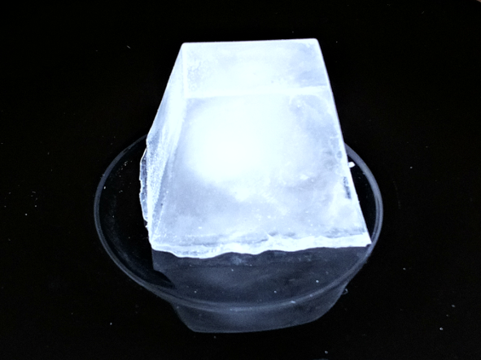 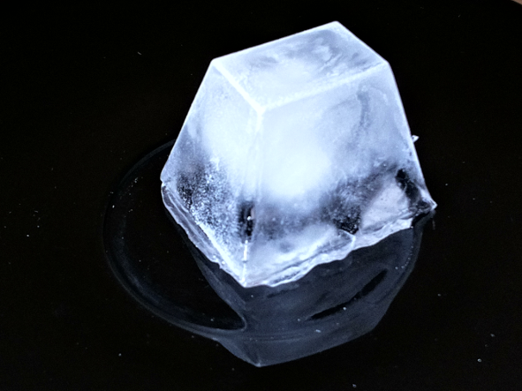 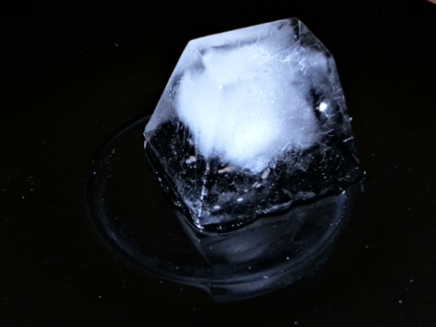
0 min 2 min 4 min
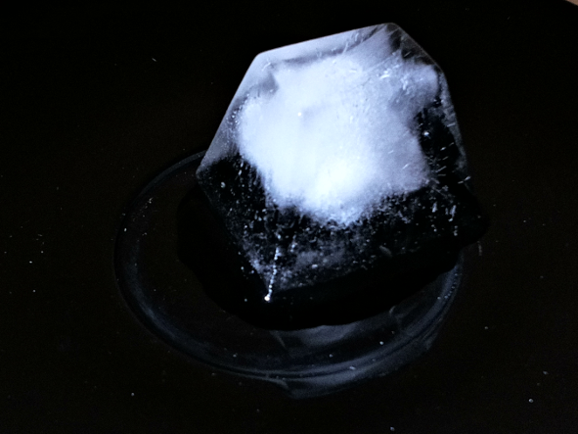 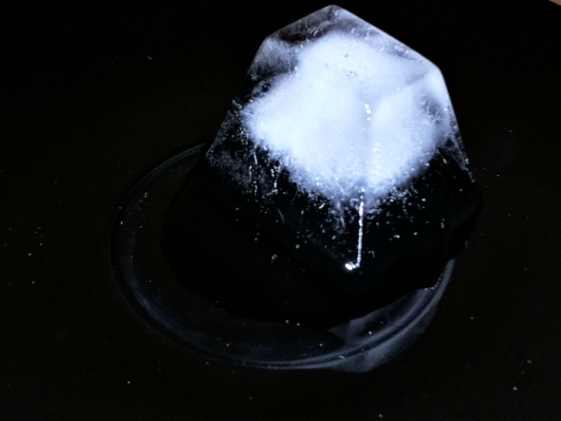 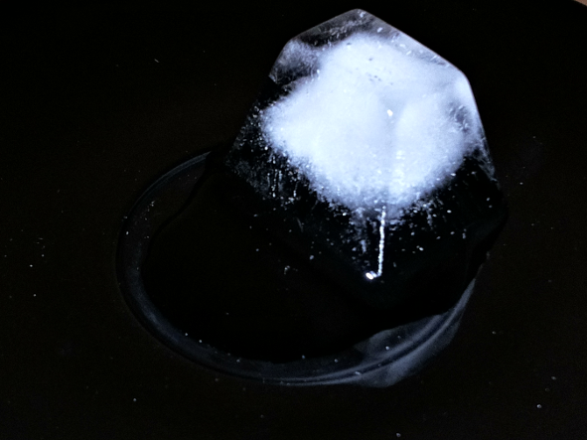
6 min 8 min 10 min
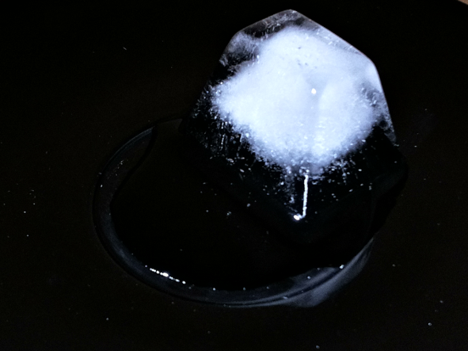 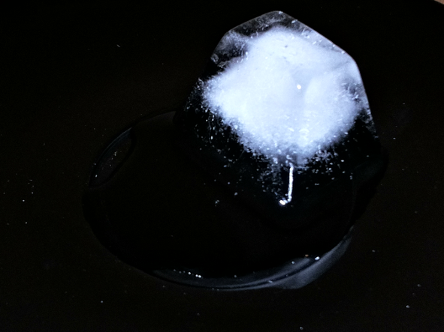 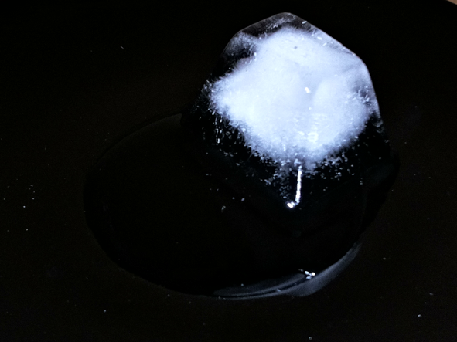
12 min 14 min 16 min
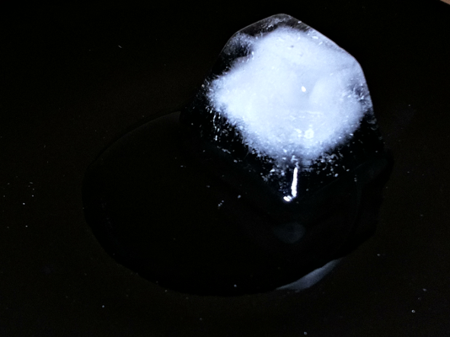 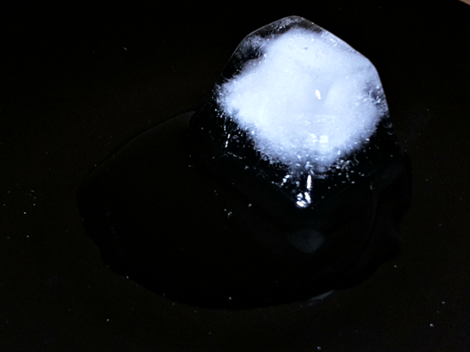 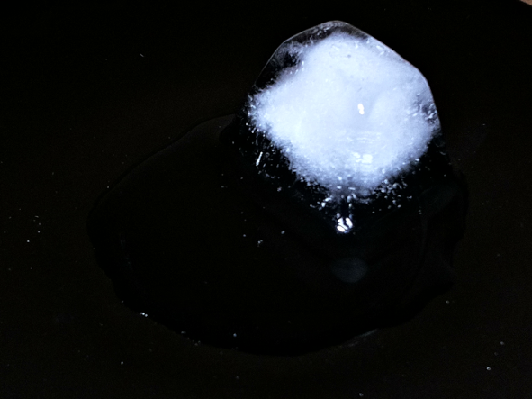
18 min 20 min 22 min
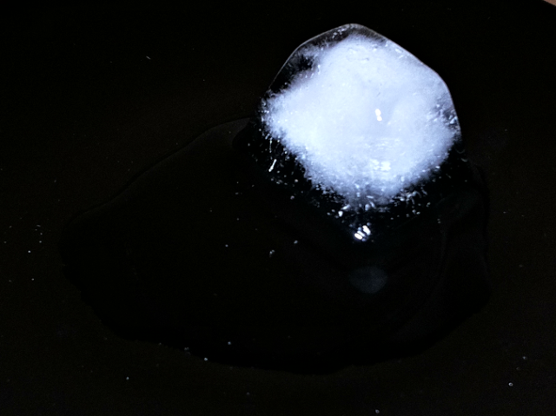 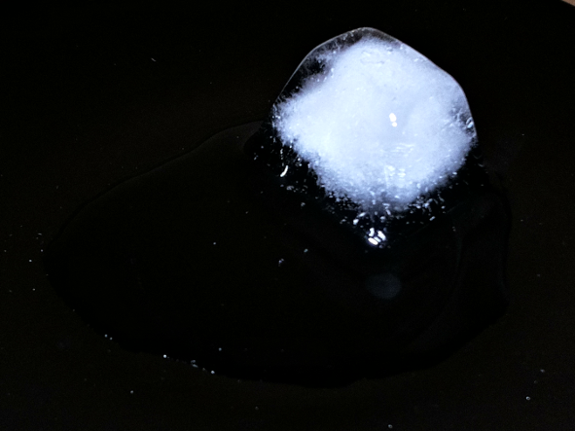 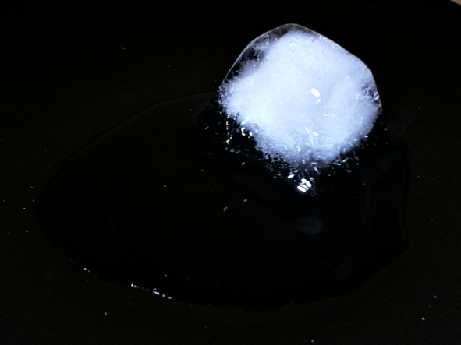
24 min 26 min 28 min
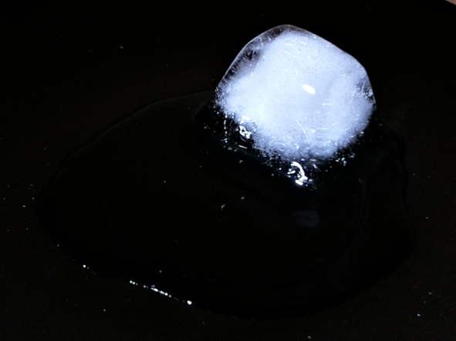 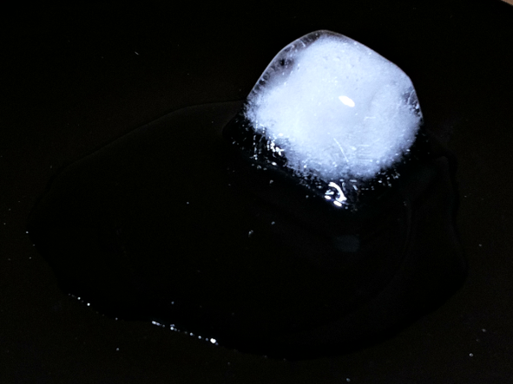
30 min 32 min
Capture parameters for the pictures above:
Time-lapse parameters:
Quality: 90
ISO value: 100
Exposure: 30000
Duration: 1800000
Interval: 120000
Start frame: 1

Although this application provides a preview option, the use of it should be considered when using a short interval. Especially 1 s interval time could result in loss of frames or delayed capture times. Other factors that increases loss of frames: running time-lapse on a slower computer (RPI 3), large screen resolution and long exposure times (>20 ms). Hence, the preview is disabled as default on a RPI 3.

The following example shows what kind of questions has to be answered before starting to capture 10 s time-lapse with 1 s interval:
$ timelapse.py
Time-lapse program for Raspberry Pi camera v. 2.x (c) Kim Miikki 2019
Select image quality (1...100; default: 90): 90
List disk and partitions:
NAME MAJ:MIN RM SIZE RO TYPE MOUNTPOINT
sda 8:16 0 223.6G 0 disk
└─sda1 8:17 0 223.6G 0 part /media/pi/data
mmcblk0 179:0 0 14.8G 0 disk
├─mmcblk0p1 179:1 0 2.2G 0 part
├─mmcblk0p2 179:2 0 1K 0 part
├─mmcblk0p5 179:5 0 32M 0 part
├─mmcblk0p6 179:6 0 256M 0 part /boot
└─mmcblk0p7 179:7 0 12.3G 0 part /
Path to images (current directory: <Enter>):
Time-lapse project name: tl
Select ISO (100, 200, ... 800): 100
Select exposure time (1...330000) µs: 35000
Select interval (1...86400) s: 1
Select time-lapse duration (1...31536000) s: 10
Start time-lapse shooting now (Y/N, Default Y: <Enter>):
Default selected: starting the time-lapse shooting.
...

Video Recording
fpsvideo.py
- Record videos in slow, normal or high speed (up to 200 FPS)
- Requires a RPI and a camera module
- Requires raspivid
- Generates and executes a script (recording command) which can be executed without Python
Although it is possible to record videos with the RPI camera module up to 1000 frames per second [1], fpsvideo.py uses standard RPI raspivid application which limits the FPS to 200. This can be done without compiling source codes and playing with raw Bayer format frames.
Here is an example of a 90 FPS at 1280x720 (720 p) what raspivid is capable to produce:
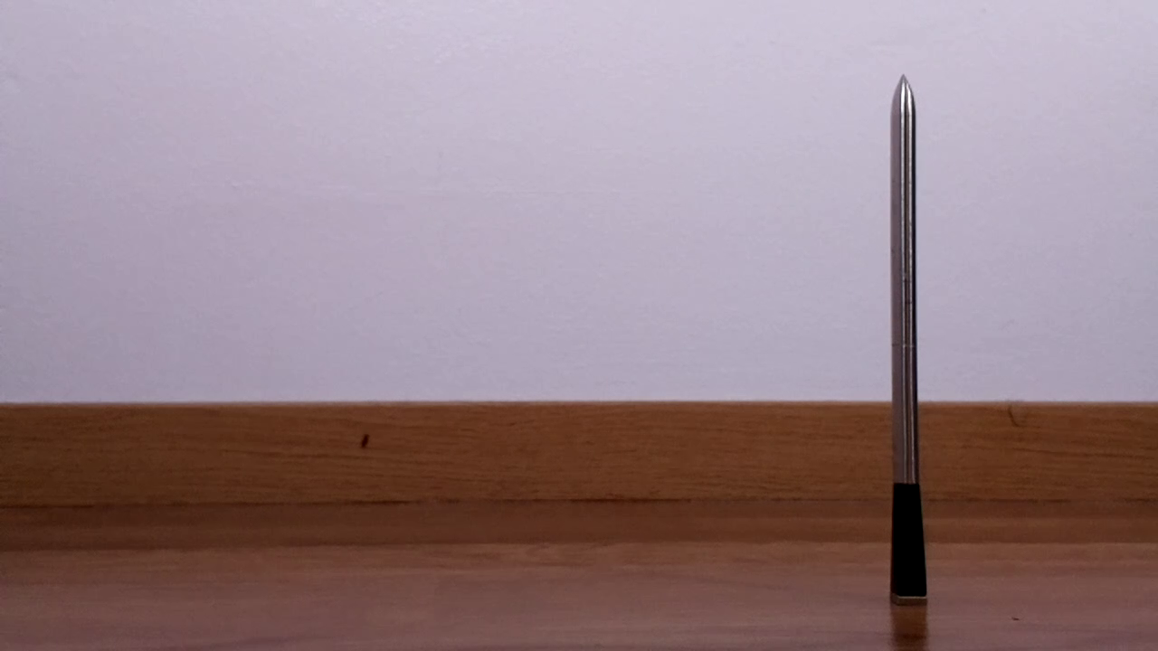 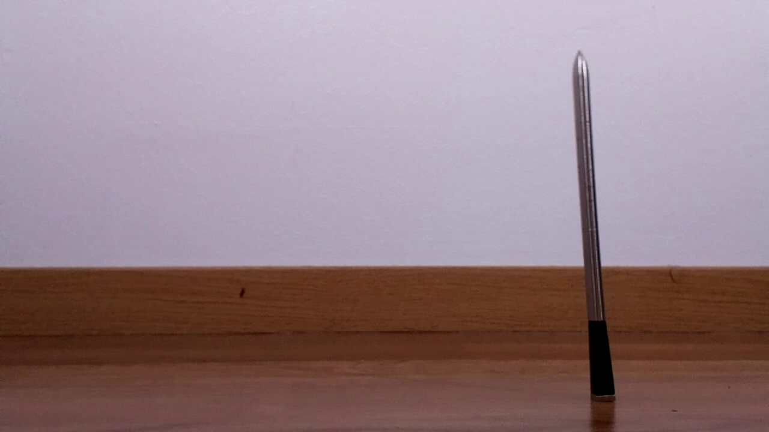 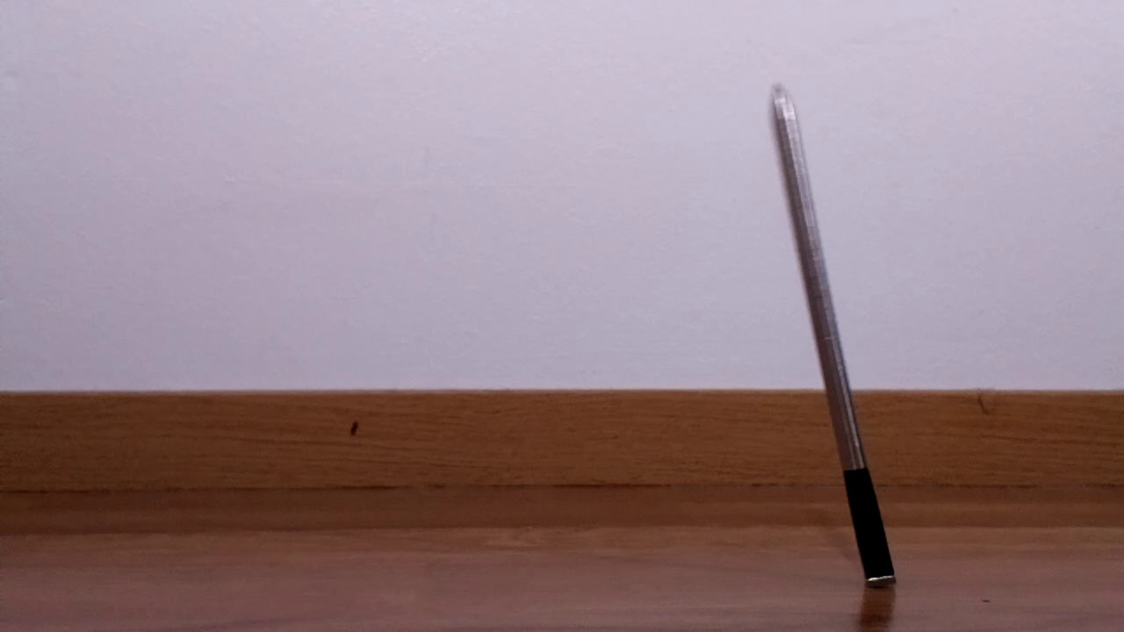
Frame: 420 Frame: 435 Frame: 445
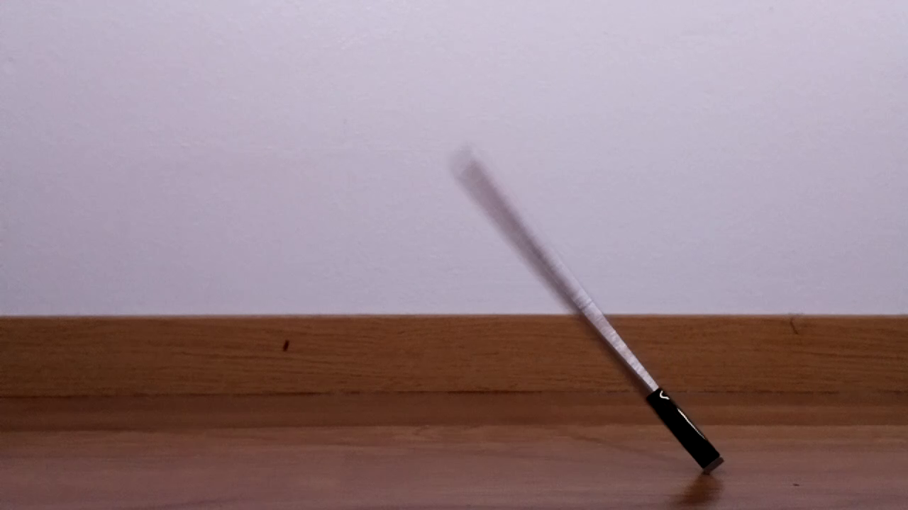 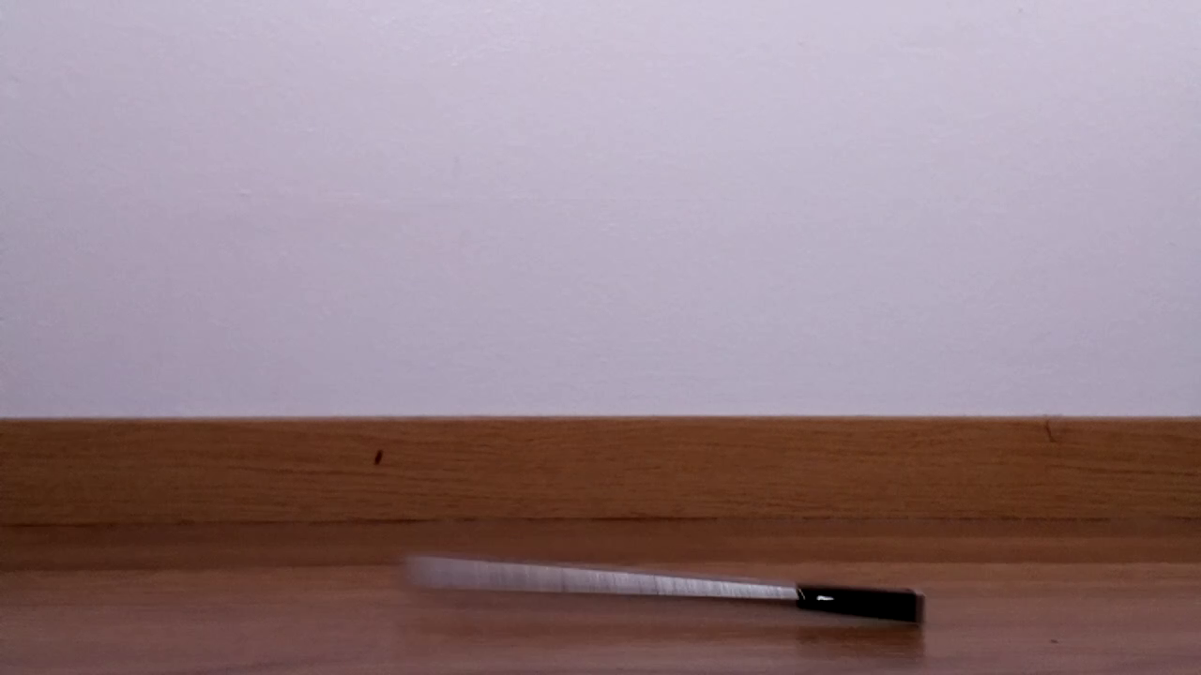 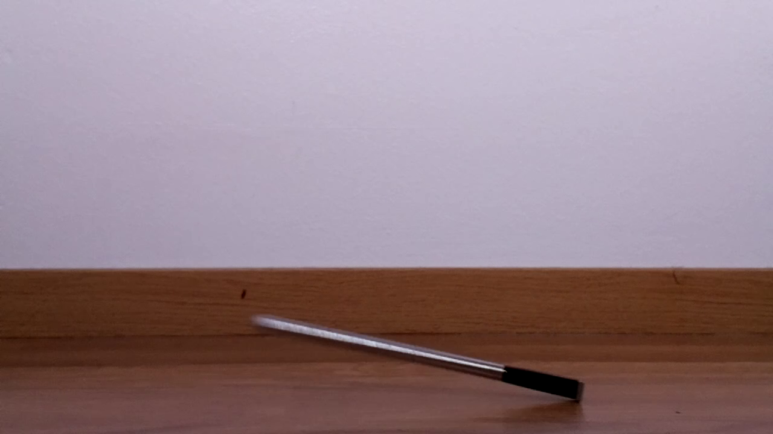
Frame: 455 Frame: 463 Frame:464
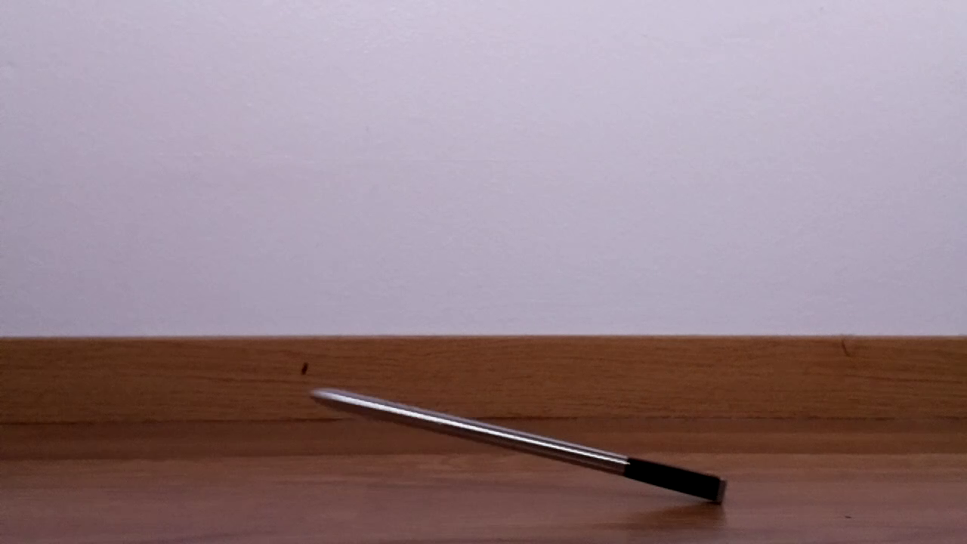 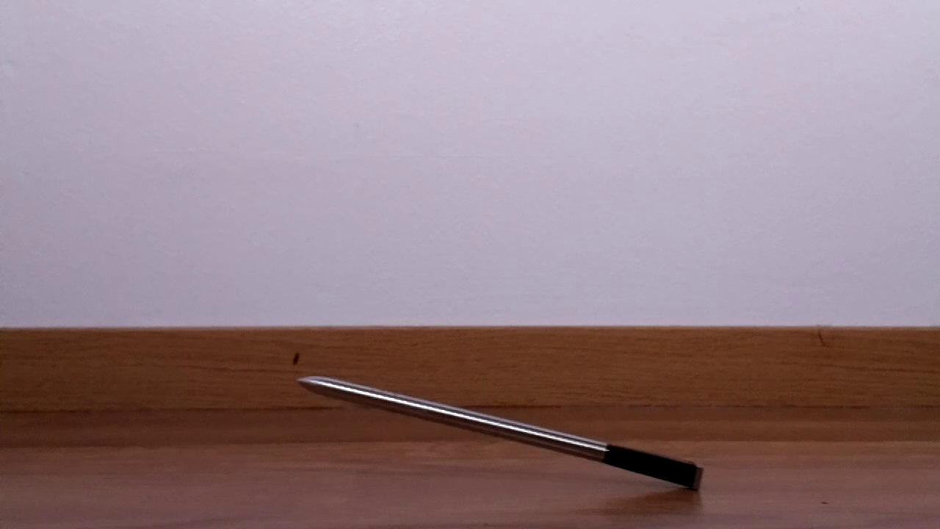
Frame: 465 Frame: 466 Frame: 467
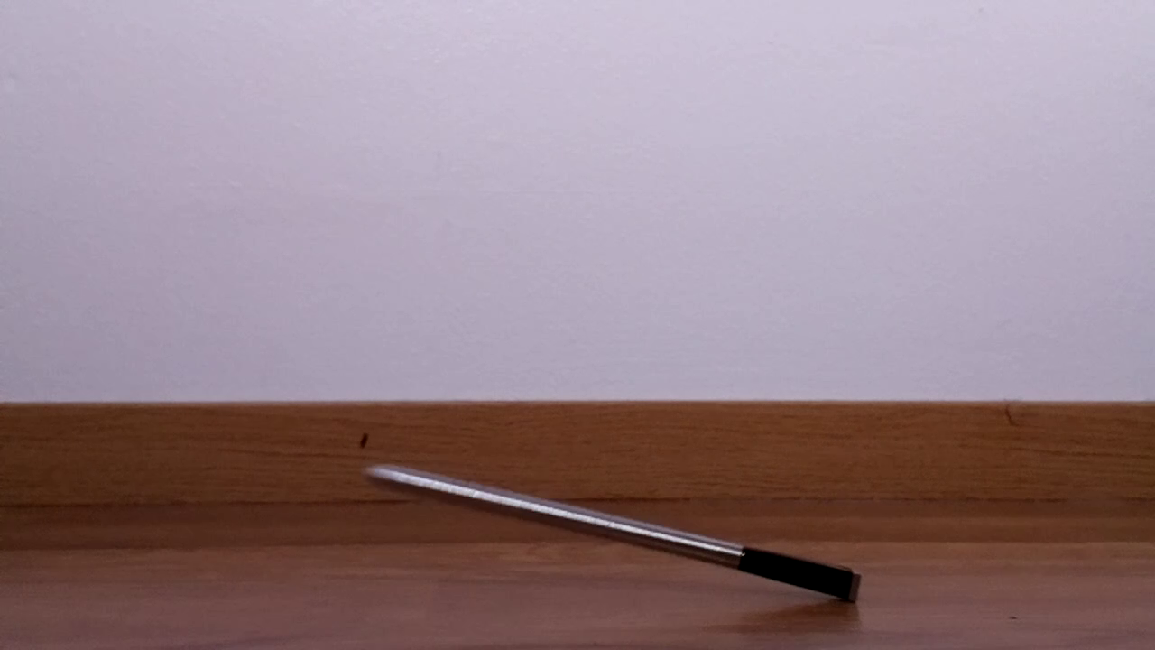 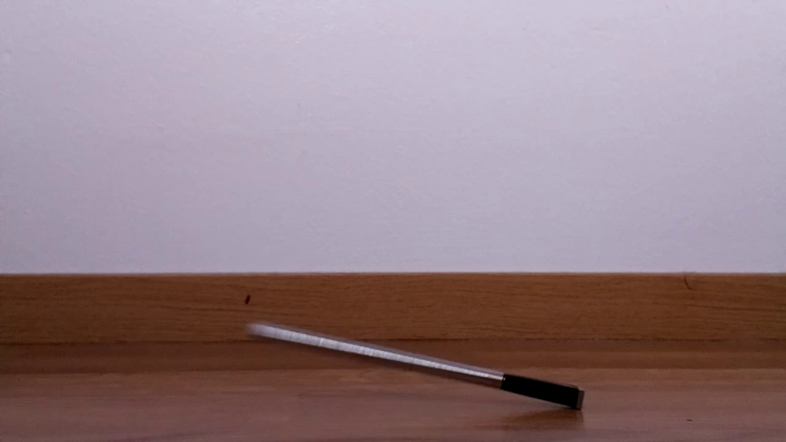 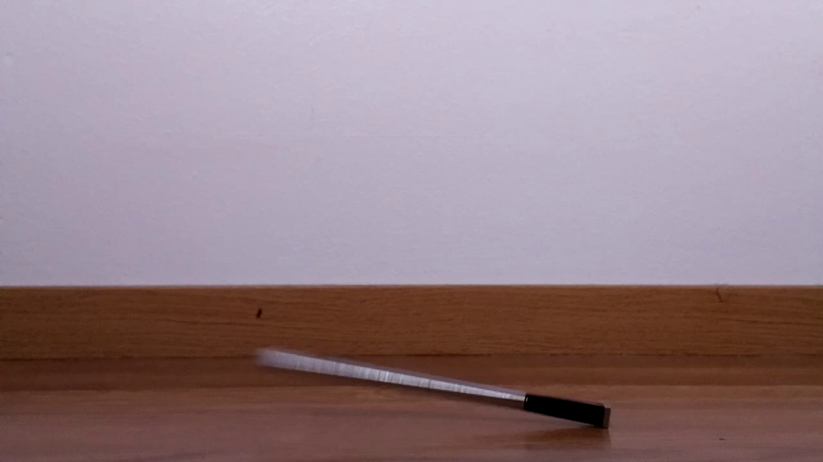
Frame: 468 Frame: 469 Frame: 470
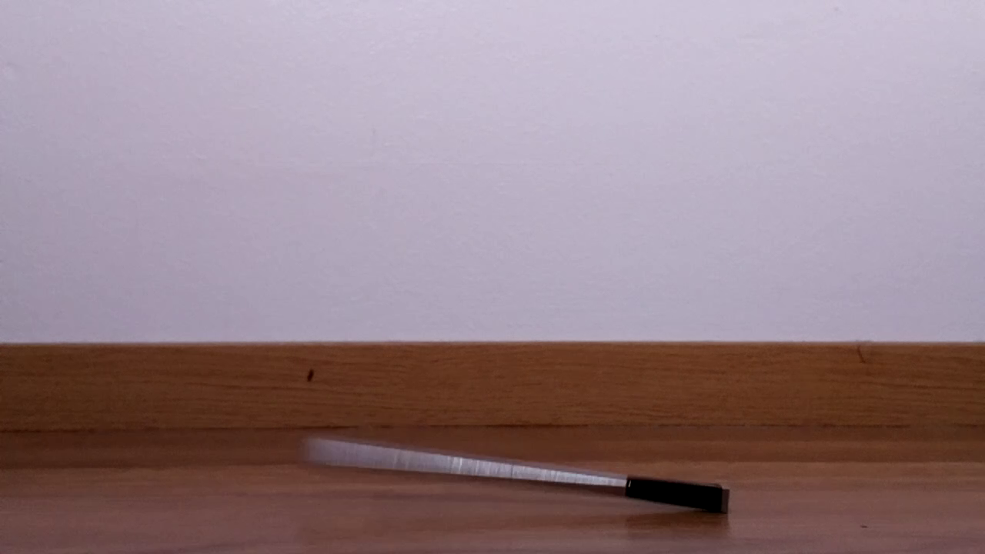 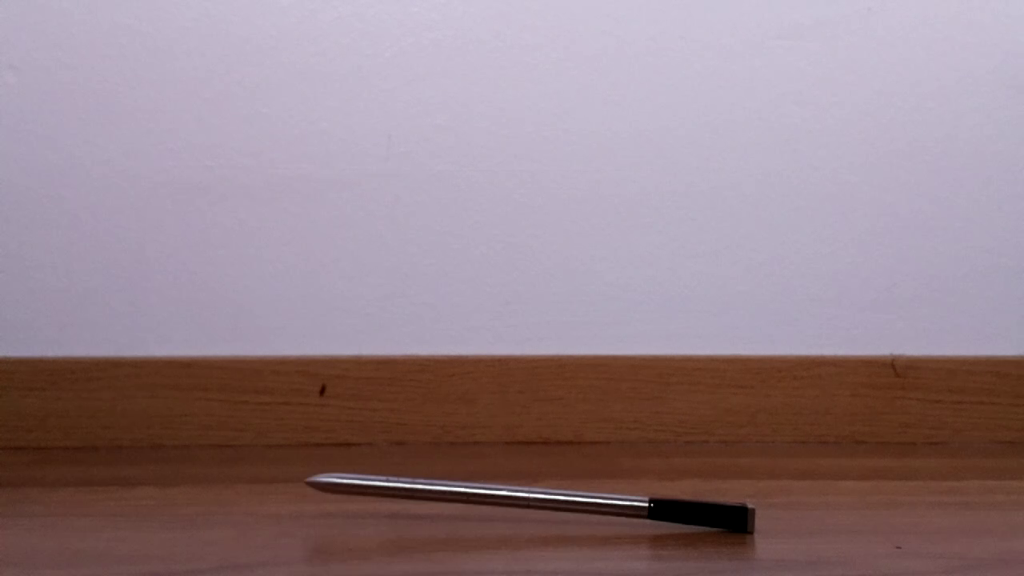 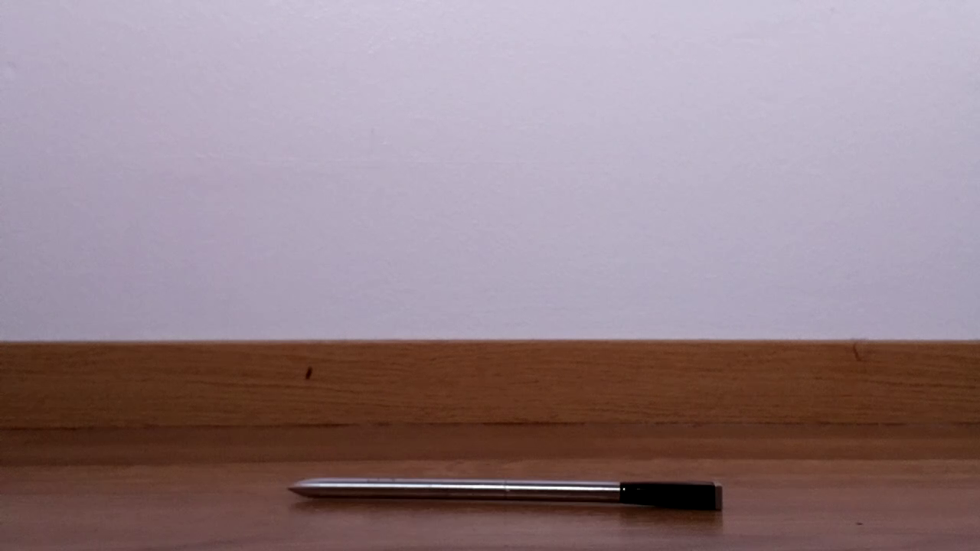
Frame: 471 Frame: 475 Frame: 480
The video slowdown rate is 3.6 when the normal play speed is 25 FPS. The capture parameters are shown below:
Log created on 2019.12.31-12:27:01
File path: Not defined
Files:
Video: probe-1280x720_90fps_11111ss_30s.h264
PTS: probe-1280x720_90fps_11111ss_30s.pts
Log: probe-1280x720_90fps_11111ss_30s.log
REC: probe-1280x720_90fps_11111ss_30s.rec
FPS video parameters:
Sensor mode: 6
Resolution: 1280x720
Exposure: 11111 µs
FPS: 90
AWB: Auto
Duration: 30 s
Preview: on
Record video:
raspivid -md 6 -w 1280 -h 720 -ss 11111 -fps 90 -t 30000 -v -pts probe-1280x720_90fps_11111ss_30s.pts -o probe-1280x720_90fps_11111ss_30s.h264 2>&1 | tee probe-1280x720_90fps_11111ss_30s.rec
mkvmerge -o probe-1280x720_90fps_11111ss_30s.mkv probe-1280x720_90fps_11111ss_30s.h264 2>&1 | tee -a probe-1280x720_90fps_11111ss_30s.rec
In this experiment, compressed air was used to make the probe to fall. The settle down time for the probe, after it started to fall was about 0.7 s. The frames were extracted by using FFmpeg [2].
This application generates scripts, which will start raspivid and mkvmerge [3]. The first program will record the video and the second convert it to a MKV file.
If normal video playback is 25 FPS, then the slowdown (depending on the video mode), is at maximum FPS:
Md | Video resolution | Maximum FPS | Video slowdown
1 | 1920x1080 | 30 | 1.2
2 | 1920x1080 | 15 | 0.6
3 | 1920x1080 | 15 | 0.6
4 | 1640x1232 | 40 | 1.6
5 | 1640x922 | 40 | 1.6
6 | 1280x720 | 90 | 3.6
7 | 640x480 | 200 | 8
Video slowdown at 25 FPS
Standard raspistill command for composition is not enough before recording a video. RPI application vidpreview.py will do the job with ROI.
This application creates some additional files which can be useful for debugging or if exact times for frames are required:
LOG All selections and video commands are stored in this file
PTS Save timestamp information to the specified file
REC Redirect stdout and stderr to the REC file
Videos are stored at least as H.264 and (optionally) transformed to MKV.
The requested FPS is not necessary what is acquired. Hence a timing correction is required. The following formula calculates the correct time for one frame

where FPS_{reference} is the normal playback speed (25 frames/s).
Running the Application
This example shows how to run the application:
$ fpsvideo.py
FPS video program for Raspberry Pi camera v. 2.x (c) Kim Miikki 2019
List disk and partitions:
NAME MAJ:MIN RM SIZE RO TYPE MOUNTPOINT
sda 8:0 0 223.6G 0 disk
└─sda1 8:1 0 223.6G 0 part /media/pi/data
mmcblk0 179:0 0 14.8G 0 disk
├─mmcblk0p1 179:1 0 2.2G 0 part
├─mmcblk0p2 179:2 0 1K 0 part
├─mmcblk0p5 179:5 0 32M 0 part
├─mmcblk0p6 179:6 0 256M 0 part /boot
└─mmcblk0p7 179:7 0 12.3G 0 part /
Path to images (current directory: <Enter>):
Video project name: test
Select bitrate (1-25000000 bits/s, automatic: <Enter>):
Automatic bitrate selected.
Video modes
1 1920x1080 16:9 30
2 1920x1080 4:3 15
3 1920x1080 4:3 15
4 1640x1232 4:3 40
5 1640x922 16:9 40
6 1280x720 16:9 90
7 640x480 4:3 200
8 640x480 4:3 180
Select video mode (1...8): 7
Select FPS: (40...200, Default 200: <Enter>):
Default selected: 200 FPS
Select exposure time (1...5000) µs: 5000
Select video duration (1...31536000) s: 2
Enable preview (Y/N, Default N: <Enter>): y
Preview enabled
Convert to MKV file (Y/N, Default Y: <Enter>):
Default selected: MKV conversion enabled
Start recording now (Y/N, Default Y: <Enter>):
Default selected: starting to record.
raspivid -md 7 -w 640 -h 480 -ss 5000 -fps 200 -t 2000 -ex off -ag 1.0 -dg 1.0 -awb off -awbg 1,1 -v -pts test-640x480_200fps_5000ss_2s.pts -o test-640x480_200fps_5000ss_2s.h264 2>&1 | tee test-640x480_200fps_5000ss_2s.rec
mkvmerge -o test-640x480_200fps_5000ss_2s.mkv test-640x480_200fps_5000ss_2s.h264 2>&1 | tee -a test-640x480_200fps_5000ss_2s.rec
"raspivid" Camera App (commit )
Camera Name imx219
Width 640, Height 480, filename test-640x480_200fps_5000ss_2s.h264
Using camera 0, sensor mode 7
GPS output Disabled
bitrate 17000000, framerate 200, time delay 2000
H264 Profile high
H264 Level 4
H264 Quantisation level 0, Inline headers No
H264 Fill SPS Timings No
H264 Intra refresh type (null), period -1
H264 Slices 1
Wait method : Simple capture
Initial state 'record'
Preview Yes, Full screen Yes
Preview window 0,0,1024,768
Opacity 255
Sharpness 0, Contrast 0, Brightness 50
Saturation 0, ISO 0, Video Stabilisation No, Exposure compensation 0
Exposure Mode 'off', AWB Mode 'off', Image Effect 'none'
Flicker Avoid Mode 'off'
Metering Mode 'average', Colour Effect Enabled No with U = 128, V = 128
Rotation 0, hflip No, vflip No
ROI x 0.000000, y 0.000000, w 1.000000 h 1.000000
Camera component done
Encoder component done
Starting component connection stage
Connecting camera preview port to preview input port
Starting video preview
Connecting camera video port to encoder input port
Opening output file "test-640x480_200fps_5000ss_2s.h264"
Opening output file "test-640x480_200fps_5000ss_2s.pts"
Enabling encoder output port
Starting video capture
Finished capture
Closing down
Close down completed, all components disconnected, disabled and destroyed
mkvmerge v31.0.0 ('Dolores In A Shoestand') 32-bit
'test-640x480_200fps_5000ss_2s.h264': Using the demultiplexer for the format 'AVC/h.264'.
'test-640x480_200fps_5000ss_2s.h264' track 0: Using the output module for the format 'AVC/h.264 (unframed)'.
The file 'test-640x480_200fps_5000ss_2s.mkv' has been opened for writing.
Warning: 'test-640x480_200fps_5000ss_2s.h264' track 0: This AVC/h.264 track's timing information indicates that it uses a variable frame rate. However, no default duration nor an external timestamp file has been provided for it, nor does the source container provide timestamps. The resulting timestamps may not be useful.
Progress: 100%
The cue entries (the index) are being written…
Multiplexing took 0 seconds.
Cited references:
[1] https://github.com/6by9/raspiraw, 1.1.2020
[2] https://www.ffmpeg.org, 2.1.2020
[3] https://mkvtoolnix.download/doc/mkvmerge.html, 2.1.2020

Creating Videos from Pictures
gtlvideo.py
- Generates videos in MKV format from PNG, JPG and CR2 pictures
- Python version 3.5 or higher is required
- Requires exifread, PIL, numpy and pandas Python libraries
- Requires FFmpeg and darktable_cli (if using CR2 files)
- Generates and executes a script (recording command) which can be executed without Python
This application is the most complicated of these RPI camera applications. PNG, JPG or CR2 files are required for video creation. The program search for those files in current directory. If it finds same amount of CR2, PNG and JPG files, the priority for video creation is CR2 > PNG > JPG. The images must be numbered consecutively (with leading zeros) before the extension and the file name have to be constant before the numbering. The amount of image files (PNG, JPG or CR2) are counted and checked that there are no missing or additional frames. Otherwise to program will terminate. The program assumes that all frames have the same resolution.
In order to create a video of pictures, aspect ratio for source and target is one of the most important thing to consider. The easiest thing is to crop images without scaling. In this case, an arbitrary A/R can be selected. In crop and scale mode the maximum amount of information will be saved when either source width or height will be constant, and cropping have to be done on the opposite axis, in order to get same geometry for source and destination resolution.
However, the program start by asking for the project name. By pressing Enter the default project name will be video. The next question is about video mode. Possible choices are landscape or portrait (default is landscape).
A dynamic table of video modes will be presented on the basis of the picture resolution. This example illustrates this (resolution was 1024x768):
Video modes
0 Native 1024x768 1024:768
9 SD 720x576 16:9
10 XGA 1024x768 4:3
11 VGA 640x480 4:3
12 GIF 320x200 4:3
13 Custom ?x? x:y
Select video mode (Default mode is: 10 = 1024x768 <Enter>):
Next selection is how to crop the images when producing a video. Default mode is C&R on order to save as much information as possible. The images on the following pages will illustrate what different cropping means.
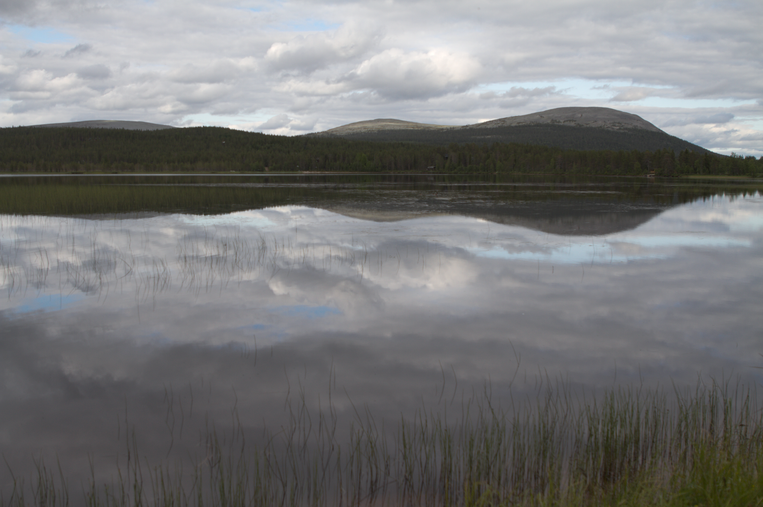
Original picture 1

Predefined crop areas in Crop mode:
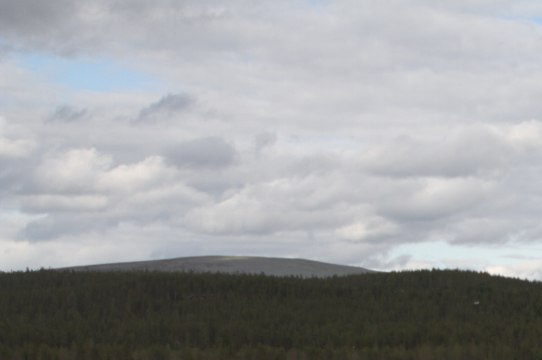 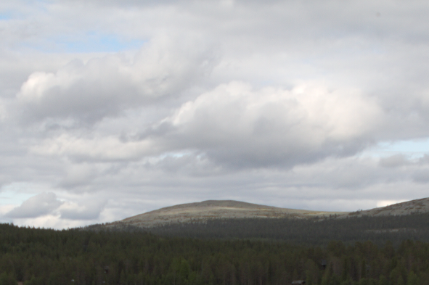 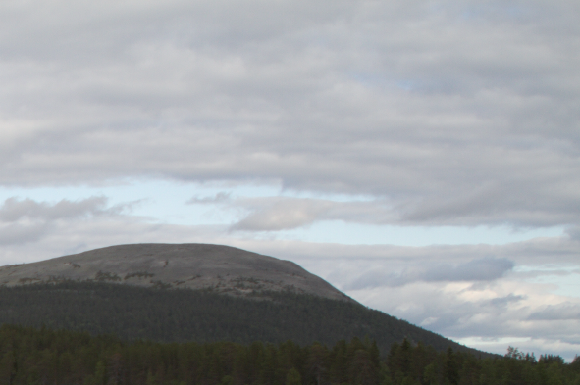
Top and Left Top and Center Top and Right
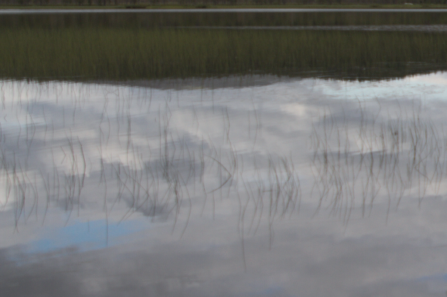 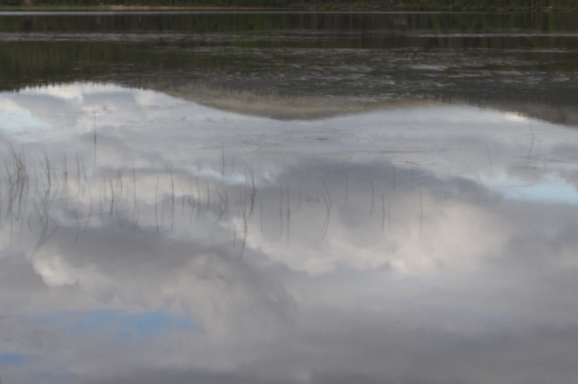 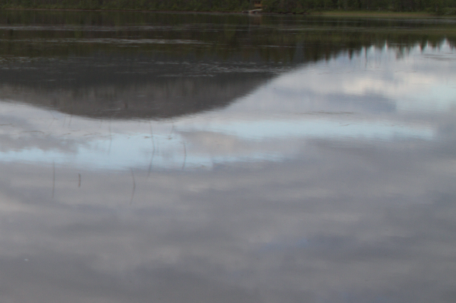
Center and Left Center and Center Center and Right
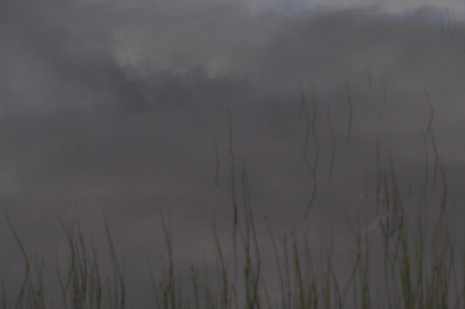 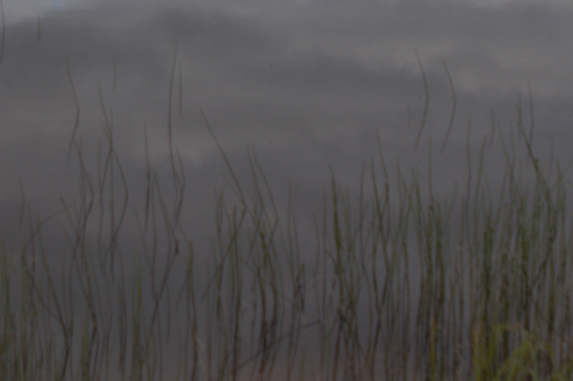 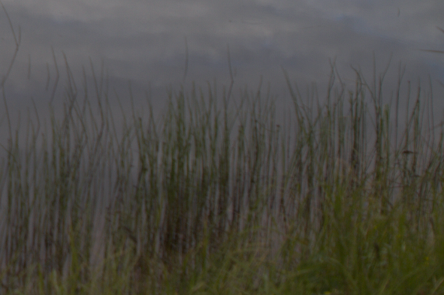
Bottom and Left Bottom and Center Bottom and Right

Predefined crop areas in Crop & Resize mode:
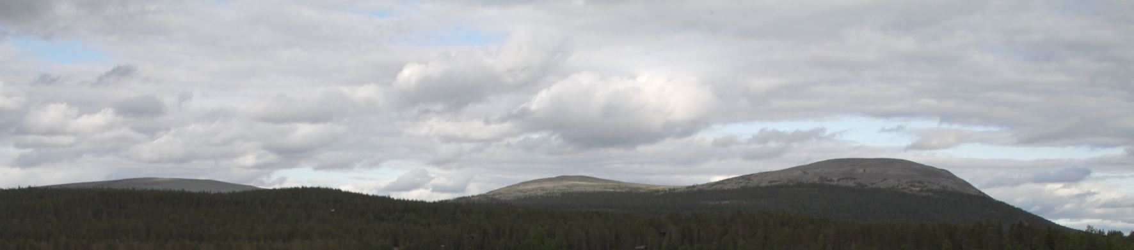
Top crop
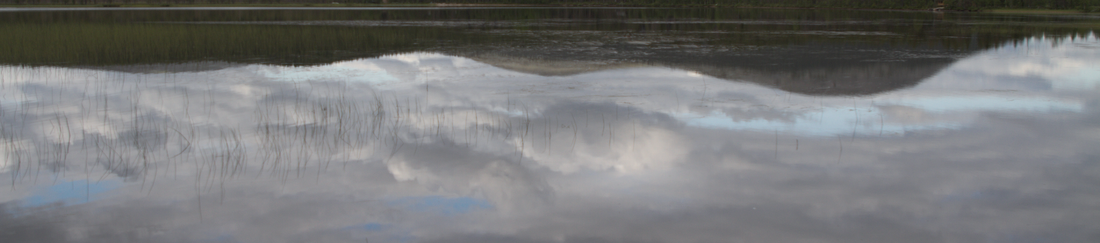
Horizontal center crop
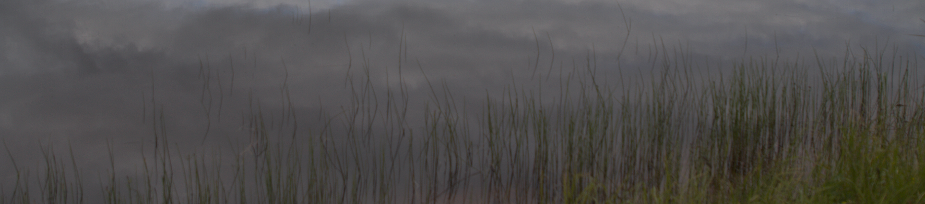
Bottom crop

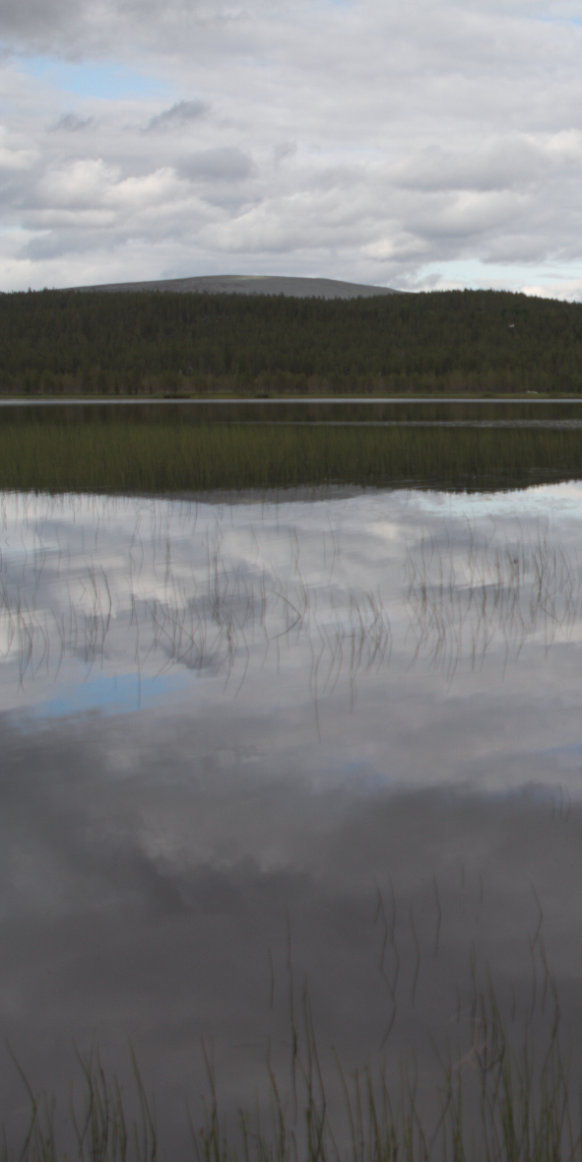 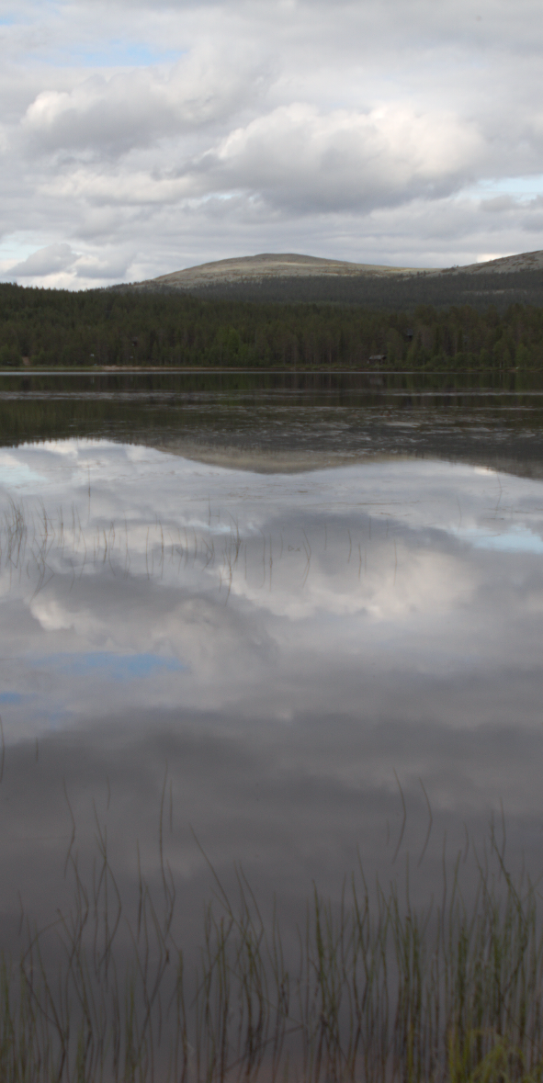 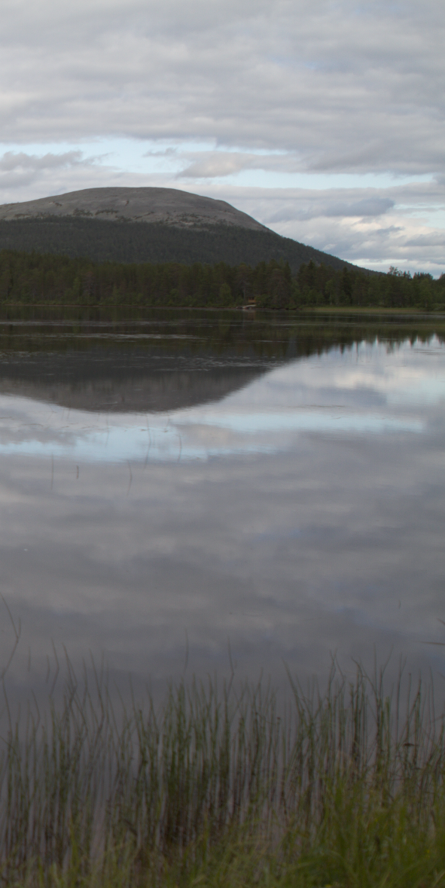
Left crop Center vertical crop Right crop
Custom crop area:
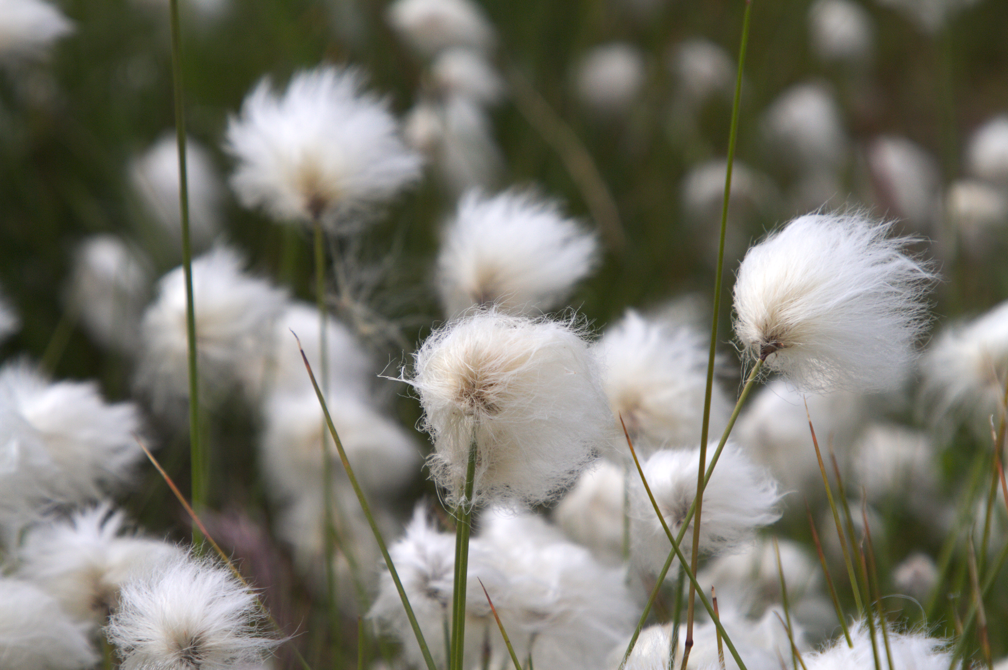
Original picture 2
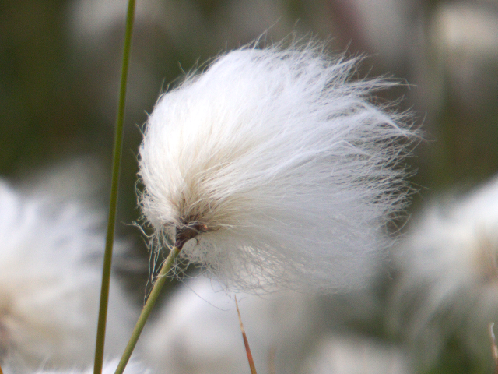
ROI: Crop size 640x480 and start coordinates: (1111, 315)
The menus depends of the source and target geometry of resolutions, and choices done. Therefore it is not useful to show every possible menu in this manual.
After crop menus (if cropping was required) the program asks for video FPS (default is 25). Then the duration of the video is calculated and shown. Next decision has to be made on CRF (video quality; default is 23). Lower value is better but the size of video file will increase if better quality is required.
Finally, a summary of selections is given, and the final question asks if video creation should be done.
Two sub directories will be created: png and video. All crops and image conversion files will be stored in the first one. The video directory consist of the video and log files.
This example illustrates how to run the program:
$ gtlvideo.py
Generate time-lapse video from images
Version 0.921 (beta) (C) Kim Miikki 2020
Python version: 3.5
Scanning supported image files in current directory...
CR2 info:
Files: 0
Width: 0
Height: 0
PNG info:
Files: 49
Width: 5202
Height: 3464
JPG info:
Files: 0
Width: 0
Height: 0

Sample file name: IMG_5010.png
Digits before file extension: 4
Default picture format: PNG
Select project name (Default: video <Enter>): sunset
Project name: sunset
Video name : sunset.mkv
Select video mode (landscape=L, portrait=P, Default: Landscape <Enter>):
Landscape video mode selected
Video modes
0 Native 5202x3464 5202:3464
2 4K/DCI 4096x2160 256:135
3 4K/UHD 3840x2160 16:9
4 2K 2560x1440 16:9
5 Full HD 1920x1080 16:9
6 Pi/md4 1640x1232 4:3
7 Pi/md5 1640x922 16:9
8 HD 1280x720 16:9
9 SD 720x576 16:9
10 XGA 1024x768 4:3
11 VGA 640x480 4:3
12 GIF 320x200 4:3
13 Custom ?x? x:y
Select video mode (Default mode is: 0 = 5202x3464 <Enter>): 5
Crop & Resize or only Crop?
Select Crop & Resize or only Crop (C&R=Y, C=N, Default: C&R <Enter>):
C&R mode selected
Crop mode: vertical
Image original size: 5202 x 3464
Image size before scaling: 5202 x 2926
Video size after scaling: 1920 x 1080
0 = Middle crop
1 = Top crop
2 = Bottom crop
3 = Custom crop start Y (0...537)
Select crop mode (Default: 0)? 2
Standard video frame rates: 24, 25, 30, 48, 50 and 60
Select video FPS (1...60, Default=25 <Enter>): 10
Video information
Frames: 49
FPS: 10
Duration: 4.9 s
Select 10 frames/s (Y/N, Default: Y <Enter>):
Default FPS selected
Constant Rate Factor: 0 (lossless) - 18 - 23 (default) - 28 - 51 (worst)
Select video CRF for x264 (0...51, Default=23 <Enter>):
Default CRF selected
"/home/.../png/"
---------------------
Summary of selections:
Program version: 0.921 (beta)
Project name: sunset
Video name: sunset.mkv
Video resolution is smaller than image size
Crop mode: crop and resize
Crop direction: vertical
Crop selection: Bottom crop
Crop coordinates: (0,537)-(5201,3463)
Crop geometry error: -0.00 %
Image size: 5202x3464
Cropped image size: 5202x2926
Video size: 1920x1080
Picture geometry (h/w): 0.6658977316416763
Cropped image geometry (h/w): 0.5624759707804691
Video geometry (h/w): 0.5625
File format: PNG
File sample name: IMG_5010.png
First new file name: IMG_4980.png
Working path: /home/...
PNG path: /home/.../png/
Video and log path: /home/.../video/
Video name: sunset.mkv
Log name: sunset.log
File format digits: 4
First frame: 4980
Last frame: 5028
Calculated number of frames: 49
Files: 49
FPS: 10
Duration: 4.9 s
Constant Rate Factor (CRF): 23
Stage 1: PNG→PNG
for i in "/home/.../"*.png ; do ffmpeg -y -i "$i" -vf crop=5202:2926:0:537,scale=1920:1080 "/home/.../png/""sunset-$(basename "$i" ".png")".png ; done
Stage 2: Create video
ffmpeg -y -r 10 -start_number 4980 -i "/home/.../png/sunset-IMG_%04d.png" -c:v libx264 -crf 23 "/home/.../video/sunset.mkv"
Are you sure you want to proceed (Y/N, Default=Y <Enter>)? y
...
Stage 1 duration: 0:01:20.655601
Stage 2 duration: 0:00:04.607428

RGB Color Analysis
rgbinfo.py
- Calculate RGB and BW means of PNG and JPG pictures
- Requires numpy and opencv Python libraries
- RPI is not required
Current directory is scanned and color analysis is carried out if the picture is in PNG or JPG format. Here is an example of an experiment where the palm tree was illuminated by an infrared heater. The RPI camera module used was v. 2.x NoIR. The sample picture’s exposure time was 20 ms.
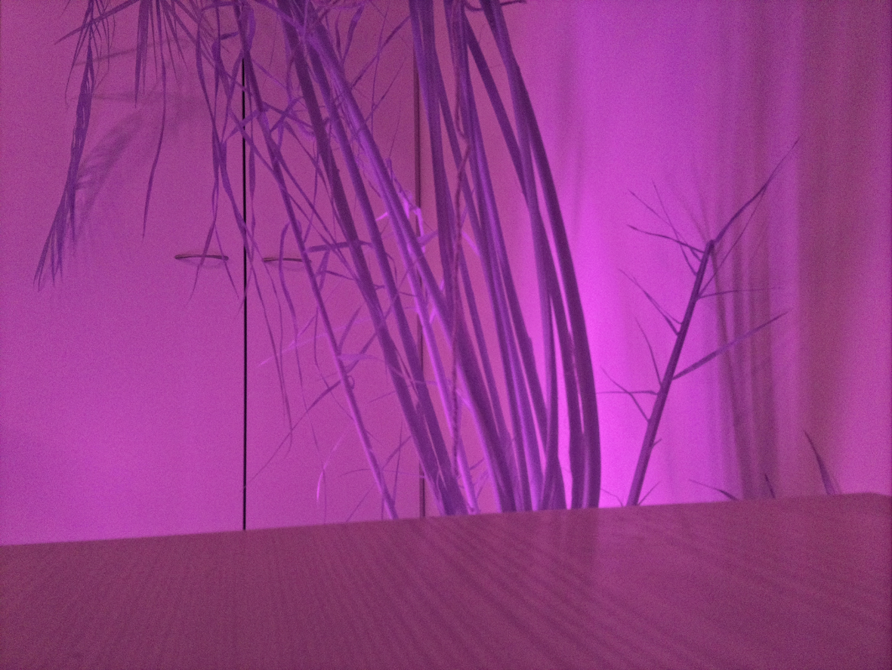
VIS and IR illuminated composition at 20 ms exposure.
An exposure bracketing experiment was performed and here is the result as a function of time:
Color analysis performed by rgbinfo.py.

This program calculates the average R, G and B channels and BW of each picture in current directory.
Here is an example run of the program:
$ rgbinfo.py
RGBinfo 1.0, (c) Kim Miikki 2019
Analyzing:
20190322_102606.png: 4032x2268
20190322_102611.png: 4032x2268
20190322_102612.png: 4032x2268
Pictures analyzed: 3
Time elapsed: 0:00:01.290984
$ cat rgb-png.txt
picture_name;rgb_avg;r_avg;g_avg;b_avg;rgb_ratio;r_ratio;g_ratio;b_ratio
20190322_102606.png;106.70739222901095;95.30768676426332;104.93878688306599;119.87570303970354;0.41846036168239586;0.3737556343696601;0.41152465444339603;0.47010079623413153
20190322_102611.png;126.4928493859821;119.13333105876096;125.56441917044596;134.7807979287394;0.4960503897489494;0.46718953356376847;0.4924094869429253;0.5285521487401544
20190322_102612.png;125.87577109461755;118.75658915186445;124.93207055198623;133.93865358000195;0.49363047488085315;0.46571211432103704;0.4899296884391617;0.5252496218823606
Pictures analyzed:;3
Time elapsed:;0:00:01.290984

Splitting RGB Channels into Separate Images
The RPI camera software suite provides tools to split images into RGB channels in two different ways. The first one splits images into 3 channel red, green and blue colored images. The second one splits them into 1 channel gray scale images, where the RGB channel information is stored as a filename prefix of the color split image.

Splitting RGB Channels into separate RGB Images
rgbsplit.py
- Split RGB channels of PNG or JPG pictures into separate images
- Requires numpy and cv2 Python libraries
- RPI is not required
An experiment was conducted in Ylläs, Lapland, Finland on 16.7.2019 (by shooting in time-lapse mode) with a Canon 7D camera. The interval between pictures was 20 s. This sample shows how rgbsplit.py can be used to split images into red, green and blue color channel images, and black & white images:
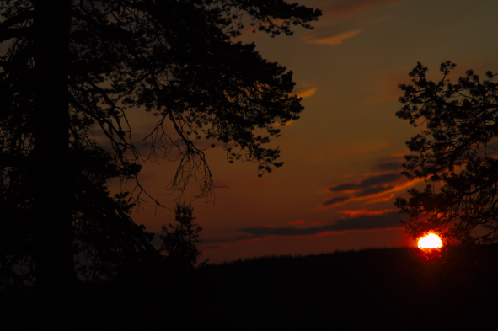 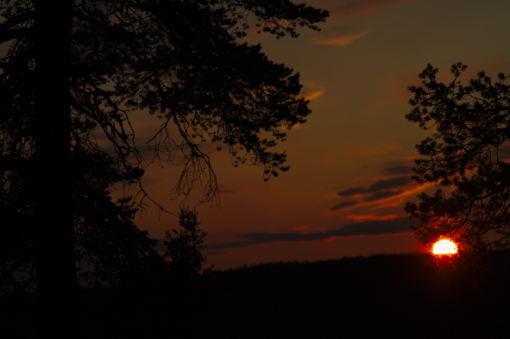 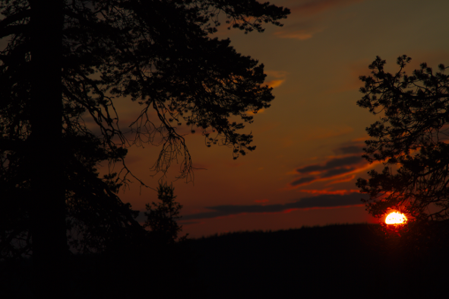
sunset-IMG_5010.png sunset-IMG_5011.png sunset-IMG_5012.png
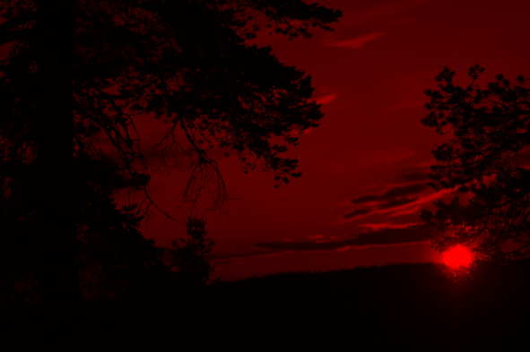 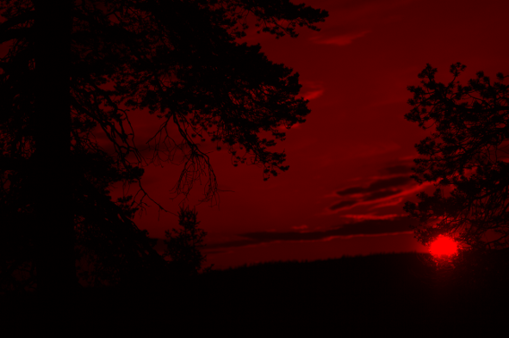 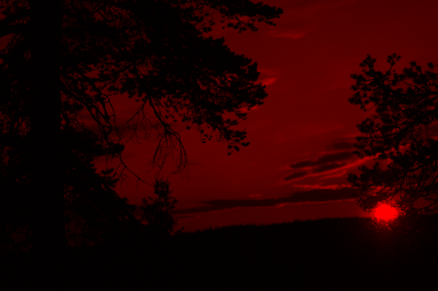
R-sunset-IMG_5010.png R-sunset-IMG_5011.png R-sunset-IMG_5012.png
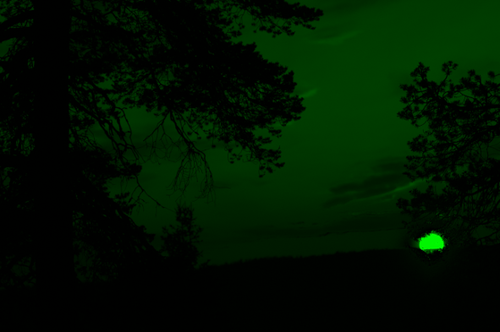 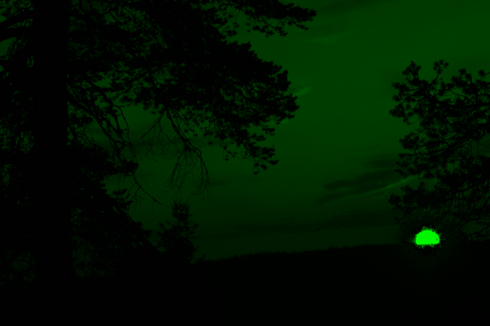 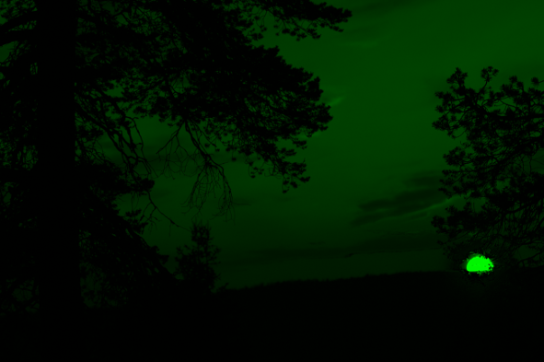
G-sunset-IMG_5010.png G-sunset-IMG_5011.png G-sunset-IMG_5012.png
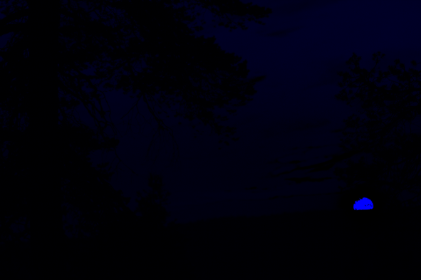 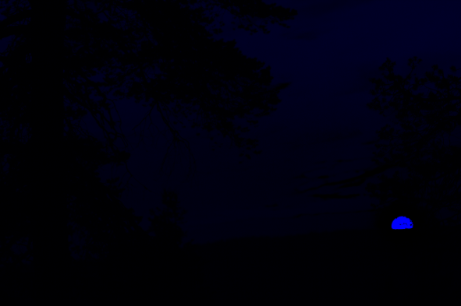 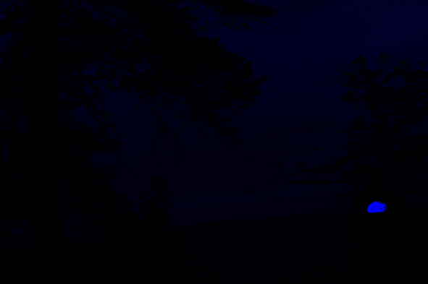
B-sunset-IMG_5010.png B-sunset-IMG_5011.png B-sunset-IMG_5012.png
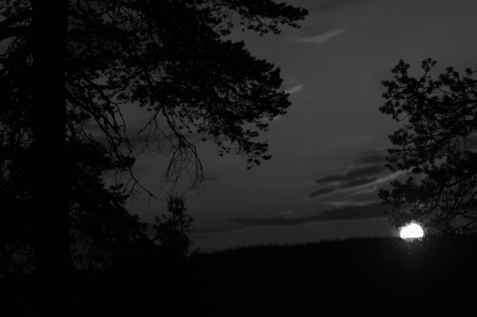 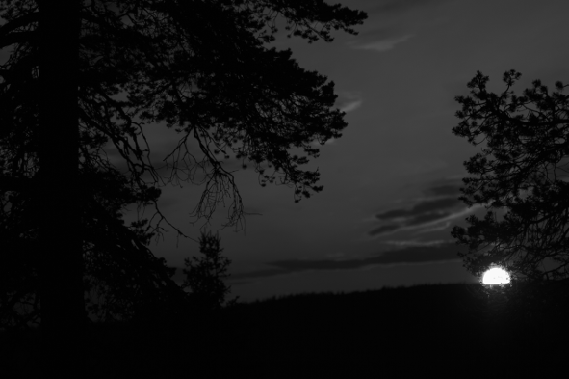 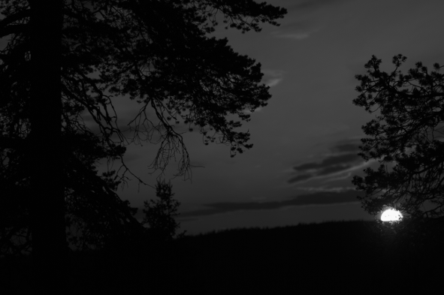
BW-sunset-IMG_5010.png BW-sunset-IMG_5011.png BW-sunset-IMG_5012.png
This program does not require a RPI. The only requirements is that the pictures have to be in PNG or JPG format. R-, G-, B- and BW- prefixed images are stored in the same directory where the source images are located.
This conversion was executed this way:
$ rgbsplit.py
RGBsplit 1.0, (c) Kim Miikki 2019
Splitting color channels:
sunset-IMG_5010.png: 5202x3464
sunset-IMG_5011.png: 5202x3464
sunset-IMG_5012.png: 5202x3464
Pictures processed: 3
Time elapsed: 0:00:08.240715

Splitting RGB Channels into Separate Gray Scale Images
bw-rgbsplit.py
• Split RGB channels of PNG or JPG pictures into separate gray scale images
• Requires numpy and cv2 Python libraries
• RPI is not required
This program splits RGB color images into 8-bit gray scale images, like the following example shows:
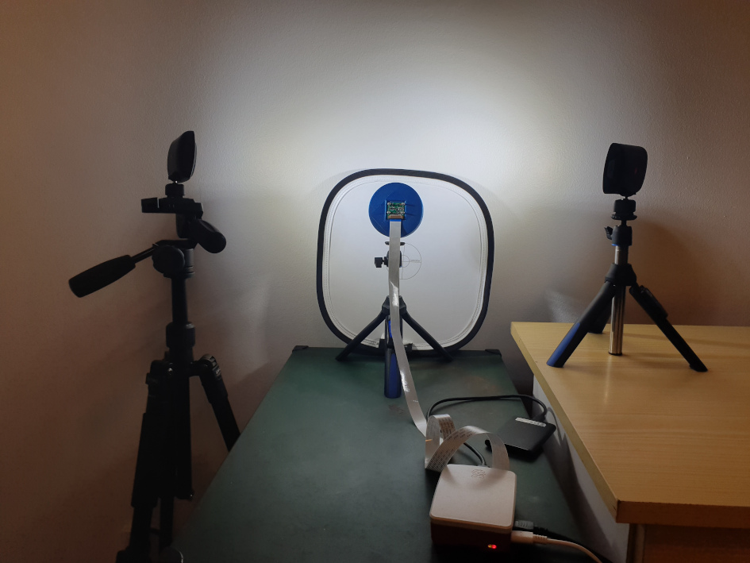 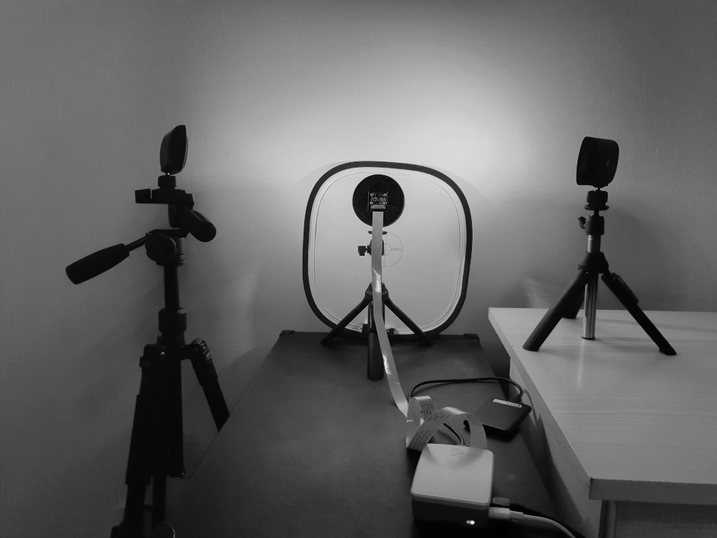
Original 3 channel RGB picture Red channel as 8-bit gray scale image
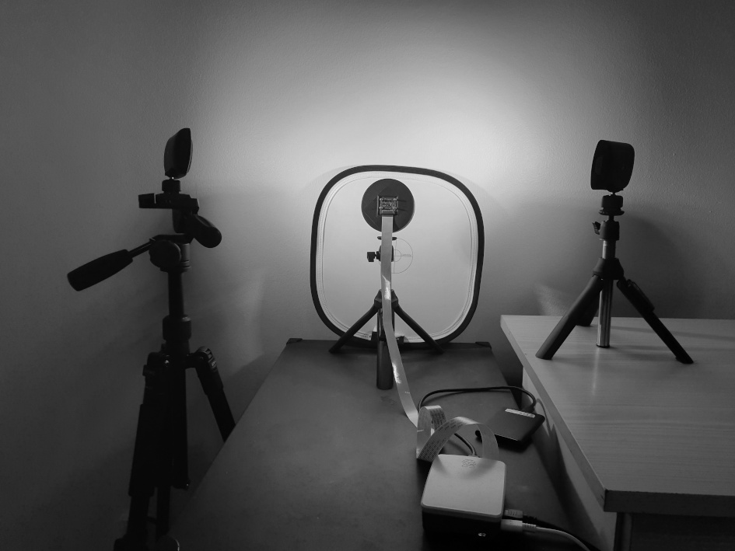 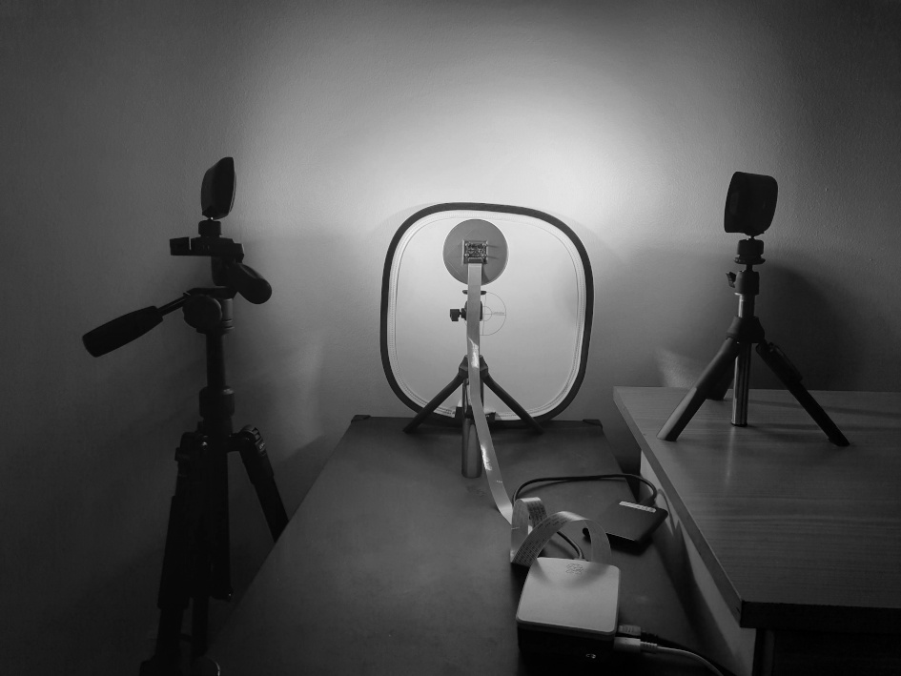
Green channel as 8-bit gray scale image Blue channel as 8-bit gray scale image
The color channel information is stored in file names as prefixes:
BWR-: Red channel
BWG-: Green channel
BWB-: Blue channel

Otherwise original file names are stored directly after these prefixes. The program should be executed in the same directory, where the pictures are located:
$ bw-rgbsplit.py
BW-RGBsplit 1.0, (c) Kim Miikki 2020
Splitting color channels:
20200406_090114.jpg: 4032x3024
Pictures processed: 1
Time elapsed: 0:00:00.644501

Combining RGB split Images into Color Images
All of these color channel separation operations can be reversed by merging color channels back into RGB color images. Normally merging is done after enhancing etc. the individual color channels.

Combining 3 Channel RGB split Images into Color Images
rgbcombine.py
• Merge RGB split 3 channel PNG or JPG images into color images
• Requires numpy and cv2 Python libraries
• RPI is not required
This program search for B-, G- and R- prefixed images in current directory, and merge them into color images. The color split images must be 3 channel RGB color split images. Here is an example how to use the program:
$ ls -1
B-20200406_090114.jpg
G-20200406_090114.jpg
R-20200406_090114.jpg
$ rgbcombine.py
RGBcombine 1.0, (c) Kim Miikki 2020
Combining color channels:
20200406_090114.jpg: 4032x3024
Pictures processed: 1
Time elapsed: 0:00:00.858192

Combining 1 Channel RGB split Images into Color Images
bw-rgbcombine.py
• Merge RGB split 1 channel PNG or JPG images into color images
• Requires numpy and cv2 Python libraries
• RPI is not required
This program search for BWB-, BWG- and BWR- prefixed images in current directory, and merge them into color images. The color split images must be 1 channel gray scale images. The following example demonstrate how to use this program:
$ ls -1
BWB-20200406_090114.jpg
BWG-20200406_090114.jpg
BWR-20200406_090114.jpg
$ bw-rgbcombine.py
BW-RGBcombine 1.0, (c) Kim Miikki 2020
Combining color channels:
20200406_090114.jpg: 4032x3024
Pictures processed: 1
Time elapsed: 0:00:00.600683

Batch Resize Images
resize-batch.py
- Batch resize images
- Requires opencv Python library
This program resizes images from the working directory to a sub-directory named resize_x or resize_y. By default resizing is width based and new height is calculated based on original A/R of the image. As default cv2.INTER_CUBIC method is used when resizing images. It can be overridden by changing the value. Valid methods are listed in an array named inter_methods.
Usage of this program and the generated output structure can be seen from following example:
$ resize-batch.py
Image batch resize tool
Override default options (Y/N, Default N: <Enter>):
Default selected: override disabled
Resize by width (Y/N, Default Y: <Enter>):
Default selected: width enabled
Select width (1...10000, Default=1600: <Enter>): 640
Resize options
--------------
Convert images to PNG: no
A/R round method: int
Resize method: 2
Only landscape images will be resized
Resized: ptfe-h2o-frame00000001.jpg >> 640x512
Resized: ptfe-h2o-frame00000100.jpg >> 640x512
Resized: ptfe-h2o-frame00000200.jpg >> 640x512
Resized: ptfe-h2o-frame00000300.jpg >> 640x512
Resized: ptfe-h2o-frame00000400.jpg >> 640x512
Resized: ptfe-h2o-frame00000500.jpg >> 640x512
Pictures resized: 6
Time elapsed: 0:00:00.678194
pi@rpicam:/media/pi/data/PTFE/roi $ tree
.
├── ptfe-h2o-frame00000001.jpg
├── ptfe-h2o-frame00000100.jpg
├── ptfe-h2o-frame00000200.jpg
├── ptfe-h2o-frame00000300.jpg
├── ptfe-h2o-frame00000400.jpg
├── ptfe-h2o-frame00000500.jpg
└── resize_x
├── ptfe-h2o-frame00000001.jpg
├── ptfe-h2o-frame00000100.jpg
├── ptfe-h2o-frame00000200.jpg
├── ptfe-h2o-frame00000300.jpg
├── ptfe-h2o-frame00000400.jpg
└── ptfe-h2o-frame00000500.jpg
1 directory, 12 files
pi@rpicam:/media/pi/data/PTFE/roi $ mediainfo resize_x/ptfe-h2o-frame00000001.jpg
General
Complete name : resize_x/ptfe-h2o-frame00000001.jpg
Format : JPEG
File size : 59.6 KiB
Image
Format : JPEG
Width : 640 pixels
Height : 512 pixels
Color space : YUV
Chroma subsampling : 4:2:0
Bit depth : 8 bits
Compression mode : Lossy
Stream size : 59.6 KiB (100%)
The resized images are shown in the following sequence:
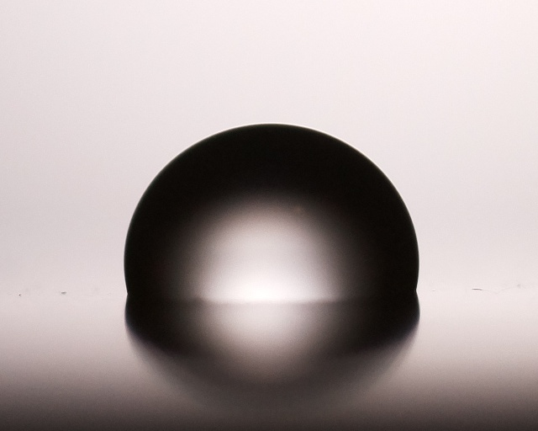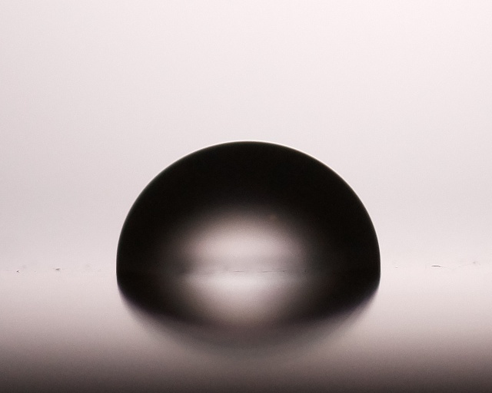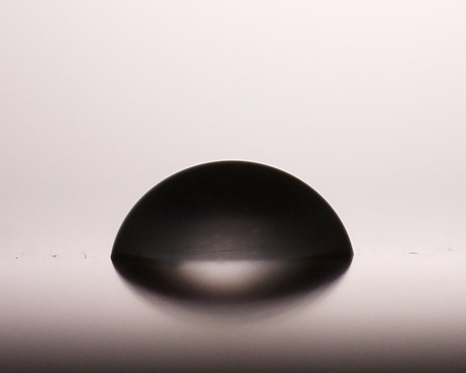
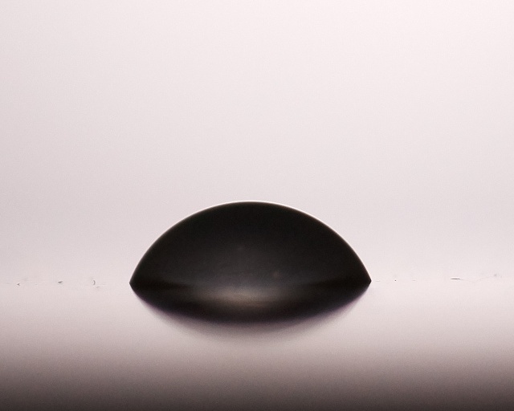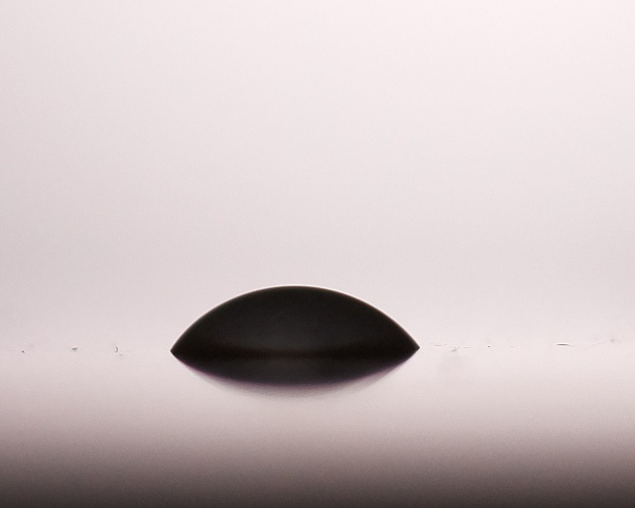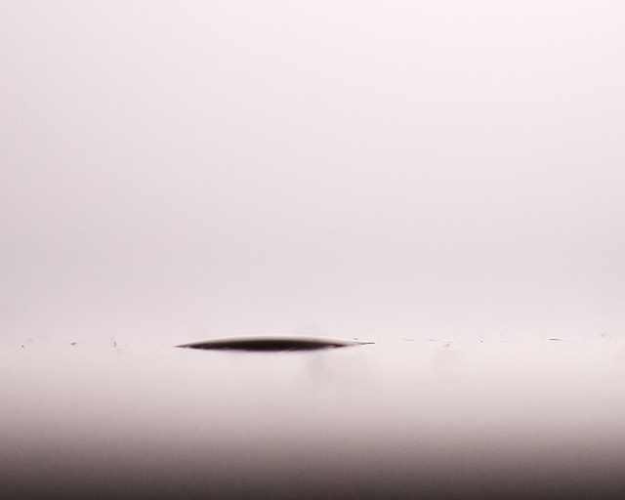
Resized time-lapse images of a water droplet on PTFE.

Convert Images to PNG Format
pics2png.py
- Convert image formats which PIL supports to PNG format
- Requires python PIL library
- RPI is not required
This simple program tries to read all files in current directory as PIL images. If it succeeds, then the image will be converted as a PNG file saved in a png named sub directory. The program does not require a RPI.
Here is an example run of the program:
$ pics2png.py
Pics to PNG files 1.0, (c) Kim Miikki 2019
20190322_102606.jpg (4032x2268) -> 20190322_102606.png
20190322_102611.jpg (4032x2268) -> 20190322_102611.png
20190322_102612.jpg (4032x2268) -> 20190322_102612.png
No PNG conversion: 20190322_102628.mp4
Pictures converted: 3
Time elapsed: 0:00:07.493193

Pictures to Time-lapse Files
gen_tlfiles.py
- Copy and rename PNG or JPG files to time-lapse files
- RPI is not required
This application converts file names into time-lapse format (img_0001, img_0002 etc.). The files are copied and renamed. The program calculates a ratio of the nearest 10^{digits of pictures}. If the amount of pictures is equal or more than 90 % to the following tenfold, the program will increase leading zeroes by one. New files are stored in a tl named directory under the the current directory.
Here is an example run of the program:
$ gen_tlfiles.py
Pictures to Time-lapse Files 1.0, (c) Kim Miikki 2020
cp /home/kim/pictemp/20190710_184746.jpg /home/kim/pictemp/tl/img_01.jpg
cp /home/kim/pictemp/20190710_184747.jpg /home/kim/pictemp/tl/img_02.jpg
cp /home/kim/pictemp/20190710_184749.jpg /home/kim/pictemp/tl/img_03.jpg
cp /home/kim/pictemp/20190710_184805.jpg /home/kim/pictemp/tl/img_04.jpg
cp /home/kim/pictemp/20190710_184808.jpg /home/kim/pictemp/tl/img_05.jpg
cp /home/kim/pictemp/20190710_184810.jpg /home/kim/pictemp/tl/img_06.jpg
cp /home/kim/pictemp/20190710_184814.jpg /home/kim/pictemp/tl/img_07.jpg
cp /home/kim/pictemp/20190710_184815.jpg /home/kim/pictemp/tl/img_08.jpg
cp /home/kim/pictemp/20190710_184821.jpg /home/kim/pictemp/tl/img_09.jpg
cp /home/kim/pictemp/20190710_184825.jpg /home/kim/pictemp/tl/img_10.jpg
cp /home/kim/pictemp/20190710_184826.jpg /home/kim/pictemp/tl/img_11.jpg
cp /home/kim/pictemp/20190710_184827.jpg /home/kim/pictemp/tl/img_12.jpg
cp /home/kim/pictemp/20190710_184828.jpg /home/kim/pictemp/tl/img_13.jpg
cp /home/kim/pictemp/20190710_184830.jpg /home/kim/pictemp/tl/img_14.jpg
cp /home/kim/pictemp/20190710_184832.jpg /home/kim/pictemp/tl/img_15.jpg
cp /home/kim/pictemp/20190710_184833.jpg /home/kim/pictemp/tl/img_16.jpg
cp /home/kim/pictemp/20190710_184834.jpg /home/kim/pictemp/tl/img_17.jpg
cp /home/kim/pictemp/20190710_184835.jpg /home/kim/pictemp/tl/img_18.jpg
cp /home/kim/pictemp/20190710_185016.jpg /home/kim/pictemp/tl/img_19.jpg
cp /home/kim/pictemp/20190710_185020.jpg /home/kim/pictemp/tl/img_20.jpg
cp /home/kim/pictemp/20190710_185026.jpg /home/kim/pictemp/tl/img_21.jpg
cp /home/kim/pictemp/20190710_185105.jpg /home/kim/pictemp/tl/img_22.jpg
Time elapsed:0:00:00.072638

Additional Info
RPI High Speed Camera Suite, documentation and information for the RPI camera module:
https://github.com/kmiikki/rpi-camera, 20.10.2020
https://www.raspberrypi.org/documentation/raspbian/applications/camera.md, 27.12.2019
https://picamera.readthedocs.io/en/release-1.13, 2.1.2020

