THOR
1 Nodalization scheme
Figure 1 shows nodalization scheme of the NACIE-UP facility for the THOR. The scheme consists of two circulation loops and six heat structure. Also in the scheme there is a node with a free level of lead-bismuth modeling the expansion tank. The primary loop coolant is lead-bismuth, in the second loop is water. The primary loop consists of two communication lines separated by a node.
Figure 1: Nodalization scheme of the NACIE-UP facility for the THOR
2 Boundary condition
The gas injection into the coolant cannot be implemented in THOR. Forced circulation flowrate was simulated using a pump. When gas injection stops, the pump turn off (the pump’s pressure was reduced to zero in order to replicate the flow rate dynamics in the experiment) and natural circulation begins to be established.
The boundary condition at the beginning (steady state 1) and end (steady state 2) of transient tests is shown in Table 1.
Table 1: Boundary condition
Parameter | Value
 | ADP10 |  | ADP06 |  | ADP07
 | Steady state 1 | Steady state 2 | Steady state 1 | Steady state 2 | Steady state 1 | Steady state 2
Q_{FPS}, kW | 30 | 30 | 30 | 30 | 38 | 38
Q_{TFM}, kW | 1.915 | 1.650 | 1.933 | 1.657 | 1.960 | 1.684
m_{LBE}, kg/s | 2.56 | - | 2.66 | - | 3.07 | -
P_{gas}, bar | 1.42 | 1.42 | 1.42 | 1.42 | 1.42 | 1.42
m_{water}, kg/s | 2.494 | 2.494 | 2.494 | 2.494 | 2.494 | 2.494
T_{water,} °C | 170 | 170 | 170 | 170 | 170 | 170
P_{water}, bar | 16 | 16 | 16 | 16 | 16 | 16
3 Constitutive relations
The friction pressure loss was calculated by the code using the built-in subroutine. This subroutine contains a method for calculating friction according to the data from the [Idelchik I.E., Hydraulic resistance handbook. Мoscow., "Mashinostroeniye", 1992 (in russian)]. Local resistances were calculated according to [Idelchik I.E., Hydraulic resistance handbook. Мoscow., "Mashinostroeniye", 1992 (in russian)] and set in the scheme.
The calculation of the heat transfer coefficient for lead-bismuth was carried out according to the Eq. (1):
 |  |  |  | (1)
where | α | - | heat transfer coefficient, W/m²·°C;
 | Pe | - | Peclet number;
 | λ | - | thermal conductivity, W/m·°C;
 | d | - | hydraulic diameter, m.
The calculation of the heat transfer coefficient for water was carried out according to the Eq. (2):
 |  |  |  |  | (2)
where | Re |  | - | Reynolds number;
 | Pr |  | - | Prandtl number.
4 Heat losses
To calculate the heat losses in ADP10, ADP06, ADP07 test the thickness of the thermal insulator is 100 mm was applied to the outer surface of the pipes (TC 2-5 Fig. 1). The thermal conductivity of this thermal insulator were set according to the data from [Piazza I.Di, Hassan H., Lorusso P., Martelli D., Benchmark specification for NACIE-UP facility: non-uniform power distribution tests (rev5)]. The boundary condition for the heat transfer coefficient and the environmental temperature was set on the outer surface of the thermal insulation. The environmental temperature for the experiment is fixed to 10°C.
5 Properties of materials
All properties of materials were set according to the data from the [Piazza I.Di, Hassan H., Lorusso P., Martelli D., Benchmark specification for NACIE-UP facility: non-uniform power distribution tests (rev5)].
6 Description of the results
An uncertainty analysis was performed for all tests. Variable parameters and variation range:
- heat transfer coefficient for lead-bismuth ± 20 %;
- heat transfer coefficient for water ± 10 %;
- friction factor ± 10 %;
- coefficients of local hydraulic resistance ± 10 %;
- thermal conductivity stainless steel powder ± 30 %;
- thermal conductivity stainless steel AISI316L ± 7 %.
Based on the results of this analysis, the maximum errors for flow rate and temperature LBE were determined on a time interval corresponding to the steady state natural circulation.
Maximum calculation error was carried out according to the Eq.(3):
 |  |  |  |  | (3)
where |  |  | - | maximum deviation of the calculation based on the results of the uncertainty analysis from the experiment;
 |  |  | - | experimental value of the parameter (including measurement error).
ADP10 test results
Figure 2: Flow rate of lead-bismuth
Figure 3: Temperature of lead-bismuth at the entrance to FPS (TP101) and at the outlet of FPS (TP102)
Figure 4: Temperature of lead-bismuth in hot leg (TP103)
Figure 5: Temperature of lead-bismuth in hot leg (TP104)
Figure 6: Temperature of lead-bismuth at the entrance to HE (TP105) and at the outlet of HE (TP106)
Figure 7: Temperature of lead-bismuth in cold leg (TP107)
Maximum error ADP10 test for natural circulation regime is given in Table 2.
Table 2
Parameter | σ, %
σ(G) | 6
σ(T101) | 9
σ(T102) | 3
σ(T103) | 4
σ(T104) | 4
σ(T105) | 4
σ(T106) | 9
σ(T107) | 8
ADP06 test results
Figure 8: Flow rate of lead-bismuth
Figure 9: Temperature of lead-bismuth at the entrance to FPS (TP101) and at the outlet of FPS (TP102)
Figure 10: Temperature of lead-bismuth in hot leg (TP103)
Figure 11: Temperature of lead-bismuth in hot leg (TP104)
Figure 12: Temperature of lead-bismuth at the entrance to HE (TP105) and at the outlet of HE (TP106)
Figure 13: Temperature of lead-bismuth in cold leg (TP107)
Maximum error ADP06 test for natural circulation regime is given in Table 3.
Table 3
Parameter | σ, %
σ(G) | 5
σ(T101) | 9
σ(T102) | 4
σ(T103) | 5
σ(T104) | 4
σ(T105) | 5
σ(T106) | 8
σ(T107) | 8
ADP07 test results
Figure 14: Flow rate of lead-bismuth
Figure 15: Temperature of lead-bismuth at the entrance to FPS (TP101) and at the outlet of FPS (TP102)
Figure 16: Temperature of lead-bismuth in hot leg (TP103)
Figure 17: Temperature of lead-bismuth in hot leg (TP104)
Figure 18: Temperature of lead-bismuth at the entrance to HE (TP105) and at the outlet of HE (TP106)
Figure 19: Temperature of lead-bismuth in cold leg (TP107)

MATADOR
1 Nodalization scheme
In the MATADOR code, the calculation model of cross-section flow area of fuel pin simulator consists of 42 sub-channels and 60 links (Fig. 20). The model is divided into 331 axial layers. There are 72 axial layers for one complete spin of the wire winding.
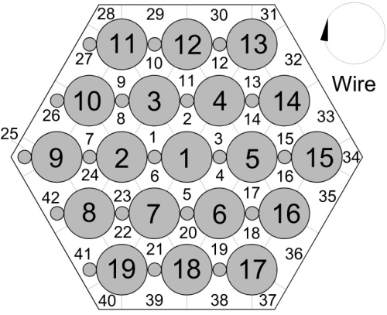  a | 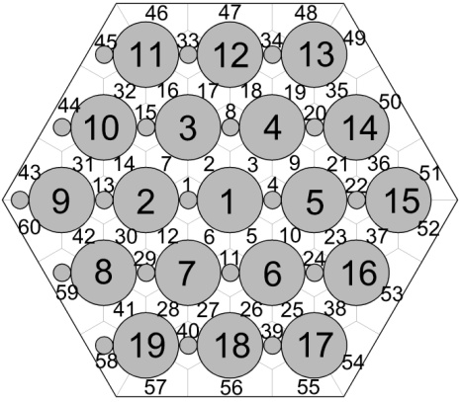  b
Figure 20: Cross-section flow area of fuel pin simulator: sub-channels (a) and links (b)
The calculation model of fuel pin consists of 10 radial layers and 5 or 6 azimuthal layers (it depends on the location of the rod). The model is divided into 100 axial layers. Schematic section of the pin in the heated area is shown in figure 21.
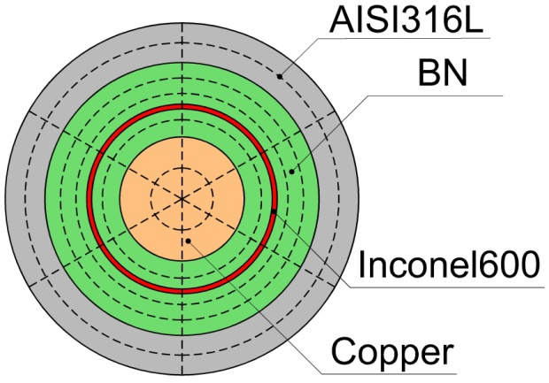
Figure 21: Schematic section of the calculation model of the pin in the heated area
In the calculation model, it is assumed that the pin had a stainless steel AISI316L clad, a central copper conductor and an insulator powder of bohrium nitride (BN); there is also an intermediate pipe made of AISI316L stainless steel (because of Inconel600 properties are not known).
The calculation model of hexagonal wrapper consists of 27 radial layers and 18 azimuthal layers. The model is divided into 100 axial layers. Schematic section of the hexagonal wrapper is shown in figure 22. The boundary conditions on the inner surface of the hexagonal wrapper are calculated based on the thermohydraulic parameters of the edge and corner sub-channels. It is assumed that the air temperature is set to 10 degrees on the outer surface of the hexagonal wrapper.
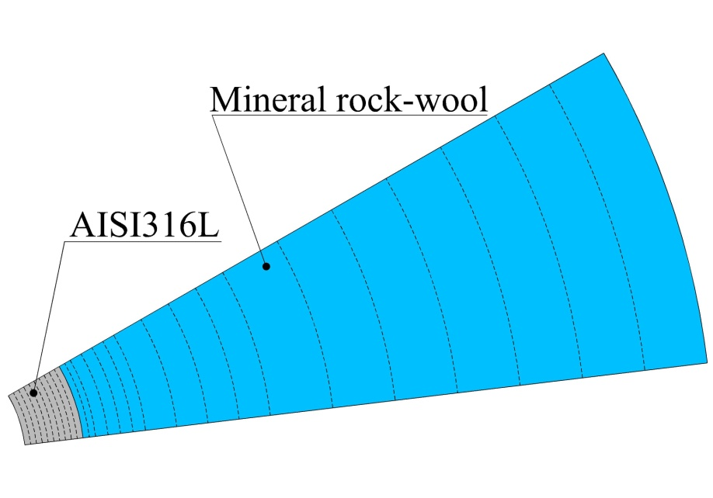
Figure 22: Schematic section of the calculation model of hexagonal wrapper.
2 Boundary condition
The boundary condition at the beginning (steady state 1) and end (steady state 2) of transient tests is shown in Table 4.
Table 4: Boundary condition
Parameter | Value
 | ADP10 |  | ADP06 |  | ADP07
 | Steady  state 1 | Steady  state 2 | Steady  state 1 | Steady  state 2 | Steady  state 1 | Steady  state 2
m_{LBE}, kg/s | 2.56 | 2.56 | 2.66 | 1.33 | 3.07 | 1.60
T_{in}, °C | 225.4 | 207.5 | 228.2 | 207.9 | 237.2 | 217.9
Q_{eff}, kW | 26.791 |  | 26.786 |  | 33.935
Q_{pre}, kW | 2.268 |  | 2.268 |  | 2.873
3 Constitutive relations
The constitutive relations, which are used in calculations:
- Friction factor (axial direction) − Pacio J., Chen S.K., Chen Y.M., Todreas N.E. Analysis of Pressure Losses and Flow Distribution in Wire-Wrapped Hexagonal Rod Bundles for Licensing. Part I: The Pacio-Chen-Todreas Detailed Model (PCTD). Nuclear Engineering and Design, 2022, vol. 92, no. 2, pp. 227 251.
- Friction factor (lateral direction) − Suh K.Y., Todreas N.E. An Experimental Correlation of Cross-Flow Pressure Drop for Triangular Array Wire-Wrapped Rod Assemblies. Nuclear Technology, 1987, vol. 76, no. 2, pp. 229 240.
- Mixing coefficients − Bogoslovskaya G.P., Zhukov A.V., Sorokin A.P. Models and Characteristics of Interchannel Exchange in Pin Bundles Cooled by Liquid Metal. In: LMFR core thermohydraulics: status and prospects, Number TECDOC–1157 IAEA, 2000.
- Heat transfer coefficient − Ushakov P.A., Zhukov A.V., Matyukhin N.M. Heat Transfer to Liquid Metal in Regular Arrays of Fuel Elements. High Temperature, 1977, vol. 15, no. 5, pp. 1027-1033.
4 Properties of materials
All properties of materials were set according to the data from the [Piazza I.Di, Hassan H., Lorusso P., Martelli D., Benchmark specification for NACIE-UP facility: non-uniform power distribution tests (rev5)].
5 Description of the results
An uncertainty analysis was performed for all steady state tests. Variable parameters, range of variation and distribution law are shown in Table 5.
Table 5
Parameter | Symbol | Range of variation | Distribution law
Power, % | ΔQ | 3.9 | Uniform distribution
Mass flow-rate, % | ΔG | 7 | Normal distribution
Inlet temperature, °C | ΔT | 1.5 | Normal distribution
Diameter of pin, mm | Δd_{pin} | 0.1 | Normal distribution
Pitch, mm | ΔS | 0.1 | Normal distribution
Diameter of wire, mm | Δd_{wire} | 0.1 | Normal distribution
Thermo-physical properties of LBE, %:  density;  heat capacity;  dynamic viscosity;  thermal conductivity | Δρ_{LBE}  ΔC_{LBE}  Δμ_{LBE}  Δλ_{LBE} | 0.8  5  8  15 | Uniform distribution
Thermal conductivity of stainless steel AISI316L, % | Δλ_{AIS} | 10 | Uniform distribution
Thermal conductivity of BN, % | Δλ_{BN} | 10 | Uniform distribution
Thermal conductivity of Copper, % | Δλ_{CU} | 10 | Uniform distribution
Parameter | Symbol | Range of variation | Distribution law
Friction factor (axial direction), % | Δξ_{axial} | 5 | Uniform truncated distribution
Friction factor (lateral direction), % | Δξ_{lateral} | 10 | Uniform truncated distribution
Mixing coefficients, % | Δμ_{mix} | 15 | Uniform truncated distribution
Heat transfer coefficient, % | Δα | 15 | Uniform truncated distribution
The error was carried out according to the Eq.(4)-(5):
(4)
(5)
ADP10 test results
Steady state 1
Figure 23: Wall temperature of fuel pin simulator and LBE temperature at the monitored sections B
Figure 24: Wall temperature of fuel pin simulator and LBE temperature at the monitored sections C
Figure 25: Wall temperature for pin 3 along the 13 monitored axial positions
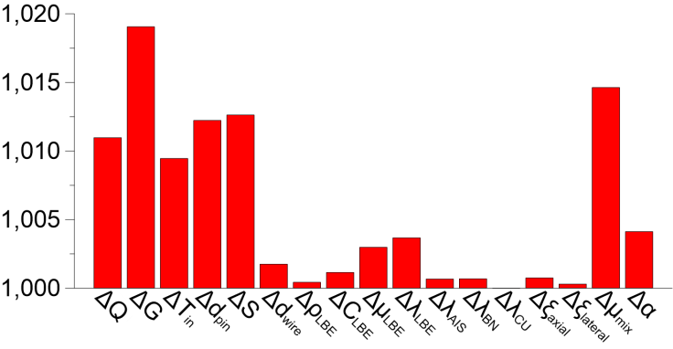
Figure 26: Linear regression coefficient (wall temperature)
Steady state 2
Figure 27: Wall temperature of fuel pin simulator and LBE temperature at the monitored sections B
Figure 28: Wall temperature of fuel pin simulator and LBE temperature at the monitored sections C
Figure 29: Wall temperature for pin 3 along the 13 monitored axial positions
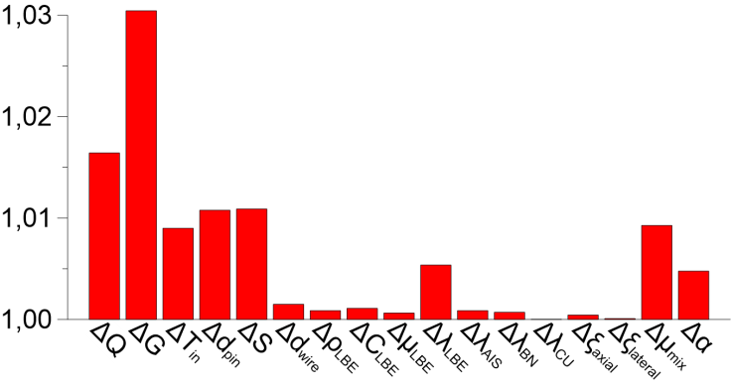
Figure 30: Linear regression coefficient (wall temperature)
Table 5: Temperature deviations
Parameter | Value
 | Steady  state 1 | Steady  state 2
, °C | 4 | 6
, °C | 4 | 4
, % | 4 | 4
, % | 7 | 2

Transient test
Figure 31: Time trend of bulk temperature for sub-channel 6
Figure 32: Time trend of bulk temperature for sub-channel 39
Figure 33: Time trend of bulk temperature for sub-channel 25
ADP06 test results
Steady state 1
Figure 34: Wall temperature of fuel pin simulator and LBE temperature at the monitored sections B
Figure 35: Wall temperature of fuel pin simulator and LBE temperature at the monitored sections C
Figure 36: Wall temperature for pin 3 along the 13 monitored axial positions
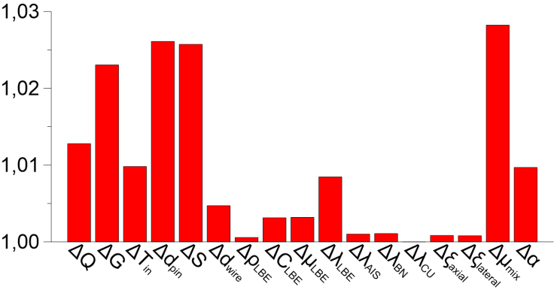
Figure 37: Linear regression coefficient (wall temperature)
Steady state 2
Figure 38: Wall temperature of fuel pin simulator and LBE temperature at the monitored sections B
Figure 39: Wall temperature of fuel pin simulator and LBE temperature at the monitored sections C
Figure 40: Wall temperature for pin 3 along the 13 monitored axial positions
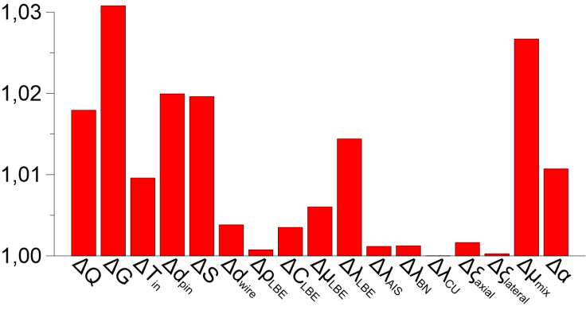
Figure 41: Linear regression coefficient (wall temperature)
Table 6: Temperature deviations
Parameter | Value
 | Steady  state 1 | Steady  state 2
, °C | 16 | 24
, °C | 10 | 17
, % | 15 | 12
, % | 22 | 10

Transient test
Figure 42: Time trend of bulk temperature for sub-channel 6
Figure 43: Time trend of bulk temperature for sub-channel 39
Figure 44: Time trend of bulk temperature for sub-channel 25
ADP07 test results
Steady state 1
Figure 45: Wall temperature of fuel pin simulator and LBE temperature at the monitored sections B
Figure 46: Wall temperature of fuel pin simulator and LBE temperature at the monitored sections C
Figure 47: Wall temperature for pin 3 along the 13 monitored axial positions
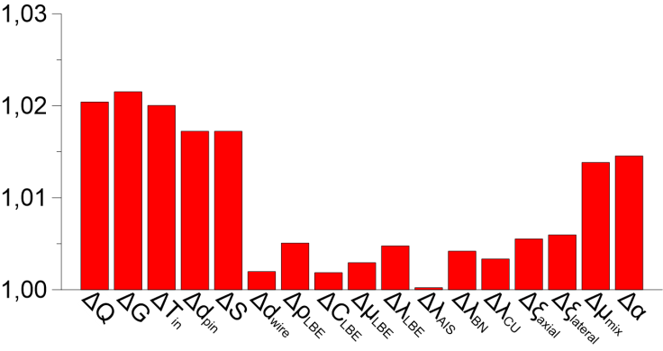
Figure 48: Linear regression coefficient (wall temperature)
Steady state 2
Figure 49: Wall temperature of fuel pin simulator and LBE temperature at the monitored sections B
Figure 50: Wall temperature of fuel pin simulator and LBE temperature at the monitored sections C
Figure 51: Wall temperature for pin 3 along the 13 monitored axial positions
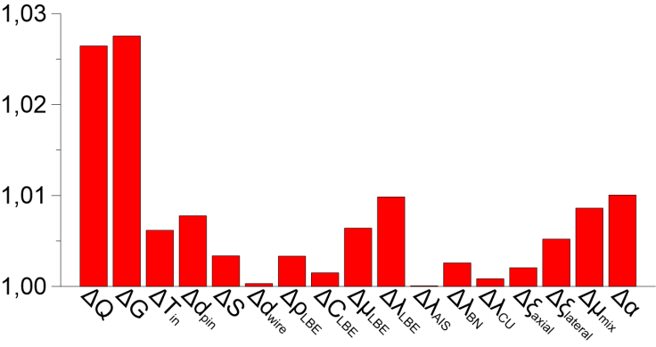
Figure 52: Linear regression coefficient (wall temperature)
Transient test
Figure 53: Time trend of bulk temperature for sub-channel 6
Figure 54: Time trend of bulk temperature for sub-channel 39
Figure 55: Time trend of bulk temperature for sub-channel 25

