SAM/MOOSE SCM
Argonne’s transient simulations of NACIE-UP tests were performed with the coupled system-level and subchannel simulation with the system analysis code System Analysis Module (SAM) [1] and subchannel analysis code MOOSE SubChannel Module (SCM) [2].
SAM is an advanced system analysis tool being development at Argonne to support safety analysis of advanced non-LWR reactors. It is under the support of the U.S. Department of Energy (DOE) Nuclear Energy Advanced Modeling and Simulation (NEAMS) program. The tool is intended to provide whole-plant transient analysis capabilities for advanced non-light-water reactor concepts, including LMRs (liquid-metal-cooled fast reactors), FHRs (fluoride-salt-cooled high temperature reactors), MSRs (molten salt reactors), HTGRs (high-temperature gas-cooled reactors), and heat-pipe-cooled reactors. Built on object-oriented application framework MOOSE [3] and its underlying meshing and finite-element library libMesh [4] as well as the linear and non-linear solvers PETSc [5], SAM leverages modern advanced software environments and numerical methods. SAM aims to solve the tightly coupled physical phenomena including fission reaction, heat transfer, fluid dynamics, and thermal-mechanical response in advanced reactor structures, systems and components with high accuracy and efficiency.

MOOSE SCM is a MOOSE-based subchannel module developed for single-phase subchannel simulations. It supports both square and hexagonal lattice configurations, cooled by water or liquid metal such as lead, sodium, and LBE. MOOSE SCM utilizes PETSc [5]-based Newton non-linear solver to solve the subchannel equations. It permits seamless coupling with other MOOSE applications/modules like BISON [6]/heat-transfer [7]. Figure 1 illustrates the subchannel index in MOOSE SCM for a triangular lattice in a hexagonal duct.

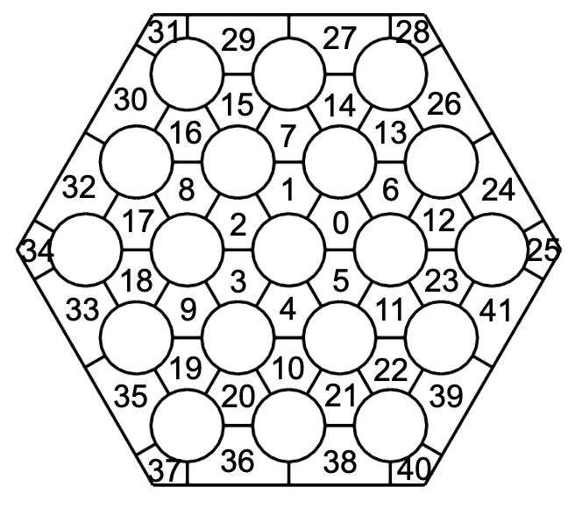
Figure 1. MOOSE SCM Subchannel Index Notation for a Triangular Lattice

In the coupled SAM and MOOSE SCM simulation, the domain overlapping approach is employed, as illustrated in Figure 2. This coupling methodology shows superior stability compared to the domain decomposition method without the additional computational requirements [8]. In this approach, the FPS region is represented as a detailed subchannel model in MOOSE SCM and a surrogate channel in SAM. During each timestep, SAM system model simulates the overall system behavior and provides the inlet temperature and mass flow rate to the MOOSE SCM calculation. Meanwhile, the MOOSE SCM model simulates the local behavior within the FPS and transfers the average pressure drop per unit length to the overlapping surrogate channel in SAM. Picard iteration is performed in each timestep to ensure the convergence between the SAM and MOOSE SCM solutions. This domain overlapping coupling between SAM and MOOSE SCM is achieved through the MOOSE MultiApp and Transfer systems. The coupled steady state calculation is obtained through null-transient simulation, and the coupled transient simulations are initialized from the steady state results.

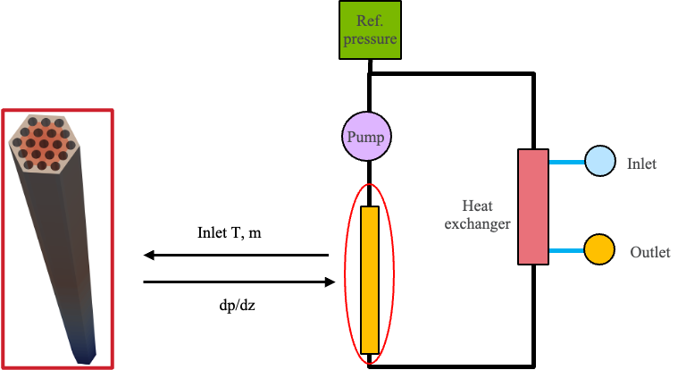
Figure 2. Domain Overlapping Coupling Approach in the Coupled MOOSE SCM (Left) and SAM (Right) Simulation

References for ANNEX II
- R. Hu, et al., “SAM: A Modern System Code for Advanced Non-LWR Safety Analysis,” Nuclear Technology, 211(9), 1883–1902, 2024.
- V. Kyriakopoulos, M. Tano, and J. Ragusa, “Development of a single-phase, transient, subchannel code, within the moose multi-physics computational framework,” Energies, 15(11):3948, 2022.
- G. Giudicelli et al., “3.0-MOOSE: Enabling Massively Parallel Multiphysics Simulations,” SoftwareX, 26, 101690, 2024.
- B. S. Kirk et al., “libMesh : A C++ Library for Parallel Adaptive Mesh Refinement/Coarsening Simulations,” Eng. Comput., 22, 3–4, 237, 2006.
- S. Abhyankar et al., “PetSc/TS: A Modern Scalable ODE/DAE Solver Library,” arXiv preprint arXiv:1806.01437, 2018.
- R. L. Williamson, et al, “BISON: A Flexible Code for Advanced Simulation of the Performance of Multiple Nuclear Fuel Forms”, Nuclear Technology, 207(7), pp. 954–980, 2021.
- https://mooseframework.inl.gov/modules/heat_transfer/
- A. Huxford et al., “A hybrid domain overlapping method for coupling System Thermal Hydraulics and CFD codes”, Ann. Nucl. Energy, vol. 189, 109842, 2023.

