SAS4A/SASSYS-1
Argonne’s transient simulations of NACIE-UP tests were performed with the fast reactor safety analysis code SAS4A/SASSYS-1 [1] for both the system-level and subchannel simulations.
SAS4A/SASSYS-1 [1] is a software simulation tool used to perform deterministic analysis of anticipated events as well as design basis and beyond design basis accidents for advanced nuclear reactors. Core models in SAS4A/SASSYS-1 consist of a number of single-pin channels and optional subchannels. The left side of Figure 1 illustrates the geometry used in SAS4A/SASSYS-1 channel thermal-hydraulic models. A single-pin channel represents the average pin in an assembly, and assemblies with similar reactor physics and thermal-hydraulic characteristics are grouped together. SAS4A/SASSYS-1 models include axial zones to represent the fueled and gas plenum regions as well as up to six upper and lower reflector zones. Each axial zone is also connected to a structure region, which can be used to model components such as the wire-wrap or duct walls.
SAS4A/SASSYS-1 includes reactor point kinetics, decay heat, and reactivity feedback models for calculating power during transient simulations. These models were not used, however, for NACIE-UP tests as these tests use electrical heating instead of nuclear fuel. The total power supplied by the heating elements was provided as input (table versus time) for the simulations.
The PRIMAR-4 module in SAS4A/SASSYS-1 simulates the thermal hydraulics of the heat transport systems outside the core. The right side of Figure 1 illustrates the geometry used in a PRIMAR-4 model. In a PRIMAR-4 model, compressible volumes, or CVs, are zero-dimensional volumes that are used to model larger volumes of coolant such as inlet and outlet plena and pools. Compressible volumes are connected by liquid segments, which are composed of one or more elements. Elements are modeled by one-dimensional, incompressible, single-phase flow and can be used to model pipes, valves, heat exchangers, steam generators, and more. SAS4A/SASSYS-1 simulates both forced and natural circulation, taking into account the impact of elevations, the coolant density distribution throughout systems, and coolant inertia terms.

Figure 1. SAS4A/SASSYS-1 Single-Pin Channel Geometry (left) and Heat Transport Systems Model Geometry (right)
The subchannel treatment in SAS4A/SASSYS-1 includes axial coolant flow parallel to the pins and cross flow between coolant subchannels driven by pressure differences and wire wrap sweeping. Heat flow between adjacent coolant subchannels is calculated, including effects of turbulent mixing. The channel treatment includes the whole length of the subassembly, with the detailed subchannel treatment in the pin section and a simpler treatment above and below the pins. Figure 2 shows a typical subchannel treatment for fuel pins with a triangular arrangement in a hexagonal duct, as well as where subchannel (3-D) treatment is applied in a pin. In this arrangement, there are interior subchannels, edge subchannels and corner subchannels. If the pins are wrapped with spacer wires, then there would be wire wrap flow sweeping along the duct walls in the edge and corner subchannels. The subchannel model is flexible enough to model other geometries, such as pins in a square arrangement with grid spacers and no wire wrap. The channels represented by the single pin model and sub-channel model collectively form the core model, which is coupled to models representing the heat transport systems beyond the core.

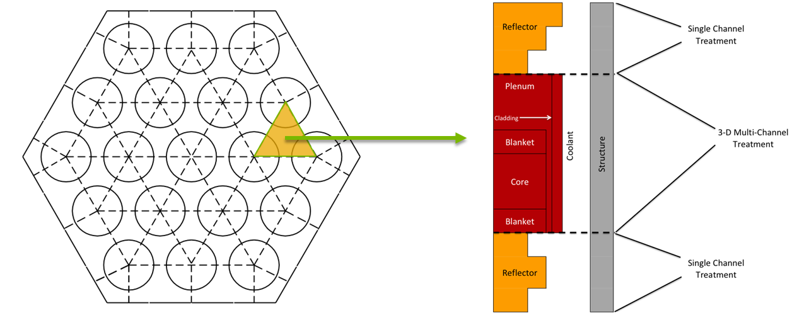
Figure 2. SAS4A/SASSYS-1 Coolant Subchannels Example

References for ANNEX II
- D. O’Grady, et. al., “The SAS4A/SASSYS-1 Version 5.7 Safety Analysis Code System”, ANL/NSE-SAS/5.7, Nuclear Science and Engineering Division, Argonne National Laboratory, 2023.

