- Introduction of THACS
THACS is a modular code, which is developed by Nuclear THermal-hydraulic laboratory of Xi’an Jiaotong University (NuTHeL-XJTU) to support design and safety analysis of Chinese SFR[1][2]. It is used to participate in thermal-hydraulic part of this benchmark. It initiated in 2013, was firstly called THACOS, and was renamed THACS later. It could simulate primary loop of different SFRs with typical component model such as core, hot pool, pump, pipe, pipe-net, and air heat exchanger, cold pool. Meanwhile, a home stand-alone numerical model of steam generator is also made the effort to integrate into it. With the continuous development, it has some new features and updates, for instance, original multi-channel core model is updated to muti-channel model plus subchannel model [3] to further analyse temperature distribution of subassemblies; hot pool model is substituted for 2D CFD model [4] to capture thermal stratification phenomena in hot pool; a new inter wrapper flow model (IWF) [5][6] and reactor vessel cooling model are also added to model inter wrapper region and reactor vessel cooling system. THACS utilizes finite volume method for numerical discretization of one-dimensional governing equations. GEAR and SIMPLE algorithms are adopted for matrix solving and iterative solution control, respectively. It has been validated by different benchmark organized by IAEA such as BN800, EBR-Ⅱ, PHENIX.
- Key modules
  - Overview of THACS
The framework and calculation procedure of THACS is shown as Fig. 1,
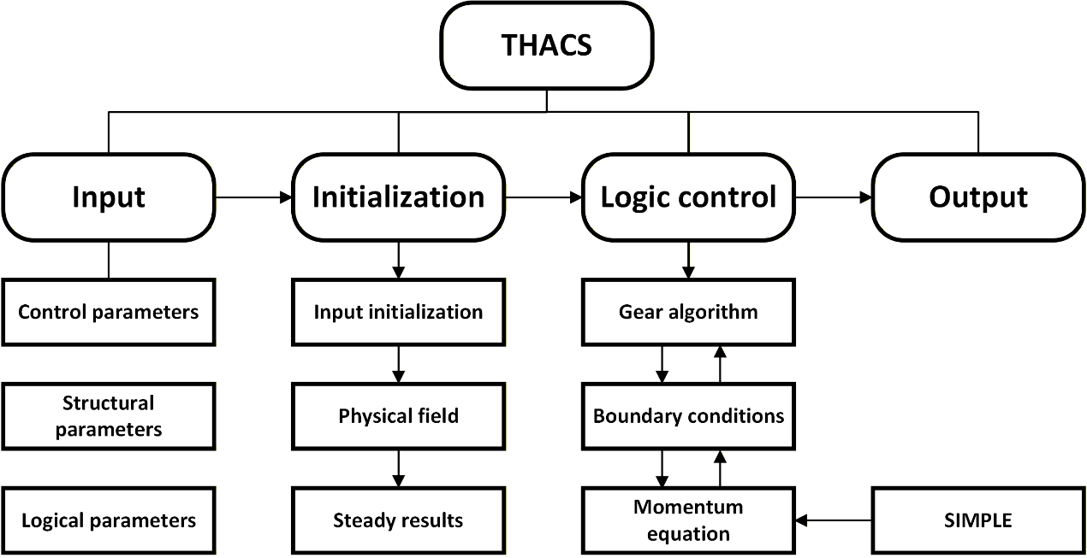
Fig. 1 Framework and procedure of THACS.
The key modules of THACS consist of core module, inter-wrapper flow module, plenum module, intermediate heat exchanger module, pipe net and pump, which together simulate the coolant flow and heat transfer processes in the reactor system (see Fig. 2).
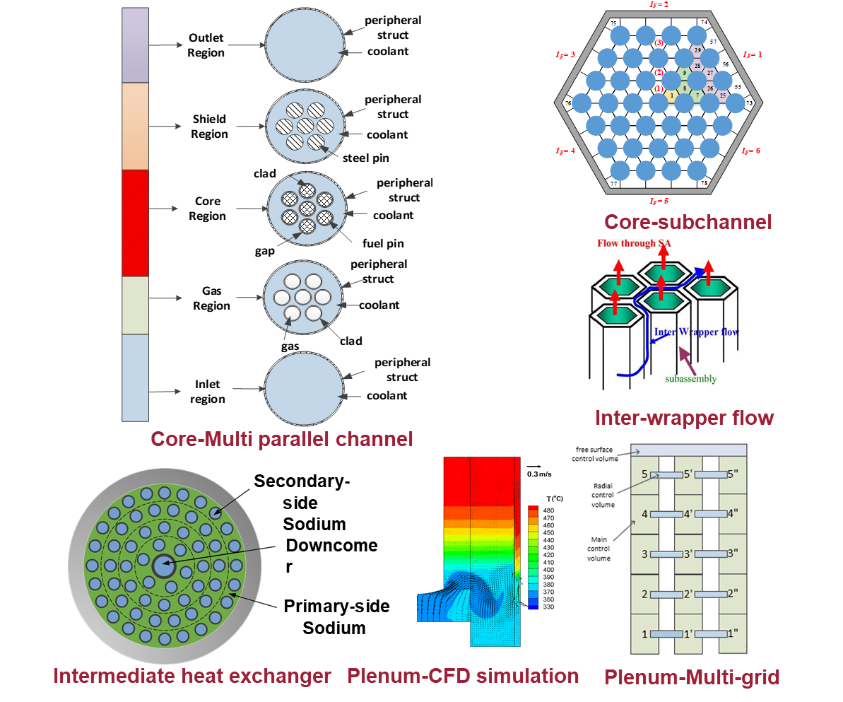
Fig. 2 Key modules of THACS.
The core module adopts a multi-channel model to represent the coolant flow and heat transfer behavior in different fuel channels, allowing the program to capture the thermal–hydraulic characteristics inside the reactor core. The inter-wrapper flow module incorporates an integrated two-dimensional CFD model based on the SIMPLE algorithm, which is used to simulate the cross-flow and momentum exchange between neighboring subchannels or wrapper gaps. The plenum module includes a multi-grid approach combined with a junction model, as well as an integrated two-dimensional CFD model, enabling accurate prediction of flow mixing, pressure distribution, and coolant redistribution in the plenum regions. For heat transfer between primary and secondary circuits, the intermediate heat exchanger module employs a multi-layer model to simulate the radial temperature distribution and thermal coupling across different structural layers. In addition, the program contains a pipe network and pipe module to represent the coolant transport system and hydraulic connections throughout the loop, and a pump module to model the driving force of the circulation system.
Together, these modules form a comprehensive thermal–hydraulic simulation framework capable of describing the coupled phenomena of fluid flow, heat transfer, and system circulation in the reactor cooling system.
  - Thermophysical properties of LBE
Thermo-physical properties of LBE implemented in THACS are listed in Table 1, which are temperature-dependent function.
Table 1 Thermo-physical properties of LBE as a function of temperature (T in Kelvin, SI Units), from OECD/NEA Handbook 2015
Property | Correlation | Units | Maximum Uncertainty | Standard deviation
Density |  |  | ≤0.8% | 0.58%
Specific heat capacity |  |  | ≤5.0% | 2.4%
Dynamic viscosity |  |  | ≤6.0%-8.0% | 7.2%
Thermal conductivity |  |  | ≤10.0%-15.0% | 6.2%

  - Heat conduction in a fuel rod
The heat conduction model is based on the assumption that the axial heat conduction is neglected. And the heat conduction in a fuel rod could be described by the following equations:
where the subscripts f and c represent the fuel pin and the cladding, respectively. The gas heat conduction and radiation heat transfer are considered to calculate the heat transfer of the gap between the fuel pin and the fuel cladding. And the heat transfer boundary of the inner surface of the fuel rod is the zero flux condition and the heat transfer boundary of the rod surface is the heat convection condition between the cladding and the sodium.
  - LBE flow and heat transfer
Basic laws of conservation of mass, energy and momentum for sodium flow in one dimension through a constant area are:
Staggered spatial mesh is applied, where scalar properties (pressure, energies, and void fraction) of the flow are defined at the cell centers, and vector quantities (velocities) are defined on the cell boundaries.
  - Main pump model
Three identical centrifugal pumps are applied as main pumps. The characteristic of a pump is generally described by empirically developed sets of curves related to the pump head and the hydraulic torque to the volumetric flow rate and the pump impeller speed ω and these curves are known as four quadrant curves, which are generally supplied by the pump manufacturers. Four quadrant curves model are applied in THACS, and and could be calculated from the curves by giving and .
For dynamic simulation, is the inlet volumetric flow rate of the pump, while the needs to be calculated by the following equation:
where is the pump electrical torque, is the pump frictional torque and is the pump rotational inertia. could be calculated by Eq. :
where is the pump rated speed, and ci a constant is inputted by users. There are three typical conditions: (1) Constant pump speed; (2) Zero pump speed for simulating pump rotor seizure accident; (3) being zero for loss of flow accident.
  - Intermediate heat exchanger model
Three IHXs are applied to transfer the heat from the main heat transport system to the secondary loops, which consist of three steam generators. The shell side of the IHX connects the hot pool to the cold pool, where the primary sodium is driven to flow downward by the pressure difference between the inlet and the outlet of the IHX, as is shown in Fig. 6. And the mass flow rate equation for each IHX, WIHX is shown as follows:
Thermal simulation of IHX could be carried out by a lumped parameter single tube model or a detailed multi-channel model. They noted that the single tube model provided similar results with the multi-channel model for transient simulation. Therefore, single tube model is applied, assumed that all the tubes have the same transient behavior, to save the calculation time.
For simplification, other reasonable assumptions are also needed: (1) The flow in the IHX is single phase; (2) Axial heat conduction of sodium is neglected; (3) Axial heat conduction in the tube wall is neglected. For the primary side sodium, secondary side sodium and the middle wall, a certain amount of control volumes are divided, respectively.
  - Assistant models
For flow in a pipe, the correlation for calculating the frictional coefficient of laminar flow is
and for turbulent flow in a rough pipe, the empirical Blasius formula is selected:
The laminar heat transfer coefficient is calculated by Mikityuk[7]:
and for the turbulent region Mikityuk[7],
Linear interpolation is applied between the laminar and turbulent correlations for the transition region.
  - Modeling of NACIE-UP
Fig. 3 shows the comparison of old and new modeling methods in THACS for NACIE-UP. In one-dimensional system-level thermal-hydraulics analysis, the NACIE-UP circulation facility could be expected to be simplified to 1 fuel-pin simulation (FPS), 1 heat exchanger, and several pipelines. In our old modeling, pump is not considered and the numerical prediction of THACS also not in good agreement with the experimental measurements. In the new modeling, pump functional facility is added to simulation the gas injection.
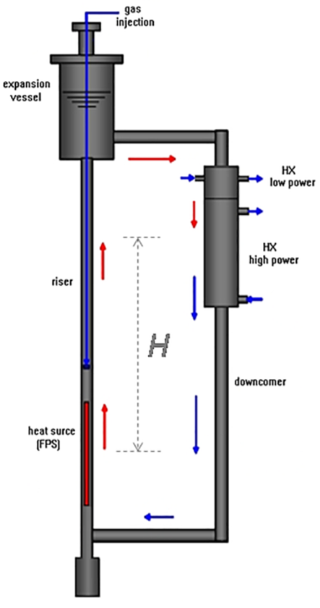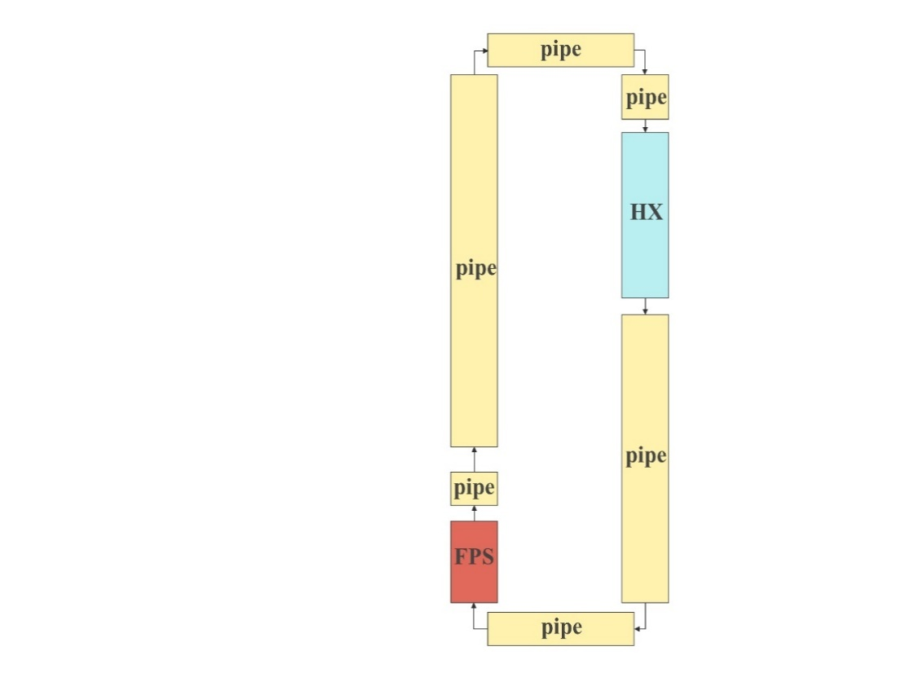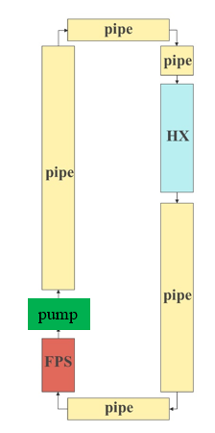
(a) NACIE-UP facility (b) old model (c) new model
Fig. 3 Comparison of old and new modeling methods in THACS for NACIE-UP
Fig. 4 and Fig. 5 shows the mass flow rate and thermal-couple (TP) temperature prediction of new modeling in THACS for NACIE-UP facility. From the result, it can be seen that overall transient variation of mass flow rate predicted by THACS is in good agrement with that of experimental measurements.
For the temperature measurement points such as TP101 to TP107, the temperature variation trends are basically consistent with the experiment. Most of the results have small errors when comparing to experimental values.
The results show that new modeling in THACS for ADP-10 is proper, which can be used for further system-level thermal-hydraulics analyses for NACIE-UP facility.
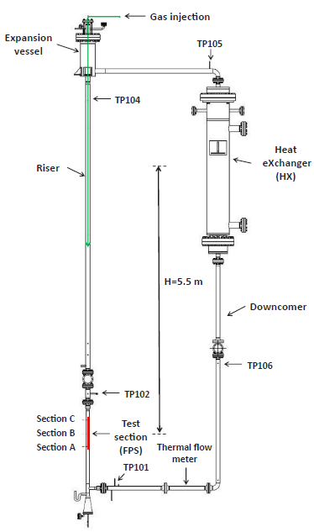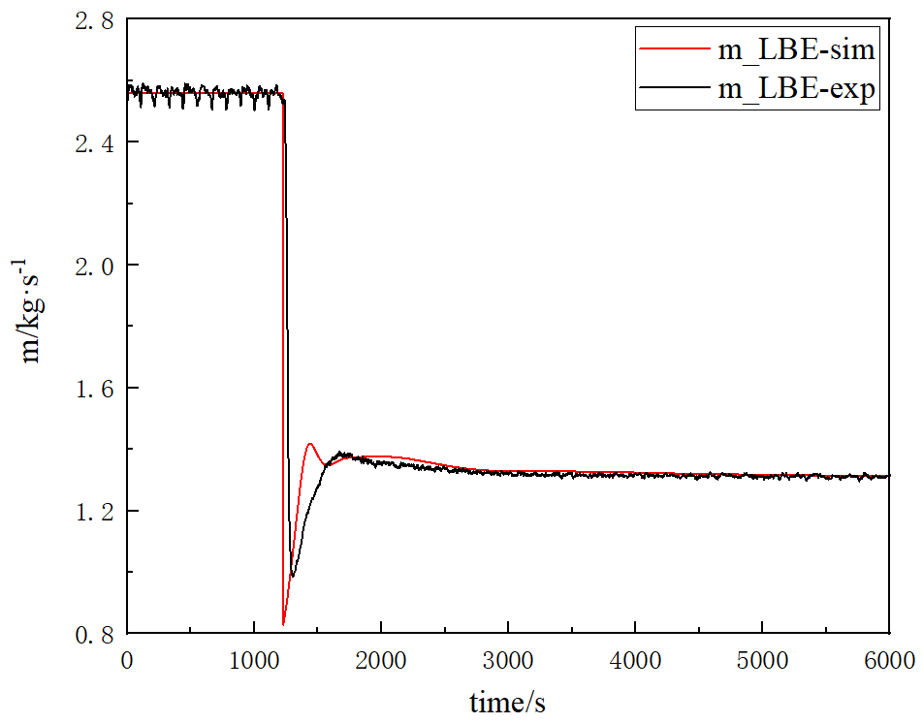
(a) NACIE-UP facility (b) mass flow rate
Fig. 4 Mass flow rate of new modeling in THACS
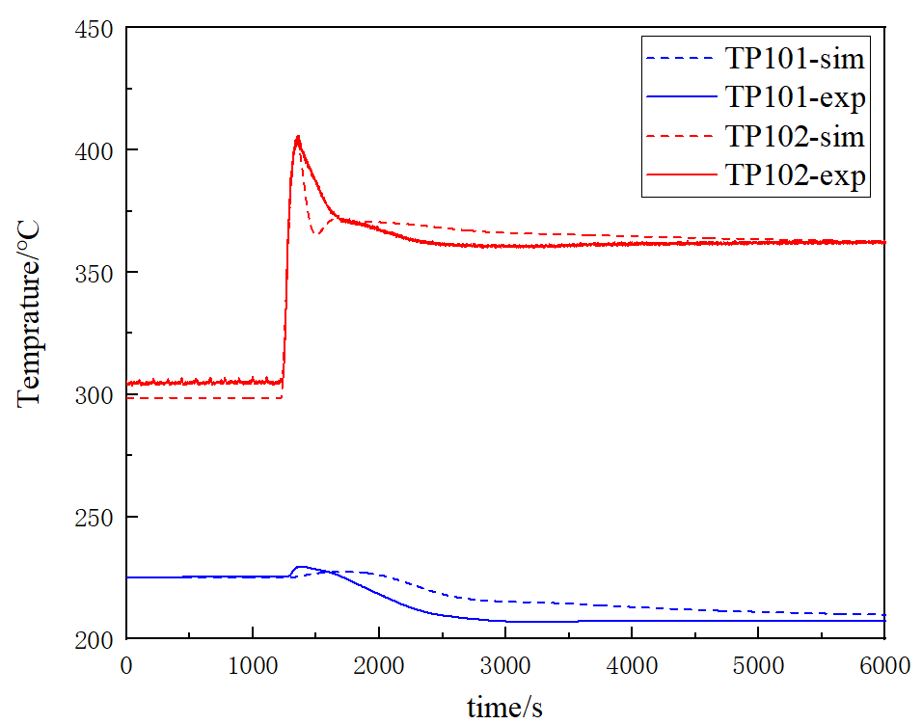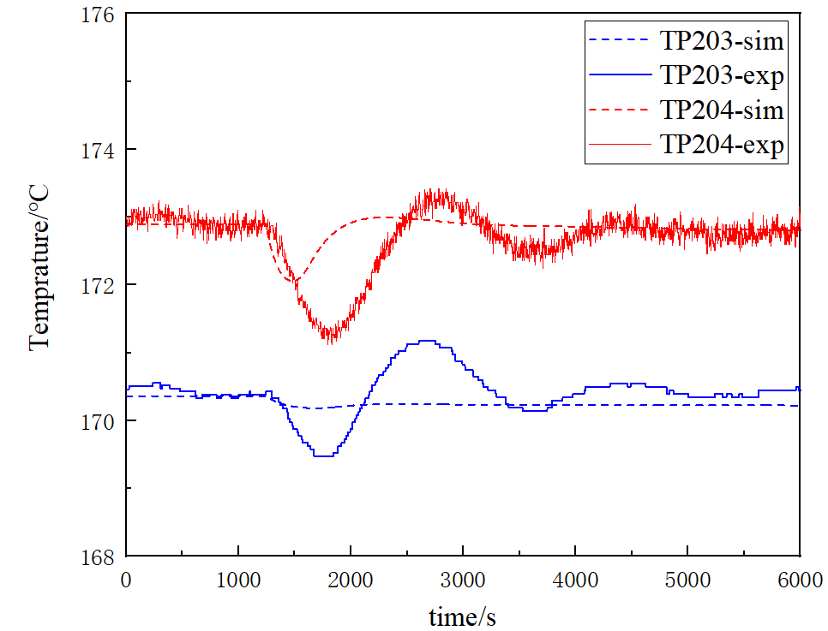
(a) TP101 and TP102 (b) TP203 and TP204
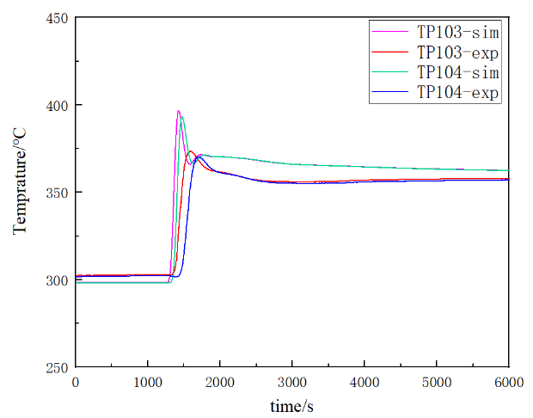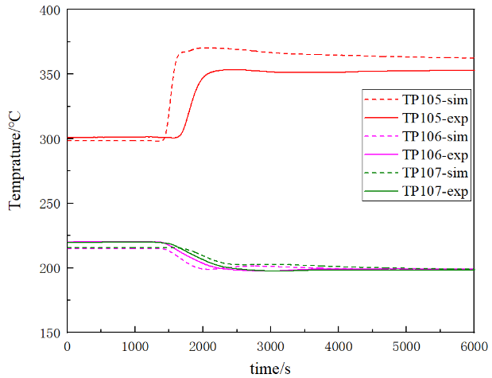
(c) TP103 and TP104 (d) TP105, TP106, and TP107
Fig. 5 Thermal-couple (TP) temperature prediction of new modeling in THACS

References
- HU, B.X., WU, Y.W., TIAN, W.X., et al. Development of a transient thermal-hydraulic code for analysis of China Demonstration Fast Reactor. Annals of Nuclear Energy 55, (2013) 302-311.
- MA, Z., YUE, N., ZHENG, M., et al. Basic verification of THACS for sodium-cooled fast reactor system analysis. Annals of Nuclear Energy 76, (2015) 1-11.
- WANG, S., ZHANG, D., LIANG, Y., et al. Development a methodology for evaluating inter‐assembly heat transfer effect through reactor core in system safety analysis of sodium‐cooled fast reactor. International Journal of Energy Research 45, (2021) 12258-12271.
- WANG, S., ZHANG, D., SONG, P., et al. Validation of a methodology for thermal stratification analysis in sodium-cooled fast reactors. International Journal of Energy Research 42, (2018). 3803-3822.
- YUE, N., MA, Z., CAI, R., et al. Thermal-hydraulic analysis of EBR-II Shutdown Heat Removal Tests SHRT-17 and SHRT-45R. Progress in Nuclear Energy 85, (2015). 682-693.
- YUE, N., ZHANG, D., CHEN, J., et al. The development and validation of the inter-wrapper flow model in sodium-cooled fast reactors. Progress in Nuclear Energy 108, (2018) 54-65.
- Mikityuk K. Heat transfer to liquid metal: review of data and correlations for tube bundles[J]. Nuclear Engineering and Design, 2009, 239(4): 680-687.

