TITLE: | Description of subchannel code – YAOGUANG developed by Xi’an Jiaotong University
AUTHORS: | Dalin Zhang, Rong Zhang, Lei Zhou, Xingguang Zhou.
SUMMARY: | This report presents the primary description of subchannel code YAOGUANG for lead-based fast reactor. The code structures, governing equations, empirical models, and computational processes are introduced in detail.
DATE: | 12 Mar. 2026

LIST OF CONTENTS

LIST OF CONTENTS 2
1. Introduction 3
1.1. Governing equations 3
1.2. Empirical models 4
1.3. Heat conduction model 4
2. Description of the empirical models 5
2.1. Models adopted for the simulation 5
2.1.1. Heat transfer model 5
2.1.2. Pressure drop model 6
2.1.3. Turbulent mixing model 7
2.1.4. Conduction shape factor 7
2.2. Material properties 7
3. Code description of YAOGUANG 8
3.1. Computational process 8
3.2. Computational models 9
3.3. Comparison between SACOS and YAOGUANG 10
4. Summary 11
References 11

Introduction
In our previous work, the NACIE-UP steady and transient subchannel analyses of ADP-10, ADP-06, and ADP-07 are completed with the classic subchannel code SACOS. In this work, a new subchannel analysis code “YAOGUANG” is developed based on open-source finite volume method (FVM) framework OpenFOAM. Comparing to classic subchannel analysis code, it is expected that YAOGUANG has advantages on more intuitive modeling, flexible numerical scheme selection, high-efficiency on huge matrix solving, and convenient visualization post-processing. Main framework of YAOGUANG can refer to Figure 1. There are mainly 4 parts in the code, such as input, initialization, main program, and output. In main program, the basic 3D CFD-based governing equations will be solved with several empirical auxiliary models. The heat conduction model is also developed for fuel pin temperature solving. The visualization of output is carried out by ParaView, which is convenient for direct post-processing of calculation results by YAOGUANG.
Figure 1 Overview of YAOGUANG code.

Governing equations
Liquid lead-bismuth eutectic (LBE) is deemed as the incompressible fluid flow and heat transfer process in subchannel analysis. The 3D CFD-based governing equations are shown below.
Mass conservation equation:
Energy conservation equation:
Momentum conservation equation:
in which , , and represent velocity vector, pressure, and temperature, respectively. , , are density, specific heat capacity, and molecular dynamic viscosity, respectively. and are responsible to turbulent mixing effect of energy and momentum.

Empirical models
In consideration of the wire-wrapped structure and the flow characteristics of the coolant, many experiments are performed to propose auxiliary models for the liquid metal fast reactors (LMFR), including heat transfer, pressure drop, turbulent mixing, conduction shape factor and so on. Among the existing correlations, several correlations are proven which show high prediction accuracy and are widely accepted by subchannel code. Table 1 presents the correlations implemented in YAOGUANG and the scope of application.
Table 1 Correlations implemented in YAOGUANG.
 | Model | P/D | Pe | H/D | Re
Heat transfer model | West^{[1]} | 1.05-1.30 | 10-5000 | / | /
 | Borishanskii^{[2]} | 1.1-1.5 | 60-2200 | / | /
 | Mikityuk^{[3]} | 1.1-1.95 | 30-5000 | / | /
Pressure drop model | Novendstern^{[4]} | 1.06-1.42 | / | 8.0-96.0 | 2600-10⁵
 | CT^{[5]} | 1.0-1.42 | / | 4.0-52.0 | 50-10⁶
Turbulent mixing model | Rowe and Angle^{[6]} | / | / | / | /
Conduction shape factor | Jeong.H^{[7]} | / | / | / | /
 | Cheng-Todreas^{[8]} | / | / | / | /

Heat conduction model
The conduction model is simplified in the fuel element with axisymmetric geometry, unirradiated conditions, and no heat source in the cladding. Based on those assumptions, heat conduction equations are presented as:
To solve the equations, boundary conditions are given as:
- Insulation conditions at the center of the pellet leads to zero heat flux:
- The gap is filled with gas, so there exist two relations between the outer surface of the pellet and the inner surface of the cladding:
- At the interface of the outer surface of cladding and the coolant:
In order to obtain the precise temperature distribution inside the fuel element, the equations are discretized by finite difference method. Axial grids correspond to the axial scalar grid of subchannels and Figure 2 depicts the radial control volumes. The number of control volumes for fuel pellet could be defined by user and the cladding is divided into two control volumes, respectively corresponding to the inner and outer surface. In the circumferential direction, the pin is divided into the number of surrounding subchannels and the grid size depends on the ratio of wetted perimeter by one subchannel. For example, if the pin is surrounded by six interior subchannels, the circumferential direction of pin is equally divided into six parts.
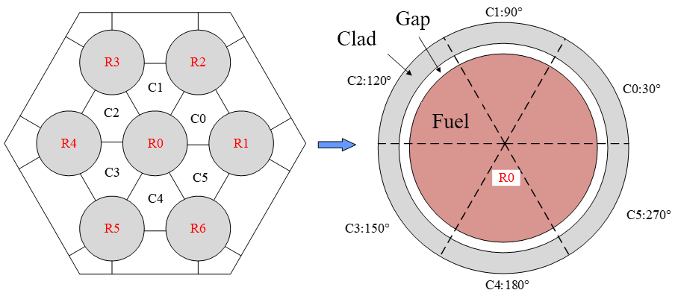
Figure 2 Radial nodes definition for fuel element.

Description of the empirical models

Models adopted for the simulation

Heat transfer model
For the benchmark tests, the value is 1.2824 and number is between 50 and 250. Figure 3 compares the Nusselt number from experimental measurements with three existing correlations^{[9]}. Overall, the Borishanskii model^{[2]} and Mikityuk model^{[3]} overestimate the Nu number. The measured values seem to be best fitted by the West model^{[1]} and thus it was selected for the subchannel simulation. This correlation was proposed by Kazami and Carelli and the expression for is:
Figure 3 Comparison of Nusselt number from experimental measurements with existing correlations, test ADP10.

Pressure drop model
The pressure drop model proposed by Cheng and Todreas^{[5]} considered the impact of flow pattern and channel geometries on the friction factor. It has been proved high prediction accuracy and been widely applied for wire-wrapped rod bundles. Therefore, CT model is selected for the simulation of NACIE-UP benchmark activity.
The transition Reynold numbers are determined by:
For laminar () and turbulent flow (), the friction factors are defined with different subchannel types, which are obtained as below:
Where for laminar flow and for turbulent flow; is the friction factor for bare rod, obtained by . Table 2 presents the coefficients for three kinds of subchannels in hexagonal rod bundles. is wire drag constant and is the wire sweeping constant, expressed by:
In the transitional zone (), the friction factor f is given by:
where is the intermittency factor, representing the fraction of turbulent flow in the transitional region.

Table 2 Coefficients for the hexagonal rod bundles
Flow regime | Channel  type
 |  | a | b₁ | b₂ | a | b₁ | b₂
Laminar | interior | 26.00 | 888.2 | -3334. | 62.97 | 216.9 | -190.2
 | edge | 26.18 | 554.5 | -1480. | 44.40 | 256.7 | -267.6
 | corner | 26.98 | 1636.0 | -10050 | 87.26 | 38.59 | -55.12
Turbulent | interior | 0.09378 | 1.398 | -8.664 | 0.1458 | 0.03632 | -0.03333
 | edge | 0.09377 | 0.8732 | -3.341 | 0.1430 | 0.04199 | -0.04428
 | corner | 0.1004 | 1.625 | -11.85 | 0.1499 | 0.006706 | -0.009567
Note: is numerically equal to for edge and corner subchannels.

Turbulent mixing model
In this code, the turbulent mixing is evaluated by the turbulent mixing rate and the relation proposed by Rowe and Angle^{[6]} is adopted, which is expressed as:
where is the gap width (m); is the mean mass flux of adjacent subchannels (kg/m²/s); is the turbulent mixing coefficient. In this code, this coefficient is set as a constant.

Conduction shape factor
The conduction shape factor is introduced to correct the finite difference in the transverse conduction term in the energy equation (see (1-2)). The correlation used in this benchmark activity is proposed by Jeong. H^{[7]}:

Material properties
In the subchannel simulation, LBE physical properties, which are all temperature-dependent, are evaluated using empirical correlations suggested in the OECD/NEA Handbook 2015^{[10]}. Formulas for density, specific heat, dynamic viscosity and conductivity are reported in Table 3. As for the pin materials, thermo-physical properties of stainless steel AISI316L^{[11]}, Bohrium Nitride (BN)^{[12]} and Copper are presented in Table 4, given by the benchmark specifications.
Table 3 Thermo-physical properties of LBE, T in Kelvin.
Property | Correlation | Maximum uncertainty | Standard deviation
Density, kg·m⁻³ |  | 0.8% | 0.58%
Specific heat capacity,  J·kg⁻¹·K⁻¹ |  | 5.0% | 2.4%
Thermal conductivity, W·m⁻¹·K⁻¹ |  | 5.0% | 7.2%
Dynamic viscosity, Pa·s |  | 6.0% | 6.2%
Table 4 Thermo-physical properties of pin materials.
Material | Property | Correlation | Range  (T in K)
AISI316L | Density
 | Heat capacity
 | Thermal conductivity
 | Linear expansion coefficient
BN | Density |  | Temperature independent
 | Heat capacity |  | Temperature independent
 | Thermal conductivity |  | 293-1393
Copper | Density |  | Temperature independent
 | Heat capacity |  | Temperature independent
 | Thermal conductivity |  | Temperature independent

Code description of YAOGUANG

Computational process
YAOGUANG is developed based on OpenFOAM, mainly contains pre-process, main program, and post-process functions. Figure 4 shows the computational process of YAOGUANG. Visual modeling of subchannel object is carried out with general CAD software, such as Salome and Gmsh. We import the external mesh to OpenFOAM and convert it into OpenFOAM-format mesh for subchannel identification. Based on the geometric parameters, the modification of surface and volume of each channel is conducted for subchannel analysis. Empirical models are selected as above-mentioned, which mainly consist of friction drag model, heat transfer model, turbulent mixing model, shape conduction model, and fuel pin gap model.
The core of YAOGUANG is calculation model. Since YAOGUANG adopts the 3D CFD-based governing equations, the governing equations can be easily coupled with empirical models. The SIMPLE and PIMPLE algorithms are inherited from the original OpenFOAM steady and transient solvers. While YAOGUANG finishes simulation, the OpenFOAM-stype output file can be directly recognized by ParaView to make the convenient post-processing.
Furthermore, we develop the run-time selection (RTS) based on OpenFOAM for YAOGUANG, that allows users to easily choose proper numerical schemes, solving strategy, and empirical models.
Figure 4 Computational process of YAOGUANG

Computational models
Figure 5 shows the computational models in YAOGUANG, part of implemented empirical models are shown here for the sake. There are mainly 9 models inherited and developed with OpenFOAM for subchannel analysis code YAOGUANG. It is worth noting that each model is separated with each other. Hence the code structure of YAOGUANG is clear and clean. If the user or developer would like to add or delete any models, it is convenient to carry out with modern C++ programming style.
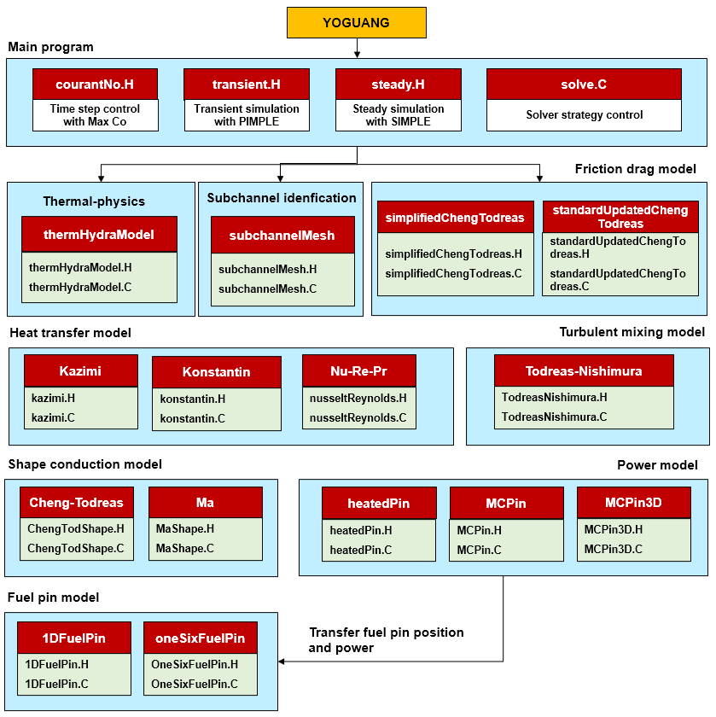
Figure 5 Computational models in YAOGUANG

Comparison between SACOS and YAOGUANG
Table 5 shows the brief comparison between classic subchannel code SACOS and YAOGUANG developed from OpenFOAM on the aspects of governing equations, subchannel identification method, modelling method, post-processing method, and code extension ability.
It can be seen that YAOGUANG has many advantages comparing to SACOS, particularly on code extension ability, which allows us to choose proper models, algorithms, and solvers corresponding to different problems.
Table 5 Brief comparison between SACOS and YAOGUANG
Index | SACOS (classic subchannel code) |  | YAOGUANG (from OpenFOAM)
Governing equations | 1 continuity equation, 2 momentum equations, 1 energy equation | 3D CFD-based equations
Subchannel identification | Manual numbering with code script | Automated identification with topological algorithm
Modelling | Manual write input cards | Use CAD software to model in visual
Post-processing | Manually extract results from output cards | Use ParaView to directly visualize the results
Code extension | Numerical schemes and solving strategy are fixed with hard-coding style | Numerical schemes, solving strategy, and matrix decomposition solving are all inherited from OpenFOAM with high extension

Summary
In this work, we pay efforts on developing a new subchannel analysis code “YAOGUANG” based on OpenFOAM. The code structure, models, and computational process are illustrated. Comparison between classic subchannel code SACOS and new subchannel code YAOGUANG is also discussed.
It would be expected that YAOGUANG gives new insights on governing equations, empirical models, and code structure for subchannel analyses of lead-based cooled fast reactor.

References
- Kazami, M., Carelli, M., 1976. Heat transfer correlation for analysis of CRBRP Assemblies. Westinghouse Report. CRBRP-ARD-0034.
- Borishanskii, V., Gotovskii, M., Firsova, E., 1969. Heat transfer to liquid metals in longitudinally wetted bundles of rods. Soviet Atomic Energy 27, 1347-1350.
- Mikityuk, K., 2009. Heat transfer to liquid metal: review of data and correlations for tube bundles. Nucl. Eng. Des. 239 (4), 680–687.
- Novendstern, E., 1972. Turbulent flow pressure drop model for fuel rod assemblies utilizing a helical wire-wrap spacer system. Nuclear Engineering and Design 22, 28-42.
- Cheng, S.K., Todreas, N.E., 1986. Hydrodynamic models and correlations for bare and wire-wrapped hexagonal rod bundles-bundle friction factor, Subchannel friction factors and mixing parameters. Nucl. Eng. Des. 92, 227–251.
- Rowe, D., 1973. COBRA IIIC: digital computer program for steady state and transient thermal-hydraulic analysis of rod bundle nuclear fuel elements. Battelle Pacific Northwest Labs., Richland, WA (United States).
- Jeong H, Ha K, Kwon Y, et al. Evaluation of the conduction shape factor with a CFD code for a liquid–metal heat transfer in heated triangular rod bundles[J]. Nuclear engineering and design, 2007, 237(6): 648-654.
- Cheng S K, Todreas N E. Constitutive correlations for wire-wrapped subchannel analysis under forced and mixed convection conditions. Part II. [LMFBR][J]. Computer Codes, 1984.
- Marinari, R., Di Piazza, I., Tarantino, M., et al., 2019. Experimental tests and post-test analysis of non-uniformly heated 19-pins fuel bundle cooled by Heavy Liquid Metal. Nuclear Engineering and Design 343, 166-177.
- OECD. Handbook on lead-bismuth eutectic alloy and lead properties, materials compatibility, thermal hydraulics and technologies[M/OL]. Paris: Organisation for Economic Co-operation and Development, 2015
- C.S.Kim, “Thermophysical properties of stainless steels”, ANL-75-55, 1975.
- J.Pacio, S. Keijers, Reference physical properties in the KALLA rod bundle tests, SCKCEN/40672921, 2021.

