WP1 IBRAE RAN calculation results
The HYDRA-IBRAE/LM code [1, 2], which is being developed at the Nuclear Safety Institute of the Russian Academy of Sciences (IBRAE RAN), was used for calculations. For two open and one blind tests, flomassw rate and temperature values were calculated. A description of the calculations performed is given below.
Figure 1 shows computational scheme used for simulation. The scheme contained all main elements of NACIE-UP facility [3]: Fuel Pin Simulator (FPS), heat exchanger, expansion tank, riser and downcomer, two horizontal pipes. 19 pins in the FPS were simulated by heat structures that were connected to the channel. Geometric parameters of the FPS were taken into account in detail in the calculations: pin diameters and pitch , active length etc. Using heat structures in FPS, the energy power corresponding to the experiment was set.
The facilitypipes were simulated using channels, the walls were defined using heat structures, and the geometry details and material thermal properties were taken into account. The calculation scheme consisted of 407 calculation cells.

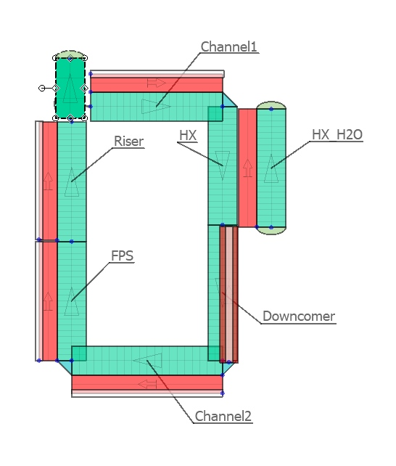
Figure 1 – Nodalization scheme used for calculations

To simulate forced coolant circulation (the first phase of the experiments), no pump was used; instead, the argon flow rate was set according to the experimental description. Thus, the gas lift simulation was performed directly. Then the argon injection was stopped and the transition from forced circulation to natural circulation was carried out.
To define the properties of materials, a database is used, which is also being developed at IBRAE RAN. For the LBE, the properties from [4] were used.

Open phase simulations

Preliminary calculations of open tests showed good agreement with experimental data for steady-state values for forced and natural circulation, but there were significant differences in the values for the transient regime. To improve the accuracy of modeling the transition from forced to natural circulation, the calculation scheme was significantly refined: the thermal parameters of the walls and heat-conducting structures were taken into account in more detail. This resulted in a smoother and more physically correct transition.
A comparison of the old and new calculation results for the transient regime is shown in the figure below.

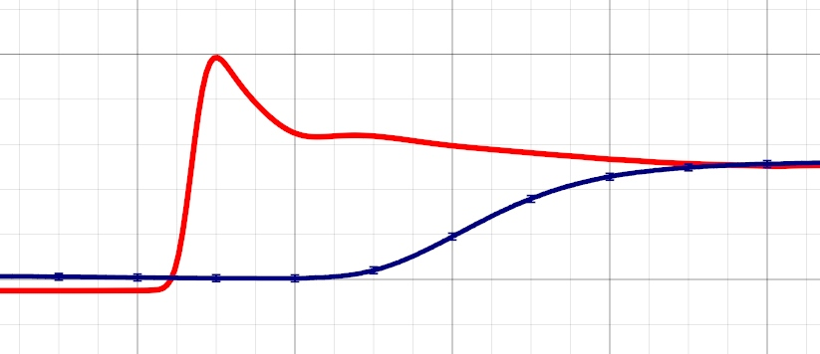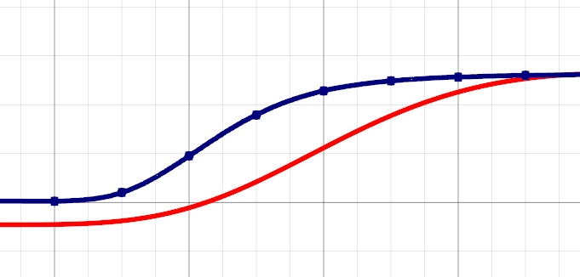
Figure 2 – A comparison of the transient regime

ADP10 results
The first test under consideration is the ADP10. In this test, all pins were active. Figure 2 shows the results of the calculations of the coolant mass flow rate.

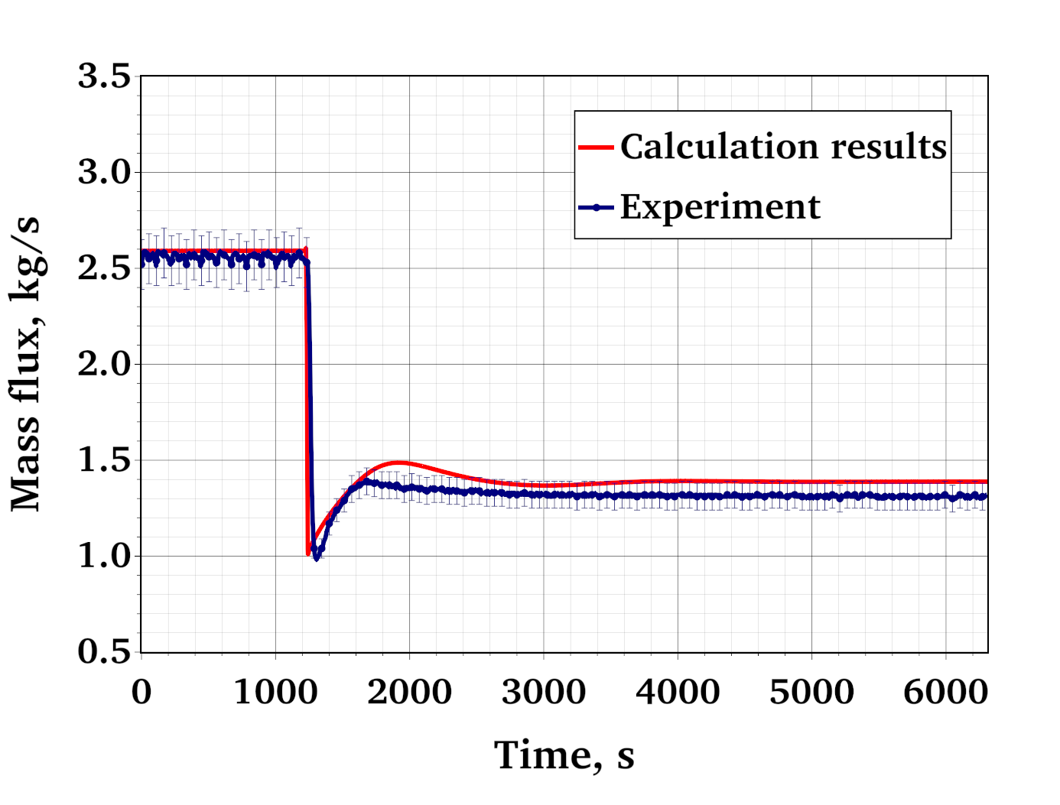
Figure 2 – Mass flux calculation results for ADP10

The calculated temperature values of LBE and water are shown in the figure 3.

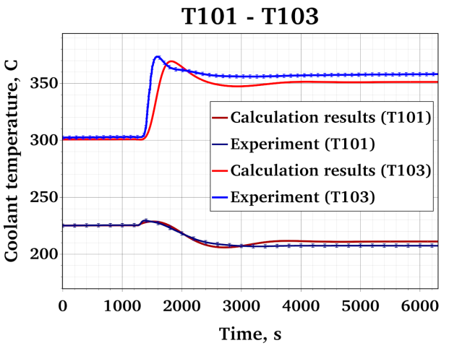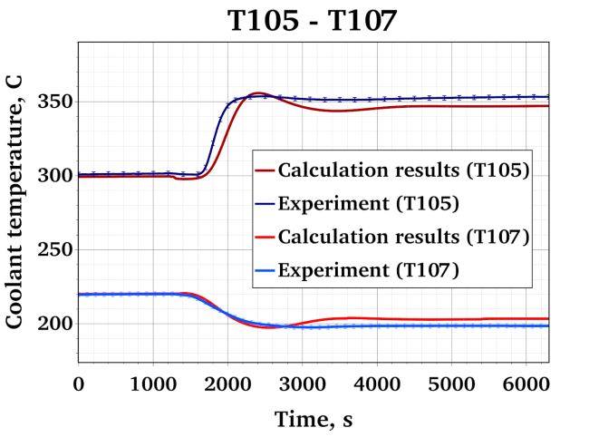
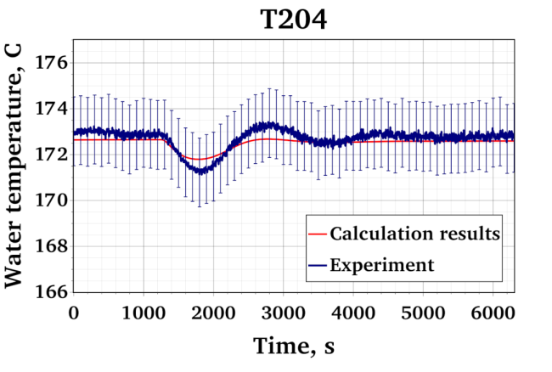
Figure 3 –Temperature calculation results for ADP10

For gas lift, very good agreement is observed between the calculated and experimental results for mass flow rate. For natural circulation mode, the calculated flow rate is slightly higher than the experimental value. Good accuracy in describing the transient process for both mass flow rate and temperature is noteworthy.

ADP06 results
The second experimental test is ADP06, where 7 pins were active. The calculation results are similar to the results obtained for ADP06. The results of the mass flow calculation are shown in Figure 4, and the temperature calculation results are shown in Figure 5.

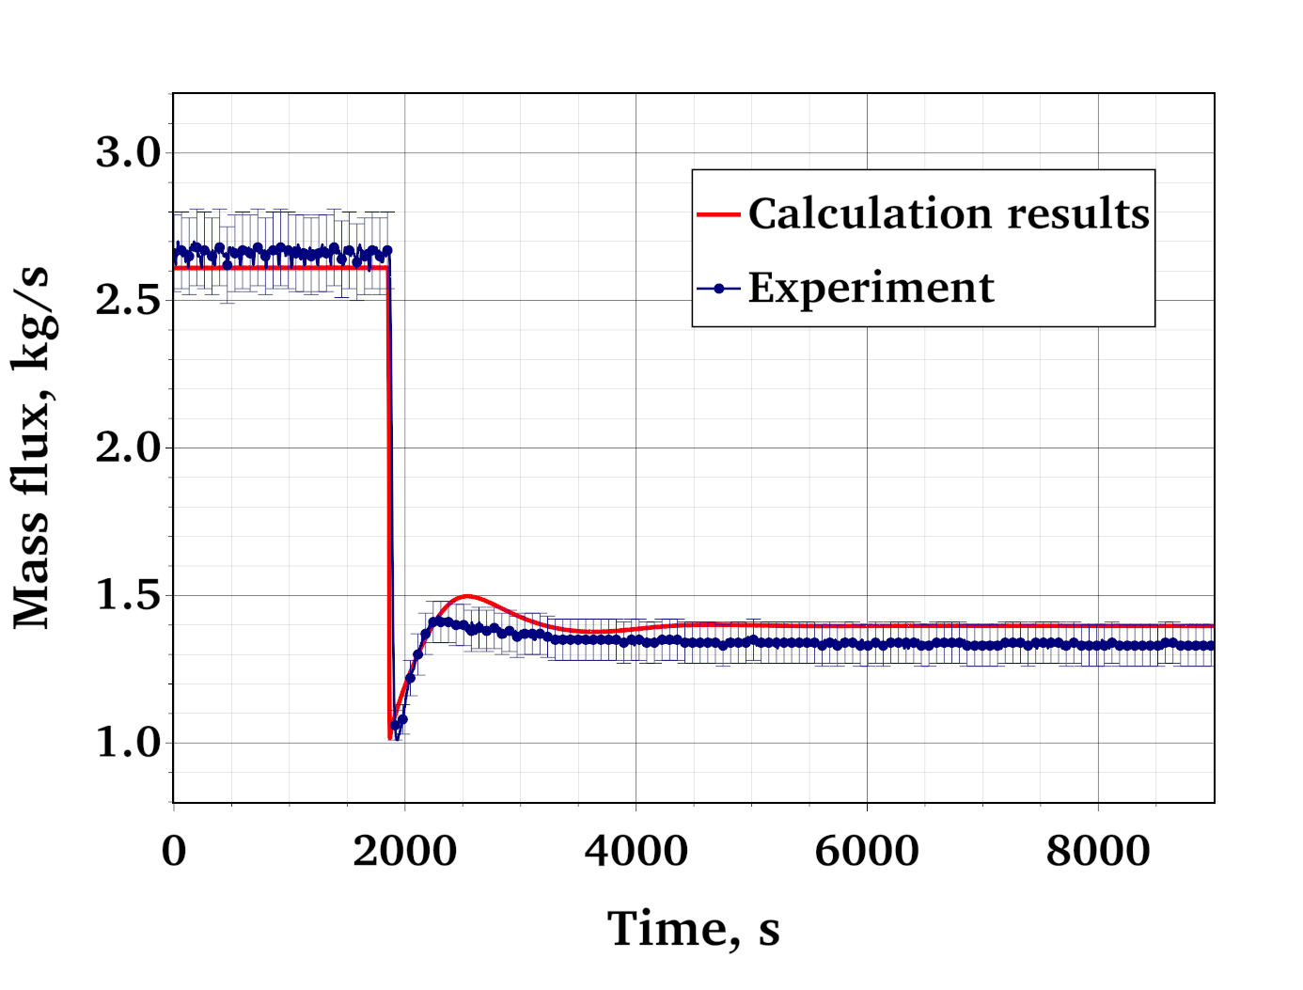
Figure 4 – Mass flux calculation results for ADP06

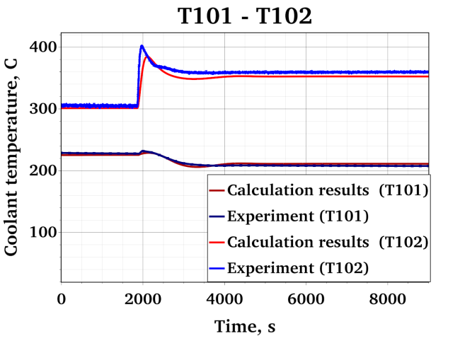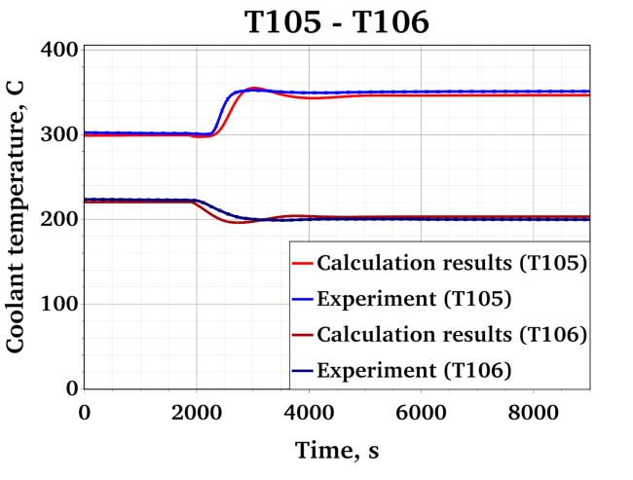
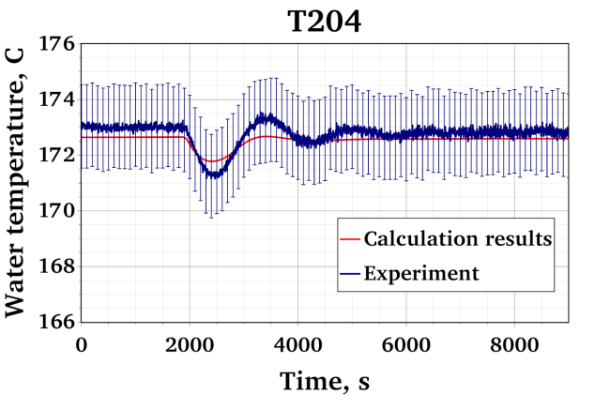
Figure 5 –Temperature calculation results for ADP06

The calculation results of this test also reflect the dynamics of mass flow and temperature quite accurately.

Blind phase simulations

ADP07 results
Next, we will consider the results of the blind test calculations. The same nodalization scheme used for open tests was used to simulate the blind ADP07 test. The accuracy was even higher than for open tests. The results of the mass flow simulation are shown in the figure 6.
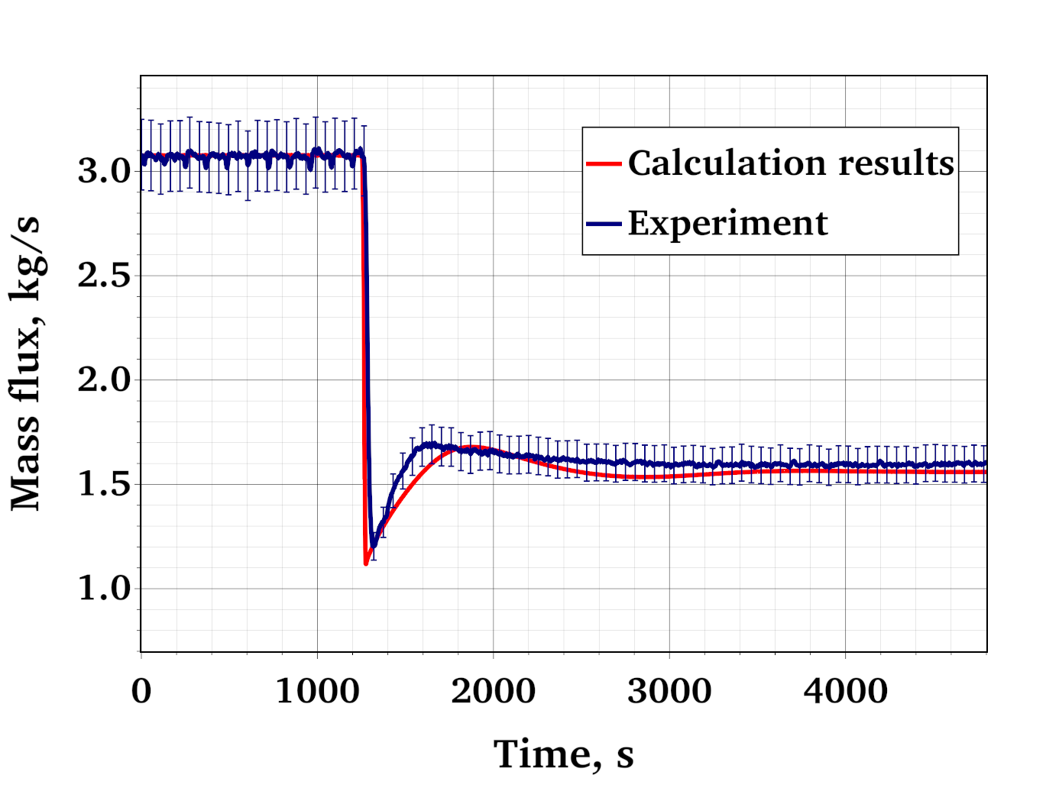
Figure 6 – Mass flux calculation results for ADP07
For the blind test, the temperatures of LBE and water were also calculated. The results are shown in the figures below.

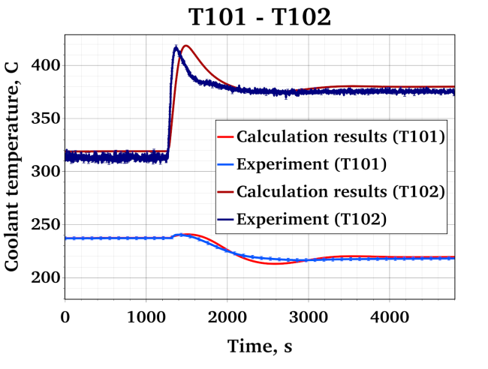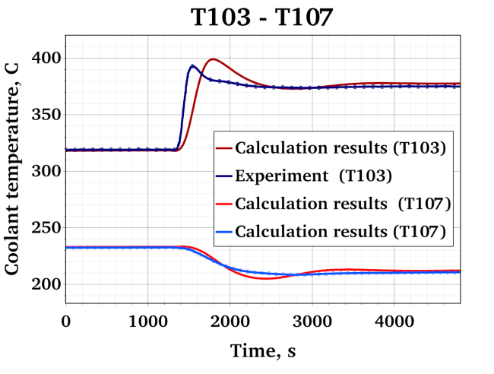
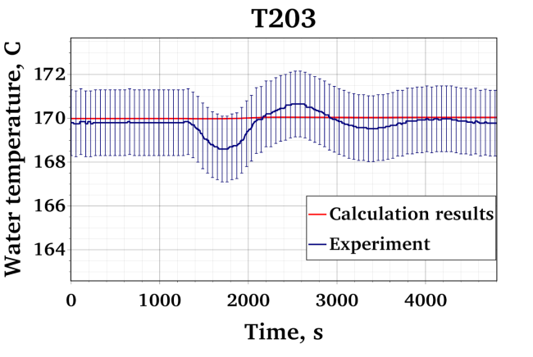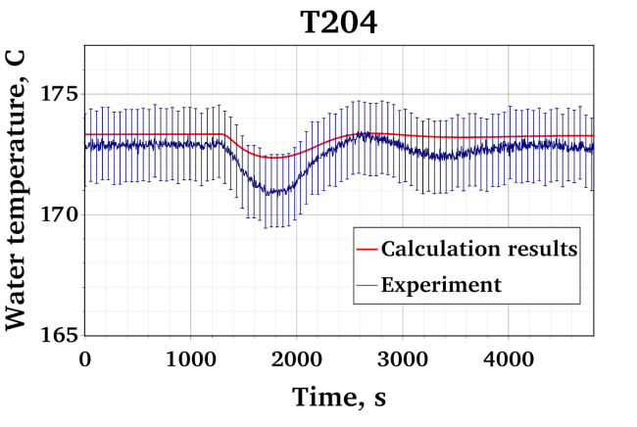
Figure 7 –Temperature calculation results for ADP07

The obtained results demonstrate very good agreement between the calculated values and experimental data. For steady-state conditions (gas lift and natural circulation), the calculated values were almost identical to the experimental data. A discrepancy is observed in the transient mode, indicating inaccuracies in the heat transfer parameters of the facility.

Conclusions
Thus, a simulation of the process of transition from forced to natural circulation was carried out. A calculation scheme containing all the main parameters of the installation was prepared. Forced circulation, which was achieved through gas lift, was simulated directly: the code has the ability to calculate the dynamics of gas bubbles in a lead-bismuth coolant. It can be noted that the detailed knowledge of thermal properties of all facility components is essential for reliable simulation of the transition from forced to natural circulation.
The calculation results showed very good qualitative and quantitative agreement with the experimental data, in some cases they were practically identical.The code error E was estimated as the mean difference between the simulation and the experiment [5]:
here J is the number of measurements, E_{j} is the mean error for a given measurement obtained from multivariate simulations.
The mass flow rate calculation error was 2 %, while the temperature calculation error was 2.5 K.
This study demonstrates the successful application and validation of HYDRA-IBRAE/LM system code for modeling transition from forced circulation to natural circulation. Key parameters such as mass flow rate, temperature distribution, and system response to power or boundary condition changes were predicted with high precision. Therefore, this work substantiates that the presented system code represents a powerful and reliable engineering tool. It offers a significant advantage in terms of computational cost and setup time while delivering results of high accuracy for analysis of transition from forced circulation to natural circulation.

REFERENCES
- V.M. Alipchenkov, Ya.V. Grudtsyn, O.H. Ilyasova, N.A. Mosunova, Simulation of the processes occurring during steam generator tube rupture in the lead cooled reactor unit using HYDRA-IBRAE/LM code, Progress in Nuclear Energy, V. 149, 104278. (2022) https://doi.org/10.1016/j.pnucene.2022.104278.
- O.H. Ilyasova, V.M. Alipchenkov, N.A. Mosunova, Ya.V. Grudtsyn, Simulation of natural circulation experiments for heavy liquid metal coolant using HYDRA-IBRAE/LM code. Progress in Nuclear Energy, V. 173, 105233 (2024)
- I. Di Piazza, H. Hassan, et. al, Benchmark specifications for NACIE-UP facility: non-uniform power distribution tests, rev. 5, IAEA CRP-I31038, Vienna, Austria (2024).
- NEA/OECD, Handbook on Lead-bismuth Eutectic Alloy and Lead Properties, Materials Compatibility, Thermal- hydraulics and Technologies, 2015.
- E.V. Moiseenko, N.A. Mosunova, V.F. Strizhov, D.S. Synitcyn., Uniform approach to validation of codes in application for conservative and realistic accidents modeling, Progress in Nuclear Energy, 2026, Vol. 193, 106195. https://doi.org/10.1016/j.pnucene.2025.106195

- WP3 IBRAE RAN calculation results
  - Description of the model (Code CELSIST/V1.0)

Friction coefficient [1]:

Re ≤ 2000: $λ=\frac{64}{Re}∙\left(0.41+1.9∙\sqrt{\frac{s}{d}-1}\right)$
Re > 2000: $λ=0.11∙{\left(\frac{∆}{d_{h}}+\frac{68}{Re}\right)}^{0.25}∙\left\{0.59+0.19∙\left(\frac{s}{d}-1\right)+0.52∙\left\{1-exp\left[-10∙\left(\frac{s}{d}-1\right)\right]\right\}\right\}$

Nusselt number [1]:

$$Nu=7.55∙\frac{s}{d}-14∙{\left(\frac{s}{d}\right)}^{-5}+0.007∙{Pe}^{0.64+0.246∙\left(\frac{s}{d}\right)}$$

Cross-flow mass exchange [1]:

$$β^{M}=\left\{2.75∙\left(\frac{s}{d}\right)-3.57∙exp\left\{-119.0∙{\left[\left(\frac{s}{d}\right)-1\right]}^{2.12}+1\right\}\right\}∙\left[1.085-0.754∙exp\left(-132∙Re\right)\right]∙\frac{F}{∆∙SS}$$

Cross-flow heat exchange [1]:

$$β^{H}=0.7β^{M}$$
In the input file of CELSIST, the properties of materials are set as constants. There can be set only 3 fuel element layers: cladding, gap and fuel. Since there are more layers in the experimental rod, the values of properties for fuel were calculated by means of averaging, taking the dimensions into account. The dimensions and properties of the materials are given in the tables 1 - 6. The coolant properties are taken from the documentation.

Table 1: Properties of materials in the ADP10 steady state 1
Layer | Dimensions, mm | Material | Values of properties
 |  |  | Density | Heat capacity | Thermal conductivity
Cladding | o.d. 6.55, i.d. 5.08 | AISI316L | 7850.21 | 528.88 | 17.57
Gap | o.d. 5.08, i.d. 3.53 | BN | 2000 | 800 | 12.17
Fuel | o.d. 3.53, i.d. 0 | Complicated | 6864.77 | 512.42 | 266.88

Table 2: Properties of materials in the ADP10 steady state 2
Layer | Dimensions, mm | Material | Values of properties
 |  |  | Density | Heat capacity | Thermal conductivity
Cladding | o.d. 6.55, i.d. 5.08 | AISI316L | 7834.91 | 533.26 | 18.09
Gap | o.d. 5.08, i.d. 3.53 | BN | 2000 | 800 | 11.88
Fuel | o.d. 3.53, i.d. 0 | Complicated | 6864.77 | 512.42 | 266.79

Table 3: Properties of materials in the ADP06 steady state 1
Layer | Dimensions, mm | Material | Values of properties
 |  |  | Density | Heat capacity | Thermal conductivity
Cladding | o.d. 6.55, i.d. 5.08 | AISI316L | 7845.12 | 530.34 | 17.74
Gap | o.d. 5.08, i.d. 3.53 | BN | 2000 | 800 | 12.07
Fuel | o.d. 3.53, i.d. 0 | Complicated | 6864.77 | 512.42 | 266.85

Table 4: Properties of materials in the ADP06 steady state 2
Layer | Dimensions, mm | Material | Values of properties
 |  |  | Density | Heat capacity | Thermal conductivity
Cladding | o.d. 6.55, i.d. 5.08 | AISI316L | 7836.31 | 532.86 | 18.04
Gap | o.d. 5.08, i.d. 3.53 | BN | 2000 | 800 | 11.91
Fuel | o.d. 3.53, i.d. 0 | Complicated | 6864.77 | 512.42 | 266.8

Table 5: Properties of materials in the ADP07 steady state 1
Layer | Dimensions, mm | Material | Values of properties
 |  |  | Density | Heat capacity | Thermal conductivity
Cladding | o.d. 6.55, i.d. 5.08 | AISI316L | 7836.31 | 532.86 | 18.04
Gap | o.d. 5.08, i.d. 3.53 | BN | 2000 | 800 | 11.91
Fuel | o.d. 3.53, i.d. 0 | Complicated | 6864.77 | 512.42 | 266.8

Table 6: Properties of materials in the ADP07 steady state 2
Layer | Dimensions, mm | Material | Values of properties
 |  |  | Density | Heat capacity | Thermal conductivity
Cladding | o.d. 6.55, i.d. 5.08 | AISI316L | 7822.34 | 536.84 | 18.51
Gap | o.d. 5.08, i.d. 3.53 | BN | 2000 | 800 | 11.67
Fuel | o.d. 3.53, i.d. 0 | Complicated | 6864.77 | 512.42 | 266.73

Fuel properties are calculated by the formula:
$${prop}_{fuel}\left(T_{in}\right)={prop}_{Inconel600}\left(\frac{T_{in}-T_{out}}{2}\right)∙\left(\frac{0.00353-0.00335}{0.00353}\right)+{prop}_{BN}\left(\frac{T_{in}-T_{out}}{2}\right)∙\left(\frac{0.00335-0.00231}{0.00353}\right)+{prop}_{Copper}\left(\frac{T_{in}-T_{out}}{2}\right)∙\left(\frac{0.00231}{0.00353}\right)$$
  - Description of results:

Figure 9 shows the comparison of the calculation schemes of the CELSIST code and the FPS.

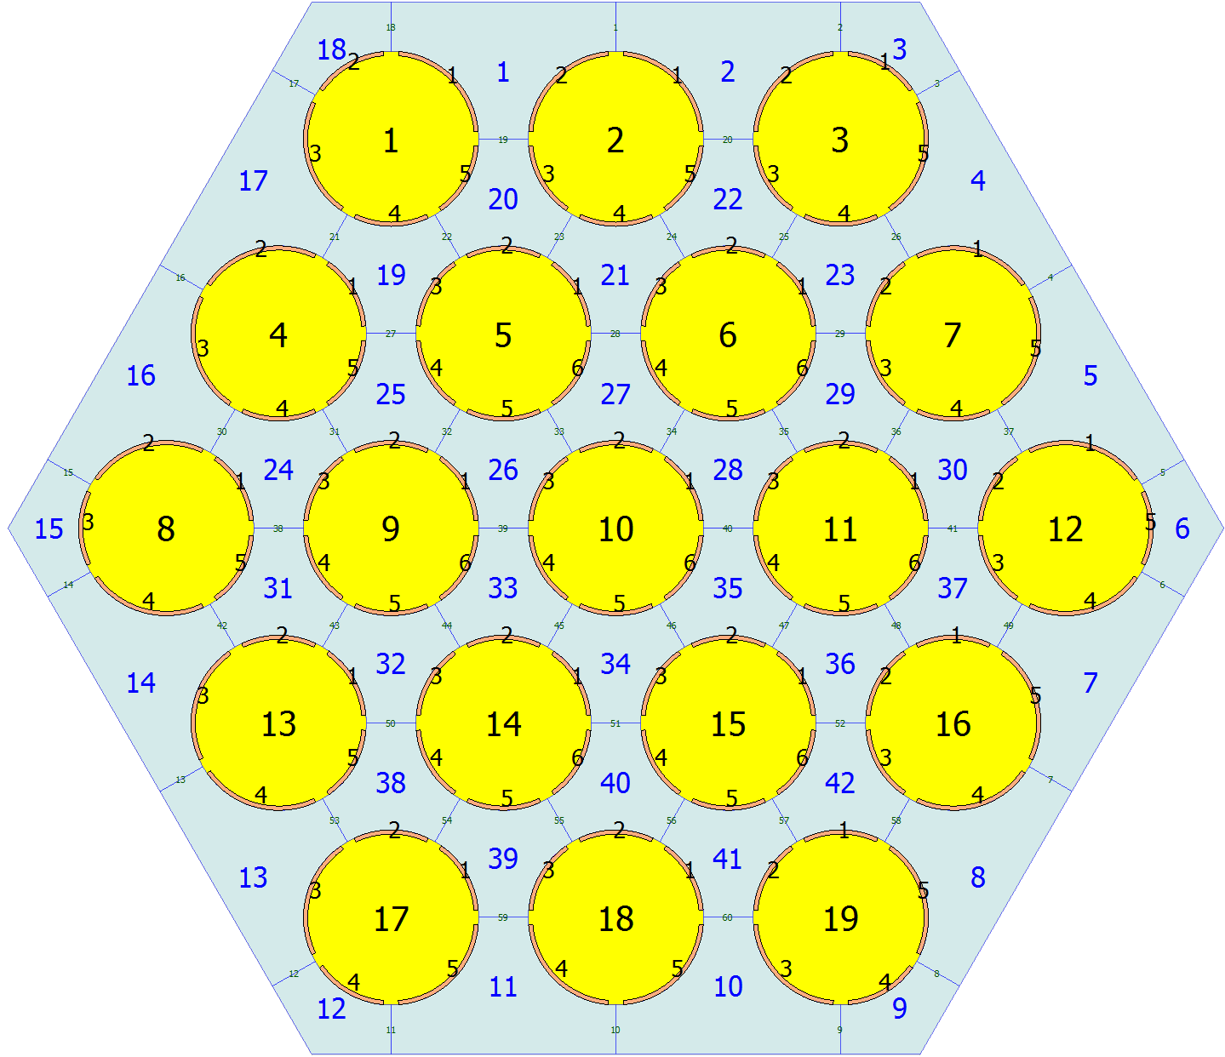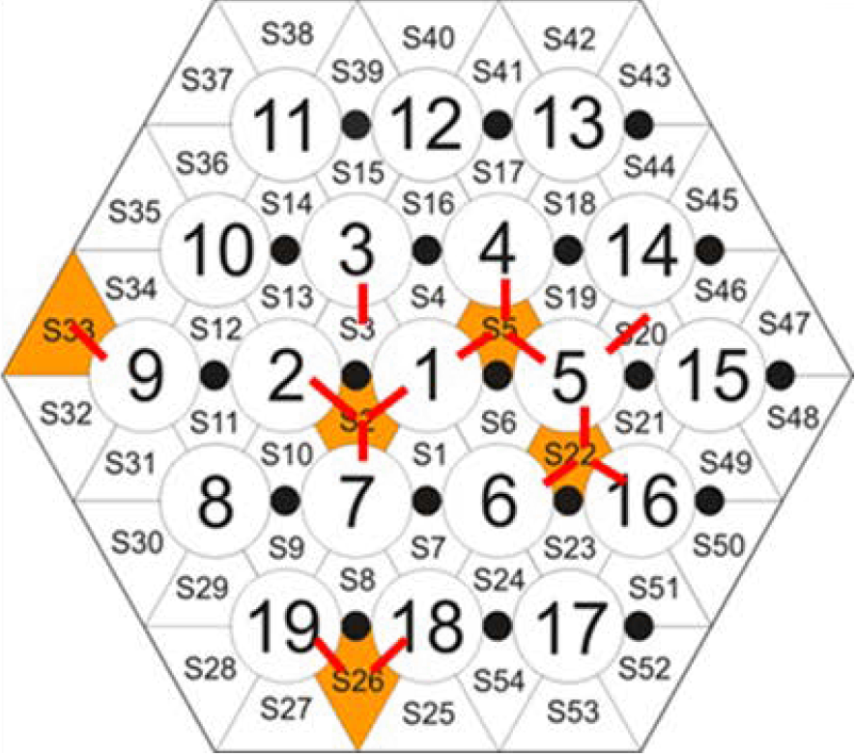
Figure
9- Comparison of the calculation schemes

The position of the thermocouples in FPS is fully taken into account by the CELSIST scheme. Comparing the temperature in the FPS 33 cell, the average value between CELSIST cells 15 and 16 was used. The remaining values were compared directly.
The input data for the calculations were used exactly from the tables in Appendix A of the report.
Maximum time step 0.01 s. 106 axial cells.
A comparison of the calculation results and experimental data is shown in Tables 7-12 and Figures 2-7.

Table 7 - Comparison of the calculation results and experimental data for ADP10 Steady state 1
TC name | Experimental data, ˚C | Calculation results, ˚C
TC-FPS-01 | 239.2 | 240.4
TC-FPS-02 | 234.7 | 240.4
TC-FPS-03 | 236.8 | 239.7
TC-FPS-04 | 232.8 | 233.8
TC-FPS-05 | 236.1 | 233.5
TC-FPS-06 | 281.3 | 283.1
TC-FPS-07 | 279.4 | 283.1
TC-FPS-08 | 276.1 | 278.5
TC-FPS-10 | 255.9 | 259.8
TC-FPS-11 | 320.6 | 318.9
TC-FPS-12 | 312.0 | 318.9
TC-FPS-13 | 308.9 | 312.1
TC-FPS-14 | 295.1 | 291.1
TC-FPS-15 | 285.0 | 289.8
TC-FPS-16 | 245.2 | 246.8
TC-FPS-17 | 242.0 | 246.8
TC-FPS-18 | 245.8 | 246.5
TC-FPS-19 | 242.3 | 246.5
TC-FPS-20 | 242.9 | 246.5
TC-FPS-21 | 242.3 | 246.0
TC-FPS-22 | 242.5 | 245.1
TC-FPS-23 | 242.1 | 246.0
TC-FPS-24 | 243.4 | 246.5
TC-FPS-25 | 242.3 | 243.7
TC-FPS-26 | 241.4 | 245.6
TC-FPS-27 | 238.6 | 244.1
TC-FPS-28 | 238.1 | 243.9
TC-FPS-29 | 287.1 | 289.2
TC-FPS-30 | 285.5 | 289.2
TC-FPS-31 | 287.1 | 287.8
TC-FPS-32 | 283.3 | 287.8
TC-FPS-33 | 284.9 | 287.8
TC-FPS-34 | 281.8 | 284.5
TC-FPS-35 | 281.6 | 280.4
TC-FPS-36 | 282.1 | 284.5
TC-FPS-37 | 285.5 | 287.8
TC-FPS-38 | 266.2 | 271.1
TC-FPS-39 | 278.5 | 282.1
TC-FPS-40 | 269.8 | 272.8
TC-FPS-41 | 268.9 | 271.8
TC-FPS-42 | 325.6 | 324.8
TC-FPS-43 | 320.8 | 324.8
TC-FPS-44 | 323.7 | 322.8
TC-FPS-45 | 314.4 | 322.8
TC-FPS-46 | 317.0 | 322.8
TC-FPS-47 | 315.2 | 317.9
TC-FPS-48 | 313.9 | 312.6
TC-FPS-49 | 315.5 | 317.9
TC-FPS-50 | 324.8 | 322.8
TC-FPS-51 | 296.2 | 301.2
TC-FPS-52 | 309.7 | 314.9
TC-FPS-53 | 302.5 | 303.2
TC-FPS-54 | 304.5 | 301.9
TC-FPS-55 | 242.2 | 246.5
TC-FPS-56 | 251.1 | 254.0
TC-FPS-57 | 256.3 | 261.2
TC-FPS-58 | 263.6 | 268.2
TC-FPS-59 | 272.6 | 274.9
TC-FPS-60 | 279.2 | 281.4
TC-FPS-61 | 284.5 | 287.8
TC-FPS-62 | 292.6 | 293.9
TC-FPS-63 | 298.7 | 299.9
TC-FPS-64 | 303.9 | 305.8
TC-FPS-65 | 309.1 | 311.6
TC-FPS-66 | 313.6 | 317.2
TC-FPS-67 | 320.1 | 322.8

Table 8 - Comparison of the calculation results and experimental data for ADP10 Steady state 2
TC name | Experimental data, ˚C | Calculation results, ˚C
TC-FPS-01 | 234.9 | 236.6
TC-FPS-02 | 227.8 | 236.6
TC-FPS-03 | 230.6 | 235.3
TC-FPS-04 | 222.8 | 224.0
TC-FPS-05 | 228.3 | 223.4
TC-FPS-06 | 311.1 | 316.6
TC-FPS-07 | 306.8 | 316.6
TC-FPS-08 | 301.4 | 308.7
TC-FPS-10 | 275.7 | 276.8
TC-FPS-11 | 378.9 | 382.5
TC-FPS-12 | 367.3 | 382.5
TC-FPS-13 | 362.8 | 372.4
TC-FPS-14 | 344.0 | 339.3
TC-FPS-15 | 336.4 | 337.2
TC-FPS-16 | 241.9 | 243.7
TC-FPS-17 | 236.7 | 243.7
TC-FPS-18 | 242.2 | 243.2
TC-FPS-19 | 236.8 | 243.2
TC-FPS-20 | 237.3 | 243.2
TC-FPS-21 | 237.0 | 242.2
TC-FPS-22 | 236.7 | 240.8
TC-FPS-23 | 236.9 | 242.2
TC-FPS-24 | 239.6 | 243.2
TC-FPS-25 | 235.7 | 236.3
TC-FPS-26 | 234.6 | 241.1
TC-FPS-27 | 231.0 | 237.1
TC-FPS-28 | 230.3 | 236.6
TC-FPS-29 | 317.4 | 323.1
TC-FPS-30 | 314.5 | 323.1
TC-FPS-31 | 316.9 | 320.6
TC-FPS-32 | 309.5 | 320.6
TC-FPS-33 | 311.7 | 320.6
TC-FPS-34 | 307.4 | 315.1
TC-FPS-35 | 305.9 | 308.7
TC-FPS-36 | 308.6 | 315.1
TC-FPS-37 | 314.8 | 320.6
TC-FPS-38 | 287.2 | 291.2
TC-FPS-39 | 301.9 | 310.7
TC-FPS-40 | 290.7 | 294.4
TC-FPS-41 | 289.4 | 292.4
TC-FPS-42 | 382.9 | 388.6
TC-FPS-43 | 377.0 | 388.6
TC-FPS-44 | 381.7 | 385.7
TC-FPS-45 | 370.2 | 385.7
TC-FPS-46 | 372.2 | 385.6
TC-FPS-47 | 369.4 | 378.5
TC-FPS-48 | 367.3 | 370.9
TC-FPS-49 | 370.5 | 378.5
TC-FPS-50 | 382.2 | 385.7
TC-FPS-51 | 348.6 | 351.3
TC-FPS-52 | 363.0 | 373.5
TC-FPS-53 | 356.0 | 354.8
TC-FPS-54 | 355.9 | 352.6
TC-FPS-55 | 238.5 | 243.2
TC-FPS-56 | 253.6 | 257.7
TC-FPS-57 | 263.9 | 271.4
TC-FPS-58 | 277.2 | 284.5
TC-FPS-59 | 291.4 | 297.0
TC-FPS-60 | 302.8 | 309.0
TC-FPS-61 | 313.3 | 320.6
TC-FPS-62 | 326.7 | 331.9
TC-FPS-63 | 337.1 | 343.0
TC-FPS-64 | 346.2 | 353.9
TC-FPS-65 | 355.4 | 364.6
TC-FPS-66 | 364.6 | 375.2
TC-FPS-67 | 376.0 | 385.7

Table 9 - Comparison of the calculation results and experimental data for ADP06 Steady state 1
TC name | Experimental data, ˚C | Calculation results, ˚C
TC-FPS-01 | 264.2 | 259.8
TC-FPS-02 | 251.6 | 259.8
TC-FPS-03 | 248.4 | 249.4
TC-FPS-04 | 228.8 | 232.1
TC-FPS-05 | 228.6 | 231.7
TC-FPS-06 | 342.3 | 336.5
TC-FPS-07 | 329.7 | 336.5
TC-FPS-08 | 301.7 | 302.4
TC-FPS-10 | 236.5 | 247.2
TC-FPS-11 | 391.2 | 382.4
TC-FPS-12 | 376.3 | 382.4
TC-FPS-13 | 323.7 | 340.2
TC-FPS-14 | 273.6 | 275.0
TC-FPS-15 | 259.6 | 272.5
TC-FPS-16 | 278.9 | 276.7
TC-FPS-17 | 271.3 | 276.7
TC-FPS-18 | 279.0 | 273.8
TC-FPS-19 | 269.6 | 273.8
TC-FPS-20 | 271.2 | 273.8
TC-FPS-21 | 264.9 | 266.5
TC-FPS-22 | 265.0 | 260.0
TC-FPS-23 | 265.8 | 266.5
TC-FPS-24 | 274.9 | 273.8
TC-FPS-25 | 228.8 | 233.0
TC-FPS-26 | 235.1 | 246.0
TC-FPS-27 | 229.2 | 234.4
TC-FPS-28 | 228.6 | 233.3
TC-FPS-29 | 361.7 | 352.2
TC-FPS-30 | 352.5 | 352.2
TC-FPS-31 | 351.3 | 343.4
TC-FPS-32 | 327.0 | 343.4
TC-FPS-33 | 336.0 | 343.4
TC-FPS-34 | 315.9 | 319.3
TC-FPS-35 | 305.1 | 299.3
TC-FPS-36 | 326.3 | 319.3
TC-FPS-37 | 351.1 | 343.4
TC-FPS-38 | 241.7 | 251.4
TC-FPS-39 | 276.7 | 292.1
TC-FPS-40 | 250.4 | 256.3
TC-FPS-41 | 247.8 | 252.7
TC-FPS-42 | 416.8 | 397.6
TC-FPS-43 | 401.8 | 397.6
TC-FPS-44 | 399.6 | 386.9
TC-FPS-45 | 363.8 | 386.9
TC-FPS-46 | 373.9 | 386.9
TC-FPS-47 | 342.4 | 356.7
TC-FPS-48 | 335.2 | 332.1
TC-FPS-49 | 352.0 | 356.7
TC-FPS-50 | 406.4 | 386.9
TC-FPS-51 | 266.2 | 277.6
TC-FPS-52 | 302.0 | 327.9
TC-FPS-53 | 280.9 | 283.7
TC-FPS-54 | 280.0 | 279.3
TC-FPS-55 | 269.4 | 273.8
TC-FPS-56 | 288.2 | 288.4
TC-FPS-57 | 297.7 | 301.6
TC-FPS-58 | 310.5 | 313.5
TC-FPS-59 | 324.1 | 324.4
TC-FPS-60 | 333.4 | 334.3
TC-FPS-61 | 343.0 | 343.4
TC-FPS-62 | 358.6 | 351.8
TC-FPS-63 | 362.9 | 359.6
TC-FPS-64 | 361.7 | 367.0
TC-FPS-65 | 363.9 | 374.0
TC-FPS-66 | 375.1 | 380.6
TC-FPS-67 | 391.9 | 386.9

Table 10 - Comparison of the calculation results and experimental data for ADP06 Steady state 2
TC name | Experimental data, ˚C | Calculation results, ˚C
TC-FPS-01 | 271.4 | 265.1
TC-FPS-02 | 253.7 | 265.1
TC-FPS-03 | 246.5 | 247.4
TC-FPS-04 | 211.4 | 216.8
TC-FPS-05 | 212.1 | 216.1
TC-FPS-06 | 390.1 | 389.9
TC-FPS-07 | 360.6 | 389.8
TC-FPS-08 | 325.1 | 340.0
TC-FPS-10 | 240.9 | 252.0
TC-FPS-11 | 458.8 | 460.8
TC-FPS-12 | 435.2 | 460.8
TC-FPS-13 | 372.3 | 404.5
TC-FPS-14 | 313.4 | 309.9
TC-FPS-15 | 296.0 | 305.8
TC-FPS-16 | 289.0 | 282.7
TC-FPS-17 | 277.4 | 282.7
TC-FPS-18 | 285.3 | 277.5
TC-FPS-19 | 272.8 | 277.5
TC-FPS-20 | 273.9 | 277.5
TC-FPS-21 | 264.3 | 265.6
TC-FPS-22 | 261.8 | 255.1
TC-FPS-23 | 266.8 | 265.6
TC-FPS-24 | 282.5 | 277.5
TC-FPS-25 | 213.3 | 218.8
TC-FPS-26 | 225.6 | 241.0
TC-FPS-27 | 213.9 | 221.6
TC-FPS-28 | 212.3 | 219.3
TC-FPS-29 | 409.4 | 405.6
TC-FPS-30 | 390.6 | 405.5
TC-FPS-31 | 396.9 | 392.2
TC-FPS-32 | 354.7 | 392.2
TC-FPS-33 | 364.8 | 392.1
TC-FPS-34 | 339.4 | 357.4
TC-FPS-35 | 326.1 | 328.7
TC-FPS-36 | 355.4 | 357.4
TC-FPS-37 | 396.4 | 392.2
TC-FPS-38 | 250.5 | 260.1
TC-FPS-39 | 291.1 | 323.5
TC-FPS-40 | 263.2 | 268.7
TC-FPS-41 | 257.3 | 262.3
TC-FPS-42 | 481.2 | 475.6
TC-FPS-43 | 463.2 | 475.6
TC-FPS-44 | 466.3 | 461.1
TC-FPS-45 | 423.4 | 461.1
TC-FPS-46 | 431.6 | 461.1
TC-FPS-47 | 392.0 | 421.1
TC-FPS-48 | 383.7 | 388.4
TC-FPS-49 | 405.2 | 421.1
TC-FPS-50 | 470.5 | 461.1
TC-FPS-51 | 305.7 | 314.7
TC-FPS-52 | 345.6 | 386.7
TC-FPS-53 | 326.7 | 324.3
TC-FPS-54 | 322.5 | 317.3
TC-FPS-55 | 275.3 | 277.5
TC-FPS-56 | 303.9 | 303.3
TC-FPS-57 | 320.5 | 325.6
TC-FPS-58 | 338.1 | 345.1
TC-FPS-59 | 352.5 | 362.4
TC-FPS-60 | 364.6 | 378.0
TC-FPS-61 | 381.4 | 392.2
TC-FPS-62 | 404.6 | 405.3
TC-FPS-63 | 411.8 | 417.5
TC-FPS-64 | 410.1 | 429.1
TC-FPS-65 | 412.5 | 440.1
TC-FPS-66 | 429.8 | 450.8
TC-FPS-67 | 453.0 | 461.1

Table 11- Comparison of the calculation results and experimental data for ADP07 Steady state 1
TC name | Experimental data, ˚C | Calculation results, ˚C
TC-FPS-01 | 267.3 | 265.7
TC-FPS-02 | 244.6 | 248.8
TC-FPS-03 | 240.6 | 250.0
TC-FPS-04 | 254.7 | 255.0
TC-FPS-05 | 258.6 | 248.8
TC-FPS-06 | 344.7 | 338.4
TC-FPS-07 | 267.4 | 283.1
TC-FPS-08 | 267.4 | 289.1
TC-FPS-10 | 300.6 | 285.1
TC-FPS-11 | 411.0 | 389.3
TC-FPS-12 | 292.9 | 314.2
TC-FPS-13 | 273.9 | 324.9
TC-FPS-14 | 343.5 | 368.9
TC-FPS-15 | 344.2 | 324.2
TC-FPS-16 | 281.7 | 279.4
TC-FPS-17 | 268.1 | 267.5
TC-FPS-18 | 284.4 | 280.0
TC-FPS-19 | 239.0 | 247.0
TC-FPS-20 | 240.3 | 248.1
TC-FPS-21 | 238.0 | 249.0
TC-FPS-22 | 236.8 | 241.3
TC-FPS-23 | 264.1 | 269.0
TC-FPS-24 | 280.3 | 281.8
TC-FPS-25 | 277.0 | 274.5
TC-FPS-26 | 237.9 | 249.0
TC-FPS-27 | 271.1 | 280.0
TC-FPS-28 | 269.6 | 280.0
TC-FPS-29 | 343.2 | 345.8
TC-FPS-30 | 307.2 | 306.5
TC-FPS-31 | 356.6 | 347.7
TC-FPS-32 | 251.5 | 276.8
TC-FPS-33 | 260.0 | 280.8
TC-FPS-34 | 257.6 | 285.1
TC-FPS-35 | 247.4 | 256.7
TC-FPS-36 | 302.9 | 312.7
TC-FPS-37 | 358.6 | 353.6
TC-FPS-38 | 323.4 | 313.8
TC-FPS-39 | 258.2 | 285.2
TC-FPS-40 | 323.2 | 338.0
TC-FPS-41 | 331.5 | 337.7
TC-FPS-42 | 396.6 | 393.7
TC-FPS-43 | 336.5 | 339.7
TC-FPS-44 | 413.6 | 396.7
TC-FPS-45 | 274.6 | 305.3
TC-FPS-46 | 280.0 | 311.3
TC-FPS-47 | 267.5 | 319.1
TC-FPS-48 | 260.5 | 277.4
TC-FPS-49 | 314.1 | 350.5
TC-FPS-50 | 415.4 | 404.8
TC-FPS-51 | 369.6 | 353.9
TC-FPS-52 | 268.8 | 320.0
TC-FPS-53 | 355.6 | 393.2
TC-FPS-54 | 371.9 | 394.0
TC-FPS-55 | 249.5 | 253.7
TC-FPS-56 | 259.8 | 262.1
TC-FPS-57 | 264.8 | 270.1
TC-FPS-58 | 273.1 | 277.7
TC-FPS-59 | 279.7 | 285.1
TC-FPS-60 | 280.4 | 292.2
TC-FPS-61 | 288.5 | 299.0
TC-FPS-62 | 303.4 | 305.6
TC-FPS-63 | 316.3 | 312.1
TC-FPS-64 | 321.6 | 318.4
TC-FPS-65 | 319.5 | 324.5
TC-FPS-66 | 325.5 | 330.5
TC-FPS-67 | 339.8 | 336.5

Table 12 - Comparison of the calculation results and experimental data for ADP07 Steady state 2
TC name | Experimental data, ˚C | Calculation results, ˚C
TC-FPS-01 | 273.3 | 270.7
TC-FPS-02 | 233.2 | 240.4
TC-FPS-03 | 228.6 | 242.8
TC-FPS-04 | 250.4 | 251.6
TC-FPS-05 | 259.5 | 240.4
TC-FPS-06 | 392.8 | 398.5
TC-FPS-07 | 269.9 | 307.2
TC-FPS-08 | 272.3 | 318.5
TC-FPS-10 | 340.2 | 312.8
TC-FPS-11 | 487.2 | 487.2
TC-FPS-12 | 328.4 | 367.3
TC-FPS-13 | 298.1 | 387.5
TC-FPS-14 | 411.4 | 470.4
TC-FPS-15 | 419.0 | 391.1
TC-FPS-16 | 287.5 | 283.8
TC-FPS-17 | 264.2 | 263.3
TC-FPS-18 | 291.2 | 285.2
TC-FPS-19 | 224.9 | 236.8
TC-FPS-20 | 226.8 | 239.0
TC-FPS-21 | 224.1 | 240.7
TC-FPS-22 | 220.3 | 227.2
TC-FPS-23 | 259.6 | 266.5
TC-FPS-24 | 287.7 | 288.7
TC-FPS-25 | 280.4 | 272.4
TC-FPS-26 | 223.1 | 240.8
TC-FPS-27 | 271.7 | 282.6
TC-FPS-28 | 270.1 | 282.4
TC-FPS-29 | 380.6 | 401.4
TC-FPS-30 | 324.3 | 337.6
TC-FPS-31 | 403.5 | 405.1
TC-FPS-32 | 252.2 | 295.7
TC-FPS-33 | 260.1 | 303.2
TC-FPS-34 | 260.0 | 311.1
TC-FPS-35 | 243.1 | 263.0
TC-FPS-36 | 318.0 | 349.5
TC-FPS-37 | 405.9 | 415.4
TC-FPS-38 | 364.6 | 349.7
TC-FPS-39 | 256.4 | 311.7
TC-FPS-40 | 366.7 | 393.1
TC-FPS-41 | 376.9 | 393.1
TC-FPS-42 | 459.4 | 485.9
TC-FPS-43 | 383.2 | 400.3
TC-FPS-44 | 486.4 | 491.7
TC-FPS-45 | 305.4 | 352.0
TC-FPS-46 | 307.7 | 362.7
TC-FPS-47 | 289.5 | 377.2
TC-FPS-48 | 276.1 | 308.7
TC-FPS-49 | 350.6 | 420.8
TC-FPS-50 | 485.0 | 505.3
TC-FPS-51 | 443.7 | 428.6
TC-FPS-52 | 287.1 | 379.6
TC-FPS-53 | 431.5 | 496.7
TC-FPS-54 | 446.7 | 499.2
TC-FPS-55 | 243.9 | 248.7
TC-FPS-56 | 260.2 | 264.5
TC-FPS-57 | 270.5 | 279.5
TC-FPS-58 | 284.3 | 293.8
TC-FPS-59 | 294.3 | 307.4
TC-FPS-60 | 300.3 | 320.5
TC-FPS-61 | 314.9 | 333.2
TC-FPS-62 | 339.3 | 345.4
TC-FPS-63 | 361.1 | 357.3
TC-FPS-64 | 366.8 | 369.0
TC-FPS-65 | 364.8 | 380.5
TC-FPS-66 | 375.2 | 391.9
TC-FPS-67 | 394.4 | 403.1

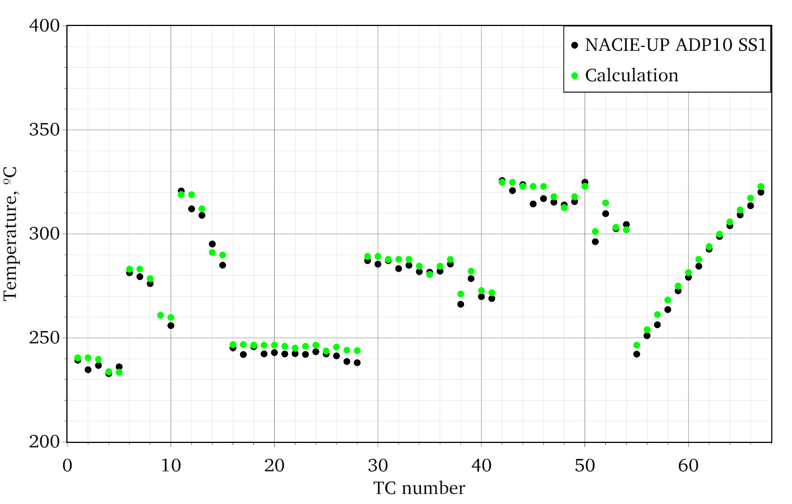
Figure 2 - Comparison of the calculation results and experimental data for ADP10 Steady state 1

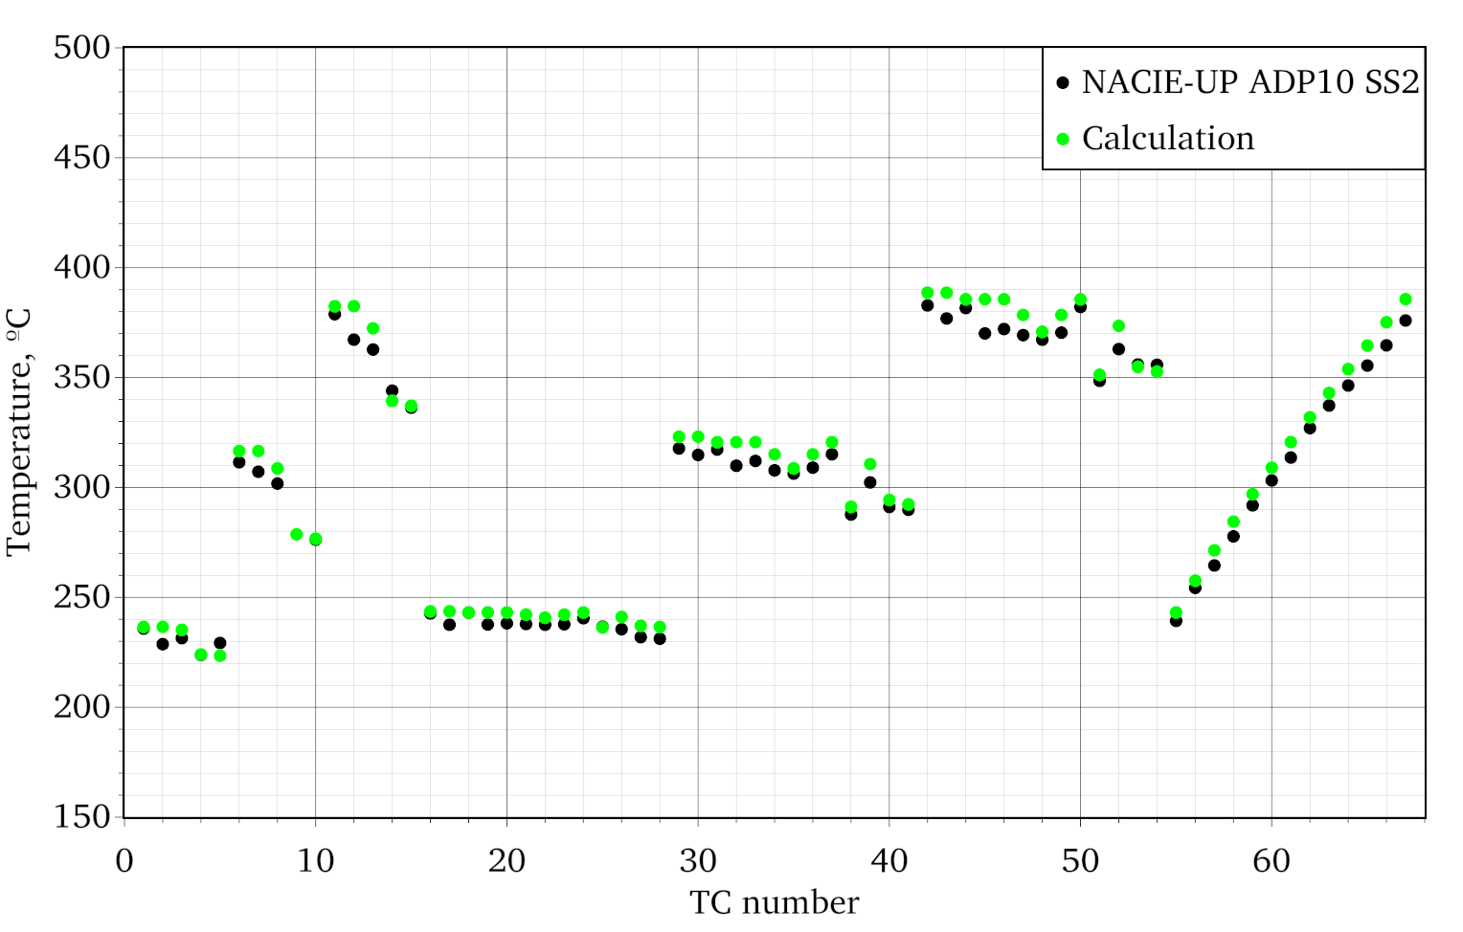
Figure 3 - Comparison of the calculation results and experimental data for ADP10 Steady state 2

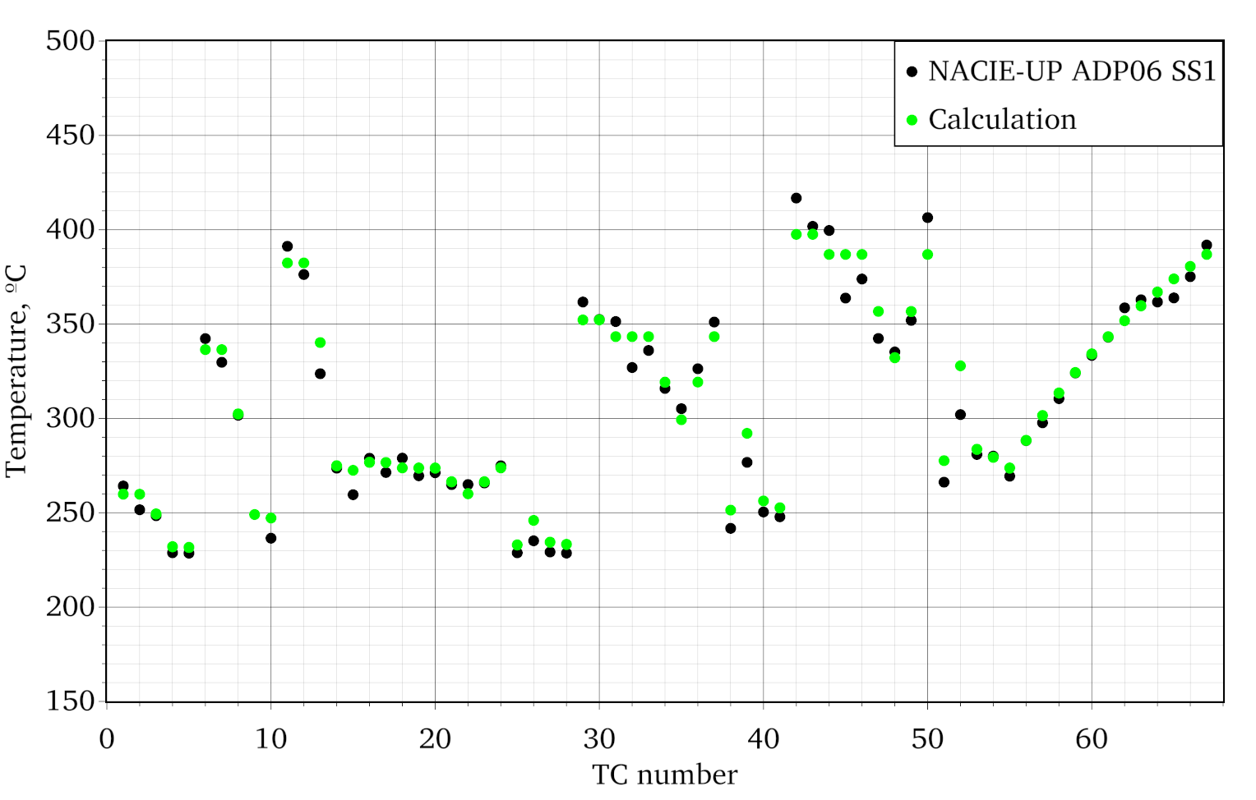
Figure 4 - Comparison of the calculation results and experimental data for ADP06 Steady state 1

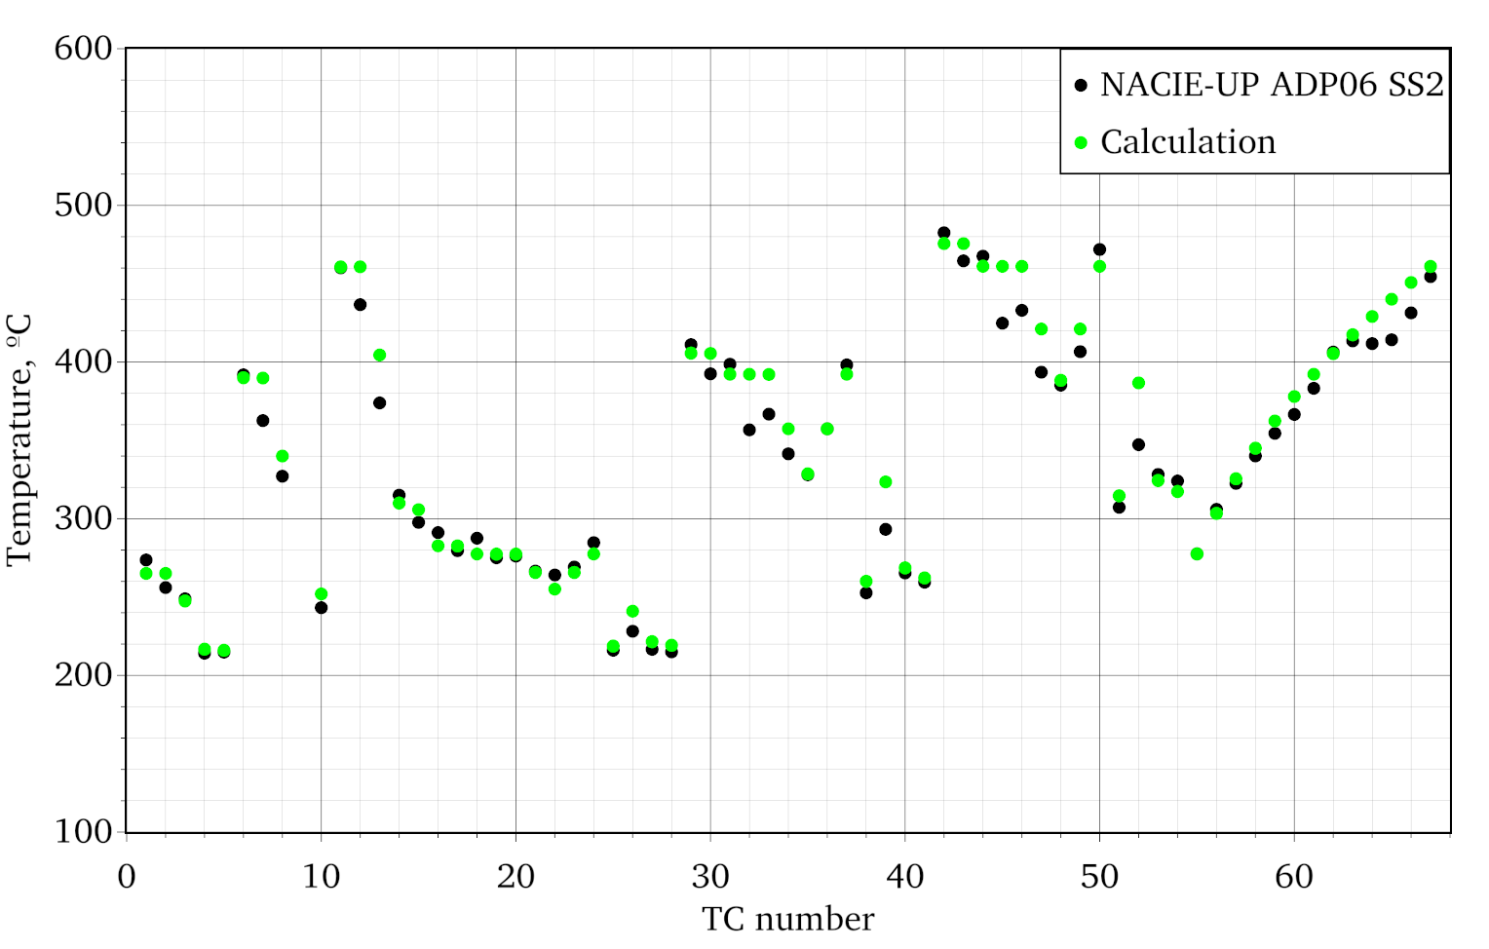
Figure 5 - Comparison of the calculation results and experimental data for ADP06 Steady state 2

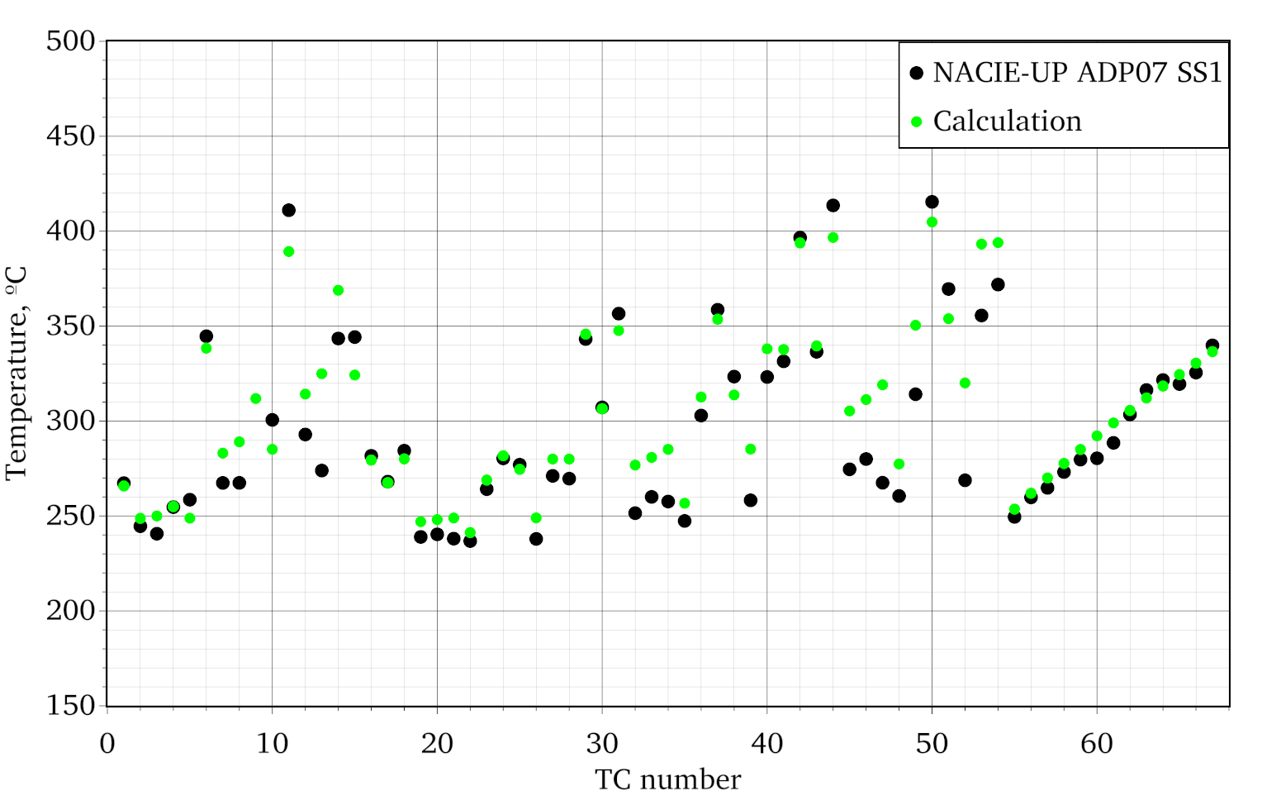
Figure 6 - Comparison of the calculation results and experimental data for ADP07 Steady state 1

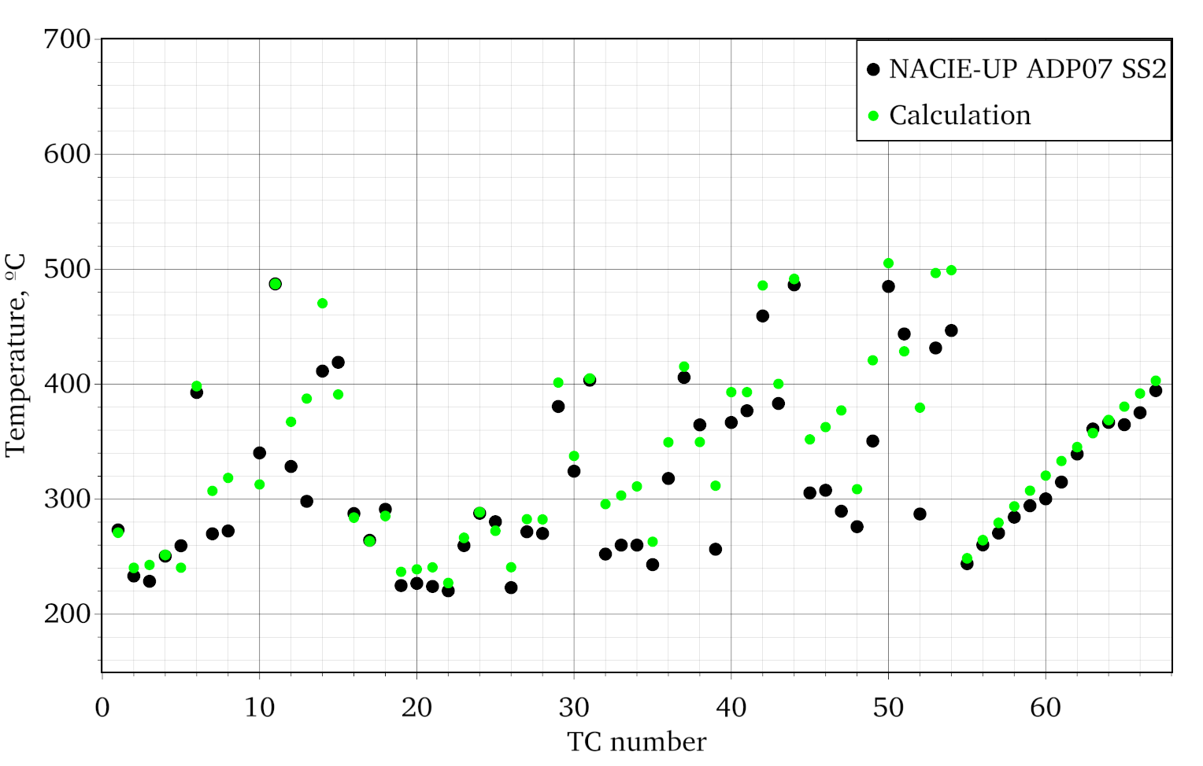
Figure 7 - Comparison of the calculation results and experimental data for ADP07 Steady state 2

Conclusion
In most of the experiments considered, there is a slight overheating. In experiments with nonuniform heat release, the error is greater. This is because empirical correlations for inter-channel heat and mass transfer are not designed for nonuniform heat dissipation. An average error of 7.9 degrees is acceptable, and the fact that the error is positive for almost all points indicates conservatism in calculations, which is positive for calculations to justify safety at nuclear power plants.

REFERENCES
- Zhukov A. V. et al. Methodological instructions and recommendations for thermohydraulic calculations of fast-reactor cores //RTM 1604.008-88. GKAÉ. Izd. FÉI. – 1989.

