KIT Simulation Results
The STAR-CCM+ code was used for the benchmark simulations. Due to the complexity of the bundle geometry, further simplification based on symmetry assumptions was not feasible; therefore, all rods were explicitly modelled. Figure 1 illustrates the computational domain of the test section. Two heater modelling approaches were considered. In the first approach, a simplified heater was modelled by prescribing the generated heat as a heat flux on the inner surface of the cladding. In the second approach, a fully resolved heater model was used, in which all heater layers were explicitly represented. The start of heating was taken as the reference point for the axial coordinate system, as shown in Figure 1a. This figure also shows a cross-section of the computational domain in the x–y plane, where the cladding layer of the simplified heater is shown in red. Figure 1b illustrates the fully resolved heater model. Figures 1c and 1d present sections of the meshes used, Mesh I and Mesh II, respectively. Mesh I was applied for simulations with the simplified heater, whereas Mesh II was used for simulations with the fully resolved heater. Figure 1e shows the mesh resolution at the contact between the wire and the pin for Mesh II. Both the heated and preheated parts of the bundle were simulated. Heat transfer and fluid flow were modelled using the SST turbulence model with all y⁺ wall treatment. Heat losses to the environment were neglected by assuming adiabatic boundary conditions. Conjugate heat transfer to the rods and the wrapper was applied. Physical properties were defined according to the benchmark specifications [1].
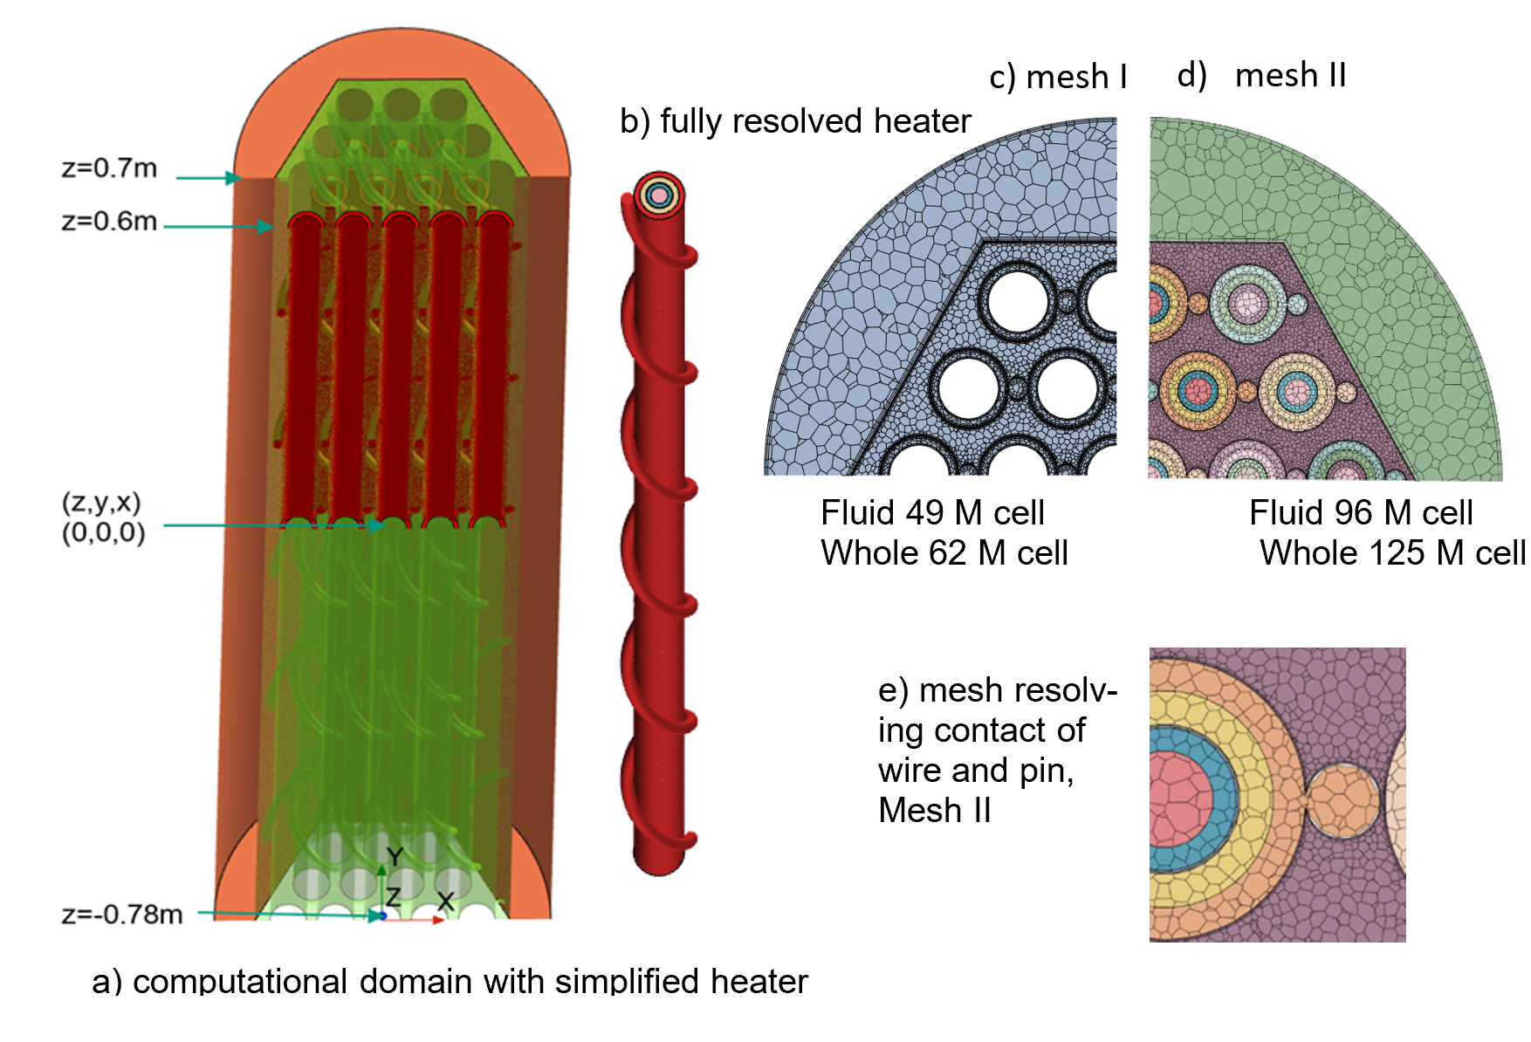
Figure 1 Computational domains for fluid and heaters, mesh I&II, Mesh resolving contact of wire and pin.
Case APD10 SS1 was considered for the assessment of different mesh and heater modelling approaches. The available experimental data were revised several times, resulting in only minor differences in the input data. Figure 2 shows the simulation results obtained with the simplified heater (Mesh I, revision 1input data) and the fully resolved heater (Mesh II, revisions 1 and 5 input data), compared with the experimental data. The meshes and heater models used provide sufficient accuracy to achieve good agreement with the experimental results. Consequently, Mesh II with the fully resolved heater was selected for the remaining benchmark cases. Figures 3–7 present the results of the numerical simulations using revision 5 input data, compared with the experimental results. A detailed discussion of the results is provided in [2–4]. In general, the simulations show good agreement with respect to the locations of high temperature increases. However, in regions with low temperature rise due to heating, the comparison exhibits higher percentage errors than in regions with higher temperature increases.
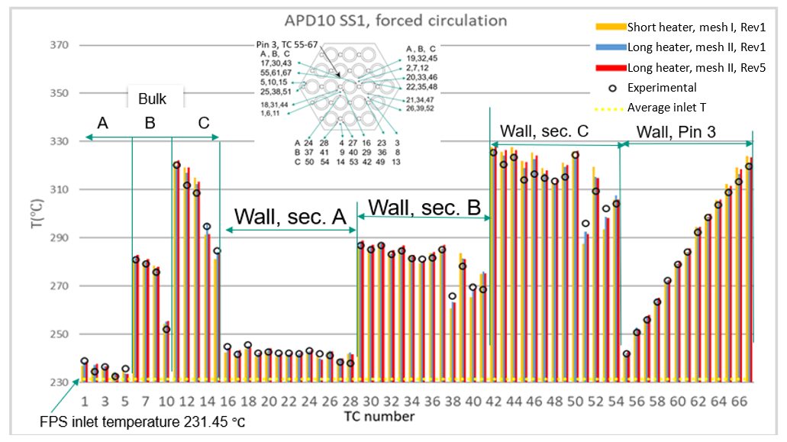
Figure 2. Forced circulation results mesh I, mesh II with short and long heaters considering data from revision (Rev.)1&5 compared to experimental data for case ADP10 Steady state I.

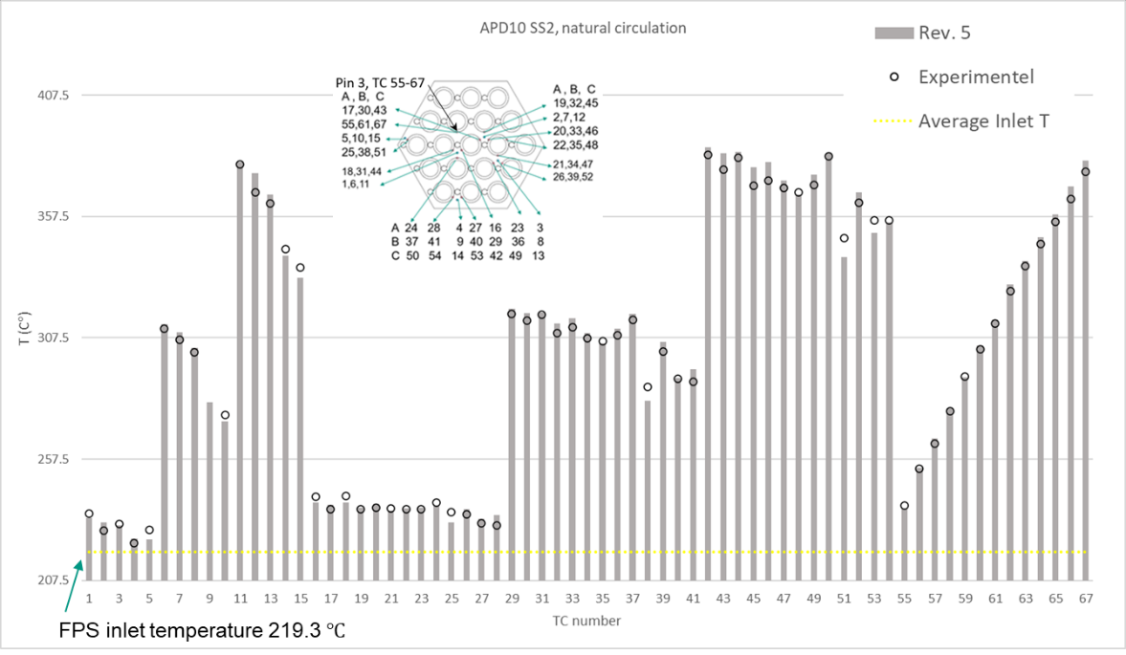
Figure 3. Natural circulation results for mesh II, long heater considering data from rev. 5 compared to experimental data for case ADP10 Steady state II.

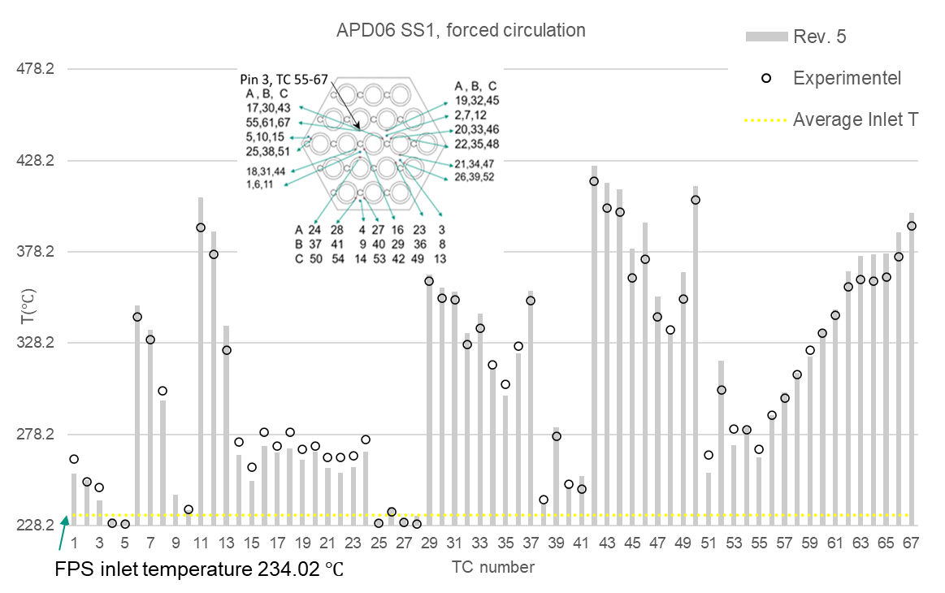
Figure 4. Forced circulation results, mesh II, long heaters considering data from revision 5 compared to experimental data for case ADP06 Steady state I.

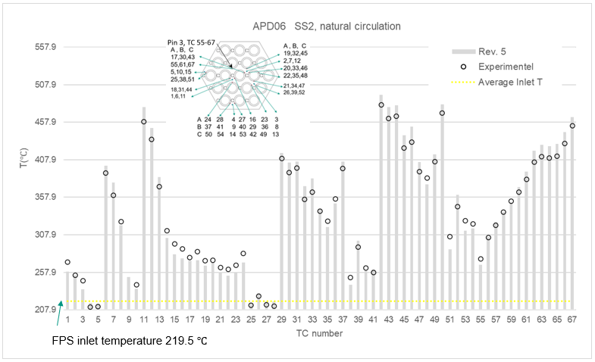
Figure 5 Natural circulation results, mesh II, long heaters considering data from revision 5 compared to experimental data for case ADP06 Steady state II.

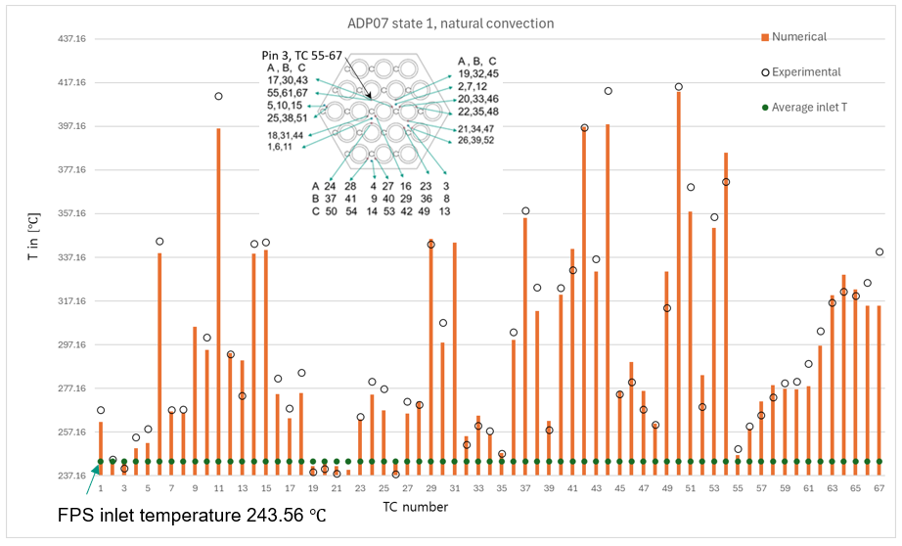
Figure 6. Forced circulation results, mesh II, long heaters considering data from revision 5 compared to experimental data for case ADP07 Steady state I.

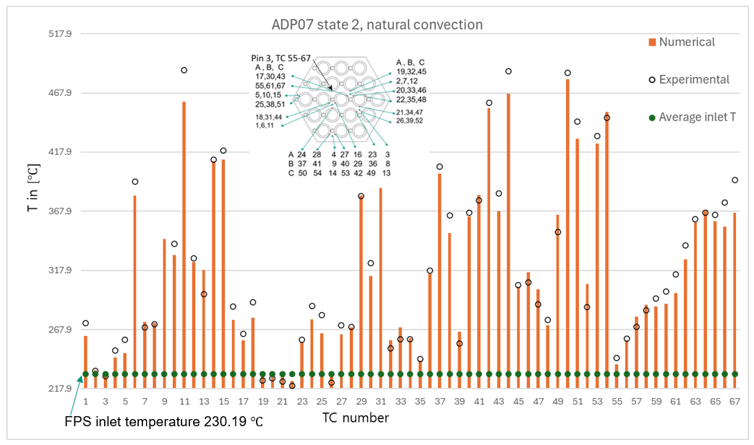
Figure 7. Natural circulation results, mesh II, long heaters considering data from revision 5 compared to experimental data for case ADP07 Steady state II.

Conclusions
The open-phase results, considering various heater modelling approaches, show only a small influence on the results and low sensitivity to mesh refinement. Sufficient accuracy throughout the bundle was found. The numerical precision is comparable to the uncertainties associated with measurements, material properties, and geometrical dimensions. No systematic deviations between simulation and experiment were observed; all discrepancies can be attributed to well-explainable sources. The largest errors in the inlet section are likely related to boundary condition effects. Smaller errors in high-temperature regions can be attributed to benchmark specification limitations, such as the neglect of possible deformations, modelling assumptions, material property uncertainties, turbulence models, and mesh effects.
In the blind case, lower accuracy compared to the open-phase results was observed, mainly due to asymmetric heating. A detailed discussion of measured axial temperatures in and around rod 3 shows that the numerical results exhibit a linear temperature increase with a superimposed spatially periodic oscillation, whereas the experimental data show a weaker oscillation. The computed temperature is highly sensitive to misalignment between the predicted temperature field and the thermocouple location accuracy.

REFERENCES
- Di Piazza, H. Hassan, P. Lorusso, D. Martelli, “Benchmark specifications for NACIE-UP facility: non-uniform power distribution tests”, Ref. NA-I-R-542, Issued: 28/02/2023 ENEA, Italy
- Batta, A. Class A., “CFD validation of forced and natural convection for the open phase of IAEA benchmark CRP - I31038”, SCOPE (Saudi International Conference on Nuclear Power Engineering) King Fahd Conference Center, KFUPM, Dhahran, KSA, 13–15 Nov 2023.
- Batta, A. Class A., “IAEA Benchmark CRP - I31038: Open Phase liquid-metal CFD results for fuel pin simulator”, paper no 222, NUTHOS-14, Vancouver, BC, Canada, 2024
- Batta, A.; Class, A. G. “CFD Validation on Liquid Metal Flow in 19 Wire Wrapped Bundle Flow Investigated in the IAEA Coordinated Research Projekt CRPI31038 Using NACIE Experimental Data”, NURETH 2021, paper no:1811, Busan, south Korea, 2025.

