- PUB description
Currently, POLITEHNICA Bucharest has 21 faculties and 19 doctoral schools, ensuring for the approximately 40,000 students a high-performance education, supported by a complex research activity, according to European requirements and with the means offered by the modern information society at all three university cycles. In addition, approximately 1200 international students study at the university, coming from over 59 countries, enrolled in all three university cycles. In the Bucharest university centre there are 15 faculties that manage bachelor's and master's degree programs in 21 fields, and in the Pitești university centre there are 6 faculties that manage bachelor's and master's degree programs in 26 fields; 8 master's degree programs are found in both university centres.
POLITEHNICA Bucharest is a member of 23 international organizations and two university consortia: EELISA, at the international level, and ARUST, at the national level.

- Simulation code
The code used during this work is RELAP 5 code from the RELAP5/SCDAPSIM/MOD4.1 package.

- Simulation Results

3.1 Model description
The RELAP5/SCDAPSIM/MOD4.1 (RS4.1) [1] model for the NACIE-UP test section is depicted in Figure 1.
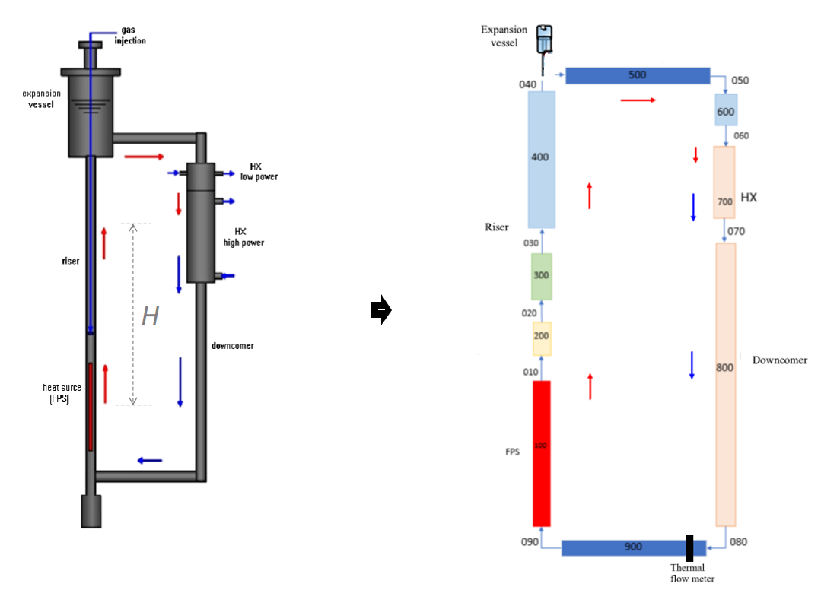
Fig.1 RS 4.1 model for the NACIE-UP test section

Generally, the pipe and junction components of RS4.1 is used to model components of NACIE-UP primary loop. Thus, the riser region of the loop is modeled by two pipe component, one with four control volumes for the portion befor the argon injection point and 20 control volumes after the argon injection point. The structure of expansion vessel are modeled through 4 control volumes with an time-dependent volume to set the boundary condition for the argon layer on the top of the vessel. A 10 control volumes pipe represent the horizontal hot leg whereas 5 control volumes model the vertical cold leg section between the horizontal pipe and the heat exchanger entrance. The heat exchanger model consists of two pipe of ten control volumes each, one for the low power heat exchanger and one for the high power heat exchanger. To close the loop, the doncomer consist of one pipe containing 20 control volumes and a pipe with ten control volumes for the horizontal cold leg. Three models were considered for fuel pin simulator (FPS) (Figure 1):
- one lumped single channel for all FPS subchannels
- three channels with crossflow, one for central pin (no. 1), one for inner pins row (no. 2 to 7) and one for outer pins row (no. 8 to 19).
- 42 channels for a subchannel model

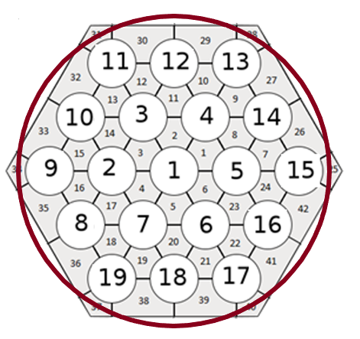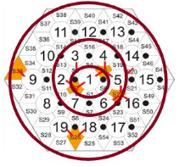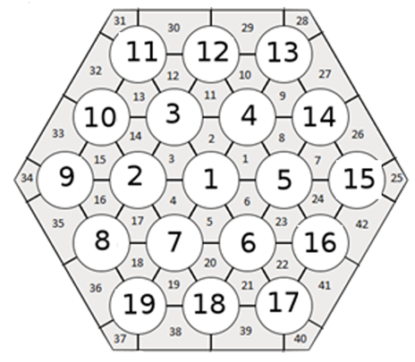
a) b) c)
Fig.2 FPS model

For all models, both the vertical portion before the preheated region and the last part of the FPS to the flange are modeled by a pipe with 5 control volumes. For one channel and three channels model, the preheated region of FPS is modeled as pipe component with 10 control volumes, the portion after the active region component consists as a pipe with 5 control volumes whereas for active region 27 control volumes were considered in order to better track temperature distributions inside fuel element simulator.

For the 42 subchannel model, consisting of 24 interior subchannels, 12 edge subchannels, and 6 corner subchannels, a pipe with 4 control volumes for the nonactive region at the fuel simulator inlet were considered, 5 for the active length and one control volume for the unheated exit region. A smaller number of control volumes were imposed by the the large number of control components necessary to model the interaction between subchannels. As RS4.1 cross junction model shown no influence on subchannel temperature distribution, only radial conduction within the coolant and a turbulent mixing was considered for the subchannel model.
Heat structures were used to simulate heat transfer from FPS to lead-bismuth coolant, heat transfer from lead-bismuth to water through heat exchanger, heat transfer from thermal flow meter to lead-bismuth and heat losses to environment.

The actual version of RS4.1 has not yet implemented two phase model for lead-bismuth eutectic (LBE) coolant, thus gas-lift in NACIE facility could not be simulated directly. Hence, forced convection flow rate was obtained by using a pump model. No pump inertia was modeled, so as the argon injection is cut off, the pump will stop suddenly.

The evaluation of the form losses from sudden area changes, valves and elbows has been estimated with correlations from Idelchik handbook [2], the form losses from the grid were evaluated from [3], whereas friction factor for the wire-wrapped rod bundle was estimated with Cheng and Todreas correlation [4].
3.2 Results
3.2.1 LBE flow rate

The loop flow rate for the lead-bismuth eutectic (LBE) is shown in Figure 3 for all the three tests, whereas Table 1 present the results obtained for the LBE loop flow rate for initial and final steady state.
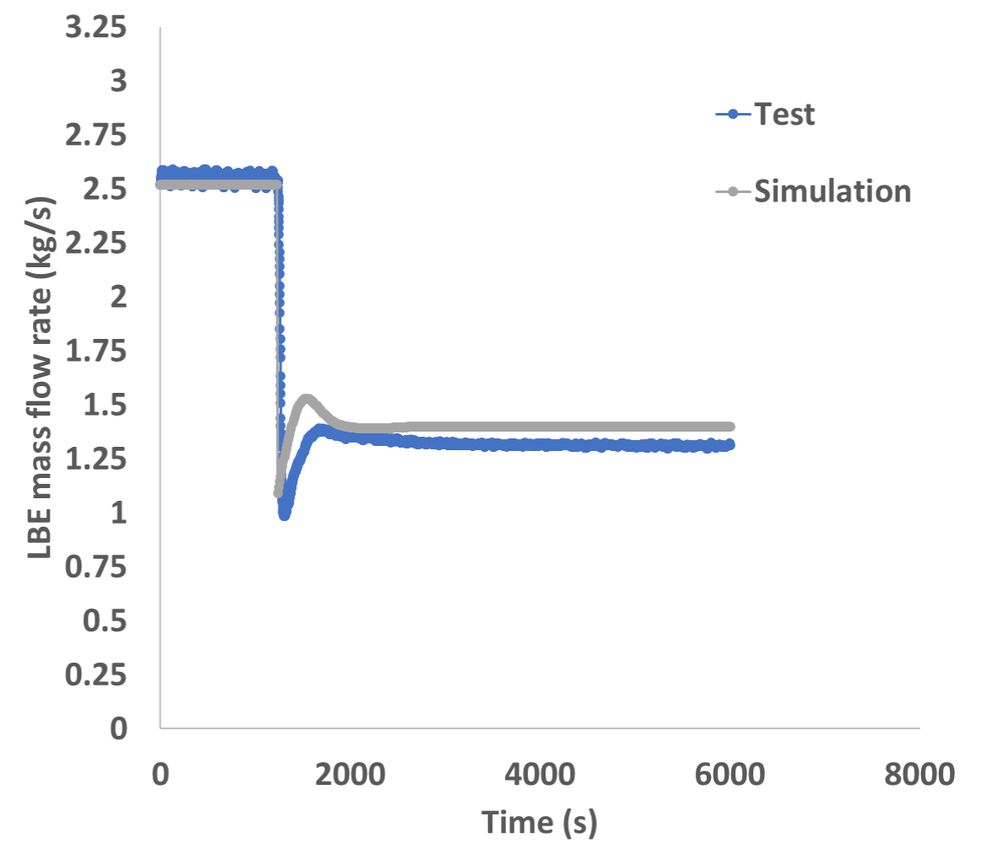
ADP10
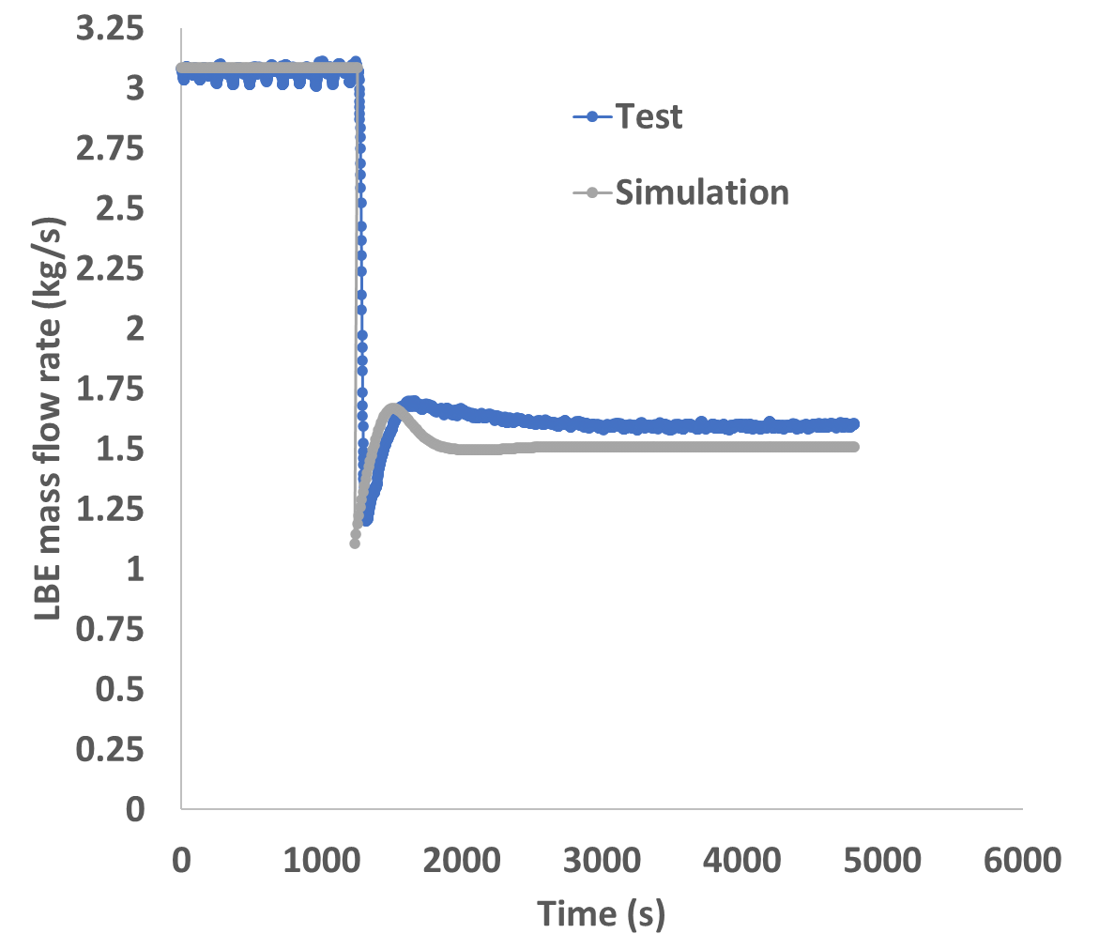
ADP06

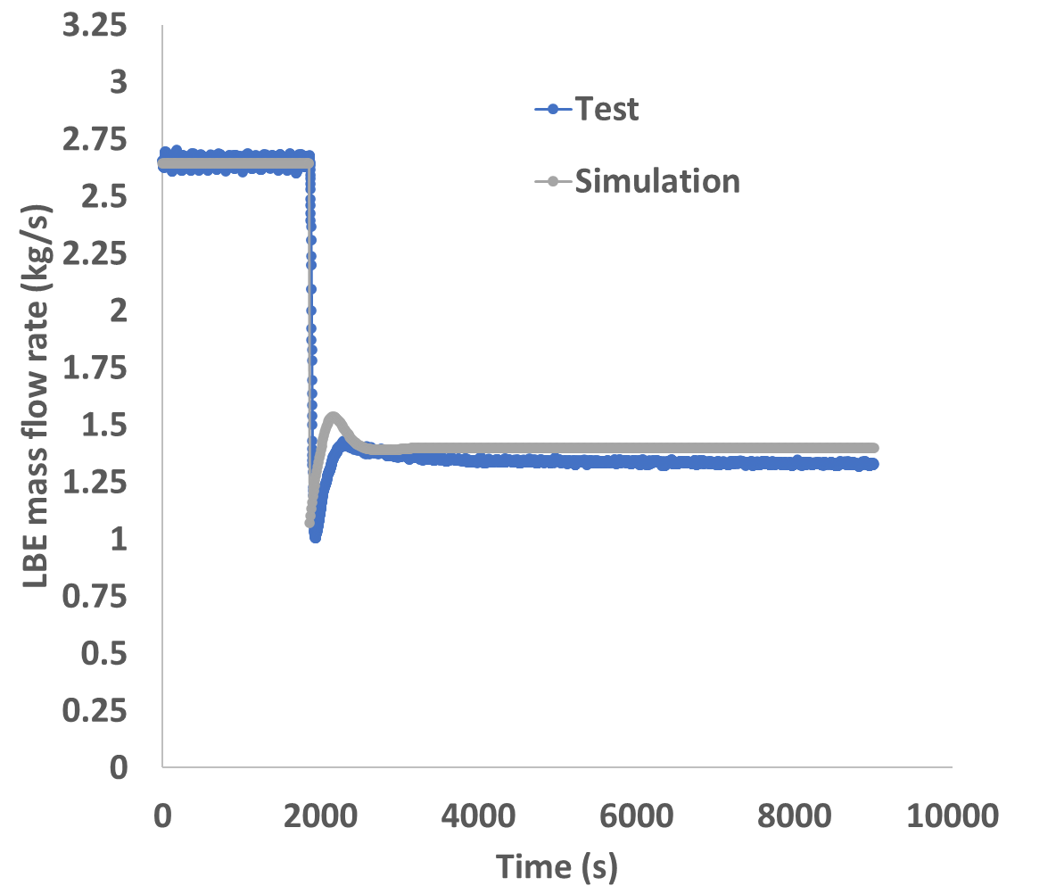
ADP07
Fig. 3 Mass flow rate

Table 1 Loop flow rate results
 | ADP 10 |  |  | ADP06 |  |  | ADP07
 | Simulation  (kg/s) | Test  (kg/s) | Relative error (%) | Simulation  (kg/s) | Test  (kg/s) | Relative error (%) | Simulation  (kg/s) | Test  (kg/s) | Relative error (%)
Initial steady state | 2.521 | 2.559 | -1.48 | 2.644 | 2.66 | -0.59 | 3.086 | 3.07 | 0.53
Final steady state | 1.398 | 1.32 | 5.9 | 1.399 | 1.342 | 4.34 | 1.506 | 1.602 | -6.01

As can be seen from Figure 3, the RS4.1 code can predict with good accuracy the the flow behaviour in the LBE loop during transition from forced to natural circulation regime for all test. After stopping the argon injection, there is a sharper flow rate reduction predicted for the RS4.1 as the pump inertia was neglected in the model, so that the delay in the removal of argon from the riser can not be captured by the code. The steady state flow rate prediction for initial and final steady state prediction show good agreement with experimental data for all tests. However, the results for natural circulation steady state for test ADP 10 and ADP07 are slightly larger than the uncertainty related to the measured quantities for LBE mass flow rate ($±5\%)$.

3.2.2 LBE loop temperature along the loop
The LBE temperature distribution along NACIE loop is shown in Figure 4.

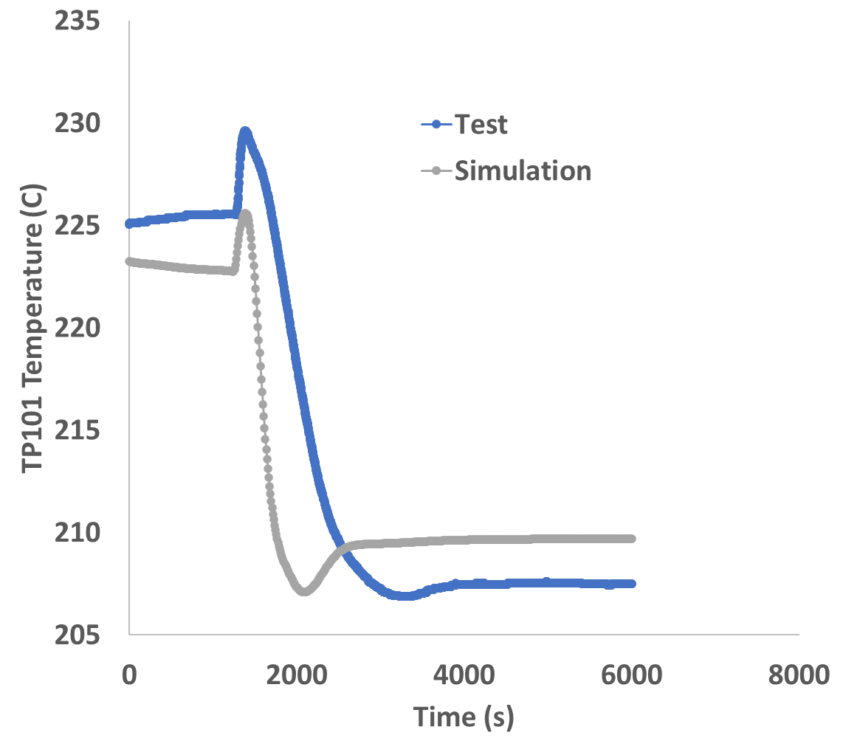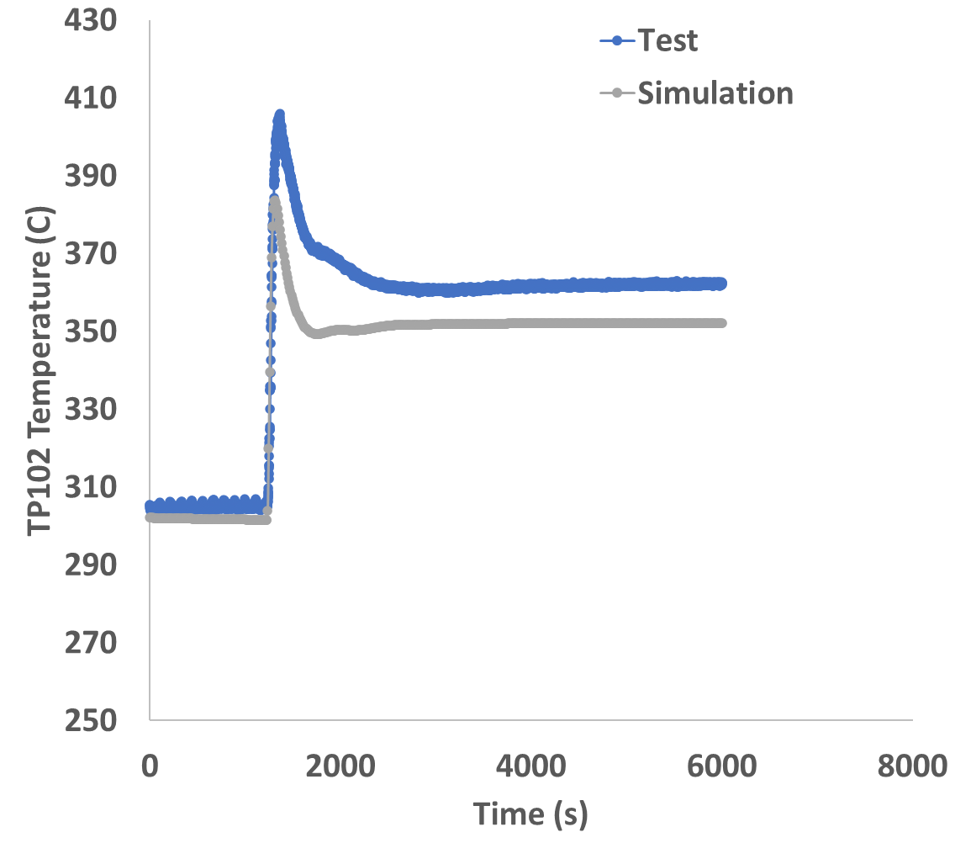

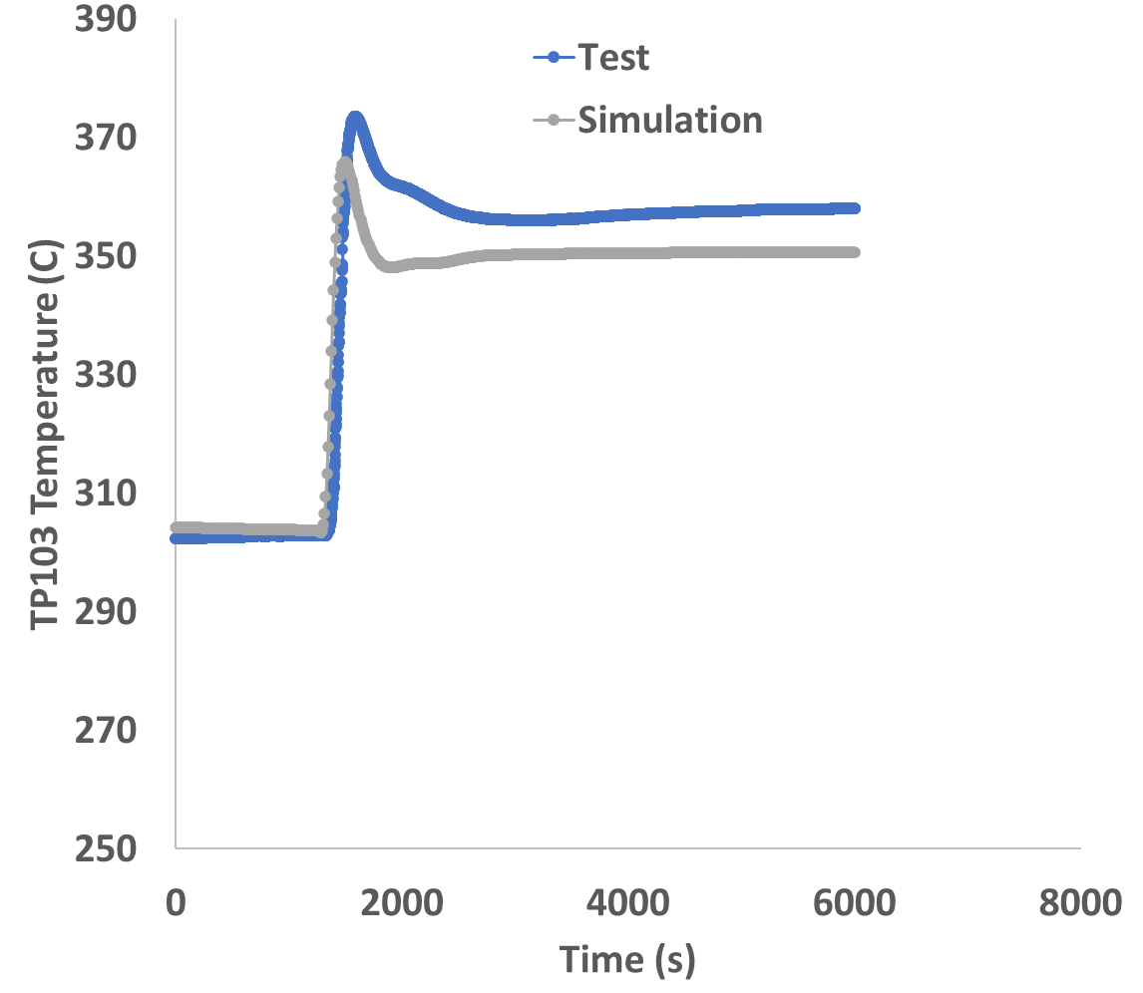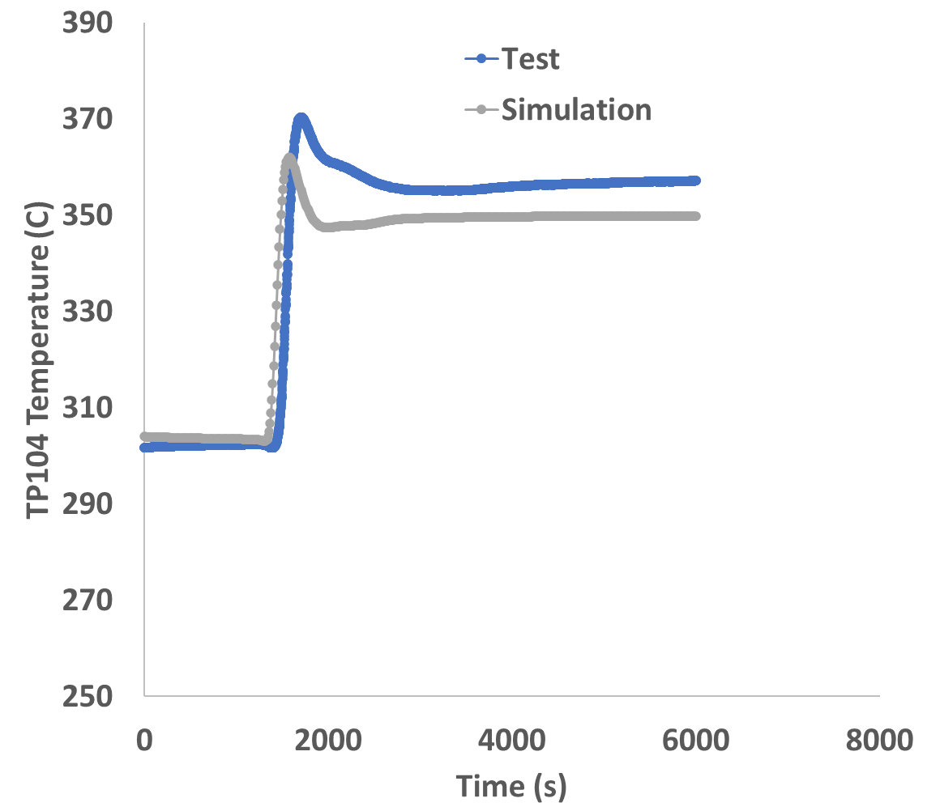
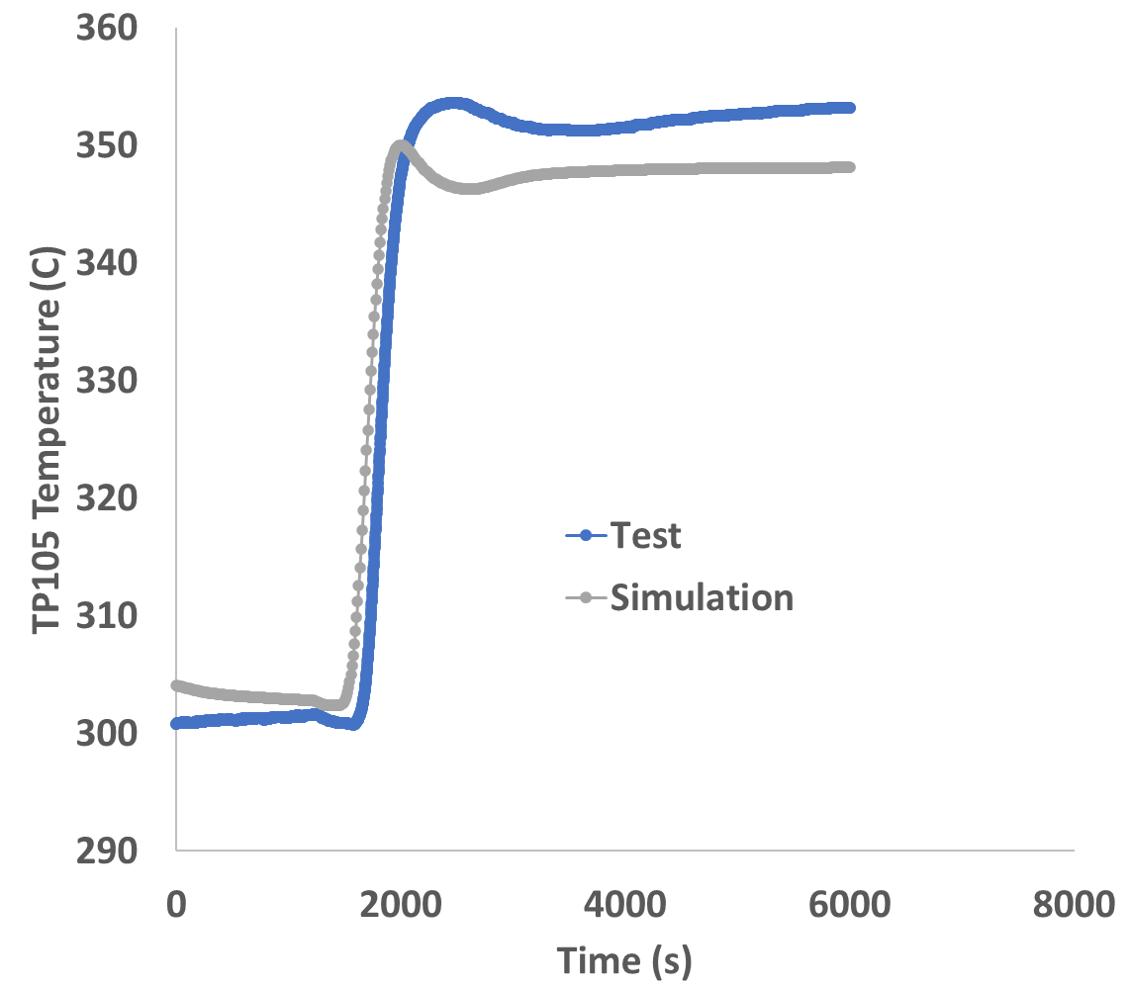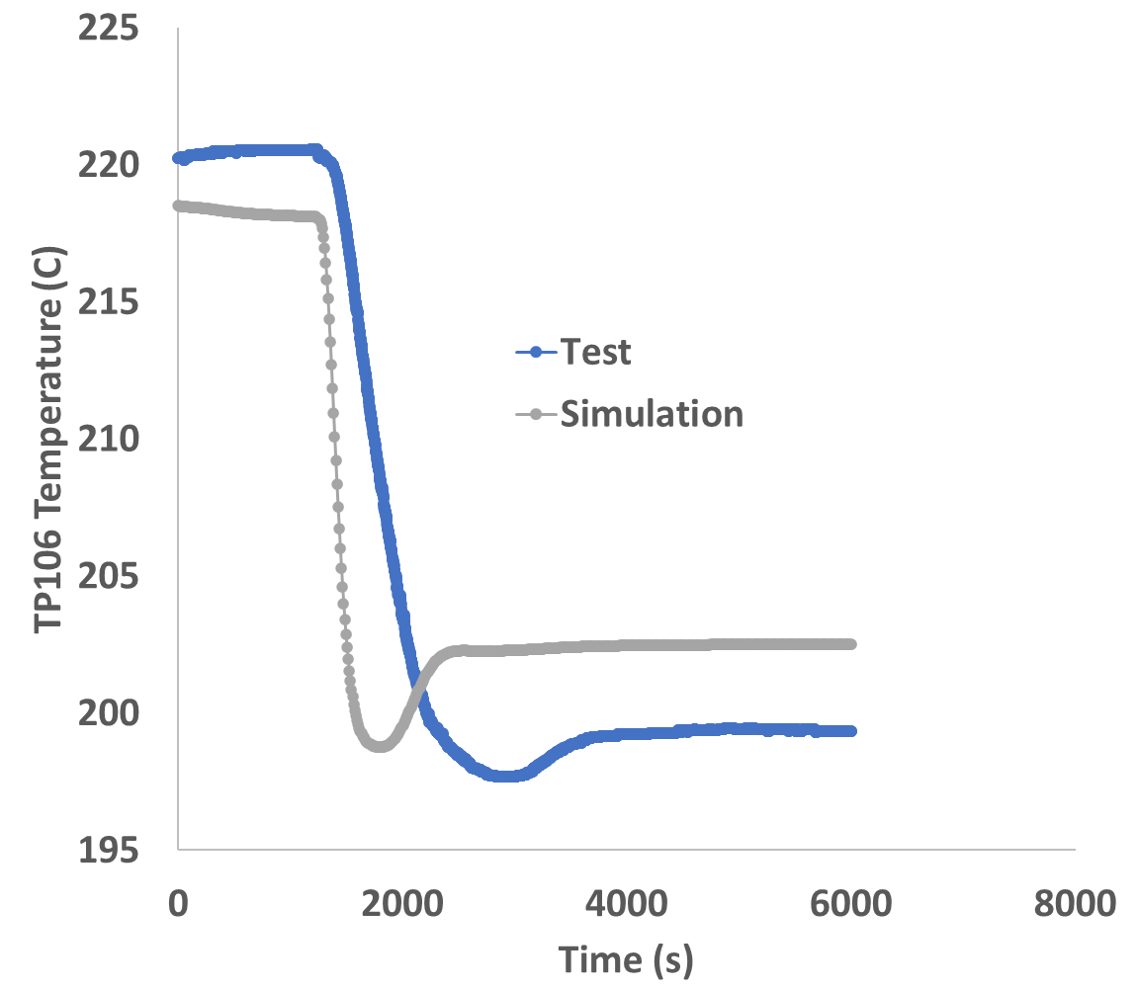

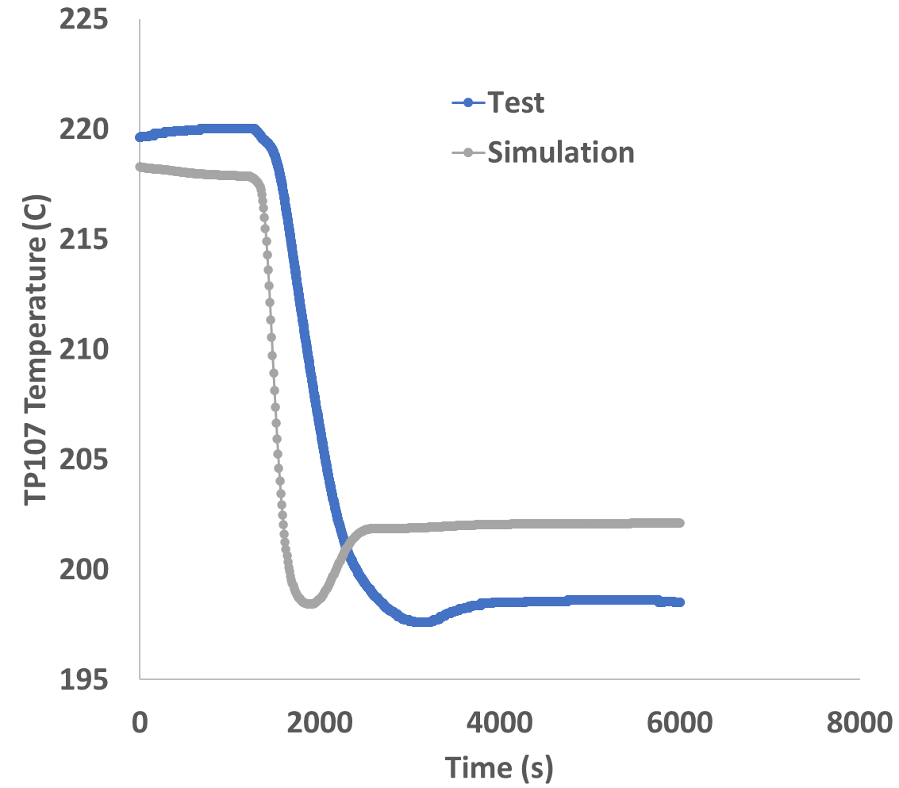
ADP10

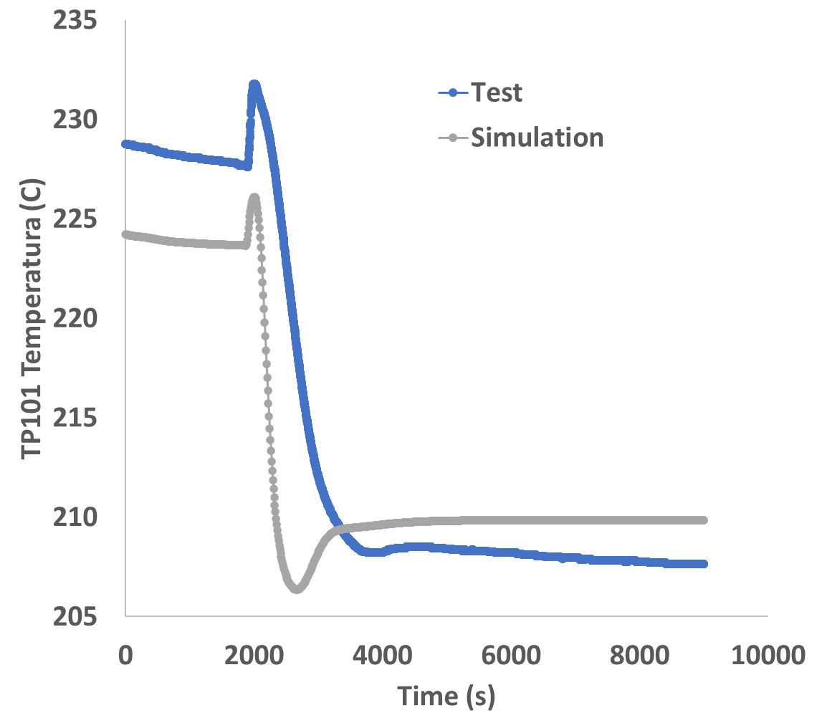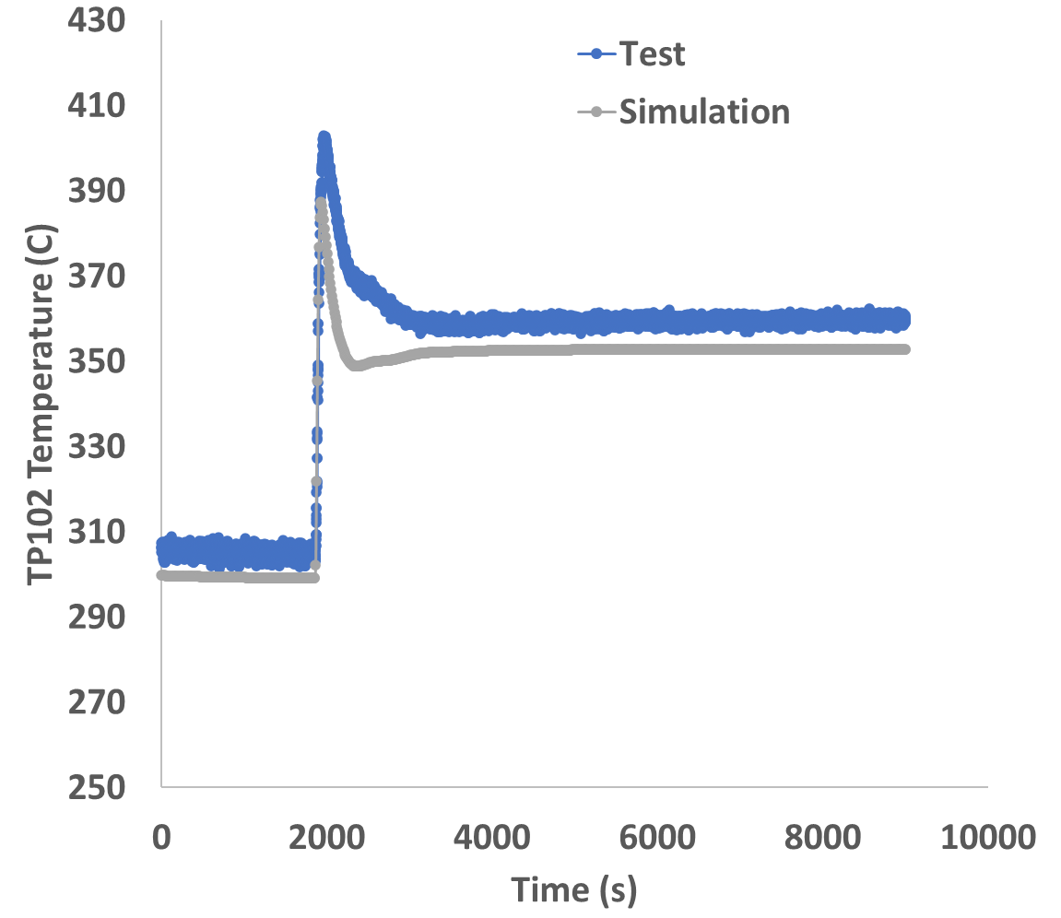

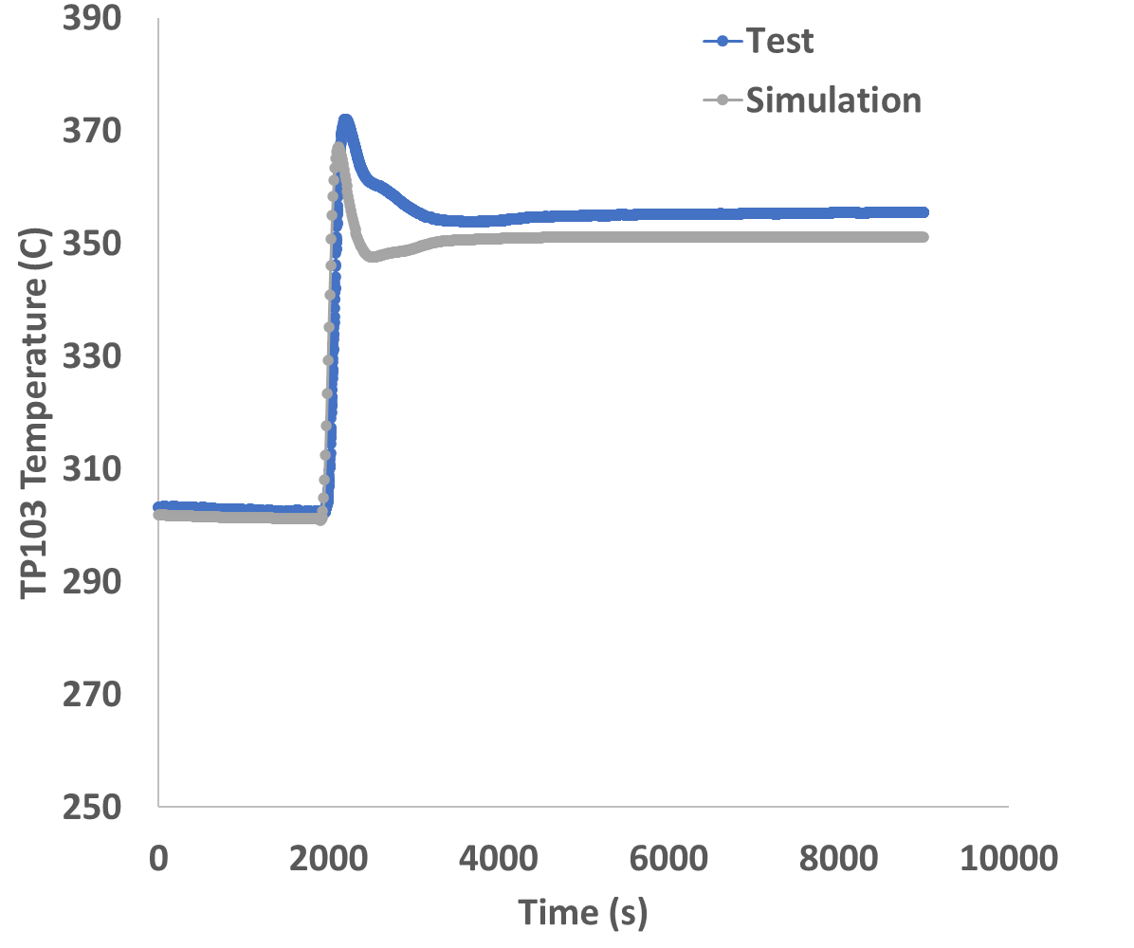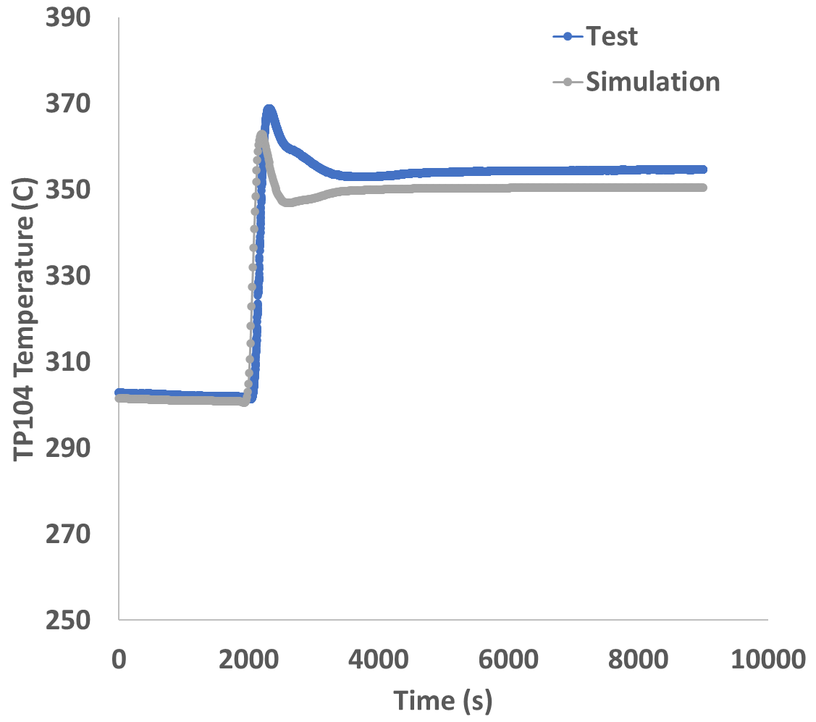

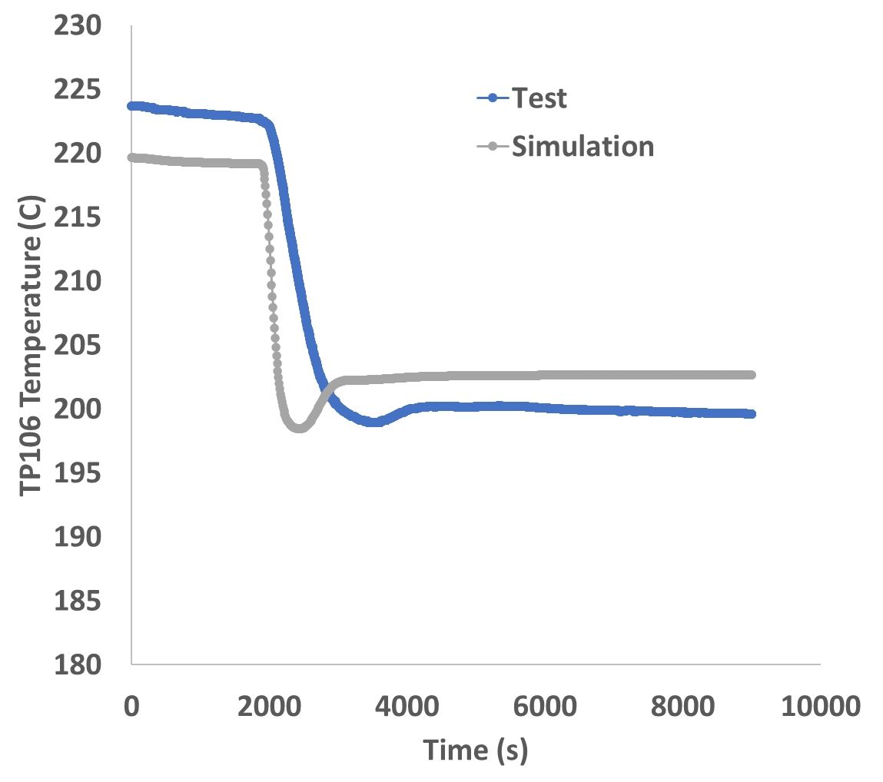

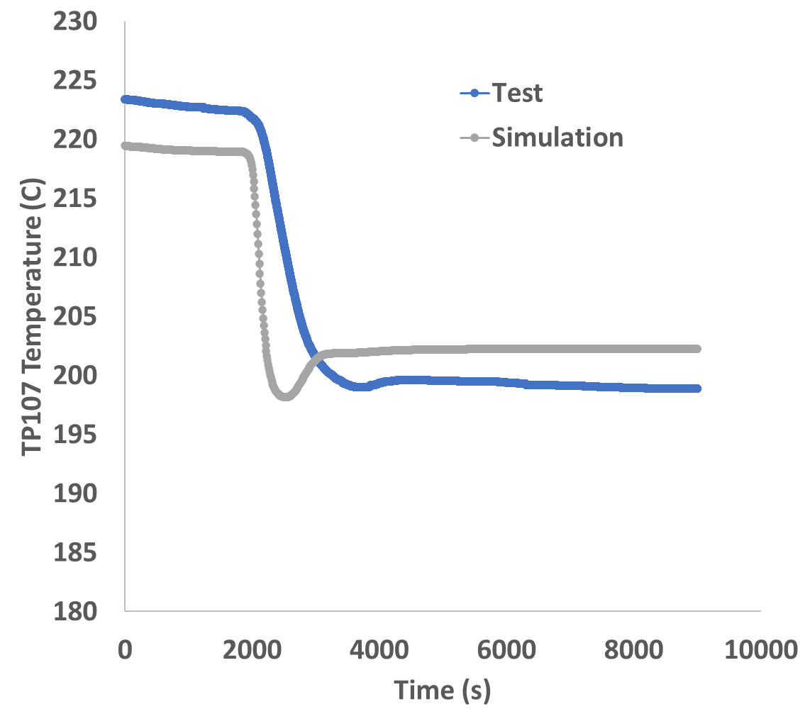
ADP06

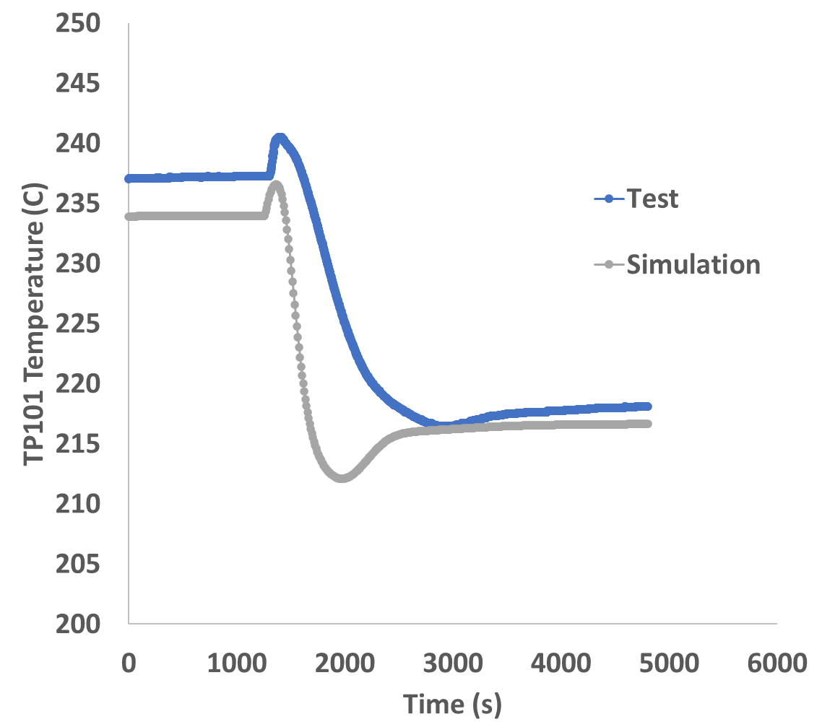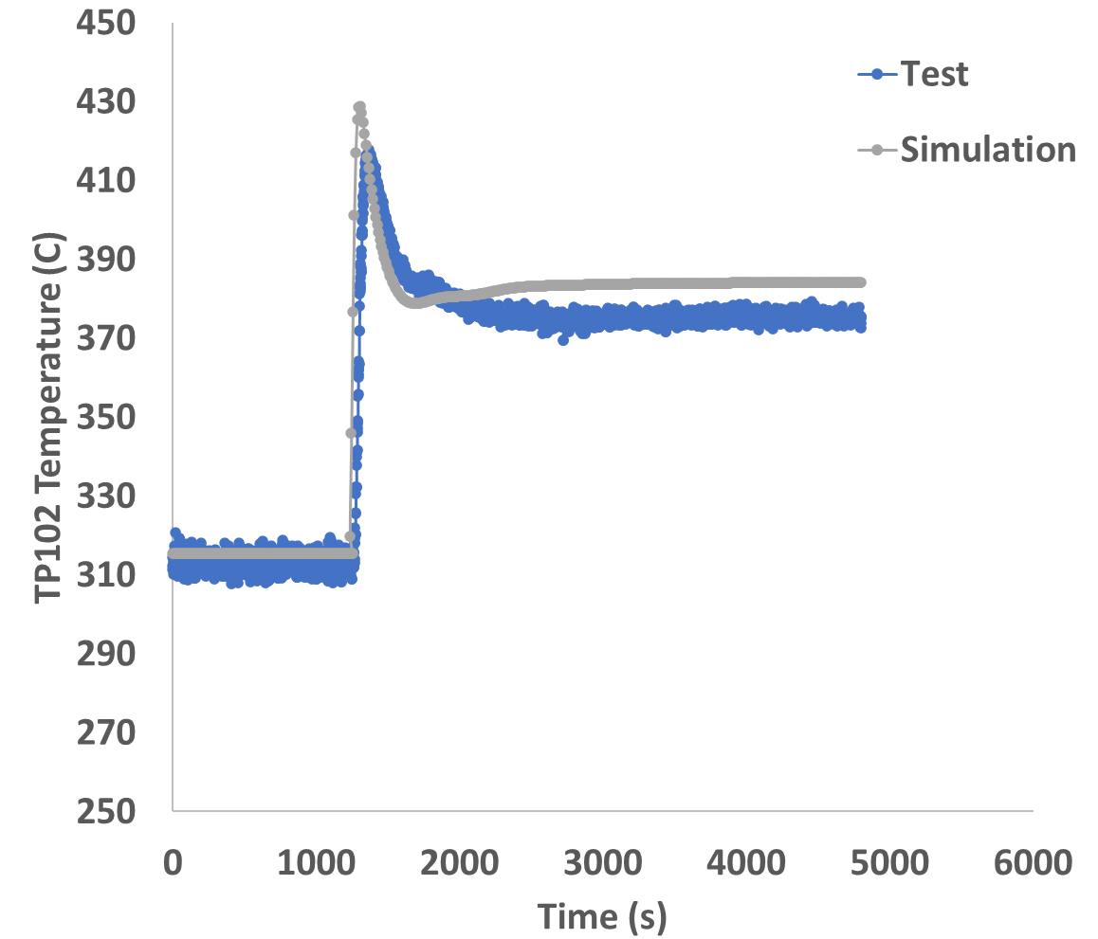

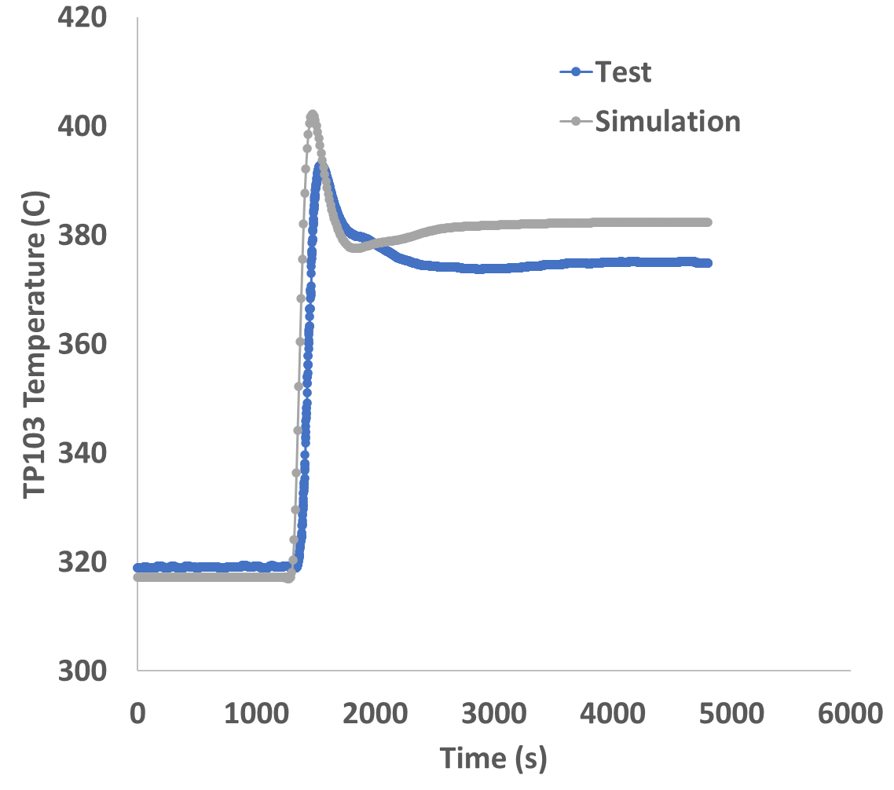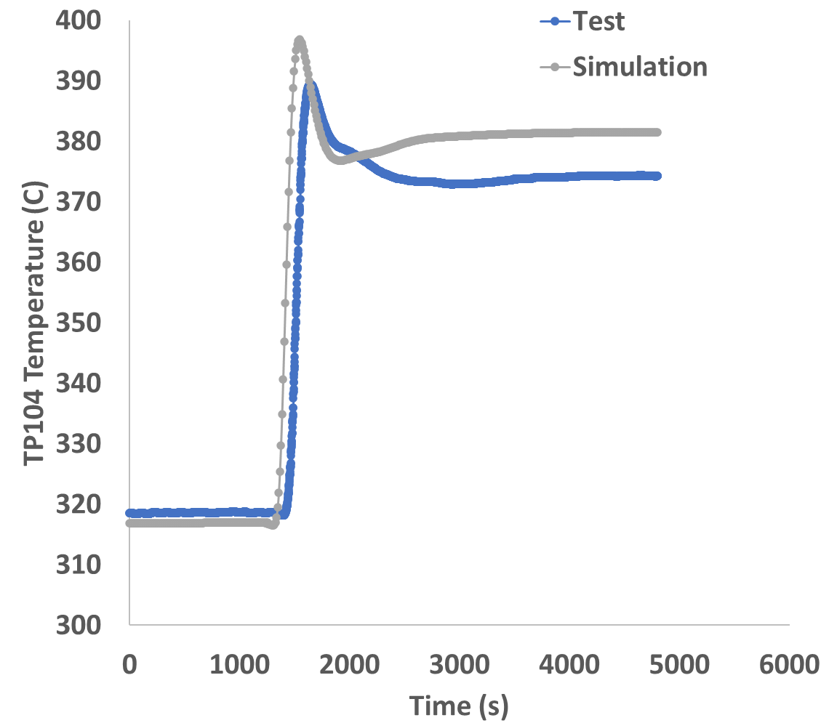
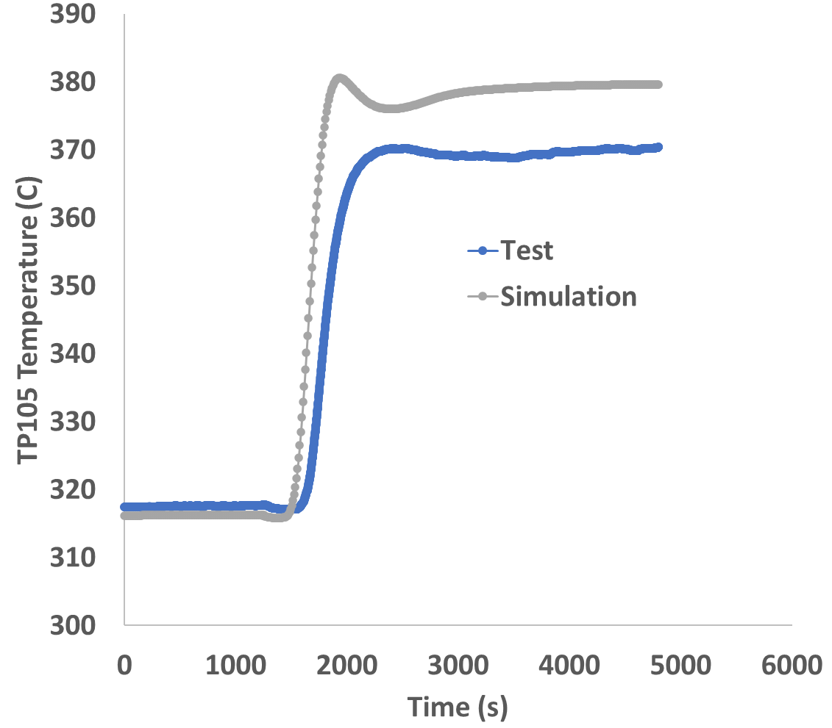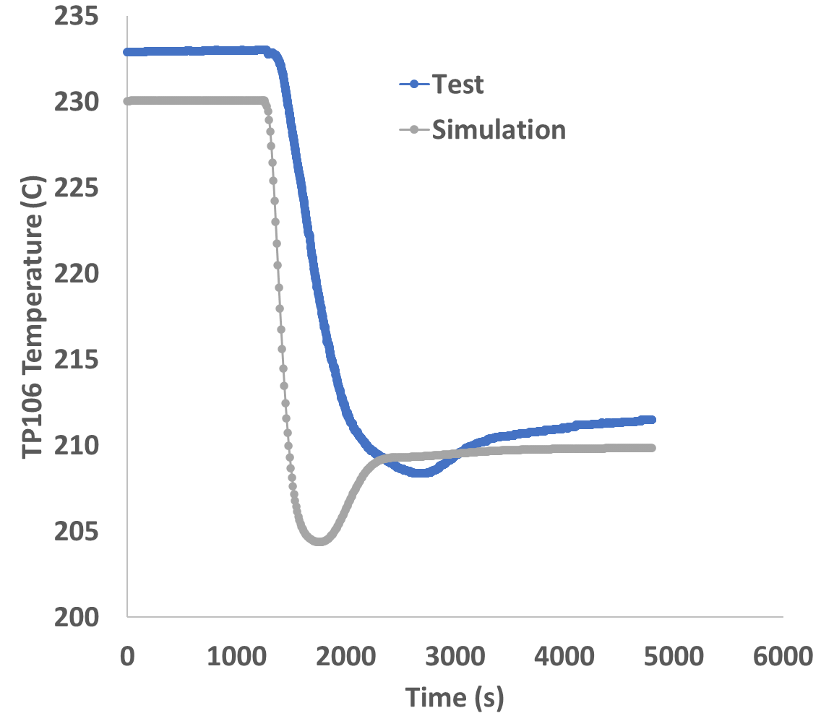

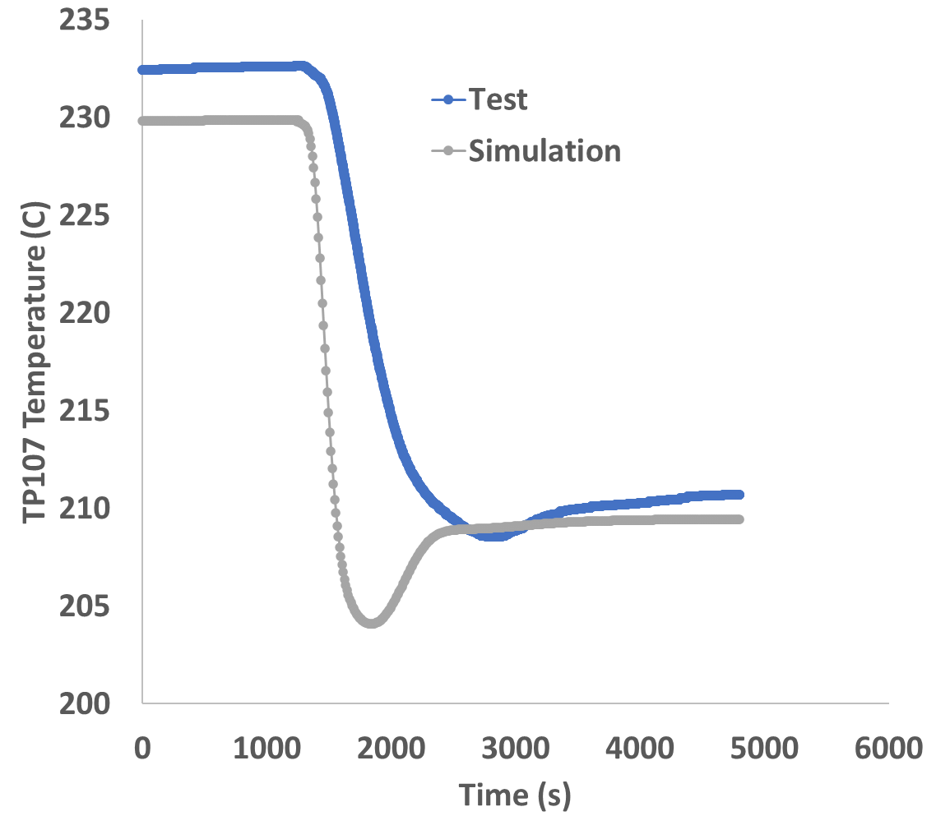
ADP07
Fig. 4 LBE temperature distribution along NACIE loop

The RS4.1 can predict the LBE temperature behaviour along the loop for all three tests. Main differences apear during the transition from forced to natural circulation regime. This is mainly due to the flow behavior in the loop. In the RS4.1 model, there is a sudden transition to natural circulation regim after the stops of the pump as no pump inertia are introduced in model, whereas there is a smoother transition in the test due to the presence of gas buble in the riser portion (due to gas time transition in gas injection sistem and gas rise velocity in the riser portion) until it is removed. The simulation results for the transient seem to be more accurate in the loop portion between FPS outlet and heat exchanger inlet than for the loop portion between heat exchanger outlet and FPS inlet.
Table 2 shows the comparison between the values ​​obtained by RS4.1 and experimentally measured data for the initial and final steady state. Most of the simulation results are bellow or slighly to the uncertainty of thermocouples which is $±1℃$. The largest relative error was -2.66 % for TP102 for the ADP 10 test final steady state.
Table 2 Loop Tempearture results
 |  | ADP 10 |  |  | ADP06 |  |  | ADP07
 |  | Simulation  (ºC) | Test  (ºC) | Relative error (%) | Simulation  (ºC) | Test  (ºC) | Relative error (%) | Simulation  (ºC) | Test  (ºC) | Relative error (%)
TP101 | Initial steady state | 225.39 | 222.96 | -1.08 | 228.19 | 223.86 | -1.9 | 237.16 | 233.9 | -1.35
 | Final steady state | 207.39 | 209.64 | 1.09 | 208.06 | 209.8 | 0.85 | 217.47 | 216.4 | -0.48
TP102 | Initial steady state | 304.88 | 301.82 | -1.00 | 305.16 | 299.37 | -1.9 | 312.89 | 315.5 | 0.84
 | Final steady state | 361.67 | 352.06 | -2.66 | 359.4 | 352.7 | -1.86 | 375.17 | 383.9 | 2.32
TP103 | Initial steady state | 302.69 | 303.98 | 0.43 | 302.81 | 301.4 | -0.45 | 319.09 | 317.2 | -0.58
 | Final steady state | 357.17 | 350.51 | -1.86 | 355.17 | 351.2 | -1.13 | 374.56 | 382.1 | 2.01
TP104 | Initial steady state | 302.1 | 303.65 | 0.52 | 302.32 | 301.1 | -0.4 | 318.61 | 316.9 | -0.53
 | Final steady state | 356.2 | 349.68 | -1.83 | 354.28 | 350.4 | -1.11 | 373.75 | 381.1 | 1.98
TP105 | Initial steady state | 301.22 | 303.23 | 0.67 | 301.77 | 300.7 | -0.37 | 317.56 | 316.3 | -0.41
 | Final steady state | 352.16 | 347.89 | -1.21 | 350.57 | 348.6 | -0.56 | 373.75 | 378.8 | 1.36
TP106 | Initial steady state | 220.47 | 218.26 | -1.00 | 223.17 | 219.3 | -1.72 | 232.95 | 230.1 | -1.23
 | Final steady state | 199.13 | 202.5 | 1.67 | 199.96 | 202.6 | 1.34 | 210.37 | 209.7 | -0.32
TP107 | Initial steady state | 219.92 | 218.02 | -0.86 | 222.82 | 219.1 | -1.67 | 232.54 | 229.8 | -1.16
 | Final steady state | 199.13 | 202.1 | 1.47 | 199.24 | 202.2 | 1.49 | 209.85 | 209.3 | -0.27

3.2.3 Heat exghanger water temperature

The water temperature behaviour at inlet and outlet heat exchanger is shown in Figure 5. In the RS4.1 model the inlet water temperature is considered as a boundary condition and is keep constant during the tests. However, in the test there is a slightly temperature variation, 2-3 ºC, after the cutoff of argon injection. This small variation is also observed in outlet water temperature. The simulations result for outlet water temperature confirm that RS4.1 model accurate represent the heat transferred by the LBE coolant to the water side of heat exchanger.

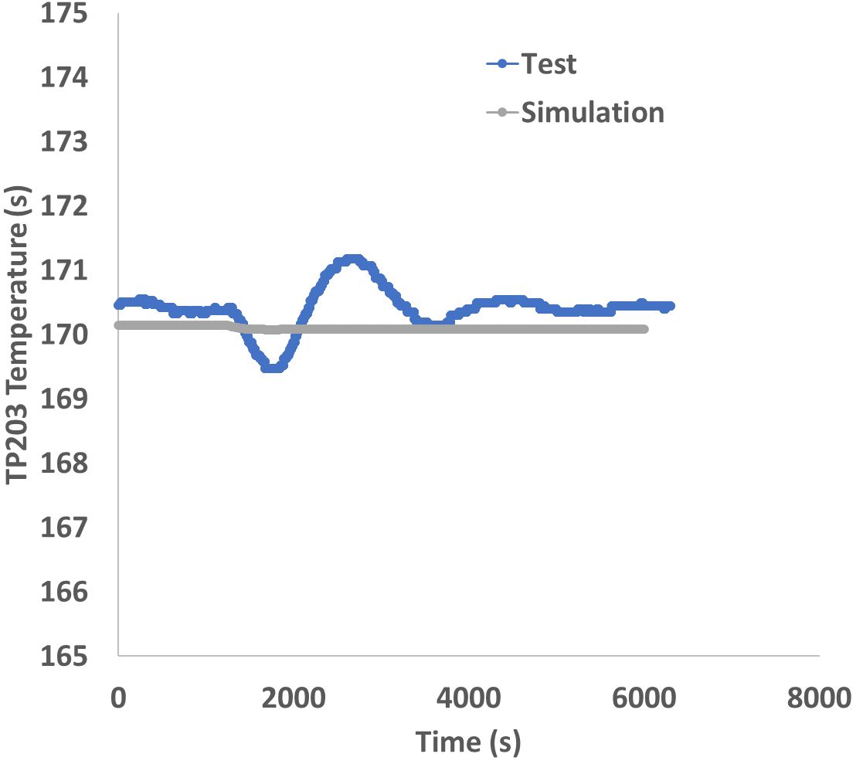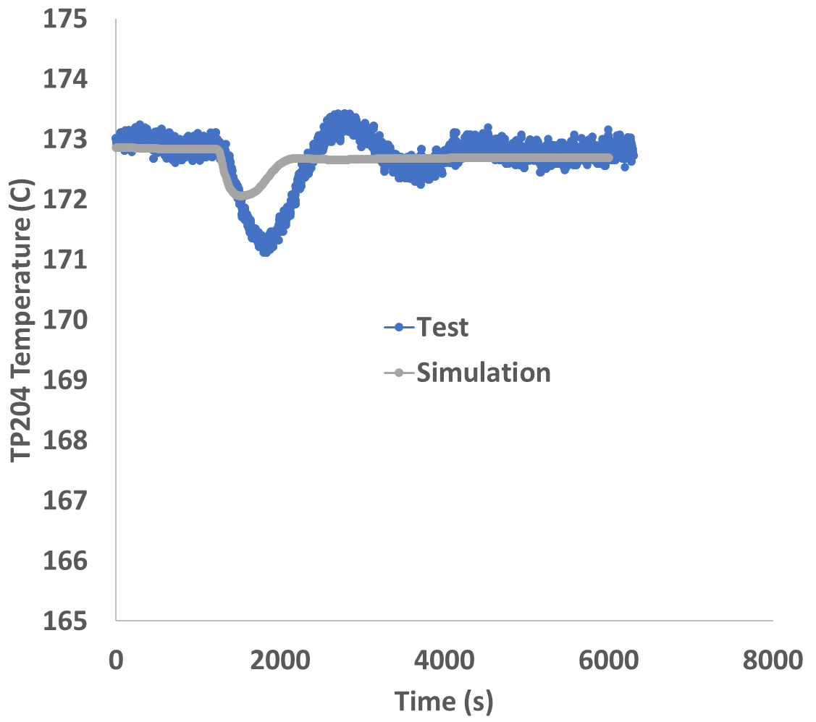
ADP10

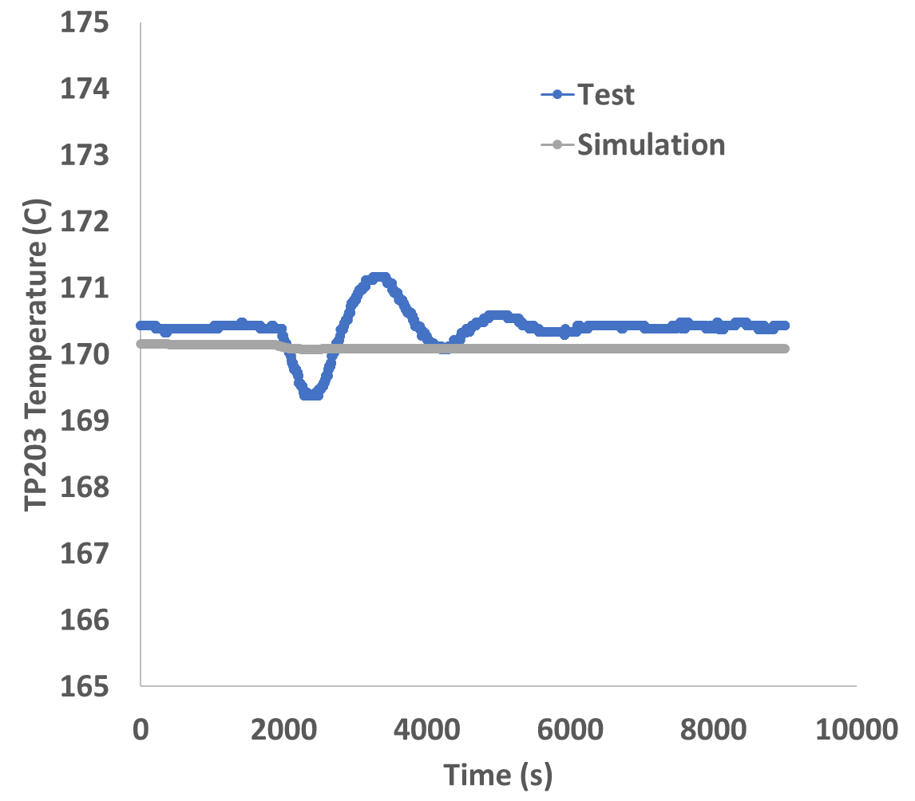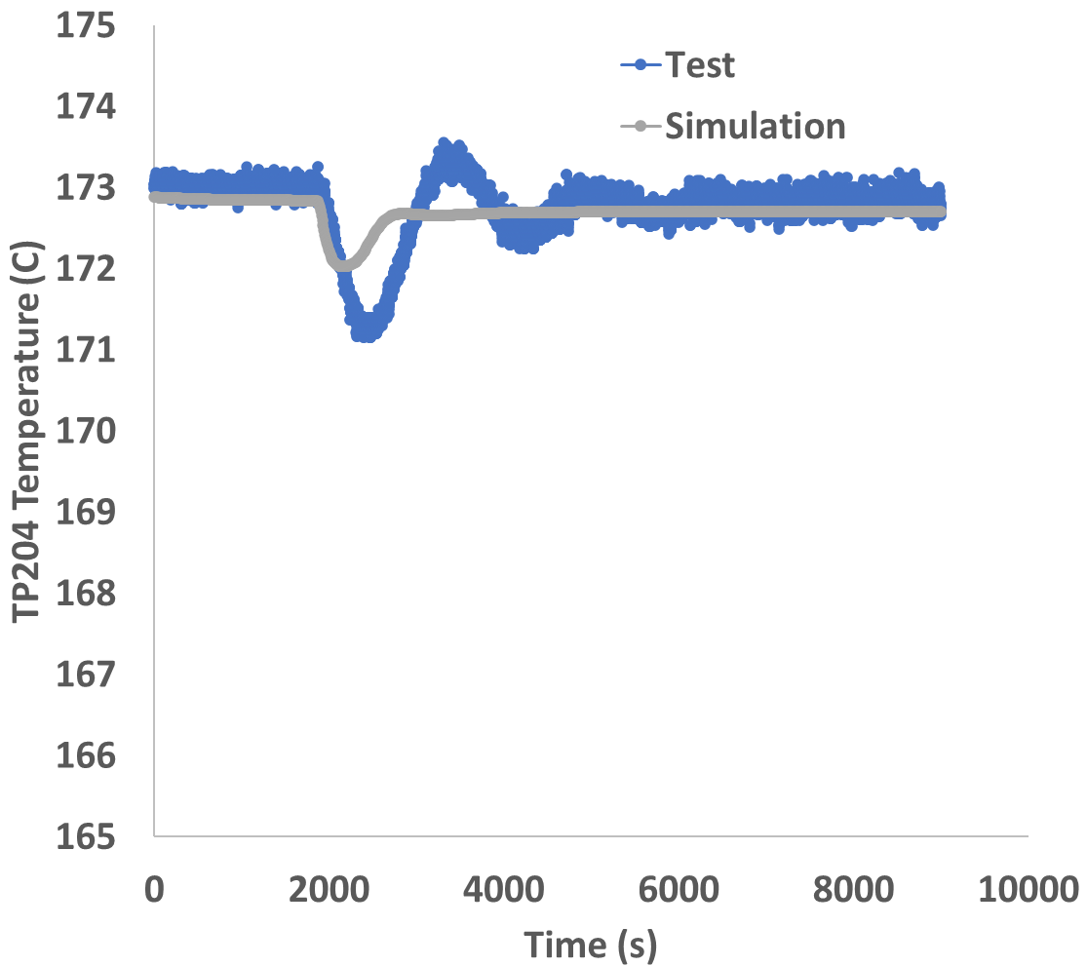
ADP06

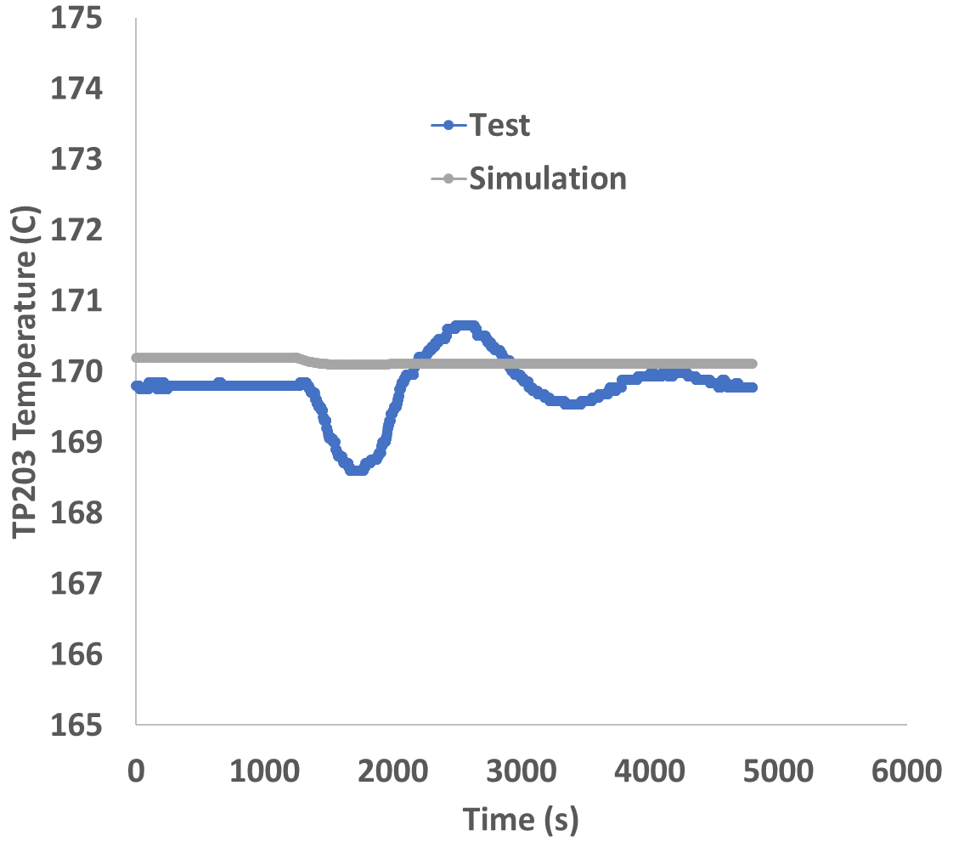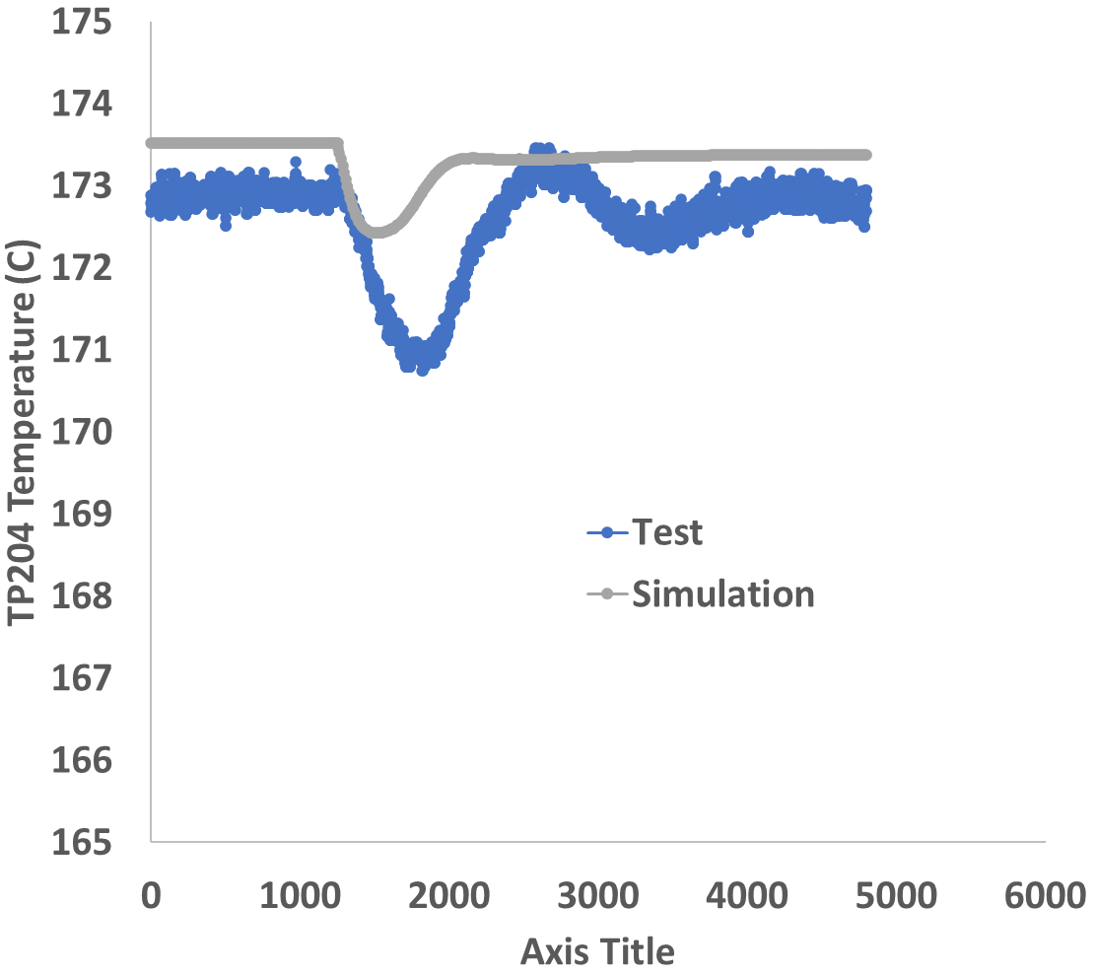
ADP07
Fig. 5 Heat exchanger water temperature

3.2.4 Pressure along the loop

The LBE pressure loss along the loop is much smaller than the differences due to hydrostatic pressure of LBE in the vertical portions of the loop. As is shown in Figure 6 the RS4.1 capture well the pressure didtribution in the riser portion of the loop. After the cutoff of argon injection, the messured pressure in the upper part of the riser increas slighly whereas in the RS4.1 simulation the pressure is nearly constant. The increase of upper riser pressure in the tests is due to the removal of argon from the riser and replacement with LBE, whereas the constant pressure in the simulation is due the lack of modeling of the gas lift phenomena. The the effect is more pronounced for P103 than for P105 due to the higher elevation of the former pressure transducer.

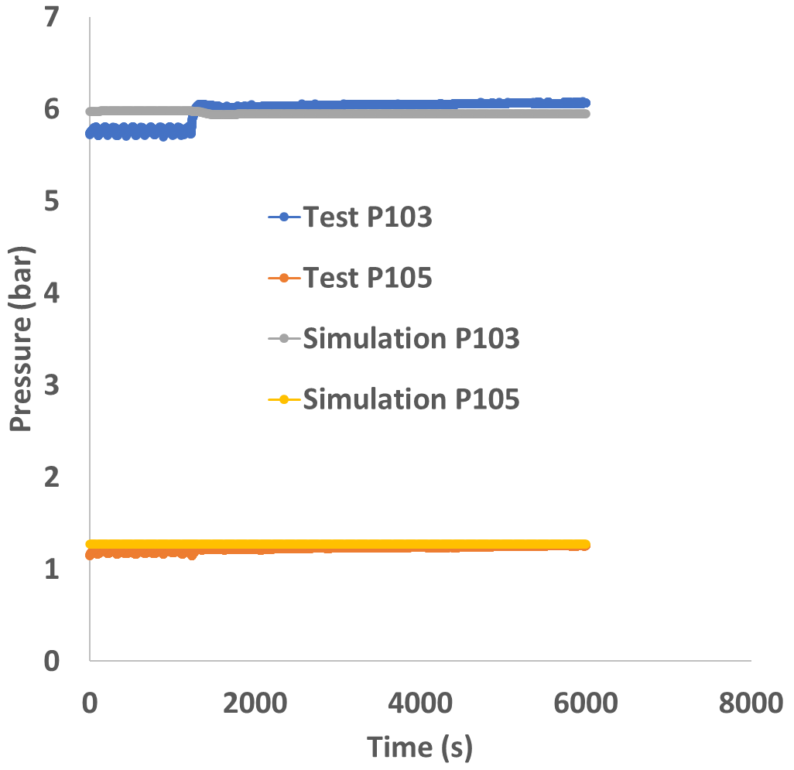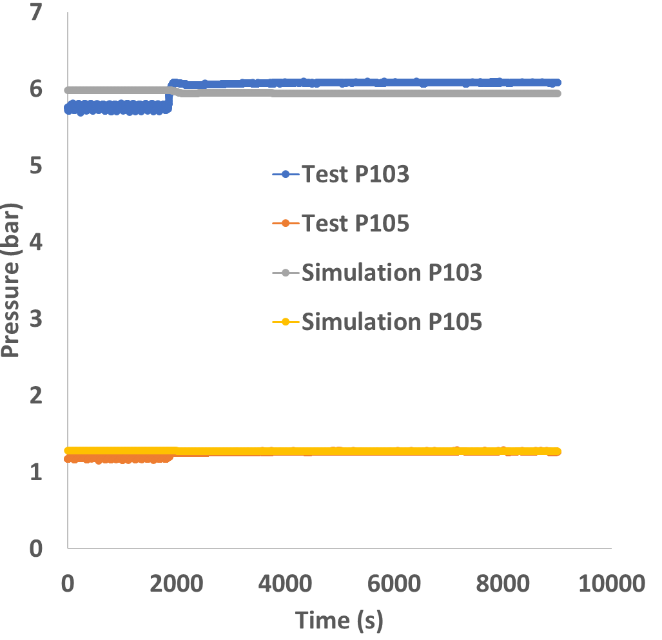
ADP10 ADP06

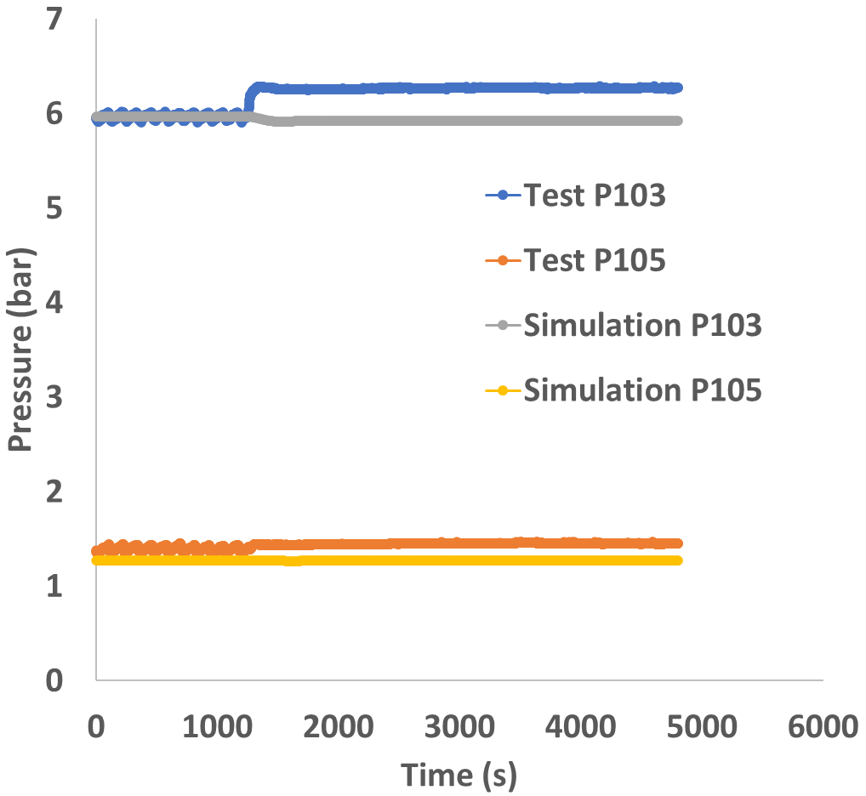
ADP07
Fig. 6 Loop pressure

3.3 Conclusion

The three tests ADP10, ADP06 and ADP07 of the NACIE-UP experimental facility were simulated using the RELAP5/SCDAPSIM/MOD4.1 code, and the following conclusions were obtained:
- The comparison between the experimental and the numerical results showed good agreement for all three tests ADP10, ADP06 and ADP07.
- Mass flow rate predictions seem to be inside the provided uncertainty range when imposing the nominal reference conditions. Some limits in the prediction of the gas lift phenomena were observed. Further analyses will be performed including uncertainties and actual measurements for the imposed boundary conditions. Improvements may be achieved during the first phases of the transition by regulating the injected Argon mass flow rate.
- Temperature predictions seem to be reproducing the measured values sufficiently well, especially from the phenomenological point of view for all three tests. Deviations to be connected to the differences between the predicted and measured mass flow rate are of course observed. Intrinsic limits in the FPS temperature predictions are observed.

[1] Allison, C.M. and Hohorst, J.K. (2010) Role of RELAP/SCDAPSIM in Nuclear Safety. Science and Technology of Nuclear Installations, 2010, Article ID: 425658. https://doi.org/10.1155/2010/425658
[2] Idelchik, I.E., “Handbook of Hydraulic Resistance”, begell house, inc., 2007.

[3] OECD/NEA Nuclear Science Committee, “Handbook on Lead-bismuth Eutectic Alloy and Lead Properties, Materials Compatibility, Thermal-hydraulics and Technologies”, 2015 edition.

[4] Cheng, S.K., Todreas, N.E., 1986. Hydrodynamic models and correlations for bare and wire-wrapped hexagonal rod bundles–bundle friction factors, subchannel friction factors and mixing parameters. Nuclear Engineering and Design, Vol. 92, pp. 227–251.

