IAEA CRP on Benchmark of Transition from Forced to Natural Circulation Experiment with Heavy Liquid Metal Loop
(NACIE CRP I31038)

Sapienza University of Rome Contribution:
Work Package 1 (System Level Analysis)
Work Package 3 (Subchannel Analysis)

Contributors:
Cristiano Ciurluini
Fabio Giannetti
Gianfranco Caruso

WP1: System Level Analysis

RELAP5-3D© System Thermal-Hydraulic (STH) model

Fluids and Materials
The fluids needed to perform the benchmark calculations are the Lead-Bismuth Eutectic (LBE) and water. They are used in the primary and secondary loop of the facility, respectively. In RELAP5-3D© code, for each system, a fluid type must be specified. Its properties are stored in an external data file, named tpf + fluid name [1]. For example, the one related to the LBE is called tpfbipb. LBE properties adopted for calculations are the ones suggested in the benchmark specifications [2]. They have been implemented in RELAP5-3D© by Sapienza. Instead, for water, the adopted properties are the ones implemented in the original version of the code [1]. In the primary loop, in the first part of the experimental tests, the LBE circulation is enhanced thanks to gas lift. For this purpose, argon is used. For this gas, the adopted properties are the ones implemented in the original version of the code [1].
Referring to the Fuel Pin Simulator (FPS), the main solid structures interfacing with the fluid domain are: the electrically heated pins and the external hexagonal duct, provided with an adequate layer of insulator to minimize the component heat losses. The pins have a stainless steel AISI316L clad, a central copper conductor and an insulator powder of Bohrium Nitride (BN); there is also an intermediate pipe made of Inconel600. The radial dimensions of the different layers, as well as the reference thermal properties to solve the heat conduction problem (i.e., density, heat capacity and thermal conductivity), are reported in [2]. In the same reference, the thickness and the thermal conductivity of the thermal insulator applied on the hexagonal duct external surface are also indicated. The same material, a mineral rock-wool layer with binding thermosetting resin, is used in the whole primary loop. The corresponding thickness is the same in all the sections of the circuit (see [2]). In addition, all the components and piping of the NACIE-UP facility are manufactured in AISI316L. Finally, for the Heat eXchanger (HX), the tube geometry is “tube in tube” with a gap filled by AISI316 powder. For it, the correlation suggested in [2] for the thermal conductivity was employed in the RELAP5-3D© input deck.
For solid materials involved in the heat transfer problem, RELAP5-3D© code prompts the user to enter the needed thermal properties. The required input consists of two tables collecting the thermal conductivity and volumetric heat capacity (i.e., density per heat capacity) trends against temperature, [1]. These properties were used to solve the Fourier's law for heat conduction in solid layers, [1].

Hydraulic Model
The FPS was simulated by using a lumped model. All the subchannels (interior, edge, corner, see Figure 1) are collapsed in an equivalent pipe component. The FPS axial nodalization consists of ten Control Volumes (CV). They are distributed among the Entry Non-Active Region (ENAR, four), the Active Region (AR, five), and the Unheated Exit Region (UER, one). The vertical discretization is reported in Table 1. The beginning of the AR is considered as the reference elevation (z = 0m). Within the FPS, bulk and wall temperatures are measured at three axial elevations, considered from the beginning of the AR, namely section A (0.038 m), B (0.3 m) and C (0.562 m). They coincide with the final elevations of 5th, 7th and 9th volumes, respectively (see Table 1). The flow area and hydraulic diameter adopted for the equivalent pipe are the ones of the FPS bundle (see Table 2), aligned with the data provided in the benchmark specifications [2]. The presence of wires wrapped around the pins leads to an increase in bundle pressure drops. To account for this aspect, the theory developed by Cheng and Todreas (C&T) in their work of 1986 is adopted [3]. RELAP5-3D© gives the user the possibility to insert a customized pressure drop correlation within the input deck, as discussed in [4].
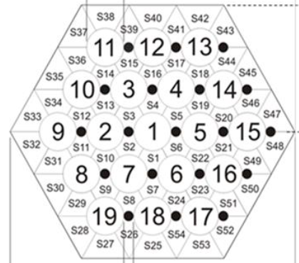
Figure 1 – FPS subchannel divisions derived from the benchmark specifications, [2].

Table 1 – FPS equivalent pipe: Axial nodalization.
CV# | Region | Axial Length [m] | Bottom Quote [m] | Top Quote [m]
1 | ENAR | 0.139 | -0.695 | -0.556
2 | ENAR | 0.139 | -0.556 | -0.417
3 | ENAR | 0.139 | -0.417 | -0.278
4 | ENAR | 0.139 | -0.278 | -0.139
5 | AR | 0.177 | -0.139 | 0.038
6 | AR | 0.131 | 0.038 | 0.169
7 | AR | 0.131 | 0.169 | 0.300
8 | AR | 0.131 | 0.300 | 0.431
9 | AR | 0.131 | 0.431 | 0.562
10 | UER | 0.153 | 0.562 | 0.715

Table 2 – FPS equivalent pipe: Main hydraulic features.
Parameter | Unit | Value
Flow Area | m² | 6.54E-04
Hyd. Diam. | m | 4.14E-03
$f$, Laminar Reg.: Φ_{s}-Coeff.¹ | - | 0.7077
$f$, Turbulent Reg.: A-Coeff.¹ | - | 0.022
$f$, Turbulent Reg.: B-Coeff.¹ | - | 38.40
$f$, Turbulent Reg.: C-Coeff.¹ | - | 0.883
¹ : These coefficients are entered in the RELAP5-3D© input deck to reproduce the behavior of a pressure drop experimental correlation, in this case C&T. For more details, see [4].
The loop nodalization scheme is shown in Figure 2. Riser pipeline is 2” ½ Sch. 40S. The Outer Diameter (OD), thickness and Inner Diameter (ID) are 73, 5.16 and 62.68 mm [2]. The argon pipe OD (inserted within the riser) is 12.7 mm. The RELAP5-3D© pipe component is composed of 24 Control Volumes (CV). The first 5 have higher flow area (3.088E-03 m²) while the lasting ones have reduced flow area (2.959E-03 m²) for the presence of the argon tube. Argon injection is connected to the inlet of the 6th volume of the pipe. The gas mass flow and inlet conditions are simulated with a time-dependent volume, setting the gas inlet temperature and pressure, and a time-dependent junction, imposing the mass flow.
The expansion tank is 10” Sch. 40S. The OD, thickness and ID are 273, 9.27 and 254.46 mm, respectively [2]. The component is modelled with the following elements:
  - A single junction connecting the top of the riser to the inlet of the 2nd CV of the equivalent pipe simulating the inner half of the tank.
  - Two vertical pipes, each one simulating a half of the LBE inventory within the tank (inner and the outer ones). They are characterized by the same vertical nodalization (2 CVs of 0.2 and 0.206175 m) and the same flow areas (2.33E-02 and 2.54E-02 m², respectively for the 1st and 2nd volume in upwards direction). The first value is lower than the second due to the presence of the riser pipe entering the tank.
  - A multiple junction, managing the lateral junctions linking the two vertical pipes and the vertical junctions connecting the two pipes with the uppermost gas plenum.
  - Gas plenum is represented by a fake pipe extending upwards with 10 CVs of 0.206175 m (for a total of 2.06175 m). The pipe height was arbitrarily extended for numerical reasons: this allow to better manage the free surface between LBE and noncondensables and to better accommodate pressure oscillations in the circuit. This component is omitted in Figure 2.
  - Above the pipe simulating the gas plenum, a single junction and a time-dependent volume impose the loop pressure (1.42E+05 Pa).
  - A single junction connects the outer half of the tank to the upper horizontal pipeline.
Upper Horizontal Pipeline (UHP) has 8 horizontal CVs, for a total length of 2.2635 m. Downcomer (DC) simulates the downwards section of the rectangular loop, including the tube side of the HX low/high power sections. The total number of CVs is 33. HX segment goes from 2nd CV (inlet plenum) to 13th CV (outlet plenum). The thermal height goes from 5th to 12th CV (8*0.2625=2.1 m). The 3rd and 4th CVs are the vertical section of the tube bundle related to the low power section (inactive during ADP tests). The tube bundle consists of 7 tubes, whose ID is 62.68 mm (as for the primary loop pipelines). Lower Horizontal Pipeline (LHP) has 10 horizontal CVs, one of which simulates the thermal flowmeter. The overall length is 2.4 m. UHP, DC and LHP features are the same as the riser.
Secondary water system is limited to the HX secondary side and related boundary conditions. The following components are used:
  - An inlet time-dependent volume sets the inlet temperature, 170 °C.
  - An inlet time-dependent junction sets the water mass flow, 10 m³/h (2.4943 kg/s @ 170 °C and 16 bar).
  - An inlet branch is used to monitor the inlet temperature.
  - A vertical pipe simulates the HX secondary side, considering the thermal height section (8 CVs*0.2625 m = 2.1 m).
  - An outlet branch is used to monitor the outlet temperature.
  - An outlet single junction and time-dependent volume set the outlet pressure, 16 bar.
One of the main modelling issues is the correct representation of the primary loop pressure drops, due to their influence on the natural circulation establishing in the second part of the ADP tests (after the gas flow ramp down). For the distributed pressure drops, the default correlation adopted by RELAP5-3D© is the Zigrang-Sylvester approximation to the Colebrook-White correlation [5]. Instead, the concentrated pressure drops were evaluated with a case-by-case approach by using the formulas suggested in [6]. The main concentrated pressure drops modelled in the primary loop are reported in Table 3.

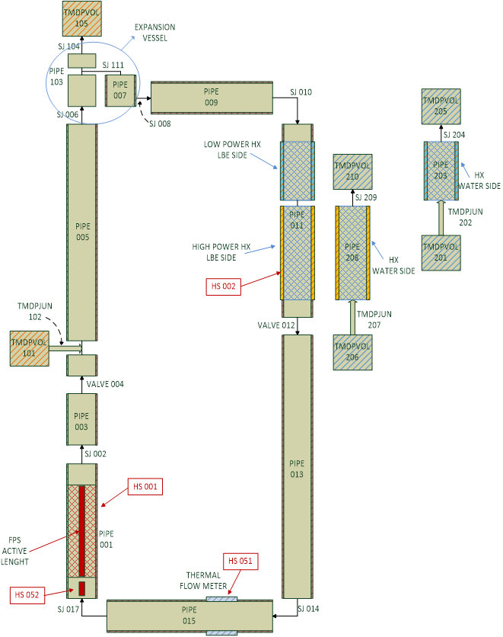
Figure 2 – NACIE-UP nodalization scheme for WP1 STH analysis.
Table 3 – Main primary loop pressure drops modelled in the RELAP5-3D© input deck.
Description | Value/Formula | Ref.
Curves:  UHP → DC  DC → LHP | 0.45 | [6]
FPS Inlet | $K_{1}=1.2*k_{Δ}k_{Re}k_{l}C_{1}A$ with  $k_{Δ}=1$,  $$k_{Re}=4.06/Re^{0.118}$$  $$k_{l}=0.99$$  $$C_{1}=1$$  $$A=1.2$$  $$K_{2}=Area Changes$$  $$K=K_{1}+K_{2}=1.3045+5.7879*Re^{-0.118}$$
Tank Inlet  (Riser → Tank Inner Half) | $$1-{\left(\frac{A_{min} }{A_{max}}\right)}^{2}=0.9966$$
Tank Outlet  (Tank Outer Half → Upper Hor. Pipe) | $$K=K'\left(1-\frac{A_{min} }{A_{max}}\right)+K_{curve}=1.0103$$  $$K^{'}=ƒ\left(\frac{δ}{D_{h}};\frac{b}{D_{h}}\right)$$
HX Inlet | $$1-{\left(\frac{A_{min} }{A_{max}}\right)}^{2}=0.9993$$
Bundle Inlet | 0.5*$\left(1-\frac{A_{min} }{A_{max}}\right)=0.4869$
Bundle Outlet | $$1-{\left(\frac{A_{min} }{A_{max}}\right)}^{2}=0.9993$$
HX Outlet | 0.5*$\left(1-\frac{A_{min} }{A_{max}}\right)=0.4869$
Flowmeter | See section 1.2
FPS Outlet Grid | $$K=C_{v}*{\left(\frac{A_{grid} }{A_{flow}}\right)}^{2}$$  $$C_{v}=3.5+\frac{73.5}{Re^{0.264}}+\frac{2.79*{10}^{10}}{Re^{2.79}}$$  $$K=3.5+8500000*Re^{-1.85}$$ | [7]

Thermal Model
RELAP5-3D© Heat Structure (HS) components are used in the input deck for several purposes:
- Power produced within the pins by electrical heating. This heat structure simulates the thermal power produced within the FPS due to the pin electrical heating, differentiated for ENAR and AR. The internal geometry of the pins was strictly reproduced starting from data in [2]. Fifteen radial intervals are used, five for the internal copper, two for the inner BN, one for the Inconel600, three for the outer BN and four for the AISI316L clad. Radially, an internal power source is associated to the copper mesh intervals only. Left Boundary (LB) is of reflective type, while Right Boundary (RB) are the CVs of the equivalent pipe simulating the FPS. For the wall-to-fluid Heat Transfer Coefficient (HTC), being a bundle geometry, Westinghouse correlation is adopted [8], with the p/d provided by the benchmark specifications [2]. The heated diameter is the one calculated with the C&T theory, see Table 2. Ten axial meshes are associated with each HS. They are uniquely related to the subchannel CVs (from the 1st to the 10th).
- Heat losses through the FPS hexagonal duct. The hexagonal duct is equivalently simulated by means of cylindrical geometry, adapting the geometrical features. Externally with respect to the duct, 10 cm of thermal insulator are also considered. LB are the CVs of the equivalent pipe simulating the FPS. Also in this case, ten axial meshes are associated with each HS, uniquely related to the FPS CVs. For the left HTC, Seban-Shimazaki correlation (for non-bundle geometries) has been preferred and adopted [9]. On the external surface of the insulator, as RB, an imposed air temperature and HTC are considered. They are derived from the benchmark specifications [2].
- Thermal transfer within the HX high power section. Left boundary consists of the DC pipe CVs (from 5th to 12th). For the HTC calculation, since LBE flows within the tubes, Seban-Shimazaki correlation is used [9]. RB is the secondary side water pipe CVs (from 8th to 1st). Right HTC is computed with Dittus-Boelter correlation [10], considering the Inayatov multiplier [11], based on the p/d. The latter is introduced to account for the turbulence introduced by the tube bundle. Eight axial HSs are adopted. Cylindrical geometry is used. Radial thickness is composed of 4 mesh intervals of SA-213 TP316H, 4 mesh intervals of AISI powder and further 4 mesh intervals for the outer tube (SA-213 TP316H). Powder thermal conductivity is evaluated by means of the correlation provided by benchmark specifications [2] ($T$ is in °C, $k_{powder}$ is in W/m*K).
$$k_{powder}=0.3+0.005*\left(T-200\right)$$
- Thermal flowmeter power. A HS is thermally coupled with one of the CVs of the LHP to simulate the power term associated with the thermal flowmeter.
- Loop heat losses. They are passive heat structures simulating the loop heat losses. LB are the CVs associated with the various pipes simulating the facility piping. For the HTC calculation, Seban-Shimazaki [9] or Dittus-Boelter [10] correlations are used. The latter is used where the pipe component simulates the water flowing outside the HX tube bundle. For RB an imposed air temperature and HTC are considered, according to the benchmark specifications [2]. Axial HS number depends on the nodalization of the correspondent pipeline. Cylindrical geometry is used. Radial thickness is composed of NN mm (where NN is the steel thickness of the correspondent component) of SA-213 TP316H (stainless steel, with three mesh intervals) and 10 cm of Rockwool (4 mesh intervals). The latter is valid for the whole loop, as indicated in [2].

Simulation Results
In the following section the results of the simulation activity will be discussed.
Selected Boundary Conditions [2]: The water thermodynamic conditions at the HX secondary side are set by means of boundary conditions. Two time-dependent volumes and a time-dependent junction are adopted to impose the inlet temperature, outlet pressure and inlet mass flow. In the same way, the gas thermodynamic conditions at the injection point are set by means of a time-dependent volume and a time-dependent junction, imposing the inlet temperature and mass flow. Finally, the different power terms (Pin active length, Pin entry length and Thermal flowmeter power) are provided thanks to inner source terms associated with the heat structures described in section 1.1.3. The same set of boundary conditions was adopted for all the ADPs, while values are differentiated for each test, according to the data available in [2].
Lessons learned. From the system level point of view, the three ADPs, object of the current benchmark exercise, are very similar. In each test, the transition from forced to natural circulation was investigated. The main difference is related to the power distribution among the pins composing the FPS. However, since the total FPS power is similar for all the tests considered, this aspect has negligible influence on the transient TH behavior of the overall facility, that is the focus of the analyses performed in the WP1. For this, the considerations discussed in the following are valid for all the tests (ADP06, ADP07 and ADP10). The most important Figure of Merit (FoM) to be investigated is the LBE flow rate. During the first open phase of the CRP, related to ADP06 and ADP10 tests, two main issues arose when the simulation results were compared to the experimental results.
- When gas lift is disabled and the LBE mass flow is due only to natural circulation (Steady State 2, SS2), the system code strongly overestimates this parameter. This is because in the RELAP5-3D© input deck the simulated pressure drops are far lower with respect to the experimental conditions. Indeed, if the experimental temperatures and pressures and the suggested LBE properties are used to determine the riser and downcomer densities, the corresponding driving force can be computed as:
$$∆ρ*g*∆h_{FPS/HX thermal centers }$$
The riser temperature can be evaluated as the mean of the SS2 values of TP-103 and TP-104. The downcomer temperature can be assessed as the mean of the SS2 values of TP-106 and TP-107. The corresponding densities are computed with the formula provided in [2]. The height difference between the FPS and HX thermal centers is reported in the benchmark specifications. The resulting driving force is equal to 9.7 kPa. The three main pressure drops of the primary loop are: the distributed pressure drops within the FPS (simulated by using C&T theory, see section 1.1.2), and the minor head losses associated with the FPS inlet and the FPS outlet grid. For them, the models used in the RELAP5-3D© input deck are derived from [6] and [7], respectively. All these pressure drops, both distributed and concentrated, can be theoretically evaluated by using the experimental data, i.e., FPS inlet/outlet temperatures (TP-101 and TP-102) and mass flow, and the LBE properties suggested in [2]. The C&T distributed pressure drops are equals to nearly 3 kPa (value also confirmed by CFD simulations), the FPS inlet minor head loss accounts for nearly 150 Pa and the corresponding one at the FPS outlet grid corresponds to about 900 Pa. Thus, nearly 5.65 kPa of circuit pressure drops are not modelled in the RELAP5-3D© input deck. They have been preliminary assigned to the inlet of the thermal flowmeter, that is the coldest region of the primary loop. The numerical simulations have been repeated by considering this additional pressure drop.
- Referring to the first part of the transient, when gas lift enhances the LBE circulation (Steady State 1, SS1), the average void fraction present in the riser column during the experimental test can be evaluated by the following formula:
$$α_{exp}=\frac{ρ_{LBE}-ρ_{m}}{ρ_{LBE}-ρ_{gas}} with ρ_{m}={∆p}_{exp}/(g*∆h_{pressure taps})$$
${∆p}_{exp}$ can be evaluated as the difference of the SS1 values of P-103 and P-105, located at mid and top riser quote, respectively. The height difference between these pressure taps is derived from the benchmark specifications (i.e., the drawings of the primary loop) and it is equals to 4.7 m. The $ρ_{gas}$ depends on the gas thermodynamic conditions within the riser and it is not easy to precisely determine. However, its value is negligible if compared with the LBE density. The resulting $α_{exp}=0.044$. The corresponding value predicted by RELAP5-3D© is 0.020. Thus, the system code strongly underpredicts the gas lift and the corresponding LBE mass flow during SS1. The reason why RELAP5-3D© cannot correctly predict the void fraction axial profile within the riser with the nominal gas flow is because the drift-flux models adopted in the case of liquid metals/noncondensables are the same developed for the water/noncondensable case. During ADP10 and ADP06 tests, at SS1, when forced circulation is promoted by the gas injection, the flow in the riser section is characterized by the following features: upflow and high mass flux (> 100 kg/m²s). In these conditions, the EPRI model is adopted by the code [12] and, as mentioned before, the computed average void fraction is half of the experimental one. Thus, the model proved to not be suitable for liquid metals. To compensate for this code limitation, the gas mass flow rate injected in the riser was doubled, matching in this way the void fraction profile calculated starting from the experimental data.
After the modifications in the loop pressure drops and the gas mass flow discussed above, the code is able to well predict the SS1 and SS2 values of the LBE flow rate in all the tests considered, as shown in Figure 3. The only slight deviation lies in the SS2 mass flow for ADP07 test. This is probably due to the fact that the missing pressure drop contribute discussed above was entered into the RELAP5-3D© input deck by using a constant k-coefficient. The latter was derived by considering the ADP10 and ADP06 thermal field. Instead, the one of ADP07 is slightly different (because of a higher power boundary condition used in the FPS).
Higher discrepancies are still present in the ramp down transient. The numerical trend anticipates the experimental one. A possible explanation for this deviation can be the thermal inertia of the flowmeter. Indeed, the LBE mass flow was indirectly evaluated by knowing the power provided to the instrument and by measuring its inlet/outlet temperatures. Thus, a delay in the outlet temperature reading due to the flowmeter thermal inertia can propagate to the LBE mass flow trend, justifying the time shift with respect to the numerical trend.
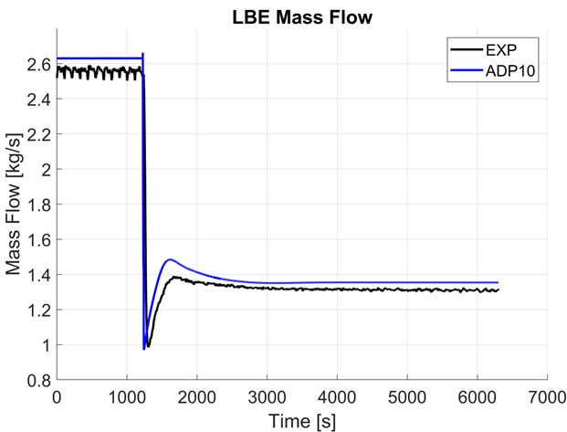 | 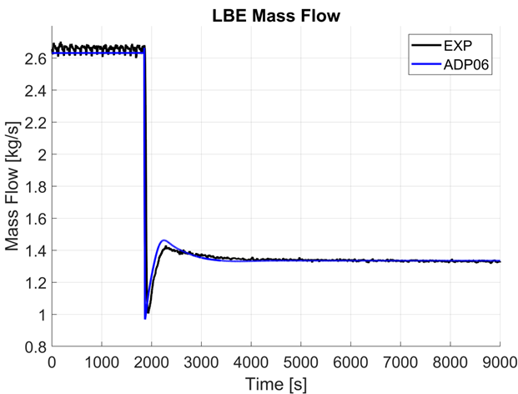
(a) | (b)
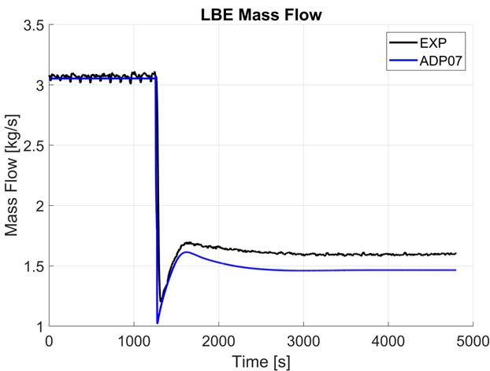
(c)
Figure 3 – LBE flow rate during ADP10 (a), ADP06 (b) and ADP07 (c) tests.
Final simulation results. The results obtained at the end of the second open phase of the CRP are collected in Figure 4. They show the comparison between the temperatures predicted by the code and the various measurements present in the facility. The primary loop temperatures can be grouped considering the ones belonging to the hot and cold circuit sections. The system code well reproduces the former, above all the FPS outlet one (TP-102). For ADP06 and ADP10, during SS2, it slightly underestimates the heat losses in the riser and expansion tank, leading to higher values of the corresponding temperatures (TP-103, TP-104, TP-105 and TP-310). A higher discrepancy is visible for ADP07, but it is consistent with the flow rate underestimation in Figure 3. Instead, some degrees-discrepancies are visible in the cold section temperatures considering both SS1 and SS2 (TP-101, TP-106 and TP-107). The magnitude of the difference slightly increases from SS1 to SS2. However, the relative error in terms of LBE thermal gradient decreases. Thus, the code slightly underestimates the heat transfer in the HX.
Another aspect to be highlighted is that the thermal transient detected by the ThermoCouples (TC) is faster than the one registered by the thermal flowmeter for the LBE mass flow (see for example the trend of TP-102 for ADP10 reported in Figure 4g). The system code predictions result aligned with the temperature readings but anticipate the mass flow (as discussed above and visible in Figure 3). This is a further clue that the actual influence of the thermal flowmeter inertia on the mass flow measurement must be evaluated and considered when the experimental and numerical trends are compared (above all in the transient phase after the gas mass flow ramp down).
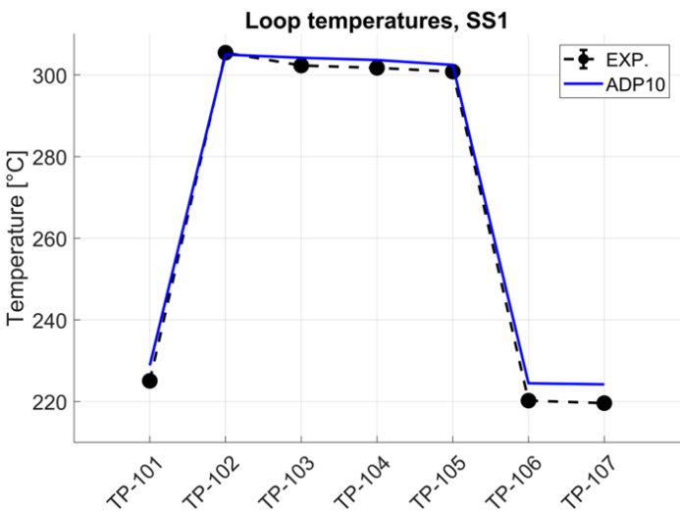 | 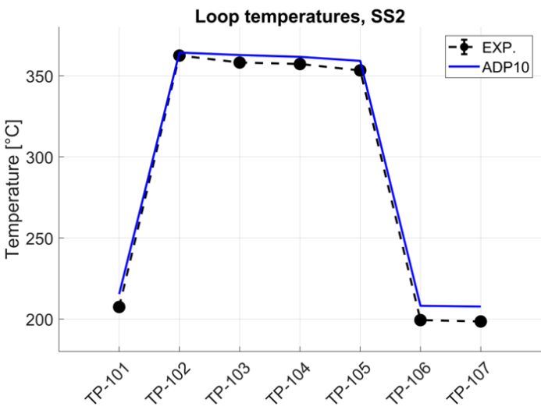
(a) | (b)
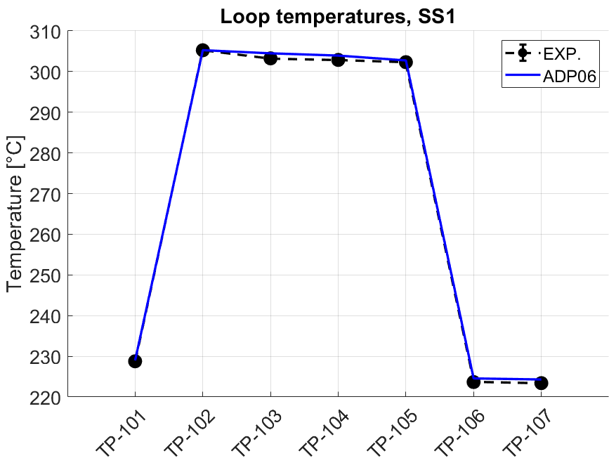 | 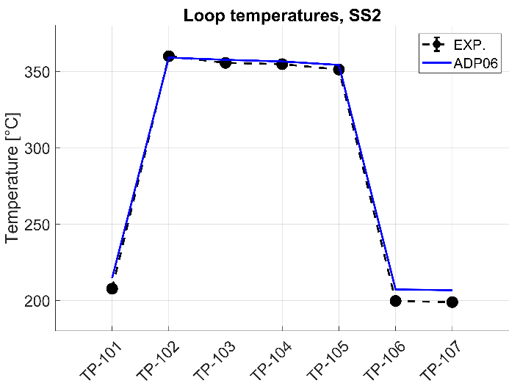
(c) | (d)
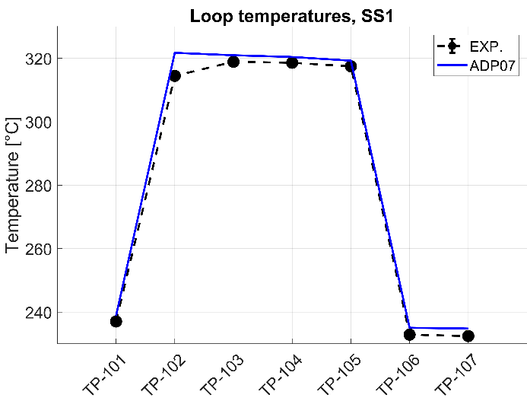 | 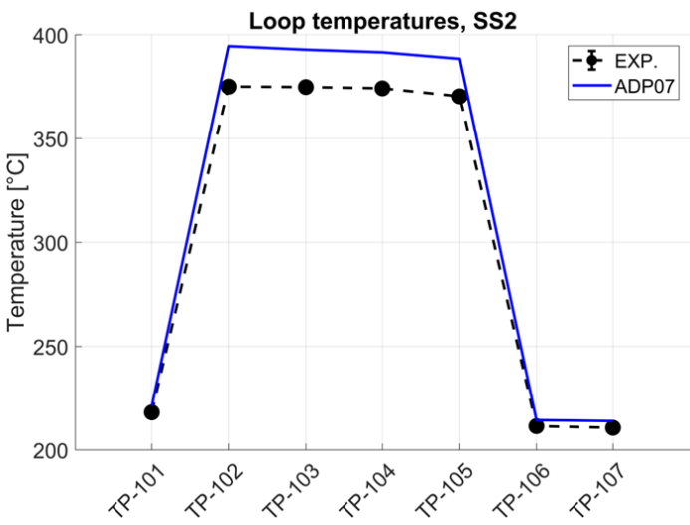
(e) | (f)
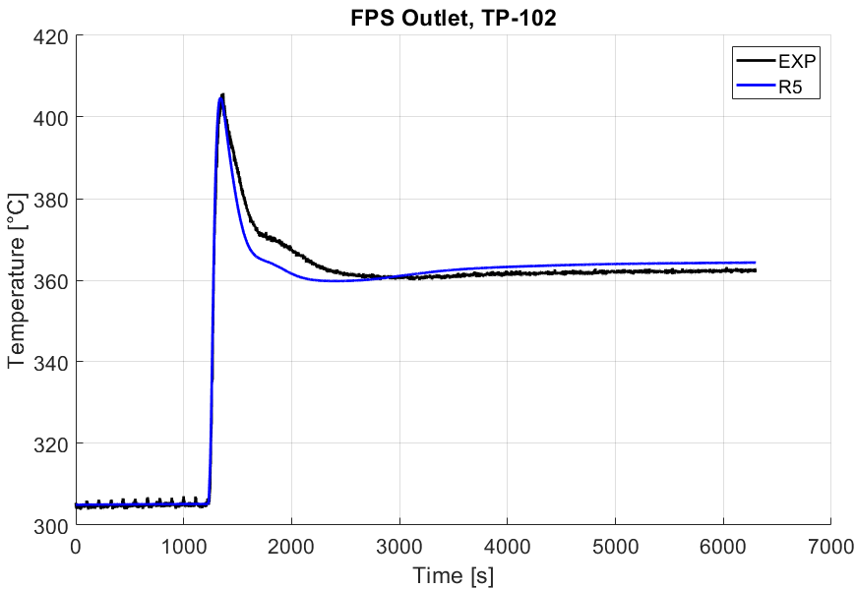
(g)
Figure 4 – Loop temperatures referred to ADP10 SS1 (a) and SS2 (b); ADP06 SS1 (c) and SS2 (d); ADP07 SS1 (e) and SS2 (f). TP-102 temperature for ADP10.

Conclusions
The main conclusions related to WP1 are:
- RELAP5-3D© can well reproduce the overall STH behavior of the facility, with some deviations whose origin has been identified.
- The code lacks dedicated drift flux models to handle the liquid metal/noncondensable interface. This strongly affects its predictive capabilities with respect to problems involving the gas lift simulation.
- When the proper pressure drops were entered in the input deck, the code demonstrated that can well simulate the natural circulation regime.
- RELAP5-3D© anticipates the transition from forced to natural circulation, but this could be due to some issues regarding the measurements provided by the thermal flowmeter.

WP3: Subchannel Analysis

RELAP5-3D© Thermal-Hydraulic model
The fluid and material properties used in the SubChannel (SC) analysis are the same already described for the STH analysis, see section 1.1.1.

Hydraulic Model
The FPS was modelled by using a SC approach. This methodology was based on the theory developed by Cheng & Todreas in their 1986 paper [3]. It was already adopted by Memmott et al. for Sodium Fast Reactors [13]. The scope of the work performed at Sapienza is to validate this approach also for HLM applications.
In Figure 5, it is reported the comparison between the FPS subchannel division derived from the benchmark specifications (a, [2]) and the one adopted for the RELAP5-3D© hydraulic model (b). The main differences are related to the edge region. There, the C&T theory identify two different channel types: edge (red in Figure 5b) and corner (green in Figure 5b). Instead, all triangular subchannels are present in the benchmark specification division. No differences can be observed for the interior subchannels (blue in Figure 5b).
 | 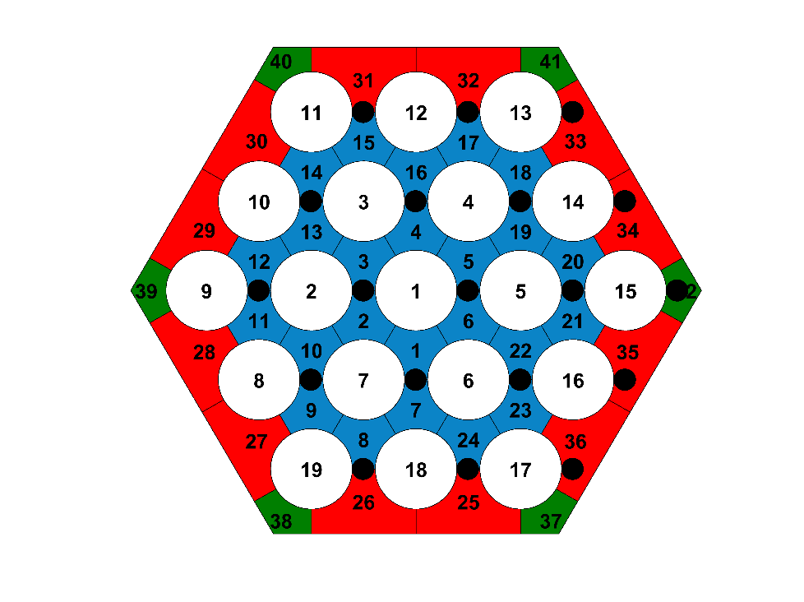
(a) | (b)
Figure 5 – Comparison between the FPS subchannel divisions derived from the benchmark specifications (a, [2]) and adopted for the RELAP5-3D© hydraulic model (b).
The same FPS axial nodalization of the STH model was selected, see Table 1. According to C&T theory, the overall FPS was divided into 42 subchannels, grouped into three categories: interior (I, 24 subchannels), edge (E, 12 subchannels), and corner (C, 6 subchannels), colored in Figure 5b with blue, red and green. They are characterized by different TH behavior. For this, each channel was modeled with a dedicated pipe component. The hydraulic features associated with each subchannel type are collected in Table 4. The presence of wires wrapped around the pins leads to an increase in bundle axial pressure drops. To account for this aspect, the 1986 C&T theory was adopted [3]. As already mentioned, RELAP5-3D© gives the user the possibility to include in the input deck ad-hoc pressure drop correlations (see [4]). In this case, the coefficients reported in Table 2 were recalculated for each subchannel type (I, E and C).

Table 4 – Hydraulic features characterizing the different subchannel types (internal, edge and corner).
Parameter | Unit | Interior | Edge | Corner
Number | - | 24 | 12 | 6
Flow Area | m² | 1.249E-05 | 2.496E-05 | 9.121E-06
Hyd. Diam. | m | 3.830E-03 | 4.654E-03 | 3.555E-03
$f$, Laminar Reg.:  Φ_{s}-Coeff.¹ | - | 0.7438 | 0.6492 | 0.6443
$f$, Turbulent Reg.:  A-Coeff.¹ | - | 0.0153
$f$, Turbulent Reg.:  B-Coeff.¹ | - | 10.50 | 2.20 | 2.55
$f$, Turbulent Reg.:  C-Coeff.¹ | - | 0.7085 | 0.50
¹ : These coefficients are entered in the RELAP5-3D© input deck to reproduce the behavior of a pressure drop experimental correlation, in this case C&T. For more details, see [4].
The crossflow among adjacent subchannels is also considered. Several multiple junction components manage the 600 cross junctions needed to simulate the crossflow between adjacent subchannels (60 subchannel pairs per 10 axial CVs). In particular:
  - 60 junctions to connect 1st row interior subchannels.
  - 60 junctions to connect 1st and 2nd row interior subchannels.
  - 180 junctions to connect 2nd row interior subchannels.
  - 120 junctions to connect 2nd row interior and edge subchannels.
  - 120 junctions to connect edge and corner subchannels.
  - 60 junctions to connect edge subchannels.
The lateral mass transfers depend on the pressure gradient and the hydraulic resistance only. To properly simulate them, k-loss coefficients are entered in the RELAP5-3D© input deck and associated with the cross junction components. They are evaluated by using the formulas available in [6] and, being Reynolds-dependent, they are inserted in the input deck following the procedure described in [4]. The adopted formulas are reported below:
$K=\left(z_{p}+1\right)*A*φ*{Re}^{-0.27}$, with $A=3.2+0.66a_{1}$ and $a_{1}={\left(1.7-\overline{s}\right)}^{1.5}$
Where $φ$ and $\overline{s}$ are equal to 1 for the fuel bundle.
The presence of the wires wrapped around the fuel pins produces an assembly-wide swirl flow passing through each of the edge subchannels of the assembly in the rotational direction of the wire wrap. This effect is illustrated in Figure 6. This flow flattens the temperature distribution along the assembly duct, above all in the periphery. Otherwise, it would be significantly non-uniform due to the small power to-flow ratio in the corner subchannels with respect to the edge subchannels. To account for this effect, a set of Control Variables (CNTRLVARs) and time dependent junction components is used. Specifically, for each pair of adjacent subchannels belonging to the assembly periphery, i.e., edge-corner or edge-edge, a mass flow term ($M_{SF,i-j}$) is computed according to the following:
$$M_{SF,i-j}=C_{1,L}*v_{i}*ρ_{i}*A_{t}$$
Where, $C_{1,L}$ is called edge transverse velocity ratio and it is defined as the ratio between the transverse velocity through the gap dividing two adjacent subchannels and the velocity in the axial direction ($v_{i}$, that is nearly the same for all the edge subchannels); $ρ_{i}$ is the fluid density; $A_{t}$ is the area of the gap dividing two adjacent subchannels in the transverse direction, see Figure 6. This mass flow term is headed from channel $i$ to channel $j$ in clockwise/anticlockwise direction, according to the wire orientation. This effect is accomplished by means of a time dependent junction. Summarizing, along the periphery of the NACIE-UP FPS, there are 18 pairs of adjacent subchannels. Considering the ten axial meshes adopted for the FPS vertical discretization, a total number of 180 CNTRLVARs and 180 time dependent junctions were used to simulate the swirl flow.
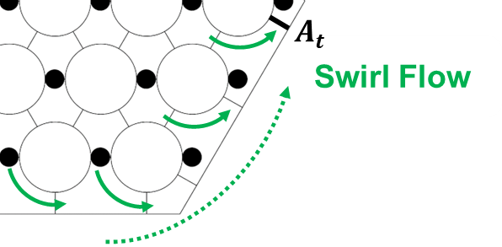
Figure 6 – Swirl flow produced in the FPS periphery by the presence of the wire-wrapped pins.

Thermal Model
RELAP5-3D© heat structure components are used in the input deck for several purposes:
- Power source term related to the pin electrical heating. One of these heat structures is associated with each pair Pin/Channel, for a total of 102 HSs. They simulate the thermal power produced within the FPS due to the pin electrical heating, differentiated for ENAR and AR. The pin has a stainless steel AISI316L clad, a central Copper conductor and an insulator powder of Bohrium Nitride (BN); there is also an intermediate pipe made of Inconel600. The main dimensions of the different parts of the pin are resumed in [2] and adopted to strictly reproduce the pin geometry. Fifteen radial intervals are used, five for the internal copper, two for the inner BN, one for the Inconel600, three for the outer BN and four for the AISI316L clad. Radially, an internal power source is associated to the copper mesh intervals only. LB is of reflective type, while RB is the CVs belonging to the associated subchannel. For the right HTC different correlations were assessed, see section 2.2. The heated diameters for interior, edge and corner subchannels are the ones calculated with the C&T theory, see Table 4. Ten axial meshes are associated with each HS. They are uniquely related to the subchannel CVs (from the 1st to the 10th). For each pair pin/channel the pin surface fraction associated with the considered channel is evaluated (1/6 for interior and corner channels and 1/4 for edge ones). For each HS axial mesh, the heat transfer surface is computed as: mesh axial height * pin surface fraction.
- Heat losses through the FPS hexagonal duct. There is a HS for each edge and corner subchannel (for a total of 18 components). The hexagonal duct is equivalently simulated by means of cylindrical geometry, adapting the geometrical features. Externally with respect to the duct, 10 cm of thermal insulator are also considered. LB consists of the subchannel CVs. Also in this case, ten axial meshes are associated with each HS, uniquely related to the subchannel CVs. For the left HTC, Seban-Shimazaki correlation (for non-bundle geometries) has been selected and adopted [9]. On the external surface of the insulator, as RB, an imposed air temperature and HTC are considered. They are derived from the benchmark specifications [2].
- Wire turbulent mixing (WTM). These HSs are used to simulate the energy exchange among adjacent subchannels due to the presence of the wire. By means of a set of more than three thousands RELAP5-3D© CNTRLVARs, it is computed a power term for each pair of adjacent subchannels and each axial quote.
$$q_{i,j,k}=m_{t,i,j,k}*\overline{c_{p,i,j,k}}*\left(T_{j,k}-T_{i,k}\right)=M_{WTM}*\overline{v_{i,j,k}}*\overline{ρ_{i,j,k}}*A_{t}*\overline{c_{p,i,j,k}}*\left(T_{j,k}-T_{i,k}\right)$$
Where: $k$ is the axial CV (from 1st to 10th); $i$ and $j$ are the adjacent subchannels; $q$ is the power transferred from one subchannel to another; $m_{t}$ is the transverse mass flow rate; $c_{p}$ the average specific heat; $T_{i,k}$ and $T_{j,k}$ the bulk temperatures of the i^{th} and j^{th} subchannels at the axial node $k$. The transverse mass flow rate is computed as the product between the average density $ρ$, the transverse flow area $A_{t}$ and the axial velocity $v$. Three combinations of subchannel pairs are possible: interior-interior (I-I), interior-edge (I-E) and edge-corner (E-C). $M_{WTM}$ parameter varies according to the pair of adjacent subchannels that is considered. It is different for interior and edge regions since it has a different physical meaning in these two cases. For the details, refer to [3]. For I-I and I-E pairs, $M_{WTM}$ is the dimensionless effective eddy diffusivity ($ε^{*}$), while for the E-C pairs it is the edge transverse velocity ratio ($C_{1L}$). Two different sets of formulas were considered for these parameters. The first set is derived from the original C&T theory [3].
$$ε^{*}=C_{m}*{\left[\frac{\left(\frac{π}{6}\right){\left(P-\left(\frac{D_{0}}{2}\right)\right)}^{2}-(\frac{πD_{0}^{2}}{24})}{\left(\frac{\sqrt{3}}{4}\right)P^{2}-(\frac{πD_{0}^{2}}{8})}\right]}^{0.5}tanθ$$
$$C_{1L}=C_{s}*{\left[\frac{\left(\frac{π}{4}\right){\left(\left(\frac{D_{0}}{2}\right)+D_{w}\right)}^{2}-(\frac{πD_{0}^{2}}{16})}{P*\left(\left(\frac{D_{0}}{2}\right)+D_{w}\right)-(\frac{πD_{0}^{2}}{8})}\right]}^{0.5}tanθ$$
$$cosθ=\frac{H_{w}}{\sqrt{H_{w}^{2}+{\left(π\left(D_{0}+D_{w}\right)\right)}^{2}}}$$
where $P$ is the pin pitch, $D_{0}$ is the pin outside diameter, $D_{w}$ is the wire-wrap spacer diameter and $H_{w}$ is the helical wire-wrap pitch. $C_{m}$ and $C_{s}$ are Reynolds-dependent parameters whose expressions are reported in [3]. They have two different formulas for laminar and turbulent regions. In the transition region, that is the one of interests for the current simulation activity, they are interpolated. The second set of formulas for $M_{WTM}$ parameters was derived from studies carried out by Chiu, Rohsenow and Todreas (CRT) in 1978 [14]. The following formulas are suggested:
$$ε^{*}=0.128*{\left(\frac{P}{P-D_{0}}\right)}^{0.5}*{\left(\frac{A_{r1}}{A_{1}^{'}}\right)}^{0.5}*\frac{\left(D_{0}+D_{w}\right)P^{2}}{\sqrt{π^{2}{\left(D_{0}+D_{w}\right)}^{2}+H_{w}^{2}}}*\left(\frac{1}{A_{1}^{'}}\right)$$
$$C_{1L}=10.5*{\left(\frac{P-D_{0}}{P}\right)}^{0.35}*{\left(\frac{A_{r2}}{A_{2}^{'}}\right)}^{0.5}*\frac{\left(D_{0}+D_{w}\right)}{\sqrt{π^{2}{\left(D_{0}+D_{w}\right)}^{2}+H_{w}^{2}}}$$
In this case, formulas are valid for both the laminar and turbulent regimes. $A_{r1}$, $A_{r2}$, $A_{1}^{'}$ and $A_{2}^{'}$ are the same parameters used also in the C&T theory, see [3]. Once calculated, these power terms are used as internal sources in ad-hoc heat structure components used to simulate the wire turbulent mixing. One of these heat structures is associated with each subchannel (for a total of 42 components). Ten axial meshes are associated with each HS. They are uniquely related to the subchannel CVs (from the 1st to the 10th). These HSs are characterized by a virtual thin layer of AISI316L and a very large heat transfer surface. In this way, the FPS thermal inertia is not altered by the insertion of a non-existent material and the power term associated with the HS mesh is transferred without time delay to the coolant.
- Thermal conduction within the LBE fluid. RELAP5-3D© was originally developed to simulate safety-relevant transient scenarios belonging to light water reactors [1]. When it comes to water, energy exchange due to conduction is negligible with respect to convection. For this, RELAP5-3D© lacks a model accounting for such a heat transfer mechanism. Nevertheless, it can significantly affect thermal problems involving liquid metals. Studies present in literature [15] propose the adoption of a modified Peclet number (Pe*) as the reference parameter to assess the relative importance of conduction along the axial and radial directions. As discussed in [4], axial conduction never plays a significant role in the liquid metal thermal-hydraulic behavior. Thus, it was neglected in the current work. However, radial conduction can moderately influence the transients characterized by low flow rate, as in the case of ADPs experiments. It was modeled by adding ad hoc HS components to the RELAP5-3D© input deck. 60 heat structures are used to thermally couple the adjacent subchannels. In particular:
  - 6 heat structures to couple the 1st row interior subchannels.
  - 6 heat structures to couple the 1st and 2nd row interior subchannels.
  - 18 heat structures to couple the 2nd row interior subchannels.
  - 12 heat structures to couple the 2nd row interior and edge subchannels.
  - 12 heat structures to couple the edge and corner subchannels.
  - 6 heat structures to couple the edge subchannels.
The material used is a fake LBE characterized by its thermal conductivity and a negligible heat capacity. The thickness adopted is the distance between the centers of two adjacent subchannels. Moreover, to exclude the convective thermal resistance, a very high multiplicative factor was entered into these HSs (for further details, see [4]).

Simulation Results
In the following sections the results of the simulation activity will be discussed.
Selected Boundary Conditions: The analysis related to the WP3 is focused on the evaluation of the FPS thermal-hydraulic performances during selected transient conditions. For this, as discussed in the previous section, the input deck is limited to the FPS and proper boundary conditions must be chosen to perform the numerical activity. In particular, the LBE inlet temperature and mass flow experimental trends were used as inputs to the model. For the former, the TP-101 reading was considered as the most appropriate. For example, the time trends of the selected boundary conditions are shown in Figure 7 for ADP10.
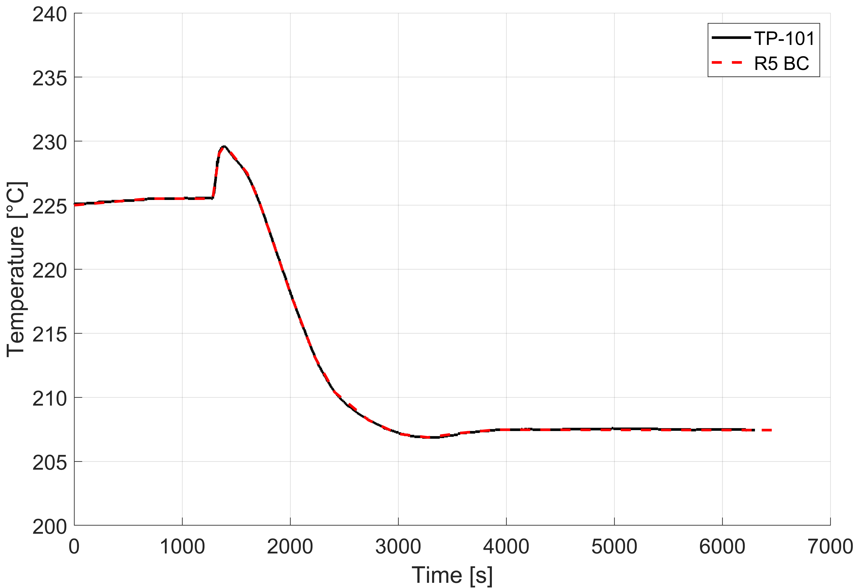 | 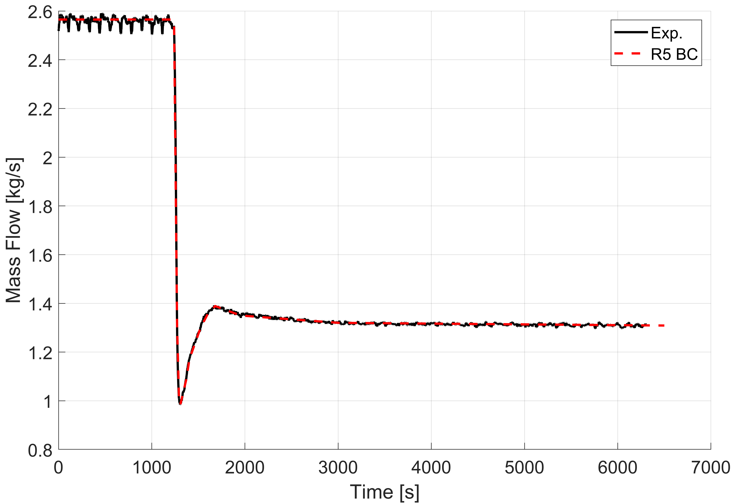
(a) | (b)
Figure 7 – Selected boundary conditions to perform the ADP10 test for WP3: LBE inlet temperature (a, TP-101) and mass flow (b) experimental trends.
FPS global parameters: The first outcome to be discussed is the trend of the FPS outlet temperature. The comparison between the numerical results and the experimental data is shown in Figure 8, taking as example the ADP10. These considerations, since referred to the FPS global parameters, are common to all the ADP tests considered. For the comparison, the temperature reading labeled as ‘FPS-out’ was chosen among the available experimental data since it was considered the most appropriate. As visible in Figure 8a, RELAP5-3D© can well predict the steady state values of this parameter at both SS1 and SS2. This means that the system code well reproduces the FPS overall power balance. This result is quite expected since the pin electrical heating and the LBE inlet temperature and mass flow are provided as boundary conditions. In addition, the LBE thermophysical properties adopted by the system code are aligned with the benchmark specifications. Only heat losses can be also included in the power balance, but the simulation results prove that their contribution is negligible. What is worth discussing is the discrepancy in the FPS outlet temperature time trend, just after the gas mass flow ramp down (see Figure 8b). The RELAP5-3D© trend (blue solid line) can catch the peak related to the experimental data (black solid line) but with a time delay of about 60 s. This behavior is consistent with the considerations already done in section 1.2 about the mass flow measurement. In the system level analysis related to WP1, when it comes to the LBE flow rate, the code anticipates the ramp down with respect to the experimental data provided by the thermal flowmeter. At the same time, the TC readings are aligned with the RELAP5-3D© calculation outcomes. In Figure 8, this aspect is recalled even if reverted. Since the experimental trend of the LBE flow rate is used as boundary condition, an eventual delay in the ramp down results in a consequent delay in the FPS outlet temperature. This seems a reasonable justification for the time shift in Figure 8b, also experienced in ADP06 and ADP07 tests.
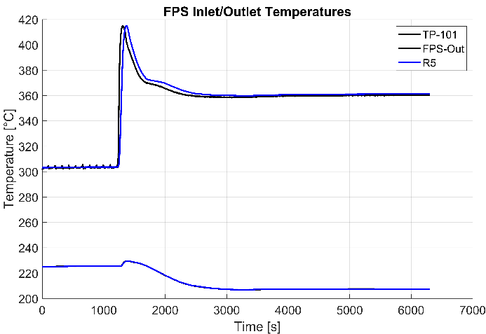 | 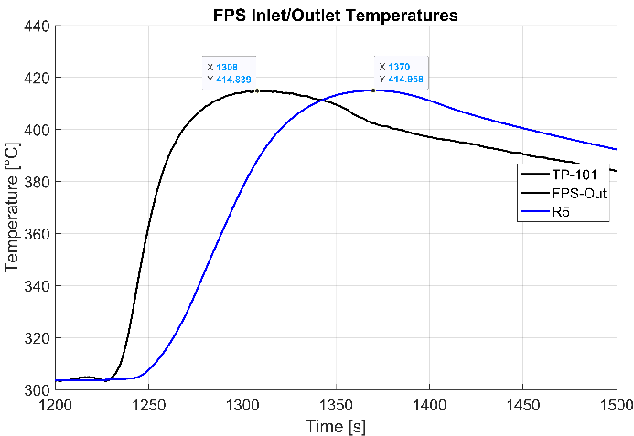
(a) | (b)
Figure 8 – ADP10, comparison between numerical results and experimental data: FPS inlet/outlet temperatures. In (a) is reported the overall transient while in (b) a zoom of the TW after the gas mass flow ramp down.
Conventions for comparison plots: The comparison between numerical outcomes and experimental trends is performed by considering both bulk and wall temperatures. The bulk temperatures belonging to the same section (i.e., A, B or C) were sorted based on their radial distance from the FPS center (r = 0). Positive and negative values are both considered to differentiate subchannels at the same radial distance (e.g., subchannel 2 and 5). The correspondence between instrumented subchannels and radial positions used in the x-axis of the bulk temperatures figures are summarized in Table 5. For the wall temperatures, the standard numbering convention indicated in the benchmark specifications was used [2].
Table 5 – Numbering convention for FPS bulk temperatures belonging to the same section (A, B or C).
Subchannel | Radial Position [mm]
33 in Figure 5a  (29 in Figure 5b) | -20.4
2 | -4.9
5 | 4.9
22 | 9.5
26 | 17.9
Sensitivity Analysis: To better evaluate the impact of some phenomena on the simulation results a sensitivity analysis was performed on some selected parameters belonging to the input deck. In particular:
- The $M_{WTM}$ parameters, i.e. the dimensionless effective eddy diffusivity ($ε^{*}$) and the edge transverse velocity ratio ($C_{1L}$). For them, two different sets of formulas were considered: the ones derived by the original C&T theory [3] and the ones indicated in the studies carried out by Chiu, Rohsenow and Todreas in 1978 [14]. The sensitivity on these parameters allows to assess the effect of the wire turbulent mixing and its capability to smooth the LBE radial temperature gradient present within the FPS transversal section.
- The HTC correlation to be used for the wall-to-fluid heat transfer between electrically heated pins and LBE. This aspect only influences the wall temperatures. The aim of this sensitivity is to identify the most suitable correlation among the ones available in literature for bundle geometry. The selected candidates are Westinghouse (default correlation in RELAP5-3D^{©28} [8]), Mikityuk [16], Ushakov [17] and Graber-Rieger [18]. All these correlations were evaluated against the NACIE-UP FPS geometry. The HTC vs temperature trend was calculated for each expression, considering a temperature range enveloping all the transient evolutions eventually occurring during the ADP tests considered, i.e., $T ∈\left[200;520\right] °C$. They are collected in Figure 9. The Reynolds numbers needed to compute the HTCs were assessed by taking into account the velocity profile related to an interior subchannel during ADP10 SS1. As visible, in the considered temperature range, the two edge correlations, bounding all the others, are the Ushakov and Westinghouse ones, representing the upper and lower cases, respectively. The same result was also obtained by accounting for the other tests (ADP06 and ADP07), the other steady state condition (SS2, characterized by natural circulation) and the other subchannel types (edge and corners). These two correlations were, thus, selected to perform the simulation of the ADP tests. For what concerns the Ushakov correlation, since not available in RELAP5-3D©, it was inserted in the input deck by means of a fouling factor. The comprehensive description of the needed procedure is provided in [4].
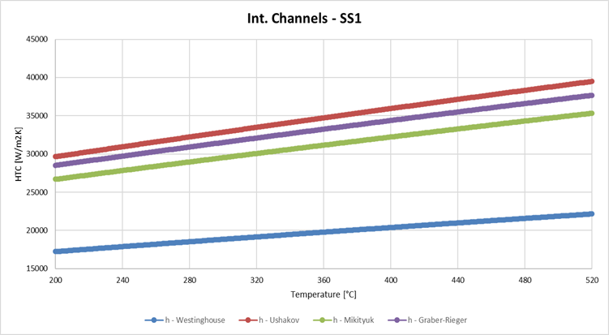
Figure 9 – HTC vs temperature trend for the selected correlations related to bundle geometry.
Final simulation results. When it comes to WP3, since it is focused on the FPS subchannel analysis, it is not possible to identify a common behavior characterizing all the ADP tests. Indeed, the different pin power distributions adopted in each experiment strongly influence the thermal-hydraulics within the component. For this, each test is separately discussed in the following.
ADP10
The LBE bulk temperatures related to the instrumented channels belonging to section C (i.e., outlet section) at both SS1 and SS2 (i.e., 1000 s and 6300 s, respectively) are collected in Figure 10. The five instrumented channels are uniquely identified by their position with respect to the assembly center, as indicated in Table 5. The corresponding wall temperatures referred to the instrumented pins are shown in Figure 11. They have been sorted in ascending order, according to the classification present in [2]. In Figure 10 and Figure 11, test data are plotted with a black solid line together with error bars, representing the measurement uncertainty (±1°C). Different cases were simulated, based on the sensitivity parameters discussed above. The description of the cases considered is reported in Table 6. For each case and for both SS1 and SS2, the average temperature difference ($T_{err,avg}$) between simulation results and experimental data was computed and the resulting values are gathered in Table 6, for bulk temperatures, and Table 7, for wall temperatures. The main aspects to be highlighted are:
- As a general trend, the system code tends to predict more peaked bulk temperature distributions within the FPS, resulting in lower temperatures in the edge region and higher temperatures in the interior channels (see Figure 10). This trend is smoothed where and when the LBE experiences lower temperature gradients. Axially speaking, this means in section A, i.e., at the beginning of the thermal length. Transversal gradients increase with the thermal height (i.e., sections B and C), as well as the differences between numerical results and experimental data. Timely speaking, the discrepancies are higher at SS2, when the LBE mass flow decreases (due to the transition from gas-enhanced regime to natural circulation) and the temperature gradient between FPS inlet/outlet temperatures is higher.
- Another aspect to be noted is that the system code predicts the same temperature for channels 2 and 5, as well as for channels 26 and 33. From both the hydraulic and thermal points of view (see sections 2.1.1 and 2.1.2), there are no differences between these channels within the input deck, so the resulting temperatures are equals (i.e., the transversal temperature distribution predicted by the code is symmetrical). Although, the experimental data for them are quite different, showing an asymmetrical behavior within the FPS. This dissymmetry can only be caused by the local effects induced by the wire rotation. An additional model would be needed in the system code to account for the actual azimuthal position of the wire around the pin as a function of the axial elevation. However, this additional model is quite complex to be developed and implemented and, thus, so far, it has not been considered, even if its effect on the simulation results is not negligible.
- Among the two WTM models considered, CRT demonstrated a higher agreement with respect to experimental data. The computed $ε^{*}$ and $C_{1L}$ are higher and this promotes an increased lateral energy transfer, smoothing the radial temperature gradient and narrowing the temperature differences with the test data. To obtain a similar effect with C&T, the $ε^{*}$ must be nearly doubled.
- The effect of the addition of the CNTRLVARs and time dependent junctions simulating the swirl flow is negligible. This is expected since the power distribution used as boundary condition for ADP10 is symmetrical and thus, there are weaker radial temperature gradients within the FPS transversal section. Swirl flow is expected to have a higher influence when more dissymmetry is present, i.e., ADP06 but, above all, ADP07.
- Regarding the wall temperatures (Figure 11), as expected, the general trend reflects the one already observed for the bulk temperatures. The system code overpredicts the wall temperatures related to the interior channels and tends to underpredict the ones associated with the edge channels. Moreover, RELAP5-3D© computes the same wall temperature for all the pins associated with the same channel since the heat conduction problem is solved with the same boundary conditions (i.e., fluid bulk temperature and convective heat transfer coefficient, power source term within the pin and pin materials). Instead, dissymmetry is visible in experimental data. Once again, it can be only due to the local presence of the wire, that is not accounted in the current input deck.

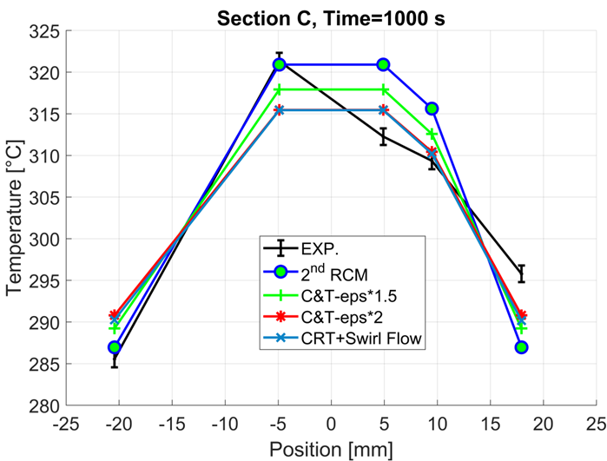 | 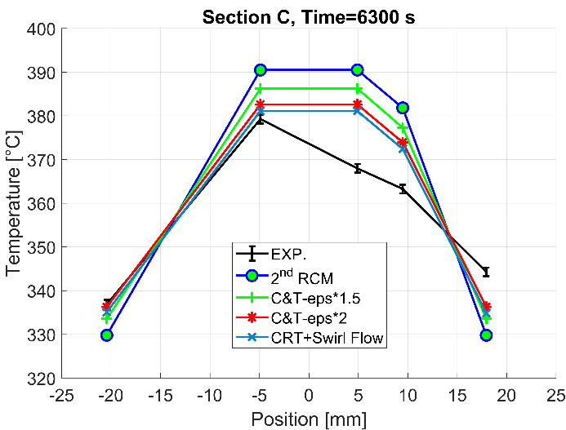
(a) | (b)
Figure 10 – ADP10, LBE bulk temperatures in the instrumented channels, Section C, SS1 (a) and SS2 (b). For the correspondence between subchannel number and FPS radial position see Table 5. For the description of the sensitivity cases see Table 6.

Table 6 – ADP10, LBE bulk temperatures in the instrumented channels, Section C, SS1 and SS2. Description of sensitivity cases and average temperature errors with respect to experimental data.
Case Label | Case Description | $T_{err,avg}$ @ SS1 [°C] | $T_{err,avg}$ @ SS2 [°C]
2nd RCM | Westinghouse HTC Correlation;  $ε^{*}$ and $C_{1L}$ calculated with C&T theory. | 5.1 | 14.7
C&T - eps*1.5 | Ushakov HTC Correlation;  $ε^{*}$ and $C_{1L}$ calculated with C&T theory;  $ε^{*}$ enhanced by 1.5 times. | 4.5 | 10.7
C&T - eps*2 | Ushakov HTC Correlation;  $ε^{*}$ and $C_{1L}$ calculated with C&T theory;  $ε^{*}$ enhanced by 2 times. | 4.1 | 7.4
CRT + Swirl Flow  (Submitted Results) | Ushakov HTC Correlation;  $ε^{*}$ and $C_{1L}$ calculated with CRT theory;  CNTRLVARs and time dependent junctions added to simulate the swirl flow (see section 2.1.1). | 4.0 | 7.0

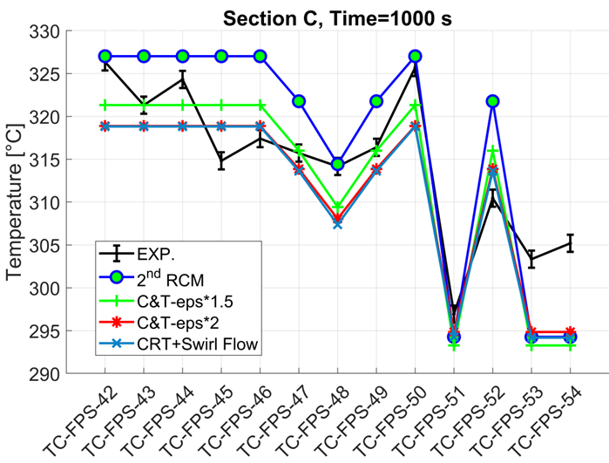 | 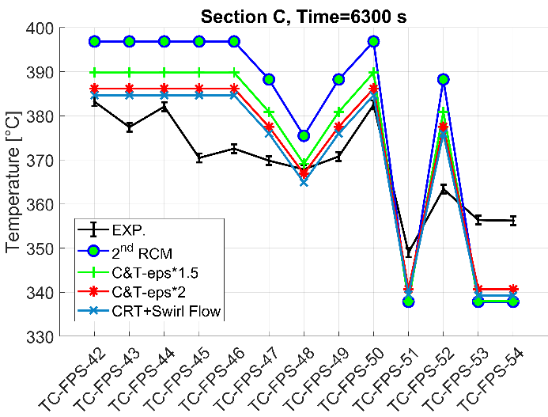
(a) | (b)
Figure 11 – ADP10, wall temperatures in the instrumented pins, Section C, SS1 (a) and SS2 (b). The numbering convention is the one indicated in [2]. For the description of the sensitivity cases see Table 6.
Table 7 – ADP10, wall temperatures in the instrumented pins, Section C, SS1 and SS2. Average temperature errors with respect to experimental data.
Case Label (See Table 6) | $T_{err,avg}$ @ SS1 [°C] | $T_{err,avg}$ @ SS2 [°C]
2nd RCM | 6.0 | 17.6
C&T - eps*1.5 | 4.6 | 12.1
C&T - eps*2 | 4.8 | 9.1
CRT + Swirl Flow  (Submitted Results) | 5.0 | 8.5

ADP06
The LBE bulk temperatures related to the instrumented channels belonging to section C (i.e., outlet section) at both SS1 and SS2 (i.e., 1000 s and 9000 s, respectively) are collected in Figure 12. The corresponding wall temperatures referred to the instrumented pins are shown in Figure 13. The figure features are the same already described for the corresponding elements belonging to ADP10. The description of the cases considered for ADP06 is reported in Table 8. For each case and for both SS1 and SS2, the average temperature difference ($T_{err,avg}$) between simulation results and experimental data was computed and the resulting values are gathered in Table 8, for bulk temperatures, and Table 9, for wall temperatures. The main aspects to be highlighted are:
- The general trend that can be observed is the same already pointed out for ADP10 but boosted. The system code tends to predict more peaked bulk temperature distributions with respect to the experiments (see Figure 12). This is enhanced in the case of ADP06 since the power distribution is peaked itself (only pins 1 to 7 are heated) instead of being uniform (as for ADP10). As in the previous test, the differences increment with the axial quote and passing from SS1 to SS2, since the LBE inlet/outlet temperature gradient is increased by the transition from gas-lift regime to natural circulation.
- An aspect to be considered and that is missing in the current RELAP5-3D© input deck is the thermal conduction through the inactive pins. This phenomenon is not present in ADP10 since all the pins are electrically heated. Instead, in ADP06 it can play a significant role, above all because of the strong temperature gradients between interior and edge channels. However, this additional model is quite complex to be developed and implemented and, thus, so far, it has not been considered, even if its effect on the simulation results is not negligible.
- As for ADP10, the system code cannot catch the dissymmetry produced at each axial location by the local position of the wire. Thus, it predicts the same bulk temperature for channels 2 and 5 and channel 26 and 33, as well as the same wall temperature for all the pins interfaced with the same channel (see Figure 13).
- Regarding WTM, CRT model demonstrated a higher agreement with respect to experimental data. The computed $ε^{*}$ and $C_{1L}$ are higher and this promotes an increased lateral energy transfer, smoothing the radial temperature gradient and narrowing the temperature differences with the test data. To obtain a similar effect with C&T, the $ε^{*}$ must be nearly doubled (see Figure 12).
- The effect of the addition of the CNTRLVARs and time dependent junctions simulating the swirl flow is small. The radial dissymmetry in the power distribution used as boundary condition for ADP06 is not enough to produce a significant swirl flow in the FPS periphery (see ‘CRT’ and ‘CRT + Swirl Flow’ cases in Figure 12).
- Regarding the wall temperatures (Figure 13), the same considerations already made for ADP10 are still valid. The system code overpredicts the wall temperatures related to the interior channels and tends to underpredict the ones associated with the edge channels. Moreover, RELAP5-3D© computes the same wall temperature for all the pins associated with the same channel. For what concerns HTC correlations, the one that seems most suitable for FPS application is the Ushakov one (compare ‘2nd RCM’ and ‘C&T + Ushakov’ trends in Figure 13). For this, it has been used for most of the simulations related to WP3.
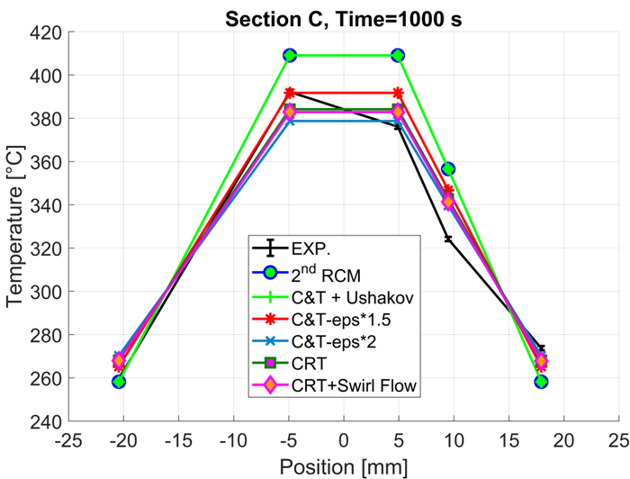 | 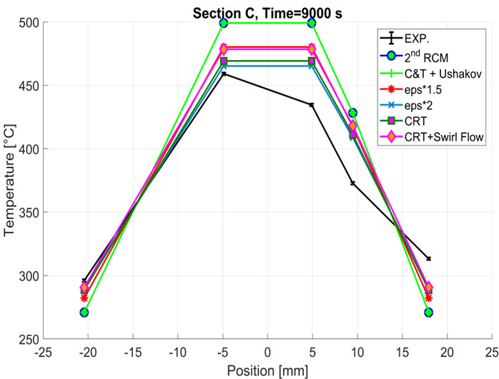
(a) | (b)
Figure 12 – ADP06, LBE bulk temperatures in the instrumented channels, Section C, SS1 (a) and SS2 (b). For the correspondence between subchannel number and FPS radial position see Table 5. For the description of the sensitivity cases see Table 8.
Table 8 – ADP06, LBE bulk temperatures in the instrumented channels, Section C, SS1 and SS2. Description of sensitivity cases and average temperature errors with respect to experimental data.
Case Label | Case Description | $T_{err,avg}$ @ SS1 [°C] | $T_{err,avg}$ @ SS2 [°C]
2nd RCM | Westinghouse HTC Correlation;  $ε^{*}$ and $C_{1L}$ calculated with C&T theory. | 19.8 | 45.5
C&T + Ushakov | Ushakov HTC Correlation;  $ε^{*}$ and $C_{1L}$ calculated with C&T theory. | 19.8 | 45.5
C&T - eps*1.5 | Ushakov HTC Correlation;  $ε^{*}$ and $C_{1L}$ calculated with C&T theory;  $ε^{*}$ enhanced by 1.5 times. | 10.6 | 31.2
C&T - eps*2 | Ushakov HTC Correlation;  $ε^{*}$ and $C_{1L}$ calculated with C&T theory;  $ε^{*}$ enhanced by 2 times. | 9.1 | 20.1
CRT | Ushakov HTC Correlation;  $ε^{*}$ and $C_{1L}$ calculated with CRT theory; | 9.7 | 23.0
CRT + Swirl Flow  (Submitted Results) | Ushakov HTC Correlation;  $ε^{*}$ and $C_{1L}$ calculated with CRT theory;  CNTRLVARs and time dependent junctions added to simulate the swirl flow (see section 2.1.1). | 9.5 | 27.3

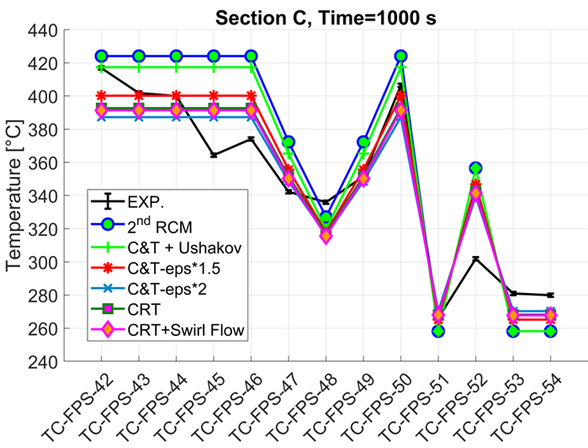 | 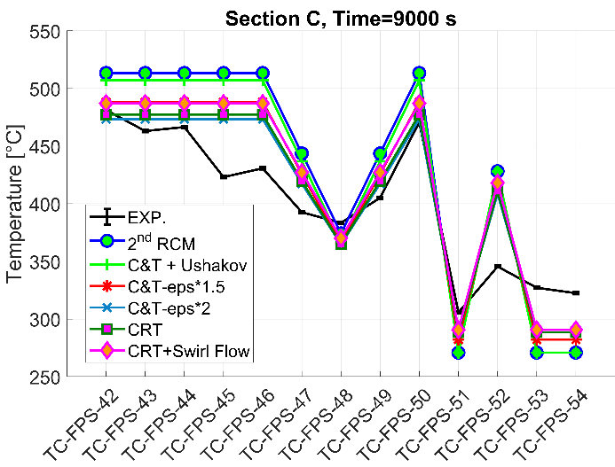
(a) | (b)
Figure 13 – ADP06, wall temperatures in the instrumented pins, Section C, SS1 (a) and SS2 (b). The numbering convention is the one indicated in [2]. For the description of the sensitivity cases see Table 8.
Table 9 – ADP06, wall temperatures in the instrumented pins, Section C, SS1 and SS2. Average temperature errors with respect to experimental data.
Case Label (See Table 8) | $T_{err,avg}$ @ SS1 [°C] | $T_{err,avg}$ @ SS2 [°C]
2nd RCM | 26.8 | 51.5
C&T + Ushakov | 23.1 | 48.0
C&T - eps*1.5 | 15.3 | 34.3
C&T - eps*2 | 15.6 | 24.8
CRT | 15.1 | 27.0
CRT + Swirl Flow  (Submitted Results) | 15.4 | 31.7
ADP07
The LBE bulk temperatures related to the instrumented channels belonging to section C (i.e., outlet section) at both SS1 and SS2 (i.e., 1000 s and 4800 s, respectively) are collected in Figure 14. The corresponding wall temperatures referred to the instrumented pins are shown in Figure 15. The figure features are the same already described for the corresponding elements belonging to the previous tests. The description of the cases considered for ADP07 is reported in Table 10. For each case and for both SS1 and SS2, the average temperature difference ($T_{err,avg}$) between simulation results and experimental data was computed and the resulting values are gathered in Table 10, for bulk temperatures, and Table 11, for wall temperatures. The main aspects to be highlighted are:
- The bulk temperature distribution related to ADP07 is completely different from the ones of ADP10 and ADP06. In this test, due to the selected pin power distribution, a very strong dissymmetry is imposed. Power is produced in the left bottom corner of the FPS and from there, hottest LBE diffuses in the transversal direction while axially flowing thorough the FPS. This is illustrated by Figure 14c. When it comes to the LBE bulk temperatures (Figure 14), the code can reproduce with good accuracy the temperatures at the periphery of the heated zone (subchannels 29/33 and 26). In addition, it is visible the improvement due to the addition of the swirl flow contribution (compare first and last temperature points for the cases ‘C&T-eps*1.5’ and ‘CRT+Swirl Flow’ in Figure 14a and b). Instead, it overestimates the lateral energy transfer from subchannel 2 to subchannels 5 and 22. Indeed, it underestimates the temperature in the former and predicts an excessive temperature in the latter. This is quite the opposite with respect to what is observed in the previous comparisons, where it is RELAP5-3D© to predict more peaked temperature distributions. This reverted behavior could be partially explained by considering the wire local orientation, but it needs to be further and deeply investigated. If more subchannel data, i.e., a more detailed bulk temperature distribution, were available, it would have been possible to evaluate if the lateral energy transfer is actually overestimated by the code or if the lower experimental readings are due to a local effect induced by wire orientation.
- Regarding WTM, results are consistent with the ones already obtained for ADP06 and ADP10, confirming that CRT model enhances the lateral energy transfer with respect to C&T theory.
- Regarding the wall temperatures (Figure 15), deviations are consistent with the ones already discussed for the LBE bulk temperatures. They are higher for the measurements related to subchannels 5 and 22 and lower for the others. Also in this case, the usage of Ushakov correlation introduce an improvement, even if limited, in the simulation results (this cannot be inferred by the trends in Figure 15 since the case where only the HTC correlation is changed is not reported).
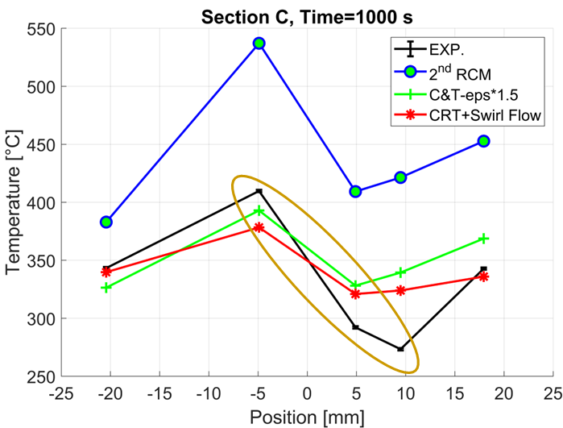 | 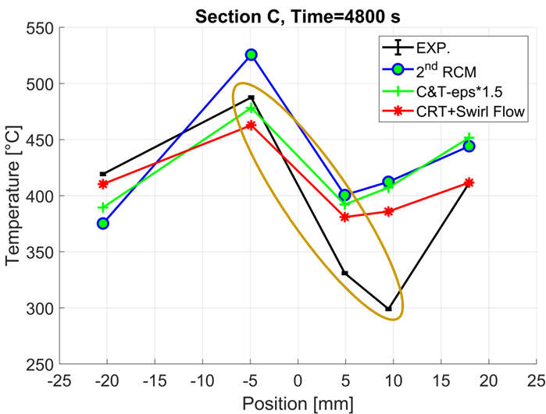
(a) | (b)
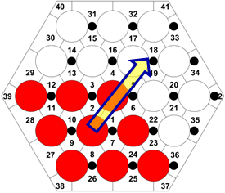
(a)
Figure 14 – ADP07, LBE bulk temperatures in the instrumented channels, Section C, SS1 (a) and SS2 (b). For the correspondence between subchannel number and FPS radial position see Table 5. For the description of the sensitivity cases see Table 10. In addition, the heated pins are shown in (c).

Table 10 – ADP07, LBE bulk temperatures in the instrumented channels, Section C, SS1 and SS2. Description of sensitivity cases and average temperature errors with respect to experimental data.
Case Label | Case Description | $T_{err,avg}$ @ SS1 [°C] | $T_{err,avg}$ @ SS2 [°C]
2nd RCM | Westinghouse HTC Correlation;  $ε^{*}$ and $C_{1L}$ calculated with C&T theory. | 108.4 | 59.6
C&T - eps*1.5 | Ushakov HTC Correlation;  $ε^{*}$ and $C_{1L}$ calculated with C&T theory;  $ε^{*}$ enhanced by 1.5 times. | 32.3 | 49.8
CRT + Swirl Flow  (Submitted Results) | Ushakov HTC Correlation;  $ε^{*}$ and $C_{1L}$ calculated with CRT theory;  CNTRLVARs and time dependent junctions added to simulate the swirl flow (see section 2.1.1). | 24.2 | 34.2

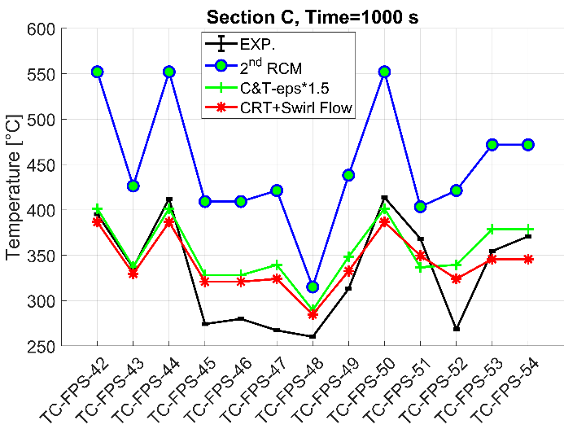 | 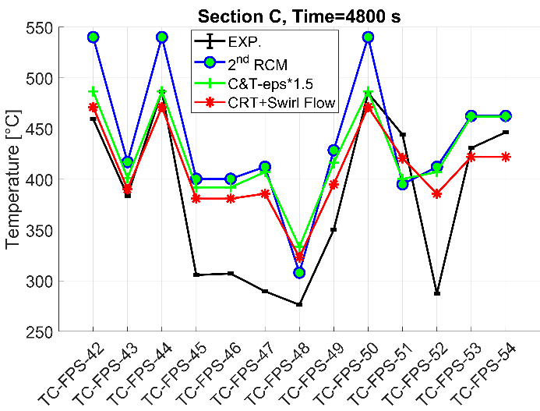
(a) | (b)
Figure 15 – ADP07, wall temperatures in the instrumented pins, Section C, SS1 (a) and SS2 (b). The numbering convention is the one indicated in [2]. For the description of the sensitivity cases see Table 10.
Table 11 – ADP07, wall temperatures in the instrumented pins, Section C, SS1 and SS2. Average temperature errors with respect to experimental data.
Case Label (See Table 10) | $T_{err,avg}$ @ SS1 [°C] | $T_{err,avg}$ @ SS2 [°C]
2nd RCM | 117.6 | 66.5
C&T - eps*1.5 | 31.0 | 51.4
CRT + Swirl Flow  (Submitted Results) | 28.1 | 41.4

Conclusions
The main conclusions related to WP3 are:
- In ADP10 and ADP06, RELAP5-3D© tends to predict a more peaked LBE bulk temperature distribution with respect to experimental data. This trend is smoothed where and when the LBE experiences lower temperature gradients (SS1 vs SS2, section A vs Section C). Instead, in ADP07, the lateral energy transfer seems to be overestimated. However, this aspect must be further investigated.
- Regarding wall temperatures, they are always consistent with the bulk temperature distributions.
- For what concerns the wall-to-fluid heat transfer, Ushakov correlation proved to be the most suitable for the FPS application, reducing the error with respect to experimental data.
- Referring to WTM, among the two models investigated, CRT enhances the lateral energy transfer with respect to C&T theory. To obtain a similar radial effect with the latter, the $ε^{*}$ must be nearly doubled. Thus, when ADP06 and ADP10 are considered, the usage of CRT allows to better match the experimental data, by increasing the radial temperature diffusion and smoothening the radial temperature gradient.
- When it comes to the swirl flow, its contribution is relevant only when a strong dissymmetry is present in the FPS transversal section, as in the ADP07 test. In this case, its introduction allows to obtain a better representation of the LBE temperatures at the assembly periphery.
- In conclusion, the adoption of RELAP5-3D© for subchannel analysis is envisaged only when the transient to be simulated is symmetrical. In these cases, e.g., ADP10, the code predictive capabilities are good (see the low average temperature differences in Table 6 and Table 7). The code is also able to handle a weak dissymmetry, as in the case of ADP06, but with increasing errors. Instead, when a strong dissymmetry is introduced, e.g., ADP07, the STH code cannot be selected as a proper numerical tool to simulate the TH phenomena occurring within the fuel assembly. As a final consideration, it must be noted that the occurrence of strong dissymmetrical transients like ADP07 is very unlikely in nuclear reactors, considering both operational and accidental scenarios.

References
- INL, The RELAP5-3D Code Development Team, RELAP5-3D Code Manual Volume I: Code Structure, System Models and Solution Methods, INL-MIS-15-36723, Revision 4.3, 2015.
- I. Di Piazza et al. Benchmark specifications for NACIE-UP facility: non-uniform power distribution tests, rev5, NA-I-R-542, IAEA CRP-I31038, Vienna, Austria, December 2024.
- S.K. Cheng, N.E. Todreas, Hydrodynamic models and correlations for bare and wire-wrapped hexagonal rod bundles – bundle friction factors, subchannel friction factors and mixing parameters. Nucl. Eng. Des. 92, 227–251, 1986. https://doi.org/10.1016/0029-5493(86)90249-9.
- V. Narcisi et al., Thermal-hydraulic transient analysis of the FFTF LOFWOS Test #13. Nucl. Eng. Des. 383, 111405, 2021. https://doi.org/10.1016/j.nucengdes.2021.111405.
- D. J. Zigrang and N. D. Sylvester, A Review of Explicit Friction Factor Equations, Transactions of ASME, Journal of Energy Resources Technology, 107, pp. 280-283, 1985.
- I. E. Idelchik, Handbook of Hydraulic Resistance, 2nd ed., Hemisphere Publishing Corporation, London, 1986.
- K. Rehme, Pressure drop correlations for fuel element spacers, Nucl. Technol. 17, pp. 15-23, 2017. https://doi.org/10.13182/NT73-A31250.
- M. S. Kazimi and M. D. Carelli, Clinch River Breeder Reactor Plant Heat Transfer Correlation for Analysis of CRBRP Assemblies, CRBRP-ARD-0034, Westinghouse, 1976.
- R. A. Seban, T. T. Shimazaki, Heat transfer to a fluid flowing turbulently in a smooth pipe with walls at constant temperature. Trans. Am. Soc. Mech. Engrs. 73, pp. 803-809, 1951.
- F. Dittus, L. Boelter, Heat transfer in automobile radiators of the tubular type, University of California Publications in Engineering, volume 2, 443-461, 1930.
- A. Y. Inayatov, Correlation of Data on Heat Transfer Flow Parallel to Tube Bundles at Relative Tube Pitches of 1.1 < s/d < 1.6, Heat Transfer-Soviet Research, 7, 3, May-June 1975, pp. 84-88.
- B. Chexal and G. Lellouche, A Full-Range Drift-Flux Correlation for Vertical Flows (Revision 1), EPRI NP-3989-SR, Electric Power Research Institute, September 1986. Available online at: https://www.epri.com/research/products/NP-3989-SR. Last visited: 19/09/2024.
- M. Memmott et al., On the use of RELAP5-3D as a subchannel analysis code. Nuclear Engineering and Design, vol. 240, pp. 807–815, 2010. https://doi.org/10.1016/j.nucengdes.2009.11.006.
- C. Chiu, W. M. Rohsenow and N. E. Todreas, Turbulent sweeping flow mixing model for wire wrapped LMFBR assemblies. Massachusetts Institute of Technology, Cambridge, 1978. Available online at: https://www.osti.gov/servlets/purl/6304126/.
- Y. J. Yoo et al., Effects of Fluid Axial Conduction on Liquid Metal Natural Circulation and Linear Stability, Proc. 2003 ANS/ENS Int. Winter Mtg., New Orleans, Louisiana, 2003, p. 1523, American Nuclear Society, 2003.
- K. Mikityuk, Heat transfer to liquid metal: Review of data and correlations for tube bundles, Nuclear Engineering and Design, vol. 239, pp. 680-687, 2009. https://doi.org/10.1016/j.nucengdes.2008.12.014.
- P. A. Ushakov et al., Heat transfer to liquid metals in regular arrays of fuel elements, High Temperature (translated from Teplofizika Vysokikh Temperatur), vol. 15, pp. 868-873, 1977.
- W. T. Sha and B. E. Launder, A model for turbulent momentum and heat transport in large rod bundles. Argonne, Illinois (US) : Internal report Argonne National Laboratory ANL-77-73, 1979.

