Westinghouse and ANL - SAS4A/SASSYS-1 model and results description- WP1 and WP3 (section for Appendix 3 of TECDOC)
Title:
Assessment of SAS4A/SASSYS-1 Model with NACIE-UP Experimental Facility
Authors:
Jun Liao (Westinghouse Electric Company)
Daniel OGrady, Rachel Thomas (Argonne National Laboratory)

- Introduction
SAS4A/SASSYS-1 (SAS) [1] is a simulation tool used to perform safety analyses of anticipated events as well as design basis and beyond design basis accidents for advanced liquid-metal-cooled nuclear reactors. SAS4A/SASSYS-1 computer code was selected as the safety analysis computer code for the LFR technology development in Westinghouse [2].
A significant joint development among Westinghouse, Argonne National Laboratory (ANL) and Fauske & Associates (FAI) [3] led to the mechanistic source term analysis capability [4], enhanced oxide fuel performance model [5] [6], the coupling between SAS and GOTHIC computer code to model the passive heat removal system (PHRS) of the LFR [7] [8], the capability of modeling LFR primary heat exchangers, and enhancing verification and validation (V&V) matrix with CIRCE integral effects test [9]. These developments were supported by US Department of Energy with Technology Commercialization Fund.
The International Atomic Energy Agency (IAEA) Coordinated Research Project (CRP) on the “Transition from Forced to Natural Circulation Experiment with Heavy Liquid Metal Loop (NACIE),” provided opportunity to assess the performance of the SAS computer code for NACIE LBE loop. The three experiments, ADP10, ADP06 and ADP07, in CRP focused on the transition from forced circulation to natural circulation in a LBE loop and thermal hydraulics in fuel pin bundle simulator. The Westinghouse and ANL team joined Work Package 1 (WP1), which focused on system thermal hydraulics, and Work Package 3 (WP3), which investigated thermal hydraulics in the NACIE FPS bundle with subchannel analysis. Both simulations were performed with the SAS computer code, but a SAS average channel model is used for WP1 and a SAS sub-channel model is used for WP3.
Next, the SAS model of the NACIE-UP facility developed by Westinghouse and ANL team will be presented along with comparisons between the SAS model and the experimental measurements will be summarized.

- Model Development
A graphical representation of the NACIE-UP SAS model is shown in Figure 1. The SAS model consists of multiple segments (S) and compressible volumes (CV), where each segment in the model is made up of different elements (E). The SAS representation attempts, as close as reasonably possible, to preserve the characteristics and geometry of the NACIE-UP facility. CV 1, the inlet plenum, represents the T-junction that connects the downcomer to FPS and the structures and materials that exist axially below the T-junction.
This CV uses a 0D perfect mixing formulation for the temperature of the coolant and neglects any pressure losses that are not caused by gravity. The pins present within this volume and structure of the junction are lumped into a 0D heat structure, where the heat capacity and heat transfer area are preserved in order to account for thermal inertia. A similar approach is taken for CV 2, the outlet plenum, CV 4, the inlet to the steam generator, and CV 5, the outlet of the steam generator. Similar to all other CVs, CV 3 is modeled using a 0D perfect mixing formulation, however in addition to gravity effects, CV 3 includes a cover gas component and level tracking.
Segment 2 represents the riser of the facility. In this segment, coolant flows through a pipe and into a valve, where it then passes by the gas injection system that is modeled using a series of pipes and a surrogate pump component. Each of these elements utilizes a one-dimensional formulation for the mass, momentum, and energy conservation. The environmental heat loss at the outer wall of each of these components is captured by assuming a constant temperature of 10 ℃ at the outer surface of the pipe insulation. A similar approach is taken for Segments 3 and 5, which represent the entrance to the heat exchanger and the system downcomer. In order to capture the temperature effect of the resistive heating flow meter, direct coolant heating is applied in Element 16. Using direct element heating, the measured heat deposited within the flow meter is applied directly to the coolant within Element 16. Although the resistance of the heating element is neglected, this captures the impact of the flow meter reasonably well.
Outside of the core channels, SAS is only capable of modeling single phase flow and cannot directly model the gas injection system. As experiments have shown that all injected gas exits the LBE and enters the cover gas, a pump is included in Segment 2 to capture the positive driving force of the gas injection system. As SAS requires users to define the steady state flow rate in the system and calculates the required pump head to balance the pressure drops, the neglection of the gas injection does not impact the initial steady state predictions. For the transients of interest, this approximation does not impact the quantities of interest significantly, because the gas injection system is turned off promptly. For transients where the gas injection system was reduced more gradually, a pump let down curve would need to be developed to capture the impact of the gradual lift reduction.
Segment 4 represents the low-power and high-power steam generator. For the transients of interest, the low power section of the steam generator is disabled, and no active heat transfer occurs in this section, Element 9. The high-power steam generator is modeled using a primary heat exchanger component in SAS. The primary heat exchanger component represents a shell and tube heat exchanger and allows users to define the coolant properties, coolant flow rate, and coolant inlet temperature and the inlet of the secondary side. For these transients, the water in the steam generator remains subcooled and it is assumed that subcooled boiling does not occur. Similar to the rest of the loop, the environmental heat losses at the outer wall of the steam generator are captured by assuming a constant temperature of 283.15 K at the outer surface of the insulation.
Figure 1. SAS representation of the NACIE-UP experimental facility.
Segment 1 represents the FPS and within SAS is considered the reactor core. Two different SAS models have been created, one that utilizes the traditional average channel approach and one that utilizes a subchannel approach. In the average channel approach, a single fuel pin is modeled, and its behavior is assumed to represent all actively heated pins within the FPS. Alongside the fuel pin, SAS allows user to represent an associated structure. In general, this structure is intended to represent any associated wire wrap and duct wall, which will impact the thermal response of the channel. For ADP10, where all 19 fuel pins are heated, all 19 of the fuel pins are represented by the fuel pin in the average channel. The duct wall and wire wrap for each pin are captured using the channel structure. For ADP06, there are 7 heated pins and 12 unheated pins in two different channels. For ADP07, the heating area is located at the bottom left corner with 9 heated pins and 10 unheated pins in one channel.
For the SAS sub-channel model, a total of 42 core channels are utilized. A schematic of the 42 coolant channels, together with the numbered fuel pins, is shown in Figure 2. Conceptually, these channels are nearly identical to the standard average configuration. However, the sub-channel model accounts for radial mixing between the different fuel channels and allow for consideration of the coolant swirl effect that is introduced by the wire wraps. Additionally, as shown in the schematic, each SAS core channel now represent 1/3, 1/2, or 1/6 of a fuel pin, as compared to the average channel which represent more than 1 fuel pin. This presents a unique modeling difficulty for the ADP06 experiment, where channels 7 – 24 represent both heated and not-heated pins. While it is not difficult to conserve the total power in this configuration, the radial power profile becomes smeared.
Figure 2. SAS sub-channel representation of the NACIE-UP FPS.
ADP10, ADP06 and ADP07 represent unprotected loss of flow events of lead cooled reactor. Following an initial zero transient period, the gas injection system is abruptly turned off, while the FPS power and boundary conditions at the steam generator remain constant. The initial and boundary conditions used to create the SAS model are shown in Table I. In order to account for the time it takes for the gas bubble to travel through the riser into the cover gas, the pump head is linearly ramped to zero over a period of 100 seconds.
Table I. Initial and boundary conditions for experiments ADP10, ADP06 and ADP07.
 | ADP10 | ADP06 | ADP07
Initial Flow Rate (kg/s) | 2.56 | 2.66 | 3.07
Total Power (kW) | 29.24 | 29.31 | 38
Heated Pins | 1-19 | 1-7 | 1-2,6-9,17-19
Water Inlet Temperature (C) | 170 | 170 | 170
Water Flow Rate (kg/s) | 2.4 | 2.4 | 2.4
Pump Trips Time (s) | 1225.0 | 1852.0 | 1254.0

- Results and Discussion
ADP10, ADP06 and ADP07 were simulated using SAS Version 5.7.1. For these transients, the average channel model runs in the order of seconds, and the sub channel model runs on the order of minutes. All SAS simulations were performed using a single processor.
  - SAS Predictions for ADP10
Utilizing the measured initial flow rate and steam generator inlet temperature, SAS is able to determine the initial steady state conditions throughout the experimental loop. As shown in Figure 3 - Figure 5, which contain the mass flow rate, steam generator inlet/outlet temperatures and inlet/outlet plenum temperatures as a function of time, the initial steady state predictions are in good agreement with the experimental measurements. In general, the agreement between SAS and the experimental measurements remains acceptable throughout the transient, the error in the mass flow rate is within 0.1 kg/s and the error in the temperature predictions is within 10 K. For reference, the measurement uncertainty for flow and temperature are 10% and 1.5 K, respectively.
It is observed that thermal inertia of the systems appears to be misrepresented by the current assumptions in the SAS model. Between 1700 and 3000 seconds, the temperature response of the SAS model is quicker than the experimental measurements. This is potentially caused by the assumptions being used at the boundary of the experiment. Within SAS, only the pipe wall of the facility is currently being represented and the temperature of the insultation is assumed to vary linearly based on the thermal conductivity of the insultation. It is also possible that the support structures of the experiment, which are currently being neglected, plays an important role in the transient response of the facility. It has also been observed that the thermal conductivity of the heat exchanger tube has a significant impact on the temperatures throughout the system. Further investigation is required to reduce the transient error between SAS and the experiment.
From the system’s perspective, the SAS average channel and sub-channel model are in good agreement. The temperature and flow rate throughout the transient are comparable and only a minor difference is evident between the two modeling options. This difference is likely caused by difference in the temperature distribution within the fuel pin simulator, which impacts the buoyancy force and therefore the flow rate. Although the system response is consistent between the two models, the temperatures within the flow rate vary significant with respect to the model fidelity. Figure 6 displays the bulk coolant temperature as a function of radial and axial position. Figure 7 contains the cladding surface temperature as a function of radial at an axial location of 0.56 m from the bottom of the active heating region and Figure 8 contains the cladding surface temperature for pin 3 as a function of axial position.
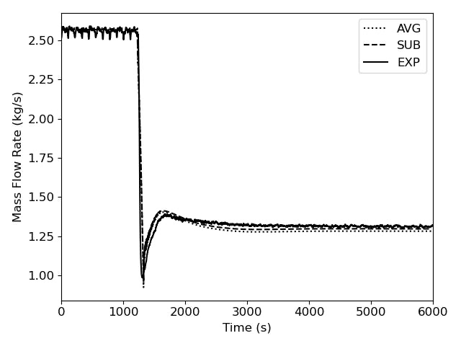
Figure 3. SAS predictions for the ADP10 mass flow rate (AVG – average channel model, SUB – subchannel model, EXP – experimental data).
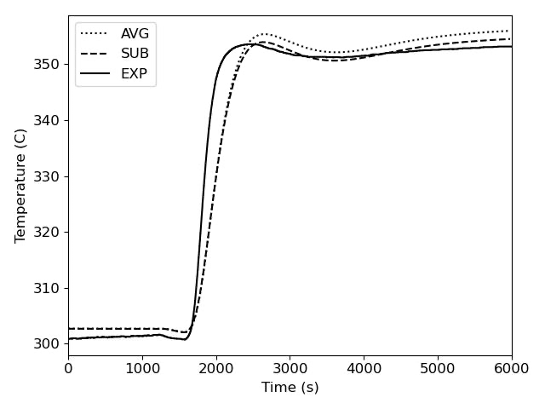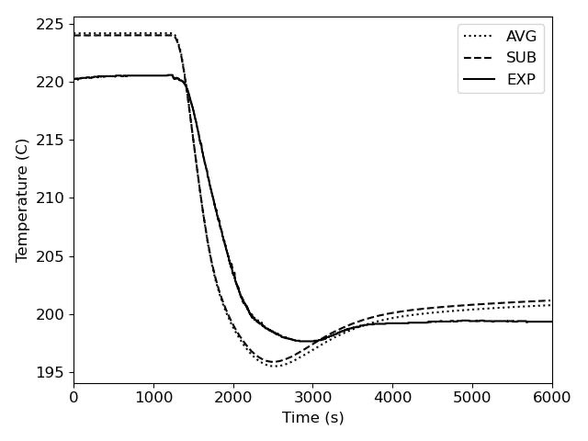
Figure 4. SAS predictions for the ADP10 steam generator inlet (left) and outlet (right) temperature.
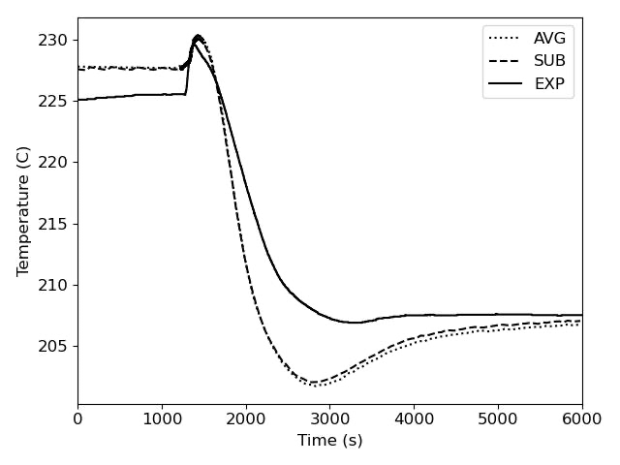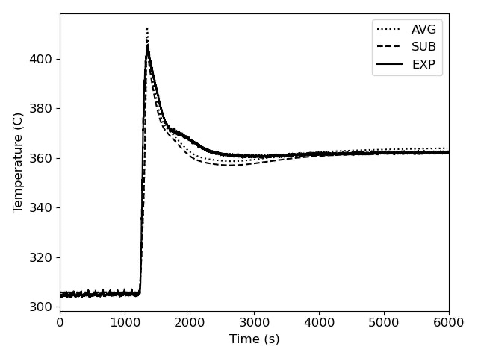
Figure 5. SAS predictions for the ADP10 inlet (left) and outlet (right) plenum temperature.
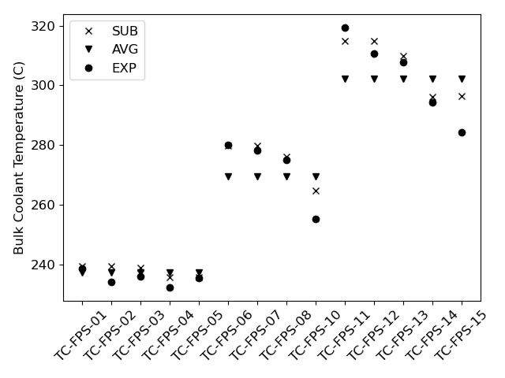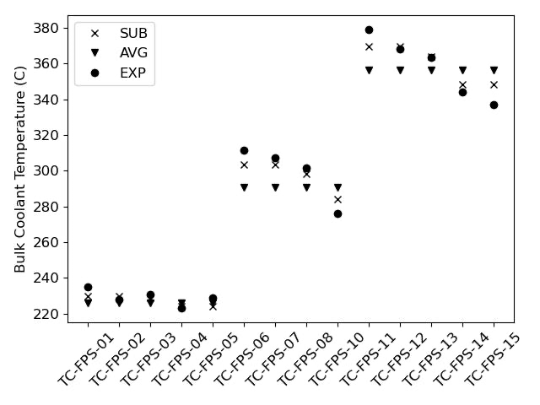
Figure 6. SAS predictions for the ADP10 bulk coolant temperature at the initial (left) and final (right) steady state conditions.
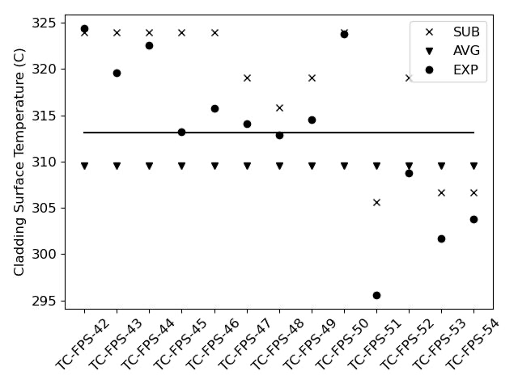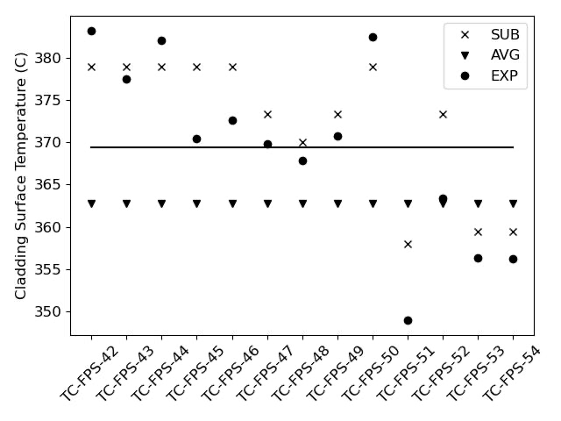
Figure 7. SAS predictions for the ADP10 clad surface temperature at the initial (left) and final (right) steady state conditions (solid line is experiment average value).
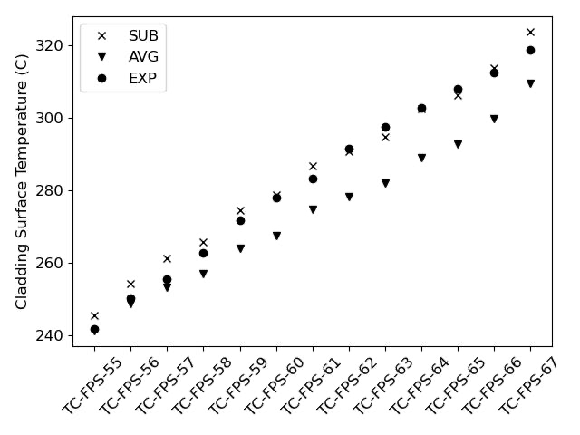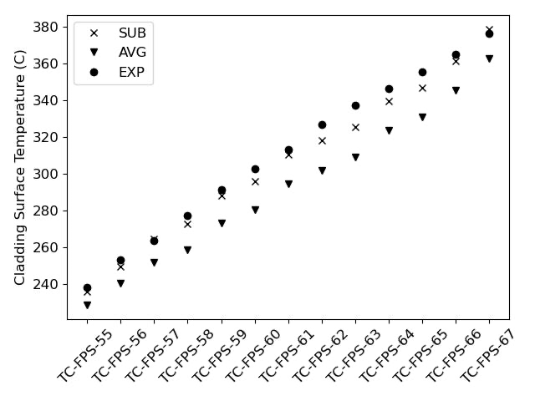
Figure 8. SAS predictions for the ADP10 axial clad surface temperature of pin 3 at the initial (left) and final (right) steady state conditions.
As expected, Figure 6 and Figure 8 demonstrate that the SAS sub-channel model is able to provide more resolution than the SAS average channel model. The SAS sub-channel model shows good agreement with the experimental measurements for in the radial and axial direction. Specifically, for pin 3 the SAS subchannel model is able to predict the temperature within 5 K. From Figure 6 it is evident that the SAS average channel model does a sufficient job capturing the average response of the pins, with the average channel prediction close to the average of the radial temperature measurements. This is further confirmed by Figure 7, which displays a solid line at the average of the experimental cladding surface temperature, where the SAS average channel model predicts a cladding surface temperature within 5K of the experimental average. Although the SAS sub-channel model is providing more resolution, it is evident from the comparisons that temperature variations caused wire-wrap induced swirling are not being fully captured by the model. For example, in Figure 6 the sub-channel model always predicts the same temperature for the two inner-most radial positions at a given axial location (i.e. TC-FPS-10 and TC-FPS-11), although the experimental measurements indicate that these temperatures vary. Additional work is required to determine why the SAS sub-channel model is not predicting the temperature variations between the inner sub-channels.

  - SAS Predictions for ADP06
Similar to the predictions for ADP10, the SAS predictions for the system response of ADP06 are in good agreement with the experimental measurements. Figure 9 and Figure 10 contain the comparisons of the mass flow rate and the inlet/outlet plenum temperature, respectively. While the agreement between SAS and the experiments remains adequate, within 0.1 kg/s for the flow rate and 10 K for the temperature, the agreement between the two SAS models begins to degrade. As shown in Figure 10, the SAS sub-channel outlet temperature is lower than the prediction from the average channel model. This is likely being caused by the pressure initialization routines of the average channel model. In order to balance the pressures between the heated and unheated channels during steady state initialization, SAS introduced an artificial loss coefficient at the inlet of the heated channels to overcome the larger acceleration pressure drop within the channel. In future revisions of the model, the user-defined flow rate in the heated channel will be increased to balance the pressure drop between the two channels.
The impact of an artificially low flow rate within the heated channels is also evident in Figure 11 and Figure 12, which show the bulk coolant temperature as a function of radial and axial position and cladding surface temperature as a function of axial position on pin 3. In Figure 11 the heated channel consistently predicts a bulk coolant temperature that is higher in the heated channels and lower in the unheated channels. In addition to the reduced flow rate, the average channel models also assume that the heated and unheated channels are thermally isolated, which further degrades the temperature discrepancy. Using these observations, the average channel representation can be improved for ADP06. The SAS sub-channel model for ADP06 shows significant improvements over the average channel model, although further improvement is needed when compared to the experimental measurements. With the outer ring of pins unheated, the impact of wire-wrap induced swirling, and in general inter-channel heat transfer, is more evident in ADP06. While the SAS sub-channel model is capturing the radial temperature profile of the FPS, the slope of the radial temperature decrease is underpredicted, along with the maximum clad surface temperature and bulk coolant temperature.

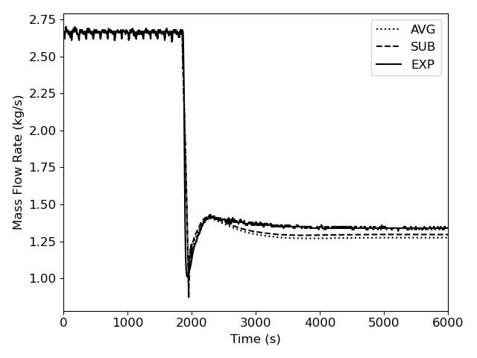
Figure 9. SAS predictions for the ADP06 mass flow rate.
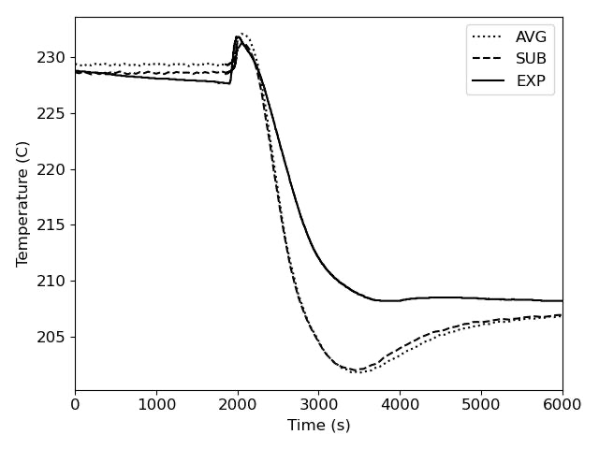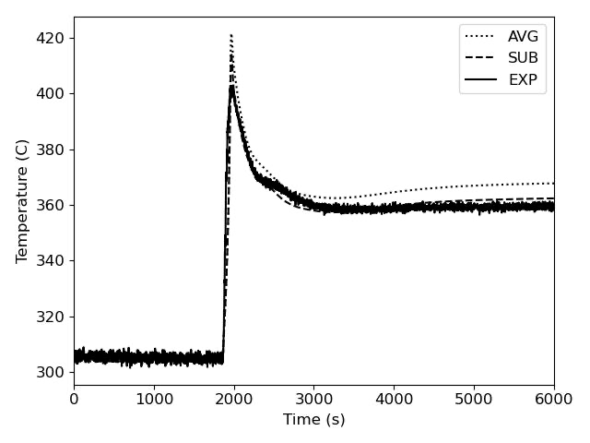
Figure 10. SAS predictions for the ADP06 inlet (left) and outlet (right) plenum temperature.
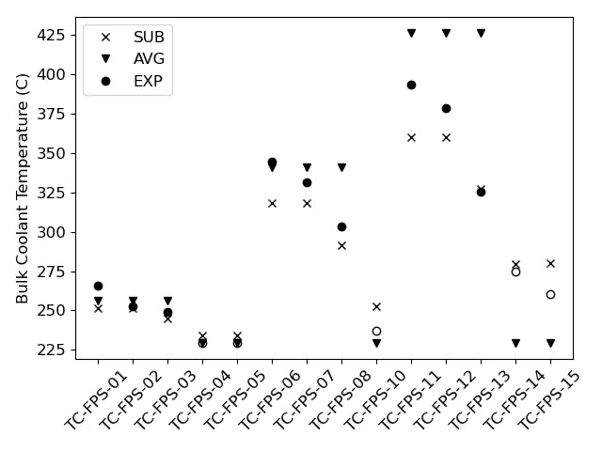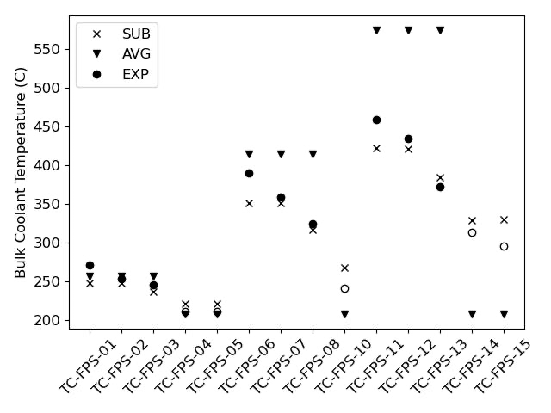
Figure 11. SAS predictions for the ADP06 bulk coolant temperature at the initial (left) and final (right) steady state conditions (hollow EXP circles are unheated channels).
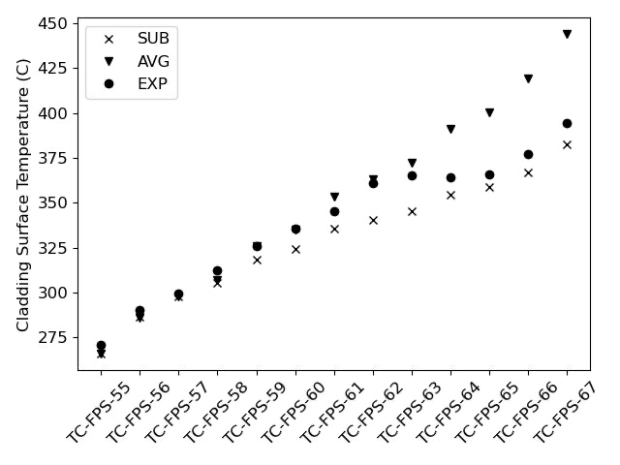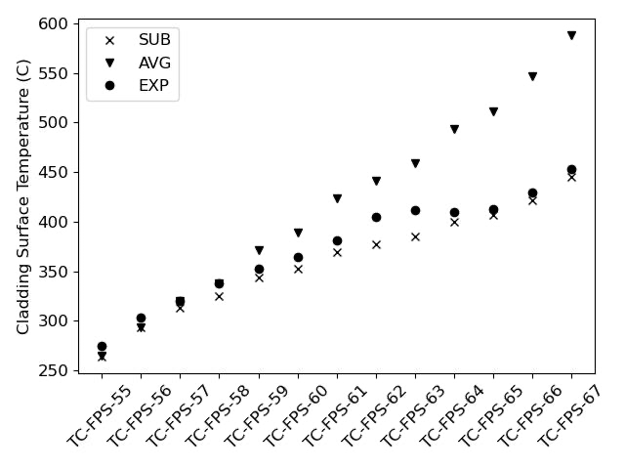
Figure 12. SAS predictions for the ADP06 axial clad surface temperature of pin 3 at the initial (left) and final (right) steady state conditions.

  - SAS Predictions for ADP07
The SAS predictions for the system response of ADP07 generally agree with the experimental measurements. Figure 13 and Figure 14 contain comparisons of the mass flow rate and the inlet/outlet plenum temperature, respectively. Compared with ADP10 and ADP06, the prediction for the flow rate and temperature less agree with the experimental data, although the overall trend is predicted well.
Figure 15 shows the SAS sub-channel outlet temperature prediction is much better than those from the average channel model though there is discrepancy to the measured temperature. Figure 16 shows axial clad surface temperature of pin 3 at the initial (left) and final (right) steady state conditions. The average channel model over-predicts the clad temperature in general, and the subchannel model shows even higher clad temperature. However, it is noted that the coolant temperature is overly predicted in the loop model in both models as shown in Figure 13, which is consistent with the observation in Figure 16.
Additional model refinement is expected to improve the prediction of system behavior in ADP07, and therefore the fuel pin predictions.

Figure 13. SAS predictions for the ADP07 mass flow rate.
Figure 14. SAS predictions for the ADP07 inlet (left) and outlet (right) plenum temperature.
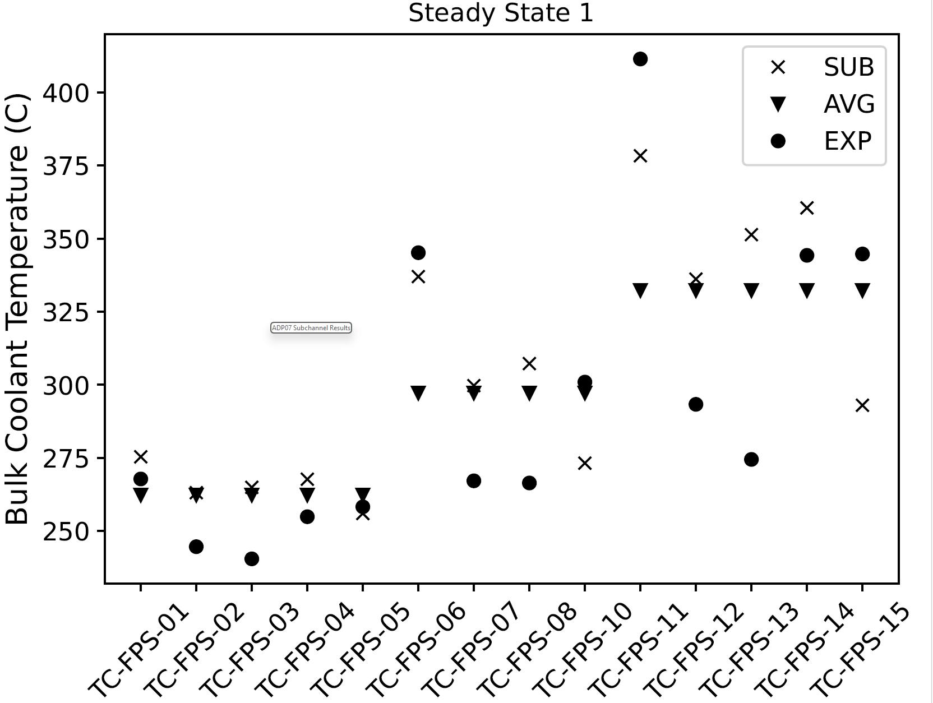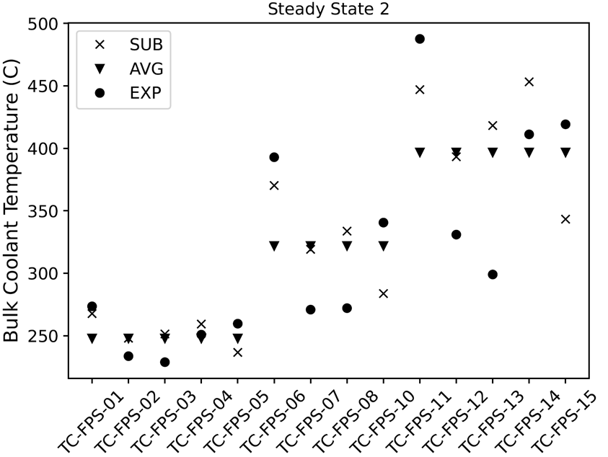
Figure 15. SAS predictions for the ADP07 bulk coolant temperature at the initial (left) and final (right) steady state conditions (hollow EXP circles are unheated channels).
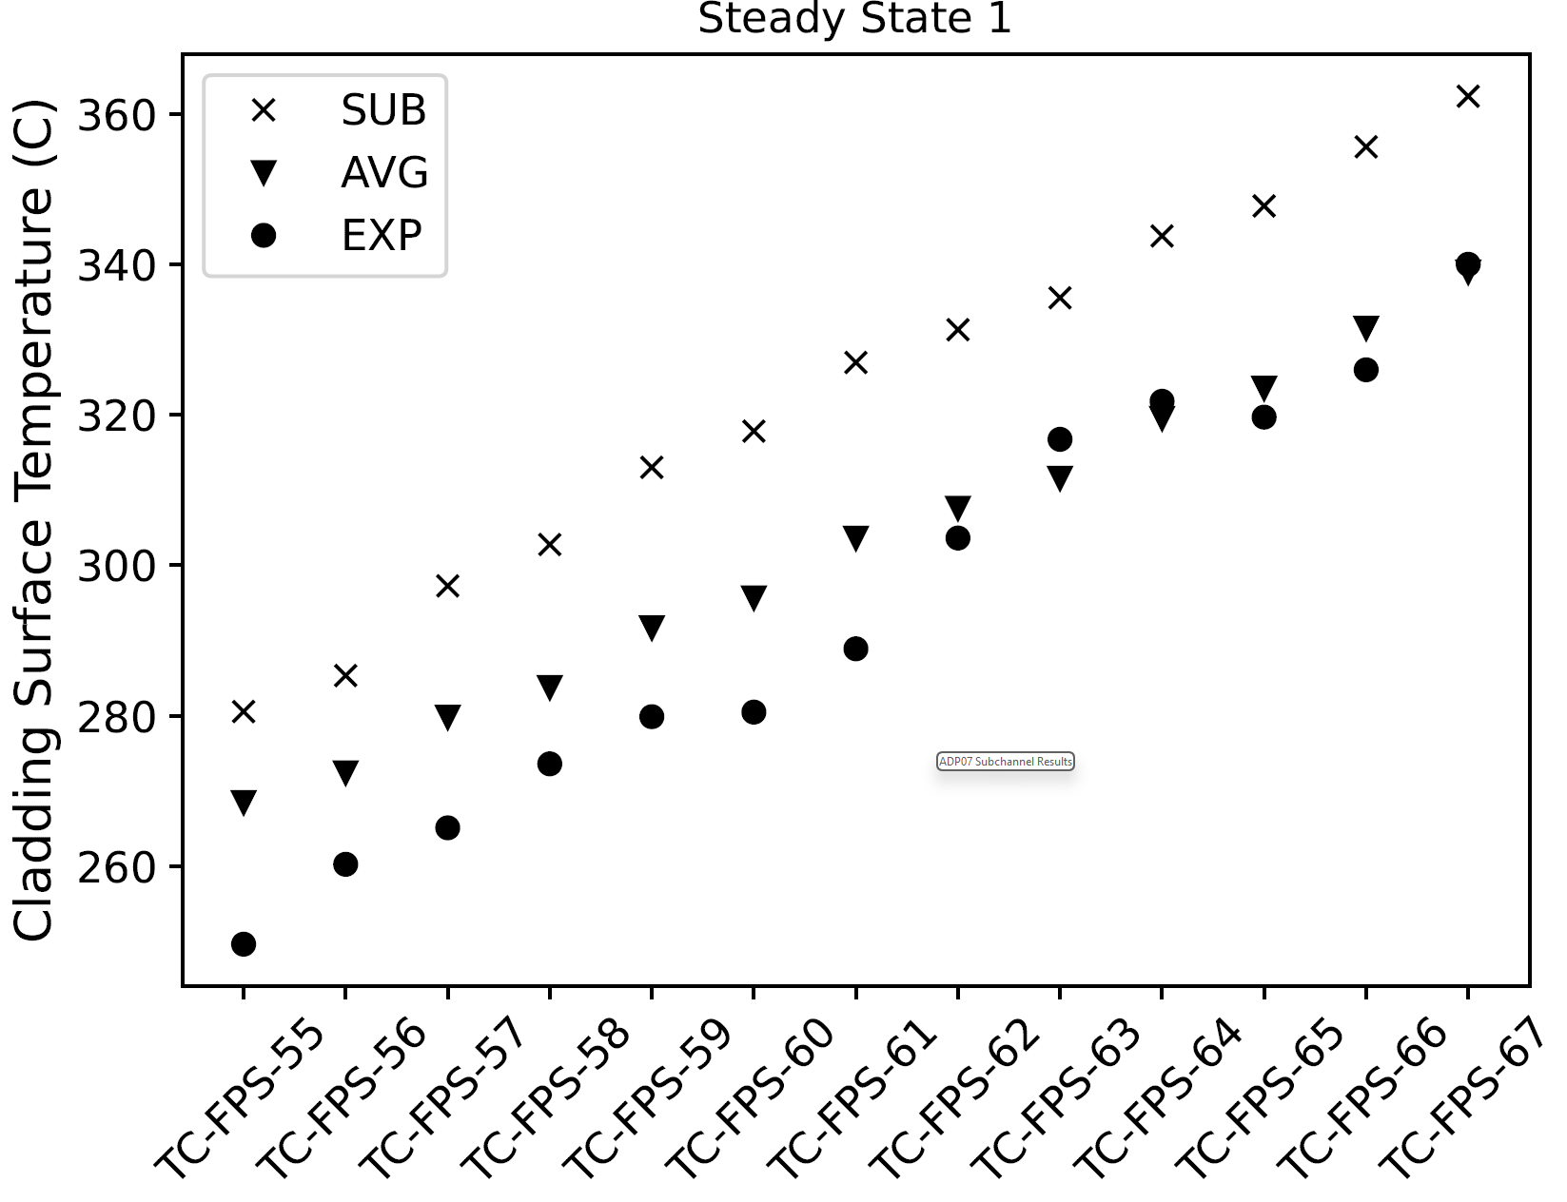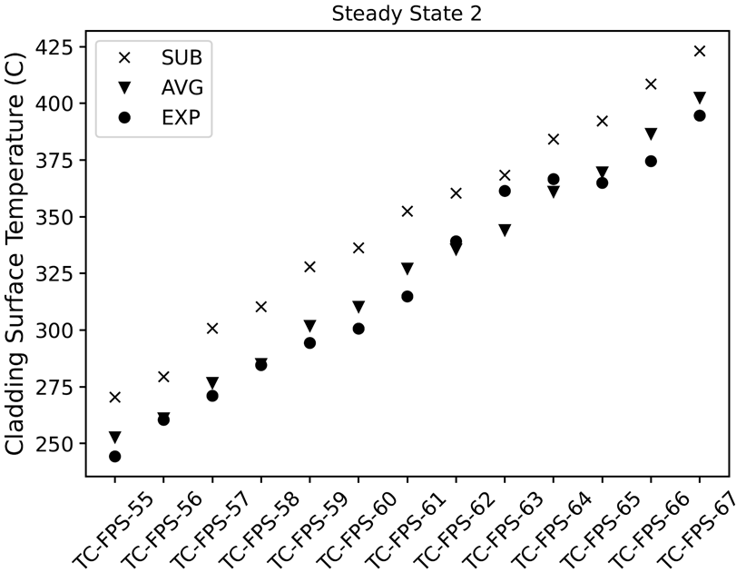
Figure 16. SAS predictions for the ADP07 axial clad surface temperature of pin 3 at the initial (left) and final (right) steady state conditions.

- Conclusions
A SAS model for the NACIE-UP experimental facility has been analyzed for three loss of flow experiments, one with uniform heating (ADP10) and two with non-uniform heating (ADP06 and ADP07) in the FPS. Two different core models have been utilized for the SAS model, an average channel model and a sub-channel model. From the systems perspective, the SAS models reasonably predict the system’s response to a loss of flow. The transient response of the SAS model appears to underpredict the thermal inertia of the system, resulting in overshooting of the final equilibrium condition during the transient. A comparison between the average channel and sub-channel model has been presented. While the SAS sub-channel model is able to provide more granularity for both the loss of flow experiments, the average channel model is able to predict the average response with reasonable accuracy for uniform heating. When comparing the SAS sub-channel model to the experiment measurements, it was observed that the general trend of the measurements is captured, however the agreement could be further improved. Additional work is required to capture the transient response of the system and the radial temperature profile within the FPS more accurately.

References:
[1] D. J. O'Grady et al., "The SAS4A/SASSYS-1 Version 5.7 Safety Analysis Code System," Argonne National Laboratory, Lemont, IL, ANL/NSE-SAS/5.7, June 2023.
[2] S.J. Lee, J. Liao, D.L. Wise, R. Wright, P. Ferroni, “Preliminary Assessment of the Safety Performance of Westinghouse LFR,” IAEA Technical Meeting on State-of-the-Art Thermal Hydraulics of Fast Reactors, Camugnano, Italy, 26 Sept. –30 Sept. 2022.
[3] J. Liao et al., “Joint SAS4A/SASSYS-1 Development for Lead Cooled Fast Reactor Safety Analysis,” Transactions of the American Nuclear Society, 123, 1743-1746, 2020.
[4] T. Q. Hua, S. J. Lee, J. Liao, A. Moisseytsev, P. Ferroni, A. Karahan, C. Y. Paik, A. M. Tentner, T. Sofu “Development of Mechanistic Source Term Analysis Tool SAS4A-FATE for Lead- and Sodium-Cooled Fast Reactors,” Nuclear Technology, 2019.
[5] A. Karahan, “Validation of Extended Oxide Fuel Performance Models of SAS4A,” ANS Winter Meeting, Chicago, USA, 2020.
[6] A. Karahan, et al., “A Stochastic Clad Damage Propagation Model for Lead Fast Reactors,” ANS Winter Meeting, Chicago, USA, 2020.
[7] D.J. O’Grady, A.J. Brunett, and T.H. Fanning, “Implementation of an Extended Reactor Vessel Heat Rejection Modeling Capability in SAS4A/SASSYS-1,” ANS Winter Meeting, 2020.
[8] D.L. Wise, J. Liao, S.J. Lee, R. Wright, P. Ferroni, “Passive Heat Removal Analysis for The Westinghouse Lead Fast Reactor,” Proceedings of Conference on Fast Reactors and Related Fuel Cycles (FR22), Vienna, Austria, 2022.
[9] D. O’Grady, et al., “Assessment of SAS4A/SASYS-1 Against CIRCE-HERO Loss Of Flow Test,” Proceedings of 19th International Topical Meeting on Nuclear Reactor Thermal Hydraulics (NURETH-19), Brussels, Belgium, March 6-11, 2022.

