Description of the NACIE-UP facility

Basic Description of NACIE-UP facility
The NACIE-UP facility is a rectangular loop composed of two vertical pipes (inner diameter 62.68 mm), with an overall height of approximately 7.7 m, and two horizontal pipes (inner diameter 62.68 mm) each 2.4 m in length. A prototypical wire-spaced fuel pin bundle simulator (FPS) is installed in the lower section of the riser. The FPS and its associated instrumentation are described in detail in subsequent sections. A heat exchanger (HX) is located in the upper portion of the downcomer, as illustrated in Figure 3-1; a comprehensive description of the HX is provided later. The vertical distance between the center of the heated section and the center of the heat exchanger, H, is 5.5 m. For the experiments discussed in this work, only the high-power section of the heat exchanger was employed.
An argon gas injection system is installed within the riser to provide the driving force required to maintain forced convection in the loop. The system consists of a pipe with an inner diameter of 9 mm and a total length of 6135 mm, starting from the 2½″ coupling flange located at the top of the expansion tank and terminating in a hook-shaped pipe with an inner diameter of 4.35 mm.
The primary system is instrumented with eight bulk thermocouples (TP101–TP107 and TP310) to measure the fluid temperature along the flow path of the loop. The thermocouple locations are shown in Figure 3-2. The FPS test section is equipped with a total of 67 thermocouples, arranged to monitor different subchannel ranks at various axial and radial positions.
The primary loop is also thermally insulated with a mineral rock-wool layer bonded by a thermosetting resin. The thermal conductivity of the resin is temperature dependent, as reported in Table 3-1 (manufacturer-provided data). The insulation thickness is 100 mm along the entire loop.
Table 3-1 Thermal conductivity (k) of the thermal insulator
T [°C] | k [W/(m*K)]
0 | 0.035
50 | 0.037
100 | 0.043
150 | 0.052
200 | 0.062
250 | 0.074
300 | 0.089

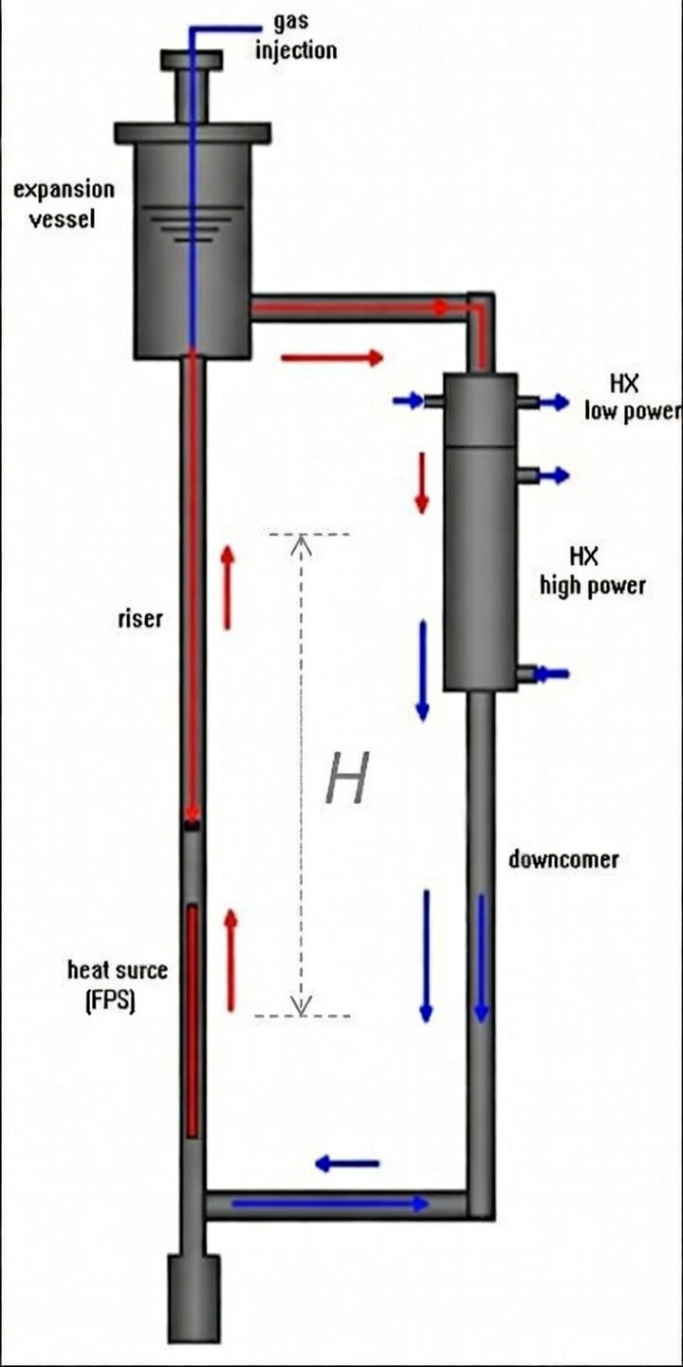
Figure 3-1: Schematic representation of the NACIE-UP primary loop.
Figure 3-2: Layout of NACIE-UP facility.

Loop Instrumentation
The loop instrumentation includes several thermocouples. The thermocouples are inserted into the primary and secondary loops through Swagelok fittings and therefore directly measure the coolant temperature (LBE or water).
The thermocouple identification is defined as follows:
for the primary loop: TP-101, TP-102, TP-103, TP-104, TP-105, TP-106, TP-107, and TP-310;
for the secondary loop, the thermocouples relevant for the benchmark are those located at the inlet and outlet of the main section of the heat exchanger, namely TP-203 and TP-204.
The thermocouple positions can be inferred from the NACIE-UP layout and the corresponding NACIE-UP P&ID included in this document (see Appendix B). All thermocouples have a diameter of 3 mm and are K-type, Class 1. Accordingly, their accuracy, in compliance with IEC 60584-3 (2007), is ±1.5 °C in the temperature range from −40 °C to +375 °C and ±0.004·t from 375 °C to 1000 °C.
In addition, the cover gas pressure in the expansion tank is monitored by the Barksdale pressure transducer P110. The overall measurement chain error for the thermocouples has been independently verified.

Thermal Flow Meter
A prototypical thermal flow meter (FM101) was used to measure the LBE mass flow rate in the loop. The thermal flow meter is based on the energy balance and it is shown schematically in Figure 3-3.
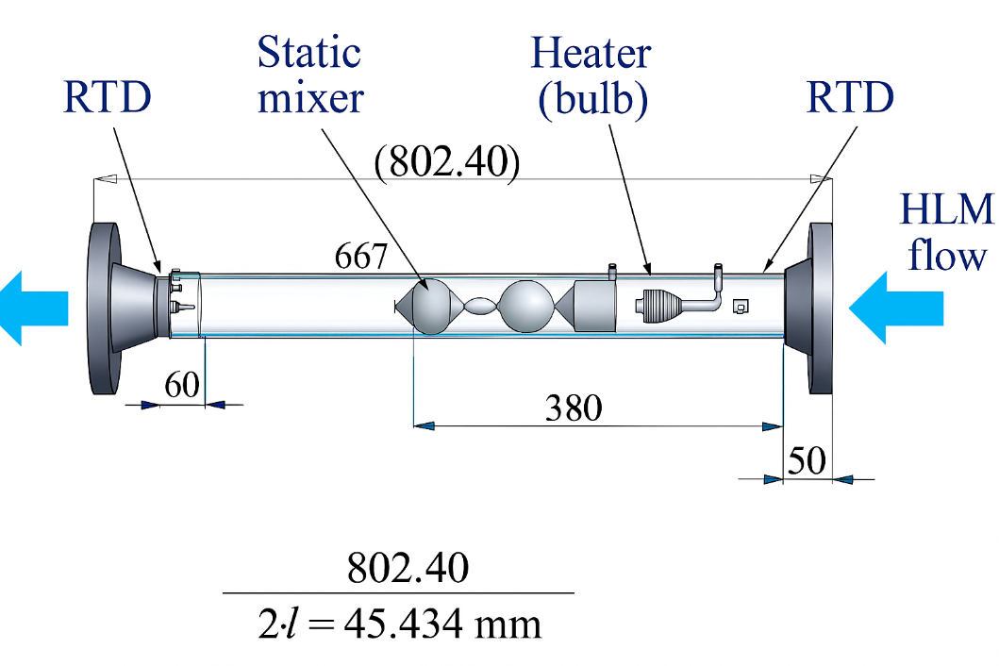
Figure 3-3: Schematic view of the thermal flow meter.
The component is made by a flanged pipe (SS) with an heater developed by Thermocoax (6 kW maximum power), a static mixer, 2 Resistance Temperature Detector (RTD) and an internal RTD in the bulb. The mass flow rate will be computed by the thermal balance:

(1)

Under steady-state conditions, Eq. (1) yields an accurate evaluation of the mass flow rate. During transient operation, the bulb heater is actively regulated to maintain a constant temperature difference between the heater and the inlet RTD. In addition, an inlet–outlet temperature compensation is implemented to account for the fluid transit time through the 800 mm pipe. These two features, implemented within the Data Acquisition and Control System (DACS) of the instrument, ensure a fast and accurate response under transient conditions.
The thermal flow meter was developed at ENEA in collaboration with Thermocoax and was successfully tested first in water and subsequently in heavy liquid metal (HLM) during several experimental campaigns conducted in the NACIE facility. Compared with alternative measurement technologies, it offers the advantages of very low pressure losses and a very high maximum operating temperature. The instrument provides reliable measurements even at low HLM mass flow rates, down to 0.6 kg/s. The thermal flow meter operating according to a “thermal balance” principle demonstrated good stability and repeatability, a favorable response to transient conditions, and no requirement for calibration, as it relies on fundamental conservation laws.
For the NACIE-UP facility operating in the present configuration, the thermal flow meter FM101 is configured to measure mass flow rates in the range from 0.6 kg/s to 10 kg/s. The correspondence between the electrical output signal (current) and the measured mass flow rate is 4–20 mA for 0.6–10 kg/s. The measurement accuracy was assessed both numerically and analytically using error propagation theory and is estimated to be approximately 5% under the present operating conditions [1].
The measurement chain error of the thermal flow meter was evaluated using a calibrator in place of the instrument. For the calibration procedure, five different current values I [mA] were considered. These current levels correspond to mass flow rates according to the relation $Q [kg/s]=0.5875⋅I-1.75$. A maximum error of 0.1% of the instrument full scale was deemed acceptable. The measurement chain error was assessed and found to be negligible, remaining below 0.1% of full scale.
The bulb heater power applied during the experimental tests will be provided for use in the simulations.

The fuel bundle simulator
The FPS consists of 19 wire-spaced electrically heated pins arranged in a triangular lattice and enclosed by a dedicated hexagonal wrapper. Each pin has a diameter of D = 6.55 mm and a pitch-to-diameter ratio (P/D) of 1.2824. The total pin length, including the non-active sections and electrical connectors, is 2000 mm, while the heated (active) length is 600 mm. Spacer wires are helically wrapped around each pin with an axial pitch of Pw = 262 mm. The maximum thermal power of the bundle is approximately 250 kW, corresponding to a peak wall heat flux of about 1 MW/m². The main FPS design parameters are summarized in Table 3-2. The pin dimensions and overall structure are representative of the MYRRHA fuel assembly design.
The main geometrical dimensions of the fuel bundle, together with an overall sketch of the cross section, are shown in Figure 3-4. The total flow area is conventionally subdivided into 54 subchannels of different ranks (S1–S54). The pins and subchannels are numbered to facilitate their identification and the reference to the associated instrumentation.
The inner rank consists of the central pin No. 1 and subchannels S1–S6; the intermediate rank includes pins No. 2–7 and subchannels S7–S24; the outer rank (N) is formed by pins No. 8–19 and subchannels S25–S54.
The overall layout of the fuel pin bundle simulator, including its main dimensions, is illustrated in Figure 3-5 and provided separately. In addition, a detailed drawing of a single pin with the spacer wire is supplied. At the pin foot, a bottom grid is installed to maintain the structural integrity of the bundle, while the conical section allows elastic bending of the pins, which is required for the correct installation of the electrical connectors. A drawing of the bottom grid, which is the only component required for numerical fluid-dynamics modeling, is provided separately to the participants.

Table 3-2: FPS design parameters
Parameter | Value
$$D_{pin}$$ | 6.55 mm
P | 8.4 mm
P/D | 1.2824 mm
d_{wire} | 1.75 mm
$$P_{wire}$$ | 262 mm
$$L_{total}$$ | 2000 mm
$$L_{active}$$ | 600 mm
$$D_{H,nom}$$ | 3.84 mm
$$q_{max}^{''}$$ | $${1 MW/m}^{2}$$

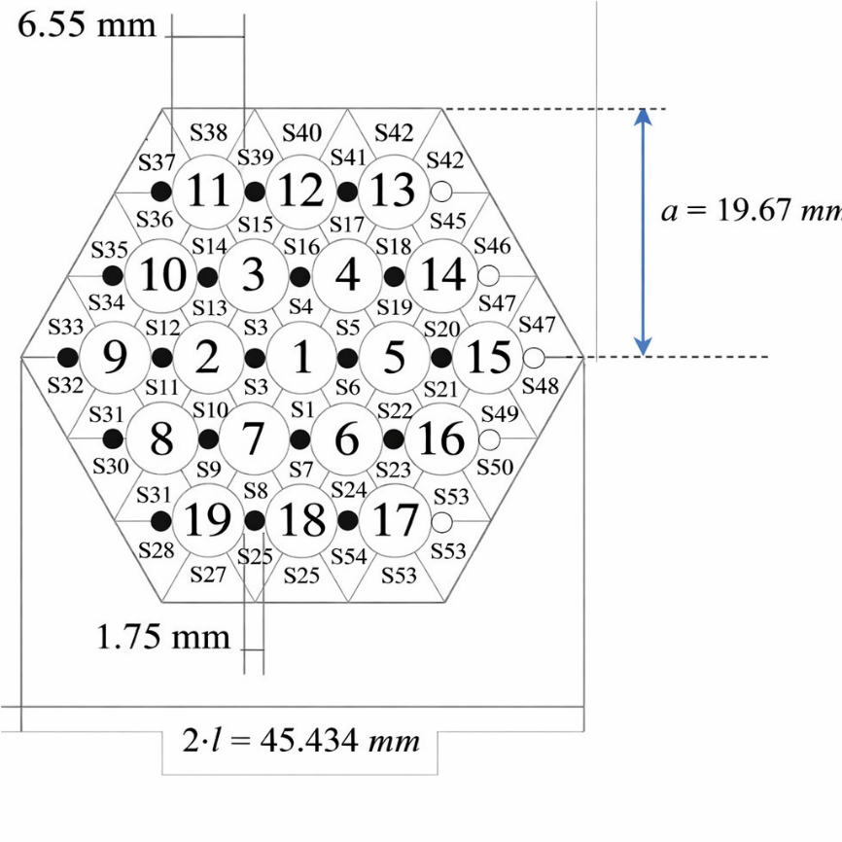
Figure 3-4: cross-section of the electrical wire-spaced FPS.

Figure 3-5 FPS layout.

Fuel Bundle Instrumentation
Pins No. 1, 2, 4, 5, 6, 7, 9, 16, 18, and 19 are instrumented with wall-embedded thermocouples located on one or more generatrices parallel to the pin axis, as summarized in Table 3-3 and illustrated in Figure 3-6. Three axial measurement levels are considered, at z = 38, 300, and 562 mm measured from the bottom of the active pin region, as shown in Figure 3-6(a). By convention, the measurement planes at z = 38, 300, and 562 mm are referred to as Sections A, B, and C, respectively.
The selected measurement sections share the same geometrical configuration, since the wire pitch is P_{w} = 262 mm, which corresponds to the axial distances between successive sections (300 − 38 mm and 562 − 300 mm). In addition, Pin No. 3 is instrumented along a single generatrix with 13 wall-embedded thermocouples distributed over the active length, spaced every P_{w} /6 = 43.66 mm starting from z = 38 mm.
Subchannels S2, S5, S22, S26, and S33 are instrumented with bulk thermocouples of 0.5 mm diameter at the same three measurement sections A, B, and C (see Table 3-4). A schematic view of a generic measurement section, including both wall-embedded thermocouples and instrumented subchannels, is shown in Figure 3-6 (b). The relative positions of the grooves, i.e., the generatrices (highlighted in red) for the different pins, can also be inferred by considering the reference azimuthal pin angle θ, defined as positive in the anticlockwise direction when the bundle cross section is viewed from the top.
Table 3-5 summarizes all the relevant information associated with the thermocouples, including the pin or wire number, thermocouple type (‘Wall’ or ‘Bulk’), thermocouple diameter, subchannel number for bulk thermocouples, azimuthal angle, axial z location measured from the beginning of the active region, and the corresponding measurement section (A, B, or C). In cases where the information is not defined, the symbol “–” is used.
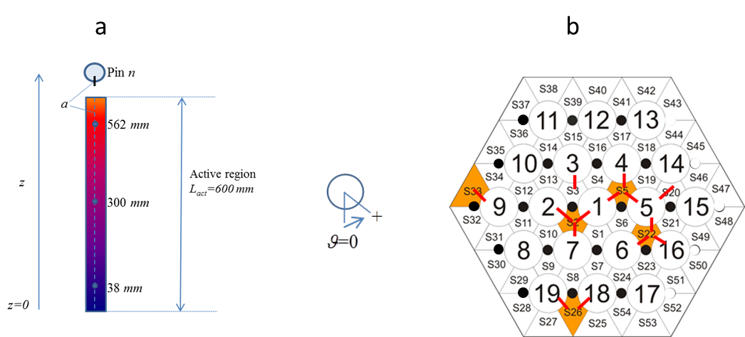
a
b
Figure 3-6: Axial (a) and section (b) locations of wall embedded and bulk TCs for pins n. 1,3, 2, 4, 5, 6, 7, 9, 16, 18, 19.
Table 3-3:Azimuthal angles of the pin generatrices where the wall embedded Thermocouples are located.
Pin number | Azimuthal angles ϑ[°] | Location [mm] | Number of  wall TCs | TC diameter  [mm]
1 | -60, +120 | z= 38, 300, 562 | 6 | 0.35
2 | +60 | z= 38, 300, 562 | 3 | 0.35
4 | 0 | z= 38, 300, 562 | 3 | 0.35
5 | -120,0,+120 | z= 38, 300, 562 | 9 | 0.35
6 | +120 | z= 38, 300, 562 | 3 | 0.35
7 | +180 | z= 38, 300, 562 | 3 | 0.35
9 | -120 | z= 38, 300, 562 | 3 | 0.35
16 | -120 | z= 38, 300, 562 | 3 | 0.35
18 | -60 | z= 38, 300, 562 | 3 | 0.35
19 | +60 | z= 38, 300, 562 | 3 | 0.35

Table 3-4: Azimuthal angles of the generatrices where the bulk Thermocouples are located for each sub-channel instrumented.
Sub-channel  number | Pin (wire) number | Azimuthal angle ϑ[°] | Location [mm] | Number of  bulk TCs | TC  diameter  [mm]
S5 | 1 | +120 | z= 38, 300, 562 | 3 | 0.5
S2 | 2 | +60 | z= 38, 300, 562 | 3 | 0.5
S22 | 6 | +120 | z= 38, 300, 562 | 3 | 0.5
S33 | 9 | -120 | z= 38, 300, 562 | 3 | 0.5
S26 | 19 | +60 | z= 38, 300, 562 | 3 | 0.5

Table 3-5: Thermocouples names with all the relevant information associated.
TC  name | Pin (wire) number | type | TC  diameter  [mm] | Subchannel  number  (Bulk TC) | Azimuthal  angle [°]  (wall TC) | z Location  [mm] | Section
TC-FPS-01 | 2 | Bulk | 0.5 | S2 | +60 | 38 | A
TC-FPS-02 | 1 | Bulk | 0.5 | S5 | +120 | 38 | A
TC-FPS-03 | 6 | Bulk | 0.5 | S22 | +120 | 38 | A
TC-FPS-04 | 19 | Bulk | 0.5 | S26 | +60 | 38 | A
TC-FPS-05 | 9 | Bulk | 0.5 | S33 | -120 | 38 | A
TC-FPS-06 | 2 | Bulk | 0.5 | S2 | +60 | 300 | B
TC-FPS-07 | 1 | Bulk | 0.5 | S5 | +120 | 300 | B
TC-FPS-08 | 6 | Bulk | 0.5 | S22 | +120 | 300 | B
TC-FPS-09 | 19 | Bulk | 0.5 | S26 | +60 | 300 | B
TC-FPS-10 | 9 | Bulk | 0.5 | S33 | -120 | 300 | B
TC-FPS-11 | 2 | Bulk | 0.5 | S2 | +60 | 562 | C
TC-FPS-12 | 1 | Bulk | 0.5 | S5 | +120 | 562 | C
TC-FPS-13 | 6 | Bulk | 0.5 | S22 | +120 | 562 | C
TC-FPS-14 | 19 | Bulk | 0.5 | S26 | +60 | 562 | C
TC-FPS-15 | 9 | Bulk | 0.5 | S33 | -120 | 562 | C
TC-FPS-16 | 1 | Wall | 0.35 | - | -60 | 38 | A
TC-FPS-17 | 1 | Wall | 0.35 | - | +120 | 38 | A
TC-FPS-18 | 2 | Wall | 0.35 | - | +60 | 38 | A
TC-FPS-19 | 4 | Wall | 0.35 | - | 0 | 38 | A
TC-FPS-20 | 5 | Wall | 0.35 | - | -120 | 38 | A
TC-FPS-21 | 5 | Wall | 0.35 | - | 0 | 38 | A
TC-FPS-22 | 5 | Wall | 0.35 | - | +120 | 38 | A
TC-FPS-23 | 6 | Wall | 0.35 | - | +120 | 38 | A
TC-FPS-24 | 7 | Wall | 0.35 | - | +180 | 38 | A
TC-FPS-25 | 9 | Wall | 0.35 | - | -120 | 38 | A
TC-FPS-26 | 16 | Wall | 0.35 | - | -120 | 38 | A
TC-FPS-27 | 18 | Wall | 0.35 | - | -60 | 38 | A
TC-FPS-28 | 19 | Wall | 0.35 | - | +60 | 38 | A
TC-FPS-29 | 1 | Wall | 0.35 | - | -60 | 300 | B
TC-FPS-30 | 1 | Wall | 0.35 | - | +120 | 300 | B
TC-FPS-31 | 2 | Wall | 0.35 | - | +60 | 300 | B
TC-FPS-32 | 4 | Wall | 0.35 | - | 0 | 300 | B
TC-FPS-33 | 5 | Wall | 0.35 | - | -120 | 300 | B
TC-FPS-34 | 5 | Wall | 0.35 | - | 0 | 300 | B
TC-FPS-35 | 5 | Wall | 0.35 | - | +120 | 300 | B
TC-FPS-36 | 6 | Wall | 0.35 | - | +120 | 300 | B
TC-FPS-37 | 7 | Wall | 0.35 | - | +180 | 300 | B
TC-FPS-38 | 9 | Wall | 0.35 | - | -120 | 300 | B
TC-FPS-39 | 16 | Wall | 0.35 | - | -120 | 300 | B
TC-FPS-40 | 18 | Wall | 0.35 | - | -60 | 300 | B
TC-FPS-41 | 19 | Wall | 0.35 | - | +60 | 300 | B
TC-FPS-42 | 1 | Wall | 0.35 | - | -60 | 562 | C
TC-FPS-43 | 1 | Wall | 0.35 | - | +120 | 562 | C
TC-FPS-44 | 2 | Wall | 0.35 | - | +60 | 562 | C
TC-FPS-45 | 4 | Wall | 0.35 | - | 0 | 562 | C
TC-FPS-46 | 5 | Wall | 0.35 | - | -120 | 562 | C
TC-FPS-47 | 5 | Wall | 0.35 | - | 0 | 562 | C
TC-FPS-48 | 5 | Wall | 0.35 | - | +120 | 562 | C
TC-FPS-49 | 6 | Wall | 0.35 | - | +120 | 562 | C
TC-FPS-50 | 7 | Wall | 0.35 | - | +180 | 562 | C
TC-FPS-51 | 9 | Wall | 0.35 | - | -120 | 562 | C
TC-FPS-52 | 16 | Wall | 0.35 | - | -120 | 562 | C
TC-FPS-53 | 18 | Wall | 0.35 | - | -60 | 562 | C
TC-FPS-54 | 19 | Wall | 0.35 | - | +60 | 562 | C
TC-FPS-55 | 3 | Wall | 0.35 | - | 0 | 38 | A
TC-FPS-56 | 3 | Wall | 0.35 | - | 0 | 81.7 | -
TC-FPS-57 | 3 | Wall | 0.35 | - | 0 | 125.3 | -
TC-FPS-58 | 3 | Wall | 0.35 | - | 0 | 169 | -
TC-FPS-59 | 3 | Wall | 0.35 | - | 0 | 212.7 | -
TC-FPS-60 | 3 | Wall | 0.35 | - | 0 | 256.3 | -
TC-FPS-61 | 3 | Wall | 0.35 | - | 0 | 300 | B
TC-FPS-62 | 3 | Wall | 0.35 | - | 0 | 343.7 | -
TC-FPS-63 | 3 | Wall | 0.35 | - | 0 | 387.3 | -
TC-FPS-64 | 3 | Wall | 0.35 | - | 0 | 431 | -
TC-FPS-65 | 3 | Wall | 0.35 | - | 0 | 474.6 | -
TC-FPS-66 | 3 | Wall | 0.35 | - | 0 | 518.3 | -
TC-FPS-67 | 3 | Wall | 0.35 | - | 0 | 562 | C

Heat Exchanger
The heat exchanger is of the shell-and-tube type and is designed to transfer thermal power up to 250 kW. It consists of two separate shell sections: a low-power crossflow section (0–30 kW) and a high-power counter-current section (30–250 kW), both connected to the pressurized-water secondary side. The two sections can be independently drained and filled (see Figure 3-1 and Figure 3-2). The tube geometry follows a “tube-in-tube” configuration, with an annular gap of 2.45 mm filled with AISI 316 powder.
The secondary side is a closed-loop pressurized water circuit operating at 16 bar and equipped with a circulation pump, a pre-heater, the shell side of the heat exchanger, an air cooler, and a pressurizer. An ultrasonic flow meter installed between the air cooler and the pump is used to monitor the secondary water mass flow rate, while several thermocouples measure temperatures throughout the loop. The combination of these measurements allows the thermal power exchanged in each heat exchanger section to be quantified. All geometrical details of the heat exchanger and the secondary loop can be derived from the drawings provided in Appendix B.
In the three experiments discussed in this report, only the high-power counter-current section of the heat exchanger is utilized. The counter-current flow arrangement simplifies the thermo-fluid-dynamic modeling of the heat exchanger.

Gap Thermal Conductivity
The heat exchanger features double walls filled with AISI stainless-steel powder; therefore, an accurate numerical modeling of the heat exchanger is essential to correctly predict the average LBE temperature in the loop under all the investigated operating conditions. A technical drawing of the heat exchanger is provided in Figure 3-7.
Figure 3-7 Technical drawing of the Heat Exchanger.
During the blind phase of a previous benchmark conducted within the SESAME project, the predicted average temperatures were significantly lower than the corresponding experimental values for all three tests. As illustrated in Figure 3-8 for Test-3, the simulated average temperature remains well below the measured value throughout the entire test duration, with deviations ranging from approximately 50 to 30 °C relative to the experimental data.
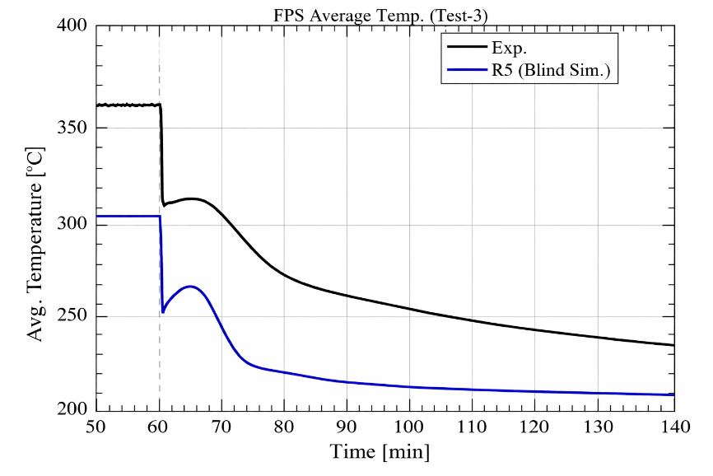
Figure 3-8: Comparison of the average loop temperature (blind simulation and experimental data, Test-3).
This inconsistency made a more detailed analysis of the previous heat exchanger (HX) “blind model” adopted in the SESAME benchmark mandatory. Consequently, a refined assessment of the overall heat-transfer performance of the HX component was performed. In particular, the re-evaluation focused on the thermal conductivity of the stainless-steel powder filling the 2.45 mm gap. This contribution accounts for nearly 50% of the total thermal resistance of the HX and therefore has a major impact on the global heat-transfer performance and, ultimately, on the mean temperature of the loop.
Based on more reliable experimental data [2], it was concluded that the powder thermal conductivity assumed in the blind simulations was overestimated. The powder thermal conductivity reported in [2] is summarized in Figure 3-9, which shows experimental correlations as a function of temperature for three increasing powder compaction levels, denoted as RUN 0.0, 1.0, and 5.0 (dotted lines). The figure also includes the thermal conductivity adopted in the blind RELAP5 simulations (blue line) and the updated value used in the post-test RELAP5 analyses (red line).
A systematic post-test analysis performed with RELAP5 [3] allowed an analytical expression for the powder thermal conductivity to be derived, which is strongly recommended for adoption in the present benchmark:
 | $$k_{powder}=0.3+0.005∙\left(T-200\right)$$ | (2)

where T is in °C and k in W/(m*K).
This assumption is more consistent with the currently available experimental data and provides a more accurate representation of the HX thermal performance and, more generally, of the system behavior. Regarding the assumptions on the HX geometrical parameters, such as heat-transfer surfaces and double-wall tube thicknesses, these were taken directly from the design drawings [4].
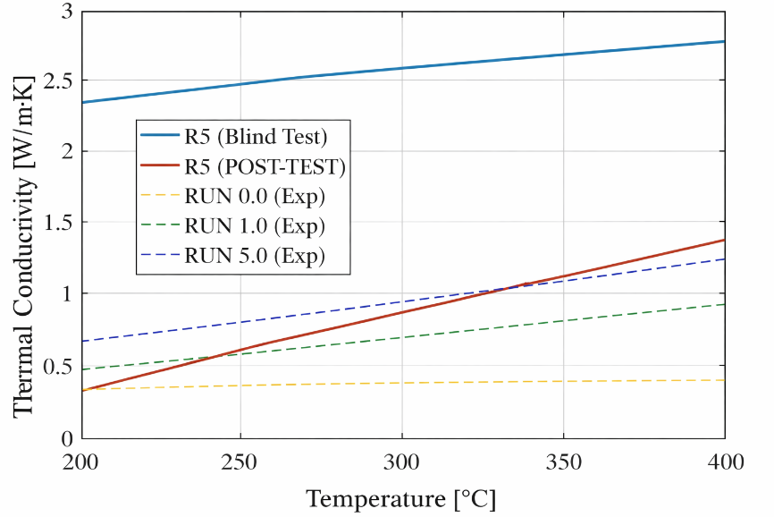
Figure 3-9: Stainless steel powder thermal conductivity.

The Gas Injection System
The gas injection device currently installed and used during the experimental tests is composed of a 12.70 mm (1/2 inch) outer-diameter pipe, 6135 mm in length, which is inserted through the 2½″ coupling flange located at the top of the expansion tank by means of a Swagelok tube fitting. Technical drawings of the terminal section of the device, including its functional dimensions, are shown in Figure 3-10.
The gas is discharged through five holes, each with a diameter of 1 mm, aligned along a generatrix of four short outlet pipes (five holes per pipe). The four short pipes are arranged in a plane perpendicular to the main 6135 mm pipe and are mutually oriented at 90° with respect to each other [5].

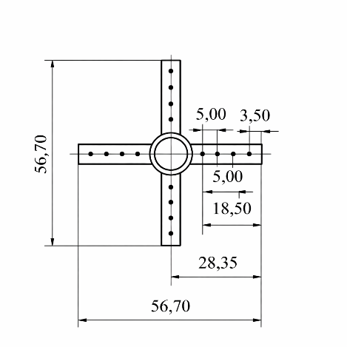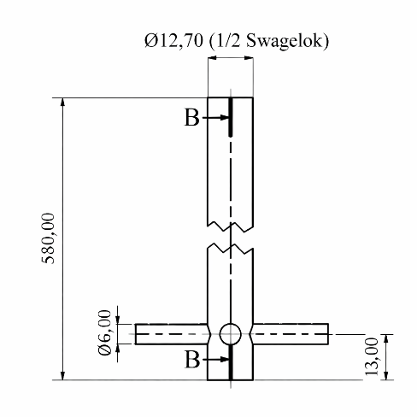
Figure 3-10: Technical drawings of the gas injection device.
With regard to the gas injection system, the control unit allows the argon volumetric flow rate to be set. However, the resulting void fraction α in the NACIE-UP primary circuit cannot be determined a priori, and therefore the pressure head provided to the loop cannot be directly estimated in advance. It is well established that the relationship between the injected argon volumetric flow rate and the resulting LBE mass flow rate in the primary circuit is non-linear.
In addition, the gas injection system exhibits intrinsic operational limitations related to this non-linear behavior. At high gas mass flow rates, the pumping capability approaches saturation, and the overall efficiency of the system decreases.

Expansion vessel
The expansion vessel is located at the top of the riser and is partially filled with argon, which acts as a cover gas to control the pressure in the primary circuit. Two level sensors, LD102 and LD101, are installed inside the expansion vessel at 80 mm and 180 mm, respectively, above the riser outlet nozzle.
During circuit filling, the LBE level is above the LD102 sensor (LD102 active) but below the LD101 sensor (LD101 inactive). Nevertheless, LBE levels reaching the LD101 position are still acceptable for facility operation. The low-level sensor (LD102) is positioned 150 mm from the top of the incoming vertical nozzle (i.e., 150 + 285 = 435 mm from the bottom of the expansion vessel), while the high-level sensor (LD101) is located 230 mm from the top of the same nozzle. A cross-sectional view of the expansion vessel (S101) is shown in Figure 3-11.
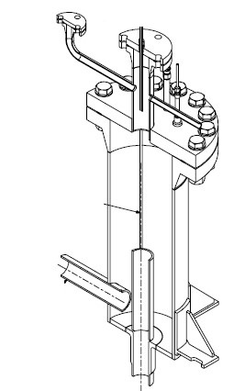
Figure 3-11: cross-section of expansion vessel.

Data acquisition and control system
The Data Acquisition and Control System (DACS) is implemented using LabVIEW System Design Software in combination with National Instruments hardware. Both the primary and secondary systems of the NACIE-UP facility are remotely controlled, and the filling and draining operations of the plant are also performed remotely. Figure 3-12 presents the control and monitoring interface used to remotely actuate components and valves, from which temperatures and pressures in the primary and secondary systems are continuously monitored.
Figure 3-13 shows the remote-control panel dedicated to the activation and regulation of power generation. The power level, the number of energized pins, and the power ramp rate can be adjusted as required, as illustrated in the same figure. In addition, all wall and bulk thermocouples within the fuel pin bundle simulator can be continuously monitored through the interface shown in Figure 3-14. Each pin can be controlled independently, enabling the execution of asymmetric heating tests for code validation purposes. Transitions between different power levels can also be performed through controlled power ramps.

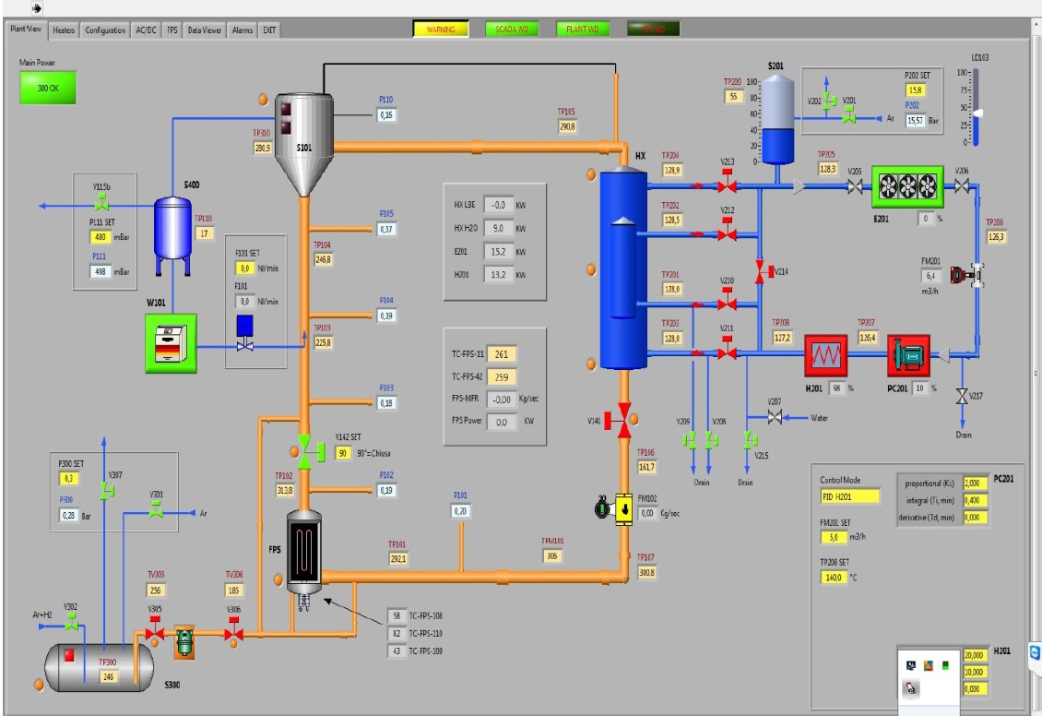
Figure 3-12: Remote control panel of the NACIE-UP facility.

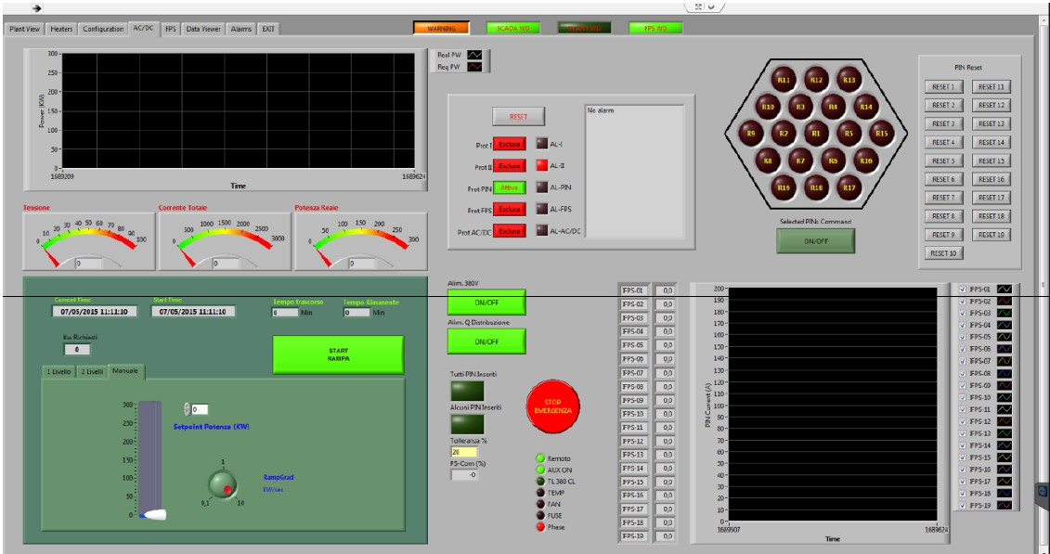
Figure 3-13: Control panel of the Fuel Pin simulator power.

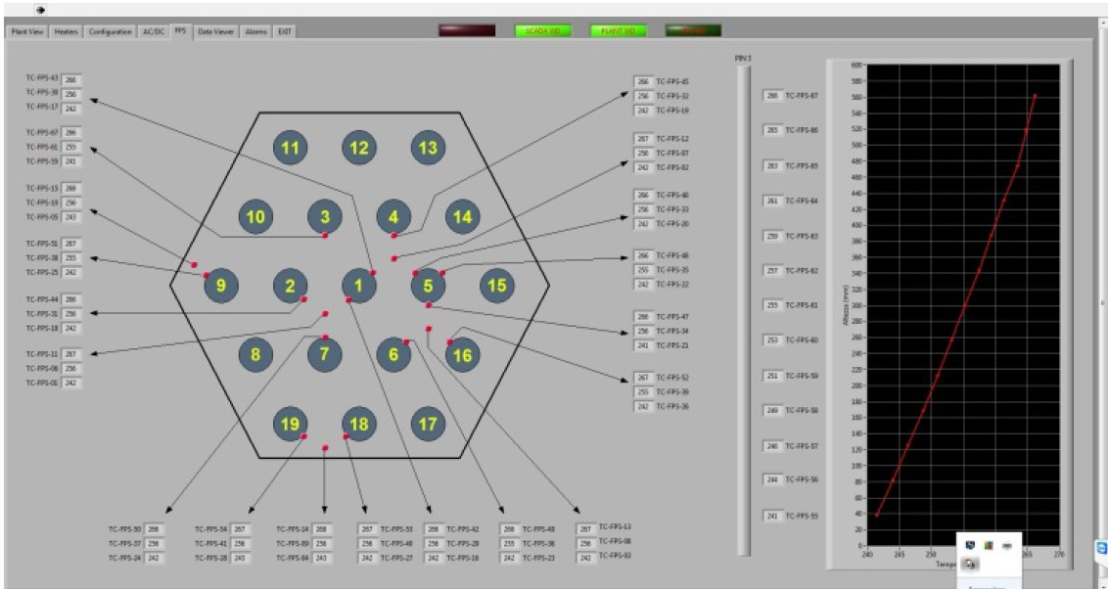
Figure 3-14: Monitoring panel of the FPS temperatures.

References
- P. Cioli Puviani, I. Di Piazza, Estimation of the accuracy of the thermal flow meter, ENEA report TH-N-R-712, 2023.
- D. Rozzia, G. Fasano, I. Di Piazza, M. Tarantino, , “Experimental Investigation on Powder Conductivity for the Application to Double Wall Heat Exchanger (NACIE-UP)”, Journal of Nuclear Engineering and Design, vol.283, pp. 100-113, 2015.
- N. Forgione, D. Martelli, G. Barone, F. Giannetti, P. Lorusso, T. Hollands, A. Papukchiev, M. Polidori, A. Cervone, I. Di Piazza, “Post-test simulations for the NACIE-UP benchmark by STH codes”, Nuclear Engineering and Design, Volume 353, November 2019, 110279
- N.Forgione, “ Post Test Simulation for The NACIE-UP Benchmark By STH Codes”,2018
- AA.VV. SESAME Deliverable D4.9, (2016). NACIE-UP Experimental Setup and Test Matrix for PLOFA Experiment.

