Description of the experimental tests
The experimental campaign was designed to characterize the thermal–hydraulic behavior of a heavy liquid metal (HLM)–cooled fuel assembly during the transition from forced to natural circulation. Nevertheless, some tests were performed with a non-uniform distribution of the total power among the 19 pins, while maintaining an equal power level within selected subsets of pins in the bundle (ADP10). One test considered only the seven central pins (ADP06, including the central pin and the second rank) and was compared with another test characterized by the same total power but with all pins energized. A third test (ADP07) involved two-sixths of the hexagonal bundle being active.
Each test consisted of a mass flow transient. In the initial phase, gas was injected into the riser to enhance LBE circulation. After steady-state conditions were established, the gas injection was switched off, while the total thermal power remained unchanged. During the second phase, natural circulation was the sole driving mechanism for the flow in the loop. As a consequence of the constant power level, temperatures downstream of the FPS increased, whereas temperatures in the colder sections of the loop decreased.

LBE and Material properties

LBE Physical properties
In the present work, the physical properties of LBE, all of which are temperature dependent, are evaluated using empirical correlations recommended in the OECD/NEA Handbook (2015) [1]. Correlations for density, specific heat, dynamic viscosity, and thermal conductivity are reported in Table 3-1 in SI units. The maximum deviation of the experimental data underlying each correlation is also provided. In addition, the standard deviation of the experimental data used to derive each correlation was calculated from the source datasets and is reported in the last column of Table 3-1.
These property correlations are recommended for use in the benchmark, and participants are expected to adopt them in their numerical simulations. If this is not feasible, participants are required to explicitly state which physical property correlations have been employed.
Table 3-1 Thermo-physical properties of LBE as a function of temperature (T in Kelvin, SI Units), from LBE-Handbook.
Property | Symbol | Correlation | Maximum Uncertainty | Standard deviation
Density
Heat capacity |  | $$164.8-3.94∙{10}^{-2}∙T+1.25∙{10}^{-5}∙T^{2}-4.56∙{10}^{5}∙T^{-2}$$
Dynamic viscosity
Thermal conductivity |  | $3.284+1.617∙{10}^{-2}∙T-2.305∙{10}^{-6}∙T^{2}$

Stainless steel thermo-physical properties
All components and piping of the NACIE-UP facility, as well as the spacer wires in the pin bundle, are manufactured from AISI 316L stainless steel. The thermo-physical properties of stainless steel are widely available in the literature, and the impact of variations in these properties on the computational results is expected to be of secondary importance. Nevertheless, property functions are provided to minimize discrepancies among benchmark participants.
The thermo-physical properties are taken from an ANL publication [2] and are strongly recommended for use in the benchmark. Table 3-2 lists the corresponding thermo-physical property functions in SI units.
Table 3-2 Thermo-physical properties of stainless steel AISI316L as a function of temperature (T in Kelvin, SI Units)
Property | Symbol | Correlation
Density | $$ρ_{ss}$$ | $$8084.2-0.42086∙T-3.8942∙{10}^{-5}∙T^{2}$$
Heat capacity | $$c_{p,ss}$$ | $$458.546+0.1327∙T$$
Thermal conductivity | $$k_{ss}$$ | $$9.248+1.57∙{10}^{-2}∙T$$
Linear expansion coefficient | $$∝_{ss}$$ | $$1.7887∙{10}^{-5}+2.3977∙{10}^{-9}∙T+3.692∙{10}^{-13}∙T^{2}$$

Pin materials thermo-physical properties
Particularly for CFD analyses, it may be important to explicitly model the pin cladding and internal structure within the active region. The complete pin drawing is proprietary and cannot be shared with the benchmark participants. Nevertheless, a schematic cross section of the pin in the active region is provided in Figure 3-1 for modeling purposes.
The pin is mono-filar; therefore, the heat flux is azimuthally uniform over the pin surface. The pin consists of an AISI 316L stainless-steel cladding, a central copper conductor, and a boron nitride (BN) insulating powder; an intermediate pipe made of Inconel 600 is also present. The main dimensions of the different pin components are summarized in Table 3-3.
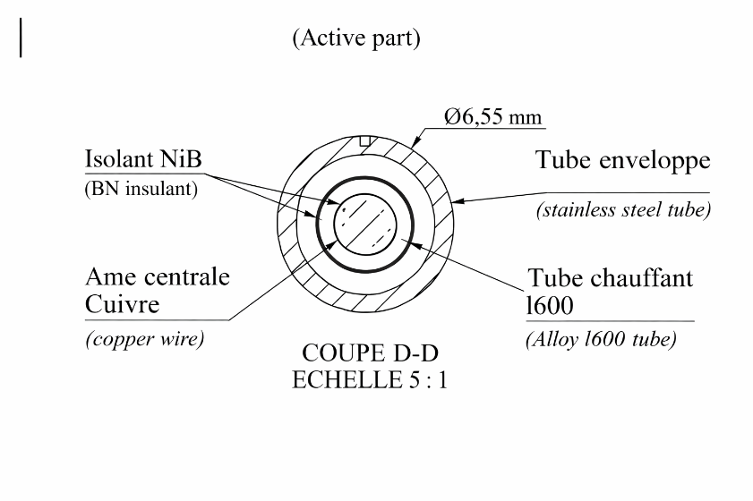
Figure 3-1 Schematic drawing of the section of the pin in the active part.
Table 3-3 Diameters of the different parts of the pin in the active region.
Part | Internal diameter [mm] | External diameter [mm]
Clad (AISI316L) | 5.08 | 6.55
Heating tube (Inconel600) | 3.35 | 3.53
Central conductor (Copper) | - | 2.31
1st insulant layer (BN) | 2.31 | 3.35
2nd insulant layer (BN) | 3.53 | 5.08

For modeling purposes, it was agreed among the partners that, in CFD analyses, the pin cladding should be explicitly modeled by all participants in order to impose the correct thermal boundary condition of uniform heat flux. The modeling of the internal pin components is left to the discretion of each participant. In any case, the Inconel 600 intermediate pipe was neglected, as its influence on the analysis was deemed marginal.
With respect to the physical properties of the various materials, the thermo-physical properties of AISI 316L stainless steel were provided in the previous section, while the properties of boron nitride (BN) and copper are reported in Table 3-4 and in Table 3-5, respectively, based on reference [3]. The thermo-physical properties of BN were supplied by Thermocoax [4].
Table 3-4 Thermo-physical properties of Bohrium Nitride (BN) as a function of temperature (T in Kelvin, SI Units)
Property | Symbol | Correlation | Range (T in K)
Density | $$ρ_{BN}$$ | $$2000$$ | Temperature independent
Heat capacity | $$c_{p,BN}$$ | $$800$$ | Temperature independent
Thermal conductivity | $$k_{BN}$$ | $$-2.416∙\ln\left(T-273.16\right)+25.578$$ | 293-1393

Table 3-5 Thermo-physical properties of Copper (SI Units)
Property | Symbol | Correlation | Range (T in K)
Density | $$ρ_{Copper}$$ | $$8933$$ | Temperature independent
Heat capacity | $$c_{p,Copper}$$ | $$385$$ | Temperature independent
Thermal conductivity | $$k_{Copper}$$ | $$401$$ | Temperature independent

Boundary conditions
The boundary conditions of the experimental tests are described in the following sections. For the experimental thermal balance, including reference values of the thermal power in the active region, the pre-heating section, and the thermal flow meter under initial and final steady-state conditions, the reader is referred to Appendix A. The ambient temperature for the experiments is fixed at 10 °C, corresponding to the average temperature of the experimental hall.

ADP10-All pins on
The first test, ADP10, consists of a gas transition transient performed at constant power, with the total power uniformly distributed among the 19 pins. The nominal electrical power of the FPS was 30 kW, corresponding to a nominal wall heat flux . Figure 3-2 shows a schematic view of the 19-pin fuel bundle simulator during test ADP10; the active pins are highlighted in blue.

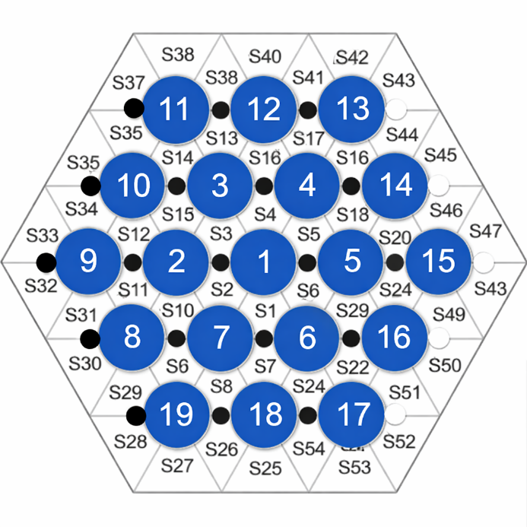
Figure 3-2: Active pins (in red) during test ADP10.
During the first stage of the test, the nominal gas flow rate in the primary loop was set to 10 Nl/min. The secondary side, filled with water at a pressure of 16 bar, was operated with an inlet temperature of 170 °C and a total volumetric flow rate of 10 m³/h. Only the high-power section of the heat exchanger was in operation during the test. The experiment was initiated after steady-state conditions had been achieved in both the primary and secondary circuits and was maintained for approximately 20 minutes.
The transient was triggered at time t = 1225 s by reducing the gas flow rate from the initial nominal value of 10 Nl/min to 0 Nl/min. The gas transition lasted 1 s, and the gas flow rate stabilized at zero at t = 1226 s. The secondary side was operated under the same conditions as in the first stage, namely a water inlet temperature of 170 °C and a total volumetric flow rate of 10 m³/h, as summarized in Table 3-6, which reports the boundary conditions at the beginning of the transient (BoT) and at the end of the transient (EoT).
Table 3-6:boundary conditions of ADP10 Test
Parameter | BOT | EOT
FPS Power | 30 kW | 30 kW
$$\dot{{ m}_{gas}}$$ | 10 Nl/min | 0
$${\dot{m}}_{H2O}$$ | 10 $m^{3}/h$ | 10 $m^{3}/h$
$$T_{{inlet,H}_{2}O}$$ | 170$℃$ | 170$℃$

Table 3-7:Sequence of events of ADP10 Test
Parameter | Time [s]
Start of steady state I | 0
Beginning of gas transient | 1225
End of gas transient | 1226
End of steady state II | 6000

After the transient, a new steady-state condition was reached and maintained for an additional period exceeding 30 minutes in order to obtain statistically significant data. The experimental trend of the argon flow rate is shown in Figure 3-3(a), while a zoomed view of the transition phase is presented in Figure 3-3(b).
The cyclic behavior of the gas injection observed prior to the transition is associated with the operation of the gas system in closed-circuit mode. In this configuration, the compressor W101 periodically refills the high-pressure tank located downstream of the compressor in response to a low-pressure signal. During compressor operation, the pressure upstream of the compressor and in the loop cover gas decreases.
The thermal power released by the thermal flow meter during the transient, on the order of 2 kW, is provided to the benchmark participants to enable realistic simulations. For a detailed thermal balance of the loop and the correct power values to be adopted in the calculations, the reader is referred to Appendix A.
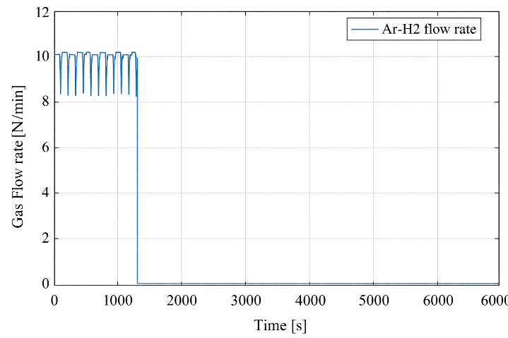 | 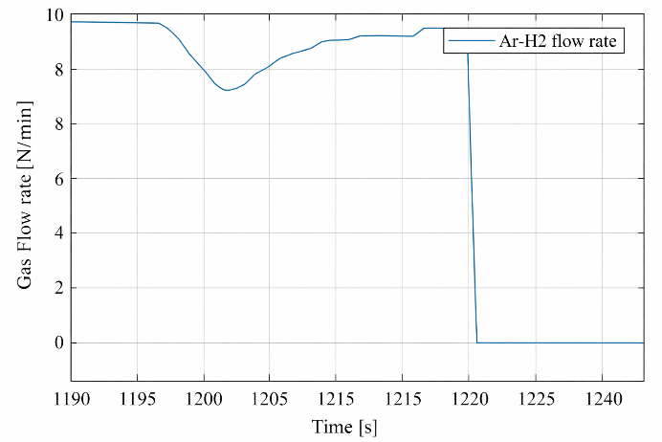
a) | b)
Figure 3-3: Time trend of the gas flow rate (a) and zoom of the transition (b),
test ADP10.

ADP06-7 central pins on
The second test, ADP06, involves a gas transition transient performed at constant power, with the total power uniformly distributed among the seven central pins (Pins 1 to 7). Figure 3-4 presents a schematic view of the fuel bundle simulator, with the active pins highlighted in blue. The nominal electrical power of the FPS was 30 kW, corresponding to a nominal wall heat flux . For comparison purposes, the total nominal power was selected to be identical to that of test ADP10.

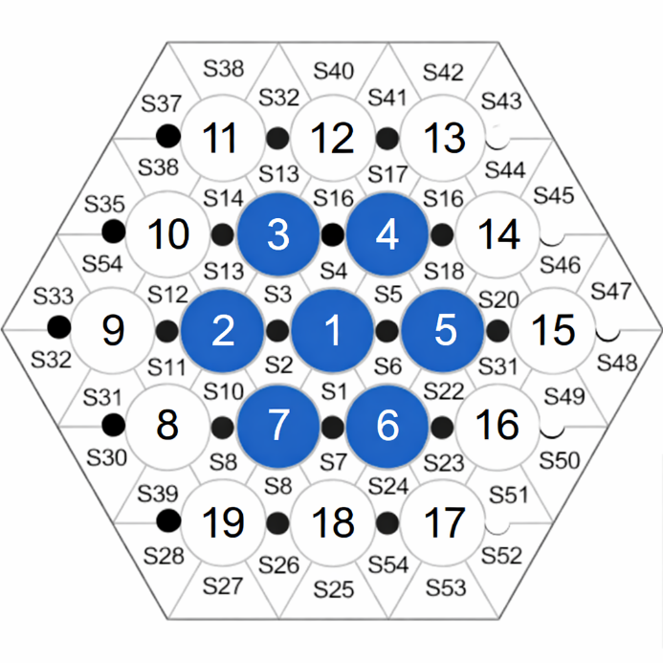
Figure 3-4: Active pins (in red) during test ADP06.
During the first phase of the test, a nominal gas flow rate of 10 Nl/min was supplied to the primary loop to sustain LBE circulation. The secondary side was operated with water at a pressure of 16 bar, an inlet temperature of 170 °C, and a total volumetric flow rate of 10 m³/h. Only the high-power section of the heat exchanger was in operation during the test. Steady-state conditions were reached in both the primary and secondary circuits and subsequently maintained for approximately 30 minutes (t = 0–1852 s).
The transient was initiated at t = 1852 s by reducing the gas flow rate from the initial nominal value of 10 Nl/min to 0 Nl/min. The gas transition lasted 1 s, and the gas flow rate stabilized at zero at t = 1853 s. The secondary side was operated under the same conditions as in the first phase, namely a water inlet temperature of 170 °C, a total volumetric flow rate of 10 m³/h, and a pressure of 16 bar, as summarized in Table 3-8, which reports the boundary conditions at the beginning (BoT) and end (EoT) of the transient.
Table 3-8: boundary conditions of ADP06 Test
Parameter | BOT | EOT
FPS Power | 30 kW | 30 kW
$$\dot{{ m}_{gas}}$$ | 10 Nl/min | 0
$${\dot{m}}_{H2O}$$ | 10 $m^{3}/h$ | 10 $m^{3}/h$
$$T_{{inlet,H}_{2}O}$$ | 170$℃$ | 170$℃$

Table 3-9:Sequence of events of ADP06 Test
Parameter | Time [s]
Start of steady state I | 0
Beginning of gas transient | 1852
End of gas transient | 1853
End of steady state II | 9000

After the transient, a new steady-state condition was reached and maintained for approximately one hour (t = 5000–9000 s) in order to obtain statistically significant data. The experimental trend of the argon flow rate is shown in Figure 3-5 (a), while a magnified view of the transition phase is provided in Figure 3-5 (b). The cyclic behavior of the gas injection is also evident during the initial phase of test ADP06, with its origin as previously explained.
Figure 4-6 presents the nominal power and the actual power released along the active length of the FPS during the test. The discontinuity observed in the actual power profile is related to the method used to evaluate this quantity. Specifically, the actual power was calculated by means of an energy balance over the active region. For numerical simulations, the actual power should be imposed over the active region, while the remaining fraction of the total power is assumed to be released in the entry region of the FPS. In addition, the thermal power released by the thermal flow meter during the transient, on the order of 2 kW, is provided to the benchmark participants to enable realistic simulations. Further details are available in Appendix A.
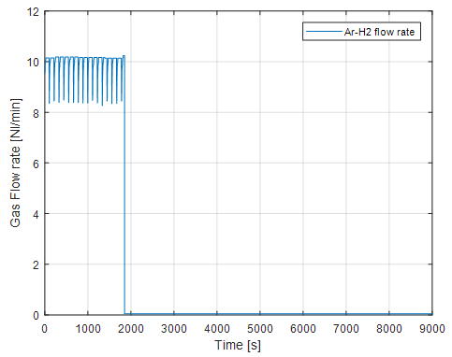 | 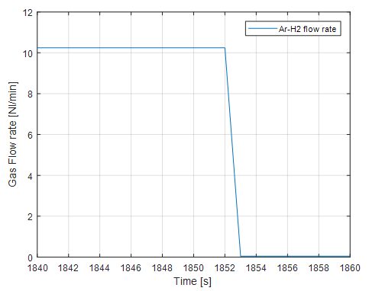
a) | b)
Figure 3-5: Time trend of the gas flow rate (a) and zoom of the transition (b),
test ADP06.

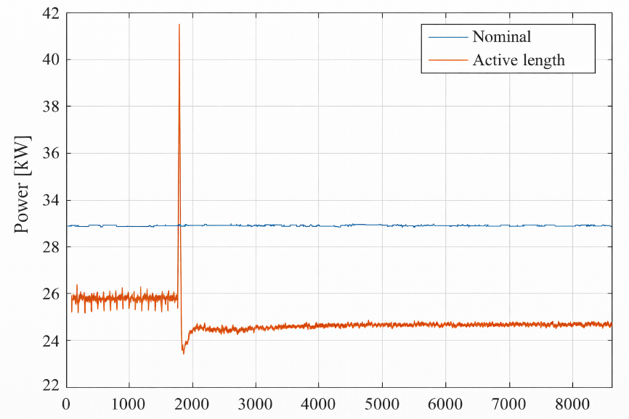
Figure 3-6: FPS power during test ADP06.

ADP07-Two sectors pins on
The third test, ADP07, involves a gas transition transient conducted at constant power, with the total power uniformly distributed among nine pins corresponding to two triangular sectors of the hexagonal bundle. The active pins were Nos. 1, 2, 6, 7, 8, 9, 17, 18, and 19, and are highlighted in red in Figure 3-7. The nominal electrical power of the FPS was 38 kW, corresponding to a nominal wall heat flux , selected to achieve wall heat flux values on the active pins comparable to those obtained in test ADP06.
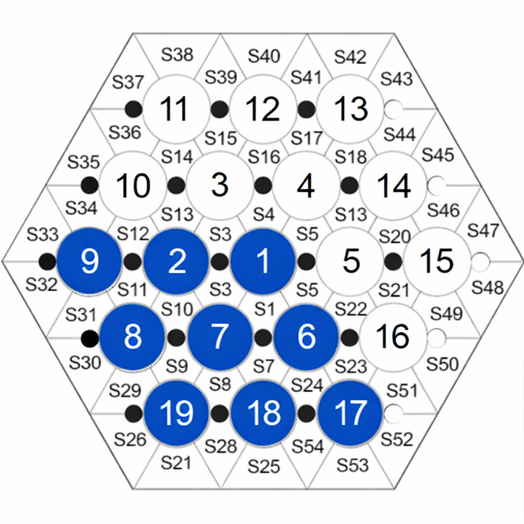
Figure 3-7: Active pins (in red) during test ADP07.

During the first phase of the test, a nominal gas flow rate of 10 Nl/min was supplied to the primary loop to sustain LBE circulation. The secondary side was operated with water at a pressure of 16 bar, an inlet temperature of 170 °C, and a total volumetric flow rate of 10 m³/h. Only the high-power section of the heat exchanger was in operation during the test. Steady-state conditions were reached in both the primary and secondary circuits and subsequently maintained for approximately 20 minutes (t = 0–1254 s).
The transient was initiated at t = 1254 s by reducing the gas flow rate from the initial nominal value of 10 Nl/min to 0 Nl/min. The gas transition lasted 1 s, and the gas flow rate stabilized at zero at t = 1255 s. During the second phase of the test, the secondary side was operated under the same conditions as in the first phase, namely a water inlet temperature of 170 °C, a total volumetric flow rate of 10 m³/h, and a pressure of 16 bar, as summarized in Table 3-10, which reports the boundary conditions at the beginning (BoT) and end (EoT) of the transient.
Table 3-10: boundary conditions of ADP07 Test
Parameter | BOT | EOT
FPS Power | 38 kW | 38 kW
$$\dot{{ m}_{gas}}$$ | 10 Nl/min | 0
$${\dot{m}}_{H2O}$$ | 10 $m^{3}/h$ | 10 $m^{3}/h$
$$T_{{inlet,H}_{2}O}$$ | 170$℃$ | 170$℃$

Table 3-11:Sequence of events of ADP07 Test
Parameter | Time [s]
Start of steady state I | 0
Beginning of gas transient | 1254
End of gas transient | 1255
End of steady state II | 4800

After the transient, a new steady-state condition was reached and maintained for an additional 30 minutes (t = 3000–4800 s) in order to obtain statistically significant data. The experimental trend of the argon flow rate is shown in Figure 3-8.

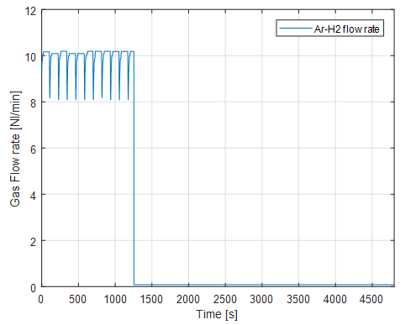 | 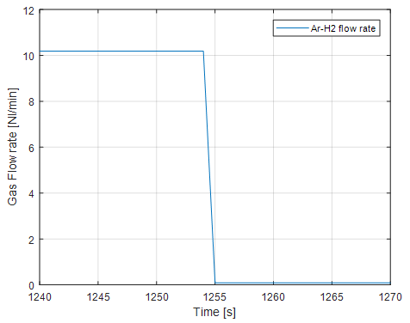
a) | b)
Figure 3-8: Time trend of the gas flow rate (a) and zoom of the transition (b),
test ADP07.

Figure 3-9 shows the nominal power and the actual power released along the active length of the FPS during test ADP07. The remaining fraction of the total power is assumed to be released in the inlet region of the FPS. In addition, the thermal power released by the thermal flow meter during the transient, on the order of 2 kW, is provided to the benchmark participants to enable realistic simulations. Further details are given in Appendix A.
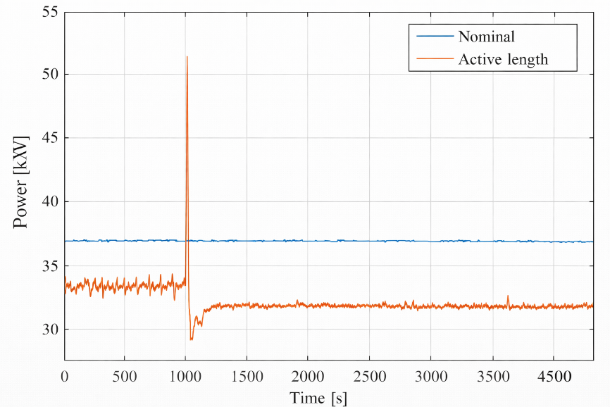
Figure 3-9: FPS power during test ADP07.

Further details on the configuration and the tests can be found in [5].

Appendix A Reference values to be used
Table 3-12: Integral parameters for the initial and final steady state of test ADP10.
Test ADP10 | Steady state 1 |  |  | Steady state 2
Parameter | Data | $$σ$$ | $σ$[%] | Data | $$σ$$ | $σ$[%]
$$\dot{{ m}_{gas}}(Nl/min)$$ | 10 | 0.5 | 5 | 0 | 0 | 0
$$\dot{{ m}_{LBE}}(kg/s)$$ | 2.56 | 0.13 | 5 | 1.31 | 0.05 | 3.7
TP101[°C] | 225.4 | 1.5 |  | 207.5 | 1.5
$${∆T}_{pre} [℃]$$ | 6.05 | 1.7 | 28.1 | 11.8 | 1.7 | 14.4
$Q_{nom}$ [W] | 29997 | 46 | 0.15 | 29997 | 46 | 0.15
$Q_{eff}$ [W] | 26791 | 1555 | 5.8 | 26791 | 1214 | 4.53
$Q_{pre}$ [W] | 2268 | 669 | 29.5 | 2268 | 342 | 15.1
$Q_{tfm}$ [W] | 1915 | 3 | 0.15 | 1650 | 23 | 1.4

Table 3-13: Integral parameters for the initial and final steady state of test ADP06.
Test ADP06 | Steady state 1 |  |  | Steady state 2
Parameter | Data | $$σ$$ | $σ$[%] | Data | $$σ$$ | $σ$[%]
$$\dot{{ m}_{gas}}(Nl/min)$$ | 10 | 0.5 | 5 | 0 | 0 | 0
$$\dot{{ m}_{LBE}}(kg/s)$$ | 2.66 | 0.14 | 5.2 | 1.33 | 0.05 | 3.8
TP101 [°C] | 228.2 | 1.5 |  | 207.9 | 1.5
$${∆T}_{pre} [℃]$$ | 5.82 | 1.75 | 30.05 | 11.6 | 1.82 | 15.7
$Q_{nom}$ [W] | 29991 | 46 | 0.15 | 29991 | 46 | 0.15
$Q_{eff}$ [W] | 26786 | 1555 | 5.8 | 26786 | 1214 | 4.53
$Q_{pre}$ [W] | 2268 | 669 | 29.5 | 2268 | 342 | 15.1
$Q_{tfm}$ [W] | 1933 | 3 | 0.16 | 1657 | 22 | 1.32

Table 3-14: Integral parameters for the initial and final steady state of test ADP07.
Test ADP07 | Steady state 1 |  |  | Steady state 2
Parameter | Data | $$σ$$ | $σ$[%] | Data | $$σ$$ | $σ$[%]
$$\dot{{ m}_{gas}}(Nl/min)$$ | 10 | 0.5 | 5 | 0 | 0 | 0
$$\dot{{ m}_{LBE}}(kg/s)$$ | 3.07 | 0.18 | 5.8 | 1.6 | 0.07 | 4.1
TP101 [°C] | 237.16 | 1.5 |  | 217.9 | 1.5
$${∆T}_{pre} \left[℃\right]$$ | 6.4 | 1.93 | 30.16 | 12.29 | 1.94 | 15.8
$Q_{nom}$ [W] | 37996 | 45 | 0.12 | 37996 | 45 | 0.12
$Q_{eff}$ [W] | 33935 | 1970 | 5.8 | 33935 | 1538 | 4.53
$Q_{pre}$ [W] | 2873 | 847 | 29.5 | 2873 | 433 | 15.1
$Q_{tfm}$ [W] | 1960 | 3 | 0.13 | 1684 | 31 | 1.84

Pressure in the cover gas P110 =0.42 bar in all the test cases.

References
- N. E. Agency, “Handbook on Lead-bismuth Eutectic Alloy and Lead Properties, Materials Compatibility , Thermal- hydraulics and Technologies,” Nucl. Sci., pp. 647–730, 2015.
- C.S.Kim, “Thermophysical properties of stainless steels”, ANL-75-55, 1975.
- J.Pacio, S. Keijers, Reference physical properties in the KALLA rod bundle tests, SCK-CEN/40672921, 2021.
- Thermocoax, private communication.
- I.Di Piazza, H. Hassan, P. Lorusso, D. Martelli, “Benchmark Specifications For NACIE-UP Facility: Non-Uniform Power Distribution Tests”, ENEA Report NA-I-R-542, rev.5, 2024.

