WP3 – Subchannel Analysis

Introduction
TBD
Quantitative results are reported in the Chapter exploiting the following definitions:
$\left|ε\right|$ is the absolute difference between computed and measured values of a TC;
${\left|ε\right|}_{ave}$ is the average of $\left|ε\right|$ over all TCs;
${\left|σ\right|}_{\left|ε\right|}$ is the standard deviation of $\left|ε\right|$;
${\left|ε\right|}_{max}$ is the maximum value of $\left|ε\right|$.
  - Description of expected and optional output
TBD
  - Participants
A wide spectrum of SC codes have been used in the benchmark, including system thermal-hydraulics codes with SC-like models for the pin bundle portion. Currently, a total of 11 organizations and 9 different codes have participated in the CRP with a SC code or a system code with SC capabilities. The complete list of codes by organization is reported in Table III. The main modelling choices or features of each SC are also summarized where the meaning is the following:
Wire model type (correlation) means the type of model to axially resolve the wire and can be either lumped or distributed (i.e., the wire position at the different axial elevations is explicitly resolved). The correlation reports the literature reference used for the correlation for energy exchange due to wire sweeping.
Rod conduction exchange means the ability to consider the effect of energy exchange among SCs due to conduction through the solid pin. This is believed to be important in case of extreme temperature gradients in the bundle.
Clad-coolant exchange means the correlation used to calculate the Nusselt’s number for establishing the outer clad surface-bulk coolant temperature difference.
As it can be seen most SC codes relies on a lumped model for the wire and the use of the correlation by Cheng and Todreas (C&T). Rod conduction effects are also modeled by many participants, albeit with different approaches.

Table III. List of SC codes in the CRP and main models adopted.
Organization (Country) | SC code | Wire model type (correlation) | Rod conduction exchange | Clad-cool exchange
CNPRI (CH) | ATHAS-LBE | Lumped (C&T [3]) | N/A | N/A
XJTU (CH) | YAOGUANG [4,5] | Lumped (C&T [3]) | Yes | Kazimi [6]
JRC (EC) | COBRA-4I (JRC version) [X] | Lumped | No | Ushakov [7]
ENEA (IT) | ANTEO+ [8] | Lumped (C&T [3]) | Yes | Ma [9]
La Sapienza (IT) | RELAP5-3D© (v4.3.4) [10] | Lumped (C&T [3]) | No | Kazimi [6]
RATEN ICN (RO) | ANTEO+/RELAP5 (SCADAP-SIM) [8,11] | Lumped (C&T [3]) | No | Mikityuk [12]
Gidropress (RU) | MATADOR [13] | Distributed (Geometry change method [14]) | Yes | Ushakov [7]
IBRAE (RU) | EUCLID/V2 (subchannel module CELSIST) | Lumped (Zhukov [15]) | Yes | Zhukov [15]
NIKIET (RU) | PUCHOK GMT [16,17] | Lumped (Zhukov [15]) | Yes | N/A
ANL (USA) | SAS4A/SASSYS-1 [18] | Lumped (C&T [3]) | Yes | Mikityuk [12]
Westinghouse (USA) | SAS4A/SASSYS-1 [18] | Lumped (C&T [3]) | Yes | Calamai [19]

For the open cases where boundary conditions of the FPS where available, allowing for a stand-alone use of the SC code, many participants have also tackled the force-to-natural transition during the experiment. For compactness and to allow the inclusion of all participants, in the present paper focus is mostly on the steady state cases since results for the transient are generally in line, for the bundle part, with what described in [20].
  - Open phase simulations
TBD
    - ADP10 – All pins heated
The comparison of SC codes with experimental data for all the TCs of the FPS, with the exception of the ones related to pin 3, is presented in Figure 4, where the part related to the bulk and clad temperatures is explicitly shown as well as the Section to which they belong. Similarly, results for the axial clad temperature profile of pin 3 are reported in Figure 5.
As can be seen from Figure 4, bulk temperatures, both at SS1 and SS2, are generally well captured by the codes, especially at Sections B and C where differences with experimental data are, on average, below 5 °C and 10 °C. In the simulations it can be observed the tendency to predict a sharper gradient passing from internal to near wall SCs which is an effect magnified by the small number of pins of the NACIE-UP bundle. This tendency is increased in the operating regimen reached after the transient. This could be due to an underestimation of the energy exchange via the wire sweeping or the heat conduction through the rod; indeed, after the transient the difference between the hottest and coldest point of the bundle can be higher than 40°C (SS2 at Section C).

- SC and clad outer temperatures at SS1
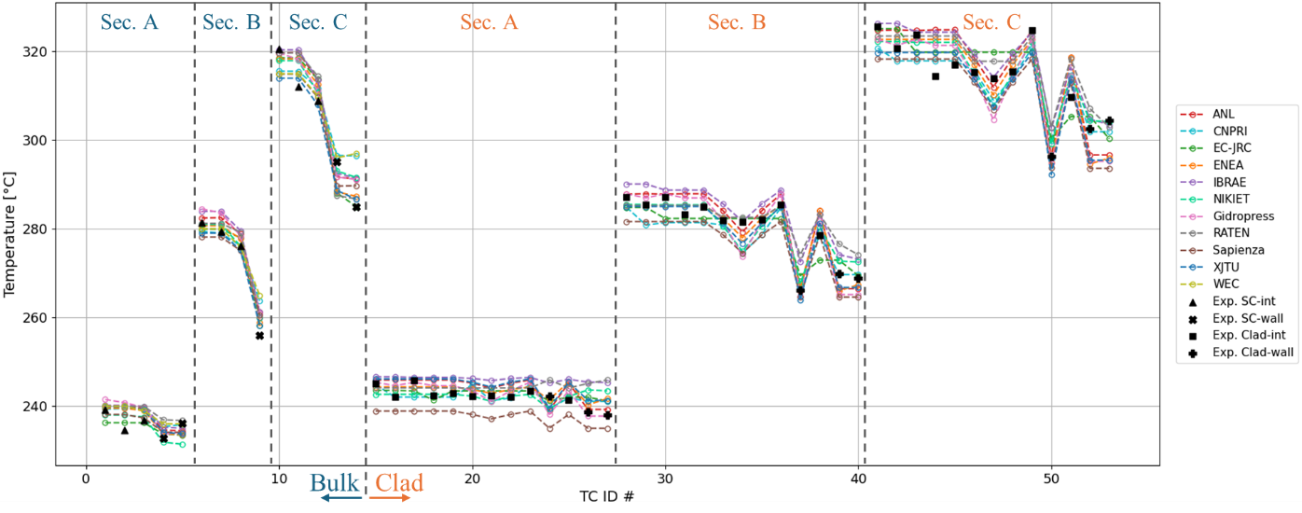
- SC and clad outer temperatures at SS2
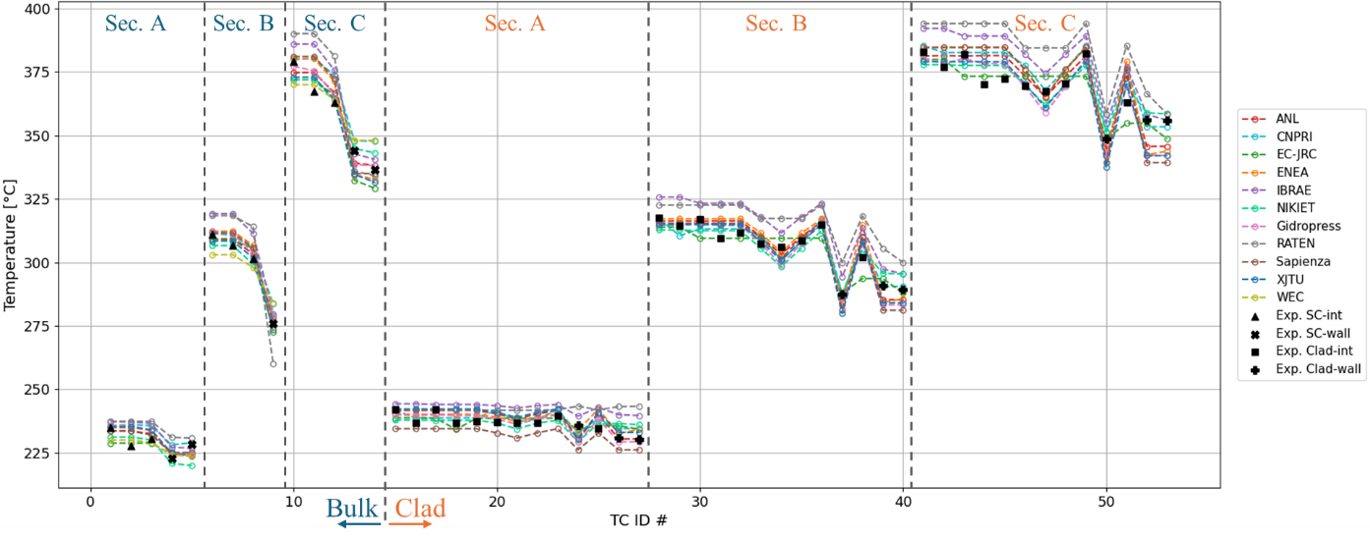
Figure 4. Comparison of SC codes with experimental data of ADP10 for SC and clad TC for SS1 (a) and SS2 (b). Interior, Near-wall and Clad of internal and near wall pins experimental values have different symbols.

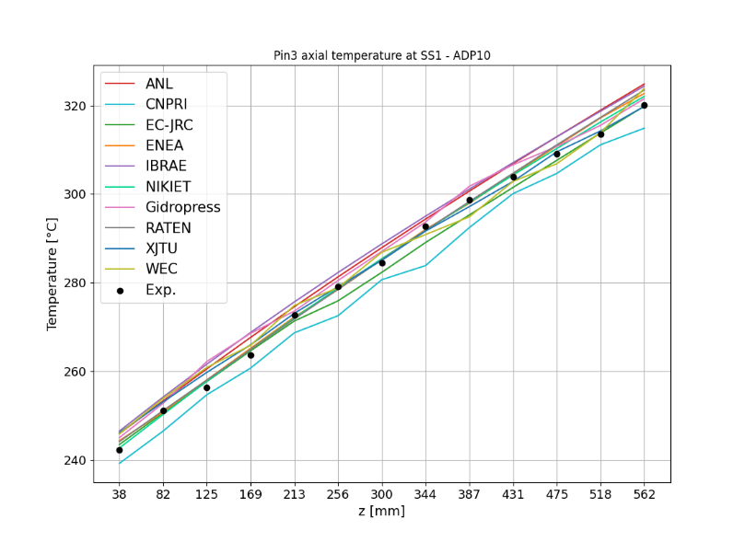  - SS1 | 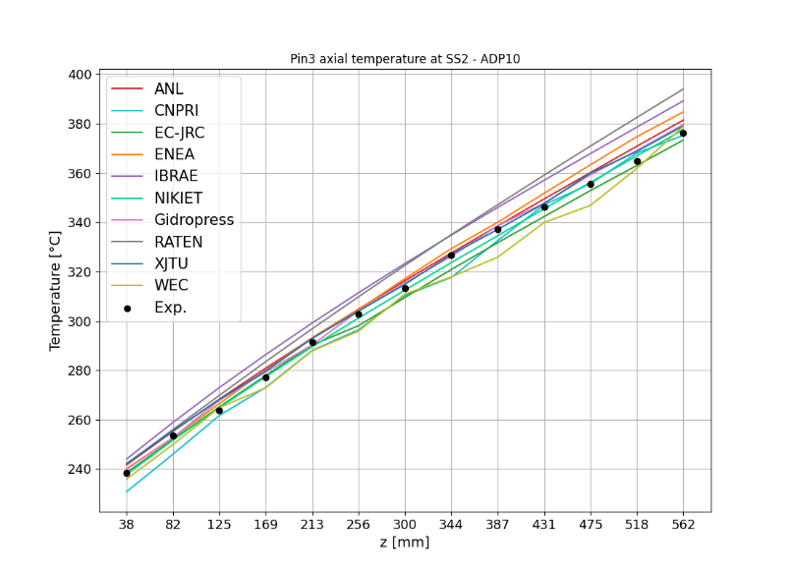  - SS2
Figure 5. Comparison of SC codes with experimental data of ADP10 for Pin3 TC measuring the clad outer temperature. Elevations z taken from the bottom of the active region.

Table IV. Main statistical performance parameters for the various SC codes on ADP10. All values in [°C].
Organization (Country) | SC code | SS1 |  |  | SS2
 |  | $${\left|ε\right|}_{ave}$$ | $${\left|σ\right|}_{\left|ε\right|}$$ | $${\left|ε\right|}_{max}$$ | $${\left|ε\right|}_{ave}$$ | $${\left|σ\right|}_{\left|ε\right|}$$ | $${\left|ε\right|}_{max}$$
CNPRI (CH) | ATHAS-LBE | 2.9 | 2.3 | 11.5 | 4.0 | 3.4 | 13.0
XJTU (CH) | YAOGUANG | 2.6 | 1.9 | 9.0 | 3.8 | 3.1 | 14.1
JRC (EC) | COBRA-4I (JRC version) | 2.4 | 1.8 | 7.1 | 3.4 | 2.5 | 11.8
ENEA (IT) | ANTEO+ | 2.4 | 2.2 | 9.0 | 4.7 | 3.9 | 16.0
La Sapienza (IT) | RELAP5-3D© (v4.3.4) | 4.0 | 2.2 | 10.9 | 5.4 | 4.2 | 16.9
RATEN ICN (RO) | ANTEO+/RELAP5 (SCADAP-SIM) | 2.8 | 2.4 | 9.1 | 10 | 5.6 | 23.8
Gidropress (RU) | MATADOR | 2.8 | 2.2 | 9.3 | 3.3 | 2.9 | 14.0
IBRAE (RU) | EUCLID/V2 (subchannel module CELSIST) | 3.8 | 2.0 | 10.0 | 8.3 | 4.0 | 18.9
NIKIET (RU) | PUCHOK GMT | 2.1 | 1.9 | 7.7 | 3.0 | 2.2 | 8.3
ANL (USA) | SAS4A/SASSYS-1 | 3.1 | 2.2 | 10.5 | 3.6 | 2.6 | 11.2
Westinghouse (USA) | SAS4A/SASSYS-1 | 3.1 | 2.6 | 12.0 | 4.3 | 2.9 | 11.5

The trend of clad temperatures closely follows the one of the SC previously depicted, but with a slightly higher variability possibly due to the higher sensitivity of the measured quantity to local effect (e.g., the wire position). Errors are slightly higher for near walls pins suggesting that the used correlations do not completely capture the perturbation in the heat exchange process brought about by the wire and the wrapper; indeed, there is no strong evidence for widespread and superior accuracy of any of the correlations reported in Table II.
The axial evolution of pin 3, shown in Figure 5, is well captured by the codes with relatively errors on the temperature increase well below 8% both before and after the transient. The main discrepancy is at the very top of the pin where many SC codes overpredicts the temperature, the overprediction being higher in relative terms at SS2. This difference could be due again to the heat diffused via the pin thanks to higher gradient in the top portion and/or to the swirling motion of the wire bringing cold fluid from the near wall SCs.

    - ADP06 – Only 7 central pins heated
The comparison of SC codes with experimental data for all the TCs of the FPS, with the exception of the ones related to pin 3, is presented in Figure 6. Similarly, results for the axial clad temperature profile of Pin 3 are reported in Figure 7. Finally quantitative results are reported in Table V.
- Bulk and clad outer temperatures at SS1
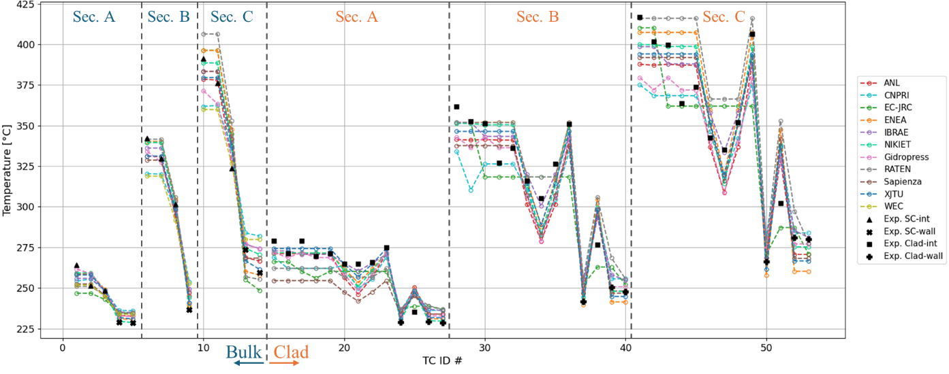
- Bulk and clad outer temperatures at SS2
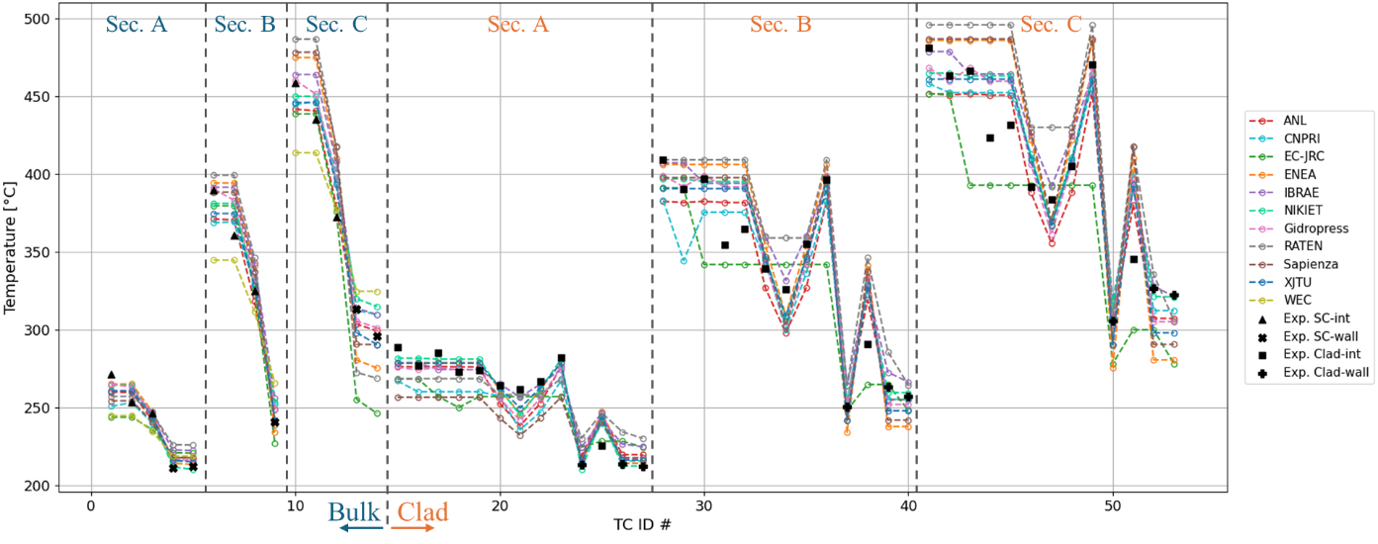
Figure 6. Comparison of SC codes with experimental data of ADP06 for SC and clad TC for SS1 (a) and SS2 (b). Interior, Near-wall and Clad of internal and near wall pins experimental values have different symbols.

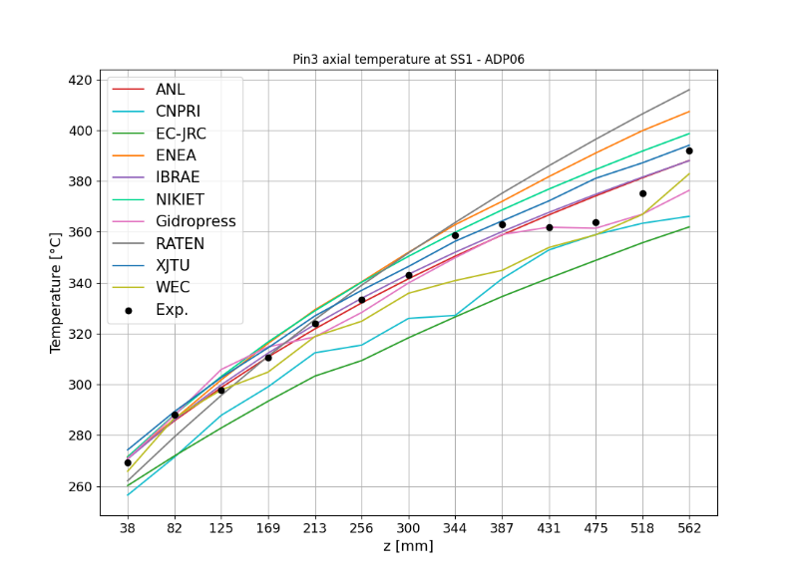  (a) SS1 | 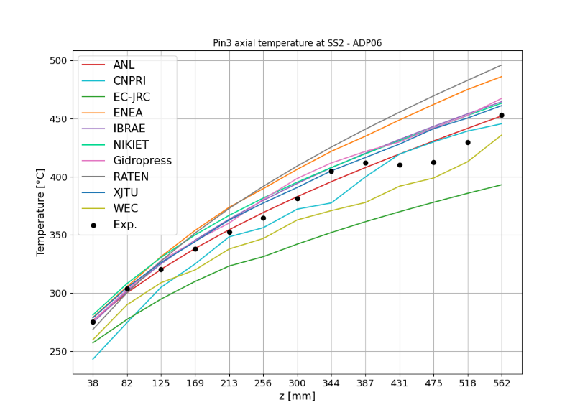  (b) SS2
Figure 7. Comparison of SC codes with experimental data of ADP06 for Pin3 TC measuring the clad outer temperature. Elevations z taken from the bottom of the active region.

Table V. Main statistical performance parameters for the various SC codes on ADP06. All values in [°C].
Organization (Country) | SC code | SS1 |  |  | SS2
 |  | $${\left|ε\right|}_{ave}$$ | $${\left|σ\right|}_{\left|ε\right|}$$ | $${\left|ε\right|}_{max}$$ | $${\left|ε\right|}_{ave}$$ | $${\left|σ\right|}_{\left|ε\right|}$$ | $${\left|ε\right|}_{max}$$
CNPRI (CH) | ATHAS-LBE | 14.3 | 9.9 | 42.2 | 15.1 | 10.8 | 55.6
XJTU (CH) | YAOGUANG | 7.7 | 7.3 | 35.1 | 11.9 | 10.4 | 47.8
JRC (EC) | COBRA-4I (JRC version) | 13.5 | 9.5 | 44.5 | 23.9 | 18.4 | 77.5
ENEA (IT) | ANTEO+ | 9.9 | 10.1 | 45.5 | 20.1 | 16.8 | 64.9
La Sapienza (IT) | RELAP5-3D© (v4.3.4) | 12.5 | 8.3 | 39.8 | 20.7 | 16.2 | 72.5
RATEN ICN (RO) | ANTEO+/RELAP5 (SCADAP-SIM) | 13.2 | 11.5 | 52.2 | 23.9 | 18.3 | 72.7
Gidropress (RU) | MATADOR | 9.2 | 8.4 | 37.2 | 11.9 | 11.1 | 51.8
IBRAE (RU) | EUCLID/V2 (subchannel module CELSIST) | 7.2 | 5.9 | 27.2 | 12.9 | 11.5 | 44.8
NIKIET (RU) | PUCHOK GMT | 7.9 | 8.3 | 36.1 | 11.6 | 10.6 | 46.7
ANL (USA) | SAS4A/SASSYS-1 | 8.9 | 7.4 | 29.1 | 11.7 | 8.9 | 34.8
Westinghouse (USA) | SAS4A/SASSYS-1 | 11.4 | 8.7 | 40.8 | 19.3 | 12.1 | 47.2

For bulk temperatures, the general trend of errors observed for ADP10 is also observed in Figure 6 (i.e., sharper gradient between inner and near-wall SCs), but with a higher absolute and relative magnitude. Errors on the temperature increase can indeed be as high as 35% amounting to 30°C and 55°C before and after the transient, respectively (at Section C). The motivation of the difference are believed to be the same as the ones highlighted for ADP10, but with a higher magnitude due to the higher temperature difference between internal and near-wall SCs (as high as 150°C in SS2 and Section C). Spread among participants also considerably increased highlighting the effect of the different modelling choices with such a strong temperature gradient.
Similarly to ADP10, the agreement with experimental values for the clad temperatures follows the same behavior as the SC temperatures, with higher errors around non-powered pins (see “Clad-wall” in Figure 6). Relative errors on the temperature increase as high as 65% can be reached both in SS1 and SS2 (meaning absolute difference of 40 °C and 75 °C in SS1 and SS2, respectively).
For pin 3 axial clad temperature evolution (Figure 7), the agreement with measured value is acceptable in the lower portion of the active region but, similarly to what observed in ADP10, SC codes are not able to consistently capture data in the top portion. Similar physical explanations to ADP10 are believed to apply but again increased by the even higher difference between internal and near-wall regions of the bundle. Errors on the relative temperature increase are, in any case, below 20%. To discuss further pin 3 behavior, the cold fluid swept by the wire takes almost two full wire rotations to arrive at the second row of pins (where pin 3 is located) an effect only captured by MATADAOR (Gidropress) thanks to the “distributed” approach in wire modelling; none of the SC codes is however able to capture it consistently among SS1 and SS2 suggesting that some inertia effect of the fluid swept by the wire may be involved (and partially confirmed by CFD analysis inside the CRP [21]). The latter is beyond SC codes since one of the fundamental assumptions is that fluid loses direction memory when passing from one SC to another [22].
  - Blind phase simulations
TBD
  - Refined final calculations
TBD

Conclusions
TBD
The main results for SC codes applied to the open cases ADP10 and ADP06 of the IAEA CRP “Benchmark of Transition from Forced to Natural Circulation Experiment with Heavy Liquid Metal Loop (NACIE)-CRP-I31038” have been presented.
The comparison with the more operation-oriented case ADP10 has shown the strong predictive capabilities of SC codes with errors and standard deviation presumably within experimental uncertainties. The accuracy is quite uniform for bulk and clad temperatures with possible improvements for the Nusselt number correlations for near-wall pins.
ADP06, due to its strong interior/near-wall temperature gradient, has revealed errors consistently higher and, especially for the maximum ones, well above experimental uncertainties. This has highlighted the main shortcomings of SC codes in capturing the full implication of the internal pin structure and, mostly, the sweeping effect of the wire and related fluid inertia effects amplified in a 19-pin bundle. While distributed approaches to wire modelling could help in more consistently capture such effects further modelling improvements are needed to ensure predictive capabilities can be extrapolated to different strong-gradient conditions and different bundle sizes.
The blind case of ADP07, with its strong non-symmetrical profile, and the sensitivity and uncertainty analysis to be performed in the CRP will prove fundamental in further assessing SC codes areas of improvement when applied to wire-spaced bundles.

References
- I Di PIAZZA, et al., Benchmark specifications for NACIE-UP facility: non-uniform power distribution tests, Presentation delivered at the First RCM of the IAEA CRP I31038, July 2022, Vienna, Austria (2022)
- I. Di piazza, et al., “The IAEA Benchmark on Transition from Forced to Natural Circulation with NACIE Heavy Liquid Metal Loop”, 21st International Topical Meeting on Nuclear Reactor Thermal Hydraulics (NURETH-21), Busan, Korea, August 1– September 5, in press (2025).
- S.K. Cheng and N.E. Todreas, “Hydrodynamic modes and correlations for bare and wire-wrapped hexagonal rod bundles – bundle friction factors, subchannel friction factors and mixing parameters”, Nuclear Engineering and Design, 92, pp. 227-251 (1986).
- Zhang Rong, et al. "Subchannel thermal–hydraulic analysis of a wire-wrapped 19-pin rod bundle in the NACIE-UP facility." Annals of Nuclear Energy 196. (2024).
- Liang Yu, et al. "A subchannel analysis code SACOS-Na for sodium-cooled fast reactor." Progress in Nuclear Energy 166. (2023).
- M. Kazami and M. Carelli, “Heat transfer correlation for analysis of CRBRP Assemblies”, Westinghouse Report CRBRP-ARD-0034, (1976).
- P.A. Ushakov, A.V. Zhukov and N.M. Matyukhin, “Heat transfer to liquid metals in regular arrays of fuel elements”, Teplofiz. Vys. Temp., 15, no. 5, pp. 1027-1033 (1977).
- F. Lodi and G. Grasso, “Extension of the sub-channel code ANTEO+ to the mixed convection regime”, Nuclear Engineering and Design, 322, pp. 368-378 (2017).
- Z. Ma, et al., “An innovative method for prediction of liquid metal heat transfer rate for rod bundles based on annuli”, Annals of Nuclear Energy, 47, pp. 91-97 (2012).
- The RELAP5-3D© Code Development Team, 2015. RELAP5-3D Code Manual Vol. I: Code Structure, System Models, and Solution Methods. INL/MIS-15-36723 Volume I, Revision 4.3, Idaho Falls, Idaho, USA.
- M.P. Ferragut, et al., “The Development of RELAP5/SCDAPSIM/MOD4.0 for Advanced Fluid Systems Design and Analysis” 23rd International Conference on Nuclear Engineering (ICONE 23), Makuhari Messe, Chiba, Japan, May 17th - 21st (2015).
- K. Mikityuk, “Heat transfer to liquid metal: Review of data and correlations for tube bundles”, Nuclear Engineering and Design, 239, pp. 680-687 (2009).
- A.S. Zalesov and A.N. Churkin, “MATADOR Code for Calculating Local Inhomogeneous Heat and Mass Transfer Processes in Rod Bundles”, Problems of Atomic Science and Engineering. Series: Physics of Nuclear Reactors, 3, pp. 29-40 (2023). (In Russian)
- S. Pramuditya and M. Takahashi, “Thermal–hydraulic analysis of wire-wrapped SFR test subassemblies by subchannel analysis method”, Annals of Nuclear Energy, 54, pp. 109–119 (2013).
- A.V. Zhukov, et al., “Methodical Instructions and Recommendations for Thermal-Hydraulic Calculation of Active Zones of Fast Reactors”, RTM (Technical Guide) 1604.008-88, Obninsk: Fiz.-Energ. Inst., (1988).
- S.Yu. Afonin, et al., “Validation of the Subchannel Puchok-LM Code Applied to the MBIR Fast Neutron Reactor”, Nuclear Physics and Engineering, vol. 5, № 7-8, pp. 564-577 (2014).
- S.Yu. et al., “Combined Methodology of Thermal-hydraulic Calculation of Fuel Assemblies of Reactors with Liquid Metal Coolant and its Justification”, Problems of Atomic Science and Engineering. Series: Ensuring the Safety of NPP, № 36, pp. 78-85 (2016).
- D. J. O'Grady et al., The SAS4A/SASSYS-1 Version 5.7 Safety Analysis Code System, Argonne National Laboratory, Lemont, IL, ANL/NSE-SAS/5.7, June 2023.
- G. Calamai, R. Coffield, L. Jossens, et al. Steady State Thermal and Hydraulic Characteristics of the FFTF Fuel Assemblies. Technical Report ARD-FRT-1582, Westinghouse Electric Corporation, 1974.
- K. Mikityuk, et al., “Simulation of NACIE Tests with Thermal Hydraulics Systems Codes ”, 21st International Topical Meeting on Nuclear Reactor Thermal Hydraulics (NURETH-21), Busan, Korea, August 1– September 5, in press (2025).
- M. Akshat, et al., “CFD benchmark for non-uniform heating experiments in NACIE rod bundle ”, 21st International Topical Meeting on Nuclear Reactor Thermal Hydraulics (NURETH-21), Busan, Korea, August 1– September 5, in press (2025).
- N.E. Todreas and M.S. Kazimi, Nuclear Systems II: Elements of Thermal Hydraulic Design, Chapter 6, Taylor and Francis, USA (2003).

Considering the temperature increase in the bundle basically double due to the halved mass flow rate passing from SS1 to SS2 (see Table II), if the error is normalized to the temperature increase the relative error stays almost constant.

