- WP4-Multiphysics
  - Introduction
Multiphysics analysis is foreseen to play a relevant role in Generation IV applications. Indeed, owing to the considered reactor concept designs and involved fluids and fluid-dynamic phenomena, the 1D approaches which proved to be suitable for LWRs may not be enough to achieve a sufficient level of detail. In this sense, CFD and subchannel codes may provide relevant information allowing jumping the gap and solving issues related to complicated components geometries or configurations. CFD may indeed allow achieving suitable predictions of intrinsically 3D environments, as the large pools foreseen for LMFBRs as well as detailed information about bulk and wall temperatures in fuel elements. Nevertheless, owing to the large computational cost, such detailed approaches should be limited to vital components for which the System Thermal Hydraulics 1D approach could be hardly applied, even after a suitable tuning of the lumped parameters and the considered nodalization. Coupling STH and subchannel codes, instead, my add depth to the analysis without increasing too much the computational cost. Consequently, the development of Multiphysics approaches, or coupled codes applications, may help in overcoming the limits of stand-alone applications while granting the advantages of each code when used in its natural suitable environment.
In the framework of the present Coordinated Research Project, Multiphysics approaches were intended as coupled applications between STH and CFD codes and STH and subchannel codes. The main goal of all the participants was providing detailed information during the postulated transient scenarios of the temperature trends inside the Fuel Pin Simulator. As a consequence, concerning coupled CFD/STH codes applications, the NACIE-UP loop was simulated adopting a STH approach except for the Fuel Pin Simulator region, which was instead simulated via CFD applications. This way, the computational cost of the calculations is reduced allowing for a more cost-effective simulation. Participants were free to select any STH or CFD code to be coupled as well as the spatial and temporal discretizations. A similar strategy was considered for the considered coupled STH/subchannel code application. The performed work mainly consisted of two phases: an open phase in which participants tested their models against the available data for ADP06 and ADP10 and a blind phase for ADP07. Unlike other WPs, it must be here remarked that coupled applications could be performed only after a solid base for both STH and CFD (or STH and subchannel code) stand-alone applications was achieved. With respect to other WPs, indeed, WP4 started operations later and, owing to the larger computational cost with respect to other applications, only a few calculations per participant were performed. A refinement of the results after the release of data for the blind case was in addition not possible for all the participants. As a consequence, in the present chapter comparisons for the open and blind phase only will be reported. In the next sections, the activities performed in the WP4 are reported, mainly focusing on the selected discretizations strategies, adopted codes and comparison of the obtained results, trying to finally draw the lessons learned. The first subsection refers to coupled CFD/STH calculations while the second one reports about the coupled STH/subchannel code calculation performed at EC-JRC.

  - Coupled STH/CFD applications

    - Description of the expected and optional outputs
The amount of information that can be provide by Multiphysics approaches is huge. Unlike STH codes, owing to the CFD domain, millions of cells are included in the calculation and detailed temperature and velocity distributions can of course be derived. As also mentioned above, this comes at the cost of large computational efforts, both in terms of spatial and temporal discretizations. Indeed, the simulation of the Fuel Pin Simulator required from 6 to 60 million cells, depending on the considered level of detail. In addition, sufficiently small time steps ranging from 0.025s to 10s were considered which relevantly increased the global computational cost.
Owing to these issues, during the WP4 Kick-Off Meeting no minimum contribution per participant was fixed, letting everyone contribute with what could be actually afforded. This consequently translated in a slightly scattered contribution with some institutions focusing only on the blind case while other managing to run all cases, depending on the readiness level at the beginning of the project and on the available manpower and computational resources.
Most of the institutions agreed, and managed, to run at least one calculation per each transient scenario and this will be the basis of the comparisons reported in the present chapter. Owing to differences in the adopted simulations strategies and adopted codes, the comparison is performed only for some experimental values, without including any information for which an experimental result is available. Particularly, the mandatory information to be supplied were:

- Mass flow rate time trend
- Temperatures time trends for the inlet and outlet sections of the FPS (TP101 and TP102)
- Temperatures time trend for some bulk thermocouples in the FPS section (TC2, TC4, TC12, TC14)
- Temperatures time trend for some wall thermocouples in the FPS section (TC25, TC51, TC55, TC67)
The selected information, yet not representing of course the totality of the available data, were considered sufficient at least to understand the big picture of the involved phenomena. Thanks to the information already available at that time about both STH and CFD applications, some general trends were already observed in stand-alone applications and assumed to be repeated as well in the coupled codes applications. Particularly, the selection of the wall and bulk thermocouples allows to test the difference between channels, and pin walls, which could be heated or unheated depending on the simulated transient. The observed trends were sufficiently in line with the stand-alone applications and similar patterns were indeed obtained for the initial and final steady state conditions.
Of course, no upper limit was set for the amount of information to be provided, each institution thus contributed according to its own capabilities. In the following, results will be mainly provided for comparisons in which several predictions can be included. Values reported by only a few participants are sometimes reported in order to show the global performance that can be expected in some regions of the loop or of the FPS in order to provide a sounder analysis of the capabilities and limits of the adopted applications. It is here remarked that the added value of CFD is of course the capability to achieve detailed temperature and velocity distributions inside the Fuel Pin Simulator, something that could not be achieved adopting a STH approach. Contour plots of some relevant quantities are thus reported as well in order to provide a qualitative description of the involved phenomena, while punctual numerical vs. experimental values are considered for a quantitative assessment.
    - Participants, adopted codes and coupling strategies
Among all the Coordinated Research Project participants, only five institutions joined the WP4 activities, namely ENEA, IGCAR, NRG-PALLAS, UniPi and XJTU. All the participants were tasked to perform calculations addressing the considered experimental conditions adopting coupled STH/CFD approaches.
During the first phase of the project, ADP06 and ADP10 worked as valuable case studies to train the model and find out about their limits and capabilities, providing indeed a solid benchmark also to check the soundness of the assumed modelling hypotheses. This is very important to be remarked as the participants reported a scattered level of readiness at the beginning of the project as well as different levels of experience with code coupling. While ENEA and UniPi already dealt in the past with the NACIE-UP facility (Angelucci, 2018; Martelli et al., 2013; Pucciarelli et al., 2020), for other institutions this was a completely new task and a longer training and development phase was required in order to set both the best discretization and modelling techniques to be associated to the adopted codes.
Each institution developed indeed a unique combination of modelling tools, to be also combined with different discretization strategies both for the spatial and temporal domains. The most relevant information is reported in Table 11. 1. The achieved diversification of the adopted approaches allows gaining a sufficiently wide range of settings to be explored which should help to draw general lessons regarding both limits and capabilities of the adopted approach. Moreover, combining the present results with the ones provided by stand-alone applications reported in WP1 and WP2, both a qualitative and quantitative analysis of the results can be performed. This is a relevant point to be bore in mind since, even if the Multiphysics analysis may help overcoming some of the intrinsic limits of stand-alone applications, some of the drawbacks and lacks in the modelling approach are inevitably inherited from the stand-alone applications and cannot be overcome unless the issue is solved by developing a more suitable modelling approach for the addressed phenomena. This is for example the case of some issues reported for the gas-liquid metal interactions in the riser, which even in WP4 is completely dealt by the STH code, which proved to be a limit in the WP1 applications due to inaccuracies in the available modelling tools in the considered codes. Similar effects were coherently observed also in the present coupled STH/CFD applications.

Table 11. 1 – Considered modelling tools and discretizations strategies by the Institutions attending WP4
Institution | CFD Code | STH Code | Geometrical Coupling Approach | Time Advancing Scheme
ENEA | ANSYS CFX | RELAP5 | Decomposition Method | Semi-Implicit
IGCAR | ANSYS Fluent | Flownex | Decomposition Method | Explicit
NRG PALLAS | STAR-CCM+ | SPECTRA | Domain Overlapping | Explicit
UNIPI | STAR-CCM+ | RELAP5 | Decomposition Method | Explicit
XJTU | ANSYS Fluent | RELAP5 | Decomposition Method | Explicit

As Table 11. 1 clearly shows, most of the institutions adopted a Decomposition Method for the spatial discretization approach. This technique considers that none of the coupled codes deal with the whole computational domain: each one is assigned instead to a specific region and information must be exchanged at the interfaces between the two codes. All the participant institutions applied CFD for the Fuel Pin Simulator region, either for the active part only or for the whole hexagonal duct depending on the available computational resources and considered modelling hypotheses, while the STH code was adopted for the simulation of the remaining part of the primary loop and of the secondary side. Mass flow, temperature and pressure information, to be updated at each time-step is exchanged at the interfaces between the CFD and STH domains, providing each code with suitable boundary conditions to run the transient calculation. Figure 11. 1 and Figure 11. 2 report as an example the coupling scheme adopted at the University of Pisa, in which the pressure information exchange occurs to be achieved via providing the STH code with the global pressure drop experienced in the CFD domain both as a consequence of friction and pressure head effects. Differently from the other institutions, NRG-PALLAS adopted a domain overlapping approach. By adopting this approach, the STH code is ideally capable of solving in stand-alone the numerical problem, while reckoning on CFD for a more accurate definition of key phenomena occurring in the Fuel Pin Simulator. CFD here works indeed in parallel with the STH code, and the improved pressure drop estimation is later fed to the STH code which adopts it to tune the pressure drop experienced in the FPS region and thus achieve a better estimation of the loop mass flow rate. Temperature information is also provided by CFD for the outlet section of the Fuel Pin Simulator. A scheme of the considered modelling approach is reported in Figure 11. 3.
Moving to the time-advancing schemes it can be observed again from Table 11. 1 that almost all the institutions went for an explicit approach, while only ENEA adopted a semi-implicit time advancing scheme. It must be here remarked that for the present applications, explicit and implicit, together with the well-known Courant limits should not be interpreted as strictly as in the traditional analysis. Since both the CFD and STH codes are sufficiently large with respect to the considered phenomena, information usually takes quite a long time to travel from the inlet and outlet interfaces the considered time advancing scheme should not in general affect the code stability. Nevertheless, semi-implicit or implicit approaches could help in making the coupling between the codes more solid, better bounding the two calculations. In fact, adopting an explicit approach, each code performs the calculation for the present time-step only once, providing the other one with the updated boundary conditions. While the other code is processing, the first one waits for the updated boundary conditions and then proceeds towards the next time level. No check on the exchanged quantities and balances is performed. Figure 11. 4 reports as example the time advancing scheme adopted by UniPi. The picture also reports on the need to use an external master code, MATLAB in the present application, which is capable to manage the coupling between the two codes. In the semi-implicit approach adopted by ENEA, instead, several internal iterations per time-step are performed, eventually moving towards the next time level once some convergence criteria are met regarding the exchanged quantities. A higher computational cost is thus to be expected per time-step, which should be rewarded by a higher accuracy of the coupling approach. The explicit approach grants instead a smaller computational cost per time step but may require smaller time-step sizes in order to make it so that inaccuracies at the interface are sufficiently small not to prevent the global prediction performance.
At the present stage, as no general statements can be formulated about the superiority or limitis of the selected approaches; the trade-off between decomposition/overlapping methods or explicit/implicit time advancing scheme could depend on the specific application, thus on the adopted codes and addressed phenomena.
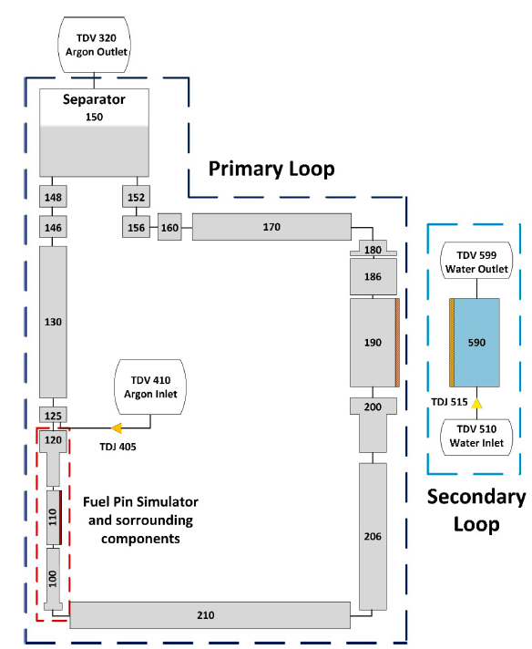  Figure 11. 1 RELAP5 nodalizationadopted at UniPi. | 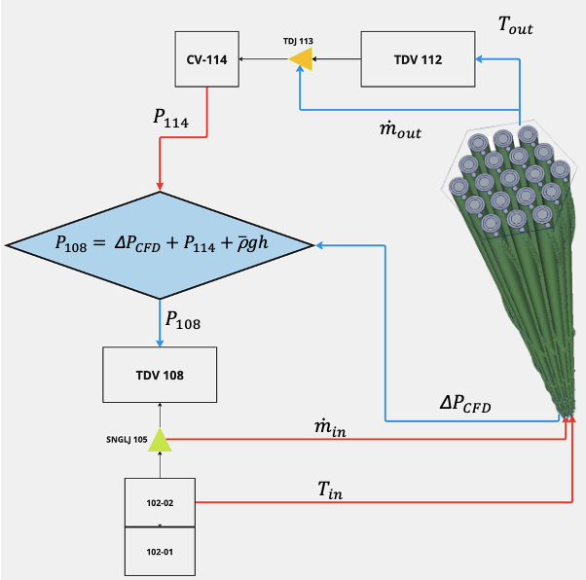  Figure 11. 2 Detail exchanged information scheme at the STH/CFD interface adopted at UniPi.

As mentioned above, each participant was set free to adopt its own best estimated model to perform the coupled STH/CFD calculations. The adopted model of course strongly depended on the available computational resources and manpower. As a consequence, a quite diverse range of approaches, spatial refinements and time-step sizes was considered by the participants. In this sense, it must be remarked the Coordinated Research Project proved to be the perfect environment also to test new modelling approaches. Owing to computational cost limitations, both UniPi and XJTU tried to reduce the global computational effort of the calculations by developing coarser CFD nodalizations. UniPi tried to reduce the computational cost by first creating a nodalization for the bare bundle and later remove cells occupied by the wrapped wires by means of User Defined Functions (UDF) and field functions respectively.
More detailed domains were considered IGCAR and NRG-PALLAS A good level of detail was achieved by ENEA as well despite the small cell count thanks to a modular generation of the nodalization. For a more detailed information about the work performed at ENEA, NRG-PALLAS and University of Pisa the reader is referred to Del Moro et al. (2024), Pangukir et al. (2025) and Stefanini et al. (2025), respectively.
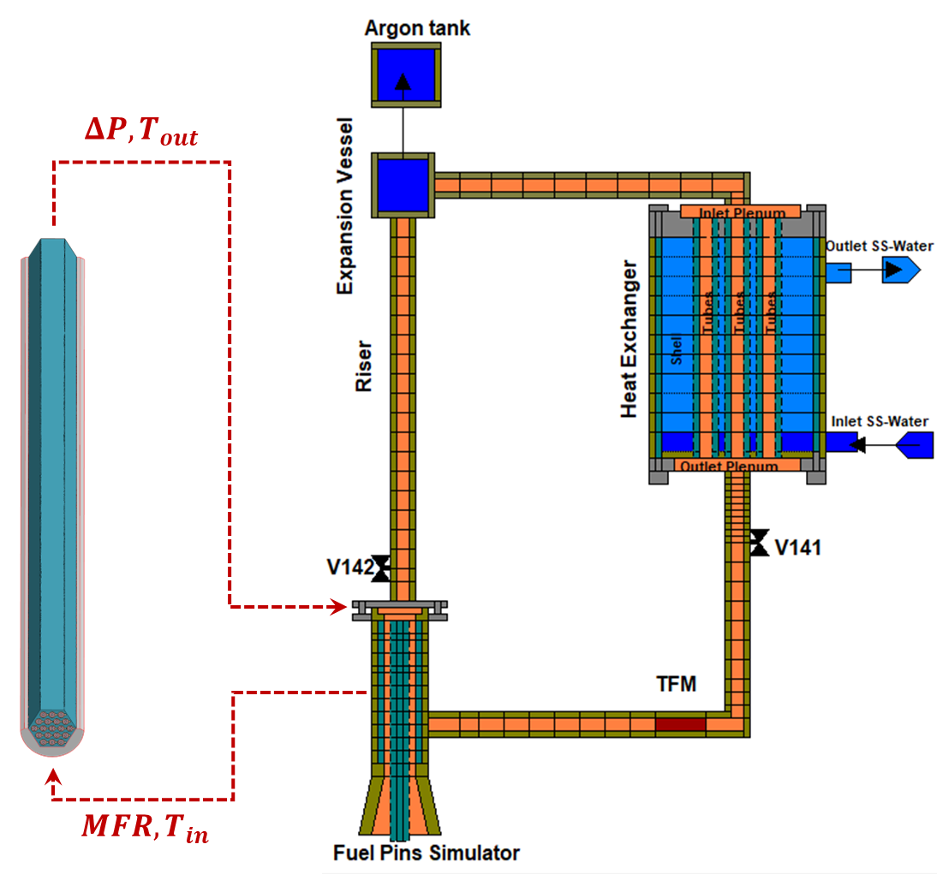
Figure 11. 3 Detail of the coupling CFD/STH interface exchanged information at NRG PALLAS
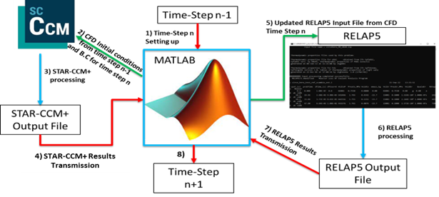
Figure 11. 4 Detail of the time advancement and information exchange scheme adopted by UniPi

Table 11. 2 reports about the main parameters of the nodalization, showing that a quite large range of mesh sizes, straddling between 1.7 and 59 million cells was considered. This translates of course in different calculations times, also depending on the adopted time-step size ranging from a few days to 6 weeks, also depending on the available number or cores. The time step size was mainly connected to need of achieving a good sampling of the needed information and granting a certain degree of stability and consistency to the coupling approach. Variable time-step sizes were considered by some institutions depending on the transient phase, smaller values were indeed considered for the initial phase of the transient, where steeper derivatives were observed, while larger time steps were considered for the second phase of the transient approaching a new steady state, were properties and quantities changed instead more smoothly.

Table 11. 2 Information regarding adopted time-steps and the computational effort experienced by each participant.
Institution | CFD Mesh Size  [millions] | CFD Time Step  Size [s] | STH  Time Step  Size [s] | Number of Cores | Time to run 1000s of calculated time
ENEA | 4.4 | 0.025 to 0.1 | 1/10 of CFD step | 48 | 5-8 days
IGCAR | 57 | 1 to 10 | 1 | 32 | 4-5 days
NRG PALLAS | 59 | 0.5 | 0.001 | 24 | 6 weeks
UNIPI | 4.7 | 0.05 to 0.5 | 0.001 | 24 | 4-7 days
XJTU | 1.7 | 0.25 | 0.25 | 12 | 1-2 days

Eventually, the last differences in the adopted approaches among the participants are related to the gas lift component modelling. While this component was included by everyone in the STH portion of the model, inheriting limits and capabilities observed in the frame of WP1, the effects of the selected models cannot be disregarded even in the present application. Particularly, ENEA, NRG PALLAS and UniPi modelled the gas lift occurring in the hot leg as a consequence of the argon injection at the bottom of the riser component. On the other hand, IGCAR and XJTU instead used pump components mimicking the effects of the gas injection system. Consequently, when comparing results, it should be expected that, at least for ADP06 and ADP10 cases, IGCAR and XJTU should achieve a better quality in terms of mass flow rate predictions as the pump component allows a better management of the flow rate both during the initial steady state and the first phase of the transient.
Moving instead to CFD settings and adopted turbulence models, all the participants adopted the SST k-ω model in association with a simple gradient approach for the estimation of the turbulent heat flux contribution. The considered turbulent Prandtl number values, also inheriting the lesson drawn in the frame of WP2 were in the 1.5-4 range in accordance with typical values adopted in the liquid metal thermal-hydraulics analyses. Nevertheless, a minor impact of this parameter on the obtained results was observed.
    - Open phase simulations
      - ADP10 case
ADP10 represents the base benchmark case as all the rods are heated uniformly, the best predictions were achieved for this very case in WP1 and WP2 as well. Figure 11. 5 reports about the comparison between the predicted and measured mass flow rate. As it can be observed, both the initial and final steady state values were predicted sufficiently well by all the participants, a poorer quality was instead reported in the initial phase of the transient especially by UniPi. This is mainly connected to the limits of the available models in the adopted STH codes in dealing with the gas/liquid metal interaction occurring in the riser. XJTU, who modelled the Argon Injection System introducing a pump component, managed instead to reproduce the experimental trend after a tuning of the input parameters. Figure 11. 6 to Figure 11. 11 show instead the comparison between the measured and predicted temperature for the thermocouples positioned along the NACIE-UP loop. TP101 and TP102 are located right upstream and downstream the FPS, respectively, TP106 after the steam generator, while the others between the riser and the steam generator itself. As it can be observed, all the participants managed to predict the measured trends sufficiently well, TP102 was strongly overpredicted by UniPi, mainly due to the very low mass flow rate predicted during the very first phase of the transient. As the final steady state is approached, predicted and measured values become very close.
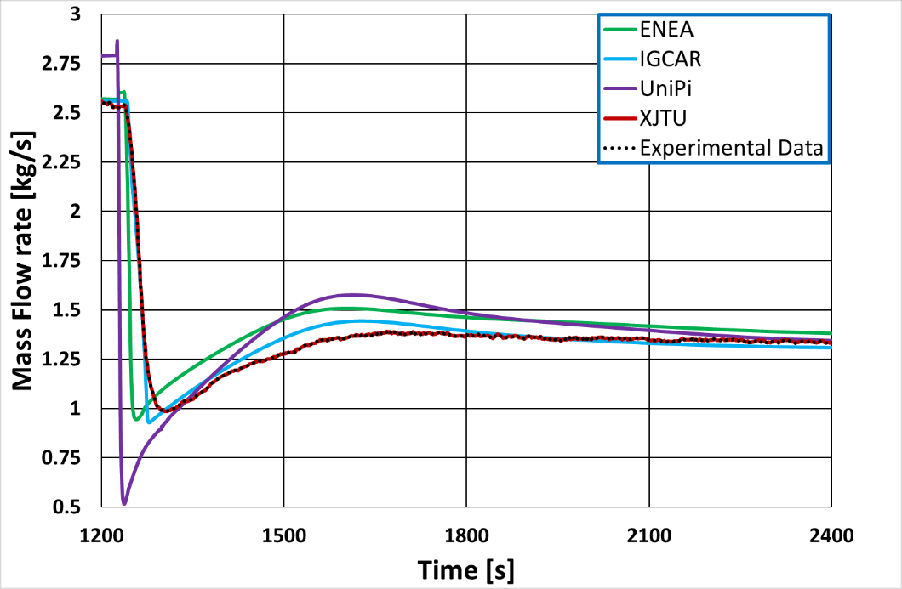
Figure 11. 5 ADP10 – Experimental and Calculated Mass flow rate time trends
It is worth observing that the delays in the experience of the hot wave coming from the FPS at the beginning of the transient is generally well predicted (see e.g. TP103-TP105). Inaccuracies may also be related to the positioning of the thermocouple, especially for TP102, as the tool provides a punctual measurement while the STH code provides instead a mass flow averaged value.
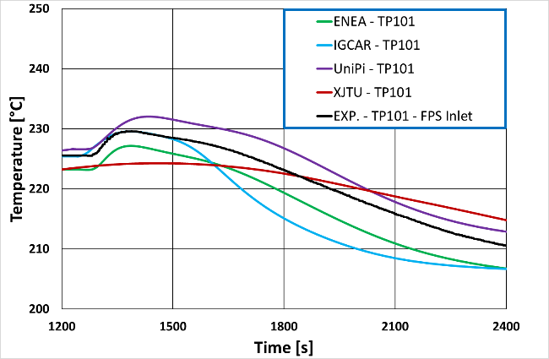  Figure 11. 6 ADP10 – Experimental and Calculated TP101 temperature time trends | 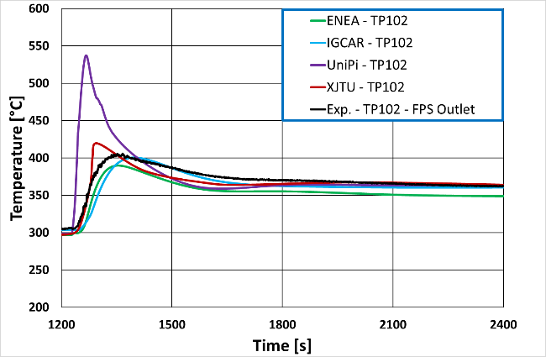  Figure 11. 7 ADP10 – Experimental and Calculated TP102 temperature time trends
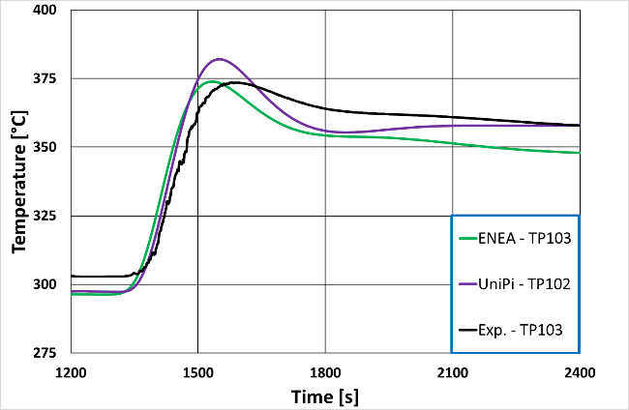  Figure 11. 8 ADP10 – Experimental and Calculated TP103 temperature time trends | 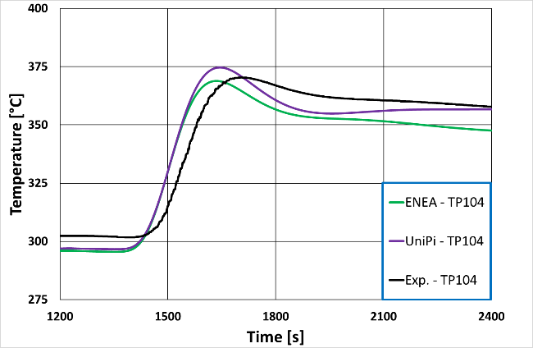  Figure 11. 9 ADP10 – Experimental and Calculated TP104 temperature time trends
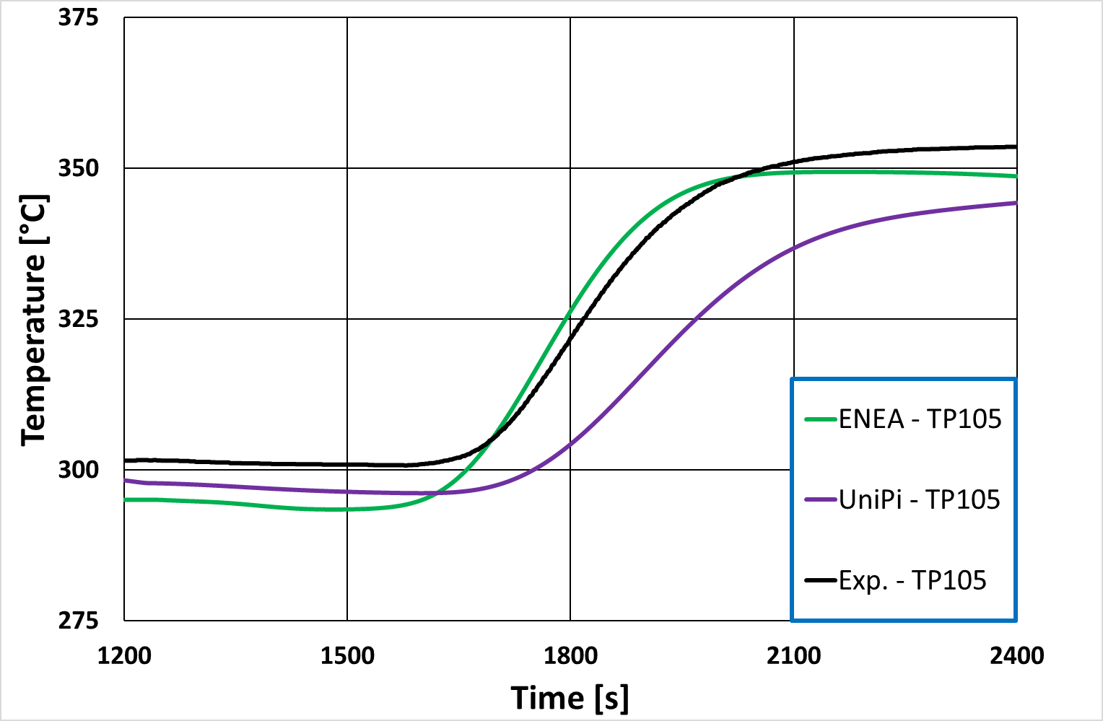  Figure 11. 10 ADP10 – Experimental and Calculated TP105 temperature time trends | 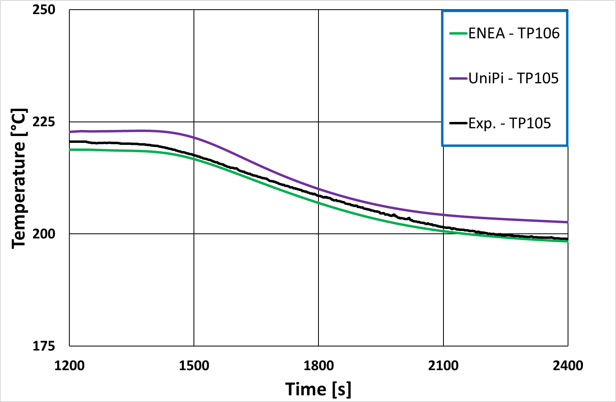  Figure 11. 11 ADP10 – Experimental and Calculated TP106 temperature time trends

The groups of figures Figure 11. 12 - Figure 11. 15 and Figure 11. 16 - Figure 11. 19 report about the comparison between measured and calculated values for some selected bulk and wall thermocouples located in the FPS, respectively. Generally speaking, also owing to the uniform heating conditions experienced in the FPS for this very case, almost all the involved institutions managed to predict quite well the experimental trends, especially after a few hundreds of seconds from the start of the transient. Again, some inaccuracies were predicted by UniPi at the very beginning owing to the too low predicted mass flow rate, while instead it reports the best results when approaching to the final steady state conditions.
As a general comment on this case, it can be stated that very good results were achieved, as all the participants managed to reproduce quite well the addressed scenario. This is very important as owing to the test conditions, ADP10 could be the most common condition to be faced in case of accidents. Main flaws in the prediction of the mass flow rate can be connected to the injection gas system modelling, something which should not be present in real NPPs, thus suggesting that very promising capabilities are to be expected in a real scenario application.
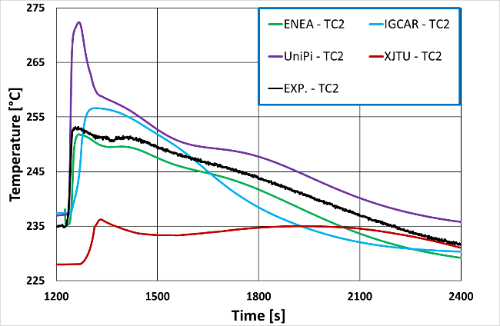  Figure 11. 12 ADP10 – Experimental and Calculated FPS Bulk TC2 temperature time trends | 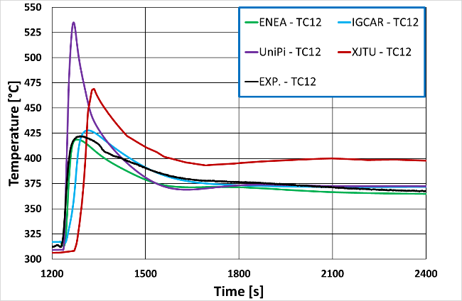  Figure 11. 13 ADP10 – Experimental and Calculated FPS Bulk TC12 temperature time trends
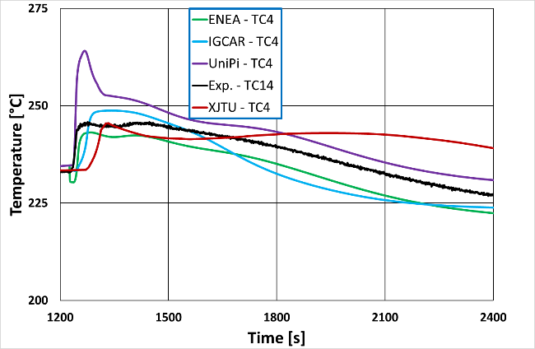  Figure 11. 14 ADP10 – Experimental and Calculated FPS Bulk TC4 temperature time trends | 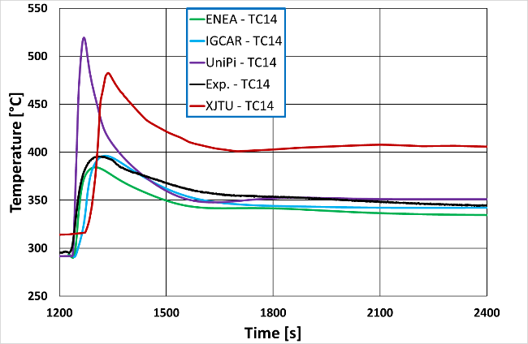  Figure 11. 15 ADP10 – Experimental and Calculated FPS Bulk TC14 temperature time trends

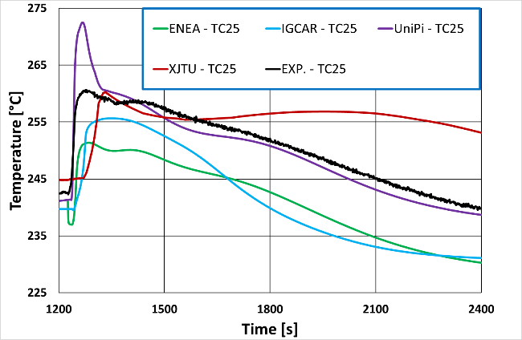  Figure 11. 16 ADP10 – Experimental and Calculated FPS Wall TC25 temperature time trends | 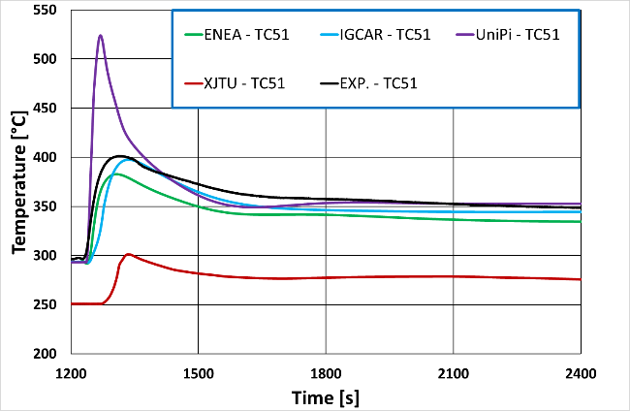  Figure 11. 17 ADP10 – Experimental and Calculated FPS Wall TC51 temperature time trends
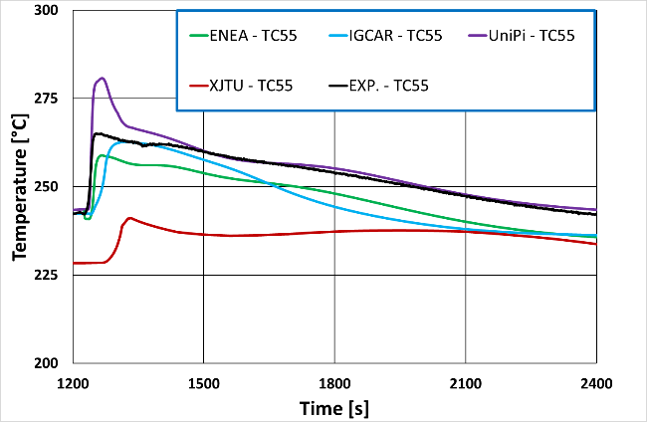  Figure 11. 18 ADP10 – Experimental and Calculated FPS Wall TC55 temperature time trends | 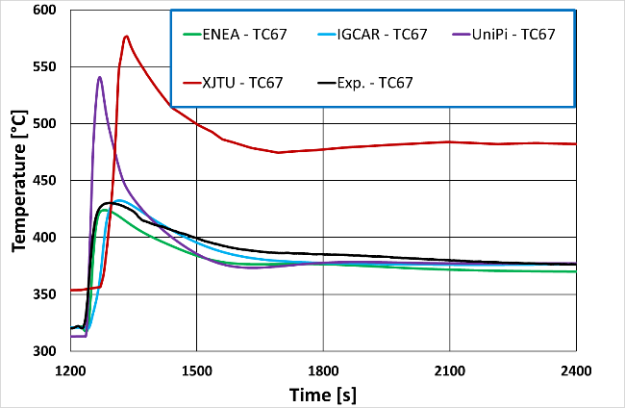  Figure 11. 19 ADP10 – Experimental and Calculated FPS Wall TC67 temperature time trends

      - ADP06 case
ADP06 shares the same general conditions of ADP10 in terms of total supplied power, gas injection and feedwater mass flow rate and inlet temperature. No surprise that very similar trends in terms of mass flow rates and loop temperature distributions were achieved by all the participants as from a numerical point of view ADP10 and ADP06 are identical in the STH part of the domain. The only differences are of course included in the CFD domain, as a non-uniform heat distribution occurs in the rods, with only the 7 central ones heated up.
Figure 11. 20 reports the comparison between the measured and experimental mass flow rates while Figure 11. 21 and Figure 11. 22 report the comparison for the temperature experienced at TP101 and TP102. Almost the same trends experienced for ADP10 were reported, coherently in the calculations, except for XJTU who set the pump in order to follow the experimental mass flow rate which turned to be slightly different during the initial steady state conditions.
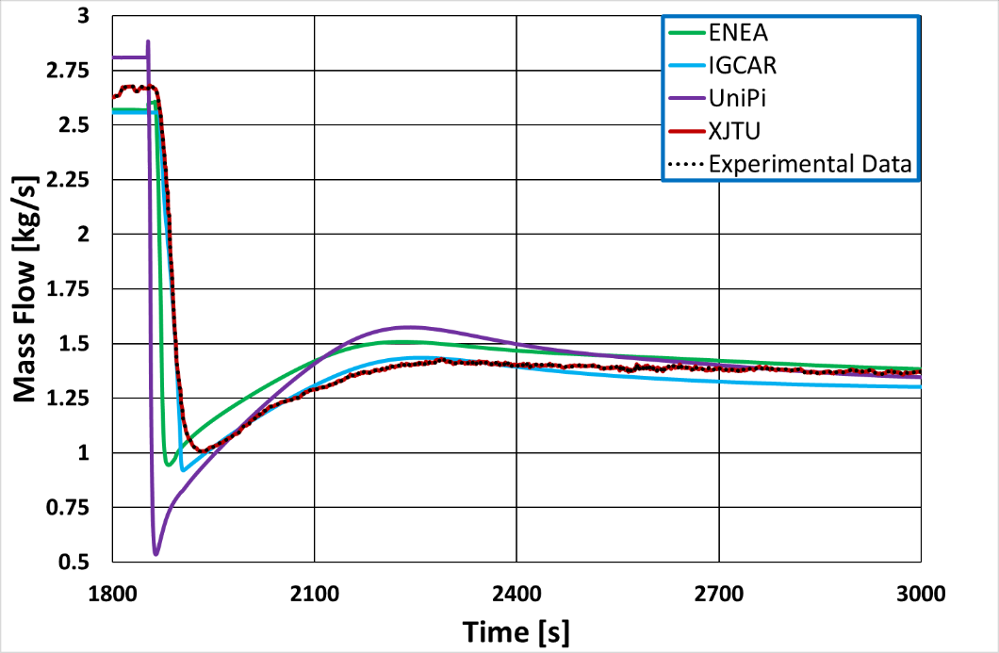
Figure 11. 20 ADP06 – Experimental and Calculated Mass flow rate time trends

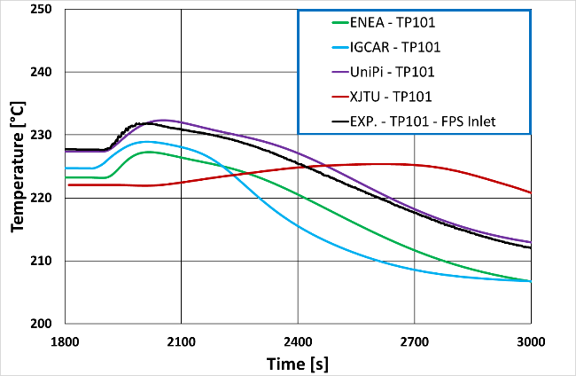  Figure 11. 21 ADP06 – Experimental and Calculated TP101 temperature time trends | 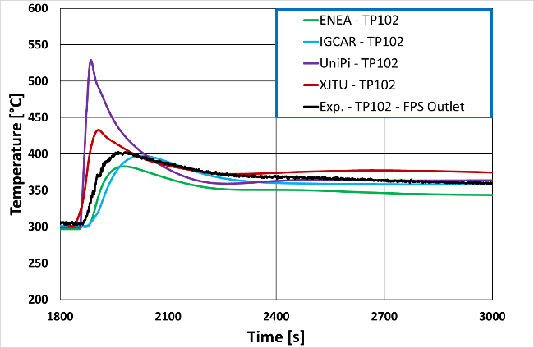  Figure 11. 22 ADP06 – Experimental and Calculated TP102 temperature time trends

Figure 11. 23 to Figure 11. 26 show the comparison between experimental and computational results for some selected thermocouples. Here the first relevant changes with respect to case ADP10 can be spotted. TC2 and TC12 are located in stead in the centre of the FPS at section A and C, respectively and they experience way larger temperatures with respect to TC4 and TC12 which are located instead at the very same section but in the periphery, in a channel which is not heated. This is indeed coherent with the imposed conditions and represents one of the advantages of using coupled STH/CFD codes with respect to STH codes stand-alone applications, as this differentiation between centre and periphery could not be experienced by a STH code.
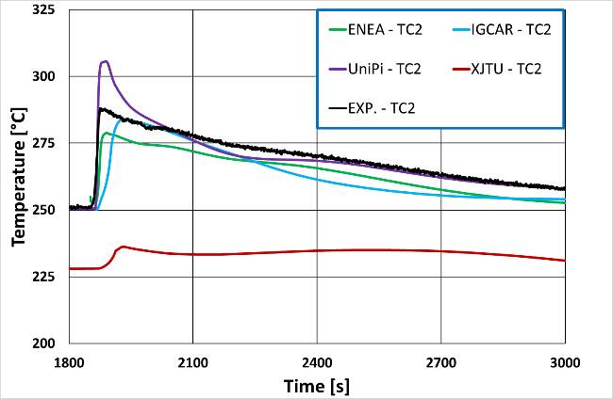  Figure 11. 23 ADP06 – Experimental and Calculated FPS Bulk TC2 temperature time trends | 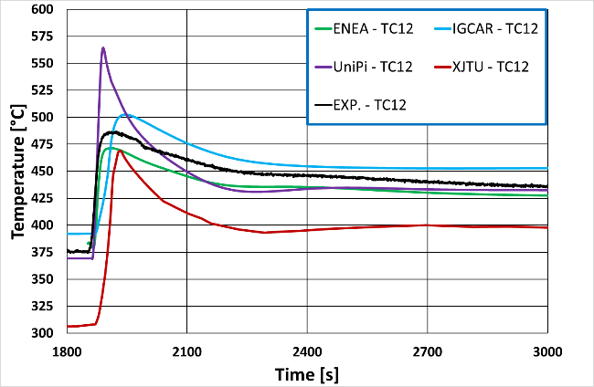  Figure 11. 24 ADP06 – Experimental and Calculated FPS Bulk TC12 temperature time trends
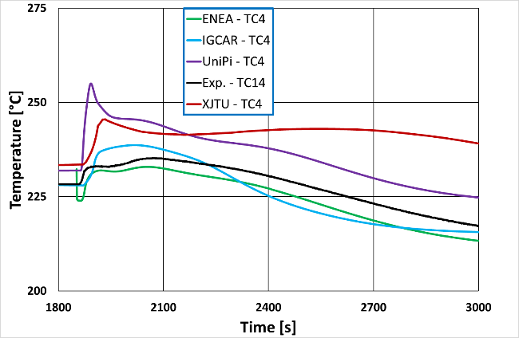  Figure 11. 25 ADP06 – Experimental and Calculated FPS Bulk TC4 temperature time trends | 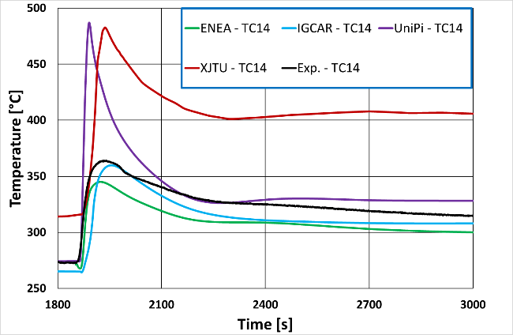  Figure 11. 26 ADP06 – Experimental and Calculated FPS Bulk TC12 temperature time trends

Figure 11. 27 to Figure 11. 30 report instead about the comparison between measured and computational values for some selected wall thermocouples. Conclusions similar to the ones drawn for the bulk thermocouples can be repeated for this case. TC55 and TC67 are indeed located on one of the central heated rods, while TC21 and TC51 are located in one of the unheated rods. The differences between heated and unheated locations becomes here, coherently, more pronounced with respect to the bulk thermocouples.
Generally speaking, very good results were again achieved. Some discrepancies were spotted in the first part of the transient especially for UniPi owing to the mentioned difficulties in replicating the experimental mass flow rate. XJTU results seem deviating from the others, it is speculated that some incomprehension’s regarding the location of the thermocouples or miss-positioning of the sampling points in the CFD domain occurred.
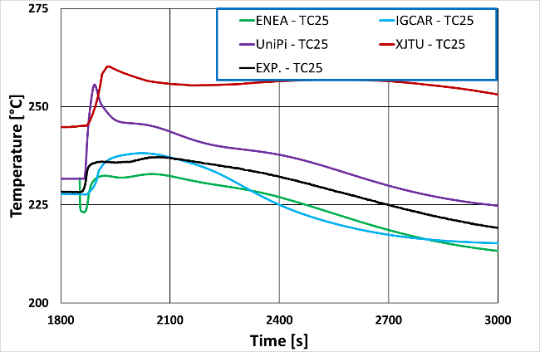  Figure 11. 27 ADP06 – Experimental and Calculated FPS Wall TC25 temperature time trends | 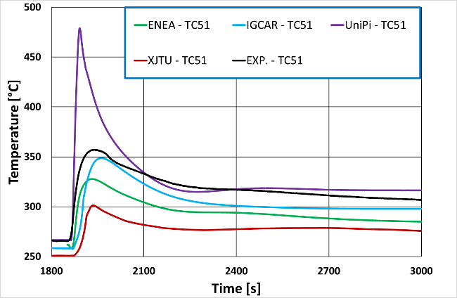  Figure 11. 28 ADP06 – Experimental and Calculated FPS Wall TC51 temperature time trends
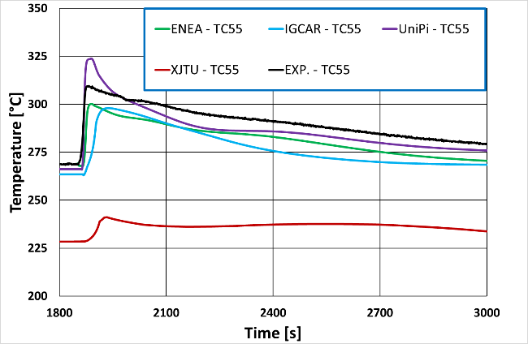  Figure 11. 29 ADP06 – Experimental and Calculated FPS Wall TC55 temperature time trends | 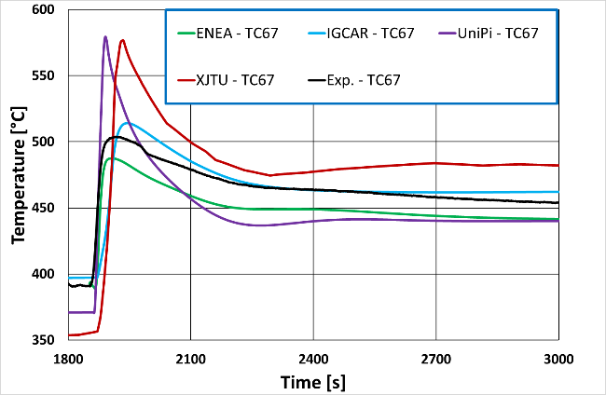  Figure 11. 30 ADP06 – Experimental and Calculated FPS Wall TC67 temperature time trends

    - Blind Calculations
The blind case ADP07 proved to be the most challenging case, not only for it being indeed blind, but because of the presence of a single heated sector of the FPS which showed some limits for the CFD application in dealing with the complex cross-flows induced by the presence of the wrapped wires. This aspect was deeply investigated in WP2, its consequences are experienced even in WP4, nevertheless here the comparison will mainly focus on the time domain instead than in the space domain.
Figure 11. 31 reports about the comparison between the experimental results and the computational values. As it can be observed almost all the participants managed to reproduce the final steady-state values, where only natural circulation occurs. More difficulties were reported for the initial steady state, when the impact of the already mentioned issues in modelling the gas lift induce some inaccuracies. XJTU strongly underpredicted the mass flow rate for the whole time interval; it must be instead stressed that both IGCAR and NRG-PALLAS achieved very good results adopting a pump component and the gas lift approach respectively. In the former case the issues with gas lift are thus overcome avoiding introducing gas at all in the calculation, in the latter, a superior behaviour of SPECTRA with respect to the other adopted STH codes for this very topic is probably at the basis of the very good prediction results. Another possibility for the better results provided by NRG-PALLAS, yet to be proved with other applications, is the use of an overlapping coupling approach which allows the STH code to manage the whole loop without any hole in the nodalization.
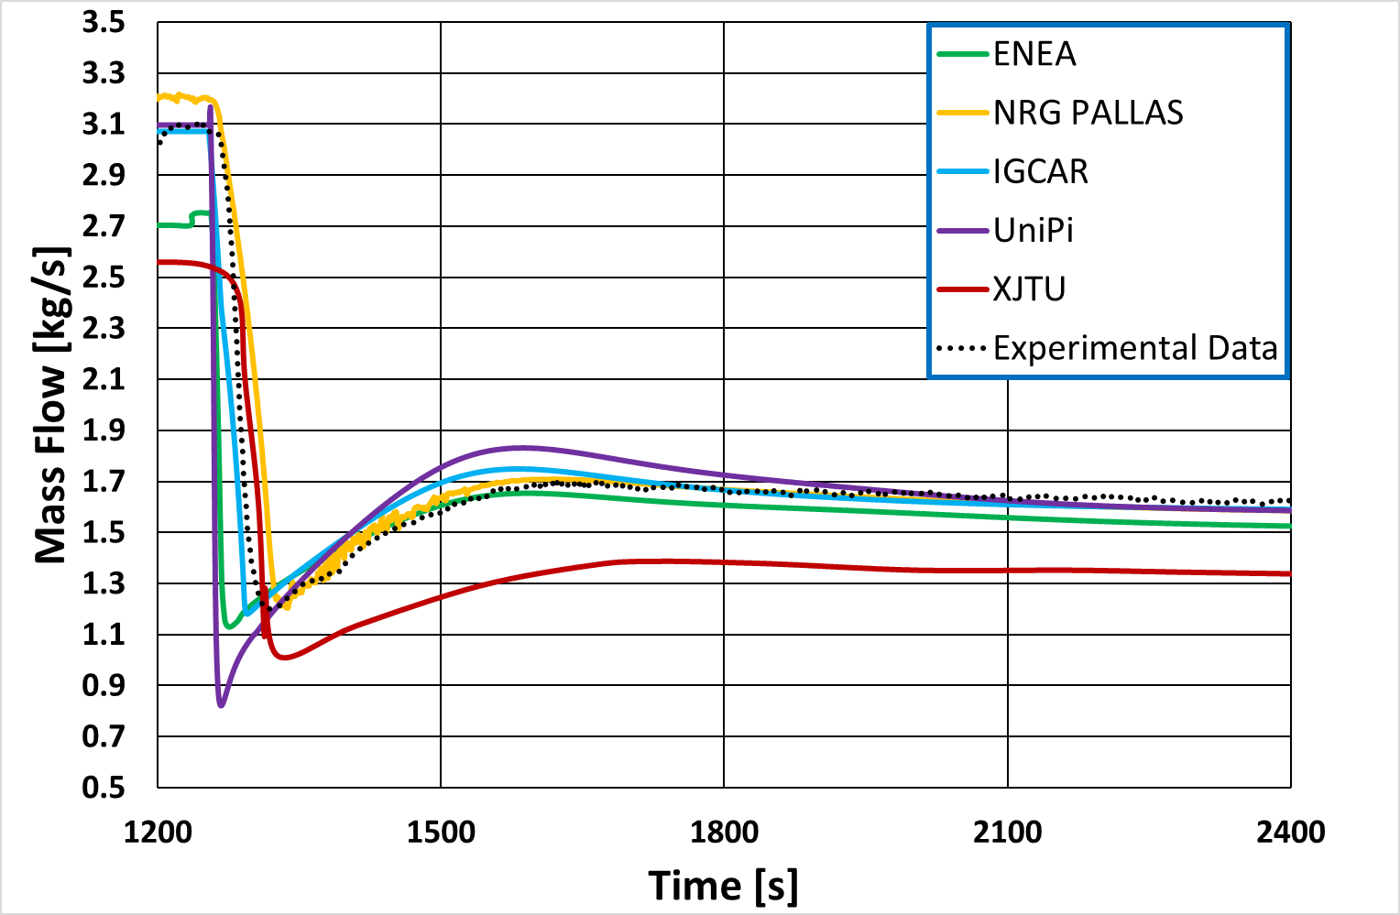
Figure 11. 31 ADP07 – Experimental and Calculated Mass flow rate time trends

Figure 11. 32 to Figure 11. 37 report about the comparison of the temperature trends predicted at measured at the instrumented locations along the loop. Generally speaking, very good predictions were obtained by all the participants for all the thermocouples: particularly, the best results were provided by NRG-PALLAS, mainly owing to the very good prediction of the mass flow rate trend. On the other hand, UniPi and XJTU overestimated the temperature values at TP102 at the beginning of the transient as a consequence of the calculated very small mass flow rate in that time interval.
Good capabilities were reported also for the FPS bulk temperatures for which a comparison between numerical and experimental results is reported in Figure 11. 38 to Figure 11. 41. Unlike the previous ADP10 and ADP06 cases, in ADP07 TC4 and TC14 are located in a heavily heated region while TC2 and TC12 are instead on the border between the heated and unheated section. As a consequence, larger temperature are coherently predicted here and this is acknowledged by almost all the participant institutions.
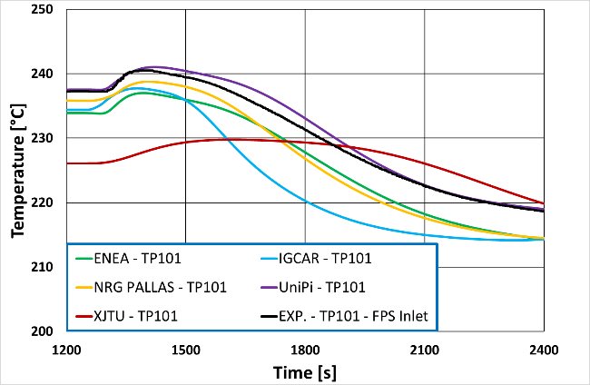  Figure 11. 32 ADP07 – Experimental and Calculated TP101 temperature time trends | 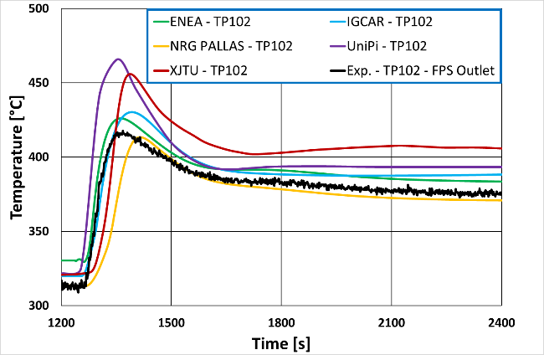  Figure 11. 33 ADP07 – Experimental and Calculated TP102 temperature time trends
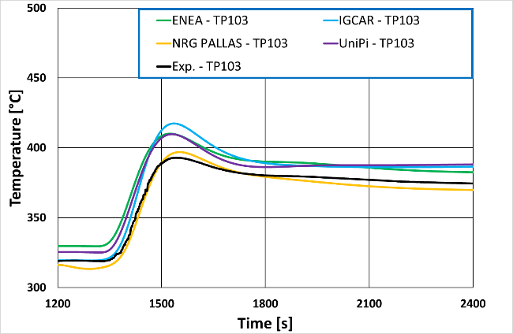  Figure 11. 34 ADP07 – Experimental and Calculated TP103 temperature time trends | 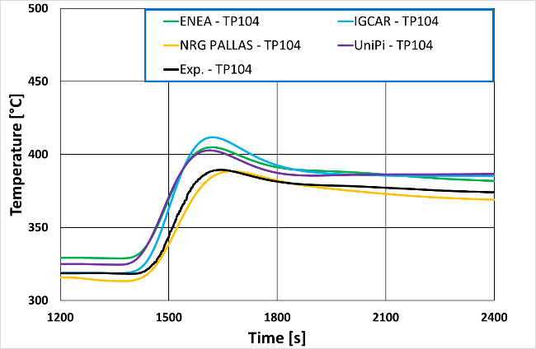  Figure 11. 35 ADP07 – Experimental and Calculated TP104 temperature time trends
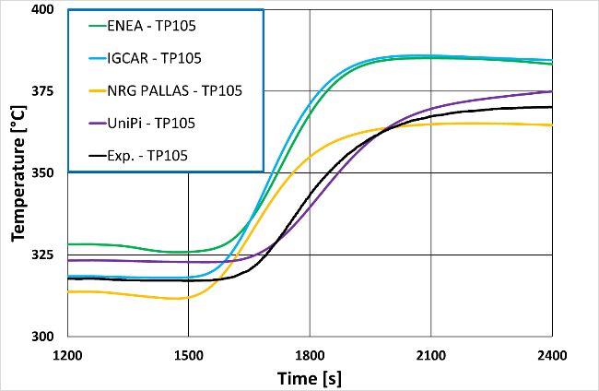  Figure 11. 36 ADP07 – Experimental and Calculated TP105 temperature time trends | 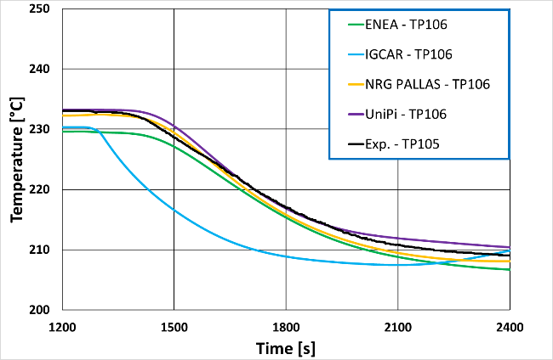  Figure 11. 37 ADP07 – Experimental and Calculated TP106 temperature time trends

Figure 11. 42 to Figure 11. 45 report instead the comparison between the numerical and experimental results for some selected wall thermocouples in the Fuel Pin Simulator. Very good results were reported by UniPi for the thermocouples at Section A (TC25 and TC55) while overestimating the ones at Section C during the first phase of the transient owing to the smaller predicted mass flux. It is particularly relevant to focus attention on TC67 in Figure 11. 45. This thermocouple is located on an unheated rod which is on the frontier between the heated and unheated regions. Everyone except XJTU, whose results are divergent from the others strongly underestimated the experimental wall temperature trend. This is to be probably mainly connected to issues also investigated in the frame of WP2 regarding the prediction of cross-sectional flows. Indeed, depending on the mutual position of the wrapped, TC67 may be invested by hotter fluid coming from the heated region or colder fluid coming from the unheated one thus making a very complicated environment to be simulated. The divergent results of XJTU are probably to be connected with errors in the positioning of the sampling points in the CFD domain. Eventually, Figure 11. 46 and Figure 11. 47 report a sample of the velocity distributions predicted by UniPi for the final steady state at section B. The main aim of these figures is to highlight again the added value of CFD in thise kind of STH/CFD applications. It allows observing complicated temperature and velocity distributions, something which very on topic in this CRP and especially for ADP07, something that could not be predicted at all with a STH stand-alone approach. The additional computational cost is thus compensated and justified by a far richer amount of information.
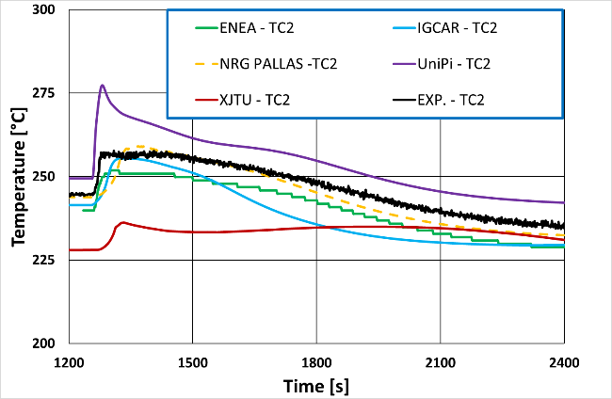  Figure 11. 38 ADP07 – Experimental and Calculated FPS Bulk TC2 temperature time trends | 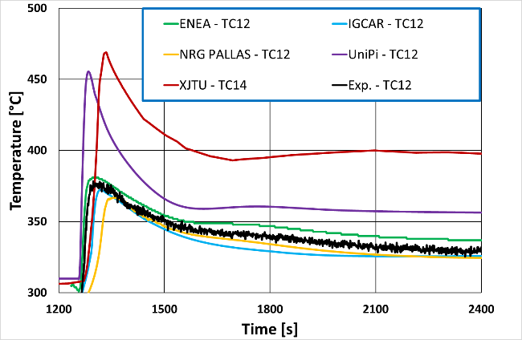  Figure 11. 39 ADP07 – Experimental and Calculated FPS Bulk TC12 temperature time trends
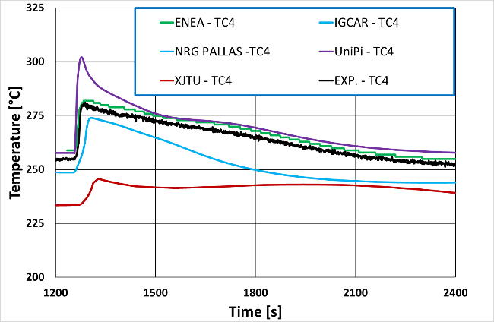  Figure 11. 40 ADP07 – Experimental and Calculated FPS Bulk TC4 temperature time trends | 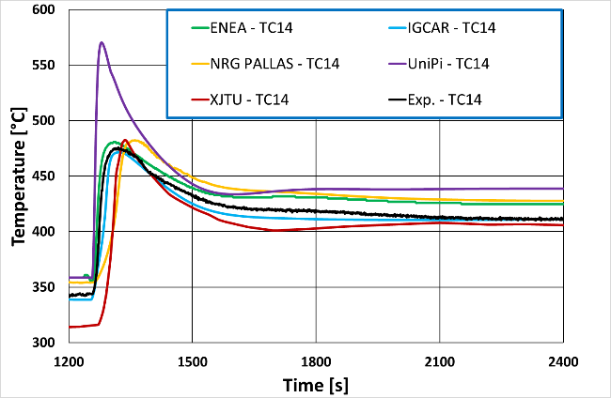  Figure 11. 41 ADP07 – Experimental and Calculated FPS Bulk TC14 temperature time trends

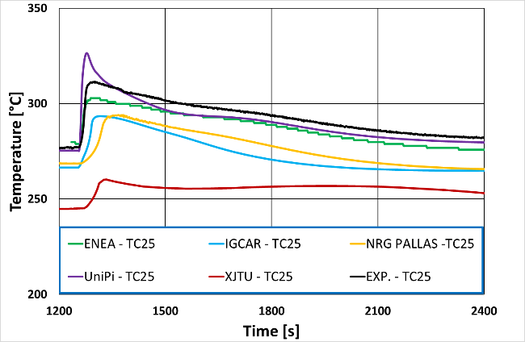  Figure 11. 42 ADP07 – Experimental and Calculated FPS Wall TC25 temperature time trends | 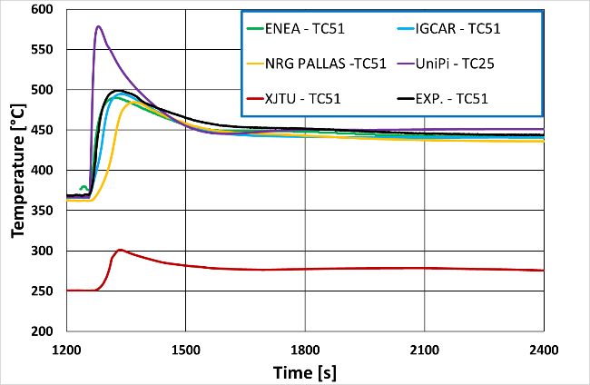  Figure 11. 43 ADP07 – Experimental and Calculated FPS Wall TC51 temperature time trends
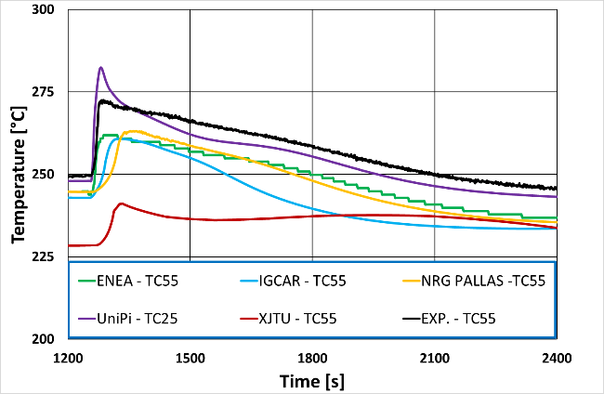  Figure 11. 44 ADP07 – Experimental and Calculated FPS Wall TC55 temperature time trends | 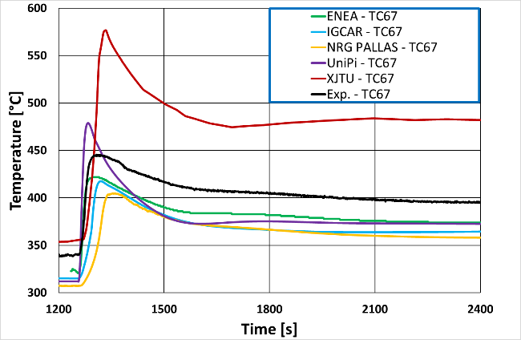  Figure 11. 45 ADP07 – Experimental and Calculated FPS Wall TC67 temperature time trends

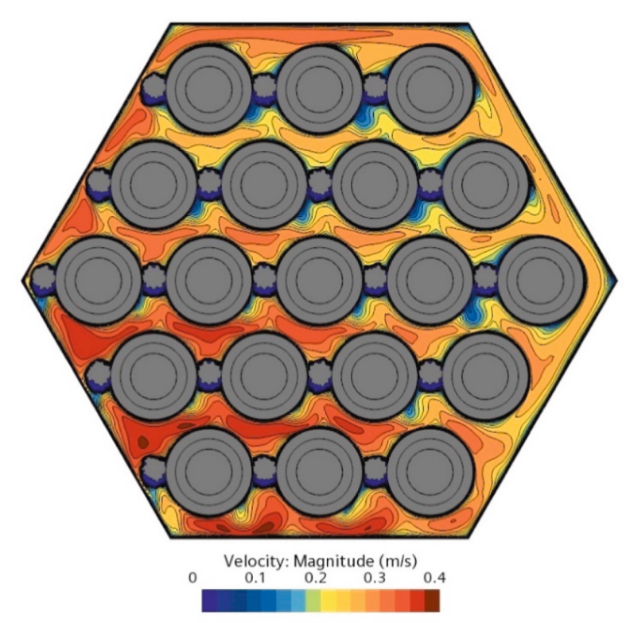  Figure 11. 46 ADP07 – axial velocity distribution predicted at Section B - UniPi | 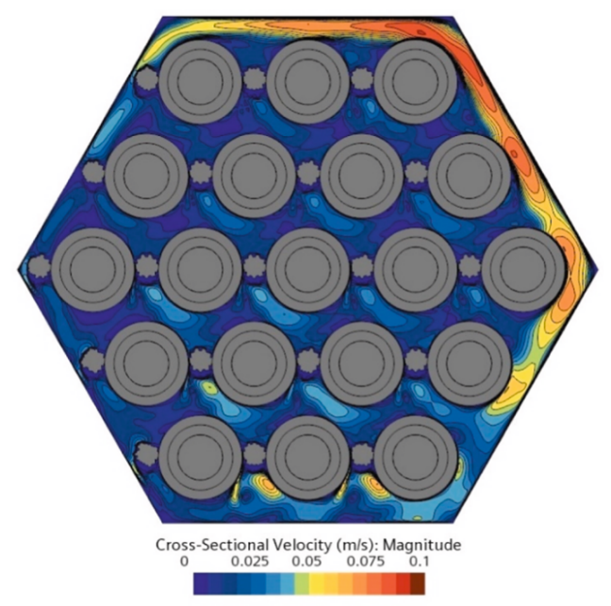  Figure 11. 47 ADP07 – Cross-Sectional velocity distribution predicted at Section B - UniPi

  - One-way coupling STH/subchannel codes analysis
Unlike other participants in the framework of the present Coordinated Research Project, EC-JRC explored a simpler coupling approach by means of a one-way coupling multiphysics analysis between STH and sub-channel (SCH) codes, using TRACE and COBRA-I-IV codes respectively. In this method, the first physics domain (STH) is solved first and its results are, then, used as input for the second physics domain (SCH) without any feedback action. The main assumption is that the feedback action between domains is close to zero or negligible. This approach and the use of a SCH code instead of CFD code saves in simulation time and can be considered as an intermediate stage to the two-way STH/CFD coupling.
In the current analysis, the coupling between the two mentioned codes is done by means of data exchange. The TRACE code provides to COBRA the inlet bundle temperature and mass flow and the bundle outlet pressure. This input data is used by COBRA to compute the temperatures (coolant and cladding) inside the fuel bundle. The main assumption of the one-way coupling is that the difference in the outlet bundle temperatures computed by the two codes is negligible. The outlet bundle temperature is indeed the feedback output that would be returned to the STH in case of two-way coupling. A diagram of the data exchange is shown in Figure 11. 48.
T_{in,FPS}; m_{in,FPS}; P_{out,FPS}
T_{out, FPS, TRACE} – T_{out, FPS, COBRA < δ}
COBRA
TRACE

Figure 11. 48 Data exchange diagram
The TRACE and COBRA models used in the coupling are the same presented in WP1 and WP3. The coupling was applied to test ADP10 and its results are presented below

    - ADP10 case
The ADP10 is the reference case in the benchmark and was chosen to assess the one-way coupling approach. The STH results are the same ones reported by EC-JRC in WP1 for ADP10 case and are not repeated here. It is worth instead to look at the outlet bundle temperature computed by the two codes (Figure 11. 49).
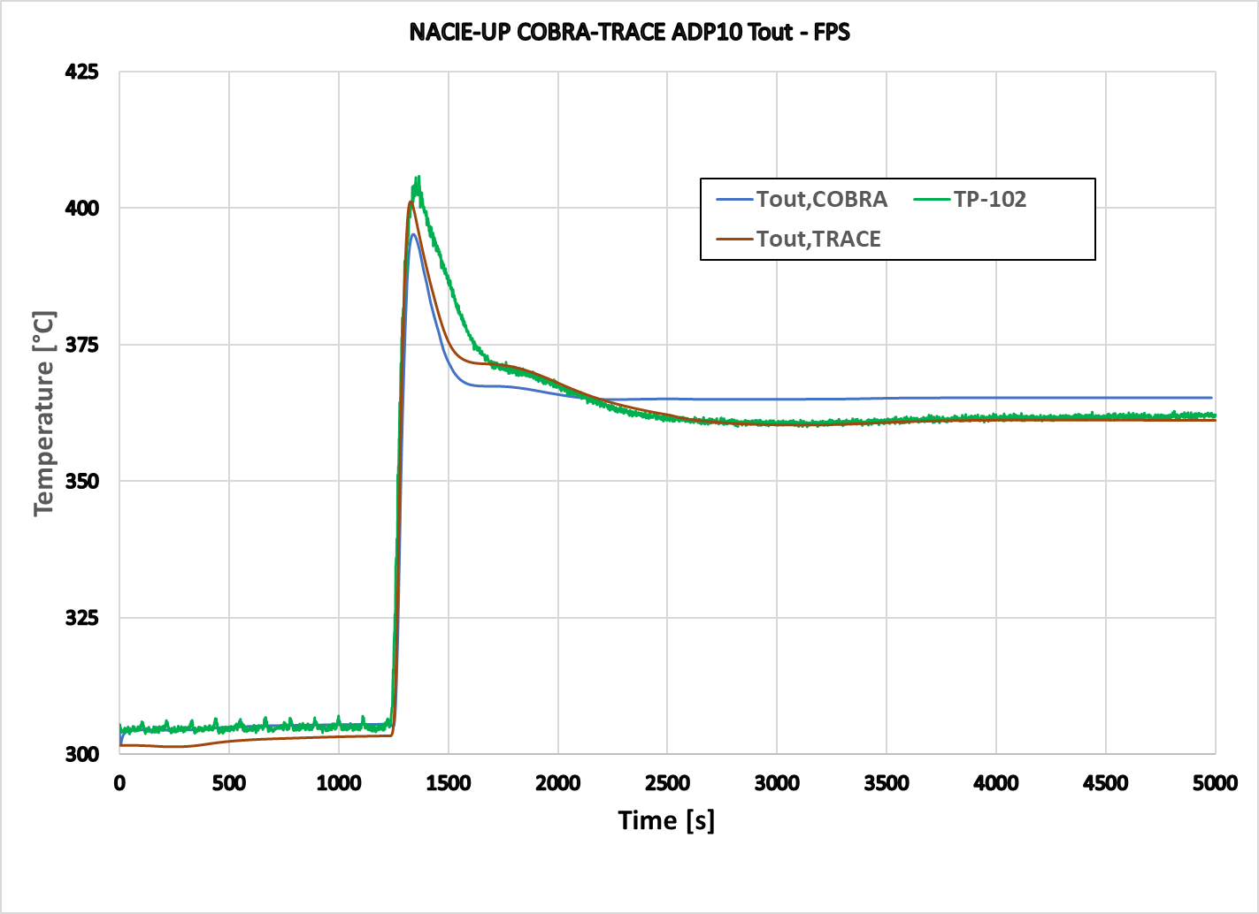
Figure 11. 49 Outlet bundle temperature
The major differences are observed during the forced-to-natural flow transition phase and natural circulation phase. Since the inlet bundle temperature and the mass flow are imposed, the coolant properties and the heat losses (not computed in COBRA) may partially explain the discrepancies. However looking at absolute difference of the two temperatures (Figure 11. 50), it remains within ± 5 °C across most of the transient with the exception of the transition face.
Figure 11. 51 to Figure 11. 54 show the comparison between experimental values and values calculated in the COBRA model using experimental input data and in the one-way coupled COBRA-TRACE approach for some selected bulk and wall thermocouples located in the FPS. The uniform heating conditions of ADP10 test allows the STH/SCH one-way coupling to produce results that are very similar to those observed in the previous section for the fully coupled STH/CFD multiphysics analysis.
As test ADP10 represents the operation condition of fuel bundle to be addressed in the safety case, the STH/SCH approach can be used to analyse real case scenarios

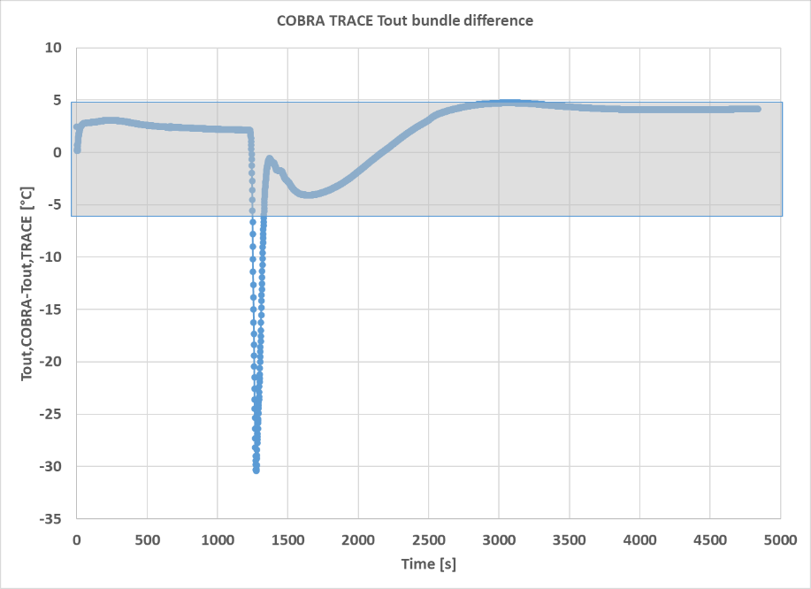
Figure 11. 50 Outlet bundle temperature
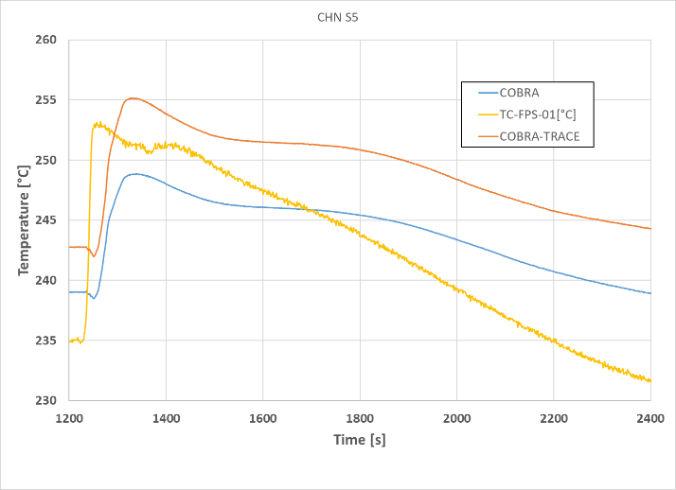  Figure 11. 51 ADP07 – Experimental and Calculated FPS Bulk TC2 temperature time trends | 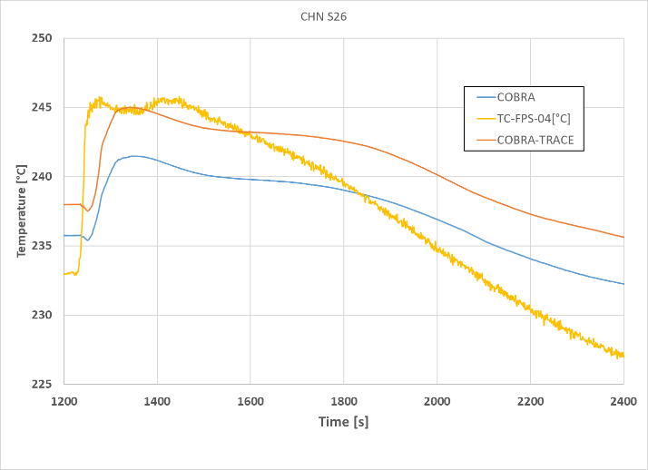  Figure 11. 52 ADP07 – Experimental and Calculated FPS Bulk TC4 temperature time trends

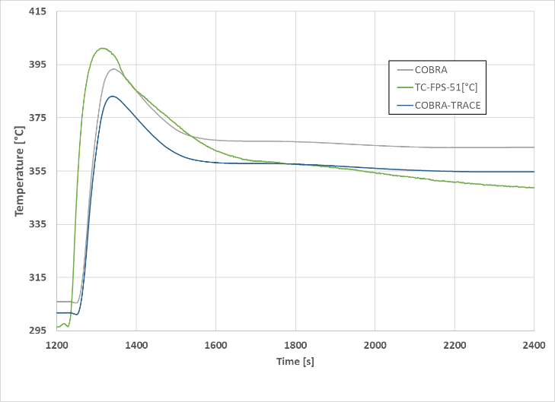  Figure 11. 53 ADP07 – Experimental and Calculated FPS Wall TC51 temperature time trends | 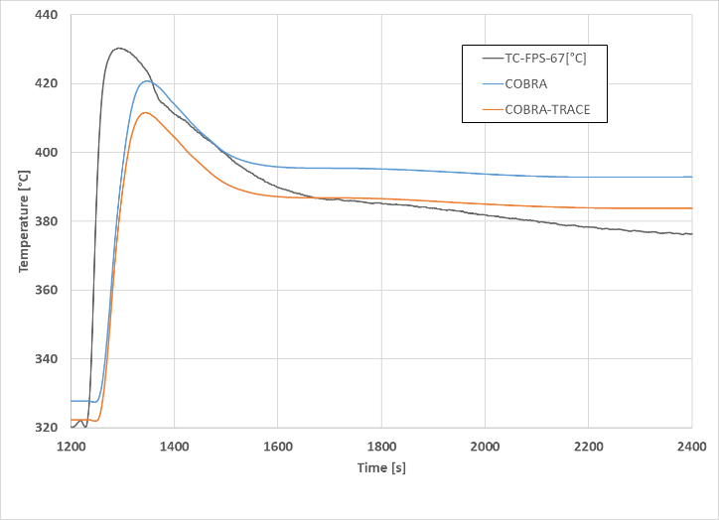  Figure 11. 54 ADP07 – Experimental and Calculated FPS Wall TC67 temperature time trends

  - Conclusions
The present chapter resumed the results submitted by the participants for WP4, Multiphysics. Most institutions performed coupled STH/CFD calculations addressing the Fuel Pin Simulator adopting the CFD approach. One institution explored the one-way coupling between the STH code TRACE and the SCH code COBRA-I-IV. This allowed for a suitable representation of the three-dimensional environment of the rod bundle, granting richness of information about temperature and velocity distributions while keeping the total computational cost sufficiently small thanks to the STH portion of the domain in the loop.Results were in general promising, reporting good capabilities in dealing with all the addressed scenarios. All the modelling strategies proved to be good options and no relevant differences between the submitted results were observed except for the ones related to superior capabilities of the adopted codes, either STH or CFD, with respect to others.It must be mentioned that the computational cost is not negligible. Participants experienced computational times straddling from a week to about a month to achieve predictions that could be provided in terms of hours adopting a STH stand alone approach. This is also the main reason behind the lack of refinement calculations submitted after the release of experimental data. Nevertheless, the payback of the additional cost was rewarded by the capability of sensing the difference between the postulated heating configurations. In this respect, the computational burden of the one-way STH/SCH coupling was comparable to the STH stand-alone approach and could be considered as a preliminary, intermediate approach to the fully coupled STH/CFD one.
As a general statement the following strategy could be considered: STH calculations should be performed first, together with CFD calculations in order to investigate possible transients as well as potential challenging or dangerous conditions, or if available perform STH/SCH coupled analyses. Coupled STH/CFD calculations should be adopted in order to refine the initial reconnaissance and achieve a better clue about the possible safety margins of the addressed conditions.The present CRP proved to be a very good benchmark for the assessment of coupling techniques. At the present stage it seems that no particular issues can be strictly connect to coupling tools, while larger improvement chances are to be connected to the development of more suitable models in both STH and CFD stand-alone applications. Coupled STH/CFD or earlier STH/SCH applications addressing Multiphysics phenomena may thus play a relevant role in the development of GEN IV nuclear reactors, especially for LMFBRs, as sound support to refined safety analysis assessment.
  - References
Angelucci, M., 2018. Coupling between System and CFD codes for the analysis of thermal-hydraulic phenomena relevant for LMFR.
Del Moro, T., Cioli Puviani, P., Gonfiotti, B., Di Piazza, I., Martelli, D., Ciurluini, C., Giannetti, F., Zanino, R., Tarantino, M., 2024. Analysis of the experimental tests performed at NACIE-UP facility through a novel CFX-RELAP5 codes coupling. Nucl. Eng. Des. 429, 113676. https://doi.org/10.1016/j.nucengdes.2024.113676
Martelli, D., Forgione, N., Di Piazza, I., Agostini, P., Tarantino, M., Gaggini, P., Polazzi, G., 2013. NACIE-UP: an heavy liquid metal loop for mixed convection experiments with instrumented pin bundle.
Pangukir, F.S.L., Hussain, M.M.M.D., Mathur, A., Stempniewicz, M.M., Roelofs, F., 2025. Multi-scale numerical simulation of NACIE-UP forced-to-natural circulation transition experiment for non-uniform heating. Nucl. Eng. Des. 443, 114301. https://doi.org/10.1016/j.nucengdes.2025.114301
Pucciarelli, A., Galleni, F., Moscardini, M., Martelli, D., Forgione, N., 2020. STH/CFD coupled calculations of postulated transients from mixed to natural circulation conditions in the NACIE-UP facility. Nucl. Eng. Des. 370, 110913. https://doi.org/10.1016/j.nucengdes.2020.110913
Stefanini, P., Pucciarelli, A., Halim, O., Forgione, N., Di Piazza, I., 2025. Validation of a coupled STH and low-fidelity CFD approach using experimental data from NACIE-UP test facility. Nucl. Eng. Des. 444, 114353. https://doi.org/10.1016/j.nucengdes.2025.114353

