- Sensitivity and uncertainty analysis (WP5)
  - Introduction
Four organizations performed sensitivity and uncertainty analysis of the simulations: ENEA, Gidropress, IBRAE RAN, and the University of Pisa. They employed different approaches and different code types (system, subchannel, and CFD). The lists of the considered uncertain input parameters and the estimates of their uncertainties, although mainly based on the experiment specification, varied as well. This makes the direct comparison of the results practically impossible. Therefore, the descriptions of the approaches and the results are presented separately for each organization.
  - ENEA
    - Methodological background
The sub-channel (SC) code ANTEO+ is a steady-state, single phase, thermal-hydraulic problem solver whose series of assumptions allows for a decoupling of coolant and pin calculations, simplifying the solution procedure and facilitating the use of S/U analysis based on a variational approach of Generalized Perturbation Theory (GPT) [1]. The application of GPT for obtaining sensitivity coefficients, while being standard practice in nuclear fields such as neutronics, is quite uncommon for thermal-hydraulics [2], where stochastic methods and direct perturbations (DP) prevail. Despite the mathematical and numerical difficulties, it could entail in complex problems, GPT offers advantages in terms of computational efficiency and physical insights in understanding the main phenomena contributing to sensitivities coefficients.
As a first attempt in the framework of the CRP, the GPT is applied under the forced convection assumption, implying SCs are modelled under the assumptions of constant mass flow, weak hydrodynamic coupling, fully developed flow, and uniform pressure over the bundle cross section.
The systems of equations involve the conservation of mass, transverse momentum, axial momentum, and energy. The latter is written along the axial direction $z$ as:
$$\frac{d\vec{h}}{dz}=\frac{1}{\dot{\vec{m} }}\left(W\vec{h}+ \vec{χ}\right) ,$$
where $\dot{\vec{m}}$ is the vector of all SC mass flow rates, $\vec{h}=\vec{h}\left(z\right)$ is the vector of all SC specific enthalpies, $W$ is the matrix of effective energy exchange rates per unit length between SCs, and $\vec{χ}$ is the vector of linear powers discharged to SCs from the pins. This equation can be appended to a response functional for the construction of a constrained response functional, which is then minimized through a first-order variational approach to define GPT sensitivity coefficients. The constrained functional $K$ is:
$$\begin{aligned}K=R-{\left\langle {\vec{h}}^{*},\frac{d\vec{h}}{dz}-\frac{1}{\dot{\vec{m}}}\left(W\vec{h}+\vec{χ}\right)\right\rangle }_{z},\#\left(1\right)\end{aligned}$$
where$R$ is the unconstrained response functional, ${\vec{h}}^{*}={\vec{h}}^{*}\left(z\right)$ is the vector of fixed Lagrange multipliers, and ${\left\langle …\right\rangle }_{z}$ indicates integration of the constraint between inlet ($z=z_{\text{in}}$) and outlet ($z=z_{\text{out}}$). Note that, since the constraint involves the energy conservation equation, it is identically zero and so, value-wise, $K = R$. If an input datum $α$ is subject to a small perturbation $δα$ so that it becomes $α^{'}=α+δα$, then the uncostrained response becomes $R^{'}=R+δR$, where $δR$ is the perturbation induced by $δα$. In turn, the constrained response becomes $K^{'}=K+δK$, with again the perturbation $δK$ being a consequence of $δα$. Expanding $K'$ about $K$ in a first-order functional Taylor series leads to:
$$\begin{aligned}K^{'}≈K+{\left\langle \frac{∂K}{∂α} δα\right\rangle }_{z}+{\left\langle \frac{∂K}{∂\vec{h}}⋅δ\vec{h}\right\rangle }_{z}.\#\left(2\right)\end{aligned}$$
The partial derivatives in Eq. (2) are related to the definitions of ${\vec{h}}^{*}$ and sensitivity coefficients.
In case of final responses (i.e., depending at most on input data and quantities at $z_{\text{out}}$), the quantity ${\vec{h}}^{*}$ is defined through the following, which is obtained as part of the minimization process by forcing $K$ to be stationary with respect to variations of$\vec{h}$ (i.e. $∂K/∂\vec{h}=0$):
$$\begin{aligned}-\frac{d{\vec{h}}^{*}}{dz}-\frac{W^{*}}{\dot{\vec{m}}}{\vec{h}}^{*}=0; {\vec{h}}^{*}\left(z_{\text{out}}\right)={\left.\frac{∂R}{∂\vec{h}}\right|}_{z=z_{\text{out}}}; z∈\left[z_{\text{in}},z_{\text{out}}\right] ,\#\left(3\right)\end{aligned}$$where the differential equation, given its form, is called the adjoint enthalpy equation, and the vector of Lagrange multipliers is consequently denoted also as the vector of adjoint enthalpies. The adjoint enthalpy $h_{j}^{*}\left(z\right)$ of the generic $j$-th SC is the importance that the (specific) enthalpy of the coolant in that SC at axial position $z$ has for the value of $R$. The equation is to be solved backward in space starting from the final conditions at $z_{\text{out}}$. A parallelism can be drawn between the adjoint enthalpy equation of SC problems and the adjoint Bateman equation of depletion problems: the latter must be solved backward in time starting from end-of-depletion adjoint isotopic concentrations.
To ensure the invariance of the sum of all adjoint enthalpies with respect to $z$, a normalization must be applied to ${\vec{h}}^{*}$ after its first computation:
$$\begin{aligned}{\vec{h}}^{*,\text{norm}}=\frac{\dot{\vec{m}} {\vec{h}}^{*}}{\dot{\vec{m}}⋅{\vec{h}}^{*}} .\#\left(4\right)\end{aligned}$$
In the following, the superscript $"\text{norm"}$ will be dropped for simplicity.
As shown in Eq. (3), depending on the type of final response, the definitions of final adjoint enthalpies vary accordingly. For the CRP, two types of responses are of interest:
- coolant bulk temperatures (or enthalpies in our formulation),
- clad outer temperatures.
If $R$ is the outlet enthalpy $h_{i}\left(z_{\text{out}}\right)$ of the $i$-th SC, then:
$$\begin{aligned}h_{j}^{*}\left(z_{\text{out}}\right)={\left.\frac{∂h_{i}}{∂h_{j}}\right|}_{z=z_{\text{out}}}=δ_{ij} ∀j ,\#\left(5\right)\end{aligned}$$
where $δ_{ij}$ is the Kronecker delta associated with the $i$-th and the $j$-th SCs. If $R$ is the outlet outer cladding temperature $T_{\text{co},k,i}$ of the $k$-th pin facing the $i$-th SC, computed as
$$\begin{aligned}R=T_{\text{co},k,i}\left(z_{\text{out}}\right)=T_{\text{bulk},i}\left(z_{\text{out}}\right)+\frac{χ_{\text{p},k}\left(z_{\text{out}}\right)}{πD_{k}a_{\text{p}}} ,\#\left(6\right)\end{aligned}$$
where $T_{\text{bulk},i}$ is the bulk coolant temperature of the $i$-th SC, $χ_{\text{p},k}$ is the linear power of the pin, $D_{k}$ is the pin diameter, and $a_{\text{p}}$ is the convection coefficient. The bulk coolant temperature is directly related to the SC enthalpy via $c_{\text{p},j},$ the specific heat capacity at constant pressure of the coolant in the $j$-th SC. Considering the linear dependency of bulk temperatures on SC enthalpies, the final adjoint enthalpy in this case is:
$$\begin{aligned}h_{j}^{*}\left(z_{\text{out}}\right)={\left.\frac{∂T_{\text{co},k,i}}{∂h_{j}}\right|}_{z=z_{\text{out}}}=\frac{δ_{ij}}{c_{\text{p},j}} ∀j .\#\left(7\right)\end{aligned}$$
The first-order sensitivity coefficient of $R$ with respect to the generic input datum $α$ is defined as a logarithmic total derivative, but via GPT (in particular, considering the surviving term $∂K/∂α$ in Eq. (2)) it becomes a logarithmic partial derivative of $K$:
$$\begin{aligned}S_{GPT}\left(R,α\right)=\frac{α}{R}\frac{∂R}{∂α}-\frac{1}{R}{\left\langle {\vec{h}}^{*},-α\frac{∂}{∂α}\left(\frac{1}{\dot{\vec{m}}}\left(W\vec{h}+\vec{χ}\right)\right)\right\rangle }_{z},\#\left(8\right)\end{aligned}$$
where the term with $∂R/∂α$ is called the direct sensitivity term, while the one in which ${\vec{h}}^{*}$ acts as weighting function is the indirect contribution. If, instead of having $R$ depending at most on input data and quantities at $z_{\text{out}}$, $R$ depends more generically at most on input data and quantities at $z_{\text{p}}∈ ]z_{\text{in}}, z_{\text{out}}]$, then Eqs. (2) – (8) still hold, but all the instances of $z_{\text{out}}$ must be replaced with $z_{\text{p}}$. The specific form of Eq. (8) varies depending on the combination of $R$ and $α$. For instance, if $R=h_{i}\left(z_{\text{out}}\right)$ (and similarly if $R=h_{i}(z_{\text{p}})$), then, for $α= {\dot{m}}_{\text{tot}}$ and $α= q_{\text{tot}}$, the sensitivity coefficients are without direct contribution and take the following forms:
$$\begin{aligned}S_{GPT}\left(h_{i}\left(z_{\text{out}}\right),{\dot{m}}_{\text{tot}}\right)=\frac{{\dot{m}}_{\text{tot}}}{h_{i}\left(z_{\text{out}}\right)}{\left\langle {\vec{h}}^{*},\frac{∂}{∂{\dot{m}}_{\text{tot}}}\left(\frac{W}{\dot{\vec{m}}}\vec{h}+\frac{\vec{χ}}{\dot{\vec{m}}}\right)\right\rangle }_{z},\#\left(9\right)\end{aligned}$$
$$\begin{aligned}S_{GPT}\left(h_{i}\left(z_{\text{out}}\right),q_{\text{tot}}\right)=\frac{q_{\text{tot}}}{h_{i}\left(z_{\text{out}}\right)}{\left\langle {\vec{h}}^{*},\frac{∂}{∂q_{\text{tot}}}\left(\frac{\vec{χ}}{\dot{\vec{m}}}\right)\right\rangle }_{z}.\#\left(10\right)\end{aligned}$$
If $R=T_{\text{co},k}\left(z_{\text{out}}\right)$ (and similarly if $R = T_{co,k,i}(z_{p})$), then, for $α= {\dot{m}}_{\text{tot}}$ and $α=q_{\text{tot}}$, the sensitivity coefficients are:
$$\begin{aligned}S_{GPT}\left(T_{\text{co},k,i}\left(z_{\text{out}}\right),{\dot{m}}_{tot}\right)=\frac{{\dot{m}}_{tot}}{T_{\text{co},k,i}\left(z_{\text{out}}\right)}\frac{∂T_{\text{co},k,i}\left(z_{\text{out}}\right)}{∂\dot{m_{\text{tot}}}}+\frac{{\dot{m}}_{tot}}{T_{\text{co},k,i}\left(z_{\text{out}}\right)}{\left\langle {\vec{h}}^{*},\frac{∂}{∂{\dot{m}}_{tot}}\left(\frac{W}{\dot{\vec{m}}}\vec{h}+\frac{\vec{χ}}{\dot{\vec{m}}}\right)\right\rangle }_{z},\#\left(11\right)\end{aligned}$$
$$\begin{aligned}S_{GPT}\left(T_{\text{co},k,i}\left(z_{\text{out}}\right),q_{\text{tot}}\right)=\frac{q_{\text{tot}}}{T_{\text{co},k,i}\left(z_{\text{out}}\right)}\frac{∂T_{\text{co},k,i}\left(z_{\text{out}}\right)}{∂q_{\text{tot}}}+\frac{q_{\text{tot}}}{T_{\text{co},k,i}\left(z_{\text{out}}\right)}{\left\langle {\vec{h}}^{*},\frac{∂}{∂q_{\text{tot}}}\left(\frac{\vec{χ}}{\dot{\vec{m}}}\right)\right\rangle }_{z}.\#\left(12\right)\end{aligned}$$
The quantity $∂\left(W/\dot{\vec{m}}\right)/∂{\dot{m}}_{tot}$ is implemented applying the quotient rule. Regarding the computation of the associated $∂W/∂{\dot{m}}_{tot}$ derivative, it relies on a direct perturbation of ${\dot{m}}_{tot}$ which allows for using the approximating finite difference $\left(W^{'}-W\right)/\left({\dot{m}'}_{tot}-{\dot{m}}_{tot}\right)$, where primed terms denote perturbed quantities. This direct perturbation is local, i.e., it does not affect anything else in ANTEO+. The computation of $∂T_{\text{co},k,i}\left(z_{\text{out}}\right)/∂{\dot{m}}_{tot}$ is approximated analogously. It has been verified that the entity of local direct perturbations does not alter significantly the resulting derivatives, provided that this value remains below 1% of the reference value of ${\dot{m}}_{tot}$.
    - Results
The results of the S/U analyses obtained with ANTEO+ will be presented only for ADP10-SS1 and ADP10-SS2 cases and are shown in Tables I and II, respectively; SS2 is considered, even if the GPT formulation is targeting forced convection, so to highlight capabilities of the methodology in comparison with other calculation methods. The two types of responses, coherent with the quantities measured in the FPS, have been considered, namely SC enthalpies (as representative of coolant bulk temperatures) and outer cladding temperatures, both at axial positions of planes B and C spread in the inner and outer part of the FPs. For each type, the ones foreseen to be the most impactful input data have been selected for the evaluation of sensitivity coefficients: the total mass flow rate ${\dot{m}}_{tot}$ and the total linear power $q_{\text{tot}}$. Sensitivities were computed using both GPT and DP, with DP taken as the reference for evaluating the relative discrepancies $ε$; the associated relative uncertainties are reported for the GPT results, labelled as $U_{GPT}$. DP is performed applying a 1% perturbation on $α$.
For both cases, sensitivities tend to have lower discrepancies between GPT and DP when $α=q_{\text{tot}}$, with $\left|ε\right|$ consistently below 2% for enthalpies as well as outer cladding temperatures. The highest discrepancy is only $≈2.21$%. The very good agreement observed for $α=q_{\text{tot}}$ is mainly related to the (close to) linear dependence of the responses to this parameter, which facilitates the implementation of Eqs. (10) and (12) in ANTEO+.
From the physical standpoint, it is confirmed the expected high sensitivity of SC temperatures to the input power which remains constant both axially and radially in the bundle leading to significant relative uncertainties around 7.6% and 5.3% for SS1 and SS2, respectively. For clad outer temperatures, sensitivities are much lower and tend to increase at higher elevations due to the increasing contribution coming from the coolant bulk temperature; also, due to lower enthalpy gain of outer SCs, their sensitivities tend to be lower than central SCs, for the same elevation. Due to the higher temperature increase in SS2, relative to SS1, sensitivities are higher. Uncertainties are considerably well below 1% for plane B and around 2.2% and 1.5% for plane C for SS1 and SS2 respectively, with the latter being lower even with higher sensitivities due to the reduction in the experimental uncertainty on the power level.
Moving to $α={\dot{m}}_{tot}$, since the dependency of $W$ and outer cladding temperatures on it is nonlinear and considering the approximations adopted for the implementation of Eqs. (9) and (11), the sensitivities exhibit larger discrepancies between GPT and DP. Nonetheless, they are still acceptable, as $\left|ε\right|$ ranges from $≈3.18$% to $≈10.31$%, with case ADP10-SS2 having a slightly better alignment between the methods than ADP10-SS1. The smallest discrepancies are observed for SC S2 at z = 540 mm, i.e. close to the bundle centre and approximately at the centre of the heated region. In this region, GPT sensitivities slightly underestimate the DP reference. Conversely, as the response location moves towards the outlet and radially outward, the discrepancy with DP increases and GPT tends to overestimate the sensitivities. The largest sensitivity discrepancies are observed in both ADP10-SS1 and ADP10-SS2 in relation to the enthalpy of SC S26 at 1060 mm (near the outlet and the radial boundary) and are $≈10.31$% and $≈8.21$%, respectively.
Physically speaking, the expected high sensitivity of SC temperatures to the total mass flow rate is confirmed, which remains almost constant both axially and radially, although a slight reduction can be observed at increasing elevations and for outer SCs, due to energy mixing effects. Uncertainties remain significant assessing around 4.7%/5.4% and 3.4%/4.0% for SS1 and SS2 and internal/edge SC, respectively. For clad outer temperatures, sensitivities are again much lower, tend to increase at higher elevations and are higher in SS2, in complete analogy to sensitivities on the input power. Uncertainties are considerably lower than 1% for plane B and around 1.2% and 1.5% for plane C for SS1 and SS2, respectively.
Table I. Main S/U results for ADP10-SS1.

ID | SC | PIN | $z_{\text{p}}$ [mm] | $$R$$ | $$S_{DP}\left(R,α\right)$$ | $$S_{GPT}\left(R,α\right)$$ | $$ε$$ | $$U_{GPT}\left(R,α\right)$$
Response: $h$ [J/kg] – $α$: $m_{\text{tot}}$
TC-FPS_01 | S2 | - | 540 | 2.10E+03 | -1.00E+00 | -9.59E-01 | -4.12% | 4.80%
TC-FPS_11 | S2 | - | 1060 | 1.40E+04 | -9.93E-01 | -9.20E-01 | -7.34% | 4.60%
TC-FPS_04 | S26 | - | 540 | 1.19E+03 | -9.86E-01 | -1.07E+00 | 9.03% | 5.37%
TC-FPS_14 | S26 | - | 1060 | 8.93E+03 | -9.95E-01 | -1.10E+00 | 10.31% | 5.49%
Response: $T_{\text{co}} [°C]$ – $α$: $m_{\text{tot}}$
TC-FPS_16 | S2 | 1 | 540 | 2.44E+02 | -6.37E-02 | -5.89E-02 | -7.56% | 0.29%
TC-FPS_05 | S2 | 1 | 1060 | 3.25E+02 | -2.96E-01 | -2.73E-01 | -7.61% | 1.37%
TC-FPS_27 | S26 | 18 | 540 | 2.40E+02 | -4.45E-02 | -4.78E-02 | 7.40% | 0.24%
TC-FPS_53 | S26 | 18 | 1060 | 2.93E+02 | -2.16E-01 | -2.38E-01 | 10.10% | 1.19%
TC-FPS_48 | S20 | 5 | 1060 | 3.11E+02 | -2.64E-01 | -2.44E-01 | -7.42% | 1.22%
Response: $h$ [J/kg] – $α$: $q_{\text{tot}}$
TC-FPS_01 | S2 | - | 540 | 2.10E+03 | 9.98E-01 | 1.00E+00 | 0.19% | 7.65%
TC-FPS_11 | S2 | - | 1060 | 1.40E+04 | 9.96E-01 | 1.00E+00 | 0.37% | 7.65%
TC-FPS_04 | S26 | - | 540 | 1.19E+03 | 1.00E+00 | 1.00E+00 | 0.01% | 7.66%
TC-FPS_14 | S26 | - | 1060 | 8.93E+03 | 1.00E+00 | 9.99E-01 | -0.49% | 7.64%
Response: $T_{\text{co}} [°C]$ – $α$: $q_{\text{tot}}$
TC-FPS_16 | S2 | 1 | 540 | 2.44E+02 | 7.43E-02 | 7.59E-02 | 2.21% | 0.58%
TC-FPS_05 | S2 | 1 | 1060 | 3.25E+02 | 3.09E-01 | 3.07E-01 | -0.61% | 2.35%
TC-FPS_27 | S26 | 18 | 540 | 2.40E+02 | 6.02E-02 | 6.10E-02 | 1.21% | 0.47%
TC-FPS_53 | S26 | 18 | 1060 | 2.93E+02 | 2.32E-01 | 2.30E-01 | -1.08% | 1.76%
TC-FPS_48 | S20 | 5 | 1060 | 3.11E+02 | 2.75E-01 | 2.76E-01 | 0.46% | 2.11%

Table II. Main S/U results for ADP10-SS2.

ID | SC | PIN | $z_{\text{p}}$ [mm] | $$R$$ | $$S_{DP}\left(R,α\right)$$ | $$S_{GPT}\left(R,α\right)$$ | $$ε$$ | $$U_{GPT}\left(R,α\right)$$
Response: $h$ [J/kg] – $α$: $m_{\text{tot}}$
TC-FPS_01 | S2 | - | 540 | 4.13E+03 | -9.96E-01 | -9.57E-01 | -3.91% | 3.54%
TC-FPS_11 | S2 | - | 1060 | 2.72E+04 | -9.73E-01 | -9.08E-01 | -6.71% | 3.36%
TC-FPS_04 | S26 | - | 540 | 2.33E+03 | -9.97E-01 | -1.07E+00 | 7.77% | 3.97%
TC-FPS_14 | S26 | - | 1060 | 1.76E+04 | -1.02E+00 | -1.10E+00 | 8.21% | 4.07%
Response: $T_{\text{co}} [°C]$ – $α$: $m_{\text{tot}}$
TC-FPS_16 | S2 | 1 | 540 | 2.40E+02 | -1.18E-01 | -1.14E-01 | -3.18% | 0.42%
TC-FPS_05 | S2 | 1 | 1060 | 3.99E+02 | -4.65E-01 | -4.28E-01 | -7.90% | 1.58%
TC-FPS_27 | S26 | 18 | 540 | 2.32E+02 | -8.20E-02 | -8.69E-02 | 5.94% | 0.32%
TC-FPS_53 | S26 | 18 | 1060 | 3.36E+02 | -3.75E-01 | -4.03E-01 | 7.39% | 1.49%
TC-FPS_48 | S20 | 5 | 1060 | 3.72E+02 | -4.27E-01 | -3.98E-01 | -6.63% | 1.47%
Response: $h$ [J/kg] – $α$: $q_{\text{tot}}$
TC-FPS_01 | S2 | - | 540 | 4.13E+03 | 9.95E-01 | 1.00E+00 | 0.46% | 5.35%
TC-FPS_11 | S2 | - | 1060 | 2.72E+04 | 9.90E-01 | 1.00E+00 | 1.03% | 5.35%
TC-FPS_04 | S26 | - | 540 | 2.33E+03 | 1.00E+00 | 1.00E+00 | -0.15% | 5.36%
TC-FPS_14 | S26 | - | 1060 | 1.76E+04 | 1.01E+00 | 9.99E-01 | -1.00% | 5.34%
Response: $T_{\text{co}} [°C]$ – $α$: $q_{\text{tot}}$
TC-FPS_16 | S2 | 1 | 540 | 2.40E+02 | 1.35E-01 | 1.36E-01 | 1.01% | 0.73%
TC-FPS_05 | S2 | 1 | 1060 | 3.99E+02 | 4.79E-01 | 4.80E-01 | 0.33% | 1.58%
TC-FPS_27 | S26 | 18 | 540 | 2.32E+02 | 1.05E-01 | 1.05E-01 | -0.22% | 0.32%
TC-FPS_53 | S26 | 18 | 1060 | 3.36E+02 | 3.87E-01 | 3.82E-01 | -1.49% | 1.49%
TC-FPS_48 | S20 | 5 | 1060 | 3.72E+02 | 4.42E-01 | 4.42E-01 | -0.02% | 1.47%

  - Gidropress
Gidropress used the approach similar to the GRS methodology [3].Variable parameters and their variation ranges are the following:
- heat transfer coefficient for lead-bismuth ± 20 %;
- heat transfer coefficient for water ± 10 %;
- friction factor ± 10 %;
- coefficients of local hydraulic resistance ± 10 %;
- thermal conductivity stainless steel powder ± 30 %;
- thermal conductivity stainless steel AISI316L ± 7 %.
The simulation results with the uncertainty and sensitivity assessment are presented in Annex III.
  - IBRAE RAN
    - Methodology overview
IBRAE RAN employed the approach for code error estimation recommended for codes validation by Russian regulator. This approach yields an error estimate with respect to the realistic modelling of the related processes. It is based on the concept that the simulation and the experiment results are random values reflecting the unknown “true” value of the parameter of interest. Both of these results are influenced by various uncertainties. For an experiment, these are the measurement accuracy, variability of the conditions, etc. The simulation results are influenced by the limitations of code models, discretisation, uncertainties of the input parameters, etc. An overview of these uncertainties and approaches to their quantification and minimisation can be found in [4].
Therefore, the code error is a random value as well, and can be characterized by its mathematical expectation and dispersion. They relate to the systematic and stochastic component of the error respectively. The aim the validation is to distinguish the code error component due to the model simplification and assumptions and to express it through known values: experimental uncertainties, estimates of the discretization error, multivariate simulations results. The approach is described in ASME verification and validation standard for CFD codes [5]. It was then extended to the case of multiple validation results [6] and developed into the methodology applicable for practical use in codes validation [7].
The code error due to the model simplification and assumptions δ_{model} with respect to the “true” value T can be expressed in the following way. Let δ_{S} be full code error. It is a combination of the abovementioned δ_{model}, the error due to the discretization δ_{numl}, and the error from uncertainty of the input parameters δ_{input}:
δ_{S} = δ_{model} + δ_{num} + δ_{input}. (1)
The experimental value has its own error δ_{D}. Since the simulation result and the experimental value are random values, their expectations are R and D respectively. R is estimated as a mean of multivariate simulations results, D is the experimental value (assumed to be unbiased). The difference E = R – D is then the systematic error of the code that can be expressed as:
E = δ_{S} – δ_{D}. (2)
δ_{model} can be expressed from (1) and (2):
δ_{model} = Е – (δ_{input} + δ_{num} – δ_{D}). (3)
δ_{input} is estimated from the multivariate simulations as a standard uncertainty (standard deviation) u_{input} of their results. These simulations are performed with random sampling of input variables in the similar way as in the GRS methodology [3]. An estimate of δ_{D} is the standard uncertainty u_{D} of the experimental result. δ_{num} can be estimated with the related uncertainty u_{num} as described in [5]. However, in many cases it can be shown that it is negligibly small in comparison with δ_{input} and δ_{D}. For a system thermal hydraulics code, to achieve this, one can choose the number of cells in channels large enough so that its change did not affect the result considerably. The total validation uncertainty u_{tot} is expressed as (δ_{input} , δ_{num} and δ_{D} are independent):
. (4)
It represents the stochastic component of code error. Thus, the interval [E-u_{tot}, E+u_{tot}] can be treated as an estimate of the code error due to the model simplification and assumptions δ_{model}. In most cases it is represented as a relative value in per cent. One of the exceptions is temperature due the ambiguity K vs ºC.
For multiple experimental points (experiment runs, measurements at different locations, etc.), the overall systematic error of the code is obtained as the mean value of E_{j}, the systematic errors for individual measurements:
(5)
J is the number of measurements, E_{j} = – D_{j} for absolute or
(6)
for relative values. is the mean of the simulation results, D_{j} – experimental value for j-th measurement.
To obtain the final estimate for the stochastic part u_{tot} of the code error for multiple points the following procedure is used. First, an individual validation uncertainty for each measurement u_{val,j} is calculated:
. (7)
for absolute, or
(8)
for relative values. u_{D,j} is the absolute, u_{D,j,rel} is the relative experimental uncertainty for j-th measurement, s_{j} is the standard deviation of the multivariate simulations, u_{num,j} is the uncertainty due to the discretization. Then the final estimate for u_{tot} is obtained as [6, 7]:
, (9)
where u_{val} is the mean value of u_{val,j}, u_{E} is the standard deviation of E_{j}, u_{u,val} is the standard deviation of u_{val,j} over the range j = 1..J.
An extension of this procedure for the case of multiple experiments on different facilities is described in [7].
The number of multivariate simulations is chosen according to the following considerations. The number of simulations required for estimating the mean value with desired confidence can be obtained with Z-score or using t-distribution; for standard deviation – using χ² distribution. If we are interested not only in the values of E and u_{tot}, but also in the estimate of the uncertainty range of the output parameters, the necessary number of simulations n can be obtained from Wilks’ formula. For two-sided tolerance limit, the expression is [8]:
β ≤ 1 – nα^{n-1} + (n – 1)α^{n}, (10)
where α – chosen quantile, β – desired confidence. For α = β = 0.95, 93 simulations are sufficient.
Another requirement can be posed by the sensitivity analysis. If the Spearman rank correlation coefficients are used, stochastic error asymptotically depends on the number of simulations n as . Thus, 100 simulations are necessary to obtain the accuracy of ~0.1.
    - Choice of input parameters for uncertainty assessment
The initial choice of the input parameters for variation was based on the expert judgement and reflected the uncertainties of the material properties (coolant, heat exchanger), experiment conditions (water mass flow rate, power in the test section), and model parameters (local resistance coefficients). The variation ranges were derived from the experiment description. The varied parameters were:
- Initial lead-bismuth temperature;
- Inlet water temperature;
- Water mass flow rate;
- Power;
- Stainless steel powder thermal conductivity;
- Lead-bismuth density;
- Lead-bismuth heat capacity;
- Lead-bismuth thermal conductivity;
- Local resistance coefficients.
Uniform distribution was taken for all parameters since it has the highest entropy for the finite interval. The first simulations showed that some of these parameters have very weak influence either on the LBE temperature, or on its mass flow rate. As a result, initial temperature and thermal conductivity of the LBE and inlet water temperature were excluded from variation. Although non-influencing in the first simulations, water mass flow rate was kept among the varied parameters to keep track of possible effect of the uncertainties related to the cooling. The final list of the varied parameters and the ranges of their variation are shown the table below.
Parameter | Variation range
Water mass flow rate | ± 3%
Power | ± 3%
Stainless steel powder thermal conductivity | 0.3… 0.6
Lead-bismuth density | ± 0.2%
Lead-bismuth heat capacity | ± 5.5%
Local resistance coefficients | 35… 50

    - Simulations results with uncertainty and sensitivity assessment
According to the methodology of uncertainty analysis, 100 calculations were carried out for each experimental test. The parameters values were randomly selected from the corresponding variation ranges. Then the statistical assessment of the results was performed, where estimates for the minimum, mean, and maximum values were calculated, code error was estimated, and the sensitivity coefficients were obtained. The LBE mass flow rate and LBE temperatures were considered. For the open tests, the calculation results are shown in Figures 1 – 4.
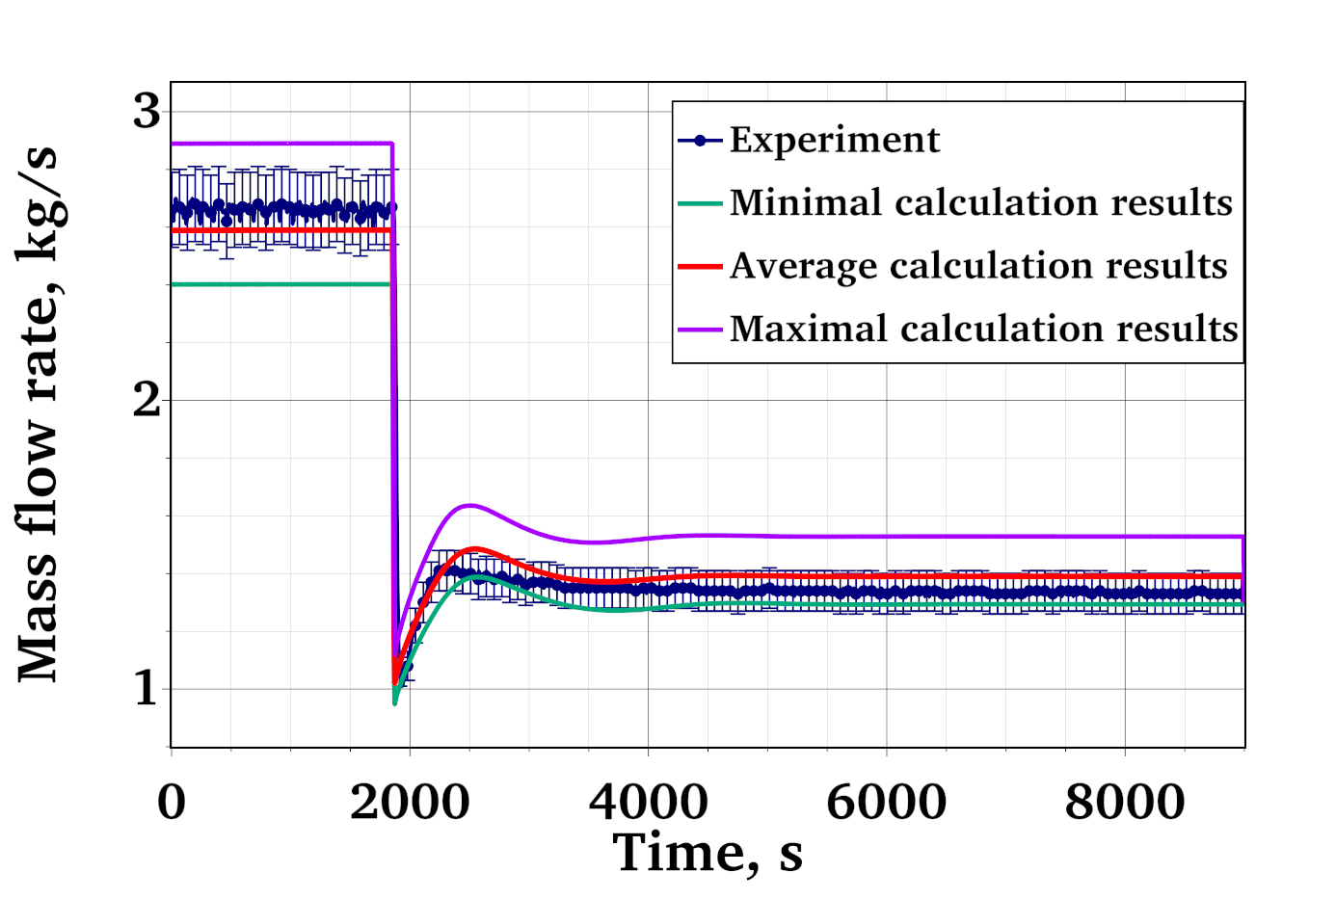
Figure 1 – Mass flow rate calculation results for ADP06

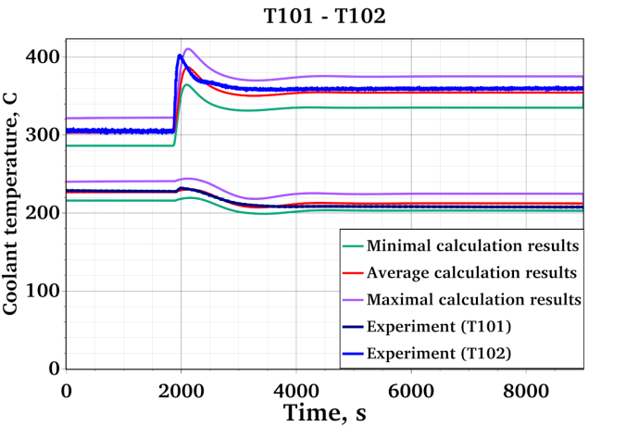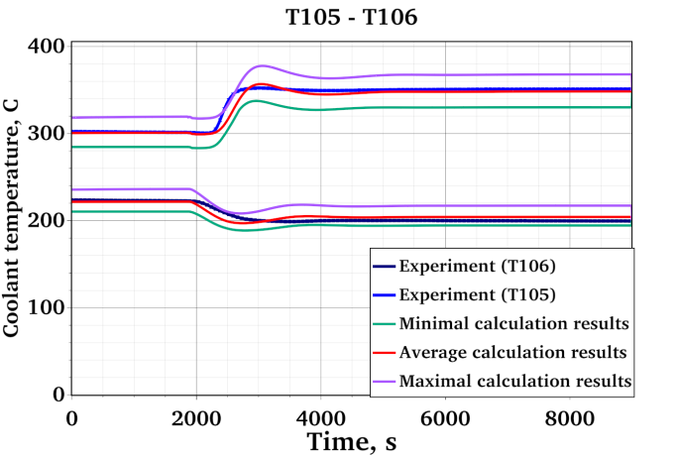

Figure 2 –Temperature calculation results for ADP06

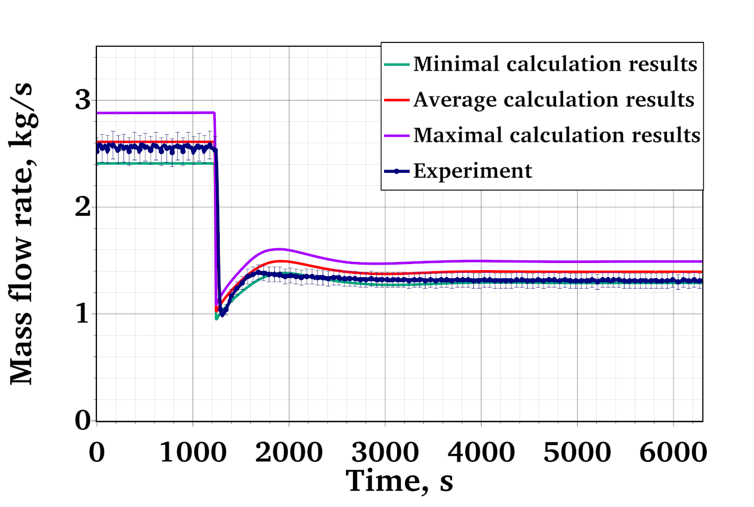
Figure 3 – Mass flow rate calculation results for ADP10

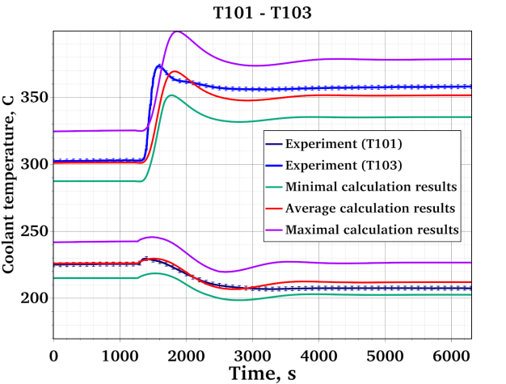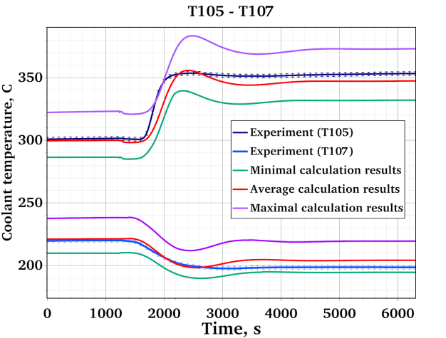
Figure 4 –Temperature calculation results for ADP10
A good agreement between the experimental data and the simulation results in both experimental tests can be seen. In the steady states, the mean calculated temperature follows the experimental line, with minor deviations. The uncertainty range is quite large. This is the results of highly uncertain thermal conductivity of the steel powder in the heat exchanger. As the sensitivity analysis shown below suggests, it has the highest influence on the coolant temperature. As for the mass flow rate, the calculated mean mainly lies within the experimental uncertainty range.
The transition from forced to natural circulation is also simulated well; the uncertainty band quite accurately follows the experimental data, mainly encompassing it. This indicates the high accuracy of the models and the correct consideration of the parameters of the facility under consideration.
A similar uncertainty analysis was conducted for the blind test. The results for mass flow rate and temperature are shown in the Figures 5-6.
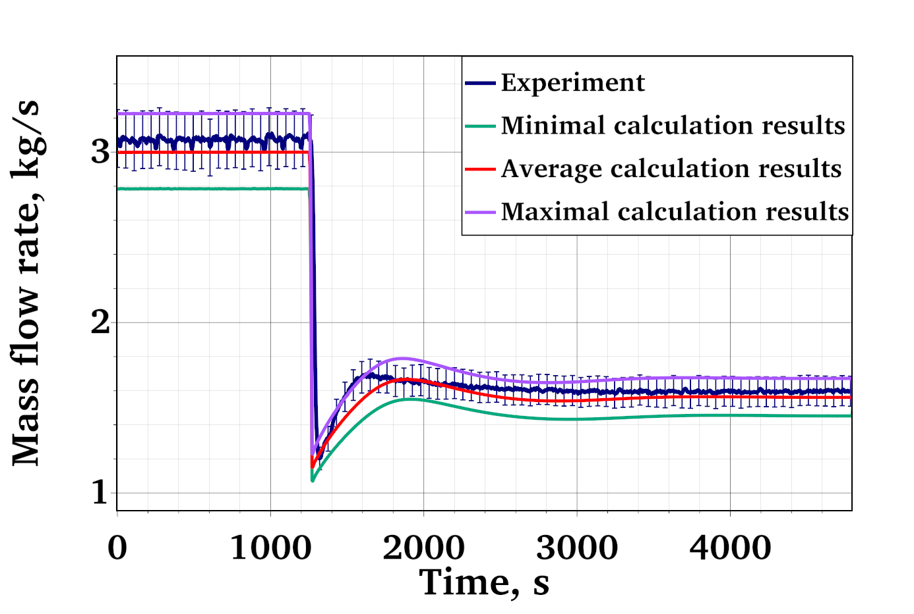
Figure 5 – Mass flow rate calculation results for ADP07

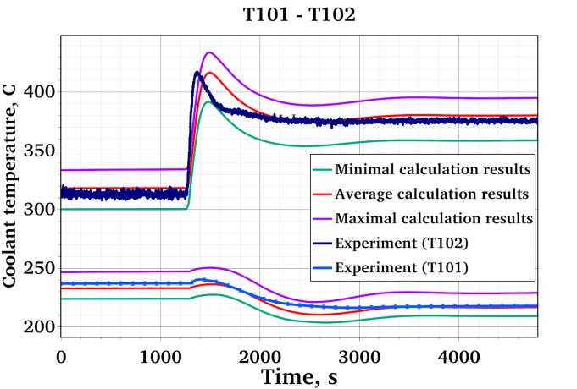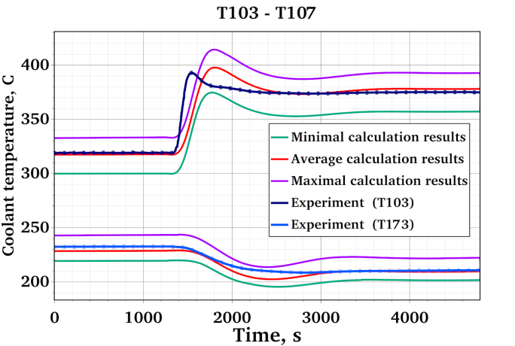
Figure 6 –Temperature calculation results for ADP07
It is notable, that, as one can see, for the blind tests, the calculated results showed even higher accuracy than for the open ones. This demonstrates the high predictive power of the code.
The sensitivity analysis results highlight the parameters that have the most significant impact on the calculation results. The Spearman rank correlation coefficients used as sensitivity measure are shown in the Figures 7 - 9. Positive values mean that the increase of an input parameter yields the increase of the simulation result. Negative values mean that the simulation result decreases with an increase of this input parameter. Values close to zero indicate the parameters with weak influence on the result. The rank correlation coefficients were chosen since in some cases the response was non-linear, but always monotonous.
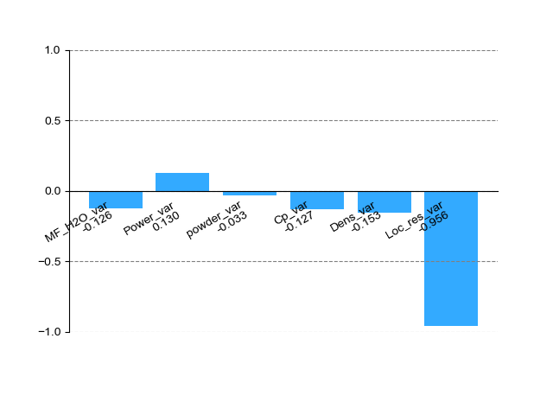
Figure 7 –– Sensitivity coefficients for LBE mass flow rate

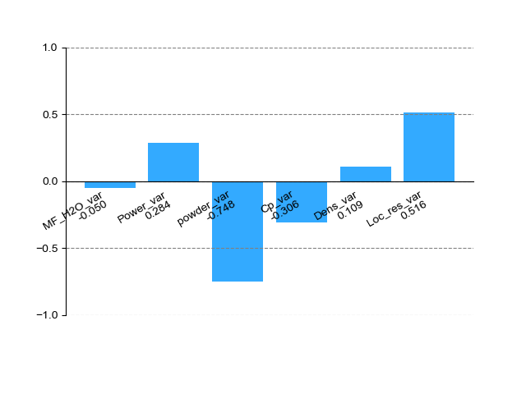
Figure 8 –– Sensitivity coefficients for temperature (T103)

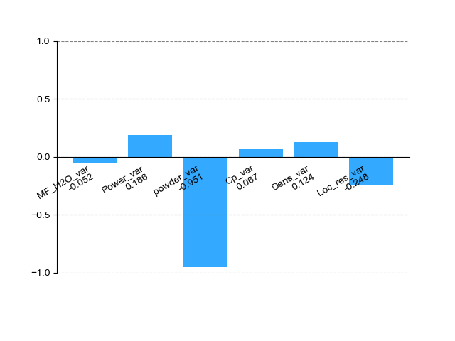
Figure 9 –– Sensitivity coefficients for temperature (T107)
The results confirm the analytical estimates and assumptions: the greatest influence on the results of the mass flow calculation is exerted by the variation of the local resistance coefficients (Loc_res_var), and the temperature values are influenced by the heat removal to the water. This means that special attention should be given to the construction of the heat exchanger and its material properties. Here, the crucial influence of the stainless steel powder thermal conductivity (powder_var) can be seen. Unfortunately, this is the parameter with quite high uncertainty, since it depends very highly on the production technology and is hard to control.
The calculation error was estimated using the methodology described above. The average error E its uncertainty range u_{val} for mass flow rate and for the temperature at several thermocouples locations are presented in the table below.
Parameter |  | E | u_{val}
LBE mass flow rate |  | 2.0 | 9.3
Temperature | T101 | 0.1 | 2.4
 | T102 | -5.0 | 6.7
 | T103 | -5.0 | 7.4
 | T104 | -5.0 | 8.4
 | T105 | -4.0 | 4.2
 | T106 | 0.4 | 3.9
 | T107 | 1.0 | 2.5

For the temperature, the combined values for the code mean error E and error uncertainty u_{tot} from all thermocouples were obtained as well. They amounted to E = -2.5 K; u_{val} =6.3 K.

    - Discussion
The methodology allowed obtaining realistic (non-conservative) estimates of the HYDRA-IBRAE/LM thermal-hydraulic system code error for the LBE and water temperatures as well as for the LBE mass flow rate. It uses the same statistical approach as the one used in metrology [9] for accuracy assessment of the measurements. The “measurements” (simulations) are compared with the “standard gauge” (experiment), and the results of the comparison are statistically processed. As a result, a systematic (bias) and stochastic (uncertainty range) components of the error were obtained.
Combined estimates are presented for all three regimes: forced circulation, transition, and natural circulation, since the systematic error was close for all the regimes. Otherwise, separate estimates would have been necessary.
For all simulations, the bias was quite small. It was negative (underestimation) for LBE temperature and positive (overestimation) for mass flow rate in the open tests. In the blind test, the situation was different: the code overestimated the temperature and underestimated the mass flow rate. However, in all cases the absolute value of the bias was smaller than the error uncertainty range. This shows that the obtained results are “best-estimate” not only in the regulatory (no intended conservative bias), but also in statistical (low-bias) sense.
It can be noted that the error uncertainty of the LBE mass flow rate mainly stems from its experimental uncertainty. In contrast, for the LBE temperature, the error uncertainty is defined by the uncertainty of the input parameters. It therefore can be reduced if better estimates of the input parameters are available, especially since one of the most uncertain parameters – steel powder thermal conductivity – influences the temperature most.

  - UNIPI
The University of Pisa addressed the WP5 activities performing CFD calculations adopting the coarse “Solid-Wire” nodalization introduced in the UniPi CFD section. In this frame, the typical Monte Carlo approaches, which require hundreds of calculations to achieve a suitable sampling, become too much expensive. As a consequence, other strategies have to be adopted. During the last years the Deterministic Sampling approach [10] is being proposed as a valuable method to perform UQ analyses while limiting the total number of calculations needed for the analysis. It indeed considers only a limited number of calculation for the derivation of uncertainties: instead of running hundreds of calculations to make it so the sample is converging towards the same values of the reference conditions (achieving same first and higher order momenta), Deterministic Sampling a priori selects a sample which grants that at least some of the distribution momenta are respected. In the present application, the Standard, Modified Hadamard and Random Sampling methods were considered.
$$Σ_{STD}^{T}=\sqrt{8}\left(\begin{matrix}Sample & {\overset{˙}{m}}_{\text{LBE }} & T_{\text{IN,FPS }} & Q_{\text{eff }} & Q_{\text{pre }} & k & C_{P} & v & ρ \\ STD01 & σ_{1} & 0 & 0 & 0 & 0 & 0 & 0 & 0 \\ STD02 & -σ_{1} & 0 & 0 & 0 & 0 & 0 & 0 & 0 \\ STD03 & 0 & σ_{2} & 0 & 0 & 0 & 0 & 0 & 0 \\ STD04 & 0 & -σ_{2} & 0 & 0 & 0 & 0 & 0 & 0 \\ STD05 & 0 & 0 & σ_{3} & 0 & 0 & 0 & 0 & 0 \\ STD06 & 0 & 0 & -σ_{3} & 0 & 0 & 0 & 0 & 0 \\ STD07 & 0 & 0 & 0 & σ_{4} & 0 & 0 & 0 & 0 \\ STD08 & 0 & 0 & 0 & -σ_{4} & 0 & 0 & 0 & 0 \\ STD09 & 0 & 0 & 0 & 0 & σ_{5} & 0 & 0 & 0 \\ STD10 & 0 & 0 & 0 & 0 & -σ_{5} & 0 & 0 & 0 \\ STD11 & 0 & 0 & 0 & 0 & 0 & σ_{6} & 0 & 0 \\ STD12 & 0 & 0 & 0 & 0 & 0 & -σ_{6} & 0 & 0 \\ STD13 & 0 & 0 & 0 & 0 & 0 & 0 & σ_{7} & 0 \\ STD14 & 0 & 0 & 0 & 0 & 0 & 0 & -σ_{7} & 0 \\ STD15 & 0 & 0 & 0 & 0 & 0 & 0 & 0 & σ_{8} \\ STD16 & 0 & 0 & 0 & 0 & 0 & 0 & 0 & -σ_{8}\end{matrix}\right)$$

As an example, using a local sensitivity approach [11] to investigate a local range around a fixed point in the parameter space and the corresponding change in the outputs when changing each input parameter individually it is possible to derive the diagram reported in Figure 10. This shows that uncertainties on the thermal conductivity, dynamic viscosity and density only play a minor role in the propagation of uncertainties. Larger contributions are instead reported by the mass flow rate, power (Qeff and Qpre), specific heat and inlet temperature. As a consequence, only these latest five parameters were considered for additional calculations involving the modified Hadamard and Random Sampling Approaches.
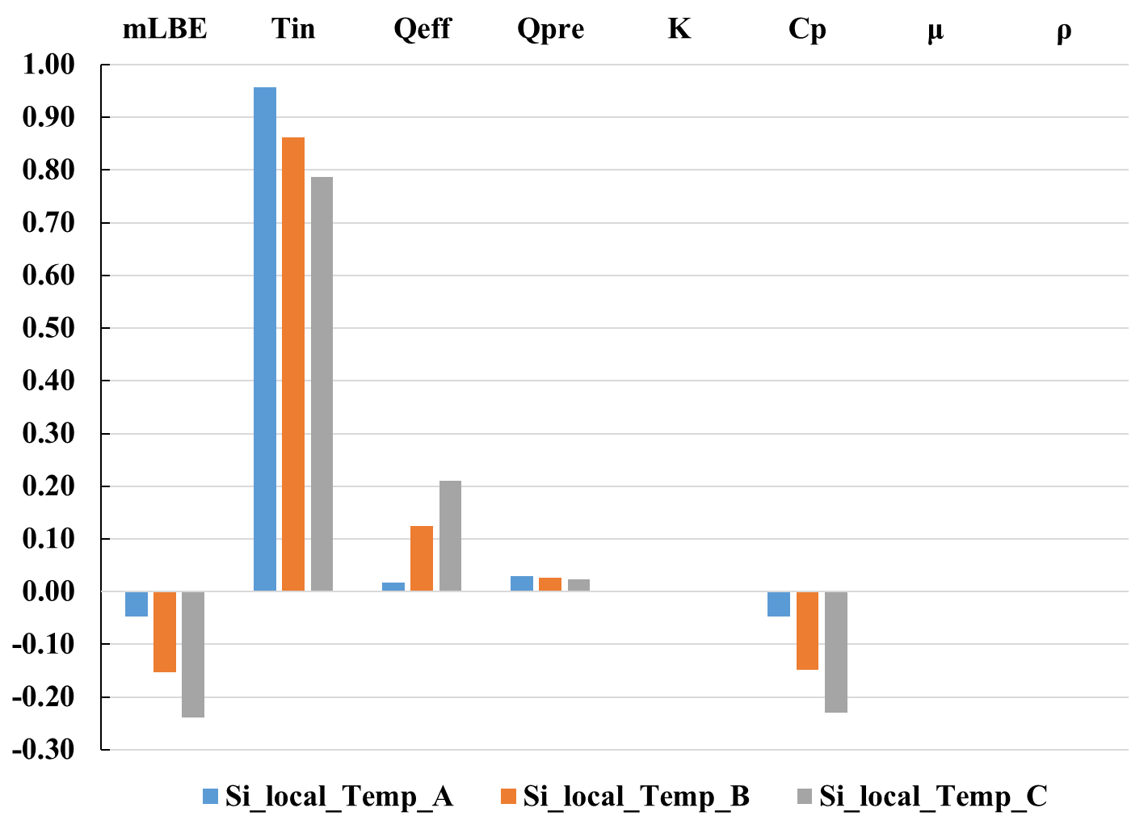
Figure 10 –– Local SA for the input parameters in the ADP10 1SS (STD ensemble) case.
The modified Hadamard approach considers that all the involved parameters are changed in each calculation. It is an advanced approach as it allows observing the mutual impact of different parameters. Again, on average, the selected group (a group which is sampled deterministically) grants that on average, the sample represents the reference conditions; once again all the sigmas are balanced in another run of the sample. Again, see the matrix below, only sixteen calculations are required to perform the uncertainty quantification analysis.
$$Σ_{HAD}^{T}=\left(\begin{matrix} \text{Sample} & {\overset{˙}{m}}_{LBE} & T_{IN,FPS} & Q_{\text{eff }} & Q_{pre} & C_{p} \\ HAD01 & σ_{1} & σ_{2} & σ_{3} & σ_{4} & σ_{5} \\ HAD02 & σ_{1} & -σ_{2} & σ_{3} & -σ_{4} & σ_{5} \\ HAD03 & σ_{1} & σ_{2} & -σ_{3} & -σ_{4} & σ_{5} \\ HAD04 & σ_{1} & -σ_{2} & -σ_{3} & σ_{4} & σ_{5} \\ HAD05 & σ_{1} & σ_{2} & σ_{3} & σ_{4} & -σ_{5} \\ HAD06 & σ_{1} & -σ_{2} & σ_{3} & -σ_{4} & -σ_{5} \\ HAD07 & σ_{1} & σ_{2} & -σ_{3} & -σ_{4} & -σ_{5} \\ HAD08 & σ_{1} & -σ_{2} & -σ_{3} & σ_{4} & -σ_{5} \\ HAD09 & -σ_{1} & -σ_{2} & -σ_{3} & -σ_{4} & -σ_{5} \\ HAD10 & -σ_{1} & σ_{2} & -σ_{3} & σ_{4} & -σ_{5} \\ HAD11 & -σ_{1} & -σ_{2} & σ_{3} & σ_{4} & -σ_{5} \\ HAD12 & -σ_{1} & σ_{2} & σ_{3} & -σ_{4} & -σ_{5} \\ HAD13 & -σ_{1} & -σ_{2} & -σ_{3} & -σ_{4} & σ_{5} \\ HAD14 & -σ_{1} & σ_{2} & -σ_{3} & σ_{4} & σ_{5} \\ HAD15 & -σ_{1} & -σ_{2} & σ_{3} & σ_{4} & σ_{5} \\ HAD16 & -σ_{1} & σ_{2} & σ_{3} & -σ_{4} & σ_{5}\end{matrix}\right)$$
In the Random Sampling Approach (RS), instead, it is assumed that the actual values of each parameter are distributed following the normal distribution around the average value $μ_{i}$. To be coherent with the approach, several values have to be sampled inside a ±2$σ_{i}$ (standard deviation) range straddling the average value. This approach requires way more calculations than the previous ones and it was considered as reference for the present application.
The Figure 11 below reports a comparison between the experimental values (red line) and its corresponding uncertainty range, together with the results from the CFD calculation performed adopting the reference conditions (Black line) and the calculations performed following the Standard approach. For a more detailed description the reader is referred to [12]. Each blue line represents one of the sixteen calculations, the green dashed line represents their average while the blue shaded area represents a range of two standard deviations straddling the average value. As it can be observed, the average value from the UQ analyses is very close to the CFD reference calculation. UQ calculations overpredicting or underpredicting the experimental values do exist and, once the average and standard deviation are calculated, all the measured values are included in a ±2$σ$ range. It can also be observed that the uncertainty range increases while moving towards the outlet of the FPS, this is in accordance with the fact that uncertainties related to the mass flow, supplied heat and specific heat build up along the heated section; they are small at the inlet but way larger at the outlet.
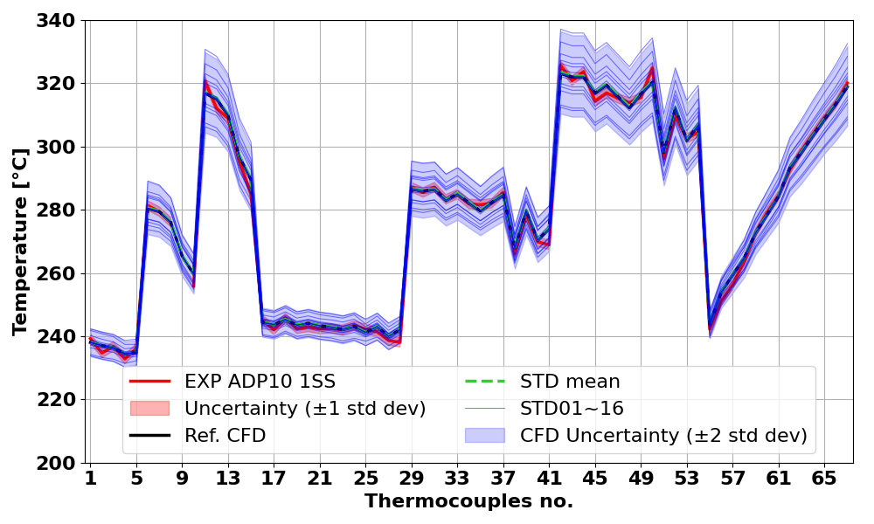
Figure 11 –– Comparison of experimental data measurements and CFD Prediction
in the ADP10 1SS (STD ensemble) case.
Once the other approaches are applied it is possible to compare the results. As it can be observed, in this case the Standard and Hadamard approaches report similar uncertainty ranges while the RS approach returns a smaller uncertainty range, more in line with the experimental one. All the approaches managed to provide similar average values and in general achieve some level of success in suitably propagating the uncertainties.
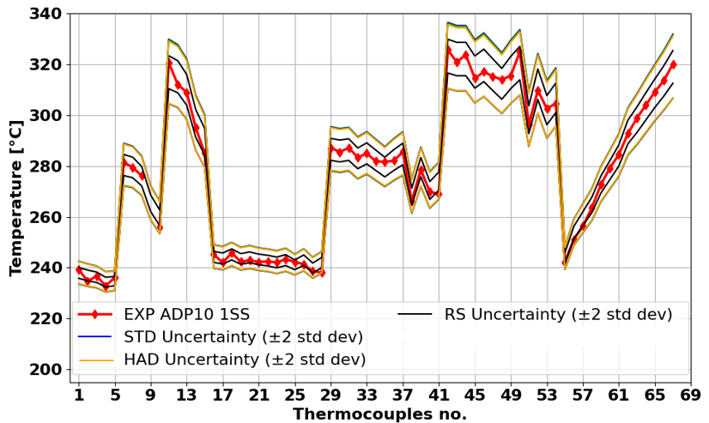
Figure 12 –– Upper and lower bound for the methods adopted in the UQ analysis.
As a final statement on this application, it can be reported that three different UQ methods; namely the DS method, the RS method were applied to the NACIE-UP benchmark ADP10 1SS test case.
For the STD ensemble, the confidence interval was found to overestimate by a factor of 1.7 the standard deviation spread around the experimental data. For the HAD ensemble, the confidence interval overestimated the standard deviation spread by a factor of 1.6. For the RS sample, the confidence interval again overestimated the standard deviation but by a smaller factor (0.7) with the model prediction closely aligned with experimental data. Correlation analysis indicated that inlet temperature had the most significant impact on temperature distribution at Section-A, followed by upstream power release and mass flow rate. Thermophysical properties such as density, viscosity, and thermal conductivity had a negligible influence on temperature distribution within the FPS.
Furthermore, the application of UQ methodologies confirms the robustness of these models in predicting temperature distributions, with inlet temperature, upstream power release, and mass flow rate emerging as the most influential parameters. These findings emphasize the suitability of the Porous-Wire and Solid-Wire approaches for extensive engineering use, particularly in large CFD domains and uncertainty quantification studies.

  - Conclusions
Despite relatively low number of the participants who presented the results of the uncertainty and sensitivity analysis in this paper, it reflects the variety of existing approaches. The reason for this variety is not individual preference, but the specifics of the TH codes used. First of all, it is the computational burden. System codes allow running hundreds of multivariate simulations, making classic statistical approaches applicable. Subchannel codes are also computationally efficient, opening the way to perturbation theory approaches and related explicit physical insights on the sensitivity contribution of the involved parameters. CFD codes, being much more computationally heavy, limit the number of possible simulations to about a dozen, thus reducing the choice of applicable methods.
The difference in the approaches, used TH codes, and studied parameters do not allow any direct comparison of the uncertainty and sensitivity study results. However, some common features can be mentioned. First, the sensitivity study allowed the participants to check the correctness of their TH simulations by comparing its results with theoretical predictions. Second, the results allowed to more reliably quantify the codes errors with respect to different uncertainties and to understand the influence of these uncertainties.
ENEA demonstrated the feasibility of generalized perturbation theory approaches when applied to the subchannel code ANTEO+. GPT allows for direct evaluation of sensitivity coefficients without the need to statistically interpret results, and thus more intuitively retrieving the physical contribution and its origin in the various terms of the conservation equations. Further development will be elaborated to extend the approach to other parameters of interest.
IBRAE RAN successfully applied their methodology to estimate the code error with strong statistical support and account for different types of uncertainties. The comparison of the error estimates for open and blind tests showed the predictive capability of the methodology as well as of the HYDRA-IBRAE/LM code.
With regard to the CFD-based uncertainty quantification activities carried out at UniPi, it should be emphasised that the high computational demand represents a significant obstacle to widespread application. Nevertheless, the use of the DS method in this study proved to be both effective and robust, yielding uncertainty bounds comparable to more computationally intensive approaches while maintaining a reasonable and manageable cost. Although high-resolution three-dimensional simulations require substantial computational resources—thus limiting their use for real-time or full-system analyses—alternative strategies may help alleviate this constraint. In particular, GPU-accelerated solvers and hybrid modelling approaches, such as CFD–system code coupling, could be further explored to enhance efficiency without compromising predictive capability.
References:
- Williams, M. L. (1979). Development of depletion perturbation theory for coupled neutron/nuclide fields. Nuclear Science and Engineering, 70(1), 20-36.
- Parks, C. V., Tomlinson, E. T. and E. M. Oblow (1979). The application of generalized perturbation theory to fast reactor safety sensitivity studies. Technical Report 7908/6-29.
- Glaeser, Horst. ‘GRS Method for Uncertainty and Sensitivity Evaluation of Code Results and Applications’. Science and Technology of Nuclear Installations 2008 (2008): 1–7. https://doi.org/10.1155/2008/798901.
- Oberkampf, William L, and Christopher J Roy. Verification and Validation in Scientific Computing. Cambridge University Press, 2010.
- Standard for Verification and Validation in Computational Fluid Dynamics and Heat Transfer. An American National Standard. ASME V&V 20 – 2009. 2009.
- Ryzhov, N.I., K.S. Dolganov, Yu.A. Zvonarev, et al. ‘Evaluation of Uncertainties Associated with Best Estimates of Parameters in the Deterministic Analysis of a Severe Accident’. Nuclear Engineering and Design 415 (December 2023): 112741. https://doi.org/10.1016/j.nucengdes.2023.112741.
- Moiseenko, E.V., N.A. Mosunova, V.F. Strizhov, and D.S. Synitcyn. ‘Uniform Approach to Validation of Codes in Application for Conservative and Realistic Accidents Modeling’. Progress in Nuclear Energy 193 (March 2026): 106195. https://doi.org/10.1016/j.pnucene.2025.106195.
- Best Estimate Safety Analysis for Nuclear Power Plants: Uncertainty Evaluation. Safety Reports Series 52. Internat. Atomic Energy Agency, 2008.
- ISO/IEC. Uncertainty of Measurement. ISO/IEC Guide 98-3:2008. Pt 3, Guide to the Expression of Uncertainty in Measurement (GUM:1995). International Organization for Standardization, 2008.
- Hessling, J.P., 2013. Deterministic Sampling for Propagating Model Covariance. SIAMASA J. Uncertain. Quantif. 1, 297–318. https://doi.org/10.1137/120899133
- Smith, R., C., 2014. Uncertainty Quantification: Theory, Implementation, and Applications | SIAM Publications Library [WWW Document]. Comput. Sci. Eng. URL https://epubs.siam.org/doi/book/10.1137/1.9781611973228 (accessed 2.16.2026)
- Abedelhalim, O.M.M., 2025. Use of Computational Fluid Dynamics Analysis to Support Safety Assessment of Innovative Nuclear Reactors (PhD Thesis). Università di Pisa

