WP3 – Subchannel Analysis

Introduction
Work Package 3 of the CRP is devoted to the benchmarking of Subchannel (SC) codes. SC codes have been mainly used to simulate the two steady states for each case, before and at the end of the forced-to-natural circulation transition. Some participant also used them to simulate the transition phase either with the coupling of a system code or, for the open cases, directly exploiting experimental data for boundary conditions.
The first (open) phase of the benchmark involved all benchmark participants building, verifying and optimizing models based on the available experimental data for symmetric heating cases – ADP10 and ADP06. The second (blind) phase of the benchmark involved validating their final selected model against the non-uniform asymmetric heating case – ADP07. The final phase of the benchmark involved refining the simulations based on the released data of ADP07.
Quantitative results are reported in the Chapter exploiting the following definitions:
$\left|ε\right|$ is the absolute difference between computed and measured values of a TC;
${\left|ε\right|}_{ave}$ is the average of $\left|ε\right|$ over all TCs;
${\left|σ\right|}_{\left|ε\right|}$ is the standard deviation of $\left|ε\right|$;
${\left|ε\right|}_{max}$ is the maximum value of $\left|ε\right|$.
  - Description of expected and optional output
All participants were expected to produce results to be compared with the 67 TC of the FPS for the pre- and post-transition steady states of the three cases.
Results related to the transition were optional and based on the various codes capabilities. Furthermore, to gain insights for the comparison against experimental data, participants could provide information related to the coolant mass flow rate profile inside the FPS for comparison against a CFD among the one of WP2.
  - Participants
A broad range of SC codes has been employed in the WP, including system thermal-hydraulics codes that incorporate SC-like models for the pin bundle section. A total of 11 organizations have been involved with 10 different codes, using either a SC code or a system code with SC capabilities. The full list of codes by organization is presented in Table 1. The main modelling choices or features of each SC are also summarized, with the following meanings:
Wire model type (correlation) refers to the approach used to axially resolve the wire, which can be either lumped or distributed (i.e., when the wire position is explicitly taken into account at different axial elevations). The correlation indicates the reference used to model energy exchange due to wire sweeping.
Rod conduction exchange refers to the capability to account for energy transfer among SCs through conduction in the solid pin. This effect is considered important in cases of extreme temperature gradients within the bundle.
Clad–coolant exchange refers to the correlation used for the Nusselt’s number for determining the temperature difference between the outer clad surface and the bulk coolant.
As visible in Table 1, most SC codes rely on a lumped wire model and use the correlation developed by Cheng and Todreas [1]. Rod conduction effects are also considered by many participants, although different approaches are adopted.

Table 1: List of SC codes used in WP3. Main models adopted are also reported.
Organization (Country) | SC code | Wire model type (correlation) | Rod conduction exchange | Clad-cool exchange
CNPRI (CH) | ATHAS-LBE | Lumped (C&T [1]) | N/A | N/A
XJTU (CH) | YAOGUANG [2,3] | Lumped (C&T [1]) | Yes | Kazimi [4]
JRC (EC) | COBRA-4I (JRC version) [5] | Lumped | No | Ushakov [6]
ENEA (IT) | ANTEO+ [7] | Lumped (C&T [1]) | Yes | Ma [8]
La Sapienza (IT) | RELAP5-3D© (v4.3.4) [9] | Lumped (C&T [1]) | No | Kazimi [4]
RATEN ICN (RO) | ANTEO+/RELAP5 (SCADAP-SIM) [7,10] | Lumped (C&T [1]) | No | Mikityuk [11]
Gidropress (RU) | MATADOR [12] | Distributed (Geometry change method [13]) | Yes | Ushakov [6]
IBRAE (RU) | EUCLID/V2 (subchannel module CELSIST) | Lumped (Zhukov [14]) | Yes | Zhukov [14]
NIKIET (RU) | PUCHOK GMT [15,16] | Lumped (Zhukov [14]) | Yes | N/A
ANL (USA) | SAS4A/SASSYS-1 [17] | Lumped (C&T [1]) | Yes | Mikityuk [11]
ANL (USA) | SAM/SCM MOOSE [18] | Lumped (C&T [1]) | Yes | Mikityuk [11]
Westinghouse (USA) | SAS4A/SASSYS-1 [17] | Lumped (C&T [1]) | Yes | Calamai [19]

The summary of results’ type submitted by each participant are reported in Table 2. Information with regards to the system-level code used for the blind calculations are also given. More information on the system codes models can be found in Chapter related to WP1 results.
Table 2: Summary of type of results submitted by each organization.
Organization (Country) | SC code | Steady states | Transition (blind phase coupling) | Mass flow rates
CNPRI (CH) | ATHAS-LBE | Yes | Yes (LOCUST) | No
XJTU (CH) | YAOGUANG | Yes | Yes (RELAP5) | No
JRC (EC) | COBRA-4I (JRC version) | Yes | Yes (TRACE) | No
ENEA (IT) | ANTEO+ | Yes | No | Yes
La Sapienza (IT) | RELAP5-3D© (v4.3.4) | Yes | Yes (self-consistent) | Yes
RATEN ICN (RO) | ANTEO+/RELAP5 (SCADAP-SIM) | Yes | No | No
Gidropress (RU) | MATADOR | Yes | Yes (not for blind phase) | Yes
IBRAE (RU) | EUCLID/V2 (subchannel module CELSIST) | Yes | No | No
NIKIET (RU) | PUCHOK GMT | Yes | No | Yes
ANL (USA) | SAS4A/SASSYS-1 | Yes | Yes (self-consistent) | No
ANL (USA) | SAM/SCM MOOSE | Yes | Yes (self-consistent) | No
Westinghouse (USA) | SAS4A/SASSYS-1 | Yes (not for ADP07) | Yes (self-consistent) | No

  - Open phase simulations
Results for the open cases ADP10 and ADP06 where performed using the boundary conditions available in the specifications.
    - ADP10 – All pins heated
      - Steady-states
The comparison of SC codes with experimental data for all the TCs of the FPS, with the exception of the ones related to pin 3, is presented in Figure 1, where the part related to the bulk and clad temperatures is explicitly shown as well as the Section to which they belong. Similarly, results for the axial clad temperature profile of pin 3 are reported in Figure 2. The quantitative errors evaluation, in steady state conditions, is reported in Table 3.
As can be seen, particularly for SS1, SC codes reproduce the FPS behaviour quite consistently, with average errors always below 4 °C and peak errors below 12 °C, showing only little sensitivity to the specific wire model or the associated correlations. For SS2, the situation is similar, although with slightly higher errors, both in terms of the average (below 7 °C) and the maximum (below 20 °C). Considering the temperature increase in the bundle basically doubles, due to the halved mass flow rate, passing from SS1 to SS2, if the error is normalized to the temperature increase the relative error stays almost constant further indication of the consistent predictive capabilities of the codes. Simulations also tend to predict slightly stronger interior-to-near-wall gradients, an effect amplified by the limited number of pins in the NACIE-UP bundle. This may be due to an underestimation of inertia effect of the wire sweeping, energy exchange caused by wire or heat conduction through the rod. The latter could be of lower influence since the gradient prediction error is present almost independently of the fact that the SC code used is exploiting a rod conduction model or not.

- SC and clad outer temperatures at SS1
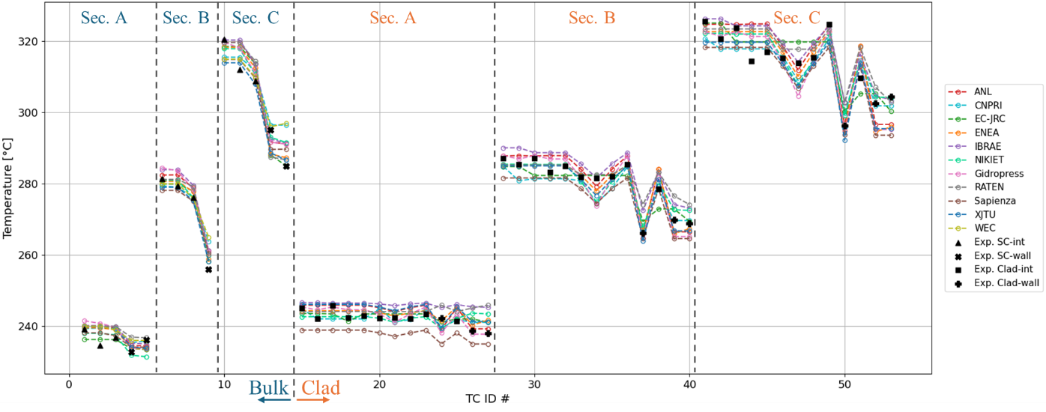
- SC and clad outer temperatures at SS2
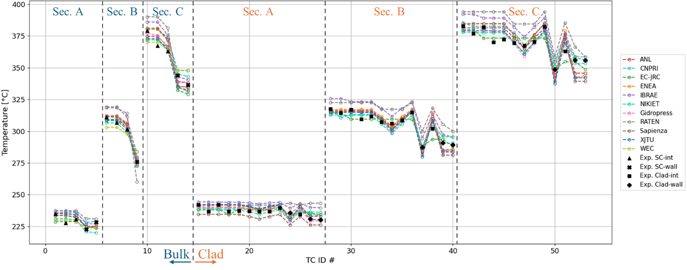
Figure 1: Comparison of SC codes with experimental data of ADP10 for SC and clad TC for SS1 (a) and SS2 (b). Interior, Near-wall and Clad of internal and near wall pins experimental values have different symbols.

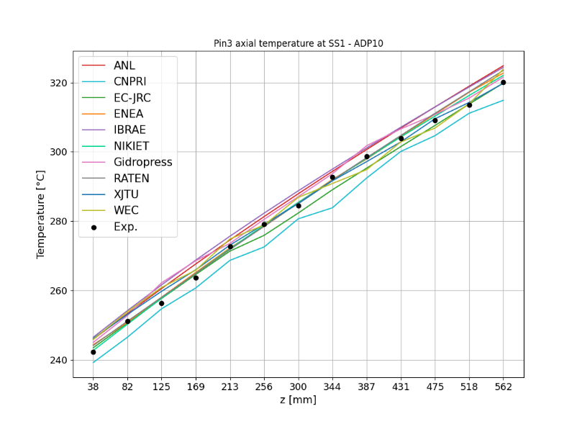  - SS1 | 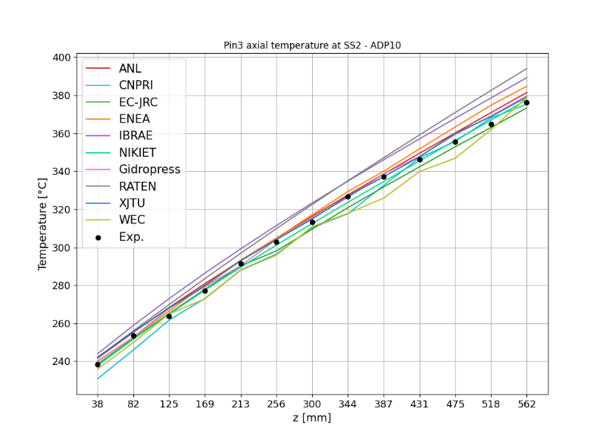  - SS2
Figure 2: Comparison of SC codes with experimental data of ADP10 for Pin3 TC measuring the clad outer temperature. Elevations z taken from the bottom of the active region.

Table 3: Main statistical performance parameters on all TCs for ADP10. All values in [°C].
Organization (Country) | SC code | SS1 |  |  | SS2
 |  | $${\left|ε\right|}_{ave}$$ | $${\left|σ\right|}_{\left|ε\right|}$$ | $${\left|ε\right|}_{max}$$ | $${\left|ε\right|}_{ave}$$ | $${\left|σ\right|}_{\left|ε\right|}$$ | $${\left|ε\right|}_{max}$$
CNPRI (CH) | ATHAS-LBE | 2.9 | 2.3 | 11.5 | 4.0 | 3.4 | 13.0
XJTU (CH) | YAOGUANG | 2.6 | 1.9 | 9.0 | 3.8 | 3.1 | 14.1
JRC (EC) | COBRA-4I (JRC version) | 3.3 | 2.9 | 14.1 | 6.2 | 5.2 | 21.6
ENEA (IT) | ANTEO+ | 2.4 | 2.2 | 9.0 | 4.7 | 3.9 | 16.0
La Sapienza (IT) | RELAP5-3D© (v4.3.4) | 4.0 | 2.2 | 10.9 | 5.4 | 4.2 | 16.9
RATEN ICN (RO) | ANTEO+/RELAP5 (SCADAP-SIM) | 2.7 | 2.0 | 11.2 | 5.4 | 4.2 | 11.2
Gidropress (RU) | MATADOR | 2.8 | 2.2 | 9.3 | 3.3 | 2.9 | 14.0
IBRAE (RU) | EUCLID/V2 (subchannel module CELSIST) | 3.6 | 2.0 | 10.0 | 7.5 | 3.7 | 17.5
NIKIET (RU) | PUCHOK GMT | 2.1 | 1.9 | 7.7 | 3.0 | 2.2 | 8.3
ANL (USA) | SAS4A/SASSYS-1 | 3.1 | 2.2 | 10.5 | 3.6 | 2.6 | 11.2
ANL (USA) | SAM/SCM MOOSE | 3.6 | 2.5 | 10.8 | 5.4 | 4.7 | 18.1
Westinghouse (USA) | SAS4A/SASSYS-1 | 3.1 | 2.6 | 12.0 | 4.3 | 2.9 | 11.5

The behavior of the clad temperatures largely mirrors that of the SC described earlier, although it shows slightly greater variability. This may be attributed to the stronger influence of local effects on the measured quantity, such as the position of the wire. Higher errors are observed for pins located near the walls, indicating that the applied correlations may not fully account for the disturbances in heat transfer caused by the wire and the wrapper. In fact, none of the correlations listed in Table 1 demonstrate clearly superior or consistently reliable accuracy or better, any possible superiority is within the variability in predicting coolant bulk temperatures.
The axial profile of pin 3 (Figure 2) is generally well reproduced by the codes, with errors on temperature remaining below 6 °C before the transient and under 15 °C afterward. The most notable deviation occurs near the top of the pin, where many SC codes tend to overestimate the temperature; this overprediction is relatively more pronounced at SS2. Such discrepancies may again be linked to heat conduction along the pin due to steeper temperature gradients in the upper region and/or to the swirling flow induced by the wire, which transports cooler fluid from the near-wall subchannels.

      - Transition
As per Table 2, some participants also modeled the transition. A comparison with experimental data for the forced-to-natural circulation phase is presented in Figure 3, considering both a central subchannel bulk temperature and the cladding temperature of a near-wall pin at plane A and C. As already discussed for WP1 results, an inconsistency is observed in the timing of the peak temperature when using either system-code-predicted LBE mass flow rates or measured values. Despite this issue, the overall trend is reasonably well reproduced. In particular, the peak temperature during the transition – arguably the most critical parameter from a safety standpoint – is predicted within a ±10 °C range for the central SC and with slightly larger deviations observed for the cladding temperature of pins located near the wall.

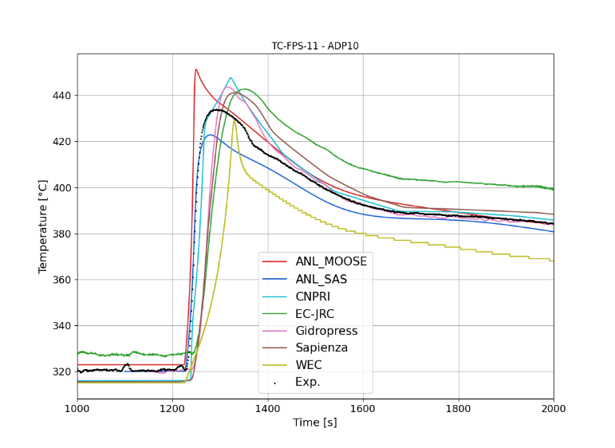 | 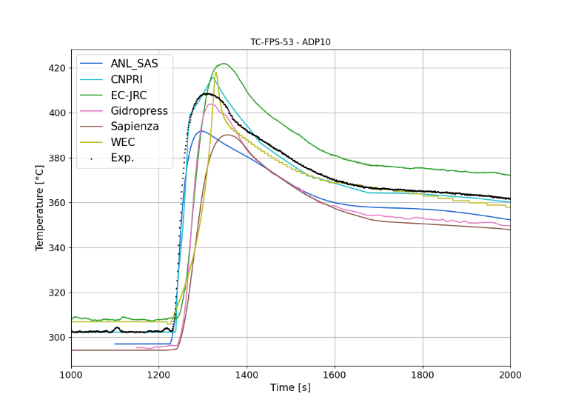
 | 
Figure 3: Force-to-natural transition simulation-to-data comparison for an internal SC (left) and for the clad of a near-wall pin (right) at plane A (top) and C (bottom) for ADP10.
    - ADP06 – Only 7 central pins heated
The comparison with experimental data of the FPS with the temperatures simulated by the SC codes is presented in Figure 4, with the exception of the ones related to pin 3 which are instead reported in Figure 5. The quantitative errors evaluation, in steady state conditions, is reported in Table 4.

- Bulk and clad outer temperatures at SS1
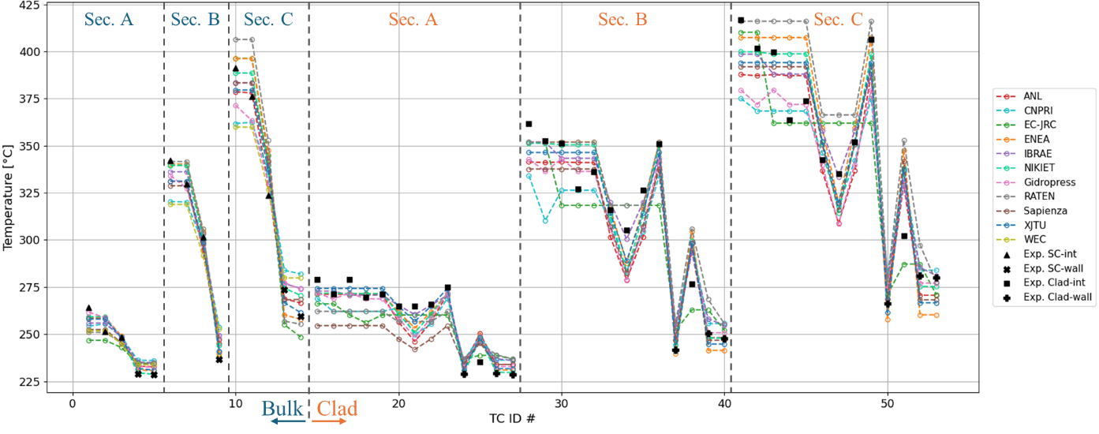
- Bulk and clad outer temperatures at SS2
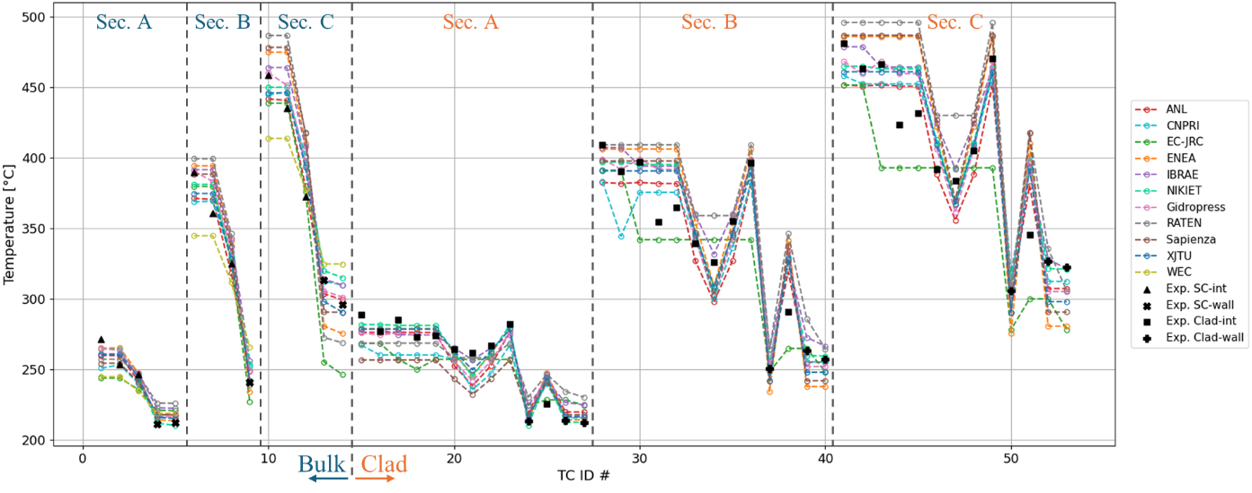
Figure 4: Comparison of SC codes with experimental data of ADP06 for SC and clad TC for SS1 (a) and SS2 (b). Interior, Near-wall and Clad of internal and near wall pins experimental values have different symbols.

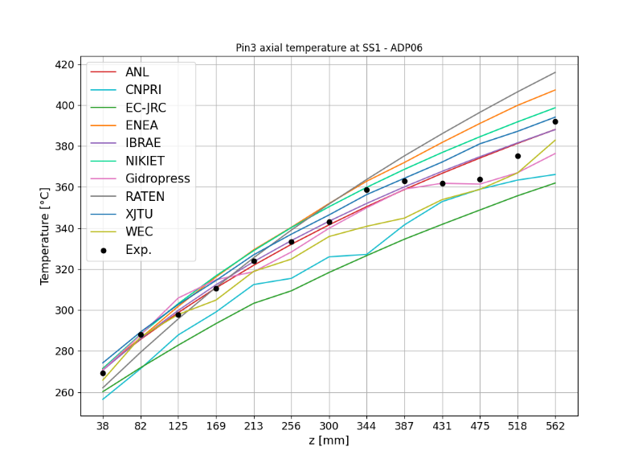  (a) SS1 | 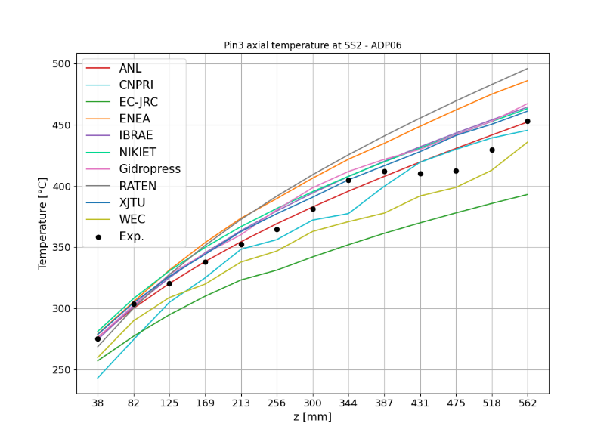  (b) SS2
Figure 5: Comparison of SC codes with experimental data of ADP06 for Pin3 TC measuring the clad outer temperature. Elevations z taken from the bottom of the active region.

Table 4: Main statistical performance parameters on all TCs for ADP06. All values in [°C].
Organization (Country) | SC code | SS1 |  |  | SS2
 |  | $${\left|ε\right|}_{ave}$$ | $${\left|σ\right|}_{\left|ε\right|}$$ | $${\left|ε\right|}_{max}$$ | $${\left|ε\right|}_{ave}$$ | $${\left|σ\right|}_{\left|ε\right|}$$ | $${\left|ε\right|}_{max}$$
CNPRI (CH) | ATHAS-LBE | 14.3 | 9.9 | 42.2 | 15.1 | 10.8 | 55.6
XJTU (CH) | YAOGUANG | 7.7 | 7.3 | 35.1 | 11.9 | 10.4 | 47.8
JRC (EC) | COBRA-4I (JRC version) | 10.1 | 8.7 | 46.0 | 16.5 | 14.8 | 67.8
ENEA (IT) | ANTEO+ | 9.9 | 10.1 | 45.5 | 20.1 | 16.8 | 64.9
La Sapienza (IT) | RELAP5-3D© (v4.3.4) | 12.5 | 8.3 | 39.8 | 20.7 | 16.2 | 72.5
RATEN ICN (RO) | ANTEO+/RELAP5 (SCADAP-SIM) | 9.0 | 8.4 | 38.2 | 21.5 | 16.4 | 62.2
Gidropress (RU) | MATADOR | 9.2 | 8.4 | 37.2 | 11.8 | 11.0 | 51.8
IBRAE (RU) | EUCLID/V2 (subchannel module CELSIST) | 7.1 | 5.8 | 26.7 | 17.4 | 14.3 | 52.9
NIKIET (RU) | PUCHOK GMT | 7.9 | 8.3 | 36.1 | 11.6 | 10.6 | 46.7
ANL (USA) | SAS4A/SASSYS-1 | 8.6 | 7.4 | 30.9 | 11.6 | 9.4 | 40.2
ANL (USA) | MOOSE | 7.3 | 5.1 | 19.9 | 14.1 | 10.5 | 32.9
Westinghouse (USA) | SAS4A/SASSYS-1 | 14.3 | 9.9 | 42.2 | 15.1 | 10.8 | 55.6

For bulk temperatures, the error pattern identified in ADP10 is also evident – namely, a steeper gradient between inner and near-wall subchannels – but with both greater absolute and relative deviations. Errors on temperatures can reach up to 46 °C and over 70 °C for SS1 and SS2 respectively. The best performing SCs are able to keep average errors below 10 °C and maximum ones below 40 °C. The underlying causes are thought to be the same as those discussed for ADP10, though amplified here due to the larger temperature gap between inner and near-wall SCs, which can be as high as 150 °C in SS2 at Section C. The variability among participants also increases significantly, underscoring the impact of different modeling approaches under such pronounced thermal gradients.
As in ADP10, the comparison with experimental data for clad temperatures reflects trends similar to those observed for SC temperatures, with larger discrepancies occurring near non-powered pins (see “Clad-wall” in Figure 4). Relative errors in temperature rise can reach up to 65% in both SS1 and SS2, corresponding to absolute differences of roughly 46 °C and 73 °C, respectively.
Regarding the axial evolution of the clad temperature for pin 3, agreement with experimental data is reasonable in the lower part of the active region. However, consistent with ADP10 observations, SC codes struggle to accurately reproduce the “”plateau” behavior in the upper region. The same physical explanations proposed for ADP10 likely apply here as well, though intensified by the even larger temperature differences between inner and near-wall regions of the bundle. Nevertheless, errors on temperature remain well below 20 °C and 35°C for almost all SC codes. A more detailed interpretation of pin 3 behavior suggests that the colder fluid transported by the wire requires nearly two full wire rotations to reach the second row of pins, where pin 3 is located. This effect is only captured by MATADAOR (Gidropress) in SS1, owing to its “distributed” wire modeling approach. In contrast, none of the SC codes reproduce this feature consistently across SS1 and SS2, indicating that fluid inertia associated with the wire-induced flow may play a role – an effect partially supported by CFD analyses of WP2. Such phenomena lie beyond the capabilities of standard SC codes, as they rely on the fundamental assumption that the fluid loses directional memory when moving between adjacent subchannels [20].
      - Transition
A comparison with experimental data for the forced-to-natural circulation phase is presented in Figure 6, considering the same SCs as section 7.1.1.1 for consistency. In general, in the NACIE-UP loop, the power distribution of the FPS does significantly changes the overall behavior in the transient as already discussed for WP1 results. Trends thus follow what outlined for the steady-states but with spread during the transition generally increasing; some error compensation is also present like for the COBRA-4I (JRC version) which, for the internal SC, well captures the peak temperature but overestimates the starting temperature in forced circulation. Notwithstanding, the maximum temperature during the transition is predicted within a ±30 °C envelope for the central SC and even higher for the near-wall pin clad temperature; for the latter, situated in an un-heated region of the FPS, a clear underestimation is visible by almost participants.

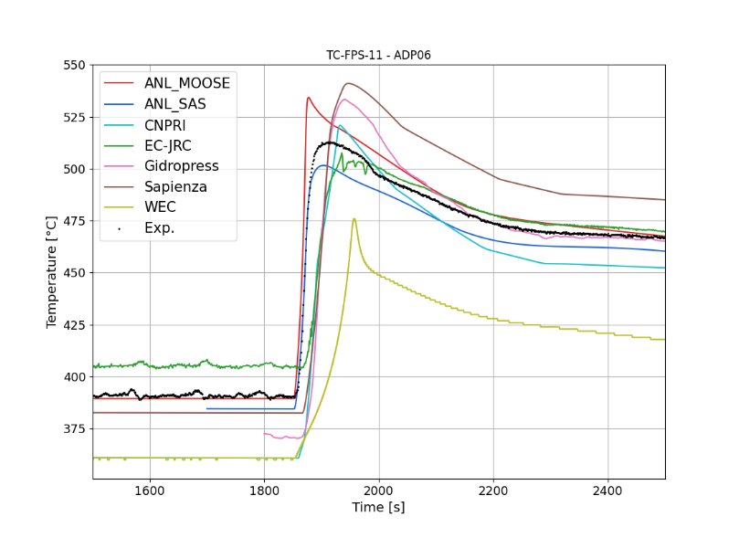 | 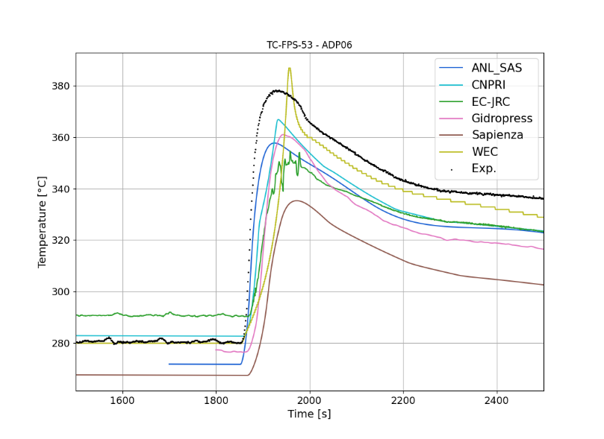
 | 
Figure 6: Force-to-natural transition simulation-to-data comparison for an internal SC (left) and for the clad of a near-wall pin (right) at plane A (top) and C (bottom) for ADP06.
  - Blind phase simulations
For ADP07, steady-states simulations where performed blind based on the lessons learned from ADP10 and ADP06 and with the boundary conditions for the FPS given by the specifications. A graphical comparison of codes versus experimental data is visible in Figure 7 for all TCs, expect the ones for Pin 3 which are shown in Figure 8. The comparison is quantitatively summarized in Table 6. As anticipated, the agreement deteriorates compared to ADP06, since the pronounced temperature gradient is now coupled with a marked asymmetry. This combination further amplifies errors, particularly those associated with conductive heat transfer through the pin internals and its contribution to energy mixing. Average discrepancies are on the order of 15 °C for SS1 and, for some participant, exceed 20 °C for SS2, peak errors vary widely among participants, ranging from around 50 °C to well in excess of 100 °C. These maximum deviations are generally observed in near-wall SCs located close to the interface between heated and unheated regions.
For pin 3, MATADOR partly succeeds in reproducing the main features of the observed variability, including the effect of colder fluid sweeping from the much colder region of the bundle. A similar capability is shown by COBRA-4I (JRC version), which captures this behavior particularly well under SS1 conditions. However, for COBRA-4I, this agreement appears to rely partly on compensating errors, as the same capability is not retained in SS2.
- Bulk and clad outer temperatures at SS1
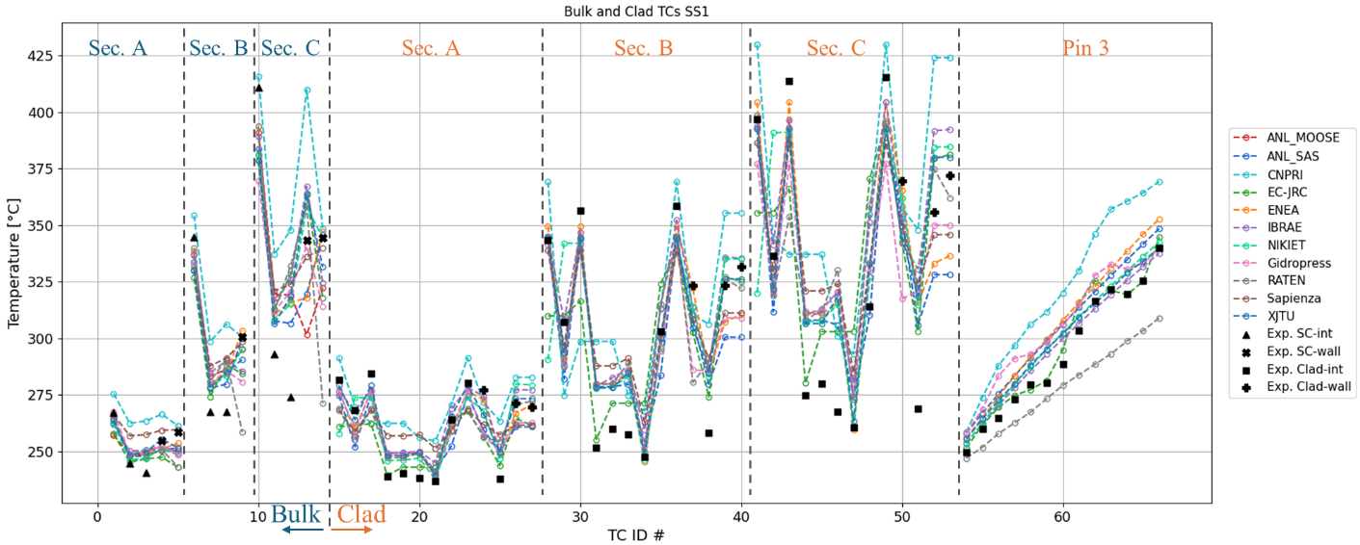
- Bulk and clad outer temperatures at SS2

Figure 7: Comparison of SC codes with experimental data of ADP07 for SC and clad TC for SS1 (a) and SS2 (b). Interior, Near-wall and Clad of internal and near wall pins experimental values have different symbols.

  (a) SS1 |   (b) SS2
Figure 8: Comparison of SC codes with experimental data of ADP07 for Pin3 TC measuring the clad outer temperature. Elevations z taken from the bottom of the active region.

Table 5: Main statistical performance parameters on all TCs for ADP07. All values in [°C].
Organization (Country) | SC code | SS1 |  |  | SS2
 |  | $${\left|ε\right|}_{ave}$$ | $${\left|σ\right|}_{\left|ε\right|}$$ | $${\left|ε\right|}_{max}$$ | $${\left|ε\right|}_{ave}$$ | $${\left|σ\right|}_{\left|ε\right|}$$ | $${\left|ε\right|}_{max}$$
CNPRI (CH) | ATHAS-LBE | 27.7 | 19.4 | 79.1 | 48.2 | 29.3 | 132.5
XJTU (CH) | YAOGUANG | 12.6 | 11.5 | 50.8 | 17.8 | 15.8 | 71.7
JRC (EC) | COBRA-4I (JRC version) | 15.4 | 13.8 | 56.3 | 20.8 | 21.3 | 86.7
ENEA (IT) | ANTEO+ | 13.2 | 11.0 | 48.2 | 19.1 | 16.9 | 72.8
La Sapienza (IT) | RELAP5-3D© (v4.3.4) | 19.1 | 13.3 | 56.5 | 28.1 | 25.2 | 98.7
RATEN ICN (RO) | ANTEO+/RELAP5 (SCADAP-SIM) | 19.2 | 16.5 | 73.0 | 29.1 | 25.7 | 117.6
Gidropress (RU) | MATADOR | 17.1 | 13.0 | 53.2 | 22.9 | 19.4 | 82.3
IBRAE (RU) | EUCLID/V2 (subchannel module CELSIST) | 13.7 | 12.5 | 52.8 | 24.7 | 22.9 | 94.4
NIKIET (RU) | PUCHOK GMT | 15.3 | 15.0 | 76.7 | 22.5 | 21.2 | 94.5
ANL (USA) | SAS4A/SASSYS-1 | 15.0 | 9.8 | 43.8 | 19.3 | 12.5 | 51.2
ANL (USA) | MOOSE | 17.0 | 12.8 | 45.3 | 25.5 | 19.9 | 68.3

      - Transition
A comparison with experimental data for the forced-to-natural circulation phase is presented in Figure 9, considering the same SCs as section 7.1.1.1 for consistency. As previously highlighted, the power distribution of the FPS does significantly changes the overall behavior in the transient as confirmed by ADP07 as well. Trends thus follow what outlined for the steady-states but with even higher spread during the transition. Notwithstanding error compensation during the transitions, the maximum temperature during the transition is predicted within a ±90 °C envelope for the central SC and even higher for the near-wall pin clad temperature. For some participant spread is considerably lower (within 50 °C) albeit still important.

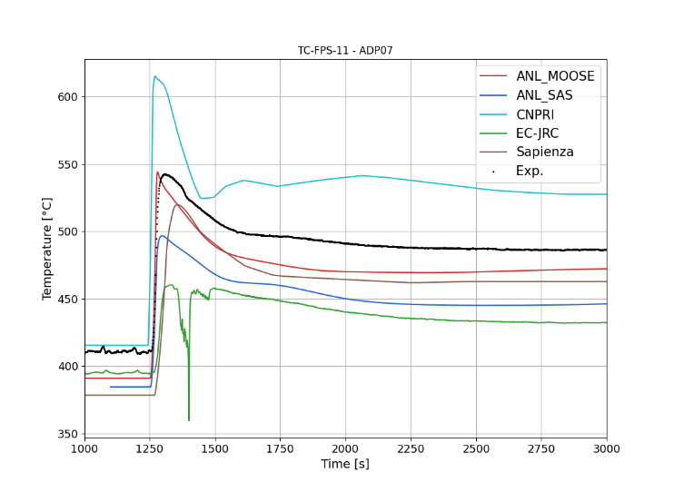 | 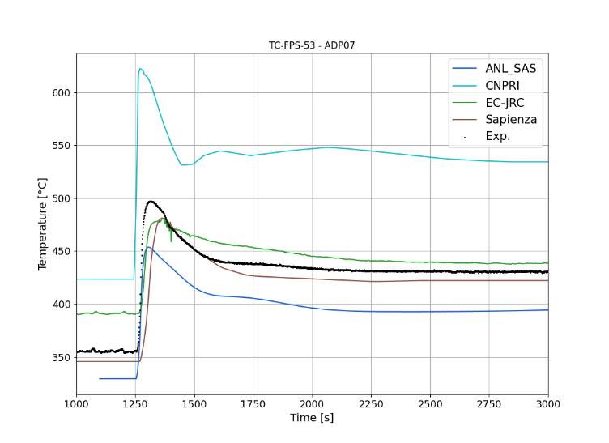
 | 
Figure 9: Force-to-natural transition simulation-to-data comparison for an internal SC (left) and for the clad of a near-wall pin (right) at plane A (top) and C (bottom) for ADP06.
      - Mass flow comparison
To study more in detail the motivations behind the large discrepancies encountered, some participant produced mass flow rates distribution among SCs which was then compared with a reference CFD simulation. Such comparison featuring the mass flux (i.e., the mass flow rate divided by the SC flow area) is shown in Figure 10 where the CFD results have been averaged at SC scale to facilitate the comparison. Figure 10 clearly indicates that some SC codes are generally able to reproduce the overall flow behavior, even under complex power distributions such as ADP07. Nevertheless, the combined effects of fluid inertia and strong local perturbations induced by the wire – especially under steep temperature gradients – can still result in significant inaccuracies in local predictions. In general, when very strong gradients at scales lower than the SC one persist like for ADP06 and even more for ADP07, SC codes can struggle to capture local measurements for which SC-averaged quantities are not representative anymore.

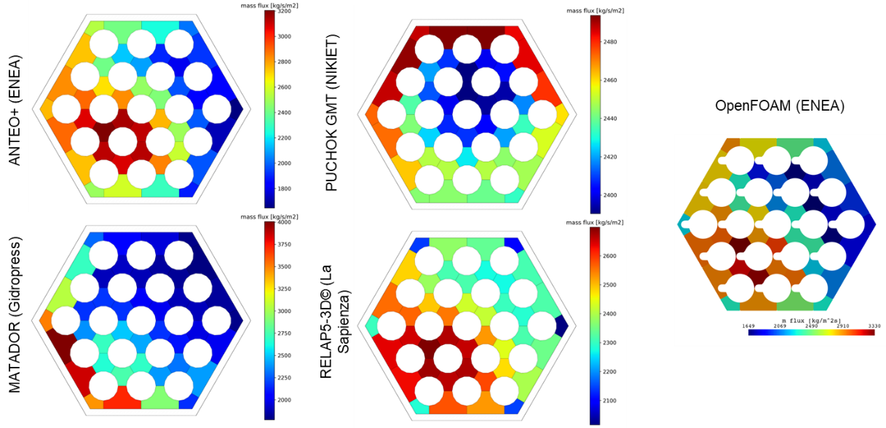
Figure 10: Comparison of SC codes axial mass fluxes with a reference CFD calculation for ADP07-SS2 at plane C.

Conclusions
11 organizations with 12 different SC codes produced results for assessing strong and weal points of SC application for pin bundle cooled by heavy liquid metals. For case ADP10 – considered the most representative of standard operating conditions and the one of interest for design – the comparison with experimental data highlights the strong predictive performance of SC codes. Both the errors and their standard deviation remain within the expected computational and experimental uncertainty and are consistent with results from CFD analyses. The tested correlations all provide satisfactory predictions, although further refinement -particularly of Nusselt number correlations and energy exchange for near-wall pins - could enhance accuracy especially in small bundles.

In contrast, cases ADP06 and ADP07, which are characterized by significant temperature gradients, exhibit consistently larger deviations, with peak errors well beyond experimental uncertainty bounds. These results, albeit not directly applicable to standard design conditions due to artificially high gradients in the bundle and inside the SCs, clearly emphasize the current limitations of SC approaches in capturing the combined effects of pin internal structure and, more critically, the wire-induced crossflow and associated fluid inertia – phenomena that become especially relevant in a 19-pin bundle. While the implementation of axially distributed wire models may improve the representation of these effects, further developments are required to ensure reliable predictive capability across high-gradient conditions and for bundles of varying geometries.
Finally, the transient analyses indicate that SC codes can achieve a level of accuracy comparable to steady-state conditions when simulating transition scenarios. This outcome broadens the potential applicability of SC methodologies to a wider range of operational regimes if coupled (or directly embedded) with system level codes.

References
- S.K. Cheng and N.E. Todreas, “Hydrodynamic modes and correlations for bare and wire-wrapped hexagonal rod bundles – bundle friction factors, subchannel friction factors and mixing parameters”, Nuclear Engineering and Design, 92, pp. 227-251 (1986).
- Zhang Rong, et al. "Subchannel thermal–hydraulic analysis of a wire-wrapped 19-pin rod bundle in the NACIE-UP facility." Annals of Nuclear Energy 196 (2024).
- Liang Yu, et al. "A subchannel analysis code SACOS-Na for sodium-cooled fast reactor." Progress in Nuclear Energy 166. (2023).
- M. Kazami and M. Carelli, “Heat transfer correlation for analysis of CRBRP Assemblies”, Westinghouse Report CRBRP-ARD-0034, (1976).
- C. L. Wheeler, et al., "COBRA-IV-I: an interim version of COBRA for thermal-hydraulic analysis of rod bundle nuclear fuel elements and cores", Tech. Rep. BNWL-1962 (1976).
- P.A. Ushakov, A.V. Zhukov and N.M. Matyukhin, “Heat transfer to liquid metals in regular arrays of fuel elements”, Teplofiz. Vys. Temp., 15, no. 5, pp. 1027-1033 (1977).
- F. Lodi and G. Grasso, “Extension of the sub-channel code ANTEO+ to the mixed convection regime”, Nuclear Engineering and Design, 322, pp. 368-378 (2017).
- Z. Ma, et al., “An innovative method for prediction of liquid metal heat transfer rate for rod bundles based on annuli”, Annals of Nuclear Energy, 47, pp. 91-97 (2012).
- The RELAP5-3D© Code Development Team, 2015. RELAP5-3D Code Manual Vol. I: Code Structure, System Models, and Solution Methods. INL/MIS-15-36723 Volume I, Revision 4.3, Idaho Falls, Idaho, USA.
- M.P. Ferragut, et al., “The Development of RELAP5/SCDAPSIM/MOD4.0 for Advanced Fluid Systems Design and Analysis” 23rd International Conference on Nuclear Engineering (ICONE 23), Makuhari Messe, Chiba, Japan, May 17th - 21st (2015).
- K. Mikityuk, “Heat transfer to liquid metal: Review of data and correlations for tube bundles”, Nuclear Engineering and Design, 239, pp. 680-687 (2009).
- A.S. Zalesov and A.N. Churkin, “MATADOR Code for Calculating Local Inhomogeneous Heat and Mass Transfer Processes in Rod Bundles”, Problems of Atomic Science and Engineering. Series: Physics of Nuclear Reactors, 3, pp. 29-40 (2023). (In Russian)
- S. Pramuditya and M. Takahashi, “Thermal–hydraulic analysis of wire-wrapped SFR test subassemblies by subchannel analysis method”, Annals of Nuclear Energy, 54, pp. 109–119 (2013).
- A.V. Zhukov, et al., “Methodical Instructions and Recommendations for Thermal-Hydraulic Calculation of Active Zones of Fast Reactors”, RTM (Technical Guide) 1604.008-88, Obninsk: Fiz.-Energ. Inst., (1988).
- S.Yu. Afonin, et al., “Validation of the Subchannel Puchok-LM Code Applied to the MBIR Fast Neutron Reactor”, Nuclear Physics and Engineering, vol. 5, № 7-8, pp. 564-577 (2014).
- S.Yu. et al., “Combined Methodology of Thermal-hydraulic Calculation of Fuel Assemblies of Reactors with Liquid Metal Coolant and its Justification”, Problems of Atomic Science and Engineering. Series: Ensuring the Safety of NPP, № 36, pp. 78-85 (2016).
- D. J. O'Grady et al., The SAS4A/SASSYS-1 Version 5.7 Safety Analysis Code System, Argonne National Laboratory, Lemont, IL, ANL/NSE-SAS/5.7, June 2023.
- V. Kyriakopulos, et al., “Development of a single-phase, transient, subchannel code, within the moose multi-physics computational framework,” Energies, 15(11):3948 (2022).
- G. Calamai, R. Coffield, L. Jossens, et al. Steady State Thermal and Hydraulic Characteristics of the FFTF Fuel Assemblies. Technical Report ARD-FRT-1582, Westinghouse Electric Corporation, 1974.
- N.E. Todreas and M.S. Kazimi, Nuclear Systems II: Elements of Thermal Hydraulic Design, Chapter 6, Taylor and Francis, USA (2003).

