IAEA-TECDOC-XXXX
TITLE IS HERE
subtitle

Foreword
Body text placeholder.

CONTENTS
Foreword 2
CONTENTS 3
1 Introduction 10
1.1 Background of the CRP 10
1.2 Objectives of the CRP 10
1.3 Scope of the CRP 10
1.4 Structure of the Document 10
2 CRP Phases and implementation 12
3 Description of the NACIE-UP facility 14
3.1 Basic Description of NACIE-UP facility 14
3.2 Fuel bundle simulator 16
3.3 Heat Exchanger 17
3.4 Gas injection system 20
3.5 Expansion vessel 21
3.6 instrumentation 22
3.6.1 Loop instrumentation 22
3.6.2 FPS instrumentation 22
3.7 Thermal Flow Meter 25
3.8 Loop insulation 26
3.9 Data acquisition and control system 26
4 Description of the experimental tests 29
4.1 LBE and Material properties 29
4.1.1 Thermo-physical properties of LBE 29
4.1.2 Thermo-physical properties of stainless steel 29
4.1.3 Thermo-physical properties of pin materials 30
4.2 Boundary conditions 31
4.3 ADP10: All pins on 31
4.4 ADP06: 7 central pins on 33
4.5 ADP07: pins on in Two sectors 35
5 WP1: System thermal hydraulics 38
5.1 Introduction 38
5.2 Participants 38
5.3 Open Phase Simulations (ADP10 and ADP06) 39
5.3.1 ADP10 39
5.3.2 ADP06 41
5.4 Blind Phase Simulations (ADP07) 43
5.5 DISCUSSION OF THE FORCED-TO-NATURAL CIRCULATION TRANSITION 45
5.6 CONCLUSIONS 46
6 WP2: Computational Fluid Dynamics (CFD) 48
6.1 Introduction 48
6.2 Participants 49
6.3 Open Phase Simulations (ADP10 and ADP06) 51
6.3.1 ADP10 51
6.3.2 ADP06 52
6.3.3 Temperature deviation 53
6.4 Blind Phase Simulations (ADP07) 56
6.4.1 Temperature deviation 57
6.5 Normalization of temperature deviations 59
6.5.1 Total rise of temperature 59
6.5.2 Local rise of temperature 59
6.5.3 Friction temperature 59
6.5.4 Wall-bulk ‘film’ temperature difference 59
6.6 Conclusions 60
7 WP3: Subchannel Analysis 61
7.1 Introduction 61
7.2 Description of expected and optional output 61
7.3 Participants 61
7.4 Open phase simulations 63
7.4.1 ADP10 – All pins heated 63
7.4.2 ADP06 – Only 7 central pins heated 66
7.5 Blind phase simulations 70
7.6 Conclusions 73
8 WP4: Multiphysics 74
8.1 Introduction 74
8.2 Coupled STH/CFD applications 74
8.2.1 Description of the expected and optional outputs 74
8.2.2 Participants, adopted codes and coupling strategies 75
9 WP5: Sensitivity and uncertainty analysis 80
9.1 Introduction 80
9.2 ENEA 80
9.2.1 Methodological background 80
9.2.2 Results 82
9.3 Gidropress 84
9.4 IBRAE RAN 85
9.4.1 Methodology overview 85
9.4.2 Choice of input parameters for uncertainty assessment 87
9.4.3 Simulations results with uncertainty and sensitivity assessment 87
9.4.4 Discussion 91
9.5 UNIPI 91
9.6 Conclusions 94
10 Conclusions 96
11 List of Abbreviations 97
12 ANNEX I. TECHNICAL SPECIFICATION 98
13 ANNEX II. DESCRIPTION OF ORGANIZATIONS 99
13.1 Argonne National Laboratory (ANL) 99
13.2 China Institute of Atomic Energy (CIAE) 99
13.3 CNPRI 99
13.4 National Agency for New Technologies, Energy and Sustainable Economic Development (ENEA) 99
13.5 GIDROPRESS 100
13.6 International Academy of Neutron Science (IANS) 100
13.7 Nuclear Safety Institute of the Russian Academy of Sciences (IBRAE) 100
13.8 Indira Gandhi Centre for Atomic Research (IGCAR) 101
13.9 The European Commission Joint Research Centre (JRC) 101
13.10 KAERI 102
13.11 Karlsruhe Institute of Technology (KIT) 102
13.12 NIKIET 102
13.13 NINE 103
13.14 Nuclear Research and consultancy Group (NRG) 103
13.15 Paul Scherrer Institute (PSI) 103
13.16 National University of Science and Technology POLITEHNICA Bucharest (PUB) 103
13.17 Institute for Nuclear Research Pitești (RATEN) 104
13.18 Sapienza University of Rome (SAPIENZA) 104
13.19 University of Pisa (UNIPI) 105
13.20 Westinghouse Electric Company (WEC) 106
13.21 Xi'an Jiaotong University (XJTU) 106
14 ANNEX III. DESCRIPTION OF CODES 108
14.1 anteo + 108
14.2 celsist 108
14.3 cfx 108
14.4 cobra 108
14.5 ctfr 109
14.6 flownex 109
14.7 fluent 109
14.8 frtac 110
14.9 gamma 110
14.10 hydra ibrae lm 110
14.11 locust 111
14.12 logos 111
14.13 matador 112
14.14 nekrs cardinal 112
14.15 openfoam baram 113
14.16 openfoam 113
14.17 puchok gmt 113
14.18 relap5 113
14.19 relap 3d 113
14.20 relap scdapcim 113
14.21 sam moose scm 113
14.22 sas4a sassys 113
14.23 spectra 113
14.24 star ccm 113
14.25 thacs 113
14.26 thor 113
14.27 trace 114
14.28 xathas lbe 114
14.29 yaoguang 114
15 ANNEX IV. INDIVIDUAL RESULTS (ANL) 115
15.1 SAS4A/SASSYS-1 115
15.1.1 Description of the NACIE-UP System-Level Model 115
15.1.2 Description of the NACIE-UP Subchannel Model 119
15.1.3 Open Phase Results for Tests ADP06 and ADP10 122
15.1.4 Blind Phase Results for ADP07 Test 128
15.1.5 Refined Results for ADP07 Test 131
15.1.6 Conclusions 134
15.2 SAM/MOOSE SCM 134
15.2.1 Description of the NACIE-UP coupled SAM system-level and MOOSE SCM subchannel model 134
15.2.2 Open Phase Results for Tests ADP06 and ADP10 137
15.2.3 Blind Phase Results for ADP07 Test 142
15.2.4 Refined Results for ADP07 Test 144
15.2.5 Conclusions 146
15.3 NEKRS AND CARDINAL 147
15.3.1 Description of the NACIE-UP FPS CFD Models 147
15.3.2 Open Phase Results 152
15.3.3 Blind Phase Results for ADP07 Test 157
16 ANNEX V. INDIVIDUAL RESULTS (CIAE) 159
16.1 ADP10 159
16.2 ADP06 159
16.3 ADP07 159
16.4 Sensitivity Analysis 159
16.5 Final conclusion and prospects 159
17 ANNEX VI. INDIVIDUAL RESULTS (CNPRI) 160
18 ANNEX VII. INDIVIDUAL RESULTS (ENEA) 161
18.1 Model descriptions 161
18.2 Results 161
19 ANNEX VIII. INDIVIDUAL RESULTS (GIDROPRESS) 162
19.1 THOR 162
19.2 MATADOR 162
20 ANNEX IX. INDIVIDUAL RESULTS (IANS) 163
20.1 Analysis method 163
20.2 Methodology 163
20.3 Results and discussions 163
20.4 Conclusion 163
21 ANNEX X. INDIVIDUAL RESULTS (IBRAE) 164
21.1 WP1 164
21.2 WP3 164
22 ANNEX XI. INDIVIDUAL RESULTS (IGCAR) 165
22.1 WP2 results 165
22.2 WP4 results 165
23 ANNEX XII. INDIVIDUAL RESULTS (JRC) 166
23.1 WP1 166
23.2 WP2 166
23.3 WP3 166
24 ANNEX XIII. INDIVIDUAL RESULTS (KAERI) 167
25 ANNEX XIV. INDIVIDUAL RESULTS (KIT) 168
25.1 WP2 168
25.2 Conclusions 168
26 ANNEX XV. INDIVIDUAL RESULTS (NIKIET) 169
26.1 WP1 169
26.2 WP2 169
26.3 WP3 169
27 ANNEX XVI. INDIVIDUAL RESULTS (NINE) 170
28 ANNEX XVII. INDIVIDUAL RESULTS (NRG) 171
28.1 WP1 171
28.2 WP2 171
28.3 WP4 171
29 ANNEX XVIII. INDIVIDUAL RESULTS (PSI) 172
30 ANNEX XIX. INDIVIDUAL RESULTS (PUB) 173
30.1 Model description 173
30.2 Results 173
30.3 Conclusions 173
31 ANNEX XX. INDIVIDUAL RESULTS (RATEN) 174
32 ANNEX XXI. INDIVIDUAL RESULTS (SAPIENZA) 175
32.1 WP1 175
32.2 WP3 175
33 ANNEX XXII. INDIVIDUAL RESULTS (UNIPI) 176
33.1 WP1 176
33.2 WP2 176
33.3 WP4 176
33.4 WP5 176
34 ANNEX XXIII. INDIVIDUAL RESULTS (WEC) 177
34.1 Introduction 177
34.2 Model development 177
34.3 Results and discussion 177
34.4 Conclusions 177
35 ANNEX XXIV. INDIVIDUAL RESULTS (XJTU) 178
35.1 WP1 178
35.2 WP2 178
36 REFERENCES 179
37 LIST OF ABBREVIATIONS 184
38 CONTRIBUTORS TO DRAFTING AND REVIEW 185

Introduction

Background of the CRP
The Coordinated Research Project (CRP) focused on thermal-hydraulic analysis of the tests performed at the forced to natural circulation experimental (NACIE) facility at ENEA (Italy) in 2017. NACIE-UP is a rectangular loop in which there is a difference in height (about 5 m) between heat source (FPS) and heat sink (HX): this allows Natural circulation. Forced circulation is guaranteed by a gas-injection (Argon) in the riser of the facility: the gas will lighten the riser and the hydrostatic unbalance between the two columns will provide a positive pressure head. This method is called gas-lift. Transient analysis of thermal hydraulic phenomena in NACIE loop tests provided an excellent opportunity for validation of the physical and mathematical models and numerical simulation codes using actual experimental data. The experimental data were available both for integral values and local temperature distribution that makes it possible the validation and comparison of reactor system codes, subchannel analysis and CFD simulations versus experimental data.
This publication provides a detailed description of the benchmarking exercise along with the results of the simulations performed by the participants.

Objectives of the CRP
The overall objective of the CRP was to improve the Member States' analytical capabilities in the field of simulation of fast reactors cooled by heavy liquid metals.
A necessary condition towards achieving this objective was a wide international validation and qualification effort of the analysis methodology and codes currently employed in the fields of fast reactor neutronics, thermal hydraulics and plant dynamics to achieve enhanced safety. The main aim was to enable Member States to make informed decisions on the development of new or advanced fast reactor designs, and to increase cooperation between Member States in achieving advances in fast reactor technology development through international collaborative R&D.
The CRP was implemented as a programmatic activity of the IAEA Project 1.1.5.3 “Advanced technology for fast reactors” starting with the IAEA Program and Budget Cycle 2022 – 2023. The Project 1.1.5.3 had the objective, among others, to enable Member States to make informed decisions on the development of new or advanced fast reactor designs, and to increase cooperation between Member States in achieving advances in fast reactor technology development through international collaborative R&D. Given its aforementioned overall objective, the CRP clearly responded to the objectives of the IAEA Project 1.1.5.3.

Scope of the CRP
The main scope of the CRP was to contribute to validation of the simulation codes and models, investigate the applicability of existing codes to the heavy liquid metals coolants, investigate the heat transfer of the wire wrapped fuel assembly.

Structure of the Document
This publication is organized in 8 major Sections including this introduction Section. Section 2 presents the CRP phases and timeline of their implementation. Section 3 gives the overview of the NACIE facility, and the test selected for this CRP. Section 4 describes the technical specification used for the benchmarking exercise. Section 5 describes the mathematical model: assumptions and simplifications. Section 6 describes the comparison of simulation results by all participants versus experimental observations. Section 7 describes the sensitivity and uncertainty analysis. The main conclusions and recommendations are presented in Section 8.

CRP Phases and implementation
Twenty organizations from eleven countries participated in the Coordinated Research Project (CRP). They are listed in Table 1. From these, twenty organizations contributed to this TECDOC. The CRP was divided into two phases and five working packages (WP) (Table 2).
The first Research Coordination Meeting (RCM) of the CRP was held from 12–15 July 2022 in Brasimone, Italy organized by IAEA and hosted by ENEA. 57 participants (15 in person, 42 online) from 10 Member States/International Organizations out of 23 participating organizations attended. The purpose of the first RCM was to introduce the facility and agree on the model and input setup:
- Introduced the participating researchers and their organizations, objectives, and tools;
- Organized the planned activities into 5 Work Packages (WP) and designate WP leaders;
- ENEA organized technical tour to the NACIE facility;
- Introduced and familiarized participants with IAEA collaboration tools and resources;
- Defined an action plan to complete the CRP tasks and tasks to be performed in the period up to the 2nd RCM in 2023.
The second RCM of the CRP was held from 20–24 November 2023 at the IAEA in Vienna. 46 participants (12 in-person in Vienna) from 10 Member States and one International Organization (EC/JRC) out of 23 participating organizations attended. The Second RCM presented the Phase 1 simulation results with first RCM input information:
- Participants presented the results of Phase 1 calculation model and simulation results;
- WP leaders compared organizations simulation results versus experiments in 4 WPs: system codes, subchannel analysis, CFD, multi-physics codes;
- Phase 1 results sensitivity & uncertainty were analysed and WP5 work was discussed;
- Defined actions items and tasks to be performed in the period up to the 3rd RCM in 2024.
The third RCM of the IAEA CRP was held from 22-25 October 2024 at the IAEA in Vienna. 52 participants (20 in-person in Vienna) from 10 Member States, 20 participating organizations attended. The third RCM included:
- Phase 1 simulation results (including ‘blind’ ADP-07) presented by participating organizations;
- Phase 1 simulation results versus experiments were compared by WP leaders;
- Phase 1 results sensitivity & uncertainty were analysed;
- Work plan for Phase 2 final simulations with refined models and updated inputs and codes were defined.
Structure and content of IAEA TECDOC were discussed and responsibilities to chapter chairs were distributed.

Table 1. Organizations participating the CRP
# | Organization | Abbreviation | Country
1. | Argonne National Laboratory | ANL | US
2. | China Institute of Atomic Energy | CIAE | China
3. | CNPRI | CNPRI | China
4. | Agenzia Nazionale per le nuove tecnologie, l’energia e lo sviluppo economico sostenibile | ENEA | Italy
5. | OKB “Gidropress” | Gidropress | Russian Federation
6. | International Academy of Neutron Science | IANS | China
7. | Nuclear Safety Institute of the Russia Academy of Sciences | IBRAE | Russian Federation
8. | Indira Gandhi Centre for Atomic Research | IGCAR | India
9. | European Commission / Joint Research Centre | JRC | EC
10. | Korea Atomic Energy Research Institute | KAERI | Republic of Korea
11. | Karlsruhe Institute of Technology | KIT | Germany
12. | NIKIET | NIKIET | Russian Federation
13. | Nuclear and Industrial Engineering | NINE | Italy
14. | Nuclear Research and Consultancy Group | NRG | Netherlands
15. | Paul Scherrer Institut | PSI | Switzerland
16. | Politehnica University of Bucharest | PUB | Romania
17. | Institute for Nuclear Research | RATEN ICN | Romania
18. | Sapienza University of Rome | Sapienza | Italy
19. | University of Pisa | UNIPI | Italy
20. | Westinghouse Electric Corporation | Westinghouse | US
21. | Xi’an Jiatong University | XJTU | China
Table 2. Work packages of the CRP
WP | Leader | Deputy
WP 1. System thermal hydraulics | Konstantin Mikityuk, PSI | Anton Moisseytsev, ANL
WP 2. Computational Fluid Dynamics | Akshat Mathur, NRG | Konstantin Sergeenko, NIKIET
WP 3. Subchannel analysis | Francesco Lodi, ENEA
WP 4. Multiphysics | Andrea Pucciarelli UNIPI | Dalin Zhang, XJTU
WP 5. Sensitivity and uncertainty analysis | Eugenii Moiseenko, IBRAE | Olga Ilyasova, IBRAE

Description of the NACIE-UP facility

Basic Description of NACIE-UP facility
The NACIE-UP facility (FIG. 1 and FIG. 2) is a rectangular loop composed of two vertical pipes (inner diameter 62.68 mm), with an overall height of approximately 7.7 m, and two horizontal pipes (inner diameter 62.68 mm) each 2.4 m in length.
A prototypical wire-spaced fuel pin bundle simulator (FPS) is installed in the lower section of the riser. The FPS and its associated instrumentation are described in detail in subsequent sections. A heat exchanger (HX) is located in the upper portion of the downcomer, as illustrated in FIG. 1; a detailed description of the HX is provided later. The vertical distance between the center of the heated section and the center of the heat exchanger, H, is 5.5 m. For the experiments discussed in this work, only the high-power section of the heat exchanger was employed.
An argon gas injection system is installed within the riser to provide the driving force required to maintain forced convection in the loop. The system consists of a pipe with an inner diameter of 9 mm and a total length of 6135 mm, starting from the 2½″ coupling flange located at the top of the expansion tank and terminating in a hook-shaped pipe with an inner diameter of 4.35 mm.
FIG. 1. Schematic representation of the NACIE-UP primary loop.
FIG. 2. Technical drawing of the NACIE-UP primary loop.

Fuel bundle simulator
The FPS consists of 19 wire-spaced electrically heated pins arranged in a triangular lattice and enclosed by a dedicated hexagonal wrapper. Each pin has a diameter of D = 6.55 mm and a pitch-to-diameter ratio (P/D) of 1.2824. The total pin length, including the non-active sections and electrical connectors, is 2000 mm, while the heated (active) length is 600 mm. Spacer wires are helically wrapped around each pin with an axial pitch of Pw = 262 mm. The maximum thermal power of the bundle is approximately 250 kW, corresponding to a peak wall heat flux of about 1 MW/m². The main FPS design parameters are summarized in Table 3. The pin dimensions and overall structure are representative of the MYRRHA fuel assembly design.
Table 3. FPS design parameters
Parameter | Value
$$D_{pin}$$ | 6.55 mm
P | 8.4 mm
P/D | 1.2824 mm
d_{wire} | 1.75 mm
$$P_{wire}$$ | 262 mm
$$L_{total}$$ | 2000 mm
$$L_{active}$$ | 600 mm
$$D_{H,nom}$$ | 3.84 mm
$$q_{max}^{''}$$ | 1 MW/m²

The main geometrical dimensions of the fuel bundle, together with an overall sketch of the cross section, are shown in FIG. 3. The total flow area is conventionally subdivided into 54 subchannels of different ranks (S1–S54). The pins and subchannels are numbered to facilitate their identification and the reference to the associated instrumentation.
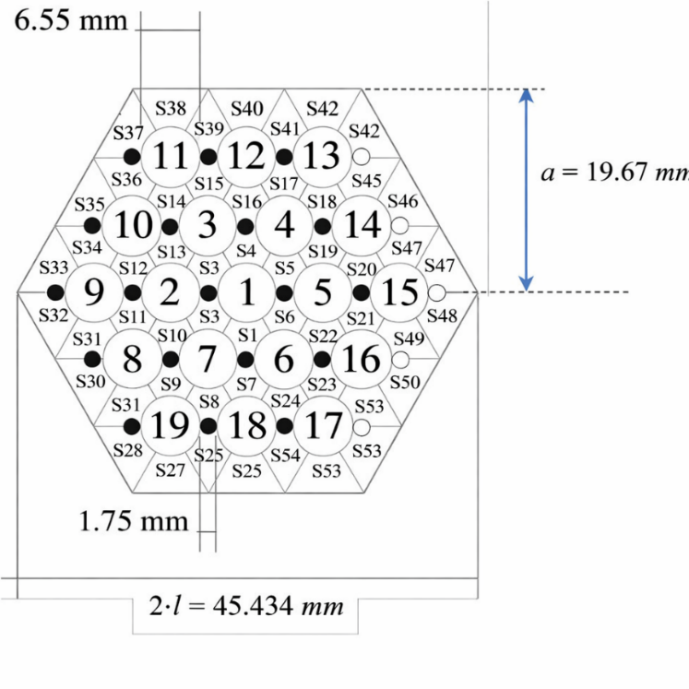
FIG. 3. Cross-section of the electrical wire-spaced FPS.
The inner rank consists of the central pin No. 1 and subchannels S1–S6; the intermediate rank includes pins No. 2–7 and subchannels S7–S24; the outer rank (N) is formed by pins No. 8–19 and subchannels S25–S54.
The overall layout of the fuel pin bundle simulator, including its main dimensions, is illustrated in FIG. 4. In addition, a detailed drawing of a single pin with the spacer wire is supplied. At the pin foot, a bottom grid is installed to maintain the structural integrity of the bundle, while the conical section allows elastic bending of the pins, which is required for the correct installation of the electrical connectors. A drawing of the bottom grid, which is the only component required for numerical fluid-dynamics modeling, is provided separately to the participants.
FIG. 4. Technical drawing of the FPS.

Heat Exchanger
The heat exchanger is of the shell-and-tube type and is designed to transfer thermal power up to 250 kW. It consists of two separate shell sections: a low-power crossflow section (0–30 kW) and a high-power counter-current section (30–250 kW), both connected to the pressurized-water secondary side. The two sections can be independently drained and filled (see FIG. 1 and FIG. 2). The tube geometry follows a “tube-in-tube” configuration, with an annular gap of 2.45 mm filled with AISI 316 powder.
The secondary side is a closed-loop pressurized water circuit operating at 16 bar and equipped with a circulation pump, a pre-heater, the shell side of the heat exchanger, an air cooler, and a pressurizer. An ultrasonic flow meter installed between the air cooler and the pump is used to monitor the secondary water mass flow rate, while several thermocouples measure temperatures throughout the loop. The combination of these measurements allows the thermal power exchanged in each heat exchanger section to be quantified. A technical drawing of the heat exchanger is provided in FIG. 5. All geometrical details of the heat exchanger and the secondary loop can be derived from the drawings provided in Appendix B.
FIG. 5. Technical drawing of the heat exchanger.
In the three experiments discussed in this report, only the high-power counter-current section of the heat exchanger is utilized. The counter-current flow arrangement simplifies the thermo-fluid-dynamic modeling of the heat exchanger.
The heat exchanger features double walls filled with AISI stainless-steel powder; therefore, an accurate numerical modeling of the heat exchanger is essential to correctly predict the average LBE temperature in the loop under all the investigated operating conditions.
During the blind phase of a previous benchmark conducted within the SESAME project, the predicted average temperatures were significantly lower than the corresponding experimental values for all three tests. As illustrated in FIG. 6 for Test 3, the simulated average temperature remains well below the measured value throughout the entire test duration, with deviations ranging from approximately 50 to 30 °C relative to the experimental data.
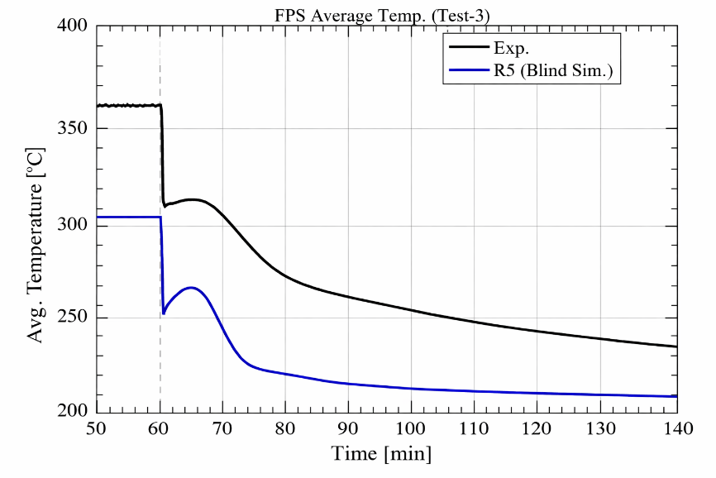
FIG. 6. Comparison of the average loop temperature (blind simulation and experimental data, Test-3).
This inconsistency made a more detailed analysis of the previous heat exchanger (HX) “blind model” adopted in the SESAME benchmark mandatory. Consequently, a refined assessment of the overall heat-transfer performance of the HX component was performed. In particular, the re-evaluation focused on the thermal conductivity of the stainless-steel powder filling the 2.45 mm gap. This contribution accounts for nearly 50% of the total thermal resistance of the HX and therefore has a major impact on the global heat-transfer performance and, ultimately, on the mean temperature of the loop.
Based on more reliable experimental data [2], it was concluded that the powder thermal conductivity assumed in the blind simulations was overestimated. The powder thermal conductivity reported in [2] is summarized in FIG. 6, which shows experimental correlations as a function of temperature for three increasing powder compaction levels, denoted as RUN 0.0, 1.0, and 5.0 (dotted lines). The figure also includes the thermal conductivity adopted in the blind RELAP5 simulations (blue line) and the updated value used in the post-test RELAP5 analyses (red line).
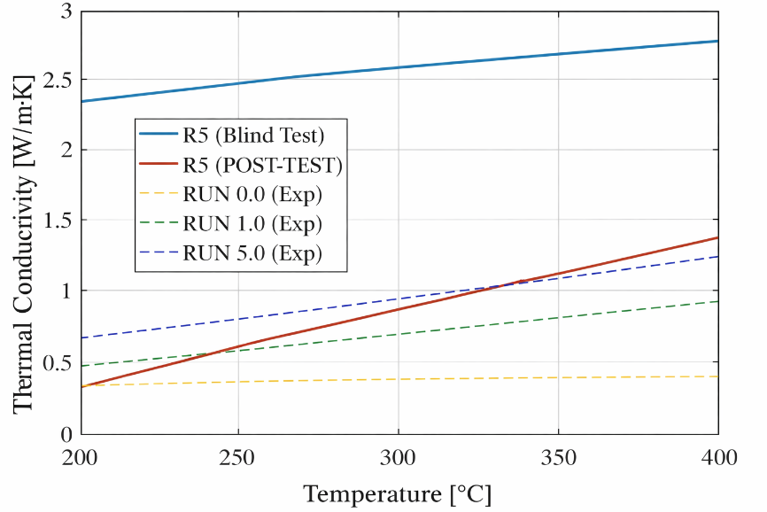
FIG. 7. Stainless steel powder thermal conductivity.
A systematic post-test analysis performed with RELAP5 [3] allowed an analytical expression for the powder thermal conductivity to be derived, which is strongly recommended for adoption in the present benchmark, Eq. (1).
 | $$k_{powder}=0.3+0.005∙\left(T-200\right)$$ | (1)
where T is in °C and k in W/(m K).
This assumption is more consistent with the currently available experimental data and provides a more accurate representation of the HX thermal performance and, more generally, of the system behavior. Regarding the assumptions on the HX geometrical parameters, such as heat-transfer surfaces and double-wall tube thicknesses, these were taken directly from the design drawings [4].

Gas injection system
The gas injection device currently installed and used during the experimental tests is composed of a 12.70 mm (1/2 inch) outer-diameter pipe, 6135 mm in length, which is inserted through the 2½″ coupling flange located at the top of the expansion tank by means of a Swagelok tube fitting. Technical drawings of the terminal section of the device, including its functional dimensions, are shown in FIG. 8.
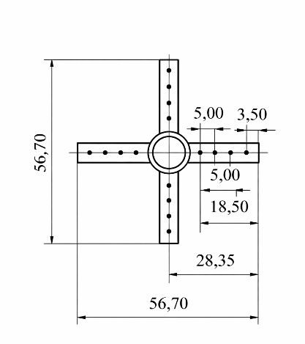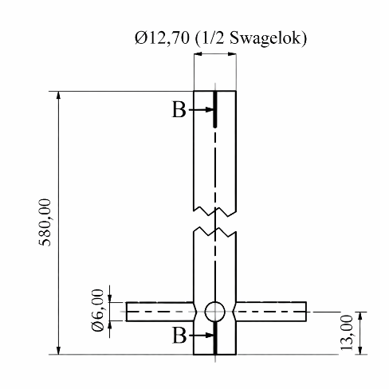
FIG. 8. Technical drawings of the gas injection device.
With regard to the gas injection system, the control unit allows the argon volumetric flow rate to be set. However, the resulting void fraction α in the NACIE-UP primary circuit cannot be determined a priori, and therefore the pressure head provided to the loop cannot be directly estimated in advance. It is well established that the relationship between the injected argon volumetric flow rate and the resulting LBE mass flow rate in the primary circuit is non-linear.
The gas is discharged through five holes, each with a diameter of 1 mm, aligned along a generatrix of four short outlet pipes (five holes per pipe). The four short pipes are arranged in a plane perpendicular to the main 6135 mm pipe and are mutually oriented at 90° with respect to each other [5].

Expansion vessel
The expansion vessel is located at the top of the riser and is partially filled with argon, which acts as a cover gas to control the pressure in the primary circuit. Two level sensors, LD102 and LD101, are installed inside the expansion vessel at 80 mm and 180 mm, respectively, above the riser outlet nozzle.
During circuit filling, the LBE level is above the LD102 sensor (LD102 active) but below the LD101 sensor (LD101 inactive). Nevertheless, LBE levels reaching the LD101 position are still acceptable for facility operation. The low-level sensor (LD102) is positioned 150 mm from the top of the incoming vertical nozzle (i.e., 150 + 285 = 435 mm from the bottom of the expansion vessel), while the high-level sensor (LD101) is located 230 mm from the top of the same nozzle. A cross-sectional view of the expansion vessel (S101) is shown in FIG. 9.
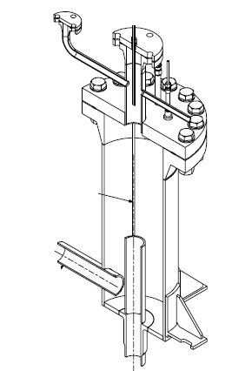
FIG. 9. Cross-section of expansion vessel.

instrumentation

Loop instrumentation
The loop instrumentation includes several thermocouples. The thermocouples are inserted into the primary and secondary loops through Swagelok fittings and therefore directly measure the coolant temperature (LBE or water).
The thermocouple identification is defined as follows:
- for the primary loop: TP-101, TP-102, TP-103, TP-104, TP-105, TP-106, TP-107, and TP-310;
- for the secondary loop, the thermocouples relevant for the benchmark are those located at the inlet and outlet of the main section of the heat exchanger, namely TP-203 and TP-204.
The thermocouple positions can be inferred from the NACIE-UP layout (FIG. 2) and the corresponding NACIE-UP P&ID included in this document (see Appendix B). All thermocouples have a diameter of 3 mm and are K-type, Class 1. Accordingly, their accuracy, in compliance with IEC 60584-3 (2007), is ±1.5°C in the temperature range from −40°C to +375°C and ±0.004·t from 375°C to 1000°C.
In addition, the cover gas pressure in the expansion tank is monitored by the Barksdale pressure transducer P110. The overall measurement chain error for the thermocouples has been independently verified.

FPS instrumentation
The FPS test section is equipped with a total of 67 thermocouples, arranged to monitor different subchannel ranks at various axial and radial positions.
Pins No. 1, 2, 4, 5, 6, 7, 9, 16, 18, and 19 are instrumented with wall-embedded thermocouples located on one or more generatrices parallel to the pin axis, as summarized in Table 4 and illustrated in FIG. 10. Three axial measurement levels are considered, at z = 38, 300, and 562 mm measured from the bottom of the active pin region, as shown in FIG. 10(a). By convention, the measurement planes at z = 38, 300, and 562 mm are referred to as Sections A, B, and C, respectively.
Table 4. Azimuthal angles of the pin generatrices where the wall embedded Thermocouples are located
Pin number | Azimuthal angles ϑ [°] | Axial location [mm] | Number of wall TCs | TC diameter [mm]
1 | –60, +120 | z= 38, 300, 562 | 6 | 0.35
2 | +60 | z= 38, 300, 562 | 3 | 0.35
4 | 0 | z= 38, 300, 562 | 3 | 0.35
5 | –120,0,+120 | z= 38, 300, 562 | 9 | 0.35
6 | +120 | z= 38, 300, 562 | 3 | 0.35
7 | +180 | z= 38, 300, 562 | 3 | 0.35
9 | –120 | z= 38, 300, 562 | 3 | 0.35
16 | –120 | z= 38, 300, 562 | 3 | 0.35
18 | –60 | z= 38, 300, 562 | 3 | 0.35
19 | +60 | z= 38, 300, 562 | 3 | 0.35

a) |  | b)
FIG. 10. Axial (a) and section (b) locations of wall embedded and bulk TCs for pins n. 1,3, 2, 4, 5, 6, 7, 9, 16, 18, 19.
The selected measurement sections share the same geometrical configuration, since the wire axial pitch is P_{w} = 262 mm, which corresponds to the axial distances between successive sections (300 − 38 mm and 562 − 300 mm). In addition, Pin No. 3 is instrumented along a single generatrix with 13 wall-embedded thermocouples distributed over the active length, spaced every P_{w} /6 = 43.66 mm starting from z = 38 mm.
Subchannels S2, S5, S22, S26, and S33 are instrumented with bulk thermocouples of 0.5 mm diameter at the same three measurement sections A, B, and C (see Table 5). A schematic view of a generic measurement section, including both wall-embedded thermocouples and instrumented subchannels, is shown in FIG. 10(b). The relative positions of the grooves, i.e., the generatrices (highlighted in red) for the different pins, can also be inferred by considering the reference azimuthal pin angle θ, defined as positive in the anticlockwise direction when the bundle cross section is viewed from the top.
Table 5. Azimuthal angles of the generatrices where the bulk Thermocouples are located for each sub-channel instrumented.
Sub-channel number | Pin (wire) number | Azimuthal angle ϑ[°] | Location [mm] | Number of bulk TCs | TC diameter [mm]
S5 | 1 | +120 | z= 38, 300, 562 | 3 | 0.5
S2 | 2 | +60 | z= 38, 300, 562 | 3 | 0.5
S22 | 6 | +120 | z= 38, 300, 562 | 3 | 0.5
S33 | 9 | -120 | z= 38, 300, 562 | 3 | 0.5
S26 | 19 | +60 | z= 38, 300, 562 | 3 | 0.5

Table 6 summarizes all the relevant information associated with the thermocouples, including the pin or wire number, thermocouple type (‘Wall’ or ‘Bulk’), thermocouple diameter, subchannel number for bulk thermocouples, azimuthal angle, axial z location measured from the beginning of the active region, and the corresponding measurement section (A, B, or C). In cases where the information is not defined, the symbol “–” is used.
Table 6. Azimuthal angles of the generatrices where the bulk Thermocouples are located for each sub-channel instrumented.
TC  name | Pin (wire) number | type | TC  diameter  [mm] | Subchannel  number  (Bulk TC) | Azimuthal angle [°] (wall TC) | Axial location  [mm] | Section
TC-FPS-01 | 2 | Bulk | 0.5 | S2 | +60 | 38 | A
TC-FPS-02 | 1 | Bulk | 0.5 | S5 | +120 | 38 | A
TC-FPS-03 | 6 | Bulk | 0.5 | S22 | +120 | 38 | A
TC-FPS-04 | 19 | Bulk | 0.5 | S26 | +60 | 38 | A
TC-FPS-05 | 9 | Bulk | 0.5 | S33 | -120 | 38 | A
TC-FPS-06 | 2 | Bulk | 0.5 | S2 | +60 | 300 | B
TC-FPS-07 | 1 | Bulk | 0.5 | S5 | +120 | 300 | B
TC-FPS-08 | 6 | Bulk | 0.5 | S22 | +120 | 300 | B
TC-FPS-09 | 19 | Bulk | 0.5 | S26 | +60 | 300 | B
TC-FPS-10 | 9 | Bulk | 0.5 | S33 | -120 | 300 | B
TC-FPS-11 | 2 | Bulk | 0.5 | S2 | +60 | 562 | C
TC-FPS-12 | 1 | Bulk | 0.5 | S5 | +120 | 562 | C
TC-FPS-13 | 6 | Bulk | 0.5 | S22 | +120 | 562 | C
TC-FPS-14 | 19 | Bulk | 0.5 | S26 | +60 | 562 | C
TC-FPS-15 | 9 | Bulk | 0.5 | S33 | -120 | 562 | C
TC-FPS-16 | 1 | Wall | 0.35 | - | -60 | 38 | A
TC-FPS-17 | 1 | Wall | 0.35 | - | +120 | 38 | A
TC-FPS-18 | 2 | Wall | 0.35 | - | +60 | 38 | A
TC-FPS-19 | 4 | Wall | 0.35 | - | 0 | 38 | A
TC-FPS-20 | 5 | Wall | 0.35 | - | -120 | 38 | A
TC-FPS-21 | 5 | Wall | 0.35 | - | 0 | 38 | A
TC-FPS-22 | 5 | Wall | 0.35 | - | +120 | 38 | A
TC-FPS-23 | 6 | Wall | 0.35 | - | +120 | 38 | A
TC-FPS-24 | 7 | Wall | 0.35 | - | +180 | 38 | A
TC-FPS-25 | 9 | Wall | 0.35 | - | -120 | 38 | A
TC-FPS-26 | 16 | Wall | 0.35 | - | -120 | 38 | A
TC-FPS-27 | 18 | Wall | 0.35 | - | -60 | 38 | A
TC-FPS-28 | 19 | Wall | 0.35 | - | +60 | 38 | A
TC-FPS-29 | 1 | Wall | 0.35 | - | -60 | 300 | B
TC-FPS-30 | 1 | Wall | 0.35 | - | +120 | 300 | B
TC-FPS-31 | 2 | Wall | 0.35 | - | +60 | 300 | B
TC-FPS-32 | 4 | Wall | 0.35 | - | 0 | 300 | B
TC-FPS-33 | 5 | Wall | 0.35 | - | -120 | 300 | B
TC-FPS-34 | 5 | Wall | 0.35 | - | 0 | 300 | B
TC-FPS-35 | 5 | Wall | 0.35 | - | +120 | 300 | B
TC-FPS-36 | 6 | Wall | 0.35 | - | +120 | 300 | B
TC-FPS-37 | 7 | Wall | 0.35 | - | +180 | 300 | B
TC-FPS-38 | 9 | Wall | 0.35 | - | -120 | 300 | B
TC-FPS-39 | 16 | Wall | 0.35 | - | -120 | 300 | B
TC-FPS-40 | 18 | Wall | 0.35 | - | -60 | 300 | B
TC-FPS-41 | 19 | Wall | 0.35 | - | +60 | 300 | B
TC-FPS-42 | 1 | Wall | 0.35 | - | -60 | 562 | C
TC-FPS-43 | 1 | Wall | 0.35 | - | +120 | 562 | C
TC-FPS-44 | 2 | Wall | 0.35 | - | +60 | 562 | C
TC-FPS-45 | 4 | Wall | 0.35 | - | 0 | 562 | C
TC-FPS-46 | 5 | Wall | 0.35 | - | -120 | 562 | C
TC-FPS-47 | 5 | Wall | 0.35 | - | 0 | 562 | C
TC-FPS-48 | 5 | Wall | 0.35 | - | +120 | 562 | C
TC-FPS-49 | 6 | Wall | 0.35 | - | +120 | 562 | C
TC-FPS-50 | 7 | Wall | 0.35 | - | +180 | 562 | C
TC-FPS-51 | 9 | Wall | 0.35 | - | -120 | 562 | C
TC-FPS-52 | 16 | Wall | 0.35 | - | -120 | 562 | C
TC-FPS-53 | 18 | Wall | 0.35 | - | -60 | 562 | C
TC-FPS-54 | 19 | Wall | 0.35 | - | +60 | 562 | C
TC-FPS-55 | 3 | Wall | 0.35 | - | 0 | 38 | A
TC-FPS-56 | 3 | Wall | 0.35 | - | 0 | 81.7 | -
TC-FPS-57 | 3 | Wall | 0.35 | - | 0 | 125.3 | -
TC-FPS-58 | 3 | Wall | 0.35 | - | 0 | 169 | -
TC-FPS-59 | 3 | Wall | 0.35 | - | 0 | 212.7 | -
TC-FPS-60 | 3 | Wall | 0.35 | - | 0 | 256.3 | -
TC-FPS-61 | 3 | Wall | 0.35 | - | 0 | 300 | B
TC-FPS-62 | 3 | Wall | 0.35 | - | 0 | 343.7 | -
TC-FPS-63 | 3 | Wall | 0.35 | - | 0 | 387.3 | -
TC-FPS-64 | 3 | Wall | 0.35 | - | 0 | 431 | -
TC-FPS-65 | 3 | Wall | 0.35 | - | 0 | 474.6 | -
TC-FPS-66 | 3 | Wall | 0.35 | - | 0 | 518.3 | -
TC-FPS-67 | 3 | Wall | 0.35 | - | 0 | 562 | C

Thermal Flow Meter
A prototypical thermal flow meter (FM101) was used to measure the LBE mass flow rate in the loop. The thermal flow meter is based on the energy balance and it is shown schematically in Figure 3 3.
The component is made by a flanged pipe (SS) with an heater developed by Thermocoax (6 kW maximum power), a static mixer, 2 Resistance Temperature Detector (RTD) and an internal RTD in the bulb. The mass flow rate was computed by the thermal balance, according to Eq. (2).
(2)
Under steady-state conditions, Eq. (2) yields an accurate evaluation of the mass flow rate. During transient operation, the bulb heater is actively regulated to maintain a constant temperature difference between the heater and the inlet RTD. In addition, an inlet–outlet temperature compensation is implemented to account for the fluid transit time through the 800 mm pipe. These two features, implemented within the Data Acquisition and Control System (DACS) of the instrument, ensure a fast and accurate response under transient conditions.
The thermal flow meter was developed at ENEA in collaboration with Thermocoax and was successfully tested first in water and subsequently in heavy liquid metal (HLM) during several experimental campaigns conducted at the NACIE facility. Compared with alternative measurement technologies, it offers the advantages of very low pressure losses and a very high maximum operating temperature. The instrument provides reliable measurements even at low HLM mass flow rates, down to 0.6 kg/s. The thermal flow meter operating according to a “thermal balance” principle demonstrated good stability and repeatability, a favorable response to transient conditions, and no requirement for calibration, as it relies on fundamental conservation laws.
For the NACIE-UP facility operating in the present configuration, the thermal flow meter FM101 is configured to measure mass flow rates in the range from 0.6 kg/s to 10 kg/s. The correspondence between the electrical output signal (current) and the measured mass flow rate is 4–20 mA for 0.6–10 kg/s. The measurement accuracy was assessed both numerically and analytically using error propagation theory and is estimated to be approximately 5% under the present operating conditions .
The measurement chain error of the thermal flow meter was evaluated using a calibrator in place of the instrument. For the calibration procedure, five different current values I [mA] were considered. These current levels correspond to mass flow rates according to the relation Q [kg/s]=0.5875⋅I – 1.75. A maximum error of 0.1% of the instrument full scale was deemed acceptable. The measurement chain error was assessed and found to be negligible, remaining below 0.1% of full scale.
The bulb heater power applied during the experimental tests was provided for use in the simulations.

Loop insulation
The primary loop is thermally insulated with a mineral rock-wool layer bonded by a thermosetting resin. The thermal conductivity of the resin is temperature dependent, as reported in Table 7 (manufacturer-provided data). The insulation thickness is 100 mm along the entire loop.
Table 7. Thermal conductivity of the thermal insulator
Temperature [°C] | Thermal conductivity [W/(m K)]
0 | 0.035
50 | 0.037
100 | 0.043
150 | 0.052
200 | 0.062
250 | 0.074
300 | 0.089

Data acquisition and control system
The Data Acquisition and Control System (DACS) is implemented using LabVIEW System Design Software in combination with National Instruments hardware. Both the primary and secondary systems of the NACIE-UP facility are remotely controlled, and the filling and draining operations of the plant are also performed remotely.
FIG. 11 presents the control and monitoring interface used to remotely actuate components and valves, from which temperatures and pressures in the primary and secondary systems are continuously monitored. FIG. 12 shows the remote-control panel dedicated to the activation and regulation of power generation. The power level, the number of energized pins, and the power ramp rate can be adjusted as required, as illustrated in the same figure. In addition, all wall and bulk thermocouples within the fuel pin bundle simulator can be continuously monitored through the interface shown in FIG. 13. Each pin can be controlled independently, enabling the execution of asymmetric heating tests for code validation purposes. Transitions between different power levels can also be performed through controlled power ramps.

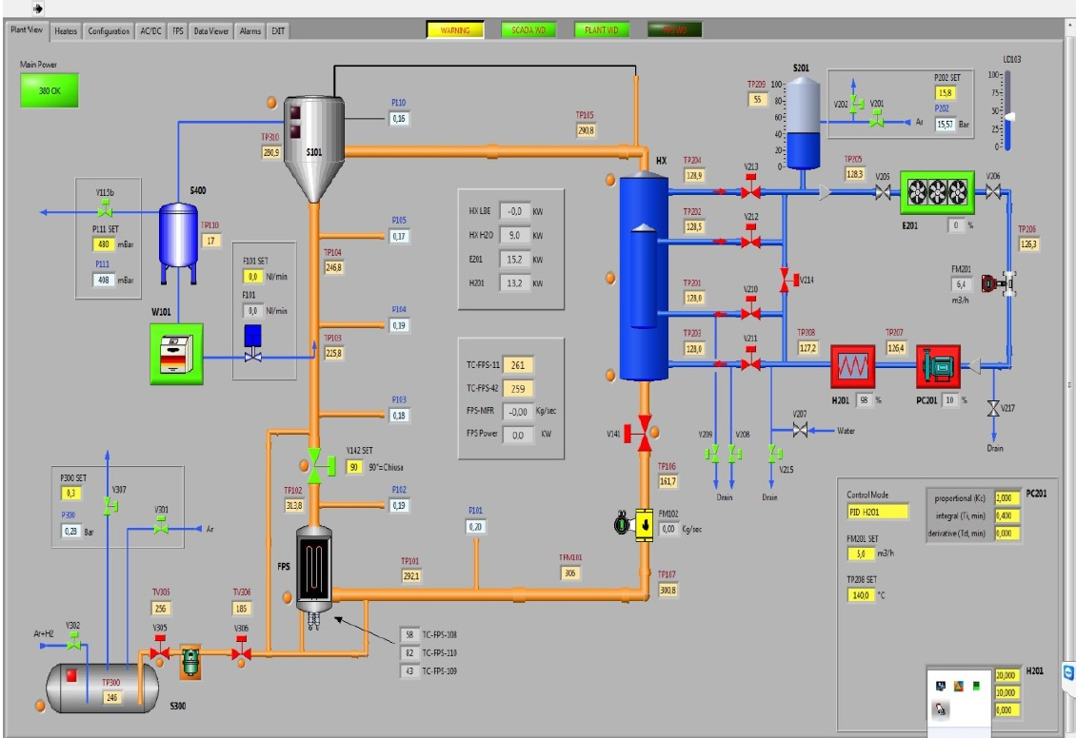
FIG. 11. Remote control panel of the NACIE-UP facility.

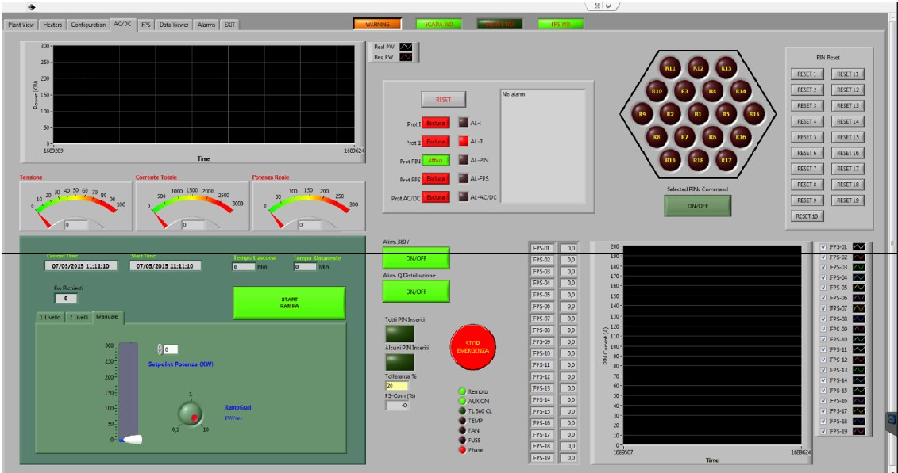
FIG. 12. Control panel of the FPS power.

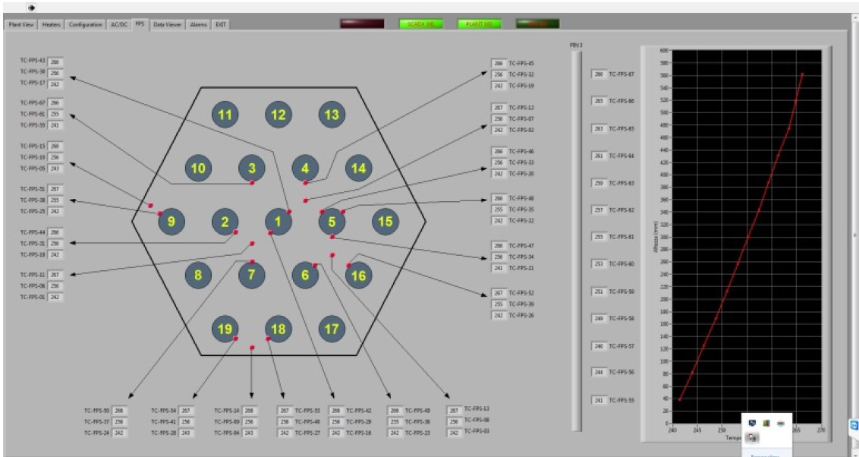
FIG. 13. Monitoring panel of the FPS temperatures.

Description of the experimental tests
The experimental campaign was designed to characterize the thermal-hydraulic behavior of a heavy liquid metal (HLM)-cooled fuel assembly during the transition from forced to natural circulation. Nevertheless, some tests were performed with a non-uniform distribution of the total power among the 19 pins, while maintaining an equal power level within selected subsets of pins in the bundle (ADP10). One test considered only the seven central pins (ADP06, including the central pin and the second rank) and was compared with another test characterized by the same total power but with all pins energized. A third test (ADP07) involved two-sixths of the hexagonal bundle being active.
Each test consisted of a mass flow transient. In the initial phase, gas was injected into the riser to enhance LBE circulation. After steady-state conditions were established, the gas injection was switched off, while the total thermal power remained unchanged. During the second phase, natural circulation was the sole driving mechanism for the flow in the loop. As a consequence of the constant power level, temperatures downstream of the FPS increased, whereas temperatures in the colder sections of the loop decreased.

LBE and Material properties

Thermo-physical properties of LBE
In the present work, the physical properties of LBE, all of which are temperature dependent, are evaluated using empirical correlations recommended in the OECD/NEA Handbook (2015) [6]. Correlations for density, specific heat, dynamic viscosity, and thermal conductivity are reported in Table 8 in SI units. The maximum deviation of the experimental data underlying each correlation is also provided. In addition, the standard deviation of the experimental data used to derive each correlation was calculated from the source datasets and is reported in the last column of Table 8.
These property correlations are recommended for use in the benchmark, and participants are expected to adopt them in their numerical simulations. If this is not feasible, participants are required to explicitly state which physical property correlations have been employed.
Table 8. Thermo-physical properties of LBE as a function of temperature (T in Kelvin, SI Units), from LBE-Handbook.
Property | Symbol | Correlation | Maximum uncertainty | Standard deviation
Density | $$ρ\left(T\right)$$ | $$11065-1.293⋅T$$ | $≤$0.8% | 0.58%
Heat capacity | $$c_{p}\left(T\right)$$ | $$164.8-3.94∙{10}^{-2}∙T+$$  $$+1.25∙{10}^{-5}∙T^{2}-4.56∙{10}^{5}∙T^{-2}$$ | $≤$5% | 2.4%
Dynamic viscosity | $$μ\left(T\right)$$ | $$4.94⋅10^{-4}\exp\left(\frac{754.1}{T}\right)$$ | $≤$6-8% | 7.2%
Thermal conductivity | $$k\left(T\right)$$ | $3.284+1.617∙{10}^{-2}∙T-2.305∙{10}^{-6}∙T^{2}$ | $≤$10-15% | 6.2%

Thermo-physical properties of stainless steel
All components and piping of the NACIE-UP facility, as well as the spacer wires in the pin bundle, are manufactured from AISI 316L stainless steel. The thermo-physical properties of stainless steel are widely available in the literature, and the impact of variations in these properties on the computational results is expected to be of secondary importance. Nevertheless, property functions are provided to minimize discrepancies among benchmark participants.
The thermo-physical properties are taken from an ANL publication [7] and are strongly recommended for use in the benchmark. Table 9 lists the corresponding thermo-physical property functions in SI units.
Table 9. Thermo-physical properties of stainless steel AISI316L as a function of temperature (T in Kelvin, SI Units)
Property | Symbol | Correlation
Density | $$ρ_{ss}$$ | $$8084.2-0.42086∙T-3.8942∙{10}^{-5}∙T^{2}$$
Heat capacity | $$c_{p,ss}$$ | $$458.546+0.1327∙T$$
Thermal conductivity | $$k_{ss}$$ | $$9.248+1.57∙{10}^{-2}∙T$$
Linear expansion coefficient | $$∝_{ss}$$ | $$1.7887∙{10}^{-5}+2.3977∙{10}^{-9}∙T+3.692∙{10}^{-13}∙T^{2}$$

Thermo-physical properties of pin materials
Particularly for CFD analyses, it may be important to explicitly model the pin cladding and internal structure within the active region. The complete pin drawing is proprietary and cannot be shared with the benchmark participants. Nevertheless, a schematic cross section of the pin in the active region is provided in FIG. 14 for modeling purposes.
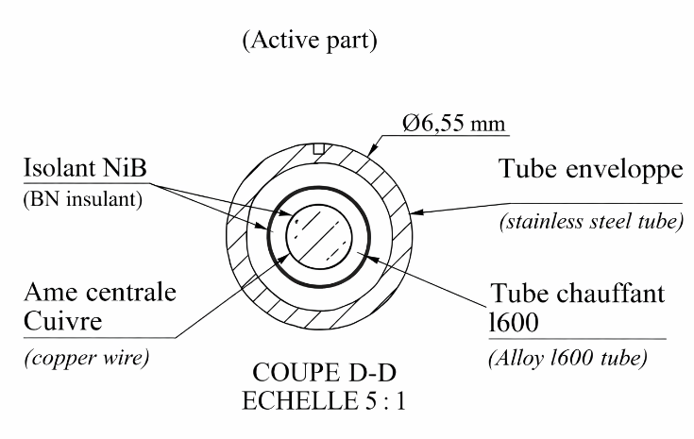
FIG. 14. Schematic drawing of the section of the pin in the active part.
The pin is mono-filar; therefore, the heat flux is azimuthally uniform over the pin surface. The pin consists of an AISI 316L stainless-steel cladding, a central copper conductor, and a boron nitride (BN) insulating powder; an intermediate pipe made of Inconel 600 is also present. The main dimensions of the different pin components are summarized in Table 10.
Table 10. Diameters of the different parts of the pin in the active region.
Part | Internal diameter [mm] | External diameter [mm]
Clad (AISI316L) | 5.08 | 6.55
Heating tube (Inconel600) | 3.35 | 3.53
Central conductor (Copper) | - | 2.31
1st insulant layer (BN) | 2.31 | 3.35
2nd insulant layer (BN) | 3.53 | 5.08

For modeling purposes, it was agreed among the partners that, in CFD analyses, the pin cladding should be explicitly modeled by all participants in order to impose the correct thermal boundary condition of uniform heat flux. The modeling of the internal pin components is left to the discretion of each participant. In any case, the Inconel 600 intermediate pipe was neglected, as its influence on the analysis was deemed marginal.
With respect to the physical properties of the various materials, the thermo-physical properties of AISI 316L stainless steel were provided in the previous section, while the properties of boron nitride (BN) and copper are reported in Table 11 and in Table 12, respectively, based on reference [8]. The thermo-physical properties of BN were supplied by Thermocoax [9].
Table 11. Thermo-physical properties of Boron Nitride (BN) as a function of temperature (T in Kelvin, SI Units).
Property | Symbol | Correlation | Range (T in K)
Density | $$ρ_{BN}$$ | $$2000$$ | –
Heat capacity | $$c_{p,BN}$$ | $$800$$ | –
Thermal conductivity | $$k_{BN}$$ | $$-2.416∙\ln\left(T-273.16\right)+25.578$$ | 293-1393

Table 12. Thermo-physical properties of Copper (SI Units).
Property | Symbol | Correlation | Range (T in K)
Density | $$ρ_{Copper}$$ | $$8933$$ | –
Heat capacity | $$c_{p,Copper}$$ | $$385$$ | –
Thermal conductivity | $$k_{Copper}$$ | $$401$$ | –

Boundary conditions
The boundary conditions of the experimental tests are described in the following sections. For the experimental thermal balance, including reference values of the thermal power in the active region, the pre-heating section, and the thermal flow meter under initial and final steady-state conditions, the reader is referred to Appendix A. The ambient temperature for the experiments is fixed at 10°C, corresponding to the average temperature of the experimental hall.

ADP10: All pins on
The first test, ADP10, consists of a gas transition transient performed at constant power, with the total power uniformly distributed among the 19 pins. The nominal electrical power of the FPS was 30 kW, corresponding to a nominal wall heat flux of about 127.9 kW/m². FIG. 15 shows a schematic view of the 19-pin fuel bundle simulator during test ADP10; the active pins are highlighted in blue.
During the first stage of the test, the nominal gas flow rate in the primary loop was set to 10 Nl/min. The secondary side, filled with water at a pressure of 16 bar, was operated with an inlet temperature of 170 °C and a total volumetric flow rate of 10 m³/h. Only the high-power section of the heat exchanger was in operation during the test. The experiment was initiated after steady-state conditions had been achieved in both the primary and secondary circuits and was maintained for approximately 20 minutes.

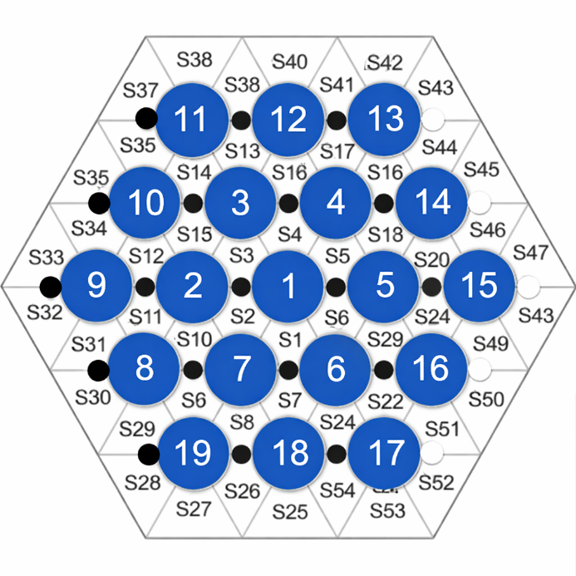
FIG. 15. Active pins (in blue) during test ADP10.
The sequence of events of test ADP10 is presented in Table 13. The transient was triggered at time 1225 s by reducing the gas flow rate from the initial nominal value of 10 Nl/min to 0 Nl/min. The gas transition lasted 1 s, and the gas flow rate stabilized at zero at 1226 s. The secondary side was operated under the same conditions as in the first stage, namely a water inlet temperature of 170°C and a total volumetric flow rate of 10 m³/h, as summarized in Table 14, which reports the boundary conditions at the beginning of the transient (BoT) and at the end of the transient (EoT).
Table 13. Sequence of events of ADP10 Test
Parameter | Time [s]
Start of steady state I | 0
Beginning of gas transient | 1225
End of gas transient | 1226
End of steady state II | 6000

Table 14. Boundary conditions of ADP10 Test
Parameter | BoT | EoT
FPS Power | 30 kW | 30 kW
Gas flow rate | 10 Nl/min | 0
Water flowrate | 10 m³/h | 10 m³/h
Water temperature at HX inlet | 170$℃$ | 170$℃$

After the transient, a new steady-state condition was reached and maintained for an additional period exceeding 30 minutes in order to obtain statistically significant data. The experimental trend of the argon flow rate is shown in FIG. 16(a), while a zoomed view of the transition phase is presented in FIG. 16 (b).
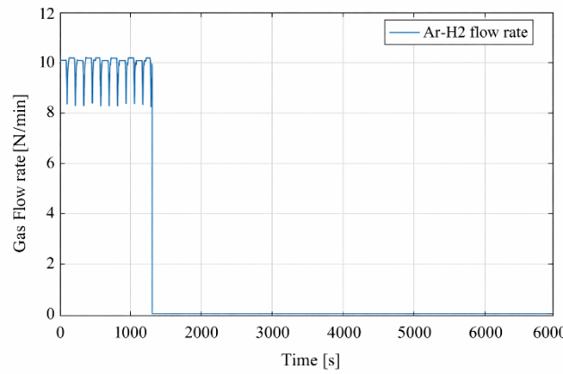 | 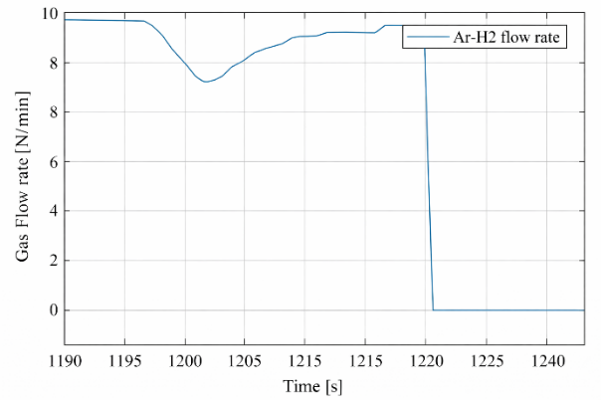
a) | b)
FIG. 16. Time trend of the gas flow rate (a) and zoom of the transition (b), test ADP10.

The cyclic behavior of the gas injection observed prior to the transition is associated with the operation of the gas system in closed-circuit mode. In this configuration, the compressor W101 periodically refills the high-pressure tank located downstream of the compressor in response to a low-pressure signal. During compressor operation, the pressure upstream of the compressor and in the loop cover gas decreases.
The thermal power released by the thermal flow meter during the transient, on the order of 2 kW, is provided to the benchmark participants to enable realistic simulations. For a detailed thermal balance of the loop and the correct power values to be adopted in the calculations, the reader is referred to Appendix A.

ADP06: 7 central pins on
The second test, ADP06, involves a gas transition transient performed at constant power, with the total power uniformly distributed among the seven central pins (Pins 1 to 7). FIG. 17 presents a schematic view of the fuel bundle simulator, with the active pins highlighted in blue. The nominal electrical power of the FPS was 30 kW, corresponding to a nominal wall heat flux of about 347.1 kW/m² . For comparison purposes, the total nominal power was selected to be identical to that of test ADP10.
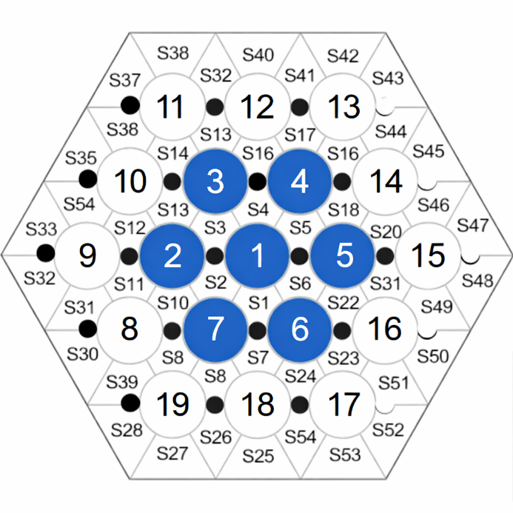
FIG. 17. Active pins (in blue) during test ADP06.
During the first phase of the test, a nominal gas flow rate of 10 Nl/min was supplied to the primary loop to sustain LBE circulation. The secondary side was operated with water at a pressure of 16 bar, an inlet temperature of 170°C, and a total volumetric flow rate of 10 m³/h. Only the high-power section of the heat exchanger was in operation during the test. Steady-state conditions were reached in both the primary and secondary circuits and subsequently maintained for approximately 30 minutes (t = 0–1852 s).
The sequence of events of test ADP06 is presented in Table 15. The transient was initiated at 1852 s by reducing the gas flow rate from the initial nominal value of 10 Nl/min to 0 Nl/min. The gas transition lasted 1 s, and the gas flow rate stabilized at zero at 1853 s. The secondary side was operated under the same conditions as in the first phase, namely a water inlet temperature of 170°C, a total volumetric flow rate of 10 m³/h, and a pressure of 16 bar, as summarized in Table 16, which reports the boundary conditions at the beginning (BoT) and end (EoT) of the transient.
Table 15. Sequence of events of ADP06 Test
Parameter | Time [s]
Start of steady state I | 0
Beginning of gas transient | 1852
End of gas transient | 1853
End of steady state II | 9000

Table 16. Boundary conditions of ADP06 Test
Parameter | BoT | EoT
FPS Power | 30 kW | 30 kW
Gas flow rate | 10 Nl/min | 0
Water flowrate | 10 m³/h | 10 m³/h
Water temperature at HX inlet | 170$℃$ | 170$℃$

After the transient, a new steady-state condition was reached and maintained for approximately one hour (t = 5000–9000 s) in order to obtain statistically significant data. The experimental trend of the argon flow rate is shown in FIG. 18 (a), while a magnified view of the transition phase is provided in FIG. 18 (b). The cyclic behavior of the gas injection is also evident during the initial phase of test ADP06, with its origin as previously explained.
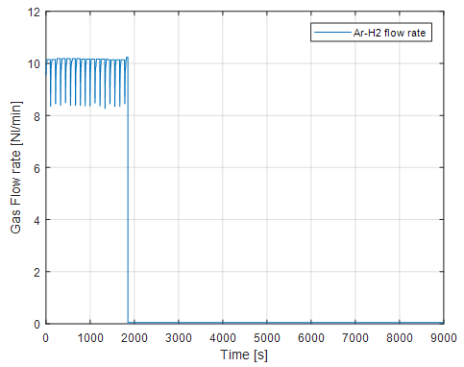 | 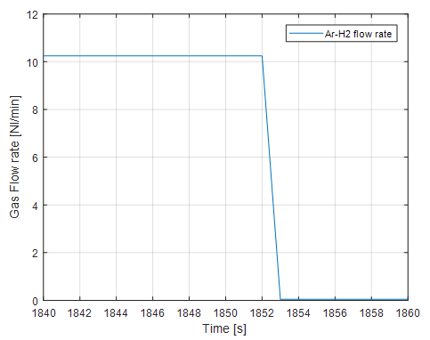
a) | b)
FIG. 18. Time trend of the gas flow rate (a) and zoom of the transition (b), test ADP06.
FIG. 19 presents the nominal power and the actual power released along the active length of the FPS during the test. The discontinuity observed in the actual power profile is related to the method used to evaluate this quantity. Specifically, the actual power was calculated by means of an energy balance over the active region. For numerical simulations, the actual power should be imposed over the active region, while the remaining fraction of the total power is assumed to be released in the entry region of the FPS. In addition, the thermal power released by the thermal flow meter during the transient, on the order of 2 kW, is provided to the benchmark participants to enable realistic simulations. Further details are available in Appendix A.
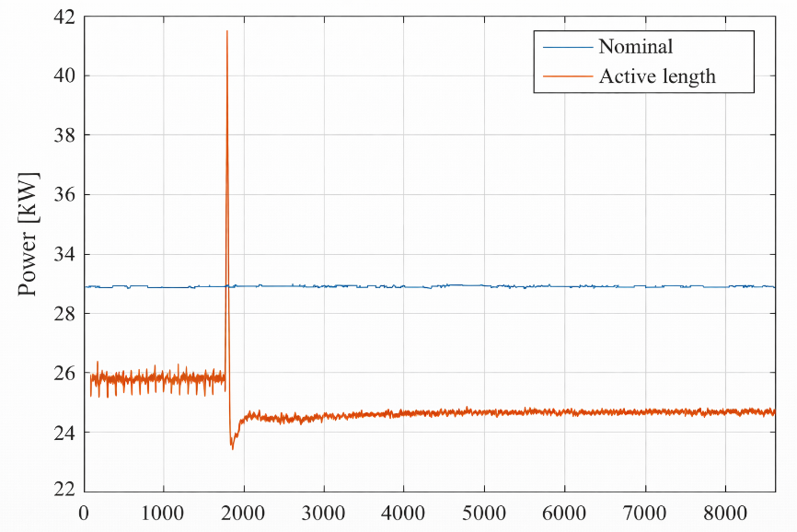
FIG. 19. FPS power during test ADP06.

ADP07: pins on in Two sectors
The third test, ADP07, involves a gas transition transient conducted at constant power, with the total power uniformly distributed among nine pins corresponding to two triangular sectors of the hexagonal bundle. The active pins were Nos. 1, 2, 6, 7, 8, 9, 17, 18, and 19, and are highlighted in blue in FIG. 20. The nominal electrical power of the FPS was 38 kW, corresponding to a nominal wall heat flux of about 342.0 kW/m² , selected to achieve wall heat flux values on the active pins comparable to those obtained in test ADP06.
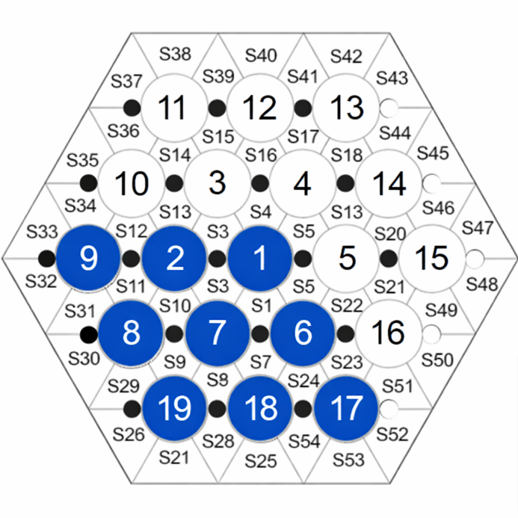
FIG. 20. Active pins (in blue) during test ADP07.
During the first phase of the test, a nominal gas flow rate of 10 Nl/min was supplied to the primary loop to sustain LBE circulation. The secondary side was operated with water at a pressure of 16 bar, an inlet temperature of 170°C, and a total volumetric flow rate of 10 m³/h. Only the high-power section of the heat exchanger was in operation during the test. Steady-state conditions were reached in both the primary and secondary circuits and subsequently maintained for approximately 20 minutes (t = 0–1254 s).
The sequence of events of test ADP07 is presented in Table 17. The transient was initiated at 1254 s by reducing the gas flow rate from the initial nominal value of 10 Nl/min to 0 Nl/min. The gas transition lasted 1 s, and the gas flow rate stabilized at zero at 1255 s. During the second phase of the test, the secondary side was operated under the same conditions as in the first phase, namely a water inlet temperature of 170°C, a total volumetric flow rate of 10 m³/h, and a pressure of 16 bar, as summarized in Table 18, which reports the boundary conditions at the beginning (BoT) and end (EoT) of the transient.
Table 17. Sequence of events of ADP07 Test
Parameter | Time [s]
Start of steady state I | 0
Beginning of gas transient | 1254
End of gas transient | 1255
End of steady state II | 4800

Table 18. Boundary conditions of ADP07 Test
Parameter | BoT | EoT
FPS Power | 38 kW | 38 kW
Gas flow rate | 10 Nl/min | 0
Water flowrate | 10 m³/h | 10 m³/h
Water temperature at HX inlet | 170$℃$ | 170$℃$
After the transient, a new steady-state condition was reached and maintained for an additional 30 minutes (t = 3000–4800 s) in order to obtain statistically significant data. The experimental trend of the argon flow rate is shown in FIG. 21.
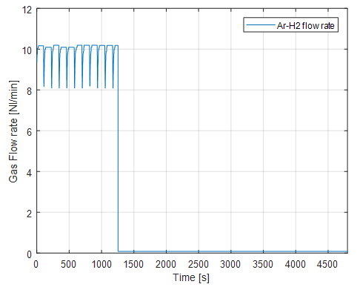 | 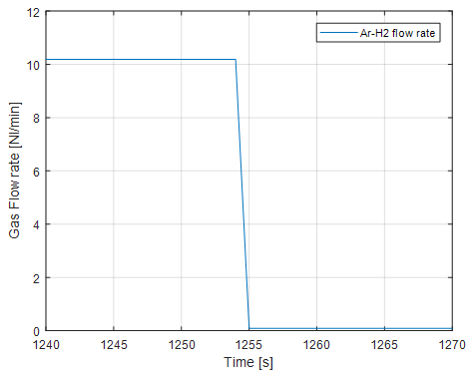
a) | b)
FIG. 21. Time trend of the gas flow rate (a) and zoom of the transition (b), test ADP07.
Figure 3 9 shows the nominal power and the actual power released along the active length of the FPS during test ADP07. The remaining fraction of the total power is assumed to be released in the inlet region of the FPS. In addition, the thermal power released by the thermal flow meter during the transient, on the order of 2 kW, is provided to the benchmark participants to enable realistic simulations. Further details are given in Appendix A.
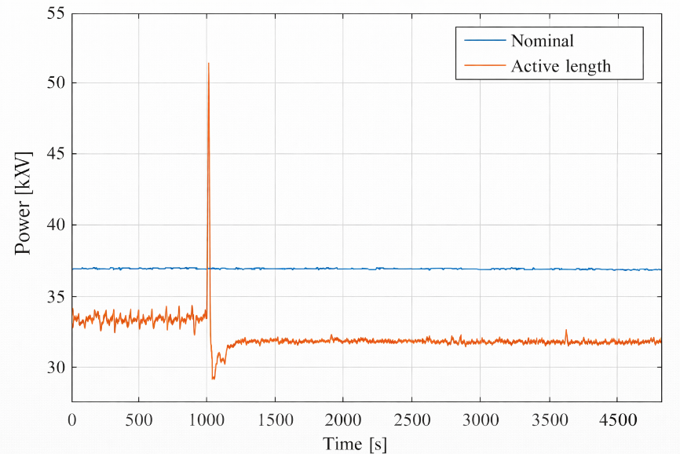
FIG. 22. FPS power during test ADP07.
Further details on the configuration and the tests can be found in [10].

WP1: System thermal hydraulics

Introduction
Work Package 1 of the CRP is devoted to the system thermal-hydraulic simulation of the NACIE-UP forced-to-natural circulation experiments. The objective of WP1 is to assess the capability of system codes to reproduce the integral response of a heavy liquid metal loop during the loss of forced circulation and the establishment of natural circulation.
The NACIE-UP facility is particularly suitable for this purpose because the heat source and the heat sink are vertically separated. The fuel pin simulator (FPS) is installed in the lower part of the riser, while the heat exchanger (HX) is located in the upper part of the downcomer. The elevation difference between the centre of the heated section and the centre of the heat exchanger provides the hydrostatic driving head required for natural circulation. During the initial phase of each test, forced circulation is sustained by argon gas injection in the riser. The gas reduces the average density of the riser column and creates an additional pressure head, commonly referred to as gas-lift. When the gas injection is switched off, this forced-circulation contribution disappears and the loop flow is driven only by buoyancy due to the temperature difference between the hot riser and the cold downcomer.
The selected benchmark tests are ADP10, ADP06 and ADP07. All three tests are constant-power transients in which the argon gas flow rate is reduced from approximately 10 Nl/min to zero within about 1 s. ADP10 and ADP06 were used in the open phase of the benchmark, while ADP07 was used in the blind phase. ADP10 is characterized by uniform heating of all 19 pins. ADP06 has the same nominal FPS power but only the seven central pins are powered. ADP07 is an asymmetric heating case, with nine pins active in two sectors of the bundle.
For WP1, the primary quantities of interest are the LBE temperatures at the loop thermocouple positions and the LBE mass flow rate. The participants calculated and reported the temperatures corresponding to the available experimental measurements in the primary loop, including the regions upstream and downstream of the FPS and HX. For compact comparison and discussion, these temperature data are represented through selected inlet and outlet temperatures of the FPS and HX, as well as temperature differences across the main loop components. For codes modelling the gas-lift explicitly, the void fraction distribution in the riser during the forced-circulation phase was also reported. The comparison therefore focuses on the ability of the codes to reproduce the measured thermal response of the loop, the initial gas-lift driven state (S1), the final natural-circulation state (S2), and the transient evolution between them.

Participants
The WP1 benchmark involved system thermal-hydraulic codes and plant-dynamics codes from a broad set of participating organizations. Table 19 summarizes the submitted WP1 solutions, the codes used, and whether the submission included void-fraction predictions, LBE flow rate predictions and temperature predictions. The table also defines the colour code used to identify the corresponding participants and code results in all figures presented in this section.
The submitted models differed in the level of geometrical detail, the treatment of the heat exchanger, the representation of the FPS, the modelling of thermal losses, and the approach used to reproduce the gas-lift effect. Some codes explicitly calculated the gas volume fraction in the riser, while others represented the forced-circulation phase by an equivalent driving force or by calibrated boundary conditions. These differences are reflected primarily in the predicted initial forced-circulation state and in the early part of the transient after gas shut-off.
Table 19. Solutions of WP1 System thermal hydraulics
Colour code | Code | Organization | Country | Void | LBE flow rate | Temperatures
 | FRTAC | CIAE | China
 | LOCUST | CNPRI | China
 | THACS | XJTU | China
 | TRACE | JRC | EC
 | RELAP5 | ENEA | Italy
 | RELAP5-3D | La Sapienza | Italy
 | RELAP5 | UNIPI | Italy
 | GAMMA+ | KAERI | Korea
 | SPECTRA | NRG | Netherlands
 | RELAP/SCDAPSIM | PUB | Romania
 | RELAP5 | RATEN ICN | Romania
 | THOR | Gidropress | Russia
 | HYDRA-IBRAE/LM | IBRAE | Russia
 | HYDRA-IBRAE/LM | NIKIET | Russia
 | TRACE | PSI | Switzerland
 | SAS4A/SASSYS-1 | ANL | USA
 | SAS4A/SASSYS-1 | Westinghouse | USA
 | SAM | ANL | USA
 | Experiment

Open Phase Simulations (ADP10 and ADP06)

ADP10
Test ADP10 corresponds to the symmetric heating case with all 19 pins powered (FIG. 15). The nominal FPS power is 30 kW and the initial forced-circulation phase is established with an argon flow rate of 10 Nl/min. The transient is initiated by switching off the gas injection at approximately 1225 s. The power and the secondary-side boundary conditions are kept constant.
FIG. 23 compares the WP1 results for ADP10. The void-fraction distributions predicted by the codes that model the gas-lift are shown in FIG. 23(a). The void fraction increases with elevation in the riser, as expected from gas expansion and the upward transport of the gas-liquid mixture. The spread between calculations is significant, indicating that the gas-lift model is one of the main sources of uncertainty in the initial forced-circulation state. This is expected, since the relation between the injected argon flow rate and the resulting LBE mass flow rate is nonlinear and depends on the two-phase flow regime, bubble slip, gas expansion and the detailed geometry of the injection device.
The mass-flow-rate response is shown in FIG. 23(b). Before the transient, the experimental flow rate is about 2.5–2.6 kg/s. After the gas injection is stopped, the mass flow rate decreases rapidly to a minimum and then recovers to a lower natural-circulation value of about 1.3 kg/s. Most calculations reproduce the main trend: a sharp reduction after gas shut-off, followed by partial recovery and stabilization. The depth of the undershoot and the timing of the recovery, however, differ among participants. This part of the transient is sensitive to the treatment of loop inertia, the decay of the gas-lift driving head, the friction model and the thermal inertia of the structures.
The FPS inlet and outlet temperatures are shown in FIG. 23(c). After the gas injection is switched off, the LBE mass flow rate decreases while the FPS power remains constant. As a result, the temperature rise across the FPS increases. This leads to a clear increase of the FPS outlet temperature. At the same time, the FPS inlet temperature decreases slightly. This behaviour is caused by the stronger cooling of the LBE in the HX region after the reduction of the primary flow rate: the residence time in the heat exchanger becomes longer, while the secondary-side water boundary conditions remain close to the initial steady-state values. Therefore, the LBE returning to the FPS inlet becomes colder.
The HX inlet and outlet temperatures are shown in FIG. 23(d). The HX inlet temperature follows the hot-leg response and increases after a transport delay, because hotter LBE from the FPS outlet reaches the heat exchanger. In contrast, the HX outlet temperature decreases by degree defined by the balance between the reduced LBE flow rate, the secondary-side water conditions, heat losses to the environment, and the thermal inertia of the HX structures. The main differences among the calculations are observed in the transient temperature peak after the gas shut-off and in the final steady-state temperature level.
The FPS outlet temperature exhibits a pronounced overshoot after the flow reduction and then gradually stabilizes at the new natural-circulation level. This behaviour reflects the rapid increase of the FPS temperature rise immediately after the mass flow rate decreases. The same thermal disturbance is seen more smoothly at the HX inlet. The difference between the sharp FPS outlet response and the smoother HX inlet evolution can be attributed to heat losses and thermal mixing along the hot leg between the FPS outlet and the HX inlet. In addition, the hot temperature front is smeared during transport through the piping and loop components. The thermal inertia of the pipe walls and other structures also damps the temperature transient, reducing the peak and broadening the response before the hot fluid reaches the HX inlet. These effects are discussed further below using the temperature-difference plots between the FPS outlet and HX inlet.
The temperature difference between the FPS outlet and the HX inlet is shown in FIG. 23(e). This difference exhibits a pronounced peak shortly after the flow reduction. The peak reflects the propagation of the hot temperature front from the FPS towards the HX. Immediately after the gas shut-off, the FPS outlet temperature rises rapidly because the same power is transferred to a lower LBE mass flow rate. During transport along the hot leg, this thermal front is progressively attenuated and smeared by heat losses to the environment, thermal mixing, and the thermal inertia of the piping and other structures. The FPS outlet–HX inlet temperature difference therefore provides an integral indication of the heat losses and transient damping between the heat source and the heat sink.
The temperature difference between the FPS inlet and the HX outlet is shown in FIG. 23(f). This difference is smaller than that between the FPS outlet and HX inlet, but it remains clearly visible during the transient. It reflects the propagation of the colder fluid from the HX outlet towards the FPS inlet, together with the thermal inertia of the cold-leg structures. In addition, the thermal flow meter located in this part of the loop introduces a small heat source. The corresponding heat input contributes to the slight but clearly visible increase in the temperature between the HX outlet and the FPS inlet.

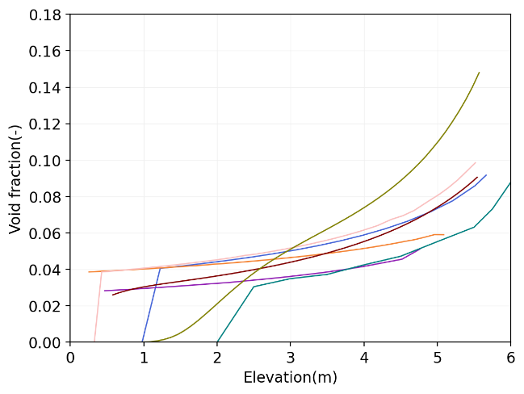 | 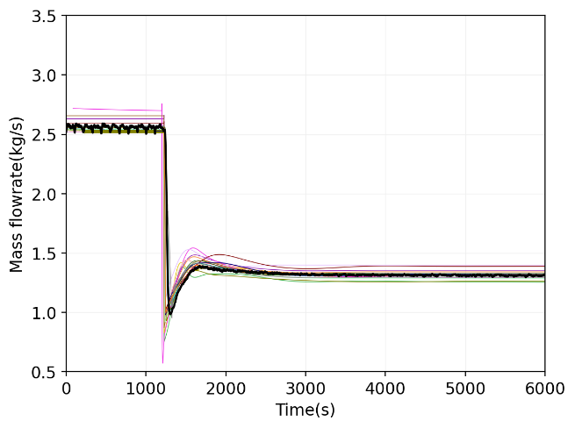
a) | b)
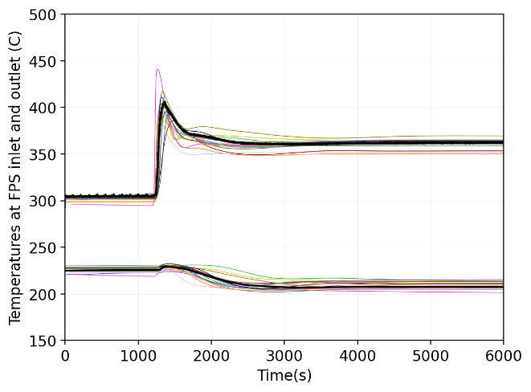 | 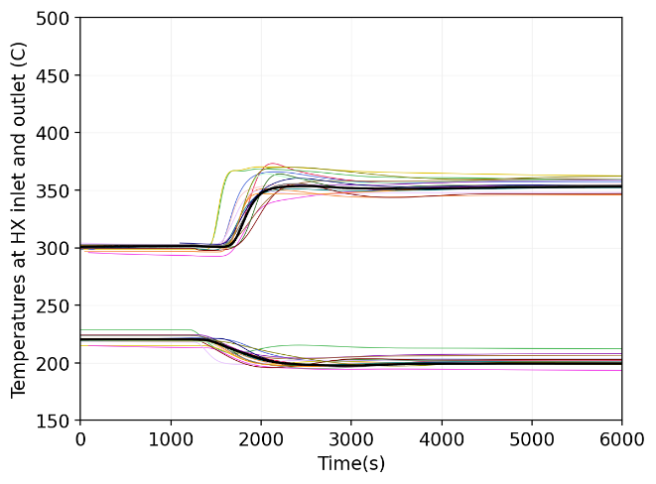
c) | d)
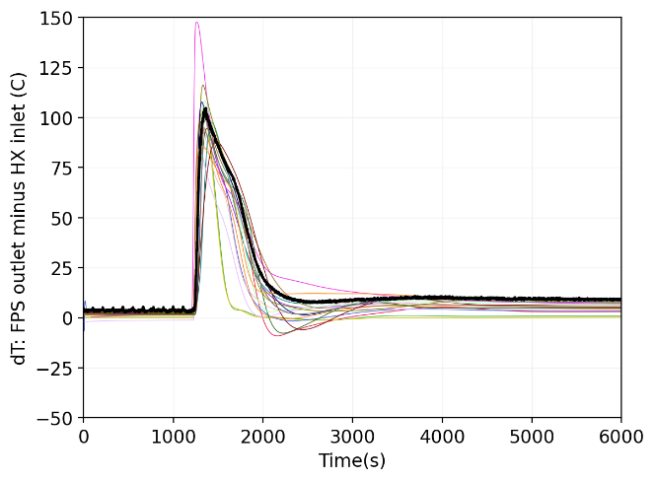 | 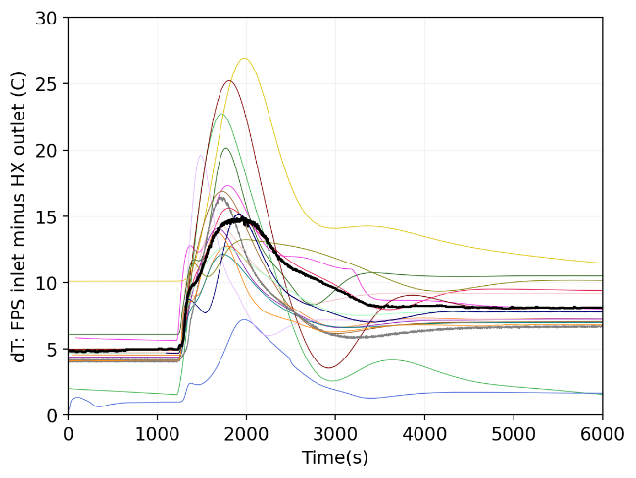
e) | f)
FIG. 23. Comparison of system thermal-hydraulic code results for test ADP10: (a) void-fraction distribution in the riser during the initial gas-lift forced-circulation phase; (b) LBE mass flow rate; (c) FPS inlet and outlet temperatures; (d) HX inlet and outlet temperatures; (e) temperature difference between FPS outlet and HX inlet; (f) temperature difference between FPS inlet and HX outlet.

ADP06
Test ADP06 has the same nominal FPS power as ADP10, but the power is deposited only in the seven central pins (FIG. 17). From a system-code point of view, the total power and loop boundary conditions are similar to ADP10, but the radial distribution of heat generation in the FPS is different. This makes ADP06 useful for checking whether a system-code model calibrated on integral quantities remains valid when the local bundle heat distribution changes.
FIG. 24 presents the WP1 results for ADP06. The predicted void-fraction distributions in FIG. 24(a) are similar in shape to those obtained for ADP10. The gas-lift modelling uncertainty remains comparable, because the initial argon flow rate and the overall loop configuration are unchanged. Differences in the void fraction again translate into differences in the predicted initial forced-circulation mass flow rate.
The mass-flow-rate transient in FIG. 24(b) is close to the ADP10 response. The flow rate is initially about 2.6–2.7 kg/s and decreases after the gas shut-off to a natural-circulation value of about 1.3 kg/s. The calculated curves reproduce the rapid loss of forced circulation and the recovery towards the final natural-circulation state. As in ADP10, the largest discrepancies occur during the short transition period immediately after gas injection is stopped.
The FPS inlet and outlet temperatures are shown in FIG. 24(c), while the HX inlet and outlet temperatures are shown in FIG. 24(d). The response is similar to ADP10. After the gas injection is switched off, the LBE mass flow rate decreases while the FPS power remains constant. Consequently, the FPS outlet temperature increases and shows a transient overshoot before stabilizing at the new natural-circulation level. The FPS inlet temperature slightly decreases because the reduced primary flow increases the residence time in the HX, while the secondary-side water boundary conditions remain close to the initial steady-state values.
The HX inlet temperature evolves more smoothly than the FPS outlet temperature. This is caused by heat losses, thermal mixing and the thermal inertia of the piping and structures between the FPS outlet and the HX inlet, which attenuate and smear the hot temperature front. The HX outlet and FPS inlet temperatures show a weaker but still visible transient response in the cold leg. Part of the small temperature increase between the HX outlet and the FPS inlet is associated with the thermal flow meter heat input.
The temperature-difference plots in FIG. 24(e) and FIG. 24(f) confirm these trends. The FPS outlet–HX inlet difference reflects heat losses and damping along the hot leg, while the FPS inlet–HX outlet difference reflects the cold-leg response and the additional heat input from the thermal flow meter. Overall, ADP06 confirms the main observations from ADP10, with the integral loop response governed primarily by total power, flow-rate reduction, HX cooling and loop thermal inertia.
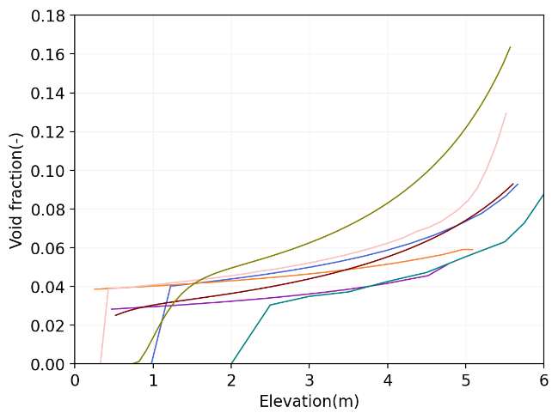 | 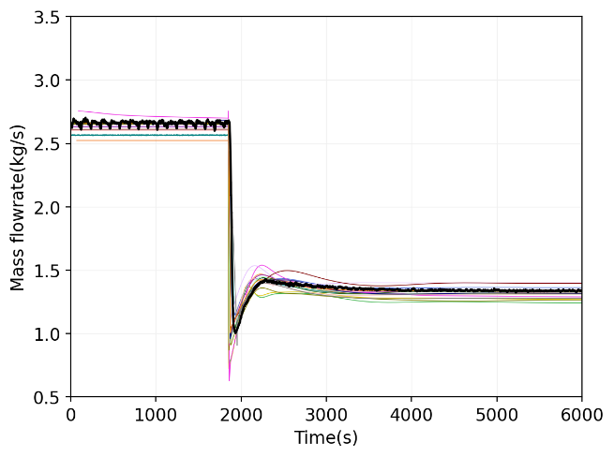
a) | b)
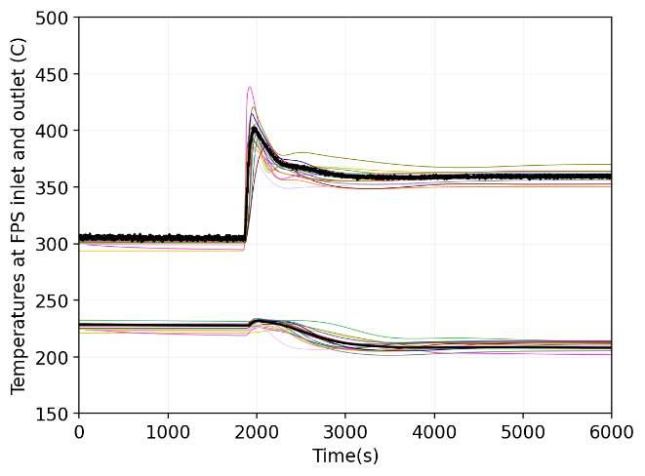 | 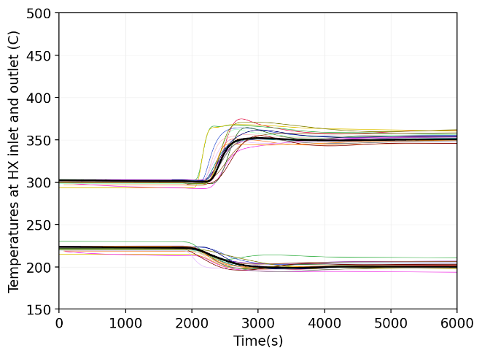
c) | d)
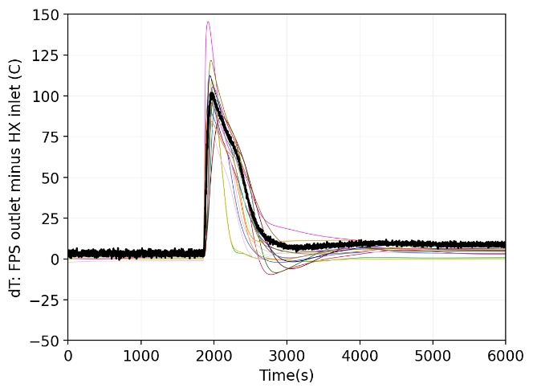 | 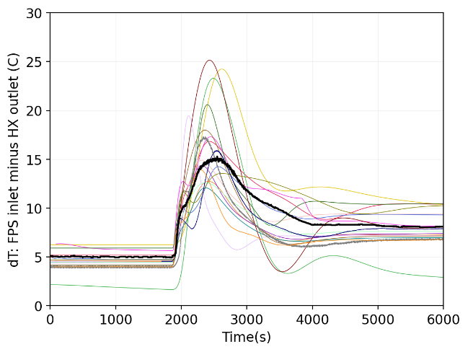
e) | f)
FIG. 24. Comparison of system thermal-hydraulic code results for test ADP06: (a) void-fraction distribution in the riser during the initial gas-lift forced-circulation phase; (b) LBE mass flow rate; (c) FPS inlet and outlet temperatures; (d) HX inlet and outlet temperatures; (e) temperature difference between FPS outlet and HX inlet; (f) temperature difference between FPS inlet and HX outlet.

Blind Phase Simulations (ADP07)
Test ADP07 was selected as the blind case. The 9 active pins are arranged in a 1/6th sector of the bundle (FIG. 20) and the nominal FPS power is increased to 38 kW. The wall heat flux on the active pins is therefore comparable to ADP06, while the total power is higher and the heating pattern is asymmetric.
FIG. 25 compares the WP1 results for ADP07. The predicted void-fraction distributions in FIG. 25(a) again show an increasing trend with elevation, but with a large spread among codes. Since the void fraction was not directly measured in the experiment, the comparison mainly reflects the different gas-lift models used to establish the initial forced-circulation state. This uncertainty affects the predicted forced-flow level before the transient.
The LBE mass-flow-rate response is shown in FIG. 25(b). The initial forced-circulation flow rate is higher than in ADP10 and ADP06, while the final natural-circulation flow rate is also higher. This is consistent with the larger total power in ADP07, which produces a larger temperature difference between the hot and cold legs and therefore a stronger buoyancy head. Most calculations reproduce the main sequence of the transient: rapid flow reduction after gas shut-off, followed by recovery and stabilization at the natural-circulation level.
The FPS inlet and outlet temperatures are shown in FIG. 25(c), and the HX inlet and outlet temperatures in FIG. 25(d). As in the open-phase tests, the FPS outlet temperature increases after the flow reduction and shows a transient overshoot before stabilizing. The FPS inlet temperature slightly decreases because the reduced primary flow increases the residence time in the HX, while the secondary-side water boundary conditions remain close to the initial steady-state values. The HX inlet temperature follows the FPS outlet response more smoothly, due to heat losses, thermal mixing and thermal inertia along the hot leg.
The temperature-difference plots in FIG. 25(e) and FIG. 25(f) confirm the same interpretation. The FPS outlet–HX inlet difference reflects attenuation of the hot front between the heat source and the heat sink. The FPS inlet–HX outlet difference is smaller and reflects the cold-leg response, including the small heat input from the thermal flow meter. Compared with ADP10 and ADP06, the higher power of ADP07 leads to larger temperature excursions and a stronger natural-circulation driving head.
Overall, ADP07 demonstrates that system codes are able to predict the main integral response of the NACIE-UP loop also for the asymmetric heating case. However, the detailed local redistribution of temperature inside the FPS cannot be fully assessed with integral system quantities and is addressed more directly in the CFD (see Section 6)and subchannel (see Section 7) work packages.
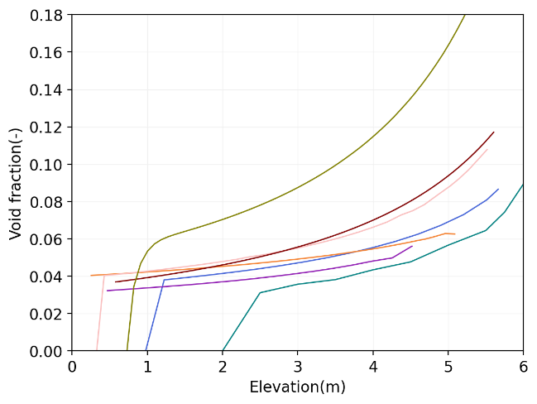 | 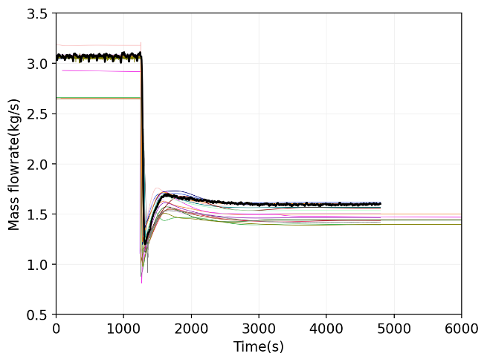
a) | b)
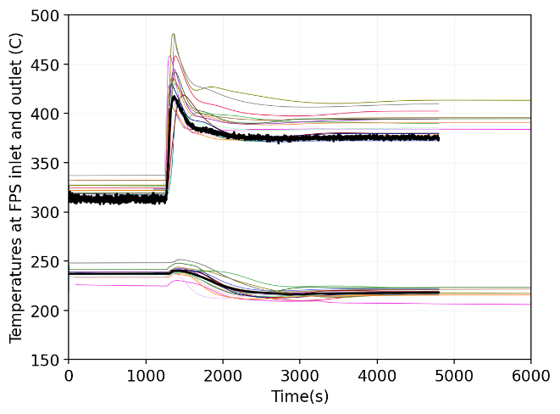 | 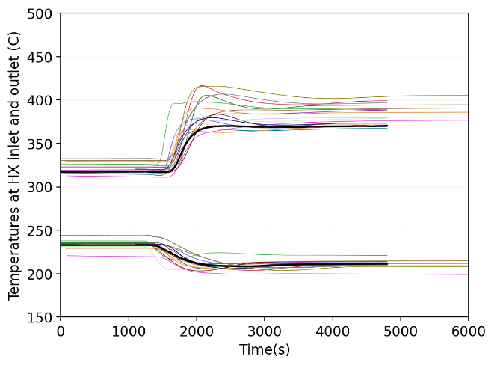
c) | d)
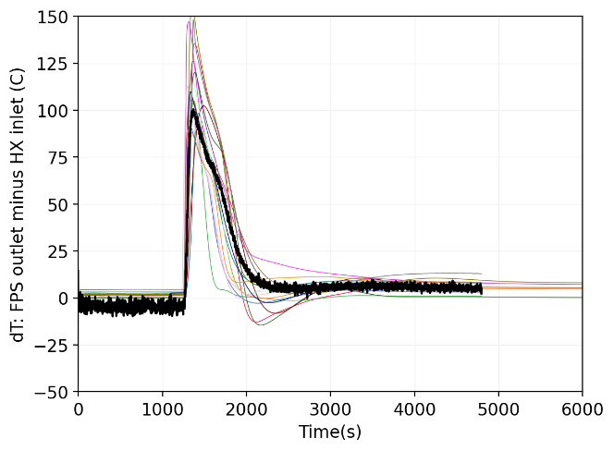 | 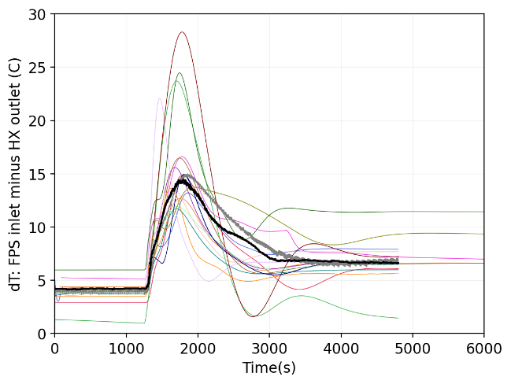
e) | f)
FIG. 25. Comparison of system thermal-hydraulic code results for test ADP07: (a) void-fraction distribution in the riser during the initial gas-lift forced-circulation phase; (b) LBE mass flow rate; (c) FPS inlet and outlet temperatures; (d) HX inlet and outlet temperatures; (e) temperature difference between FPS outlet and HX inlet; (f) temperature difference between FPS inlet and HX outlet.

DISCUSSION OF THE FORCED-TO-NATURAL CIRCULATION TRANSITION
The forced-to-natural circulation transition in NACIE-UP is governed by the balance between driving heads and hydraulic losses in the loop. During the initial forced-circulation phase, argon injection into the riser creates a two-phase gas-liquid mixture. Since the average density of this mixture is lower than the density of the single-phase LBE in the downcomer, a hydrostatic pressure difference is created between the two vertical legs of the loop. This gas-lift pressure head is added to the thermal buoyancy head produced by the temperature difference between the hot riser and the cold downcomer.
When the argon injection is stopped, the gas-lift contribution is rapidly removed. The void fraction in the riser collapses as the remaining gas is transported out of the active two-phase region. The loop therefore loses a major part of its driving force within a short time. The LBE mass flow rate decreases rapidly because the hydraulic resistance of the loop can no longer be balanced by the previous gas-lift head.
The minimum flow rate reached shortly after the gas shut-off is controlled by several competing effects. The first is fluid inertia, which prevents the flow from changing instantaneously. The second is hydraulic friction, which rapidly dissipates the kinetic energy of the initial forced flow. The third is the growth of the thermal buoyancy head: as the flow decreases while the FPS power remains constant, the temperature rise across the FPS increases. This makes the riser hotter and lighter, while the downcomer remains colder due to heat removal in the HX. The density difference between the two legs therefore increases and gradually establishes a new natural-circulation driving head.
The final natural-circulation state is reached when the buoyancy head is balanced by the single-phase hydraulic losses in the loop. In simplified form, the steady-state balance may be interpreted as:
driving buoyancy head ≈ distributed and local pressure losses.
The driving head increases with the vertical separation between heat source and heat sink and with the temperature difference between the riser and downcomer. The pressure losses increase with the square of the mass flow rate in turbulent conditions. Therefore, the natural-circulation flow rate adjusts to a lower value than the initial gas-lift forced flow, but it is still sufficient to remove the imposed heat. This explains why the mass flow rate decreases after gas shut-off, while the FPS outlet and HX inlet temperatures increase.
The heat exchanger plays a central role in this process. It defines the cold-leg temperature and therefore directly affects the density difference between the riser and downcomer. An overprediction of the HX heat-transfer capability would lead to excessive cooling of the downcomer and could distort the average loop temperature and the buoyancy head. For this reason, the thermal resistance of the HX double-wall structure and the stainless-steel powder gap is an important modelling parameter.
The transient temperature peaks observed in the FPS outlet, HX inlet and component temperature differences are a consequence of heat-transport delay and thermal inertia. Immediately after the flow reduction, the FPS heats the LBE more strongly because the same power is carried by a smaller mass flow rate. However, this hotter fluid reaches the HX only after a finite transport time. During this period, the heat source, heat sink and loop inventory are temporarily out of thermal equilibrium. The magnitude and duration of this mismatch depend on nodalization, loop volume distribution, metal heat capacity, thermal losses, and the HX model.
For heavy liquid metals, low Prandtl number effects are also relevant. LBE has high thermal conductivity, so thermal diffusion is strong compared with momentum diffusion. This affects heat transfer in the FPS and HX and makes the selection of appropriate liquid-metal heat-transfer correlations important. However, the WP1 comparison shows that, for the integral loop response, the dominant effects are the loop pressure balance, gas-lift representation, buoyancy generation, heat-exchanger performance and thermal inertia.

CONCLUSIONS
The WP1 system thermal-hydraulic benchmark assessed the capability of a broad range of system codes to simulate forced-to-natural circulation transients in the NACIE-UP LBE loop. The benchmark included two open-phase cases, ADP10 and ADP06, and one blind-phase case, ADP07.
The following conclusions can be drawn.
- The system codes generally reproduced the main physical sequence of the tests: gas-lift forced circulation, rapid loss of driving head after gas shut-off, mass-flow-rate reduction, increase of FPS temperature rise, and establishment of a lower natural-circulation flow rate.
- The predicted initial forced-circulation state is sensitive to the treatment of gas injection and void fraction in the riser. The relation between argon injection rate, void distribution and LBE mass flow rate is nonlinear and remains one of the largest modelling uncertainties for WP1.
- The final natural-circulation mass flow rate is mainly governed by the balance between buoyancy head and loop hydraulic losses. The higher power of ADP07 leads to a higher final natural-circulation flow rate than in ADP10 and ADP06, which is consistent with the larger temperature difference between the hot and cold legs.
- The transient temperature peaks after gas shut-off are more difficult to predict than the final steady states. These peaks depend on the representation of loop inertia, heat transport delay, heat losses, metal heat capacity and HX thermal performance.
- The heat exchanger model is essential for accurate prediction of the average loop temperature and the natural-circulation driving head. In particular, the double-wall tube structure and the stainless-steel powder gap should be represented consistently with the benchmark specification.
- For ADP10 and ADP06, the system-code results indicate that the integral loop response is mainly determined by total power and total mass flow rate. The difference between uniform heating and central-pin heating is more important for local bundle temperatures than for the integral system response.
- For ADP07, the system codes captured the main integral response of the asymmetric heating transient, but detailed local effects of the asymmetric power distribution require CFD or subchannel analysis.
- Overall, the WP1 results confirm that current system thermal-hydraulic codes are capable of simulating the principal behaviour of LBE loops during forced-to-natural circulation transition. Further improvements should focus on gas-lift modelling, heat-exchanger thermal resistance, thermal-loss characterization and transient heat-transport delays.

WP2: Computational Fluid Dynamics (CFD)

Introduction
Work Package 2 of the CRP is devoted to validation and benchmarking of CFD codes. The CFD benchmark is limited to the two steady states for each case, before and at the end of the forced-to-natural circulation transition.
The first (open) phase of the benchmark involved all benchmark participants building, verifying and optimizing CFD models based on the available experimental data for symmetric heating cases – ADP10 and ADP06. The second (blind) phase of the benchmark involved validating their final selected CFD model against the non-uniform asymmetric heating case – ADP07. The final phase of the benchmark involved refining the simulations based on the released data of ADP07.
The experimental facility was instrumented with a total of 67 thermocouples (TCs) inside the rod bundle. Temperature measurements were taken mostly at three measurement planes – A, B and C – separated by an axial distance of one wire-pitch. The positions of these planes relative to the start of active length (z = 0 mm) are 38, 300 and 562 mm respectively. At each measurement planes, there were 5 TCs in the bulk and 13 TCs in the solid pin cladding. In addition, one pin (#3) was instrumented with 13 TCs located at uniform distances from plane A to plane C. The locations of the TCs across the bundle cross-section are illustrated in FIG. 26. Here, each location is annotated with three numbers. These are TC serial numbers at planes A, B and C, respectively. The temperature prediction by each participant is evaluated at these 67 TC locations.
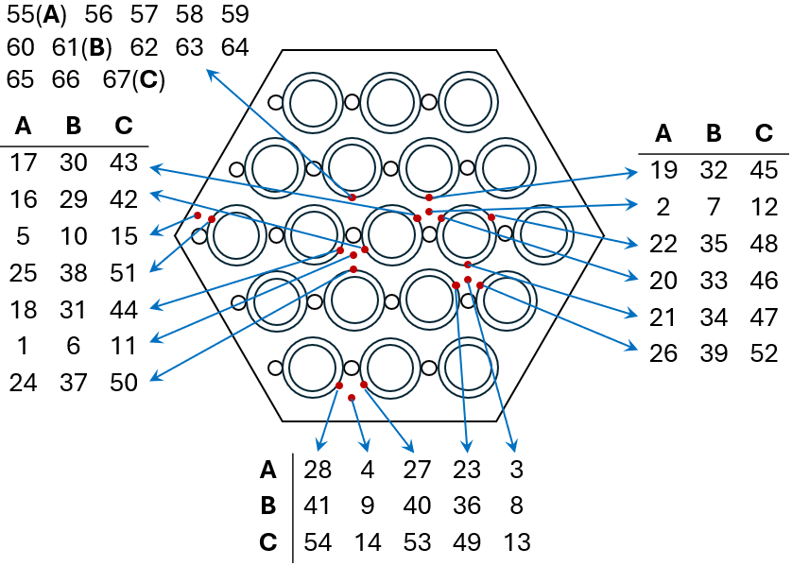
FIG. 26. Location of thermocouples (TCs) across the bundle cross-section
In order to quantify the difference between the CFD prediction and experimental data, a local deviation between the CFD and experiments, $\left(T_{i,CFD}-T_{i,exp}\right)$, may be calculated for any TC location, $i$. In order to assess the overall performance of a CFD model, two different metrics are used herein:
- the maximum absolute deviation (MAD), Eq. (3):
 | $$\max_{1≤i≤67}\left|T_{i,CFD}-T_{i,exp}\right|$$ | (3)
- the root-mean-square deviation (RMSD), Eq. (4):
 | $$\sqrt{\frac{1}{N}\sum_{1≤i≤67}{{\left(T_{i,CFD}-T_{i,exp}\right)}^{2}}}$$ | (4)

Participants
The CFD benchmark consisted of 12 participating organizations. The participants were allowed to submit multiple entries, using different solvers and/or computational models. A list of participants and number of entries submitted by each participant is given in Table 20. Also given in the table, are abbreviations given to each participant which will be used in rest of this chapter.
Table 20. List of participants in WP2
No | Participants | Abbr. | Entries
1 | International Academy of Neutron Science, China | IANS | 1
2 | Xi'an Jiaotong University, China | XJTU | 1
3 | Karlsruhe Institute of Technology, Germany | KIT | 1
4 | Joint Research Centre, European Commission | JRC | 1
5 | Indira Gandhi Centre for Atomic Research, India | IGCAR | 1
6 | Italian National Agency for New Technologies, Energy and Sustainable Economic Development, Italy | ENEA | 2
7 | University of Pisa, Italy | UniPi | 1
8 | Institute for Nuclear Research Pitesti, Romania | RATEN | 1
9 | Korea Atomic Energy Research Institute, South Korea | KAERI | 1
10 | Nuclear Research and Consultancy Group, The Netherlands | NRG | 1
11 | Dollezhal Research and Development Institute of Power Engineering, Russia | NIKIET | 4
12 | Argonne National Laboratory, USA | ANL | 2

The final selection of the computational domain by each participant is presented in Table 21. The choice of modelling the inlet bend (fluid domain), pin internals (solid domain), and exterior wrapper (solid domain) was left open for the participants. Table 21 lists the participants modelling choices for these components. Also listed in the table is the selection of pin-wire contact treatment by each participant. Here, ‘II’ denotes inward indentation of the wire inside the solid pin; ‘FL’ denotes flattening of the wire at the end near the adjacent pin; ‘RC’ denotes rounding the pin-wire corner shape; and ‘MC’ denotes an ad-hoc modified corner shape. It should be noted that JRC modelled a bare rod bundle for the CFD calculations, neglecting the wires altogether. RATEN employs the ‘II’ approach for the wire-wrap which increases the flow area up to 3.5%. Finally, UniPi employs a geometry extraction method to include the solid wire, instead of modelling the wires explicitly.
Table 22 lists the final selection of computational models used by each participant. Each participant selected the CFD solver, turbulence model and thermal turbulence model independently, as listed in the table. Also listed in the tale, is the relative size of the computational mesh employed by each participant. Since the domain (lengths) modelled by each participant may be different, comparing the total mesh sizes directly is unfair. Thus, the table shows the mesh size as total number of mesh elements in the fluid domain per until length of the modelled rod bundle.
Table 21. Domain selection by each participant
Color code | Org. | Inlet  Bend | Pin  Internals | Exterior  Wrapper | Pin-wire  contact
 | IANS | × |  |  | II
 | XJTU |  |  |  | II, RC
 | KIT | × |  |  | MC
 | JRC | × |  |  | -
 | IGCAR |  |  | × | II
 | ENEA-1 | × |  |  | MC
 | ENEA-2 | × |  |  | MC
 | UniPi | × |  |  | -
 | RATEN | × |  | × | II
 | KAERI | × |  | × | MC
 | NRG |  |  |  | II, RC
 | NIKIET-1 |  |  |  | MC
 | NIKIET-2 |  |  |  | MC
 | NIKIET-3 |  |  |  | MC
 | NIKIET-4 |  |  |  | MC
 | ANL-1 | × |  | × | II, FL, RC
 | ANL-2 | × |  | × | II, FL, RC

Table 22. Computational model selection by each participant
Color code | Org. | Solver | Turbulence Model | Thermal Model | Mesh Size  (10⁶ / m)
 | IANS | ANSYS Fluent | $k$-$ω$ SST | ${Pr}_{t}$ = 1.5 | 34.1
 | XJTU | ANSYS Fluent | $k$-$ω$ SST | Cheng-Tak [11] | 26.6
 | KIT | STAR-CCM+ | $k$-$ω$ SST | ${Pr}_{t}$ = 0.9 | 64.8
 | JRC | ANSYS CFX | RSM | ${Pr}_{t}$ = 0.85 | 14.5
 | IGCAR | ANSYS Fluent | $k$-$ω$ SST | ${Pr}_{t}$ = 0.85 | 18.0
 | ENEA-1 | ANSYS CFX | $k$-$ω$ SST | ${Pr}_{t}$ = 3.5 | 6.1
 | ENEA-2 | OpenFOAM | $k$-$ω$ SST | $k_{θ}$-$ε_{θ}$ model [12] | 8.6
 | UniPi | STAR-CCM+ | $k$-$ω$ SST | ${Pr}_{t}$ = 1.5 | 3.5
 | KAERI | OpenFOAM | $k$-$ω$ SST | ${Pr}_{t}$ = 1.5 | 45.3
 | RATEN | OpenFOAM | $k$-$ω$ SST | ${Pr}_{t}$ = 0.9 | 22.2
 | NRG | STAR-CCM+ | $k$-$ω$ SST | ${Pr}_{t}$ = 2.0 | 41.7
 | NIKIET-1 | ANSYS CFX | Mod.$k$-$ω$ SST | ${Pr}_{t}$ model [13] | 11.5
 | NIKIET-2 | ANSYS Fluent | Mod.$k$-$ω$ SST | ${Pr}_{t}$ model [13] | 11.5
 | NIKIET-3 | LOGOS | Mod.$k$-$ω$ SST | ${Pr}_{t}$ model [13] | 11.5
 | NIKIET-4 | STAR-CCM+ | Mod.$k$-$ω$ SST | ${Pr}_{t}$ model [13] | 16.1
 | ANL-1 | NekRS / Cardinal | LES Filter | - | 255 (GLL)
 | ANL-2 | NekRS / Cardinal | $k$-$τ$ | ${Pr}_{t}$ = 0.85 | 255 (GLL)

Open Phase Simulations (ADP10 and ADP06)

ADP10
The temperature predictions by each participant for the cases ADP10 SS1 and SS2 are presented in FIG. 27 and FIG. 28, respectively. Here, the black markers denote the experimental measurements, while the coloured markers (as given in Table 21) denote the participants’ data. In the figure, the TC locations are divided into several sections by means of vertical dashed lines. The first three sections with 5 data points each denote the fluid TCs at planes A, B and C. The next three sections with 12 data points each, denote the solid cladding TCs at planes A, B and C. The final section with 13 data points denotes the TCs on the instrumented pin #3, starting with TC #55 at plane A until TC #67 at plane C.
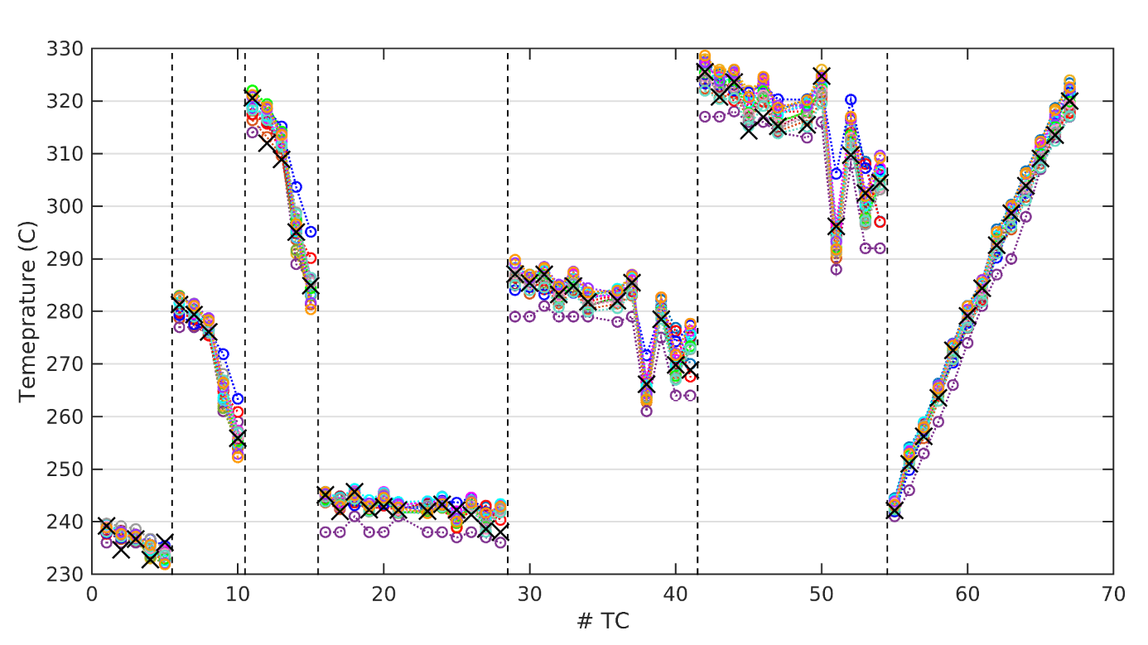
FIG. 27. Temperature predictions by each participant for ADP10 SS1. Black markers (×) denote the experimental measurements
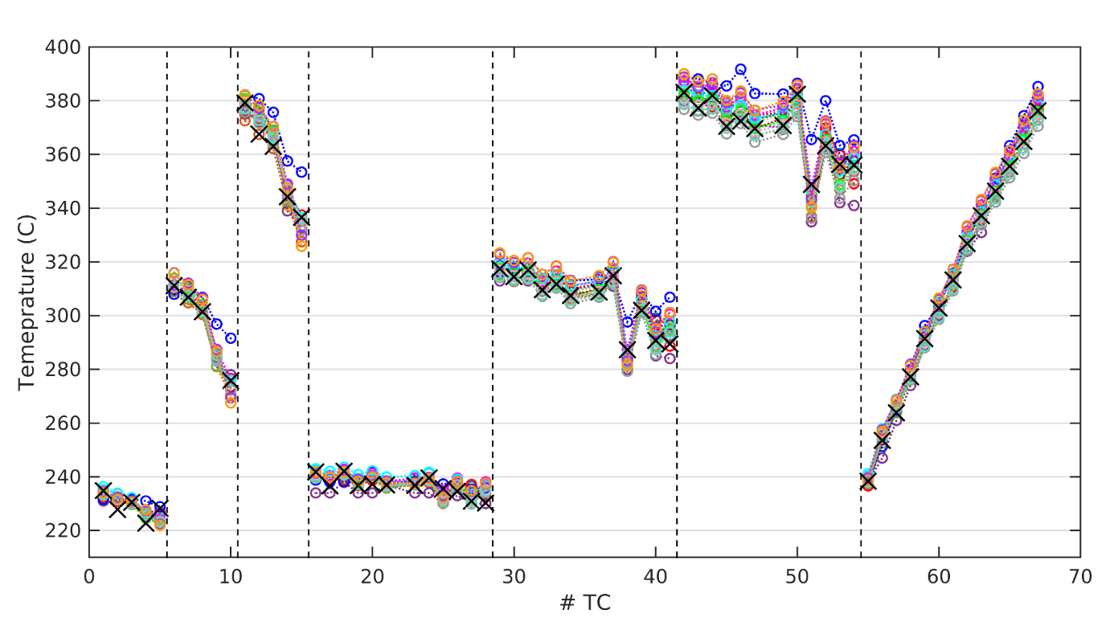
FIG. 28. Temperature predictions by each participant for ADP10 SS2. Black markers (×) denote the experimental measurements
It can be seen in FIG. 27 and FIG. 28 that all CFD results generally capture the trend of temperature distribution quite well for uniform symmetric heating. It should be noted that JRC only models a bare rod bundle neglecting the wire-wraps and RATEN models sunken wire-wraps increasing the flow area. Both the above modelling strategies result in large deviations in comparison to the experimental data. With the exception of the JRC and RATEN submissions, all temperature predictions are seen to be within 8°C and 13°C from the experimental measurements at any TC location for SS1 and SS2, respectively. These deviations are within 12% of the total rise of temperature in the bundle. The data from different submissions is seen to be quite precise for inner subchannel TC locations but slightly dispersed for outer subchannels TC locations. The maximum scatter between all CFD results is only 13°C and 17°C for SS1 and SS2, respectively.
Looking at the results, it may be concluded that accurate modelling of temperature distribution for this case seems quite straight-forward. This is not surprising because with uniform and symmetric heating, the temperature distributions are largely dependent on an overall heat balance in the rod bundle which CFD models can capture very well.

ADP06
The case of non-uniform heating appears to be less simple, as apparent in FIG. 29 and FIG. 30 showing the temperature predictions for ADP06 SS1 and SS2, respectively. Here, the inner 7 pins are heated resulting in the inner subchannels showing a larger temperature than the intermediate and outer layers of subchannels. The rotation of the wire and non-uniform heating makes the temperature distribution dependent on fluid flow.
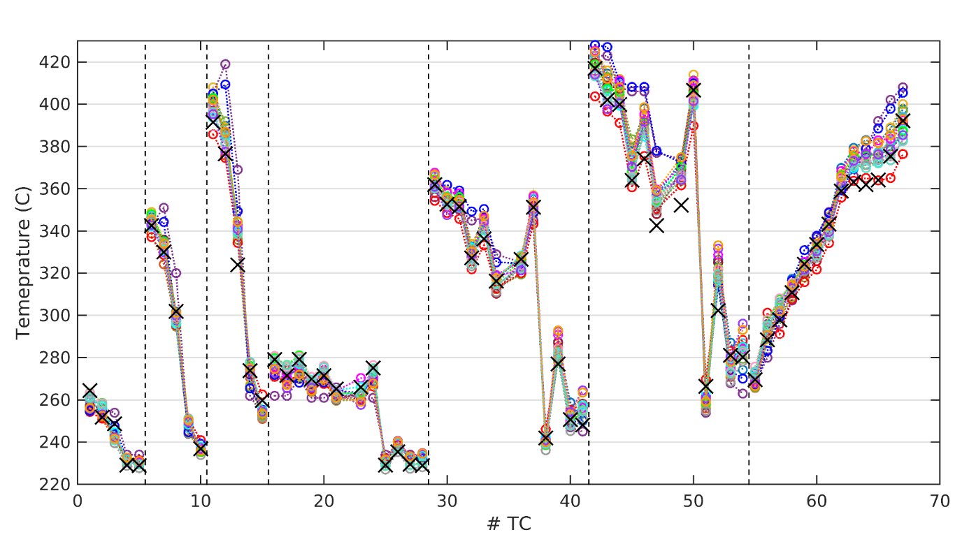
FIG. 29. Temperature predictions by each participant for ADP06 SS1. Black markers (×) denote the experimental measurements
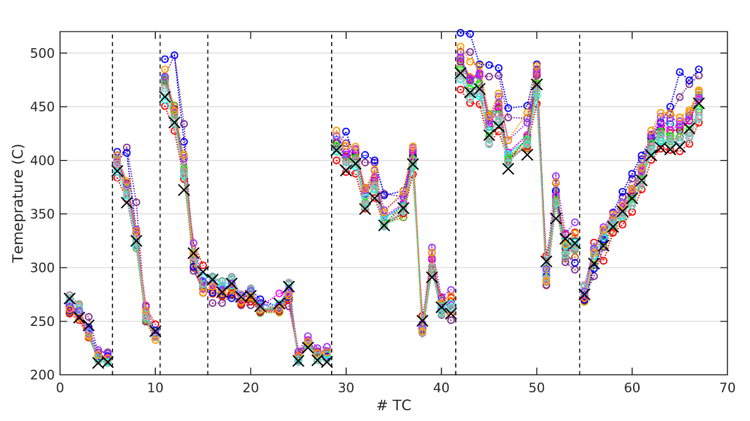
FIG. 30. Temperature predictions by each participant for ADP06 SS2. Black markers (×) denote the experimental measurements
At plane C, it is observed that most CFD models overpredict the temperature in the intermediate subchannels (TC locations #13, 47, 49, 52), while underpredicting the temperature in outer subchannels (TC locations #14, 15, 51, 53, 54).
It appears that most CFD models employed here underpredict the mixing and distribution of flow from interior to outer subchannels. Thus, the intermediate subchannels are predicted to be hotter and outer subchannels are predicted to be colder, compared to the experimental measurements.
The rise of temperature along the length of the bundle in any subchannel also shows a non-linear trend, as shown by local ‘flattening’ of temperature in the last section in the figure (TC locations #63-65). Most CFD models also over-predict the temperature here. With the exception of the JRC and RATEN submissions, all temperature predictions are seen to be within 31°C and 40°C from the experimental measurements at any TC location for SS1 and SS2, respectively. This is about 45% and 30% of the total rise of temperature in the bundle for SS1 and SS2, respectively. Here, the maximum scatter between all CFD results is about 24°C and 40°C for SS1 and SS2, respectively.

Temperature deviation
The local temperature deviations, for each of the 67 TC location, are presented for ADP10 in FIG. 31 and for ADP06 in FIG. 32.
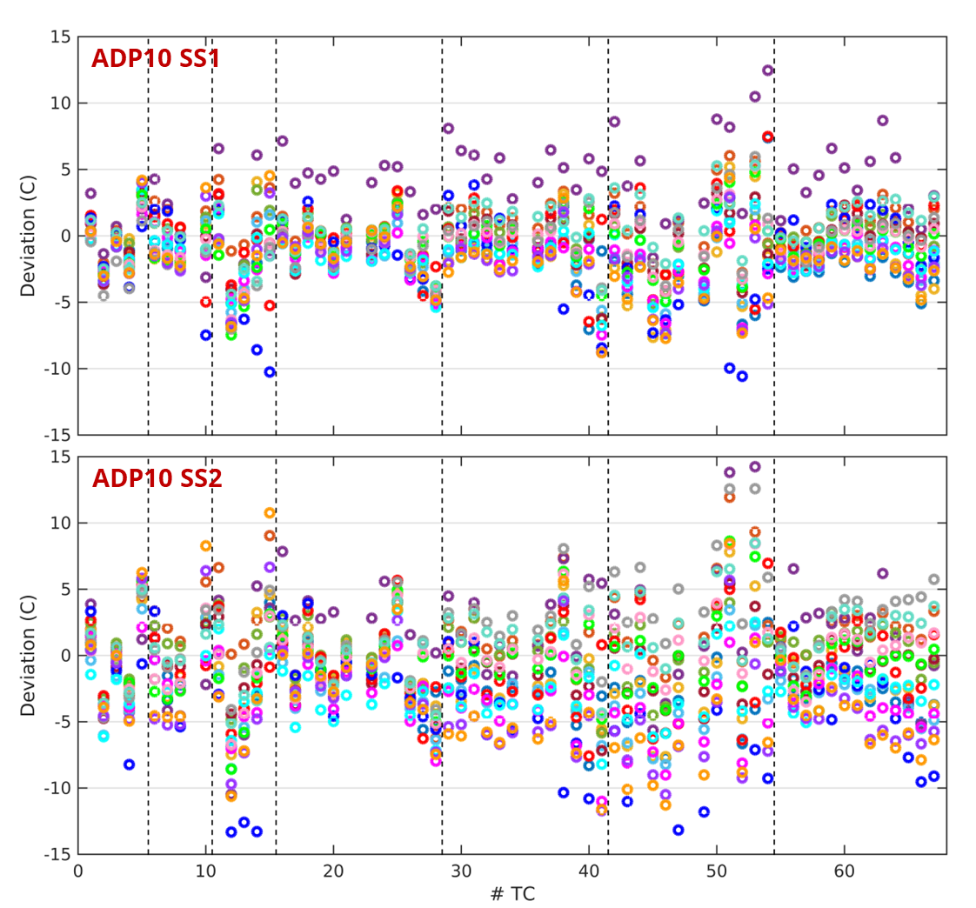
FIG. 31. Temperature deviations for ADP10 (top) SS1 and (bottom) SS2
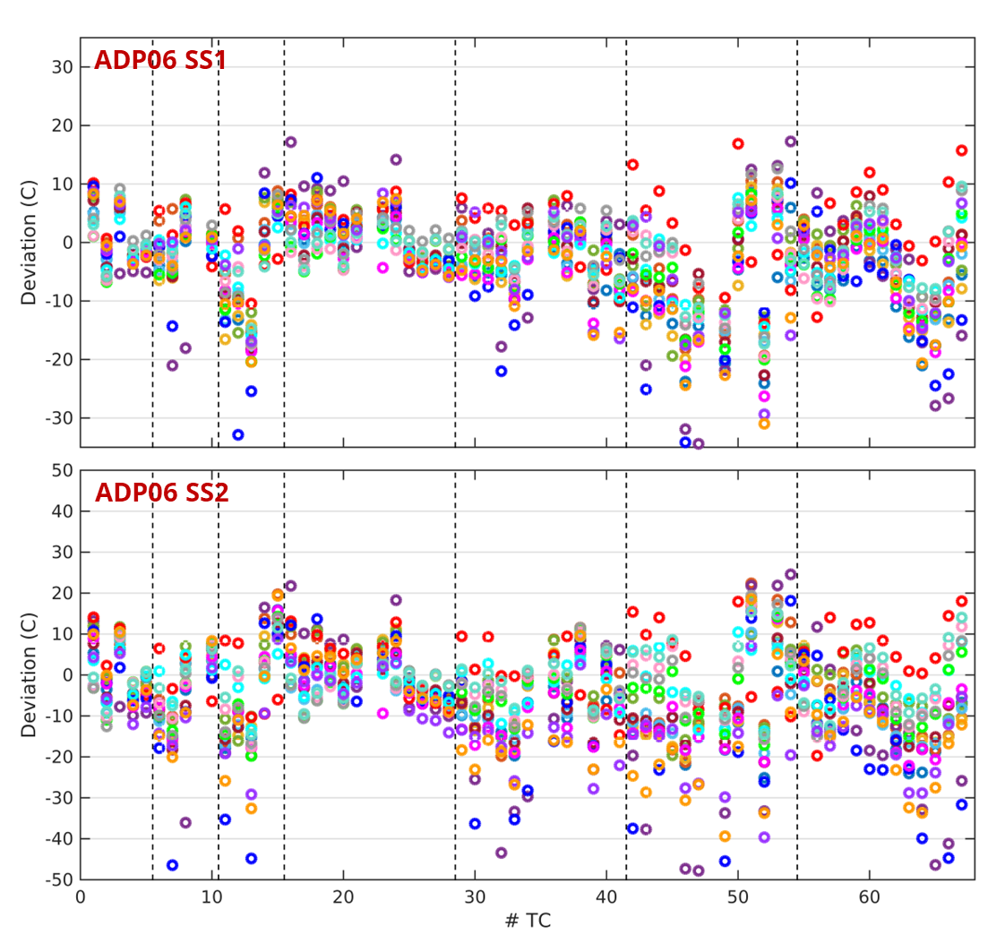
FIG. 32. Temperature deviations for ADP06 (top) SS1 and (bottom) SS2
The maximum absolute deviation and root-mean-square deviation among all TC locations, for the four steady state cases of the open phase, are presented in Table 23.
Table 23. Temperature deviations for open phase simulations
Org. | RMS Deviation (°C) |  |  |  | Max. Deviation (°C)
Org. | 10 SS1 | 10 SS2 | 06 SS1 | 06 SS2 | 10 SS1 | 10 SS2 | 06 SS1 | 06 SS2
IANS | 3.5 | 3.7 | 10.6 | 13.3 | 7.4 | 8.3 | 24.1 | 25.1
XJTU | 2.5 | 3.9 | 7.6 | 12.2 | 6.3 | 11.9 | 19.3 | 22.4
KIT | 3.3 | 3.8 | 9.3 | 12.2 | 7.7 | 7.8 | 19.9 | 20.3
JRC | 5.3 | 5.5 | 17.6 | 29.0 | 12.5 | 15.1 | 45.1 | 62.8
IGCAR | 2.1 | 2.3 | 7.5 | 8.7 | 6.2 | 5.8 | 19.4 | 19.6
ENEA-1 | 2.5 | 3.9 | 7.7 | 11.5 | 5.9 | 8.5 | 17.7 | 19.1
ENEA-2 | 2.0 | 2.4 | 7.9 | 11.6 | 6.2 | 7.2 | 22.7 | 21.3
UniPi | 2.8 | 3.5 | 7.5 | 9.6 | 7.5 | 7.6 | 16.9 | 19.7
RATEN | 4.5 | 9.2 | 15.4 | 32.2 | 10.6 | 19.4 | 44.2 | 69.6
KAERI | 2.7 | 4.5 | 9.7 | 12.9 | 7.5 | 11.0 | 26.3 | 22.1
NRG | 2.2 | 2.7 | 6.6 | 6.7 | 6.4 | 7.1 | 18.3 | 13.7
NIKIET-1 | 2.4 | 3.1 | 8.2 | 9.7 | 7.5 | 8.6 | 20.3 | 19.7
NIKIET-2 | 2.1 | 2.9 | 7.2 | 8.7 | 6.3 | 8.4 | 19.5 | 17.5
NIKIET-3 | 2.4 | 4.5 | 7.1 | 9.2 | 7.0 | 12.6 | 17.2 | 19.3
NIKIET-4 | 2.3 | 3.0 | 6.4 | 7.7 | 5.3 | 8.5 | 17.3 | 15.5
ANL-1 | 3.3 | 6.1 | 8.8 | 17.7 | 8.8 | 11.7 | 29.4 | 39.6
ANL-2 | 3.6 | 6.6 | 10.9 | 20.0 | 8.8 | 11.6 | 31.0 | 39.4

Blind Phase Simulations (ADP07)
The second phase of the benchmark involved employing the CFD models, which were based on the open cases, for the blind cases of ADP07 (SS1 and SS2). The experimental data for these blind cases was hidden from the participants. FIG. 33 and FIG. 34 present the temperature predictions by each participant for the cases ADP07 SS1 and SS2, respectively, in comparison to the experimental data. The heated pins are located in one-third sector of the bundle, resulting in larger temperatures in that region. The rotation of the wire further disperses the higher temperatures towards adjacent subchannels.
At plane C, it can be seen that most CFD models underpredict the temperature in subchannels surrounded by heated pins (TC locations #11, 42, 44, 50, 51), while overpredicting in subchannels adjacent to the heated sector in the bundle (TC locations #13, 46, 47, 49, 52).
As the wire rotates around pin #3, the CFD models also predict local drops in temperature (TC locations #59-60, #65-66) along the length of the pin, as seen in the last section of FIG. 34. The experimental measurements reveal that the temperature does not undergo a local drop, but only a slight flattening.
With the exception of the JRC and RATEN submissions, all temperature predictions are seen to be within 45°C and 52°C from the experimental measurements for SS1 and SS2, respectively. These deviations are 57% and 35% of the total rise of temperature in the bundle for SS1 and SS2, respectively. The maximum scatter between all CFD results is about 41°C for both SS1 and SS2.
The above two features of the temperature predictions seem to suggest that for these two cases, most CFD models employed overpredict the mixing and distribution of flow from the subchannels inside the heated sector to those outside. This is somewhat in contrast to the findings of the open phase results for ADP06 cases.
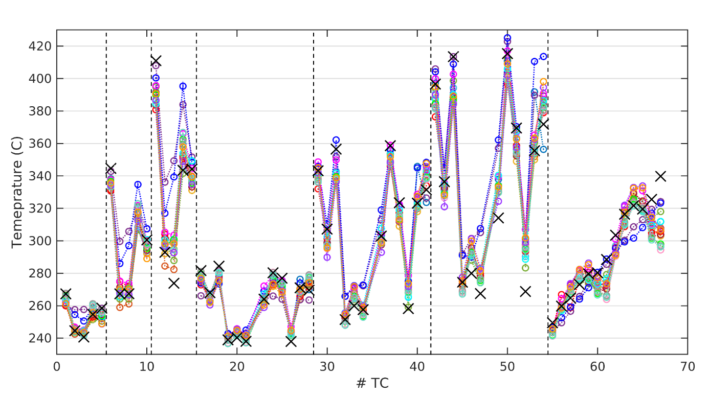
FIG. 33. Temperature predictions by each participant for ADP07 SS1. Black markers (×) denote the experimental measurements
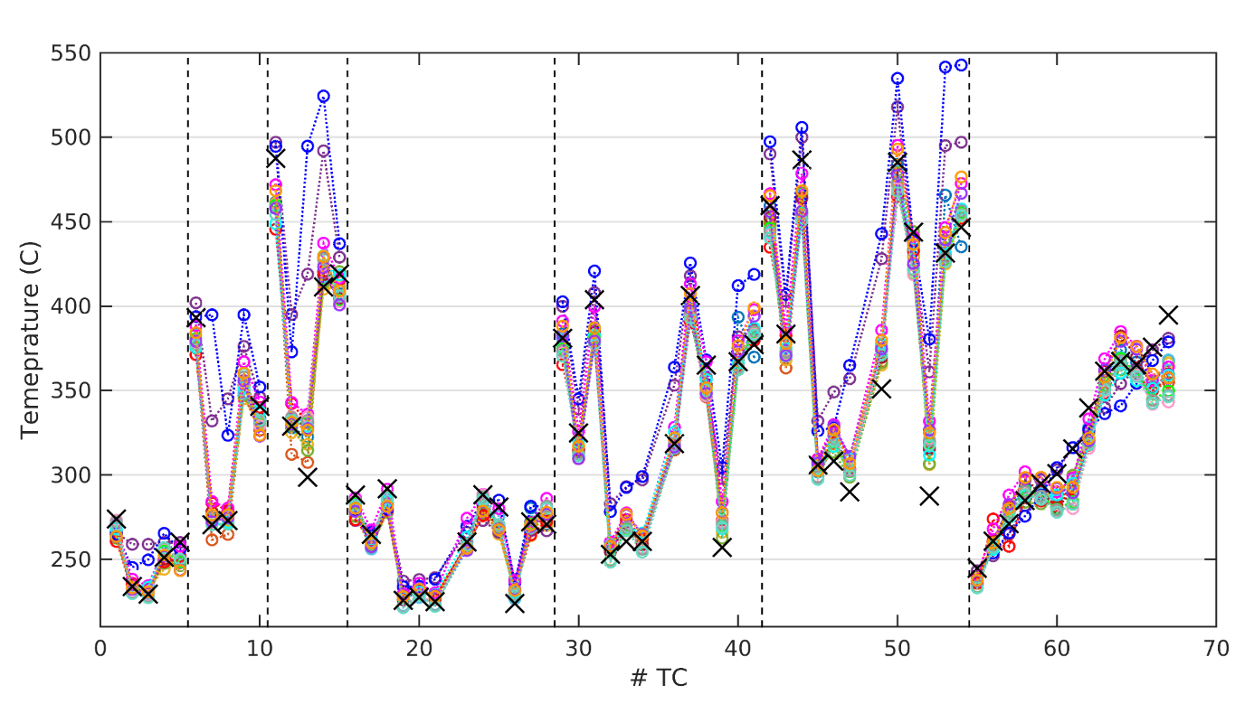
FIG. 34. Temperature predictions by each participant for ADP07 SS2. Black markers (×) denote the experimental measurements

Temperature deviation
The local temperature deviations, for each of the 67 TC location, are presented for ADP07 in FIG. 35.
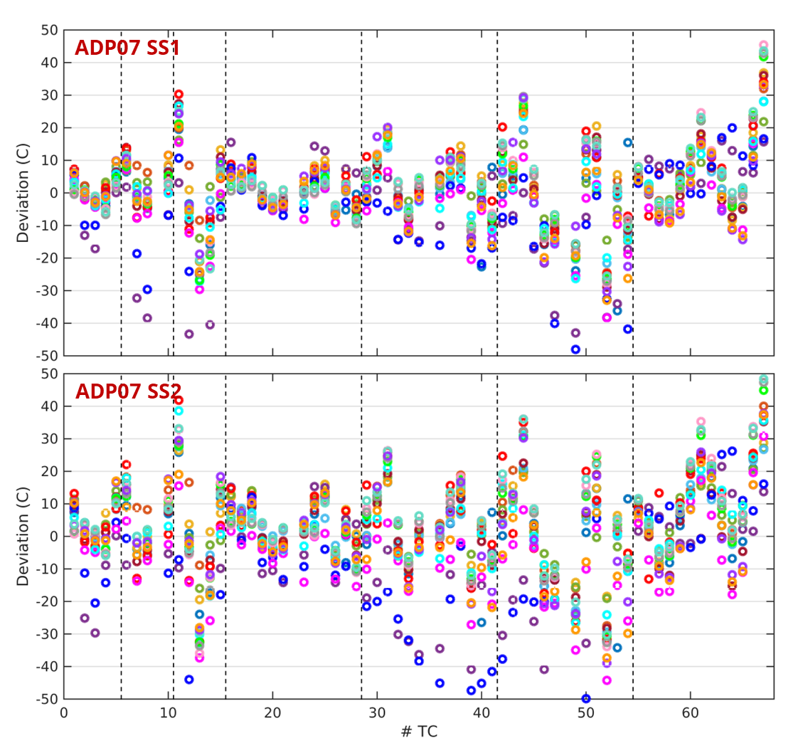
FIG. 35. Temperature deviations for ADP07 SS1 (top) and SS2 (bottom)
The maximum absolute deviation and root-mean-square deviation among all TC locations, for the two steady state cases of the blind phase, are presented in Table 24.
Table 24. Temperature deviations for blind phase simulations
Org. | RMS Deviation (°C) |  | Max. Deviation (°C)
Org. | 07 SS1 | 07 SS2 | 07 SS1 | 07 SS2
IANS | 13.2 | 15.5 | 36.2 | 37.4
XJTU | 11.9 | 15.9 | 32.0 | 40.0
KIT | 13.3 | 11.7 | 36.8 | 28.7
JRC | 21.7 | 39.1 | 75.5 | 120.5
IGCAR | 8.2 | 11.2 | 21.9 | 27.5
ENEA-1 | 10.8 | 13.3 | 28.1 | 32.8
ENEA-2 | 13.5 | 14.7 | 36.0 | 35.2
UniPi | 13.3 | 17.7 | 34.0 | 41.8
RATEN | 22.3 | 54.4 | 65.5 | 196.2
KAERI | 13.3 | 16.7 | 38.3 | 44.3
NRG | 11.6 | 15.3 | 28.0 | 38.6
NIKIET-1 | 13.7 | 16.9 | 41.8 | 44.9
NIKIET-2 | 14.2 | 18.8 | 45.4 | 51.6
NIKIET-3 | 14.0 | 17.4 | 42.8 | 47.3
NIKIET-4 | 14.0 | 17.9 | 43.6 | 48.4
ANL-1 | 13.9 | 17.0 | 32.9 | 39.0
ANL-2 | 13.5 | 15.8 | 33.2 | 37.4

Normalization of temperature deviations
The sections above quantify the differences between the temperature prediction and experimental measurements based on maximum absolute deviation and root-mean-square deviation among TC locations. These deviations are presented in absolute units, i.e. °C or K. However, to enable meaningful comparison of the model performance and extrapolate it to reactor conditions, the deviations must be normalized by a reference value, $T_{ref}$.
There are several ways to define an appropriate $T_{ref}$. Understanding of each normalization approach and what they represent is essential before they can be employed for comparison or extrapolation. A brief overview to some of the normalization approaches is presented below.

Total rise of temperature
The total rise of bulk fluid temperature in the entire bundle may be chosen as $T_{ref}$, Eq. (5).
 | $$T_{i,ref}=ΔT_{i}=T_{i,exp}-T_{in,FPS}$$ | (5)
where $T_{in,FPS}$ and $T_{out,FPS}$ are the inlet and outlet bulk temperatures of the fuel pin simulator (FPS) section of the bundle.

Local rise of temperature
The local rise of temperature at each TC location may be chosen as $T_{ref}$, Eq. (6). Thus, the deviation at each TC location, $i$, is normalized,

 | $$T_{i,ref}=ΔT_{i}=T_{i,exp}-T_{in,FPS}$$ | (6)
where $T_{i,exp}$ is the experimental measurement at TC location, $i$.

Friction temperature
The friction temperature may be used as $T_{ref}$, Eq. (7).
 | $$T_{ref}=T_{τ}=\frac{q_{w}}{u_{τ}ρC_{p}}$$ | (7)
where $u_{τ}$ is the friction velocity which may be calculated from the pressure loss correlations such as UCTD [14], PCTD [15], etc. for wire-wrapped rod bundles.

Wall-bulk ‘film’ temperature difference
The wall-bulk ‘film’ temperature may be used as $T_{ref}$, Eq. (8).
 | $$T_{ref}=ΔT_{w-b}=\frac{q_{w}}{Nu_{ref}}⋅\frac{L}{λ}$$ | (8)
where $Nu_{ref}$ is the reference Nusselt number which may be estimated from correlations such as by Mikityuk [16], Ushakov [17], Kazimi-Carelli [18].

Conclusions
A total of 14 benchmark submissions from 10 participating organisations were included in WP2. Experimental measurements for symmetric (uniform and non-uniform) heating cases were used to build, verify and optimize CFD models by each participant independently. The final CFD models were then validated against experimental measurements for non-uniform asymmetric heating case.
During the open phase simulations, it was observed that all the CFD models were able to predict the temperature distribution with reasonable accuracy for symmetric uniform heating, with local temperature deviations within 10% from the experimental data. The predicted temperature distribution for uniform heating cases is more or less directed by the heat balance, which CFD models were able to capture quite well. The accuracy, however, dropped when considering non-uniform heating, with the local temperature deviations observed to be within 35%.
During the blind phase simulations for asymmetric non-uniform heating case, a considerable drop in accuracy was observed, with the local temperature deviations as high as 55%. For the non-uniform and, especially, asymmetric heating cases, the temperature distribution appears to be highly dependent on the flow such as inter-subchannel mixing from active to inactive regions. Accurate prediction of flow is then paramount to reasonable accuracy in temperature prediction. CFD models, which perform well for uniform heating, may still lead to large deviations for non-uniform heating case. Further investigations, involving verification of detailed flow prediction must be performed for lower-order CFD models before they can be faithfully used for such cases.

WP3: Subchannel Analysis

Introduction
Work Package 3 of the CRP is devoted to the benchmarking of Subchannel (SC) codes. SC codes have been mainly used to simulate the two steady states for each case, before and at the end of the forced-to-natural circulation transition. Some participant also used them to simulate the transition phase either with the coupling of a system code or, for the open cases, directly exploiting experimental data for boundary conditions.
The first (open) phase of the benchmark involved all benchmark participants building, verifying and optimizing models based on the available experimental data for symmetric heating cases – ADP10 and ADP06. The second (blind) phase of the benchmark involved validating their final selected model against the non-uniform asymmetric heating case – ADP07. The final phase of the benchmark involved refining the simulations based on the released data of ADP07.
Quantitative results are reported in the Chapter exploiting the following definitions:
$\left|ε\right|$ is the absolute difference between computed and measured values of a TC;
${\left|ε\right|}_{ave}$ is the average of $\left|ε\right|$ over all TCs;
${\left|σ\right|}_{\left|ε\right|}$ is the standard deviation of $\left|ε\right|$;
${\left|ε\right|}_{max}$ is the maximum value of $\left|ε\right|$.

Description of expected and optional output
All participants were expected to produce results to be compared with the 67 TC of the FPS for the pre- and post-transition steady states of the three cases.
Results related to the transition were optional and based on the various codes capabilities. Furthermore, to gain insights for the comparison against experimental data, participants could provide information related to the coolant mass flow rate profile inside the FPS for comparison against a CFD among the one of WP2.

Participants
A broad range of SC codes has been employed in the WP, including system thermal-hydraulics codes that incorporate SC-like models for the pin bundle section. A total of 11 organizations have been involved with 10 different codes, using either a SC code or a system code with SC capabilities. The full list of codes by organization is presented in Table 1. The main modelling choices or features of each SC are also summarized, with the following meanings:
Wire model type (correlation) refers to the approach used to axially resolve the wire, which can be either lumped or distributed (i.e., when the wire position is explicitly taken into account at different axial elevations). The correlation indicates the reference used to model energy exchange due to wire sweeping.
Rod conduction exchange refers to the capability to account for energy transfer among SCs through conduction in the solid pin. This effect is considered important in cases of extreme temperature gradients within the bundle.
Clad-coolant exchange refers to the correlation used for the Nusselt number for determining the temperature difference between the outer clad surface and the bulk coolant.
As visible in Table 25, most SC codes rely on a lumped wire model and use the correlation developed by Cheng and Todreas [19]. Rod conduction effects are also considered by many participants, although different approaches are adopted.
Table 25. List of SC codes used in WP3. Main models adopted are also reported.
Organization (Country) | SC code | Wire model type (correlation) | Rod conduction exchange | Clad-cool exchange
CNPRI (CH) | ATHAS-LBE | Lumped (C&T [19]) | N/A | N/A
XJTU (CH) | YAOGUANG [20], [21] | Lumped (C&T [19]) | Yes | Kazimi [22]
JRC (EC) | COBRA-4I (JRC version) [23] | Lumped | No | Ushakov [24]
ENEA (IT) | ANTEO+ [25] | Lumped (C&T [19]) | Yes | Ma [26]
La Sapienza (IT) | RELAP5-3D© (v4.3.4) [27] | Lumped (C&T [19]) | No | Kazimi [22]
RATEN ICN (RO) | ANTEO+/RELAP5 (SCADAP-SIM) [25], [28] | Lumped (C&T [19]) | No | Mikityuk [16]
Gidropress (RU) | MATADOR [29] | Distributed (Geometry change method [30]) | Yes | Ushakov [24]
IBRAE (RU) | EUCLID/V2 (subchannel module CELSIST) | Lumped (Zhukov [31]) | Yes | Zhukov [31]
NIKIET (RU) | PUCHOK GMT [32], [33] | Lumped (Zhukov [31]) | Yes | N/A
ANL (USA) | SAS4A/SASSYS-1 [34] | Lumped (C&T [19]) | Yes | Mikityuk [16]
ANL (USA) | SAM/SCM MOOSE [35] | Lumped (C&T [19]) | Yes | Mikityuk [16]
Westinghouse (USA) | SAS4A/SASSYS-1 [34] | Lumped (C&T [19]) | Yes | Calamai [36]

The summary of results’ type submitted by each participant are reported in Table 26. Information with regards to the system-level code used for the blind calculations are also given. More information on the system codes models can be found in Chapter 5 related to WP1 results.
Table 26. Summary of type of results submitted by each organization.
Organization (Country) | SC code | Steady states | Transition (blind phase coupling) | Mass flow rates
CNPRI (CH) | ATHAS-LBE | Yes | Yes (LOCUST) | No
XJTU (CH) | YAOGUANG | Yes | Yes (RELAP5) | No
JRC (EC) | COBRA-4I (JRC version) | Yes | Yes (TRACE) | No
ENEA (IT) | ANTEO+ | Yes | No | Yes
La Sapienza (IT) | RELAP5-3D© (v4.3.4) | Yes | Yes (self-consistent) | Yes
RATEN ICN (RO) | ANTEO+/RELAP5 (SCADAP-SIM) | Yes | No | No
Gidropress (RU) | MATADOR | Yes | Yes (not for blind phase) | Yes
IBRAE (RU) | EUCLID/V2 (subchannel module CELSIST) | Yes | No | No
NIKIET (RU) | PUCHOK GMT | Yes | No | Yes
ANL (USA) | SAS4A/SASSYS-1 | Yes | Yes (self-consistent) | No
ANL (USA) | SAM/SCM MOOSE | Yes | Yes (self-consistent) | No
Westinghouse (USA) | SAS4A/SASSYS-1 | Yes (not for ADP07) | Yes (self-consistent) | No

Open phase simulations
Results for the open cases ADP10 and ADP06 where performed using the boundary conditions available in the specifications.

ADP10 – All pins heated
Steady-states
The comparison of SC codes with experimental data for all the TCs of the FPS, with the exception of the ones related to pin 3, is presented in FIG. 36, where the part related to the bulk and clad temperatures is explicitly shown as well as the Section to which they belong. Similarly, results for the axial clad temperature profile of pin 3 are reported in FIG. 37. The quantitative errors evaluation, in steady state conditions, is reported in Table 27.
As can be seen, particularly for SS1, SC codes reproduce the FPS behaviour quite consistently, with average errors always below 4°C and peak errors below 12°C, showing only little sensitivity to the specific wire model or the associated correlations. For SS2, the situation is similar, although with slightly higher errors, both in terms of the average (below 7°C) and the maximum (below 20°C). Considering the temperature increase in the bundle basically doubles, due to the halved mass flow rate, passing from SS1 to SS2, if the error is normalized to the temperature increase the relative error stays almost constant further indication of the consistent predictive capabilities of the codes. Simulations also tend to predict slightly stronger interior-to-near-wall gradients, an effect amplified by the limited number of pins in the NACIE-UP bundle. This may be due to an underestimation of inertia effect of the wire sweeping, energy exchange caused by wire or heat conduction through the rod. The latter could be of lower influence since the gradient prediction error is present almost independently of the fact that the SC code used is exploiting a rod conduction model or not.

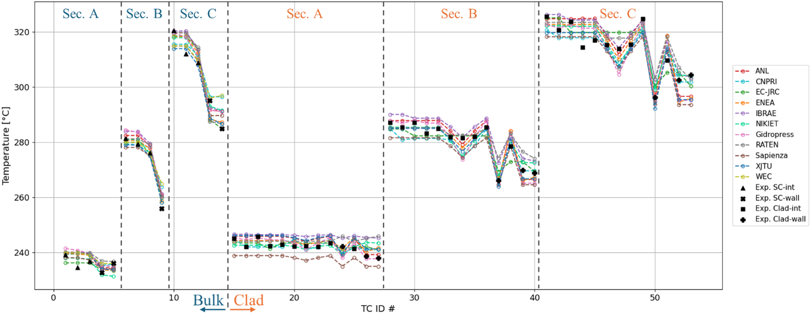
a) SC and clad outer temperatures at SS1
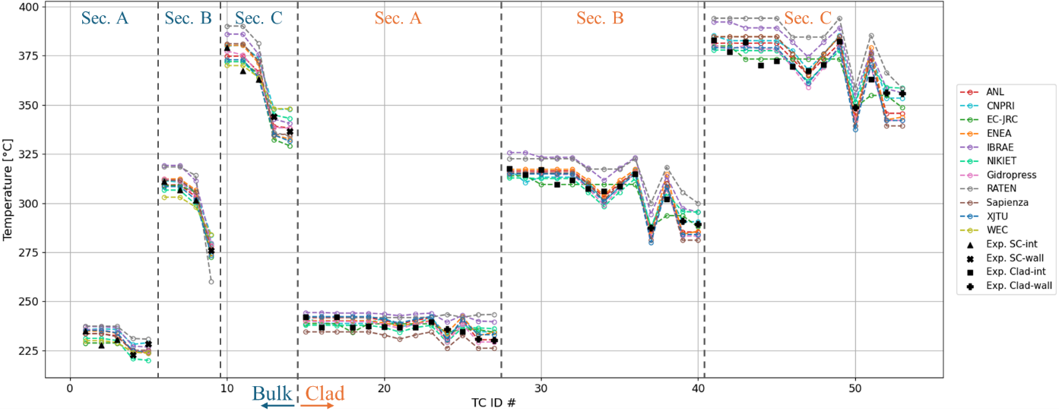
b) SC and clad outer temperatures at SS2
FIG. 36. Comparison of SC codes with experimental data of ADP10 for SC and clad TC for SS1 (a) and SS2 (b). Interior, Near-wall and Clad of internal and near wall pins experimental values have different symbols.
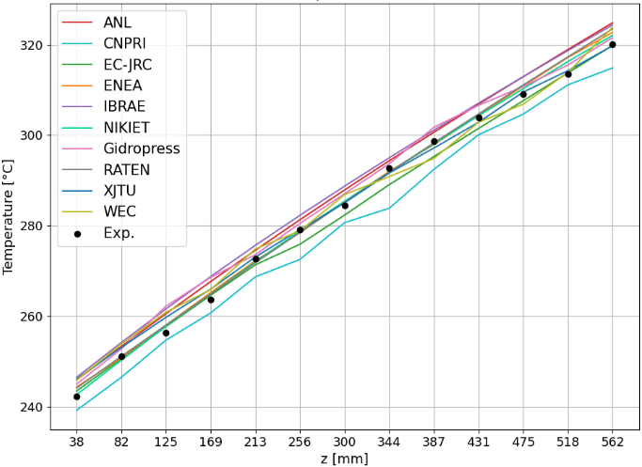  a) SS1 | 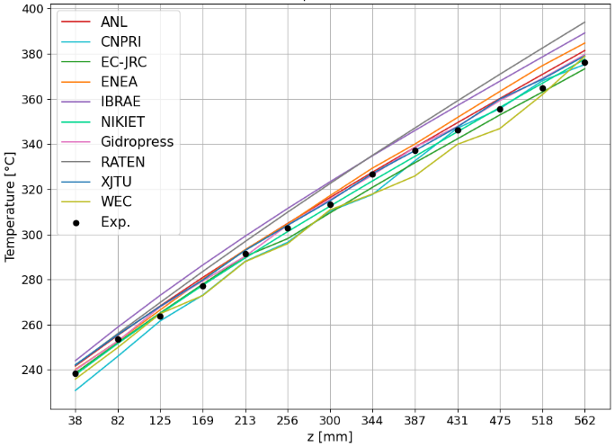  b) SS2
FIG. 37. Comparison of SC codes with experimental data of ADP10 for Pin3 TC measuring the clad outer temperature. Elevations z taken from the bottom of the active region.
Table 27. Main statistical performance parameters on all TCs for ADP10. All values in [°C].
Organization (Country) | SC code | SS1 |  |  |  | SS2
Organization (Country) | SC code | $${\left|ε\right|}_{ave}$$ | $${\left|σ\right|}_{\left|ε\right|}$$ | $${\left|ε\right|}_{max}$$ | $${\left|ε\right|}_{ave}$$ |  | $${\left|σ\right|}_{\left|ε\right|}$$ | $${\left|ε\right|}_{max}$$
CNPRI (CH) | ATHAS-LBE | 2.9 | 2.3 | 11.5 | 4.0 |  | 3.4 | 13.0
XJTU (CH) | YAOGUANG | 2.6 | 1.9 | 9.0 | 3.8 |  | 3.1 | 14.1
JRC (EC) | COBRA-4I (JRC version) | 3.3 | 2.9 | 14.1 | 6.2 |  | 5.2 | 21.6
ENEA (IT) | ANTEO+ | 2.4 | 2.2 | 9.0 | 4.7 |  | 3.9 | 16.0
La Sapienza (IT) | RELAP5-3D© (v4.3.4) | 4.0 | 2.2 | 10.9 | 5.4 |  | 4.2 | 16.9
RATEN ICN (RO) | ANTEO+/RELAP5 (SCADAP-SIM) | 2.7 | 2.0 | 11.2 | 5.4 |  | 4.2 | 11.2
Gidropress (RU) | MATADOR | 2.8 | 2.2 | 9.3 | 3.3 |  | 2.9 | 14.0
IBRAE (RU) | EUCLID/V2 (subchannel module CELSIST) | 3.6 | 2.0 | 10.0 | 7.5 |  | 3.7 | 17.5
NIKIET (RU) | PUCHOK GMT | 2.1 | 1.9 | 7.7 | 3.0 |  | 2.2 | 8.3
ANL (USA) | SAS4A/SASSYS-1 | 3.1 | 2.2 | 10.5 | 3.6 |  | 2.6 | 11.2
ANL (USA) | SAM/SCM, MOOSE | 3.6 | 2.5 | 10.8 | 5.4 |  | 4.7 | 18.1
Westinghouse (USA) | SAS4A/SASSYS-1 | 3.1 | 2.6 | 12.0 | 4.3 |  | 2.9 | 11.5

The behavior of the clad temperatures largely mirrors that of the SC described earlier, although it shows slightly greater variability. This may be attributed to the stronger influence of local effects on the measured quantity, such as the position of the wire. Higher errors are observed for pins located near the walls, indicating that the applied correlations may not fully account for the disturbances in heat transfer caused by the wire and the wrapper. In fact, none of the correlations listed in Table 25 demonstrate clearly superior or consistently reliable accuracy or better, any possible superiority is within the variability in predicting coolant bulk temperatures.
The axial profile of pin 3 (FIG. 37) is generally well reproduced by the codes, with errors on temperature remaining below 6°C before the transient and under 15°C afterward. The most notable deviation occurs near the top of the pin, where many SC codes tend to overestimate the temperature; this overprediction is relatively more pronounced at SS2. Such discrepancies may again be linked to heat conduction along the pin due to steeper temperature gradients in the upper region and/or to the swirling flow induced by the wire, which transports cooler fluid from the near-wall subchannels.
Transition
As per Table 26, some participants also modeled the transition. A comparison with experimental data for the forced-to-natural circulation phase is presented in FIG. 38, considering both a central subchannel bulk temperature and the cladding temperature of a near-wall pin at plane A and C. As already discussed for WP1 results, an inconsistency is observed in the timing of the peak temperature when using either system-code-predicted LBE mass flow rates or measured values. Despite this issue, the overall trend is reasonably well reproduced. In particular, the peak temperature during the transition – arguably the most critical parameter from a safety standpoint – is predicted within a ±10°C range for the central SC and with slightly larger deviations observed for the cladding temperature of pins located near the wall.
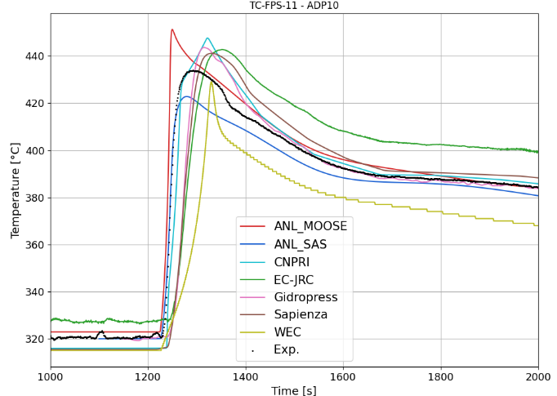 | 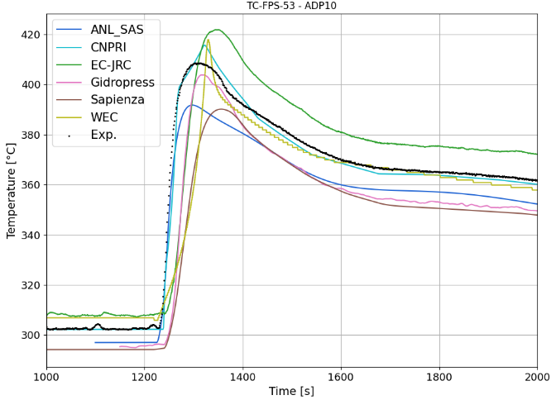
FIG. 38. Force-to-natural transition simulation-to-data comparison for an internal SC (left) and for the clad of a near-wall pin (right) at plane A (top) and C (bottom) for ADP10.

ADP06 – Only 7 central pins heated
The comparison with experimental data of the FPS with the temperatures simulated by the SC codes is presented in FIG. 39, with the exception of the ones related to pin 3 which are instead reported in FIG. 40. The quantitative errors evaluation, in steady state conditions, is reported in Table 28.
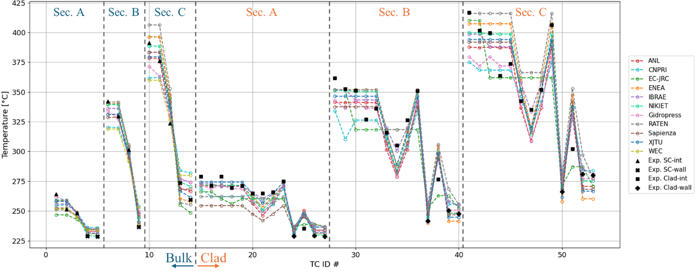
a) Bulk and clad outer temperatures at SS1
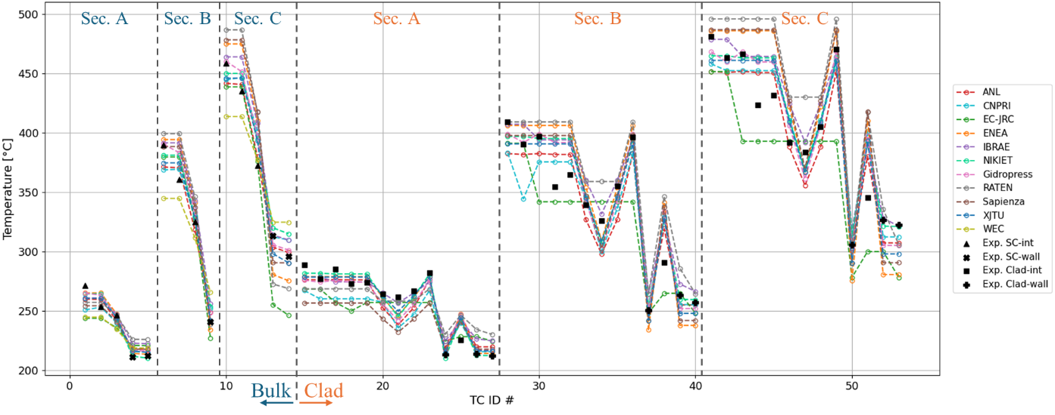
b) SC and clad outer temperatures at SS2
FIG. 39. Comparison of SC codes with experimental data of ADP06 for SC and clad TC for SS1 (a) and SS2 (b). Interior, Near-wall and Clad of internal and near wall pins experimental values have different symbols.
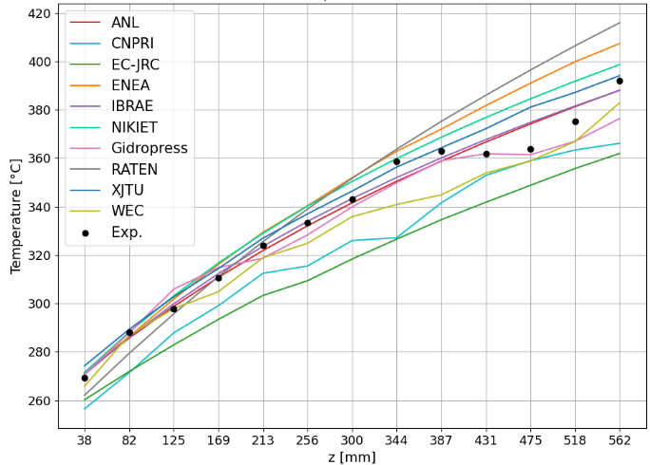  a) SS1 | 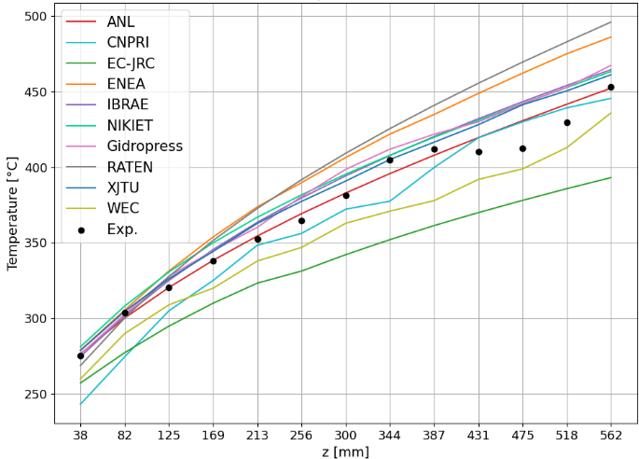  b) SS2
FIG. 40. Comparison of SC codes with experimental data of ADP06 for Pin3 TC measuring the clad outer temperature. Elevations z taken from the bottom of the active region.
Table 28. Main statistical performance parameters on all TCs for ADP06. All values in [°C].
Organization (Country) | SC code | SS1 |  |  | SS2
Organization (Country) | SC code | $${\left|ε\right|}_{ave}$$ | $${\left|σ\right|}_{\left|ε\right|}$$ | $${\left|ε\right|}_{max}$$ | $${\left|ε\right|}_{ave}$$ | $${\left|σ\right|}_{\left|ε\right|}$$ | $${\left|ε\right|}_{max}$$
CNPRI (CH) | ATHAS-LBE | 14.3 | 9.9 | 42.2 | 15.1 | 10.8 | 55.6
XJTU (CH) | YAOGUANG | 7.7 | 7.3 | 35.1 | 11.9 | 10.4 | 47.8
JRC (EC) | COBRA-4I (JRC version) | 10.1 | 8.7 | 46.0 | 16.5 | 14.8 | 67.8
ENEA (IT) | ANTEO+ | 9.9 | 10.1 | 45.5 | 20.1 | 16.8 | 64.9
La Sapienza (IT) | RELAP5-3D© (v4.3.4) | 12.5 | 8.3 | 39.8 | 20.7 | 16.2 | 72.5
RATEN ICN (RO) | ANTEO+/RELAP5 (SCADAP-SIM) | 9.0 | 8.4 | 38.2 | 21.5 | 16.4 | 62.2
Gidropress (RU) | MATADOR | 9.2 | 8.4 | 37.2 | 11.8 | 11.0 | 51.8
IBRAE (RU) | EUCLID/V2 (subchannel module CELSIST) | 7.1 | 5.8 | 26.7 | 17.4 | 14.3 | 52.9
NIKIET (RU) | PUCHOK GMT | 7.9 | 8.3 | 36.1 | 11.6 | 10.6 | 46.7
ANL (USA) | SAS4A/SASSYS-1 | 8.6 | 7.4 | 30.9 | 11.6 | 9.4 | 40.2
ANL (USA) | MOOSE | 7.3 | 5.1 | 19.9 | 14.1 | 10.5 | 32.9
Westinghouse (USA) | SAS4A/SASSYS-1 | 14.3 | 9.9 | 42.2 | 15.1 | 10.8 | 55.6

For bulk temperatures, the error pattern identified in ADP10 is also evident – namely, a steeper gradient between inner and near-wall subchannels – but with both greater absolute and relative deviations. Errors on temperatures can reach up to 46°C and over 70°C for SS1 and SS2 respectively. The best performing SCs are able to keep average errors below 10°C and maximum ones below 40°C. The underlying causes are thought to be the same as those discussed for ADP10, though amplified here due to the larger temperature gap between inner and near-wall SCs, which can be as high as 150°C in SS2 at Section C. The variability among participants also increases significantly, underscoring the impact of different modeling approaches under such pronounced thermal gradients.
As in ADP10, the comparison with experimental data for clad temperatures reflects trends similar to those observed for SC temperatures, with larger discrepancies occurring near non-powered pins (see “Clad-wall” in FIG. 39). Relative errors in temperature rise can reach up to 65% in both SS1 and SS2, corresponding to absolute differences of roughly 46°C and 73°C, respectively.
Regarding the axial evolution of the clad temperature for pin 3, agreement with experimental data is reasonable in the lower part of the active region. However, consistent with ADP10 observations, SC codes struggle to accurately reproduce the “plateau” behavior in the upper region. The same physical explanations proposed for ADP10 likely apply here as well, though intensified by the even larger temperature differences between inner and near-wall regions of the bundle. Nevertheless, errors on temperature remain well below 20°C and 35°C for almost all SC codes. A more detailed interpretation of pin 3 behavior suggests that the colder fluid transported by the wire requires nearly two full wire rotations to reach the second row of pins, where pin 3 is located. This effect is only captured by MATADAOR (Gidropress) in SS1, owing to its “distributed” wire modeling approach. In contrast, none of the SC codes reproduce this feature consistently across SS1 and SS2, indicating that fluid inertia associated with the wire-induced flow may play a role – an effect partially supported by CFD analyses of WP2. Such phenomena lie beyond the capabilities of standard SC codes, as they rely on the fundamental assumption that the fluid loses directional memory when moving between adjacent subchannels [37].
Transition
A comparison with experimental data for the forced-to-natural circulation phase is presented in FIG. 41, considering the same SCs as section 7.4.1 for consistency. In general, in the NACIE-UP loop, the power distribution of the FPS does significantly changes the overall behavior in the transient as already discussed for WP1 results. Trends thus follow what outlined for the steady-states but with spread during the transition generally increasing; some error compensation is also present like for the COBRA-4I (JRC version) which, for the internal SC, well captures the peak temperature but overestimates the starting temperature in forced circulation. Notwithstanding, the maximum temperature during the transition is predicted within a ±30°C envelope for the central SC and even higher for the near-wall pin clad temperature; for the latter, situated in an un-heated region of the FPS, a clear underestimation is visible by almost participants.
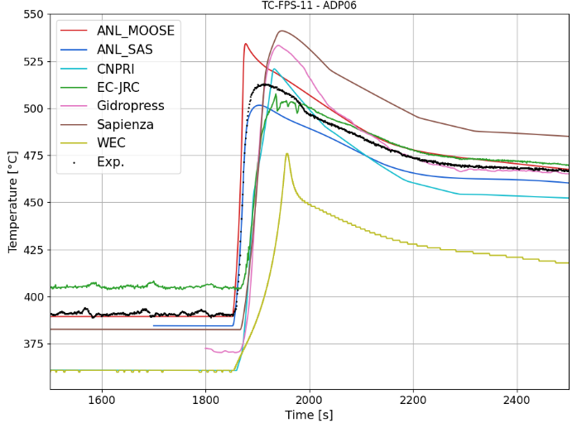 | 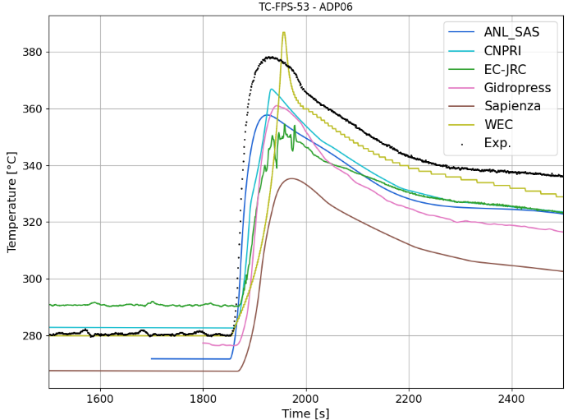
FIG. 41. Force-to-natural transition simulation-to-data comparison for an internal SC (left) and for the clad of a near-wall pin (right) at plane A (top) and C (bottom) for ADP06.

Blind phase simulations
For ADP07, steady-states simulations where performed blind based on the lessons learned from ADP10 and ADP06 and with the boundary conditions for the FPS given by the specifications. A graphical comparison of codes versus experimental data is visible in FIG. 42 for all TCs, expect the ones for Pin 3 which are shown in FIG. 43. The comparison is quantitatively summarized in Table 6. As anticipated, the agreement deteriorates compared to ADP06, since the pronounced temperature gradient is now coupled with a marked asymmetry. This combination further amplifies errors, particularly those associated with conductive heat transfer through the pin internals and its contribution to energy mixing. Average discrepancies are on the order of 15°C for SS1 and, for some participant, exceed 20°C for SS2, peak errors vary widely among participants, ranging from around 50°C to well in excess of 100°C. These maximum deviations are generally observed in near-wall SCs located close to the interface between heated and unheated regions.
For pin 3, MATADOR partly succeeds in reproducing the main features of the observed variability, including the effect of colder fluid sweeping from the much colder region of the bundle. A similar capability is shown by COBRA-4I (JRC version), which captures this behavior particularly well under SS1 conditions. However, for COBRA-4I, this agreement appears to rely partly on compensating errors, as the same capability is not retained in SS2.
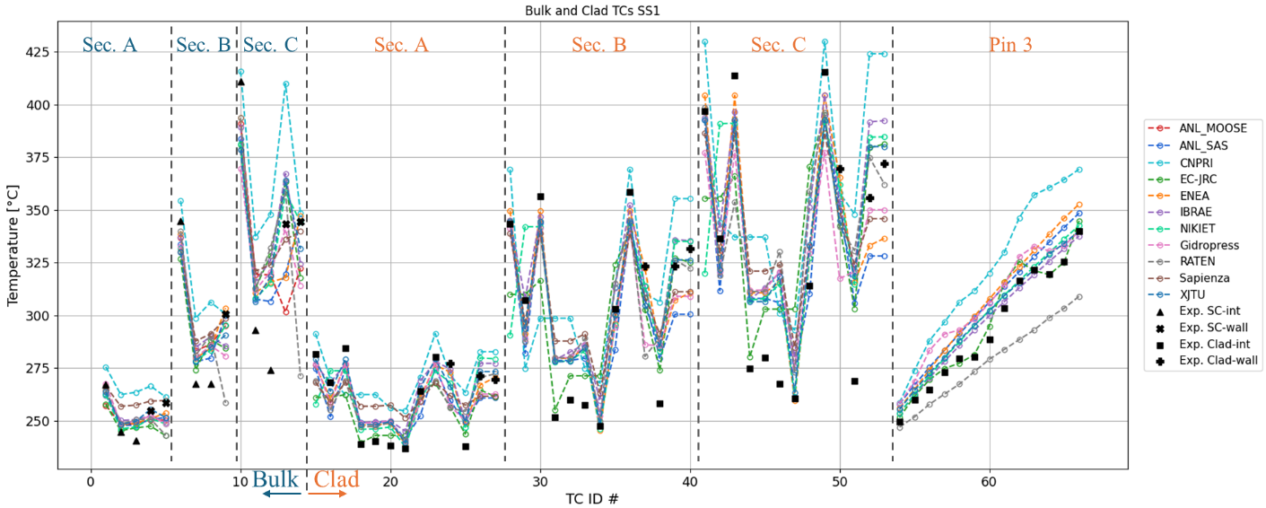
a) Bulk and clad outer temperatures at SS1
b) SC and clad outer temperatures at SS2
FIG. 42. Comparison of SC codes with experimental data of ADP07 for SC and clad TC for SS1 (a) and SS2 (b). Interior, Near-wall and Clad of internal and near wall pins experimental values have different symbols.
a) SS1 | b) SS2
FIG. 43. Comparison of SC codes with experimental data of ADP07 for Pin3 TC measuring the clad outer temperature. Elevations z taken from the bottom of the active region.
Table 29. Main statistical performance parameters on all TCs for ADP07. All values in [°C].
Organization (Country) | SC code | SS1 |  |  |  | SS2
Organization (Country) | SC code | $${\left|ε\right|}_{ave}$$ | $${\left|σ\right|}_{\left|ε\right|}$$ | $${\left|ε\right|}_{max}$$ | $${\left|ε\right|}_{ave}$$ |  | $${\left|σ\right|}_{\left|ε\right|}$$ | $${\left|ε\right|}_{max}$$
CNPRI (CH) | ATHAS-LBE | 27.7 | 19.4 | 79.1 | 48.2 |  | 29.3 | 132.5
XJTU (CH) | YAOGUANG | 12.6 | 11.5 | 50.8 | 17.8 |  | 15.8 | 71.7
JRC (EC) | COBRA-4I (JRC version) | 15.4 | 13.8 | 56.3 | 20.8 |  | 21.3 | 86.7
ENEA (IT) | ANTEO+ | 13.2 | 11.0 | 48.2 | 19.1 |  | 16.9 | 72.8
La Sapienza (IT) | RELAP5-3D© (v4.3.4) | 19.1 | 13.3 | 56.5 | 28.1 |  | 25.2 | 98.7
RATEN ICN (RO) | ANTEO+/RELAP5 (SCADAP-SIM) | 19.2 | 16.5 | 73.0 | 29.1 |  | 25.7 | 117.6
Gidropress (RU) | MATADOR | 17.1 | 13.0 | 53.2 | 22.9 |  | 19.4 | 82.3
IBRAE (RU) | EUCLID/V2 (subchannel module CELSIST) | 13.7 | 12.5 | 52.8 | 24.7 |  | 22.9 | 94.4
NIKIET (RU) | PUCHOK GMT | 15.3 | 15.0 | 76.7 | 22.5 |  | 21.2 | 94.5
ANL (USA) | SAS4A/SASSYS-1 | 15.0 | 9.8 | 43.8 | 19.3 |  | 12.5 | 51.2
ANL (USA) | MOOSE | 17.0 | 12.8 | 45.3 | 25.5 |  | 19.9 | 68.3

Transition
A comparison with experimental data for the forced-to-natural circulation phase is presented in FIG. 44, considering the same SCs as section 7.4.1 for consistency. As previously highlighted, the power distribution of the FPS does significantly changes the overall behavior in the transient as confirmed by ADP07 as well. Trends thus follow what outlined for the steady-states but with even higher spread during the transition. Notwithstanding error compensation during the transitions, the maximum temperature during the transition is predicted within a ±90°C envelope for the central SC and even higher for the near-wall pin clad temperature. For some participant spread is considerably lower (within 50 °C) albeit still important.
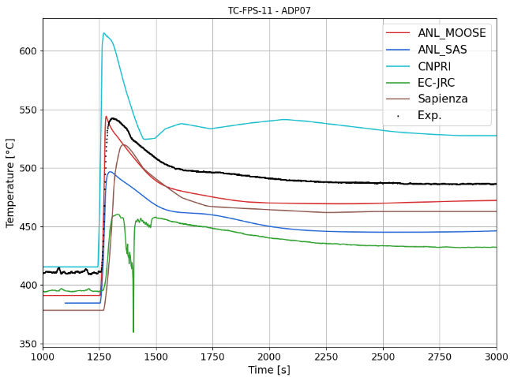 | 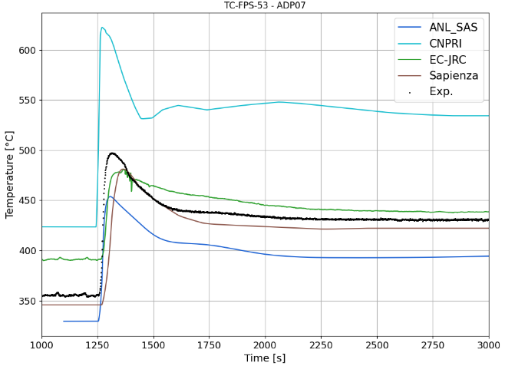
FIG. 44. Force-to-natural transition simulation-to-data comparison for an internal SC (left) and for the clad of a near-wall pin (right) at plane A (top) and C (bottom) for ADP07.
Mass flow comparison
To study more in detail the motivations behind the large discrepancies encountered, some participant produced mass flow rates distribution among SCs which was then compared with a reference CFD simulation. Such comparison featuring the mass flux (i.e., the mass flow rate divided by the SC flow area) is shown in FIG. 45 where the CFD results have been averaged at SC scale to facilitate the comparison. FIG. 45 clearly indicates that some SC codes are generally able to reproduce the overall flow behavior, even under complex power distributions such as ADP07. Nevertheless, the combined effects of fluid inertia and strong local perturbations induced by the wire – especially under steep temperature gradients – can still result in significant inaccuracies in local predictions. In general, when very strong gradients at scales lower than the SC one persist like for ADP06 and even more for ADP07, SC codes can struggle to capture local measurements for which SC-averaged quantities are not representative anymore.
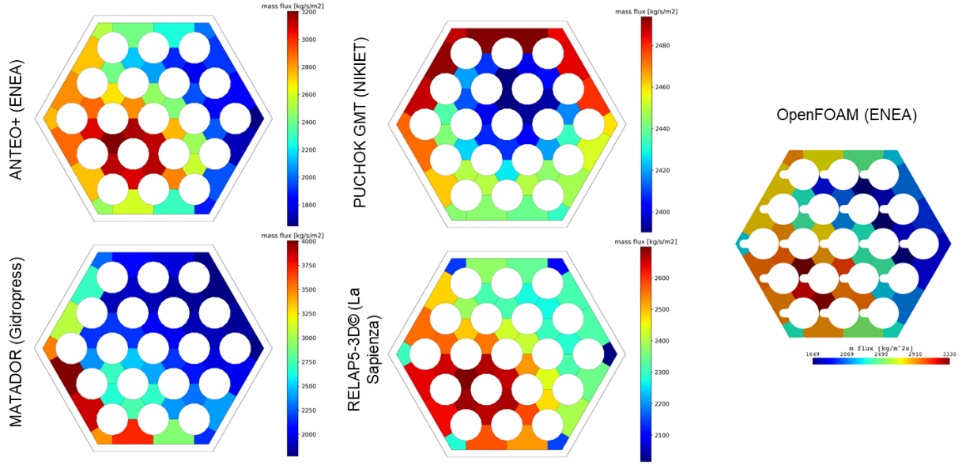
FIG. 45. Comparison of SC codes axial mass fluxes with a reference CFD calculation for ADP07-SS2 at plane C.

Conclusions
11 organizations with 12 different SC codes produced results for assessing strong and weak points of SC application for pin bundle cooled by heavy liquid metals. For case ADP10 – considered the most representative of standard operating conditions and the one of interest for design – the comparison with experimental data highlights the strong predictive performance of SC codes. Both the errors and their standard deviation remain within the expected computational and experimental uncertainty and are consistent with results from CFD analyses. The tested correlations all provide satisfactory predictions, although further refinement -particularly of Nusselt number correlations and energy exchange for near-wall pins - could enhance accuracy especially in small bundles.
In contrast, cases ADP06 and ADP07, which are characterized by significant temperature gradients, exhibit consistently larger deviations, with peak errors well beyond experimental uncertainty bounds. These results, albeit not directly applicable to standard design conditions due to artificially high gradients in the bundle and inside the SCs, clearly emphasize the current limitations of SC approaches in capturing the combined effects of pin internal structure and, more critically, the wire-induced crossflow and associated fluid inertia – phenomena that become especially relevant in a 19-pin bundle. While the implementation of axially distributed wire models may improve the representation of these effects, further developments are required to ensure reliable predictive capability across high-gradient conditions and for bundles of varying geometries.
Finally, the transient analyses indicate that SC codes can achieve a level of accuracy comparable to steady-state conditions when simulating transition scenarios. This outcome broadens the potential applicability of SC methodologies to a wider range of operational regimes if coupled (or directly embedded) with system level codes.

WP4: Multiphysics

Introduction
Multiphysics analysis is foreseen to play a relevant role in Generation IV applications. Indeed, owing to the considered reactor concept designs and involved fluids and fluid-dynamic phenomena, the 1D approaches which proved to be suitable for LWRs may not be enough to achieve a sufficient level of detail. In this sense, CFD and subchannel codes may provide relevant information allowing jumping the gap and solving issues related to complicated components geometries or configurations. CFD may indeed allow achieving suitable predictions of intrinsically 3D environments, as the large pools foreseen for LMFBRs as well as detailed information about bulk and wall temperatures in fuel elements. Nevertheless, owing to the large computational cost, such detailed approaches should be limited to vital components for which the System Thermal Hydraulics (STH) 1D approach could be hardly applied, even after a suitable tuning of the lumped parameters and the considered nodalization. Coupling STH and subchannel codes, instead, my add depth to the analysis without increasing too much the computational cost. Consequently, the development of Multiphysics approaches, or coupled codes applications, may help in overcoming the limits of stand-alone applications while granting the advantages of each code when used in its natural suitable environment.
In the framework of the present Coordinated Research Project, Multiphysics approaches were intended as coupled applications between STH and CFD codes and STH and subchannel codes. The main goal of all the participants was providing detailed information during the postulated transient scenarios of the temperature trends inside the Fuel Pin Simulator. As a consequence, concerning coupled CFD/STH codes applications, the NACIE-UP loop was simulated adopting an STH approach except for the Fuel Pin Simulator region, which was instead simulated via CFD applications. This way, the computational cost of the calculations is reduced allowing for a more cost-effective simulation. Participants were free to select any STH or CFD code to be coupled as well as the spatial and temporal discretizations. A similar strategy was considered for the considered coupled STH/subchannel code application. The performed work mainly consisted of two phases: an open phase in which participants tested their models against the available data for ADP06 and ADP10 and a blind phase for ADP07. Unlike other WPs, it must be here remarked that coupled applications could be performed only after a solid base for both STH and CFD (or STH and subchannel code) stand-alone applications was achieved. With respect to other WPs, indeed, WP4 started operations later and, owing to the larger computational cost with respect to other applications, only a few calculations per participant were performed. A refinement of the results after the release of data for the blind case was in addition not possible for all the participants. As a consequence, in the present chapter comparisons for the open and blind phase only will be reported. In the next sections, the activities performed in the WP4 are reported, mainly focusing on the selected discretizations strategies, adopted codes and comparison of the obtained results, trying to finally draw the lessons learned. The first subsection refers to coupled CFD/STH calculations while the second one reports about the coupled STH/subchannel code calculation performed at JRC.

Coupled STH/CFD applications

Description of the expected and optional outputs
The amount of information that can be provide by Multiphysics approaches is huge. Unlike STH codes, owing to the CFD domain, millions of cells are included in the calculation and detailed temperature and velocity distributions can of course be derived. As also mentioned above, this comes at the cost of large computational efforts, both in terms of spatial and temporal discretizations. Indeed, the simulation of the Fuel Pin Simulator required from 6 to 60 million cells, depending on the considered level of detail. In addition, sufficiently small time steps ranging from 0.025s to 10s were considered which relevantly increased the global computational cost.
Owing to these issues, during the WP4 Kick-Off Meeting no minimum contribution per participant was fixed, letting everyone contribute with what could be actually afforded. This consequently translated in a slightly scattered contribution with some institutions focusing only on the blind case while other managing to run all cases, depending on the readiness level at the beginning of the project and on the available manpower and computational resources.
Most of the institutions agreed, and managed, to run at least one calculation per each transient scenario and this will be the basis of the comparisons reported in the present chapter. Owing to differences in the adopted simulations strategies and adopted codes, the comparison is performed only for some experimental values, without including any information for which an experimental result is available. Particularly, the mandatory information to be supplied were:
- Mass flow rate time trend;
- Temperatures time trends for the inlet and outlet sections of the FPS (TP101 and TP102);
- Temperatures time trend for some bulk thermocouples in the FPS section (TC2, TC4, TC12, TC14);
- Temperatures time trend for some wall thermocouples in the FPS section (TC25, TC51, TC55, TC67).
The selected information, yet not representing of course the totality of the available data, were considered sufficient at least to understand the big picture of the involved phenomena. Thanks to the information already available at that time about both STH and CFD applications, some general trends were already observed in stand-alone applications and assumed to be repeated as well in the coupled codes applications. Particularly, the selection of the wall and bulk thermocouples allows to test the difference between channels, and pin walls, which could be heated or unheated depending on the simulated transient. The observed trends were sufficiently in line with the stand-alone applications and similar patterns were indeed obtained for the initial and final steady state conditions.
Of course, no upper limit was set for the amount of information to be provided, each institution thus contributed according to its own capabilities. In the following, results will be mainly provided for comparisons in which several predictions can be included. Values reported by only a few participants are sometimes reported in order to show the global performance that can be expected in some regions of the loop or of the FPS in order to provide a sounder analysis of the capabilities and limits of the adopted applications. It is here remarked that the added value of CFD is of course the capability to achieve detailed temperature and velocity distributions inside the Fuel Pin Simulator, something that could not be achieved adopting a STH approach. Contour plots of some relevant quantities are thus reported as well in order to provide a qualitative description of the involved phenomena, while punctual numerical vs. experimental values are considered for a quantitative assessment.

Participants, adopted codes and coupling strategies
Among all the Coordinated Research Project participants, only five institutions joined the WP4 activities, namely ENEA, IGCAR, NRG-PALLAS, UniPi and XJTU. All the participants were tasked to perform calculations addressing the considered experimental conditions adopting coupled STH/CFD approaches.
During the first phase of the project, ADP06 and ADP10 worked as valuable case studies to train the model and find out about their limits and capabilities, providing indeed a solid benchmark also to check the soundness of the assumed modelling hypotheses. This is very important to be remarked as the participants reported a scattered level of readiness at the beginning of the project as well as different levels of experience with code coupling. While ENEA and UniPi already dealt in the past with the NACIE-UP facility [38], [40], [42], for other institutions this was a completely new task and a longer training and development phase was required in order to set both the best discretization and modelling techniques to be associated to the adopted codes.
Each institution developed indeed a unique combination of modelling tools, to be also combined with different discretization strategies both for the spatial and temporal domains. The most relevant information is reported in Table 30. The achieved diversification of the adopted approaches allows gaining a sufficiently wide range of settings to be explored which should help to draw general lessons regarding both limits and capabilities of the adopted approach. Moreover, combining the present results with the ones provided by stand-alone applications reported in WP1 and WP2, both a qualitative and quantitative analysis of the results can be performed. This is a relevant point to be bore in mind since, even if the Multiphysics analysis may help overcoming some of the intrinsic limits of stand-alone applications, some of the drawbacks and lacks in the modelling approach are inevitably inherited from the stand-alone applications and cannot be overcome unless the issue is solved by developing a more suitable modelling approach for the addressed phenomena. This is for example the case of some issues reported for the gas-liquid metal interactions in the riser, which even in WP4 is completely dealt by the STH code, which proved to be a limit in the WP1 applications due to inaccuracies in the available modelling tools in the considered codes. Similar effects were coherently observed also in the present coupled STH/CFD applications.
Table 30. Considered modelling tools and discretizations strategies by the Institutions attending WP4.
Institution | CFD Code | STH Code | Geometrical Coupling Approach | Time Advancing Scheme
ENEA | ANSYS CFX | RELAP5 | Decomposition Method | Semi-Implicit
IGCAR | ANSYS Fluent | Flownex | Decomposition Method | Explicit
NRG PALLAS | STAR-CCM+ | SPECTRA | Domain Overlapping | Explicit
UNIPI | STAR-CCM+ | RELAP5 | Decomposition Method | Explicit
XJTU | ANSYS Fluent | RELAP5 | Decomposition Method | Explicit

As Table 30 clearly shows, most of the institutions adopted a Decomposition Method for the spatial discretization approach. This technique considers that none of the coupled codes deal with the whole computational domain: each one is assigned instead to a specific region and information must be exchanged at the interfaces between the two codes. All the participant institutions applied CFD for the Fuel Pin Simulator region, either for the active part only or for the whole hexagonal duct depending on the available computational resources and considered modelling hypotheses, while the STH code was adopted for the simulation of the remaining part of the primary loop and of the secondary side. Mass flow, temperature and pressure information, to be updated at each time-step is exchanged at the interfaces between the CFD and STH domains, providing each code with suitable boundary conditions to run the transient calculation. FIG. 46 and FIG. 47 report as an example the coupling scheme adopted at the University of Pisa, in which the pressure information exchange occurs to be achieved via providing the STH code with the global pressure drop experienced in the CFD domain both as a consequence of friction and pressure head effects. Differently from the other institutions, NRG-PALLAS adopted a domain overlapping approach. By adopting this approach, the STH code is ideally capable of solving in stand-alone the numerical problem, while reckoning on CFD for a more accurate definition of key phenomena occurring in the Fuel Pin Simulator. CFD here works indeed in parallel with the STH code, and the improved pressure drop estimation is later fed to the STH code which adopts it to tune the pressure drop experienced in the FPS region and thus achieve a better estimation of the loop mass flow rate. Temperature information is also provided by CFD for the outlet section of the Fuel Pin Simulator. A scheme of the considered modelling approach is reported in FIG. 48.
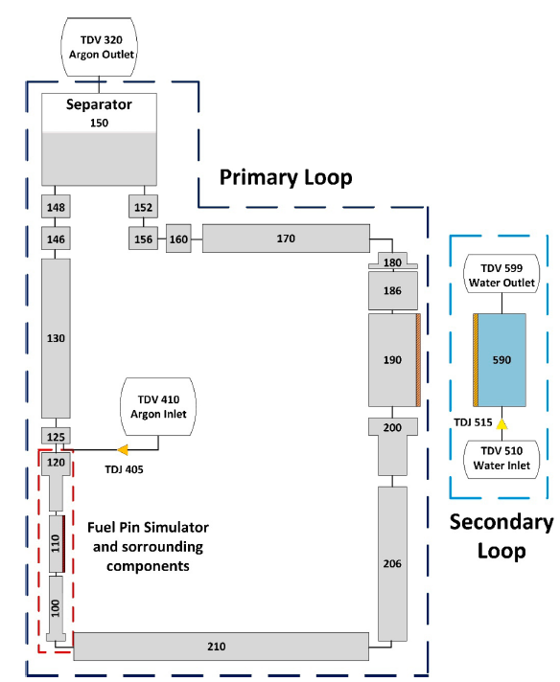  FIG. 46. RELAP5 nodalization adopted at UniPi. | 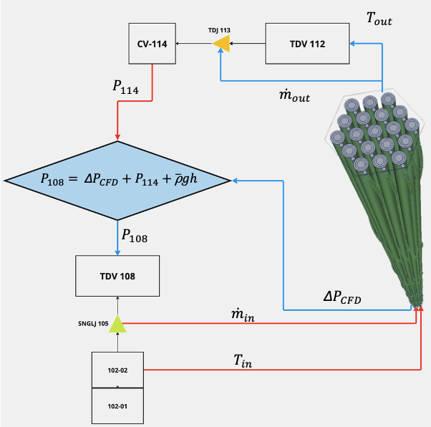  FIG. 47. Detail exchanged information scheme at the STH/CFD interface adopted at UniPi.
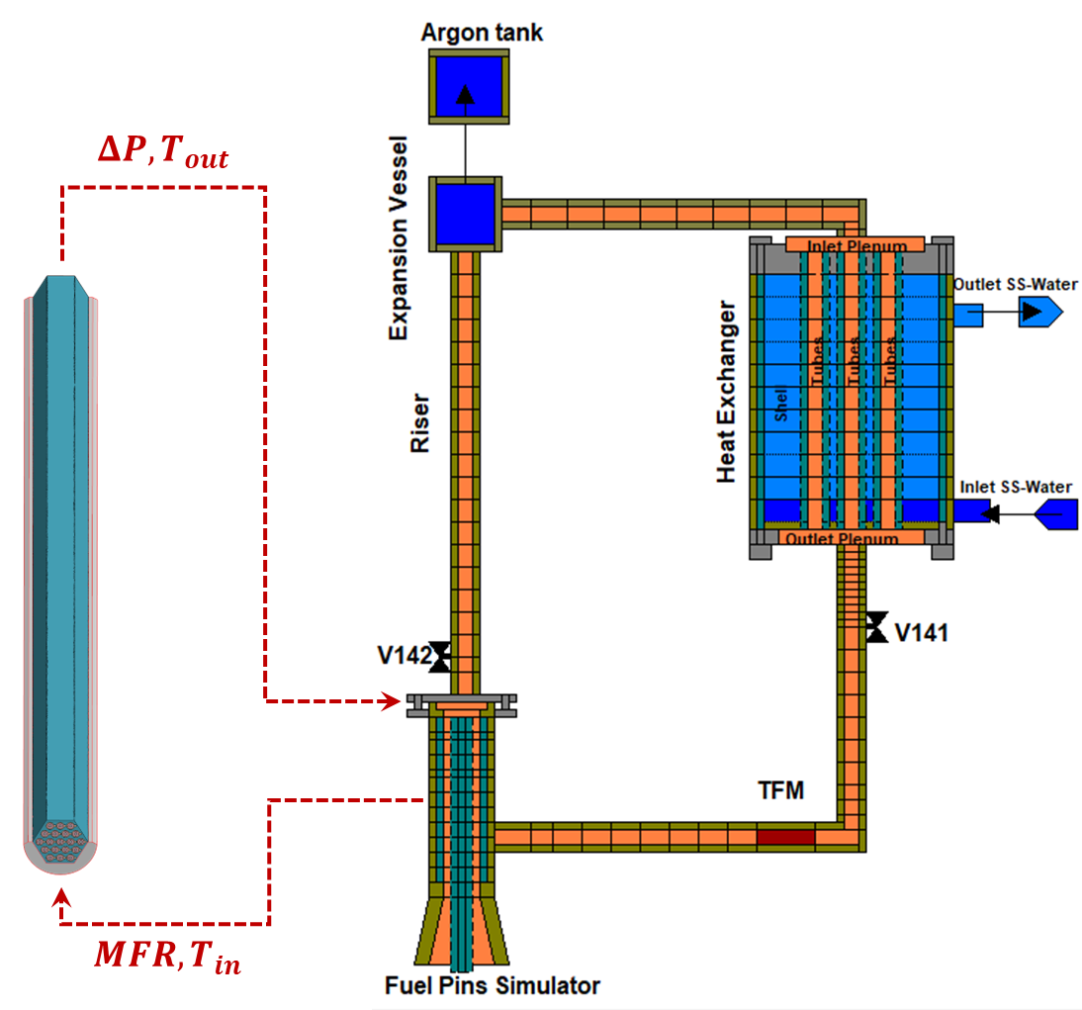
FIG. 48. Detail of the coupling CFD/STH interface exchanged information at NRG PALLAS.
Moving to the time-advancing schemes it can be observed again from Table 30 that almost all the institutions went for an explicit approach, while only ENEA adopted a semi-implicit time advancing scheme. It must be here remarked that for the present applications, explicit and implicit, together with the well-known Courant limits should not be interpreted as strictly as in the traditional analysis. Since both the CFD and STH codes are sufficiently large with respect to the considered phenomena, information usually takes quite a long time to travel from the inlet and outlet interfaces the considered time advancing scheme should not in general affect the code stability. Nevertheless, semi-implicit or implicit approaches could help in making the coupling between the codes more solid, better bounding the two calculations. In fact, adopting an explicit approach, each code performs the calculation for the present time-step only once, providing the other one with the updated boundary conditions. While the other code is processing, the first one waits for the updated boundary conditions and then proceeds towards the next time level. No check on the exchanged quantities and balances is performed. FIG. 49 reports as example the time advancing scheme adopted by UniPi. The picture also reports on the need to use an external master code, MATLAB in the present application, which is capable to manage the coupling between the two codes. In the semi-implicit approach adopted by ENEA, instead, several internal iterations per time-step are performed, eventually moving towards the next time level once some convergence criteria are met regarding the exchanged quantities. A higher computational cost is thus to be expected per time-step, which should be rewarded by a higher accuracy of the coupling approach. The explicit approach grants instead a smaller computational cost per time step but may require smaller time-step sizes in order to make it so that inaccuracies at the interface are sufficiently small not to prevent the global prediction performance.
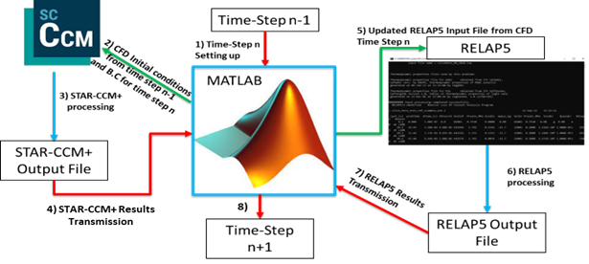
FIG. 49. Detail of the time advancement and information exchange scheme adopted by UniPi.
Table 31 reports about the main parameters of the nodalization, showing that a quite large range of mesh sizes, straddling between 1.7 and 59 million cells was considered. This translates of course in different calculations times, also depending on the adopted time-step size ranging from a few days to 6 weeks, also depending on the available number or cores. The time step size was mainly connected to need of achieving a good sampling of the needed information and granting a certain degree of stability and consistency to the coupling approach. Variable time-step sizes were considered by some institutions depending on the transient phase, smaller values were indeed considered for the initial phase of the transient, where steeper derivatives were observed, while larger time steps were considered for the second phase of the transient approaching a new steady state, were properties and quantities changed instead more smoothly.
Table 31. Information regarding adopted time-steps and the computational effort experienced by each participant.
Institution | CFD Mesh Size  [millions] | CFD Time Step  Size [s] | STH  Time Step  Size [s] | Number of Cores | Time to run 1000s of calculated time
ENEA | 4.4 | 0.025 to 0.1 | 1/10 of CFD step | 48 | 5-8 days
IGCAR | 57 | 1 to 10 | 1 | 32 | 4-5 days
NRG PALLAS | 59 | 0.5 | 0.001 | 24 | 6 weeks
UNIPI | 4.7 | 0.05 to 0.5 | 0.001 | 24 | 4-7 days
XJTU | 1.7 | 0.25 | 0.25 | 12 | 1-2 days

Eventually, the last differences in the adopted approaches among the participants are related to the gas lift component modelling. While this component was included by everyone in the STH portion of the model, inheriting limits and capabilities observed in the frame of WP1, the effects of the selected models cannot be disregarded even in the present application. Particularly, ENEA, NRG PALLAS and UniPi modelled the gas lift occurring in the hot leg as a consequence of the argon injection at the bottom of the riser component. On the other hand, IGCAR and XJTU instead used pump components mimicking the effects of the gas injection system. Consequently, when comparing results, it should be expected that, at least for ADP06 and ADP10 cases, IGCAR and XJTU should achieve a better quality in terms of mass flow rate predictions as the pump component allows a better management of the flow rate both during the initial steady state and the first phase of the transient.
Moving instead to CFD settings and adopted turbulence models, all the participants adopted the SST k-ω model in association with a simple gradient approach for the estimation of the turbulent heat flux contribution. The considered turbulent Prandtl number values, also inheriting the lesson drawn in the frame of WP2 were in the 1.5-4 range in accordance with typical values adopted in the liquid metal thermal-hydraulics analyses. Nevertheless, a minor impact of this parameter on the obtained results was observed.

WP5: Sensitivity and uncertainty analysis

Introduction
Four organizations performed sensitivity and uncertainty analysis of the simulations: ENEA, Gidropress, IBRAE RAN, and the University of Pisa. They employed different approaches and different code types (system, subchannel, and CFD). The lists of the considered uncertain input parameters and the estimates of their uncertainties, although mainly based on the experiment specification, varied as well. This makes the direct comparison of the results practically impossible. Therefore, the descriptions of the approaches and the results are presented separately for each organization.

ENEA

Methodological background
The sub-channel (SC) code ANTEO+ is a steady-state, single phase, thermal-hydraulic problem solver whose series of assumptions allows for a decoupling of coolant and pin calculations, simplifying the solution procedure and facilitating the use of S/U analysis based on a variational approach of Generalized Perturbation Theory (GPT) [44]. The application of GPT for obtaining sensitivity coefficients, while being standard practice in nuclear fields such as neutronics, is quite uncommon for thermal-hydraulics [45], where stochastic methods and direct perturbations (DP) prevail. Despite the mathematical and numerical difficulties, it could entail in complex problems, GPT offers advantages in terms of computational efficiency and physical insights in understanding the main phenomena contributing to sensitivities coefficients.
As a first attempt in the framework of the CRP, the GPT is applied under the forced convection assumption, implying SCs are modelled under the assumptions of constant mass flow, weak hydrodynamic coupling, fully developed flow, and uniform pressure over the bundle cross section.
The systems of equations involve the conservation of mass, transverse momentum, axial momentum, and energy. The latter is written along the axial direction z as in Eq. (9):
 | $$\frac{d\vec{h}}{dz}=\frac{1}{\dot{\vec{m} }}\left(W\vec{h}+ \vec{χ}\right) ,$$ | (9)
where $\dot{\vec{m}}$ is the vector of all SC mass flow rates, $\vec{h}=\vec{h}\left(z\right)$ is the vector of all SC specific enthalpies, $W$ is the matrix of effective energy exchange rates per unit length between SCs, and $\vec{χ}$ is the vector of linear powers discharged to SCs from the pins. This equation can be appended to a response functional for the construction of a constrained response functional, which is then minimized through a first-order variational approach to define GPT sensitivity coefficients. The constrained functional $K$ is written in Eq. (10).
 | $$\begin{aligned}K=R-{\left\langle {\vec{h}}^{*},\frac{d\vec{h}}{dz}-\frac{1}{\dot{\vec{m}}}\left(W\vec{h}+\vec{χ}\right)\right\rangle }_{z}\end{aligned}$$ | (10)
where$R$ is the unconstrained response functional, ${\vec{h}}^{*}={\vec{h}}^{*}\left(z\right)$ is the vector of fixed Lagrange multipliers, and ${\left\langle …\right\rangle }_{z}$ indicates integration of the constraint between inlet ($z=z_{\text{in}}$) and outlet ($z=z_{\text{out}}$). Note that, since the constraint involves the energy conservation equation, it is identically zero and so, value-wise, $K = R$. If an input datum $α$ is subject to a small perturbation $δα$ so that it becomes $α^{'}=α+δα$, then the uncostrained response becomes $R^{'}=R+δR$, where $δR$ is the perturbation induced by $δα$. In turn, the constrained response becomes $K^{'}=K+δK$, with again the perturbation $δK$ being a consequence of $δα$. Expanding $K'$ about $K$ in a first-order functional Taylor series leads to Eq. (11):
 | $$K^{'}≈K+{\left\langle \frac{∂K}{∂α} δα\right\rangle }_{z}+{\left\langle \frac{∂K}{∂\vec{h}}⋅δ\vec{h}\right\rangle }_{z}$$ | (11)
The partial derivatives in Eq. (11) are related to the definitions of ${\vec{h}}^{*}$ and sensitivity coefficients.
In case of final responses (i.e., depending at most on input data and quantities at $z_{\text{out}}$), the quantity ${\vec{h}}^{*}$ is defined through the following, which is obtained as part of the minimization process by forcing $K$ to be stationary with respect to variations of$\vec{h}$ (i.e. $∂K/∂\vec{h}=0$), see Eq. (12).
 | $$-\frac{d{\vec{h}}^{*}}{dz}-\frac{W^{*}}{\dot{\vec{m}}}{\vec{h}}^{*}=0; {\vec{h}}^{*}\left(z_{\text{out}}\right)={\left.\frac{∂R}{∂\vec{h}}\right|}_{z=z_{\text{out}}}; z∈\left[z_{\text{in}},z_{\text{out}}\right]$$ | (12)
where the differential equation, given its form, is called the adjoint enthalpy equation, and the vector of Lagrange multipliers is consequently denoted also as the vector of adjoint enthalpies. The adjoint enthalpy $h_{j}^{*}\left(z\right)$ of the generic $j$-th SC is the importance that the (specific) enthalpy of the coolant in that SC at axial position $z$ has for the value of $R$. The equation is to be solved backward in space starting from the final conditions at $z_{\text{out}}$. A parallelism can be drawn between the adjoint enthalpy equation of SC problems and the adjoint Bateman equation of depletion problems: the latter must be solved backward in time starting from end-of-depletion adjoint isotopic concentrations.
To ensure the invariance of the sum of all adjoint enthalpies with respect to $z$, a normalization must be applied to ${\vec{h}}^{*}$ after its first computation, as shown in Eq. (13):
 | $${\vec{h}}^{*,\text{norm}}=\frac{\dot{\vec{m}} {\vec{h}}^{*}}{\dot{\vec{m}}⋅{\vec{h}}^{*}}$$ | (13)
In the following, the superscript “norm” will be dropped for simplicity.
As shown in Eq. (12), depending on the type of final response, the definitions of final adjoint enthalpies vary accordingly. For the CRP, two types of responses are of interest:
- coolant bulk temperatures (or enthalpies in our formulation),
- clad outer temperatures.
If $R$ is the outlet enthalpy $h_{i}\left(z_{\text{out}}\right)$ of the $i$-th SC, then, see Eq. (14):
 | $$h_{j}^{*}\left(z_{\text{out}}\right)={\left.\frac{∂h_{i}}{∂h_{j}}\right|}_{z=z_{\text{out}}}=δ_{ij} ∀j$$ | (14)
where $δ_{ij}$ is the Kronecker delta associated with the $i$-th and the $j$-th SCs. If $R$ is the outlet outer cladding temperature $T_{\text{co},k,i}$ of the $k$-th pin facing the $i$-th SC, computed as, see Eq. (15):
 | $$R=T_{\text{co},k,i}\left(z_{\text{out}}\right)=T_{\text{bulk},i}\left(z_{\text{out}}\right)+\frac{χ_{\text{p},k}\left(z_{\text{out}}\right)}{πD_{k}a_{\text{p}}}$$ | (15)
where $T_{\text{bulk},i}$ is the bulk coolant temperature of the $i$-th SC, $χ_{\text{p},k}$ is the linear power of the pin, $D_{k}$ is the pin diameter, and $a_{\text{p}}$ is the convection coefficient. The bulk coolant temperature is directly related to the SC enthalpy via $c_{\text{p},j},$ the specific heat capacity at constant pressure of the coolant in the $j$-th SC. Considering the linear dependency of bulk temperatures on SC enthalpies, the final adjoint enthalpy in this case is, see Eq, (16):
 | $$h_{j}^{*}\left(z_{\text{out}}\right)={\left.\frac{∂T_{\text{co},k,i}}{∂h_{j}}\right|}_{z=z_{\text{out}}}=\frac{δ_{ij}}{c_{\text{p},j}} ∀j$$ | (16)
The first-order sensitivity coefficient of $R$ with respect to the generic input datum $α$ is defined as a logarithmic total derivative, but via GPT (in particular, considering the surviving term $∂K/∂α$ in Eq. (11)) it becomes a logarithmic partial derivative of $K$, see Eq. (17):
 | $$S_{GPT}\left(R,α\right)=\frac{α}{R}\frac{∂R}{∂α}-\frac{1}{R}{\left\langle {\vec{h}}^{*},-α\frac{∂}{∂α}\left(\frac{1}{\dot{\vec{m}}}\left(W\vec{h}+\vec{χ}\right)\right)\right\rangle }_{z}$$ | (17)
where the term with $∂R/∂α$ is called the direct sensitivity term, while the one in which ${\vec{h}}^{*}$ acts as weighting function is the indirect contribution. If, instead of having $R$ depending at most on input data and quantities at $z_{\text{out}}$, $R$ depends more generically at most on input data and quantities at $z_{\text{p}}∈ ]z_{\text{in}}, z_{\text{out}}]$, then Eqs. (11) – (17) still hold, but all the instances of $z_{\text{out}}$ must be replaced with $z_{\text{p}}$. The specific form of Eq. (17) varies depending on the combination of $R$ and $α$. For instance, if $R=h_{i}\left(z_{\text{out}}\right)$ (and similarly if $R=h_{i}(z_{\text{p}})$), then, for $α= {\dot{m}}_{\text{tot}}$ and $α= q_{\text{tot}}$, the sensitivity coefficients are without direct contribution and take the following forms, see Eq. (18) and (19):
 | $$S_{GPT}\left(h_{i}\left(z_{\text{out}}\right),{\dot{m}}_{\text{tot}}\right)=\frac{{\dot{m}}_{\text{tot}}}{h_{i}\left(z_{\text{out}}\right)}{\left\langle {\vec{h}}^{*},\frac{∂}{∂{\dot{m}}_{\text{tot}}}\left(\frac{W}{\dot{\vec{m}}}\vec{h}+\frac{\vec{χ}}{\dot{\vec{m}}}\right)\right\rangle }_{z}$$ | (18)
 | $$S_{GPT}\left(h_{i}\left(z_{\text{out}}\right),q_{\text{tot}}\right)=\frac{q_{\text{tot}}}{h_{i}\left(z_{\text{out}}\right)}{\left\langle {\vec{h}}^{*},\frac{∂}{∂q_{\text{tot}}}\left(\frac{\vec{χ}}{\dot{\vec{m}}}\right)\right\rangle }_{z}$$ | (19)
If $R=T_{\text{co},k}\left(z_{\text{out}}\right)$ (and similarly if $R = T_{co,k,i}(z_{p})$), then, for $α= {\dot{m}}_{\text{tot}}$ and $α=q_{\text{tot}}$, the sensitivity coefficients, see Eqs. (20) and (21), are:
 | $$S_{GPT}\left(T_{\text{co},k,i}\left(z_{\text{out}}\right),{\dot{m}}_{tot}\right)=\frac{{\dot{m}}_{tot}}{T_{\text{co},k,i}\left(z_{\text{out}}\right)}\frac{∂T_{\text{co},k,i}\left(z_{\text{out}}\right)}{∂\dot{m_{\text{tot}}}}+\frac{{\dot{m}}_{tot}}{T_{\text{co},k,i}\left(z_{\text{out}}\right)}{\left\langle {\vec{h}}^{*},\frac{∂}{∂{\dot{m}}_{tot}}\left(\frac{W}{\dot{\vec{m}}}\vec{h}+\frac{\vec{χ}}{\dot{\vec{m}}}\right)\right\rangle }_{z}$$ | (20)
 | $$S_{GPT}\left(T_{\text{co},k,i}\left(z_{\text{out}}\right),q_{\text{tot}}\right)=\frac{q_{\text{tot}}}{T_{\text{co},k,i}\left(z_{\text{out}}\right)}\frac{∂T_{\text{co},k,i}\left(z_{\text{out}}\right)}{∂q_{\text{tot}}}+\frac{q_{\text{tot}}}{T_{\text{co},k,i}\left(z_{\text{out}}\right)}{\left\langle {\vec{h}}^{*},\frac{∂}{∂q_{\text{tot}}}\left(\frac{\vec{χ}}{\dot{\vec{m}}}\right)\right\rangle }_{z}$$ | (21)
The quantity $∂\left(W/\dot{\vec{m}}\right)/∂{\dot{m}}_{tot}$ is implemented applying the quotient rule. Regarding the computation of the associated $∂W/∂{\dot{m}}_{tot}$ derivative, it relies on a direct perturbation of ${\dot{m}}_{tot}$ which allows for using the approximating finite difference $\left(W^{'}-W\right)/\left({\dot{m}'}_{tot}-{\dot{m}}_{tot}\right)$, where primed terms denote perturbed quantities. This direct perturbation is local, i.e., it does not affect anything else in ANTEO+. The computation of $∂T_{\text{co},k,i}\left(z_{\text{out}}\right)/∂{\dot{m}}_{tot}$ is approximated analogously. It has been verified that the entity of local direct perturbations does not alter significantly the resulting derivatives, provided that this value remains below 1% of the reference value of ${\dot{m}}_{tot}$.

Results
The results of the S/U analyses obtained with ANTEO+ will be presented only for ADP10-SS1 and ADP10-SS2 cases and are shown in Table 32 and Table 33, respectively; SS2 is considered, even if the GPT formulation is targeting forced convection, so to highlight capabilities of the methodology in comparison with other calculation methods. The two types of responses, coherent with the quantities measured in the FPS, have been considered, namely SC enthalpies (as representative of coolant bulk temperatures) and outer cladding temperatures, both at axial positions of planes B and C spread in the inner and outer part of the FPs. For each type, the ones foreseen to be the most impactful input data have been selected for the evaluation of sensitivity coefficients: the total mass flow rate m ̇_tot and the total linear power q_"tot" . Sensitivities were computed using both GPT and DP, with DP taken as the reference for evaluating the relative discrepancies ε; the associated relative uncertainties are reported for the GPT results, labelled as U_GPT. DP is performed applying a 1% perturbation on α.
Table 32. Main S/U results for ADP10-SS1.
ID | SC | PIN | $z_{\text{p}}$ [mm] | $$R$$ | $$S_{DP}\left(R,α\right)$$ | $$S_{GPT}\left(R,α\right)$$ | $$ε$$ | $$U_{GPT}\left(R,α\right)$$
Response: $h$ [J/kg] – $α$: $m_{\text{tot}}$
TC-FPS_01 | S2 | - | 540 | 2.10E+03 | -1.00E+00 | -9.59E-01 | -4.12% | 4.80%
TC-FPS_11 | S2 | - | 1060 | 1.40E+04 | -9.93E-01 | -9.20E-01 | -7.34% | 4.60%
TC-FPS_04 | S26 | - | 540 | 1.19E+03 | -9.86E-01 | -1.07E+00 | 9.03% | 5.37%
TC-FPS_14 | S26 | - | 1060 | 8.93E+03 | -9.95E-01 | -1.10E+00 | 10.31% | 5.49%
Response: $T_{\text{co}} [°C]$ – $α$: $m_{\text{tot}}$
TC-FPS_16 | S2 | 1 | 540 | 2.44E+02 | -6.37E-02 | -5.89E-02 | -7.56% | 0.29%
TC-FPS_05 | S2 | 1 | 1060 | 3.25E+02 | -2.96E-01 | -2.73E-01 | -7.61% | 1.37%
TC-FPS_27 | S26 | 18 | 540 | 2.40E+02 | -4.45E-02 | -4.78E-02 | 7.40% | 0.24%
TC-FPS_53 | S26 | 18 | 1060 | 2.93E+02 | -2.16E-01 | -2.38E-01 | 10.10% | 1.19%
TC-FPS_48 | S20 | 5 | 1060 | 3.11E+02 | -2.64E-01 | -2.44E-01 | -7.42% | 1.22%
Response: $h$ [J/kg] – $α$: $q_{\text{tot}}$
TC-FPS_01 | S2 | - | 540 | 2.10E+03 | 9.98E-01 | 1.00E+00 | 0.19% | 7.65%
TC-FPS_11 | S2 | - | 1060 | 1.40E+04 | 9.96E-01 | 1.00E+00 | 0.37% | 7.65%
TC-FPS_04 | S26 | - | 540 | 1.19E+03 | 1.00E+00 | 1.00E+00 | 0.01% | 7.66%
TC-FPS_14 | S26 | - | 1060 | 8.93E+03 | 1.00E+00 | 9.99E-01 | -0.49% | 7.64%
Response: $T_{\text{co}} [°C]$ – $α$: $q_{\text{tot}}$
TC-FPS_16 | S2 | 1 | 540 | 2.44E+02 | 7.43E-02 | 7.59E-02 | 2.21% | 0.58%
TC-FPS_05 | S2 | 1 | 1060 | 3.25E+02 | 3.09E-01 | 3.07E-01 | -0.61% | 2.35%
TC-FPS_27 | S26 | 18 | 540 | 2.40E+02 | 6.02E-02 | 6.10E-02 | 1.21% | 0.47%
TC-FPS_53 | S26 | 18 | 1060 | 2.93E+02 | 2.32E-01 | 2.30E-01 | -1.08% | 1.76%
TC-FPS_48 | S20 | 5 | 1060 | 3.11E+02 | 2.75E-01 | 2.76E-01 | 0.46% | 2.11%

Table 33. Main S/U results for ADP10-SS2.
ID | SC | PIN | $z_{\text{p}}$ [mm] | $$R$$ | $$S_{DP}\left(R,α\right)$$ | $$S_{GPT}\left(R,α\right)$$ | $$ε$$ | $$U_{GPT}\left(R,α\right)$$
Response: $h$ [J/kg] – $α$: $m_{\text{tot}}$
TC-FPS_01 | S2 | - | 540 | 4.13E+03 | -9.96E-01 | -9.57E-01 | -3.91% | 3.54%
TC-FPS_11 | S2 | - | 1060 | 2.72E+04 | -9.73E-01 | -9.08E-01 | -6.71% | 3.36%
TC-FPS_04 | S26 | - | 540 | 2.33E+03 | -9.97E-01 | -1.07E+00 | 7.77% | 3.97%
TC-FPS_14 | S26 | - | 1060 | 1.76E+04 | -1.02E+00 | -1.10E+00 | 8.21% | 4.07%
Response: $T_{\text{co}} [°C]$ – $α$: $m_{\text{tot}}$
TC-FPS_16 | S2 | 1 | 540 | 2.40E+02 | -1.18E-01 | -1.14E-01 | -3.18% | 0.42%
TC-FPS_05 | S2 | 1 | 1060 | 3.99E+02 | -4.65E-01 | -4.28E-01 | -7.90% | 1.58%
TC-FPS_27 | S26 | 18 | 540 | 2.32E+02 | -8.20E-02 | -8.69E-02 | 5.94% | 0.32%
TC-FPS_53 | S26 | 18 | 1060 | 3.36E+02 | -3.75E-01 | -4.03E-01 | 7.39% | 1.49%
TC-FPS_48 | S20 | 5 | 1060 | 3.72E+02 | -4.27E-01 | -3.98E-01 | -6.63% | 1.47%
Response: $h$ [J/kg] – $α$: $q_{\text{tot}}$
TC-FPS_01 | S2 | - | 540 | 4.13E+03 | 9.95E-01 | 1.00E+00 | 0.46% | 5.35%
TC-FPS_11 | S2 | - | 1060 | 2.72E+04 | 9.90E-01 | 1.00E+00 | 1.03% | 5.35%
TC-FPS_04 | S26 | - | 540 | 2.33E+03 | 1.00E+00 | 1.00E+00 | -0.15% | 5.36%
TC-FPS_14 | S26 | - | 1060 | 1.76E+04 | 1.01E+00 | 9.99E-01 | -1.00% | 5.34%
Response: $T_{\text{co}} [°C]$ – $α$: $q_{\text{tot}}$
TC-FPS_16 | S2 | 1 | 540 | 2.40E+02 | 1.35E-01 | 1.36E-01 | 1.01% | 0.73%
TC-FPS_05 | S2 | 1 | 1060 | 3.99E+02 | 4.79E-01 | 4.80E-01 | 0.33% | 1.58%
TC-FPS_27 | S26 | 18 | 540 | 2.32E+02 | 1.05E-01 | 1.05E-01 | -0.22% | 0.32%
TC-FPS_53 | S26 | 18 | 1060 | 3.36E+02 | 3.87E-01 | 3.82E-01 | -1.49% | 1.49%
TC-FPS_48 | S20 | 5 | 1060 | 3.72E+02 | 4.42E-01 | 4.42E-01 | -0.02% | 1.47%

For both cases, sensitivities tend to have lower discrepancies between GPT and DP when $α=q_{\text{tot}}$, with $\left|ε\right|$ consistently below 2% for enthalpies as well as outer cladding temperatures. The highest discrepancy is only $≈2.21$%. The very good agreement observed for $α=q_{\text{tot}}$ is mainly related to the (close to) linear dependence of the responses to this parameter, which facilitates the implementation of Eqs. (19) and (21) in ANTEO+.

Gidropress
Gidropress used the approach similar to the GRS methodology [46].Variable parameters and their variation ranges are the following:
- heat transfer coefficient for lead-bismuth ± 20 %;
- heat transfer coefficient for water ± 10 %;
- friction factor ± 10 %;
- coefficients of local hydraulic resistance ± 10 %;
- thermal conductivity stainless steel powder ± 30 %;
- thermal conductivity stainless steel AISI316L ± 7 %.
The simulation results with the uncertainty and sensitivity assessment are presented in Annex IV, see Section Error! Reference source not found..

IBRAE RAN

Methodology overview
IBRAE RAN employed the approach for code error estimation recommended for codes validation by Russian regulator. This approach yields an error estimate with respect to the realistic modelling of the related processes. It is based on the concept that the simulation and the experiment results are random values reflecting the unknown “true” value of the parameter of interest. Both of these results are influenced by various uncertainties. For an experiment, these are the measurement accuracy, variability of the conditions, etc. The simulation results are influenced by the limitations of code models, discretisation, uncertainties of the input parameters, etc. An overview of these uncertainties and approaches to their quantification and minimisation can be found in [47].
Therefore, the code error is a random value as well, and can be characterized by its mathematical expectation and dispersion. They relate to the systematic and stochastic component of the error respectively. The aim the validation is to distinguish the code error component due to the model simplification and assumptions and to express it through known values: experimental uncertainties, estimates of the discretization error, multivariate simulations results. The approach is described in ASME verification and validation standard for CFD codes [48]. It was then extended to the case of multiple validation results [49] and developed into the methodology applicable for practical use in codes validation [50].
The code error due to the model simplification and assumptions δ_{model} with respect to the “true” value T can be expressed in the following way. Let δ_{S} be full code error. It is a combination of the abovementioned δ_{model}, the error due to the discretization δ_{numl}, and the error from uncertainty of the input parameters δ_{input} (Eq. (22))
 | δ_{S} = δ_{model} + δ_{num} + δ_{input} | (22)
The experimental value has its own error δ_{D}. Since the simulation result and the experimental value are random values, their expectations are R and D respectively. R is estimated as a mean of multivariate simulations results, D is the experimental value (assumed to be unbiased). The difference E = R – D is then the systematic error of the code that can be expressed as shown in Eq. (23):
 | E = δ_{S} – δ_{D} | (23)
δ_{model} can be expressed from Eqs. (22) and (23), see Eq. (24):
 | δ_{model} = Е – (δ_{input} + δ_{num} – δ_{D}) | (24)
δ_{input} is estimated from the multivariate simulations as a standard uncertainty (standard deviation) u_{input} of their results. These simulations are performed with random sampling of input variables in the similar way as in the GRS methodology [46]. An estimate of δ_{D} is the standard uncertainty u_{D} of the experimental result. δ_{num} can be estimated with the related uncertainty u_{num} as described in [48]. However, in many cases it can be shown that it is negligibly small in comparison with δ_{input} and δ_{D}. For a system thermal hydraulics code, to achieve this, one can choose the number of cells in channels large enough so that its change did not affect the result considerably. The total validation uncertainty u_{tot} is expressed as shown in Eq. (25) (δ_{input} , δ_{num} and δ_{D} are independent):
(25)
It represents the stochastic component of code error. Thus, the interval [E-u_{tot}, E+u_{tot}] can be treated as an estimate of the code error due to the model simplification and assumptions δ_{model}. In most cases it is represented as a relative value in per cent. One of the exceptions is temperature due the ambiguity K vs ºC.
For multiple experimental points (experiment runs, measurements at different locations, etc.), the overall systematic error of the code is obtained as the mean value of E_{j}, the systematic errors for individual measurements as shown in Eq. (26):
(26)
J is the number of measurements, E_{j} = – D_{j} for absolute or as shown in Eq. (27):
(27)
for relative values. is the mean of the simulation results, D_{j} – experimental value for j-th measurement.
To obtain the final estimate for the stochastic part u_{tot} of the code error for multiple points the following procedure is used. First, an individual validation uncertainty for each measurement u_{val,j} is calculated as shown in Eq. (28) for absolute, or in Eq. (29) for relative values.
(28)
(29)
u_{D,j} is the absolute, u_{D,j,rel} is the relative experimental uncertainty for j-th measurement, s_{j} is the standard deviation of the multivariate simulations, u_{num,j} is the uncertainty due to the discretization. Then the final estimate for u_{tot} is obtained as shown in Eq. (30), according to [49] and [50]:
(30)
where u_{val} is the mean value of u_{val,j}, u_{E} is the standard deviation of E_{j}, u_{u,val} is the standard deviation of u_{val,j} over the range j = 1..J.
An extension of this procedure for the case of multiple experiments on different facilities is described in [50].
The number of multivariate simulations is chosen according to the following considerations. The number of simulations required for estimating the mean value with desired confidence can be obtained with Z-score or using t-distribution; for standard deviation – using χ² distribution. If we are interested not only in the values of E and u_{tot}, but also in the estimate of the uncertainty range of the output parameters, the necessary number of simulations n can be obtained from Wilks’ formula. For two-sided tolerance limit, the expression is as shown in Eq. [51]:
 | β ≤ 1 – nα^{n-1} + (n – 1)α^{n} | (31)
where α – chosen quantile, β – desired confidence. For α = β = 0.95, 93 simulations are sufficient.
Another requirement can be posed by the sensitivity analysis. If the Spearman rank correlation coefficients are used, stochastic error asymptotically depends on the number of simulations n as . Thus, 100 simulations are necessary to obtain the accuracy of ~0.1.

Choice of input parameters for uncertainty assessment
The initial choice of the input parameters for variation was based on the expert judgement and reflected the uncertainties of the material properties (coolant, heat exchanger), experiment conditions (water mass flow rate, power in the test section), and model parameters (local resistance coefficients). The variation ranges were derived from the experiment description. The varied parameters were:
- Initial lead-bismuth temperature;
- Inlet water temperature;
- Water mass flow rate;
- Power;
- Stainless steel powder thermal conductivity;
- Lead-bismuth density;
- Lead-bismuth heat capacity;
- Lead-bismuth thermal conductivity;
- Local resistance coefficients.
Uniform distribution was taken for all parameters since it has the highest entropy for the finite interval. The first simulations showed that some of these parameters have very weak influence either on the LBE temperature, or on its mass flow rate. As a result, initial temperature and thermal conductivity of the LBE and inlet water temperature were excluded from variation. Although non-influencing in the first simulations, water mass flow rate was kept among the varied parameters to keep track of possible effect of the uncertainties related to the cooling. The final list of the varied parameters and the ranges of their variation are shown in Table 34.
Table 34. Varied parameters and ranges of their variation.
Parameter | Variation range
Water mass flow rate | ± 3%
Power | ± 3%
Stainless steel powder thermal conductivity | 0.3… 0.6
Lead-bismuth density | ± 0.2%
Lead-bismuth heat capacity | ± 5.5%
Local resistance coefficients | 35… 50

Simulations results with uncertainty and sensitivity assessment
According to the methodology of uncertainty analysis, 100 calculations were carried out for each experimental test. The parameters values were randomly selected from the corresponding variation ranges. Then the statistical assessment of the results was performed, where estimates for the minimum, mean, and maximum values were calculated, code error was estimated, and the sensitivity coefficients were obtained. The LBE mass flow rate and LBE temperatures were considered. For the open tests, the calculation results are shown in FIG. 50 – FIG. 53.
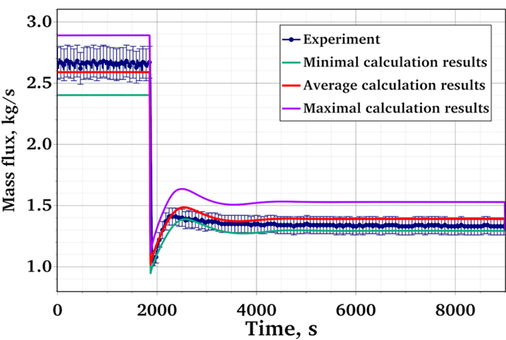 | 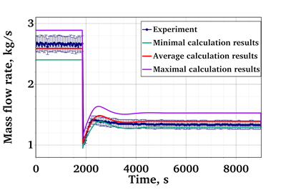
FIG. 50. Mass flow rate calculation results for ADP06.
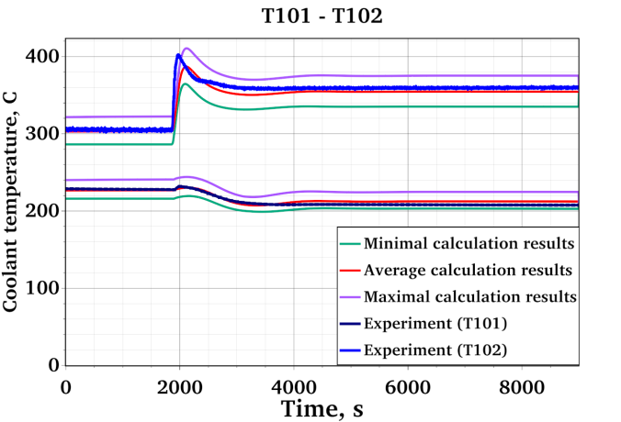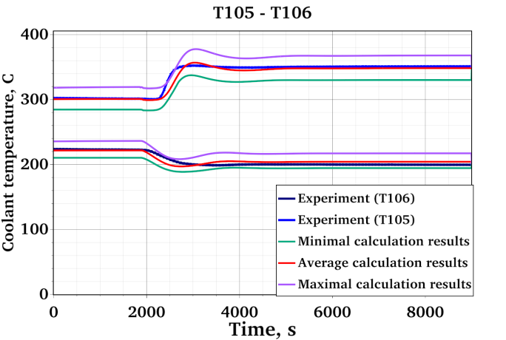
FIG. 51. Temperature calculation results for ADP06.
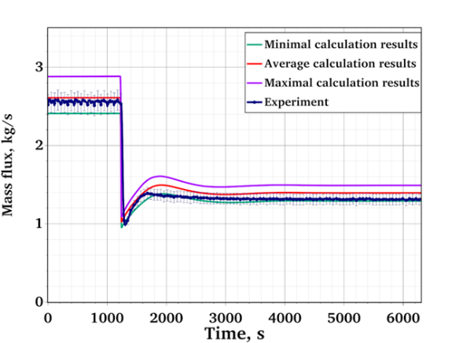 | 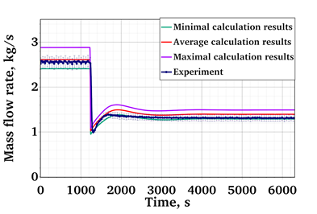
FIG. 52. Mass flow rate calculation results for ADP10.
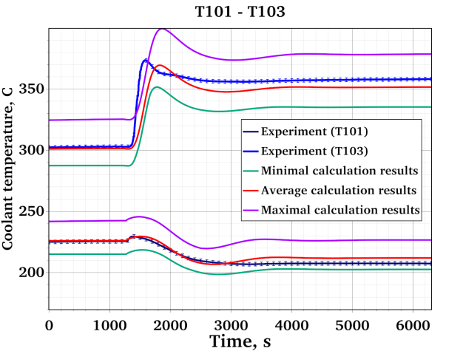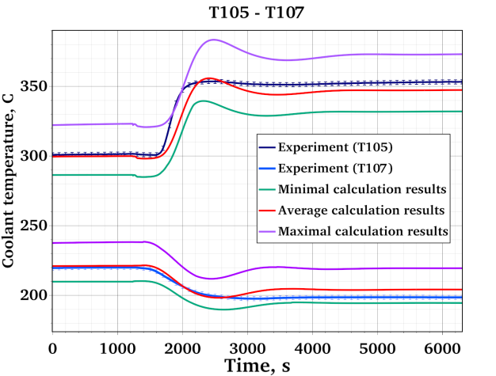
FIG. 53. Temperature calculation results for ADP10.
A good agreement between the experimental data and the simulation results in both experimental tests can be seen. In the steady states, the mean calculated temperature follows the experimental line, with minor deviations. The uncertainty range is quite large. This is the results of highly uncertain thermal conductivity of the steel powder in the heat exchanger. As the sensitivity analysis shown below suggests, it has the highest influence on the coolant temperature. As for the mass flow rate, the calculated mean mainly lies within the experimental uncertainty range.
The transition from forced to natural circulation is also simulated well; the uncertainty band quite accurately follows the experimental data, mainly encompassing it. This indicates the high accuracy of the models and the correct consideration of the parameters of the facility under consideration.
A similar uncertainty analysis was conducted for the blind test. The results for mass flow rate and temperature are shown in FIG. 54 and FIG. 55
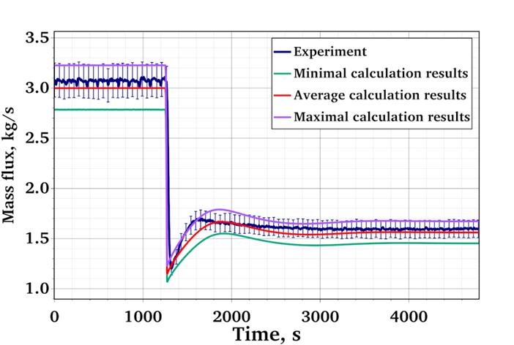 | 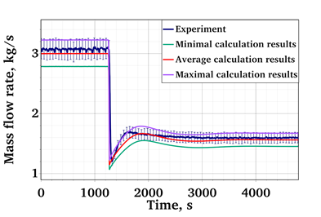
FIG. 54. Mass flow rate calculation results for ADP07.
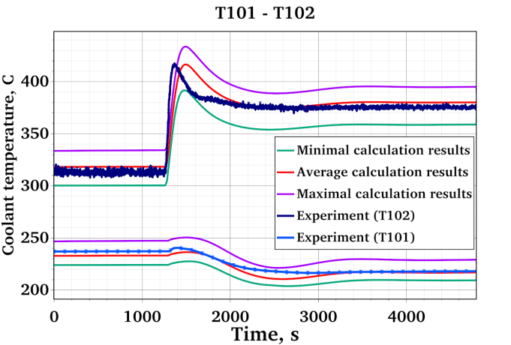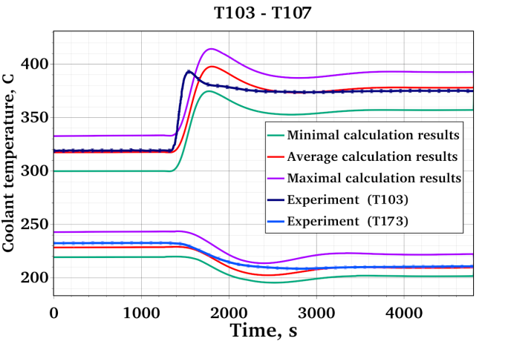
FIG. 55. Temperature calculation results for ADP07.
As one can see, for the blind tests, the calculated results showed even higher accuracy than for the open ones. This demonstrates the high predictive power of the code.
The sensitivity analysis results highlight the parameters that have the most significant impact on the calculation results. The Spearman rank correlation coefficients used as sensitivity measure are shown in the FIG. 56 – FIG. 58. Positive values mean that the increase of an input parameter yields the increase of the simulation result. Negative values mean that the simulation result decreases with an increase of this input parameter. Values close to zero indicate the parameters with weak influence on the result. The rank correlation coefficients were chosen since in some cases the response was non-linear, but always monotonous.
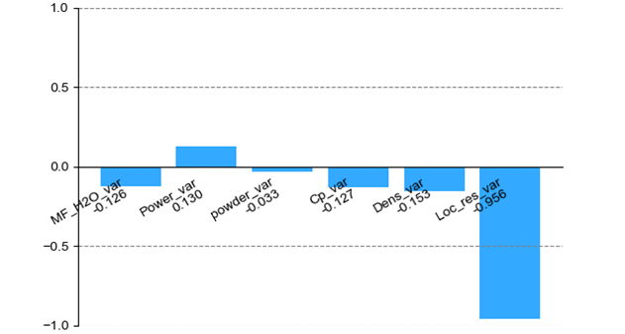
FIG. 56. Sensitivity coefficients for LBE mass flow rate.
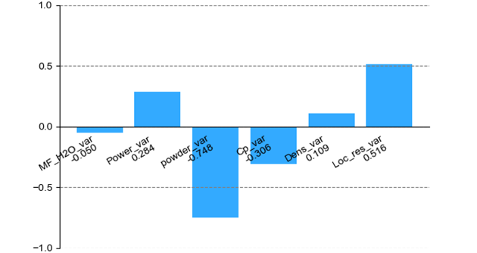
FIG. 57. Sensitivity coefficients for temperature (T103).
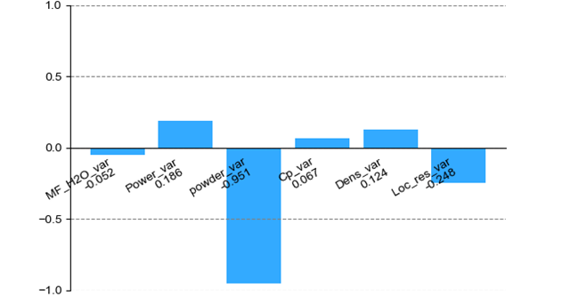
FIG. 58. Sensitivity coefficients for temperature (T107).
The results confirm the analytical estimates and assumptions: the greatest influence on the results of the mass flow calculation is exerted by the variation of the local resistance coefficients (Loc_res_var), and the temperature values are influenced by the heat removal to the water. This means that special attention should be given to the construction of the heat exchanger and its material properties. Here, the crucial influence of the stainless steel powder thermal conductivity (powder_var) can be seen. Unfortunately, this is the parameter with quite high uncertainty, since it depends very highly on the production technology and is hard to control.
The calculation error was estimated using the methodology described above. The average error E and its uncertainty range uval for mass flow rate and for the temperature at several thermocouples locations are presented in Table 35.
Table 35. Error and uncertainty range for mass flow rate and temperatures.
Parameter |  | E | u_{val}
LBE mass flow rate |  | 2.0 | 9.3
Temperature | T101 | 0.1 | 2.4
Temperature | T102 | -5.0 | 6.7
Temperature | T103 | -5.0 | 7.4
Temperature | T104 | -5.0 | 8.4
Temperature | T105 | -4.0 | 4.2
Temperature | T106 | 0.4 | 3.9
Temperature | T107 | 1.0 | 2.5

For the temperature, the combined values for the code mean error E and error uncertainty utot from all thermocouples were obtained as well. They amounted to E = -2.5 K; uval =6.3 K.

Discussion
The methodology allowed obtaining realistic (non-conservative) estimates of the HYDRA-IBRAE/LM thermal-hydraulic system code error for the LBE and water temperatures as well as for the LBE mass flow rate. It uses the same statistical approach as the one used in metrology [52] for accuracy assessment of the measurements. The “measurements” (simulations) are compared with the “standard gauge” (experiment), and the results of the comparison are statistically processed. As a result, a systematic (bias) and stochastic (uncertainty range) components of the error were obtained.
Combined estimates are presented for all three regimes: forced circulation, transition, and natural circulation, since the systematic error was close for all the regimes. Otherwise, separate estimates would have been necessary.
For all simulations, the bias was quite small. It was negative (underestimation) for LBE temperature and positive (overestimation) for mass flow rate in the open tests. In the blind test, the situation was different: the code overestimated the temperature and underestimated the mass flow rate. However, in all cases the absolute value of the bias was smaller than the error uncertainty range. This shows that the obtained results are “best-estimate” not only in the regulatory (no intended conservative bias), but also in statistical (low-bias) sense.
It can be noted that the error uncertainty of the LBE mass flow rate mainly stems from its experimental uncertainty. In contrast, for the LBE temperature, the error uncertainty is defined by the uncertainty of the input parameters. It therefore can be reduced if better estimates of the input parameters are available, especially since one of the most uncertain parameters – steel powder thermal conductivity – influences the temperature most.

UNIPI
The University of Pisa addressed the WP5 activities performing CFD calculations adopting the coarse “Solid-Wire” nodalization introduced in the UniPi CFD section. In this frame, the typical Monte Carlo approaches, which require hundreds of calculations to achieve a suitable sampling, become too much expensive. As a consequence, other strategies have to be adopted. During the last years the Deterministic Sampling approach [53] is being proposed as a valuable method to perform UQ analyses while limiting the total number of calculations needed for the analysis. It indeed considers only a limited number of calculation for the derivation of uncertainties: instead of running hundreds of calculations to make it so the sample is converging towards the same values of the reference conditions (achieving same first and higher order momenta), Deterministic Sampling a priori selects a sample which grants that at least some of the distribution momenta are respected. In the present application, the Standard, Modified Hadamard and Random Sampling methods were considered.
 | $$Σ_{STD}^{T}=\sqrt{8}\left(\begin{matrix}Sample & {\overset{˙}{m}}_{\text{LBE }} & T_{\text{IN,FPS }} & Q_{\text{eff }} & Q_{\text{pre }} & k & C_{P} & v & ρ \\ STD01 & σ_{1} & 0 & 0 & 0 & 0 & 0 & 0 & 0 \\ STD02 & -σ_{1} & 0 & 0 & 0 & 0 & 0 & 0 & 0 \\ STD03 & 0 & σ_{2} & 0 & 0 & 0 & 0 & 0 & 0 \\ STD04 & 0 & -σ_{2} & 0 & 0 & 0 & 0 & 0 & 0 \\ STD05 & 0 & 0 & σ_{3} & 0 & 0 & 0 & 0 & 0 \\ STD06 & 0 & 0 & -σ_{3} & 0 & 0 & 0 & 0 & 0 \\ STD07 & 0 & 0 & 0 & σ_{4} & 0 & 0 & 0 & 0 \\ STD08 & 0 & 0 & 0 & -σ_{4} & 0 & 0 & 0 & 0 \\ STD09 & 0 & 0 & 0 & 0 & σ_{5} & 0 & 0 & 0 \\ STD10 & 0 & 0 & 0 & 0 & -σ_{5} & 0 & 0 & 0 \\ STD11 & 0 & 0 & 0 & 0 & 0 & σ_{6} & 0 & 0 \\ STD12 & 0 & 0 & 0 & 0 & 0 & -σ_{6} & 0 & 0 \\ STD13 & 0 & 0 & 0 & 0 & 0 & 0 & σ_{7} & 0 \\ STD14 & 0 & 0 & 0 & 0 & 0 & 0 & -σ_{7} & 0 \\ STD15 & 0 & 0 & 0 & 0 & 0 & 0 & 0 & σ_{8} \\ STD16 & 0 & 0 & 0 & 0 & 0 & 0 & 0 & -σ_{8}\end{matrix}\right)$$ | (32)
As an example, using a local sensitivity approach [54] to investigate a local range around a fixed point in the parameter space and the corresponding change in the outputs when changing each input parameter individually it is possible to derive the diagram reported in FIG. 59. This shows that uncertainties on the thermal conductivity, dynamic viscosity and density only play a minor role in the propagation of uncertainties. Larger contributions are instead reported by the mass flow rate, power (Qeff and Qpre), specific heat and inlet temperature. As a consequence, only these latest five parameters were considered for additional calculations involving the modified Hadamard and Random Sampling Approaches.
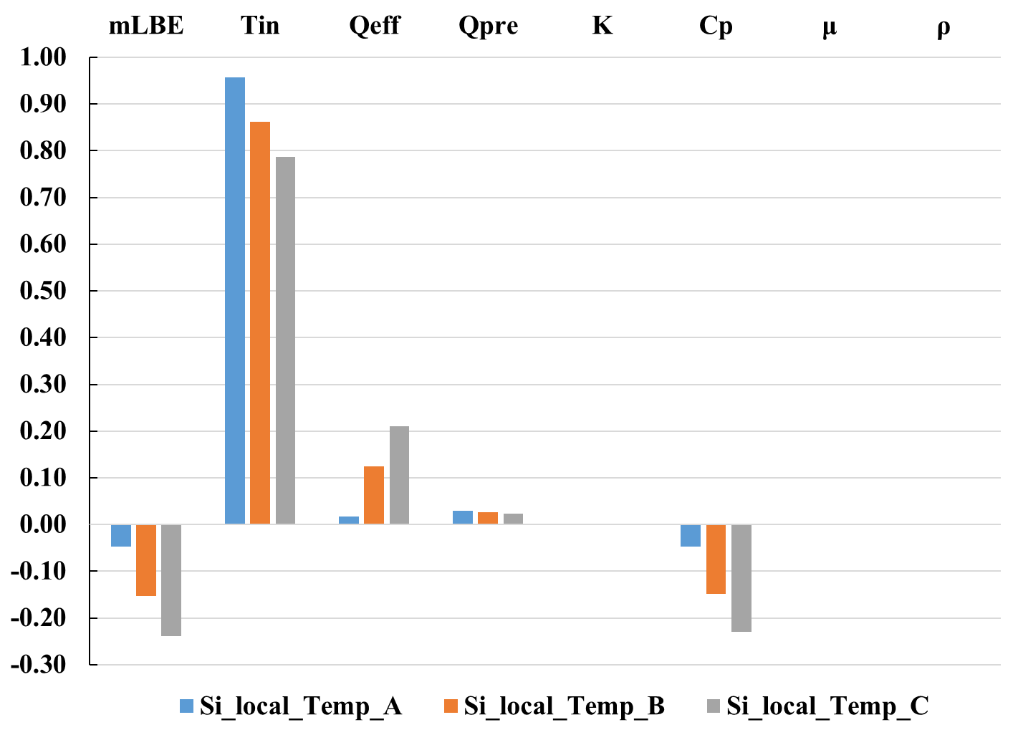
FIG. 59. Local SA for the input parameters in the ADP10 1SS (STD ensemble) case.
The modified Hadamard approach considers that all the involved parameters are changed in each calculation. It is an advanced approach as it allows observing the mutual impact of different parameters. Again, on average, the selected group (a group which is sampled deterministically) grants that on average, the sample represents the reference conditions; once again all the sigmas are balanced in another run of the sample. Again, see Eq. (33), only sixteen calculations are required to perform the uncertainty quantification analysis.
 | $$Σ_{HAD}^{T}=\left(\begin{matrix} \text{Sample} & {\overset{˙}{m}}_{LBE} & T_{IN,FPS} & Q_{\text{eff }} & Q_{pre} & C_{p} \\ HAD01 & σ_{1} & σ_{2} & σ_{3} & σ_{4} & σ_{5} \\ HAD02 & σ_{1} & -σ_{2} & σ_{3} & -σ_{4} & σ_{5} \\ HAD03 & σ_{1} & σ_{2} & -σ_{3} & -σ_{4} & σ_{5} \\ HAD04 & σ_{1} & -σ_{2} & -σ_{3} & σ_{4} & σ_{5} \\ HAD05 & σ_{1} & σ_{2} & σ_{3} & σ_{4} & -σ_{5} \\ HAD06 & σ_{1} & -σ_{2} & σ_{3} & -σ_{4} & -σ_{5} \\ HAD07 & σ_{1} & σ_{2} & -σ_{3} & -σ_{4} & -σ_{5} \\ HAD08 & σ_{1} & -σ_{2} & -σ_{3} & σ_{4} & -σ_{5} \\ HAD09 & -σ_{1} & -σ_{2} & -σ_{3} & -σ_{4} & -σ_{5} \\ HAD10 & -σ_{1} & σ_{2} & -σ_{3} & σ_{4} & -σ_{5} \\ HAD11 & -σ_{1} & -σ_{2} & σ_{3} & σ_{4} & -σ_{5} \\ HAD12 & -σ_{1} & σ_{2} & σ_{3} & -σ_{4} & -σ_{5} \\ HAD13 & -σ_{1} & -σ_{2} & -σ_{3} & -σ_{4} & σ_{5} \\ HAD14 & -σ_{1} & σ_{2} & -σ_{3} & σ_{4} & σ_{5} \\ HAD15 & -σ_{1} & -σ_{2} & σ_{3} & σ_{4} & σ_{5} \\ HAD16 & -σ_{1} & σ_{2} & σ_{3} & -σ_{4} & σ_{5}\end{matrix}\right)$$ | (33)
In the Random Sampling Approach (RS), instead, it is assumed that the actual values of each parameter are distributed following the normal distribution around the average value $μ_{i}$. To be coherent with the approach, several values have to be sampled inside a ±2$σ_{i}$ (standard deviation) range straddling the average value. This approach requires way more calculations than the previous ones and it was considered as reference for the present application.
FIG. 60 reports a comparison between the experimental values (red line) and its corresponding uncertainty range, together with the results from the CFD calculation performed adopting the reference conditions (Black line) and the calculations performed following the Standard approach. For a more detailed description the reader is referred to [55]. Each blue line represents one of the sixteen calculations, the green dashed line represents their average while the blue shaded area represents a range of two standard deviations straddling the average value. As it can be observed, the average value from the UQ analyses is very close to the CFD reference calculation. UQ calculations overpredicting or underpredicting the experimental values do exist and, once the average and standard deviation are calculated, all the measured values are included in a ±2$σ$ range. It can also be observed that the uncertainty range increases while moving towards the outlet of the FPS, this is in accordance with the fact that uncertainties related to the mass flow, supplied heat and specific heat build up along the heated section; they are small at the inlet but way larger at the outlet.
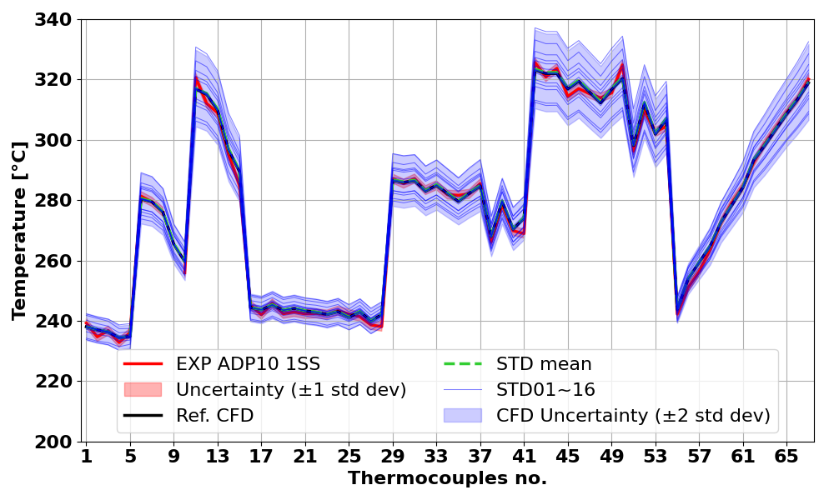
FIG. 60. Comparison of experimental data measurements and CFD Prediction in the ADP10 1SS (STD ensemble) case.
Once the other approaches are applied it is possible to compare the results. As it can be observed in FIG. 61, in this case the Standard and Hadamard approaches report similar uncertainty ranges while the RS approach returns a smaller uncertainty range, more in line with the experimental one. All the approaches managed to provide similar average values and in general achieve some level of success in suitably propagating the uncertainties.
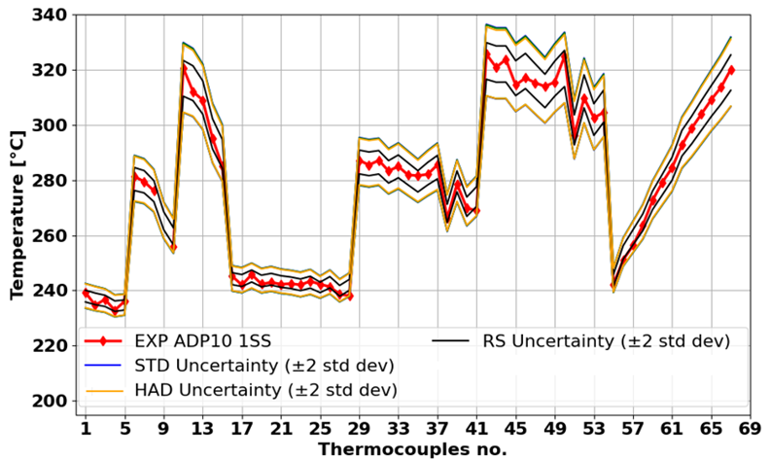
FIG. 61. Upper and lower bound for the methods adopted in the UQ analysis.

Conclusions
Despite relatively low number of the participants who presented the results of the uncertainty and sensitivity analysis in this paper, it reflects the variety of existing approaches. The reason for this variety is not individual preference, but the specifics of the TH codes used. First of all, it is the computational burden. System codes allow running hundreds of multivariate simulations, making classic statistical approaches applicable. Subchannel codes are also computationally efficient, opening the way to perturbation theory approaches and related explicit physical insights on the sensitivity contribution of the involved parameters. CFD codes, being much more computationally heavy, limit the number of possible simulations to about a dozen, thus reducing the choice of applicable methods.
The difference in the approaches, used TH codes, and studied parameters do not allow any direct comparison of the uncertainty and sensitivity study results. However, some common features can be mentioned. First, the sensitivity study allowed the participants to check the correctness of their TH simulations by comparing its results with theoretical predictions. Second, the results allowed to more reliably quantify the codes errors with respect to different uncertainties and to understand the influence of these uncertainties.
ENEA demonstrated the feasibility of generalized perturbation theory approaches when applied to the subchannel code ANTEO+. GPT allows for direct evaluation of sensitivity coefficients without the need to statistically interpret results, and thus more intuitively retrieving the physical contribution and its origin in the various terms of the conservation equations. Further development will be elaborated to extend the approach to other parameters of interest.
IBRAE RAN successfully applied their methodology to estimate the code error with strong statistical support and account for different types of uncertainties. The comparison of the error estimates for open and blind tests showed the predictive capability of the methodology as well as of the HYDRA-IBRAE/LM code.
With regard to the CFD-based uncertainty quantification activities carried out at UniPi, it should be emphasised that the high computational demand represents a significant obstacle to widespread application. Nevertheless, the use of the DS method in this study proved to be both effective and robust, yielding uncertainty bounds comparable to more computationally intensive approaches while maintaining a reasonable and manageable cost. Although high-resolution three-dimensional simulations require substantial computational resources—thus limiting their use for real-time or full-system analyses—alternative strategies may help alleviate this constraint. In particular, GPU-accelerated solvers and hybrid modelling approaches, such as CFD–system code coupling, could be further explored to enhance efficiency without compromising predictive capability.

Conclusions
Body text placeholder.

List of Abbreviations
Body text placeholder.

ANNEX I. TECHNICAL SPECIFICATION
Body text placeholder.

ANNEX II. DESCRIPTION OF ORGANIZATIONS

Argonne National Laboratory (ANL)
Argonne National Laboratory seeks solutions to pressing national problems in science and technology. The nation’s first national laboratory, Argonne conducts leading-edge basic and applied scientific research in virtually every scientific discipline. Argonne researchers work closely with hundreds of companies, universities, and federal, state, and municipal agencies to help them solve their specific problems, advance America’s scientific leadership and prepare the nation for a better future. With employees from more than 60 nations, Argonne is managed by UChicago Argonne, LLC for the U.S. Department of Energy’s Office of Science.
Argonne’s Nuclear Science and Engineering Division advances the design and operation of nuclear energy systems and applies nuclear energy-related expertise to current and emerging programs of national and international significance. The division participates in key U.S. Department of Energy (DOE) nuclear energy and national security initiatives, including leading the nation’s program for development and demonstration of advanced reactor technologies that promise to improve the affordability of nuclear power, enhancing the assurance of safety and security, and minimizing the discharge of radioactive waste.

China Institute of Atomic Energy (CIAE)
China Institute of Atomic Energy (CIAE) was founded in 1950 and grew out of the Institute of Modern Physics of the Chinese Academy of Sciences. A cradle of nuclear science and technology of China, we are an integrated nuclear R&D base that plays a fundamental, forward-looking, pioneering, and engineering role in the nuclear field. CIAE consists of six main departments: Department of Nuclear Physics, Department of Reactor Engineering Technology, Department of Radiochemistry, Department of Nuclear Safety and Environmental Engineering Technology, Department of Nuclear Engineering Design, and Department of Nuclear Technology Application. CIAE collectively cover the following disciplines: nuclear physics, nuclear chemistry and radiochemistry, nuclear reactor engineering, accelerator technology, nuclear detection, isotopes, nuclear safety, radiation measurement, nuclear fuel cycle and new energy materials.

CNPRI
Body text placeholder.

National Agency for New Technologies, Energy and Sustainable Economic Development (ENEA)
ENEA, the National Agency for New Technologies, Energy and Sustainable Economic Development, is among the largest public research institutions in Italy, with about 2.250 researchers, technologists and support staff. It has 13 research centers equipped with experimental facilities, large laboratories and advanced instrumentation and 17 territorial bureaus scattered all over Italy, plus one representative bureau in Brussels. ENEA is structured into four departments: the Department of Energy Technologies and Renewable Sources, Nuclear, Energy Efficiency and Sustainability, as well as the Antarctica Unit and the Technology Transfer Directorate. Since its foundation in 1960, it has been committed to the development and competitiveness of Italy with applied research and by providing technology transfer and technical and scientific assistance to companies, associations, territories, citizens, and central and local administrations. Today its research and dissemination activities are mainly aimed at contributing to the achievement of the energy and environmental transition, by promoting the growth and competitiveness of relevant sectors such as energy technologies (renewables, storage, smart grids), hydrogen, nuclear fusion and innovative technologies for nuclear fission, energy efficiency, energy communities, smart cities, food security, sustainable mobility, innovative and strategic raw materials, anthropogenic impacts and climate change, circular economy, biotechnologies, as well as cultural heritage technologies and seismic safety.

GIDROPRESS
OKB Gidropress JSC carries out a complex set of design, calculation, theoretical, experimental-research and production works on the creation of reactor units for nuclear power plant of various purposes.
The main activities of OKB Gidropress JSC in project development are:
- water-water power reactor (VVER) installations for nuclear power plants;
- reactor installations with lead-bismuth coolant such as SVBR-100;
- equipment for fast neutron reactor installations with sodium coolant.
The following were constructed based on designs by OKB Gidropress JSC:
- VVER-type reactor installations: VVER-210, VVER-365, VVER-440, VVER-1000, VVER-1200;
- the heavy-water research reactor at the Institute of Theoretical and Experimental Physics (Russia, Moscow);
- the MR research reactor at the Institute of Atomic Energy (Russia, Moscow);
- the steam generator and heat exchangers for the world's first nuclear power plant (Russia, Obninsk);
- the VK-50 boiling water reactor installation at the SSC RIAR (Russia, Dimitrovgrad);
- the BOR-60 fast neutron reactor, designed for experimental testing of fuel assemblies, steam generators, and other components of sodium loops (Russia, Dimitrovgrad);
- steam generators and heat exchangers for the BN-350 nuclear power plant;
- steam generators and heat exchangers for the BN-600 nuclear power plant.

International Academy of Neutron Science (IANS)
International Academy of Neutron Science (IANS) is a public institution subordinate to the government in China. As an important research unit of FDS Consortium, IANS focuses on the fundamental research of neutron transport theory, neutron source and experiment technology, and the neutron application research on advanced nuclear energy and safety, radiation medicine and radiotherapy, aerospace, industrial nondestructive testing, oil and gas logging, etc.

Nuclear Safety Institute of the Russian Academy of Sciences (IBRAE)
Nuclear Safety Institute of the Russian Academy of Sciences (IBRAE RAN) was founded in 1988 with the aim of advancing basic research and independent analysis of nuclear and radiation safety. IBRAE RAN is the only institute of the Russian Academy of Sciences specializing in comprehensive research into the safety of nuclear power facilities and industry. Today, IBRAE RAN is one of the Russian largest centres for fundamental and applied research in the field of safety of nuclear power facilities that possesses a high scientific and technical potential.
The history of IBRAE RAN covers the post-Chernobyl era. The Institute's area of research is the overall safety analysis of nuclear power facilities, including the nuclear fuel cycle, using modern computer technologies. The Institute develops efficient approaches to safety justification based on the development and practical application of modern mathematical and software algorithms, the development of detailed physical models of complex processes and probabilistic safety analysis methods, the organization of experimental and operational data banks, the creation of numerical models for the transport of radioactive and chemically hazardous substances in the environment, and efficient methods for assessing the impact of these substances on the environment and humans.
The main scientific directions of the Institute are:
- Safety justification of nuclear installations and industry facilities;
- Systematic analysis of the problems of RAW and SNF management, decommissioning of nuclear and radiation hazardous facilities and rehabilitation of territories;
- Ecological impact of nuclear power and industry facilities on the environment and population;
- Scientific bases of radiation monitoring and emergency response;
- Ocean dynamics research;
The Institute's staff (including the Novosibirsk and Krasnoyarsk branches) includes more than 550 employees.

Indira Gandhi Centre for Atomic Research (IGCAR)
Indira Gandhi Centre for Atomic Research (IGCAR) was set up in 1971 with the main objective of conducting broad multidisciplinary scientific research directed towards the development of sodium cooled Fast Breeder Reactor (FBR) technology in India. Development of FBR technology is a part of the second stage of the Indian atomic energy programme, aimed at effective utilization of the country’s extensive thorium reserves and addressing the growing electricity demand of the 21st century. Over the years, the centre has established comprehensive R&D facilities covering the entire spectrum of FBR technology related to sodium technology, reactor engineering, reactor physics, metallurgy and materials, fuel chemistry, fuel reprocessing, reactor safety, instrumentation and control, among others. At present, IGCAR operates a sodium cooled Fast Breeder Test Reactor (FBTR), with a nominal power of 40 MWt. It is the first of its kind in the world to use Plutonium Uranium mixed carbide as a driver fuel. A research reactor KAMINI using U-233 as driver fuel is also in operation at IGCAR. With the experience and expertise gained by the successful operation of FBTR, the Centre embarked upon the design of a MOX based 500 MWe, Prototype Fast Breeder Reactor (PFBR). The PFBR is in the advanced stage of commissioning and reached criticality on 6th April, 2026.

The European Commission Joint Research Centre (JRC)
The European Commission Joint Research Centre (EC-JRC) provides independent, evidence-based knowledge and science, supporting European Union policies to positively impact society. As the science and knowledge service of the European Commission (EC), the Joint Research Centre (JRC) provides independent, evidence-based scientific and technical support to help shape, implement, and evaluate European Union (EU) policies. Its mission is to deliver robust scientific knowledge that can inform decision-making across a wide range of policy areas, from climate action, energy, and digital transformation to food safety, security, and public health. Operating at the interface between science and policy, the JRC ensures that EU institutions have access to high-quality data, cutting-edge research, and transparent analytical methods, all aimed at improving policy effectiveness and societal outcomes.
The Directorate G for Nuclear Safety and Security, of the EC-JRC has the mission to implement the JRC Euratom Nuclear Research and Training Programme, the maintenance and dissemination of nu-clear competences in Europe to serve both “nuclear” and “non-nuclear” Member States.
EC-JRC Directorate G supports the relevant policy Directorates General of the European Commission, and the Directorate G is a key partner in international networks and collaborates with international organisations and prominent Academia and Research Institutes.
The Reactor Safety and Components G.4 Unit, where the IAEA CRP NACIE activities were performed, con-tributes to technological innovation of nuclear reactor safety through experimental testing, numerical simulation and analysis.

KAERI
Body text placeholder.

Karlsruhe Institute of Technology (KIT)
The Karlsruhe Institute of Technology (KIT) is “The University in the Helmholtz Association.” As the only German university of excellence with a national large-scale research sector, we offer our students, researchers, and employees unique learning, teaching, and working conditions. The roots of the academic education institution extend all the way back to 1825. Today’s structure of KIT is the result of the merger of the Technical University of Karlsruhe and Karlsruhe Research Center in 2009.
Presently, around 10000 people are working at KIT, of which more than half are conducting research in a broad range of disciplines from natural sciences to engineering, to economics, to the humanities and social sciences. This makes KIT one of the largest science institutions in Europe. Apart from excellent academic education and cutting-edge research, innovation is our central task. We do not only create and impart knowledge for the society and the environment, we also use this knowledge to develop applications for industry. It is our goal to help manage global challenges facing humankind by pioneer research contributions in the areas of energy, mobility, and information. Doing this, we attach high importance to permanent contact and exchange with society.
The Institute for Thermal Energy Technology and Safety (ITES) at the Karlsruhe Institute of Technology (KIT) uniquely embodies the energy transition: our mission is to enable innovative thermal technologies for a sustainable and safe net-zero energy supply. To this end, the ITES performs research in hydrogen safety and applications [H2], heat transfer / storage / transport using water [MPS], liquid metal [KALLA], and molten salt [FTS], efficient use of alternative heat sources [EVT], magnetohydrodynamics for fusion [MHD], numerical flow modeling [FPS], analyses of the resilience of critical infrastructures, atmospheric dispersion and impact assessment of hazardous substances (e.g. radionuclides) as well as decision support systems [RESIS]. An important part of our mission is the training and education of the next generation of practitioners and engineers through apprenticeships, lectures, internships, and theses.

NIKIET
JSC NIKIET is one of Russia's largest nuclear design and research centers specializing in reactor technology. The institute develops designs for advanced nuclear power reactors, including those for regional energy, research and isotope reactors, and nuclear physics systems for the ITER international fusion reactor. It also provides scientific and technical support for RBMK-equipped nuclear power plants, develops and supplies integrated automated control, management, and protection systems for reactor installations, and develops diagnostic systems. NIKIET conducts large-scale research into the development of nuclear power technology based on a closed fuel cycle with fast reactors using heavy liquid metal coolant. NIKIET has specialized departments for strength, thermal hydraulics, computational fluid dynamics, reliability, and service life of nuclear equipment, as well as non-destructive testing and diagnostics of metals in NPP equipment and pipelines. NIKIET's production facilities are designed for the development, manufacture, and testing of new reactor technology developed at the institute. NIKIET also has a specialized division for the development of research nuclear reactors and facilities. More than 20 research reactors have been built in Russia and abroad, either under NIKIET's designs or with its participation.

NINE
Body text placeholder.

Nuclear Research and consultancy Group (NRG)
NRG PALLAS, formerly NRG, is a leading Dutch nuclear organization based in Petten, The Netherlands, dedicated to advancing nuclear technology for medical, energy, and research applications. It is the result of a strategic collaboration between Nuclear Research and consultancy Group (NRG) and the PALLAS reactor project, combining decades of operational expertise with forward-looking infrastructure development. NRG operates the High Flux Reactor (HFR) in Petten, one of the most important research reactors in Europe for the production of medical isotopes and nuclear research. In parallel, the PALLAS project is developing a state-of-the-art multipurpose research reactor that will replace the HFR.
NRG PALLAS’s nuclear energy research programme encompasses advanced thermal-hydraulic modelling, fuel behaviour analysis, reactor safety assessments, and materials testing under irradiation. The experimental research conducted at NRG PALLAS leverage facilities such as the HFR and hot cell laboratories. The computational research employs state-of-the-art simulation tools for, among others, structural mechanics, system thermal hydraulics (STH), computational fluid dynamics (CFD), neutronics, and other multi-scale, multi-physics applications.

Paul Scherrer Institute (PSI)
The Paul Scherrer Institute (PSI) is Switzerland’s largest research institute for natural and engineering sciences and its principal national centre for nuclear engineering and reactor-safety research. PSI has extensive experience in the analysis of Generation IV reactor systems, particularly fast-spectrum reactors, covering reactor physics, fuel-cycle analysis, fuel behaviour, thermal hydraulics, multiphysics modelling and safety assessment. PSI has participated in numerous European research programmes on advanced fast reactors and heavy liquid metal technologies, including EUROTRANS, ELSY and LEADER, as well as projects addressing sodium-cooled fast reactor development and safety. Of particular relevance is the MEGAPIE project, in which a 1 MW liquid lead–bismuth eutectic spallation target was designed, licensed and successfully operated at PSI’s SINQ facility in 2006. Although MEGAPIE was developed for an accelerator-driven system rather than a lead-cooled fast reactor, it provided directly relevant experience in LBE thermal hydraulics, electromagnetic pumping, materials compatibility, irradiation effects, liquid-metal chemistry, system operation and post-irradiation examination. PSI therefore combines computational expertise in fast-reactor design and safety with experimental and operational experience involving heavy liquid metals.

National University of Science and Technology POLITEHNICA Bucharest (PUB)
Currently, POLITEHNICA Bucharest has 21 faculties and 19 doctoral schools, ensuring for the approximately 40,000 students a high-performance education, supported by a complex research activity, according to European requirements and with the means offered by the modern information society at all three university cycles. In addition, approximately 1200 international students study at the university, coming from over 59 countries, enrolled in all three university cycles. In the Bucharest university centre there are 15 faculties that manage bachelor's and master's degree programs in 21 fields, and in the Pitești university centre there are 6 faculties that manage bachelor's and master's degree programs in 26 fields; 8 master's degree programs are found in both university centres.
POLITEHNICA Bucharest is a member of 23 international organizations and two university consortia: EELISA, at the international level, and ARUST, at the national level.

Institute for Nuclear Research Pitești (RATEN)
RATEN ICN Pitesti, known also as the Institute for Nuclear Research, is a R&D organization whose main mission is to provide scientific and technological support for the national nuclear energy program. In the area of nuclear safety, the focus is to provide technical support for the CANDU Units at Cernavoda NPP for the safe lifetime operation, and to provide safety analysis for the operation of the TRIGA reactors. Also, its role is to generate contributions and expertise on the GEN IV reactors development, particularly on the lead cooled reactors. To fulfill its role in nuclear safety, specific activities include: reactor physics and thermal-hydraulic analysis; developing calculation methods and computer codes; nuclear fuel design, optimization and behavior modeling; fuel and materials tests design and experimental data evaluation.
The Institute also conducts laboratory testing and contribute to theoretical models in the analysis of nuclear materials, activates in fuel research & development, and produces radioactive sources for industrial use in the TRIGA reactor, as well as post-irradiation laboratory analysis for spent and failed fuel. Its dual core TRIGA has performed in time a whole series of tests on CANDU type fuel and structural materials.

Sapienza University of Rome (SAPIENZA)
Sapienza University of Rome was founded in 1303 by Pope Boniface VIII, resulting one of the oldest universities in the world. It is a top performer in international university rankings. It is a university that merges centuries of tradition with cutting-edge didactic activities, research and innovation. The main campus is a real city within the city located in the heart of Rome. With over 120,000 students, Sapienza is the biggest university in Europe. Ten Nobel Prize winners and internationally renowned scientists have taught and/or studied at Sapienza.
The first Engineering Study Program born in Italy was established in our faculty, by Pope Pius VII in 1817. All the engineers that studied there were trained as civil engineers, and it was only in 1913 that the school began to provide two different training programs: Civil and Industrial Engineering. In 1935 the school became the Faculty of Engineering of the University of Rome. In 1960 a special provision was issued which officially reorganized the Engineering Study Programs. This provision led to the creation of nine different Civil Engineering Degrees: Mechanical Engineering, Electrical Engineering, Chemical Engineering, Marine and Mechanical Engineering, Aeronautical Engineering, Mining Engineering, Electronic and Nuclear Engineering. The first Full Professor related to the degree of Nuclear Engineering was Maurizio Cumo, who is the leader of the nuclear research unit and in 1976 starts the college class of ‘Nuclear Power Plants’.
Nowadays, the Nuclear Engineering Research Group (NERG) is part of the Department of Electrical and Energy Engineering. The research activities carried out at NERG involve several fields, in particular: i) theoretical and experimental analyses associated with heat and mass transfer; ii) two-phase thermal-hydraulics (also coupled with neutron kinetics); iii) MagnetoHydroDynamics; iv) Severe accidents; v) Thermo-mechanical analyses; vi) study, design, construction and testing of innovative components (test sections, heat exchangers, etc.) and innovative fluid systems for heat removal. Such studies are related to both nuclear fission and fusion applications. Projects where NERG has been or is currently involved and that are worth mentioning are: GEN-IV (ALFRED, SFRs, Westinghouse and newcleo LFRs), SMRs (MARS, mini-MARS, iPWRs) and experimental nuclear fusion reactors (ITER, DEMO, ARC). The research unit consists of 5 professors and senior researchers, 2 assistant professors, 6 research fellows and 20 PhD students. Specifically referring to Liquid Metal Fast Reactors (LMFR), several analyses were carried out in the past years to understand the relevant thermal-hydraulic phenomena occurring within these systems during safety-relevant scenarios. These numerical simulations were performed by using best-estimate system code RELAP5-3D©. The most relevant research activities involve:
- Loss of Flow Accident (LOFA) tests performed at CIRCE-ICE and CIRCE-HERO experimental facilities hosted at ENEA Brasimone Research Centre (RC) to study liquid metal thermal stratification.
- LOFA tests performed at NACIE facility hosted at ENEA Brasimone RC to investigate natural circulation. In addition, Uncertainty Quantification was carried out on some selected parameters.
- EU-H2020 SESAME Project benchmark on PHÉNIX End of Life dissymmetric tests to study asymmetric effects and their influence on the reactor performances.
- OECD-NEA benchmark on PERSEO passive systems to evaluate the RELAP5-3D© modelling capabilities with respect to pool boiling and condensation, heat transfer mechanisms strongly adopted within GEN IV passive safety systems.
- ALFRED design, with a particular focus on the passive-controlled isolation condenser, simulating two-phase natural circulation with non-condensable.
- Participation in the IAEA Coordinate Research Project (CRP) I32011, related to the simulation of a Loss of Flow Without Scram test (LOFWOS test #13) performed at the American Fast Flux Test Facility (FFTF) reactor. FFTF was a loop-type sodium fast reactor prototype. Twenty-five research institutions from thirteen countries participated in this benchmark exercise. The main goal of this research activity is the coupling between neutron-kinetic (NK) and thermal-hydraulic (TH) codes for the development of a full-integrated tool to investigate safety-relevant accidental scenarios characterizing these new generation fission reactors.
- The Advanced Nuclear Safety Evaluation of Liquid Metal Using Systems (ANSELMUS) project is part of the Horizon Europe Euratom research activities. ANSELMUS final purpose is contributing to the safety risk assessment for GEN IV LMFRs, considering both sodium and lead technologies, i.e., by investigating MYRRHA and ALFRED reactors. NERG is currently involved in Work Package 1, related to the development of a Phenomena Identification and Ranking Technique (PIRT) methodology to be applied during the LMFR design process. NERG is performing TH transient simulations of ALFRED reactor during selected accidental scenarios.
- The LEad fast reactor Safety design and TOols (LESTO) project is part of the Horizon Europe Euratom research activities. NERG contributions within LESTO relate to: Support the development of a passive mitigation device for LFR and the related experimental setup (SIRIO); Post-test analysis of ATHENA facility (largest facility in Europe for research on LFR technology).

University of Pisa (UNIPI)
Body text placeholder.

Westinghouse Electric Company (WEC)
Westinghouse Electric Company LLC is a global leader in the nuclear power industry, headquartered in Cranberry Township, Pennsylvania, USA. The company provides nuclear products and services to utilities worldwide, including nuclear fuel and plant services, instrumentation and control systems, advanced reactors, such as the AP1000 pressurized water reactor, AP300 SMR, Lead Cooled Fast Reactor and eVinci microreactor. Westinghouse technology powers about 50% of the world’s nuclear reactors, and the company operates in over 20 countries with more than 11,000 employees. Westinghouse emphasizes innovation, safety, and sustainability, positioning itself as a key player in the transition to carbon-free energy.
Westinghouse has been advancing Generation IV Lead-cooled Fast Reactor (LFR) technology for more than a decade. The conceptual LFR design was completed in 2023 and features a pool-type, liquid lead-cooled fast reactor with an electrical output of about 450 MWe net. The primary coolant is liquid lead, while the secondary coolant is supercritical water or CO₂. The reactor uses oxide fuel and supports an extended fuel cycle of 8–15 years, operating at atmospheric pressure. Safety is enhanced through a Passive Heat Removal System, classified as IAEA Passive Category B, which provides reliable decay heat removal capability during accident conditions. A large experimental program consisting of seven large scale thermal hydraulic facilities and material test facilities was developed for the LFR and will contentiously support LFR technology development.

Xi'an Jiaotong University (XJTU)
Xi'an Jiaotong University (XJTU) is one of China’s leading comprehensive research universities, located in Xi’an, Shaanxi Province. The university traces its origin to Nanyang Public School, which was founded in Shanghai in 1896. In 1956, the main body of Jiaotong University was relocated from Shanghai to Xi’an to support the development of higher education in western China, and in 1959 it was officially named Xi'an Jiaotong University.
Today, Xi’an Jiaotong University is a key national university and a member of the prestigious C9 League, which represents the top tier of Chinese universities. It has also been selected for several national initiatives aimed at building world-class universities, including Project 211, Project 985, and the Double First-Class Initiative.
XJTU is a comprehensive institution offering programs across a wide range of disciplines, including science, engineering, medicine, economics, management, law, and the humanities. The university consists of multiple schools and research institutes, with numerous national key laboratories, engineering research centers, and advanced research platforms. With more than 50,000 students and nearly 4,000 faculty members, XJTU has established numerous national key laboratories and research centers. The university is particularly well known for its strengths in engineering, energy and power engineering, electrical engineering, and mechanical engineering. It also maintains strong international collaborations and has attracted thousands of international students from more than 50 countries and regions.
With more than a century of academic tradition, Xi’an Jiaotong University has developed a strong reputation for excellence in engineering and technology, as well as interdisciplinary research. The university emphasizes innovation, international collaboration, and the cultivation of high-level talents. Through its modern campuses and research facilities, XJTU continues to play a significant role in scientific advancement and higher education development in China and around the world.
The Nuclear THermal-hydraulic Laboratory of Xi'an Jiaotong University (XJTU-NuTHeL) is mainly devoted to the frontier research of nuclear reactor thermal-hydraulic safety and R&D of Innovative LMFR. The laboratory is engaged in thermal-hydraulic experiments of heat transfer and flow of liquid metal, natural and forced circulation experiments of LBE, CFD simulation and application of advanced numerical algorithm (particle method), mechanism of oxidation process in LBE. Development of system analysis program and phenomenological program, thermal-hydraulic design and safety analysis of new type reactor.
The laboratory has advanced reactor thermo-hydraulic simulation consisting of several fields, mechanism experiment, program development, CFD simulation, severe accident analysis, fuel performance analysis, advanced reactor design and analysis and artificial intelligence research on nuclear thermal-hydraulic analysis. In terms of software platform, the laboratory have system analysis programs THACS for liquid metal, sub-channel analysis programs YOGUANG for LBE thermal-hydraulic analysis, CFD programs, fuel performance analysis programs, containment analysis programs, severe accident analysis programs, coupled physical and thermal design analysis programs, steam explosion analysis programs, sodium cooled fast reactor system analysis program, supercritical water cooled reactor system analysis programs, 3-D two-phase flow field simulation and analysis program for secondary side of steam generator.
XJTU-NuTHeL has been engaged in basic experimental and theoretical research of lead cooled fast reactor for a long time. A large number of basic experiments have been carried out on the characteristics of LBE flow and heat transfer involved in operative conditions and severe accident of lead-cooled fast reactor. The laboratory has set up a series of test benches, including SGTR test setup, stratification apparatus for pool-type LBE reactor, heat transfer and flow test setup for LBE and oxidation apparatus for LBE. The mechanism models of liquid metal oxidizing within oxygen atmosphere, pressure fluctuation and bubble transportation models were constructed, and the theoretical system of liquid metal two-phase flow and heat transfer was improved.
IAEA has started up the project of Benchmark specifications for NACIE-UP facility: non-uniform power distribution tests from forced to natural circulation flow. The scope of the project is to provide system data to qualify STH codes whereas the fuel bundle simulator data, especially the ones from dissymmetric tests can be useful for the validation and benchmarking of CFD codes and coupled STH/CFD methods for HLM systems. XJTU joined this group in 2022 and undertook the task of WP1 to WP4, whose main purpose is to analyze the transient and steady state characteristics during the transition from forced to natural circulation whereby a system code THACS, subchannel code YOGUANG, CFD procedure and a coupled code THACS/FLUENT for multiscale analysis.

ANNEX III. DESCRIPTION OF CODES

anteo +
ANTEO+ [56], [57] is a subchannel thermal-hydraulic analysis code developed by ENEA (Italy). It is a code adapted to liquid metal coolants from the original ANTEO (Cevolani, 1996), developed in ENEA for light water reactors, with the aim of supporting core design activities.
ANTEO+ targets steady-state and single-phase analysis in forced and mixed convection conditions for closed fuel assemblies with either hexagonal or square pins arrangements. It has the capability to predict cladding outer temperature azimuthal distribution, to handle a bypass flow in the inter-wrapper region, enabling calculations without the adiabatic approximation, and to manage power deposition both in the wrapper and bypass regions. The code has also a graphical interface for visualizing geometry and main field (e.g., temperatures, velocities) profiles.

celsist
The sub-channel code CELSIST is designed for the thermal-hydraulic calculation of fuel assemblies with a single-phase liquid metal coolant. The CELSIST sub-channel module solves a system of finite-difference conservation equations of mass, momentum and energy. The thermal conductivity equations are being solved in the sectors of fuel rods in accordance with the wetted perimeters in the cells.

cfx
ANSYS CFX is a commercial Computational Fluid Dynamics (CFD) software developed by Ansys Inc. (USA). It is extensively utilized in nuclear engineering, power generation, and particularly in turbomachinery applications to simulate complex fluid dynamics and thermal-hydraulic phenomena. ANSYS CFX [58] is based on an element-based finite volume method (FVM) to discretize and solve the governing equations of fluid flow, ensuring strict conservation of mass, momentum, and energy. A distinguishing feature of CFX is its vertex-centered, fully coupled solver technology. Unlike segregated solvers that iterate through equations sequentially, the CFX coupled solver solves the pressure and momentum equations simultaneously as a single system. This approach provides superior numerical stability and significantly faster convergence for a wide range of flow regimes, particularly in rotating machinery and complex industrial systems. The software supports both steady-state and transient analyses, utilizing robust implicit time integration schemes. The software employs an unstructured mesh formulation, supporting a variety of cell types such as hexahedral, tetrahedral, and prism elements. It integrates seamlessly with specialized meshing tools like Ansys Meshing and supports mesh deformation and remeshing for moving boundary problems. Regarding turbulence, CFX offers a comprehensive suite of modeling approaches tailored for industrial accuracy. It features standard Reynolds-Averaged Navier–Stokes (RANS) models, including the industry-standard k-ω,Shear Stress Transport (SST) model and the k-ε model, as well as Reynolds Stress Models (RSM). For high-fidelity research and complex transient flows, it supports Scale-Adaptive Simulation (SAS), Detached Eddy Simulation (DES), and Large Eddy Simulation (LES). Its advanced wall treatment options, such as automatic near-wall scaling, provide high accuracy in boundary layer resolution across varying mesh densities.

cobra
The COBRA-I-IV (COolant Boiling in Rods Array) is a core subchannel code belonging to the COBRA code family including COBRA-IIIC, VIPRE, COBRA-TF [59]. It is able to compute the thermal-hydraulic properties in nuclear fuel rod bundles or cores in steady-state and transient conditions.
The code can operate either an explicit or implicit solution scheme to solve the balance equations of mass, momentum and energy using a finite difference scheme applied to Eulerian computational control volumes. The control volumes can range as little as the fuel assembly subchannels up to core fuel assemblies in radial, azimuthal and axial direction.
The implicit solution scheme was inherited by the COBRA-IIIC version, where the equations of mass, momentum and energy are solved using a lumped finite difference scheme. But COBRA-I-IV also provides an explicit solution scheme that allows the calculation of transients where there are experienced phenomena like flow reversals, re-circulations, and expulsion and re-entry flows, with either an inlet flow or pressure drop boundary condition specified.
The fuel thermal response is also considered and chained to the thermal-hydraulic fluid response by use of Ushakov heat transfer constitutive correlation [16], see Eq. (34):
 | $$Nu=7.55\left(\frac{p}{d}\right)-\frac{20}{{\left(\frac{p}{d}\right)}^{13}}+\frac{0.041}{{\left(\frac{p}{d}\right)}^{2}}{\left(Re Pr\right)}^{0.56+0.19\frac{p}{d}}$$ | (34)
where, $\frac{p}{d}$, pitch-to-diameter ratio, Re, Reynolds number, Pr, Prandt number Nu, Nusselt number
The friction factor, used to calculate the pressure drop in the sub-channel, is derived from Rehme correlation [60].
Additional model is applied to simulate the behaviour of wire wraps [61]. The model is based on assumption that the crossflow that is induced by the wire-wrap passing through a gap is a fraction of the subchannel flow. The cross-vs- axial split is computed as shown in Eq. (35):
 | $$w_{forced}=π(D+t)(\frac{s}{A_{i}})(\frac{δ}{Dx})m_{i}$$ | (35)
where, D, rod diameter, t, wire wrap diameter s, gap width, A_{i}, area of subchannel flow rate, Dx, axial node length, Δ, arbitrary parameter, usually set to Dx/wire-wrap pitch length.
When wire-wrap model is called, subchannel flow areas and wetted perimeters are adjusted to take account for the presence of a wire-wrap in the subchannel. The forced crossflows are then kept constant while solving the transverse momentum equations for the remaining crossflows.
COBRA is also able to compute axial fluid and fuel conduction that is particularly relevant for liquid metal studies.

ctfr
Body text placeholder.

flownex
Body text placeholder [62].

fluent
ANSYS Fluent is a high-fidelity Computational Fluid Dynamics (CFD) solver widely used for modelling complex fluid-flow and thermal phenomena across a wide range of engineering applications [63]. It provides robust capabilities for simulating laminar and turbulent flows, compressible and incompressible flows, conjugate heat transfer, radiation heat transfer, phase change phenomena, multiphase flows, chemical reactions, combustion, and species transport, among others. Moving and deforming mesh capabilities enable fluid-flow analysis coupled with rigid-body motion, rotating machinery or more complex fluid-structure interaction phenomena. It also provides user-defined functions (UDFs) to customize and extend solver capabilities by defining additional physics, boundary conditions, source terms, and material properties.

frtac
Based on the modular concept, the China Institute of Atomic Energy has independently developed a safety analysis software FRTAC (Fast Reactor Transient Analysis Code) using the C++ programming language for simulating the normal operation, expected operational events, design basis accidents, and super design basis accidents of liquid metal cooled reactors.
In 2012,during the initial development of FRTAC, an explicit algorithm was adopted. It was a system analysis code designed solely for sodium-cooled fast reactors. The version after 2018 has adopted the semi-implicit algorithm. In 2019, multi-threaded parallel computing capabilities were introduced. After 2020, the code progressively added physical properties for lithium, lead/lead-bismuth, carbon dioxide, and other materials, further expanding its application scope. It gradually evolved into a universal system transient analysis program for liquid metal cooled fast reactor. In 2022, developers optimized the program’s algorithm and added a visual interface, significantly enhancing its user-friendliness.
Currently, the FRTAC development covers multiple majors such as reactor neutron dynamics, reactor thermal-hydraulics, reactor safety, reactor systems , reactor control, etc. It has developed several calculation modules including thermal-hydraulic solution, heat transfer solution for heat structures, neutron dynamics solution, water-vapor conversion, blowdown, etc. It includes various control volume such as hydraulic components, heat structures, neutron components, etc. in the reactor, and involves multiple flow media such as water/vapor, sodium, lead/lead-bismuth, air, helium, carbon dioxide, etc. The entire process of modeling, solution and post-processing has a visual interface. The code can conduct steady-state and transient process simulation analysis for thermal systems with liquid lead/bismuth, liquid sodium, water and other fluids as the medium. It can also model and simulate the thermal-hydraulic responses during the transient and steady-state operation of fast reactor systems, as well as various accident processes such as super-power, loss of coolant accident, and loss of heat sink in fast reactors.

gamma
Body text placeholder.

hydra ibrae lm
System thermal-hydraulic code HYDRA-IBRAE/LM [64] is being developed in the Nuclear Safety Institute of the Russian Academy of Sciences (IBRAE RAN) in frame of Proryv Project for safety justification of reactor facilities with lead, lead-bismuth, and sodium coolants. The code also allows to simulate water and air circuits of these facilities. The simulation of thermal-hydraulic processes in the code is based on a non-equilibrium two-fluid model in a one-dimensional approximation taking into account admixture of noncondensable gases. A three-fluid model can be used to simulate the dispersed-annular flow regime of water.
There are a number of special models in the code, for example: heat transfer in solids in 1D and 2D; radiative heat transfer; lead coolant freezing/melting processes. There is also the possibility of individual equipment elements simulation: pumps, valves, and turbines. To perform uncertainty and sensitivity analysis, a specialized utility developed in IBRAE RAN as well, can be used. It allows running multivariate calculations with variation of input parameters and performing statistical processing of the obtained results. HYDRA-IBRAE/LM is a module of the integral codes EUCLID/V1 and EUCLID/V2. The EUCLID/V1 code is used for multiphysical simulation of reactor facilities in normal operation and abnormal operation, including the initial stages of accidents up to the moment of loss on integrity of fuel rod cladding and release of radioactive substances. The EUCLID/V2 code can be also used for severe accidents simulation.
The code has an extensive verification and validation base. For validation, experimental data obtained at sodium-cooled reactors (BN-600, BN-800, and BOR-60) was used. More than 30 experimental facilities with sodium, heavy liquid metal [65], water, and air were simulated. The code is also used to simulate the natural circulation of liquid metal coolant [66].

locust
Body text placeholder.

logos
Logos [67] is a high-precision code for solving problems of liquid and gas flow, multiphase and reactive flows, as well as acoustics in the design of high-tech industrial products. Logos is developed by VNIIEF (Russian Federation). Logos is designed to solve industrial problems. Logos is developed taking into account the requirements of domestic enterprises to solve real problems in various industries, including nuclear power, aircraft manufacturing, transport engineering and many others.
Logos allows you to solve various applied and research problems of fluid dynamics using an advanced set of models and algorithms:
- Laminar and turbulent flows
- Multicomponent and multiphase flows
- Motion of a solid body in a flow
- Combustion Far-field acoustics
- Thermal comfort
Logos allows you to significantly reduce the calculation time for resource-intensive tasks using support for cluster computing and highly efficient parallelization up to 100,000 computing cores.
Main features of LOGOS:
- Model preparation:
  - Import of geometry from neutral formats
  - Quality analysis, diagnostics and correction of geometric models
  - Simplification (modification) of geometry
  - Import and export of computational meshes
  - Automatic unstructured meshing and block-structured grids
  - Dynamic/moving and deformable grids (morphing)
  - Calculations on overlapping meshes
  - Parallelization of meshing
  - User programming, custom tables and formulas
  - Interactive control over the calculation progress
- Calculation capabilities:
  - Coupled and segregated solvers
  - Steady and unsteady processes
  - Laminar and turbulent flows, including RANS, LES, DES and hybrid turbulence models
  - Multicomponent and multiphase flows
  - Viscous and inviscid flows
  - Compressible and incompressible fluid flows
  - Supersonic flows
  - Free surface flows (VOF)
  - Porous media models
  - Heat and mass transfer and conjugate heat transfer
  - Calculation of rigid body dynamics in fluid flow (6DOF)
  - Chemical reactions and combustion models (Laminar FRC, EDM, EDC)
  - Far-field acoustics
  - Cavitation (homogeneous approximation)
  - Icing (frost formation)
  - Thermal comfort, taking into account breathing and heat release
- Results postprocessing:
  - More than 40 algorithms for graphic processing of a wide range of applications - construction of sections, isosurfaces, vector fields, streamlines, etc.
  - Hierarchical data processing (filtering)
  - Numerical processing algorithms – tabular representation, extrema and integrals, calculation of new mesh values, plots along a line, macro language
  - Processing of aeroacoustic signals – values in sensors, microphones, etc.
  - Parallelization of all stages of post-processing
  - Export of data in text and binary representation
  - Creation and export of animation.

matador
The MATADOR code is designed for subchannel computations of steady-state and transient heat and mass transfer processes in bundles of smooth rods and rods with wire-wrapped spacers. It is applicable under normal and accidental operating conditions without coolant boiling, geometry changes, and fuel element integrity. The mathematical model is based on three-dimensional mass, momentum, and energy transport equations for fixed control volumes. In each control volume, the flow characteristics and parameters are averaged. The computational domain of the fuel assembly cross section can be divided into either triangular or square lattice arrangements of fuel rods. In the axial direction, the modeled channels are divided into layers. One discretization method is used for the mass, energy and transverse momentum transport equations, while another method is used for the axial momentum transport equation, where layers are placed between the centerlines of the primary layers. The intersections of the channels and layers form offset sets of control volumes in the computational domain.
The MATADOR code uses a semi-implicit finite-difference approximation scheme for the system of transport differential equations. The implemented numerical method for solving the system is based on the SIMPLE algorithm. The primary unknown variables are the pressure, enthalpy, and mass flow rates in the axial and transverse directions, averaged over the control volumes. Other variables are determined from the equation of state or using constitutive relations. The linear algebraic equation system is solved using the Krylov methods.

nekrs cardinal
The NekRS [68] code is a next-generation highly scalable CFD code developed by the Exascale Computing Project (ECP) and the Nuclear Energy Advanced Modeling and Simulation (NEAMS) programs. It uses the spectral element method, which is a subset of the finite element method. It uses high-order Lagrange polynomials as the basis functions for spatial approximation with Gauss-Lobatto-Legendre (GLL) quadrature. This has the advantage of exponential convergence in spatial resolution error with increasing order. Spectral element methods also have negligible numerical diffusion, which is a distinct advantage for high-fidelity methods. It has demonstrated scalability on the current leadership class computers at the Oak Ridge and Argonne Leadership Computing Facilities [69] as well as impressive scalability to enable full-core reactor geometries [70].
Cardinal [71] is a NEAMS multiphysics tool which provides the capability to couple high-fidelity CFD (using NekRS) to high-fidelity neutronics (using OpenMC) and the MOOSE environment. By coupling to the MOOSE environment, Cardinal allows NekRS to be coupled with all the capabilities offered by the MOOSE framework. In this work, the solid heat conduction module in MOOSE was used for a conjugate heat transfer (CHT) capability. The advantage of this approach is that it allows the solid domain mesh to be non-conformal to the fluid domain mesh.

openfoam baram
Body text placeholder.

openfoam
Body text placeholder.

puchok gmt
Body text placeholder.

relap5
Body text placeholder.

relap 3d
Body text placeholder.

relap scdapcim
Body text placeholder.

sam moose scm
Body text placeholder.

sas4a sassys
Body text placeholder.

spectra
Body text placeholder.

star ccm
Body text placeholder.

thacs
Body text placeholder.

thor
Body text placeholder.

trace
Body text placeholder.

xathas lbe
Body text placeholder.

yaoguang
Body text placeholder.

ANNEX IV. INDIVIDUAL RESULTS (ANL)

SAS4A/SASSYS-1

Description of the NACIE-UP System-Level Model
Under NACIE Work Package 1 for system thermal hydraulics, Argonne modeled the NACIE-UP facility with the fast reactor safety analysis code SAS4A/SASSYS-1 [34]. The Argonne SAS4A/SASSYS-1 model of NACIE-UP includes models representing the fuel pin simulator (FPS), coolant heat transport system, and water side of the heat exchanger.
FPS Model
The NACIE-UP FPS was modeled using the SAS4A/SASSYS-1 core model. For the system-level calculations, the FPS is represented by a single SAS4A/SASSYS-1 channel (for a more detailed simulation, this channel is replaced with a number of subchannels described in Section Error! Reference source not found. below). FIG. 62 shows the axial structure of the SAS4A/SASSYS-1 FPS channel. The FPS structure in the model is represented by five axial zones.
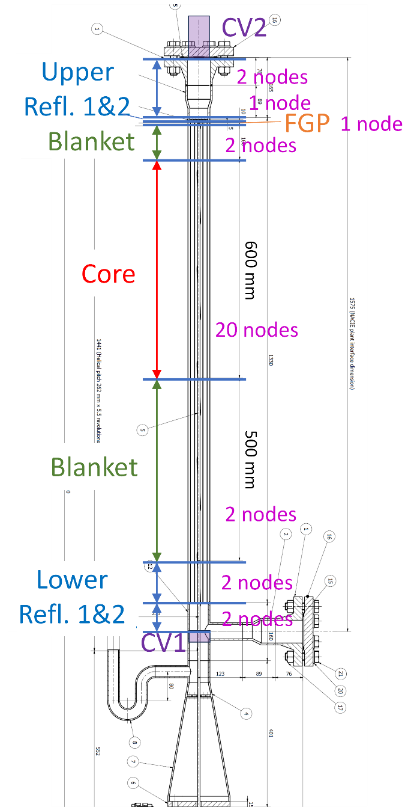
FIG. 62. SAS4A/SASSYS-1 NACIE-UP FPS Model.

The first lower reflector zone (L. Refl. 1), represents the inlet section from the bottom of the flow inlet to the bottom of the hex duct. The second reflector zone (L. Refl. 2) is the unheated section of the pins in the hex duct. From this zone up, until the upper reflector, the geometry is the same in all zones, representing 19 wire-wrapped pins in a hex duct . The fuel zone is the fuel pin zone and includes the fuel, blanket regions, and gas plenum. The “fuel” section models the actively heated part of the pins. The pin geometry was modeled according to the specifications with 316SS cladding, copper conductor “fuel”, and a fuel-cladding gap representing the remaining (NB99 and Inconel) layers in the electrical heater pins. The lower and upper blankets are used to represent the low-power sections of the pins. Two blanket regions are included to have flexibility to model heat generation both above and below the main heated section. The “fission gas plenum” is a required segment in SAS4A/SASSYS-1 and is used to represent the short (5 mm) remaining section of heater pins at the top. Upper reflector, UR1 and U. Refl. 2, represent the structure above the heater pins to the connecting flange. These zones are modeled as a circular channel with a large central opening and no pins.
Each zone in the SAS4A/SASSYS-1 channel is divided into a number of axial segments (nodes), which are also shown in FIG. 62. Twenty-four segments (SAS4A/SASSYS-1 maximum) are used in the heated section of the pins, with 20 segments in the active region and 2 segments each in the upper and lower low-power blanket sections. One segment is used in the fission gas plenum region, as well as in the first upper reflector zone. The rest of the reflector zones are simulated with two segments each. In total, there are 42 axial segments (nodes) in the SAS4A/SASSYS-1 FPS model.
To connect the core model with the rest of the loop, the SAS4A/SASSYS-1 model requires the inlet and outlet plena for the core. Therefore, sections of the FPS inlet and output pipes were modeled as compressible volumes (CV1 and CV2), as shown in FIG. 62.
NACIE-UP Loop Model
The SAS4A/SASSYS-1 point kinetic models for fission power, decay heat, and reactivity feedbacks were not used in the NACIE-UP simulations. Instead, a user-specified total power was provided in the input, as a function (i.e. table) of time. The power fractions in the active and low-power regions were initially calculated from measured FPS inlet and outlet temperatures and flow rates and were different for three tests. However, in the latest revision of the benchmark specifications, it was recommended to use the same power fractions for all tests, with 90% power generated in the active region. It was not specified where the remaining 10% is deposited. Based on measured temperatures in the ADP10 tests, it is estimated that 7.5% is generated below the active region (the lower blanket in the SAS4A/SASSYS-1 model) and 2.5% above active region (the upper blanket). These power fractions were then fixed for all tests and the duration of the tests. The power distribution inside each region was assumed to be axially uniform.
For the heat transfer correlation between the pins and coolant, the Mikityuk correlation for pin bundle is used as recommended in Reference [16], see Eq. (36).
 | $$Nu=0.047\left\{1-\exp\left[-3.8\left(\frac{P}{D}-1\right)\right]\right\}(Pe^{0.77}+250)$$ | (36)
where P/D is the pitch-to-diameter ratio. With NACIE-UP having a pitch-to-diameter ratio of 1.2824, this correlation was converted into the form used in SAS4A/SASSYS-1, as shown in (37).
 | $$Nu=C_{1}(Pe^{C_{2}}Pr^{C_{4}}+C_{3} )$$ | (37)
with C1=0.0309, C2=0.77, C3=250, C4=0.
Friction pressure drop across the pin bundle is modeled following Cheng & Todreas correlations [19].
NACIE-UP Loop Model
The SAS4A/SASSYS-1 PRIMAR-4 module calculates the thermal hydraulics of the reactor heat transport loops and was used to simulate the NACIE-UP loop outside the FPS. FIG. 63 illustrates the PRIMAR-4 modeling of the NACIE-UP loop, including flow elements (E), compressible volumes (CV), and flow segments (S). FIG. 63 also shows selected nodalization for the loop. Note that the number of temperature nodes shown in green in FIG. 63 correspond to the latest revision of the SAS4A/SASSYS-1 model used for the refined phase. For the initial calculations of open and blind phases, about one-quarter as many nodes were used in the model. It was later found beneficial to increase the number of temperature nodes as shown in FIG. 63. The benefits are mostly related to the smoothness of the reported SAS4A/SASSYS-1 results at thermocouple locations.
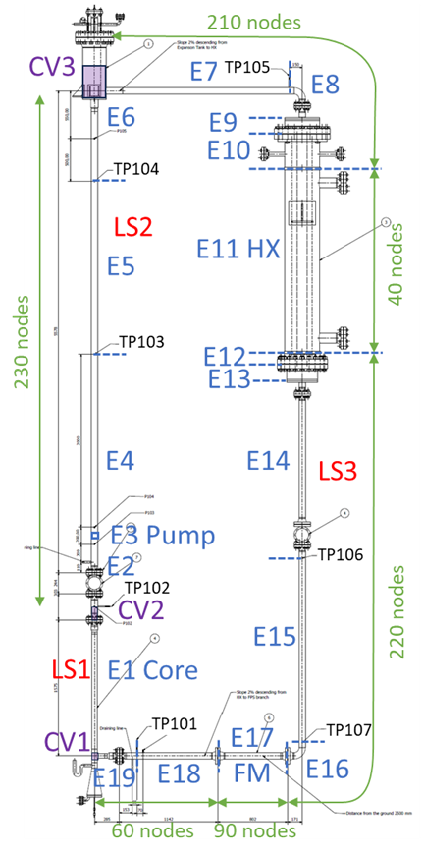
FIG. 63. PRIMAR-4 Model of NACIE-UP Loop.
The FPS core model described above is contained in Element 1 and Segment 1. The riser pipe is represented by pipe Elements 2, 4-6 and pump Element 3. These elements form Flow Segment 2 which connects the FPS-outlet volume CV2 with the expansion tank volume CV3. Here and in the rest of the loop, the pipe sections are split into a number of elements, dictated by the location of the thermocouples for easier comparison with the test. For example, thermocouple TP103 separates E4 and E5 such that the TP103 reading will be compared to the E4 outlet temperature in the SAS4A/SASSYS-1 model. The rest of the loop is modeled in a similar fashion, with pipe elements and other element types as discussed below. The number of nodes along the pipe elements are shown in FIG. 63. Note that some elements are combined into temperature groups and the number of nodes is defined for each group, rather than individual elements.
Element 3 represents the NACIE-UP gas lift-off pump. Because there is not a model for this type in SAS4A/SASSYS-1, a simple table pump model is used, where the normalized pump head (pressure rise) versus time is provided by the user. Because the NACIE-UP benchmark tests all initiated by pump shut down, the normalized pump head is reduced to zero in all simulated transients and the details of the pump modeling are not important for the transient progression from this point on. The required pump head at steady state is calculated by SAS4A/SASSYS-1 based on the specified flow rate and pressure losses in the loop. Thus, the only remaining uncertainty in the pump simulation is the duration of the pump shutdown. It was estimated that it takes the gas bubbles around 20 s to reach the expansion tank free surface from the injection point. Therefore, it the SAS4A/SASSYS-1 model, the pump head is simulated to reduce from 100% to 0 in 20 seconds after the gas flow is terminated.
The heat exchanger (Element 11) was modeled using the detailed HX model, which represents a shell and tube heat exchanger. As shown in FIG. 63, 40 nodes were used for the NACIE-UP HX. The water loop of the experiment was not modeled in SAS4A/SASSYS-1; instead, the water conditions at the HX inlet, - temperature and flow rate as function of time, - are provided to the model as defined in the Benchmark Specifications [10]. The SAS4A/SASSYS-1 HX model does not include provision for multi-layered tubes. Therefore, to simulate the NACIE-UP double-wall HX tube structure with metal powder between tubes, the tube wall thermal conductivity was adjusted to match the heat removal rate at the start of the ADP10 test (this thermal conductivity was then fixed for the rest of the ADP10 test, as well as for simulations of all other tests). The inlet and outlet sections of the HX are modeled by different elements (E9-E10 and E12-E13) defined by changing geometry, such as transitions to and from tube sheets.
The NACIE-UP thermal flow meter is modeled by Element 17. A recent SAS4A/SASSYS-1 feature (available from version 5.7) to provide direct heat input to a flow element was used to simulate the heat addition by the flow meter. The heat input is taken directly from the provided test data at every second and is assumed to be directly deposited to the coolant of Element 17.
The benchmark specification identified the location of valves in the loop, but no geometry was defined. Consequently, the valves were not explicitly modeled. The heat capacity (mass) of the valves was estimated from the available dimensions and was added to the corresponding pipe elements.
Heat losses in the NACIE-UP loop were captured with the component-to-component heat transport model. The heat loss is simulated from the pipe (flow element) wall to the constant temperature heat sink. The heat sink temperature is an ambient temperature which is assumed to be 20 °C. The heat transfer coefficient was calculated using combined thermal resistance of half-thickness pipe wall and the insulation. Because SAS4A/SASSYS-1 does not support temperature-dependent heat transfer coefficients with the component-to-component heat transport model, the thermal resistances are evaluated at the loop average temperature (for ADP10 steady-state conditions) for the pipe wall and mean between that and ambient temperature for insulation. The heat loss model was verified by comparing the calculated temperature change in the pipes against the measured data at ADP10 steady-state conditions, with good agreement for all nodes, except the pipe section between TP102 and TP103 thermocouples (see FIG. 63). Because the source of increased heat loss during the test in that location was not identified, the heat transfer coefficient for E2 was adjusted in the SAS4A/SASSYS-1 model to match the measured conditions.
The initial test run time before the pump trip (approximately 20 min) was used to simulate a zero transient in PRIMAR-4. This time was included to ensure that the simulation has come to an equilibrium when all heat losses and flow meter heating are included in the model (these aspects are only added in the SAS4A/SASSYS-1 transient simulation, not the steady-state solver). Because these results are specific for SAS4A/SASSYS-1 modeling to obtain steady-state conditions and do not reflect actual test conditions, the first approximately 1000 s of simulation are excluded from the results described in the next sections.
The heat transfer coefficient in pipes is calculated using the Kutateladze (1959) correlation recommended by Reference [6], see Eq. (38). Because the LBE flow in the heat exchanger is inside the tubes, the same correlation is also applied to the LBE flow in the heat exchanger.
 | $$Nu=5.9+0.015Pe^{0.8}$$ | (38)
Pressure losses in the loop elements calculated in PRIMAR-4 include friction and form losses, as well as driving head for natural circulation from coolant density change. Friction pressure drop is calculated using Eq. (39). Form loss coefficients were calculated using geometric information, such as flow area changes. The NACIE-UP model does not include form losses in the valves and flowmeter, because no information was provided in the specifications. It was found, however, that the pressure losses in the loop are much smaller than those calculated for FPS, as discussed in “System Level” of Section 15.1.3.
 | $$Δp_{fr}=f\frac{L}{D_{h}}\frac{w|w|}{2ρA^{2}}$$  $$f=\left\{\begin{matrix}C_{1}\left[1+{\left(C_{2}\frac{ε}{D_{h}}+\frac{C_{3}}{Re}\right)}^{C_{4}}\right] & turbulent \\ 64/Re & laminar\end{matrix}\right.$$ | (39)
where
w = mass flow rate,
ε = surface roughness,
C1 = 0.0055, C2 = 20000, C3 = 10⁶, C4 = 1/3.

Description of the NACIE-UP Subchannel Model
For Work Package 3 on subchannel modeling, the subchannel modeling capabilities of SAS4A/SASSYS-1 are used to calculate flow and temperature distributions inside the NACIE-UP FPS. FIG. 64 shows the implemented subchannel model, which is the most detailed option available in SAS4A/SASSYS-1 for subchannel representation of a fuel assembly. A total of 42 subchannels are simulated, with 24 inner channels, 12 edge channels, and 6 corner channels. The axial structure and nodalization for all subchannels remains the same as for the main core model presented in FIG. 62. The subchannel representation in SAS4A/SASSYS-1 is only applied to the “pin” zone (core + blankets in FIG. 62); in the reflector zones, the same single-channel modeling is still used.
FIG. 64. SAS4A/SASSYS-1 Subchannel Model of FPS (ADP10 Pin Heating).
The SAS4A/SASSYS-1 subchannel model calculate the axial flow distribution, along with lateral flow exchange between adjacent subchannels. The coefficients for the lateral flow equations are calculated by the SAS4A/SASSYS-1 preprocessor, PreSAS, based on the formulations in Cheng and Todreas [19]. The flow equations include the effect of the wire wrap sweeping; however, that sweeping is only applied to the edge and corner channels. It is assumed that for the internal channels, the sweeping action of two wire wraps on two pins work in opposite direction and thus approximately cancel each other. Also, in SAS4A/SASSYS-1 there is no axial resolution of the wire wrap sweeping, and thus SAS4A/SASSYS-1 subchannel model may not predict accurately local temperatures next to wire wraps.
For heat transfer calculations, the SAS4A/SASSYS-1 subchannel model accounts for heat transfer pathways in addition to the regular heat transfer from pins to coolant,. First, turbulent mixing heat transfer between adjacent subchannels (e.g., Channels 1 and 2 in FIG. 64) is calculated based on open surface area between these channels. Again, the coefficients for this heat transfer are calculated by the PreSAS preprocessor based on Cheng and Todreas correlations. This heat transfer is also enhanced by heat transfer through the cladding. SAS4A/SASSYS-1 accounts for this enhancement via a multiplication factor supplied by user. It was found based on open phase ADP10 and ADP6 results that for the NACIE-UP FPS, a multiplication factor of 1.5 provides the best agreement with the tests. The second additional heat transfer mechanism in the SAS4A/SASSYS-1 subchannel model is the heat transfer across the pins, e.g., between Channels 1 and 4 in FIG. 64. For this benchmark, the coefficient for this heat transfer was calculated based on the heater pin internal geometry (and thermal resistance of the entire pin obtained from the single-channel simulation in “FPS Model” of Section 15.1.1) and it was also adjusted further to better match the open phase results for the ADP10 and ADP06 tests.
Aside from the differences described above, the modeling of subchannels in SAS4A/SASSYS-1 is similar to regular channels. Each channel is still assigned a corresponding pin, with cladding and fuel, to calculate radial temperature profile. The only difference is that the number of pins per channel is no longer required to be an integer number and can be a fraction. For example, for each inner subchannel, there are three 1/6 pin sections, for a total number of pins per channel equal to 0.5. Importantly for comparison with the test data, SAS4A/SASSYS-1 would still calculate a single coolant and a single cladding temperature in each axial node. The SAS4A/SASSYS-1 subchannel model thus does not differentiate between cladding temperatures belonging to different pins – in SAS4A/SASSYS-1 results all three 1/6 sections would have the same cladding temperature. Similarly, SAS4A/SASSYS-1 does not resolve the coolant temperature profile inside each subchannel.
The subchannel model for the ADP06 (and ADP07) test is essentially the same as described above. The same 42 subchannels in FIG. 64 are used. The main adjustment for these tests is the per-channel power according to which pins were active in each test as shown in FIG. 65. For example, for Subchannel 10 in ADP06 test, only one 1/6 pin was heated, such that the relative power for this subchannel is 1/6 (based on the specification that all pins were uniform in power) SAS4A/SASSYS-1 then re-normalizes all powers for all channels to match the provided total power. The relative per-channel power inputs for all three tests are provided in Table 36.
FIG. 65. Subchannel Models for Test ADP06 (left) and ADP07 (right).
Another adjustment was implemented for the ADP06 subchannel model to provide better comparison with the test. As discussed above, the SAS4A/SASSYS-1 subchannel model does not differentiate between cladding temperatures for different pin sections within a subchannel. Specifically, for Subchannel 11 (subchannel S22 in Benchmark Specifications), cladding temperatures were measured for all three pins (Pins 5, 6, and 16 in Specifications). Because one of these pins (16) is unheated in the ADP06 test, its cladding temperature is recorded to be significantly lower than for the other pins. To provide this differentiation in SAS4A/SASSYS-1, the unheated pins where the cladding temperature was measured are modeled as a part of structure, rather than fuel pin. This adjustment is only applied to Channel 11 for ADP06 test. For the ADP07 test, these adjustments are applied to Pins 3, 4, 5, and 16 in SAS4A/SASSYS-1 Channels 3, 5, 11, and 13.
Table 36. Relative Per-Channel Power in Subchannel Model.
SC | ADP10 | ADP6 | ADP7 |  | SC | ADP10 | ADP6 | ADP7
1 | 0.5 | 0.5 | 0.5 |  | 22 | 0.5 | 0.166667 | 0.5
2 | 0.5 | 0.5 | 0.333333 |  | 23 | 0.5 | 0.333333 | 0.5
3 | 0.5 | 0.5 | 0.166667 |  | 24 | 0.5 | 0.166667 | 0.5
4 | 0.5 | 0.5 | 0.166667 |  | 25 | 0.166667 | 0 | 0.166667
5 | 0.5 | 0.5 | 0.333333 |  | 26 | 0.5 | 0 | 0.5
6 | 0.5 | 0.5 | 0.5 |  | 27 | 0.5 | 0 | 0.5
7 | 0.5 | 0.166667 | 0.5 |  | 28 | 0.166667 | 0 | 0.166667
8 | 0.5 | 0.333333 | 0.5 |  | 29 | 0.5 | 0 | 0.25
9 | 0.5 | 0.166667 | 0.5 |  | 30 | 0.5 | 0 | 0
10 | 0.5 | 0.166667 | 0.333333 |  | 31 | 0.166667 | 0 | 0
11 | 0.5 | 0.333333 | 0.166667 |  | 32 | 0.5 | 0 | 0
12 | 0.5 | 0.166667 | 0 |  | 33 | 0.5 | 0 | 0
13 | 0.5 | 0.166667 | 0 |  | 34 | 0.166667 | 0 | 0
14 | 0.5 | 0.333333 | 0 |  | 35 | 0.5 | 0 | 0
15 | 0.5 | 0.166667 | 0 |  | 36 | 0.5 | 0 | 0
16 | 0.5 | 0.166667 | 0 |  | 37 | 0.166667 | 0 | 0
17 | 0.5 | 0.333333 | 0 |  | 38 | 0.5 | 0 | 0
18 | 0.5 | 0.166667 | 0 |  | 39 | 0.5 | 0 | 0.25
19 | 0.5 | 0.166667 | 0 |  | 40 | 0.166667 | 0 | 0.166667
20 | 0.5 | 0.333333 | 0.166667 |  | 41 | 0.5 | 0 | 0.5
21 | 0.5 | 0.166667 | 0.333333 |  | 42 | 0.5 | 0 | 0.5
SAS4A/SASSYS-1 requires a non-zero input for channel power, so a small value (10⁻¹²) is used in the model for all 0 entries in this table

Open Phase Results for Tests ADP06 and ADP10
After the SAS4A/SASSYS-1 models were developed and initial simulation of the ADP10 test was performed, several model adjustments were implemented to improve the agreement with the test data. Unless overwise stated, all the model changes described here were made for the ADP10 simulation but were retained for the ADP06 (and ADP07) tests.
System Level
The first simulation for both the ADP10 and ADP06 tests demonstrated that the SAS4A/SASSYS-1 model noticeably overpredicts the LBE flow rate under natural circulation conditions, even when temperatures were in a better agreement. An analysis was carried out and it was concluded that in order to match the flow rate, the cumulative pressure drop around the loop should be increased significantly, compared to what SAS4A/SASSYS-1 predicted under natural circulation conditions. This analysis also showed that the majority of the loop’s pressure drop is in the FPS section – the flow areas in the rest of the loop (including the HX) are much larger than the FPS resulting in less pressure drop. Also, the form-loss pressure drops from area changes in the FPS and around the loop were estimated (and included in SAS4A/SASSYS-1 model), but those losses were also shown to be significantly lower than friction losses in the FPS. As a result, it was decided to introduce the form loss coefficient at the FPS inlet in the SAS4A/SASSYS-1 model. This adjustment is made to match the flow rate at the end of the ADP10 test under natural circulation conditions.
The last model adjustment is related to thermal inertia of some NACIE-UP loop components. Comparison of the first results for the ADP10 test against the experiment data showed that although the temperatures around the loop are generally predicted well by the model, there is a difference in transient response in temperatures downstream of the HX. To improve this agreement, the SAS4A/SASSYS-1 model was modified to include the thermal inertia (mass times heat capacity) of the loop components, such as HX tube sheets, headers, and valves. The mass of these components was estimated based on either actual or approximate dimensions and was added to the pipe heat capacity of corresponding elements.
FIG. 66 shows the results of the SAS4A/SASSYS-1 system-level predictions of the NACIE-UP ADP10 test. The SAS4A/SASSYS-1 results (orange curves) are compared against the available test data (blue curves). The results in FIG. 66 are shown for both open, in dashed lines, and refined (final) phase, in solid lines. However, the only difference in the SAS4A/SASSYS-1 model is the number of temperature nodes as described in “NACIE-UP Loop Model” of Section 15.1.1, which only has a minor effect on ADP10 results in FIG. 66.
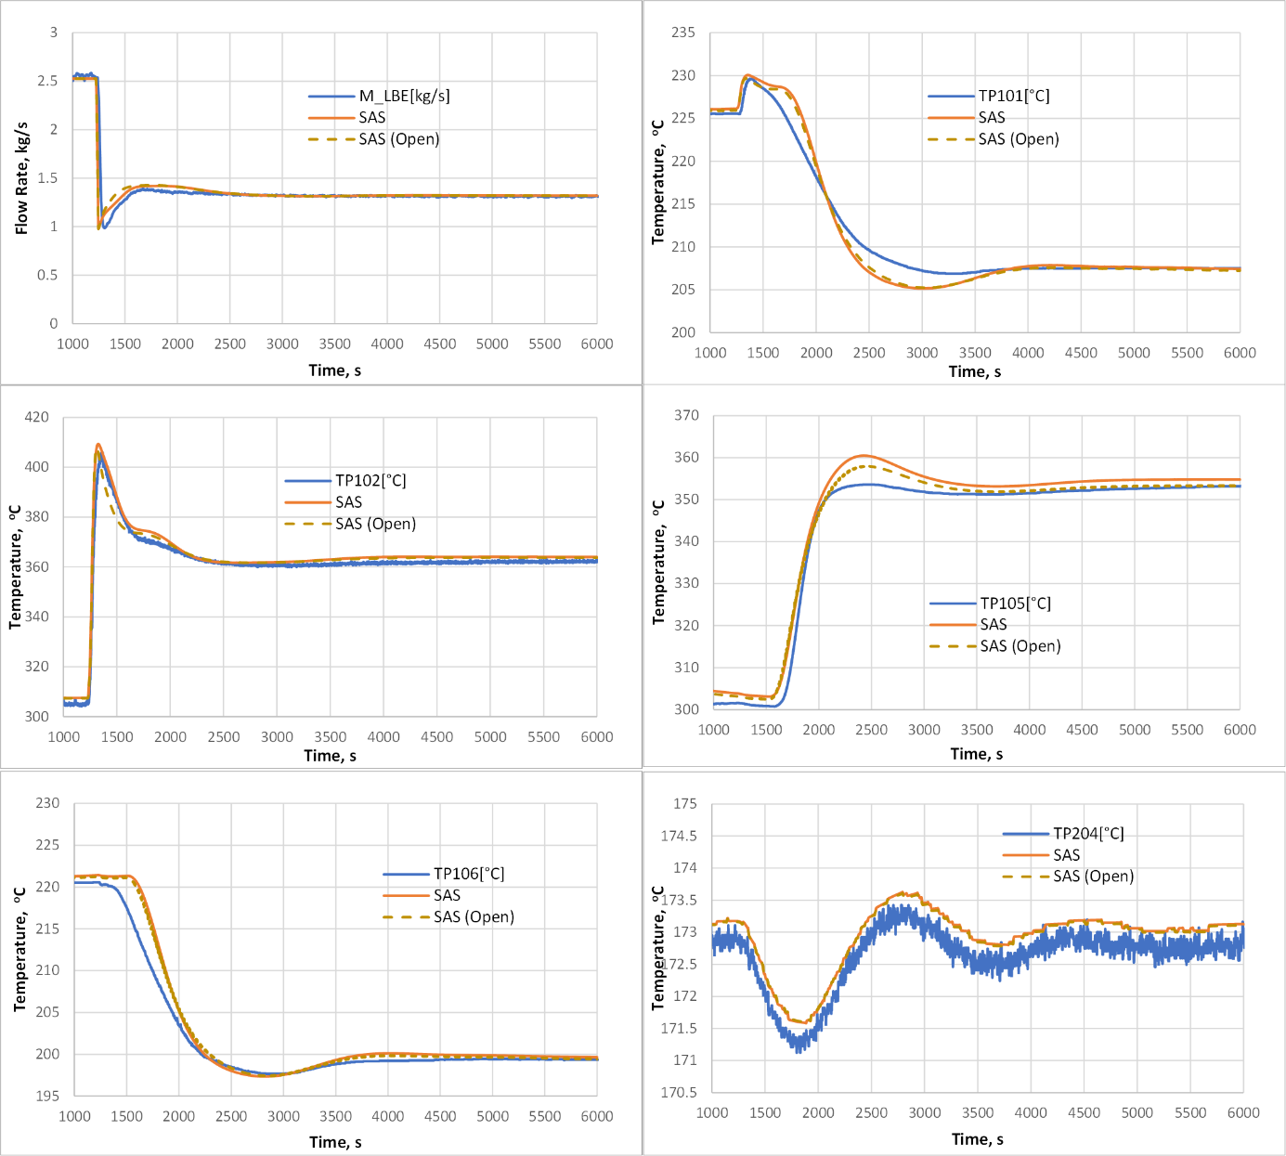
FIG. 66. ADP10 System-Level Results.
The comparison is done for the LBE flow rate, available temperatures around the loop, and the water side HX inlet/outlet temperatures. The corresponding thermocouple locations are shown in FIG. 63; TP203 and TP204 are water HX inlet and outlet temperatures. In FIG. 66 for ADP10 test, the pump trips at 1225 s. The measured flow rate uncertainty is stated to be 5%, and the thermocouples are: ±1.5°C from -40°C to +375°C; ±0.004.T from 375°C to 1000°C – these margins are not included into the figures in this document.
The results for the ADP10 test in FIG. 66 demonstrate that the agreement for flow rate is very good. However, long-term values are adjusted in the SAS4A/SASSYS-1 model, as initial conditions are matched by required pump head and the final state is adjusted by orifice coefficient to account for the previously discussed pressure drop discrepancy. The transition to natural circulation period is predicted closely by SAS4A/SASSYS-1, but the somewhat faster flow rate decrease in the SAS4A/SASSYS-1 results suggests that the estimated pump coastdown time is shorter than in the tests.
All the temperatures show very good agreement, especially in the long term. Also, TP102 (at FPS outlet) and TP204 (HX water outlet) temperatures show remarkably good agreement with the test data, confirming accurate models for the FPS and HX, respectively. Some differences in other results are briefly discussed here. In the hot leg, overprediction in the initial increase in TP105 (at the HX inlet) is likely caused by uncertainty in the LBE level, and therefore mass, in the expansion vessel. In the cold leg, there appears to be a consistent underprediction of temperatures from the TFM inlet to the FPS inlet (TP101) around 3000 s. Because better agreement is obtained for the HX outlet temperature (TP106), these results suggest that there might be additional heat capacity which is not described in the benchmark specifications and thus is not included in the SAS4A/SASSYS-1 model, such as loop support structure, for example.
The pressure measurements and results are excluded from comparison presented here for two reasons. First, of the pressure transducers, only two were operational during these tests, and second, there is a significant uncertainty in the LBE level in the expansion vessel, because of the high LBE density, resulting in significant uncertainty in absolute pressures in the loop.
The results and agreement with the test data were similar for the ADP06 test, compared to ADP10, because global conditions are similar between the two tests. FIG. 67 shows ADP06 system-level results, confirming that they are similar to the ADP10 results in FIG. 66. Also, similar to the ADP10 tests, there is little change in results between the open and final phases. In FIG. 67 for the ADP06 test, the pump trips at 1852 s.
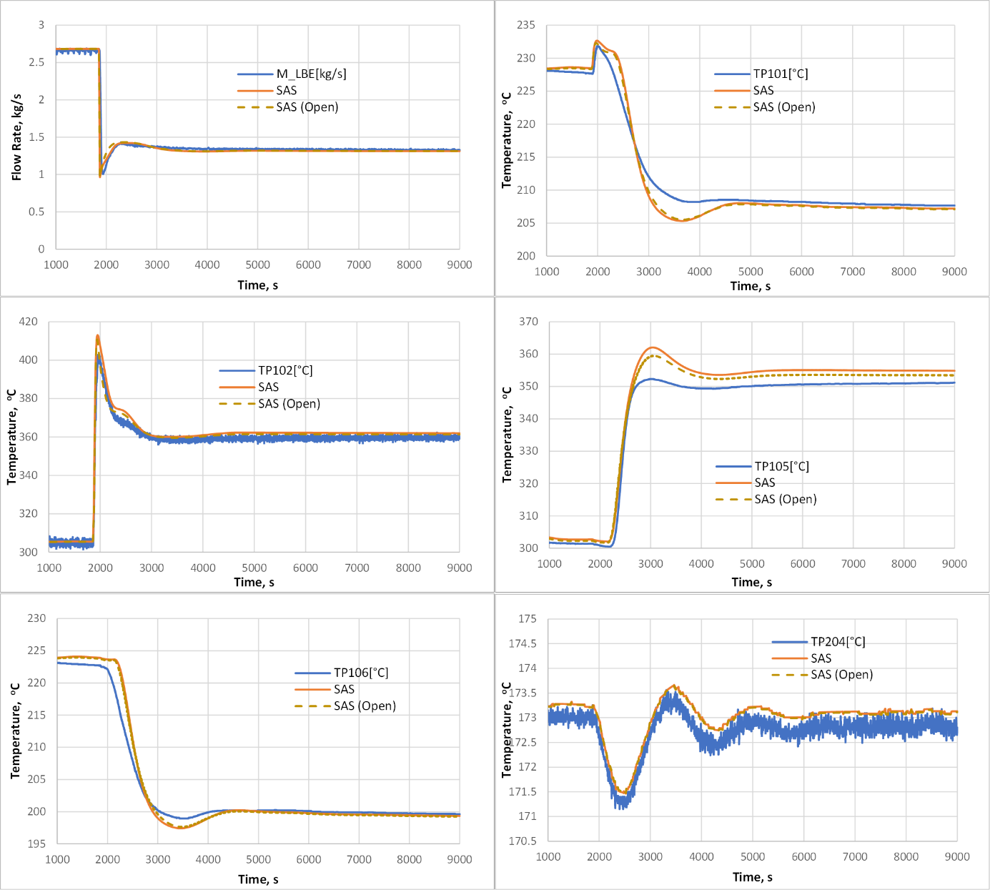
FIG. 67. ADP06 System-Level Results.
Subchannel Model
The following figures compare SAS4A/SASSYS-1 subchannel results with all available coolant and cladding thermocouples from the tests. In addition, the temperature difference plots (experimental minus SAS4A/SASSYS-1 results) are provided, which also include linear fit lines to qualify any persisting bias and trends in results. In all results, the SAS4A/SASSYS-1 temperatures were interpolated from the model nodes to the exact TC axial positions. The cladding temperatures are reported as mid-wall results in SAS4A/SASSYS-1 (TCs are imbedded inside the cladding). The results are reported at two states: the “steady-state” conditions just prior to pump trip and another “steady-state” conditions at the end of the test. In these figures, SAS4A/SASSYS-1 results are shown in orange, while test results are in blue lines. The results presented in this paper only include the two steady-state comparisons, and only a few examples are included in this report. In additional analysis, the transient results were compared for select thermocouples, and it was found that transient agreements are similar to those reported in the previous section for system-level results.
FIG. 68 shows subchannel results for the ADP10 test for the beginning of test conditions. As for the system-level results above, this and similar figure below for the ADP06 test show the combined results of the open and final phase; however, the difference between phases is small for these tests. Very good agreement with the test is obtained for all results in this test, with the maximum difference within 10 °C for all thermocouples. This good agreement was in part due to the fact that heating of all pins is the standard condition for a SAS4A/SASSYS-1 simulation of a fuel assembly, where all pins are assumed to generate nuclear heat. The largest difference with the test results for ADP10 (as well as for other tests) is attributed to modeling approaches and assumptions in the SAS4A/SASSYS-1 subchannel model. The aspect of the subchannel model with the largest impact is that SAS4A/SASSYS-1 does not resolve flow swirl in internal channels; it is assumed to be cancelled out, on average, from the wire wraps on neighboring pins effectively rotating in opposite directions. As such, the SAS4A/SASSYS-1 results are mostly symmetrical. For example, the SAS4A/SASSYS-1 coolant and cladding temperature results for Subchannels 2 and 5 on opposite sides of the central pin (see FIG. 64) are the same, as evident in the coolant thermocouples TC-FPS-11 and TC-FPS-12. At the same time, the test data for these locations show slightly different temperatures for these two channels. These discrepancies could not be resolved with modeling input adjustments in SAS4A/SASSYS-1 and would require subchannel model revisions, such as introductions of channel- and height-depended flow swirl factors. The end-of-test results for ADP10 test, shown in FIG. 69, were found to have similar agreement as beginning-of-test results.
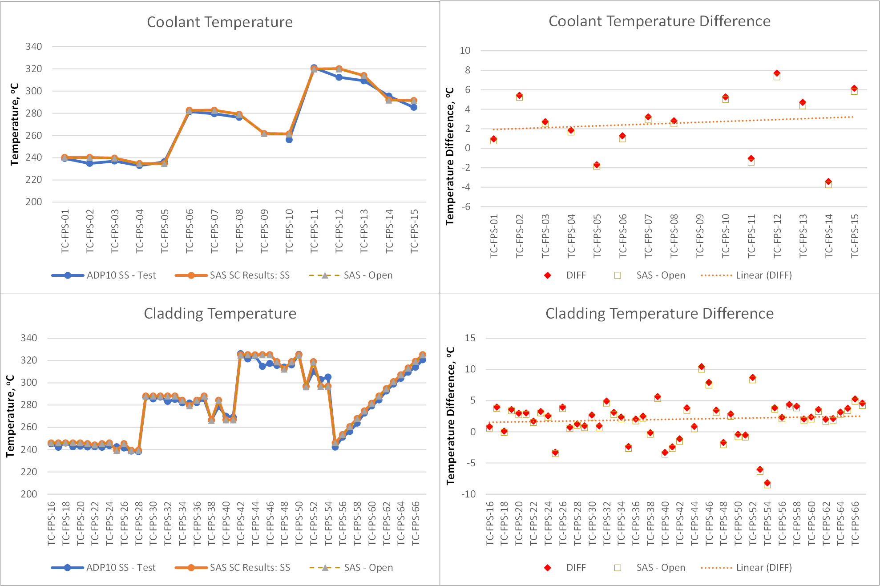
FIG. 68. ADP10 Subchannel Results, Beginning-of-Test.
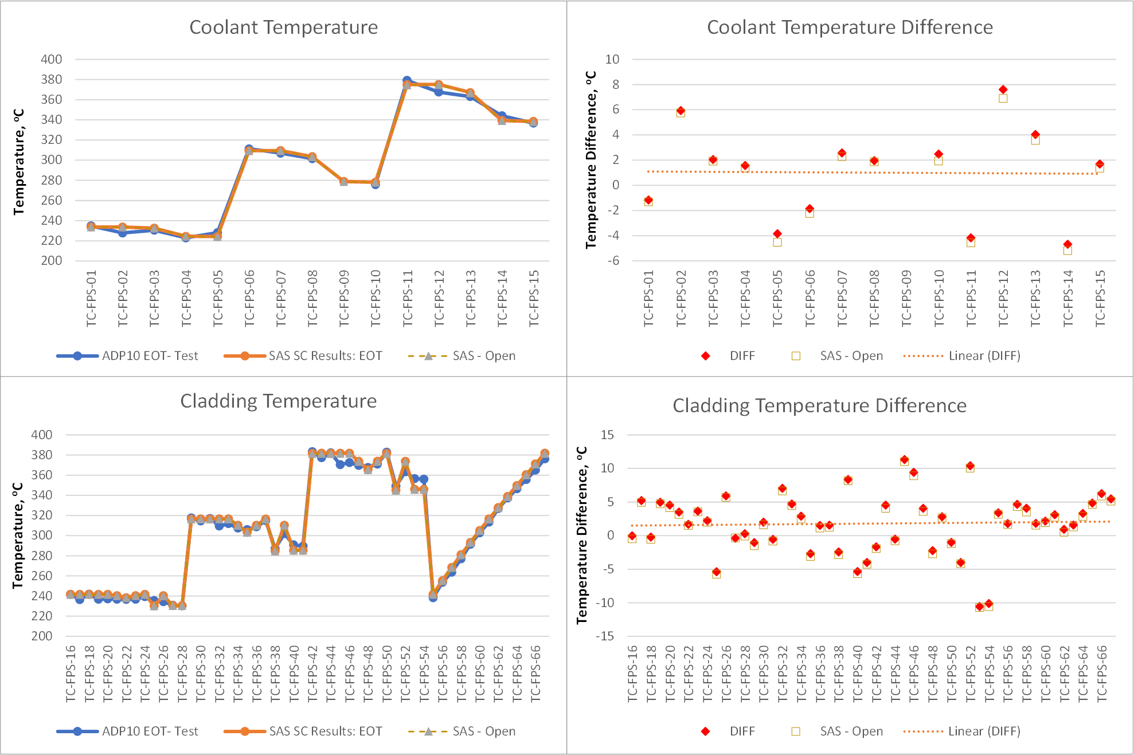
FIG. 69. ADP10 Subchannel Results, End-of-Test.
Results for the ADP06 test are shown in FIG. 70 for beginning-of-test conditions and in FIG. 71 at end-of-test conditions. Although the agreement with the test here is still good in general, the differences in temperatures, and especially for cladding temperatures, are more pronounced. While most of the coolant temperatures are again predicted within 15 °C, differences in cladding temperatures are as high as 40 °C in some locations. Some of these differences are also attributed to the symmetrical subchannel treatment discussed above for the ADP10 test. But the most significant differences comes from reporting of cladding temperatures in unheated pins and heat transfer through these unheated pins. Some of that could be resolved in future work if those unheated pins are modeled as structure rather than pins with zero power, with more detailed simulation of heat transfer between subchannels, both of which would require significant deviation from the usual practice of subchannel input generation in SAS4A/SASSYS-1. However, even though the ADP06 results shown here demonstrate larger differences with the experimental data, the overall agreement is still considered to be acceptable, given the limitations of subchannel approach. Both FIG. 70 and FIG. 71 also show an improvement from open phase to final phase. This improvement, however, is mostly related to revision of Benchmark Specifications during the project, specifically with regard to power fractions outside active region, rather than improvements in the SAS4A/SASSYS-1 subchannel model.
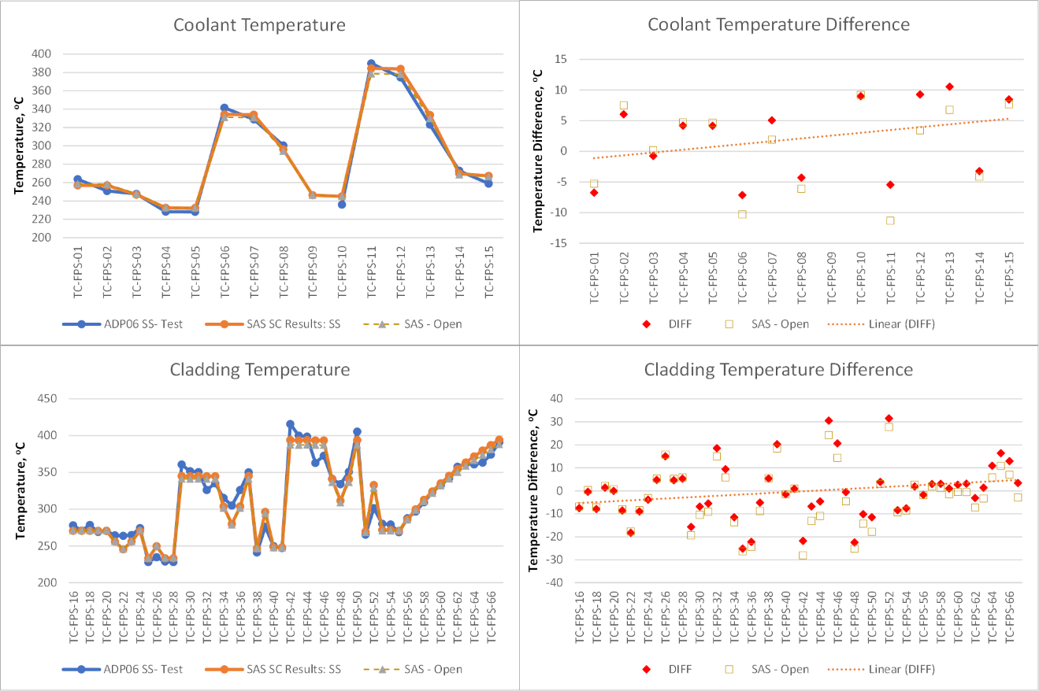
FIG. 70. ADP06 Subchannel Results, Beginning-of-Test.
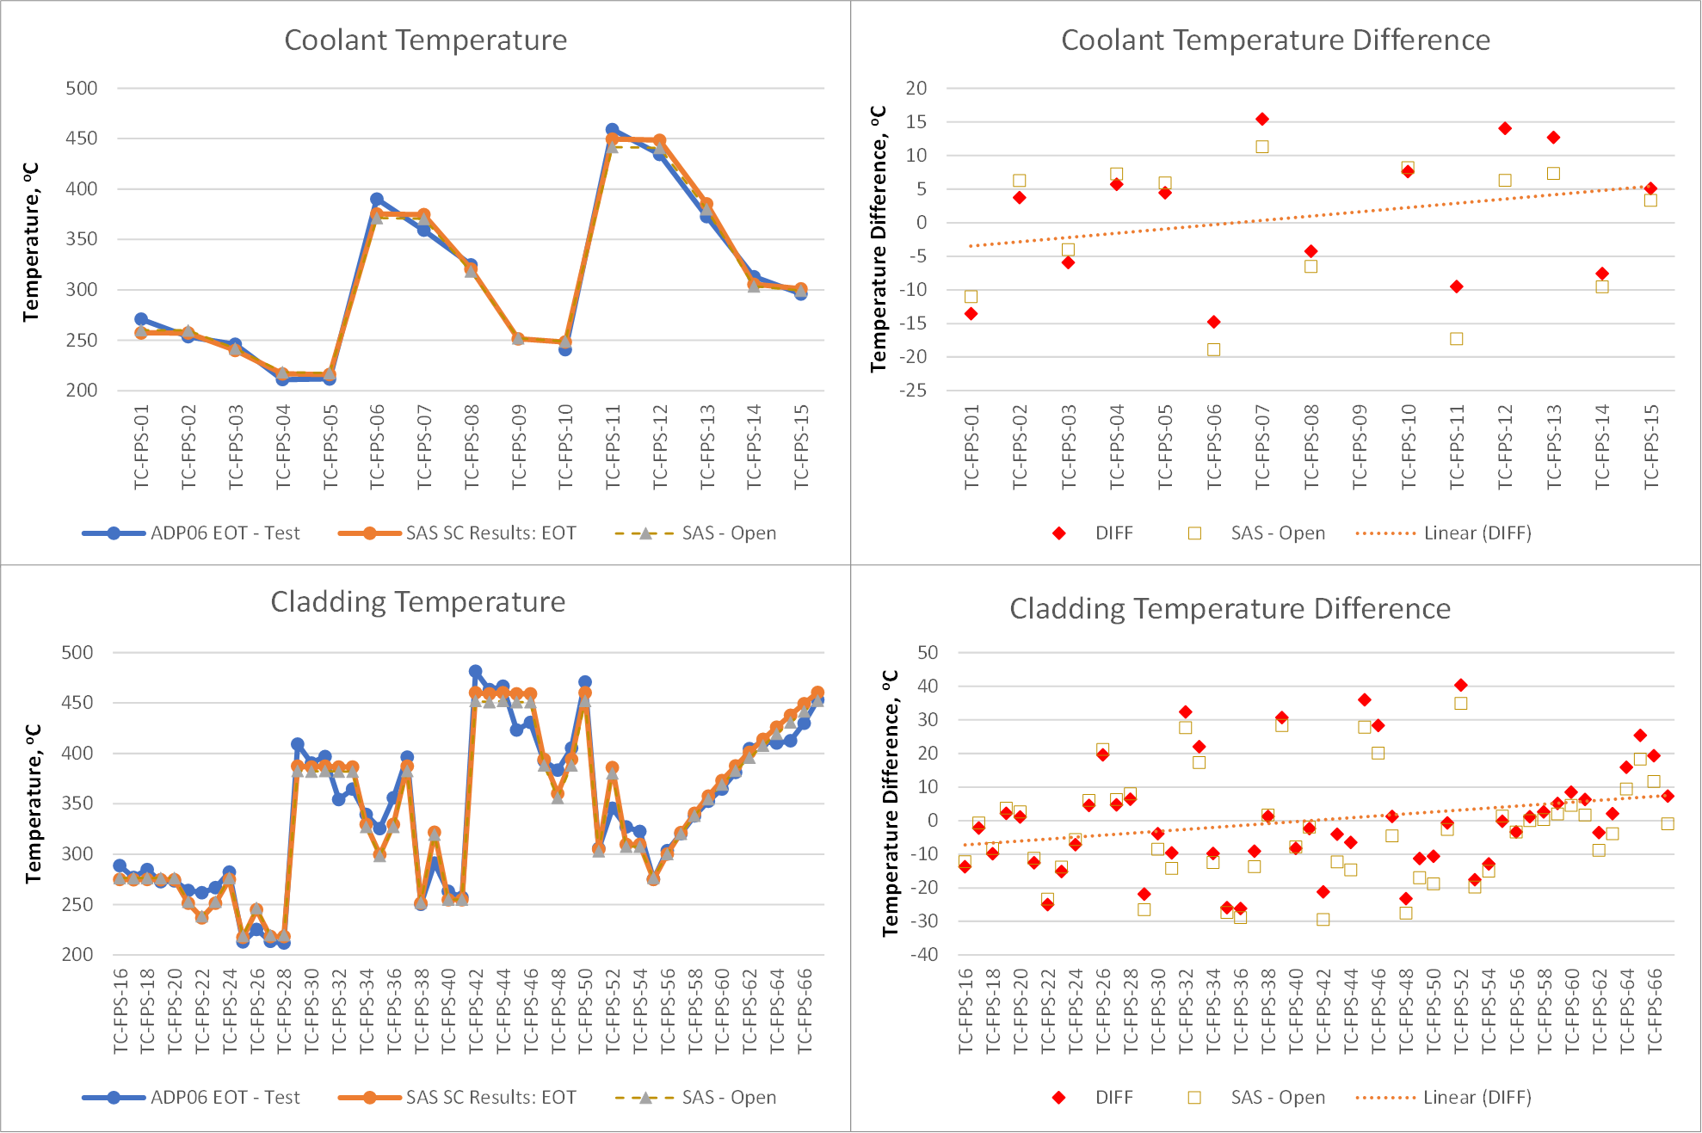
FIG. 71. ADP06 Subchannel Results, End-of-Test.

Blind Phase Results for ADP07 Test
The main difference for the NACIE-UP ADP07 test from the other tests is heating in only a section of the FPS as shown in FIG. 65. In addition to that, the boundary conditions for the ADP07 test include higher FPS power (38 kW vs 30 kW) and higher initial LBE flow rate (3.1 kg/s vs 2.6 kg/s), compared to the ADP10 and ADP06 tests. The water conditions in the HX are common for all three tests, for both the inlet temperature and flow rate.
To obtain the blind phase results presented in this section, the SAS4A/SASSYS-1 models previously developed for the ADP06 and ADP10 tests, as described above, were directly applied to the ADP07 test, with only boundary conditions adjusted per specifications. No model adjustment have been implemented at this stage. To match the specified FPS-inlet temperature, thermal conductivity of heat exchanger tubes was adjusted in SAS4A/SASSYS-1, to reflect dependency of material properties on temperatures, which are slightly different in the ADP07 test. The figures in this section compare the SAS4A/SASSYS-1 results with the test data; however, the data were only provided after the blind phase results were submitted and were not available during simulation presented in this section.
System Level
FIG. 72 shows the system-level results for the ADP07 test. Although relatively good agreement is obtained for initial steady-state conditions, there is greater discrepancy for the ADP07 test transient results, compared to the tests ADP06 and ADP10 described above. These results suggest that the model adjustments implemented for ADP06 and ADP10 tests are not fully applicable to the ADP07 test.
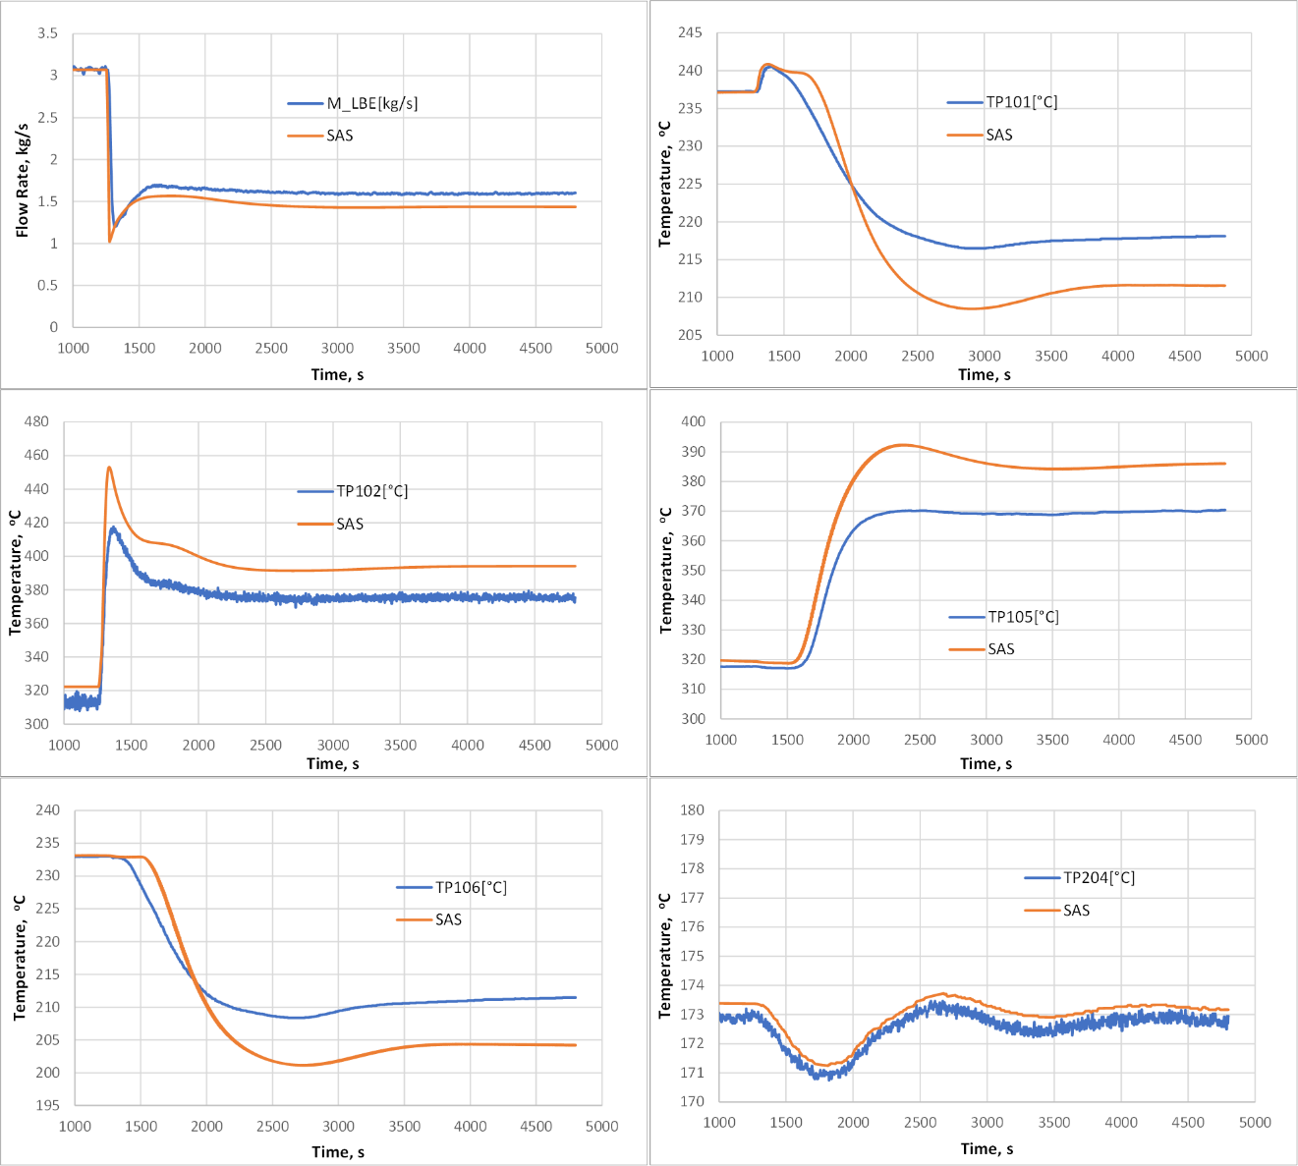
FIG. 72. ADP07 System-Level Blind Phase Results.
Subchannel Model
The subchannel model results for the ADP07 test are shown in FIG. 73 for the beginning of test and in FIG. 74 for the end of test. Note that the end-of-test results are obtained in this simulation with boundary conditions at the FPS inlet (temperature and flow rate) taken directly from the benchmark specifications, to highlight differences in the subchannel model. As it was expected for this highly asymmetrical test, the differences between the SAS4A/SASSYS-1 results and the tests are highest among all the tests.
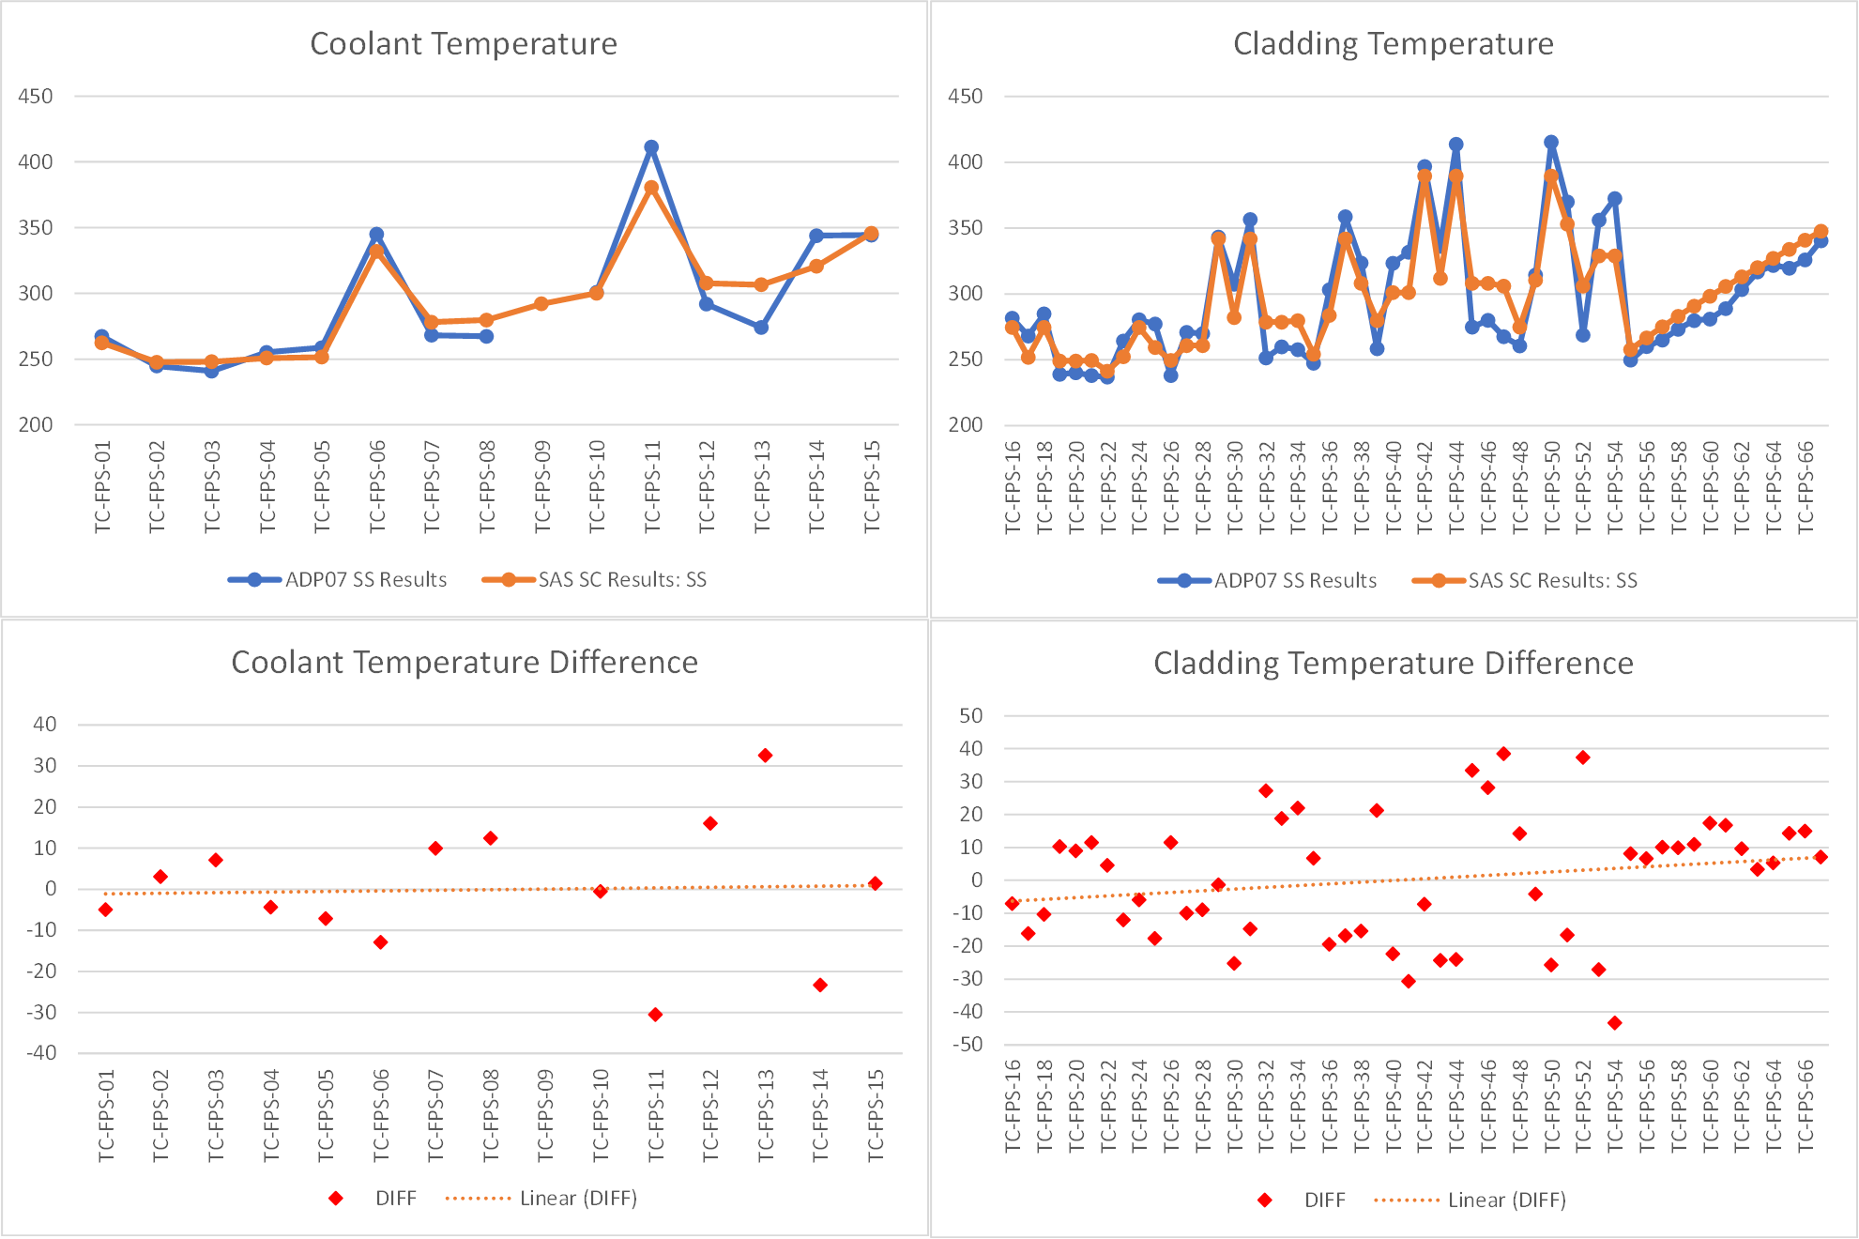
FIG. 73. Blind ADP07 Subchannel Results, Beginning-of-Test.
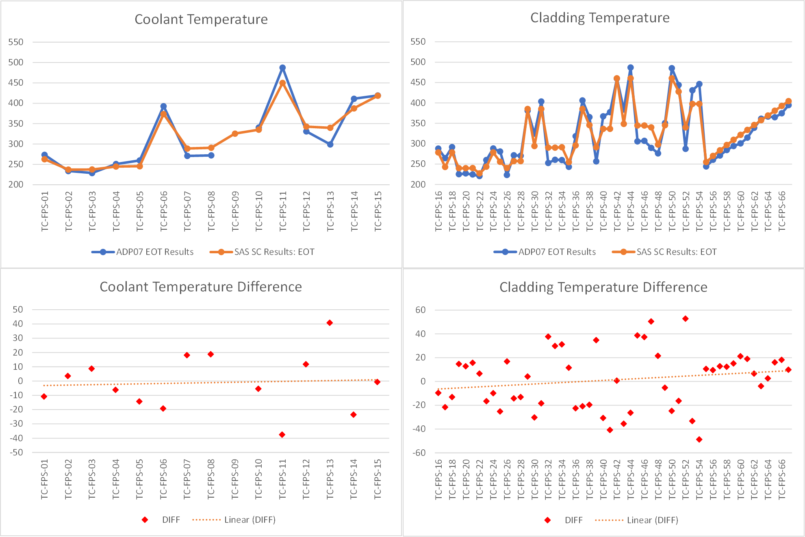
FIG. 74. Blind ADP07 Subchannel Results, End-of-Test.

Refined Results for ADP07 Test
After the test data for ADP07 was released, refinements were made to the SAS4A/SASSYS-1 model to improve agreement with the test data for the open (refined or final) stage.
System Level
To obtain better agreement with the test data, two adjustments were made to the SAS4A/SASSYS-1 model for the ADP07 test. First, the HX tube thermal conductivity was changed to match the FPS inlet temperature, not just at steady state, but consistently throughout the test. Second, the FPS inlet orifice coefficient was further adjusted to match the LBE flow rate. Both inputs were adjusted in the open phase for tests ADP10 and ADP06, but it was found that they also need to be adjusted for the ADP07 test. For tube thermal conductivity, the adjustment was needed because the ADP07 temperatures in the HX are slightly higher than in other tests, and the thermal conductivity of the metal powder between the double tubes depends on temperature (SAS4A/SASSYS-1 does not allow for temperature dependency of HX material properties). On the other hand, the reasons why the orifice coefficient needed to be adjusted between the tests is not known, whether it was due to different conditions within the facility or for other reasons. No differential pressure measurements were taken during the tests that can be compared against the predicted pressure losses, which are apparently different from the actual conditions.
The refined (final) stage results for the ADP07 test are shown in FIG. 75, both in comparison with the test data and the blind phase results. As can be seen, the agreement with the test is much better now and is comparable with that obtained for the other tests.
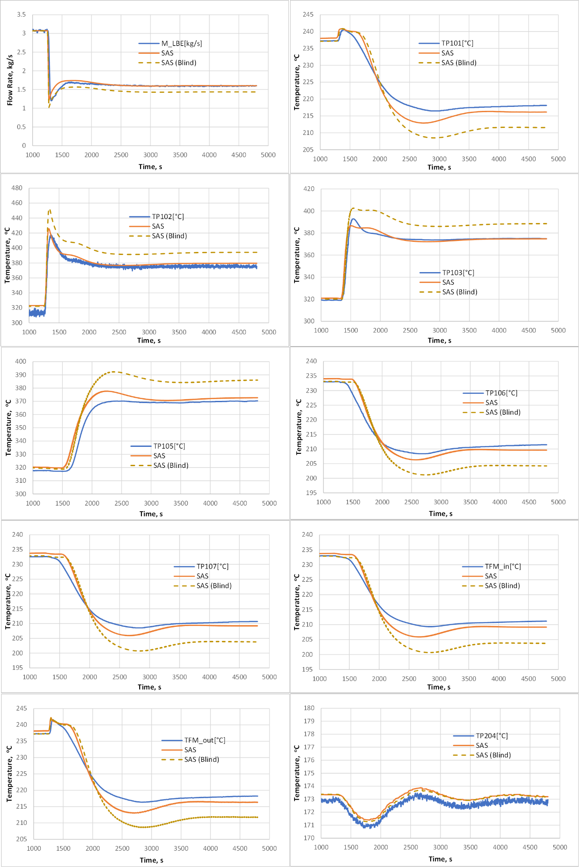
FIG. 75. Refined ADP07 System-Level Results.
Subchannel Model
No model changes were implemented for the subchannel simulation of the ADP07 test, and the subchannel results did not change significantly from blind to refined phase. FIG. 76 shows the subchannel results for the beginning of test, while the end-of-test results are shown in FIG. 77. Both figures demonstrate minor changes in the subchannel results, mostly caused by improvements in the system level modeling. One significant difference though is that the end-of-test results (as well as beginning-of-test) are obtained with fully the integrated SAS4A/SASSYS-1 model, rather than with specified FPS inlet boundary conditions.
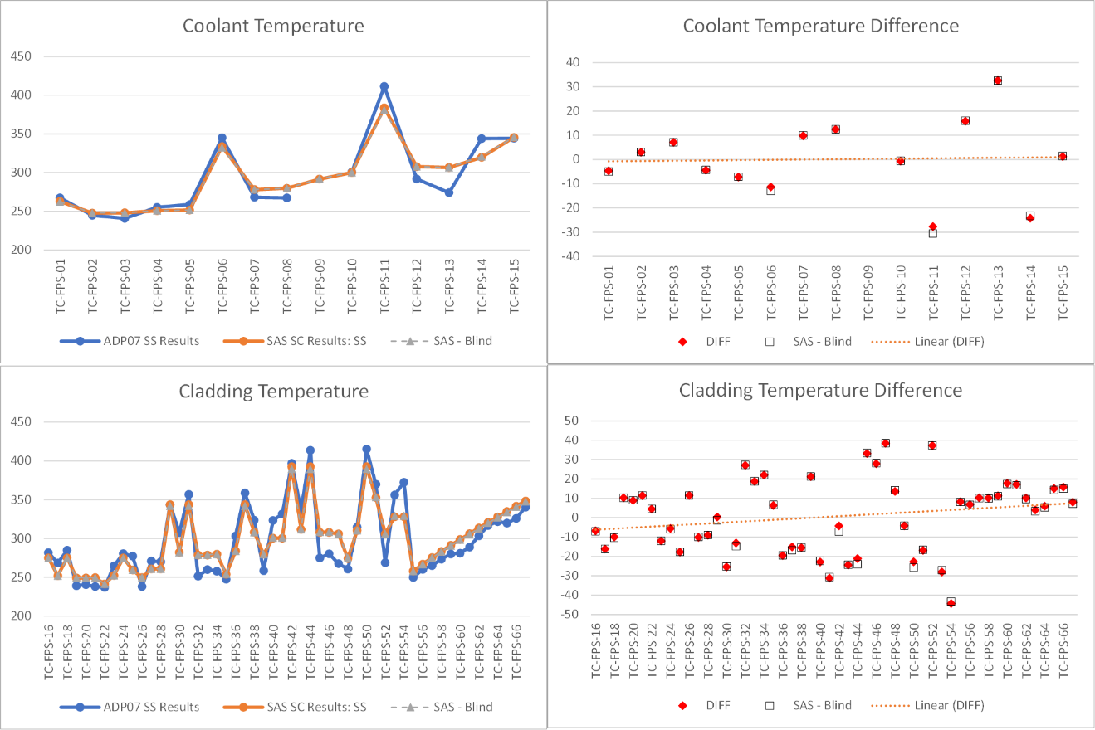
FIG. 76. Refined ADP07 Subchannel Results, Beginning-of-Test.
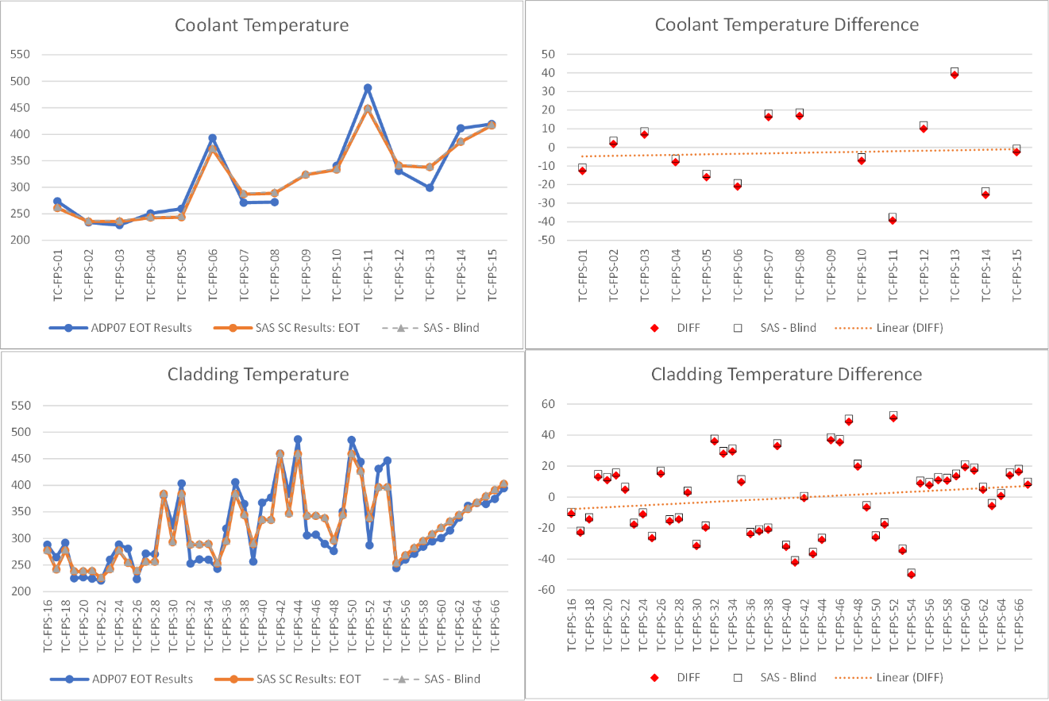
FIG. 77. Refined ADP07 Subchannel Results, End-of-Test.
Table 37 provides the summary of subchannel results across all three tests, in terms of the root mean square difference between the SAS4A/SASSYS-1 results and measurements. The difference is calculated as shown in Eq. (40):
 | $$RMS=\sqrt{\frac{\sum_{i}{{\left(T_{i}^{SAS}-T_{i}^{EXP}\right)}^{2} }}{N}}$$ | (40)
Table 37. Root Meat Square Difference for Subchannel Results for All Tests.
RMS, ºC | ADP10 |  | ADP06 |  | ADP07
RMS, ºC | SS | EOT | SS | EOT | SS | EOT
Coolant | 3.81 | 3.67 | 6.52 | 9.80 | 15.11 | 19.63
Cladding | 3.66 | 4.63 | 12.26 | 16.09 | 18.65 | 23.86
Total | 4.09 |  | 13.26 |  | 20.65

Table 37 confirms once again significantly better agreement for the ADP10 test, compared to the other tests, because this test simulates the conditions for which the SAS4A/SASSYS-1 subchannel model was developed, i.e., with power produced in each pin of a (fuel) assembly. Also, the RMS for test ADP07 is the largest one among three tests, confirming that these conditions are the most challenging to simulate with the subchannel code.

Conclusions
Argonne participated in the International Atomic Energy Agency coordinated research project on “Benchmark of Transition from Forced to Natural Circulation Experiment with Heavy Liquid Metal Loop” with the SAS4A/SASSYS-1 code, which was developed at Argonne for transient analysis of liquid metal-cooled reactors. Data from three NACIE experiments provides valuable data for SAS4A/SASSYS-1 code validation for conditions representative of loss-of-flow accidents in nuclear reactors. Argonne participated with the SAS4A/SASSYS-1 code in two NACIE CRP work packages: WP1 for system-level thermal hydraulics and WP3 for subchannel modeling.
For both the system-level and subchannel simulations of the ADP10 and ADP06 tests in open phase, very good agreement with the test data was obtained. Some model adjustments were implemented for these tests to achieve these results.
The agreement for the blind phase of ADP07 test was somewhat worse than for the other two tests. Two model adjustments, similar to those implemented for the ADP06 and ADP10 tests in the open phase, were introduced for the ADP07 model for the refined phase, which improved agreement with the test. In the system-level simulation, good agreement is now obtained for all three tests. For the subchannel model for the ADP07 test, no model adjustments were identified in the refined phase which would improve the agreement with the test, and the subchannel results for ADP07 test remain largely unchanged from the blind phase.

SAM/MOOSE SCM

Description of the NACIE-UP coupled SAM system-level and MOOSE SCM subchannel model
Argonne modeled the NACIE-UP facility with the coupled system analysis code SAM [72] and subchannel code MOOSE SCM [73]. In the coupled simulation, the SAM system model includes a surrogate channel for the fuel pin simulator (FPS), pump, heat exchanger, thermal flow meter, and pipes connecting different components in the loop. The MOOSE SCM subchannel model provides more detailed flow and temperature distributions within the FPS region.
SAM System-Level Model
The SAM model for NACIE is shown in FIG. 78. The loop is modeled with one-dimensional components and zero-dimensional lumped parameter components of SAM. It should be noted the pipes shown in FIG. 78 may be divided into several one-dimensional components in the SAM model to match the component inlet/outlet positions with the thermocouple locations. The number of elements utilized in different sections of the SAM model is also presented in FIG. 78. A zero-dimensional pump component is utilized to emulate the pressure head of a gas lift-off pump. At the initial steady state, the pump head is determined to yield the initial LBE mass flow rate in the loop. After the transient began, the gas injection was terminated. Nevertheless, gas bubbles remained in the loop and continued to enhance the circulation during the initial phase of the transient. It was estimated that these bubbles require approximately 20 s to rise from the injection point to the free surface in the expansion vessel [74]. Accordingly, in the SAM model, the pump head is assumed to decrease linearly from 100% to 0 in 20 s.
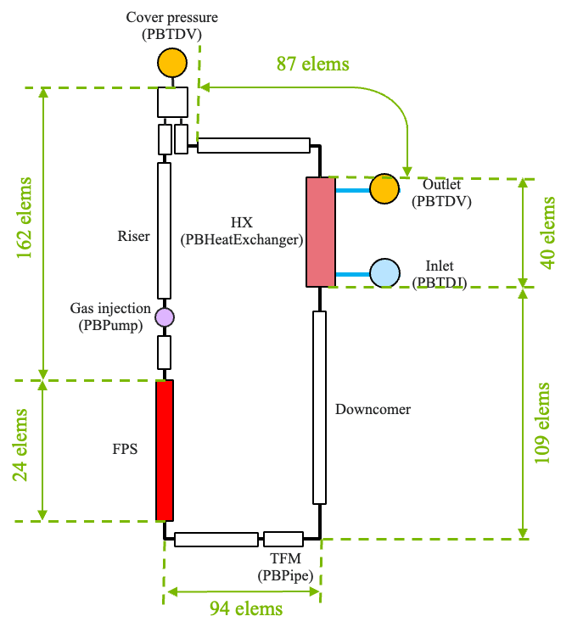
FIG. 78. SAM Model for NACIE Loop.
Above the riser, a boundary condition component sets the pressure of the cover gas in the expansion vessel to 1.4 bar. Because the crossflow low-power section of the heat exchanger is not used in the test, this inactive heat exchanger section is modeled with a pipe component in SAM, with the flow area and hydraulic diameter derived from the heat exchanger geometry specification. Assuming negligible heat loss in the inactive heat exchanger section, an adiabatic boundary condition is applied to this pipe component. A heat exchanger component in SAM is utilized to model the counter-current high-power section of the heat exchanger. On the secondary side of the heat exchanger component, the inlet velocity and temperature of the water are prescribed via a zero-dimensional boundary condition component, based on values specified in the Benchmark Specification [10]. On the tube side of the heat exchanger, the Cheng-Tak [11] correlation is used to calculate the heat transfer coefficient. For the water side, the SAM default heat transfer coefficient is utilized, which is the maximum value among the heat transfer coefficient calculated from the Dittus-Boelter [75], Sellars [76], and Churchill-Chu [77] correlations.
A pipe component, with a time-varying heat source, is utilized to model the thermal flow meter (TFM) before the flow back to the FPS. The heat source is taken directly from the experimental data and is assumed to be directly deposited to the coolant. The FPS is modeled as a surrogate single channel in SAM. The pressure drop through the FPS region is obtained from the MOOSE SCM subchannel results. The power for the FPS active region, FPS below active region, and FPS above active region are obtained from the Specifications as Q_{eff}, Q_{pre}, and Q_{nom} - Q_{eff} - Q_{pre}, respectively, for each test case. The power distribution inside each region is assumed to be uniform in the axial direction.
The built-in LBE thermophysical properties in SAM are utilized, which are derived from the OECD/NEA Handbook [6]. The thermophysical properties of water on the secondary side of the heat exchanger are taken from IAPWS97 [78]. Constant properties derived from reference [79] are assumed for the structure materials used in pipes and heat exchanger.

MOOSE SCM Subchannel Model
In the MOOSE SCM model for the FPS, a subchannel mesh for hexagonal assembly is generated. The flow area in the FPS is divided into 42 subchannels, as illustrated in FIG. 79, which includes 24 inner subchannels, 12 edge subchannels, and 6 corner subchannels. Axially the FPS is divided into 120 meshes. The Cheng-Todreas [19] correlation is utilized to calculate the friction factor and mixing parameters in the subchannels. In the MOOSE SCM input, there are two adjustable mixing parameters: β, representing the turbulent mixing parameter or thermal transfer coefficient, and C_{T}, which is the turbulent modeling parameter. For the NACIE simulations, these two parameters are not calibrated against experimental data. Instead, the default values, β = 0 and C_{T} = 1 are applied in all the three tests.
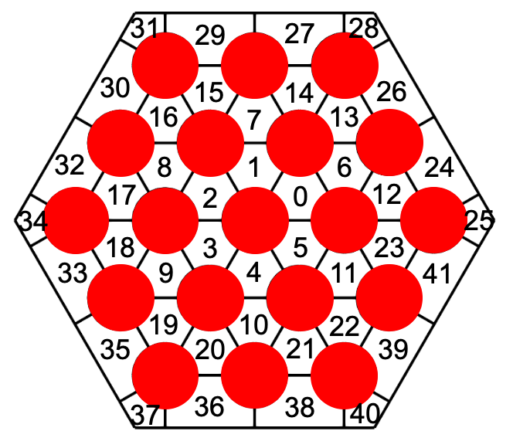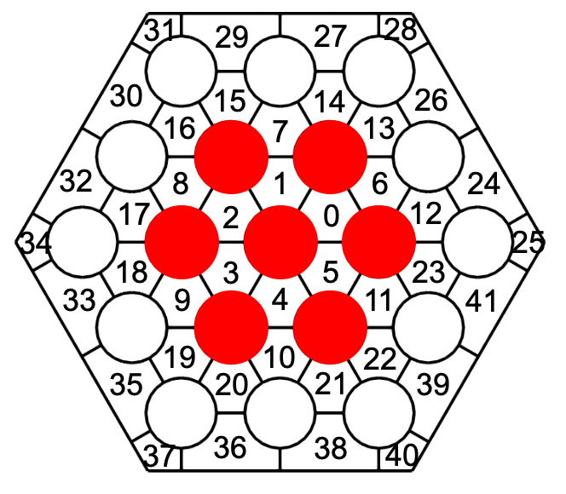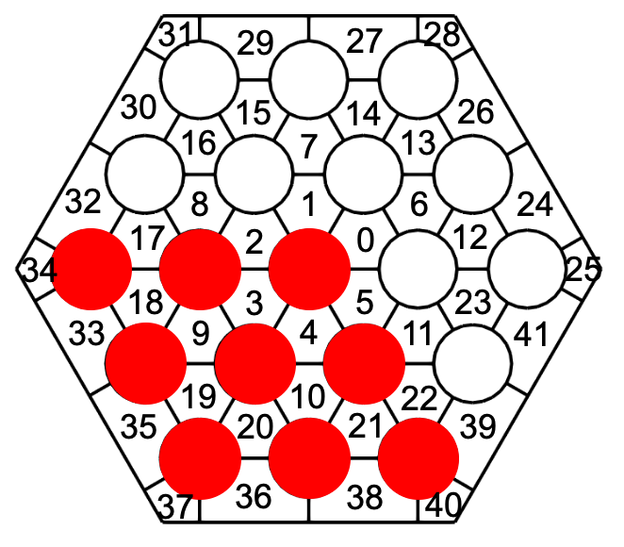
FIG. 79. Subchannel Model for tests ADP10 (left), ADP06 (middle), and ADP07(right).
The inlet temperature and mass flow rate computed by SAM serve as boundary conditions for the MOOSE SCM calculation. Consistent with the SAM model, the power in the MOOSE SCM model for the FPS active region, as well as the regions below and above the active region are obtained from the Specifications for each test case. Within each axial region, a uniform axial power distribution is assumed because no specific axial profile is specified in benchmark. Additionally, a uniform radial power distribution is applied across all active pins in all the three tests. The active pins are highlighted in red in FIG. 79. In the current MOOSE SCM model, only the fluid equations in each subchannel are solved and conjugate heat transfer with solid pin is not included. The power is deposited directly into the coolant in each subchannel, with the power in each subchannel derived from the surrounding pins. The absence of the solid fuel pin model introduces an error in representing the thermal inertia of FPS, which may affect the transient response of the system in the simulation. In the future, conjugate heat transfer with solid pin will be added in the NACIE MOOSE SCM model.

Open Phase Results for Tests ADP06 and ADP10
In this section, the results of the ADP10 and ADP06 tests from the coupled SAM and MOOSE SCM simulation are presented. In the initial ADP10 test model, the simulation results from SAM and MOOSE SCM show that the natural circulation flow rate at end of transient is overpredicted compared to the experimental data. It was decided to introduce a form loss coefficient at the FPS inlet in the SAM model. This form loss coefficient was adjusted to align the calculated LBE mass flow rate in the loop with the experimentally measured value.
FIG. 80 compares the ADP10 test system-level results from coupled the SAM and MOOSE SCM simulation with experimental data. Following the deactivation of gas lift-off pump, the LBE mass flow rate begins to decrease, followed by an oscillation that quickly dissipates. Natural circulation flow is established later in the test. With the form loss coefficient at the FPS inlet in the SAM model, the FPS inlet mass flow rate calculated by the coupled SAM and MOOSE SCM show good agreement with the experimental data. The LBE mass flow rate from the simulations drops slightly faster than the experimental results, which could be due to the estimated pump loss time of 20 seconds being shorter than the actual value in the NACIE test.
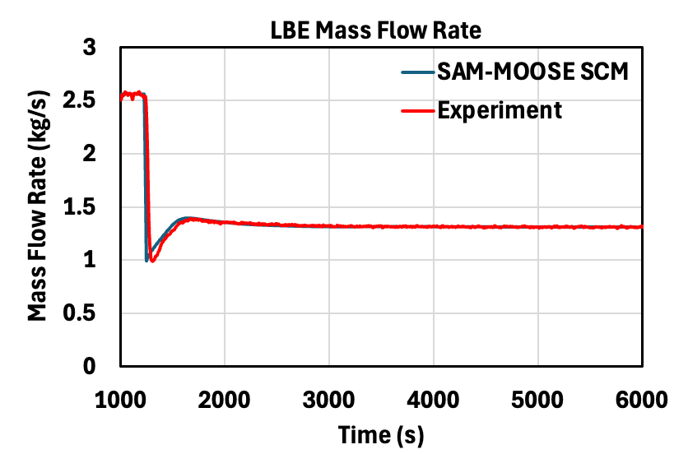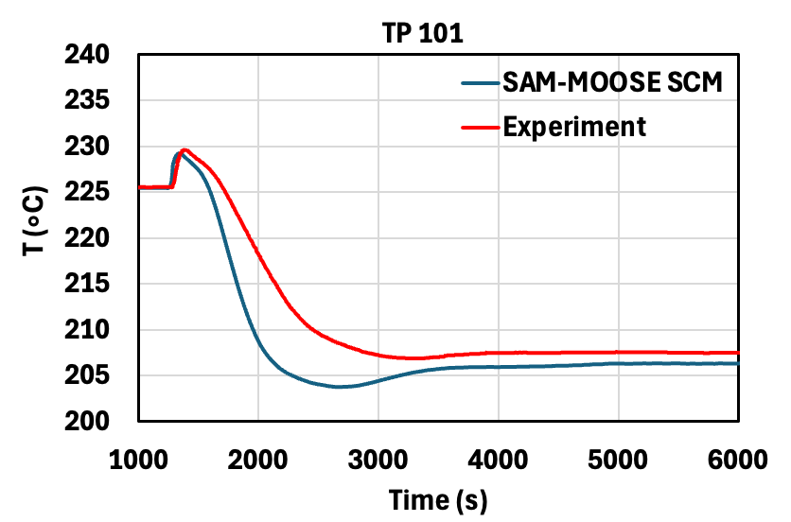
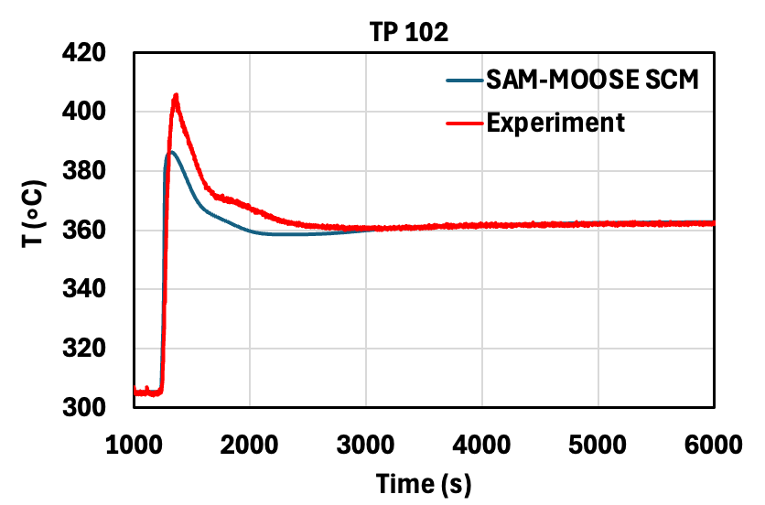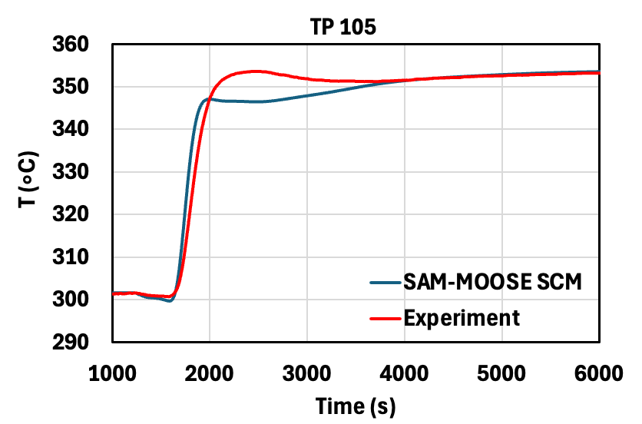
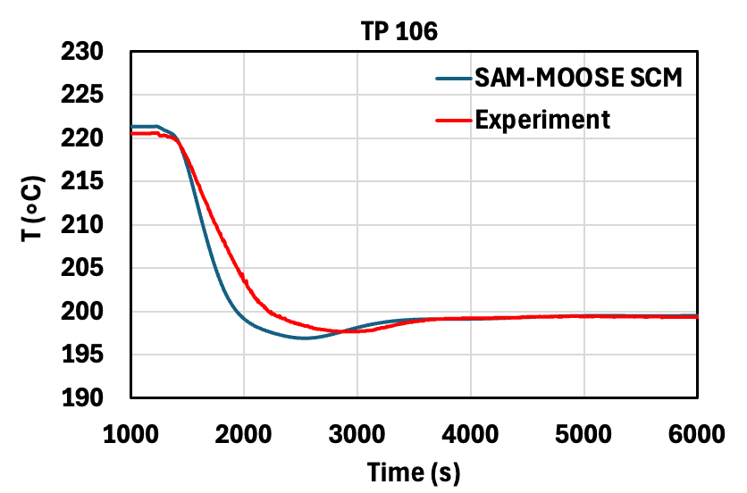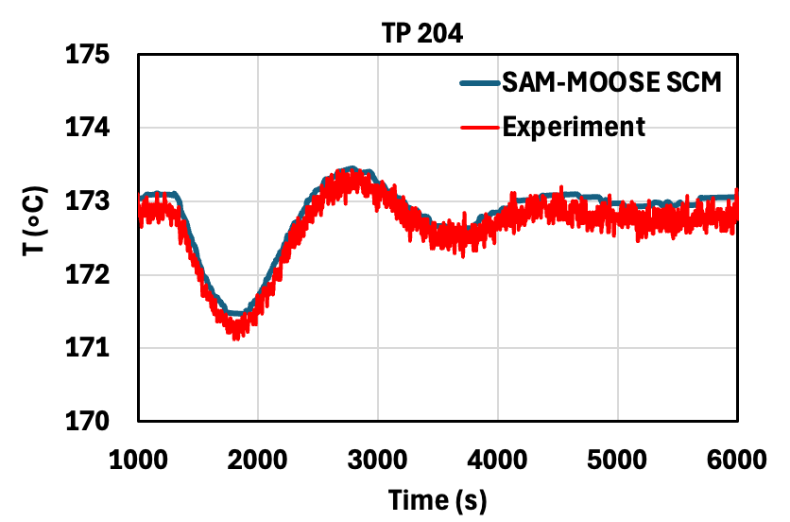
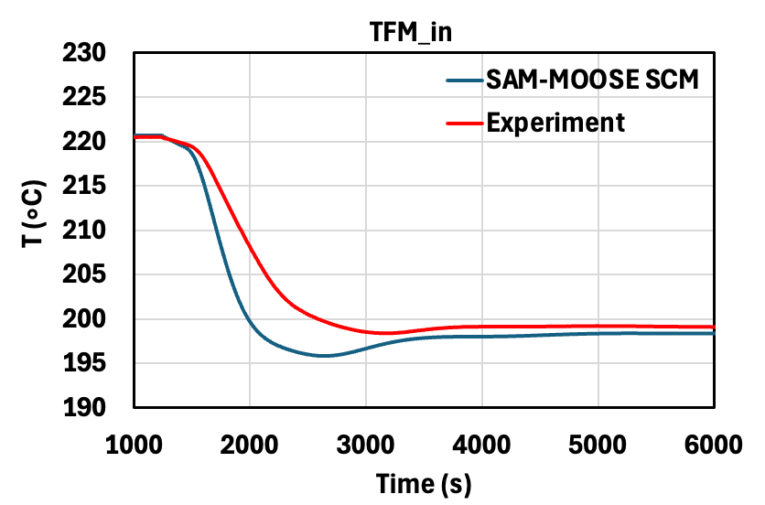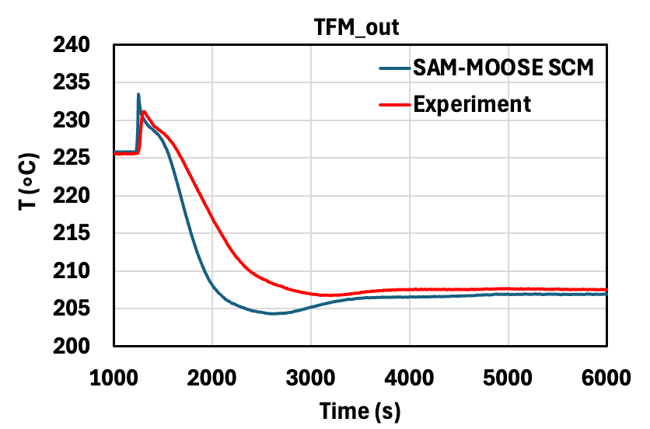
FIG. 80. ADP10 System-Level Results with Coupled SAM and MOOSE SCM.
The temperatures predicted from coupled SAM and MOOSE SCM at various locations in the loop show good agreement with the experimental data, particularly after the establishment of natural circulation. However, some discrepancies are observed in transient temperature response compared to the experimental measurements. This may be attributed to the fact that some NACIE-UP loop components are not considered in the coupled SAM and MOOSE SCM model, such as the FPS solid pins, heat exchanger tube sheets, headers, valves, and loop support structure. The thermal inertia of these components is not captured in the current model, which likely contributes to the deviation in transient thermal behavior between the model predictions and the experimental results.
In the coupled SAM and MOOSE-SC simulation, the inlet mass flow rate and temperature for the MOOSE SCM calculation are transferred from SAM. With the inlet boundary conditions from SAM, MOOSE SCM calculates the detailed temperature distribution in the subchannels.
First the initial steady state temperatures at various subchannel locations from the coupled calculation are compared with the experimental measurements in the ADP10 test. FIG. 81 presents the temperatures at three axial positions. Due to the absence of a solid pin heat conduction model, MOOSE SCM provides only the fluid temperature within each subchannel. As a result, cladding temperature predictions are not available for comparison with experimental data. TC-FPS-01 to TC-FPS-05, TC-FPS-06 to TC-FPS-09, and TC-FPS-11 to TC-FPS-15 are thermocouples located at 0.038 m, 0.3 m, 0.562 m downstream of the FPS active region, respectively. FIG. 81 also shows the beginning-of-test temperature differences (simulation minus experiment) between the coupled simulation results and experimental data in those thermocouple positions. The coupled simulation results generally overestimate the temperatures, with a maximum difference of 10.9°C at thermocouple TC-FPS-11. The Root Mean Square (RMS) error for the coupled simulation results is 4.4°C. FIG. 82 shows the end of transient temperatures at various subchannel locations from the coupled calculation as well as the differences compared to the experimental measurements in the ADP10 test. The predicted temperatures show larger difference at end of transient, with a maximum difference of 17.5°C at thermocouple TC-FPS-12. The Root Mean Square (RMS) error for the coupled simulation results is 7.0°C. The results confirm that the temperatures at different subchannels from the coupled simulation match well with the experimental data in ADP10 test.
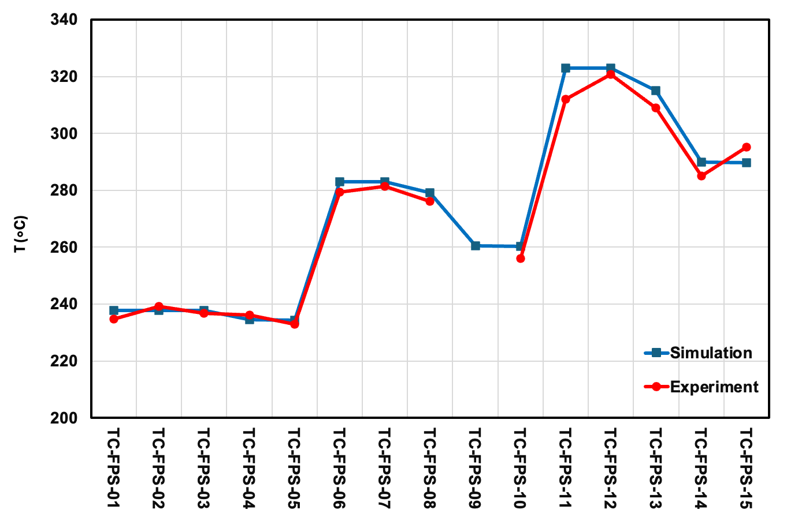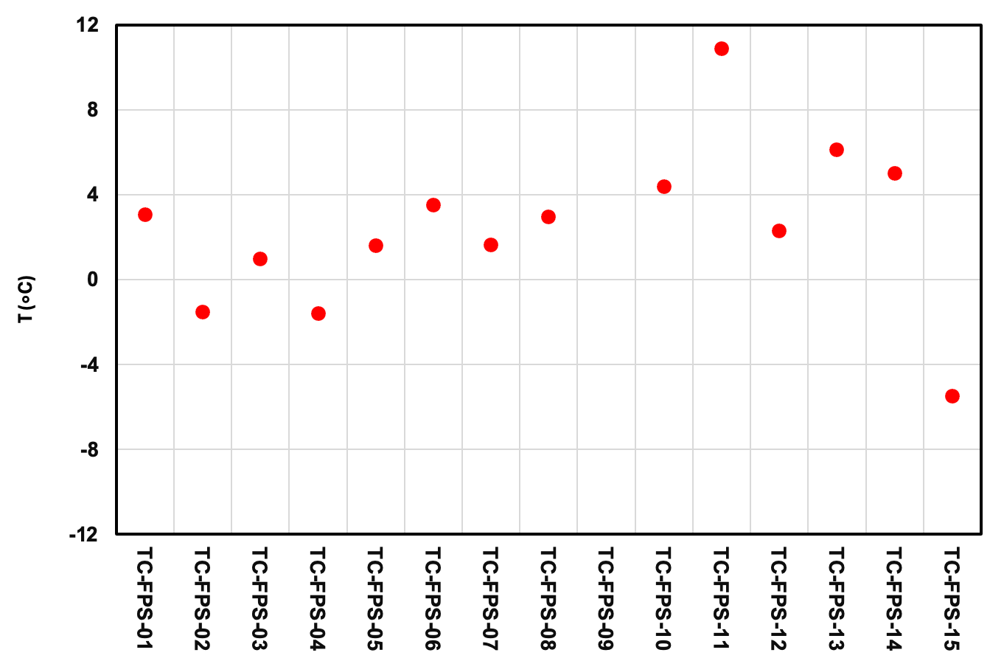
FIG. 81. ADP10 Subchannel Temperature (left) and Difference Between the Simulation and Experimental Results (right) at Beginning-of-Test with Coupled SAM and MOOSE SCM.
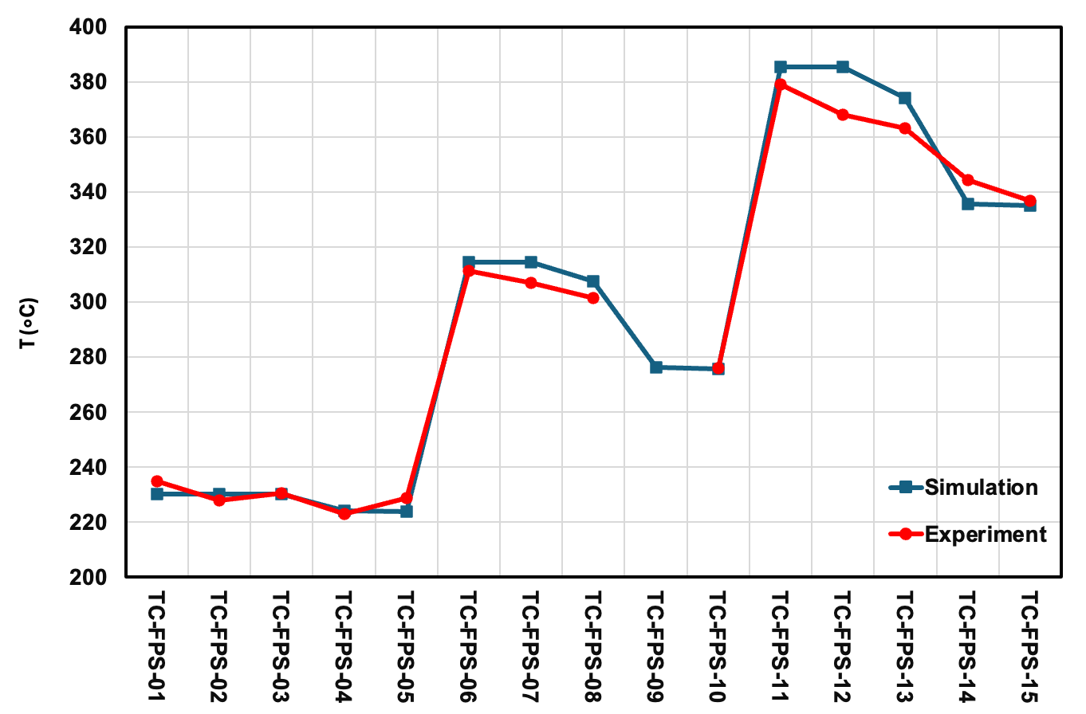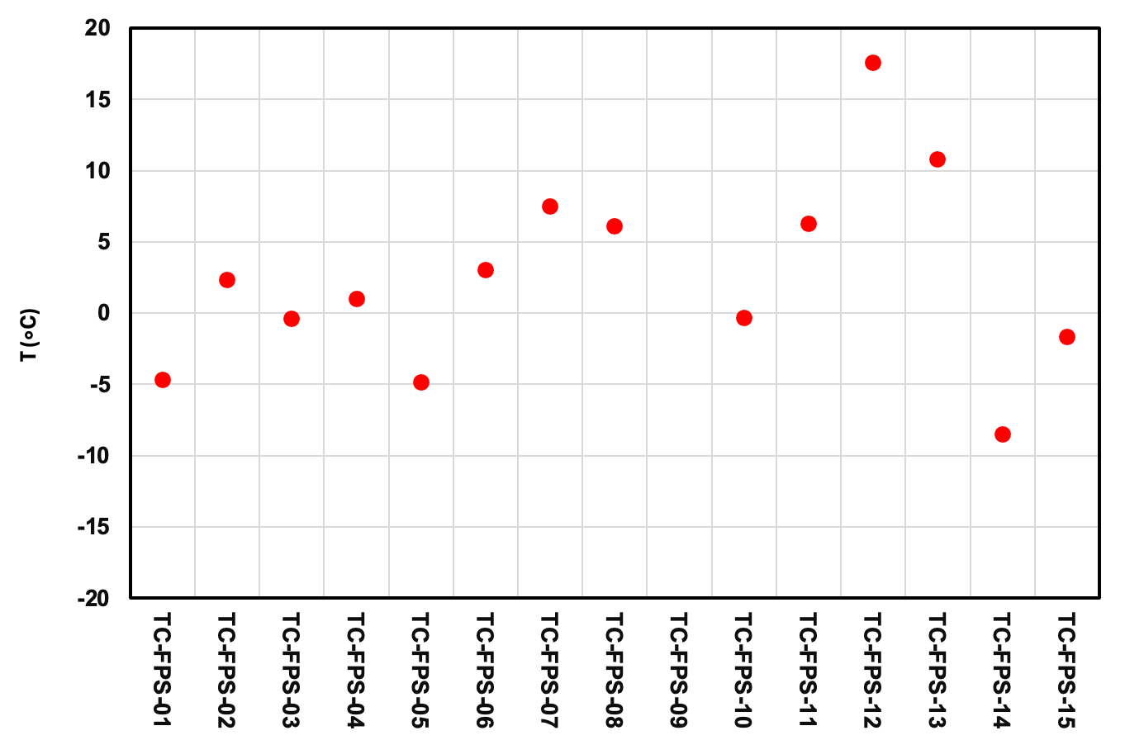
FIG. 82. ADP10 Subchannel Temperature (left) and Difference Between the Simulation and Experimental Results (right) at End-of-Test with Coupled SAM and MOOSE SCM.
FIG. 83 compares the system-level results of the ADP06 test from the coupled SAM and MOOSE SCM simulation with experimental data. Similar to the ADP10 test, the ADP06 test simulation demonstrates good overall agreement with the experimental measurements. Subchannel results at the beginning and end of the transient are shown in FIG. 84 and FIG. 85, respectively. The predicted subchannel temperatures generally follow the experimental trends. However, the difference is larger than for the ADP10 test. The maximum differences at beginning and end of transient are 19.3°C and 32.4°C, respectively. The RMS error for the subchannel temperatures is 8.9°C at the beginning of transient and 17.7°C at the end of transient.
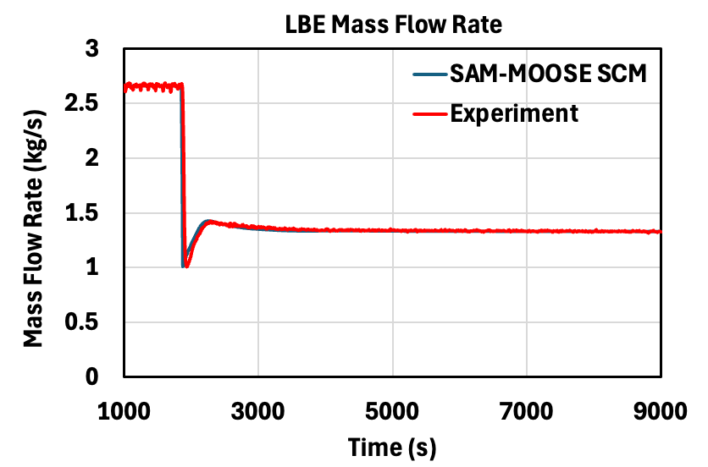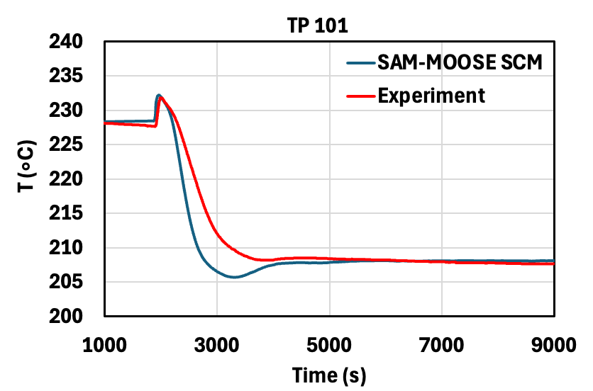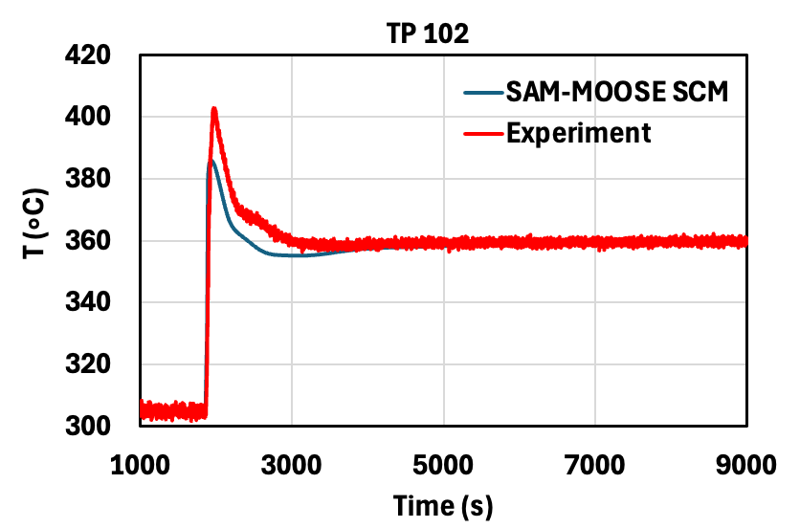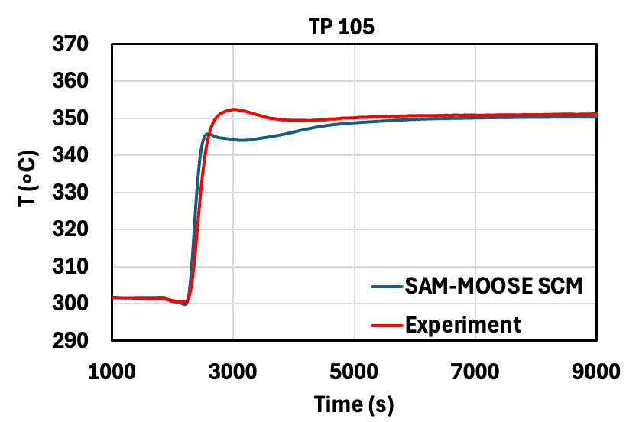
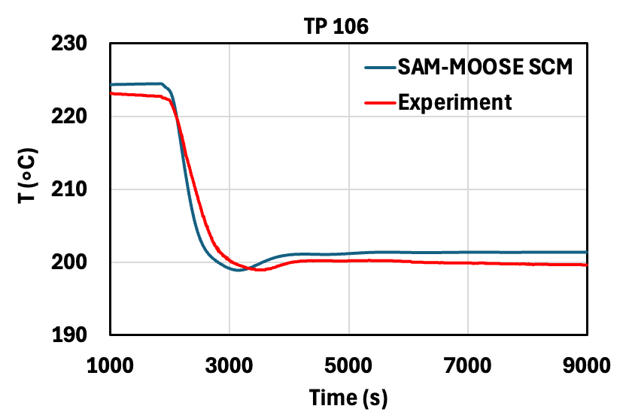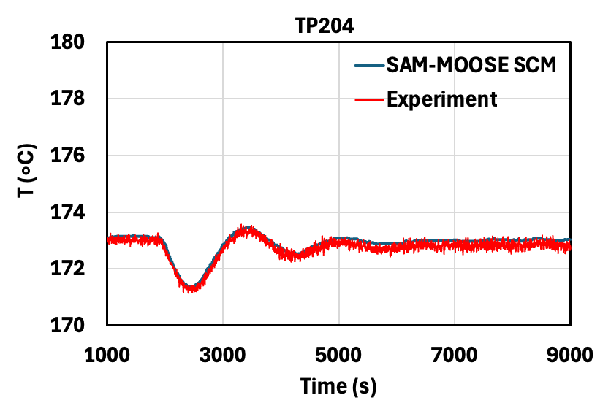
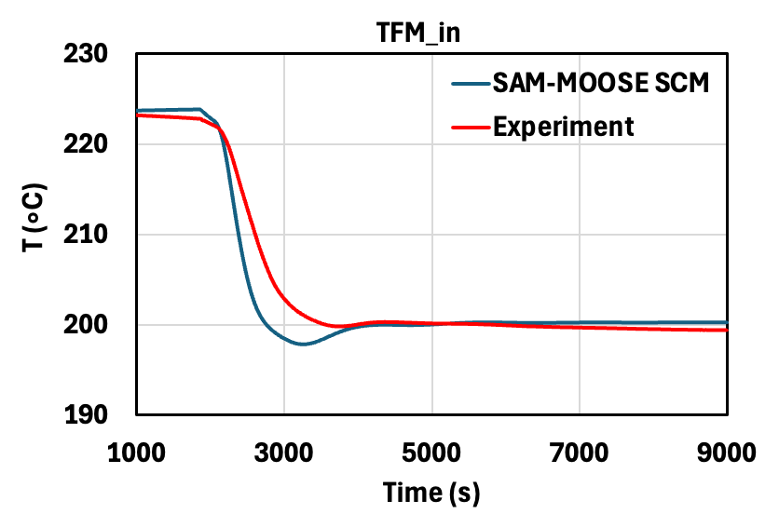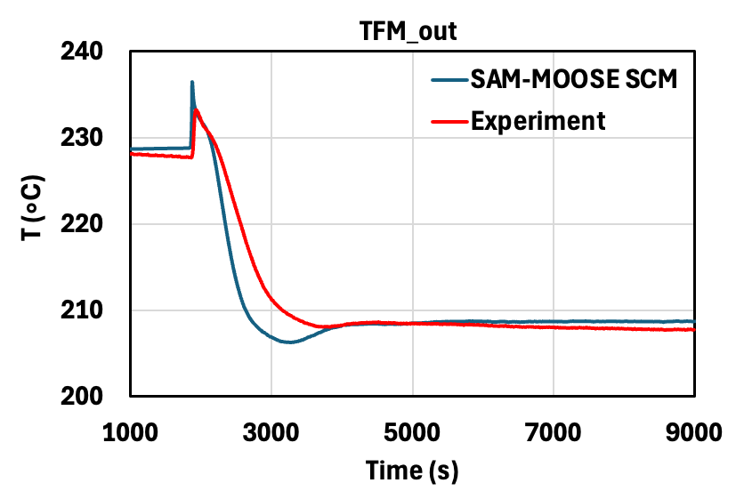
FIG. 83. ADP06 System-Level Results with Coupled SAM and MOOSE SCM.
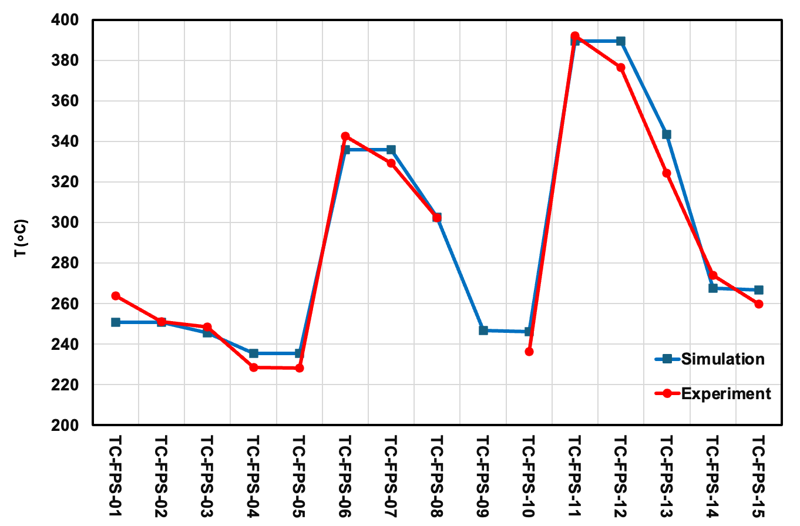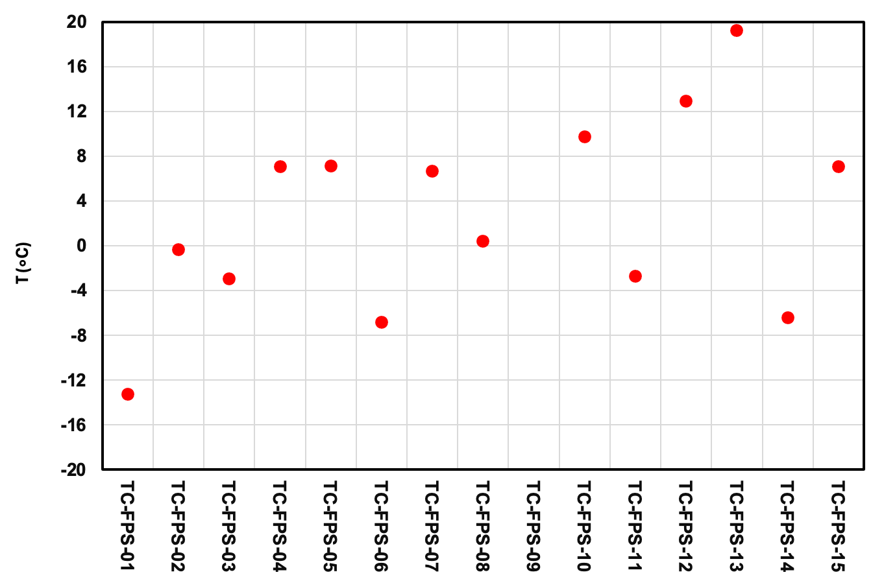
FIG. 84. ADP06 Subchannel Temperature (left) and Difference Between the Simulation and Experimental Results (right) at Beginning-of-Test with Coupled SAM and MOOSE SCM.
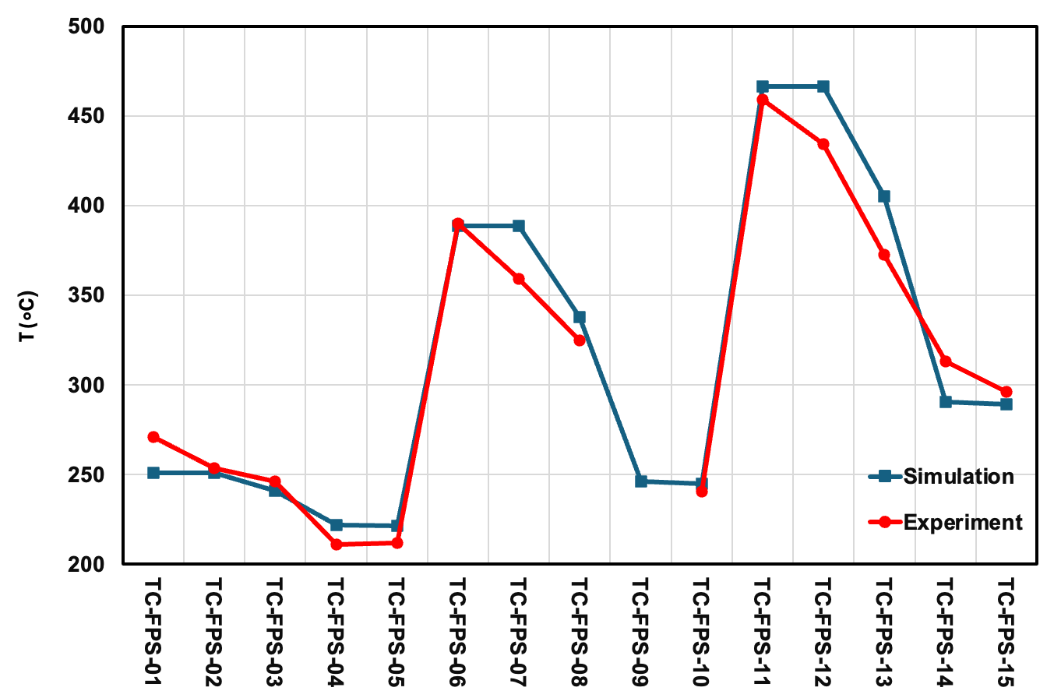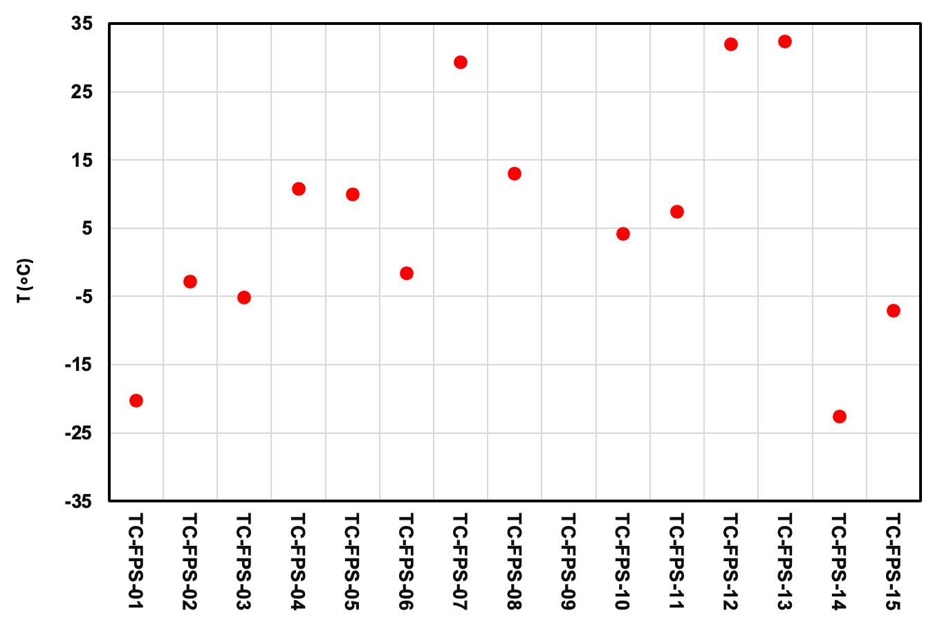
FIG. 85. ADP06 Subchannel Temperature (left) and Difference Between the Simulation and Experimental Results (right) at End-of-Test with Coupled SAM and MOOSE SCM.

Blind Phase Results for ADP07 Test
In the blind phase simulation of the ADP07 test, the model is based on the open phase simulation model of ADP10 test, with minimal modifications: the power in the FPS region and the pump head to yield the beginning of transient mass flow rate in the loop given in the benchmark specification for the ADP07 test. No other model adjustments for the ADP07 test blind phase simulation were implemented. This also includes using flowmeter heat input from the ADP10 test at this stage. The figures in this section compare the coupled SAM and MOOSE SCM results with the test data; however, the data were only provided after the blind phase results were submitted and were not available when the simulation results presented in this section were calculated. FIG. 86 presents the system-level results from the coupled SAM and MOOSE SCM simulation for the ADP07 test blind phase. The simulation results generally match the trend of the experimental measurements. The LBE mass flow rate is underestimated at the end of transient, leading to the overprediction of the temperature after FPS region at TP102. Additionally, the heat exchanger water outlet temperature at TP204 shows a different trend compared to the experiment data. This discrepancy is attributed to the assumption of a constant water inlet temperature of 170°C in this blind phase simulation, whereas the actual measured inlet temperature varied by approximately ±1°C.
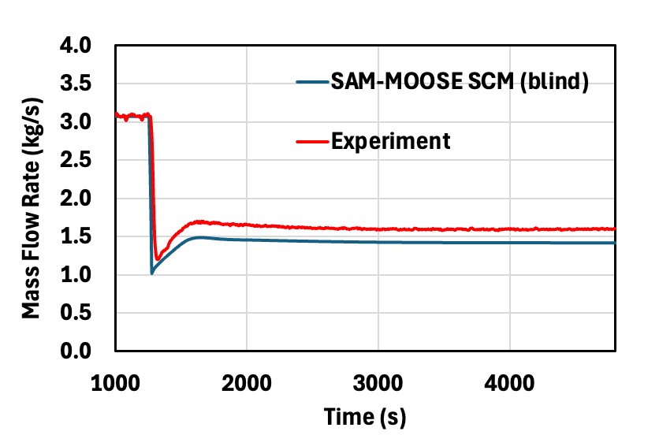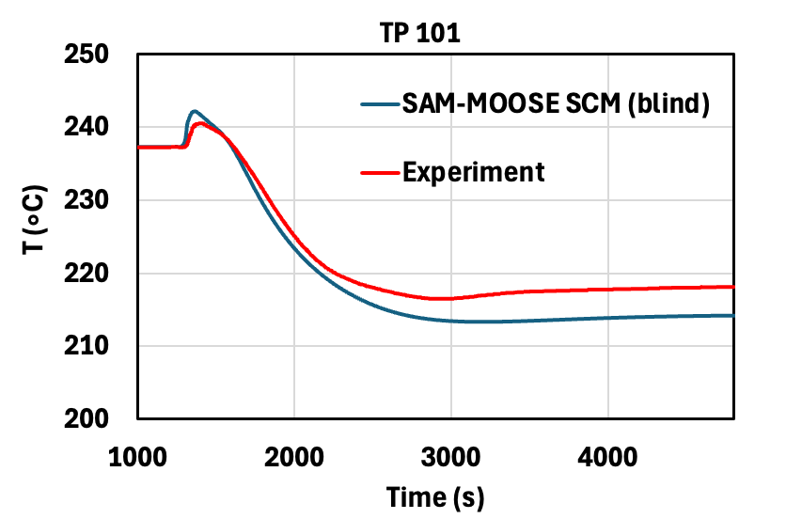
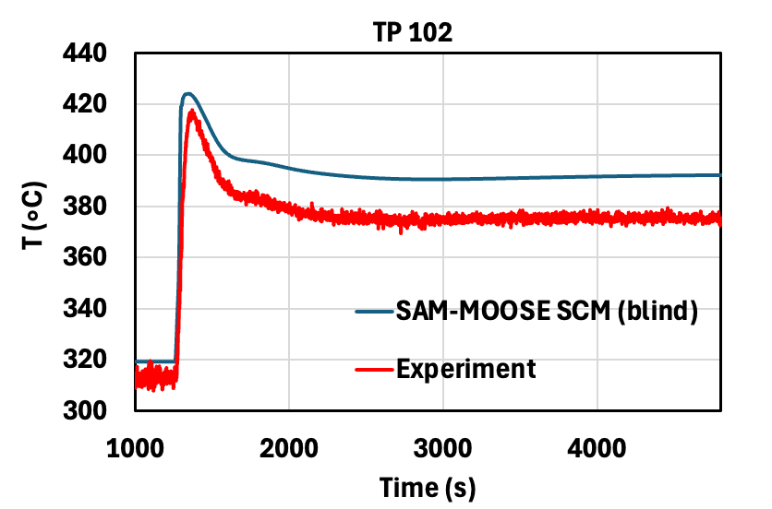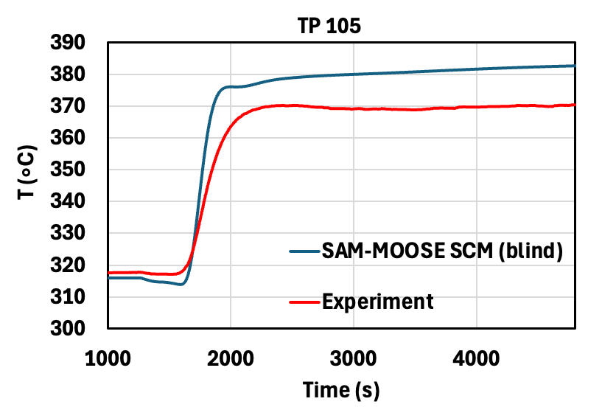
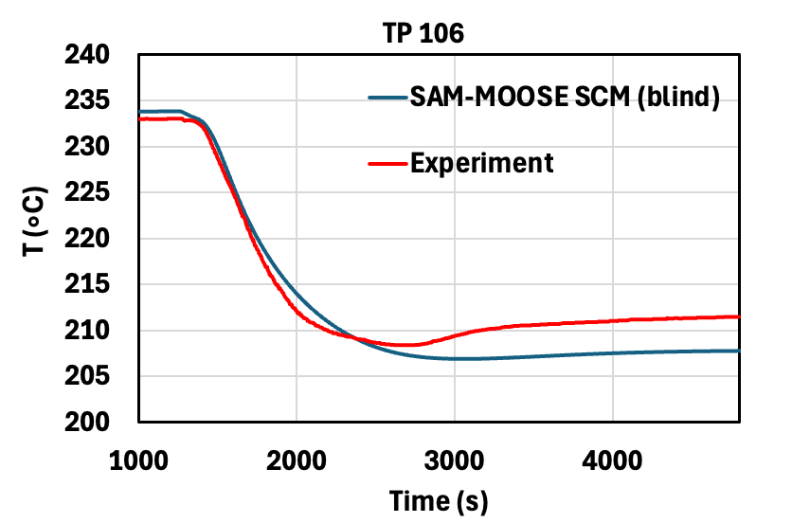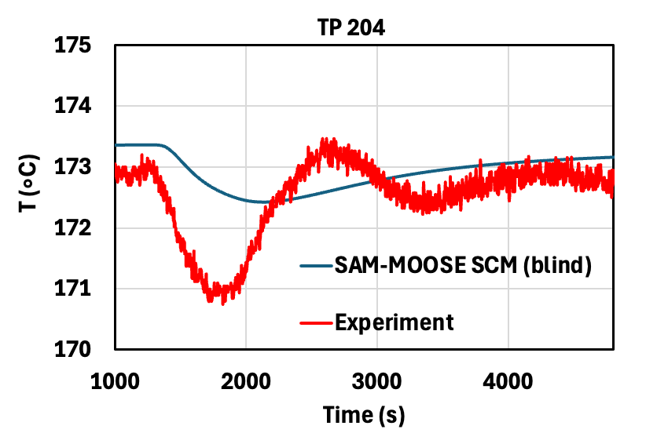
FIG. 86. ADP07 Blind Phase System-Level Results with Coupled SAM and MOOSE SCM.
FIG. 87 and FIG. 88 present the subchannel results at the beginning and end of transient for ADP07 test blind phase, respectively. Compared to tests ADP10 and ADP06, the ADP07 test blind simulation exhibits noticeably larger discrepancies with experimental measurements. At beginning of transient, the maximum difference is 45.4 °C at TC-FPS-13. The largest deviation at the end of the transient is also at TC-FPS-13, with a difference of 79.8°C. The RMS error for subchannel temperatures from the coupled simulation results is 21.4°C at beginning of transient, and 33.2°C at the end of transient.
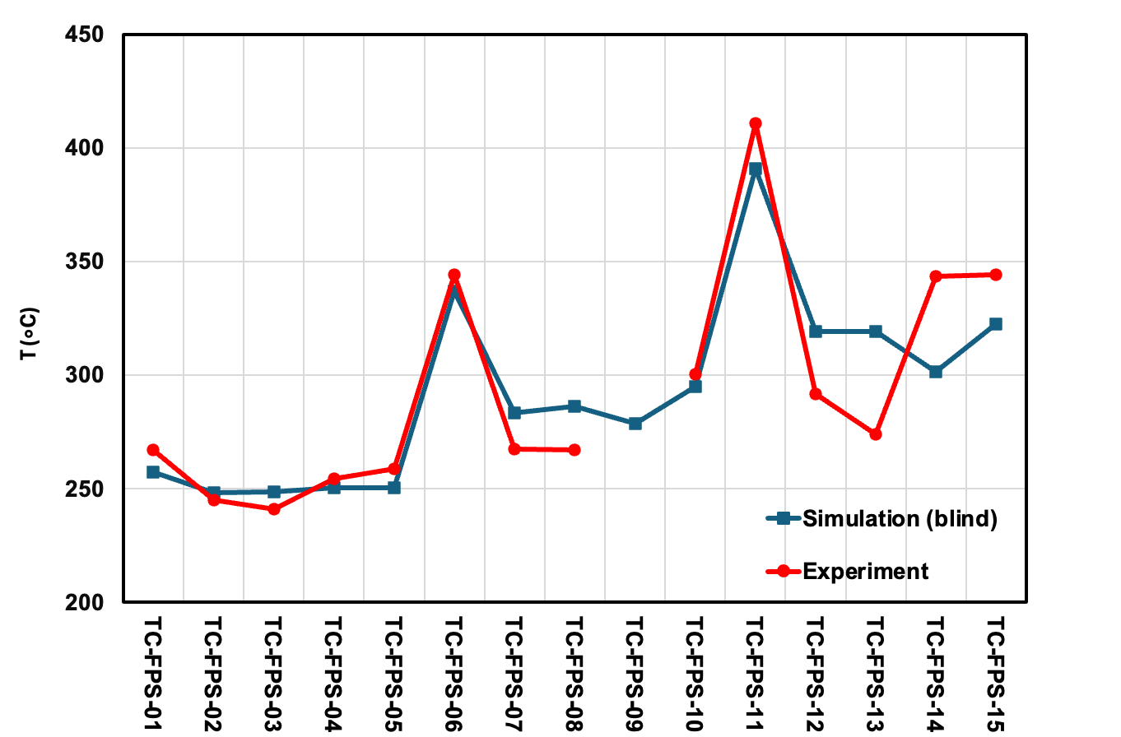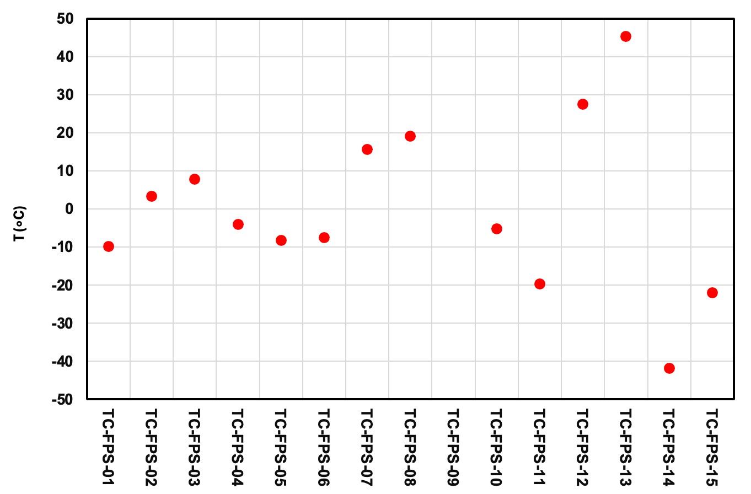
FIG. 87. ADP07 Blind Phase Subchannel Temperature (left) and Difference Between the Simulation and Experimental Results (right) at Beginning-of-Test with Coupled SAM and MOOSE SCM.
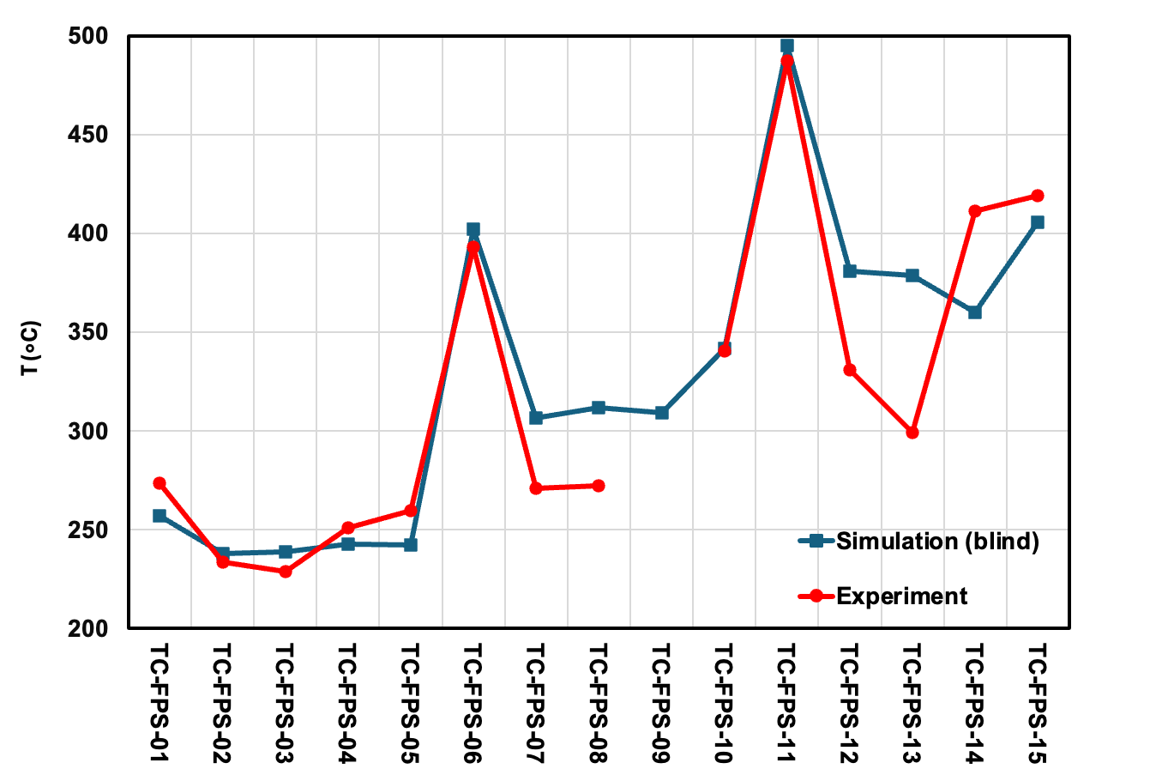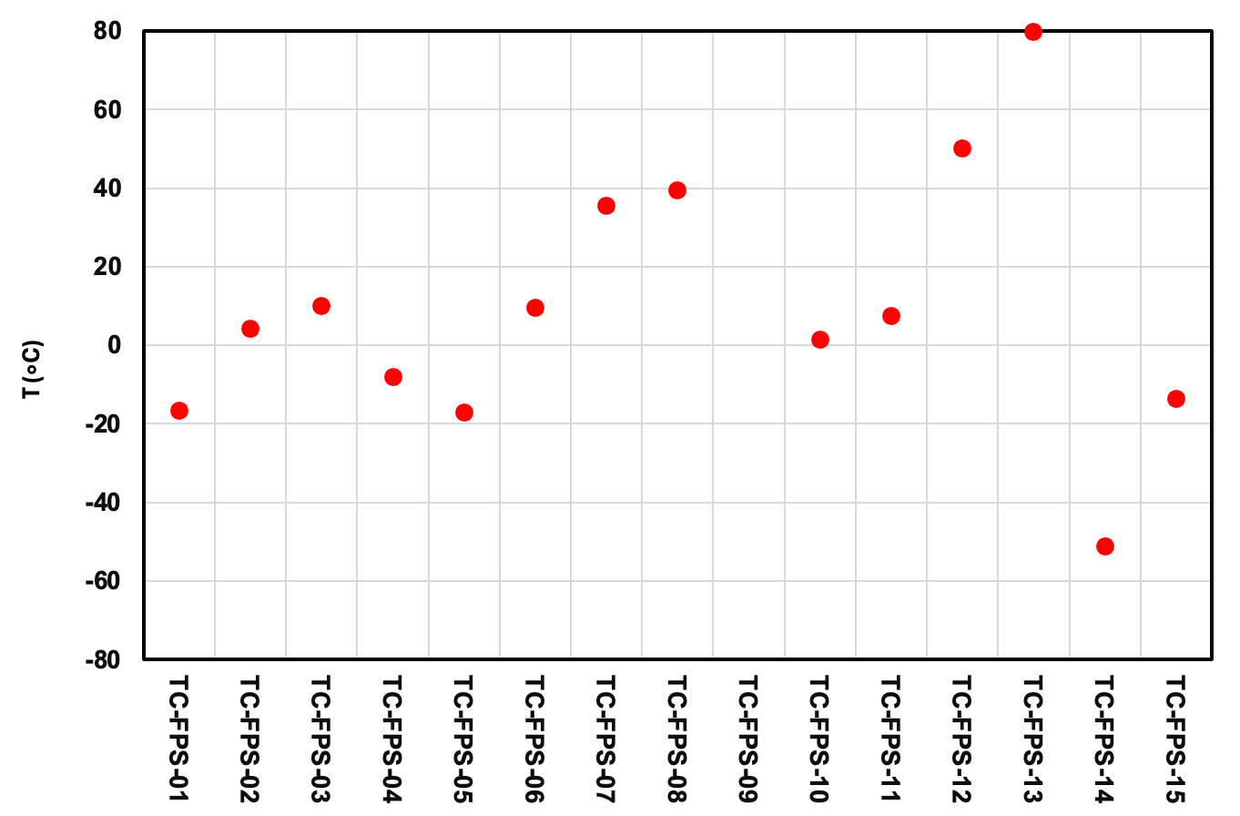
FIG. 88. ADP07 Blind Phase Subchannel Temperature (left) and Difference Between the Simulation and Experimental Results (right) at End-of-Test with Coupled SAM and MOOSE SCM.

Refined Results for ADP07 Test
In the refined phase simulation of the ADP07 test, several refinements were made from the blind phase ADP07 test model to enhance the agreement between simulation and experimental results. To improve the accuracy of the model, the power in thermal flow meter and exact water inlet temperature at the heat exchanger secondary side were extracted from the experimental data and applied directly as boundary conditions. The FPS inlet form loss coefficient is calibrated to align the calculated LBE mass flow rate in the loop with the experimentally measured value. As shown in FIG. 89, the system-level results from the coupled SAM and MOOSE SCM for the refined phase exhibit improved agreement with the experimental data, particularly toward the end of the transient. This is primarily attributed to the LBE mass flow rate having better agreement with the experimental value in the refined phase.
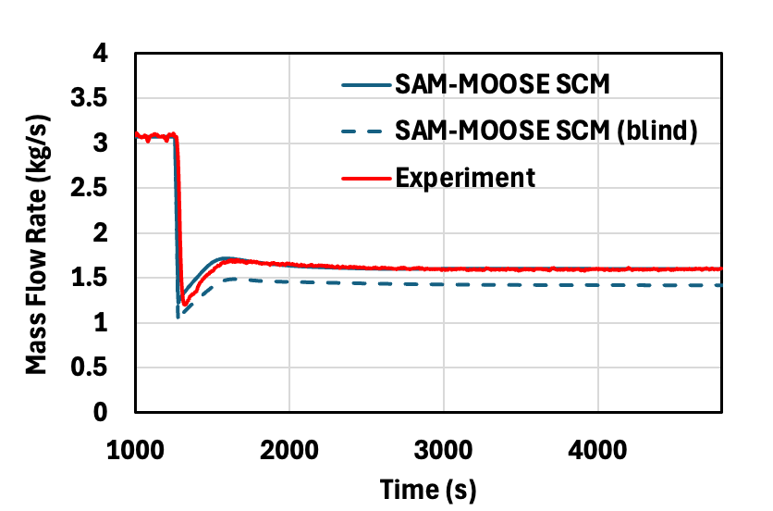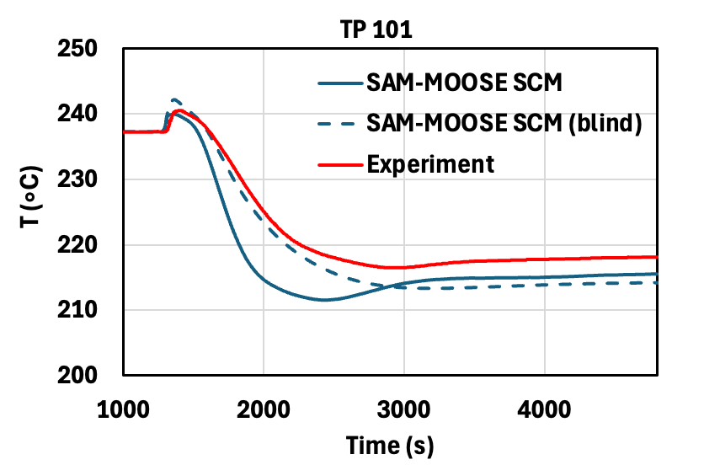
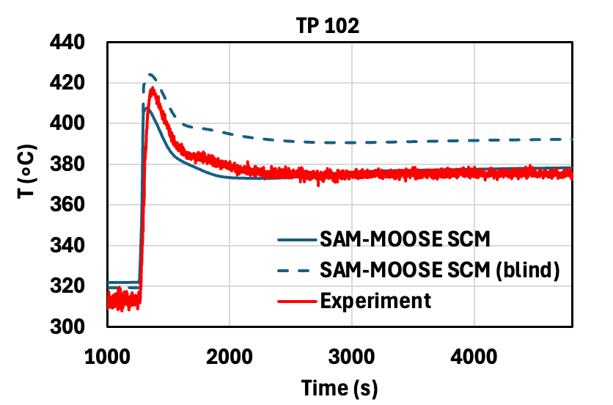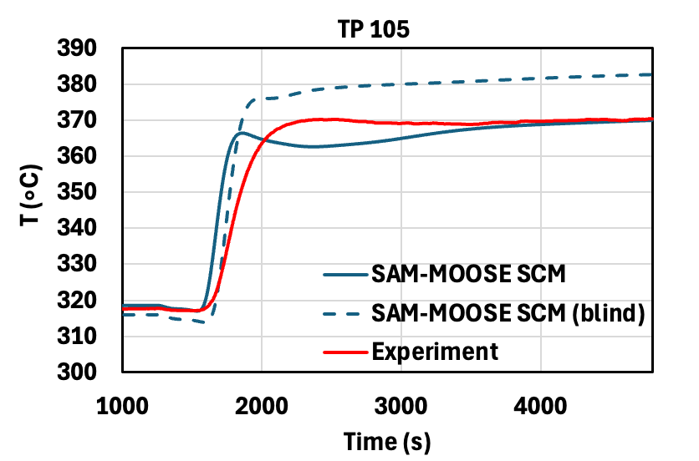
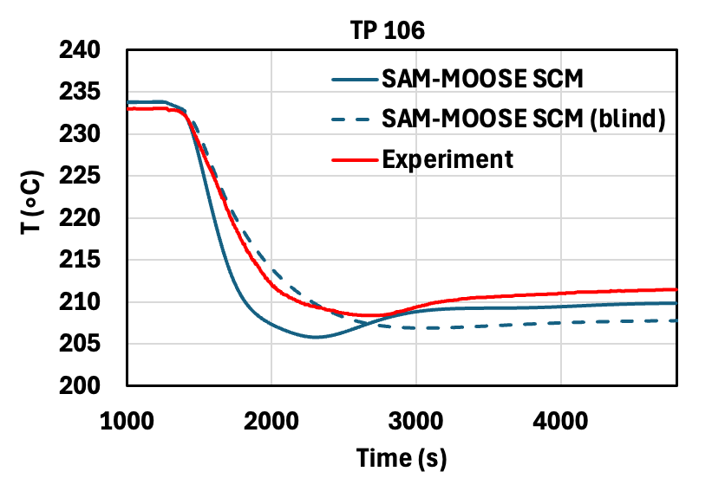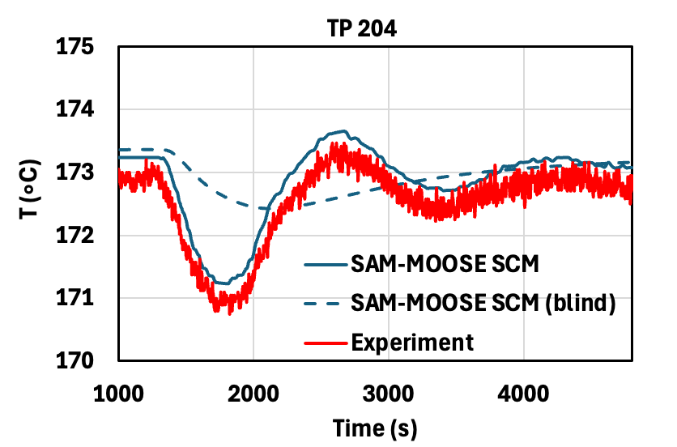
FIG. 89. ADP07 Refined Phase System-Level Results with Coupled SAM and MOOSE SCM.
FIG. 90 presents the the subchannel results at beginning of transient from the coupled SAM and MOOSE SCM simulation. At beginning of transient, the blind and refined phase results are nearly identical, with no noticeable difference. The maximum difference remains at 45.4°C at TC-FPS-13, and the RMS error is 21.4°C, consistent with the blind phase results. The subchannel results at end of transient show noticeable differences between blind and refined phases, primarily due to the differences in the predicted LBE mass flow rate at the end of transient (FIG. 91). In the refined phase simulation, the maximum deviation at the end of the transient is 68.0°C at TC-FPS-14 and the RMS error is reduced slightly to 32.0°C. Despite these refinements, the subchannel temperature discrepancies in the ADP07 test refined phase remain larger than those observed in the ADP10 and ADP06 tests. Future work will be needed to improve the subchannel modeling for the ADP07 test.
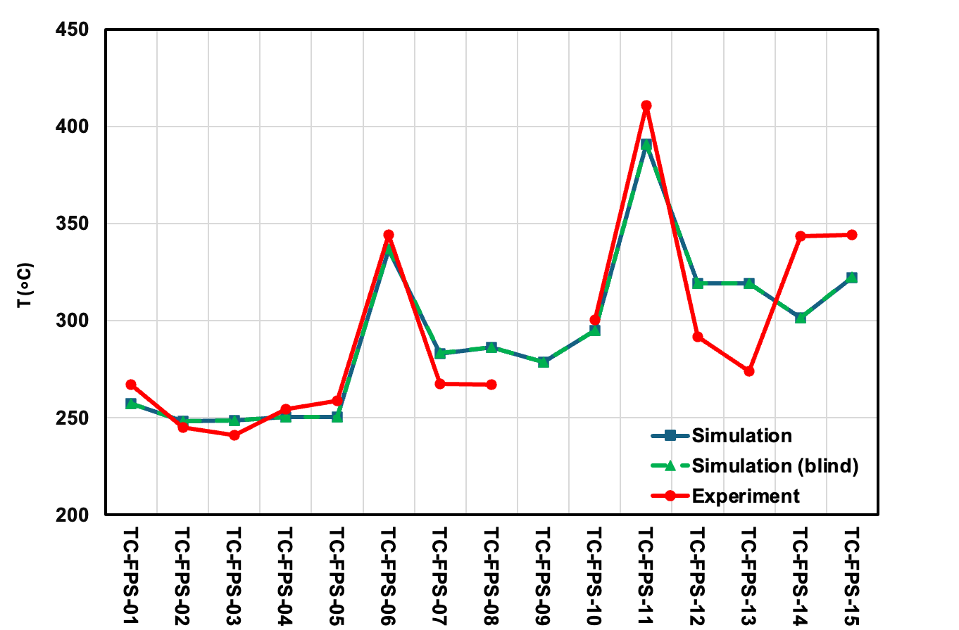
FIG. 90. ADP07 Refined Phase Subchannel Temperature (left) and Difference Between the Simulation and Experimental Results (right) at Beginning-of-Test with Coupled SAM and MOOSE SCM.
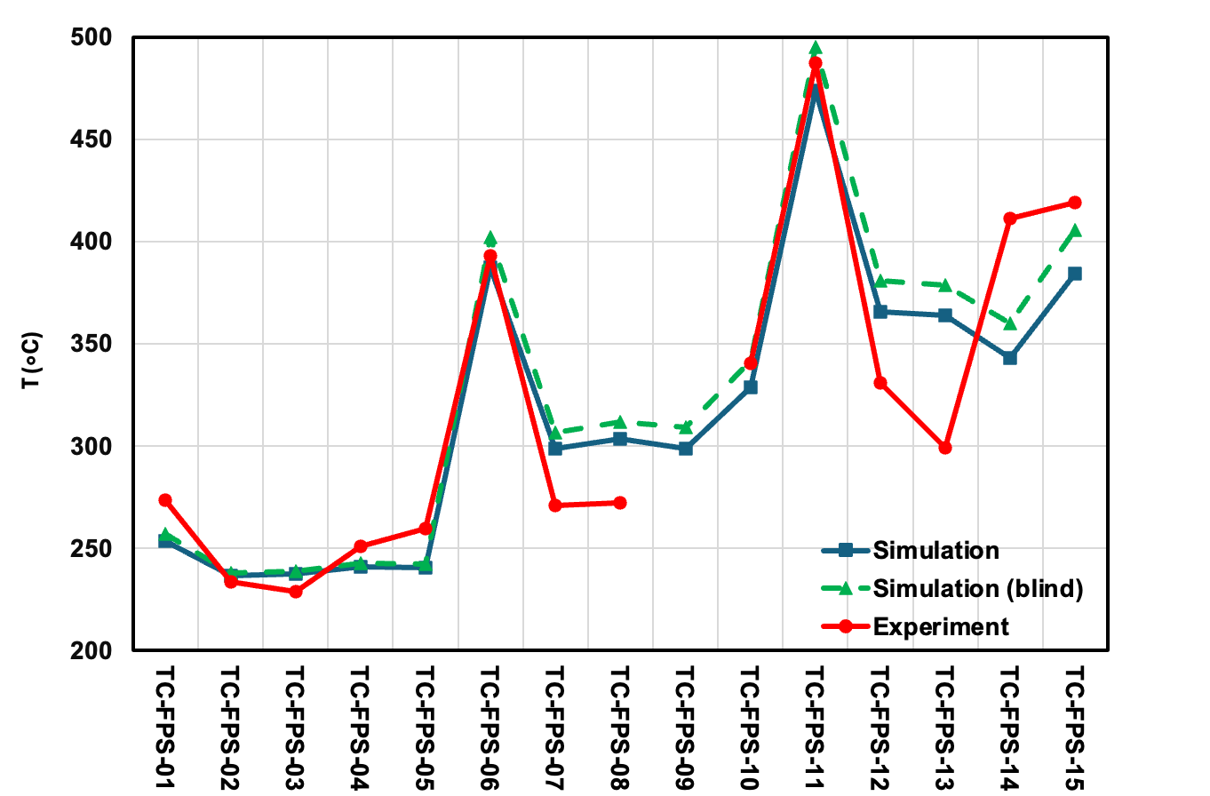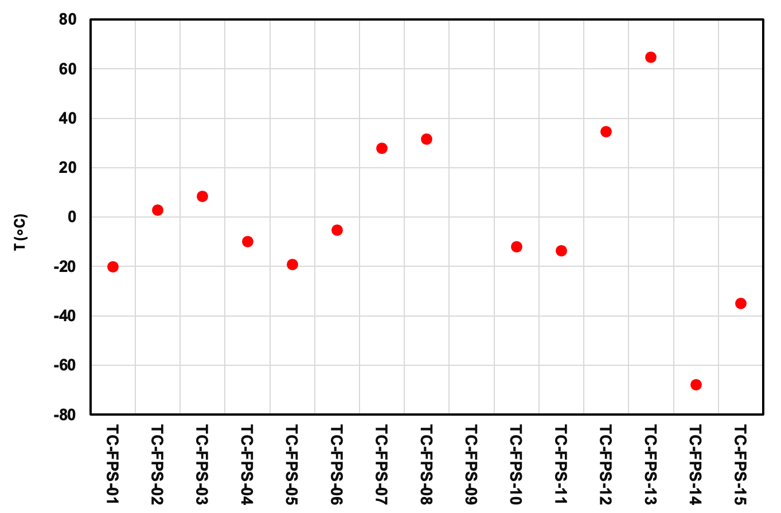
FIG. 91. ADP07 Refined Phase Subchannel Temperature (left) and Difference Between the Simulation and Experimental Results (right) at End-of-Test with Coupled SAM and MOOSE SCM.

Conclusions
Argonne is participating in the International Atomic Energy Agency (IAEA) coordinated research project (CRP) on “Benchmark of Transition from Forced to Natural Circulation Experiment with Heavy Liquid Metal Loop (NACIE)”. Three tests are included in the IAEA benchmark. During each test, the gas lift-off pump is turned off to initiate a transition from forced to natural circulation. The tests differ by which pins are activated inside the fuel pin simulator to represent conditions similar to those under partial assembly flow blockage. Argonne currently participates with the coupled SAM and MOOSE SCM code in two NACIE CRP work packages: WP1 for system-level thermal hydraulics and WP3 for sub-channel modeling.
A coupled SAM and MOOSE SCM simulation model utilizing the domain overlapping approach was developed and was used to perform simulation of the open phase tests of ADP10 and ADP06, as well as the blind and refined phase tests of ADP07. For the system-level results, the coupled SAM and MOOSE SCM simulation model accurately predicted the temperature evolution in the loop during all the three tests. For the subchannel simulation results, good agreement with the experimental data is obtained for the tests ADP10 and ADP06. The simulation results for the subchannel temperatures show relatively large difference for the ADP07 test, in both blind and refined phases. Future work is needed to enhance subchannel modeling in partial heating cases like in the ADP07 test. Some other possible areas of improvement are identified such as incorporation of the solid conduction model for fuel pins in MOOSE SCM, calibration of the mixing parameters in subchannel models, and modeling thermal inertia of some additional loop components.

NEKRS AND CARDINAL

Description of the NACIE-UP FPS CFD Models
Two levels of fidelity were used in the fluid dynamics simulations. The first is large eddy simulation (LES), a high-fidelity method which resolves the largest turbulent fluctuations in the fluid domain. An LES turbulence model can capture anisotropies in the turbulence, which are generally considered to play a significant role in heat transfer for wire-wrapped bundles, particularly at low Prandtl numbers. The second is a moderate-fidelity method, unsteady Reynolds-averaged Navier-Stokes (URANS), which does not resolve any turbulent scales and models turbulent stress and heat transfer by introducing a turbulent- or eddy-viscosity.
Both models solve the dimensionless forms of the incompressible Navier-Stokes equations with variable viscosity, conductivity and specific heat. The Boussinesq approximation for buoyancy was included. In the fluid domain, the conservation of mass (continuity), momentum and energy equations are as shown in Eqs. (41), (42) and (43).
 | $$∇⋅\vec{u}=0$$ | (41)
 | $$\frac{D\vec{u}}{Dt}=-∇P+\frac{1}{Re}∇⋅\underline{s}-Ri T {\vec{e}}_{g}$$ | (42)
 | $$c_{p}\frac{DT}{Dt}=-\frac{1}{Pe}∇⋅\vec{q}''$$ | (43)
where the shear stress tensor, $\underline{s}$, and heat flux vector, ${\vec{q}}^{''}$, are defined differently depending on the choice of turbulence model and ${\vec{e}}_{g}$ is a unit vector in the direction of gravity.
The dimensionless parameters describing the flow conditions are defined as shown in Eqs. (44), (45) and (46).
 | $$Re=\frac{ρ_{0}L_{0}u_{0}}{μ_{0}}$$ | (44)
 | $$Pe=RePr=\frac{ρ_{0}L_{0}u_{0}c_{p,0}}{λ_{0}}$$ | (45)
 | $$Ri=\frac{gL_{0}β_{0}ΔT_{0}}{u_{0}^{2}}$$ | (46)
where the subscript ‘0’ indicates a (dimensional) reference value. All reference values are evaluated at the inlet, except for density and reference length. The density is evaluated at the arithmetic mean between the inlet and outlet, and the reference length is always the pin diameter, $L_{0}=D_{pin}$. Reference values for each case are provided in the relevant subsections. Note that local variability in the thermal expansion coefficient was deemed insignificant and was not accounted for.
The remaining flow variables are non-dimensionalized as in Eqs. (47), (48), (49) and (50).
 | $$\vec{u}=\frac{\vec{u^{*}}}{u_{0}}$$ | (47)
 | $$t=\frac{t^{*}u_{0}}{L_{0}}$$ | (48)
 | $$P=\frac{P^{*}}{ρ_{0}u_{0}^{2}}$$ | (49)
 | $$T=\frac{T^{*}-T_{in}^{*}}{ΔT_{0}}$$ | (50)
where the superscript ‘*’ indicates a standard dimensional value, and $T_{in}^{*}$ is the inlet temperature. The reference temperature change is chosen from Eq. (51).
 | $$ΔT_{0}=\frac{Q_{0}}{ρ_{0}u_{0}A_{in}^{*}c_{p,0}}$$ | (51)
where $Q_{0}$ is the total power and $A_{in}^{*}$ is the dimensional area of the inlet. This choice assures a mean dimensionless temperature rise of near unity along the fluid domain. Finally, the fluid properties themselves are non-dimensionalized to their reference values as shown in Eqs. (52), (53) and (54).
 | $$μ=\frac{μ^{*}}{μ_{0}}$$ | (52)
 | $$λ=\frac{λ^{*}}{λ_{0}}$$ | (53)
 | $$c_{p}=\frac{c_{p}^{*}}{c_{p,0}}$$ | (54)
Models for the properties of lead-bismuth eutectic were provided by the benchmark specifications [10] which vary with local temperature.
LES model
In the turbulence cascade, energy contained in the largest eddies is transferred to smaller and smaller eddies until it is dissipated as heat at the shortest length scale. An LES model explicitly resolves the largest eddies and relies on the assumption that the unresolved (sub-grid) scales can be modeled as simple dissipation. NekRS uses a high pass filtering approach to account for sub-grid scale turbulence in its LES model. The filtering is included directly in the momentum and energy equations as an added term as shown in Eqs. (55) and (56).
 | $$\frac{D\vec{u}}{Dt}=-∇P+\frac{1}{Re}∇⋅\underline{s}-Ri T{\vec{e}}_{g}-χ\left(\vec{u}-H*\vec{u}\right)$$ | (55)
 | $$c_{p}\frac{DT}{Dt}=-\frac{1}{Pe}∇⋅{\vec{q}}^{''}-χ\left(T-H*T\right)$$ | (56)
where $χ$ is the filter strength and $(H*)$ is a convolution operator. To construct the convolution operator, the solution in NekRS is interpolated from the Lagrange (or nodal) basis to the Legendre (or modal) basis. Each Legendre mode corresponds directly to a resolved length scale dependent on the local element size. The Legendre modes are then weighted to decrease the amplitude on the shortest resolved length scales and re-interpolated back to the nodal basis. This produces a signal with energy removed from the shortest length scales and a momentum source is constructed to push the solution towards that signal. For further information see [80]. No additional sub-grid model is used, and the total stress tensor and heat flux vector are given by Eqs. (57) and (58).
 | $$\underline{s}=μ[∇\vec{u}+\left(∇{\vec{u})}^{T}\right]$$ | (57)
 | $${\vec{q}}^{''}=-λ∇T$$ | (58)
The LES filter is controlled in NekRS via two parameters, the filter strength and the number of filtered modes. The recommended settings were used where the filter strength is set to 10 and the number of modes is set to 2. This approach has the advantage of converging towards DNS with increasing polynomial order as the filtered scales are pushed lower with increasing order.
Due to the long unheated developing length of the NACIE fuel pin simulator domain, no special treatment of the inlet condition was necessary to develop turbulence. Typically, a recycling boundary condition or synthetic eddy method is necessary with a turbulence resolving method. However, from previous experience, wire-wrapped domains generally show fully developed turbulence within 1-2 wire pitches. Some differences may be apparent for higher-order turbulent quantities, but since only first-order quantities – specifically, temperature – are of interest, an undeveloped inlet condition was considered sufficient.
RANS Model
There are many (U)RANS models commonly used in CFD, with various two-equation models being the most popular. These models transport an additional pair of scalars, typically representing the turbulent intensity and the dissipation of turbulence. Of the two-equation models, the k-ω and k-ε families are the most often used. The variant used in NekRS is the standard k-τ model, which is a member of the k-ω family with a novel base implementation in NekRS [81] and modified to include the simple gradient diffusion hypothesis for turbulent heat transfer in flows with buoyancy effects [82].
The k-τ model implemented in NekRS is a fully wall-resolved model. It was implemented as an alternative to a standard k-ω model as it has properties that are well-suited for high-order methods. The most significant being the simple zero Dirichlet boundary condition of τ on walls. This is in opposition to the singular boundary condition for ω, which, due to the inherent properties of a spectral element method, is problematic. In addition, τ exhibits non-linear behavior near walls, which is difficult to resolve in lower-order methods, but is not a problem for a high-order method.
In a two-equation RANS model, the diffusion terms in both the momentum and energy equation are augmented to account for turbulence. The is known as a Boussinesq assumption, wherein the turbulent stress is proportional to the mean strain rate tensor as shown in Eqs. (59) and (60).
 | $$\underline{s}=\left(μ+μ_{t}\right)[∇\vec{u}+\left(∇{\vec{u})}^{T}\right]$$ | (59)
 | $${\vec{q}}^{''}=-\left(λ+\frac{μ_{t}c_{p}}{{Pr}_{t}}\right)∇T$$ | (60)
where $Pr_{t}$ is the turbulent Prandtl number. For all cases, a constant turbulent Prandtl number of 0.85 was used. The eddy viscosity in the dimensionless k-τ model is given by Eq. (61).
 | $$μ_{t}=kτ$$ | (61)
The turbulent kinetic energy and period of turbulent dissipation are modeled with the transport equations Eqs. (62) and (63).
 | $$\frac{Dk}{Dt}=\frac{1}{Re}\left[∇⋅\left(μ+\frac{μ_{t}}{C_{k}}\right)∇k+P_{k}\right]-B_{k}+G_{k}$$ | (62)
 | $$\frac{Dτ}{Dt}=\frac{1}{Re}\left[∇⋅\left(μ+\frac{μ_{t}}{C_{τ}}\right)∇τ-P_{τ}\right]+B_{τ}+α_{τ}\frac{τ}{k}G_{k}$$ | (63)
where $C_{k}$, $C_{τ}$, and $α_{τ}$ are model constants, $P_{k}$ and $P_{τ}$ are the production terms, $B_{k}$ and $B_{τ}$ are the destruction terms, and $G_{k}$ is the extra production due to buoyancy. In the simple gradient diffusion hypothesis, it is given by Eq. (64).
 | $$G_{k}=\frac{Ri}{RePr_{t}}μ_{t}\left({\vec{e}}_{g}⋅∇T\right)$$ | (64)
Fluid domain
The CFD domain only includes the fluid region around the 19-pin wire-wrapped bundle. It was generated using a custom tool and includes several geometric approximations to account for the wire-pin contact and to ensure a high-quality mesh. The wire/pin contact is filleted with a radius of 0.25 times the wire radius, the wire is sunken into the pin it’s wrapped around by 2.5% of the wire diameter, and the wire is flattened as it sweeps by a neighboring pin with 5% of the wire diameter cut off. A cross-section of the CFD domain is shown in FIG. 92 at 5th-order with the details visible. It includes 5.5 wire pitches of length from the inlet to the outlet and consists of 1.7M elements. This corresponds to 367M GLL points at 5th-order. Details of the mesh metrics are provided in Table 38. To demonstrate mesh independence, simulations were performed at 3rd, 5th, and 7th orders. Results at 5th and 7th orders were shown to have negligible differences.
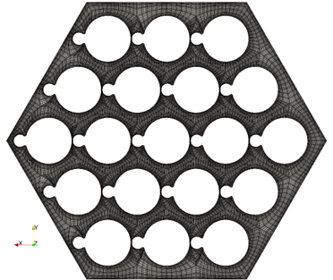
FIG. 92. Cross section of the CFD mesh at 5th order showing (left) the full mesh and (right) a detailed view around a single pin.
Table 38. Metrics for the NekRS mesh.
 | Min | Max | Average
Scaled Jacobian | 0.112 | 0.992 | 0.96
Aspect Ratio | 4.88 | 353 | 21.2

Solid Conduction Model
Cardinal was used for its ability to combine multiple physics on different computational domains without the need for a conformal mesh. That is, the surfaces between computational domains can have different mesh topologies. This allows for much greater flexibility in performing simulations on domains with complex shapes, such as an assembly of wire-wrapped fuel pins.
The solid mesh was generated using GMSH [83]. A mesh for a single pin was generated and replicated in MOOSE. The single pin mesh contains 206k hexahedral elements, for a total of 3.9M elements in the full solid domain. A section of the replicated domain is shown in FIG. 93, while a cross section of the mesh with the description of the modeled regions is shown in FIG. 94. The generated pin is the full 5.5 pitches in length and aligned with the outlet of the fluid domain. The top and bottom of the pin were insulated, and a volumetric heat source was included in the expected regions. Note that in the open phase of the benchmark, only the last 3.5 wire-pitches of the solid domain were simulated.
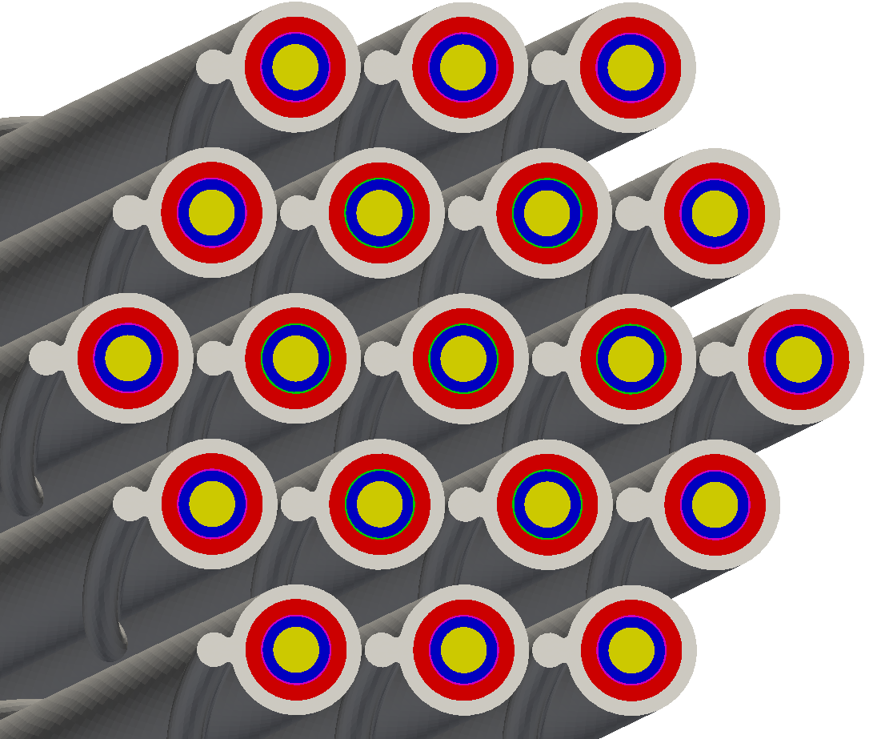
FIG. 93. 3D view of the solid domain used in Cardinal. The different colors indicate different regions of the fuel pin simulator.
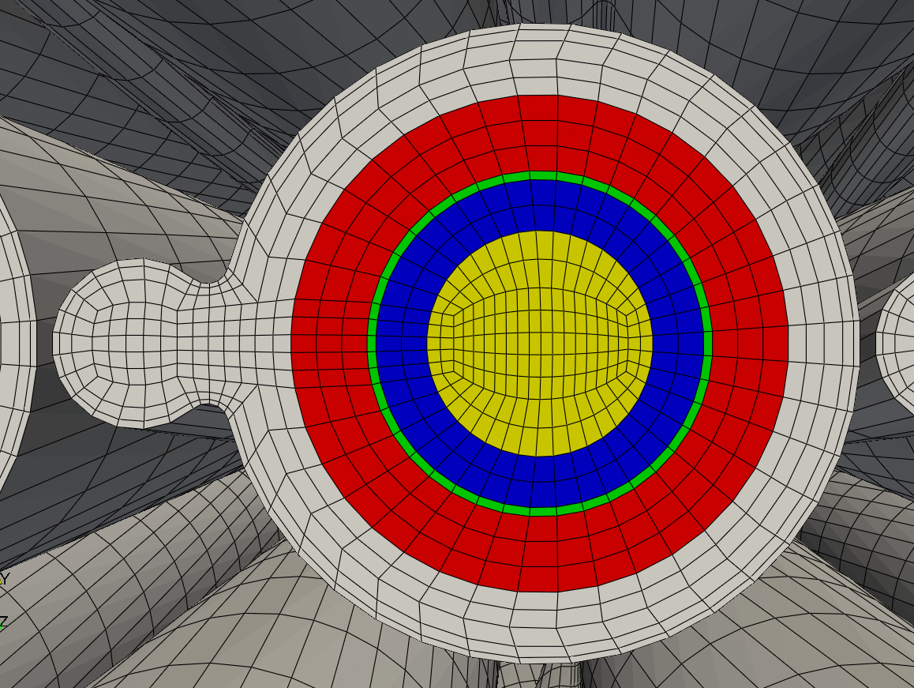
  Color | Region
  Gray | Cladding
  Red | Insulator
  Green | Heater
  Blue | Insulator
  Yellow | Copper core
FIG. 94. A zoomed in view of a single fuel pin in the Cardinal model showing the mesh. The different colors indicate different regions of the fuel pin simulator.
Cardinal was used to couple NekRS to the heat conduction module in MOOSE, which was used to solve a steady-state conduction problem in the solid domain. The conduction equation in the solid domain is given by Eq. (65):
 | $$0=\frac{1}{Pe}∇⋅λ∇T+q_{Cu}^{'''}+q_{heater}^{'''}$$ | (65)
where the total volumetric heat source is non-dimensionalized by Eq. (66):
 | $$q_{tot}^{'''}=\frac{L_{0}Q_{0}}{{{ρ_{0}u_{0}c}_{p,0}ΔT_{0}V}_{heater}^{*}}=\frac{A_{in}^{*}L_{0}}{V_{heater}^{*}}$$ | (66)
which is split into copper and heater components as shown in Eqs. (67) and (68).
 | $$q_{Cu}^{'''}=ψ_{pre}q_{tot}^{'''}$$ | (67)
 | $$q_{heater}^{'''}=\left(1-ψ_{pre}\right)q_{tot}^{'''}$$ | (68)
The copper component is only active in the copper core upstream of the heated section and the heater component is only active in the Inconel heater. The preheat fraction is $ψ_{pre}=0.078$. Note that the Peclet number appears in the solid conduction equation due to the choice of reference temperature change.
The heat conduction module in MOOSE is coupled to NekRS via a boundary condition exchange. MOOSE receives a Dirichlet boundary condition from NekRS and provides a Neumann (heat flux) boundary condition to NekRS. The rate of exchange of the boundary conditions is controllable by the user. When using a steady-state conduction model, it is only necessary to exchange this information approximately every 20-50 NekRS time steps. This implies that the MOOSE conduction problem only needs to be solved every 20-50 NekRS time steps. This can result in a significant reduction in computational time.
For a true high-fidelity simulation, a transient model should be solved in the solid domain as well as in the fluid domain. This was not done in this work because it required a much tighter coupling between MOOSE and NekRS. When it was attempted, the boundary conditions needed to be updated much more often (~1-5 NekRS timesteps) to avoid instabilities in the solution. This resulted in the computational costs becoming impractical. Additionally, since only time-averaged quantities are of interest, this was deemed unnecessary.
Properties for most of the solid regions were provided by the benchmark specification document [10]. Since only a steady state solve is performed for the solid material, only the thermal conductivity of each material is used. The thermal conductivities of the stainless-steel cladding and bohrium nitride insulator were provided as functions of temperature. A constant value was provided for the thermal conductivity of the copper core. It was recommended in the benchmark specifications to neglect the conductivity of the Inconel heater and treat it as an additional layer of bohrium nitride; however, a model for the thermal conductivity of Inconel was included in the MOOSE model as shown in Eq. (69):
 | $$λ_{INC}^{*}=0.0159 T^{*}+9.8168$$ | (69)
where $T^{*}$ is in Kelvin and $λ_{INC}^{*}$ is in W/m-K. This is based on a linear fit to tabulated values provided in [84].

Open Phase Results
Initial Results
Initial simulations were performed for the ADP10 cases with the LES model that did not include a CHT model. These were the first simulations that were performed, after which a comparison to the available experimental data showed that a CHT model is necessary. The initial CHT model only included the last 3.5 wire-pitch lengths of the solid domain. The CHT model was then adopted for the ADP10 simulations with RANS and all initial ADP06 simulations. The results of these are shown in FIG. 95, FIG. 96, FIG. 97 and FIG. 98 compared to experimental data. The advantage of using the CHT model is clearly seen in the ADP10 results in FIG. 95 and FIG. 96, where the LES results show significantly worse agreement with the experimental data. Percent differences are presented using the reference temperature increase along the FPS as shown in Eq. (70):
 | $$Δ\%=100\frac{\left|T_{CFD}^{*}-T_{exp}^{*}\right|}{ΔT_{0}}$$ | (70)
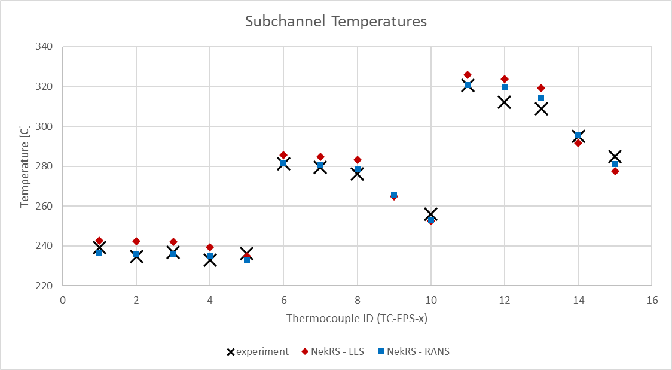 | 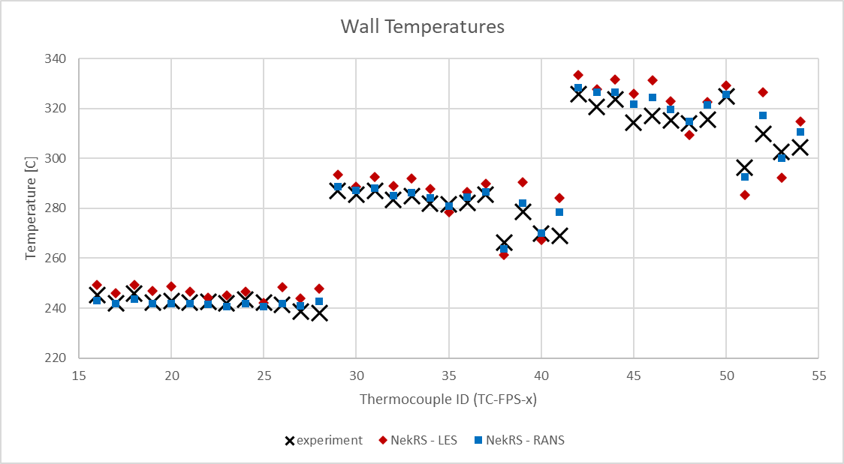
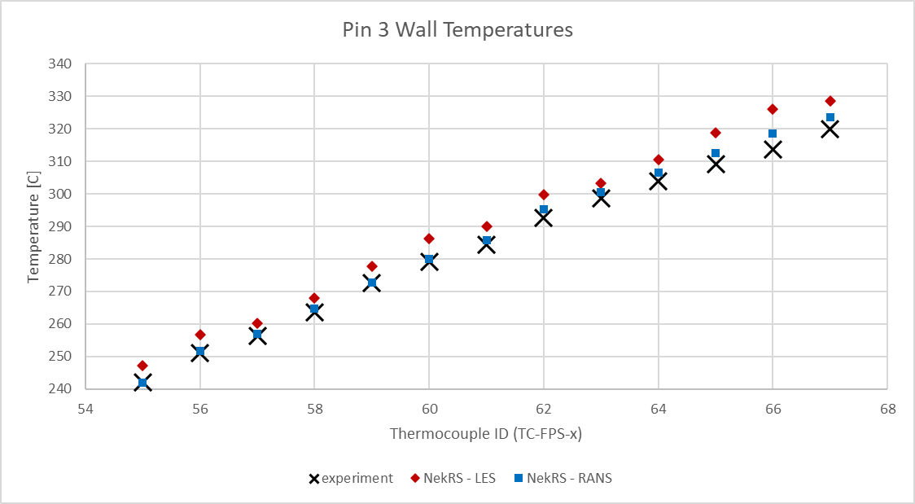 | 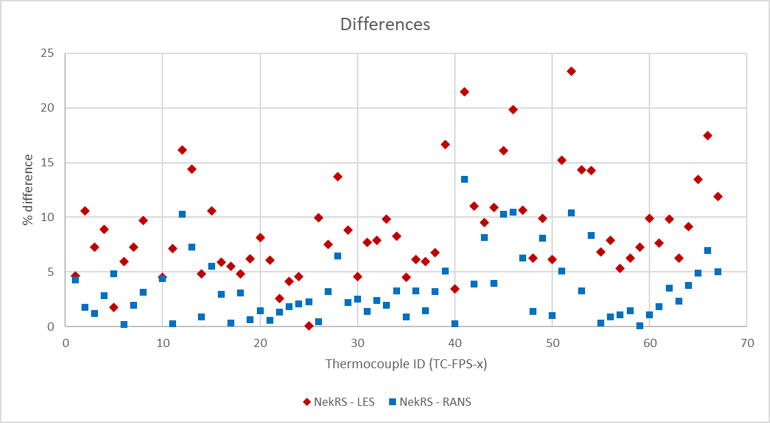
FIG. 95. Initial comparison of ADP10-SS1 results between LES, RANS, and experimental data.
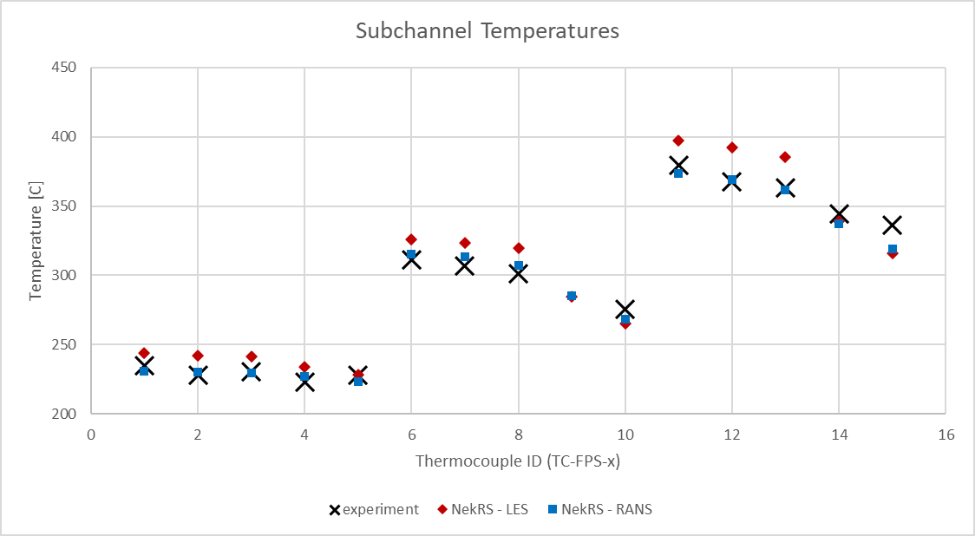 | 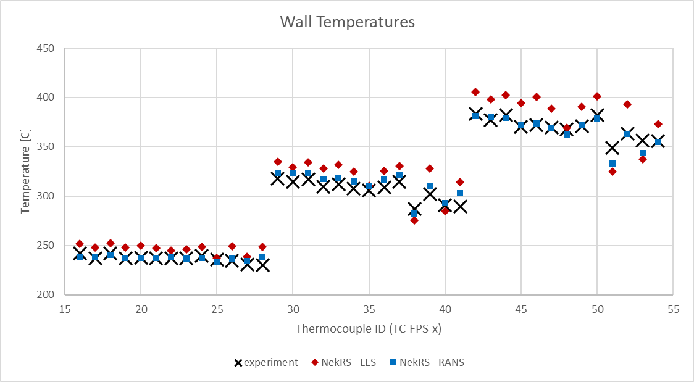
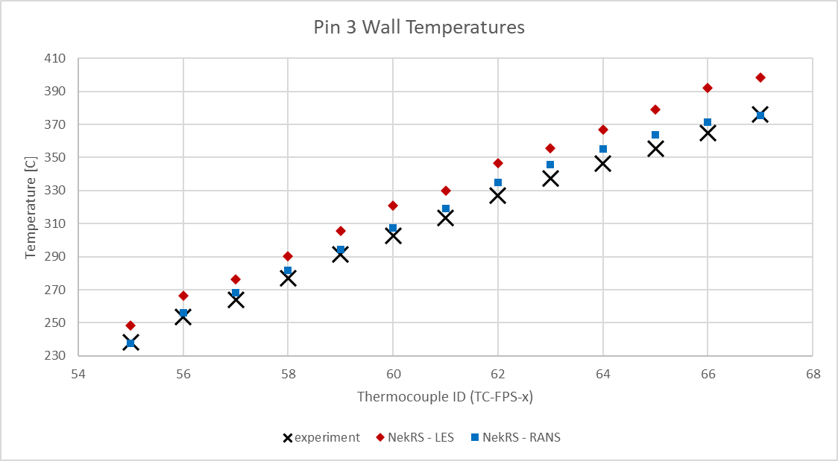 | 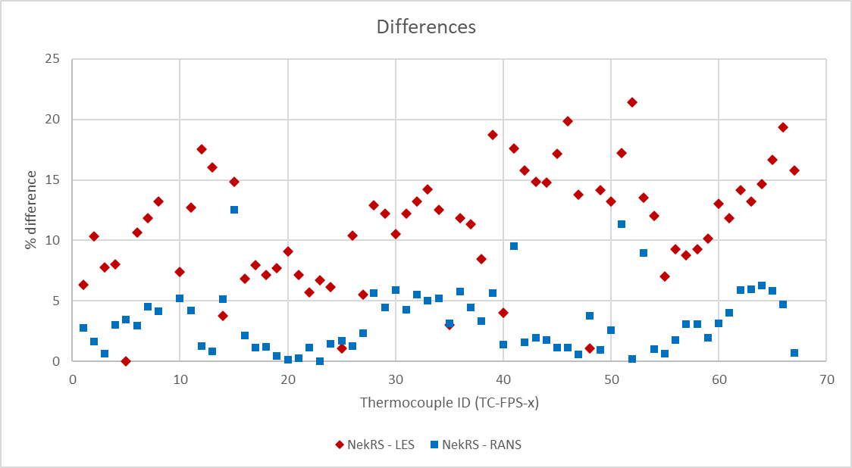
FIG. 96. Initial comparison of ADP10-SS2 results between LES, RANS, and experimental data.
The initial results for the ADP06 cases are presented in FIG. 97 and FIG. 98. These show that once a CHT model is included, the differences between the LES and RANS models are practically negligible. Typically, RANS models are modified by changing the turbulent Prandtl number in Eq. (60) to account for heat transfer in low Prandtl Number fluids such as LBE. However, the model used in NekRS is an “off-the-shelf” variant of the k-τ model without any such modification. The observed performance indicates that the phenomena accounted for by modifying the RANS models is not significant under these conditions, possibly due to the relatively low Peclet number. These results are typical of all simulated cases, where the LES model performs only marginally better than the RANS model. It was thus concluded that the RANS model needed no further modifications.
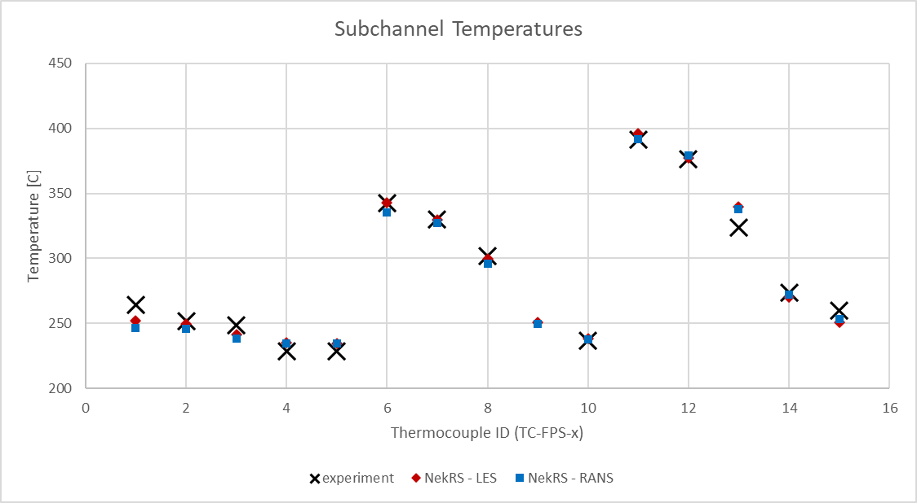 | 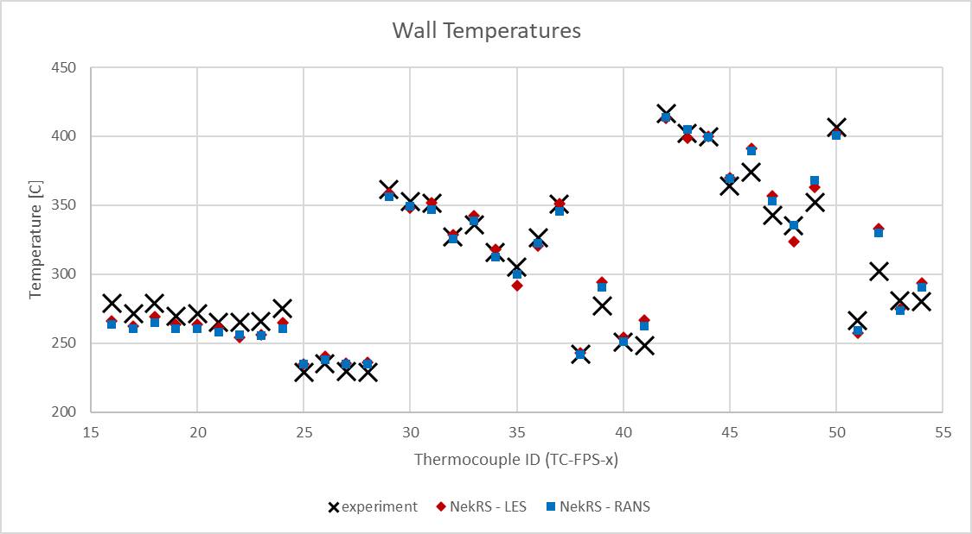
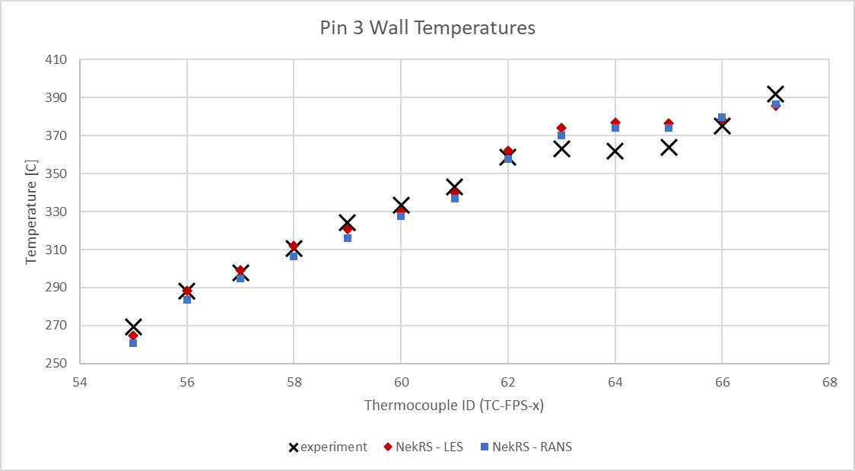 | 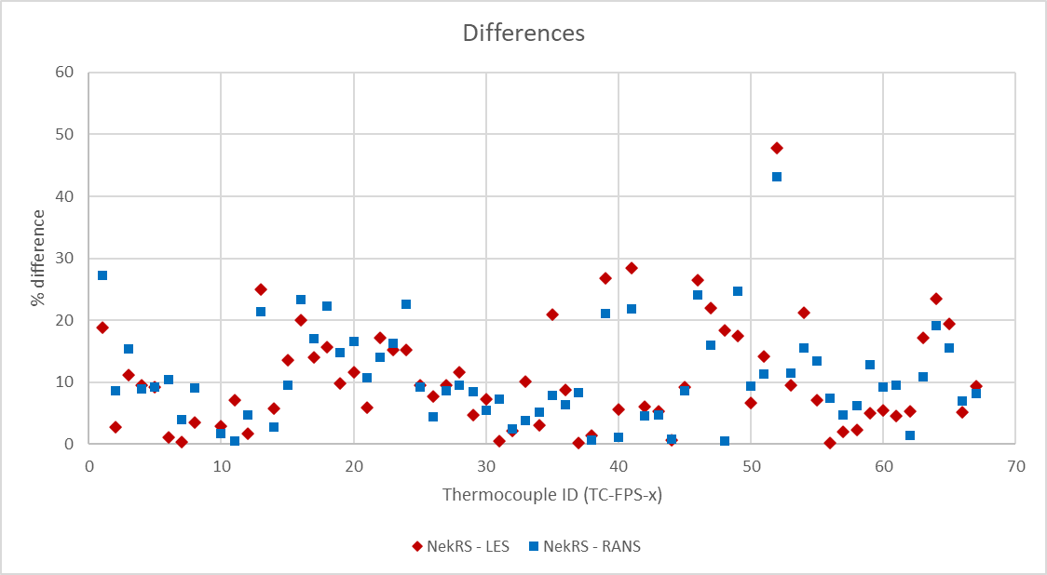
FIG. 97. Initial comparison of ADP06-SS1 results between LES, RANS, and experimental data.
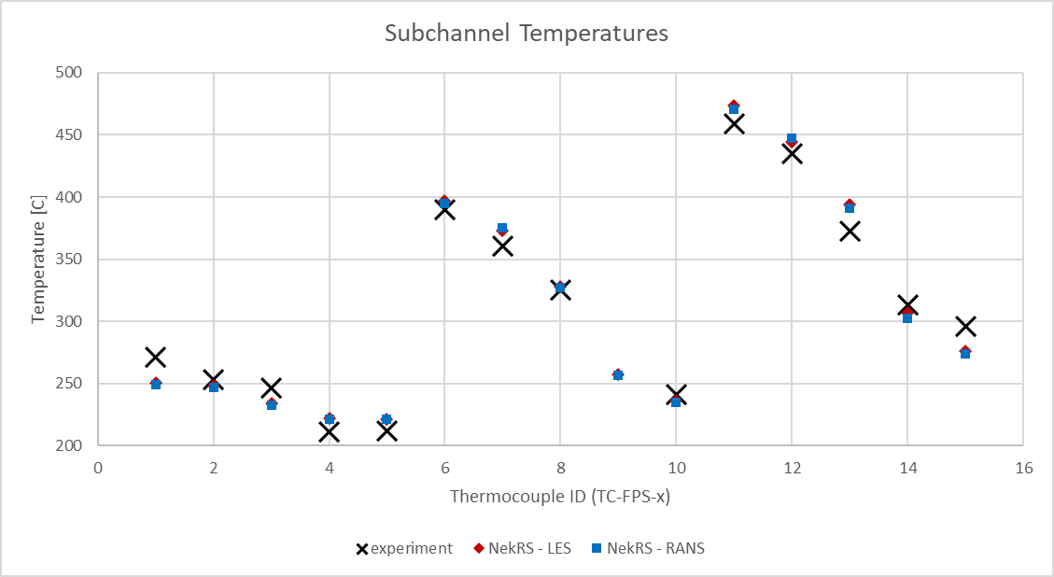 | 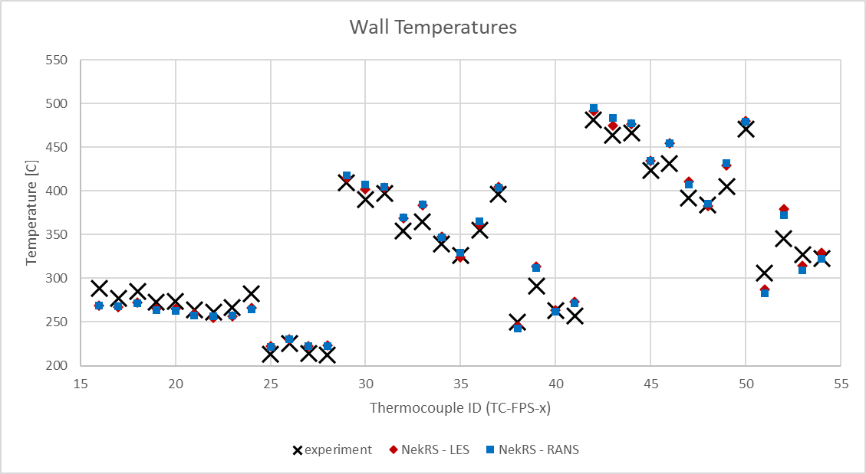
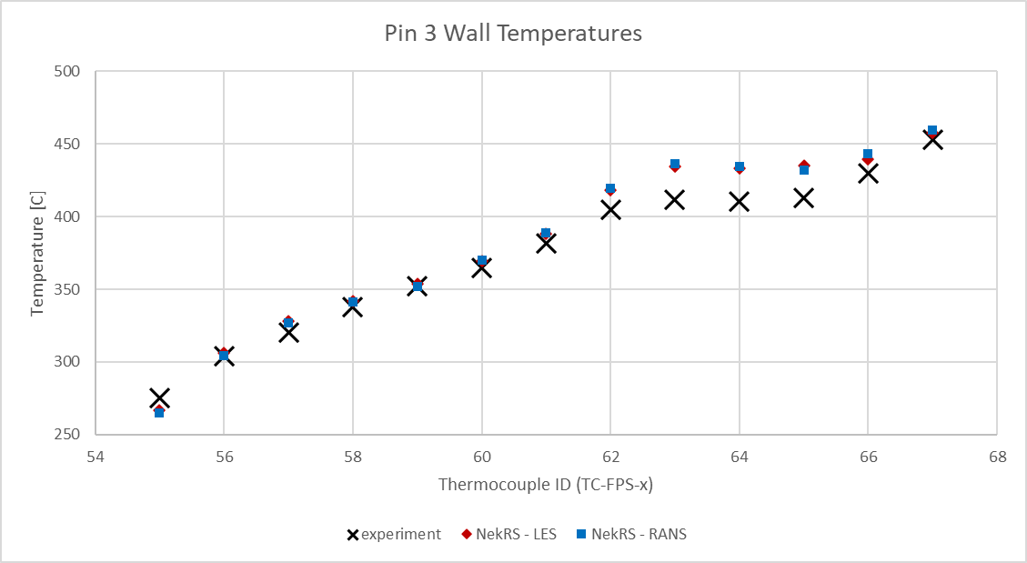 | 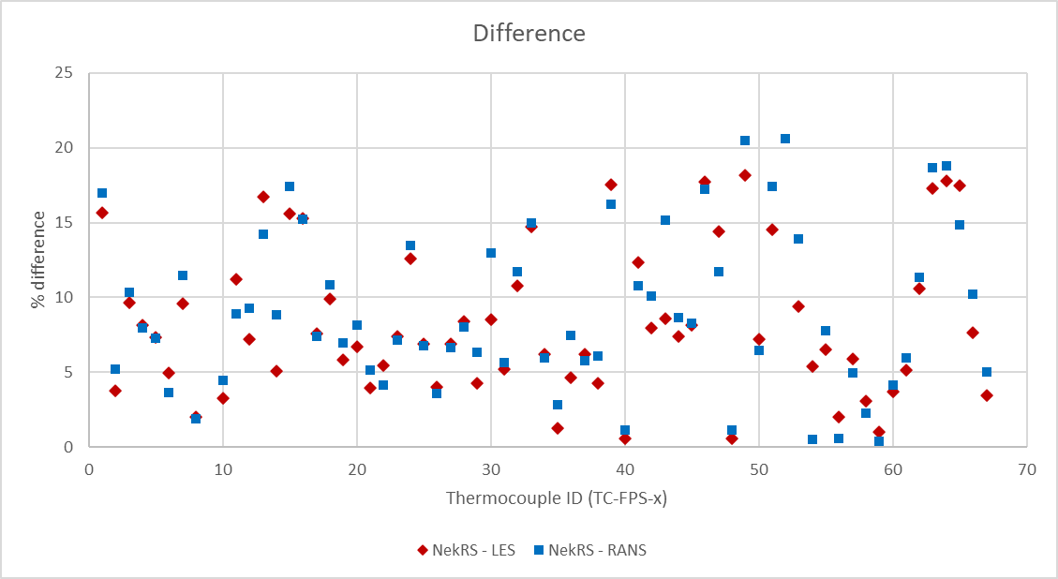
FIG. 98. Initial comparison of ADP06-SS2 results between LES, RANS, and experimental data.
Finally, all cases were checked for mesh independence. A p-type refinement study was performed where results were obtained at 3rd, 5th, and 7th orders. The results at 5th order were observed to be consistent with the results at 7th order.
Refined Results
Following the release of the 5th revision of the benchmark specifications [10], the CHT model was updated to include the full FPS length. In the new specification, some of the heat is released along the entire length of the fuel pins and the prescribed inlet temperature is decreased. The reference values used for the refined cases are presented in Table 39, the plotted results are presented in FIG. 99, FIG. 100, FIG. 101 and FIG. 102, and the mean percent differences between CFD and experimental data are tabulated in Table 40.
Table 39. Reference values for the open phase cases.
Case |  | $$u_{0}$$ | $$ρ_{0}$$ | $$μ_{0}$$ | $$c_{p,0}$$ | $$λ_{0}$$ | $$β_{0}$$ | $${ΔT}_{0}$$ | $$Q_{0}$$
 |  | m/s | kg/m³ | kg/m-s | J/kg-K | W/m-K | (10⁻⁴) 1/K | K | kW
ADP10 | SS1 | 0.370 | 10371 | 0.00224 | 148 | 10.8 | 1.25 | 77.1 | 29.06
ADP10 | SS2 | 0.190 | 10346 | 0.00237 | 149 | 10.5 | 1.25 | 151 | 29.06
ADP06 | SS1 | 0.385 | 10369 | 0.00222 | 148 | 10.8 | 1.25 | 74.2 | 29.05
ADP06 | SS2 | 0.193 | 10347 | 0.00237 | 149 | 10.5 | 1.25 | 149 | 29.05

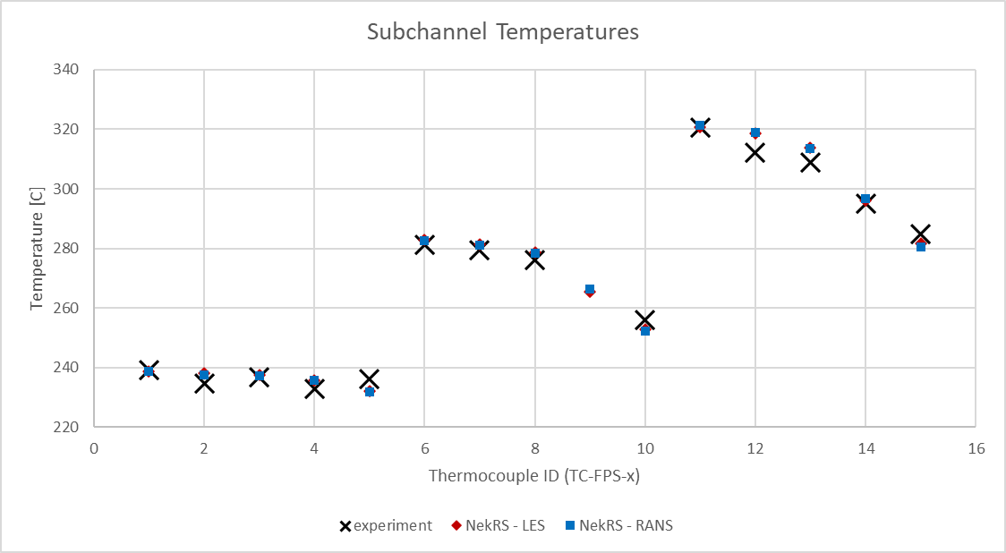 | 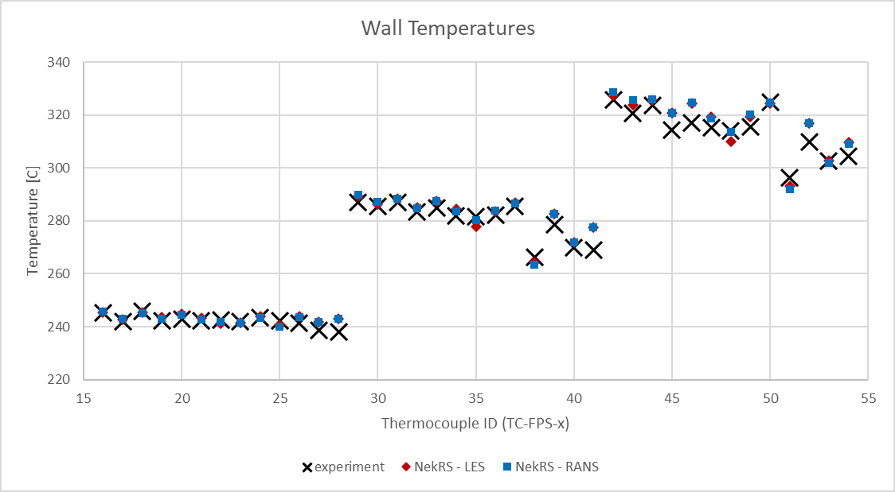
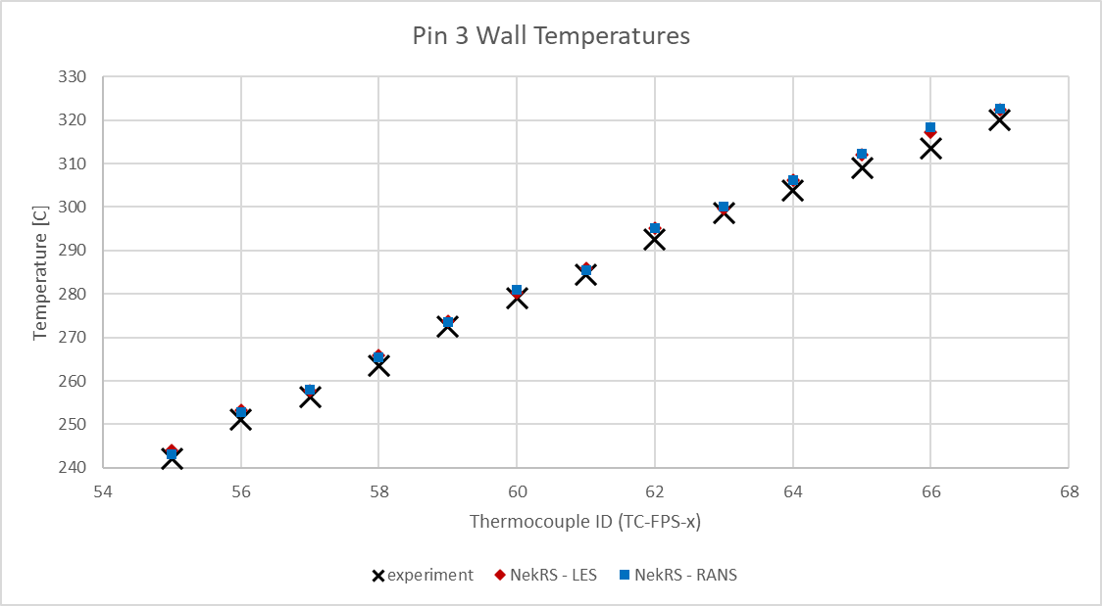 | 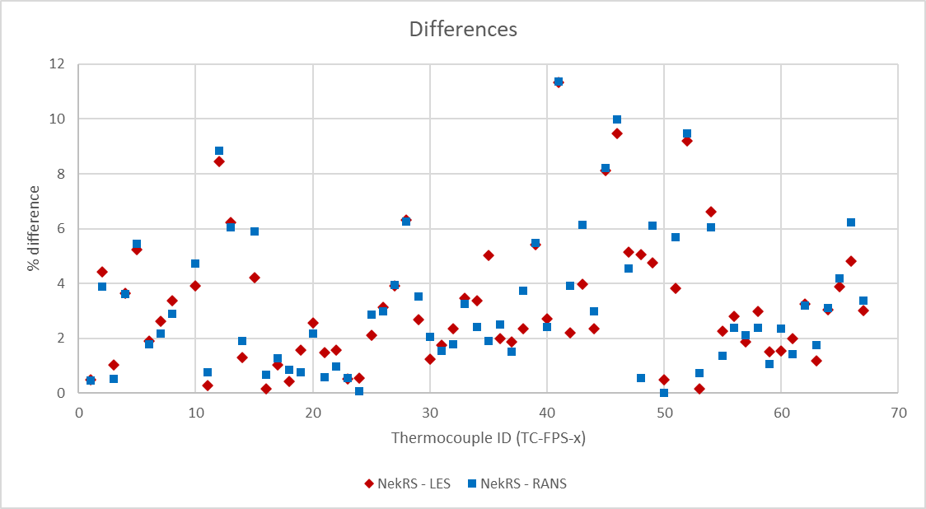
FIG. 99. Comparison of ADP10-SS1 results between LES, RANS, and experimental data.
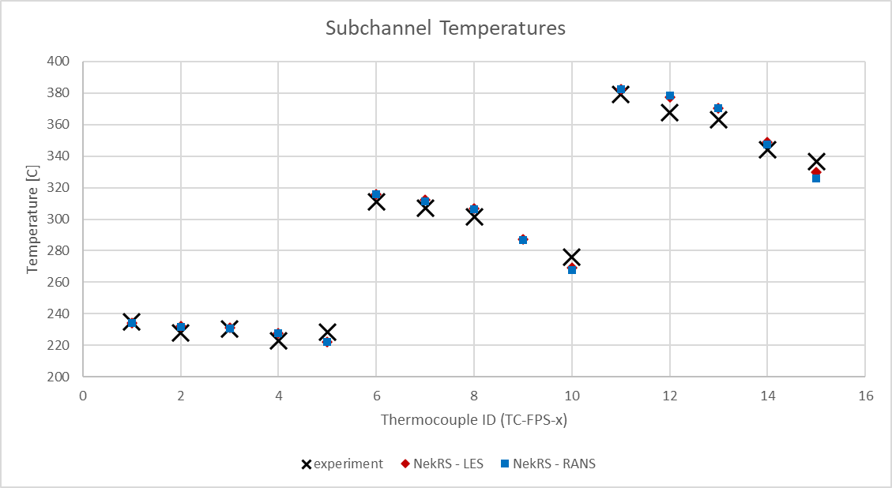 | 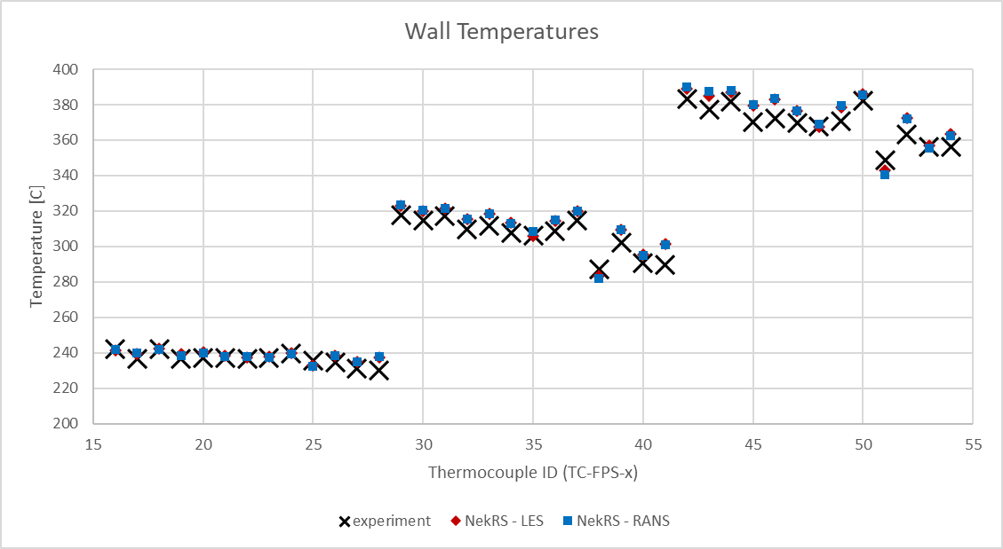
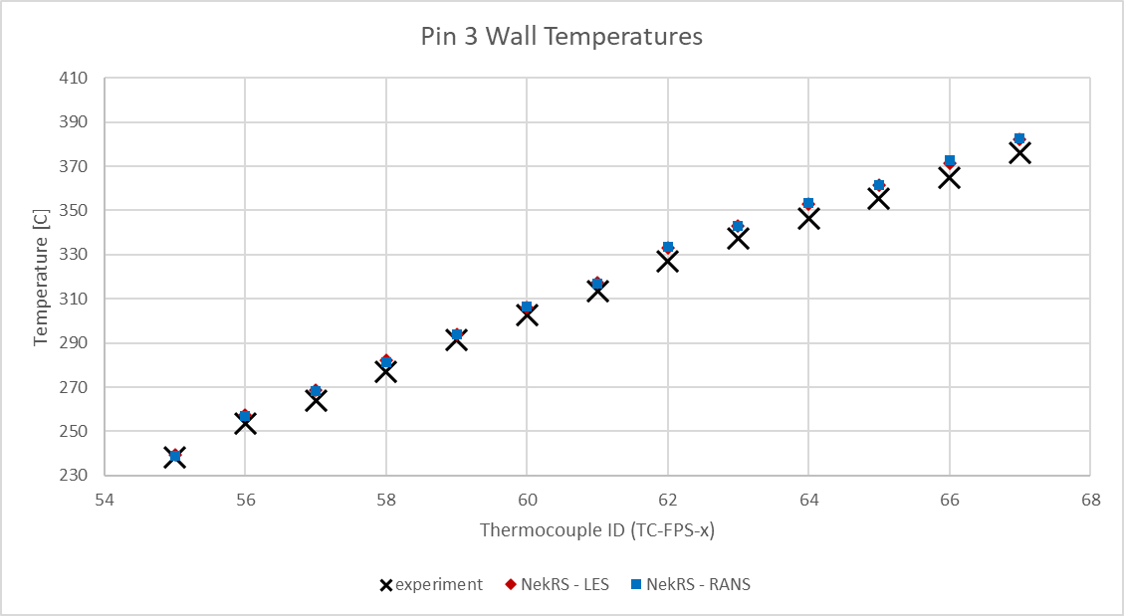 | 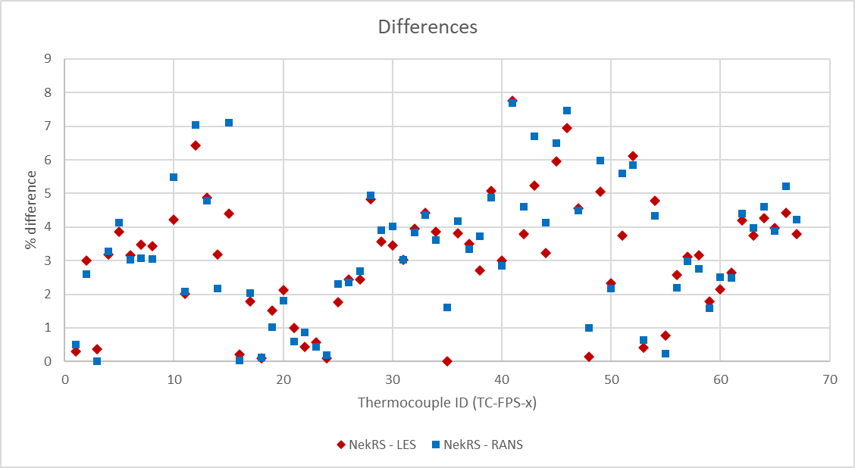
FIG. 100. Comparison of ADP10-SS2 results between LES, RANS, and experimental data.
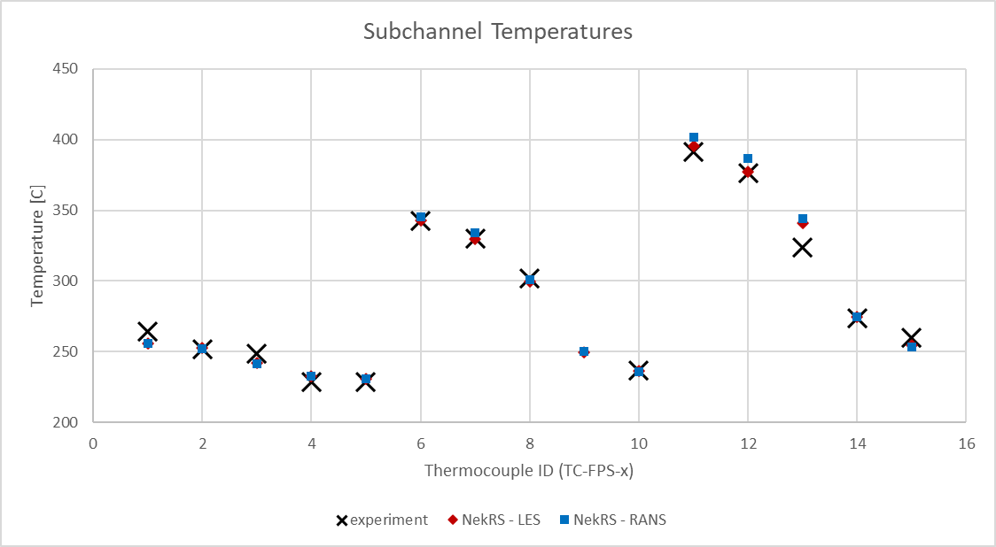 | 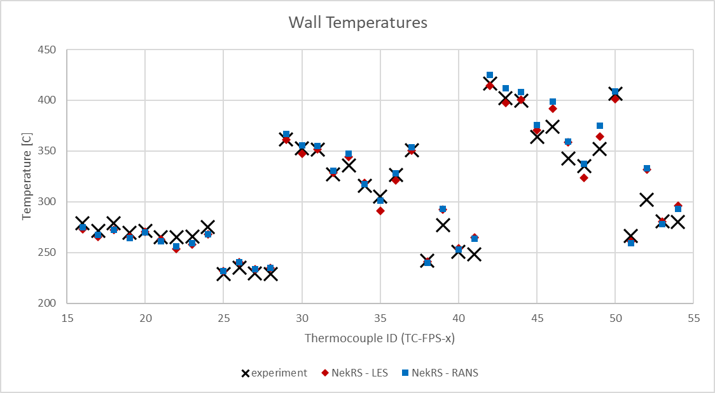
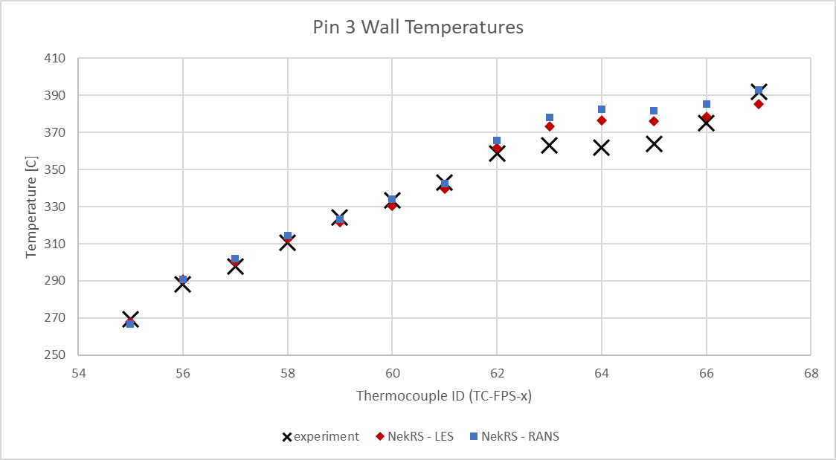 | 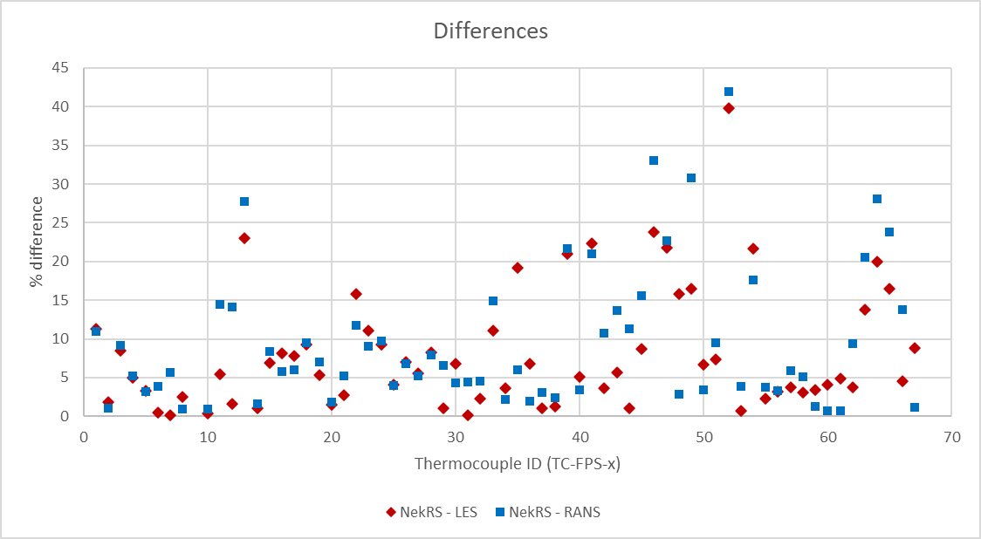
FIG. 101. Comparison of ADP06-SS1 results between LES, RANS, and experimental data.
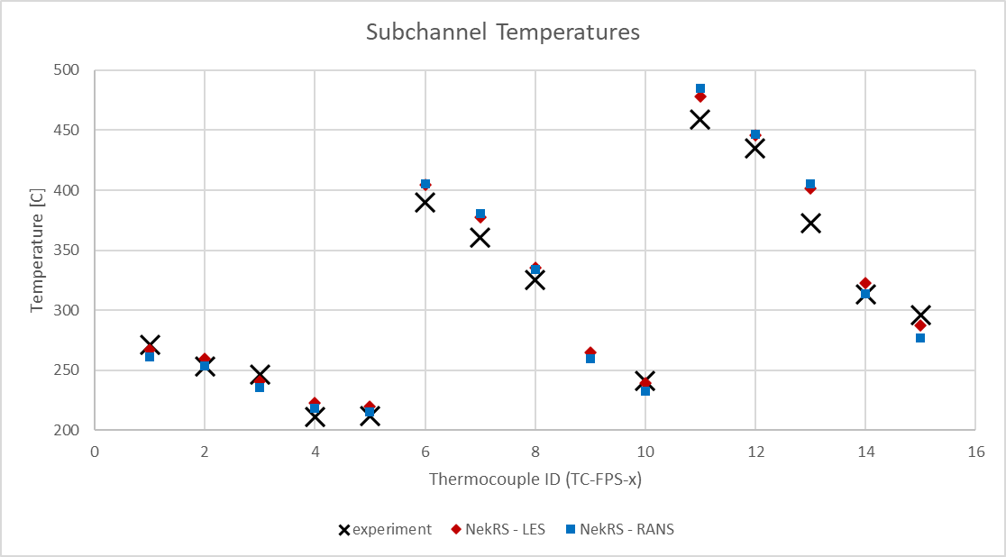 | 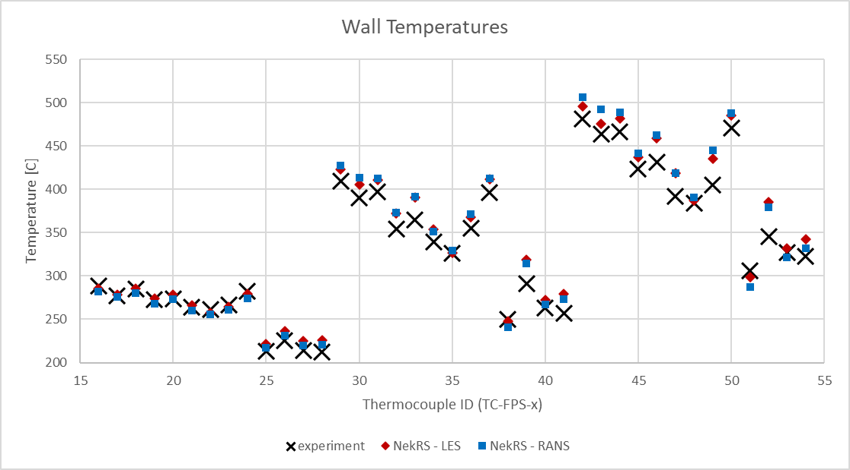
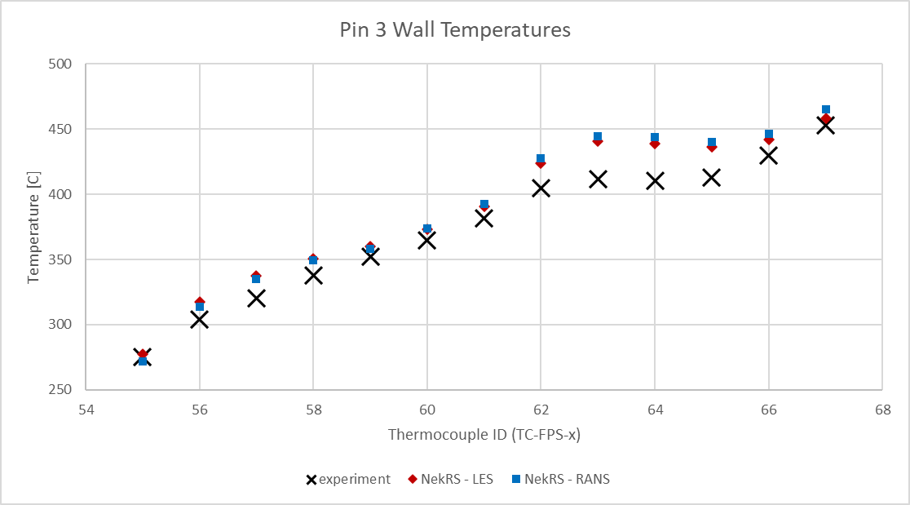 | 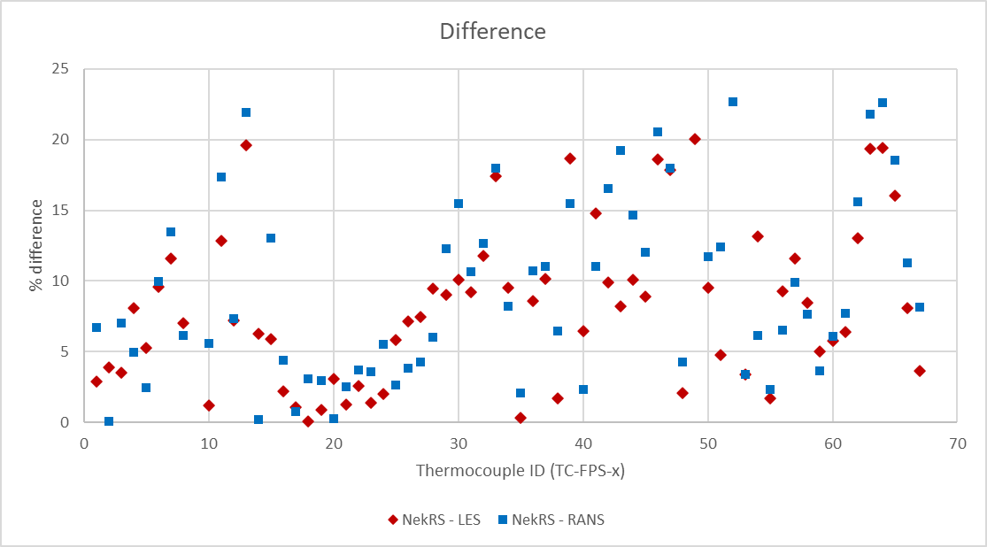
FIG. 102. Comparison of ADP06-SS2 results between LES, RANS, and experimental data.
Table 40. Experimental comparison for the open phase cases with the refined model.
Model | ADP10 |  | ADP06
Model | SS1 | SS2 | SS1 | SS2
LES | 3.2% | 3.1% | 8.1% | 8.5%
RANS | 3.3% | 3.3% | 9.5% | 9.5%

The new specification redistributed 7.8% of the total power along the length of the fuel pin upstream of the heater. Because the total power was unchanged, this redistribution had only a minor impact on the overall results. All the forced convection cases (SS1) showed marginal improvement, while the mixed convection cases (SS2) showed no improvement.
Both LES and RANS model show excellent agreement for the ADP10 cases, shown in FIG. 99 and FIG. 100. The worst percent difference is under 12% and mean values are ~3%. The ADP10 cases were uniformly heated across the entire bundle and represent the simplest heating configuration. This likely explains why the best agreement is seen for these cases.
For the ADP06 cases, shown in FIG. 101 and FIG. 102, the heating configuration is still symmetric with the outer ring of pins unheated. Overall, good agreement with the experimental data is still observed with both LES and RANS models showing a mean comparison to within 10% of the experimental data. The CFD models are both seen to over-predict the wall temperature immediately downstream of the wire. This is evident in the comparisons to thermocouples 63, 64, and 65. Because this is seen in both the LES and RANS models, this is likely due to something common to both models, such as the simplifications made to the geometry, or the use of a steady state solve for conduction in the solid domain. It’s possible that in the wake of the wire, there are significant fluctuations that are not resolved by this method.

Blind Phase Results for ADP07 Test
The final pair of cases were simulated in the blind phase of the benchmark. No additional adjustments were made to the CFD or CHT models compared to the models used for the ADP10 and ADP06 cases. The reference values used for the ADP07 cases are presented in Table 41, the plotted results are presented in FIG. 103 and FIG. 104, and the mean percent differences between CFD and experimental data are tabulated in Table 42.
Table 41. Reference values for the blind phase case.
Case |  | $$u_{0}$$ | $$ρ_{0}$$ | $$μ_{0}$$ | $$c_{p,0}$$ | $$λ_{0}$$ | $$β_{0}$$ | $${ΔT}_{0}$$ | $$Q_{0}$$
 |  | m/s | kg/m³ | kg/m-s | J/kg-K | W/m-K | (10⁻⁴) 1/K | K | kW
ADP07 | SS1 | 0.445 | 10352 | 0.00217 | 148 | 10.9 | 1.25 | 81.6 | 36.81
ADP07 | SS2 | 0.232 | 10329 | 0.00229 | 148 | 10.7 | 1.25 | 157 | 36.81

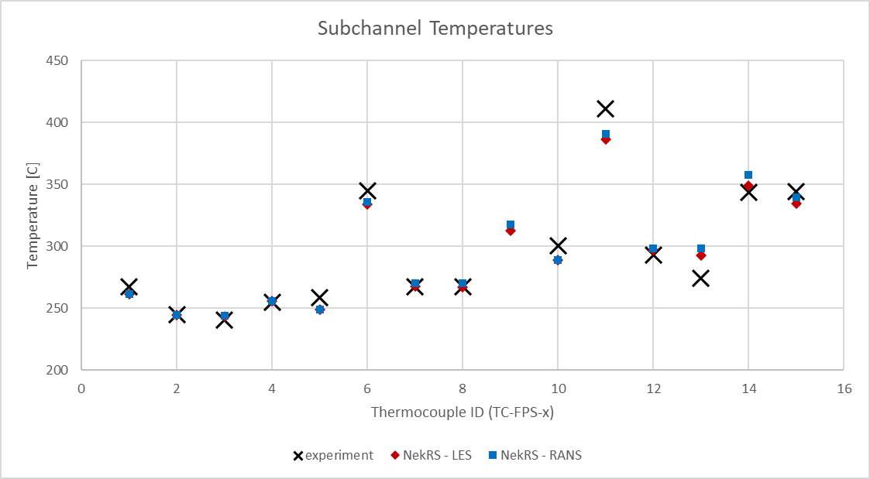 | 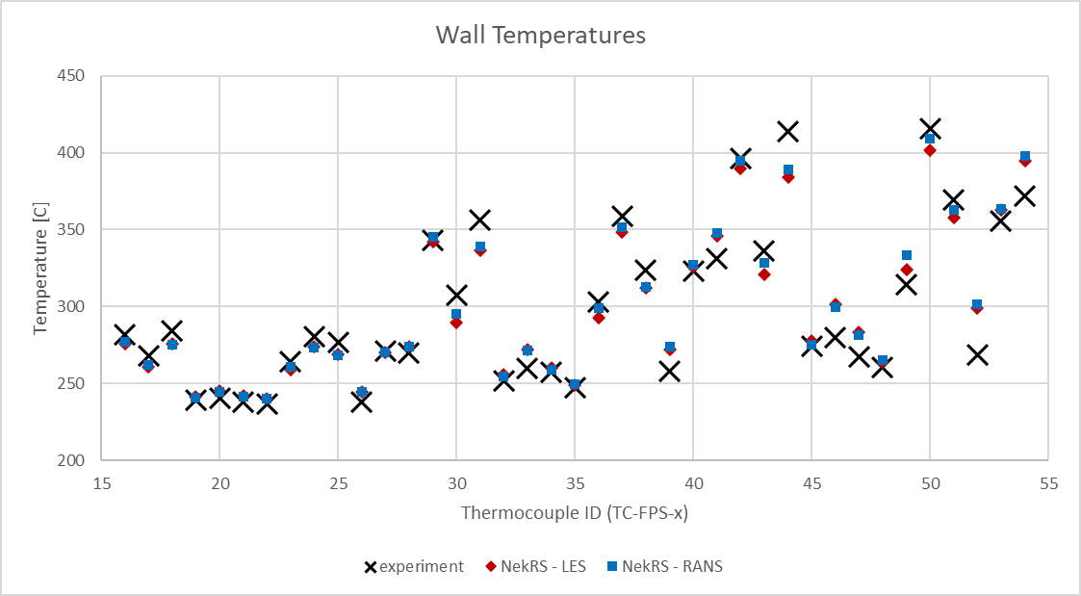
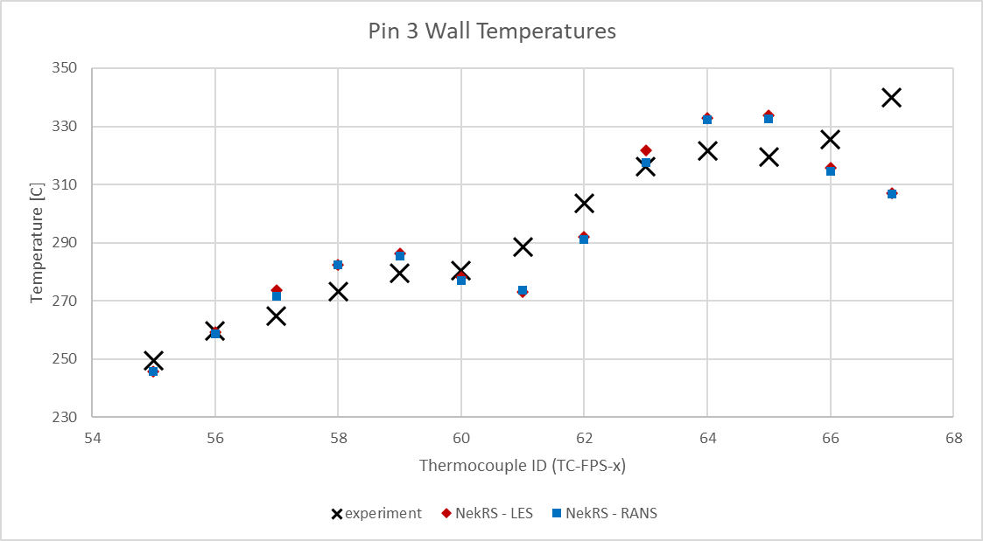 | 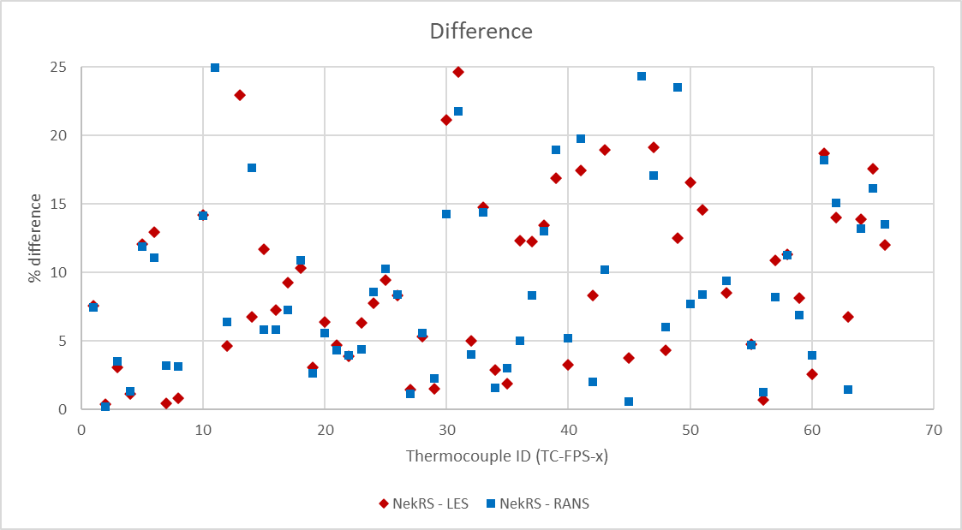
FIG. 103. Comparison of ADP07-SS1 results between LES, RANS, and experimental data.
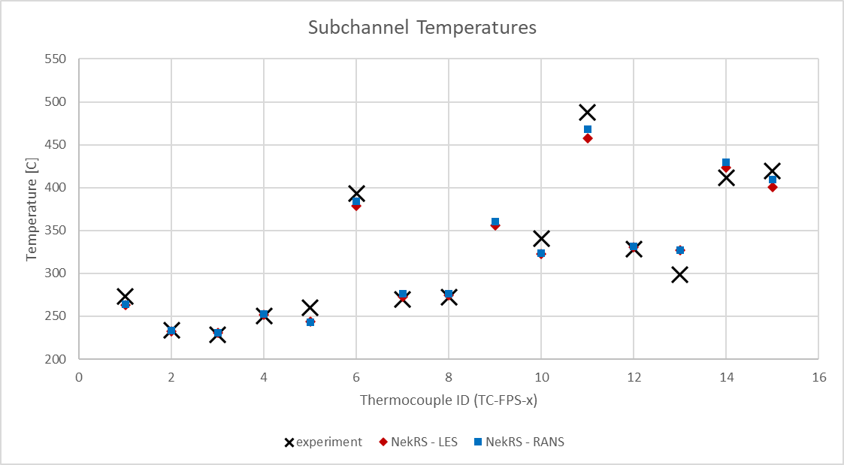 | 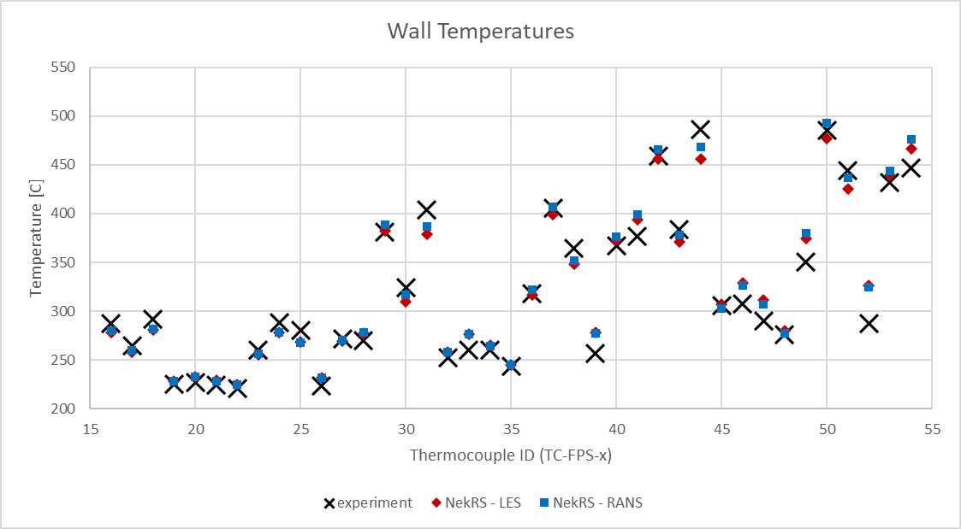
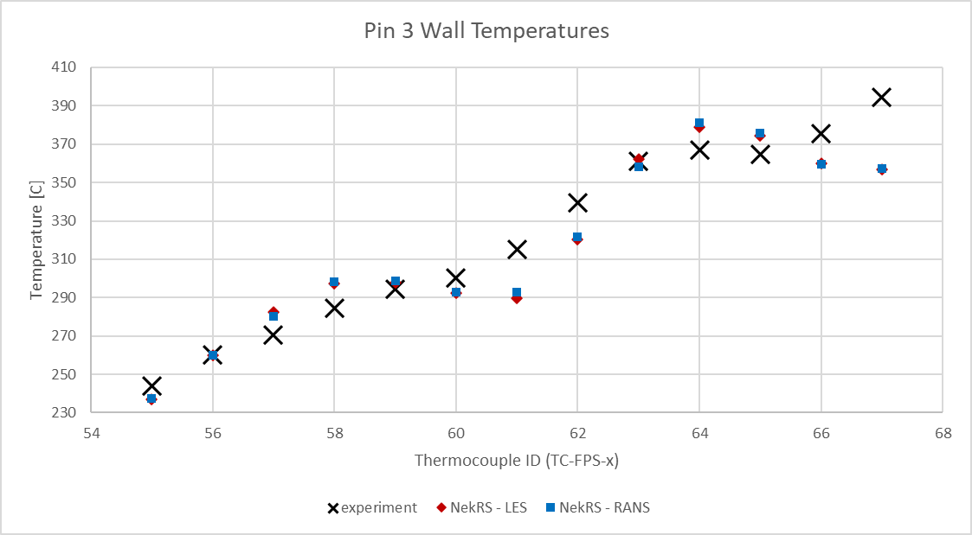 | 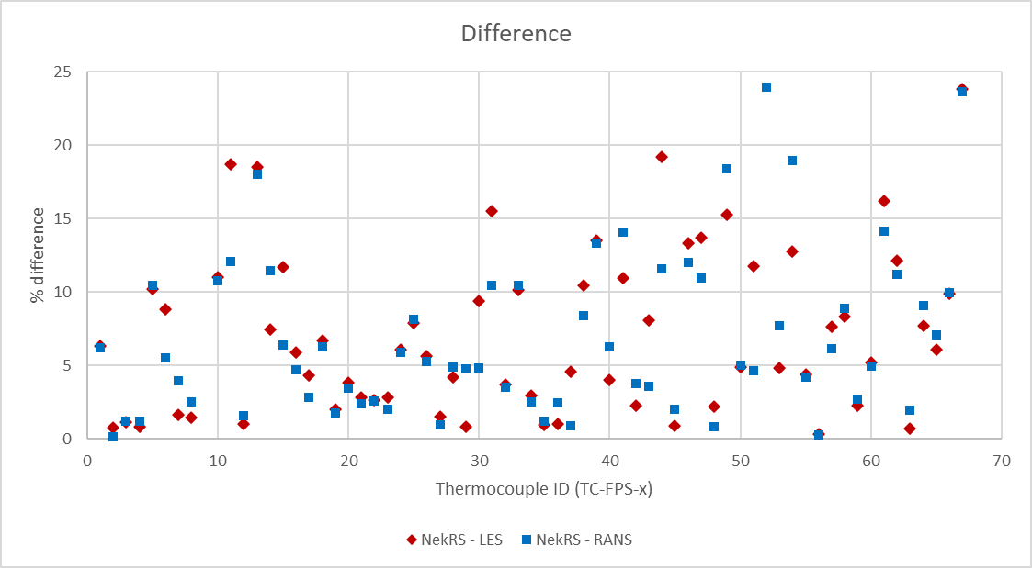
FIG. 104. Comparison of ADP07-SS2 results between LES, RANS, and experimental data.
Table 42. Experimental comparison for the blind phase case.
Model | SS1 | SS2
LES | 11.4% | 7.3%
RANS | 10.9% | 6.9%

Overall, good agreement is still observed with both LES and RANS models compared to the experimental data. Interestingly, the RANS model seems to provide slightly better agreement than the LES model. Although we note the differences between the RANS and LES results are still marginal. Additionally, the results for ADP07-SS2 compare better than those for ADP06-SS2. This was unexpected as the asymmetric heating configuration of ADP07 produces a more complex flow pattern in the assembly which should be more difficult to predict. However, it is noted that pin 3 is no longer heated and the CFD models predict a decrease in temperature in the wake of the wire which is not observed in the experimental data. As in ADP06, both the LES and RANS models give nearly identical predictions, so this is likely caused by something common to both models.

Refined Results
No additional model refinements were made. The LES turbulence model has only two adjustable parameters and the results of the open phase did not indicate that either would be appropriate to change. Adjustments to the RANS model were deemed unnecessary due to their agreement with the LES model for all cases, indicating that any disparity between simulations and experiment are not a result of the turbulence model. Future refinements may include using the newly implemented overlapping overset mesh method in NekRS to include transient conduction in the CHT model. This was not pursued for the present work as the capability was not available at the time when simulations were performed.

Conclusions
Argonne is participating in the International Atomic Energy Agency (IAEA) coordinated research project (CRP) on “Benchmark of Transition from Forced to Natural Circulation Experiment with Heavy Liquid Metal Loop (NACIE)”. NACIE is a lead-bismuth eutectic (LBE) experimental loop at the ENEA Brasimone Research Center (Italy) which included an electrically heated 19-pin simulated fuel assembly. Six CFD cases are included in the IAEA benchmark, two for each heating configuration where steady-state data was recorded at the initial state and after the loop has transitioned to natural circulation.
Participation in the NACIE CRP is beneficial for Argonne’s safety and T/H analysis codes validation for conditions associated with loss-of-flow accidents, partial assembly blockage, and natural circulation regimes with heavy-liquid metal coolants. Argonne participated with the NekRS and Cardinal codes in one NACIE CRP work package: WP2 for CFD analysis of the fuel pin simulator.
In this report, Argonne’s work on building the NACIE models in NekRS coupled to MOOSE via the Cardinal code to include conjugate heat transfer is presented. Both LES and RANS turbulence models were used. Refinements in the model and associated improvement in results demonstrate the importance of including CHT. Simulations of the open-phase tests ADP10 and ADP06 and the blind-phase test ADP07 are presented. No model improvements were considered for the refined phase of the ADP07 simulation. For all simulated cases, both the LES and RANS models agreed very well with each other, with only marginal differences observed. Overall, the agreement between NekRS and the experimental data is considered good.

ANNEX V. INDIVIDUAL RESULTS (CIAE)

ADP10

ADP06

ADP07

Sensitivity Analysis

Final conclusion and prospects

ANNEX VI. INDIVIDUAL RESULTS (CNPRI)
Body text placeholder.

ANNEX VII. INDIVIDUAL RESULTS (ENEA)

Model descriptions

Results

ANNEX VIII. INDIVIDUAL RESULTS (GIDROPRESS)

THOR

MATADOR

ANNEX IX. INDIVIDUAL RESULTS (IANS)

Analysis method

Methodology

Results and discussions

Conclusion

ANNEX X. INDIVIDUAL RESULTS (IBRAE)

WP1

WP3

ANNEX XI. INDIVIDUAL RESULTS (IGCAR)

WP2 results

WP4 results

ANNEX XII. INDIVIDUAL RESULTS (JRC)

WP1

WP2

WP3

ANNEX XIII. INDIVIDUAL RESULTS (KAERI)
Body text placeholder.

ANNEX XIV. INDIVIDUAL RESULTS (KIT)

WP2

Conclusions

ANNEX XV. INDIVIDUAL RESULTS (NIKIET)

WP1

WP2

WP3

ANNEX XVI. INDIVIDUAL RESULTS (NINE)
Body text placeholder.

ANNEX XVII. INDIVIDUAL RESULTS (NRG)

WP1

WP2

WP4

ANNEX XVIII. INDIVIDUAL RESULTS (PSI)
Body text placeholder.

ANNEX XIX. INDIVIDUAL RESULTS (PUB)

Model description

Results

Conclusions

ANNEX XX. INDIVIDUAL RESULTS (RATEN)
Body text placeholder.

ANNEX XXI. INDIVIDUAL RESULTS (SAPIENZA)

WP1

WP3

ANNEX XXII. INDIVIDUAL RESULTS (UNIPI)

WP1

WP2

WP4

WP5

ANNEX XXIII. INDIVIDUAL RESULTS (WEC)

Introduction

Model development

Results and discussion

Conclusions

ANNEX XXIV. INDIVIDUAL RESULTS (XJTU)

WP1

WP2

REFERENCES
[1] | P. Cioli Puviani, I. Di Piazza, Estimation of the accuracy of the thermal flow meter, ENEA report TH-N-R-712, 2023.
[2] | D. Rozzia, G. Fasano, I. Di Piazza, M. Tarantino, , “Experimental Investigation on Powder Conductivity for the Application to Double Wall Heat Exchanger (NACIE-UP)”, Journal of Nuclear Engineering and Design, vol.283, pp. 100-113, 2015.
[3] | N. Forgione, D. Martelli, G. Barone, F. Giannetti, P. Lorusso, T. Hollands, A. Papukchiev, M. Polidori, A. Cervone, I. Di Piazza, “Post-test simulations for the NACIE-UP benchmark by STH codes”, Nuclear Engineering and Design, Volume 353, November 2019, 110279.
[4] | N. Forgione, “Post Test Simulation for The NACIE-UP Benchmark By STH Codes”, 2018.
[5] | AA.VV. SESAME Deliverable D4.9, (2016). NACIE-UP Experimental Setup and Test Matrix for PLOFA Experiment.
[6] | S. Cornet, “Handbook on Lead-bismuth Eutectic Alloy and Lead Properties, Materials Compatibility , Thermal-hydraulics and Technologies,” OECD/NEA, Nucl. Sci., pp. 647–730 (2015).
[7] | C.S. Kim, “Thermophysical properties of stainless steels”, ANL-75-55, 1975.
[8] | J. Pacio, S. Keijers, Reference physical properties in the KALLA rod bundle tests, SCK-CEN/40672921, 2021.
[9] | Thermocoax, private communication.
[10] | I. Di Piazza, H. Hassan, P. Lorusso, D. Martelli, “Benchmark Specifications For NACIE-UP Facility: Non-Uniform Power Distribution Tests”, ENEA Report NA-I-R-542, rev.5 (2024).
[11] | X. Cheng and N. Tak, “Investigation on turbulent heat transfer to lead-bismuth eutectic flows in circular tubes for nuclear applications,” Nuclear Engineering and Design, vol. 236, no. 4, pp. 385-393 (2006).
[12] | R. Da Via, S. Manservisi and F. Menghini, “A k−ω−kθ−ωθ four parameter model logarithmic turbulence model for liquid metals,” International Journal of Heat and Mass Transfer, vol. 101, pp. 1030-1041, 2016.
[13] | K. Sergeenko, “Adaption of the turbulence model to the heat transfer in a rod bundle,” Nuclear Engineering and Design, vol. 415, p. 112664, 2023.
[14] | S. Chen, Y. Chen and N. Todreas, “The upgraded Cheng and Todreas correlation for pressure drop in hexagonal wire-wrapped rod bundles,” Nuclear Engineering and Design, vol. 335, pp. 356-373, 2018.
[15] | J. Pacio, S. Chen, Y. Chen and N. Todreas, “Analysis of pressure losses and flow distribution in wire-wrapped hexagonal rod bundles for licensing. Part I: The Pacio-Chen-Todreas Detailed model (PCTD),” Nuclear Engineering and Design, vol. 388, p. 111607, 2022.
[16] | K. Mikityuk, “Heat transfer to liquid metal: Review of data and correlations for tube bundles,” Nuclear Engineering and Design, vol. 239, pp. 680-687, 2009.
[17] | P. Ushakov, A. Zhukov and N. Matyukhin, “Heat transfer to liquid metals in regular arrays of fuel elements,” High Temperature, vol. 15, pp. 1027-1033, 1977.
[18] | M. Kazimi and M. Carelli, “Clinch River Breeder Reactor Plant heat transfer correlation for analysis of CRBRP assemblies, CRBRP-ARD-0034,” Westinghouse, 1976.
[19] | S.K. Cheng and N.E. Todreas, “Hydrodynamic modes and correlations for bare and wire-wrapped hexagonal rod bundles – bundle friction factors, subchannel friction factors and mixing parameters”, Nuclear Engineering and Design, 92, pp. 227-251 (1986).
[20] | Zhang Rong, et al. “Subchannel thermal–hydraulic analysis of a wire-wrapped 19-pin rod bundle in the NACIE-UP facility,” Annals of Nuclear Energy 196 (2024).
[21] | Liang Yu, et al. “A subchannel analysis code SACOS-Na for sodium-cooled fast reactor,” Progress in Nuclear Energy, 166 (2023).
[22] | M. Kazami and M. Carelli, “Heat transfer correlation for analysis of CRBRP Assemblies”, Westinghouse Report CRBRP-ARD-0034, (1976).
[23] | C. L. Wheeler, et al., “COBRA-IV-I: an interim version of COBRA for thermal-hydraulic analysis of rod bundle nuclear fuel elements and cores”, Tech. Rep. BNWL-1962 (1976).
[24] | P.A. Ushakov, A.V. Zhukov and N.M. Matyukhin, “Heat transfer to liquid metals in regular arrays of fuel elements”, Teplofiz. Vys. Temp., 15, no. 5, pp. 1027-1033 (1977).
[25] | F. Lodi and G. Grasso, “Extension of the sub-channel code ANTEO+ to the mixed convection regime”, Nuclear Engineering and Design, 322, pp. 368-378 (2017).
[26] | Z. Ma, et al., “An innovative method for prediction of liquid metal heat transfer rate for rod bundles based on annuli”, Annals of Nuclear Energy, 47, pp. 91-97 (2012).
[27] | The RELAP5-3D© Code Development Team, 2015. RELAP5-3D Code Manual Vol. I: Code Structure, System Models, and Solution Methods. INL/MIS-15-36723 Volume I, Revision 4.3, Idaho Falls, Idaho, USA.
[28] | M.P. Ferragut, et al., “The Development of RELAP5/SCDAPSIM/MOD4.0 for Advanced Fluid Systems Design and Analysis” 23rd International Conference on Nuclear Engineering (ICONE 23), Makuhari Messe, Chiba, Japan, May 17th - 21st (2015).
[29] | A.S. Zalesov and A.N. Churkin, “MATADOR Code for Calculating Local Inhomogeneous Heat and Mass Transfer Processes in Rod Bundles”, Problems of Atomic Science and Engineering. Series: Physics of Nuclear Reactors, 3, pp. 29-40 (2023). (In Russian)
[30] | S. Pramuditya and M. Takahashi, “Thermal–hydraulic analysis of wire-wrapped SFR test subassemblies by subchannel analysis method”, Annals of Nuclear Energy, 54, pp. 109–119 (2013).
[31] | A.V. Zhukov, et al., “Methodical Instructions and Recommendations for Thermal-Hydraulic Calculation of Active Zones of Fast Reactors”, RTM (Technical Guide) 1604.008-88, Obninsk: Fiz.-Energ. Inst., (1988).
[32] | S.Yu. Afonin, et al., “Validation of the Subchannel Puchok-LM Code Applied to the MBIR Fast Neutron Reactor”, Nuclear Physics and Engineering, vol. 5, 7-8, pp. 564-577 (2014).
[33] | S.Yu. Afonin et al., “Combined Methodology of Thermal-hydraulic Calculation of Fuel Assemblies of Reactors with Liquid Metal Coolant and its Justification”, Problems of Atomic Science and Engineering. Series: Ensuring the Safety of NPP, 36, pp. 78-85 (2016).
[34] | D. J. O'Grady et al., The SAS4A/SASSYS-1 Version 5.7 Safety Analysis Code System, Argonne National Laboratory, Lemont, IL, ANL/NSE-SAS/5.7, June 2023.
[35] | V. Kyriakopulos, et al., “Development of a single-phase, transient, subchannel code, within the moose multi-physics computational framework,” Energies, 15(11):3948 (2022).
[36] | G. Calamai, R. Coffield, L. Jossens, et al. Steady State Thermal and Hydraulic Characteristics of the FFTF Fuel Assemblies. Technical Report ARD-FRT-1582, Westinghouse Electric Corporation, 1974.
[37] | N.E. Todreas and M.S. Kazimi, Nuclear Systems II: Elements of Thermal Hydraulic Design, Chapter 6, Taylor and Francis, USA (2003).
[38] | M Angelucci, Coupling between System and CFD codes for the analysis of thermal-hydraulic phenomena relevant for LMFR (2018).
[39] | T. Del Moro, P. Cioli Puviani, B. Gonfiotti, I. Di Piazza, D. Martelli, C. Ciurluini, F. Giannetti, R. Zanino, M. Tarantino, Analysis of the experimental tests performed at NACIE-UP facility through a novel CFX-RELAP5 codes coupling. Nucl. Eng. Des. 429, 113676. https://doi.org/10.1016/j.nucengdes.2024.113676 (2024)
[40] | D. Martelli, N. Forgione, I. Di Piazza, P. Agostini, M. Tarantino, P. Gaggini, G. Polazzi, NACIE-UP: a heavy liquid metal loop for mixed convection experiments with instrumented pin bundle (2013).
[41] | F.S.L. Pangukir, M.M.M.D. Hussain, A. Mathur, M.M. Stempniewicz, F. Roelofs, Multi-scale numerical simulation of NACIE-UP forced-to-natural circulation transition experiment for non-uniform heating. Nucl. Eng. Des. 443, 114301. https://doi.org/10.1016/j.nucengdes.2025.114301 (2025).
[42] | A. Pucciarelli, F. Galleni, M. Moscardini, D. Martelli, N. Forgione, STH/CFD coupled calculations of postulated transients from mixed to natural circulation conditions in the NACIE-UP facility. Nucl. Eng. Des. 370, 110913. https://doi.org/10.1016/j.nucengdes.2020.110913 (2020)
[43] | P. Stefanini, A. Pucciarelli, O. Halim, N. Forgione, I. Di Piazza, Validation of a coupled STH and low-fidelity CFD approach using experimental data from NACIE-UP test facility. Nucl. Eng. Des. 444, 114353. https://doi.org/10.1016/j.nucengdes.2025.114353 (2025).
[44] | M.L. Williams, Development of depletion perturbation theory for coupled neutron/nuclide fields. Nuclear Science and Engineering, 70(1), 20-36 (1979).
[45] | C.V. Parks, E.T. Tomlinson, and E.M. Oblow, The application of generalized perturbation theory to fast reactor safety sensitivity studies. Technical Report 7908/6-29 (1979).
[46] | H. Glaeser, GRS Method for Uncertainty and Sensitivity Evaluation of Code Results and Applications, Science and Technology of Nuclear Installations, 1–7. https://doi.org/10.1155/2008/798901 (2008).
[47] | W.L. Oberkampf and C.J Roy, Verification and Validation in Scientific Computing. Cambridge University Press (2010).
[48] | Standard for Verification and Validation in Computational Fluid Dynamics and Heat Transfer. An American National Standard. ASME V&V 20 – 2009 (2009).
[49] | N.I. Ryzhov, K.S. Dolganov, Yu.A. Zvonarev, et al., Evaluation of Uncertainties Associated with Best Estimates of Parameters in the Deterministic Analysis of a Severe Accident, Nuclear Engineering and Design 415, 112741. https://doi.org/10.1016/j.nucengdes.2023.112741 (2023).
[50] | E.V. Moiseenko, N.A. Mosunova, V.F. Strizhov, and D.S. Synitcyn, Uniform Approach to Validation of Codes in Application for Conservative and Realistic Accidents Modeling, Progress in Nuclear Energy 193, 106195. https://doi.org/10.1016/j.pnucene.2025.106195 (2026).
[51] | Best Estimate Safety Analysis for Nuclear Power Plants: Uncertainty Evaluation. Safety Reports Series 52. International Atomic Energy Agency, 2008.
[52] | ISO/IEC. Uncertainty of Measurement. ISO/IEC Guide 98-3:2008. Pt 3, Guide to the Expression of Uncertainty in Measurement (GUM:1995). International Organization for Standardization (2008).
[53] | J.P. Hessling, Deterministic Sampling for Propagating Model Covariance. SIAMASA J. Uncertain. Quantif. 1, 297–318. https://doi.org/10.1137/120899133 (2013).
[54] | R.C. Smith, Uncertainty Quantification: Theory, Implementation, and Applications, Comput. Sci. Eng. https://epubs.siam.org/doi/book/10.1137/1.9781611973228 (2014).
[55] | O.M.M. Abedelhalim, Use of Computational Fluid Dynamics Analysis to Support Safety Assessment of Innovative Nuclear Reactors (PhD Thesis). Università di Pisa (2025).
[56] | F. Lodi, G. Grasso - ANTEO+ V.1.00 User Manual, RT/2018/17/ENEA
[57] | F. Lodi, G. Grasso - ANTEO+ V.1.00 Theory Manual, RT/2018/16/ENEA
[58] | ANSYS Inc., “Ansys CFX-Solver Theory Guide.” [Online]. Available: https://ansyshelp.ansys.com/public/account/secured?returnurl=/Views/Secured/corp/v251/en/cfx_thry/cfx_thry.html
[59] | C.L. Wheeler, C.W. Stewart, R.J. Cena, et al., “COBRA-IV-I: an interim version of COBRA for thermal-hydraulic analysis of rod bundle nuclear fuel elements and cores,” https://doi.org/10.2172/7359476 (1976)
[60] | K. Rehme, Pressure drop correlations for fuel element spacers. Nuclear Technology (1973)
[61] | T.E. Donovan, T.L. George, and C.L. Wheeler, “COBRA-IV wire wrap data comparisons. [LMFBR]”, https://doi.org/10.2172/6043692 (1979)
[62] | General User Manual, Flownex Simulation Environment (2018)
[63] | ANSYS Fluent User’s Guide, Release 18.2
[64] | V.M. Alipchenkov, А.М. Anfimov, D.А. Afremov, V.S. Gorbunov, Yu.А. Zeigarnik, А.V. Kudryavtsev, S.L. Osipov, N.A. Mosunova, V.F. Strizhov, E.V. Usov, Fundamentals, Current State of the Development of, and Prospects for Further Improvement of the New-Generation Thermal-Hydraulic Computational HYDRA-IBRAE/LM Code for Simulation of Fast Reactor Systems, Thermal Engineering. 2, 130-139 https://doi.org/10.1134/S0040601516020014 (2016)
[65] | V.M. Alipchenkov, Ya.V. Grudtsyn, O.H. Ilyasova, N.A. Mosunova, Simulation of the processes occurring during steam generator tube rupture in the lead cooled reactor unit using HYDRA-IBRAE/LM code, Progress in Nuclear Energy, V. 149, 104278, https://doi.org/10.1016/j.pnucene.2022.104278 (2022)
[66] | O.H. Ilyasova, V.M. Alipchenkov, N.A. Mosunova, Ya.V. Grudtsyn, Simulation of natural circulation experiments for heavy liquid metal coolant using HYDRA-IBRAE/LM code. Progress in Nuclear Energy, V. 173, 105233 https://doi.org/10.1016/j.pnucene.2024.105233 (2024)
[67] | LOGOS code description. https://logos-support.ru/about
[68] | P. Fischer, S. Kerkemeier, M. Min, et al., “NekRS, a GPU-Accelerated Spectral Element Navier-Stokes Solver”, Parallel Computing. 114, pp 102982, https://doi.org/10.1016/j.parco.2022.102982 (2022)
[69] | M. Min, Y.-H. Lan, P. Fischer, et al., “Nek5000/RS Performance on Advanced GPU Architectures”, ANL-22/81, Argonne National Laboratory, https://doi.org/10.2172/1894022 (2022)
[70] | D. Shaver, J. Fang, H. Yuan, et al., “Full-Core Computational Fluid Dynamics Simulations Using NekRS”, Proc. of the 20th Int’l Topical Meeting on Nucl. Reactor Thermal Hydraulics (NURETH-20). Washington DC (2023)
[71] | A. Novak, D. Andrs, P. Shriwise, et al., “Coupled Monte Carlo and Thermal-Fluid Modeling of High Temperature Gas Reactors Using Cardinal”, Annals of Nucl. Energy. 177, pp 109310, https://doi.org/10.1016/j.anucene.2022.109310 (2022)
[72] | R. Hu, et al., “SAM: A Modern System Code for Advanced Non-LWR Safety Analysis,” Nuclear Technology, 211(9), 1883–1902 (2024).
[73] | V. Kyriakopoulos, M. Tano, and J. Ragusa, “Development of a single-phase, transient, subchannel code, within the moose multi-physics computational framework,” Energies, 15(11):3948 (2022).
[74] | A. Moisseytsev, “Simulation of NACIE Benchmark Tests with the SAS4A/SASSYS-1 Code,” 21st International Topical Meeting on Nuclear Reactor Thermal Hydraulics (NURETH-21), Busan, Korea, August 31-September 5 (2025).
[75] | N. E. Todreas and M. S. Kazimi, “Nuclear Systems. Volume 1: Thermal Hydraulic Fundamentals,” CRC Press, Taylor & Francis Group, second edition (2012).
[76] | J. Sellars, M. Tribus, and J. Klein, “Heat Transfer to Laminar Flow in a Round Tube on Flat Conduit. The Graetz Problem Extended,” Trans. Am. Soc. Mech. Engrs., 78:441 (1956)
[77] | S. W. Churchill and H. H. S. Chu, “Correlating Equations for Laminar and Turbulent Free Convection From a Vertical Plate,” International Journal of Heat and Mass Transfer, 18:1323–1329 (1975)
[78] | “Revised Release on the IAPWS Industrial Formulation 1997 for the Thermodynamic Properties of Water and Steam August 2007,” International Association for the Properties of Water and Steam (2007)
[79] | T. W. Watson and H. E. Robinson, “Thermal Conductivity of a Sample of Type 316 Stainless Steel,” National Bureau of Standards (1963)
[80] | S. Stolz, P. Schlatter, and L. Kleiser, “High-pass filtered eddy-viscosity models for large-eddy simulations of transitional and turbulent flow”, Physics of Fluids. 17, pp 065103 (2005) doi.org/10.1063/1.1923048
[81] | A. Tomboulides, N. Saini, D. Shaver, et al., “A Robuse Spectral Element Implementation of the k-τ RANS Model in Nek5000/NekRS”, Int’l J. of Heat and Fluid Flow. 112, pp 109679 (2025) doi.org/10.1016/j.ijheatfluidflow.2024.109679
[82] | D. Shaver, N. Saini, A. Tomboulides, et al., “Stakeholder-Driven Improvements to Nek5000 and NekRS”, ANL/NSE-23/35, Argonne National Laboratory (2023) doi.org/10.2172/2564968
[83] | C. Geuzaine and J.-F. Remacle., “Gmsh: a three-dimensional finite element mesh generator with built-in pre- and post-processing facilities”, Int’l J. for Numerical Methods in Engineering. 79(11), pp 1309-1331, (2009)
[84] | “Inconel Alloy 600”, Online. Retrieved July 23, 2024. Available: https://www.specialmetals.com/documents/technical-bulletins/inconel/inconel-alloy-600.pdf
[85]
[86]
[87]
[88]
[89]
[90]

LIST OF ABBREVIATIONS
Body text placeholder.

CONTRIBUTORS TO DRAFTING AND REVIEW
Body text placeholder.

