IAEA-TECDOC-XXXX

TITLE is HERE
subtitle

INTERNATIONAL ATOMIC ENERGY AGENCY
VIENNA, 2023

Foreword
Body text. Normal style

Style ‘HEADING1 ‘ is used fort first level heading

Style ‘normal’ is used for the main body text. ‘Style ‘normal’ is used for the main body text. Style ‘normal’ is used for the main body text. ‘Style ‘normal’ is used for the main body text. Style ‘normal’ is used for the main body text. ‘Style ‘normal’ is used for the main body text. ‘Style ‘normal’ is used for the main body text. ‘Style ‘normal’ is used for the main body text. ‘Style ‘normal’ is used for the main body text. ‘Style ‘normal’ is used for the main body text. ‘Style ‘normal’ is used for the main body text. ‘Style ‘normal’ is used for the main body text. ‘Style ‘normal’ is used for the main body text. ‘Style ‘normal’ is used for the main body text. ‘Style ‘normal’ is used for the main body text. ‘Style ‘normal’ is used for the main body text. ‘Style ‘normal’ is used for the main body text. ‘Style ‘normal’ is used for the main body text.
Next para in ‘normal’ style

Available style are show below
- H1
- H2
- H3
- Normal

Don’t use other syles, don’ invent your own, don’t copy-paste styles with formatted text from your old documents. Use cop text-only option to

Style ‘H2’
Body text in ‘normal’ style. Refer to tables like Table 1

Table 1. Use ‘table’ Style for Table Titles
 | Organization Name | Country
1 | National Atomic Energy Commission (CNEA) | Argentina
2 | China Institute for Atomic Energy (CIAE) | China
3 | Commissariat à l'énergie Atomique et aux Énergies Alternatives (CEA) | France
4 | Helmholtz-Zentrum Dresden-Rossendorf (HZDR) | Germany
5 | Karlsruhe Institute of Technology (KIT) | Germany
6 | Indira Gandhi Centre for Atomic Research (IGCAR) | India
7 | Japan Atomic Energy Agency (JAEA) | Japan
8 | Korea Atomic Energy Research Institute (KAERI) | Republic of Korea
9 | Nuclear Research and Consultancy Group (NRG) | Netherlands
10 | Institute for Physics and Power Engineering (IPPE) | Russian Federation
11 | Argonne National Laboratory (ANL) | United States of America

Body text in normal style. Body text in normal style. Body text in normal style. Body text in normal style. Body text in normal style. Body text in normal style. Body text in normal style. Body text in normal style. Body text in normal style. Body text in normal style. Body text in normal style. Body text in normal style. Body text in normal style. Body text in normal style. Body text in normal style. Body text in normal style. Body text in normal style. Body text in normal style. Body text in normal style. Body text in normal style. Body text in normal style. Body text in normal style. Body text in normal style. Body text in normal style. k
- Style ‘List Paragraph’ is used fo0r the lists.
- Next line in the list

header 2

Heading 1 Style
Body text

Heading 2 Style
Body text

Heading 3
For your convenience, you may use these examples below to format your contributions. Below is an example figure, demonstrated in FIG. 1.

FIG. 1. Short, one-line figure caption; use ‘FIG’ style

FIG. 2. Long two+ lines figure caption, very long and some other text, tec, blah (use style’FIG-LONG’)

An example table is included below in TABLE 1.
TABLE 1. table example; use ‘TABLE’ Style
Reactor power | 1234
Fuel | 1234
Coolant | 1234
Max. fuel burnup | 1234
No. of fuel subassemblies (FSA) | 1234

An example equation is demonstrated below in Eq. (1)

Reynolds number
 | $$Re=\frac{uD_{h}}{ν}=\frac{ρuD_{h}}{μ}$$ | (1)

Where,
Please use in Word cross-referencing to refer to figures, tables, equations, or references when able (INTERNATIONAL ATOMIC ENERGY AGENCY, 2018). You may use any built-in style IEEE, APA, Chicago, etc, and this will be automatically reformatted by the IAEA.

[1]
XINGKAI, H., “Technical Specifications for Neutronics Benchmark of CEFR Start-up Tests”, presented at the 2nd RCM of the IAEA CRP I31032 on Neutronics Benchmark of CEFR Start-up Tests, Beijing, China, 2019.

[1]
Sodium Coolant Handbook: Thermal Hydraulic Correlations, Non-serial Publications, INTERNATIONAL ATOMIC ENERGY AGENCY, Vienna (2024).

In [1] we do and now to napro [2]

[1] HUO, X., VIRGILI, N., KRIVENTSEV, V., “Technical Specifications for Neutronics Benchmark of CEFR Start-up Tests”, presented at the 2nd RCM of the IAEA CRP I31032 on Neutronics Benchmark of CEFR Start-up Tests, Bejing, China, 2019.
[2] INTERNATIONAL ATOMIC ENERGY AGENCY, Sodium Coolant Handbook: Thermal-Hydraulic Correlations, IAEA, Vienna (2024).

REFERENCES
[1]

Contributors to Drafting and Review
Kriventsev V. | International Atomic Energy Agency (IAEA)

.

Structure
The NAPRO CRP WP1 was divided into three work packages and corresponding tasks as detailed in Table 2.
Participation in WP1 was very collaborative with all participants providing data, references, analysis, and reviews. Overall coordination of NAPRO WP1 was led by Argonne National Laboratory (ANL; USA) along with WP1.1. WP1.2 was coordinated by Karlsruhe Institute of Technology (KIT; Germany). WP1.3 was coordinated by Indira Gandhi Centre for Atomic Research (IGCAR; India) and Institute for Physics and Power Engineering (IPPE, Russian Federation). The approach and findings documented in this handbook were written by all participants and coordinated by each work package leader.
Given the considerable amount of data and information collected during the NAPRO CRP, it was also decided to split the handbook into two volumes:
- Sodium Coolant Handbook: Physical and Chemical Properties; and
- Sodium Coolant Handbook: Thermal-Hydraulic Correlations.

Scope
This handbook on sodium coolant thermal-hydraulic correlations summarizes the results of the work performed by WP1.2 of the NAPRO CRP. The WP1.2 under the leadership of the Karlsruhe Institute of Technology (KIT) was focused on the collection of heat transfer and pressure drop (friction factor) correlations for sodium cooled systems. A big effort has been made to review the open literature and to collect all information publicly available about such thermal-hydraulic correlations including handbooks and journal papers from the fifties to recent books and proceeding contributions. By doing this extensive revision few inconsistencies were found as well as typos in publications referring to previous works. For each inconsistency found a footnote or a clarification text is included in the corresponding correlation section.
A brief revision of heat transfer and pressure drop equations, as well as the non-dimensional numbers commonly used is presented in Chapter 2.
Chapter 3 consists of six sections, describing the heat transfer correlations for various flow conditions and geometries found in sodium cooled systems.
Chapter 0 consists of three sections, describing friction factor/pressure drop correlations for both single-phase and two-phase flow conditions for sodium cooled systems.
As the list of correlations collected is very large, it is out of scope of this handbook to perform any assessments of correlations for the different conditions and geometries of sodium systems. Chapter 5, nevertheless, provides recommendations for choosing one or another correlation for an analyst working on a specific case, as well as echoes publications assessing correlations against experimental data. It also includes the identified phenomena which should be further investigated experimentally found in the course of this work.
Chapter 6 presents the conclusions of this document and finally, Chapter 7 provides the list of references [1]-[389] used for all correlations collected in this handbook.

Users
The handbook represents a useful tool for the governmental, public and private sector organizations responsible for the development and/or deployment of innovative fast neutron systems, including designers, manufacturers, vendors, research institutions, academia and other organizations directly involved in technology development programmes on fast neutron systems and, more generally, on advanced nuclear energy systems.
The handbook also represents an important tool for the education and training of young engineers and scientists in the field of liquid metal coolants technology.

CONVECTIVE HEAT TRANSFER, PRESSURE LOSS AND NON DIMENSIONAL NUMBERS
The correlations presented in this report in most cases use non-dimensional numbers characterizing the fluid conditions, as well as other fluid variables and geometrical parameters of the cooling system. It is therefore necessary to introduce the definitions and the nomenclature used in the current work.
Following the definition of the non-dimensional numbers, the basic equations for calculating heat transfer between the wall and the fluid, as well as the pressure drop due to friction with the wall surface are presented as well.
The values of the Reynolds and Peclet numbers at which the transition between laminar and turbulent regime occurs, namely the critical values, are used in some heat transfer correlations. Therefore, the two final sections present the estimated $Re$ and $Pe$ critical values as found in the open literature.

Non dimensional numbers
The definition of the non-dimensional numbers used in the various heat transfer and pressure drop correlations are presented hereafter.

Reynolds number
 | $$Re=\frac{uD_{h}}{ν}=\frac{ρuD_{h}}{μ}$$ | (1)
where $ρ$ is the density, $u$ is the velocity, $D_{h}$ is the equivalent hydraulic diameter, and $μ$ and $ν$ are the dynamic and kinematic viscosity, respectively. In general, the hydraulic diameter is estimated as proportional to the ratio of the total flow area to the wetted perimeter of the conduit:
$D_{h}=\frac{4 Flow Area}{Wetted Perimeter}$
In case of the circular pipe $D_{h}$ is equal to the internal pipe of the pipe.
Turbulent flow is characterized by high Reynolds number ($Re≥2300$ for pipe flow). In liquid metal fast reactor (LMFR) cores, typical Reynolds numbers are of the order of 50000, that is fully turbulent flow regime.

Prandtl number
 | $$Pr=\frac{ν }{a}=\frac{c_{p}μ }{λ}$$ | (2)
where $c_{p}$ is the heat capacity, $μ$ the dynamic viscosity, and $λ$ and $a$ the thermal conductivity and diffusivity, respectively.
For liquid metals the Prandtl number is very small (generally, in the range of $0.01- 0.001$) meaning that conductive heat transfer dominates over the momentum transfer. The low Prandtl number is due to the high thermal conductivity of metals. The Prandtl number for sodium at a typical mid-core temperature of $500°C$ is $0.0042$ [3]. The molecular Prandtl numbers of NaK, mercury and lead bismuth eutectic (LBE) are similar – between $0.01 and 0.03$ [4]. Figure 1 and Fig. 2 show the Prandtl number for the saturated liquid sodium and superheated sodium vapour at atmospheric pressure as a function of temperature respectively as recommended in a companion NAPRO CRP publication “Sodium Coolant Handbook: Physical and Chemical Properties” [5].
Liquid Sodium
FIG. 1. Prandtl number for the saturated liquid sodium as a function of temperature
and uncertainties [5].

Sodium Vapour
FIG. 2. Prandtl number for superheated sodium vapour at atmospheric pressure as a function of temperature [5].

For turbulent heat transfer modelling, a turbulent Prandtl number is defined as ratio of the momentum to heat transfer turbulent eddy diffusivity:
 | $${Pr}_{t}=\frac{ε_{M}}{ε_{H}}=\frac{n_{t} }{a_{t}}$$ | (3)
where $ε_{H}$ is the eddy diffusivity for the heat transfer, $ε_{M}$ is the eddy diffusivity for the momentum, $n_{t}$ is the turbulent eddy viscosity and $a_{t}$ is the turbulent thermal diffusivity.

Peclet number
 | $$Pe=RePr =\frac{uD_{h}}{a}=\frac{ρc_{p}uD_{h}}{λ}$$ | (4)
The turbulent Peclet number used in some correlations is defined as:
 | $${Pe}_{t}=Pr\frac{ε_{M}}{ν}$$ | (5)
where $ε_{M}$ is the eddy diffusivity for the momentum and $n$ is the eddy viscosity.

Nusselt number
 | $$Nu=\frac{h l}{λ}$$ | (6)
where $h$ is the heat transfer coefficient, $l$ is the characteristic length and $λ$ the thermal conductivity.
Nusselt number plays an important role in the heat transfer calculations under forced convection conditions, therefore it is used in correlations assessing operation of the reactors cooled by liquid metals.

Grashof number
 | $$Gr=\frac{bgl^{3}DT}{ν^{2}}$$ | (7)
where $β$ is the volumetric thermal expansion coefficient, $g$ is the gravitational acceleration, $l$ is the characteristic length, $T$ is the temperature difference between the wall surface and bulk fluid, and $ν$ is the kinematic viscosity.
Similarly to the Nusselt number, Grashof number plays an important role in the heat transfer calculations under natural convection conditions, therefore it is used in correlations assessing the intrinsic behaviour of the decay heat removal systems of the liquid metal cooled reactors.

Rayleigh number
 | $$Ra=Gr Pr$$ | (8)
Following the analogy to forced convection, Rayleigh number is equivalent to the Peclet number but for natural convection conditions.

Boussinesq number
 | $$Bo=Gr {Pr}^{2}$$ | (9)
Boussinesq number reflects the type of correlation found experimentally for natural circulation in liquid metal flow where the heat transfer is found to be dependent on Grashof number and Prandtl number to the power 2, contrary to ordinary fluids where the Nusselt number for natural convection is a function of the Rayleigh number $Ra=GrPr$.

Dean number
The friction factor correlation for helical coil and curved tubes is found to depend on the Dean number that is defined as
 | $De=Re\sqrt{d/D}$ | (10)
where $D$ is the diameter of the coil and $d$ is the diameter of the pipe.

Table 3. NON-DIMENSIONAL NUMBERS
Symbol | Non-dimensional number | Definition
Re | Reynolds number | $$Re=\frac{uD_{h}}{ν}=\frac{ρuD_{h}}{μ}$$
Pr | Prandtl number | $$Pr=\frac{ν }{a}=\frac{c_{p}μ }{λ}$$
Pr_{t} | Turbulent Prandtl number | $${Pr}_{t}=\frac{ε_{M}}{ε_{H}}=\frac{n_{t} }{a_{t}}$$
Pe | Peclet number | $$Pe=RePr =\frac{uD_{h}}{a}=\frac{ρc_{p}uD_{h}}{λ}$$
Pe_{t} | Turbulent Peclet number | $${Pe}_{t}=Pr\frac{ε_{M}}{ν}$$
Nu | Nusselt number | $$Nu=\frac{h l}{λ}$$
Gr | Grashof number | $$Gr=\frac{bgl^{3}DT}{ν^{2}}$$
Ra | Rayleigh number | $$Ra=Gr Pr$$
Bo | Boussinesq number | $$Bo=Gr {Pr}^{2}$$
De | Dean number | $$De=Re\sqrt{d/D}$$

Table 4. Parameters used in Non-Dimensional Numbers
Symbol | Parameter | Definition/Units
$$ρ$$ | density | $$kg/m^{3}$$
u | velocity | $$m/s$$
$$D_{h}$$ | hydraulic diameter | $$\frac{4 Flow Area}{Wetted Perimeter}, m$$
$$μ$$ | dynamic viscosity | $$Pa×s = \frac{N×s}{m^{2}} = \frac{kg}{m×s}$$
$$ν$$ | kinematic viscosity | $$μ/ρ, {m^{2}}/s$$
$$ν_{t}$$ | turbulent viscosity | $${m^{2}}/s$$
$$λ$$ | thermal conductivity | $$\frac{W}{m K}$$
$$α$$ | thermal diffusivity | $${m^{2}}/s$$
$$α_{t}$$ | turbulent thermal diffusivity | $${m^{2}}/s$$
$$T_{w}$$ | temperature at heated wall | $$K$$
$$T_{f}$$ | bulk fluid temperature | $$K$$
q | heat flux | $$\frac{W}{m^{2}}$$
h | heat transfer coefficient | $$\left|\frac{q}{T_{w}-T_{f}}\right|, \frac{W}{m^{2}K}$$
$$b$$ | fluid expansion coefficient | $$1/K$$
$$g$$ | gravity constant | $$m/{s^{2}}$$
$$l$$ | representative length | $$m$$
$$ε_{H}$$ | Eddy diffusivity of heat transfer | $${m^{2}}/s$$
$$ε_{M}$$ | Eddy diffusivity for the momentum | $${m^{2}}/s$$
$$f$$ | Darcy friction factor | $$-$$
P | Rod bundle pitch | $$m$$
D | Pipe diameter | $$m$$

Convective heat transfer coefficient
Heat transfer between a solid surface and a fluid requires a temperature difference between the wall and the coolant [6]. The rate of heat transfer $Q$ per unit area $A$ is given by:
 | $$q=\frac{Q}{A}=h\left(T_{w}-T_{c}\right)$$ | (11)
where $h$ is the heat transfer coefficient, $T_{w}$ is the wall temperature and $T_{c}$ is the bulk coolant temperature. The convective heat transfer properties of fluids are related to their Prandtl number $Pr$ (Eq. (2))$.$
In order to calculate the temperature drop $\left(T_{w}-T_{c}\right)$ or to determine the heat flux per unit area $q$, to be expected with a given value of $\left(T_{w}-T_{c}\right)$, it is required to determine the heat transfer coefficient $h$. Thus, there are analytical equations and non-dimensional heat transfer coefficient (Nusselt number) based on experimental results that yield $h$ as a function of flow conditions in most common cooling system geometries [6].

Pressure loss and friction factor
As for the flow characteristics, liquid metals and non-metals fluids behave similarly, therefore conventional formulas and techniques of calculation can be used for liquid metal piping systems. The frictional pressure drop across a straight length of conduit can then be calculated as:
 | $$∆p=f\frac{L}{D}\frac{ρu^{2}}{2}$$ | (12)
where $f$ is the Darcy-Weisbach friction factor, which is a function of the Reynolds number and geometrical parameters, normally non-dimensional ones (e.g. relative roughness $\frac{ε}{D}$, pitch-to-diameter ratio $\frac{P}{D}$); $L$ is the length of conduit; $D$ is the inside pipe diameter or hydraulic diameter of the duct; $ρ$ is the fluid density and $u$ is the bulk fluid velocity $u=Q/A$ , where $Q$ is the total volumetric flow rate, and $A$ is the duct area.
In this document, the Darcy-Weisbach or Moody friction factor $f$ is used. It should not be confused with the Fanning friction factor which is one-fourth of the above mentioned friction factors ($f_{Darcy}=f_{Moody}=4f_{Fanning}$).

Critical Reynolds number
The critical Reynolds number is the estimated value for the transition from laminar to turbulent flow. It depends on the flow geometry (e.g. straight or curved pipes, rod bundles, etc.). For flow in a pipe, experimental observations show that for the fully developed flow, the critical Reynolds number is about 2300. According to Cheng and Todreas [7] transition from laminar to turbulent flow occurs over a wide range of Reynolds numbers in rod bundles (Fig. 3) The authors presented simple correlations for the onset and completion of transition flow over wire-wrapped rod bundles in triangular arrays as:
 | ${Re}_{crit}=300∙{10}^{1.7\left(\frac{P}{D}-1\right)}$for onset of transition | (13)
 | ${Re}_{crit}=1000∙{10}^{0.7\left(\frac{P}{D}-1\right)}$for completion of transition | (14)
where $P$ is the pitch between adjacent rod centerlines and $D$ is the outer diameter of the rod. As for other geometries, the available correlations might include the critical $Re$ values separating laminar and turbulent regimes.
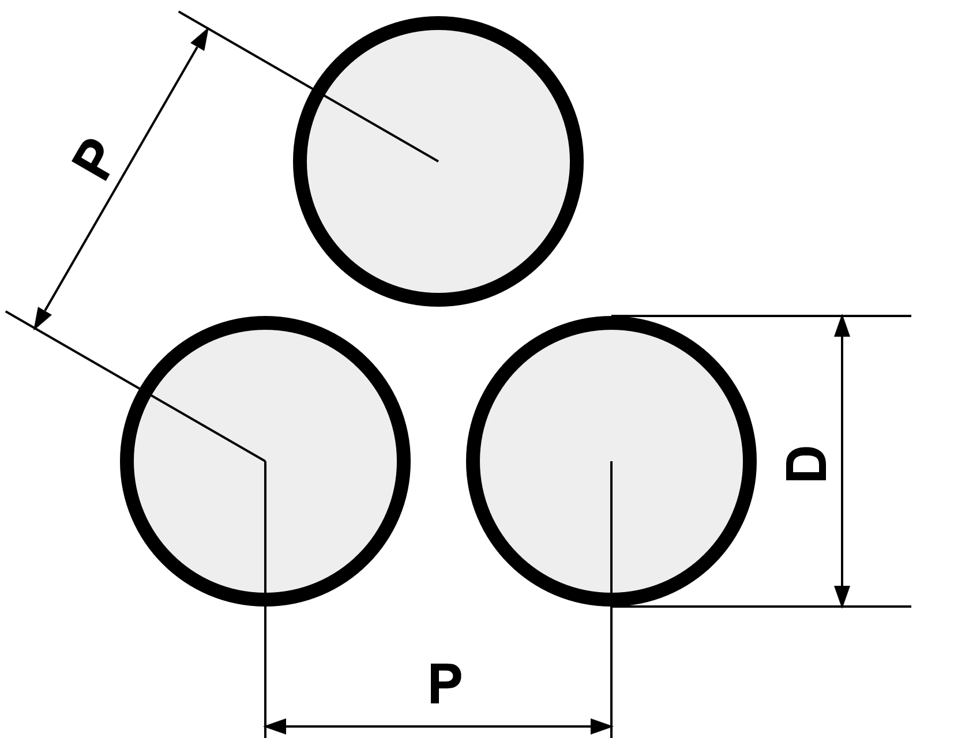 | 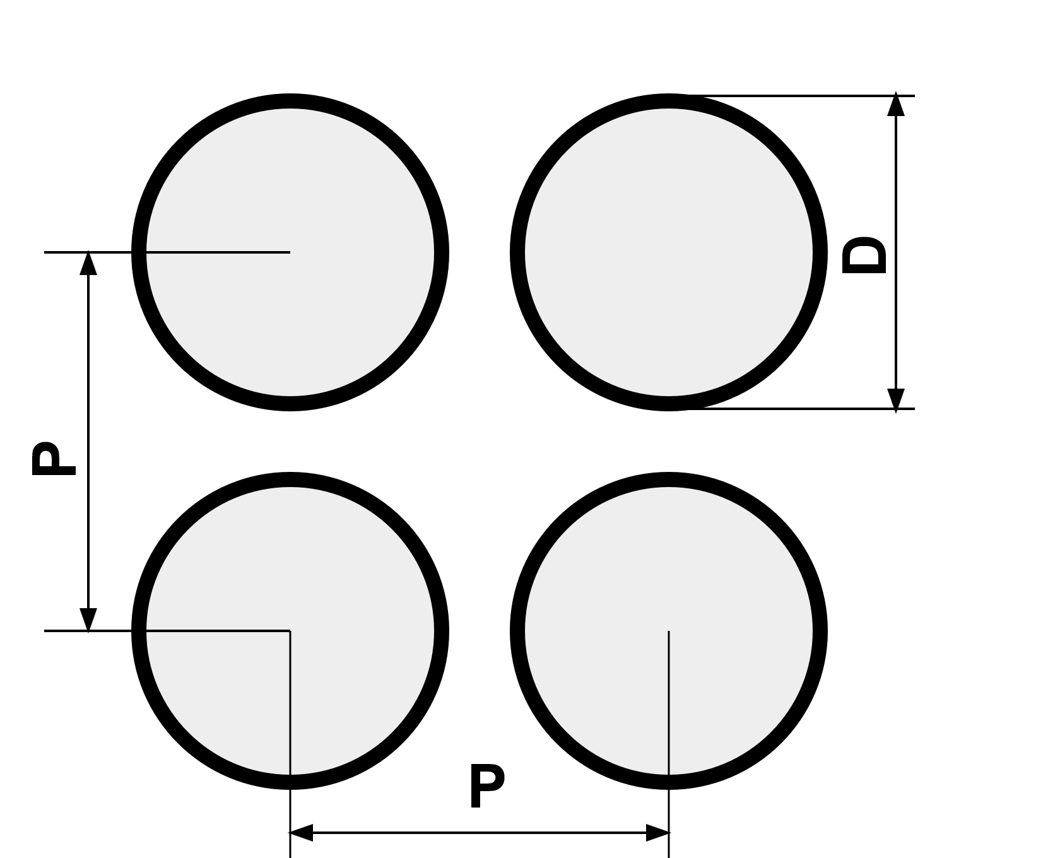
Hydraulic diameter:$D_{h}=\frac{4 Flow Area}{Wetted Perimeter}=\left\{\begin{matrix}D\left[\frac{4}{π}{\left(\frac{P}{D}\right)}^{2}-1\right] & for square array \\ D\left[\frac{2\sqrt{3}}{π}{\left(\frac{P}{D}\right)}^{2}-1\right] & for triangular array\end{matrix}\right.$
FIG. 3. Triangular and square rod array allocations

Critical Peclet number
Estimated critical Peclet numbers for different geometries and Prandtl numbers can be found in Table 5 [8].
Table 5. Critical Peclet numbers
$$Pr$$ | $${Pe}_{crit}$$
 | Tubes | Annuli | Rod bundle  $$\frac{P}{D}=1.375$$ | Rod bundle  $$\frac{P}{D}=1.700$$ | Rod bundle  $$\frac{P}{D}=2.200$$
0.005 | 117 | 270 | 460 | 622 | 770
0.01 | 131 | 300 | 530 | 720 | 890
0.02 | 144 | 330 | 582 | 800 | 1000
0.03 | 150 | 345 | 603 | 840 | 1056

HEAT TRANSFER CORRELATIONS
The first nuclear reactor producing electricity was the sodium-potassium cooled fast reactor EBR-I in 1951. Experimenters and physicists have worked together since 1930s on specific correlations for heat transfer in liquid metal. Liquid sodium has particular properties, which make it a good coolant candidate for fast reactors.
Sodium thermal behaviour is quite different from water thermal behaviour, hence the need for specific correlations to describe sodium heat transfer in thermal-hydraulic codes. Sodium allows more efficient heat removal thanks to its high heat capacity, thermal conductivity and higher boiling temperature. While the Prandtl number is quite high for water $\left(Pr≥1\right)$, it is very low for liquid metals $\left(Pr<<1\right)$ which means that thermal diffusivity dominates momentum diffusivity.
At boiling inception, large changes in heat removal properties can be expected. Sodium boiling is quite different from high-pressure water boiling. First of all, the saturation temperature is far higher than for water. Then, sodium vapour density is very small: its high liquid to vapour density ratio leads to a very specific two-phase flow behaviour.
The heat transfer coefficient between the outer surface of the pipe or plate and the bulk of the fluid can be calculated by using empirical correlations which correlate Nusselt number with both the Reynolds and the Prandtl numbers.
The collection of correlations is focused on turbulent flow regime (not laminar, except for the natural circulation) and fully developed flow (not thermal and/or velocity developing regions). This is due to the fact that sodium in SFR systems flows in turbulent regime $\left(Re \sim 50000\right)$.
As liquid metals behave as ordinary fluids in laminar heat transfer, the reader is referred to other publications (e.g. Handbook of Single-Phase Convective Heat Transfer [9]) for additional laminar flow correlations.
To obtain high accuracy, different geometries have been studied (circular tubes, flat plates, concentric annuli, horizontal or vertical rod bundles, etc.) under different conditions (natural convection, forced convection, with or without impurities, boiling, etc.) that could be encountered also in sodium cooled fast reactors.
The effects of magnetic fields in sodium flow, or bends and fittings are not considered in this document. The reader is then referred to other publications, e.g. [9] Ch. 9 “Convective Heat Transfer with Electric and Magnetic Fields” and Ch. 10 “Convective heat transfer in bends and fittings”.
Chapter 3 consists of six sections, describing turbulent Prandtl number correlations and heat transfer correlations for: forced convection, natural convection and two-phase sodium flow. Then one section presents the modelling of heat transfer in fuel rods and the last section is devoted to the heat transfer correlations used in the system codes for the safety analysis of sodium cooled reactor systems.

Turbulent Prandtl number
The ratio of the eddy diffusivity of heat transfer ($ε_{H}$) to that for momentum ($ε_{M}$) affects heat transfer in liquid metals [4] [10] [11] [12]. The turbulent Prandtl number is defined as:
 | $${Pr}_{t}=\frac{ε_{M}}{ε_{H}}=\frac{1}{y}=\frac{turbulent eddy viscosity n_{t} }{ turbulent thermal diffusivity a_{t}}=\frac{n_{t} }{\frac{l_{t}}{rc_{p}}}$$ | (15)
$y$ symbol utilized in some former publications refers to the diffusivity ratio although nowadays ${Pr}_{t}$ is more frequent.
The Turbulent Prandtl number can be estimated using empirical correlations, solutions from analytical equations, or combinations of both. The simplest way is purely empirical correlations, where ${Pr}_{t}$ is mainly fitted to various experimental data [13]. The analytic solutions give important information on the near-wall behaviour of the heat flux; however, they are not suited for numerical simulation tools.
A selection of empirical correlations are presented hereafter, but for other methods and assessment of correlations, more information can be found in ( [13] Ch. 10) [14] [15] [16].
It should be noted that a particular turbulent Prandtl number expression was often derived together with a particular turbulent heat transfer correlation or set of correlations. Developing a heat transfer correlation based upon data was carried out using them together. For consistency it is then recommended to use the turbulent Prandtl number and the heat transfer correlation from the same source.

Dwyer (1963)
In 1963, O.E. Dwyer derived theoretically an expression for the turbulent Prandtl number [10]:
 | $$\frac{1}{{Pr}_{t}}=y=1-\frac{\left(\frac{a}{Pr}\right)-c}{{\left(\frac{ε_{M}}{n}\right)}^{m}}$$ | (16)
where a, c, and m are constants, which were tentatively set at 0.2, 2 and 0.9, respectively, for liquid metal flow in pipes, annuli, parallel plates and staggered rod bundles [17]. These constants were evaluated from the experimental data available at that time and Dwyer proposed the following semi-empirical equation:
 | $$\frac{1}{{Pr}_{t}}=y=1-\frac{1.82}{Pr {\left(\frac{ε_{M}}{n}\right)}_{max}^{1.4}}$$ | (17)
where ${\left(\frac{ε_{M}}{n}\right)}_{max}$ is the maximum value of $\frac{ε_{M}}{n}$ in the channel cross-section. It is a unique function of the Reynolds number $Re$ and the channel geometry. Since $y$ cannot fall below zero, when the previous equation yields negative value, it should be taken as zero.
Figure 4 presents the values of ${\left(\frac{ε_{M}}{n}\right)}_{max}$ for fully developed turbulent flow in circular tubes, annuli and rod bundles with equilateral triangular spacing as a function of the Reynolds number.
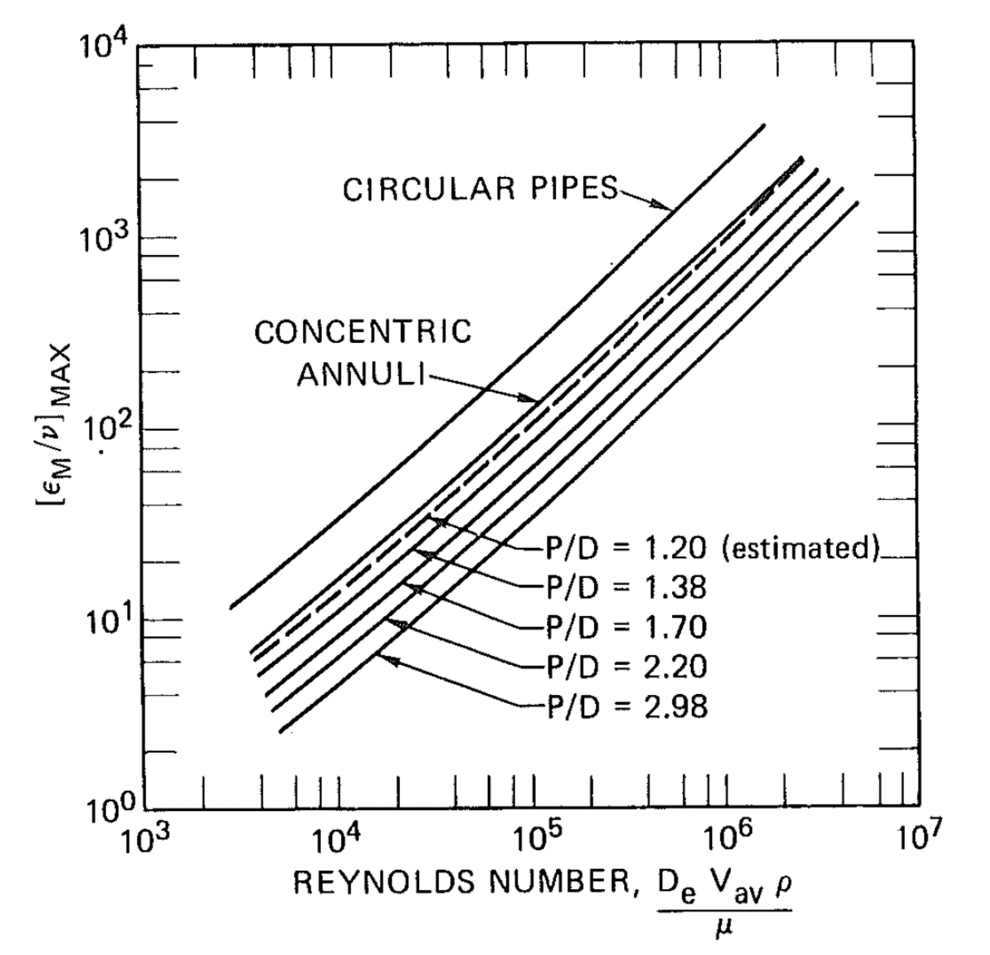
FIG. 4. Values of ${\left({ε_{M}}/ν\right)}_{max}$as a function of Reynolds number (data from [11])
${\left({ε_{M}}/ν\right)}_{max}$ can be also calculated for circular pipes from the relation ( [9] Ch. 4):
 | $${\left(\frac{ε_{M}}{ν}\right)}_{max}=0.037 Re \sqrt{\frac{f}{4}}$$ | (18)
where $f$ is the Darcy friction factor (see Section 4.1.1 for friction factor correlations for straight circular pipes).

Aoki (1963)
In 1963 S. Aoki tried to modify Deissler's equation assuming that the heat transmission from the eddy travelling along two layers could be approximated by convective heat transfer from a spherical eddy. He represented the average ratio of eddy diffusivities by the following expression specific for liquid metal flows [10] [13] [18]:
 | $$\frac{1}{{Pr}_{t}}=0.014 {Re}^{0.45}{Pr}^{0.2}\left(1- e^{-\frac{1}{0.014{Re}^{0.45}{Pr}^{0.2}}}\right)$$ | (19)

Kokorev (1963)
In 1963 L.S. Kokorev proposed the following turbulent Prandtl number correlation [19]:
 | $${Pr}_{t}=\frac{1+0.8c_{1}\left(1-f\right)}{1+c_{2}\frac{n}{ε_{M}}}$$ | (20)
where $f$ is the friction factor, $n$ is the kinematic viscosity, $c_{1} = 1$, $с_{2} = 0.5$, and $ε_{M}$ is proposed to be evaluated using Reichardt correlation [20] (Eq. (27)).

Subbotin et al. (1963)
In 1963 V.I Subbotin et al. proposed the following relation of non-similarity factors for turbulent transfer of heat and momentum [21]:
 | $$ε=\frac{{\left(ε_{H}\right)}_{max}}{{\left(ε_{M}\right)}_{max}}$$ | (21)
Although a full similarity between turbulent transfer of heat and momentum on all cross-sections of a flow is not presented, a comparison of the maximum values of ${ε_{H}}/q$ and ${ε_{M}}/n$ obtained by the following formulas shows that the relationship between factors of turbulent transfer of heat and momentum depends on $Re$ number:
 | $${\left(\frac{ε_{H}}{q}\right)}_{max}=7.5∙{10}^{-5}Re$$ | (22)
According to Prandtl:
 | $${\left(\frac{ε_{M}}{n}\right)}_{max}=1∙{10}^{-2}{Re}^{0.875}$$ | (23)
According to Reichardt [20]:
 | $${\left(\frac{ε_{M}}{n}\right)}_{max}=0.75∙{10}^{-2}{Re}^{0.875}$$ | (24)
For heat transfer in liquid metals $\left(Pr<< 1\right)$ a non-dimensional area parameter $x$ is defined as $x=0.5-0.9$. Therefore, weighted mean value of $\overline{ε}$ depends on $Re$ number calculated for the given area:
 | $$\overline{ε}=\frac{\int_{0.5}^{0.9}{εx dx}}{\int_{0.5}^{0.9}{x dx}}$$ | (25)
As $\overline{ε}$ also depends on the law of the velocity distribution, using Prandtl formula yields:
 | $\overline{ε}=0.205{Re}^{\frac{1}{8}}$, | (26)
that is similar to Reichardt formula
 | $$\overline{ε}=0.254{Re}^{\frac{1}{8}}$$ | (27)
The comparison is shown in Fig. 5.
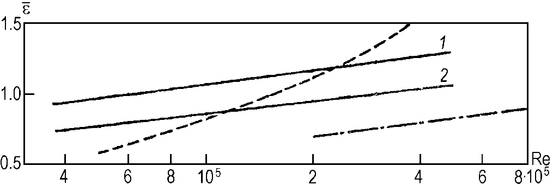
FIG. 5. An average value of $\overline{ε}$ at. radius ($x=0.5-0.9$) versus Rеynolds number:
solid line: data from [21] (1 and 2 for a velocity distribution by Reichardt and Prandtl formulas accordingly)
dashed line: data from [22]
dash-dotted line: data from [23]
Though there are the discrepancies in the experimental data, a general trend is that $ε$ value depends linearly on the $Re$ number. For the high values of the $Re$ number, the $ε$ value becomes higher than one. It indicates that the turbulent heat transfer exceeds the turbulent momentum transfer.

Kunz-Yerazunis (1969)
In 1969 H.R. Kunz and S. Yerazunis derived a relation for the turbulent Prandtl number [10] [24]:
 | $$\frac{1}{{Pr}_{t}}=1.5 e^{-\frac{0.90}{ {\left[\frac{ε_{M}}{α}\right]}^{0.64}}}$$ | (28)
Where $α=\frac{l}{C_{p}ρ}$ is the thermal diffusivity.

Notter-Kunz-Yerazunis (1969)
R. Notter (1969) and H.R. Kunz and S. Yerazunis (1969) adopted the following equation for liquid metal flows in circular ducts, accepting deviations of $±0.5\%$ from the experiments considered [13] [24] [25]:
 | $${Pr}_{t}=\frac{2}{3}e^{\left[0.9 {\left(\frac{n_{t} }{n}\right)}^{0.64}\right]}$$ | (29)
where $n$ is the kinematic viscosity and $n_{t}$ is the turbulent kinematic viscosity.

Bobkov et al. (1970)
In 1970 V.P. Bobkov et al. obtained the following formula for the turbulent Prandtl number on the basis of the uniformity model and statistical characteristics of velocity and temperature pulsations [26] [27]:
 | $${Pr}_{t}=0.69{\left(\frac{u_{0}}{u}\right)}^{\frac{1}{2}}\left[1-e^{-0.62∙{10}^{-4}Re{Pr}^{\frac{1}{3}}}\right]$$ | (30)
where $u_{0}$ is the mean of velocity on the channel symmetry line (maximum speed lines) and $u$ is the mean flow velocity.

Quarmby-Quirk (1972, 1974)
A. Quarmby and R. Quirk (1972, 1974) concluded that, in view of the scatter of the experimental measurements, it was impossible to isolate the dependence of ${Pr}_{t}$ on $Pr$ and $Re$ [13] [28] [29]. Nevertheless, they found an important radial dependence and formulated it in the following equation for their particular experiment:
 | $${Pr}_{t}={\left(1+{400}^{-\frac{y}{R}}\right)}^{-1}$$ | (31)
where y is the distance to the wall and R is the pipe radius. This yields ${Pr}_{t}=0.5$ at the wall (which is considerably too low for liquid metal flows) and ${Pr}_{t}≈1$ at the centreline (which is acceptable for $Re≥5⋅{10}^{4}$).

Reynolds (1974)
A.J. Reynolds reviewed and assessed more than 30 studies in the open literature on turbulent Prandtl number and divided them into several groups according to their approaches, i.e. from highly analytical derivation to purely empirical methods [14]. He pointed out that empirical models show clearly higher accuracy, although the highly analytical models lead to better phenomenological understanding. Therefore, for practical application he recommended empirical models [4]. The correlation he proposed in 1974 for liquid metal flows is the following:
 | $${Pr}_{t}=\left(1+100{Pe}^{-0.5}\right)\left[\frac{1}{1+120 {Re}^{-0.5}}-0.15\right]$$ | (32)
F. Gori et al. (1979) carried out a numerical prediction of heat transfer to low Prandtl number fluids in circular tubes where they employed a one-equation turbulence model in the near wall region and a two-equation turbulence model in the core region [4] [30]. As different expressions were selected for the turbulent Prandtl number, the calculated temperature profiles were compared with experimental data concluding that the models of Aoki (Section 3.1.2) and Reynolds (Section 3.1.9) are the best ones for $Re≤170000$.

Hubbard (1975)
In 1975 F.R. Hubbard used the graphical function proposed by O.E. Dwyer and fitted it to the expression [31] [32]:
 | $$\frac{1}{{Pr}_{t}}=1-\frac{0.942{ \left(P/D\right)}^{1.4}}{Pr{\left({Re}/{1000}\right)}^{1.281}}$$ | (33)
where $P/D$ is the pitch-to-diameter ratio.

LIST OF ABBREVIATIONS
ANL | Argonne National Laboratory, USA
CEA | French Alternative Energies and Atomic Energy Commission (Commissariat à l'énergie Atomique et aux Énergies Alternatives)
CFD | Computational fluid dynamics
CFX | High-performance CFD software by ANSYS company
CIAE | China Institute of Atomic Energy
CNEA | National Atomic Energy Commission, Argentina
CRP | Coordinated research project
DHX | Decay heat exchanger
DT | Developing thermal region
DTV | Developing thermal and velocity region
ENEA | Italian National Agency for New Technologies, Energy and Sustainable Economic Development
EoS | Equation of State
FBR | Fast breeder reactor
HZDR | Helmholtz Zentrum Dresden Rossendorf
IAEA | International Atomic Energy Agency
IBRAE | Nuclear Safety Institute, Russia
IGCAR | Indira Gandhi Centre for Atomic Research, India
IPPE | Institute of Physics and Power Engineering -State Science Centre of the Russian Federation
IHX | Intermediate heat exchanger
JAEA | Japan Atomic Energy Agency
KAERI | Korea Atomic Energy Research Institute
KIT | Karlsruhe Institute of Technology, Germany
LBE | Lead bismuth eutectic
LMFR | Liquid metal cooled fast reactor
LWR | Light water reactor
NAPRO | IAEA Coordinated research project on “Sodium properties and safe operation of experimental facilities in support of the development and deployment of sodium cooled fast reactors”
NRG | Nuclear Research and Consultancy Group, Netherlands
RCM | Research coordination meeting
SA, S/A | Sub-assembly
SFR | Sodium cooled fast reactor
TWG-FR | IAEA technical working group on fast reactors
WP | Work package

CONTRIBUTORS TO DRAFTING AND REVIEW

Anderhuber, M. | Centre d'études nucléaires de Cadarache (CEA), France
Athmalingam, S. | Indira Gandhi Centre for Atomic Research (IGCAR) , India
Batra, Ch. | International Atomic Energy Agency (IAEA)
Bubelis, E. | Karlsruhe Institute of Technology (KIT), Germany
Cachon, L. | Centre d'études nucléaires de Cadarache (CEA), France
Gerardi, C. | Argonne National Laboratory (ANL), USA
Gerschenfeld, A. | Centre d'études nucléaires de Cadarache (CEA), France
Hu, R. | Argonne National Laboratory (ANL), USA
Jayaraju, S.T. | Nuclear Research and Consultancy Group (NRG), The Netherlands
Khoroshev, M. | International Atomic Energy Agency (IAEA)
Kuzina, J. | Institute for Physics and Power Engineering (IPPE), Russian Federation
Kriventsev, V. | International Atomic Energy Agency (IAEA)
Lee, Y-B. | Korea Atomic Energy Research Institute (KAERI), Republic of Korea
Li, L. | International Atomic Energy Agency (IAEA)
Matteo. L. | Centre d'études nucléaires de Cadarache (CEA), France
Mahanes, J. | International Atomic Energy Agency (IAEA)
Monti, S. | International Atomic Energy Agency (IAEA)
Mui, T. | Argonne National Laboratory (ANL), USA
Morelova, N. | International Atomic Energy Agency (IAEA)
Ohira, H. | Japan Atomic Energy Agency (JAEA), Japan
Otlik, K. | International Atomic Energy Agency (IAEA)
Passerini, S. | Argonne National Laboratory (ANL), USA
Perez-Martin, S. | Karlsruhe Institute of Technology (KIT), Germany
Perumal, S. | Indira Gandhi Centre for Atomic Research (IGCAR) , India
Roelofs, F. | Nuclear Research and Consultancy Group (NRG), The Netherlands
Selvaraj, A. | Indira Gandhi Centre for Atomic Research (IGCAR) , India
Selvaraj, P. | Indira Gandhi Centre for Atomic Research (IGCAR) , India
Slobodchouk, V. | Moscow Engineering Physics Institute (MEPhI), Russian Federation
Sorokin, A. | Institute for Physics and Power Engineering (IPPE), Russian Federation
Zeman, M. | International Atomic Energy Agency (IAEA)

Research Coordination Meetings
Vienna, Austria: 11-13 November 2013, 26-28 May 2014, 12-14 June 2017
Cadarache, France: 5-9 October 2015

