Test report

NA

19 December, 2022

## ── Attaching packages ─────────────────────────────────────── tidyverse 1.3.2 ──  
## ✔ ggplot2 3.3.6 ✔ purrr 0.3.5   
## ✔ tibble 3.1.8 ✔ dplyr 1.0.10  
## ✔ tidyr 1.2.1 ✔ stringr 1.4.1   
## ✔ readr 2.1.3 ✔ forcats 0.5.2   
## ── Conflicts ────────────────────────────────────────── tidyverse_conflicts() ──  
## ✖ dplyr::filter() masks stats::filter()  
## ✖ dplyr::lag() masks stats::lag()

# Bag proposals summary

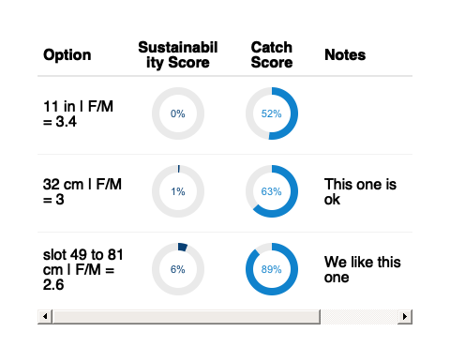

# Notes

NA